CHAPTER TITLE

CARDIOVASCULAR SYSTEM
Ms. Sejal M. Khuman¹, Ms. Jeshika B. Patel² Ms. Morvi M. Raval³, MS. Saloni S. Desai⁴

Ms. Sejal M. Khuman¹
M.Pharm,
Assistant Professor
Rofel Shri G. Bilakhia College of Pharmacy,
Rajju Shroff Rofel University, Vapi

Ms. Jeshika B. Patel²
M.Pharm,
Assistant Professor
Rofel Shri G. Bilakhia College of Pharmacy,
Rajju Shroff Rofel University, Vapi

Ms. Morvi M. Raval³
M.Pharm, Ph.D*
Assistant Professor
School of Pharmacy
Dr. Subhash University, Junagadh

MS. Saloni S. Desai⁴
M.Pharm, , Ph.D*
Assistant Professor
Rofel Shri G. Bilakhia College of Pharmacy,
Rajju Shroff Rofel University, Vapi

Topic covered

- INTRODUCTION
- HEART ANATOMY
  - Structure and function of heart
    - General introduction
    - Heart layers
    - Heart’s chamber
    - Valves of heart
    - Function of heart
- Heart circulation vessels
- Blood circulation
- Conduction system of heart
- Cardiac Cycle
- Conclusion

ABSTRACT

All bodily parts get their blood supply and drainage from the cardiovascular system. In general, the cardiovascular system consists of the heart, venous and arterial systems, as well as a vast network of microscopic capillaries. The heart is a muscle pump with a hollow structure that moves blood through a system of blood arteries. Blood is transported by arteries from the heart to the body's tissues. Blood is drawn from the body's tissues and returned to the heart via veins. The tiniest blood vessels, called capillaries, join the venous and arterial systems. Furthermore, blood arteries can be classified according to the part of the body they supply (or drain).Pulmonary circulation refers to blood vessels that connect to the lungs, and coronary circulation refers to blood vessels that supply blood to the heart muscle itself. This chapter give information about hearts anatomy and physiology.

INTRODUCTION ^{[1,2]}

The circulatory system in humans is an organ system that uses vessels to carry blood to and from all parts of the body, feeding tissues with oxygen and nutrients and eliminating waste products like carbon dioxide. The heart muscle pumps blood through a closed tubular system. The pulmonary and systemic circuits are composed of venous, capillary, and arterial components.

The main task of the heart is to pump blood into and out of arteries in all sections of the body like a muscular pump. This blood is transported throughout the body at high pressure and speed via the thick walls of the arteries, which are composed of both elastic fibrous tissue and muscle cells.

Heart anatomy

The circulatory system can be thought of as a system of big and small plumbing tubes that carry blood, and a muscular pump with one-way valves.

Structure and Functions of Heart
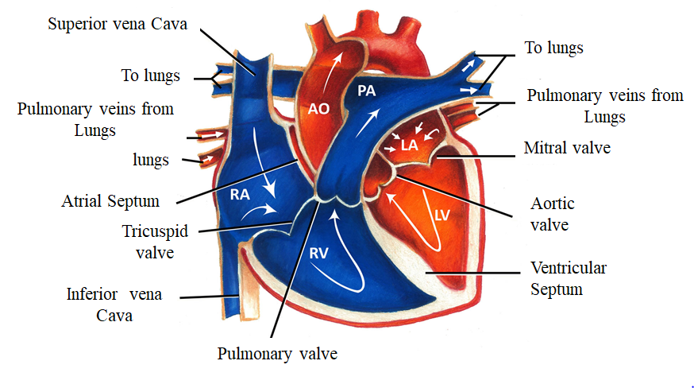
Structure of heart^{[3]}
- The typical adult human heart is approximately the size of a closed fist..
- With an average mass of 250g for adult females and 300g for adult males, At its widest point, it measures around 12 cm (5 in.) in length, 9 cm (3.5 in.) in width, and 6 cm (2.5 in.) in thickness.
- It is located in the mediastinum, an anatomical area that connects the lungs, the first rib to the diaphragm, and the sternum to the vertebral column. The heart's mass is located around two thirds to the left of the body's midline. Four chambers make up the heart. The two inferior pumping chambers are called ventricles, while the two superior receiving chambers are called atria (entrance halls or chambers).

- The pericardium^{[3,4]}

  - The pericardium is the membrane that envelops and shields the heart.
  - The heart is restricted to its location in the mediastinum, yet it still has adequate space to move around to contract rapidly and forcibly.
  - ➢ The fibrous pericardium and the serous pericardium are the two fundamental components of the pericardium. Tough, elastic, thick, uneven connective tissue makes consists the superficial fibrous pericardium.
  - The fibrous pericardium provides protection and keeps the heart from overstretching. A thinner, more sensitive membrane known as the deeper serous pericardium surrounds the heart in a double layer. The outer parietal layer of the serous pericardium is fused to the fibrous pericardium. One of the layers of the heart wall is the epicardium, or inner visceral layer of the serous pericardium, which firmly attaches to the surface of the heart.
  - There is a small layer of lubricating serous fluid between the parietal and visceral layers of the serous pericardium. As the heart beats, a substance known as pericardial fluid reduces friction between the serous pericardium's layers. The pericardial cavity is the area that holds the few milliliters of pericardial fluid.

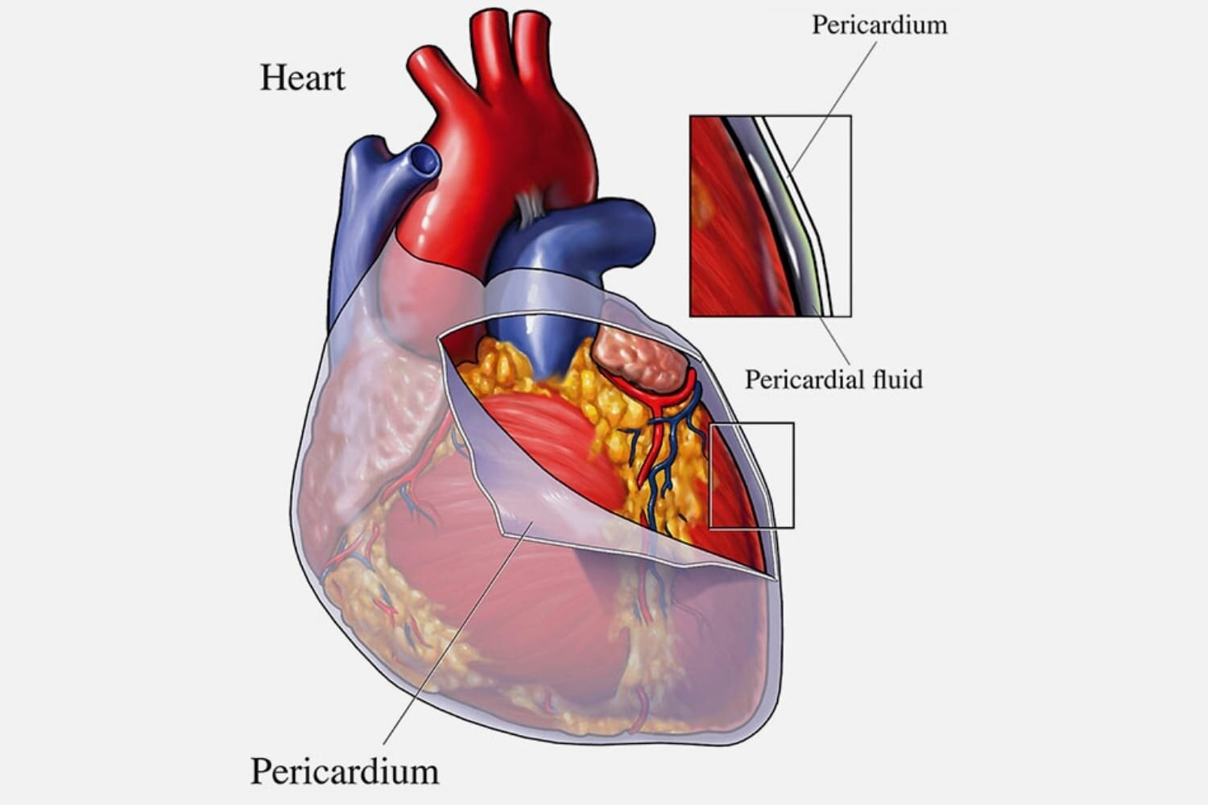

Heart’s pericardium^{[5]}
Heart layers^{[3,4]}

The three layers that collectively make up the heart muscle are as follows:

- The epicardium (external layer)
- The myocardium (middle layer), and
- The endocardium (inner layer)

  - The epicardium (external layer)
- The outermost epicardium, the thin, transparent outer layer of the heart wall, is also called the visceral layer of the serous pericardium.
- It gives the the heart's exterior a smooth, sticky texture and is made up of mesothelium and delicate connective tissue.

  - The myocardium (center layer)
- The center myocardium, which is cardiovascular muscle tissue, makes
up around 95% of the heart and is liable for its pumping activity. The cardiac muscle fibers swirl diagonally around the heart in bundles

  - The endocardium (inner layer)
- Consists of a thin layer of endothelium and a thin layer of connective tissue.
- Its primary function is to provide a smooth lining for the heart chambers and to cover the heart valves.
- Additionally, the endocardium is seamlessly connected to the endothelial lining of the major blood vessels connected to the heart, ensuring minimal surface friction.

Heart’s Chambers ^{[3,4]}

The heart is separated by septa into two halves, namely the right and left halves. Every half is further divided into two chambers: the ventricles, which pump blood to the lungs and the rest of the body, are separated by the interventricular septum, while the upper chambers, called atria, are separated by the interatrial septum. The atria receive blood from various parts of the body (called receiving chambers) and transfer it to the ventricles.

The right atrium, also known as the right superior part of the heart, is a chamber with thin walls that receives blood from all tissues except the lungs. Three veins, namely the superior and inferior vena cavae, as well as the coronary sinus, empty into the right atrium, bringing blood from the upper and lower parts of the body and draining blood from the heart itself. Blood then flows from the right atrium to the right ventricle. The right ventricle, located in the right inferior part of the heart, is responsible for pumping blood to the lungs through the pulmonary artery.

On the other hand, the left atrium, situated in the left superior part of the heart, is slightly smaller than the right atrium and has a thicker wall. It receives oxygenated blood from the lungs through the four pulmonary veins. From the left atrium, blood flows into the left ventricle. The left ventricle, found in the left inferior part of the heart, has walls that are three times thicker than those of the right ventricle. Blood is forcefully pumped from this chamber through the aorta, supplying all parts of the body except the lungs.

Valves of heart^{[4]}
The valves of the heart respond to changes in pressure by opening and closing. As the heart contracts and relaxes, these valves play a crucial role in maintaining the unidirectional flow of blood. They open to allow blood to pass through and then close to prevent any backward flow.

Atrioventricular Valves (AV)

AV valves, namely the tricuspid and bicuspid valves, are referred to as atrioventricular valves due to their positioning between an atrium and a ventricle. During the relaxation of the ventricles, the papillary muscles and chordae tendineae also relax, allowing blood to flow from the higher pressure in the atria to the lower pressure in the ventricles via the open AV valves.

Semilunar Valves

The semilunar valves, namely the aortic and pulmonary valves, derive their name from their structure, which consists of three crescent moon-shaped cusps. These valves play a crucial role in facilitating the ejection of blood from the heart into the arteries while preventing any backflow into the ventricles. As the ventricles contract, pressure gradually increases within the chambers. Subsequently, the semilunar valves open when the pressure in the ventricles surpasses the pressure in the arteries, enabling the blood to be expelled from the ventricles into the pulmonary trunk and aorta.

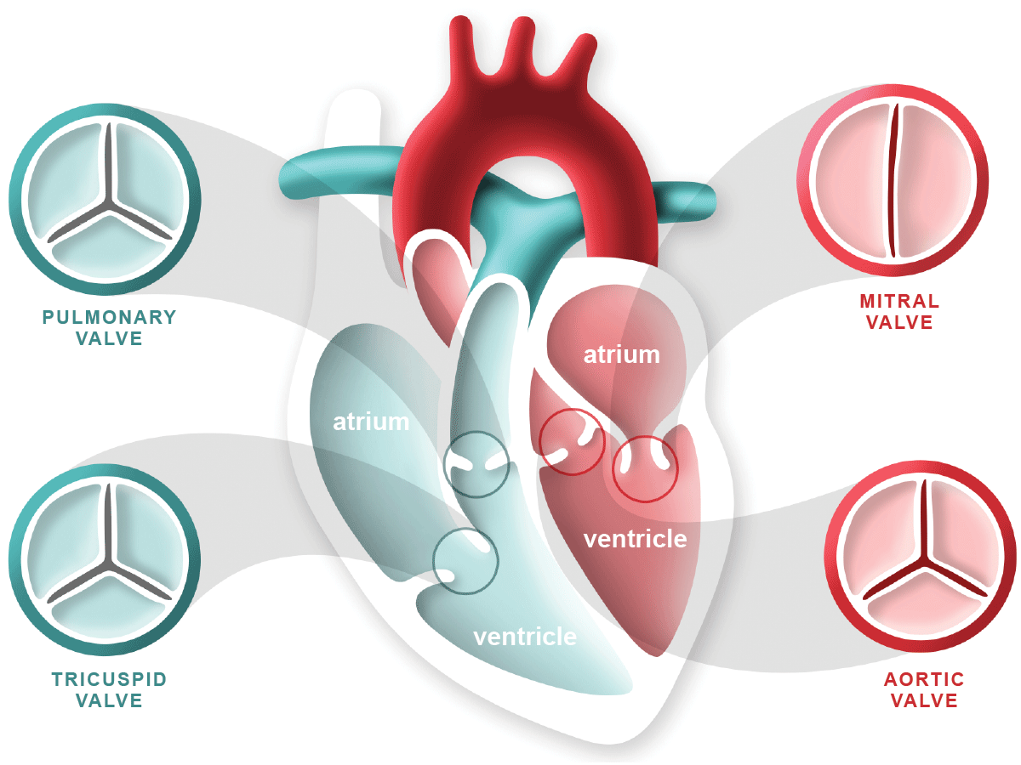

Valves of heart^{[6]}

Blood Vessels^{[7]}
The whole cardiac circulation can go forward thanks to the big blood arteries.
- The heart receives deoxygenated blood from the veins of the body through the superior and inferior vena cava. This blood is then pumped through the pulmonary trunk. The pulmonary trunk divides into the right and left pulmonary arteries, which transport the blood to the lungs. In the lungs, oxygen is taken up and carbon dioxide is released. The oxygenated blood then flows back to the left side of the heart through the four pulmonary veins. After then, the heart pumps it into the aorta, which gives rise to systemic arteries, which carry oxygen-rich blood to every part of the body..

Heart function
- Blood supply management - Blood flow is matched to the shifting metabolic requirements of the tissues during rest, exercise, and changes in body position via variations in the heart's contraction force and rhythm.

- blood pressure production The level of blood pressure is created by heart contractions and is necessary for blood to move through blood vessels.

- Ensuring unidirectional blood flow. The valves of the heart secure a one-way blood flow across the heart and blood arteries.

- Blood transmission: By keeping the pulmonary and systemic circulations apart, the heart guarantees that oxygen-rich blood reaches the tissues..

Heart Circulation Vessels^{[7]}

The heart's blood does not nourish the myocardium, despite the blood flowing through its chambers virtually constantly.

• Coronary arteries. The coronary arteries emerge from the base of the aorta and encircle the heart in the atrioventricular groove, also known as the coronary sulcus, at the point where the ventricles and atria meet. These arteries swell during periods of heart relaxation and compress during ventricle contraction.

• Cardiac veins. A number of cardiac veins drain the myocardium, and these veins empty into the coronary sinus, an enlarged conduit located on the back of the heart.

Blood vessels

Within the blood vessels, which together constitute the so-called vascular system, a closed transport system, blood flows.

- Arteries- Blood is forced out of the heart through the main arteries as it beats.

- Arterioles- After there, it enters arteries that get progressively smaller until entering arterioles, which supply the tissues' capillary beds.

- Veins- Venules, which empty into veins and ultimately into the large veins that enter the heart, drain the capillary beds.

- Tunics- The blood vessel walls are covered in three layers, or tunics, with the exception of the tiny capillaries.

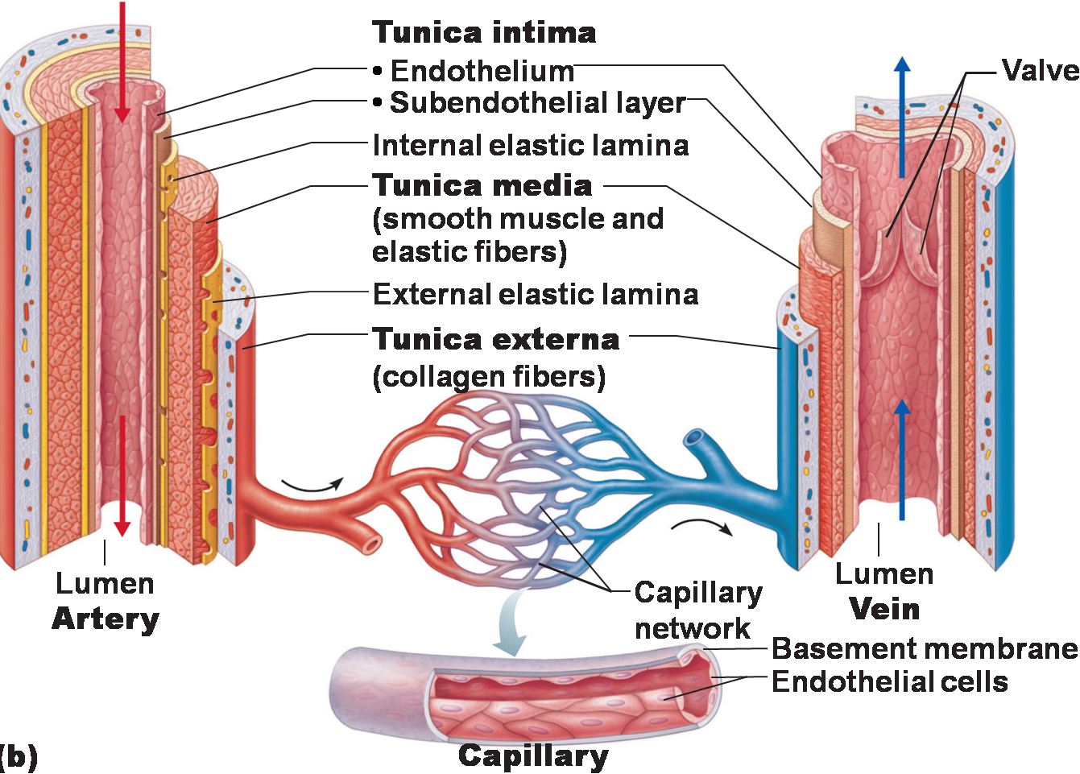

Artery, vein and capillary ^{[8]}
- Tunica intima. A thin layer of endothelium lying on a foundation membrane, the tunica intima lines the lumen, or interior, of the veins and reduces friction as blood passes through it.

- Media Tunica. The thick middle coat, or tunica media, is primarily made up of elastic fibers and smooth muscle that can contract or dilate to change blood pressure.

- External tunica. The primary purpose of the outermost tunic, known as the tunica externa, which is primarily made of fibrous connective tissue, is to support and shield the vessels.

Blood circulation ^{[4]}

- In the circulation that occurs after birth, the heart functions by pumping blood into two distinct closed circuits known as systemic circulation and pulmonary circulation.

- Arteries in systemic tissues give rise to arterioles with smaller diameters, which eventually lead to extensive networks of systemic capillaries.

- The exchange of nutrients and gases takes place across the thin walls of these capillaries. During this process, blood unloads oxygen (O2) and picks up carbon dioxide (CO2). Typically, blood flows through a single capillary before entering a systemic venules.

- These venules carry deoxygenated (oxygen-poor) blood away from the tissues and merge to form larger systemic veins. Ultimately, the blood returns to the right atrium.

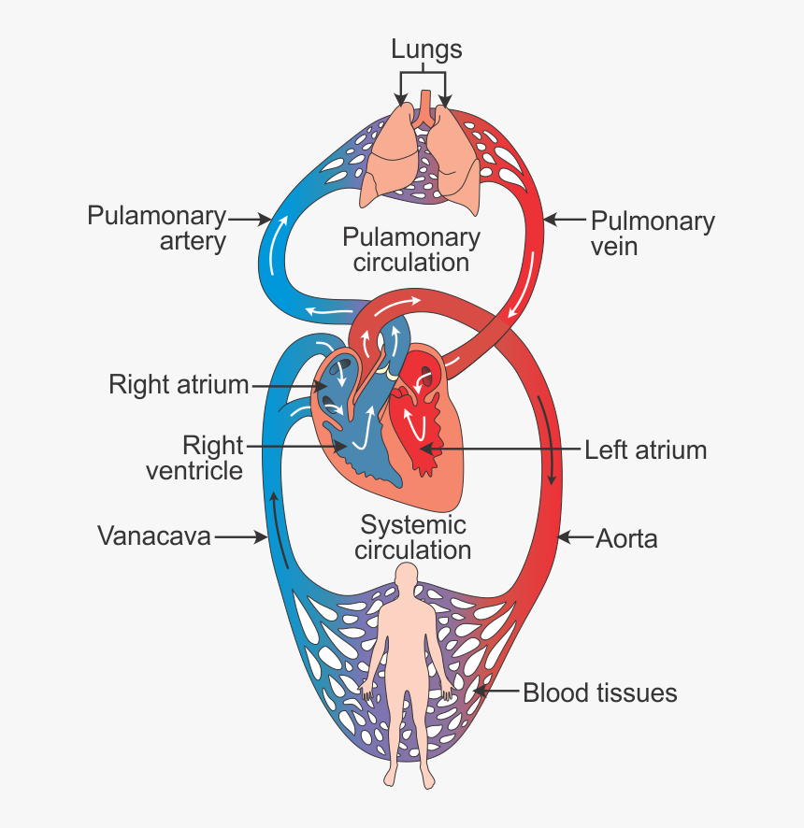
Blood circulation pathway ^{[9]}

The coronary or cardiac circulation is the name given to the complex network of blood arteries that the heart uses to supply nutrition to the myocardium. The ascending aorta is the source of these coronary arteries, which surround the heart in a circle that resembles a crown surrounding the head.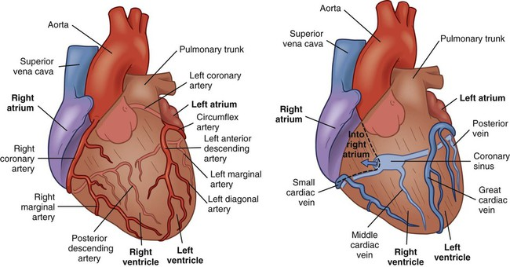
Coronary artery and coronary vein^{[11]}

Conduction system of the heart^{[10]}
- The heart's conducting system is comprised of cardiac muscle cells and conducting fibers—not nerve tissue—that are designed to rapidly initiate impulses and carry them throughout the heart.
- They initiate the normal cardiac cycle and guide the constrictions of the heart chambers.
- Both the ventricles and the two atria contract simultaneously, but atrial compression occurs first. The heart's preprogrammed musical pounding is provided by the guiding framework. The events in the circulatory cycle should be organized in a way that allows the heart to pump efficiently and the fundamental and aspiratory courses to function simultaneously.
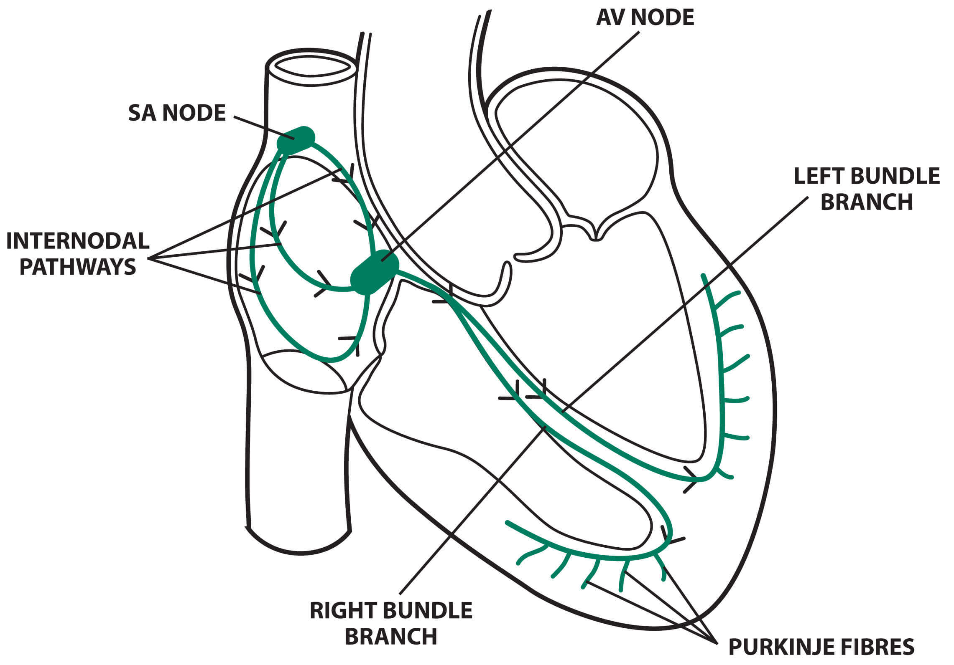

Conduction system of heart^{[13]}

SA node

The spindle-shaped Sinoatrial (SA) node is composed of densely packed cells inside a fibrous tissue matrix. It is thick, ranging in length from 10 to 20 mm, and it tends to narrow caudally toward the inferior vena cava (IVC).

The SA node is located at the side of the right atrial sulcus terminals, less than 1 mm from the epicardial surface, where the right atrium (RA) and the anteromedial portion of the superior vena cava (SVC) meet.

In 55–60% of hearts, the vein supplying the sinus node splits off from the right coronary artery, while in 40–45% of hearts, it branches from the left anterior descending artery. The artery reaches the node in either a clockwise or counterclockwise way around the SVC–RA junction.

Postganglionic adrenergic and cholinergic nerve terminals densely innervate the SA node.

Through stimulation of beta-adrenergic and muscarinic receptors, neurotransmitters affect the rate of discharge from the SA node. The SA node contains subtypes of beta1 and beta2 adrenoceptors. The beta-adrenergic and muscarinic cholinergic receptors in the human SA node are more than three times thicker than those in the surrounding atrial tissue.

Intra-atrial and internodal conduction

Anatomic evidence shows the presence of 3 intra-atrial pathways: (1) anterior internodal pathway, (2) center internodal tract and (3) posterior internodal tract .

The anterior internodal pathway originates at the initial edge of the SA node and bends anteriorly around the SVC to reach the front interatrial band, called the Bachmann group. The front internodal channel of this band enters the prominent edge of the AV node and continues to the left artery (LA). Large muscle group known as the Bachmann bundle appears to be in charge of the cardiovascular drive, particularly from the RA to the LA.

The center internodal pathway starts at the prevalent and back edges of the sinus node, makes a trip behind the SVC to the peak of the interatrial septum, and plummets in the interatrial septum to the predominant edge of the AV node.

The posterior portion of the AV node is joined by the back internodal parcel, which starts at the rear border of the sinus node and travels posteriorly around the SVC, down the crista terminalis to the eustachian edge, and into the interatrial septum above the coronary sinus.

Since these collections of internodal tissue don't appear to be histologically distinct tracts, it is appropriate to refer to them as internodal atrial myocardium rather than lots.

AV node

The smaller portion of the atrioventricular (AV) node is a shallow structure that is located directly over the septal lobe of the tricuspid valve, anterior to the coronary sinus ostium, and slightly below the RA endocardium. At its peak, the tricuspid valve forms a triangle with the Todaro tendon, which extends from the central fibrous body into the atrial septum and continues with the eustachian valve.

The blood vascular supply to the AV node in 85–90% of human hearts originates at the posterior crossing site of the AV and interventricular grooves (core), a branch of the right coronary artery. A portion of the left branch of the coronary artery provides the AV nodal supply channel in an excess of 10-15% of hearts. The AV node's lower strands may show signs of spontaneous impulse generation. The AV node's main function is to control the atrial impulses that are sent to the ventricles in order to coordinate the contraction of the ventricles and the atrium.\

The Conduction System pathway
The conduction system operates in a methodical manner by:

- SA node. The sinoatrial node starts the depolarization wave.

- Myocardium atrial. The atrial myocardium is then successively passed through by the wave.

- AV node. After reaching the AV node, the depolarization wave causes the atria to constrict.

- AV bundle. The AV bundle is then quickly traversed by it.

- Bundle branches and Purkinje fibers. The wave then passes via the bundle branches on the right and left, and finally reaches the Purkinje fibers in the ventricular walls, where it causes a contraction that forces blood out of the heart.

Cardiac Cycle ^{[12,14]}

The sequence of events that take place from the start of one heartbeat to the start of the next is known as the cardiac cycle. The heart is made up of two sequentially operating pumps..

The right atrium and right ventricle make up the first pump, which sends blood to the lungs for gas exchange (taking in oxygen and exchanging carbon dioxide). The left atrium and left ventricle make up the second pump, which circulates blood to all other bodily tissues. This process is referred to as systemic circulation. The heart's chambers include valves that allow blood to flow only in one way. These valves include the tricuspid valve, which is situated between the right and left ventricles; the mitral valve, which is situated between the left and right ventricles; the pulmonary valve, which is situated between the right and left ventricles; and the aortic valve, which is situated between the left and right ventricles and the aortic artery, which supplies oxygenated blood to the body's tissues. Pressure differentials control how these valves open and close.

Like a pump, the heart beats in two phases: the diastole and the systole. The left ventricle contracts to pump oxygenated blood throughout the entire systemic circulation during systole, whereas the right ventricle contracts to pump deoxygenated blood into the lungs for oxygenation. The pulmonary and aortic valves open during this procedure, whereas their bicuspid and tricuspid atrioventricular valves close. Blood can enter the pulmonary artery when the pulmonary valve opens as a result of the right ventricle contracting and increasing pressure. In order to pump blood into the circulation, the left ventricle contracts simultaneously, raising pressure and opening the aortic valve. The ventricles relax during diastole, which lowers the pressure. resulting in the opening of the pulmonary valve, which opens the pulmonary artery to blood flow. In order to pump blood into the circulation, the left ventricle contracts simultaneously, raising pressure and opening the aortic valve. The ventricles relax during diastole, which lowers the pressure. The ventricles can fill with blood from the atria thanks to this relaxation, which also causes the tricuspid and mitral valves to open.

There are three separate phases that make up the systole. All valves close during the initial stage of contraction, which is referred to as isovolumetric contraction. The ventricles contract during this period, which raises the pressure. There is an 8 mmHg pressure increase in the right ventricle and an 80 mmHg pressure increase in the left ventricle. As a result, the aortic and pulmonary valves open, respectively. The second phase, referred known as maximum ventricular ejection fraction, is characterized by the ejection of blood volume at a high pressure. Blood is expelled into the systemic circulation as well as the pulmonary circulation, with pressures as high as 120 mmHg. Reduced ventricular ejection rate refers to the third and last stage. The pressure and velocity of the ejection are reduced during this phase. The aortic and pulmonary valves collapse when the pressure and velocity steadily drop.

There are four main phases of diastole. The ventricles relax during the first phase, which is referred to as isovolumetric relaxation, and the internal blood volume remains constant. All valves are closed for the duration of this phase, which is between 0.03 and 0.06 seconds. The tricuspid and mitral valves open during the second phase, known as fast diastolic filling, allowing the ventricles to fill with blood. There is a small pressure rise throughout this filling procedure, about 5 mmHg. A slower blood flow from the atria to the ventricles is the characteristics of the third phase, which is sometimes referred to as sluggish diastolic filling. The ventricles' internal pressure has somewhat increased as a result. The last stage, known as atrial contraction, is when the atria contract, raising the pressure inside the ventricles. By doing this, the ventricles get ready for systole to begin.

In the right atrium, the pressure rises by 4-6 mmHg and in the left atrium, by 7-8 mmHg during atrial contraction. It is noteworthy that atrial contraction is not necessary for about 70% of the blood volume to travel straight from the atria to the ventricles. The atria's contraction only accounts for 25% of the ventricular volume rise. The atria are also referred to as a priming pump for this reason. The heart can still function without this extra 25%, though, because it pumps 300–400% more blood than the body needs.

The ventricles fill up with 110 to 120 ml of blood during diastole, the rest phase of the cardiac cycle. The last diastolic volume is the name given to this particular volume. On the other hand, this volume drops by about 70 ml during the cardiac cycle's contraction phase, or systole; this is referred to as systolic output. The final systolic volume is the amount of volume left in each ventricle, which can be anywhere between 40 and 50 ml. The ejection fraction, which is usually 60%, is the percentage of the diastolic volume that is ejected. Consequently, the rise in final diastolic volume and the decrease in final systolic volume contribute to an elevation in systolic output. Cardiac output is the amount of blood the heart pumps out in a minute.

CONCLUSION

Every part of our body receives life-sustaining blood pumping from the heart, a function made possible by the sophisticated and complex circulatory system. This system is a network of fluids, organs, and vessels that work together to carry nutrition and oxygen throughout our bodies. This guide covers the interesting anatomy and physiology of the circulatory system, covering everything from the four chambers of the heart to the complex sequence of events that make up the cardiac cycle.The blood carries waste materials out of the body and carries nutrients and oxygen to the cells. For cells to continuously obtain oxygen and nutrients, the heart cycle and cardiovascular system must function harmoniously. Blood pressure is a crucial indicator of cardiovascular health that is regulated by a number of factors, including blood volume, peripheral resistance, and cardiac output. Comprehending these crucial elements can aid medical practitioners in accurately diagnosing and treating cardiovascular disorders.

REFERENCE
  - Melanie A. Greeley and Stephanie J. White-Hunt, “Cardiovascular System.” Elsevier Inc. 2016, PP-423-437.
  - J.D. Humphrey and A.D. McCulloch, “The Cardiovascular System - Anatomy, Physiology and Cell Biology.” Springer-Verlag Wien, 2003, PP-.1-2.
  - Anatomy Of Heart, December 2023, https://healthjade.com/purpose-heart-valves
  - Human cardiovascular system -- Britannica Online Encyclopedia
  - Pericardium Of Heart, December 2023, https://heartvein.com/heart-disease/conditions/pericarditis
  - HEART VALVES, DECEMBER 2023, https://www.heartfoundation.org.nz/your-heart/heart-conditions/heart-valve-disease
  - Jan Hendrik van Weerd and Vincent M. Christoffels, “The formation and function of the cardiac conduction system.” The Company of Biologists Ltd ,Development, 2016, 143, 197-210.
  - Artery, Vein And Capilary,December 2023, https://www.pinterest.ca/pin/168885054751453242/
  - Blood Circulation Pathway,December 2023, https://www.toppr.com/ask/question/explain-double-circulation-in-human/
  - Conduction system of heart,january 2023, https://emedicine.medscape.com/article/1922987-overview?form=fpf
  - Coronary Artery And Veins, December 2023, https://nursekey.com/nursing-assessment-cardiovascular-system/
  - Vanessa Novaes Barros, “The heart cycle: review.” MOJ Womens Health. 2019, 8(1):66‒69.
  - Conduction System Of Heart, January 2024, https://www.medicalexamprep.co.uk/the-basics-of-ecg-interpretation-part-2-rate-rhythm-and-axis/cardiac-conduction-system-5/

