Physical, Optical and Structural studies of Molybdenum doped B₂O₃-CdO-Al₂O₃-PbF₂ glasses
Siddoju Rajesham^{1, 2, *}, K. Chandra Sekhar³, Md. Shareefuddin², J. Siva Kumar²
¹Department of Physics, Geethanjali College of Engineering and Technology, Cheeryal, Hyderabad, Telangana, 501301, India
²Department of Physics, Osmania University, Hyderabad, Telangana, 500007, India
³Department of Physics, University College of Science, Saifabad, Osmania University, Hyderabad, Telangana, 500004, India
Abstract:
The Preparation and thorough physical and structural analysis of B₂O₃-CdO-Al₂O₃-PbF₂ glasses supplemented with MoO₃ ions are the topics of this publication. The creation of NBOs in these glasses was confirmed by the incorporation of MoO₃, which resulted in an overall reduction in density and band gap parameters and a boost in refractive index. This transformation of Mo⁶⁺ ions to Mo⁵⁺ ions was confirmed. It was discovered that there were many borate and aluminate components in the FTIR spectrum. The FTIR spectra also showed the transformation of Mo⁶⁺ ions into Mo⁵⁺ ions. The transformation of BO4 to BO3 units, which increased NBOs and assisted in explaining the density change, was evident in the influence of MoO₃ ions on Raman spectra.
Keywords Borate glasses, Refractive index, Optical absorption, FTIR, Raman spectra
1. Introduction
Because of the growing significance of glasses for both daily necessities and numerous other uses, researchers have been forced to enlarge their field perspective in a variety of chemical compositions containing borate, silicate, phosphate, and other materials [1, 2]. Borate is generally used as a glass-forming material due to its low melting point, clarity, thermal stability, and solubility [3, 4]. The incorporation of Al₂O₃ into the borate matrix results in significant modifications to its optical, chemical, and physical properties. AlO₄ or AlO₆ units can be found in the glass network, based on the amount of Al₂O₃. Elevating the proportion of Al₂O₃ can significantly enhance its mechanical strength, chemical resistance, and moisture resistance ability. Additionally, aluminum borate glasses can combine with transition metal ions (TMI) and other metal oxides [5-7].
One of the most common metal oxides utilized to boost density in glass compositions is CdO. It is also widely recognized that CdO is utilized as control rods in nuclear reactors. Borate glasses are treated with fluorides to increase their transmission window, solubility, and fluorescence longevity, among other benefits [7-9]. PbF₂ is included in borate glasses to enhance certain optical properties and infrared transparency, which are used in laser engineering and communication systems [10].
However, it was found that molybdenum ions are excellent catalysts for examining catalytic properties since they show remarkable activity and selectivity in a variety of oxidation activities in different oxide glasses. The presence of molybdenum ions in various valence states (+3, +4, +5, and +6) could potentially enhance the optical, electrical, and electrochromic properties of the glasses. The presence of molybdenum ions in multivalence states enhances the electronic contribution to conduction because of electron hopping around molybdenum ions [11–13].
According to their analysis of MoO₃'s mol%, Ali et al. [19] determined that MoO₃ had a former and moderating effect in PbO–Sb₂O₃–As₂O₃– MoO₃ glasses. Alrowaili et al. [20] synthesized the P₂O₅–B₂O₃–Li₂O– MoO₃ glasses and found that when the MoO₃ proportion increased, the Urbach energy decreased and the density, refractive index, metallization criterion, and shielding ability increased. Other researchers, including Shaaban et al. [21], Rada et al. [22], Manisha et al. [23], and others, created glasses with different ratios that included MoO₃, and they verified that the glasses that included MoO₃ had superior uses concerning optical and shielding properties. Because of this, glasses may be formed when borate and MoO₃ combine. Moreover, recent studies have demonstrated that the glass network is significantly altered by the injection of even a tiny quantity of TMI into glasses. Furthermore, the best features, aside from the best optical endowments, are revealed in borate doped cadmium alumina matrix with varying mole percentages of metal fluoride and transition metal ions, for electronic, optoelectronic, and electrochromic applications.
2. Experimental
The glass specimens, where x = 0, 0.5, 1, 1.5, and 2mol%, were made with an unusual mixture of 60B₂O₃-20CdO-5Al₂O₃-(15-x) PbF₂-x MoO₃. Melt quenching was the technique used in the creation of glass samples. Every necessary chemical was of annular grade and weighed according to the necessary mole proportions for five different sets of glass combinations. The different mole percentages of the compounds were physically combined in an agate mortar until they were evenly blended, after which they were calibrated using an electronic monopan balance. This chemical mixture was placed in a porcelain crucible and allowed to melt uniformly for one hour at a temperature of 1000°C in an electronic furnace that operates under standard atmospheric conditions. Further melts are swirled to gain homogenization. After the resultant melt was quenched for a few hours at 200°C on a steel plate to relieve internal tensions, the glass samples were prepared for additional examination.
To determine the nature of the samples, X-ray diffraction (XRD) spectra are obtained using a Philips Xpert Pro X-ray diffractometer between 10º and 80º for 2θ. Next, density is calculated using the Archimedes principle with xylene serving as the dipping liquid. Three experimental fragments were taken out of each glass to be measured for density; the final density was calculated using the aggregate density of the three sample pieces. The computation's accuracy is 0.005 g/cc. Using a Bruker FTIR spectrometer, Fourier transform infrared (FTIR) spectra were captured with a precision of 0.01 cm⁻¹ and a resolution of 0.5 cm⁻¹. The Raman spectra of BCAPM glasses were obtained in the 200 –1800 cm⁻¹ wavenumber range using a J. Y. H. LABRAM-HR Raman spectrometer. A wavelength range of 200nm to 1000nm was covered by scanning the UV-Visible spectra of BCAPM glasses using a Shimadzu UV-1800 Spectrometer in absorption mode. Using a Bruker EPR spectrometer, EPR spectra were obtained at room temperature between 2500 and 4000G.
3. Results and discussions:
3.1. X-Ray Diffraction (XRD)
The BCAPM glasses patterns from an XRD scan are displayed in Figure 1. The illustration unequivocally shows broad humps around 2θ = 20°C and 30°C. Moreover, the lack of distinct peaks suggests that the BCAPM specimens are non-crystalline.
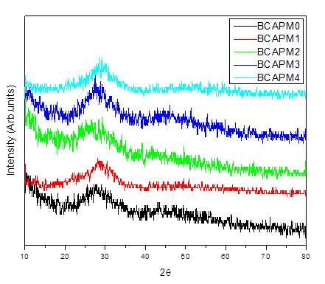
Figure 1: XRD Spectrum of BCAPM glasses
3.2. Physical and optical properties
Density is indeed an important physical property that provides information about solids; nevertheless, the more clearly the structure is known, the more useful this evidence will be [24, 25]. The density information of the samples can be used to calculate the volume of structural units embedded in the glass.
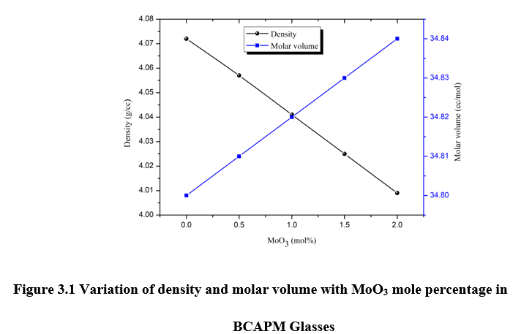
Figure 2: Variation of density and molar volume with MoO₃ mole percentage in BCAPM glasses
Density values in the BCAPM glass system were nonlinearly decreased from 4.072g/cc (BCAPM0) to 4.009g/cc (BCAPM4) in the current system. Using the obtained density and molecular weight (M) information, the molar volume (V_{m}) was computed (Table 1). The variation of V_{m} and ⍴ with MoO₃ is seen in Figure 2.
Table 1: Density, molar volume, Urbach energy, optical bandgap, refractive index, molar refraction and molar electronic polarizability of BCAPM glasses
Physical & Optical parameters | Sample Code
 | BCAPM0 | BCAPM1 | BCAPM2 | BCAPM3 | BCAPM4
Average molecular weight | 141.754 | 141.248 | 140.742 | 140.235 | 139.729
Density (ᵨ) gm/cc | 4.072 | 4.057 | 4.041 | 4.025 | 4.009
Molar Volume (V_{m}) cc/mol | 34.80 | 34.81 | 34.82 | 34.83 | 34.84
Optical band gap (E_{opt}) eV | 3.063 | 3.049 | 3.013 | 3.002 | 2.951
1-sqrt(E_{g}/20)(R_{m}) | 0.6084 | 0.6095 | 0.6119 | 0.6126 | 0.6158
Refractive index (n) | 2.379 | 2.383 | 2.393 | 2.396 | 2.410
Dielectric constantnt (ε) | 5.660 | 5.682 | 5.728 | 5.743 | 5.809
Molar refractivity (Rm) cm⁻³ | 21.17 | 21.21 | 21.30 | 21.34 | 21.45
Electronic polarizability (αm) 10⁻²¹ cm-3 | 8.38 | 8.40 | 8.44 | 8.45 | 8.50
Urbach energy (ΔE) eV | 0.257 | 0.191 | 0.213 | 0.216 | 0.223

As the mole proportion of MoO₃ increases, the density of the BCAPM glasses decreases non-linearly, as seen by the crystal densities of MoO₃ (4.70gm/cc) and PbF₂ (8.44gm/cc). The decrease in density may be explained by the fractional substitution of MoO₃ (143.94 g/mol) with PbF₂ (245.2 g/mol). The literature suggests that the decrease in density values could be caused by the transformation of [BO₄] units to [BO₃] units, where [BO₄] is denser than [BO₃] [26, 27].
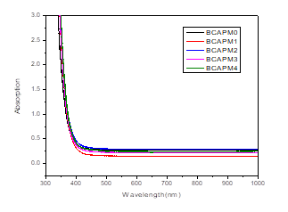
Figure 3: Absorption spectra of BCAPM glasses
Figure 3 shows the absorption spectra of BCAPM glasses. An intriguing technique is the investigation of the valence and conduction band transitions in the UV-visible zone utilizing the primitive absorption edge. The absorption coefficient α(v), which has decreasing values as a function of photon energy hν, is the primary feature of the absorption edge in non-crystalline substances [28].
$α\left(ϑ\right)= Cexp(\frac{hϑ}{∆E})$ (1)
where ΔE is Urbach energy and C is a constant. The α (ν) can be obtained from the absorbance A by using the equation below;
$α\left(ϑ\right)=2.303\frac{A}{d}$ (2)
where ‘d’ is the thickness. Davis et al [29] and Tauc et al [30] suggested relation:
($αhυ$) =$B^{2}{(hυ-E_{g})}^{2}$ (3)
The BCAPM glasses Tauc plot is displayed in Figure 4. It is possible to obtain the optical band gap (Eg) measurements (refer to Table 2) by extending the linear portion of the curve. In the current BCAPM glasses, MoO₃ enrichment from x=0 to 2 mole% causes Eg to decrease from 3.063 eV (BCAPM0) to 2.951 eV (BCAPM4). The bandgap decreases upon the addition of MoO₃, signifying the establishment of localized states for electrons in close proximity to the conduction band. It is possible to lower the bandgap by connecting these localized states to the conduction band. The decrease in band gap could have been brought on by the process of transformation of Mo⁶⁺ ions to Mo⁵⁺ ions. A decrease in bandgap and a rise in non-bridging oxygens can result from a boost in Mo⁵⁺ ions, which act as modifiers in the glass network and occupy octahedral positions [11, 31].
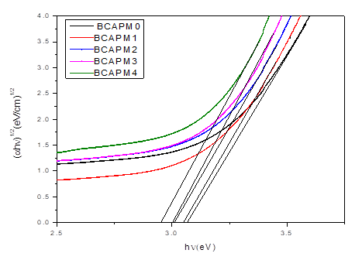
Figure 4: Tauc plot of BCAPM glasses
Urbach energy is found by calculating the inverse slope of the linear section of the Urbach plot, as shown in Figure 5. The Urbach energy provides the ability to determine the degree of disorder in the glass network. These values were discovered to be significantly lower for the BCAPM glass system, suggesting that there was less disorder in the glass structure [32].
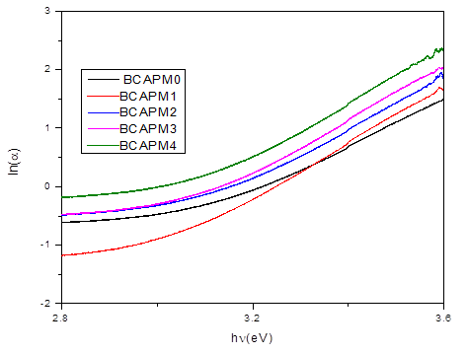
Figure 5: Urbach energy plot of BCAPM glasses
The relationships that follow [33–35] are used to estimate the remaining variables, such as molar refraction (Rm), molar electronic polarizability (αm), and refractive index (n).
$\frac{n^{2}-1}{n^{2}+2}=1-\sqrt{\frac{E_{g}}{20}}$ (4)
$R_{m}=\frac{n^{2}-1}{n^{2}+2}*V_{m}$ (5)
$α_{m}=\left(\frac{3}{4ПN_{A}}\right)*R_{m}$ (6)
The n parameters were increased from 2.379 (BCAPM0) to 2.410 (BCAPM4) due to an overabundance of MoO₃ in BCAPM glasses. Rm and ρ exhibit an increasing trend with mixture since they are both correlated with molar volume.
3.3. FTIR spectroscopy:
The method of analysis used to get infrared absorption or transmission spectra and identify different functional groups in materials is called Fourier transform infrared spectroscopy or FTIR spectroscopy. FTIR spectra can be used to investigate the impact of MoO₃ on the structural properties of BCAPM glasses having lead fluoride. Figure 6 displays the BCAPM glasses infrared absorption spectra in the 400–1600 cm⁻¹ wave number range. Table 3 lists the assignments of the numerous infrared bands (IR bands) detected from FTIR spectra: 423, 461, 517, 579, 673, 724, 901, 995, 1061, 1116, 1168, 1279, 1376, 1466, and 1549 cm⁻¹. The IR analysis generally identifies two separate frequency zones. According to references 36–38, the stretching vibrations BO₃ and BO₄ borate units are associated with ranges of 1200–1600 cm⁻¹ and 800–1200 cm⁻¹, correspondingly. Three main broad bands emerged throughout the examination, with substantial variations in the infrared spectra found at approximately 670, 1050, and 1380 cm⁻¹. The spectra showed that the core of the bands remained the same, but the bandwidths widened as the MoO₃ quantity ascended. Molybdenum ions can join the glass network as either network formers or network modifiers, depending on their valence states. Mo⁵⁺ ions can claim the former sites, whereas Mo⁶⁺ ions can claim the altering sites. When MoO₃ is added to BCAPM glasses to compensate for the loss of PbF₂, the hexavalent molybdenum ions are converted to pentavalent ions, increasing the amount of Mo⁵⁺ ions (which act as modifiers).
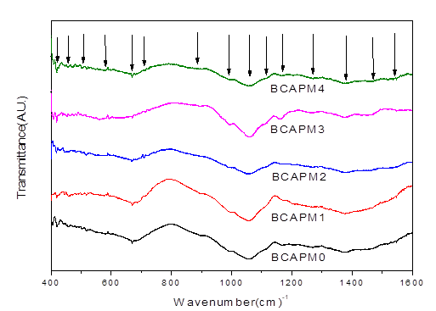
Figure 6: FTIR Spectra of BCAPM glasses
The IR Band assignments are shown in Table 2. The BCAPM glass specimen's bands ranging from 423 to 517 cm⁻¹ are ascribed to the vibrations of Pb²⁺ and Cd²⁺ as well as the octahedral AlO₆ [5, 6, 39]. The Mo-O bond vibrations in deformed MoO₄ may be the cause of the peak near 579 cm⁻¹ [13, 14]. The elongations of B-O-B bonds in BO₃ unit groups are shown by the IR band locations 673 cm⁻¹ detected in BCAPM glasses [41]. The bending vibrations of B-O links are responsible for the peak, which is located at around 724 cm⁻¹. The Mo–O–Mo bridging bonds inside the structure are what cause the band at 900 cm⁻¹. [13]. The bands between 995 and 1060 cm⁻¹ are caused by the B-O stretching vibrations of tetrahedral BO₄ units [42, 43]. The bands within 1116 and 1279 cm⁻¹ are caused by stretching vibrations of tetragonal BO₃ units from various borate groups. The band is ascribed to the stretching extensions of the B–O of trigonal (BO₃)3- units at about 1376 cm⁻¹. The IR band at 1476 - 1549 cm⁻¹ is caused by anti-symmetrical elongations B-O-B groups [44 - 46].

Table 2: IR Band Assignments of BCAPM glasses
IR band position (cm⁻¹) | Assignments
420 - 520 | Pb²⁺ , Cd²⁺ and AlO₆ octahedral
~579 | Mo-O bond vibrations
~673 | Stretching vibration of B–O–B bonds in BO₃ units
~724 | Bending vibrations of B–O linkages
~900 | Mo–O–Mo bridging bonds
990 - 1070 | B-O stretching vibrations
1110 - 1280 | Stretching vibrations of tetragonal BO₃ units
~1376 | Stretching elongations of the B–O of trigonal (BO₃)³⁻ units
1476 - 1549 | Anti-symmetrical stretching vibrations of B–O–B groups

3.4 Raman spectroscopy:
One of the most efficient tools for comprehending the structure of glasses is vibrational spectroscopy. Glasses are non-crystalline structures made up of structural units that are comparable to crystalline forms and can be freely arranged in a three-dimensional network. Raman spectroscopy is one of the finest and most effective vibrational spectroscopy methods for examining the structure of glass.
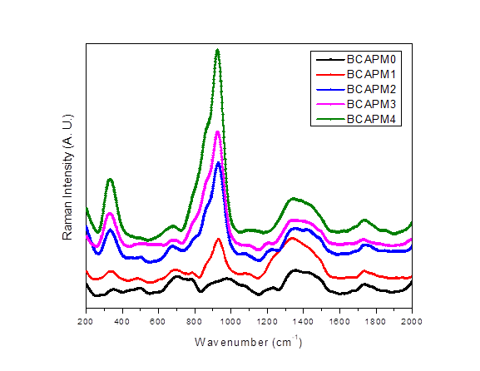
Figure 7: Raman spectra of BCAPM glasses
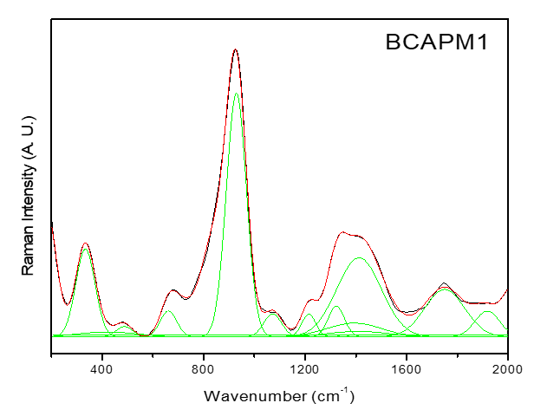
Figure 8: Deconvolution spectra for the BCAPM1 sample
In order to determine the precise Raman band locations, Figure 7 displays the Raman spectra of the BCAPM glasses, and Figure 8 shows the deconvolution spectra for the BCAPM1 sample. Table 4 lists the numerous Raman bands that have been detected from Raman spectra. These include 344 cm⁻¹, 498 cm⁻¹, 674 cm⁻¹, 789 cm⁻¹, (983 cm⁻¹ shift 925 cm⁻¹), 1079 cm⁻¹, 1229 cm⁻¹, (1347 cm⁻¹ shift 1337 cm⁻¹), 1437 cm⁻¹, and 1738 cm⁻¹. MoO₆ octahedra shared by two corners is the source of the rapidly rising Raman band at 344 cm⁻¹ [47, 48]. Isolated diborate groups are the cause of another band that is present at 498 cm⁻¹ [49]. The detection of the Raman band at 674 cm⁻¹ in BCAPM glasses led to the observation of anti-symmetric elongations of O-Mo-O linkages [50]. The stretching vibrations of Mo-O-Mo links and the creation of AlO₄ tetrahedra are the sources of another Raman band detected at 789 cm⁻¹ [5, 47]. The vibrations of Mo-O and Mo=O bonds in single and paired MoO₆ units are responsible for a significant band that is seen at ~950 cm⁻¹ in BCAPM glasses and increases sharply [51, 47]. In the current BCAPM glass system, it is evident that the two Raman peaks one at 344 cm⁻¹ and the other at 950 cm⁻¹ are growing dramatically as we increase MoO₃. In addition, the Raman band at 950 cm⁻¹ is moving from 983 cm⁻¹ to 925 cm⁻¹, and its intensity increases as MoO₃ quantities rise. This could be because MoO₃, a compound with a low molecular weight, has replaced PbF₂. The alteration in BCAPM glasses closer to a lower frequency range and greater intensity could be attributed to the conversion of [BO4] units to [BO3] with a spike in MoO₃ contents. This result confirms the observation that density fluctuation among BCAPM glasses is decreased as one raises MoO₃ doping content. The presence of diborate groups is responsible for the Raman band at 1079 cm⁻¹. The strength of the Raman bands at 789 cm⁻¹ and 1229 cm⁻¹ was found to decrease from BCAPM0 to BCAPM4 in glass specimens when the PbF₂ was substituted with MoO₃, and eventually, the Raman bands in the neighbourhood converged. Pyroborate groups and elongated B-O bands related to the borate groups are identified by a strong Raman band in BCAPM glasses at 1340 cm⁻¹ [53, 54]. The B-O- vibrations of the BO₃ units are responsible for the bands in this glass system around 1437 cm⁻¹, whereas the metaborate units of the chain and ring type are responsible for the band at 1738 cm⁻¹[54–56].
Table 3: Raman Band Assignments of BCAPM glasses
Raman band position | Band assignments
~344 | MoO₆ octahedra
~498 | Isolated diborates
~674 | Anti-symmetric elongations of O-Mo-O linkages
~789 | Stretching vibrations of Mo-O-Mo linkages and the formation of AlO4 tetrahedra
~950 | Vibrations of Mo-O
~1079 | Existence of diborate groups
~1340 | Pyroborate groups
~1437 | B–O⁻ vibrations of the BO₃ units
~1738 | Chain and ring type metaborate units

4. Conclusions:
Employing the traditional melt quenching procedure, glasses with the following composition: 60B₂O₃-20CdO-5Al₂O₃-(15-x) PbF₂-x MoO₃ (where x = 0, 0.5, 1, 1.5, and 2 mol%) were created. Physical, optical, FTIR and Raman spectroscopy methods were used to examine these materials to determine how MoO₃ affected the structural alterations that took place in them. The change from BO₄ to BO₃ units and the molecular weights of PbF₂/ MoO₃ are responsible for the specimens' decreased density. A decrease was noted in the optical band gap values, which were calculated using UV-visible spectra. The decrease in MoO₃ content is caused by the conversion of Mo⁶⁺ ions to Mo⁵⁺ ions, which occurs at the cost of PbF₂. Distinct borate and aluminate groups have been established by FTIR and Raman spectra. These spectra further validate that MoO₃ functions as a modifier in these glasses and assists the transition of Mo⁶⁺ ions into Mo⁵⁺ ions.
References
- Wang W.C., Zhou B., Xu S.H., Yang Z.M., Zhang Q.Y., Recent advances in soft optical glass fiber and fiber lasers, Pro. Mater. Sci. 101, 90–171 (2019) https://doi.org/10.1016/j.pmatsci.2018.11.003.
- Venkateswara Rao G., Shashikala H. D., Structural, optical and mechanical properties of ternary CaO–CaF₂–P₂O₅ glasses, J. Adv. Ceramics 3(2) 109–116 (2014). DOI: 10.1007/s40145-014-0099-8.
- Chandra Sekhar K., Hameed A, Sathe G., Narasimha Chary M. and Shareefuddin Md., Physical, optical and structural studies of copper-doped lead oxychloro borate glasses, Bull. Mater. Sci. 41, 79(1-7) (2018), https://doi.org/10.1007/s12034-018-1604-4.
- Mahesh M. H, Sable D.B., Solunke M.B., Jadhav K.M., Network structure analysis of modifier CdO doped sodium borate glass using FTIR and Raman spectroscopy, J. Non-Cryst. Solids 474 58–65 (2017). http://dx.doi.org/10.1016/j.jnoncrysol.2017.08.028.
- Ahmed M R, Chandra Sekhar K., Ahammed Sheik, Vasant Sathe G, Alrowaili Z. A., Mongi Amami, Olarinoye I.O., Al-Buriahi M.S., Tonguc B.T., Shareefuddin Md., Synthesis, physical, optical, structural and radiation shielding characterization of borate glasses: A focus on the role of SrO/ Al₂O₃ substitution, Ceram. Inter. 48 2124–2137 (2022). https://doi.org/10.1016/j.ceramint.2021.09.301.
- Ashok B, Sekhar K C, Chary B S, Ramadevudu G, Chary M N and Shareefuddin Md, Physical and structural study of Al₂O₃–NaBr–B₂O₃–CuO glasses, Indian J Phys (2021). https://doi.org/10.1007/s12648-021-02048-7.
- Lalitha Phani A.V., Chandra Sekhar K., Chakradhar R.P.S., Narasimha Chary M., Shareefuddin Md., EPR and FTIR spectroscopic studies of MO-Al₂O₃-Bi₂O₃-B₂O₃- MnO2(M = Pb, Zn and Cd) glasses, Mater. Res. Express 5, 035204, (2018). https://doi.org/10.1088/2053-1591/aab64d.
- Mahmoud K A, Tashlykov O L, SayyedM I, Kavaz E, The role of cadmium oxides in the enhancement of radiation shielding capacities for alkali borate glasses. Ceram. Int. 46 23337-23346 (2020), https://doi.org/10.1016/j.ceramint.2020.02.219.
- Chandra Sekhar K, Shareefuddin Md, El-Denglawey A and Saddeek Y B, Structural and optical properties of BaTiO₃ modified cadmium alkali borate glasses, Phys. Scr. 97 035704 (2022). https://doi.org/10.1088/1402-4896/ac53c7.
- Chandra Sekhar K., Kavitha B., Narsimlu N., Vasant Sathe G, Alothman M A., . Olarinoye I. O, Al-Buriahi M. S. & Shareefuddin Md., Enhancement of shielding ability using PbF₂ in Fe-reinforced bismuth borate glasses, J. Mater. Sci.: Mater. Electronics 32, 23047–23065 (2021). https://doi.org/10.1007/s10854-021-06788-4.
- Ali M. Ibrahim, and Hend I. Alkhammash, Influence of extra-addition of sulfur on the optical, electrical, and photoconductivity of the borate glasses containing MoO3, J Mater Sci: Mater Electron (2021) 32:7294–7306, https://doi.org/10.1007/s10854-021-05440-5.
- Arunkumar V. Banagar, M. Prashant Kumar, N. Nagaraja, Effect of Mixed Transition Metal Ions in B₂O₃-V₂O₅-MoO₃ Glass System, J. Elect. Mater, 49 12 (2020), https://doi.org/10.1007/s11664-020-08499-8.
- Saddeek Y B, Abousehly A M and Shaban I Hussien, Synthesis and several features of the Na₂O-B₂O₃-Bi₂O₃-MoO₃ glasses, J. Phys. D: Appl. Phys. 40 4674–4681 (2007), doi:10.1088/0022-3727/40/15/048.
- Abouhaswa, A.S.; Zakaly, H.M.H.; Issa, S.A.M.; Rashad, M.; Pyshkina, M.; Tekin, H.O.; El-Mallawany, R.; Mostafa, M.Y.A. Synthesis, physical, optical, mechanical, and radiation attenuation properties of TiO2–Na2O–Bi2O3–B2O3 glasses. Ceram. Int., 47, 185–204 (2021), https://doi.org/10.1016/j.ceramint.2020.08.122.
- Saddeek, Y.B.; Zakaly, H.M.H.; Sekhar, K.C.; Issa, S.A.M.; Alharbi, T.; Badawi, A.; Shareefuddin, M. Investigations of mechanical and radiation shielding properties of BaTiO3-modified cadmium alkali borate glass. Appl. Phys. A, 128, 1–10, (2022) https://doi.org/10.1007/s00339-022-05413-3.
- Mostafa A.M.A., Issa S.A.M., Zakaly H.M.H., Zaid M.H.M., Tekin H.O., Matori K.A., Sidek H.A.A., Elsaman R., The influence of heavy elements on the ionizing radiation shielding efficiency and elastic properties of some tellurite glasses: Theoretical investigation, Results Phys. 19 103496 (2020). https://doi.org/10.1016/j.rinp.2020.103496.
- Zakaly, H.M.H.; Saudi, H.A.; Issa, S.A.M.; Rashad, M.; Elazaka, A.I.; Tekin, H.O.; Saddeek, Y.B. Alteration of optical, structural, mechanical durability and nuclear radiation attenuation properties of barium borosilicate glasses through BaO reinforcement: Experimental and numerical analyses. Ceram. Int., 47, 5587–5596, (2021) https://doi.org/10.1016/j.ceramint.2020.10.143.
- Zakaly, H.M.H.; Issa, S.A.M.; Tekin, H.O.; Badawi, A.; Saudi, H.A.; Henaish, A.M.A.; Rammah, Y.S. An experimental evaluation of CdO/PbO-B2O3 glasses containing neodymium oxide: Structure, electrical conductivity, and gamma-ray resistance. Mater. Res. Bull., 151 111828 (2022), https://doi.org/10.1016/j.materresbull.2022.111828
- Aly K. A., Dahshan A., Saddeek Y B., Effect of MoO₃ additions on the thermal stability and crystallization kinetics of PbO–Sb₂O3–As₂O₃ glasses, J Therm Anal Calorim 100 543–549 (2010) DOI 10.1007/s10973-009-0018-3.
- Alrowaili Z. A., Atif Mossad Ali, Ateyyah M. Al‑Baradi, Al‑Buriahi M. S., Abdel Wahab E. A., Shaaban Kh. S., A significant role of MoO₃ on the optical, thermal, and radiation shielding characteristics of B₂O₃–P₂O₅–Li₂O glasses, Opt. Quant. Electr. 54 88 (2022), https://doi.org/10.1007/s11082-021-03447-0.
- Shaaban Kh. S., Zahran H. Y., Yahia I. S., Elsaeedy H. I., Shaaban E. R., Sayed A. Makhlouf, Abdel Wahab E. A., Sayed Yousef El, Mechanical and radiation‑shielding properties of B₂O₃–P₂O₅–Li₂O–MoO₃ glasses, Appl. Phys. A 126 804 (2020) https://doi.org/10.1007/s00339-020-03982-9.
- Rada M., Rada S., Pascuta P., Culea E., Structural properties of molybdenum-lead-borate glasses, Spectrochimica Acta Part A 77 832–837 (2010). doi:10.1016/j.saa.2010.08.014
- Manisha P., Hirota K., Tsujigami Y., Sakata H., Structural and electrical properties of MoO₃-TeO₂ glasses, J. Phys. D. Appl. Phys. 34 459(2001).
- Singh L, Vanita Thakur, Punia R, Kundu R S, Anupinder Singh, 2014 Structural and optical properties of barium titanate modified bismuth borate glasses, Solid State Sci. 37 64-71. https://doi.org/10.1016/j.solidstatesciences.2014.08.010
- Saddeek Y. B, Gaafar M. S., Physical and structural properties of some bismuth borate glasses, Mat. Chem. Phys. 115 280-286 (2009). https://doi.org/10.1016/j.matchemphys.2008.12.004.
- Sangeetha G. Chandra Sekhar K, Hameed A, Ramadevudu G. Narasimha Chary, M, and Shareefuddin Md 2021 Influence of CaO on the structure of zinc sodium tetra borate glasses containing Cu²⁺ ions, J. Non-Cryst. Solids 563 120784, https://doi.org/10.1016/j.jnoncrysol.2021.120784
- Chandra Sekhar K., Abdul Hameed, Narsimlu N., Jamila S. Alzahrani, Miysoon A. Alothman, Olarinoye I.O., Al-Buriahi M.S., Shareefuddin Md, Synthesis, optical, structural, and radiation transmission properties of PbO/Bi₂O₃/B₂O₃/Fe₂O₃ glasses: An experimental and in silico study, Opt. Mater. 117, 111173 (2021). https://doi.org/10.1016/j.optmat.2021.111173
- Urbach F, Phys. The Long-Wavelength Edge of Photographic Sensitivity and of the Electronic Absorption of Solids Phys. Rev. 92 1324 (1953). https://doi.org/10.1103/PhysRev.92.1324.
- Davis A and Mott N F, Conduction in non-crystalline systems V. Conductivity, optical absorption and photoconductivity in amorphous semiconductors Philos. Mag. 22 903-922 (1970). https://doi.org/10.1080/14786437008221061.
- Tauc J and Menth A, States in the gap J. Non-Cryst. Solids 8 569-585(1972). https://doi.org/10.1016/0022-3093(72)90194-9
- Lakshmana Rao B., Jyothi Raju K., Prasad S.V.G.V.A., Mater Today: Proc. 5, 26298 (2018). https://doi.org/10.1016/j.matpr.2018.08.080.
- Thakur V, Singh A, Punia R, Kaur M, Lakhwant Singh, Effect of BaTiO₃ on the structural and optical properties of lithium borate glasses, Ceram Inter 41 10957 (2015). http://dx.doi.org/10.1016/j.ceramint.2015.05.039
- Dimitrov V and Sakka S, Electronic oxide polarizability and optical basicity of simple oxides. I, J. Appl. Phys. 79 736 (1996). https://doi.org/10.1063/1.360962
- Dimitrov V and Komatshu T, Classification of simple oxides: A Palarizability approach. J. Solid State Chem. 163 100 (2002). https://doi.org/10.1006/jssc.2001.9378
- Duffy J A, Chemical bonding in the oxides of the elements: A new appraisal J. Solid State Chem. 62 145 (1986). https://doi.org/10.1016/0022-4596(86)90225-2.
- Saddeek Y B, Structural analysis of alkali borate glasses, Physica B 344 163-175 (2004). https://doi.org/10.1016/j.physb.2003.09.254
- Balachander L., Ramadevudu G., Shareefuddin Md., Sayanna R., Venudhar Y.C., IR analysis of borate glasses containing three alkali oxides, Sci. Asia 39 278 (2013). https://doi.org/10.2306/scienceasia1513-1874.2013.39.278
- Chandra Sekhar K., Narsimlu N., Al-Buriahi M. S., Yakout H. A., Olarinoye I. O., Sultan Alomairy, Shareefuddin Md., Synthesis, optical, and radiation attenuation properties of CaF₂-TeO₂-Na₂B₄O₇-CuO glass system for advanced shielding applications. Eur. Phys. J. Plus 136, 903, (2021).https://doi.org/10.1140/epjp/s13360-021-01906-x.
- Vedavyas S, Chandra Sekhar K., et al., Physical and structural studies of cadmium lead boro-tellurite glasses doped with Cu²⁺ ions, J Mater Sci: Mater Electron. 32 3083 (2021). https://doi.org/10.1007/s10854-020-05058-z
- Iordanova R, Dimitrov V, Dimitriev Y and Klissurski D Glass formation and structure of glasses in the V₂O₅-MoO₃-Bi₂O₃ system. J. Non-Cryst. Solids 180 58 (1994), https://doi.org/10.1016/0022-3093(94)90397-2.
- Yadav A K, Gautam C.R., Gautam A., Mishra V.K., Structural and crystallization behavior of (Ba,Sr)TiO₃ borosilicate glasses, Phase Trans. 86 1000-1016 (2013). https://doi.org/10.1080/01411594.2012.747686
- Rajyasree Ch, Krishna Rao D, Spectroscopic properties of RBiBO₄ (R = Ca, Sr) glasses doped with TiO₂, J. Mol. Struct. 1007 168-174 (2012). https://doi.org/10.1016/j.molstruc.2011.10.039.
- Ardelean I, Cora S, Rusu D, EPR and FT-IR spectroscopic studies of Bi₂O₃–B₂O₃–CuO glasses, Phys. B 403 3682-3685 (2008). https://doi.org/10.1016/j.physb.2008.06.016
- Chandrakiram G., Kumar Yadav A., Kumar Singh A., A Review on Infrared Spectroscopy of Borate Glasses with Effects of Different Additives, ISRN Ceram 428497 (2012). https://doi.org/10.5402/2012/428497
- Nagaraju R., Chandra Sekhar K., Shareefuddin Md., Haritha L., Lalitha G., Vijaya Kumar K., Influence of ZnF2/PbF2 on physical and structural characteristics of bismuth borate glasses reinforced with chromium ions, Optik 247, 168028 (2021). https://doi.org/10.1016/j.ijleo.2021.168028
- Chandra Sekhar K, Mohamed Raheem, Narsimlu N, Uday Deshpande, V G Sathe, Shareefuddin Md, The effect of the addition of CaF₂ and PbF₂ on boro-tellurite glasses doped with chromium ions, Mater. Res. Express 6 125206 (2019), https://doi.org/10.1088/2053-1591/ab619f..
- Amandeep Kaur, Atul Khanna, Fernando González, Carmen Pesquera, Banghao Chenc, Structural, optical, dielectric and thermal properties of molybdenum tellurite and borotellurite glasses, J. Non-Cryst. Solids 444 1–10 (2016), http://dx.doi.org/10.1016/j.jnoncrysol.2016.04.033.
- Sekiya T., Mochida N., Ogawa S., Structural study of MoO₃-TeO₂ glasses, J. Non-Cryst. Solids 185 135–144 (1995). https://doi.org/10.1016/0022-3093(94)00667-9.
- Alemi A.A., Sedghi H., Mirmohseni A.R., Golsanamlu V., Synthesis and characterization of cadmium doped lead-borate glasses, Bull. Mater. Sci. 29 55 (2006), https://doi.org/10.1007/BF02709356.
- Seguin L., Figlarz M., Cavagnat R., Lassegues J.C., Infrared and Raman spectra of MoO₃ molybdenum trioxides and MoO₃.xH₂O molybdenum trioxide hydrates, Spectrochimica. Acta. Part A 51 1323–1344(1995). https://doi.org/10.1016/0584-8539(94)00247-9.
- Sokolov V.O., Plotnichenko V.G., Koltashev V.V., Grishin I.A., On the structure of molybdate–tellurite glasses, J. Non-Cryst. Solids 355 239–251 (2009). https://doi.org/10.1016/j.jnoncrysol.2008.11.017.
- Osipov A A, Osipova L M, Branislav Hruška, Artem A. Osipov, Marek Liška, FTIR and Raman spectroscopy studies of ZnO-doped BaO-2B₂O₃ glass matrix, Vibrat Spect 105 102921 (2019). https://doi.org/10.1016/j.vibspec.2019.05.003.
- Ciceo-Lucacel R., Ardelean I., FT-IR and Raman study of silver lead borate-based glasses, J. Non-Cryst. Solids 353, 2020 (2007) https://doi.org/10.1016/j. jnoncrysol.2007.01.066
- Meera B.N., Sood A.K., Chandrabhas N., Ramakrishna J., Raman study of lead borate glasses, J. Non-Cryst. Solids 126,224 (1990).https://doi.org/10.1016/0022-3093(90)90823-5
- Dwivedi B.P., Khanna B.N., Cation dependence of raman scattering in alkali borate glasses, J. Phys. Chem. Solids 56, 39–49 (1995). https://doi.org/10.1016/0022-3697(94)00130-8
- Padmaja G., Kistaiah P., Infrared and Raman Spectroscopic Studies on Alkali Borate Glasses: Evidence of Mixed Alkali Effect, J. Phys. Chem. A 113, 2397 (2009). https://doi.org/10.1021/jp809318e

