GREEN CHEMISTRY APPROACH IN EFFLUENT TREATMENT

K.K. Sivakumar and N. Vanitha

Abstract: When compared to other industries in India like fast developing nations, the textile sector has the most workers. Despite ongoing efforts to stop these enterprises from polluting the water supply, the high levels of Total Dissolved Solid (TDS) (5000–10,000 mg/L) in the effluent have not yet been effectively addressed. India is a tropical nation with abundant solar radiation throughout the year, which allows enterprises to employ sun evaporation ponds as a simple and reasonably priced treatment technique. A natural black stone is used to create an experimental textile effluent evaporation tank. Excellent evaporation outcomes using solar energy were demonstrated. Depending on the season, the initial liquid depth can range from 5 to 15 cm, while the overall pond depth is 17.5 cm. A salt removal period of five to six days will enable the solar evaporation pond to recover the dissolved salts in an efficient manner. We can now determine the average evaporation that may be anticipated in the Tamil Nadu region of India according to the data that has been gathered. Based on this, a solar effluent treatment system is suggested for the textile sector, which might result in the recycling of water and chemicals by solar evaporation. According to calculations, in the spectrum of small textile effluent treatment facilities, the suggested technology is fairly competitive with conventional coagulation. It is evident that distilled condensate water has a pH of 6.6 to 7.4, which is neutral in nature. In order to design and construct a dynamic solar effluent treatment unit, the study is concluded.

Keywords: Effluent Treatment, Effluent, dyestuff, solar evaporation, zero liquid discharge; Distillation, Solar still

INTRODUCTION
The textile industry employs the greatest number of people in India as compared to other industries in fast-developing nations. Despite continuous efforts to prevent water contamination from these sectors, the excessive total dissolved solids (TDS) in the effluent have not yet been successfully handled. Because India is a tropical country with year-round sunshine, businesses can employ solar evaporation ponds as a simple and cost-effective treatment solution. Because solar evaporation ponds do not effectively exploit the available solar radiation energy, the attempt to use them to recover the salts from the effluent gave the mistaken impression that they are ineffective treatment systems.

The availability of fresh and clean water is a very limited resource in the world. The requirement of safe, clean drinking water is increasing rapidly day by day. It is roughly estimated that out of 1, 52, 000 of 6, 15, 000 Indian village faces the problem of hardness/contaminated water [1]. Occurrences such as droughts limit access to fresh and clean water, meaning people need to take steps to reduce water use and save as much water as possible in many ways of its utilization. In some areas of the world, access to water is limited due to contamination. Effluent is the water that materializes after fresh water is used by human beings for domestic, commercial and industrial use or any other means. By and large, it is fresh water that is used for a variety of domestic uses such as bathing, washing & flushing toilets. Washing involves the washing of utensils, cooking vegetables and other food items, washing hands, bathing, washing clothes. The water that emerges after these uses contains, oils used in cooking, vegetable matter detergents, dirt floors that have been washed, soap used in bathing along with oils/greases washed from the human body. Now this water is referred to as “Grey Water” as per the scientific term. Water is used to flush toilets to evacuate human excreta is called “Black Water” technically. As per standards by the CPHEEO (Central Public Health Environmental & Engineering Organization), the water consumption per day per person should be between 145 - 160 litres per day [9]. Also expressed as “liters per capita daily” (lpcd). Our country still uses the bygone methods of water treatments in most of the residential areas. It is estimated that the average usage of a common household which do not have a drainage system is up to 135 to 150 liters per person with respect to society of living status.
A sewage treatment plant (STP) on the property receives the total amount (number of residents x 150 liters); this volume must be treated. Regardless of the population or nation of residence, the actual amount of waste produced usually surpasses this amount, causing the STP/ETP to become overloaded. It has been noted that only large cities have implemented the advanced water monitoring system. This typically occurs because the majority of residential complexes do not have water meters, water volume meters, or flow measurement equipment installed to monitor community water usage. As a result, consumption has been found to be threefold or at least double the recommended average freshwater usage when a device has been installed and measurements are monitored. Distillation is the most used method for purifying water. It is well known that solar still distillation is a current environmental phenomenon that occurs naturally on Earth. Evaporation occurs continuously throughout the day and at night once solar radiation properly heats the water in the lake and sea. In a natural hydrological cycle, water vapor condenses in the atmosphere and returns to the land as rainwater. Solar still systems, the most popular technique for solar water distillation, reproduce this natural phenomena on a small scale in basin-type systems. The utilization of unconventional energy is essential to the system, and a reliable wastewater treatment mechanism that is not financially constrained for the average human being has not yet been developed. For parametric research, a solar still was created and built; several factors, including the amount of water distilled, the average water temperature inside the device, and the solar intensity, were examined. A typical summer day in Chennai or the surrounding suburbs, which are situated at 13°02′N 80°10′E / 13.04°N 80.17°E / 13.04; 80.17 on the southeast coast of India and in the northeast corner of Tamil Nadu, was used to mimic the system using real variations in sun intensity and ambient temperature. A dynamic solar water distillation device is recognized as a precursor.

EXPERIMENTAL SETUP

Selecting a Solar Still System
In Fig. [2], it shows the fabricated Solar still system, which consists mainly of an glass cover and absorber plate which creates a cavity for the condensate to settle. The absorber plate is made of kadappa stone/aluminum and is painted to form a black surface (Absorptivity of about 0.95 and emissivity of about 0.07). The insulation material used from all sides is wood (Transmissivity level of about 0.85). Dimensions of the still are provided in table [1]. The system is inclined at an optimum angle of 30 deg in order to allow the dripping of condensed water droplets and to insure that at most times of the day the solar rays are normal to the surface. Solar energy warms the absorber plate. The solar still was exposed to solar rays for the time period of 8 hrs (10am – 6pm). Initially 1liter of saline water was feed into the still and continuously monitored its level of evaporation. It is noted that the water level before condensation was 2.5cm and continuous water level and different temperatures (water temperature & still temperature) were measured periodically. Thermocouple was used for measuring the temperature of both solar still and entire system.

Principle of Soar Evaporator
Heat transfers from the higher body temperature to the lower body temperature when two bodies are separated in space or even if there is a vacuum between them. We call this process radiation. Radiant heat is the term for the energy that the sun transmits to the earth through the heat transfer method known as radiation. The amount of energy that radiates from a surface as heat depends on its kind and absolute temperature. A perfect radiator, sometimes referred to as a "black body" (made of kadappa stone or aluminum), emits light from its surface at a rate "Q," which is established by
Q = A σ t4 --------(1)
Where, A is the area of the body, T is absolute temperature (degree Kelvin) and σ is a constant known as Stefan’s Boltzmann constant.
The real bodies do not meet the specifications of an ideal radiation and emit radiation at a lower rate than black bodies. The ratio of the radiation emission of a real body to the radiation emission of a black body at the same temperature is called the emittance. Thus a real body emits radiation at a rate by following expression.
Q = ε A σ t4 --------- (2)

Where, ε is the average emittance of the surface.

According to physical phenomena, a surface that absorbs all incident energy is referred to as a "black surface." This type of surface is employed extensively in radiation heat transfer operations because it absorbs all incident energy and does not reflect any.
The energy that is received from the Sun travels into space as electromagnetic waves. The solar constant is the 1367 watts of power per square meter that sunlight transports above the earth's atmosphere. The solar constant is the total amount of solar radiation received outside the planet's atmosphere on a unit area perpendicular to the sun's rays, at the average distance between the earth and the sun. Over the top of its atmosphere, the Earth continuously receives 1.8 x 1017 W of solar radiation. Just 50% of it makes it to the surface. The decrease in solar radiation is caused by elements such as light absorption, reflection, and scattering throughout its passage. The low-density solar energy is exposed.
Incident radiations were recorded from 06:00 am to 06:00 pm in Chennai of Tamil Nadu, India. The radiations peaked from 10:00 am to 03:00 pm. Highest recorded readings were at 14:00 pm (0.567 MJ/m²). The radiations incident on the solar still were completely natural and no accessories were used for the enhancement of the results. Inclusion of reflectors and fins have shown a rise of over 45%-64% increase in efficiency theoretically [2].
The solar evaporation tank's dyeing effluent is either entirely or partially untreated. Natural buoyancy forces cause the heated water layers to rise as the water becomes less thick; the heat is subsequently transferred to the air by convection. As the heavier, colder part lowers to replace the hot part, a natural convection circulation circulates the water and disperses the heat.

First, 15 L of effluent is introduced to tank I, which is 9.2 cm deep. The tank is filled with 0.5 ppm polyelectrolyte and 10 ppm alum to help in clariflocculation. After that, the liquid supernatant is allowed to enter tanks II and III. At the moment, each tank is 4.2 cm deep. The TDS of both tanks was found to be roughly 4264 ppm using a TDS meter. Both tanks are currently in direct sunshine on the first day. The temperature of the effluent is taken with a thermometer at 10 a.m., and the sewage depth is then checked hourly after that. TDS and temperature effluent were recorded in tanks II and III. The same procedure was carried out till 4 p.m. In order to achieve full evaporation, it is continued for six days.

The same procedure is followed with 10 L of effluent in tank-I. The tank-I depth is 6.2 cm. The tank-II and III depth is about 2.7 cm each. The process had 5 days for complete evaporation.

In the sun evaporation ponds, research has been done to determine the following:
The average daily rate at which the effluent in the evaporation pond evaporates
the effluent's initial liquid depth that must be kept in the pond for it to function effectively; a straightforward technique to accelerate the pond's effluent's rate of evaporation;
a regression equation that uses the TDS of the wastewater and widely accessible meteorological data to estimate the rate of evaporation of the effluent contained in the pond.
When the effluent is held in various ponds, its rate of evaporation varies from that of water, salt water, and effluent that has been treated with black dye.

RESULT AND DISCUSSION
Solar evaporation undoubtedly contributes to the deeper effluent level drop in tanks II and III to a greater degree in proportion to the temperature, which raises the effluent concentration in the tanks and amply demonstrates the evaporation.
The temperature of the tank in relation to its depth and temperature in relation to TDS in the tank effluent are explained in Figures 1 through 22. The five factors—temperature, wind speed, atmospheric pressure, effluent's free surface area, and the amount of vapor already in the atmosphere—all have a significant impact on evaporation. The kinetic energy of the molecules increases with the liquid's temperature, which speeds up the creation of vapor. Since the effluent molecules that escape from its surface are quickly taken away as they leave the effluent, the rate of evaporation rises with the wind speed blowing over the exposed effluent's surface.
The air pressure has an inverse relationship with the rate of evaporation. Experimental research has shown that low atmospheric pressure accelerates evaporation, which reaches its maximum in a vacuum. The rate of evaporation rises with the area of the effluent's free surface exposed to the atmosphere. Additionally, when the amount of liquid vapor in the air increases, the pace at which any effluent evaporates reduces.

FIGURES AND TABLES

Table 1 - 15 L Effluent under Solar Evaporation (Day – 1)
Sl. No. | Day: 1 Time | Temp. (deg C) | Depth (cm) | TDS (ppm)
Sl. No. | Tank-II and III | Tank-II and III | Tank-II and III | Tank-II and III
1 | 10:00 AM | 30 | 4.1 | 4264
2 | 11:00 AM | 33 | 4 | 4325
3 | 12:00 PM | 35 | 3.9 | 4522
4 | 1:00 PM | 37 | 3.8 | 4845
5 | 2:00 PM | 40 | 3.7 | 5120
6 | 3:00 PM | 38 | 3.6 | 5327
7 | 4:00 PM | 35 | 3.5 | 5418

Table 2 - 15 L Effluent under Solar Evaporation (Day – 2)
Sl. No. | Day: 2 Time | Temp. (deg C) | Depth (cm) | TDS (ppm)
Sl. No. | Tank-II and III | Tank-II and III | Tank-II and III | Tank-II and III
1 | 10:00 AM | 28 | 3.4 | 5450
2 | 11:00 AM | 33 | 3.3 | 5621
3 | 12:00 PM | 35 | 3.2 | 5840
4 | 1:00 PM | 38 | 3.1 | 6345
5 | 2:00 PM | 41 | 3 | 6690
6 | 3:00 PM | 39 | 2.9 | 6870
7 | 4:00 PM | 36 | 2.8 | 6910

Table 3 - 15 L Effluent under Solar Evaporation (Day – 3)
Sl. No. | Day: 3 Time | Temp. (deg C) | Depth (cm) | TDS (ppm)
Sl. No. | Tank-II and III | Tank-II and III | Tank-II and III | Tank-II and III
1 | 10:00 AM | 32 | 2.7 | 7012
2 | 11:00 AM | 35 | 2.6 | 7420
3 | 12:00 PM | 42 | 2.5 | 8032
4 | 1:00 PM | 43 | 2.4 | 9078
5 | 2:00 PM | 44 | 2.3 | 10128
6 | 3:00 PM | 38 | 2.2 | 11140
7 | 4:00 PM | 36 | 2.1 | 12022

Table 4 - 15 L Effluent under Solar Evaporation (Day – 4)
Sl. No. | Day: 4 Time | Temp. (deg C) | Depth (cm) | TDS (ppm)
Sl. No. | Tank-II and III | Tank-II and III | Tank-II and III | Tank-II and III
1 | 10:00 AM | 30 | 2 | 12124
2 | 11:00 AM | 33 | 1.9 | 14248
3 | 12:00 PM | 36 | 1.8 | 15120
4 | 1:00 PM | 35 | 1.7 | 15215
5 | 2:00 PM | 40 | 1.7 | 16820
6 | 3:00 PM | 42 | 1.6 | 17182
7 | 4:00 PM | 37 | 1.5 | 17520

Table 5 - 15 L Effluent under Solar Evaporation (Day – 5)
Sl. No. | Day: 5 Time | Temp. (deg C) | Depth (cm) | TDS  (ppm)
Sl. No. | Tank-II and III | Tank-II and III | Tank-II and III | Tank-II  and III
1 | 10:00 AM | 32 | 1.4 | 17610
2 | 11:00 AM | 34 | 1.3 | 18425
3 | 12:00 PM | 40 | 1.2 | 19856
4 | 1:00 PM | 42 | 1.1 | 21240
5 | 2:00 PM | 43 | 1 | 22850
6 | 3:00 PM | 37 | 0.9 | 23170
7 | 4:00 PM | 38 | 0.8 | 23820

Table 6 - 15 L Effluent under Solar Evaporation (Day – 6)
Sl. No. | Day: 6 Time | Temp. (deg C) | Depth  (cm) | TDS (ppm)
Sl. No. | Tank-II and III | Tank-II and III | Tank-II  and III | Tank-II and III
1 | 10:00 AM | 29 | 0.7 | 24010
2 | 11:00 AM | 33 | 0.6 | 25420
3 | 12:00 PM | 40 | 0.5 | 27320
4 | 1:00 PM | 42 | 0.3 | 28560
5 | 2:00 PM | 43 | 0.2 | 29870
6 | 3:00 PM | 39 | 0.1 | 30420
7 | 4:00 PM | Completely Evaporated

Table 7 - 10 L Effluent under Solar Evaporation (Day – 1)
Sl. No. | Day: 1 Time | Temp. (deg C) | Depth (cm) | TDS (ppm)
Sl. No. | Tank-II and III | Tank-II and III | Tank-II and III | Tank-II and III
1 | 10:00 AM | 30 | 2.7 | 4214
2 | 11:00 AM | 33 | 2.6 | 4340
3 | 12:00 PM | 35 | 2.5 | 4548
4 | 1:00 PM | 37 | 2.4 | 4870
5 | 2:00 PM | 40 | 2.3 | 5180
6 | 3:00 PM | 38 | 2.2 | 5400
7 | 4:00 PM | 35 | 2.1 | 5430

Table 8 - 10 L Effluent under Solar Evaporation (Day – 2)
Sl. No. | Day: 2 Time | Temp. (deg C) | Depth (cm) | TDS  (ppm)
Sl. No. | Tank-II and III | Tank-II and III | Tank-II and III | Tank-II and III
1 | 10:00 AM | 28 | 2 | 5520
2 | 11:00 AM | 33 | 1.9 | 5605
3 | 12:00 PM | 35 | 1.8 | 5780
4 | 1:00 PM | 38 | 1.7 | 6315
5 | 2:00 PM | 41 | 1.6 | 6648
6 | 3:00 PM | 39 | 1.5 | 6826
7 | 4:00 PM | 36 | 1.5 | 6840

Table 9 - 10 L Effluent under Solar Evaporation (Day – 3)
Sl. No. | Day: 3 Time | Temp. (deg C) | Depth (cm) | TDS (ppm)
Sl. No. | Tank-II and III | Tank-II and III | Tank-II and III | Tank-II and III
1 | 10:00 AM | 32 | 1.4 | 6880
2 | 11:00 AM | 35 | 1.3 | 7210
3 | 12:00 PM | 42 | 1.3 | 7953
4 | 1:00 PM | 43 | 1.2 | 9015
5 | 2:00 PM | 44 | 1.2 | 10054
6 | 3:00 PM | 38 | 1.1 | 11028
7 | 4:00 PM | 36 | 1 | 11840

Table 10 - 10 L Effluent under Solar Evaporation (Day – 4)
Sl. No. | Day: 4 Time | Temp. (deg C) | Depth (cm) | TDS (ppm)
Sl. No. | Tank-II and III | Tank-II and III | Tank-II and III | Tank-II and III
1 | 10:00 AM | 30 | 0.9 | 11900
2 | 11:00 AM | 33 | 0.8 | 12456
3 | 12:00 PM | 36 | 0.7 | 14862
4 | 1:00 PM | 35 | 0.6 | 15021
5 | 2:00 PM | 40 | 0.5 | 15947
6 | 3:00 PM | 42 | 0.5 | 16340
7 | 4:00 PM | 37 | 0.4 | 16862

Table 11 - 10 L Effluent under Solar Evaporation (Day – 5)
Sl. No. | Day: 5 Time | Temp. (deg C) | Depth (cm) | TDS (ppm)
Sl. No. | Tank-II and III | Tank-II and III | Tank-II and III | Tank-II and III
1 | 10:00 AM | 32 | 0.3 | 16940
2 | 11:00 AM | 34 | 0.25 | 17358
3 | 12:00 PM | 40 | 0.2 | 18210
4 | 1:00 PM | 42 | 0.15 | 19980
5 | 2:00 PM | 43 | 0.1 | 20740
6 | 3:00 PM | 37 | 0.1 | 21125
7 | 4:00 PM | Completely Evaporated

Fig. 1Solar radiation Vs Time
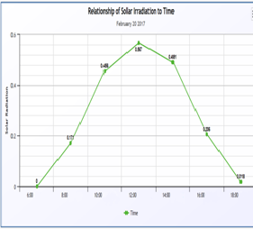

Fig. 2 Energy flow diagram of solar still
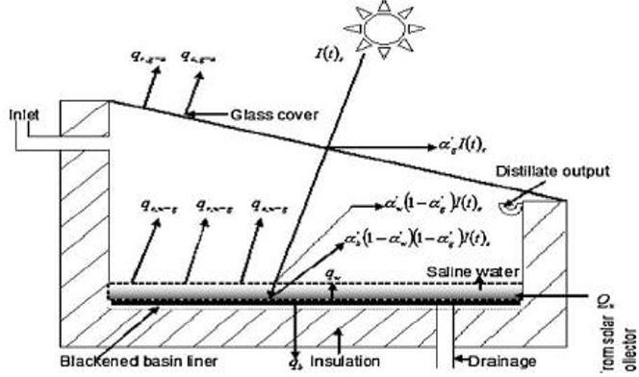

Fig. 3 Collective figures of Temperature Vs Depth with respect to days of exposure to sunlight

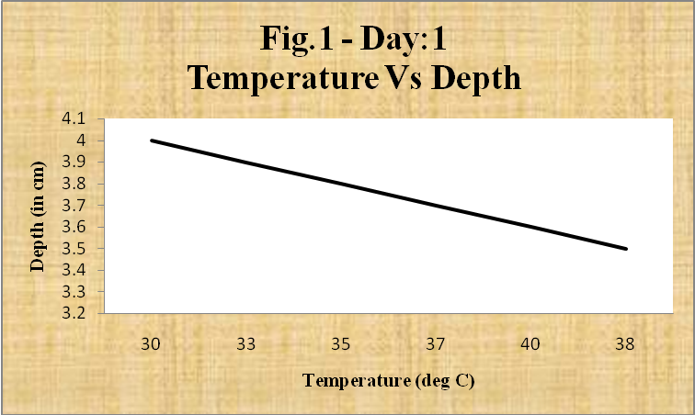
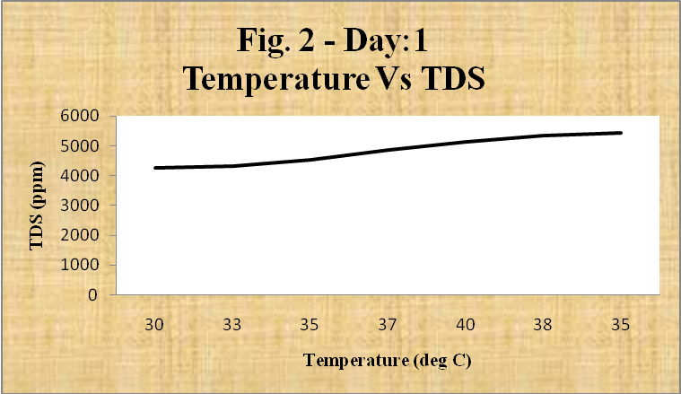
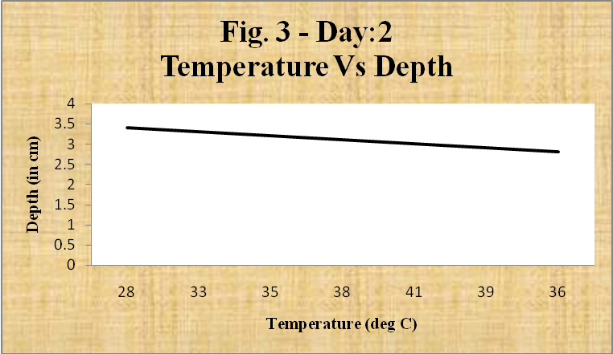
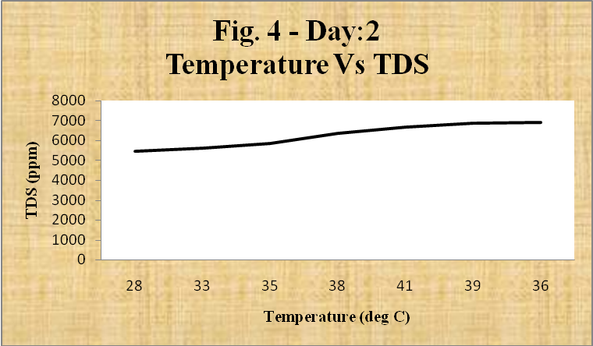
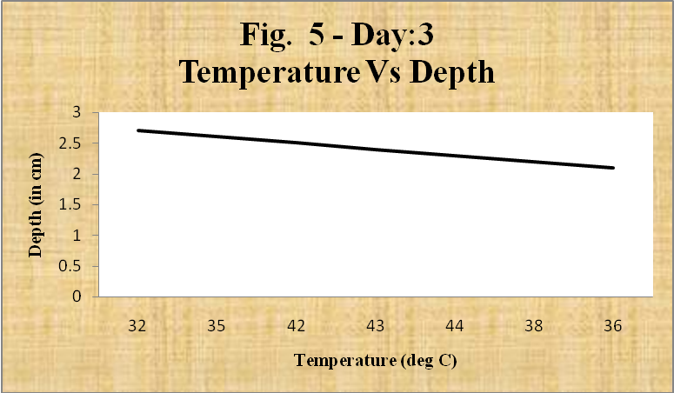
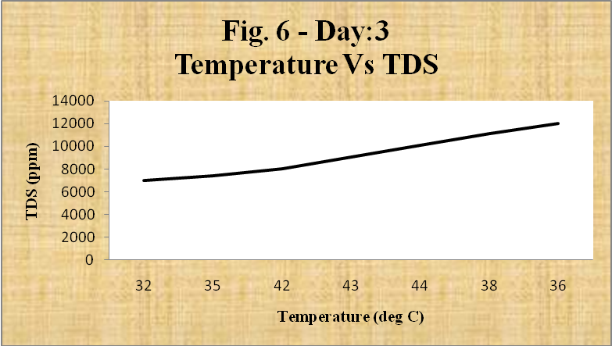
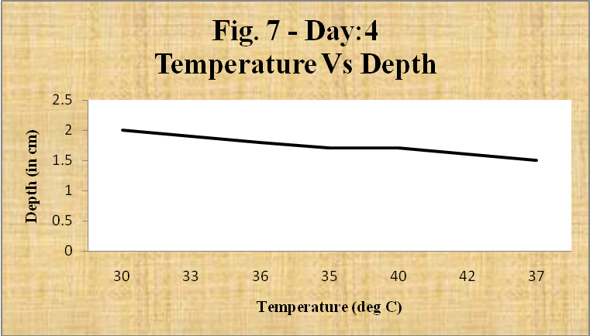
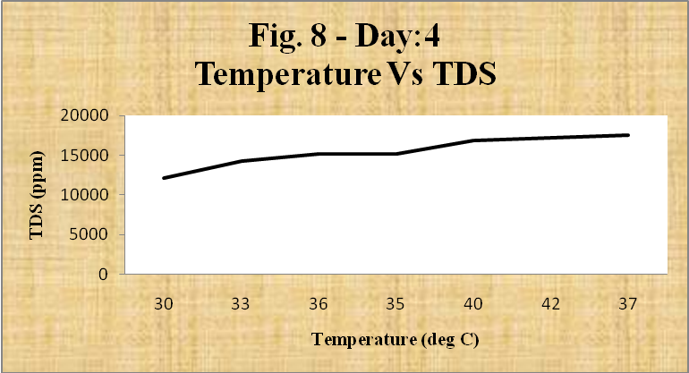
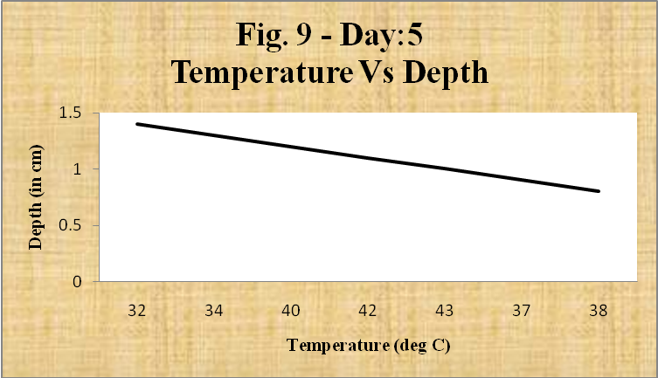
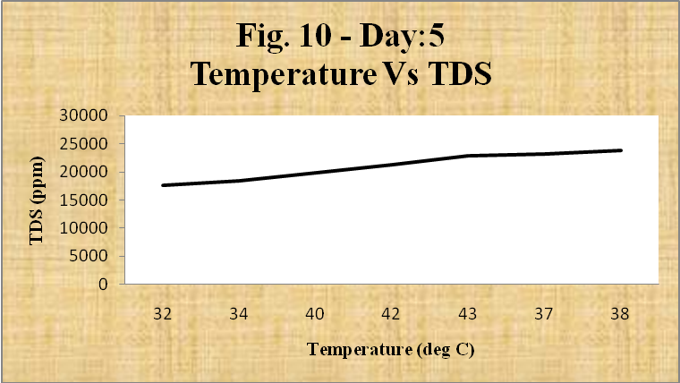
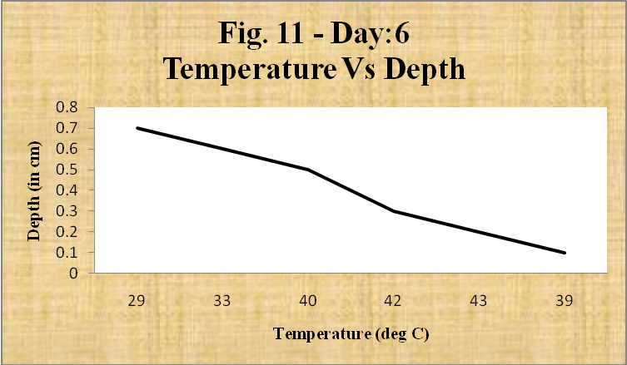
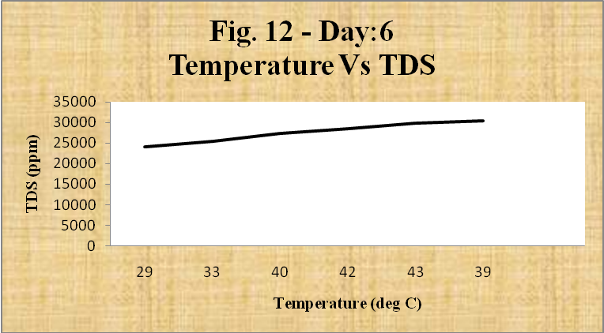
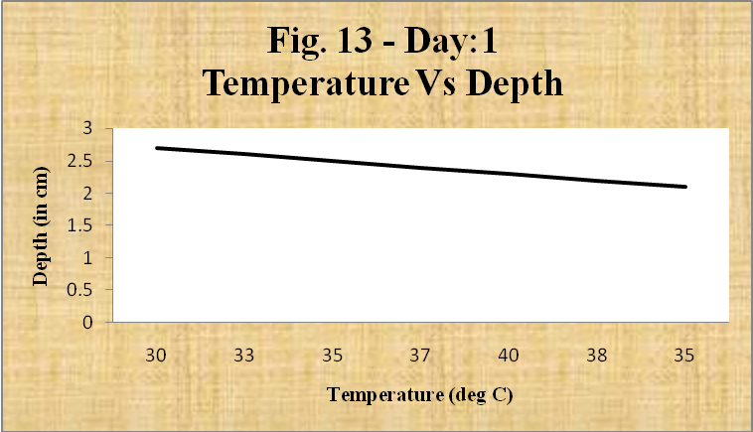
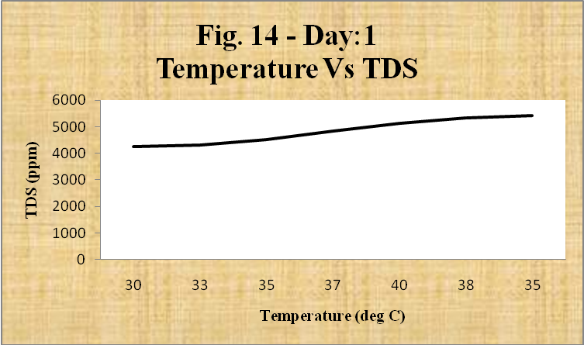
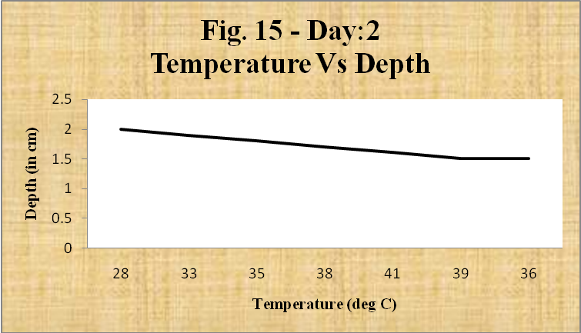
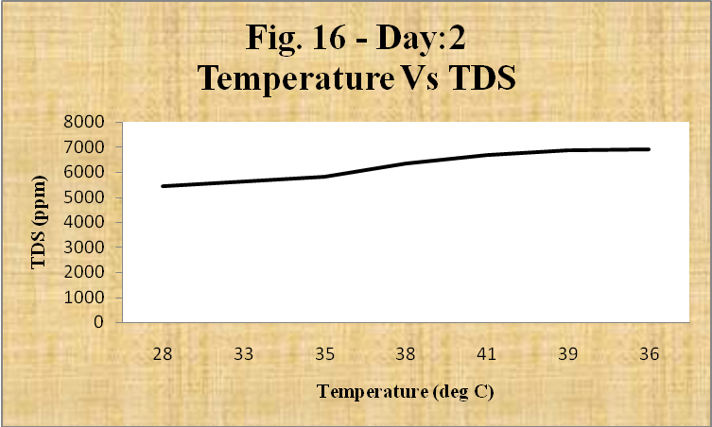
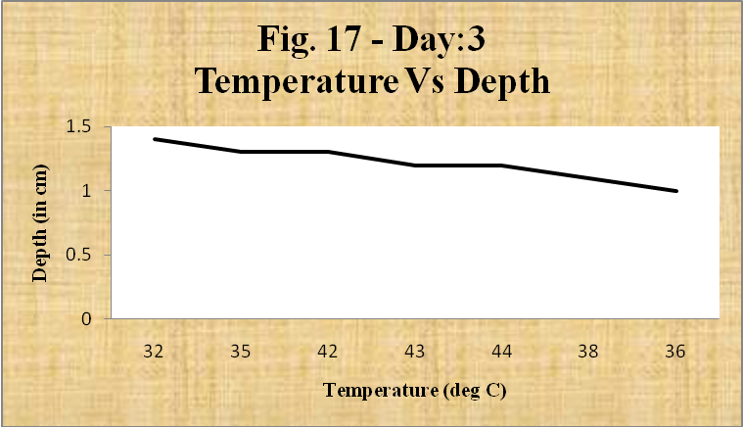
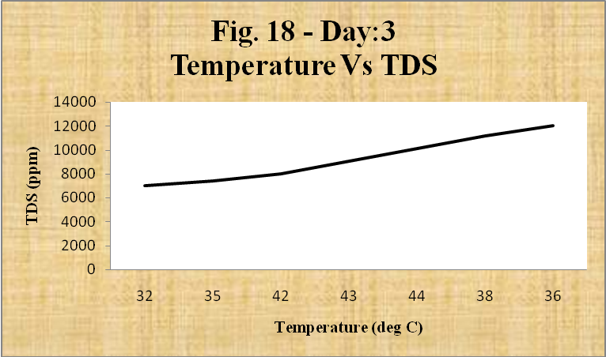
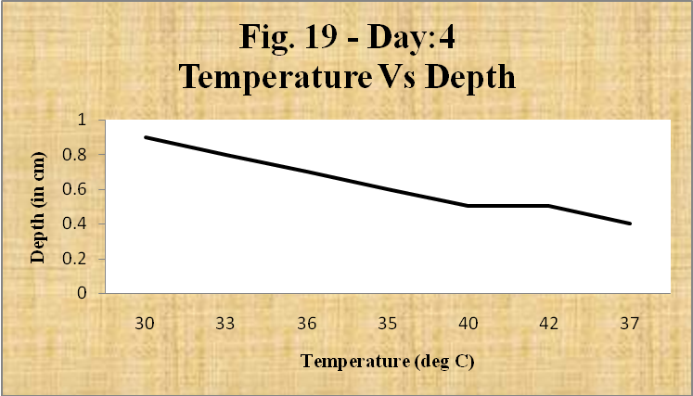
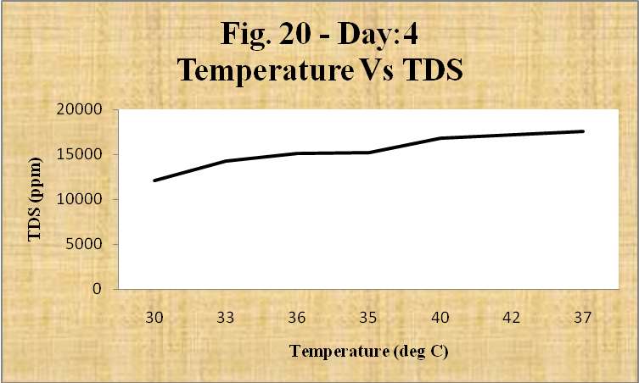
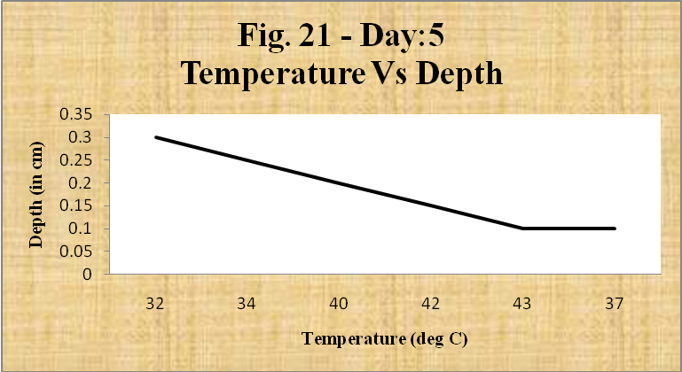
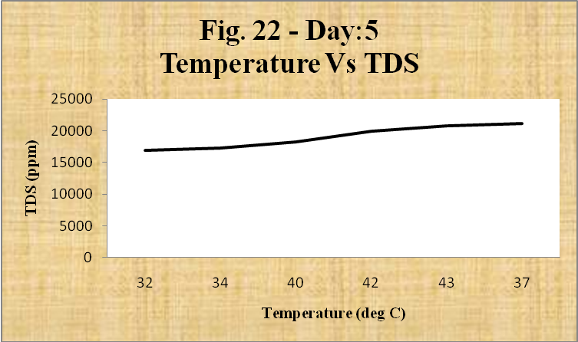

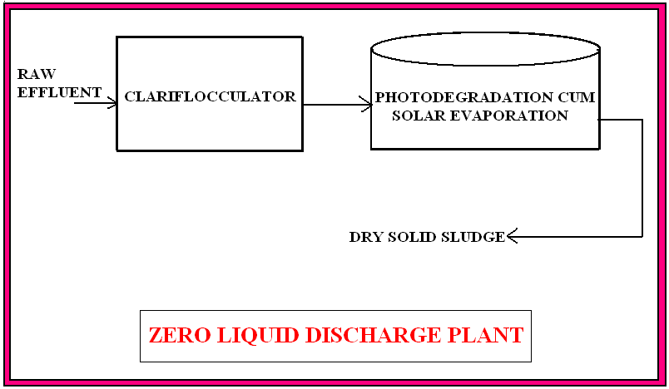

CONCLUSION
A number of discussions regarding the solar still are attempted in this chapter. The design and construction of the solar still system are extensively covered in this paper. Solar still distillation is a straightforward technique for eliminating salts and other water contaminants. The distilled water analysis concludes that all sizes of solar still water are pure. Due to increased exposure to solar radiation, a solar still with a large surface area may distill a comparatively larger amount of water. Keeping the initial water level as low as feasible will increase the distillation rate. The collector's surface area, which is in charge of absorbing both direct and diffused radiation, is the primary determinant of the solar still's production. Additionally, a thinner glass cover and enough insulation on all sides are necessary for a more efficient solar still system. As a result, the solar still's convective and evaporative heat transfer coefficients rise significantly. To determine the ideal circumstances, a pH test was conducted concurrently with three distinct waste water samples in the solar still system. Samples of both acidic (below 7) and basic (above 7) types were collected, and tests revealed that the samples' pH values ranged from 6.8 to 7.2, which is neutral. Following solar distillation in the solar still, the levels of TS, TDS, TSS, sulphate, phosphate, and chloride were all lowered to zero. It guarantees the use of distilled water during the research process. This work is nearly flawless in its analysis of the pattern of solar radiation, and its results and commentary are well-explained. This aids in determining the window of time during which the still produces its most.

ACKNOWLEDGMENT
The unwavering encouragement and financial assistance in promoting such a creative solution to the environmental effluent problem, the authors are extremely grateful to the management of Mohan Babu University in Tirupati.

REFERENCES
- Jadhav S.L, Chavan B.L. and Patil S.S., Designing, fabrication and performance analysis of solar still for purification of water, Innovative Systems Design and Engineering, 2, 2012.
- Ajay Kumar Kaviti, Akhilesh Yadav and Amit Shukla, Inclined solar still designs: A review, Department of Mechanical Engineering, Sagar Institute of Science and Technology, Gandhinagar, Bhopal, India.
- Helmy E Gad, El-Gayar SM, Hisham E Gad. Performance of a solar still with clothes moving wick. Fifteenth international water technology conference.
- Swami Prakash Srivastava and Surat Prakash Srivastava, Solar Energy and its role in Indian Economy, International Journal of Environmental Science: Development and Monitoring (IJESDM) ISSN No. 2231-1289, 4 (3), (2013).
- Nithin P K and Hariharan R, Design and Heat Loss Calculations from Double Effect Type Solar Still Integrated with LFPC, department of ME, LBS College of Engineering, Kasaragod, India.
- Tiwari G N and Sangeetha Suneja, Performance Evaluation of an inverted absorber solar still, Energy convers Mgmt., 39 (1996) pp 173-180.
- Tiwari G N, Kupfermann A and Shruti Aggarwal, A new design for a double slope condensing chamber solar still, Desalination 114 (1997) 153-164.
- Hikmet S. Aybar, Mathematical modeling of an inclined solar water distillation system, Department of Mechanical Engineering, Eastern Mediterranean University, G. Magosa, North Cyprus.
- Solar Radiation Hand Book, A joint Project of Solar Energy Centre, MNRE Indian Metrological Department, 2008.
- Sukhatme S P, Solar Energy: Principles of Thermal Collection and Storage G. Eason, B. Noble, and I.N. Sneddon, “On certain integrals of Lipschitz-Hankel type involving products of Bessel functions,” Phil. Trans. Roy. Soc. London, A247, pp. 529-551, 1955.
- Nielsen C, Akbarzadeh A, Andrews, Becerra H R L and Golding P, The History of Solar Pond Science and Technology, proceedings of the 2005 Solar World Conference Orlando, FL , 2005.
- Sivakumar K.K. and Dheenadayalan M.S. Studies on Utilization of Solar Energy in Effluent Treatment. European Chemical Bulletin. 2012, 1(5), p.146-149.
- Jarboui R, Sellami, Azri C, Gharsallah N and Ammar E, Olive mill wastewater evaporation management using PCA method –case study, J Hazard Mater., 2010, 176 (1-3), p.992-1005.

AUTHORS PROFILE


Dr. K.K. Sivakumar is currently as Associate Professor, AMET University, Chennai. He has been in the field of teaching and research for the past 21 years. In the preceding years he was with the renowned institutions such as Chettinad Engineering College, Tamil Nadu, India, Yanbu Industrial College, Saudi Arabia, Royal University of Bhutan, Phuentsholing, Bhutan and Ethiopian Universities.
Industrial Experience with 500 MW Thermal Power Station promoted by Reliance Energy Limited at Mumbai and Kerala for about 3 years.
Obtained Masters in Chemical & Environmental specialization from Madurai Kamaraj University. Published 28 papers in International and National refereed journals and presented about 20 papers in International and National conferences.
Authored for 2 books in Environmental Science and Engineering and laboratory manuals. Life member of ISTE, ICC and RJC. Journal Editorial Board member for 4 refereed journals.

 

