**The Urgency of Sustainability in Clinical Medicine**

**Pratap Singh 1**

M.Sc. Research Fellow

Department of Radiological Imaging Technique

College of Paramedical Sciences, Teerthanker Mahaveer University, Moradabad (U.P)

E-mail: [pratap.053078@tmu.ac.in](mailto:pratap.053078@tmu.ac.in)

**Mamta Verma 2**

Assistant professor

Department of Radiological and Imaging Techniques,

College of Paramedical Sciences,

Teerthanker Mahaveer University,

Moradabad (U.P)

E-mail: [mamtav.paramedical@tmu.ac.in](mailto:mamtav.paramedical@tmu.ac.in)

**Raushan Kumar 3**

Assistant professor

Department of Radiological and

Imaging Techniques,

College of Paramedical Sciences,

Teerthanker Mahaveer University,

Moradabad (U.P)

E-mail: [raushank.paramedical@tmu.ac.in](mailto:raushank.paramedical@tmu.ac.in)

**ABSTRACT**

Healthcare systems around the world face the challenge of balancing diminishing resources with growing demands, all while ensuring the provision of high-quality, equitable, and accessible care. Worldwide, healthcare systems struggle to balance dwindling resources with increasing demands while maintaining high-quality, equitable, and accessible care. In the medical field, sustainability has become a pressing issue due to the environmental impact of medical practices, resource consumption, and waste generation, which have substantial implications for both human health and planetary well-being. This chapter identified four primary categories of sustainable practices in hospital operations: environmental, customer-focused, employee-oriented, and community-centered. Integrating sustainability into healthcare workers' professional mindset can encourage sustainable practices within organizations, generate practical knowledge, and promote sustainability thinking among medical professionals. Additionally, this paper examines the adverse ecological effects of the healthcare industry and various factors influencing the demand for sustainability. Historically, the sustainability of healthcare delivery systems has been threatened by a combination of factors, including elderly demographics, rising rates of long-term illness, and increasing costs associated with medical technologies and consumer expectations. The historical trajectory of sustainability in clinical medicine highlights the urgent need for coordinated efforts across healthcare sectors to translate policies into practice, ensuring that sustainability becomes a central tenet of healthcare in the face of evolving challenges. This chapter explores the negative ecological effects of healthcare industries and different factors influencing the demand for sustainability. It explores barriers to sustainability while promoting innovative practices, which is essential for achieving a resilient healthcare system that focuses on both human and planetary health.

Keywords: Healthcare facilities; Sustainability; Environment; Public health; Waste management; Clinical medicine

1. **INTRODUCTION**

Sustainability has emerged as a crucial concept in today's modern world, as we confront the urgent issues of environmental deterioration, resource scarcity, and the imperative to secure a better future for upcoming generations. The United Nations Organization has recently emphasized the significance of sustainable development through its Sustainable Development Goals, which seek to tackle a broad spectrum of challenges, ranging from poverty and hunger to climate change and environmental conservation. (1).

The concept of sustainability is grounded in the principle that our present actions and choices should not hinder the capacity of future generations to fulfill their own requirements. The present generation bears a distinctive responsibility in this context, as the decisions and practices we adopt now will have enduring effects on the world our descendants will receive. The idea of sustainable development underscores the necessity of striking a balance between economic advancement, environmental preservation, and social equity, ensuring that our progress does not come at the cost of future generations. Sustainability acknowledges that our actions have extensive ramifications, both in terms of depleting natural resources and impacting the overall carrying capacity of our planet, which must be carefully evaluated and addressed to protect the welfare of future generations (2).

1. **Definition of sustainability in clinical medicine**

The concept of sustainability in clinical medicine has evolved in response to various pressing challenges faced by healthcare systems globally. Historically, the sustainability of healthcare delivery systems has been threatened by a combination of elements, including elderly demographics, rising rates of chronic illness, and increasing costs associated with medical technologies and consumer expectations (3,4). These challenges have intensified the focus on sustainable practices in healthcare, emphasizing the need for systems that can adapt and endure amidst crises, such as natural disasters and pandemics (4). In recent years, the healthcare sector has begun to recognize its significant environmental footprint, stemming from waste generation, energy consumption, and greenhouse gas emissions. This awareness has generated a movement towards integrating environmentally friendly practices into healthcare operations, promoting a dual focus on health outcomes and environmental stewardship (5).

The term sustainability refers to the practice of utilizing resources to fulfill current needs without hindering the capacity of future generations to satisfy their own requirements. According to sustainable approaches and sustainable agriculture, two of the most frequently used definitions of sustainability from an environmental point of view are 1) Describing a technique for utilizing or gathering resources in a manner that avoids their exhaustion or irreversible harm. 2) Pertaining to or characterizing a way of life that incorporates practices aimed at long-term environmental and resource conservation [an enduring community] (6).

Healthcare facilities aim to enhance and maintain public health, but their environmental footprint can adversely impact the well-being of humans and other living organisms. Consequently, ensuring the sustainability of hospitals and medical institutions is crucial for promoting human health and overall welfare. Sustainability in healthcare extends beyond environmental considerations, encompassing a holistic approach that also addresses the social aspects of the industry. Specifically, the social component of sustainability within healthcare emphasizes factors including fairness, autonomy, inclusivity, engagement, cultural heritage, and organizational durability, all of which are crucial in ensuring the long-term well-being of individuals and communities (7). The transformation aims not only to address immediate health needs but also to ensure long-term ecological integrity, aligning healthcare delivery with public and professional expectations regarding climate change and sustainability (8). Moreover, various theoretical frameworks have been developed to conceptualize and measure sustainability within healthcare program evaluations. These frameworks help identify key factors affecting sustainability, such as intervention characteristics, population needs, and organizational capacity (5,9).

Sustainability in healthcare is not merely a matter of justifying the current rate of spending. Rather, it requires a comprehensive and strategic approach that brings into account the various aspects of sustainability, including social, environmental, and economic (organizational) factors [Figure 1] (10). These factors are used as evaluation criteria for checking the sustainability practices in a particular healthcare system. Healthcare managers and leaders play a vital role in developing strategies aligning with the organization's vision, values, and mission while ensuring the system's long-term viability. As healthcare systems strive for resilience and efficiency, the integration of innovation and emerging technologies is increasingly viewed as essential to achieving a sustainable healthcare model (11,12). The historical trajectory of sustainability in clinical medicine highlights the urgent need for coordinated efforts across healthcare sectors to translate policies into practice, ensuring that sustainability becomes a central tenet of healthcare delivery in the face of evolving challenges (8,13).

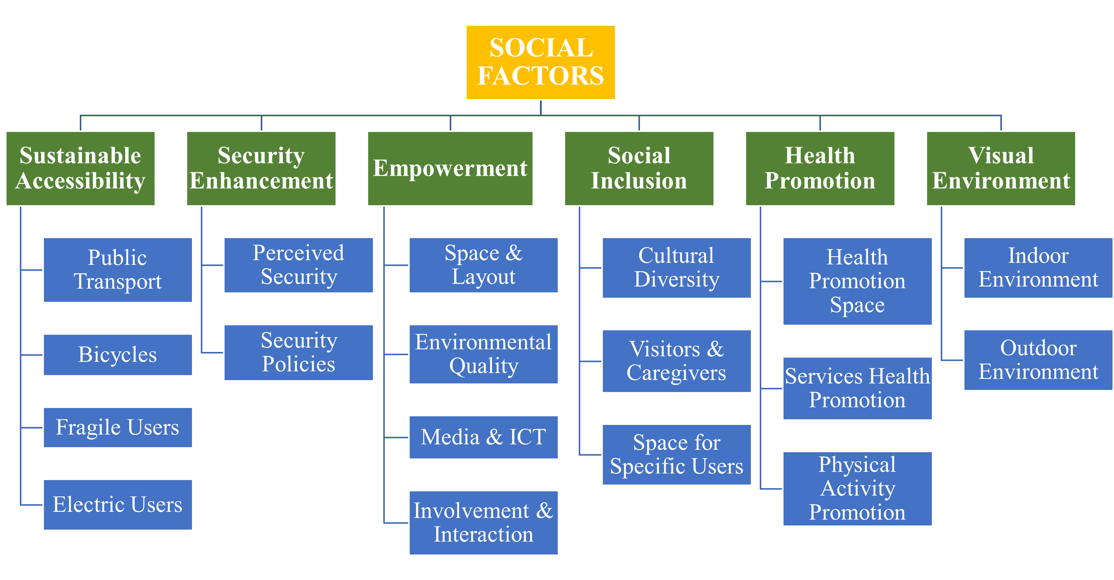

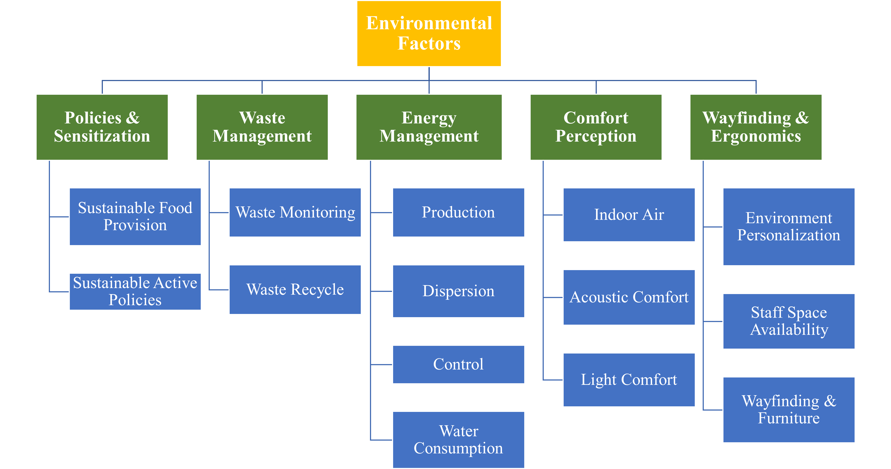

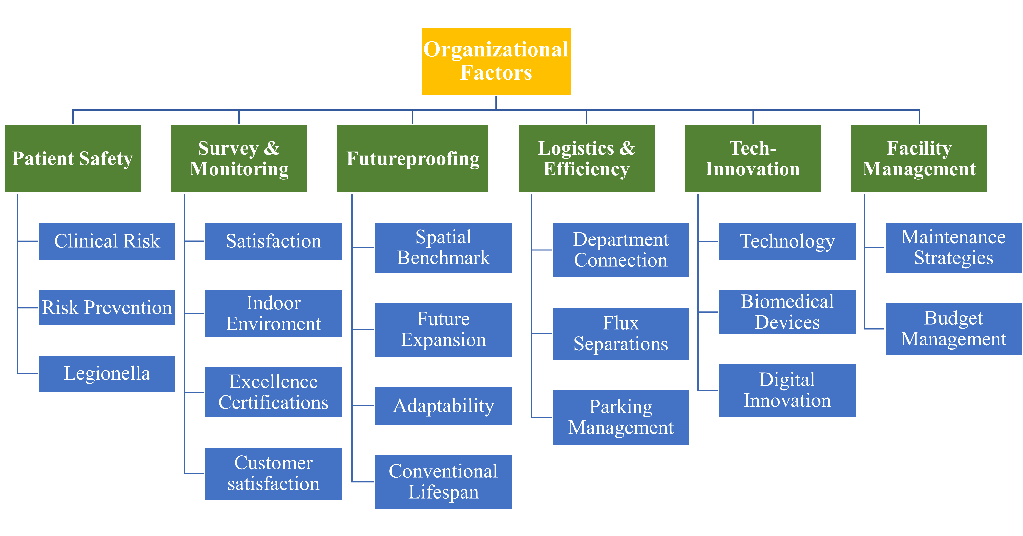

**Figure 1: Sustainability measurement criteria for a healthcare system** (10)

1. **Why sustainability is an urgent issue in modern healthcare?**

Sustainability has become an increasingly pressing concern in the healthcare industry, as the environmental impact of medical practices, the utilization of resources, and the generation of waste have significant implications for both human health and the overall well-being of our planet. The global healthcare system faces the challenge of balancing diminishing resources with growing demands, all while ensuring the provision of high-quality, equitable, and accessible care. (14). The healthcare sector's significant contribution to environmental degradation and climate change is a primary driver behind the urgent need for sustainability. (15).

1. **The Impact of Healthcare on the Environment**

The healthcare industry significantly contributes to environmental pollution, which adversely affects human health. Pollution is a primary cause of morbidity and fatality, accounting for 16% of all fatalities worldwide in 2015, equivalent to 9 million premature deaths. Air pollution is currently associated with the majority of these environment-related deaths, causing 1 in 8 deaths globally.

Fossil fuel combustion is the principal source of both air pollution and climate change, with the latter being identified as the most critical public health challenge of the 21st century. Annually, an estimated 150,000 deaths occur worldwide due to health hazards associated with climate change, including extreme weather events, deteriorating air quality, food and waterborne diseases, vector-borne illnesses, food and water insecurity, and social instability (16). Between 2030-2050, an additional 250,000 lives per year are projected to be lost due to climate change, and vital earth systems will face further disruption unless urgent action is taken to reduce emissions (17).

Paradoxically, the modern healthcare industry itself is a significant source of environmental pollutants that are detrimental to human health. In 2001, the Institute of Medicine outlined specific goals for improving healthcare quality in "Crossing the Quality Chasm," which included preventing patient injuries from intended care, enhancing efficiency, and eliminating waste. Despite this, the United States healthcare sector alone is responsible for 9% of criteria air pollutants and 9-10% of greenhouse gas emissions nationally, as well as other toxic emissions, resulting in a loss of 614,000 Disability-Adjusted Life Years (DALYs) annually (18).

The healthcare sector significantly contributes to global greenhouse gas emissions, which is approximately 4.4% of total emissions worldwide. This impact is primarily due to the energy consumption of healthcare facilities, with a large proportion stemming from the operation of medical devices, travel associated with healthcare access, and the production and transportation of healthcare products. Figure 2 represents the pollution pathway of natural or environmental sinks by different byproducts of various healthcare industries (19).

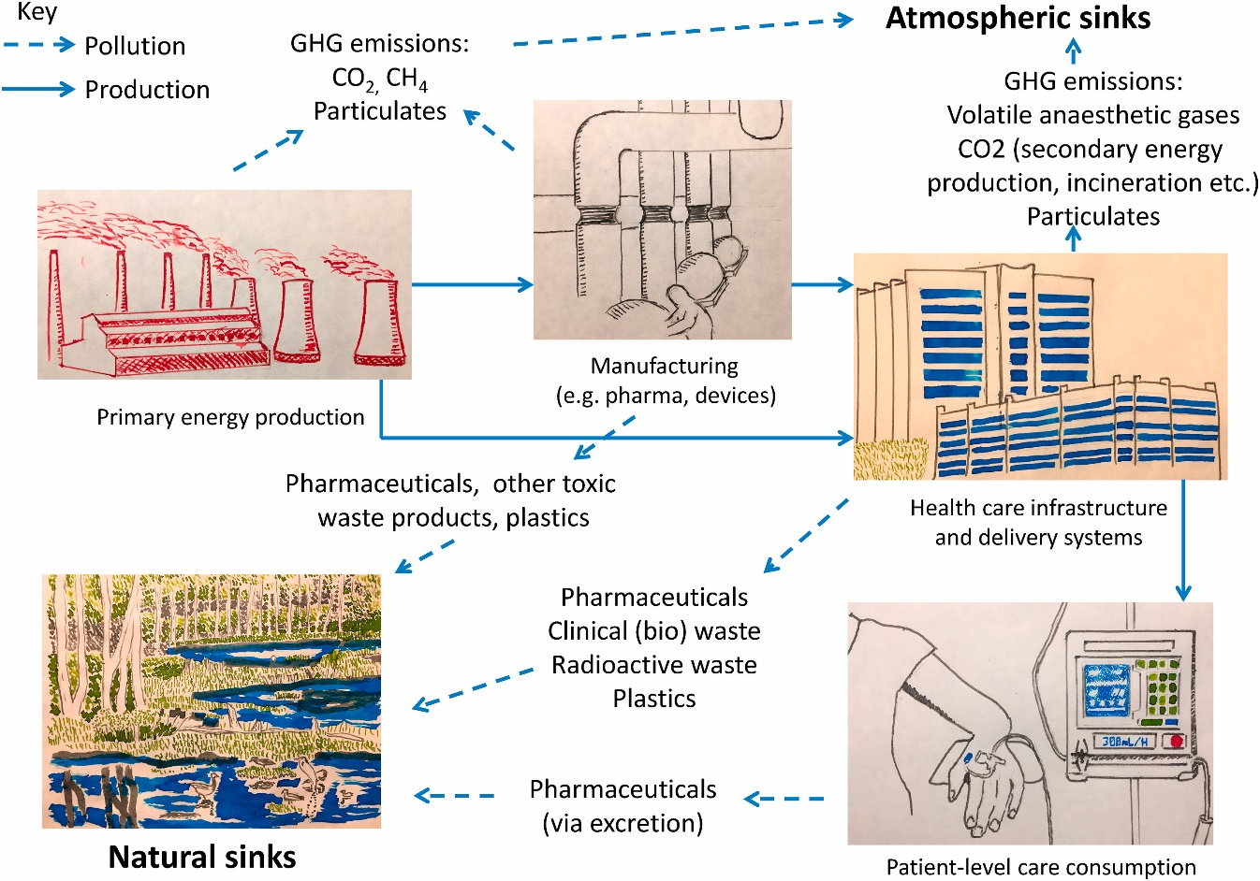

**Figure 2: Pollution pathway of healthcare system**(19)

1. **Energy consumption, waste generation, and resource depletion in clinical settings**

The healthcare industry ranks among the world's most resource-intensive sectors, significantly impacting energy utilization, waste generation, and resource consumption. Medical facilities such as hospitals and clinics consume substantial amounts of energy to operate sophisticated equipment, regulate indoor environments, and maintain life-support systems.

Indeed, the energy consumption of intensive care units alone can be comparable to that of small residential areas. Moreover, the sector's extensive use of disposable medical items, sterilization processes, and packaging materials contributes to a mounting waste crisis, generating millions of tons of refuse annually. The environmental challenges are further exacerbated by the disposal of hazardous materials, including sharp objects and pharmaceuticals. Improper management of these substances can result in soil and water contamination.

Furthermore, the extraction of natural resources for manufacturing and transporting medical supplies underscores the pressing need for sustainable procurement strategies and circular economy principles in healthcare. These measures are crucial for mitigating the industry's environmental impact while maintaining high standards of patient care (20).

Example: **(I)** Clinical laboratories are significant consumers of water, energy, and hazardous chemicals that can utilize 5-10 times greater energy per square meter than a normal office. The different electrical appliances, such as centrifuges, auto analyzers, ultra-low temperature freezers, hospital or laboratory information systems, water treatment plants, air conditioners, multiple computer systems, exhaust fans, lights, and vacuum systems operating continuously, contribute to the production of a significant amount of greenhouse gases (GHG), resulting in high plug loads and increased carbon footprints. The necessity of controlling humidity and temperature, as well as implementing methods to fulfill the required air circulation per hour by laboratory safety protocols, which compromises sustainability (21).

**(II)** Recent studies have highlighted that medical devices used in radiology departments, such as MRI and CT scanners, are particularly energy-intensive. Research indicates that between 40% and 91% of the energy consumed by these devices is classified as "nonproductive," meaning the devices are on but not actively being used. This excessive idle energy consumption underscores the necessity for optimizing device usage and implementing strategies such as turning off machines during idle periods. Such practices can lead to substantial energy savings, estimated between 14,180 and 171,000 kWh annually per device (22).

1. **The evolving concept of sustainability in clinical medicine**

In recent years, the notion of sustainability in clinical medicine has expanded significantly, moving beyond environmental concerns to encompass a wider range of healthcare delivery aspects. While initially centered on reducing the ecological footprint of medical practices, sustainability now includes economic feasibility, social accountability, and enduring health outcomes. This holistic approach seeks to create healthcare systems that are not only environmentally responsible but financially feasible too, and equitable in their service delivery. Healthcare practitioners are increasingly recognizing the need to consider resource distribution, waste minimization, and the enduring effects of medical interventions on both individuals and larger populations. This shift in mindset has prompted a reassessment of conventional medical practices and the creation of innovative healthcare delivery methods. For example, telemedicine and remote patient monitoring have emerged as sustainable alternatives to traditional in-person visits, decreasing travel-related emissions and enhancing care accessibility for underserved communities.

The incorporation of sustainability principles into clinical medicine has also sparked a renewed emphasis on preventive care and health promotion. By prioritizing early intervention and lifestyle changes, healthcare providers aim to lessen the impact of chronic diseases and reduce the need for resource-intensive treatments. This proactive strategy not just enhances patient outcomes but also contributes to the overall sustainability of healthcare systems by decreasing long-term expenses and resource usage. Moreover, the concept of sustainability in clinical medicine extends to medical research and innovation.

Scientists are increasingly evaluating the environmental and social impacts of new medical technologies and treatments throughout their entire lifecycle, from development to disposal. This comprehensive approach ensures that advancements in medical science positively contribute to both human health and environmental well-being. Sustainable clinical practices now highlight preventive care, patient education, and the prudent use of medical resources to maximize health outcomes while minimizing unnecessary expenses and environmental damage. This involves implementing evidence-based guidelines, reducing overdiagnosis and overtreatment, and fostering shared decision-making between healthcare providers and patients. By empowering patients with knowledge and involving them in their care decisions, medical professionals can promote a more sustainable and patient-centered approach to medicine. The pursuit of sustainability in clinical medicine also requires collaboration across various divisions of the healthcare industry.

Pharmaceutical industries, hospitals, medical device manufacturers, and healthcare policymakers must cooperate to develop and implement sustainable practices throughout the entire healthcare value chain. This collaborative effort can result in more efficient supply chains, reduced waste generation, and the development of eco-friendly medical products and technologies. Furthermore, the concept of sustainability in clinical medicine is increasingly being integrated into medical education and training programs. Future healthcare professionals are being equipped with the knowledge and skills necessary to practice medicine sustainably, ensuring that sustainability principles become deeply ingrained in medical culture.

This evolving concept challenges healthcare professionals to balance immediate patient needs with the broader goal of maintaining a resilient and effective healthcare system for future generations. It necessitates a paradigm shift in how medical care is conceptualized, delivered, and evaluated, with a focus on long-term outcomes rather than short-term interventions alone.

1. **Aspects of Sustainable Practices in Healthcare**

Research suggests that incorporating sustainability into healthcare operations can result in improvements in both financial performance and quality of care. To maximize the advantages of sustainable practices within an organization, it is crucial to comprehend sustainability-based strategies. By examining existing literature on sustainability in the healthcare sector, this research identified four main categories of sustainable practices in hospital operations: environmental, customer-focused, employee-oriented, and community-centered. These categories form an approach to achieving sustainability objectives for the ongoing enhancement of quality and financial outcomes. Figure 3 illustrates this expanded sustainability framework.

1. *Environmentally-Focused Sustainability*

The healthcare industry is recognized for its environmental sustainability efforts, which aim not only to reduce environmental pollution by decreasing waste (e.g., minimizing hazardous chemical usage and water recycling) in operations but also to cut operational costs. Some environmental sustainability initiatives in healthcare include mercury elimination, healthcare waste toxicity reduction, and minimizing hazardous chemical use Additionally, recycling has been introduced to address increasing quantities and treatment expenses. In recent years, the scope of environmental sustainability has expanded to include sustainable design and construction techniques to create genuine healing environments (6,23,24).

1. *Customer-Centered Sustainability*

Healthcare providers have also recognized the significance of delivering high-quality assistance to patients and strive to stabilize resource allocation with patient needs as part of their sustainability practices. (25). Beyond the increased use of technology in healthcare to provide effective treatment and assistance to customers, many healthcare institutions have now evolved e-health strategies or health information. Information technology plays a crucial role in guiding health organizations towards sustainability by enhancing efficiency, creating sustainability tools, and transforming products into services (e.g., integrating systems and lifestyles through vaccination reminder services) (26). Patient satisfaction is considered a key indicator of healthcare sustainability, closely linked to providing quality service improvement, reducing medical costs, and matching customer expectations (6).

1. *Sustainability focused on employees.*

In healthcare, sustainability extends beyond patient care to include creating a healthier workplace for employees. Occupational sustainability in healthcare involves adapting to changing operations without compromising the well-being of medical practitioners. Establishing a healthy work environment is crucial for enhancing staff job satisfaction. Integrating sustainability into the professional mindset of healthcare workers can foster sustainability practices within the organization, generating practical knowledge and promoting sustainability thinking among health professionals. Some healthcare organizations also focus on addressing outdated practices and behaviors among healthcare professionals. (6,27). Studies have also highlighted the significance of spatial design, equipment, and supplies in boosting nurses' satisfaction and job efficiency (27).

1. *Sustainability oriented towards the community.*

Regarding community-focused sustainability, some research has explored healthcare delivery through 'home-based healthcare' programs as a sustainable initiative. This approach addresses limited facilities, negligence, and medical errors in rural areas. Community-based sustainable services have been enhanced with technology, such as tele-monitoring and patient monitoring systems, evolving from initial health information exchange systems. Additionally, in responding to public concerns, the healthcare industry has taken steps toward resource conservation and pollution reduction. Many healthcare organizations have adopted the principle of "first do not harm" in their professional practice.

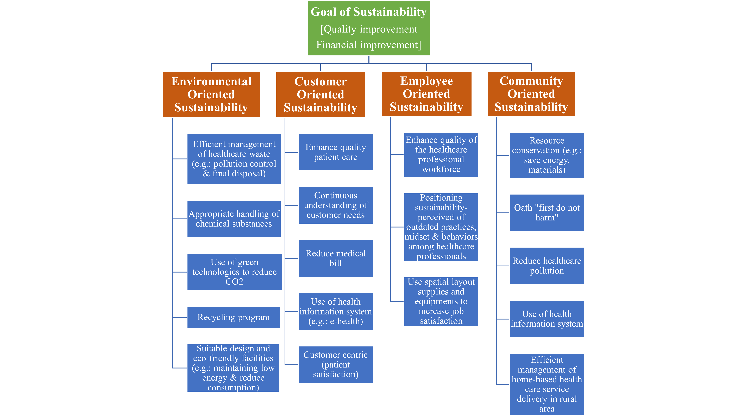

**Figure 3: Goals of sustainability** (6)

1. **Effect of Unsustainable Practices on Health**

The intersection of environmental sustainability and patient health in clinical medicine highlights the unintended consequences of unsustainable healthcare practices. These effects are multifaceted, involving direct health impacts from pollution and waste mismanagement, exacerbated climate-related health crises, and the deepening of global health inequities.

1. **Pollution from Healthcare Activities**

Healthcare systems are significant contributors to global emissions of greenhouse gas (GHG), resulting in approximately 4.4% of the total. Activities such as energy use in hospitals, transport, and resource-intensive procedures release substantial amounts of pollutants, including carbon dioxide, particulate matter (PM), and nitrogen oxides. These pollutants directly affect human health by exacerbating respiratory and cardiovascular conditions, particularly in high-risk populations, such as children, aged populations, and individuals with preexisting conditions.

For example:

* Respiratory Illnesses: Exposure to air pollution linked to healthcare emissions can lead to increased hospitalizations for chronic obstructive pulmonary disease (COPD), asthma, and lung infections.
* Cardiovascular Risks: Fine particulate matter (PM2.5) has been linked with higher incidences of heart attacks and strokes.

1. **Hazardous Waste Mismanagement**

The improper handling and disposal of medical waste, including plastics, sharps, and e-waste, pose severe health risks. Only about 20% of e-waste is formally recycled, while the remainder often ends up in landfills or informal recycling sectors in low-income regions. This mismanagement leads to:

* Toxic Exposures: Communities near waste dumpsites face exposure to heavy metals like lead, mercury, and cadmium, resulting in neurological damage, cancers, and kidney dysfunctions.
* Child Health Hazards: In many regions, children are involved in informal e-waste recycling, exposing them to hazardous chemicals. This leads to developmental issues and cognitive impairments.

Unregulated methods such as open burning of medical waste further exacerbate air pollution and release carcinogenic compounds, endangering both local populations and healthcare workers involved in disposal.

1. **Climate Change and Health Crises**

Healthcare systems' unsustainable operations contribute to climate change, creating a feedback loop where environmental degradation directly worsens patient health.

Key climate-related health impacts include:

* Heat-Related Illnesses: Rising global temperatures increase instances of heat strokes and dehydration, and exacerbate chronic conditions such as cardiovascular and renal diseases. Vulnerable populations, including the elderly and those in urban heat islands, are disproportionately affected.
* Infectious Disease Outbreaks: Shifts in climate patterns increase the prevalence of vector-borne illnesses including malaria and dengue fever.
* Increased flooding also amplifies waterborne infections, including cholera and typhoid.
* Mental Health Effects: Natural disasters such as floods and wildfires disrupt lives, and lead to a condition called post-traumatic stress disorder (PTSD), depression, and anxiousness.

1. **Exacerbating Health Inequalities**

Unsustainable practices disproportionately affect nations with low or middle-income countries (LMICs), which carry the brunt of climate change impacts despite contributing minimally to global emissions. Examples include:

* Food and Water Insecurity: Climate change exacerbates droughts and extreme weather events, threatening food supplies and leading to malnutrition. Those in LMICs are particularly vulnerable to these crises, with long-term impacts on child development and chronic disease prevalence.
* Healthcare Disruptions: Damage to healthcare infrastructure during extreme weather events disproportionately affects rural and underserved communities (28,29).

1. **Economic Urgency: Rising Healthcare Costs and Sustainability**

The economic burden of unsustainable healthcare practices has become a growing concern, as the global healthcare system continues to face significant challenges in terms of environmental impact, waste, and inefficient resource utilization. The healthcare industry, which accounts for a significant portion of economic activity, has a responsibility to mark these issues and implement sustainable practices to mitigate environmental and financial costs (6,30).

The discussion on sustainability in healthcare has acquired momentum in recent years, with scholars and healthcare professionals recognizing the need for a more holistic approach to managing the industry's environmental impact (6). Healthcare facilities consume a significant amount of resources, including energy, materials, and water, and inevitably generate waste that can have detrimental effects on the environment (31). The increasing reliance on technology-based and expensive treatments, coupled with the growing burden of chronic conditions that are frequently caused by lifestyle and environmental factors, has further exacerbated the problem. (30).

Addressing the environmental impacts of healthcare practices can not only create considerable benefits for the environment but contribute to cost savings too, and improve the public image of healthcare organizations. Sustainable methods, such as lowering energy use, improving waste management, and using environmentally friendly products, can result in considerable cost savings for healthcare providers (32).

Additionally, the integration of sustainability principles into medical education has been identified as a key strategy for promoting sustainable healthcare practices. Educating future healthcare professionals on the importance of sustainable practices and providing them with the essential information and skills can contribute to the long-term sustainability of the healthcare industry (6,30).

1. **Financial benefits of adopting sustainable practices in clinical medicine**
2. **Cost Savings through Waste Reduction**

Waste management is a considerable expenditure in clinical settings, particularly with medical waste disposal, which requires specialized treatment due to its hazardous nature. By adopting sustainable practices such as source segregation, recycling programs, and the reuse of materials when safe, hospitals can significantly reduce waste disposal costs. For example, proper segregation of general waste from biohazardous waste can lower the volume of high-cost medical waste processing. A study demonstrated that introducing comprehensive waste management systems reduced hospital waste costs by 30%, translating into substantial annual savings for large institutions (33).

1. **Energy Efficiency and Reduced Utility Costs**

Healthcare facilities are among the most energy-intensive institutions, with 24/7 operations and the use of advanced medical equipment. Implementing energy-efficient technologies like LED lighting, high-efficiency HVAC systems (Heat, Ventilation, and Air Conditioning), and regenerated energy sources, can drastically cut utility bills. For instance, retrofitting an average-sized hospital with energy-efficient systems was shown to reduce annual energy costs by 20%–40%, saving hundreds of thousands of dollars annually.

Additionally, incorporating smart energy management systems can optimize energy usage by identifying peak consumption periods and redistributing load effectively, further enhancing savings (32).

1. **Savings through Sustainable Procurement**

Sustainable procurement practices, including purchasing reusable surgical instruments and biodegradable packaging materials, can lower operational costs. Though the initial expenditure may be more, the long-term benefits surpass the expenses. For instance, transitioning to reusable surgical gowns and drapes has been shown to reduce procurement costs by 30% while decreasing environmental impact (34).

1. **Financial Incentives and Grants**

Healthcare institutions that adopt sustainable practices often qualify for government grants, tax incentives, and funding from environmental organizations. These financial supports reduce the overall cost burden of implementing green initiatives and make sustainable healthcare financially viable.

1. **Enhanced Patient Volume and Reputation**

Patients increasingly value environmentally conscious healthcare providers. Hospitals with green certifications or sustainability initiatives attract more patients, boosting revenue through increased patient volume. Moreover, sustainability practices enhance staff morale, resulting in greater retention rates and decreasing expenses related to turnover and training (32–34).

The incorporation of sustainable practices in clinical medicine offers a significant opportunity for cost savings and financial benefits. As healthcare systems worldwide face increasing financial pressures, adopting environmentally conscious strategies can yield both ecological and economic gains. The following are the financial advantages of waste reduction, energy efficiency, and other sustainable interventions.

1. **Factors Affecting Healthcare Sustainability**

The healthcare sector integrates sustainability into its operations based on social responsibility and responsiveness. A survey of the literature on sustainability in clinical medicine indicates that there are several helping to expand the use of sustainable healthcare methods, as Figure 4 illustrates. Among the variables that contribute are:

* Governments throughout the world are becoming more concerned about sustainability in clinical medicine; for example, many healthcare institutions have been forced to include sustainability in their operations to conserve energy and protect the environment.
* Environmental changes like pollution, global warming, and the depletion of natural resources (including water and energy) eventually push the healthcare sector to figure out how to integrate sustainability-based strategies into its operations.
* Healthcare is under pressure to implement sustainability-based methods into its operations as a result of education and public awareness campaigns about how businesses use natural resources and how their operations lead to pollution and limited resources.
* In many healthcare companies, corporate sustainability is becoming more and more important. The integration of sustainability in healthcare is naturally influenced by several factors, including employee development, workplace atmosphere, creativity, social responsibility, and ethical conduct.
* Many nations have been forced to prioritize sustainability as a way to lower operational expenses due to the increasing expenses related to healthcare.

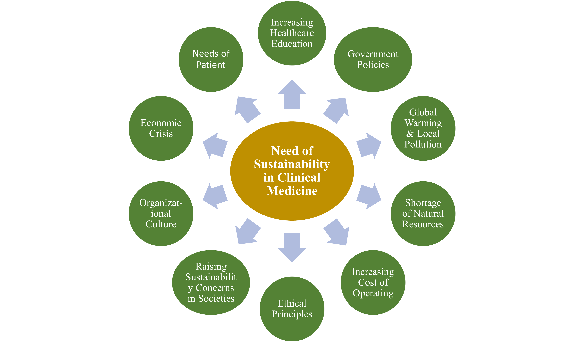

**Figure 4: Factors influencing the urgency of sustainability**(6)

1. **Methods For Effective Sustainability Implementation in Healthcare**

Increasing resource costs, changing climate, public awareness, and evolving lifestyles are likely to drive healthcare organizations toward implementing sustainable operations. To establish an enduring culture of sustainability in clinical medicine, the following approaches and recommendations are proposed:

* Improve sustainability leadership to devise particular approaches and continually check their execution.
* Increase staff involvement in steering committees and conduct staff learning assessments. Promoting a healthy atmosphere shows the sustainability of employee leadership in consistently improving service quality.
* To maintain and enhance sustainability practices in healthcare, it is crucial to boost awareness and encourage staff participation. Ongoing efforts should focus on expanding programs that include motivation, training, and creating educational resources.
* Greater emphasis should be placed on advancing innovations that promote healthcare sustainability across all aspects of sustainable practices.
* Research in social and psychological fields should be conducted among healthcare professionals to gain insights into the behaviors, attitudes, and cultural factors necessary for improving hospital sustainability.
* Enhanced collaboration between various medical specialties and non-medical experts, such as engineers and architects, is essential to help healthcare organizations address sustainability challenges.
* Furthermore, healthcare institutions should broaden their partnerships with relevant associations and non-governmental organizations (6).

1. **Future Directions**

**Recommendations for Policy and Practice**

To effectively embed sustainability into clinical medicine, policymakers must establish frameworks that encourage healthcare organizations to adopt sustainable practices. This includes developing policies that prioritize sustainable resource management and incentivize innovations that reduce environmental impacts within healthcare systems. The integration of sustainability into the missions and values of healthcare institutions must begin at the governance level, with boards and executive management setting a clear agenda for sustainability initiatives. Moreover, healthcare leaders should collaborate with organizations focused on safety and quality, such as the Institute of Healthcare Improvement (IHI), to enhance educational efforts surrounding sustainable practices and improve patient care outcomes (35).

**Emphasizing Adaptation and Innovation**

Future studies should focus on the mechanisms of adaptation in healthcare interventions aimed at sustainability. Understanding the reasons behind changes made to interventions, as well as the impact of these adaptations on outcomes, will provide valuable insights for practitioners (36).

**Addressing Barriers and Facilitators**

Identifying and addressing barriers to the implementation of sustainable practices in clinical medicine is essential for fostering a supportive environment for change. Research indicates that interpersonal dynamics, leadership support, and socio-political factors often impede sustainability initiatives. By focusing on these barriers, healthcare organizations can develop targeted strategies to enhance buy-in from staff and overcome resistance to change. Training programs that emphasize the interconnectedness of sustainability with clinical care will empower healthcare professionals to prioritize sustainable practices in their daily operation (37).

**Long-Term Strategic Planning**

Finally, a long-term strategic plan that incorporates preventive care alongside clinical goals is vital for achieving sustainability in healthcare. This plan should involve enhancing primary care access, utilizing early detection tools, and addressing social determinants of health to support overall sustainability goals. By embedding sustainability into the fabric of healthcare delivery, organizations can contribute to the decarbonization of their operations and promote a healthier society (35).

**Conclusion**

This chapter emphasizes the critical and immediate necessity for action within the healthcare sector to address pressing environmental challenges. This urgency arises from the recognition that sustainable practices in clinical medicine are not merely advantageous, but essential for safeguarding the long-term health of both patients and the environment. The intricate relationship between human health and environmental well-being necessitates a fundamental shift in health care delivery and management.

It also explores the negative ecological effects of healthcare industries and different factors influencing the demand for sustainability. The rise of sustainability in healthcare entails striking a balance between four important aspects of its operations: patient, employee, and community demands as well as environmental considerations to continually enhance quality and save costs.

As awareness of climate change and its health implications continues to rise, the need for coordinated efforts across healthcare sectors to embed sustainable practices into everyday operations has never been more urgent. Different studies identify a gap in the implementation of sustainability measures in healthcare management. According to these existing studies, the meaning of sustainability is not only concerning the environment but also to the consumers, staff, and public. Addressing the barriers to sustainability while promoting innovative practices is essential for achieving a strong healthcare system that prefers both human and planetary health.

To facilitate this transition towards a more sustainable healthcare system, there is an urgent need for increased research, education, and policy changes. Research efforts should focus on developing innovative, environmentally friendly medical technologies and practices that reduce waste, conserve energy, and minimize the use of harmful substances. Educational initiatives are essential to equip current and future healthcare practitioners with the knowledge and skills necessary to implement sustainable practices effectively. Furthermore, policy should be changed at institutional, national, and international levels to create a supportive framework for sustainable healthcare practices.

Healthcare professionals, who occupy a unique position at the intersection of science, patient care, and public trust, bear significant responsibility for exemplifying leadership. This leadership role extends beyond individual actions to encompass the implementation of environmentally conscious practices in daily clinical operations and advocacy for broader systemic changes within the healthcare industry. By adopting sustainable practices, healthcare providers can substantially reduce their environmental impact, while concurrently improving patient outcomes and operational efficiency.

It is imperative to recognize that sustainability in healthcare is not an isolated objective but an integral component of providing high-quality, ethical patient care. By embracing sustainable practices, healthcare institutions can enhance patient care while also contributing to the broader goal of environmental stewardship.

The conclusion emphatically states that immediate action is imperative. Delays in adopting sustainable practices in clinical medicine will have far-reaching and potentially irreversible consequences for global health and the environment. The healthcare industry, as a significant contributor of carbon emissions and waste production, has both the opportunity and the obligation to lead the charge in environmental sustainability.

In conclusion, the urgency of sustainability in clinical medicine cannot be overstated. It demands a concerted effort by every stakeholder in the healthcare community. – from individual practitioners to large institutions, policymakers, and patients. By embracing sustainable practices, the healthcare sector can not only mitigate its environmental impact but also improve health outcomes, reduce costs, and set a powerful example for other industries. The path to a sustainable future in healthcare is challenging but necessary, and immediate action is required.

**References**

1. Dixit A, Chaudhary R. Sustainability: an Essential Concept for Current and Upcoming Technological Practices. IOP Conf Ser Mater Sci Eng. 2020 Apr;804(1):012023.

2. Hackler D. Economic Sustainability in Arlington, Virginia Cultivating Community Sustainability Through Resiliency, Competitiveness, and Innovation [Internet]. Rochester, NY: Social Science Research Network; 2011 [cited 2024 Nov 28]. Available from: https://papers.ssrn.com/abstract=2015046

3. Fragão-Marques M, Ozben T. Digital transformation and sustainability in healthcare and clinical laboratories. Clin Chem Lab Med CCLM. 2023 Mar 1;61(4):627–33.

4. Holmes S. We can progress toward sustainable healthcare by breaking silos and changing behaviours. BMJ. 2024 Apr 8;385:q813.

5. Shaban MM, Alanazi MA, Mohammed HH, Mohamed Amer FG, Elsayed HH, Zaky ME, et al. Advancing sustainable healthcare: a concept analysis of eco-conscious nursing practices. BMC Nurs. 2024 Sep 16;23(1):660.

6. Marimuthu M, Paulose H. Emergence of Sustainability Based Approaches in Healthcare: Expanding Research and Practice. Procedia - Soc Behav Sci. 2016 Jun 15;224:554–61.

7. Faezipour M, Ferreira S. A System Dynamics Perspective of Patient Satisfaction in Healthcare. Procedia Comput Sci. 2013 Jan 1;16:148–56.

8. Bennett K. Achieving sustainability in healthcare: Trends and practices (YEL2022) [Internet]. IHF. 2022 [cited 2024 Nov 30]. Available from: https://ihf-fih.org/news-insights/achieving-sustainability-in-healthcare-trends-and-practices/

9. Braithwaite J, Smith CL, Leask E, Wijekulasuriya S, Brooke-Cowden K, Fisher G, et al. Strategies and tactics to reduce the impact of healthcare on climate change: systematic review. BMJ. 2024 Oct 8;387:e081284.

10. Brambilla A, Apel JM, Schmidt-Ross I, Buffoli M, Capolongo S. Testing of a Multiple Criteria Assessment Tool for Healthcare Facilities Quality and Sustainability: The Case of German Hospitals. Sustainability. 2022 Jan;14(24):16742.

11. Bhopal A, Norheim OF. Priority setting and net zero healthcare: how much health can a tonne of carbon buy? BMJ. 2021 Oct 28;375:e067199.

12. Brown C, Bhatti Y, Harris M. Environmental sustainability in healthcare systems: role of frugal innovation. BMJ. 2023 Oct 2;383:e076381.

13. Making sustainable healthcare decisions: three turns towards sustainable guidelines | BMJ Evidence-Based Medicine [Internet]. [cited 2024 Nov 30]. Available from: https://ebm.bmj.com/content/29/4/219

14. Faezipour M, Ferreira S. A System Dynamics Perspective of Patient Satisfaction in Healthcare. Procedia Comput Sci. 2013 Jan 1;16:148–56.

15. Biermann F. Scientific evidence on the political impact of the Sustainable Development Goals | Nature Sustainability [Internet]. [cited 2024 Nov 16]. Available from: https://www.nature.com/articles/s41893-022-00909-5

16. Sherman JD, Thiel C, MacNeill A, Eckelman MJ, Dubrow R, Hopf H, et al. The Green Print: Advancement of Environmental Sustainability in Healthcare. Resour Conserv Recycl. 2020 Oct 1;161:104882.

17. Organization WH. Global Health Risks: Mortality and Burden of Disease Attributable to Selected Major Risks. World Health Organization; 2009. 71 p.

18. Eckelman MJ, Sherman JD, MacNeill AJ. Life cycle environmental emissions and health damages from the Canadian healthcare system: An economic-environmental-epidemiological analysis. PLOS Med. 2018 Jul 31;15(7):e1002623.

19. Hensher M, Canny B, Zimitat C, Campbell J, Palmer A. Health care, overconsumption, and uneconomic growth: A conceptual framework. Soc Sci Med. 2020 Dec 1;266:113420.

20. De Waele JJ, Hunfeld N, Baid H, Ferrer R, Iliopoulou K, Ioan AM, et al. Environmental sustainability in intensive care: the path forward. An ESICM Green Paper. Intensive Care Med. 2024 Nov 1;50(11):1729–39.

21. Thakur A, Mukhopadhyay T, Ahirwar AK. Approaching sustainability in Laboratory Medicine. Clin Chem Lab Med CCLM. 2024 Aug 1;62(9):1787–94.

22. Designing for Healthcare Sustainability: A Framework [Internet]. [cited 2024 Nov 30]. Available from: https://www.ache.org/blog/2021/designing-for-healthcare-sustainability-a-framework

23. Yang C, Peijun L, Lupi C, Yangzhao S, Diandou X, Qian F, et al. Sustainable management measures for healthcare waste in China. Waste Manag. 2009 Jan 20;29(6):1996.

24. Kim S, Osmond P. Analyzing green building rating tools for healthcare buildings from the building user’s perspective. Indoor Built Environ. 2014 Aug 1;23(5):757–66.

25. Faezipour M, Ferreira S. A System Dynamics Perspective of Patient Satisfaction in Healthcare. Procedia Comput Sci. 2013 Jan 1;16:148–56.

26. Coiera E, Hovenga EJS. Building a sustainable health system. Yearb Med Inform. 2007;11–8.

27. Pinzone M, Lettieri E, Masella C. Sustainability in Healthcare: Combining Organizational and Architectural Levers. Int J Eng Bus Manag. 2012 Jan 1;4:38.

28. Environmental Impacts of the U.S. Health Care System and Effects on Public Health - PubMed [Internet]. [cited 2024 Nov 16]. Available from: https://pubmed.ncbi.nlm.nih.gov/27280706/

29. Romanello M, McGushin A, Di Napoli C, Drummond P, Hughes N, Jamart L, et al. The 2021 report of the Lancet Countdown on health and climate change: code red for a healthy future. Lancet Lond Engl. 2021 Oct 30;398(10311):1619–62.

30. Tun S. Fulfilling a new obligation: Teaching and learning of sustainable healthcare in the medical education curriculum. Med Teach. 2019 Oct;41(10):1168–77.

31. Alharbi NS, Alhaji JH, Qattan MY. Toward Sustainable Environmental Management of Healthcare Waste: A Holistic Perspective. Sustainability. 2021 Jan;13(9):5280.

32. Eckelman MJ, Sherman J. Environmental Impacts of the U.S. Health Care System and Effects on Public Health. PloS One. 2016;11(6):e0157014.

33. Chung JW, Meltzer DO. Estimate of the carbon footprint of the US health care sector. JAMA. 2009 Nov 11;302(18):1970–2.

34. McGain F, Story D, Hendel S. An audit of intensive care unit recyclable waste. Anaesthesia. 2009 Dec;64(12):1299–302.

35. Lennox L, Linwood-Amor A, Maher L, Reed J. Making change last? Exploring the value of sustainability approaches in healthcare: a scoping review. Health Res Policy Syst. 2020 Oct 13;18(1):120.

36. Cowie J, Nicoll A, Dimova ED, Campbell P, Duncan EA. The barriers and facilitators influencing the sustainability of hospital-based interventions: a systematic review. BMC Health Serv Res. 2020 Jun 28;20(1):588.

37. Green health: how to decarbonise global healthcare systems | Sustainable Earth Reviews | Full Text [Internet]. [cited 2024 Dec 1]. Available from: https://sustainableearthreviews.biomedcentral.com/articles/10.1186/s42055-024-00098-3