Title:- Overview of Intestinal Coccidian Parasites in Human Beings
Introduction
Intestinal Coccidian parasites are a group of protozoan parasites belong to the phylum Apicomplexa ,class coccidea , family Eimeriidae. [Table-1] Some of the common intestinal coccidian parasites that infect humans include Cryptosporidium spp., Cyclospora cayetanensis, and Isospora spp. The importance of intestinal coccidian parasites in immunocompromised patients lies in the increased risk of severe disease and the potential for opportunistic infections. In immunocompetent individuals, infection with intestinal coccidian parasites may cause self-limiting symptoms such as diarrhea, abdominal pain, nausea, and vomiting. However, in immunocompromised patients, such as those with HIV/AIDS, organ transplants, or undergoing chemotherapy, these infections can lead to severe and potentially life-threatening complications. Immunocompromised individuals are more susceptible to developing chronic and disseminated infections with intestinal coccidian parasites. The parasites can cause prolonged diarrhea, malabsorption, weight loss, dehydration, and electrolyte imbalances in these patients. Additionally, coccidian parasites may lead to extra-intestinal manifestations, such as biliary tract involvement or systemic dissemination, leads to significant morbidity and mortality in immunocompromised individuals. Monitoring and managing coccidian parasite infections in immunocompromised patients are crucial to prevent complications and improve clinical outcomes. Strategies for prevention, early detection, and treatment of coccidian parasite infections are essential in this vulnerable patient population.
Table 1: classification of phylum Apicomplexa
Kingdom | Subkingdom | Phylum | Class | Order | Genus
Protozoa | Neozoa | Apicomplexa (Sporozoa ) | Coccidea | Eimeriida | Eimeria  Toxoplasma  Cryptosporidium  Cyclospora  Isospora  Sarcocystis
 |  |  |  | Haemosporida | Plasmodium
 |  |  |  | Piroplasmida | Babesia

Epidemiology:
The burden of intestinal coccidian parasitic infections is significant, with estimates suggesting that millions of cases occur annually worldwide. These infections disproportionately affect vulnerable populations, such as children, the elderly, and individuals with weakened immune systems. The epidemiology of intestinal coccidian parasites is influenced by factors such as poor sanitation, overcrowding, inadequate healthcare infrastructure, and socioeconomic disparities. The lack of comprehensive surveillance data and the limited availability of diagnostic tools pose challenges in assessing the true burden of these infections in the country.
- Cryptosporidium spp.: Cryptosporidiosis is a leading cause of diarrheal illness worldwide, particularly in low- and middle-income countries with poor sanitation and water quality. Outbreaks of Cryptosporidium infection have been reported in settings such as childcare facilities, healthcare institutions, and recreational water sources.
- Cyclospora cayetanensis: Cyclosporiasis is more commonly reported in tropical and subtropical regions with inadequate sanitation and water treatment systems. Outbreaks of Cyclospora infection have been associated with the consumption of contaminated fresh produce, including berries and leafy vegetables.
- Isospora spp.: Infection with Isospora parasites is also prevalent in areas with poor sanitation and hygiene practices. The transmission of Isospora oocysts occurs through the ingestion of contaminated food or water, leading to symptomatic infections, especially in immunocompromised individuals.

Lifecycle
The life cycle of intestinal coccidian parasites, such as Cryptosporidium spp., Cyclospora cayetanensis, and Isospora (Cystoisospora) spp., involves complex stages of development within the host's gastrointestinal tract. Overviews of the typical life cycle of these coccidian parasites are as follows
- Oocyst Stage: The infective stage of coccidian parasites is the oocyst, a thick-walled structure that contains sporulated sporozoites. Oocysts are shed in the feces of infected hosts and can contaminate the environment, including food and water sources.
- Ingestion and Excystation: The host, usually through the ingestion of contaminated food or water, ingests the oocysts. Once inside the host's gastrointestinal tract, oocysts undergo excystation, in which the sporozoites are released from the oocyst wall.
- Invasion and Replication: The released sporozoites invade the host's intestinal epithelial cells, where they undergo asexual replication (merogony). This process involves the formation of merozoites, which further invade and multiply within adjacent cells, leading to the development of schizonts or meronts.
- Formation of Gametocytes: Some parasites differentiate into sexual stages, the male (microgametocytes) and female (macrogametocytes) gametocytes. Fertilization occurs when microgametocytes release microgametes that fertilize macrogametes, forming zygotes.
- Oocyst Formation and Shedding: Zygotes develop into oocysts, which undergo sporogony, leading to the formation of sporulated oocysts containing infective sporozoites. These sporulated oocysts are shed in the host's feces, completing the life cycle and providing a source of transmission to other hosts.
- Environmental Contamination: Shed oocysts contaminate the environment, including water sources, soil, and food. This contamination can lead to the ingestion of oocysts by susceptible hosts, perpetuating the cycle of infection.
- Cycles of Infection: In the case of Cryptosporidium spp., the life cycle involves both asexual and sexual reproduction stages within the host's intestinal epithelium. The rapid replication of the parasites and the production of large numbers of oocysts contribute to the persistence of infection and the potential for environmental contamination. Fig1- 3 showing life cycle of coccidian parasites

Figure-1 : Showing life cycle of Cryptosporidium species (source- CDC)

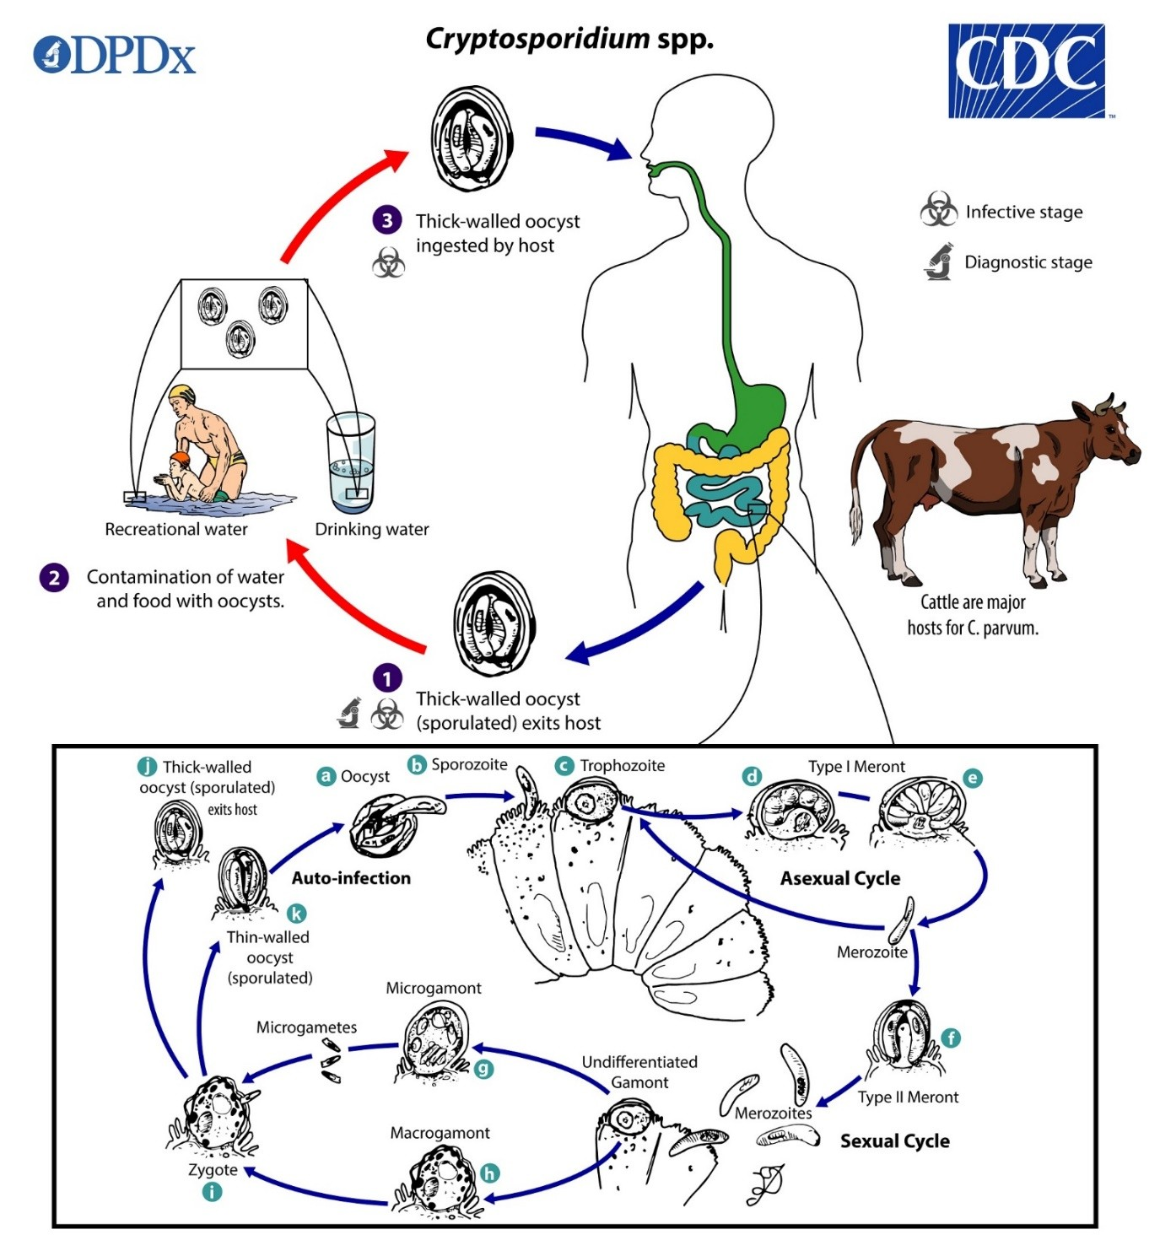

1. Sporulated oocysts, containing 4 sporozoites, are excreted by the infected host through feces (and possibly other routes such as respiratory secretions).
2.Transmission of Cryptosporidium spp. occurs mainly through ingestion of fecally contaminated water (e.g., drinking or recreational water) or food (e.g., raw milk) or following direct contact with infected animals or people .
3. Following ingestion (and possibly inhalation) by a suitable host , excystation occurs. The sporozoites are released and parasitize the epithelial cells ( , ) of the gastrointestinal tract (and possibly the respiratory tract). In these cells, usually within the brush border, the parasites undergo asexual multiplication (schizogony or merogony) ( , , ) and then sexual multiplication (gametogony) producing microgamonts (male) and macrogamonts (female) . Upon fertilization of the macrogamonts by the microgametes ( ) that rupture from the microgamont, oocysts develop and sporulate in the infected host. Zygotes give rise to two different types of oocysts (thick-walled and thin-walled). Thick-walled oocysts are excreted from the host into the environment , whereas thin-walled oocysts are involved in the internal autoinfective cycle and are not recovered from stools . Oocysts are infectious upon excretion, thus enabling direct and immediate fecal-oral transmission. Extracellular stages have been reported, but their relevance in the overall life cycle is unclear.

Figure-2 : Showing life cycle of Cystoisospora species (source- CDC)

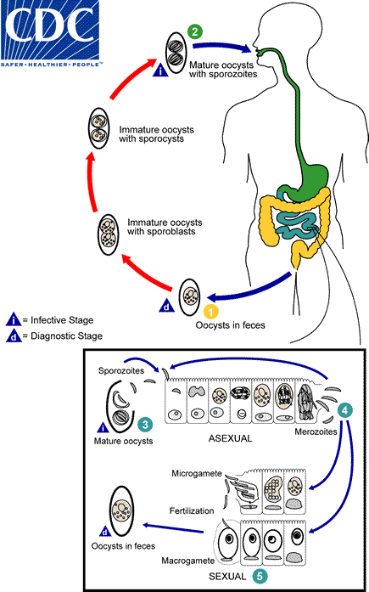
1. At time of excretion, the immature oocyst contains usually one sporoblast (more rarely two). In further maturation after excretion, the sporoblast divides in two (the oocyst now contains two sporoblasts); the sporoblasts secrete a cyst wall, thus becoming sporocysts; and the sporocysts divide twice to produce four sporozoites each
2. Infection occurs by ingestion of sporocysts-containing oocysts: the sporocysts excyst in the small intestine and release their sporozoites, which invade the epithelial cells and initiate schizogony
3. Upon rupture of the schizonts, the merozoites are released, invade new epithelial cells, and continue the cycle of asexual multiplication
4. Trophozoites develop into schizonts which contain multiple merozoites. After a minimum of one week, the sexual stage begins with the development of male and female gametocytes
5. Fertilization results in the development of oocysts that are excreted in the stool

Figure-3 : Showing life cycle of species (source- CDC)
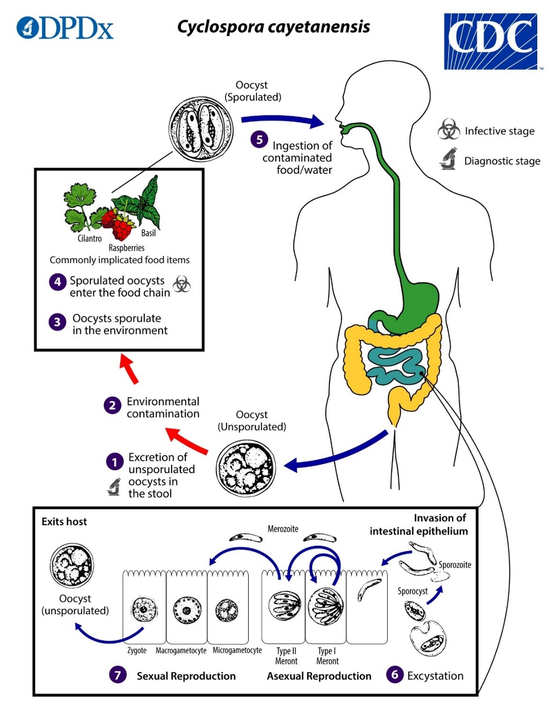
1. Oocyst in Freshly passed stools is not infective (thus, direct fecal-oral transmission cannot occur; this differentiates Cyclospora from another important coccidian parasite, Cryptosporidium).
2 &3. In the environment , sporulation occurs after days/ weeks at temperatures 22°C to 32°C, resulting in division into two sporocysts, each containing two elongate sporozoites .
4&5. The sporulated oocysts can contaminate water/or enter in food chain which are then ingested .
6.The oocysts excyst in the gastrointestinal tract, freeing the sporozoites, which invade the epithelial cells of the small intestine
7 . Inside the cells they undergo asexual multiplication into type I and type II meronts. Merozoites from type I meronts likely remain in the asexual cycle, while merozoites from type II meronts undergo sexual development into macrogametocytes and microgametocytes upon invasion of another host cell. Fertilization occurs, and the zygote develops to an oocyst which is released from the host cell and shed in the stool . Several aspects of intracellular replication and development are still unknown, and the potential mechanisms of contamination of food and water are still under investigation.

Pathogenesis
The pathogenesis of these parasites involves several key factors that contribute to their ability to cause disease in vulnerable hosts:
- Infectivity and Replication: Opportunistic coccidian parasites have a unique life cycle that involves both asexual and sexual reproduction stages. Upon ingestion of infectious oocysts through contaminated food or water, sporozoites are released and invade the intestinal epithelial cells. These parasites replicate asexually within the host cells, leading to the production of numerous merozoites and ultimately more oocysts. This continuous cycle of invasion and replication contributes to the parasite's ability to establish and maintain infection in the host.
- Host-Parasite Interaction: The interaction between opportunistic coccidian parasites and the host immune system is critical in determining the outcome of infection. In immunocompromised individuals, such as those with HIV/AIDS or undergoing immunosuppressive therapy, the immune response is impaired, leading to inadequate control of parasite replication. This allows the parasites to proliferate unchecked in the intestinal epithelium, leading to severe and chronic infections.
- Intestinal Damage and Malabsorption: Opportunistic coccidian parasites, particularly Cryptosporidium spp., are known to cause significant damage to the intestinal epithelium. Parasite attachment and invasion of enterocytes result in villous blunting, inflammation, and disruption of the mucosal barrier. This can lead to malabsorption of nutrients, electrolyte imbalances, and impaired intestinal function, contributing to symptoms such as diarrhea, weight loss, and dehydration.
- Extra-intestinal Manifestations: In addition to intestinal pathology, opportunistic coccidian parasites can disseminate beyond the gastrointestinal tract in immunocompromised patients. This extra-intestinal spread can involve organs such as the biliary tract, respiratory system, liver, and gallbladder, leading to complications such as cholecystitis, pneumonia, and hepatitis. Disseminated infections are associated with increased morbidity and mortality in susceptible individuals.
- Chronic Infection and Immune Evasion: Opportunistic coccidian parasites have developed strategies to evade host immune responses and establish chronic infections in immunocompromised hosts. Factors such as antigenic variation, intracellular survival mechanisms, and inhibition of immune signaling pathways contribute to the persistence of infection and the difficulty in eradicating the parasites.
Understanding the pathogenesis of opportunistic coccidian parasites is essential for developing effective prevention strategies, diagnostic approaches, and treatment interventions to mitigate the impact of these infections on immunocompromised individuals. Targeting key aspects of parasite infectivity, host-parasite interactions, and disease progression can help improve clinical outcomes and reduce the burden of infection in vulnerable populations.
CLINICAL SIGNIFICANCE
Diarrhea, malaise, lack of energy, and appetite are symptoms associated with several gastrointestinal pathogens, and are present in patients with cyclosporiasis in developed countries. In endemic areas, clinical infections are usually detected in children 4–10 years of age. About 50% of these children present with diarrhea and other gastrointestinal discomforts, including malaise, bloating, and anorexia. Infections may resolve spontaneously, suggesting that immunity may play a role in clearance of infections. In the case of human isosporiasis, severe symptoms have been reported in AIDS patients or people with other forms of immune-suppression. The most frequently clinical symptoms are fever, malaise, chronic and persistent diarrhea, steatorrhea, and loss of weight. The infection can even cause death.

Diagnosis
Diagnostic methods for detecting intestinal coccidian parasites in immunocompromised patients play a crucial role in early identification, treatment, and management of infections. Several laboratory techniques are available for diagnosing these parasites. Here are some of the common diagnostic methods used:
- Stool Examination: Microscopic examination of stool samples is a primary and widely used method for detecting coccidian parasites. Routine stool examination by using saline wetmount and Specific staining techniques, such as modified acid-fast stains (e.g., Ziehl-Neelsen stain), can help visualize oocyst of Cryptosporidium spp., Cystoisospora spp and Cyclospora cayetanensis. The presence of oocysts, sporulated oocysts, or other parasite stages in stool samples confirms the infection. (Figure 1a-3a & 1b-3b)
- Direct Fluorescent Antibody (DFA) Test: DFA testing is a sensitive and specific method for detecting Cryptosporidium spp. and other coccidian parasites in stool samples. The procedure involves using specific fluorescent-labeled antibodies that bind to the parasites, allowing visualization under a fluorescent microscope.
- Polymerase Chain Reaction (PCR): PCR-based assays are highly sensitive molecular techniques used to detect and identify coccidian parasites in clinical samples. Targeting specific genetic markers, PCR can provide rapid and accurate diagnosis, even in low parasite concentrations. It also allows for species identification and differentiation.
- Enzyme-Linked Immunosorbent Assay (ELISA): ELISA tests can detect parasite-specific antigens in stool samples, providing a rapid and sensitive method for diagnosing infections caused by coccidian parasites like Cryptosporidium. ELISA kits are commercially available and offer high throughput for diagnostic laboratories.
- Microscopy of Duodenal Biopsy Samples: In cases where other diagnostic methods are inconclusive or when assessing extra-intestinal involvement, duodenal biopsy samples may be examined microscopically for the presence of coccidian parasites in intestinal mucosa.
- Immunofluorescence Assay (IFA): IFA can be used to detect specific antibodies against coccidian parasites in patient serum samples, indicating recent or past infections. Serological testing is not usually used for primary diagnosis but can be helpful in epidemiological studies or surveillance.
- Antigen Detection Tests: Rapid antigen detection tests, such as lateral flow assays, are available for diagnosing Cryptosporidium infections in stool samples. These tests provide quick results without the need for sophisticated laboratory equipment.

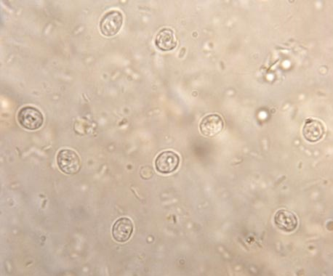  1a | 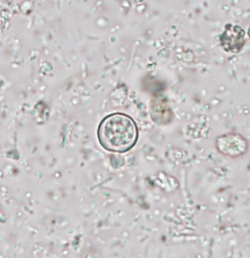  2a | 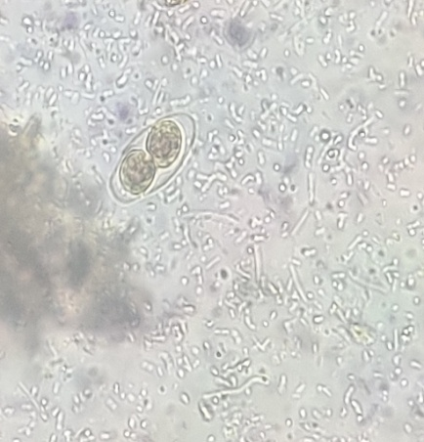  3a
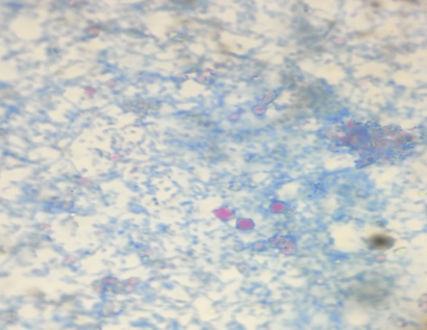  1b | 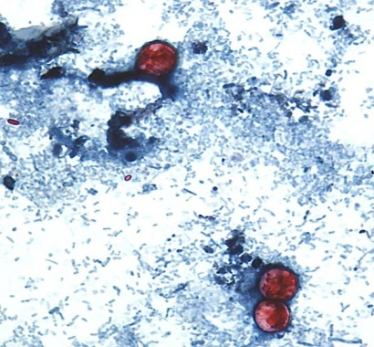  2b | 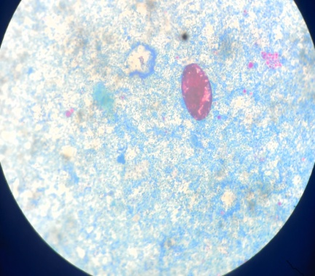  3b
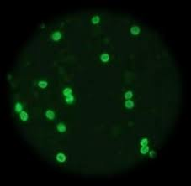  1c | 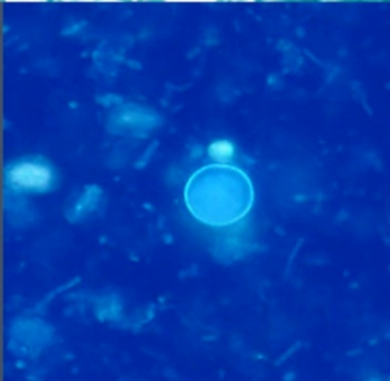  2c | 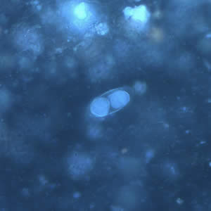  3c

Figure 1a to 1c: Cryptosporidium species
(1a). Round oocyst (4-6µm) in saline wet mount
(1b). Modified Ziehl-Neelsen stain shows red color round oocyst against blue background.
(1c). Direct fluorescent antibody staining shows brilliant green fluroscent oocysts
Figure 2a to 2c: Cyclospora species
(2a). Round unsporulated oocyst (08-10µm) in saline wet mount)
(2b). Modified Ziehl-Neelsen stain shows red color round oocyst against blue background.
(2c). UV fluorescence microscopy shows oocyst wall is autofluorescent
Figure 3a to 3c: Cystoisospora species
(3a). Oval sporulated oocyst (25-35µm) in saline wet mount
(3b). Modified Ziehl-Neelsen stain shows red color oval unsporulated oocyst
(3c). UV fluorescence microscopy shows fluorescent oocyst

Treatment
The treatment of coccidian parasites, such as Cryptosporidium spp., Cyclospora cayetanensis, and Isospora (Cystoisospora) spp., typically involves the use of specific medications aimed at controlling the infection. It is important to note that treatment options may vary depending on the specific parasite involved, the severity of the infection, and the immune status of the patient. Here are some commonly used medications for treating coccidian parasitic infections:
- Nitazoxanide: Nitazoxanide is the first-line treatment for Cryptosporidium infection in both immunocompetent and immunocompromised individuals. It can also be effective against Cyclospora and Isospora infections. Nitazoxanide disrupts parasite metabolism and replication, helping to alleviate symptoms and clear the infection. It is available in both pediatric and adult formulations.
- Trimethoprim-sulfamethoxazole (TMP-SMX): TMP-SMX is another medication commonly used to treat coccidian parasitic infections. It has shown efficacy against Isospora infections in particular. TMP-SMX works by inhibiting the parasite's folic acid synthesis, preventing replication and controlling the infection. However, its use in immunocompromised patients with severe infections may be limited due to the risk of adverse effects and the potential for developing drug resistance.
- Spiramycin: Spiramycin is an antibiotic used to treat certain parasitic infections, including Cryptosporidium infections in immunocompetent individuals. While it may not be as effective in immunocompromised patients, it can be considered as a treatment option in selected cases.
- Supportive Care: In addition to specific antiparasitic medications, supportive care is important to manage symptoms and prevent complications associated with coccidian parasitic infections. This may include oral rehydration solutions, electrolyte replacement, nutritional support, and management of associated gastrointestinal symptoms.
It is crucial to consult with a healthcare professional or infectious disease specialist for accurate diagnosis and appropriate management of coccidian parasitic infections. The specific treatment regimen will depend on factors like the parasite species, the severity of the infection, the immune status of the patient, and any associated medical conditions.

Comprehensive approach to preventing Coccidian Parasite Infections:
There are various approach to prevent infection from Coccidian parasites which includes personal hygiene practices, regular hand washing, Ensuring safe drinking water for communities by implementing proper filtration and disinfection, Practicing good food hygiene, including thorough cooking and washing of fruits and vegetables. Livestock and pets must be kept in improved sanitation conditions, regular deworming and veterinary care to reduce the spread of coccidian parasites within animal populations and to humans. These practices play a vital role in reducing the risk of coccidian parasite infections.

