Chapter 3 –Dimorphic Fungi, Molds, and Mold-like Agents of Medical Importance

Objectives:

Upon completion of this chapter, the reader should be able to:

- Describe the general characteristics and structures of the dimorphic fungi at both room temperature and at 37ºC: Blastomyces, Coccidioides, Emergomyces, Histoplasmosis, Paracoccidioides, Talaromyces, and Sporothrix.
- Describe the general characteristics and structures of molds, both asexual and sexual.
- Describe the general characteristics of the mold-like bacteria Actinomyces and Nocardia.
- Define aseptate, coencytic, and septate hyphae.
- Define phaeoid, dematiaceous, and hyaline hyphae.
- List all of the asexual conidia and their associated structures and sexual conidia of fungi.
- Define sclerotic body and fungal granules.
- Plan a basic scheme to categorize the dimorphic fungi and molds by growth patterns, hyphae characteristics, and types of infections that they cause.
- Identify the major fungal infections (diseases) caused by the fungal agents in objectives #1-#3.
- Describe the importance of the immune system to protection from fungal disease.
- Discuss the conditions that make someone more vulnerable to serious fungal infection.
- Explain how fungi are involved in allergic disease and which ones are commonly involved.
- Discuss how fungi can cause toxicosis and which ones are commonly involved.
- Discuss the following different types of mycoses:
- Superficial
- Cutaneous
- Subcutaneous
- Opportunistic
- Invasive
- Disseminated/ Systemic
- Describe Maldi-Tof mass spectrophotometry and discuss its use in fungal identification.
- Describe the molecular methods that can be used to identify fungi more safely than the old conversion methods.
- Describe the key characteristics to identify of the dimorphic fungi: Blastomyces, Coccidioides, Emergomyces, Histoplasmosis, Paracoccidioides, Talaromyces, and Sporothrix.
- Describe the key characteristics to identify the aseptate or coencytic mucormycetes.
- Describe the key characteristics to identify the septate opportunistic hyaline molds.
- Describe the key characteristics to identify the septate opportunistic phaeoid molds.
- Describe the key characteristics of the superficial ectopic hair fungal diseases, black and white piedra.
- Describe the key characteristics of the superficial ectopic skin fungal diseases, tinea nigra and tinea versicolor.
- Describe the key characteristics to identify the septate hyaline dermatophyte molds.
- Compare and contrast chromoblastomycosis, mycetoma, and sporotrichosis.
- Describe the key characteristics to identify Actinomyces spp. and Nocardia spp.
- Discuss the blood serology tests that can be used to detect invasive Aspergillosis.
- Discuss the body sites and specimens that may be cultured to detect fungal infections and which fungi commonly infect each.

Chapter 3 –Dimorphic Fungi, Molds, and Mold-like Agents of Medical Importance
Introduction to the dimorphic fungi, molds, and mold-like agents of medical importance
This chapter deals with the dimorphic fungi (capable of living as a yeast phase at body temperature and as a mold phase at room temperature), medically significant molds, and fungus-like (mold-like) bacteria, such as Norcardia spp.(aerobic) and Actinomyces spp.(anaerobic) that cause mycetoma and other pathology globally and their related pathology.
These fungi range from frank pathogens to typically benign fungi that can become opportunists. The dimorphs, particularly these endemic mycoses Blastomyces, Coccidioides, Paracoccidioides, and Talaromyces, are known for their pathogenic abilities and systemic disease. Yet, we must respect the disease-causing ability of some of the other invasive fungi, especially in the compromised host. Aspergillus fumigatus, for example, has enough pathogenic abilities to cause invasive aspergillosis worldwide and is currently #3 on the WHO fungal priorities pathogen list. Some feel it deserves to be moved to the highest rank on the prioritization scale. Beyond having worldwide distribution and concern over growing Aspergillus azole resistance, a diagnosis of invasive aspergillosis is the leading fungal infection in terms of mortality, followed by a diagnosis of chronic pulmonary aspergillosis. (1) Other fungi typically considered benign are seen increasingly as invasive in the immunocompromised because there is an ever-increasing number of compromised patients as life is extended. Most fungal infections arise in the immunocompromised, and many new fungal opportunists exist. However, the majority of fungal invasive infections are in these six categories: aspergillosis, candidiasis (candidosis), cryptococcus, mucormycosis, pneumocystis, and endemic dimorph diseases. (2)
The interrelation of fungal disease and the immune system and progression of fungal disease
A healthy immune system does a lot to protect humans from invasive fungal diseases. If a patient is immune deficient, either temporarily or from a congenital condition, such as a deficit in neutrophils or interferon, it increases their vulnerability to infection. Also, if you have breaks in your skin or mucous membrane surfaces that provide innate protection, the ease of tissue invasion significantly increases. The typically effective immune defenses are why most human fungal infections are just in the top layers of the skin, nails, hair, and mucous membranes. Agents that grow primarily on top of the surface of the skin or hair are termed superficial fungi. Those that grow inside the outer layers of the skin, hair, and nails are termed dermatophytes.
Suppose there is a break in the defenses, such as a puncture injury in chromoblastomycosis, mycetoma, sporotrichosis, a deep wound, or an IV line access site with percutaneous (or through the skin) access. In that case, the fungus can get direct tissue access and invade. Or enough spores are inhaled to allow some to get through and land deep inside the respiratory tract. In that case, the host defenses may be compromised enough that the fungus can get a foothold and grow inside the patient's tissues and organs (it becomes invasive).
Once the tissues or organs are infected, the fungi can also easily spread to nearby organs, the entire organ system (in which it has disseminated), or even eventually through multiple body systems and the whole body (it becomes systemic) via the circulatory system, the lymphatic system, and other body fluids. Similarly, a fungus in the fluid surrounding the brain and spinal cord usually causes swelling and infection of the meninges, which progresses to invasive meningitis.
The Dimorphic fungi
Blastomyces dermatitidis and Blastomyces gilchristi -Blastomyces is a dimorphic fungus that causes the systemic disease blastomycosis (Gilchrist's disease or North American blastomycosis). The genus Blastomyces has two species, Blastomyces dermatitidis and Blastomyces gilchristi. They are morphologically identical but distinguishable by their ITS region sequence analysis. (3) B. dermatitidis lives in soil and is associated with decayed vegetation. Blastomycosis is a chronic granulomatous disease with a primary pulmonary stage that is often followed by dissemination to other body sites, generally to skin and bone. (3, 4) The disease was long thought to be restricted to North America. Still, cases thought to be autochthonous (of local origin) have been reported in Africa, Asia, and rarely in Europe and India in recent years. (5, 6)
Histopathology and direst testing: Blastomyces dermatitidis tissue sections show large, broad-based, unipolar budding yeast-like cells, varying in size from 8-15 µm and larger forms up to 30 µm in diameter. (3) The thick refractile cell wall of this organism gives the appearance of a space between the fungal cell contents and the surrounding tissue when observed with hematoxylin and eosin (H&E) stain. It is sometimes difficult to observe the yeast-like Blastomyces cells in H&E preparations alone, so tissue sections must also be stained using Grocott's methenamine silver method.
Colonial description: WARNING: This is an RG-3 organism. Cultures of B. dermatitidis represent a biohazard to laboratory personnel and must be handled in a Class II Biological Safety Cabinet (BSCII). Colonies at 25ᴼC have variable morphology and growth rates. They may grow rapidly, producing a fluffy white mycelium, or slowly as glabrous, tan, nonsporulating colonies. Colonies on blood agar at 37ᴼC are wrinkled and folded, glabrous, and more yeast-like. Growth and sporulation may be enhanced by yeast extract agar. Most strains become pleomorphic with age.
Microscopically, hyaline oval to pyriform, one-celled, smooth-walled conidia (2-10 µm in diameter) of the Chrysosporium type are borne on short lateral or terminal hyphal branches. (3) The organism produces the characteristic broad-based yeast phase seen in tissue pathology as B. dermatitidis is a dimorphic fungus. In the past, conversion from the mold form to the yeast phase was necessary to positively identify this dimorphic pathogen from the non-pathogenic species Chrysosporium or Sepedonium. However, culture identification by exoantigen testing and molecular methods is now preferred to minimize manipulation of the fungus.
Molecular identification: A DNA probe assay (Gen-Probe, Inc., San Diego, CA) to identify B. dermatitidis in clinical isolates is available commercially. However, this is limited because it can only be used with pure cultures of B. dermatitidis (yeast or mold). Several PCR assays have been developed to identify B. dermatitidis from clinical specimens. (7) Sidamonidze et al. (2012) developed a real-time PCR targeting the BAD1 (formerly known as WI-1) gene to identify B. dermatitidis in tissue and culture. (8) Morjaria et al. (2015) used rDNA sequencing for identification from paraffin-embedded tissue. (9) The US Centers for Disease Control has a helpful website of information about fungal molecular techniques. https://www.cdc.gov/fungal/hcp/laboratories/settings-for-dna-amplification.html
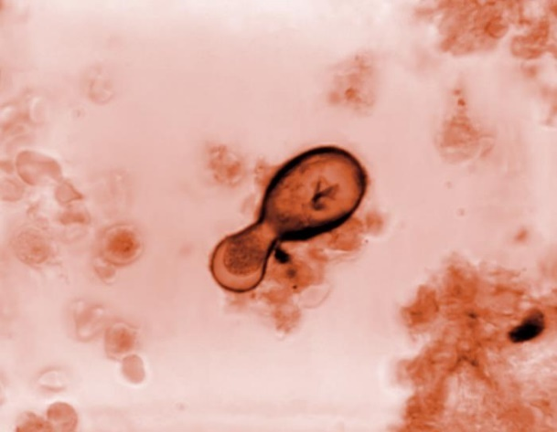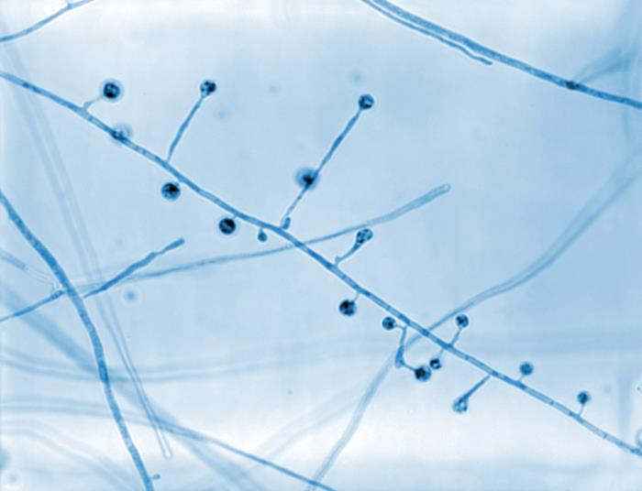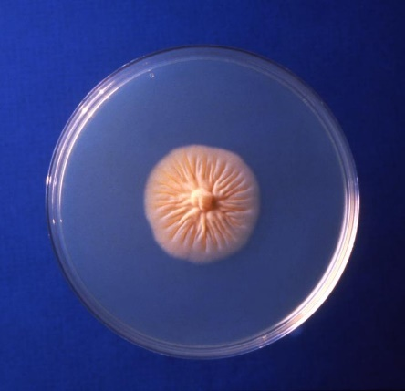
20210 Caption: Under a magnification of 800X, this photomicrograph revealed ultrastructural morphology exhibited by the fungal organism Blastomyces dermatitidis. In this view you are able to see numbers of conidiophores. Note how each conidiophore sprouted directly from the filamentous hyphae in a perpendicular arrangement and that each was topped by a spherical-shaped conidium. CDC/ Dr. Libero Ajello, 1967. Public domain, PHIL library.
20815 Caption: This photomicrograph of a Gridley-stained Congolese tissue sample, under a magnification of 1800X, revealed the presence of a Blastomyces dermatitidis fungal cell. In this view, you can see this yeast-form organism undergoing the asexual reproductive method known as budding, performing an extrusion of its cell wall and internal contents, thereby producing a new cell. CDC/ Dr. Libero Ajello, 1966. Public domain, PHIL library.
17300 Caption: This culture plate contained a growth medium of Sabouraud dextrose agar (SDA), upon which a colony of Blastomyces dermatitidis fungal organisms had been cultured. The specimen from which this culture had been derived, had originated from Africa. CDC/ Dr. Arvind A. Padhye. 1979. Public domain, PHIL library.

Coccidioides immitis and Coccidioides posadasii are dimorphic fungi that cause the systemic disease coccidioidomycosis (San Joaquin Fever or Valley fever). They are morphologically identical but can be distinguished only by genetic analysis or different growth rates in high salt concentrations (C. posadasii grows more slowly). C. immitis is geographically limited to California's San Joaquin Valley region and Mexico, whereas C. posadasii is found in California, Arizona, Texas, Mexico, and South America. (10, 11) These organisms are inhaled as spores, causing acute coccidiomycosis characterized by fever, chills, chest pain, dyspnea, and hemoptysis. (9) Chest imaging studies typically show both consolidation and cavitation. Reactivation and dissemination are possible in patients with previous infection, whether or not they are immunocompromised.
The pathology of pulmonary coccidioidomycosis is neutrophilic, suppurative, and granulomatous. The organisms appear as large spherules containing endospores, visible on silver stains. The spherules are 30–100 microns in diameter, and the endospores released into the surrounding tissue mature to become new spherules. As in histoplasmosis, cavitating lesions may have hyphal forms that begin to germinate.
Histopathology and direct testing: Coccidioides immitis tissue morphology typically shows endosporulating spherules. Young spherules have a clear center, peripheral cytoplasm, and a prominent thick wall. Endospores (sporangiospores) are later formed within the spherule by repeated cytoplasmic cleavage. Rupture of the spherule releases endospores into the surrounding tissue, where they re-initiate the cycle of spherule development. (11)
Colonial identification:WARNING: RG-3 organism. Cultures of Coccidioides immitis/posadasii represent a severe biohazard to laboratory personnel and must be cautiously handled in Class II Biological Safety Cabinet (BSCII). Cultures can grow rapidly (within 48 hours on blood agar) and are often first encountered in routine microbiology laboratories rather than specialized and contained mycology laboratories. Therefore, staff should be made aware of the risks of handling this organism, and precautions should be taken to limit these risks. C. immitis and C. posadasii colonies grown at 25C may initially be moist and glabrous but rapidly become suede-like to downy, grey-white with a tan-brown colony reverse. Considerable variation in growth rate and colony morphology is seen.
Microscopy shows single-celled, hyaline, rectangular to barrel-shaped, alternating arthroconidia, 2.5-4 x 3-6 µm in size, separated by a disjunctor cell. (10) Other soil fungi also produce similar arthroconidia, but C. immitis is the only species within the primarily pathogenic fungi that develop this type of conidia. Coccidioides immitis and C. posadasii are dimorphic fungi living in tissue (at body temperature) as spherules and endospores and in soil or culture at temperatures below 30C in mycelial form. Despite its dimorphism, the 'spherule phase' will not be observed using routine laboratory procedures, and inducing this phase should not be attempted. Culture identification by exoantigen test or DNA sequencing is preferred to minimize exposure to this infectious agent.
Molecular identification: A DNA probe to identify this species is commercially available. Sequencing the internal transcribed spacer (ITS) region of ribosomal DNA sequencing is recommended for species differentiation of these two species. (11)
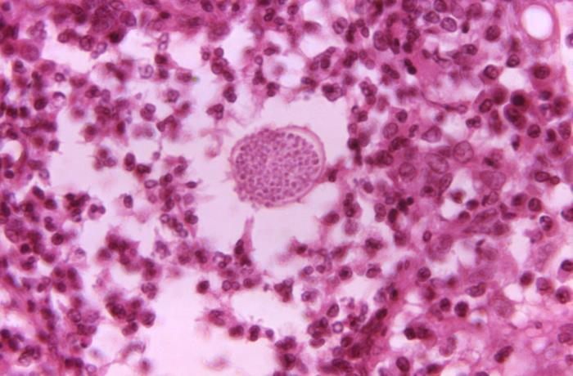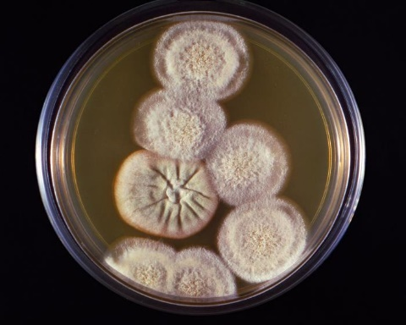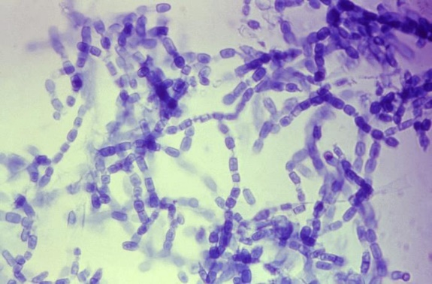
16303 Caption: Under a magnification of 600X, this photo reveals characteristics displayed by the fungal organism Coccidioides immitis. Note the numerous chains of anthrospores, which are those spores originating from the organism’s mycelia. The average arthrospore measures 3.0 x 4.5µm, and is barrel-shaped. CDC/ Dr. Brinkman, 1963. Public domain, PHIL.
20826 Caption: This culture plate contained an unknown growth medium, which was inoculated during a soil study and gave rise to these colonies of Coccidioides immitis fungal organisms. CDC/ Dr. Libero Ajello, 1966. Public domain, PHIL.
20526 Caption: Under a magnification of 500X, this photo shows histopathologic details exhibited by a tissue section extracted from a patient with a case of coccidioidomycosis, also known as valley fever, caused by the fungal organism, Coccidioides immitis. In this view, a mature spherule was visible, which contained numerous endospores that would be released into the patient’s tissues, when the spherule ruptured. CDC/ Dr. Brodsky, 1966. Public domain, PHIL.

Emergomyces (formerly Emmonsia spp.) are dimorphic fungi that cause the systemic disease emergomycosis. The global emergence of emergomycosis, a systemic fungal infection caused by this novel dimorphic fungus Emergomyces species, was observed in only immunocompromised patients. These include Emergomyces pasteurianus, Emergomyces africanus, Emergomyces canadensis, Emergomyces orientalis, and Emergomyces europaeus. (12) Emmonsia parva was renamed Blastomyces parvus. Unlike other members of the genus, Emergomyces crescens does not cause disseminated disease but causes a granulomatous pulmonary disease. (12) Emergomycosis has been found in immunodeficient persons in Asia, Europe, Africa, and North America. It is assumed to be global because of the number of HIV-positive patients. (12) Diagnosis of emergomycosis is difficult and should be considered in the diagnosis of similar histoplasmosis. The primary route of infection is thought to be inhalation of airborne conidia released from saprophytic mycelia in soil. In the human host, these conidia are transformed into yeast-like cells that can replicate and disseminate to organs other than the lungs. Almost all reported cases of disseminated infection caused by Emergomyces spp. have occurred in immunocompromised adults, the vast majority of whom had advanced HIV infection. Other underlying risk factors include neutropenia, solid organ transplantation, hematological malignancies, and immunosuppressive drugs. In a single case of the disease caused by E. orientalis, there was no underlying immunodeficiency except type 2 diabetes mellitus. Emergomycosis is a multisystem disease that involves the skin, lungs, liver, spleen, bone marrow, lymph nodes, brain, and cervix. Schwartz et al., in a study from South Africa, reported that 96% of patients with disseminated disease had cutaneous lesions; all of them had very low CD4+ T cell counts and had profound anemia. (12) Skin lesions with varying morphologies are observed in different patients.
Histopathology and direct testing: The yeast phase of E. africanus closely resembles Histoplasma capsulatum, while that of E. orientalis resembles Blastomyces dermatitidis. Histopathology can detect yeasts but cannot differentiate between the different fungal agents. Therefore, it is imperative to distinguish between these dimorphic fungi by using fungal culture. However, the mold phase of E. africanus closely resembles Sporothrix schenckii in microscopy. For all these reasons, molecular techniques like sequencing are considered the best identification tool. Serological tests for these organisms can cross-react with the Histoplasma galactomannan antigen. Inexpensive, accessible, and accurate tests are needed. (13)
Colonial description: Emergomyces spp. grow readily on routine mycology media like Sabauraud’s dextrose agar, malt extract agar, or potato dextrose agar, incubated at 24–30°C. Colonies are yellowish-white to tan, initially glabrous, becoming powdery, slightly raised and furrowed. Reverse is ochre-buff to warm-buff peripherally. Upon subculture to malt extract agar or brain heart infusion agar with blood and incubation at 35°C., yellow-white to tan, pasty, cerebriform colonies appear after 2–3 weeks of incubation. (13)

Microscopic morphology of the mold phase in lactophenol aniline blue preparation exhibits slender conidiophores arising at right angles from thin-walled hyaline hyphae, slightly swollen at the tip, sometimes with short secondary conidiophores bearing "florets" of solitary single-celled subspherical conidia. (13) Gram-stained smear prepared from culture reveals small, oval yeast cells with narrow-based budding.

Molecular identification: Sequencing the internal transcribed spacer (ITS) region of ribosomal DNA is considered the gold standard for identification. (2)
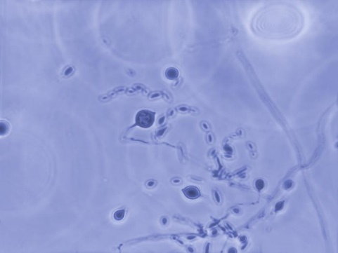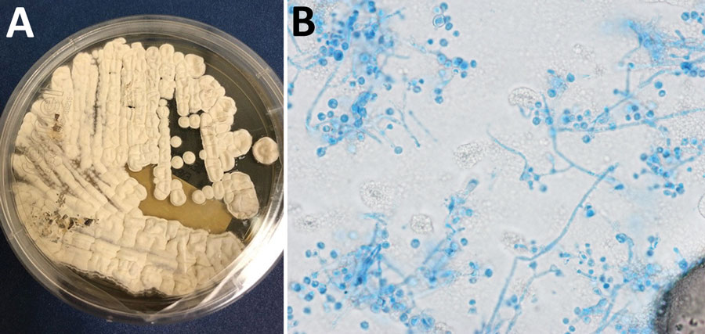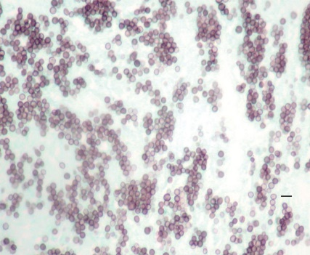
Caption: Methenamine silver stain of mediastinal lymph node biopsy, demonstrating small round or oval yeasts in tissue. The patient had Emergomyces canadensis in Saskatoon, Saskatchewan, Canada, 2003. The scale bar indicates 10 µm. Public domain, https://wwwnc.cdc.gov/eid/article/24/4/17-1765-f1 CDC.
Caption: Lung nodule biopsy and fungal culture isolate of Emergomyces pasteurianus infection in a patient returning to the United States from Liberia. A) Colony morphology on Sabouraud dextrose agar at 14 days. B) Lactophenol cotton blue tape prep; original magnification ×1,000. https://wwwnc.cdc.gov/eid/article/29/3/22-1683-f2. Public domain.

23069 Caption: Under a magnification of 500X, this photo revealed some ultrastructural morphology exhibited by an Emergomyces (Emmonsia) sp., labeled 45-883-64. Here, you are able to see the organism’s septate hyphae and numerous asexual adiaspores. CDC/ Dr. Libero Ajello, 1964. Public domain, PHIL.

The Histoplasma capsulatum complex is a group of dimorphic fungi that cause the systemic disease histoplasmosis (Darling's disease). Histoplasma capsulatum has a global distribution. However, the Mississippi-Ohio River Valley in the USA is recognized as its main endemic region. Environmental isolations of the fungus have been made from soil enriched with manure from birds and bats. Histoplasma capsulatum was recently divided into several subspecies that show extensive hybridization, which may be difficult to distinguish in practice. In South America, the Histoplasma capsulatum complex shows enormous diversity. Patients may be infected by several different genotypes. Histoplasmosis is an intracellular mycotic infection of the reticuloendothelial system caused by the inhalation of the fungus. Approximately 95% of cases of histoplasmosis are inapparent, subclinical, or benign. The remaining 5% of cases may develop chronic progressive lung disease, chronic cutaneous or systemic disease, or an acute fulminating fatal systemic disease. (14) All stages of this disease may mimic tuberculosis. Sporadic cases have been reported in Australia.
Histopathology and direct testing: The characteristically small yeasts (2-4 microns in size) with narrow-based budding grouped in clusters are seen inside macrophages in the 37ᴼC phase inside the tissues. (15)
Colonial description: WARNING: RG-3 organism. Cultures of Histoplasma capsulatum represent a severe biohazard to laboratory personnel and must be handled cautiously in a Class II Biological Safety Cabinet (BSCII). Histoplasma capsulatum exhibits thermal dimorphism, growing in living tissue or culture at 37C as a budding yeast and in soil or culture at temperatures below 30C as a mold. Colonies at 25C are slow growing, white or buff-brown, suede-like to cottony with a pale yellow-brown reverse. Other colony types are glabrous or verrucose. Colonies at 37C grown on brain heart infusion agar with blood are smooth, moist, white, and yeast-like. (14)

Microscopic morphology at temperatures under 30ᴼC shows the characteristically large, rounded, single-celled, tuberculate macroconidia, 8-14 µm in diameter, formed on short, hyaline, undifferentiated conidiophores. (14) Small, round to pyriform microconidia, 2-4 µm in diameter, that are borne on short branches or directly attached to the sides of the hyphae may also be present. (14) Colonies grown at 37ᴼC have small round or oval budding yeast-like cells, 3-4 x 2-3 µm in size, that are observed microscopically. (14) Depending on the clinical disease, three varieties of Histoplasma capsulatum are recognized: var. capsulatum is the typical agent of histoplasmosis; var. duboisii is the African type; var. farciminosum causes lymphangitis in horses. (14) Histoplasma isolates also resemble Sepedonium and Chrysosporium. Traditionally, identification required converting the mold form to the yeast form by growth at 37ᴼC on enriched media; however, culture identification by either exoantigen test or DNA/RNA sequencing is now preferred for safety. (14)

Molecular identification: Eliaset et al. (2012) developed a multiplex-PCR for identification from cultures. Scheel et al. (2014) developed a loop-mediated isothermal amplification (LAMP) assay for detection directly in clinical samples, which is affordable and useful in resource-poor facilities. (14) Sequencing the internal transcribed spacer (ITS) region of ribosomal DNA may also be used for accurate identification. A MALDI-ToF mass spectrophotometry reference database to accurately and specifically identify Histoplasma capsulatum is available. (14)
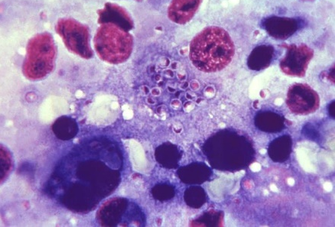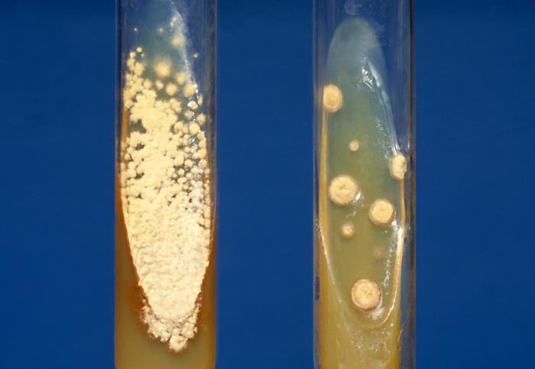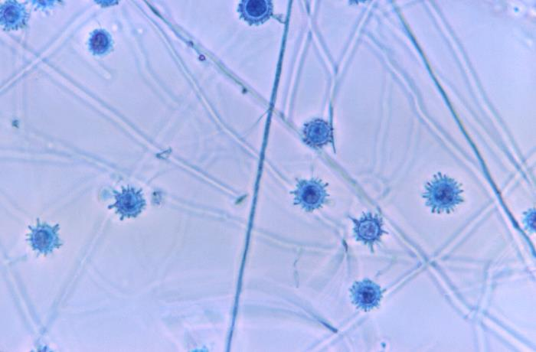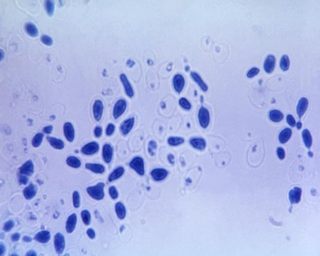
20336 Caption: Under a magnification of 1200X and processed using the lactophenol cotton blue stain, this photo revealed morphologic details of Histoplasma capsulatum extracted from a yeast phase culture. Note that some of these organisms were undergoing a yeast phase reproductive process known as budding. Public domain, PHIL. CDC/ Dr. Lucille K. Georg, 1967.
4189 Caption: Both cultures were inoculated with the pathogen, Histoplasma capsulatum. The tube on the left contained a growth medium of Sabouraud agar, while the tube on the right contained a growth medium consisting of Sabouraud dextrose agar, and brain heart infusion, and is known as SABHI agar. CDC/ Dr. Lenore Haley, 1979. Public domain, PHIL
20099 Caption: Under a magnification of 650X, this photo revealed ultrastructural details exhibited by a number of Histoplasma capsulatum tuberculated macroconidia. CDC/ Dr. Libero Ajello, 1966. Public domain, PHIL.
HOL
22054 Caption: This photo of a liver tissue specimen revealed numerous Histoplasma capsulatum fungal organisms in the yeast stage of development. This was a case of disseminated histoplasmosis. These organisms were of a Tennessee strain, 106-D. CDC/Dr. Lucille K. Georg, 1964. Public domain, PHIL.

Paracoccidioides brasiliensis and P. lutzii Paracoccidioides brasiliensis is a dimorphic fungus that causes the systemic disease paracoccidioidomycosis (South American blastomycosis or Brazilian blastomycosis). (16) Recently, P. brasiliensis has been recognized as two species: P. brasiliensis and P. lutzii. P. brasiliensis/lutzii is geographically restricted to South and Central America areas. The two species are very similar morphologically; the conidia of P. brasiliensis are pyriform, and P. lutzii is elongated. Molecular confirmation is recommended. (16)
Histopathology and direct testing: In a ring, multiple, narrow-base, budding yeast cells in a "Mariner's wheel" of P. brasiliensis are present. (3, 16)
Colonial description: Colonies grown at 25C are slow-growing and vary in morphology. Colonies may be flat, wrinkled and folded, glabrous, suede-like, or downy in texture, white-brown with a tan-brown reverse. (3, 16)
Various conidia may be seen microscopically, including pyriform microconidia, chlamydospores, and arthroconidia. (1) None of these are characteristic of the species, and most strains may grow for long periods without producing conidia. On blood agar at 37C, the mycelium converts to the yeast phase, and colonies are white to tan, moist, and glabrous, which become wrinkled, folded, and heaped. Microscopically, numerous large, 20-60 μm, round, narrow base budding yeast cells are present. (16) Single and multiple budding occurs; the latter are thick-walled cells that form the classical "Mariner's wheel" or "Mickey Mouse" forms that are diagnostic for this dimorph, especially in methenamine silver stained tissue. (1) Clinical history, tissue pathology, and culture identification with conversion to yeast phase at 37C; however, molecular identification is now recommended instead of cultural conversion from the mold into the yeast phase.
Molecular identification: Sequencing the internal transcribed spacer (ITS) region of ribosomal DNA is recommended now instead of the less safe culturing for conversion to the yeast phase. (16)
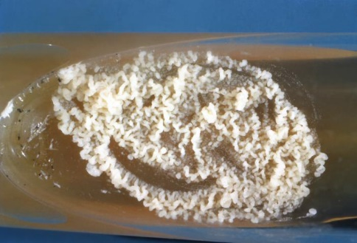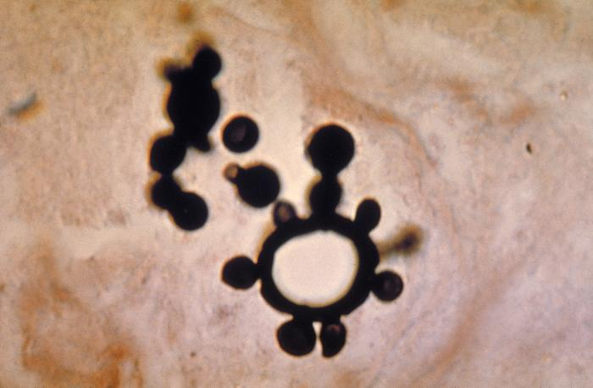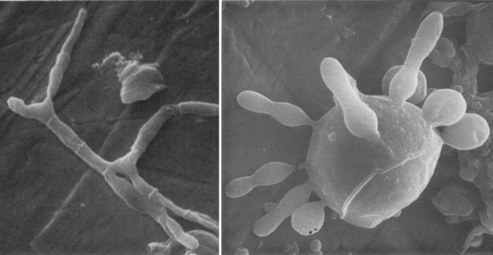
Paracoccidioides brasiliensis mycelium cells (left) and multibudding yeasts (right) by scanning electron microscopy. Original magnifications ×1,500 for the left panel and ×3,000 for the right panel. Image adapted from Vieira e Silva et al. 1974. https://wwwnc.cdc.gov/eid/article/27/9/21-0461-f2 8/24/21
4292 Caption: This photograph depicts a slant culture, which contained an unidentified growth medium, that had been inoculated with Paracoccidioides brasiliensis, and having undergone an unknown incubation period, gave rise to this yeast phase colony. CDC, 1963. Public domain, PHIL.
527 Caption: This photo of a methenamine silver-stained tissue sample revealed some of the histopathology exhibited in a case of paracoccidioidomycosis. Note the multiple buds projecting from one of the Paracoccidioides brasiliensis yeast form cells. CDC/ Dr. Lucille K. Georg, 1963. Public domain, PHIL.

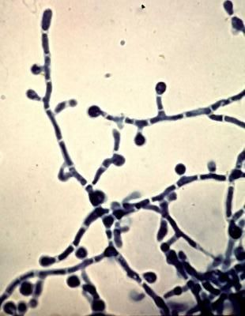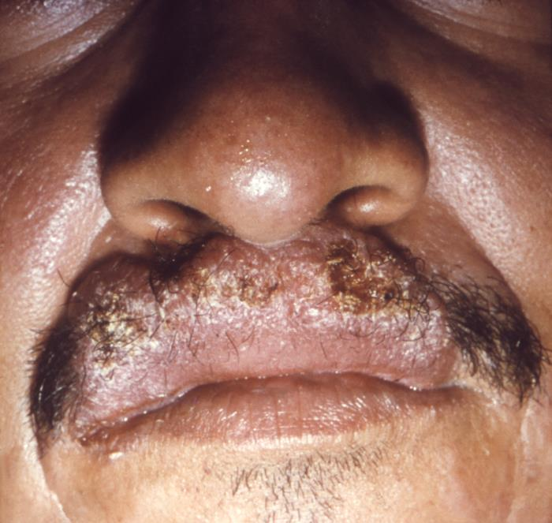
12158 Caption: This image from 1965 depicted a close view of a Sao Paulo, Brazilian man’s face highlighting his nose and lips, and the cutaneous pathologic changes that had involved his upper lip, due of the mycotic infection, paracoccidioidomycosis. Also known as Brazilian blastomycosis, this disease is caused by the fungus, Paracoccidioides brasiliensis. CDC/ Dr. Martins Castro, San Paulo, Brazil; Dr. Lucille K. Georg, 1965. Public domain, PHIL.
At left: Paracoccidioides brasiliensis, cause of paracoccidioidomycosis, aka South American Blastomycosis, Brazilian Blastomycosis Tom Volk's
Fungus of the Month.
Paracoccidioides brasiliensis mycelium room temperature mold stage with classic “lollipop conidia” and arthroconidia visible. botit.botany.wisc.edu
https://www.pinterest.com/pin/407505466258594201/

The Sporothrix schenkii complex are dimorphic fungi that cause sporotrichosis (Rose Gardeners disease). It can remain local to the site of the skin puncture, or it can become systemic. It is now recognized that the S. schenckii complex is five distinct species: S. schenckii, S. brasiliensis, S. globosa, S. mexicana, and S. luriei. (3, 17) The Sporothrix schenckii complex is a dimorphic fungus with a worldwide presence, particularly in tropical and temperate regions. It is usually found in soil and decaying vegetation. It is a well-known pathogen of humans and animals. Sporotrichosis (Rose Gardener's disease) is primarily a chronic mycotic infection of cutaneous or subcutaneous tissues and adjacent lymphatics characterized by nodular lesions that suppurate and ulcerate. (17,18) Infections are caused by the traumatic implantation of the fungus into the skin or, very rarely, by inhalation into the lungs. (3,17) Secondary spread to articular surfaces, bone, and muscle is not infrequent, and the infection may also occasionally involve the central nervous system, lungs, or genitourinary tract. (3, 17)
Histopathology and direct testing: In sporotrichosis, sections show epidermal hyperplasia overlying a marked acute and chronic inflammatory response. Careful examination of multiple sections is required to identify the causative organisms as they are often sparse and missed on direct examination. The organisms may be yeast-like, elongated (resembling cigars), or rarely hyphal in skin. “Sporothrix asteroids” are densely eosinophilic yeast forms with a surrounding ray of eosinophilic material from the H&E stain. Fluorescent antibody staining may also reveal these organisms, but it is not unusual for them to be missed on direct staining. (19)
Colonial description: RG-2 organism. Colonies at 25C are slow-growing, moist, and glabrous, with a wrinkled and folded surface. Some strains may produce short aerial hyphae, and pigmentation may vary from white to cream to black. Conidiophores arise from thin septate hyphae at right angles and are usually solitary, erect, and tapered toward the apex. Conidia are formed in clusters on tiny denticles by sympodial proliferation at the apex of the conidiophore, their arrangement often suggestive of a flower. (3, 17) As the culture ages, conidia are formed singly along the sides of conidiophores and undifferentiated hyphae. Conidia are oval or elongated, 3-6 x 2-3 µm, hyaline, one-celled, and smooth-walled. In some isolates, solitary, darkly-pigmented, thick-walled, one-celled, obovate to angular conidia may be observed along the hyphae. (17) Hyphomycete characterized by thermal dimorphism and clusters of oval, denticulate conidia produced sympodially on short conidiophores On brain heart infusion (BHI) agar containing blood at 37ᴼC, colonies are glabrous, white to grey-yellow, and yeast-like consisting of spherical or oval budding yeast cells. (3, 17)
Molecular identification: DNA sequencing using ITS, D1/D2, β-tubulin, calmodulin, and the chalcone synthase gene is recommended for species identification (Marimon et al. 2007, Romeo et al. 2011, Barros et al. 2011, Oliveira et al. 2014, Zhang et al. 2015b). (17) MALDI-TOF MS: Oliveira et al. (2015) established a MALDI-TOF protocol and reference database to identify Sporothrix species. (17)

See additional information and images in the Sporothrix schenkii case 1 in the previous chapter.

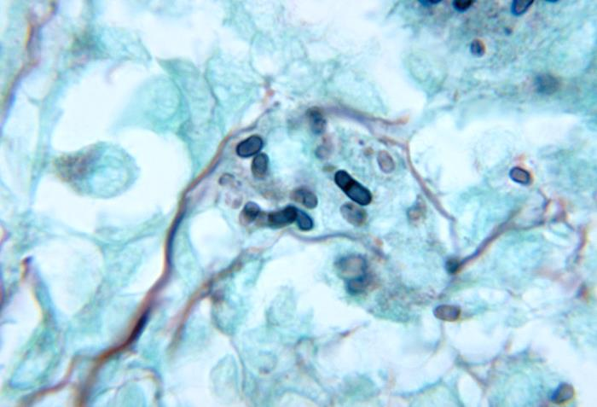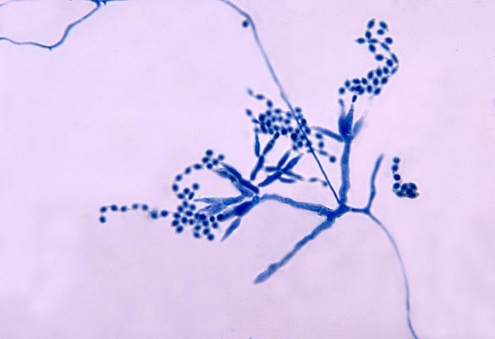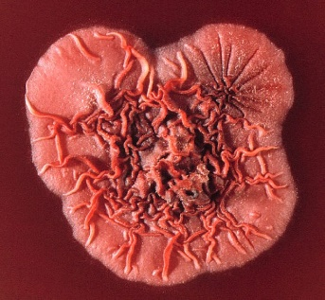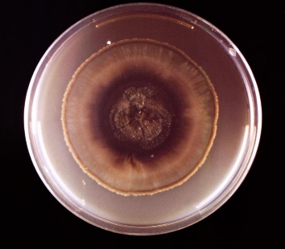
Talaromyces (Penicillium) marneffei colony.jpg
The top surface of a Talaromyces (Penicillium) marneffei colony.
James Gathany. Public domain. CDC
[[File:Penicillium marneffei colony.jpg|Penicillium_marneffei_colony]]
November 15, 2011, Obtained via Wikimedia Commons.
19550 Caption: A culture plate that contained an unidentified growth medium, which had been inoculated with Sporothrix schenckii. Note that the colony was a dark brown in its central region, while transitioning into a yellowish-gray moving towards its periphery, and was primarily glabrous or flattened overall. CDC/ Dr. Hardin, 1966. Public domain, PHIL.
4241 Caption: This is a photo revealing some of the ultrastructural morphology exhibited by the mold Talaromyces marneffei, formerly known as Penicillium marneffei, including chains of single-celled, teardrop-shaped conidia, each emanating from its respective, flask-shaped phialide. T marneffei is known to cause a disease known as talaromycosis, formerly referred to as penicilliosis. CDC/ Dr. LiberoAjello, 1972. Public domain, PHIL.
4235 Caption: This is a photoof a mouse testicle tissue specimen, which was processed using methenamine silver stain, and revealed histopathologic changes indicative of an infection known as talaromycosis, formerly referred to as penicilliosis, caused by the mold, Talaromyces marneffei, formerly known as Penicillium marneffei, including globe-shaped yeast cells undergoing multiplication through fission.
Talaromyces (formerly Penicillium) marneffei is a dimorphic fungus that causes the systemic disease penicilliosis. Patients with impaired cellular immunity due to bone marrow or organ transplantation, corticosteroid therapy, or HIV infection who reside or return from endemic areas are at increased risk for pulmonary and disseminated infections caused by Coccidioides immitis, Histoplasma capsulatum, and perhaps, other endemic molds. (3,19) By comparison, T. marneffei is a newly recognized dimorphic mold that has emerged as a frequent complication in individuals with advanced HIV disease in Southeast Asia and China and has been reported from Europe, Australia, and the USA in HIV-infected travelers returning from these areas.
T. marneffei is the only dimorphic species of this genus. It is filamentous at room temperature and has a characteristic red diffusible pigment on prolonged incubation. Existing in the filamentous stage at ambient temperature, the conidia from this mold phase in the environment likely enter through the respiratory tract and then convert to an elongated yeast form in tissues and body fluids. (3,19) T. marneffei is a predominantly intracellular pathogen that reproduces by binary fission, not budding, in vivo. Pulmonary alveolar macrophages and peripheral blood monocytes may be replete with multiple yeast forms with the characteristic binary septate morphology. Cell-mediated immunity plays a central role in host defense, but cytokine-activated polymorphonuclear leukocytes may contribute additional antifungal activity. Thus, impaired regulation of pulmonary phagocytic functions may be explanatory for the high disease rates in environmentally exposed individuals with advanced HIV infection.
The bamboo rat is blamed for the epidemiology of penicilliosis. The bamboo rat has been found to harbor and sometimes succumb to P. marneffei. While similar genotypes of T. marneffei have been identified in bamboo rats and infected humans, this relationship may be coincidental. Indeed, a case-control study revealed that patients with a recent history of occupational and other exposure to soil, especially during the rainy season, were more susceptible to T. marneffei infection. (19) But a history of exposure to or consumption of bamboo rats, the only known nonhuman host of T. marneffei, was not found to be a risk factor for infection, suggesting an environmental reservoir of the organism in the soil rather than a zoonotic source. (19)
The most common presenting features of AIDS-associated T. marneffei infection in both children and adults include fever, generalized lymphadenopathy, hepatosplenomegaly, pulmonary infiltrates, marked anemia, weight loss, failure to thrive, and a generalized papular skin rash resembling mollusca contagiosa. (19) In general, the diagnosis is easy if the clinical picture is recognized, and it can be readily established by isolating the organism from blood or skin lesions, bone marrow aspirates, or lymph node biopsies. (3, 19)
Histopathology and direct testing: Tissue sections show small, oval to ellipsoidal yeast-like cells, 3 µm in diameter, either inside histiocytes or scattered through the tissue. Occasional, large, elongated sausage-shaped cells, up to 8 µm long, with distinctive septa may be present. A presumptive diagnosis can be made by microscopic examination of appropriately stained smears from skin lesions, bone marrow aspirates, or biopsy material. (19)
Colonial description: WARNING: RG-3 organism. Cultures of Talaromyces marneffei may represent a biohazard to laboratory personnel and should be handled cautiously in a Class II Biological Safety Cabinet (BSCII). T. marneffei exhibits thermal dimorphism and is endemic in Southeast Asia and the southern region of China. It produces a red soluble pigment on general media, and conidiophores are flask-shaped to acerose phialides. Talaromyces marneffei culture showing red soluble pigment; a Giemsa stained touch smear showing typical septate yeast-like cells (arrow), phialides, and conidia. (3, 19) Colonies at 25ᴼC are fast-growing, suede-like to downy, white with yellowish-green conidial heads. Colonies become greyish-pink to brown with age, producing a diffusible brownish-red to wine-red pigment. (3,19)
Phialides are acerose to flask-shaped. Conidia are globose, 2-3 µm in diameter, smooth-walled, and are produced in basipetal succession from the phialides. (19) Colonies are rough, glabrous, tan-colored, and yeast-like on brain heart infusion agar with blood incubated at 37C. Microscopically, yeast cells are spherical to elliptical, 2-6 µm in diameter. Numerous short hyphal elements are also present. (19) Talaromyces marneffei is the only dimorphic species of Talaromyces, which grows as a yeast at 37ᴼC.

Molecular identification: ITS sequencing and β-tubulin as a secondary molecular marker for identification are recommended.
The Opportunistic Molds

Mucormycetes (or zygomycetes) – fungi with aseptate or coenocytic hyphae
The opportunistic molds are a large and very diverse group. These are molds that are particularly a problem for an immunocompromised patient. Conceptually, emerging fungal infections develop in a complex interplay of differing hosts that may have immune deficits, changing environmental conditions, and selective antifungal therapy selective pressures. Those fungi that emerge as mycological pathogens may be classified as filamentous fungi (molds), dimorphs, or yeasts first. Filamentous fungal hyphae are also classified further as septated (divided inside by a septum or cross-wall), non-septated (aseptate), or scantily septated (coenocytic). Molds are then further classified as hyaline (transparent or minimal pigment) or dematiaceous (melanin-pigmented or dark). Those hyaline molds that are aseptate or coenocytic belong to the zygomycetes group. This group is not a taxonomic group now but was formerly the group of fungi in the old division or phylum Zygomycota, which has been dropped. Recently, the taxonomy of this group of fungi has significantly changed, and they are now within the group of fungi termed Fungi incertae sedis (meaning fungi of uncertain taxonomic placement). Two phyla in the Fungi incertae sedis contain the fungi traditionally considered zygomycetes that are opportunistic human pathogens. The first phylum, Mucoromycota, contains most of the classic human opportunistic pathogens of the zygomycetes, Rhizopus, Rhizomucor, Mucor, and Lichtheimia (formerly Absidia spp). The second phylum, Zoopagomycota, includes the less common and less famous opportunistic pathogenic species from the zygomycetes, Basidiobolus, and Conidiobolus. Basidiobolus spp. can cause subcutaneous infections and, less often, intestinal and disseminated disease, and Conidiobolus spp. causes rhino-facial disease. These fungi all have similar aseptate or coenocytic, ribbon-like, broad, and polymorphic hyphae. The Entomophthoromycotina fungi Conidiobolus and Basidiobolus spp. are human pathogens that cause infections of the nasal submucosa (rhinoenthomophthoromycosis) and subcutaneous infections of the extremities and trunk (lobomycosis, respectively, predominantly in tropical regions. (21) While these organisms are generally not angioinvasive and rarely disseminate in nonimmunocompromised individuals, occasional cases of disseminated and angioinvasive disease have been reported in immunodeficient patients, suggesting a possible emerging role as opportunistic pathogens. (22)
Similar to the classic fungal opportunists, the at-risk patient population is also broad. In general, deficiencies in the number or function of phagocytic cells are associated with a wide variety of opportunistic fungi. (22) In contrast, T-lymphocyte function deficiencies or imbalances are linked to dimorphic and opportunistic molds in patients with chronic graft-vs.-host disease and advanced HIV infection. Additional nonimmunological factors include the necessary exposure to the organism, pre-existing tissue damage, colonization of mucocutaneous surfaces, use of broad-spectrum antibiotics and parenteral nutrition, and, primarily limited to yeast-like organisms, indwelling vascular catheters. As airborne pathogens, the emerging opportunistic molds that cause disease are virtually indistinguishable from those of Aspergillus spp. In addition to the invasive infections of the skin and subcutaneous tissues, they primarily affect the sinuses and the bronchial tubes and have the propensity for dissemination into the central nervous system. (22) Some hyaline molds, including Fusarium spp., Paecilomyces spp., and Acremonium spp., produce small adventitious structures in tissues that facilitate their dissemination.
Invasive infections by emerging fungal opportunists are associated with high case fatality rates that surpass those known from the classic opportunists. The diagnosis depends on identifying the organism using culture-based methods because of the lack of specific clinical, radiographic, and histological features and the absence of diagnostic surrogate markers in blood. The therapy of most emerging fungal pathogens is not standardized but relies on high-dose amphotericin B (AmB), appropriate surgical measures, and reversal of the underlying impairment of host defenses. (22) However, some organisms are inherently not susceptible to AmB and require therapies with another antifungal agent.
The Mucorales cause most cases of zygomycosis (mucormycosis or phycomycosis). The Mucorales are notorious for causing devastating, deep invasive infections in immunodeficient patients. While Rhizopus spp. is the most commonly reported organism, an ever-expanding group of additional zygomycetes has been reported during the past decade, including but not limited to Rhizomucor, Mucor, Lichtheimia, Apophysomyces, Cunninghamella, and Cokeromyces. (22) Cunninghamella bertholletiae was also associated with localized or disseminated infection in immunocompromised patients or those receiving desferrioxamine therapy and may cause breakthrough fungal infections in neutropenic patients receiving itraconazole prophylaxis. (22) In contrast to R. oryzae, C. bertholletiae seldom causes rhinocerebral zygomycosis in patients with diabetic ketoacidosis. (22)
In immunocompromised or debilitated hosts, zygomycetes have a high propensity for invading blood vessels, causing a rapidly deteriorating clinical course resistant to antifungal therapy and causing high mortality. Zygomycosis (or mucormycosis) occurs in neutropenic patients, with corticosteroid therapy, after transplantation, in patients with uncontrolled diabetic ketoacidosis or with burns, following iron treatment (desferrioxamine) and aluminum overload states, in low birth weight infants, and patients with advanced HIV-infection. (22)
The various tissue sites these fungi infect are rhinocerebral, pulmonary, skin, abdominal-pelvic, gastric, miscellaneous other sites, or disseminated disease. (22) Rhinocerebral, pulmonary, and disseminated zygomycosis are the most frequently encountered conditions among the most fulminant fungal infections. (22) Rhinocerebral zygomycosis usually begins as an infection of the maxillary or ethmoid sinus, which progresses to invade the ocular orbit, cavernous sinus, and the brain. Hemorrhagic necrosis by blood vessel fungal invasion and thrombosis is typical. A black eschar on the palate or nasal mucosa and a black discharge from the eye are characteristic manifestations of tissue infarction. However, these features may also be observed in infections by other molds and are not necessarily diagnostic for the zygomycetes. Other symptoms of rhinocerebral zygomycosis can be a unilateral headache, eye irritations, periorbital swelling and numbness, blurry vision, nasal congestion, or nose bleeds. The onset of suspicious new eye complaints in a diabetic patient, a patient on desferrioxamine, or a patient on corticosteroids should prompt a careful investigation for early rhinocerebral zygomycosis. Rhinocerebral zygomycosis can progress rapidly, resulting in death within a few days, or it may progress slowly. Magnetic resonance imaging (MRI) or computerized tomographic (CT) scans are needed to assess the extent of the suspected rhinocerebral zygomycosis and to guide surgical excision of infected tissue. (22)
Pulmonary zygomycosis in granulocytopenic patients resembles pulmonary aspergillosis with persistent fever and pulmonary infiltrates refractory to treatment. The initial bronchopneumonia is followed by pulmonary vascular invasion and thrombosis, followed by blood vessel rupture, with potential dissemination to extrapulmonary sites or severe bleeding. (22) The sensitivity of cultures from respiratory specimens is low: in a recent series, culture positive for zygomycetes was typically a preterminal finding in fatal cases. The control and normalization of the immunological or metabolic defects precipitating its development are critical to the successful outcome of zygomycoses.
In this chapter, we will not be able to cover all of the zygomycetes or related organisms, but the commonly isolated pathogenic zygomycetes will be described.
Lichtheimia corymbifera (formerly Absidia corymbifera)
The most commonly isolated patient species in this genus is Lichtheimia (Absidia) corymbifera. (23) It is the only recognized pathogen in the genus Lichtheimia. (24) Lichtheimia corymbifera is a relatively uncommon cause of human zygomycosis. Zygomycosis is an opportunistic mycosis that manifests with pulmonary, rhinocerebral, skin, renal, gastrointestinal, or meningeal involvement. Disseminated zygomycosis may originate from these infections. Zygomycosis is very rarely observed in immunocompetent hosts. L. corymbifera is more commonly reported as an animal pathogen but also causes human disease. (24) Thus, this page will discuss the essential features of L.corymbifera.
Since Lichtheimia spp. are ubiquitous, they are also frequent laboratory contaminants. Their isolation in culture requires careful evaluation. Growth of Lichtheimia from clinical samples of patients with immune deficits or diabetes should be considered potentially significant. Also, the visualization of typical aseptate hyphae of the zygomycetes on direct microscopic examination, particularly from a normally sterile body site, is considered significant even if the culture has no growth. (24)
Histopathology and direct testing: Broad, thin-walled, hyaline, often aseptate or sparsely septate hyphae are observed. The hyphae are typically not parallel, and the branches are irregular. Fungal invasion of blood vessels is significant. Pyogenic inflammation and abscess formation with suppurative necrosis are seen.
Colonial description:
Lichtheimia corymbifera grows rapidly. The rapidly growing, flat, with a woolly to cottony texture, and olive-gray colonies mature within four days. Potato glucose agar may be used to assist with sporulation. From the surface, the colony is grey. The reverse side is uncolored, with no pigment production. Lichtheimia corymbifera is a thermophilic fungus, growing more rapidly at 37°C than at room temperature. Its highest growth temperature is 48 to 52°C. The growth of L. corymbifera is optimum at 35-37°C.
Microscopic identification from culture: Lichtheimia corymbifera has wide (6-15 µm in diameter) and generally aseptate hyphae. A rare septa may occasionally be present. Rhizoids are rarely observed, but they are between the sporangiophores when seen. When seen, the sporangiophores arise on stolons from points between the rhizoids but opposite the rhizoids. The sporangiophores are branched in groups of 2-5 at the internodes. They may be arched. Sporangiophores carry pyriform, small (20-120 µm in diameter) sporangia with swelling below the columella, known as apophysis. (24) A septum is usually present just below the sporangium in the sporangiophore. The columella, the structure at the base of the sporangium, is semicircular. A short collarette may be observed over the apophysis upon dissolving the sporangial wall. The sporangiospores are single cells, hyaline to light black, round or oval in shape, smooth or rarely echinulate, and 3-4.5 µm in diameter. They are found in the sporangium and released to the surroundings when it ruptures. (24)
Molecular identification: ITS sequencing is appropriate for species identification within Zygomycetes from cultures or infected frozen tissues. (25)
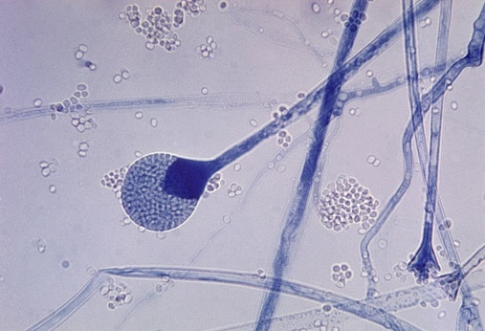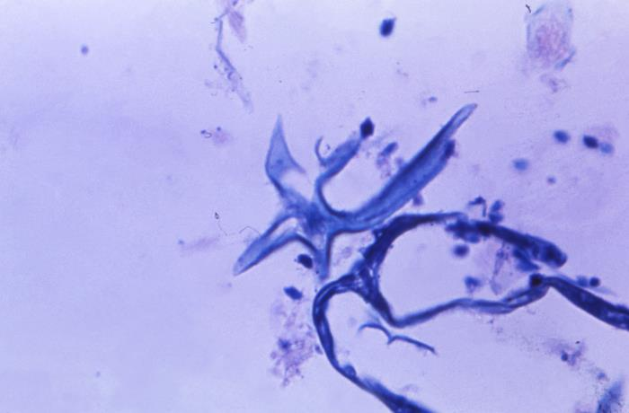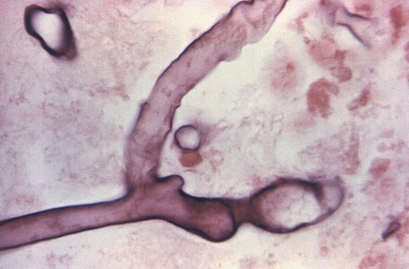
This photomicrograph reveals a mature sporangium of Lichthemia corymbifera (formerly an Absidia spp.) fungus. It is a common indoor mold and is among the fungi that cause the group of infections known as zygomycosis. The infection typically involves the rhino-facial-cranial area, lungs, GI tract, skin, or, less commonly, other organ systems. CDC/Dr. Lucille K. Georg, 1955. This image is in the public domain. Wikimedia Commons.
14551 Caption: Under a magnification of 945X, this photo of a hematoxylin-eosin (H&E) stained stomach tissue sample, revealed the presence of a mycelium from an unknown fungal organism, harvested from a patient ill with mucormycosis, otherwise known as zygomycosis.. CDC/ Dr.Lucille K. Georg, 1964. Public domain, PHIL library.
Under a magnification of 600X, this Giemsa stained photomicrograph of a right ethmoid sinus tissue specimen, revealed ultrastructural morphology exhibited by a Mucor sp. fungal organism, in a case of zygomycosis. Here, you are able to see a number of filamentous hyphae, along with numbers of free-floating sporangiospores. CDC/Dr. Lucille K. Georg, 1964 Public domain, PHIL library.

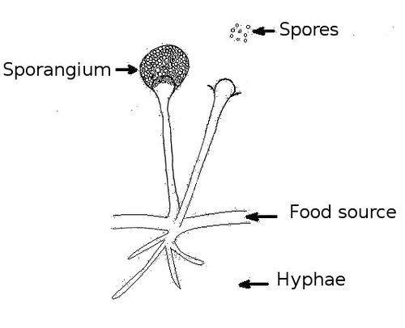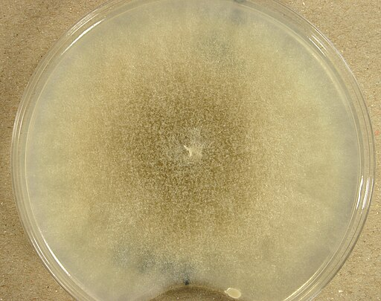
Mucor racemosus (UAMH 8346) was cultured on potato dextrose agar at 25 °C for 10 days. 19 November 2009, 13:10:47, own work, Author: Medmyco. Creative Commons Attribution-Share Alike 4.0 International license, Wikimedia Commons.
To the right: The structures of Rhizopus spp. are drawn. For Rhizopus, the rhizoid (root-like structure at the bottom part of the hyphae) is directly under the sporangiophore that holds the sporangium.
Mucor has no rhizoid. Rhizomucor and Absidia have rhizoids that are between the sporangiophores.
Drawing: DZadventiste
Source: https://commons.wikimedia.org/wiki/File:Structure_of_fungus.jpg
License: Public Domain

Rhizoid
Sporangiophore

Mucor spp.
Mucor is among the fungi that cause the characteristic infection called zygomycosis. However, the term mucormycosis is also used for this angio-invasive disease. Zygomycosis includes mucocutaneous and rhinocerebral infections, septic arthritis, dialysis-related peritonitis, kidney infections, gastritis, and lung infections. (26) Diabetic ketoacidosis and immunosuppression are the most frequent predisposing factors. Deferoxamine treatment, renal failure, extensive burns, and intravenous drug abuse may also predispose to the development of zygomycosis. Vascular invasion causes tissue necrosis, and perineural invasion is characteristic of these fungal infections. The use of itraconazole prophylaxis in immunocompromised patients may select for the fungi in phylum Zygomycota to cause infections. (26)
Histopathology and direct testing: Broad, thin-walled, hyaline, often aseptate or sparsely septate hyphae are observed. The hyphae are typically non-parallel, and the branches are irregular. Blood vessel invasion is significant. Pyogenic inflammation, abscess formation, and suppurative necrosis are observed.
Colonial description: Colonies of Mucor grow quickly at 25-30°C and cover the surface of the agar. Its fluffy appearance, with several centimeters in height, resembles cotton candy (a characteristic of the zygomycetes). From the colony top, the color is white initially and becomes grayish brown in time. From the colony's reverse side, it is white or pale buff. Rarely, a Mucor species may grow at temperatures as high as 40°C. However, Mucor racemosus and Mucor ramosissimus grow poorly or not at all at 37°C. (26)
Microscopic identification from culture: Nonseptate or sparsely septate, broad (6-15 µm) hyphae with sporangiophores, sporangia, and spores are seen. (26) Intercalary or terminal arthrospores (conidia) are located through or at the hyphae's end; some species may also produce a few chlamydospores. The apophysis, rhizoids, and stolons are absent in Mucor. Sporangiophores are shorter and may form short sympodial branches. Columella are either hyaline or phaeoid. Smaller sporangia often lack columella. Sporangia are round, 50-300 µm wide, gray or black, and filled with spores. Following the rupture of the sporangia, sporangiospores spread quickly. (26). Mucor sporangiospores are round (4-8 µm in diameter) to oval. (26)
Molecular identification: ITS sequencing is appropriate for species identification within Zygomycetes from cultures or infected frozen tissues. (25)
Rhizomucor species
Rhizomucor spp. are among the fungi that cause zygomycosis, another term for this angio-invasive disease. Vascular invasion causes tissue necrosis and perineural damage, which are characteristic of these infections. Zygomycosis is often fatal.
There are few reports of human infections due to Rhizomucor spp. Cutaneous, pulmonary, craniofacial, and disseminated zygomycosis due to Rhizomucor pusillus has so far been reported in neutropenic patients with diabetes and with hematological malignancies. Cutaneous infections caused by Rhizomucor variabilis have been reported in immune-competent individuals. In contrast to rare human infections, animal infections, mainly bovine mycotic abortion due to Rhizomucor, are common (27).
Histopathology and direct testing: Wide, ribbon-like, thin-walled hyaline hyphae that are aseptate or sparsely septate are observed in infected tissues. The hyphae are typically non-parallel, and the branches are irregular. Invasion of blood vessels is a significant finding.
Colonial description: Rhizomucor grows quickly, filling the petri dish, and matures in 4 days. The texture is typically cotton-candy-like. From the colony's top, the color of the colony is white initially and turns grey or yellow-tan over time. The reverse is white to pale buff. Significantly, Rhizomucor spp. Other than Rhizomucor variabilis, they are thermophilic and yield good growth at temperatures as high as 54-55 °C. (27, 28)
Microscopic Identification from culture: The microscopic morphology of Rhizomucor is intermediate between that of Rhizopus and Mucor. Nonseptate or sparsely septate broad hyphae, rudimentary rhizoids, sporangiophores, sporangia, and sporangiospores are seen. If they exist, Rudimentary rhizoids are few and located on stolons between the sporangiophores. Sporangiophores are irregularly branched and end in sporangia at their apices. Sporangia (40-80 µm in diameter) are brown in color and round in shape. Apophysis is absent. Columellae are prominent and spherical to pyriform in shape. Sporangiospores (3-4 µm in diameter) are small, unicellular, and round to ellipsoidal. Zygospores, if present, are formed in the aerial hyphae. They are round to slightly compressed and dark brown to blackish brown. (27)

Molecular identification: ITS sequencing is appropriate for species identification within Zygomycetes from cultures or infected frozen tissues. (25)

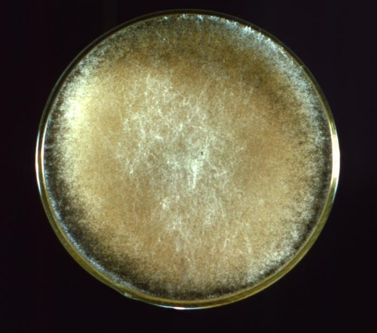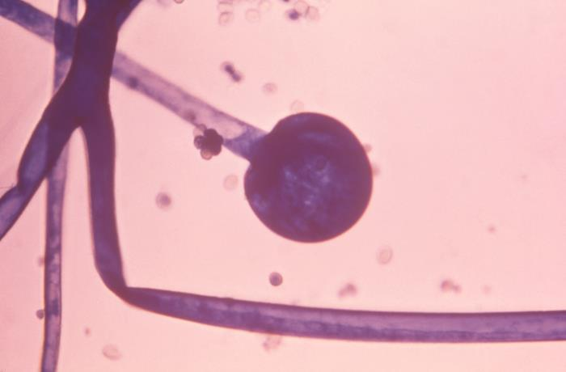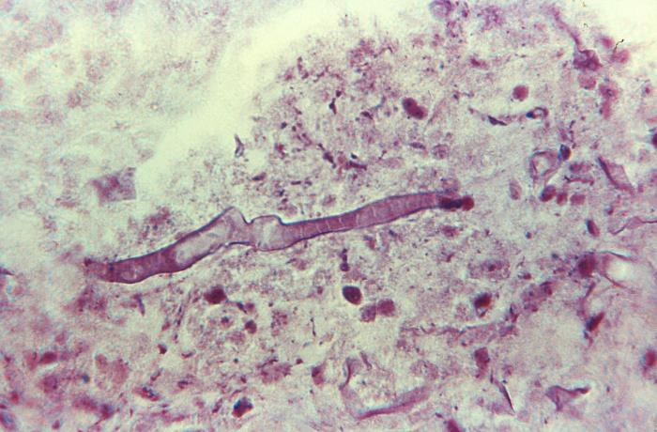
This photograph revealed morphology exhibited by a cultivated culture of the fungal organism, Rhizopus oryzae, also known as Rhizopus arrhizus var. delemar. The way in which this specimen filled the Petri dish is characteristic of this rapidly growing fungus. Also, characteristic is the colony’s cotton candy-like texture, and grayish yellow coloration.CDC/ Dr. Lucille K. Georg, 1964. Public domain. PHIL library.
Under a magnification of 610X, this photomicrograph of a Gram-stained specimen, revealed the presence of a filamentous mycelium from a Rhizopus sp. fungal organism. The specimen was harvested from a patient ill with mucormycosis, otherwise known as zygomycosis. CDC/ Dr. Lucille K. Georg, 1964. Public domain. PHIL library.

Caption: Under a magnification of 600X, this photomicrograph revealed ultrastructural morphology exhibited by an immature sporangium of the fungal organism, Rhizopus oryzae, also known as Rhizopus arrhizus var. delemar. The aseptate broad ribbon-like hyphae, the typical sporangium, and the dark conidia are all present. This specimen was isolated from a patient with a case of phycomycosis (mucormycosis), a form of zygomycosis. CDC/ Dr. Lucille K. Georg, 1968. Public domain. PHIL library.

Rhizopus spp.

Rhizopus is a genus of saprotrophic zygomycete fungi (Mucoromycotina, Mucoromycota) ubiquitous in soil, animal excrement, and rotting plant material. Certain Rhizopus species cause disease in animals, others in humans, and some are used as model organisms in studying fungal cellular and molecular biology. (29, 30) Rhizopus spp. are among the fungi causing the group of infections called zygomycosis. The term mucormycosis is also used. R. arrhizus is the most common cause of zygomycosis and is followed by R. microsporus var. rhizopodiformis. (30)
Zygomycosis includes mucocutaneous, rhinocerebral, genitourinary, gastrointestinal, lung, and disseminated infections. (30) Diabetic ketoacidosis and immunosuppression are the most frequent predisposing factors. (29) Deferoxamine treatment, renal failure, extensive burns, trauma, and intravenous drug abuse may also predispose to the development of zygomycosis. (30) Vascular Rhizopus invasion causes tissue necrosis and perineural invasion, which are the most frightening features of these infections. Zygomycosis is frequently fatal. (30)
Histopathology and direct testing: Broad, thin-walled, hyaline, often aseptate or sparsely septate hyphae are observed. The hyphae are typically non-parallel, and the branches are irregular. Blood vessel invasion is critical. Pyogenic inflammation, abscess formation, and suppurative necrosis are observed.
Colonial description: Rhizopus colonies proliferate quickly, filling the Petri dish and growing in four days. The texture is typically cotton-candy-like. From the colony's top, the color of the colony is white initially and turns grey or yellowish tan over time. The reverse is white to pale. Pathogenic species of Rhizopus can grow well at 37°C.
Microscopic identification from culture: Nonseptate or sparsely septate broad hyphae (6-15 µm in diameter), sporangiophores, rhizoids (root-like hyphae), sporangia, and sporangiospores are present. Sporangiophores are brown and usually unbranched. They can be solitary or form clusters. Rhizoids are located where the stolons and sporangiophores meet opposite the sporangiophores. Sporangia (40-350 µm in diameter) are located at the terminus of the sporangiophores. They are round with a flat base. Apophysis is generally absent, and the columellae are semicircular. Sporangiospores (4-11 µm in diameter) are single cells, round to oval, hyaline to brown, and smooth or striated in texture.
Molecular identification: ITS sequencing is appropriate for species identification within Zygomycetes from cultures or infected frozen tissues. (25)
Septate hyaline opportunistic molds
Acremonium spp. Acremonium species are environmentally widespread hyaline molds that, when grown in culture, produce small conidia on delicate phialides that resemble the early growth of Fusarium species. (22) ) However, further incubation does not reveal the characteristic Fusarium macroconidia. (22) Like Fusarium and Paecilomyces spp., Acremonium spp. may produce small adventitious unicellular forms (phialoconidia) during infection, facilitating dissemination and recovery from the bloodstream. (31) Acremonium causes a spectrum of infections, ranging from mycotic keratitis and mycetoma in immune-competent hosts to fungemia and disseminated infection in the immune deficient. The lungs and gastrointestinal tract are the entry sites for infection. Cutaneous lesions may develop during disseminated infection. (22) In general, Acremonium spp. display minor sensitivity to current antifungal agents, with the best activity seen for amphotericin B. However, reported MIC values are comparatively high, suggesting that Acremonium species may be resistant to typical doses of amphotericin B. Acremonium is one of the causative agents of mycotic white-grain mycetoma. Rare cases of onychomycosis, keratitis, endophthalmitis, endocarditis, meningitis, peritonitis, and osteomyelitis due to Acremonium have also been reported. This fungus is known to cause opportunistic infections in immunocompromised patients, such as bone marrow transplant recipients. Infections of artificial implants due to Acremonium spp. are occasionally reported. (31)
Since Acremonium species are cosmopolitan, they are most often encountered as contaminants. Thus, their isolation in culture requires cautious interpretation.
Histopathology and direct testing: The mycetoma grains of Acremonium spp. are regular and oval or round in shape and about 500-2000µm in diameter. Poorly stained dense hyphal groups are seen when infected tissue is stained with H&E. (31)
Colonial description: The growth rate of Acremonium colonies is moderately rapid, maturing within about five days. The diameter of the colony is 1-3 cm following incubation at 25°C for seven days on potato dextrose agar. (31) The texture of the colony is compact, flat, or folded, and occasionally the center is raised. It is glabrous, velvety, and membrane-like at the beginning. (31) A powdery texture may also be observed. The color of the top of the colony is white, pale grey, or pale pink on its top surface. (31) The reverse of the colony is either uncolored or has a pink to rose-colored pigment. (31)
Microscopic identification from culture: Acremonium spp. possess hyaline and septate hyphae, which are very fine and thin. Vegetative hyphae typically form hyphal ropes. Unbranched, single, erect phialides are formed directly on the tips, ropes, or both of the hyphae. The phialides taper towards their apices where the hyaline conidia 2-3×4-8µm in size are found. They usually appear in clumps, in (31) balls, or rarely as fragile chains. A gelatinous material binds the conidia. The conidia may be single-celled or multicellular, fusiform with a slight curve, or resemble a crescent but small in size. (32) The properties of conidia vary depending on the species. Acremonium falciforme usually produces crescentic, nonseptate conidia, with 2- or 3-celled conidia occasionally observed. Acremonium kiliense has straight and short conidia, and the conidia of Acremonium recifei are usually crescentic and aseptate. (31, 32)
Molecular identification: Sequence-based identification may be performed using the D1/D2 or the ITS region. (32)
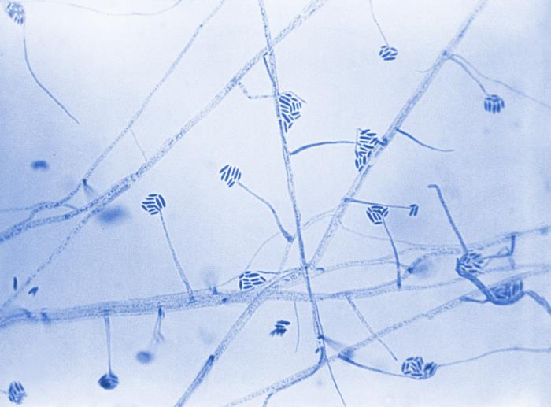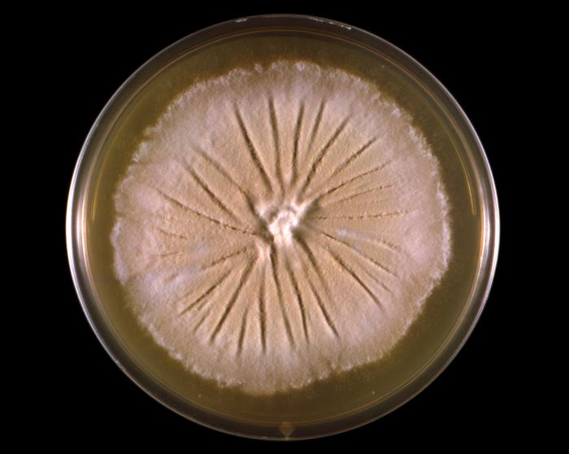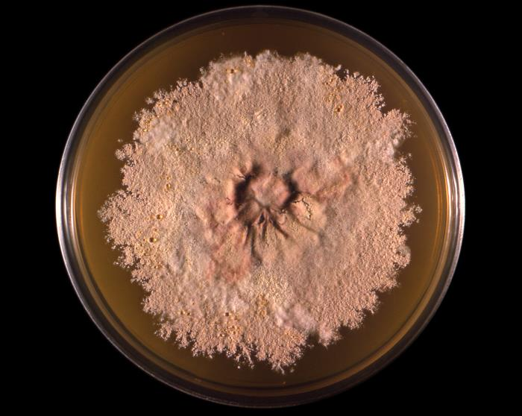
21443 Caption: This photograph depicted a frontal view of a Petri dish culture plate, which contained an unidentified growth medium that had been inoculated with the fungal organism of the genus Acremonium, formerly referred to as Cephalosporium. In this case, the Acremonium sp. was labeled as the Easter Island-65 strain (EI-65). The colony that had developed exhibited its characteristic appearance, displaying a suede-like texture and gray-to-tan coloration. CDC/ Dr. Libero Ajello, 1966. Public domain, PHIL library.
23112 Caption: Under a magnification of 475X, this photomicrograph revealed some of the ultrastructural morphology exhibited by an Acremonium sp. fungal organism, formerly referred to as Cephalosporium. Note the organism’s septate, filamentous hyphae, long, slender phialides, each topped by a cluster of cigar-shaped conidia, bundled together by sticky mucous. CDC/ Dr. Hilliard F. Hardin; Dr. Lucille K. Georg,1965. Public domain, PHIL library.
21443 Caption: This photograph depicted a frontal view of a Petri dish culture plate, which contained an unidentified growth medium that had been inoculated with the fungal organism of the genus Acremonium, formerly referred to as Cephalosporium. In this case, the Acremonium sp. was labeled as the Easter Island-65 strain (EI-65). The colony that had developed exhibited its characteristic appearance, displaying a suede-like texture and gray-to-tan coloration. CDC/ Dr. Libero Ajello, 1966. Public domain, PHIL library.

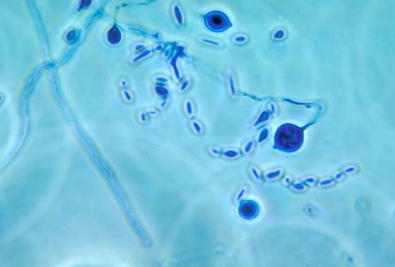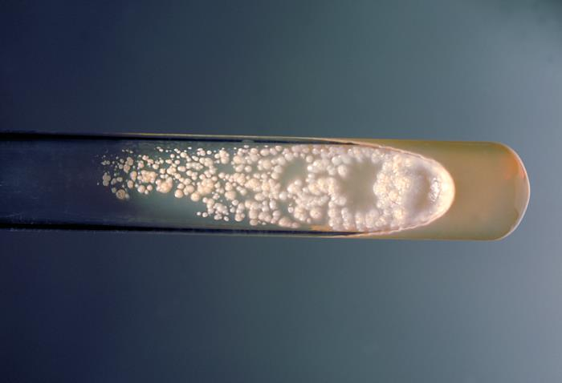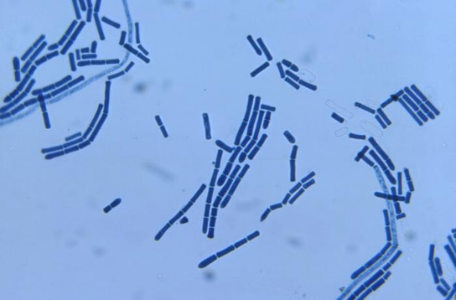
3925 Caption: This photomicrograph depicts both fungal spores and adiaspores of what may have been a Chrysosporium spp. organism. CDC/ Dr. Libero Ajello, 1964. Public domain, PHIL library.
207 Caption: This photograph depicts a slant culture test tube containing a growth medium of Sabouraud dextrose agar, which had been inoculated with the fungus Geotrichum candidum and incubated for an unknown time period at 37°C. CDC/ Dr. William Kaplan, 1969. Public domain, PHIL library.
22967 Caption: At a magnification of 400X, this was a photomicrograph of a slide culture specimen under bright field illumination and processed using lactophenol cotton blue (LPCB) stain. Ultrastructural morphology of the fungal organism, Geotrichum candidum was highlighted. In this view, you were able to see both singular, and chains of arthroconidia.

Aspergillus spp.
Aspergillus is an extensive genus containing about 250 species. These are currently classified into seven subgenera, subdivided into several sections of related species. (33) Clinical microbiology laboratories traditionally rely on morphology-based identification methods to differentiate Aspergillus species. However, many species have similar morphologies, which has allowed species to be misidentified. To avoid this, experts have clustered species with identical morphologies into "species complexes" so that laboratories may more accurately use morphology-based identifications. (33)
Aspergillus spp. is associated with three different clinical conditions in man: (i) opportunistic infections, (ii) allergic conditions, and (iii) toxicoses. Immunosuppression is the primary factor predisposing to the development of opportunistic infections. These infections may present in a diverse spectrum, varying from local conditions to dissemination as a disease called aspergillosis. Among all filamentous fungi, Aspergillus is the most common fungus isolated in invasive infections. Following the Candida species, it is the second most frequently recovered fungus in opportunistic mycoses. The most common species responsible for infections are A. fumigatus, Aspergillus flavus, and Aspergillus terreus. (32)
Almost any organ or system in the human body may be involved in aspergillosis. Onychomycosis, cutaneous aspergillosis, sinusitis, cerebral aspergillosis, meningitis, myocarditis, otitis, endocarditis, pulmonary aspergillosis, osteomyelitis, endophthalmitis, hepatosplenic aspergillosis, Aspergillus fungemia, and disseminated aspergillosis may develop. Nosocomial aspergillosis due to catheters and other devices is also a potential problem. Construction in hospital environments constitutes a significant risk for the development of aspergillosis, particularly in neutropenic patients. Aspergillus spp. may also be local colonizers in previously developed lung cavities due to tuberculosis, sarcoidosis, bronchiectasis, pneumoconiosis, ankylosing spondylitis or neoplasms, presenting as a distinct clinical syndrome called aspergilloma. Aspergilloma may also occur in the kidneys. (34)
Some Aspergillus antigens are fungal allergens that may initiate allergic bronchopulmonary aspergillosis, particularly in atopic hosts. Some Aspergillus spp. Aspergillus produces various mycotoxins. These mycotoxins, when chronically ingested, have proven to possess carcinogenic potential, particularly in animals. Aflatoxin is well-known and may induce hepatocellular carcinoma. (33) Aspergillus flavus mainly produces aflatoxin that contaminates foods such as peanuts.
Aspergillus spp. cause infections in animals and humans. Ingestion of a large amount of aflatoxin may induce lethal effects in poultry-fed grain contaminated with the toxin.
Also, since Aspergillus spp. are ubiquitous, they are common laboratory contaminants.
Histopathology and direct testing: On PAS-stain, Aspergillus fumigatus in patients with chronic granulomatous disease shows a 45-degree angle branching hypha within a giant cell. Bulbous hyphal ends are sometimes found in the histology slides of Aspergillus spp. infections.
Glucomannan (GM) direct serological testing is helpful in detecting this organism. And bronchoalveolar lavage fluid sample GM detection is valuable for the early diagnosis of invasive pulmonary aspergillosis in nonneutropenic patients and is superior to serum GM detection. Testing for the beta-(1,3)-d-glucan (BG) molecule is a helpful direct test for Aspergillus infection. The beta-(1,3)-D-glucan (BG) test is a blood test that detects the presence of fungal cell wall components, specifically beta-(1,3)-D-glucan, which can be found in various fungi, including Aspergillus species. It's used to assist in the diagnosis of invasive fungal infections, like aspergillosis.
Colonial description: They are hyaline hyphomycetes (conidial molds) that show distinctive conidial heads with flask-shaped phialides arranged in whorls on a vesicle. Colonies are usually fast-growing, white, yellow, yellow-brown, brown to black, or most often shades of green, mainly consisting of a dense felt of erect conidiophores. (33) For morphological identification, isolates are usually inoculated on Czapek Dox agar, malt extract agar, or potato dextrose agar and incubated at 25C. Most species sporulate within seven days. Descriptions are primarily based on the colony pigmentation and the morphology of the conidial head. Microscopic mounts are best made using clear cellophane tape or slide culture preparations mounted in lactophenol cotton blue. Adding a drop of alcohol is usually needed to remove bubbles and excess conidia.
Microscopic identification from culture: Conidiophores terminate in a swollen vesicle that is covered with either a single layer of phialides (uniseriate) or a layer of cells (metulae) that bear small spirals of phialides (biseriate structure). The conidial head is formed by the vesicle, phialides, metulae (if present), and conidia. (34) The conidia are single-celled, smooth, rough-walled, hyaline, or pigmented and produced in long dry chains that may be divergent (radiate) or aggregated in compact columns (columnar). Conidial head morphology in Aspergillus has either (a) uniseriate or (b) biseriate rows of phialides that produce conidia.
Molecular identification: The recommended barcoding gene β-tubulin. MALDI-TOF MS: A comprehensive 'in-house' collection of reference spectra will accurately identify species of Aspergillus even within complexes. Sequence analysis of ITS rDNA is sufficient to specify the species complex level only. For definitive identification analysis, the inclusion of the β-tubulin, calmodulin, and actin genes is required. (34)

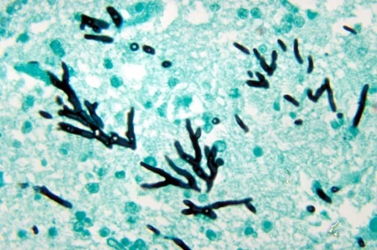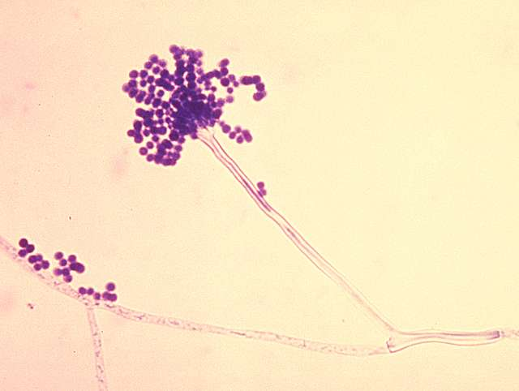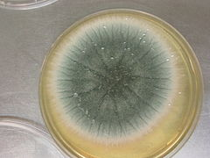
070522-aspergillus 009.jpg
kolonie van Aspergillus fumigatus (macroscopie, schimmel) eigen werk
photo: Jankaan at Dutch Wikipedia
Creative Commons Attribution-Share Alike 3.0. 25 May 2007
[[File:070522-aspergillus 009.jpg|070522-aspergillus_009]] Obtained via Wikimedia Commons.
Summary: PHIL ID#: 300 Conidia: phialoconidia of Aspergillus fumigatus. Public domain, CDC 2016. Link: http://commons.wikimedia.org/ Obtained via Picryl Public Domain Media.

This is a photomicrograph of a methenamine silver stained turkey poult brain tissue sample, which revealed histopathologic changes in a case of aspergillosis, due to the fungal organism, Aspergillus fumigatus, including the presence of numerous, darkly stained hyphae showing acute angle (< 45°) or dichotomous branching and septate hyphae. Public domain. CDC/ Dr. Lucille K. Georg, 1972.

Aspergillus fumigatus
Aspergillus is a ubiquitous saprophyte in air, soil, and organic matter. Humans usually inhale the spore form of the fungi. However, the disease is generally seen in immunocompromised patients. The immune system is essential in recognizing inhaled mold, controlling its growth, and regulating the body's allergic and inflammatory response to the infection. High mortality rates often accompany systemic Aspergillus fumigatus infections; therefore, early diagnosis and treatment in the immunocompromised population are essential. The most common species responsible for infection is A. fumigatus. A. fumigatus is a fungus from the family of Trichocomaceae. Outside the human host, the life cycle is characterized by asexual reproduction, which proceeds conidiophores, structures where the infectious form, conidia, are produced and released into the air. Conidia are responsible for fungal dispersion and preserving the fungi genome under adverse conditions. On average, humans inhale as many as a few hundred conidia daily. Species prevalence has changed over the past decade. A. fumigatus was the culprit of 90% of fungal infections with aspergillosis. In recent studies, it has been shown that the A. fumigatus species complex is responsible for approximately 60% of Aspergillus infections, followed in frequency by A. flavus, A. niger, and A. terreus, respectively. Human-host defense against inhaled spores begins with the mucous layer and the respiratory tract's ciliary action (compromised in diseases such as cystic fibrosis and asthma). Macrophages typically react upon recognizing key fungal cell wall components such as beta-D-glucan, secreting inflammatory mediators that ultimately attract neutrophils to initiate cellular immunity.
Infections caused by Aspergillus are commonly located in the lower respiratory tract, lungs, sinuses, and skin. The central nervous system (CNS) and cardiovascular system may be affected by either direct or hematogenous spread of this fungus. Invasive pulmonary aspergillosis is usually found in patients with severe prolonged neutropenia, inherited immunodeficiency, steroid dependency, use of immunosuppressive medications, transplant patients, and AIDS. Aspergillosis is an infection with histopathological confirmation and a positive specimen result from a normally sterile site. Other forms of aspergillosis, such as allergic bronchopulmonary aspergillosis (ABPA), allergic sinusitis, and saprophytic infection, are important causes of morbidity but are seldom life-threatening. Many species of Aspergillus produce toxins (aflatoxins, mycotoxins 3-nitro propionic acid, and ochratoxin A), which inhibit the action of macrophage and neutrophil phagocytosis.
Underlying immunosuppression is directly proportional to neutrophil dysfunction and fewer neutrophils. Patients on chronic steroid treatment also have an associated lack of macrophage and neutrophil function. In these cases, the disease risk and type are secondary to impaired phagocytosis, suppressed T cell function, and oxidative cascade. Vascular invasion can also occur if fungal cell surface components bind to the vessel wall components, ultimately resulting in necrosis, infarction, or hemorrhage. Chronic necrotizing pulmonary aspergillosis is characterized by granuloma formation and alveolar consolidation.
Histopathology and direct testing: Aspergillus in tissue shows acute angle (< 45°) or dichotomous branching and septate hyphae, 2.5 - 4.5 µm in diameter on histology slides. Aspergillus has a genus-specific fruiting body that develops from myercelia in areas with a high oxygen tension (e.g., lung, sinus cavities) composed of a vesicle and either one (uniserate) or two layers (biserate) of phialides that produce conidia, depending on the species. It does not develop in tissue. Since histomorphology alone is not accurate for identification, definite classification should be based on microscopic culture appearance or molecular testing. Serological galactomannan and the beta-(1,3)-D-glucan (BG) test are rapid tests for invasive aspergillosis.
Biopsies carry the risk of bleeding, which is why noninvasive testing is usually done as the initial step. These include serum biomarkers and sputum analysis. If a biopsy is warranted, it is generally guided by imaging such as bronchoscopy, video-assisted thoracoscopy surgery, or CT.
Colonial description: RG-2 organism. On Czapek Dox agar, colonies are usually blue-green with a suede-like surface of dense conidiophores. This color is strongly associated with this species.
Microscopic identification from culture: Conidial heads are columnar (up to 400 x 50 µm) but generally shorter and smaller, and the vesicle is uniseriate. Conidiophores are short, smooth-walled, and have a conical-shaped terminal vesicle that supports a single row of phialides on the upper two-thirds of the vesicle and curving to be roughly parallel. Conidia are produced in succession, forming long chains, and are round (2.5-3.0 µm in diameter), green, and finely roughened. This species is thermotolerant with a maximum growth temperature of 55ᴼC. Conidial heads of A. fumigatus have a uniseriate row of phialides on the upper two-thirds of the vesicle.
Molecular identification: The recommended barcoding gene is β-tubulin. MALDI-TOF MS is accurate and effective with a comprehensive 'in-house' collection of reference spectra that allows accurate identification of species of Aspergillus, even those in complexes, e.g., A. fumigatus. Sequence analysis of the rDNA ITS is sufficient to identify the species complex level only. For definitive identification analysis, β-tubulin, calmodulin, and actin genes are required.
Chrysosporium spp.
Chrysosporium spp. cause onychomycosis and skin infections in humans. In addition, it has been frequently isolated from systemic infections of bone marrow transplant recipients and patients with chronic granulomatous disease (35). The high mortality associated with systemic Chrysosporium infections is noteworthy. (36)
Species of Chrysosporium are isolated from skin and nail scrapings, especially from feet and toes, but they are common soil microbes, so they are usually considered contaminants. (33)
Several species of Chrysosporium are keratinolytic, and some are thermotolerant. The colonies may closely resemble some dermatophytes, such as Trichophyton spp. Other strains may resemble cultures of Histoplasma spp. and Blastomyces spp. (33)
Histopathology and direct testing: A biopsy of the lesions showed granulomatous tissue. In addition, histopathology observed a few short and thick hyphae in the lesions.
Colonial description: Chrysosporium colonies grow moderately rapidly below 30°C. The colony morphology is very variable. They may be granular, woolly, or cottony and flat or raised and folded in appearance. From the front, the color is white, cream, yellow, or tan to pale brown. The reverse is white to tan.
Microscopic identification from culture: Chrysosporium produces hyphae, conidia, and arthroconidia. Hyphae are septate, while the conidia are hyaline, broad-based, one-celled, and smooth- or rough-walled. These conidia are broader than the vegetative hyphae and occur terminally on pedicels, along the sides of the hyphae, or in intercalary positions. The conidia usually have an annular frill, the remnant of the hyphal wall that remains after detachment from the hypha. On the other hand, Arthroconidia are abundant and larger than their parent hyphae in diameter. In addition, Chrysosporium parvum forms enlarged, thick-walled cells (adiaspores) at 37-40°C.
Colonial description: Colonies are moderately fast-growing, flat, white to cream-colored, or tan to beige, often with a powdery or granular surface texture. Reverse pigment is absent or pale brownish-yellow with age.
Microscopic identification from culture: Non-specialized conidiogenous cells produce hyaline, one-celled conidia directly on vegetative hyphae. Conidia are typically pyriform to clavate with truncated bases and are formed from hyphae (arthroconidia), laterally (often on pedicels), or terminally. Conidia are numerous, clavate to pyriform, smooth (6-7 x 3.5-4 µm), and have broad bases. The conidia are formed at the tips of the hyphae, on short or long lateral branches, or are sessile along the hyphae (intercalary). No macroconidia or hyphal spirals are seen.
Molecular identification: ITS sequencing can assist in the identification of clinical isolates.
Fusarium spp.
The genus Fusarium currently contains more than twenty species. The most common of these are Fusarium oxysporum, Fusarium solani, and Fusarium chlamydosporum. (36, 37) Fusarium spp., which was once considered to cause only infections of the skin, nails, and cornea, is now representative of the emerging group of hyaline molds that cause sinopulmonary and disseminated disease, particularly in granulocytopenia patients undergoing intensive antileukemic chemotherapy or allogeneic hematopoietic stem cell transplantation. (36) Fusarium spp. has emerged as the second most common fungal pathogen after Aspergillus in some cancer centers. (36) Characterized by canoe-shaped macroconidia.
The primary portals of entry for Fusarium spp. include lungs, paranasal sinuses, vascular catheters, and breaks in the integrity of the skin, including the periungual regions of the toes. (22) Humans' Defenses depend on pulmonary alveolar macrophages for defense against conidia and neutrophils for defense against hyphal elements. (22) Among immunocompromised patients, neutropenia is the critical risk factor, with corticosteroids further adding to the immune-impaired state and invasive fusariosis. Similar to Aspergillus, Fusarium is highly angioinvasive and leads to hemorrhagic infarction in pancytopenic hosts. (22) Fusarium spp. can elaborate potentially lethal mycotoxins in crops.
The usual initial presentation of invasive fusariosis is persistent fever in a profoundly neutropenic patient. Apart from sinusitis, established infections are characterized by pulmonary infiltrates, metastatic skin lesions, and dissemination to multiple tissue sites. As a result of adventitious sporulation in tissues as a mechanism for dissemination, Fusarium spp. is recovered in blood cultures in 40–60% of cases. (34) Histopathological examination of infected tissues, however, is often nonspecific, and based on septate hyaline branching hyphae, it is difficult to distinguish Aspergillus from other hyaline molds. Thus, definite diagnosis still relies on the culture recovery of Aspergillus from infected tissues or the bloodstream. (22) Soon, however, PCR techniques may detect Fusarium spp. earlier in blood cultures or bronchoalveolar lavage samples and simultaneously distinguish it from other filamentous fungi. (22, 34) Overall death rates are from 52 to 70% and are close to 100% in patients who do not recover from neutropenia. (34) Rapid recovery from neutropenia is essential for survival. However, while recovery from neutropenia is necessary, it may not be sufficient for survival, as the infection may continue progressing. In other cases, chronic disseminated infection may follow, similar to chronic disseminated candidiasis. (22) These newer therapeutic strategies, however, provide some new hope: (1) granulocyte or granulocyte/macrophage colony-stimulating factors, (2) granulocyte transfusions from GCSF-stimulated donors, and (3) new antifungal agents.
Histopathology and direct testing: Although definitive identification of these fungi requires culture, they often can be identified provisionally in tissue sections by a combination of histologic features, including hyaline septate hyphae and characteristic reproductive structures known as phialides and phialoconidia.
Colonial description: Fusarium spp. grow rapidly on Sabdex agar below 30°C and produce woolly or cottony, flat, and spready colonies. The one slow-growing species is Fusarium dimerum. From the top, the colony color may be white, cream, tan, salmon, cinnamon, yellow, red, violet, pink, or even purple. On the colony reverse, it may be colorless, tan, red, dark purple, or pale brown. (38)
A sclerotium, which is the organized mass of hyphae that remains dormant during unfavorable conditions, may be observed macroscopically and is usually dark blue. On the other hand, sporodochium, the cushion-like mat of hyphae bearing conidiophores over its surface, is usually absent in culture. It may be observed in cream to tan or orange color, except for Fusarium solani, which gives rise to blue-green or blue sporodochia.
Colonial description: Colonies are usually fast-growing, pale or bright-colored (depending on the species) with or without a cottony aerial mycelium. The color of the thallus varies from whitish to yellow, pink, red, or purple shades.
Microscopic identification from culture: The species of Fusarium typically produce both macroconidia and microconidia from their slender phialides. The macroconidia are hyaline, two to several-celled, fusiform to sickle-shaped. The microconidia are one or two-celled, hyaline, smaller than macroconidia, pyriform, fusiform to ovoid, and straight or curved. Chlamydospores may or may not be present. (36) Identification of Fusarium spp. is often tricky because of variability between isolates (e.g., the conidia size or colony characteristics) and because not all required features are always well developed. (36) Sporulation may need to be induced on a sporulation media for some of the species. Critical characteristics used in the identification of Fusarium species are as follows.
- Colony growth diameter on potato dextrose agar after incubation in the dark for four days at 25C.
- Culture pigmentation on potato dextrose agar and potato sucrose agar after incubation for 10-14 days with daily exposure to light.
- Microscopic morphology includes the size and shape of the macroconidia, the presence or absence of microconidia, the shape and type of formation of microconidia, and the presence or absence of chlamydospores.
Hyaline septate hyphae, phialides, conidiophores, macroconidia, and microconidia are observed for microscopic identification. In addition, chlamydospores are produced by Fusarium chlamydosporum, Fusarium napiforme, Fusarium oxysporum, Fusarium solani, and Fusarium sporotrichoides.
Phialides are cylindrical, solitary, or produced as a component of a branching system. Monophialides and polyphialides (in heads or chains) may be observed. (38) Macroconidia (3-8 x 11-70 µm) are produced from phialides on unbranched or branched conidiophores. They are two or more-celled, thick-walled, smooth, cylindrical, sickle, or canoe-shaped. Macroconidia have pointed distal ends and a recognizable basal foot cell. They tend to accumulate in clumps or rafts. (38) The microconidia (2-4 x4-8 µm) are formed on long or short conidiophores. They are single-celled (occasionally 2- or 3-celled), smooth, hyaline, oval to cylindrical, and arranged in balls (occasionally in chains). Chlamydospores, when present, are sparse and found in pairs, clumps, or chains. They are thick-walled, hyaline, intercalary, or terminal. (38) These macroscopic and microscopic features, such as the color of the colony, the length and shape of the macroconidia, the number, shape, and arrangement of microconidia, and the presence or absence of chlamydospores, are essential to the differentiation of Fusarium species. (38)
Molecular identification: Current species identification is based on multilocus sequence data. FUSARIOID-ID (https://www.fusarium.org ) is an internet-accessible validated database dedicated to the identification of fusaria via ITS or multilocus nucleotide BLAST queries, available through the Westerdijk Fungal Biodiversity Institute. Molecular methods, i.e., 28S rRNA gene sequencing, are used to identify Fusarium strains at the species level rapidly. (33)
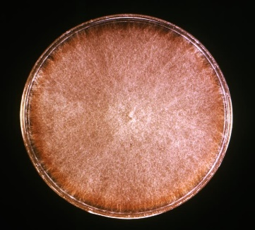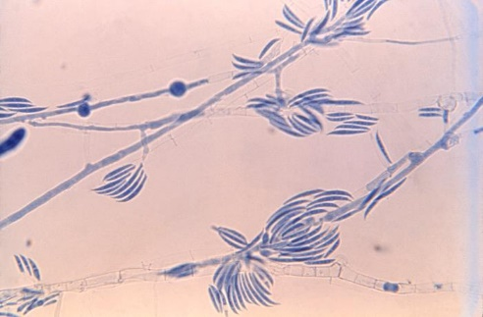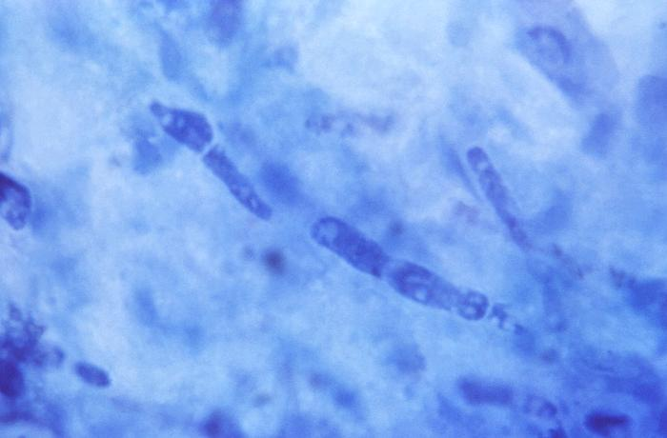
15468 Caption: This photo of a corneal tissue sample was harvested from a patient diagnosed with mycotic keratitis, also referred to as fungal keratitis, caused by Fusarium spp. Keratitis is inflammation of the cornea and is often caused by an infection by bacteria, viruses, amoebas, or fungi, as was the case here. CDC/ Dr. Lucille K. Georg, 1971. Public domain, PHIL.
23085 Caption: Under a magnification of 475X, this photo depicted clumps of elongated, sickle-shaped, multicellular macroconidia and hyaline septate hyphae exhibited by a Fusarium sp. fungal organism. CDC/ Dr. Hilliard F. Hardin, 1965. Public domain, PHIL.
17974 Caption: Culture plate of Sabouraud dextrose agar, inoculated with a culture specimen of Fusarium spp. After incubation, the media grew this pink-tan to brown, woolly textured, large colony. CDC/ Dr. Lucille K. Georg, 1972. Public domain, PHIL.

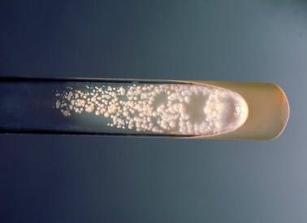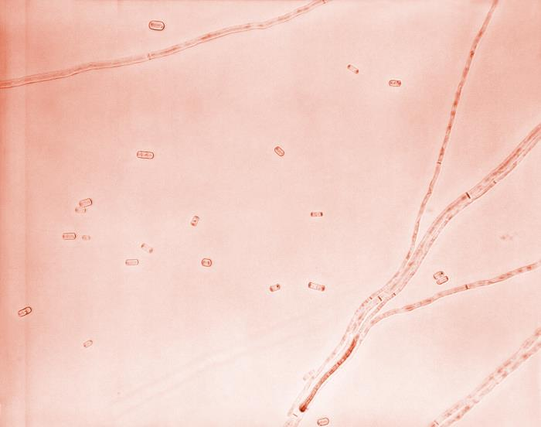
To the left. 21304 Caption: At 300X, this photo reveals the ultrastructures of Geotrichum candidum, which was grown on EMB agar. Note the branched, septate hyphae, some of which broke apart in order to release elongated arthroconidia that were, on average, 6-12µm x 3-6µm. CDC/ Dr. Hilliard F. Hardin, 1968. Public domain, PHIL.
3207 Caption: This photo is a culture tube of Sabouraud dextrose agar, inoculated with Geotrichum candidum, and at a temperature at 37°C. CDC/ Dr. William Kaplan, 1969. Public domain. PHIL.
Geotrichum spp.
Geotrichum and related species have recently undergone extensive taxonomic revision. The three species of prime interest to medical mycology are Geotrichum candidum, Magnusiomyces capitatus (previously known as Geotrichum capitatum), and Magnusiomyces clavatus (previously known as Saprochaete clavata or Geotrichum clavatum). (34)
Geotrichum candidum is a common fungus that has worldwide distribution. It is common in soil, water, air, sewage, vegetation, and the digestive tracts of humans and animals. Respiratory involvement is the most common form of the disease in humans and animals, but oral, bronchial, cutaneous, vaginal, and GI infections are also seen. (38)
Histopathology and direct testing: The lesions consist of dense granulomatous inflammation. Some of the granulomas show central neutrophilic micro-abscess formation. The fungal hyphae show marked fragmentation (arthroconidia), and no branching is seen. Periodic acid Schiff (PAS) and Grocott-Gomori's Methenamine Silver stains show arthroconidia.
Colonial description: RG-1 organism. Colonies are fast-growing, flat, white to cream, dry, and finely suede-like with no reverse pigment. Hyphae are hyaline, septate, branched and break into chains of hyaline, smooth, single-celled, cylindrical arthroconidia. Arthroconidia (6-12 x 3-6 µm in size) are released by separation of a double septum. (37)
Microscopic identification from culture: Blastoconidia production is not seen in this genus. Blastoconidia formation distinguishes Geotrichum from Trichosporon, which produces blastoconidia. (37)
Molecular identification: ITS sequencing is recommended for accurate species identification.
Lomentospora prolificans (formerly Scedosporium prolificans)
An increasingly recognized pathogen related to P. boydii is Lomentospora (formerly Scedosporium) prolificans. This organism has no known sexual state. It can cause rare asymptomatic colonization and localized infections following penetrating trauma in immunocompetent individuals; S. prolificans cause rapidly fatal disseminated infections in immunocompromised patients, particularly in those with neutropenia as a result of anticancer treatment or hematopoietic stem cell transplantation. Localized disease is managed successfully in immunocompetent patients with local surgical resection, while disseminated disease in immunosuppressed patients is almost universally lethal. (22) Clinical hallmarks of disseminated S. prolificans infections are a high rate of organism detection in blood cultures after the patient's death, disseminated hematogenous skin lesions, and CNS involvement. (22) The respiratory tract appears to be the most frequent portal of entry, but isolated cases indicate that S. prolificans may also enter the bloodstream through indwelling central venous catheters. The geographic distribution of disseminated S. prolificans infections suggests a propensity for Spain and Australia; it is unclear, however, whether there is an ecological background for this particular distribution.
Histopathology and direct testing: Granule formation is typical in mycetoma. The granules are composed of septate and branching hyphae. Chlamydospores may be seen. In other body sites of infection with this fungus, granulomatous inflammation and necrosis associated with scattered hyphae are observed.
Colonial description: RG-2 organism. Hyphomycete with an initial grey-black pasty colony. Colonies are rapidly growing, flat, spreading, olive-grey to black, and have a suede-like, downy surface texture. Growth occurs at 45C. There is no growth in media with cycloheximide.
Microscopic identification from culture: Conidia are in small groups on distinctive flask-shaped conidiophores (swollen at the base), occurring alone or in clusters along the hyphae. Conidia are clumped in slimy heads, one-celled, hyaline to tan, oval to pyriform, 3-7 x 2-5 µm, and with smooth thick walls. (40) Growth occurs at 45C. Conidiophores are seen with distinctly swollen bases and a conidial mass of apical aggregates of conidia. (40)
Molecular identification: Recommended genetic markers: ITS and β-tubulin.
Paecilomyces spp.
Paecilomyces spp. are common environmental hyaline molds associated with keratitis and soft tissue infections in immunocompetent patients but may become the cause of deeper infections in immunocompromised patients. (22) The entry points for this organism are the respiratory tract, indwelling catheters, and the skin. Invasive Paecilomyces infection may manifest as fungemia, soft tissue infections, pneumonia, and disseminated disease. (22) noted that for Fusarium and Acremonium, Paecilomyces could form adventitious structures within infected tissues morphologically consistent with microconidia and disseminate widely through the bloodstream. (35)
Paecilomycesvariety is a common environmental mold widespread in composts, soils, and food products. It is found in substrates, including food, indoor air, wood, soil, and carpet dust. However, P. variotii is an emerging causative agent of mycotic keratitis and hyalohyphomycosis in the immunocompromised patient.
Histopathology and direct testing: The necrotic areas contain many intralesional, intracellular, and extracellular, negatively stained, non-pigmented, septate acute angle branching hyphae with parallel walls measuring 3–6μm in width with polar bulbous projections measuring 7–13μm in width. Occasionally, yeast-like forms measuring 7–15μm are present. Hyphae stain with Gomori methenamine-silver (GMS) and Periodic acid-Schiff (PAS) stains.
Cultural description: RG-2 organism. Colonies are fast-growing, powdery to suede-like, tufted, yellow-brown, grey-green, pink, violet, or sand-colored—key features: Yellow-brown or grey-green colony pigmentation, cylindrical phialides, and the presence of chlamydospores.
Microscopic identification from culture: Conidiophores bearing dense branches bearing phialides are seen. Phialides are cylindrical or ellipsoidal, tapering abruptly into a long, cylindrical neck. Conidia are subspherical, ellipsoidal to fusiform, hyaline to yellow, smooth-walled, 3-5 x 2-4 µm, and are produced in long divergent chains. Chlamydospores are usually present, singly or in short chains, subspherical to pyriform, 4-8 µm in diameter, thick-walled to slightly verrucose. P. variotii: Conidiophores, phialides, conidia, and terminal chlamydospores of P. variotii.

Molecular identification: ITS sequencing is recommended for identification.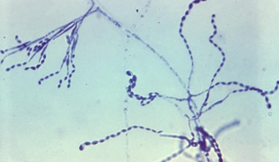 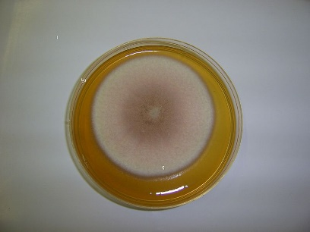 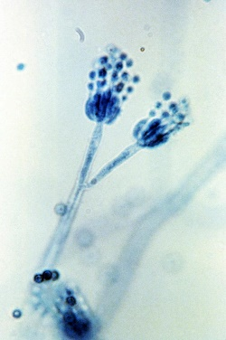 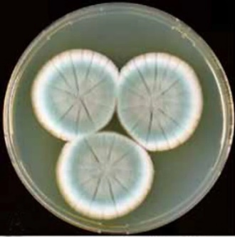
8398 Caption: At 1200x, this photo shows a bifurcated conidiophore of a Penicillium frequentans (Penicillium glabrum). The conidiophore is a stalked structure, the distal end of which produces the asexual conidia through a process of budding. Note: the round conidia are arranged as chains extending from structures known as sterigma at the end of the conidiophores. (paint-brush appearance). CDC/ Lucille Georg, 1971. PHIL.
Penicillium_rubens_(type_specimen).png ‎Penicillium rubens NRRL 792. A–C. Colonies 7 d old 25 °C. A. CYA. B. MEA. C. YES. D–H. Condiophores. I. Conidia. Bars =10 µm. 7 June 2011
Source: Fleming’s penicillin producing strain is not Penicillium chrysogenum but P. rubens. IMA Fungus 2, 87–95 (2011). https://doi.org/10.5598/imafungus.2011.02.01.12. Author: Houbraken, J., Frisvad, J.C. & Samson, R.A. Creative Commons Attribution-Share Alike 4.0 International license. Wikimedia Commons.
14-day culture of the fungus Paecilomyces lilacinus 20 November 2005
Source: Own work
Author: Чхиквадзе Василий Мауглиевич. GNU Free Documentation License, Version 1.2. Wikimedia Commons.
23113 Caption: At a magnification of 475X, this photo revealed some of the ultrastructural morphology exhibited by the genus Paecilomyces. Note the branched conidiophores emanating from septate, hyaline hyphae, each tipped by a tapered phialide, from which projected a chain of elliptical-shaped, smooth-walled conidia. CDC/ Dr. Lucille K. Georg; Dr. Hilliard F. Hardin, 1959. Public domain, PHIL.
Penicillium spp.
Penicillium is a vast and ubiquitous genus that currently contains 354 accepted species. Many species are common contaminants and are known as potential mycotoxin producers. Correct identification is therefore essential when studying possible Penicillium contamination of food. Penicillium is among the top three most common indoor airborne fungi (along with Aspergillus and Cladosporium). These same three molds and Alternaria alternata are most likely to cause allergy symptoms, typically occurring after allergic individuals inhale mold spores. Human pathogenic infectious species are rare. However, opportunistic infections leading to mycotic keratitis, otomycosis, and endocarditis (following insertion of valve prosthesis) have been reported. (38) Penicillium spp. are hyaline saprophytic molds that often contaminate the clinical microbiology laboratory plates but rarely cause infection. Morphological structures and types of conidiophore branching in Penicillium (a) Monoverticillate; (b) Biverticillate; (c) Terverticillate; (d) Quaterverticillate (see Visagie et al. 2014).
Histopathology and direct testing: Histologic examination of a punch biopsy of the right shin lesion demonstrated invasive, septate, fungal hyphae with acute-angle branching, forming a nodule of organisms in the interstitial and deep dermis. Subsequent tissue culture grew Penicillium species,
Colonial description: Penicillium colonies are rapidly growing, flat, filamentous, velvety, woolly, or cottony in texture. They are initially white and become blue-green, gray-green, olive-gray, yellow, or pinkish in time. The plate reverse is usually a pale yellowish. (34)
Microscopic identification from culture: Septate hyaline hyphae (1.5 to 5 µm in diameter), plain or branched conidiophores, metulae, phialides, and conidia are observed. Metulae are secondary branches that form on conidiophores. The metulae hold the flask-shaped phialides. The organization of the phialides at the tips of the conidiophores is very characteristic. (34) They form a brush-like cluster, which are also referred to as "penicillus" or plural "penicilli". The conidia (2.5-5µm in diameter) are round, single-celled, and visualized as unbranching chains at the tips of the phialides. (34) Penicillium differs from Paecilomyces by having flask-shaped phialides and globose to subglobose conidia; from Gliocladium by making chains of conidia; and Scopulariopsis by having phialides. (34) Hyphomycete, flask-shaped phialides arranged in groups from branched metulae forming a penicillus.
Molecular identification: ITS and β-tubulin loci are recommended for identifying Penicillium species.
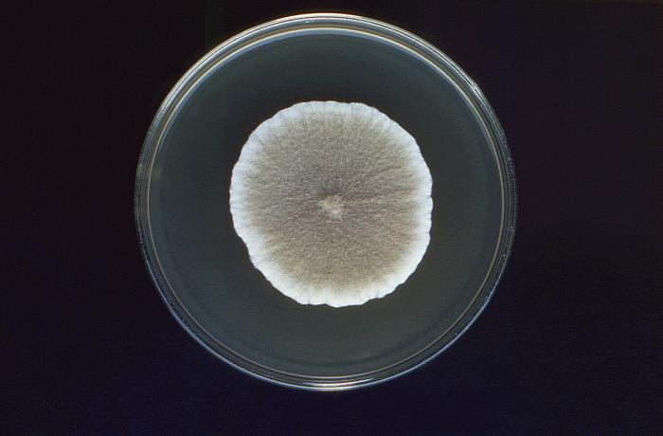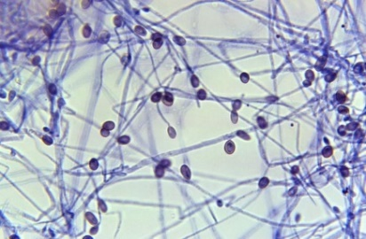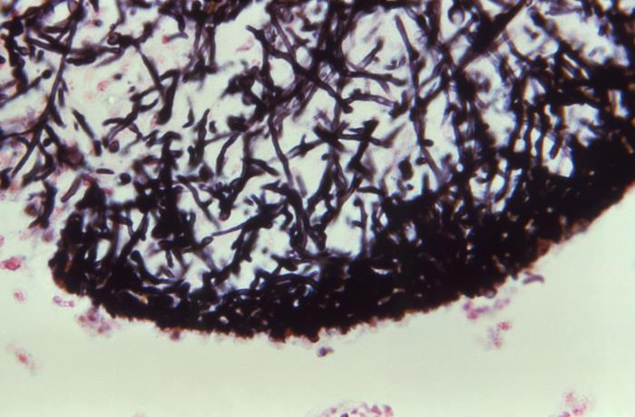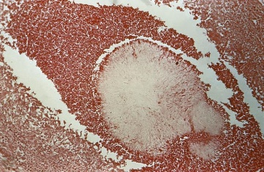
16648 Caption: At 400X, this photo of a Gömöri stained tissue sample, revealed histopathologic details of a maduromycotic mycetoma granule that had been caused by Scedosporium (Pseudallescheria) boydii. This view exposes some of the granule’s ultrastructure, including a matrix of numerous interwoven hyphae. CDC, no date given. Public domain, PHIL.
15923 Caption: This photo of an hematoxylin and eosin (H&E)-stained unidentified tissue specimen, revealed the presence of a eumycotic mycetoma, and the histopathologic changes associated with this condition caused by Scedosporium (Pseudallescheria) boydii, an ascomycetous mold. CDC/ Dr. Lucille K. Georg, 1979. Public domain, PHIL.

15753 Caption: This culture plate contained Sabouraud dextrose agar inoculated with Scedosporium (Pseudallescheria) boydii. The single, large colony displayed characteristic features, including a wooly, cottony texture, and a white coloration, which with age becomes dark gray to smoky brown. CDC/ Dr. Libero Ajello, 1974. Public domain, PHIL.

21200 Caption: Under 500X, this photo of a culture specimen, revealed numerous, ovoid-shaped, brownish-tinted conidia, some were still attached to their respective hypha, by way of long, thin filamentous conidiophore, while others were attached directly to the hyphal strand, projecting laterally. This is Scedosporium (formerly Pseudallescheria) boydii. CDC/ Dr. Hardin, 1968. Public domain, PHIL.

Scopulariopsis spp.
Scopulariopsis brevicaulis is a saprophytic hyaline mold associated with onychomycosis, especially of the toenails, and, occasionally, localized invasive infections following traumatic or surgical injury. In immunocompromised patients, S. brevicaulis can cause deeply invasive and disseminated infections with poor outcomes. Skin lesions, mycetoma, invasive sinusitis, keratitis, endophthalmitis, pulmonary diseases, endocarditis, brain abscesses, and disseminated infections due to Scopulariopsis spp. have been reported. Invasive Scopulariopsis infections are seen mainly in immunocompromised hosts. (45)
Histopathology and direct testing: While not diagnostic alone, the finding of narrow, branching septate hyphae on histopathology from a clinical specimen, along with other characteristics, can help diagnose the infection. (45)
Colonial description: Scopulariopsis colonies grow moderately rapidly and mature within five days. They are granular or powdery in texture. From the top, the color is white initially and becomes light brown or buff tan in time. The reverse color is usually tan with a light brownish center. Some species may form dark-colored colonies. (34)
Microscopic identification from culture: Septate hyphae, conidiophores, annelides, and conidia are seen. Chlamydospores may be present occasionally. Conidiophores are hyphae-like and simple or branched. Annellides are solitary, in clusters, or they form a penicillus; they are slightly swollen and cylindrical. Conidia are single-celled, round to pyriform, smooth, but more commonly rough-walled, spiny, truncate, and forming chains. (45)
Molecular identification: D1/D2 and EF-1α sequence analysis can help identify the most common clinically relevant species.
Scedosporium spp.
The taxonomy of this genus has been subject to change based on sequence data; Scedosporium apiospermum and Pseudallescheria boydii) are currently recognized as separate species that, with S. aurantiacum, are the primary human pathogens of this group. (44)
Most infections are mycetomas; the remainder include infections of the ear, eye, central nervous system, internal organs, and, more often, the lungs.
Scedosporium prolificans has been moved to the genus Lomentospora. L. prolificans is morphologically and phylogenetically distinct from the remaining Scedosporium species. (44)
Morphological identification of Scedosporium spp. is unreliable, and molecular identification methods are now recommended. The conidial appearances of S. apiospermum and S. boydii are indistinguishable, although the latter is homothallic and produces ascocarps. S. aurantiacum exhibits similar conidial morphology, but most strains produce a yellow diffusible pigment on potato dextrose agar. (44)
Colonies of Scedosporium prolificans grow rapidly under 30°C and mature in five days. Initially, the texture is cottony and moist (yeast-like), which later becomes flat with fine, short, mycelial tufts. From the top, the colony color is light gray to black and becomes dark gray to black as the colony matures. The reverse is gray to black, although the hyphae are hyaline. (44)
Microscopic identification from culture: Septate hyaline hyphae, conidiogenous cells (annelides), and conidia are visualized. Annelides may arise directly from hyphae or are formed at the tips of the conidiophores. These annelides are flask-shaped and have a swollen base and an elongated neck. Conidia (2-5 x 3-13 µm) are unicellular, oval-shaped, olive to brown, and slightly narrow, truncated base. They are formed in clusters at the apices of the annelides. In addition, some isolates may produce round, thick-walled conidia, which arise directly from the hyphae.
Histopathology and direct testing: Septate hyphae may be observed in infected tissues. (44) Granule formation is typical in mycetoma. The granules are composed of septate and branching hyphae. Chlamydoconidia may be seen. In other body sites of infection with this fungus, granulomatous inflammation and necrosis associated with scattered fungal hyphae are observed. (44)
Colonial description: Colonies are fast-growing, white to grey, suede-like to downy, with a greyish-black colony reverse. Although cultures often are grey, brown, or almost black due to pigments or the production of brown conidia, the fungus has a colorless mycelium.
Molecular identification: Recommended genetic markers are ITS and β-tubulin. MALDI-TOF MS: A comprehensive 'in-house' database of reference spectra allows accurate identification of Scedosporium and Lomentospora species.
Scedosporium (formerly Pseudallescheria) boydii
Scedosporium (formerly Pseudallescheria boydii) is a hyaline mold characterized microbiologically by terminal annelloconidia and typical cleistothecia in the sexual state (teleomorph form). Some isolates do not display a sexual state (synanamorph form) even under appropriate growth conditions. (22) For such isolates, the designation Scedosporium apiospermum is used. P. boydii may cause pneumonia, sinusitis, CNS infection, endocarditis, disseminated disease, and mycetomas, with considerable morbidity and mortality. (22) In a review of thirty-one cases of invasive infections, 61% died despite antifungal therapy; among eight patients with localized musculoskeletal soft tissue infection, seven required surgery, and three required amputations. (22) In immunosuppressed patients, the usual portal of entry is the respiratory tract. Widespread dissemination from the lungs may spread to other target organs. Cutaneous nodules may indicate dissemination to different organs and body systems, including the central nervous system. Diagnostic procedures and approaches are like those for invasive aspergillosis. (22)
Histopathology and direct testing: Hyaline septate hyphae may be observed in the infected tissues. Scedosporium species cannot be differentiated in tissue sections. Granule formation is typical in mycetoma. The granules are composed of septate and branching hyphae. Chlamydospores may be seen. In other body sites of infection with this fungus, granulomatous inflammation and necrosis associated with scattered light-brown fungal hyphae are observed.
Colonial description: Colonies are fast-growing, white to grey, suede-like to downy, with a greyish-black colony reverse. Although cultures often are grey, brown, or almost black due to pigments or the production of brown conidia, the fungus has a colorless mycelium.
Molecular identification: Recommended genetic markers are ITS and β-tubulin. MALDI-TOF MS: A comprehensive 'in-house' database of reference spectra allows accurate identification of Scedosporium and Lomentospora species.
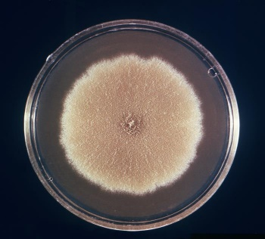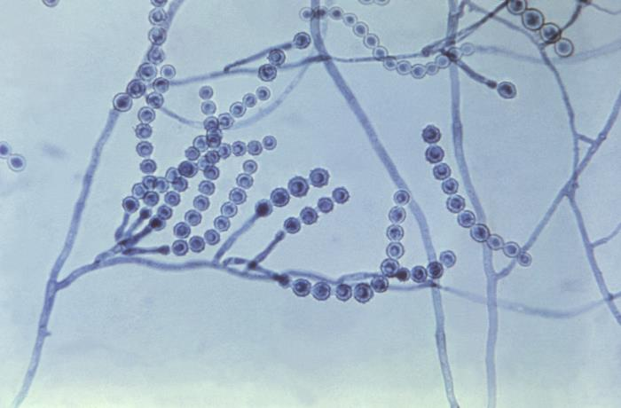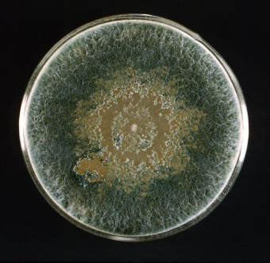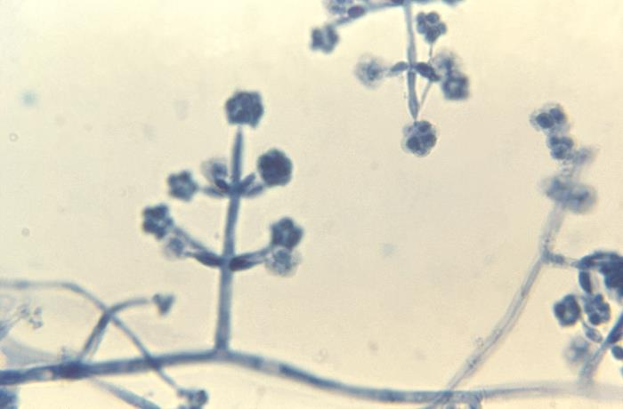
23021 Caption: This culture plate, with Sabouraud dextrose agar was inoculated with Trichoderma. After an unidentified incubation period, the culture gave rise to this single, large, woolly colony, which displayed an overall dark green coloration, and a very compact, plaque-like central region, which had developed a brownish-green color. CDC/ Dr. Hilliard F. Hardin, 1965. Public domain, PHIL.
23103 Caption: At 1200X, this photo revealed some of the ultrastructural morphology exhibited by the genus Trichoderma. Note the septate, hyaline, filamentous hyphae, and conidiophores, from which flask-shaped phialides sprouted in a perpendicular fashion, which are topped by small clusters of globose conidia. CDC/ Dr. Hilliard F. Hardin, 1965. Public domain, PHIL.
16418 Caption: This culture plate contains a growth medium of Sabouraud dextrose agar, upon which a single large colony of a species of the filamentous fungus Scopulariopsis had been cultivated. CDC/ Dr. Lucille K Georg., 1972. Public domain, PHIL

23076 Caption: At 475X, this photomicrograph revealed some of the ultrastructural morphology exhibited by a Scopulariopsis sp. fungal organism. Here, you were able to see the organism’s septate, filamentous hyphae and many basipetal chains of rough-walled conidia, each emanating from a single annelide arranged in a cluster known as a penicillus. CDC/ Dr. Hilliard F. Hardin, 1965. Public domain, PHIL.

Trichoderma species

Previously considered an environmental organism with low pathogenicity, several centers have recently reported infections caused principally by Trichoderma longibrachiatum. Although Trichoderma comprises numerous species, molecular analyses indicate that one species, T. longibrachiatum causes all human infections. (22) Trichoderma spp. has been reported to cause pulmonary, cerebral, soft tissue, and disseminated infections in immunocompromised patients, especially those with bone marrow or solid organ transplantation. (22) Clinical manifestations of trichodermasis include pneumonia (1), rhino-orbital-cerebral mycosis, oral infection, otitis externa, sinusitis, brain abscess, stomatitis, mediastinitis and peritonitis (2), endocarditis (3), skin and skin structural infection, keratitis, and septic shock (4). (22, 46) Trichoderma spp. are often isolated from tumors. In tissues, the organisms appear as hyaline molds indistinguishable from each other. The lack of response of infections caused by these organisms to antifungal chemotherapy is consistent with elevated MICs of conventional antifungal agents in the few strains tested. (22)Recovery from immunosuppression is pivotal to the response of this organism to antifungal chemotherapy. Like other opportunistic molds, high-dose amphotericin B is the initial therapeutic intervention for invasive infections.

Histopathology and direct testing: Inflammation, angioinvasion, and necrosis are seen. Immunohistochemistry shows positive Ki67, CD3, CD56, GZMB, and PRF markers. Periodic acid-Schiff staining, periodic acid-silver methenamine staining, and Calcofluor staining show fungal spores in the vascular lumen, walls, and around the blood vessels.

Colonial description: RG-1 organism. Colonies are fast-growing, at first white and downy, later turning yellowish-green to deep green with compact tufts, often only in small areas or concentric ring-like zones on the agar surface. (46)
Microscopic identification from culture: Conidiophores are branched, irregularly arranged in whorls, bearing clusters of divergent, often irregularly bent, flask-like phialides. (46) Conidia are primarily green, sometimes hyaline, with smooth or rough walls. They are formed in slimy conidial heads clustered at the ends of the phialides. The typical appearance for identification is a hyphomycete with branched conidiophores holding clusters of flask-like phialides. (46)

Molecular identification: Species identification is based on multilocus sequence data using the ITS, EF-1α, Chi18-5, and actin genes.

Septate dematiaceous (phaeoid) molds

The dematiaceous (dark melanin in their cell walls) septated molds are a diverse group of fungal pathogens with melanin-like pigments within the cell walls of their hyphae in common. Among the most prevalent causes of human infection
are Bipolaris spp., Cladophialophora banana, Cladosporium lanthanum, Cladosporium trichoid, Altemaria spp., Exophiala spp., Phialophora spp., Scedosporium spp, and Curvularia spp. (22) While the dematiaceous molds are
typically known to cause diseases in otherwise healthy hosts, such as localized skin lesions and subcutaneous tissue following a puncture injury, these pathogens are increasingly seen to cause sinusitis, pneumonia, and disseminated infections in various immunocompromised patients. (22) Laboratory and clinical studies also show these organisms have a high propensity for infection in the nervous system.
Alternaria species
Alternaria is a ubiquitous genus of common saprophytes in soil, air, and vegetation. Alternaria infectoria is the most commonly encountered clinical species. (48) Although usually seen as saprophytic contaminants, Alternaria species, notably A. alternata and A. infectoria, are recognized causative agents of subcutaneous phaeohyphomycosis and mycotic keratitis. (48) They are a rare cause of onychomycosis, usually following nail trauma.
Histopathology and direct testing: Dark-colored filamentous hyphae are observed in sections of infected tissue stained with H&E. If the pigment formation is not apparent, the Fontana-Masson silver stain, specific to melanin, is helpful.

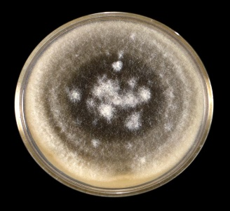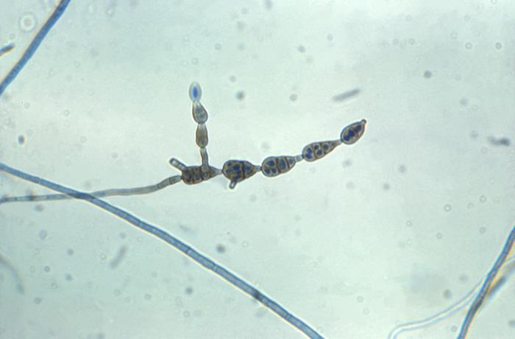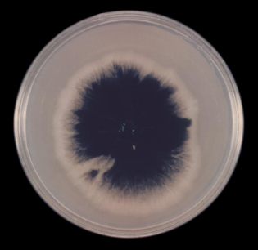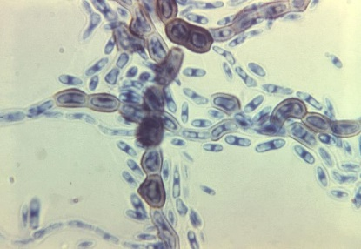
16653 Caption: At 970X, this photo of a lactophenol cotton blue (LPCB) wet mount prepared specimen revealed ultrastructural features exhibited by the dematiaceous fungal organism of the genus Aureobasidium. CDC/ Dr. Hardin, 1965. Public domain, PHIL.

23025 Caption:This image depicted a top view of a culture plate of Sabouraud dextrose agar inoculated with Aureobasidium. After a 16-day incubation period, the culture gave rise to this single, large colony, which displayed a central, darkly-colored region, surrounded by a beige periphery. CDC/ Dr. Hilliard F. Hardin, 1965.domain, PHIL.

23073 Caption: A culture with Sabouraud dextrose agar growing Alternaria. After 10 days, the culture grew this single, large colony with a characteristic wooly texture that was covered by short, gray-colored aerial hyphae. As the oldest colonial sector, its central region had begun to darken, displaying an olive-brown color. CDC/ Dr. Hilliard F. Hardin, 1965. Public domain, PHIL.

23084 Caption: At 400X, this photo depicts a chain of conidia from Alternaria spp. The spores of Alternaria sp. fungi are multicellular and pigmented and are produced in straight chains or branching chains, as depicted here. The end of each conidium, nearest the conidiophore, is rounded, tapering distally towards its apex, imparting a beak-like appearance. This specimen had been prepared using LPCB staining. CDC/ Dr. Hilliard F. Hardin, 1965. Public domain, PHIL.

Cultural description: RG-1 organism. Colonies are fast-growing, black to olivaceous-black or greyish, and are suede-like to floccose. Microscopically, branched acropetal chains of multicellular conidia are produced sympodially from simple or branched, short or elongated conidiophores. (48) Conidia are obpyriform, occasionally ovoid or ellipsoidal, often with a short conical or cylindrical top. They are pale brown, smooth-walled, or verrucose. (48) Temperature: optimum 25-28ᴼC; maximum 31-32ᴼC
Alternaria alternata show branched chains and multicelled, thicker at the base conidia with short conical beaks. Alternaria species may soon lose their ability to sporulate in culture. Potato dextrose agar and cornmeal agar are the most helpful media, and incubation under ultra-violet light is also useful to maintain their sporulation.(48) Dematiaceous hyphomycete-producing darkly pigmented, ovoid chains to obclavate microconidia, often with short conical or cylindrical beaks.
Molecular identification: Genotype studies have shown that nine genera and eight sections make up the Alternaria complex. (48) ITS sequencing is sufficient for genus and usually species-level identification and can differentiate A. alternata and A. infectoria. However, unknown sequences should be compared to those of well-characterized reference strains. (48)
Aureobasidium spp.
Aureobasidium pullulans has a global distribution and is usually isolated as a saprophyte, occasionally from skin and nails. It has also been reported as a rare causative agent of phaeohyphomycosis, mycotic keratitis, and peritonitis in patients on continuous ambulatory peritoneal dialysis (CAPD). (49)
Histopathology and direct testing: Histopathology analysis of tissue shows a noncaseating granulomatous dermatitis. Direct examination of a sample in potassium hydroxide preparation reveals the presence of fungal hyphae. (48)
Colonial description: RG-1 organism. Hyphomycete (also called black yeast) produces hyaline blastoconidia from the vegetative hyphae, which may then form chains of darkly pigmented, thick-walled arthroconidia. The colonies are fast-growing, smooth, and soon covered with slimy masses of conidia, cream to pink, later becoming brown to black. (48)
Microscopic identification from the culture: Hyphae are hyaline and septate, frequently becoming dark brown with age. They form chains of one to two-celled, thick-walled, darkly pigmented arthroconidia. These arthroconidia represent the Scytalidium anamorph of Aureobasidium and are only of secondary importance in recognizing members of this genus. (48) Conidia are produced synchronously in dense groups from indistinct scars or short denticles on undifferentiated hyaline to subhyaline hyphae. Conidia are hyaline, smooth-walled, single-celled, and ellipsoid but vary in size (8-12 x 4-6 µm) and shape, often with a hilum (i.e., scar at the point of attachment). (48) The optimum growth temperature is 25C; the maximum is 35-37C. (48) Aureobasidium pullulans cultures show black, slimy masses of conidia. Aureobasidium pullulans show one to two-celled, darkly pigmented arthroconidia and hyaline, single-celled, ovoid-shaped conidia produced on short denticles. (48)
Molecular identification: ITS, EF-1α, and D1/D2 are recommended barcoding genes.
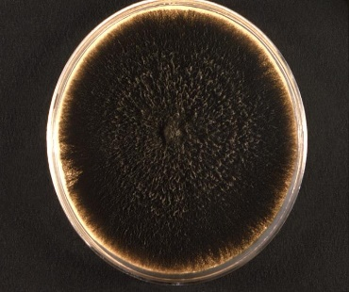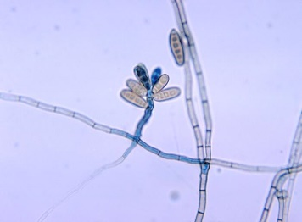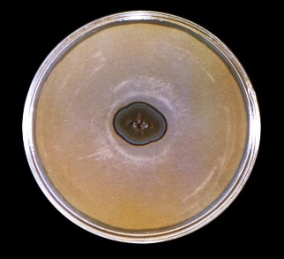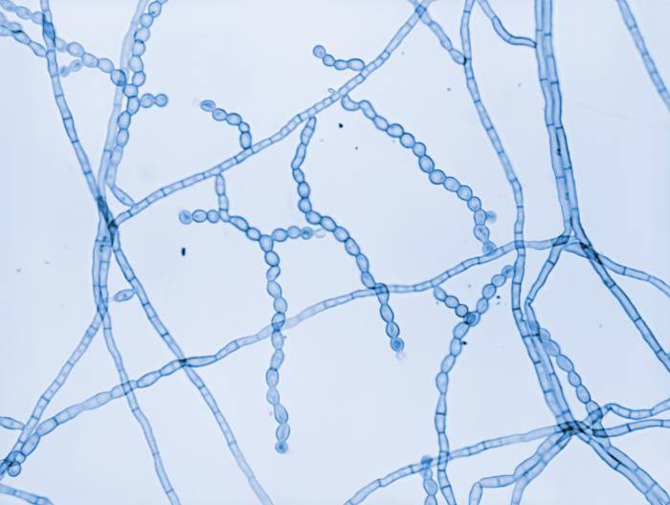
10607 Caption: This image shows Bipolaris hawaiiensis. The colonial texture appears woolly. Normally, the reverse coloration appears as black, but is sometimes observed as brown, with areas becoming black increasingly with time. CDC, 1971. Public domain, PHIL.

3059 Caption: This image depicts a top view of a culture plate containing an unidentified growth medium inoculated with the fungal organism Cladophialophora carrionii, formerly Cladosporium carrionii. After a 4-week incubation, the culture produced this olivaceous-colored colony. CDC/ Dr. Lucille K. Georg, 1963. Public domain, PHIL.

20232 Caption: Under a magnification of 510X, this photomicrograph revealed ultrastructural details exhibited by the fungal organism Cladophialophora carrionii. Here, you see the characteristic, elongated conidiophores, giving rise to smooth-walled reproductive conidia chains ranging from limoniform (lemon-shaped) to fusiform (spindle-shaped). CDC/ Dr. Libero Ajello, 1967. Public domain, PHIL

4318 Caption:This photo reveals the ultrastructural morphology of Bipolaris hawaiiensis, including its septate hyphae, septate, geniculate conidiophore, which was topped by a cluster of 3- to 6-celled conidia, referred to as poroconidia. B. hawaiiensis has been shown to be one of the causes for phaeohyphomycosis. CDC, 1971. Public domain, PHIL.

Bipolaris spp.

Bipolaris spp. is the most common cause of phaeomycotic sinusitis. Traditionally, Bipolaris sinusitis has been refractory to amphotericin B. Recent findings, however, indicate itraconazole is active against Bipolaris sinusitis, including cases that have been refractory to amphotericin B.(22) Bipolaris also causes pneumonia, fungemia, and disseminated disease. (22)

Histopathology and direct testing: Hematoxylin and eosin (H&E) staining revealed inflammatory sinonasal polyps and clusters of eosinophilic granulocytes within the mucus. Gomori methenamine silver (GMS) staining showed septate fungal hyphae not only in the fungal masses (fungus balls) but also within the mucus, where the hyphae seemed to be impacted or embedded within the clusters of eosinophils.

Colonial description: RG-1 organisms. Colonies are moderately fast-growing, grey to black-brown, suede-like to floccose on the top, with a black colony reverse. (50)

Microscopic identification from culture: Bipolaris shows the development of hyaline to deep olive pigmented, pseudoseptate conidia on a bent or zig-zagged main stem. (50) Conidia are primarily curved, canoe-shaped, fusoid, or rarely straight, with 2–14 pseudoseptae (usually more than 6), germinating only from the ends (bipolar). (50) The key features are dematiaceous hyphomycete hyphae producing pale brown, sympodial, pseudoseptate, straight, fusiform, or ellipsoidal conidia rounded at both ends. (50)

Molecular identification: ITS rDNA sequencing is used to identify clinical species, and GPDH has been determined to be the best single phylogenetic marker for Bipolaris species. (50)

Cladophilalophora species

Cladophialophora bantiana (Cladosporium bantianum) has a high propensity for CNS infection, which is frequently fatal. Notably, patients with CNS infections caused by Cladophialophora bantiana may have no apparent immunosuppression but still have high morbidity and mortality. (22) CNS infection may be best managed with surgical resection. The state of encapsulation and inflammation of the CNS lesion is critical in determining outcome, independent of antifungal chemotherapy. (22) Solitary, encapsulated, granulomatous, and resectable lesions were associated with a good prognosis. Those multiple lesions, poorly encapsulated, non-granulomatous, and multifocal lesions, had a poor prognosis. (22)

Cladophialophora spp. are the causative agents of chromoblastomycosis, phaeohyphomycosis, and mycetoma. (51, 52) C. bantiana is neurotropic and causes cerebral phaeohyphomycosis in brain abscesses, in which the disease course is usually fatal. (52) It may also cause skin lesions. While Cladophialophora boppii and Cladophialophora carrioinii are both found in patients with chromoblastomycosis, Cladophialophora boppii also causes skin lesions. (51, 52) Trauma and exposure to soil are the main predisposing factors for acquiring infections due to Cladophialophora carrionii. (52) Cladophialophora devriesii, on the other hand, has been reported to cause disseminated phaeohyphomycosis. (52)

Histopathology and direct testing: Cladophialophora is a melanin-producing mold known to cause human brain abscesses. (51, 52) It exhibits predominantly hyphal growth both in vivo and in vitro, with the typical morphology consisting of dark-colored, largely unbranched, wavy chains of conidia, each measuring 5–10 μm in length. (51, 52).

Cultural description: WARNING: RG-3 organism. C. bantiana cultures represent a severe biohazard to laboratory personnel and must be handled cautiously within a class II biological Safety cabinet. (51) Colonies are moderately fast-growing, olivaceous-grey, suede-like to floccose and grow at temperatures up to 42-43ᴼC. Cladophialophora colonies are powdery to woolly and spready. Typically, the color is olive-green to black on the colony top and black on the colony reverse. (52) Cladophialophora boppi and Cladophialophora bantiana grow at a moderate rate at 25°C on potato dextrose agar. Growth of Cladophialophora carrionii is at a slow rate under the same conditions. (52) Cladophialophora bantiana can grow at temperatures up to 42°C, but Cladophialophora carrionii does not grow above 36°C. Cladophialophora bantiana also possesses enzyme activity on urease agar. (52)

Microscopic identification from culture: Cladophialophora spp. produce septate, brown hyphae, and single-celled conidia. Cladophialophora bantiana and Cladophialophora boppi also may produce chlamydospores. (52) The conidiophores of Cladophialophora are often not differentiated from the vegetative hyphae. The conidia are light to dark brown and frequently form chains from which the conidia easily disarticulate. (52) The youngest conidium is at the apex of the chain, suggesting an acropetal (from the base up) conidia formation. No attachment scars are seen on the conidia. (52) C. bantiana produces single-celled, long chains of lemon-shaped conidia, 6-11×2.5-5 µm in size. (52)There are no shield cells on the conidiophore supporting the formation of conidia. C. boppi produces unbranched, long, smooth, round conidia chains, 2-3×3-4 µm. (52) The conidia emerge directly from the conidiophores. C. carrionii produces long, abundantly branching, single-celled, lemon-shaped conidia (4-6×2-3 µm), smooth or sporadically echinulate. (51, 52)

Molecular identification: ITS sequencing is recommended. (51)
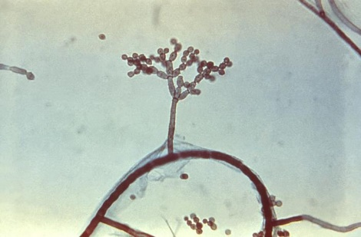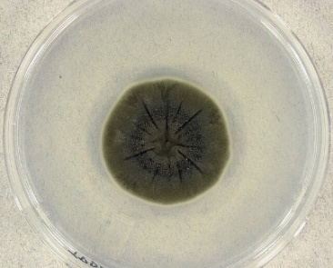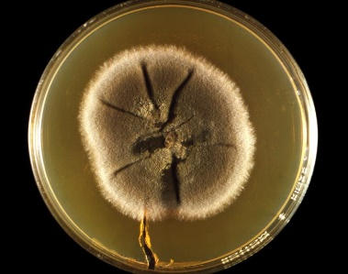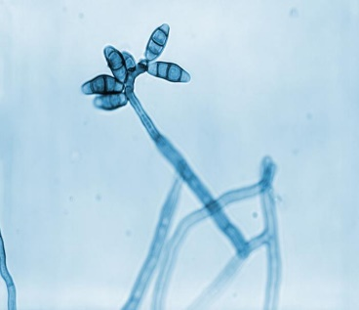
Cladosporium sphaerospermum colony.jpg Cladosporium sphaerospermum (UAMH 4745) on potato dextrose agar after incubation for 14 days at 25°C. Photo: Medmyco. Creative Commons Attribution-Share Alike 4.0. March 24, 2005. [[File:Cladosporium sphaerospermum colony.jpg|Cladosporium_sphaerospermum_colony]] Wikimedia Commons.
20241 Caption: This culture plate gave rise to a colony of Curvularia geniculata. As you can see here, the colony’s front exhibited a suede-like or downy texture and a coloration that ranged from brown, as in this example, to black. CDC/ Dr. Libero Ajello, 1967. Public domain, PHIL

20228 Caption: At a magnification of 710X, this photomicrograph revealed ultrastructural details exhibited by a solitary, Curvularia geniculata conidiophore, which was topped by a number of characteristic multiseptate conidia. CDC/ Dr. Libero Ajello, 1967. Public domain, PHIL.

15887 Caption: At 475X, this photo revealed some of the ultrastructural features exhibited by a species of dematiaceous mold, Cladosporium. Here, you can see chains of conidia, or spores, emanating from atop a brown-colored conidiophore, jutting perpendicularly from a darkly colored, septate hypha. CDC/ Dr. Hardin, 1965. Public domain, PHIL.

Cladosporium spp.

Species belonging to the Cladosporium genus are widely distributed fungi, commonly isolated from soil, food, paint, textiles, and organic debris. (53) Some species are plant pathogens, causing leaf spot or secondary invaders of leaf lesions caused by other plant pathogenic fungi. (53) Studies of air pollutants have found Cladosporium spores in most homes tested in Canada, and another study in the USA found Cladosporium spores in 70% of the homes they tested. (53)
They can cause human mycoses of lungs, eyes, skin, and nails, but rarely and predominantly in immunocompromised individuals. Cladosporium is the cause of skin lesions, keratitis, onychomycosis, sinusitis, and lung infections. (53) The main causative agents of chromoblastomycosis are members of three genera of dematiaceous fungi that inhabit the soil: Fonsecaea, Phialophora, and Cladosporium. (60)

Phaeohyphomycoses, caused by Cladosporium spp. include subcutaneous infections, onychomycosis, and keratomycosis. In severe cases, Cladosporium spores can germinate in the lungs and develop into fungal balls. However, the most frequent adverse health effects caused by these molds are allergies. C. herbarum is one of the most common experimental molds in allergy research, following Aspergillus fumigatus and Alternaria alternata. (53)

Histopathology and direct testing: Brown (phaeoid) hyphae may be observed in infected tissue samples. The fungi causing chromoblastomycosis produce a distinctive structure in infected tissues called a sclerotic body. Sclerotic bodies are thick-walled, brown, spherical, or polyhedral structures with horizontal and vertical septa. (60) They may be found singly, in clumps, or within the giant cells. (60) Melanin, produced in the sclerotic body's cell wall, gives the structure a dark brown color. Sclerotic bodies mostly divide by separation along their septa. (60) Phaeoid hyphae may also be observed in other tissue sites.

Colonial description: Cladosporium species belong to an artificial group of organisms called dematiaceous fungi, characterized by darkly pigmented hyphae. (54) Cladosporium spp. colonies vary in appearance, but generally, they are 15–40 mm in diameter, low growth, velvety, and dark green. (54) The growth rate of Cladosporium colonies is moderate on potato dextrose agar at a temperature below 30°C, and the texture is velvety or powdery. (54) Like the other dematiaceous fungi, the color is olivaceous green to black on the colony top and black on the colony reverse. (54) Most Cladosporium spp. do not grow above 35°C. (54)

Microscopic identification from the culture: Cladosporium spp. produce septate brown hyphae, pigmented conidiophores, and conidia. (54) Conidiophores of Cladosporium herbarum bear terminal and intercalary swellings. Conidia of Cladosporium spp. generally are elliptical or cylindrical, pale to dark brown, and have dark hila. They are seen in branching chains from which they can readily disarticulate. The conidial wall is either smooth or echinate. They are two- or four-celled. C. sphaerospermum produces septate, elongated shield cells, also known as ramoconidia. Their conidiophores (structures that bear asexual spores) are typically olive-colored, nearly erect, and branched. Conidia are globose to ellipsoid and olive and often have rough surfaces.

Molecular identification: Genus-level identification is typically sufficient, and morphological identification can just be confirmed by ITS and D1/D2 sequence analysis for this. Multilocus gene analysis of the ITS, D1/D2, EF-1α, and actin gene loci is necessary for precise species identification. (55)

Curvularia spp.

The genus Curvularia contains about 80 species, mainly in soil or plants. It has been shown that cultural morphology identification does not correlate with molecular identification. This prompted a phylogenetic analysis of the genera Bipolaris and Curvularia, which has re-aligned several species. In particular, clinical isolates previously identified as Bipolaris species, notably B. australiensis, B. hawaiiensis, and B. spicifera, have now been transferred to Curvularia. Curvularia spp. is a cause of phaeohyphomycosis. Wound infections, mycetoma, onychomycosis, keratitis, brain abscesses, brain inflammation, pneumonia, allergic bronchopulmonary disease, allergic sinusitis, endocarditis, peritonitis, and disseminated disease are caused by Curvularia spp. In this genus, Curvularia lunata is the most commonly encountered species. Notably, the infections may develop in patients with intact immune systems. However, like several other fungal genera, Curvularia has recently emerged as an opportunistic pathogen infecting immunocompromised hosts. (56) Previously, Curvularia lunata was the most frequently reported clinical species; however, different species, such as C. americana, C. brachyspora, C. chlamydospora, C. clavata, C. hominis, C. inaequalis, C. muehlenbeckiae, C. pallescens, C. pseudolunata, C. senegalensis, and C. verruculosa have now also been reported from clinical cases so that those numbers may change. (56)

Histopathology and direct testing: Granule formation is typical in mycetoma. The granules are composed of phaeoid septate and branching hyphae. Chlamydospores may be seen. In other body sites of infection with this fungus, granulomatous inflammation and necrosis associated with scattered light-brown fungal hyphae are observed.

Colonial description: RG-1 organisms. Curvularia produces rapidly growing, woolly colonies on potato dextrose agar at 25°C. (57) From the top, the color of the colony is initially white to pinkish gray and then turns to olive brown or black as the colony matures. Colonies are fast growing, suede-like to downy, brown to blackish brown on Sabauraud’s agar with a black reverse. (57)

Microscopic identification from culture: Conidiophores erect, straight to flexed, septate, often geniculate (producing conidia in sympodial succession). (56) Conidia are ellipsoidal, usually curved or lunate, rounded at the ends or sometimes tapering slightly towards the base, brown, medium reddish brown to dark brown, 3–10 (usually 3–5) septa, conidial wall smooth to verrucose. (56) The hilum protuberant in some species. (56) Key features: Dematiaceous hyphomycete producing sympodial, pale brown, cylindrical, or slightly curved conidia. (56,57)

Molecular identification: GPDH and ITS sequencing are used.
Genus level identification is usually sufficient, and morphological identification can be confirmed by ITS and D1/D2 sequence analysis. Multilocus gene analysis of the ITS, D1/D2, EF-1α, and actin gene loci is necessary for accurate species identification. (56)

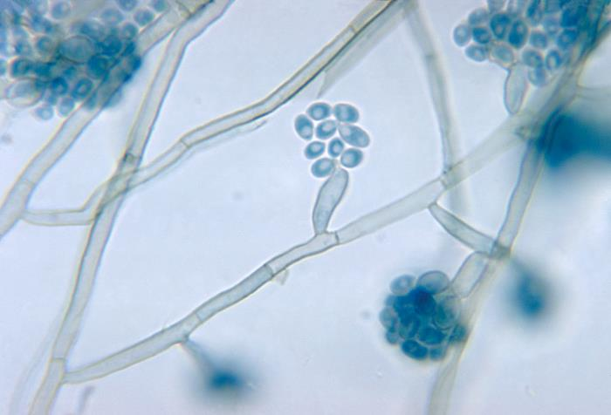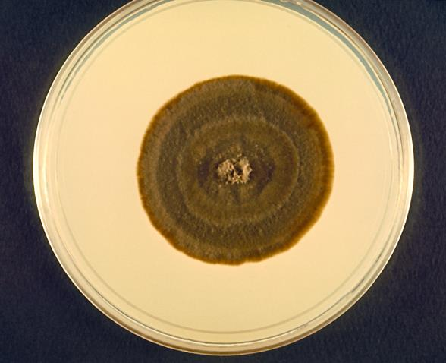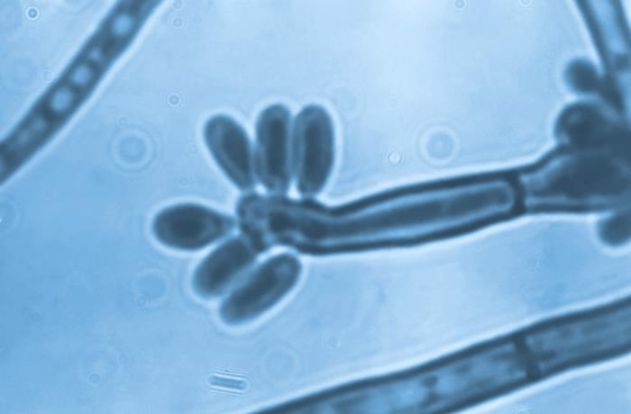
22228 Caption: This photo revealed the ultrastructural morphology of Fonsecaea pedrosoi, formerly known as Hormodendrum pedrosoi. This view demonstrated what is known as an acrotheca-type spore formation, unique to this genus, and represents the configuration of spores emanating both from the tip, and sides of a blunt-ended conidiophore. CDC/ Dr. Lucille K. Georg, 1964. Public domain, PHIL.

4160 Caption: This image depicts a frontal view of a Petri dish culture plate, which contained an undisclosed growth medium that had been inoculated with Exophiala salmonis. CDC, 1970. Public domain, PHIL.

4332 Caption: This photomicrograph reveals some of the ultrastructural morphology exhibited by a fungal organism of the genus, Exophiala, including clusters of its ellipsoidal-shaped microconidia, which were borne from annelide, rocket-shaped conidiogenous cells spouting from the septate hyphae. CDC, 1971, Public domain, PHIL.

At the right: 16442 Caption: At 1000X, this photo revealed some of the ultrastructural features exhibited by the dematiaceous, or dark-colored fungi, Fonsecaea compacta. Note the septate conidiophore, topped by three phialides, each with its own cluster of mostly barrel-shaped conidia. CDC/ Dr. Lucille K. Georg, 1961, Public domain, PHIL.

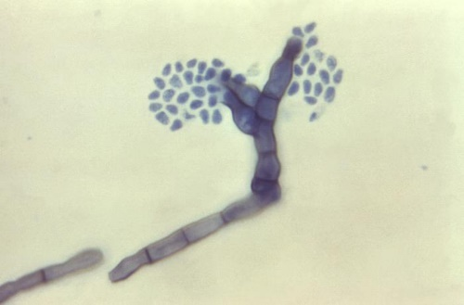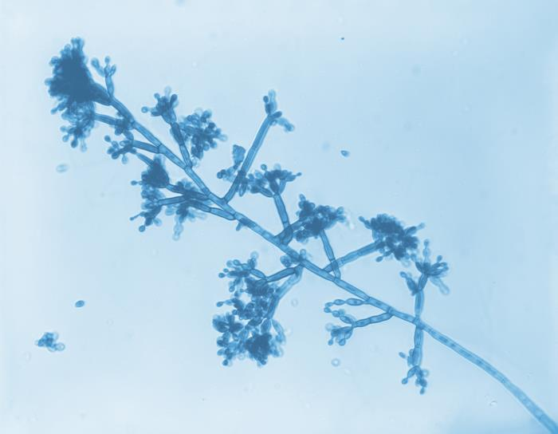
At the left: 2920 Caption: At 620X, this photo reveals some of the ultrastructural morphology exhibited by the dematiaceous Fonsecaea pedrosoi, raised in a slide culture. This image focuses on what is referred to as Cladosporium-type sporulation. CDC/ Dr. Lucille K. Georg, 1961, Public domain, PHIL.

Exophiala species., esp. Exophiala (Wangiella) dermatitidis
Several species of Exophiala, notably E. jeanselmei complex and E. spinier complex, are well-documented pathogens of humans. (58) Mycetoma (especially E. jeanselmei complex), localized cutaneous infections, subcutaneous infections, endocarditis, and cerebral and various disseminated infections are caused by Exophiala. Phaeohyphomycosis caused by Exophiala has been found in both regular and immunosuppressed patients. (59)

Exophiala spp. are among the fungi causing mycoses referred to as phaeohyphomycosis. (58) Subcutaneous infections such as mycetoma and chromoblastomycosis may be due to Exophiala spp. These infections usually occur via traumatic puncture and are often associated with the existence of local or systemic immunosuppression, such as organ transplantation. (58) Infection and abscess formation in subcutaneous tissues, prosthetic valve vegetations, fungemia, and disseminated infections due to Exophiala spp. have also been reported. Exophila pisciphila is a neurotropic species causing infections in fish and humans. (58)

Wangiella (Exophiala) dermatitidis is recovered in cultures of clinical specimens as a dematiaceous yeast; however, this organism is dimorphic and develops hyphae in human tissue. W. dermatitidis can cause catheter-related fungemia and has a high propensity for CNS infection. (59) Phaeohyphomycosis caused by Exophiala species has been reported in both regular and immunosuppressed patients. (59)

Histopathology and direct testing: Phaeoid (brown) hyphae and phaeoid yeast-like cells are in infected tissues.

Colonial description: Exophila spp. are initially yeast-like, moist, and brownish to greenish-black. The colony's texture eventually becomes velvety due to the development of short, aerial grayish hyphae. The colony's top color is olivaceous-black, and the colony reverse is black in mature colonies. (58)

Microscopic identification from culture: In the young cultures, subspherical, budding, yeast-like cells are visualized. These cells often form long chains. As the culture ages, septate hyphae, which bear conidiogenous cells (annelides), eventually form. (58) The annelides are tubular, rocket-shaped, and typically taper to create a narrow, elongated tip. Ellipsoid conidia (1-3×3-6 µm) are produced from annelides. These conidia are usually single-celled and are found in clumps at the tops of annelides or the sides of the conidiophores. (58)

Molecular identification: ITS and D1/D2 sequencing are recommended for species identification. (59) MALDI-ToF mass spectrophotometry appears to be a promising identification tool with an extensive database for some species. (59)

Fonsecaea spp.

The genus was recently revised based on ITS sequencing data. Three species from humans are currently recognized: F. monophora, F. nubica, and F. pedrosoi, although they are morphologically indistinguishable. (60, 61) All strains grow at 37C, but not 40C and these three species are recognized as etiological agents of chromoblastomycosis.
Fonsecaea is a causative agent of the traumatic, chronic infection of chromoblastomycosis. Chromoblastomycosis presents with lesions and verrucose cauliflower-type lesions, most commonly of the lower extremities (61). Primary nasal chromoblastomycosis has also been reported. The etiologic agents of chromoblastomycosis are generally members of three genera of dematiaceous fungi that inhabit the soil: Fonsecaea, Phialophora, and Cladosporium.

Fonsecaea pedrosoi is one of the primary causative agents of chromoblastomycosis in tropical areas, specifically in South America and Japan. (61) Fonsecaea compacta is a rare cause of chromoblastomycosis in tropical Central and North America. (61) Systemic invasion following chromoblastomycosis is rare. (61)

In addition to chromoblastomycosis, Fonsecaea causes other human infections, including paranasal sinusitis, keratitis, and fatal brain abscesses following hematogenous dissemination have been reported. (61)

Histopathology and direct testing: The fungi causing chromoblastomycosis produce a sclerotic body, a distinctive structure in infected tissues. Sclerotic bodies are spherical or polyhedral, dark brown, thick-walled structures with horizontal and vertical septa. Dematiaceous hyphae may also be observed in patient tissues. They may be found in clusters or within the giant cells. Melanin produced in the sclerotic body's cell wall gives the structure a dark brown color. Unlike yeasts, sclerotic bodies mostly divide by separation along the septa. (61)

Colonial description: RG-2 organism. Colonies are flat to heaped and folded, suede-like to downy, olivaceous to black with black reverse. Fonsecaea grows slowly and produces flat, raised, and folded, velvety or cotton-like colonies on sporulation media at temperatures below 30°C. The colonies mature in 14 days. On both the colony top and reverse, they are olivaceous to brown-black. (60, 61)

Microscopic identification from culture: Conidiogenous cells of a pale olive color are arranged in loosely branched systems with prominent denticles. Conidia are clavate to ellipsoidal, in short chains, subhyaline, smooth and thin-walled, 3.5-5 x 1.5-2 µm. Four types of conidiogenesis are seen with Fonsecaea (60)
(i) Fonsecaea type: Conidia are single-celled and arise upon swollen denticles at the ends of the conidiophores. These give rise to single-celled, pale brown, secondary conidia on swollen denticles. The secondary conidia often produce a tertiary series of conidia like those formed by the first conidia, resulting in a complex conidial head. This type of conidia is primarily observed in the strains of the genus Fonsecaea. (61)
(ii) Cladosporium type: Conidiophores give rise to primary shield-shaped conidia, producing long, branching chains of oval, dematiaceous conidia. These conidia have visible dark hila, which are the attachment scars. (61) This type of conidiogenesis is primarily observed in Cladosporium but may also be observed in Fonsecaea. (61)
(iii) Phialophora type: In this type of conidiogenesis, conidia are located at the ends of the vase-shaped phialides with collarettes. This type of conidiogenesis is primarily observed in the strains of the genus Phialophora but may also rarely be observed in strains of Fonsecaea. (61)
(iv) Rhinocladiella type: Conidiophores are sympodial and have denticles that bear single-celled, pale brown conidia. The conidia may be located at the ends of and along the sides of conidiophores. The formation of secondary conidia is sporadic. This type of conidiogenesis is primarily observed in Rhinocladiella and may rarely be observed in strains of Fonsecaea. (61)

Molecular identification: ITS sequencing is recommended for species identification. (60)

Hortaea werneckii

Formerly named : Cladosporium werneckii; Exophiala werneckii; and Phaeoannellomyces werneckii.
Hortaea werneckii is a common saprophytic dematiaceous fungus believed to occur in soil, compost, and wood in humid tropical and subtropical regions. It is the causative agent of the superficial skin condition tinea nigra in humans.

Histopathology and direct testing: The epidermis and dermis of the skin infected with tinea nigra are largely unremarkable. In the superficial aspects of the stratum corneum, numerous short, segmented dematiaceous hyphae and spores are seen. These organisms have a characteristic brown-yellow color on routine hematoxylin and eosin sections.

Colonial description: RG-1 organism. Colonies are slow-growing, initially mucoid, yeast-like, and shiny-black. However, they develop abundant aerial mycelia with age and become dark olivaceous in color.

Microscopic identification from culture: The dematiaceous colonies consist of brown to dark olivaceous, septate hyphal elements and numerous two-celled, pale brown, cylindrical to spindle-shaped yeast-like cells that taper towards the ends to form an annellide. Most yeast-like cells also have prominent, darkly pigmented septa. Annellides may also arise from the hyphae. Conidia are one- to two-celled, cylindrical to spindle-shaped, and hyaline to pale brown, usually occurring in aggregated masses. Chlamydospores also present. The key feature of this hyphomycete is that two-celled yeast-like cells produce annelloconidia.

Molecular identification: An ITS primer specific for H. werneckii has been developed. ITS sequencing can also assist in identification. See the previous chapter for more information and images of this yeast-like organism.

Phialophora spp.

Phialophora contains more than 40 species, most of which are saprophytes commonly found in soil or on decayed wood. Some human pathogens with phialide-type conidiogenesis previously assigned to Phialophora have been moved to two other genera, Phaeoacremonium and Pleurostomophora. Phialophora verrucosa, P. americana, P. bubakii, P. europaea, and P. reptans remain in the genus Phialophora. (63) P. verrucosa and P. americana produce conidia from phialides with conspicuous darkened collarettes. However, sequencing has demonstrated a close relatedness, suggesting that these species may be synonymous.

Phialophora species are among the etiological agents of chromoblastomycosis and phaeohyphomycosis. (64) The etiologic agents of chromoblastomycosis are generally members of three genera of dematiaceous fungi that inhabit the soil: Fonsecaea, Phialophora, and Cladosporium. P. verrucosa is the principal causative agent of chromoblastomycosis in tropical and subtropical areas, particularly in Japan and South America. The clinical forms of phaeohyphomycosis caused by Phialophora include cutaneous infections, subcutaneous cysts, keratitis, endocarditis, arthritis, osteomyelitis, cerebral infection, fatal hemorrhage, and disseminated disease.

Histopathology and direct testing: Granule formation is typical in mycetoma. The granules are composed of phaeoid septate and branching hyphae. Chlamydoconidia may be seen. In other body sites of infection with this fungus, granulomatous inflammation and necrosis associated with scattered light-brown fungal hyphae are observed.

Cultural description: Colonies (SDA) are slow-growing, initially dome-shaped, but later becoming flat, suede-like, and olivaceous to black.

Microscopic identification from culture: Phialides are flask-shaped or elliptical with distinctive funnel-shaped, darkly pigmented collarettes. Conidia are ellipsoidal, smooth-walled, hyaline, mostly 3.0-5.0 x 1.5-3.0 μm, and aggregate in slimy heads at the apices of the phialide—key features: Characteristic flask-shaped phialides with distinctive funnel-shaped, darkly pigmented collarettes.

Molecular identification: ITS sequencing is recommended. (63)

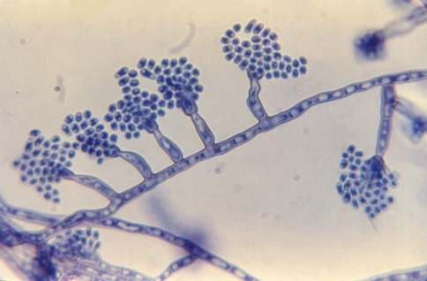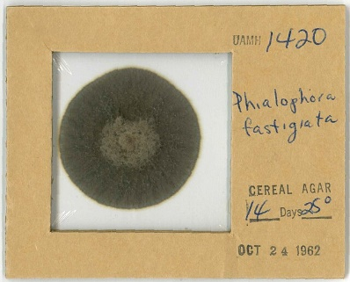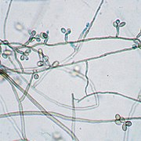
Phialophora fastigiata colony UAMH1420.jpg
Dried colony of Phialophora fastigiata UAMH 1420 on cellophane. Photo by: Medmyco
Creative Commons Attribution-Share Alike 4.0
[[File:Phialophora fastigiata colonyUAMH1420.jpg|Phialophora_fastigiata_colony_UAMH1420]] Wikimedia Commons.
October 24, 1962.

Rhinocladiella mackenziei UAMH 9926.jpg
Slide culture of UAMH 9926, Rhinocladiella mackenzei
Photo: Medmyco. Creative Commons Attribution-Share Alike 4.0
Rhinocladiella mackenziei UAMH 9926.jpg Copy
[[File:Rhinocladiella mackenziei UAMH 9926.jpg|Rhinocladiella_mackenziei_UAMH_9926]]
August 11, 2017. Wikimedia Commons.
22295 Caption: Atf 970X, this photomicrograph revealed ultrastructural morphology exhibited by the fungal organism Phialophora verrucosa. CDC/ Dr. Lucille K. Georg, 1964, public domain, PHIL.

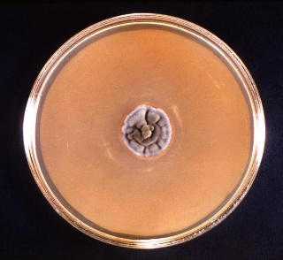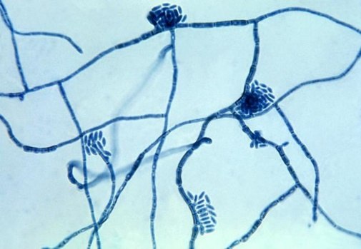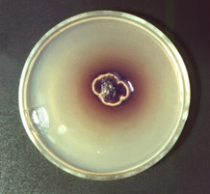
3060 Caption: A culture plate with an unidentified growth medium that was inoculated with Hortaea werneckii, and which subsequently produced this ruffled, velvety gray fungal colony, and viewed here after a 4-weeks. Colonies of H. werneckii are slow-growing, initially mucoid, yeast-like, and shiny black at maturity. It is the causative agent of tinea nigra, a superficial skin infection affecting the stratum corneum in humans. CDC/ Dr. Lucille K. Georg, 1964, public domain, PHIL.
3935 Hortaea-werneckii-fungus--causes-tinea-nigra.jpg: Micrograph of the fungus Hortaea werneckii, which is the causative agent of tinea nigra (photo taken in 1964) CDC/Dr. Lucille K. Georg, 1964. Public domain. [[File:Hortaea-werneckii-fungus]]
Obtained via Wikimedia Commons.

3058 Caption: Thi 1964, s culture plate, which contained an unidentified growth medium, was inoculated with Piedraia hortae and grew this predominantly brown, irregularly shaped colony, surrounded by a yellow tinted edge and a perimeter of a brownish-red halo. CDC/ Dr. Lucille K. Georg. 1964, public domain, PHIL..

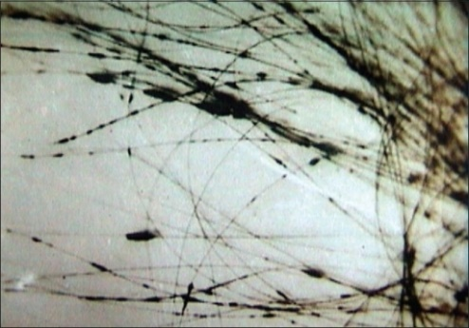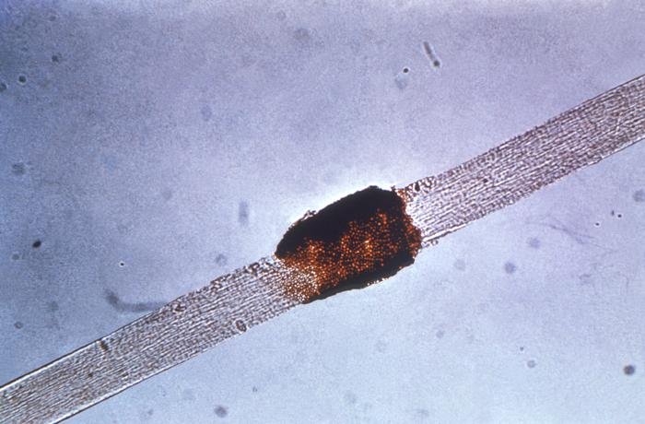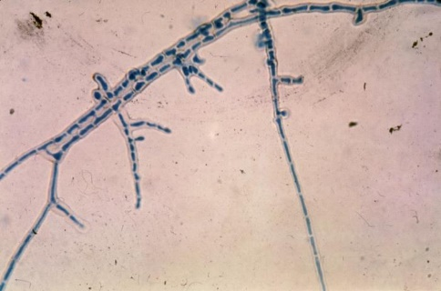
3057Caption: At 475X, this photomicrograph reveals some of the ultrastructural morphology exhibited by the mycelium of the fungal organism, Piedraia hortae. P. hortae, is the causative agent for black piedra, a superficial fungal infection of the hair shaft. Infections are usually localized to the scalp but may also be seen on hairs of the beard, moustache and pubic hair. CDC/ Dr. Lucille K. Georg, 1964. Public domain, PHIL.
Piedra Negra Micosis.png
Nódulos de Piedra negra en el cabello infectado por el hongo Piedraia hortae. https://openi.nlm.nih.gov. Creative Commons Attribution 2.0 [[File:Piedra Negra Micosis.png|Piedra_Negra_Micosis]]
December 4, 2017 Wkimedia Commons.
3937 Caption:Under low power, this photo of a hair shaft revealed some of the histopathologic changes in a hair shaft caused by a condition called black Piedra due to the fungal organism Piedraia hortae. CDC/ Dr. Lucille K. Georg, 1964. Public domain, PHIL.

Piedraia hortae

Piedraia is a dematiaceous filamentous fungus from the soil in tropical areas. The genus Piedraia contains two species: P. hortae and P. quintanilhae. One of the keratinolytic fungi, P. hortae, is the causative agent of black piedra in man. (65) Conversely, P. quintanilhae was isolated from primates in Central Africa, but not much is known about it as a pathogen. We will only discuss Piedraia hortae. (65)

Black piedra is characterized by forming brown to black nodules firmly attached to the hair shaft. The nodules comprise ascostromata, this fungus's fruiting body that contains asci and ascospores. The scalp hair is most frequently infected, but other body hair can be affected. (65) Most cases are asymptomatic and may remain so for years. However, breaks due to hair shaft weakness may eventually occur in severe cases. (65) The infection mainly involves individuals in tropical areas (South America) using oily products for hair care. Co-infections with Piedraia hortae and Trichosporon spp. may occur. (65)

Histopathology and direct testing: A direct KOH prep is most helpful to detect the dematiaceous hyphae wrapped around the hair shaft in brown or black nodules.

Colonial description: Colonies of Piedraia hortae are slow-growing, small, folded, velvety, and dark brown to black. They may remain glabrous or become velvety, covered with short aerial hyphae. (65) Piedraia hortae may produce a reddish-brown diffusable pigment. From the reverse, the colony is black. (65)

Microscopic identification from culture: Septate hyphae, ascostromata, asci, and ascospores can be seen. Hyphae are darkly pigmented and contain many intercalary chlamydospore-like cells. (65) Ascostromata are structures that are subglobose to irregular shape and black. Each usually contains one ascus. Asci are ellipsoid, solitary, or in clumps and contain eight ascospores. Ascus walls dissolve readily. Ascospores are hyaline to darkly pigmented. (65) They are single-celled, fusoid, and curved, and they taper towards both ends to form their typical whip-type appendages. (65)

Rhinocladiella species and Rhinocladiella (formerly Ramichloridium) mackenziei

Rhinocladiella has undergone renaming and has gained former Ramichloridium species. Rhinocladiella now contains six to eight species, five of which are clinically significant: R. aquaspersa, R. atrovirens, R. basitona, R. mackenziei (formerly Ramichloridium mackenziei), and R. similis. (67)

R. mackenziei is a frequently fatal neurotropic organism and appears restricted to individuals residing in, or immigrating from, Middle Eastern countries. (22) R. aquaspersa is associated with chromoblastomycosis. Ramichloridium mackenziei (Ramichloridium mackenziei) is a well-known cause of sinusitis and CNS infection in the Middle East. (67) This organism should be considered an etiological agent in patients referred from this region who manifest signs of either sinusitis or CNS infection.
R. mackenziei is a rare, neurotropic organism that causes fatal brain lesions, mainly in patients who are immunocompromised or suffer from metabolic disease. (67) This species is typically confined to the Middle East, particularly in an arid zone between Israel and Pakistan, with a single autochthonous case in India. Cases in the USA and Europe were found in patients originating from the Middle East. (67)

Histopathology and direct testing: Chronic granulomatous inflammation with histiocytes and multinucleated giant cells are seen on the H&E stain. Further staining with periodic acid-Schiff shows the presence of moderate to darkly pigmented septate hyphae with no yeast formation. In chromoblastomycosis cases, pigmented sclerotic bodies may be seen. (67)

Colonial description: Colonies growing moderately rapidly, velvety, olivaceous-brown. (67)

Microscopic identification from culture: Conidiophores arising at right angles from creeping hyphae, stout, thick-walled, brown, 3.0-4.5 µm wide, 10-25 µm long, apically with short-cylindrical denticles. Conidia brown, ellipsoidal, 8.5-12.0 × 4-5 µm, with a prominent, wide basal scar. (67)

Molecular identification: ITS and D1/D2 sequencing is recommended for accurate species identification. (67)

Fungal Infections of Human Mycoses by Body Site

Superficial Fungal Agents and Dermatophytes

Superficial fungal infections affect your skin, hair, nails, and mucous membranes (such as your mouth, throat, or vagina). (68) Examples of superficial fungal infections include:

Superficial ectopic infections of the skin

Tinea nigra. Caused by Hortae werneckii. For more information, see above molds and see the chapter on yeasts and yeast-like organisms.
Malassezia causes skin infection and discoloration called tinea versicolor (pityriasis versicolor). In rare cases, it can cause fungemia or other fungal disease. See the chapter on yeasts and yeast-like organisms.

Superficial ectopic infections of the hair

Black piedra is a superficial fungal infection of hair shafts that presents with small nodules stuck onto the shaft. It is caused by Piedraia hortae and is characterized by black-colored nodules. Black piedra is common in the tropics, especially in individuals with long hair and poor scalp hygiene. This activity shall discuss the etiology, clinical presentation, differential diagnosis, bedside evaluation methods, and treatment options for this condition pertinent to the interprofessional healthcare team.

White Piedra. White piedra is usually caused by Trichosporon spp., mainly T. cutaneum, T. ovoide, T. asahii, and T. inkin, and is also rarely caused by Acremonium species. In rare cases, Trichosporon asahii (one of the subtypes of fungus that causes white piedra) can also spread to the nails and even the lungs, causing onychomycosis and hypersensitivity pneumonitis.

Candidiasis and yeast infections of mucosal surfaces and skin

Candida (usually Candida albicans and other Candida species or yeast) cause skin and mucous membrane (mucocutaneous) infections, often called candidiasis. These include thrush (oral), some types of diaper rash, vulvovaginitis (vaginal yeast infections), esophageal candidiasis, and candidal intertrigo. (68) For more information, see the chapter on yeasts and yeast-like organisms.

Dermatophytes

The fungi that live off skin, hair, and nail cells are known as dermatophytes and cause various types of ringworm. They can infect your feet (called tinea pedis or athlete's foot), your scalp (called tinea capitis), your hands (called tinea manuum), your groin and inner thighs (called tinea cruris or jock itch), your facial hair and skin around it (called tinea barbae) and other parts of your body (called tinea corporis). See the profiles of dermatophytes below. (68)

Many fungi cause infections of your fingernails or toenails (called onychomycosis). This causes discolored, thickened, cracked, and crumbly nails. (68)

Epidermophyton floccosum

Epidermophyton floccosum has a global distribution that often causes superficial and cutaneous mycoses. It is is an anthropophilic dermatophyte. E. floccosum causes tinea corporis (ringworm), tinea pedis (athlete's foot), tinea unguium (fungal infection of the nail bed, onychomycosis), and tinea cruris (jock itch). It is not known to invade hair in vivo and has no specific growth requirements.

Histopathology and direct testing: A KOH prep is helpful as the skin or nail is dissolved to reveal the hyaline hyphae.

Colonial description: RG-2 organism. Colonies are usually slow-growing, greenish-brown, or khaki-colored with a suede-like surface, raised and folded in the center, with a flat periphery and submerged growth fringe. A deep yellow-brown pigment is usually present. Microscopic morphology shows characteristic smooth, thin-walled macroconidia produced in clusters directly from the hyphae. Chlamydospores are typically formed in older cultures. Microconidia are not formed.

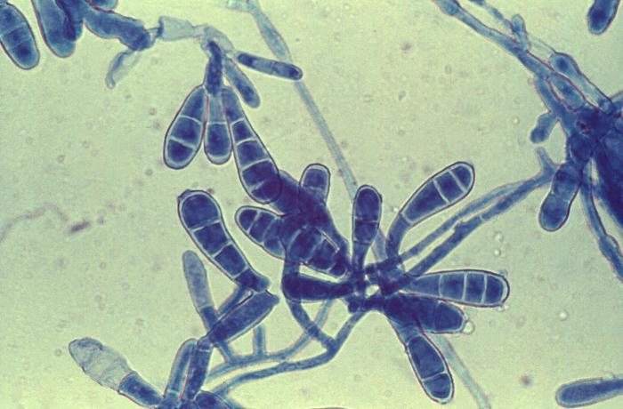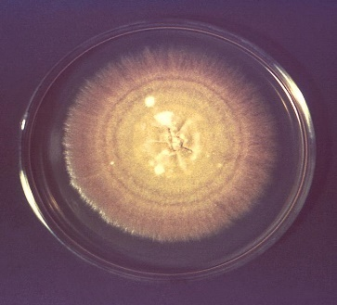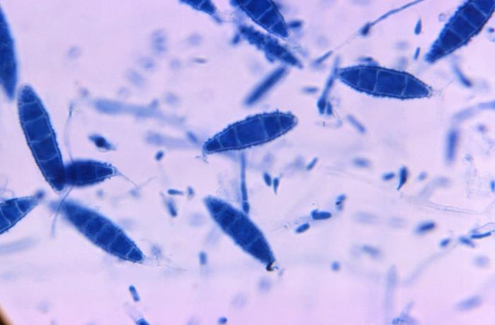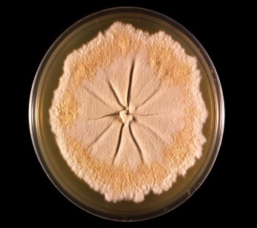
21460 Caption: This photo depicted a culture plate top, which contained an unidentified growth medium inoculated with the dermatophytic fungal organism, Nannizzia gypsea, formerly known as Microsporum gypseum. Note that this colony displayed its characteristic flat, granular surface texture, and a tawny-buff coloration. CDC/ Dr. Libero Ajello, 1966. Public domain, PHIL.

21580 Caption: Under a magnification of 166X, this photomicrograph revealed a number of oblong-shaped macroconidia, of the dermatophytic fungal organism, Nannizzia gypsea, formerly known as Microsporum gypseum. This particular specimen was labeled as strain X-462. CDC/ Dr. Libero Ajello, 1966. Public domain, PHIL.
14590 Caption: This Sabouraud dextrose agar plate was inoculated with Epidermophyton floccosum, and after incubation, gave rise to this single, large colony. E. floccosum colonies are slow growing, greenish-brown, or khaki colored, and exhibit a suede-like surface. E. floccosum is one of the common causes of dermatophytosis, and infects the skin and nails. CDC/ Dr. Lucille K. Georg, 1968. Public domain, PHIL.
14588 Caption: At 475X, this photo reveals a number of macroconidia of the dermatophytic fungus, Epidermophyton floccosum, as well as the organism’s filamentous hyphae. CDC/ Dr. Lucille K. Georg, 1964. Public domain, PHIL.
Nannizzia species

A recent multilocus phylogenetic study has reviewed the taxonomy of the dermatophytes. The genus Nannizzia now consists of 9 species. N. fulva, N. gypsea, N. nana, and N. persicolor were previously in the genus Microsporum. (72) Nannizzia gypsea is a geophilic fungus with a global distribution that may cause infections in both animals and humans, particularly in children and rural workers, during warm, humid weather. (72) It usually produces a single skin or scalp lesion. The invaded hairs show an ectothrix infection but do not fluoresce under Wood's ultra-violet light. The other species rarely cause human diseases. (72)

Histopathology and direct testing: A KOH prep is helpful as the skin or hair is dissolved to reveal the hyaline hyphae.

Colonial description: RG-1 organism. Colonies are mainly cottony to powdery, whitish to brown, with a cream-coloured, brown or red.

Microscopic identification from culture: Macroconidia are 2- or multicelled, hyaline, cylindrical, or clavate to cigar-shaped and smooth-walled. Microconidia are hyaline, 1-celled, ovoidal, pyriform to clavate and smooth-walled. N. gypsea cultures produce abundant, symmetrical, ellipsoidal, thin-walled, verrucose, four to six-celled macroconidia. Most of the macroconidia's terminal or distal ends are slightly rounded, but the proximal ends (point of attachment to hyphae) are truncated. Numerous clavate-shaped microconidia are also present, but these are not diagnostic.

Molecular identification: ITS sequencing is recommended, especially for separating N. gypsea and N. incurvata, which are morphologically similar.

Microsporum species

The genus Microsporum now has these three species: M. canis, M. ferrugineum, and M. audouinii. The remaining species, previously considered Microsporum species that are geophilic and zoophilic, have been transferred to the genera Lophophyton, Nannizzia, and Paraphyton. Lophophyton and Paraphyton rarely cause human disease. Although they are not always present, Microsporum species may form both macro- and microconidia. Cultures are mostly granular or cottony, yellow to brown on the colony top, with a cream-colored or light brown reverse. (71)

Microsporum spp. mainly infect the hair and skin, except for Microsporum persicolor, which does not infect hair. Nail infections are rare. Asymptomatic carriage may be observed. Immunocompromised patients and otherwise healthy hosts are both infected. Macroconidia are hyaline and multiseptate, with thick, rough cell walls. Macroconidia are clavate, fusiform, or spindle-shaped. Microconidia are single-celled, hyaline, smooth, and predominantly clavate in shape.

Histopathology and direct testing: A KOH prep is helpful as the skin or hair is dissolved to reveal the hyaline hyphae.

Colonial description: Microsporum colonies are glabrous, wooly, or powdery. The growth on Sabouraud dextrose agar at temperatures below 30°C may be slow to rapid, and the width of the colony varies between 1 to 9 cm after seven days of incubation. (71) The colony color varies depending on its species. It may be white, beige, yellow, or cinnamon. On the colony reverse, it may be yellow to red-brown due to pigments. (70) Strains of M. canis often do not sporulate to produce macroconidia and microconidia on primary isolation media. Subcultures onto polished rice grains or lacrimal agar are recommended to stimulate sporulation. These nonsporulating strains of M. canis are often erroneously identified as M. audouinii. (70) Surprisingly, many laboratories have difficulty differentiating M. canis and M. audouinii. The hair perforation test, the ability to grow on rice grains, and the growth at 37°C provide helpful hints to differentiate the Microsporum spp. from each other. (70)

Microscopic identification from culture: Microsporum spp. produce septate hyphae, microconidia, and macroconidia. Conidiophores are hyphae-like. Microconidia are unicellular, solitary, oval to clavate in shape, smooth, hyaline, and thin-walled. (70) Macroconidia are hyaline, echinulate to roughened, thin- to thick-walled, typically fusiform (spindle-shaped), and multicellular (2-15 cells). They often have an annular frill. (70) Inoculation onto specific media, such as potato dextrose agar supplemented with 3 to 5% sodium chloride, may be helpful in stimulating macroconidia production of some strains. (70, 71) As discussed on separate pages for each species, variations in the shape of macroconidia and abundance of microconidia help in inter-species differentiation.

Molecular identification: ITS sequencing is recommended. (71)

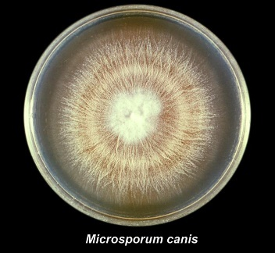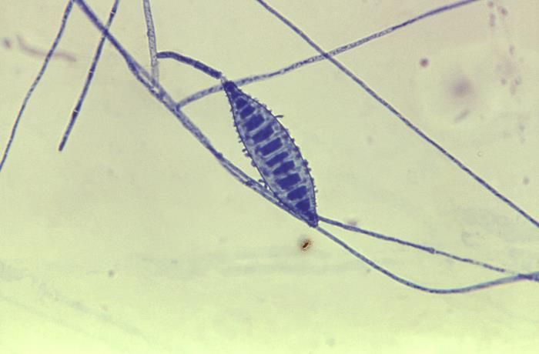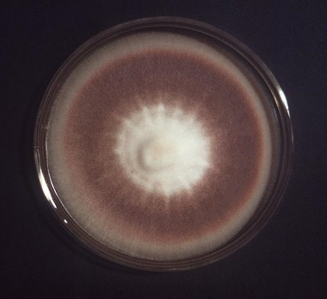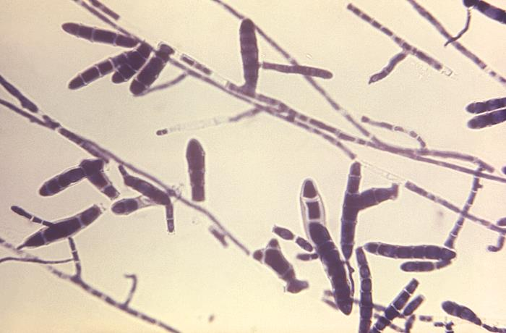
22030 Caption: This photo depicted a view of a Microsporum canis, strain A-638, viewed from the front, which revealed its characteristic, cream-colored surface that was streaked with numerous radial grooves emanating from the colony’s center. The colony had been cultivated on a growth medium of Sabouraud dextrose agar for a 3-week period. CDC/ Dr. Lucille K. Georg, 1964. Public domain, PHIL.
16018 Caption: This photograph depicted a frontal view of a Petri dish that contained the growth medium Sabouraud dextrose agar, with Trichophyton rubrum, had been cultured. Revealed is the colonial morphology, which in this case exhibited a texture that was glabrous, though fuzzy. Its frontal coloration ranged from a white central region, to a brown, rust colored mid-region, to a beige periphery. CDC/ C. Papageorge, 1976. Public domain, PHIL.
16027 Caption: At 474X, this photomicrograph revealed some of the ultrastructural morphology exhibited by the dermatophytic fungal organism, Trichophyton rubrum, strain A-600. Of importance were the large, atypically swollen forms of the multicellular macroconidia. Referred to as mitospores, for these reproductive structures are born out of the process of mitosis, and are therefore, haploid when they reach maturity. CDC/ Dr. Lucille K. Georg, 1970, Public domain, PHIL.
22255 Caption: At 475X, this photo revealed some of the ultrastructural morphology exhibited by a macroconidium of the fungus, Microsporum canis. Of note, was the spindle-shape of this reproductive structure, and its roughened surface. CDC/ Dr. Lucille K. Georg, 1964. Public domain, PHIL.

Trichophyton species

DNA sequences now delineate phylogenetic relationships, so species concepts in Trichophyton have changed. Sixteen species are now in the genus. (73) The genus Trichophyton has several species. Most common are T. mentagrophytes, T. rubrum, T. schoenleinii, T. tonsurans, T. verrucosum, and T. violaceum. (74) Trichophyton is one of the dermatophytes that inhabit the soil, humans, or animals. Trichophyton includes anthropophilic, zoophilic, and geophilic species. (74) Some species are global, while others have a restricted geographic distribution. Trichophyton concentricum, for example, is endemic in the Pacific Islands, Southeast Asia, and Central America. Trichophyton is a leading cause of skin, hair, and nail infections in humans. (74)
Several morphological and physiological characteristics are used to differentiate and identify the Trichophyton species. Trichophyton, Microsporum, Nannizzia, and Epidermophyton are the causative agents of dermatophytosis. They infect the hair, skin, and nails. Like the other three genera, Trichophyton is a keratinophilic filamentous fungus. The major virulence factor of these fungi is the ability to invade keratinized tissues because they possess several enzymes, such as acid proteinases, elastase, keratinases, and other proteinases.

Trichophyton rubrum is the most common cause of dermatophytoses globally. ( 74) Some Trichophyton species may also cause invasive infections in immunocompromised hosts.

Histopathology and direct testing: A KOH prep is helpful as the skin, hair, or nail is dissolved to reveal the hyaline hyphae. Septate, branched hyphae that become chains of arthroconidia are observed. (74)

Colonial description: The growth rate of Trichophyton colonies is slow to moderately rapid. The texture is waxy, glabrous to cottony. The color is white to bright yellow, beige, or reddish-violet from the colony top. The colony reverse is pale, yellowish, brown, or reddish-brown. (74)

Microscopic identification from the culture: The genus Trichophyton is characterized morphologically by smooth-walled macro- and microconidia development. Macroconidia are borne laterally directly on the hyphae or short pedicels and are clavate or fusiform, and they range from 4-8 x 8-50 μm. Macroconidia are few or absent in many Trichophyton species. (73) Microconidia are round, pyriform to clavate, or irregular in shape, ranging from 2-3 x 2-4 μm. (73) The presence of microconidia differentiates Trichophyton from E. floccosum, and the smooth-walled, mostly sessile macroconidia differentiates Trichophyton from Lophophyton, Microsporum, Nannizzia, and Paraphyton. In practice, two groups may be recognized on direct microscopy:

i. Those species that usually produce microconidia where macroconidia may or may not be present: T. rubrum, T. interdigitale, T. mentagrophytes, T. tonsurans, T. equinum, T. erinacei, and to a lesser extent T. verrucosum, which may occasionally produce conidia on some media. The microconidia's shape, size, and arrangements are the most helpful characteristics for identification. Culture and growth characteristics are also helpful.

ii. Those species that usually do not produce any microconidia or macroconidia. Chlamydospores or other structures in the hyphae may be seen but are not helpful for identification: T. verrucosum, T. violaceum, T. schoenleinii, T. concentricum, and T. soudanense. Culture and growth results and some clinical information, such as the site, lesion appearance, location, travel history, animal contacts, and even the occupation, may be helpful for identification.

Additional media and confirmatory tests can help to differentiate between the Trichophyton species, especially isolates of T. rubrum, T. tonsurans, and T. mentagrophytes. Various sporulation media, Sabouraud's agar with 5% Salt, bromocresol purple-dextrose agar (BCP), 1% peptone agar, urea, Trichophyton agars 1-5, and a hair perforation test can be helpful.

Molecular identification: ITS and EF-1α sequencing are recommended for species identification. MALDI-TOF MS: Methods require a good sequence database.

Fungal agents of keratitis

Fungal keratitis is an infection of the eye's cornea with a fungal organism. Fungal keratitis can develop quickly from an eye injury or incorrect contact lens use. If it is not treated, it can cause blindness. Sometimes, treatment cannot restore vision, and permanent vision impairment or blindness may result. Different fungi such as Fusarium, Aspergillus, or Candida can infect the cornea. Superficial keratitis involves the outer layer of the cornea. After this form of keratitis heals, the cornea usually has no scar. Deep keratitis affects the inner layers of the cornea, which can result in a scar on the cornea after healing, which may or may not affect your vision, depending on the scar's location.

Otomycosis

Fungal ear infections affect your outer ear — most often, your ear canal. It happens when funguses (such as Aspergillus and Candida) grow and spread in your ear. Because funguses thrive in warmer temperatures, fungal ear infections are most common during hotter months. These infections usually don't go away without treatment.

Fungal Agents of the respiratory tract

Upper respiratory tract: The mouth and throat are affected mainly by Candida albicans for fungal infections.

Sinuses: Fungal rhinosinusitis is a sinus infection from a fungus. Several different types of fungal sinus infections have similar symptoms. These include nasal congestion and sinus pain (in the cheeks, forehead, and between the eyes). Fungal sinus infections are caused by the overgrowth of fungi in the sinuses. Different fungal sinus infections include fungus balls, allergic fungal sinusitis, saprophytic fungal sinusitis, and invasive fungal sinusitis. The symptoms of a fungal sinus infection may consist of nasal congestion and inflammation, nasal polyps, headache and facial pain, fever and chills, vision problems, and eye and face swelling. Invasive fungal sinusitis can be caused by Aspergillus spp., Candida spp., Rhizpus spp., or Mucor spp. As you can read above a variety of molds can infect the sinuses, dematiaceous and hyaline.

Most cases of fungal sinusitis are treated with sinus surgery, and some forms may require additional antifungal therapy. However, people with healthy immune systems may not need treatment, and some fungal sinus infections clear up without intervention.
People with conditions that weaken the immune system (such as leukemia, lymphoma, or diabetes) are much more likely to get fungal sinusitis and have a higher risk of complications. Some fungal sinusitis infections destroy the lining of the nose and can then spread to the brain and even lead to death.

Lower respiratory tract (Bronchial/ Lung): Pathogenic fungi, such as Cryptococcus neoformans (Cn), Aspergillus (Ap), Pneumocystis (Pc), and Endemic fungi (Ef), cause pulmonary infection in human models. Fungal pathogens could trigger the host immune response upon inhalation, and lung tissue is the primary infectious target of these pathogens. Aspergillus and Cryptococcus are the most significant fungal pathogens in lung infections.

Aspergillus is one of the most frequent fungal species that sporulates in the lungs from airborne floating conidia. These spores in the air are tiny enough, at only 2 to 3 μm, to float and to get through the defenses of the human airways and into the pulmonary alveoli. There, they cause a spectrum of diseases that include lethal aspergillosis infection for primarily immune-deficient individuals and asthma allergies in atopic patients. In healthy individuals, inhaled conidia are usually phagocytized by alveolar macrophages and killed in an oxidized-lytic fashion in phagocytosis. In immunocompromised hosts, incomplete killing of the inhaled conidia results in their germination and lung tissue invasion by the resulting
mold growth.

Cryptococcosis is caused by exposure to the yeast in the lung after the airborne yeast is inhaled. As a species of Cryptococcus, C. neoformans has a global distribution, like Aspergillus, particularly in soil and in areas of avian habitation. The most severe aspect of infection with Cryptococcal infection is cryptococcal meningitis. C. neoformans and Cryptococcus gattii can spread from the lungs and invade the brain by crossing the blood-brain barrier. Fungal cells can directly penetrate the barrier by using endothelial cells in the blood vessels around the brain, using a "Trojan horse" method similar to transporting white blood cells across the vessel wall. Large-scale colonization and tissue injury can occur despite the host's defense mechanisms.

Pneumocystis pneumonia (PJP) is induced by fungal pathogens of the genus Pneumocystis, like Pneumocystis jirovecii. P. jirovecii is the most common AIDS-defining disease and is also found in non-HIV patients with an adaptive immunity deficiency or in patients taking prolonged high-dose glucocorticoids. Research continues in the development of vaccines and other treatments for PCP, with the current therapeutic strategy being to give trimethoprim-sulfamethoxazole. However, there are currently no vaccines in clinical trials to prevent PJP. There are significant obstacles to new therapies, such as the inability to culture Pneumocystis spp. in vitro.

Endemic dimorphic fungi that cause endemic mycoses usually occur in specific geographic areas and can result in severe and fatal infections. These pathogens can infect both immune-competent hosts and immunocompromised hosts. In immunodeficient patients, endemic mycoses can cause a more severe and disseminated disease, resulting in higher mortality. The increased incidence of endemic mycoses often correlates with an increasing population of immunodeficient patients. With these fungal diseases, mortality is also high in non-immunocompromised hosts. In North America, three primary endemic mycoses, including coccidioidomycosis, histoplasmosis, and blastomycosis, can present as community-acquired pneumonia. For coccidioidomycosis, half of the infected people are asymptomatic because an acute infection resembles common respiratory symptoms of a cold or bronchitis. Only a few cases develop into disseminated disease. Histoplasmosis, caused by the infectious agent Histoplasma capsulatum, is considered a community-acquired infection with an exposure history to soil containing bat or bird droppings. Most patients also present with pneumonia symptoms described as acute or chronic pulmonary histoplasmosis. Some severe cases may culminate in respiratory failure and, occasionally, death. Blastomycosis is less common than histoplasmosis and coccidioidomycosis. Additionally, paracoccidioidomycosis is geographically distributed predominantly in Latin America, where Brazil largely accounts for most of the reported cases.

Fungal Agents of Urinary Tract Infections

Most fungal kidney and bladder infections result from Candida albicans, other Candida species, and other yeasts. However, a variety of different fungi can rarely involve the kidney as a result of serious disseminated disease. These include: Aspergillus species, Fusarium species, Trichosporon species, Mucorales (e.g., Rhizopus and Mucor species), Cryptococcus spp., the endemic mycoses, and a variety of dematiaceous molds.

Table 3-1 The Most frequent culture sites for the various mycoses of medical importance
Infection | Respiratory | Skin | Subcutaneous Tissue | Blood | Bone marrow | Bone | Urinary | CSF
Blastomycosis | + | + |  | +/- |  | + |  | +
Coccidiomycosis | + | + ~15-67%⁸⁴ |  | +/- |  |  |  | +
Emergomycosis | + | + |  | +/-
Histoplasmosis | + | +/- ~5-10%⁸³ |  | + | + |  |  | +
Paracoccidiomycosis | + | + |  | +/-
Talaromycosis | + | + |  | +/-
Cryptococcosis | + | + ~10-15%⁸¹ |  | +/- |  |  | +/- | +
Invasive Aspergillosis | + | + ~5-10%⁸²
Invasive Candidiasis | + | + ~10%⁸¹ |  | + ~70% of fungemia, higher with other yeasts⁸¹ |  |  | + | +
Sporotrichosis |  | + | + |  |  | +/-
Chromoblastomycosis |  | + | +
Eumycotic mycetoma |  | + | +
Actinomycetoma |  | + | +
Phaeohyphomycosis |  | + | +
Key: + = This site is frequently involved in this mycosis and is often cultured.
+/- = This site is involved in a small to moderate percentage of these mycoses and is cultured fairly often
Remember, other sites, even if not marked can sporadically be involved in these mycoses and may need to be cultured. These are all rough estimates and to give you an idea of what you might see.

Fungal Agents of Subcutaneous Mycoses, Bone and Joint Infections, Miscellaneous Sites

You can get a fungus under the surface of your skin (subcutaneous) that causes infection (subcutaneous mycosis). This happens frequently when the fungus gets into a cut or wound, usually through an injury while working with plants (like a puncture by a barb or thorn). These infections cause lesions, rashes, and signs of skin infection. More of these types of infections occur in tropical and subtropical areas where the fungal agents grow and form reservoirs for disease. Sporothrix shenckii and a few others also have sporadic cases in temperate regions because the fungus is present worldwide despite growing better in tropical and subtropical areas. Examples of subcutaneous mycoses include:

Sporotrichosis (rose gardener's disease). Sporothrix causes sporotrichosis. It is usually local around the puncture site but can extend into areas of bone and joints nearby. From there, it can disseminate through the blood and spread to other tissues and organs. You can also get sporotrichosis in your lungs or other body parts, especially from disseminated infection with this fungus.

Chromoblastomycosis- Many different fungi can cause chromoblastomycosis, which can cause long-lasting (chronic) deep skin infections. It rarely spreads to other parts of the body. The most common fungi are Cladosporium carrionii, Phialophora verrucosa, and Fonsecaea pedrosoi. Less common pathogens are Fonsacea compactum, Rhinocladiella aquaspersa, Exophiala jeanselmei, and other Exophiala spp.

Mycetoma-Mycetoma is an infection in the skin and subcutaneous tissues. It primarily affects the feet but can also affect the hands, shoulders, abdomen, and buttocks. Scalp infections are also reported. Mycetoma is a gradually progressive disease, and after the initial infection, it may take a year to form the characteristic lesions. These lesions are painless, localized, hard subcutaneous nodes. The infection spreads and destroys surrounding tissues but does not affect tendons or nerves. Mycetoma is also called Madura Foot or Maduramycosis. Mycetoma is classified based on causative agents, the color of grains, and geographical areas. Eumycetoma: Mycetoma is caused by fungi. Depending on the fungus involved, it is associated with both black granule and white granule mycetoma. Actinomycetoma: Mycetoma is caused by bacterial actinomycetes. It is related to white or pale-grain mycetoma.

Fungal agents of other deep infections of the body systems or tissues or from wounds, abscesses or from a resulting fungemia

Deep fungal infections are found in places other than the skin, like the lungs, blood, urinary tract, and brain. Some are opportunistic infections, which usually cause disease in people with immune system deficits but can affect regular patients. These infections can disseminate throughout the body via the blood and cause fungemia (fungus in the blood).

Deep or invasive fungal infections include:

- Histoplasmosis is commonly found in the river basin areas of the Ohio and Mississippi Rivers. The fungus Histoplasma causes histoplasmosis, which can infect the lungs, brain, or other body parts. (76)

- Coccidioidomycosis (Valley fever) is endemic in the American Southwest. Caused by the fungus Coccidioides, it can infect the lungs and rarely spread to other body parts. It's most commonly seen in Arizona and California.

- Blastomyces, the fungus that causes blastomycosis, most commonly infects your skin, bones, and lungs. Rarely, it can also infect your brain and spinal cord. (76)

- Aspergillus, the mold that causes aspergillosis, causes several lung diseases, including allergic bronchopulmonary aspergillosis (ABPA) and chronic pulmonary aspergillosis. It can infect other body parts or form an aspergilloma (fungus ball). (76)

- Urinary tract infections with Candida species and other yeasts cause deep infections. Bacteria cause the vast majority of urinary tract infections (UTIs), but some are caused by yeasts, such as Candida species, especially C. albicans, and other yeasts and yeast-like organisms. (76, 77)

- Invasive candidiasis. Various Candida species, especially C. alibicans, cause invasive candidiasis. They can colonize intravenous lines and cause fungemia. These yeasts can infect your heart, blood (candidemia, fungemia), brain, eyes (endophthalmitis), bones, or other body parts, as can some other yeast species. (76)

- Pneumocystis jirovecii (previously species caronii) pneumonia (PJP-formerly PCP). This fungus, Pneumocystis jirovecii, can infect your lungs and cause Pneumocystis jirovecii pneumonia (PJP). It was an enormous problem for HIV-positive patients before treatment, but it can also infect non-HIV patients. Fungemia is very rare with P. jirovecii. (76)

- A group of molds called mucormycetes, or Mucorales, known by the older name zygomycetes, cause mucormycosis. Mucormycetes can infect your nasal sinuses and brain (rhinocerebral mucormycosis), lungs (pulmonary mucormycosis), skin (cutaneous mucormycosis), intestines (gastrointestinal mucormycosis), or many other body sites at the same time (disseminated mucormycosis). (76)

- Cryptococcus neoformans and Cryptococcus gattii cause cryptococcosis. Cryptococcus usually infects your lungs but sometimes can disseminate and infect your brain and spinal cord and cause cryptococcal meningitis. (76)

Direct Tests that might help with earlier detection of the fungal agents causing deep invasive fungal disease include the (1-3)-β-d-Glucan (BDG) serum and the glucomannan test. BDG is found in cell walls of most fungi (e.g., Aspergillus, Candida, Fusarium, Pneumocystis jirovecii) with the notable exceptions of the Cryptococcus species, the Blastomyces species, and the Mucorales (e.g., Lichtheimia, Mucor, Rhizomucor, and Rhizopus), which either lack BDG or produce it in extremely low amounts. Elevated serum levels of BDG have been associated with a fungal infection with pathogens containing BDG, e.g., Aspergillus, Candida, Fusarium, Pneumocystis jirovecii. The BDG serum levels may be detected before the patient's symptoms and before isolation or identification of the fungus via routine lab methods. A positive glucomannan test result supports a diagnosis of invasive aspergillosis (IA). Positive results should be considered with other diagnostic procedures, such as microbiologic culture, histological examination of biopsy specimens, and radiographic evidence.

Fungi found in cerebrospinal fluid

Cerebrospinal fluid should be concentrated before processing in the medical laboratory. It can e centrifuged and a direct India ink prep made to look for Cryptococcus spp. If there is more than 5ml of the spinal fluid for culture, it can filtered through a 0.45 µm sterile filter and portions of the filter can then be cultured to increase the likelihood of finding a fungus by the concentration of the sample. Other body fluids can also be concentrated in this manner.

Fungal species associated with meningitis include Cryptococcus spp., the dimorphic fungi if they disseminate such as
Histoplasma, Blastomyces, Coccidioides, and Candida species. (75) A variety of other molds such as Aspergillus spp., Fusarium spp., Scedosporium spp., and a variety of dematiaceous fungi such as Rhinocladiella spp., and Cladophialophora spp. and others are isolated in rare cases especially, but not exclusively, in the immunocompromised as discussed above.

Mold-like Bacteria of Medical Importance

Actinomyces species

Actinomycosis is a rare bacterial infection that causes pus-filled areas (abscesses) surrounded by lumpy tissue. You get it from infection with the anaerobic bacteria of the genus Actinomyces. Actinomyces live naturally in your body without harming you in the mucous membranes of your mouth and GI tracts. But surgery, injury, or disease can cause them to grow in places they don't belong. (78)

Actinomycosis spreads slowly into nearby tissues, usually causing a long-lasting, tunneling wound (an opening underneath your skin). The wound is filled with yellowish pus and "sulfur granules." Sulfur granules are clumps made up of immune cells and parts of the bacteria. (They don't contain sulfur — the name comes from the yellow color.) Actinomycosis can sometimes take weeks or months to cause symptoms after the infection starts.

Actinomyces most commonly infect areas around your mouth and face. But you can also get actinomycosis in other parts of your body. Healthcare providers refer to the type of actinomycosis by the infected part of your body. Cervicofacial actinomycosis affects the face, mouth, nose, neck, and jaw. It's sometimes called "lumpy jaw." Thoracic or pulmonary actinomycosis affects your lungs or chest. Abdominal actinomycosis affects your intestines or other abdominal organs. Uterine or pelvic actinomycosis affects your pelvic area and reproductive organs. (78)

Symptoms of actinomycosis depend on where you're infected. They include fever, weight loss, bumpy, fluid-filled areas on your neck, jaw, face, or mouth (cervicofacial infection), pain when you chew or severe jaw tightness (infection in your mouth or jaw), chest pain (lung infection), abdominal pain (pelvic or abdominal infection), vaginal bleeding or discharge (pelvic infection). Since Actinomyces grow slowly, symptoms might not develop for months or years after the surgery or illness that started the infection. (78)

Actinomyces israelii bacteria are the most common cause of actinomycosis. But many other Actinomyces spp. can also cause it, including A. naeslundii, A. odontolyticus, A. viscosus, A. gerencseriae, and others. Most of the time, Actinomyces live in specific mucous membranes, like your throat, intestinal tract (gut) and vagina. They're among thousands of bacteria that live on or in your body without harming you. But if they get into a place they shouldn't be, they'll start reproducing and cause an infection. (78)

You get actinomycosis when Actinomyces bacteria get into parts of your body where they don't belong. For instance, surgery, injury, or certain diseases can cause a break in a mucous membrane that allows the bacteria to infect part of your body where they don't usually live. Foreign objects in mucous membranes can also allow bacteria to grow. The most common way to get actinomycosis is through gum disease or dental procedures. Other causes include intrauterine devices (IUDs), getting food, liquids, or a foreign object into your lungs (aspiration), abdominal diseases like appendicitis, diverticulitis, or peptic ulcer disease, gallbladder removal (cholecystectomy), colectomy, or another surgery in your abdominal cavity. (78)

Actinomycosis is an infection with anaerobic Actinomyces bacteria. It is a gram-positive rod that is thin, branching, fragmented, and sometimes coccobacillary in form, with no spores. It can be grown in anaerobic culture from patient specimens and identified with traditional bacteriological techniques, nucleic acid methods, or Maldi-Tof mass spectrophotometry. It causes pus-filled wounds around the face and mouth that slowly spread to nearby tissue. It's usually caused by dental disease or surgery, but abdominal surgeries, aspiration, and IUDs can also cause it. Providers treat it with high doses of antibiotics over several months. (78)

Nocardia species

Nocardiosis is a disease caused by a type of aerobic bacteria called Nocardia, which is found in the environment. It's typically found in standing water, decaying plants, and soil. Nocardia and related bacteria are considered opportunistic. They infect people and animals when they have the right conditions. They can cause severe infections in people with weakened immune systems who have difficulty fighting off infections. People with cancer or those taking certain medications like steroids could have weakened immune systems. (79)

If someone breathes in dust that contains the bacteria, soil, or water carrying Nocardia bacteria, or it gets under the skin through a cut, or a hospitalized patient gets the bacteria in their surgery wound via contaminated medical equipment, the patient can acquire Nocardiosis. (79) Nocardiosis can first appear in the body as a skin or lung infection. It can also occur as an infection that has spread throughout the body (disseminated disease). In the United States, Nocardiosis most often manifests as a lung infection. No matter the cause, Nocardiosis must be treated to prevent its spread to other body sites, including the spinal cord and brain. (79)

The brain is the most common site of disseminated infection. More than eight in ten patients die after developing Nocardiosis of the brain or spinal cord. The risk of death is much higher for patients with fragile immune systems. (79)

Talk to your doctor if you have an injury that won't heal or have nocardiosis symptoms. It would help if you also told your doctor how you were wounded. Your doctor can determine if you have Nocardiosis by performing tests that look for these bacteria. Nocardia are branching, filamentous, gram-positive rods. They may exhibit a beaded appearance due to irregular staining. They are partially acid-fast using a Modified Kinyoun's stain. Nocardia can be identified with traditional bacteriological techniques, nucleic acid methods, or Maldi-Tof mass spectrophotometry. Your healthcare provider may need to take samples from an infected part of your body, such as your lungs, mucus from the lower airways, skin, or even brain tissue. (79)
Invasive pulmonary aspergillosis (IPA) in a neutropenic patient- A Case Study
INTRODUCTION: This is a case of invasive pulmonary aspergillosis (IPA) in an immunodeficient patient, along with their diagnostic results that include serum Aspergillus marker tests, computed tomography imaging, and bronchoalveolar lavage fluid testing and culture. The patient had recently been diagnosed with chronic lymphocytic leukemia and was treated with Chlorambucil-based therapy.
CASE: A 72-year-old patient, now non-compliant with therapy, presented with acute nonspecific symptoms of malaise, mild productive cough, hemoptysis, and subjective fever with chills, without chest pain. He had recently visited a local health clinic before this visit and, importantly, was not diagnosed with aspergilloma. During this hospitalization, his low-grade intermittent fever was resistant to empirical broad-spectrum antibiotic therapy. He was noted to have marked neutropenia with a WBC count of 3,500/µL and a neutrophil count of 475/µL. Imaging studies revealed the presence of a thick-walled cavitary type mass at the right lung apex with centrilobular nodes consistent with aspergilloma, with ground glass opacities around an alveolar infiltrate, consistent with the "Halo Sign" of invasive pulmonary aspergillosis. Tuberculosis was ruled out. Serum Aspergillus BDG and galactomannan tests were positive. Bronchoscopy was performed, and the bronchoalveolar lavage revealed a brown to black fluid with suspended black particles, and the fluid analysis revealed high Aspergillus titers. Microbiology cultures grew aspergillus fumigatus from a BAL fluid specimen. The patient decided to refuse antifungal treatment with voriconazole and left the emergency department against medical advice.
Follow-up calls revealed that the patient had expired twelve days later.
DISCUSSION: This patient's initial diagnosis of invasive aspergillosis presents some diagnostic challenges. A definitive identification of Aspergillus species requires culture from a normally sterile site and demonstration of fungal hyphae invasion in histology tissue samples. The diagnostic approach for patients with initial findings suspicious for aspergillosis involves non-invasive testing, such as fungal serum biomarkers, imaging studies, and fungal cultures, followed by invasive surgical procedures, such as bronchoscopy and, in some cases, biopsy.
Despite advances in combatting neutropenia through neutrophil stimulation drugs such as Neupogen and other similar biological products, none of that matters if the patient is non-compliant. Suspicion for aspergillosis in immunodeficient patients presenting with nonspecific pulmonary symptoms should remain high, especially considering the risk of high mortality from aspergillosis. Physicians should be alert to the possibility of invasive fungal infections in high-risk patients and be able to initiate antifungal therapy as soon as possible for a more favorable resolution.
References:
- Riina Rautemaa-Richardson, Malcolm D. Richardson, Systemic fungal infections. Medicine, Volume 45, Issue 12, 2017, Pages 757-762. ISSN 1357-3039. https://doi.org/10.1016/j.mpmed.2017.09.007.
(https://www.sciencedirect.com/science/article/pii/S1357303917302475)
- Firacative C. Invasive fungal disease in humans: are we aware of the real impact? Mem Inst Oswaldo Cruz. 2020 Oct 9;115:e200430. doi: 10.1590/0074-02760200430. PMID: 33053052; PMCID: PMC7546207.
- Sarah Kidd, Catriona Halliday, Helen Alexiou. DESCRIPTIONS OF MEDICAL FUNGI – third edition, revised November 2017. PDF Free Download. http://healthdocbox.com/Allergies/84244870-Descriptions-of-medical-fungi.html
- Unknown 8 | Mycology | University of Adelaide. https://www.adelaide.edu.au/mycology/mould-identification-a-virtual-self-assessment/unknown-8
- Zerbato V, Di Bella S, Pol R, D'Aleo F, Angheben A, Farina C, Conte M, Luzzaro F; Gianluigi Lombardi on behalf of the AMCLI Mycology Committee; Luzzati R, Principe L. Endemic Systemic Mycoses in Italy: A Systematic Review of Literature and a Practical Update. Mycopathologia. 2023 Aug;188(4):307-334. doi: 10.1007/s11046-023-00735-z. Epub 2023 Jun 9. PMID: 37294504; PMCID: PMC10386973.
- Randhawa HS, Chowdhary A, Kathuria S, Roy P, Misra DS, Jain S, Chugh TD. Blastomycosis in India: a case report and current status. Med Mycol. S1;2012: 185-192.doi: 10.3109/13693786.2012.68596
- Kaplan M, Zhu Y, Kus JV, McTaggart L, Chaturvedi V, Chaturvedi S. Development of a Duplex Real-Time PCR Assay for the Differentiation of Blastomyces dermatitidis and Blastomyces gilchristii and a Retrospective Analysis of Culture and Primary Specimens from Blastomycosis Cases from New York (2005 to 2019). J Clin Microbiol. 2021 Feb 18;59(3):e02078-20. doi: 10.1128/JCM.02078-20. PMID: 33298609; PMCID: PMC8106702.
- Sidamonidze K, Peck MK, Perez M, Baumgardner D, Smith G, Chaturvedi V, Chaturvedi S. Real-time PCR assay for identification of Blastomyces dermatitidis in culture and in tissue. J Clin Microbiol. 2012 May;50(5):1783-6. doi: 10.1128/JCM.00310-12. Epub 2012 Mar 7. PID: 22403418; PMCID: PMC3347106.
- Morjaria S, Otto C, Moreira A, Chung R, Hatzoglou V, Pillai M, Banaei N, Tang YW, Figueroa CJ. Ribosomal RNA gene sequencing for early diagnosis of Blastomyces dermatitidis infection. Int J Infect Dis. 2015 Aug;37:122-4. doi: 10.1016/j.ijid.2015.06.017. Epub 2015 Jun 28. PMID: 26129971.
- Unknown 34 | Mycology | University of Adelaide. https://www.adelaide.edu.au/mycology/mould-identification-a-virtual-self-assessment/unknown-34
- https://www.adelaide.edu.au/mycology/mycoses/dimorphic-systemic-mycoses#coccidioidomycosis
- Samaddar, A., & Sharma, A. (2021). Emergomycosis, an Emerging Systemic Mycosis in Immunocompromised Patients: Current Trends and Future Prospects. Frontiers in Medicine. https://doi.org/10.3389/fmed.2021.670731
- Emergomyces | Mycology | University of Adelaide
- https://www.adelaide.edu.au/mycology/fungal-descriptions-and-antifungal-susceptibility/dimorphic-fungal-pathogens#histoplasma-capsulatum
- Guarner J, Brandt ME. Histopathologic diagnosis of fungal infections in the 21st century. Clin Microbiol Rev. 2011 Apr;24(2):247-80. doi: 10.1128/CMR.00053-10. PMID: 21482725; PMCID: PMC3122495.
- https://www.adelaide.edu.au/mycology/fungal-descriptions-and-antifungal-susceptibility/dimorphic-fungal-pathogens#paracoccidioides-brasiliensislutzii-
- Unknown 33 | Mycology | University of Adelaide. https://www.adelaide.edu.au/mycology/mould-identification-a-virtual-self-assessment/unknown-33 (Sporothrix)
- Subcutaneous Mycoses | Mycology | University of Adelaide. https://www.adelaide.edu.au/mycology/mycoses/subcutaneous-mycoses
- Patrick Emanuel. Sporotrichosis pathology, 2013. DermNet. https://dermnetnz.org/topics/sporotrichosis-pathology
- Talaromyces marneffei | Mycology | University of Adelaide. https://www.adelaide.edu.au/mycology/fungal-descriptions-and-antifungal-susceptibility/hyphomycetes-conidial-moulds/talaromyces
- Vilela R, Mendoza L2018.Human Pathogenic Entomophthorales. Clin Microbiol Rev 31:10.1128/cmr.00014-18.https://doi.org/10.1128/cmr.00014-18
- Groll AH, Walsh TJ. Uncommon opportunistic fungi: new nosocomial threats. Clin Microbiol Infect. 2001;7 Suppl 2:8-24. doi: 10.1111/j.1469-0691.2001.tb00005.x. PMID: 11525222.
- Knowledge Base Archive - Page 19 of 19 - Doctor Fungus. https://drfungus.org/knowledge-base/page/19/
- Absidia Species - Doctor Fungus. https://drfungus.org/knowledge-base/absidia-species/
- Schwarz P, Bretagne S, Gantier JC, Garcia-Hermoso D, Lortholary O, Dromer F, Dannaoui E. Molecular identification of zygomycetes from culture and experimentally infected tissues. J Clin Microbiol. 2006 Feb;44(2):340-9. doi: 10.1128/JCM.44.2.340-349.2006. PMID: 16455881; PMCID: PMC1392659.
- https://drfungus.org/knowledge-base/mucor-species/
- https://drfungus.org/knowledge-base/rhizomucor-species/ .
- Barbara J. Howard. Clinical and Pathogenic Microbiology, 2nd Ed., 1994. Mosby, p. 552
- Kern, M. and Blevins, K. Medical Mycology, 2nd ed. 1997. Module 3. F.A. Davis.
- https://drfungus.org/knowledge-base/rhizopus-species/
- https://drfungus.org/knowledge-base/acremonium-species/
- https://www.adelaide.edu.au/mycology/fungal-descriptions-and-antifungal-susceptibility/hyphomycetes-conidial-moulds/acremonium
- https://www.adelaide.edu.au/mycology/fungal-descriptions-and-antifungal-susceptibility/hyphomycetes-conidial-moulds/aspergillus
- Mohammed, S. (2007). Isolation and Identification of Mycelial Fungi Associated with Human Ear Infections. https://core.ac.uk/download/pdf/71670588.pdf
- https://www.adelaide.edu.au/mycology/fungal-descriptions-and-antifungal-susceptibility/hyphomycetes/chrysosporium
- Chrysosporium Species - Doctor Fungus. https://drfungus.org/knowledge-base/chrysosporium-species/
- https://www.adelaide.edu.au/mycology/fungal-descriptions-and-antifungal-susceptibility/hyphomycetes-conidial-moulds/fusarium
- https://drfungus.org/knowledge-base/fusarium-species/
- https://www.adelaide.edu.au/mycology/fungal-descriptions-and-antifungal-susceptibility/hyphomycetes-conidial-moulds/geotrichum-candidum
- https://www.adelaide.edu.au/mycology/fungal-descriptions-and-antifungal-susceptibility/hyphomycetes-conidial-moulds/lomentospora
- https://www.adelaide.edu.au/mycology/fungal-descriptions-and-antifungal-susceptibility/hyphomycetes-conidial-moulds/paecilomyces
- https://www.adelaide.edu.au/mycology/fungal-descriptions-and-antifungal-susceptibility/hyphomycetes-conidial-moulds/penicillium
- George Manuselis Jr., Connie R. Mahon, Donald C. Lehman, et al. Textbook of Diagnostic Microbiology, Fifth Edition. ISBN:0323089895, ISBN13:9780323089890, March 2014, Saunders, Ch. 27.
- https://www.adelaide.edu.au/mycology/fungal-descriptions-and-antifungal-susceptibility/hyphomycetes-conidial-moulds/scedosporium
- https://drfungus.org/knowledge-base/scopulariopsis-species/#:~:text=Scopulariopsis%20is%20a%20filamentous%20fungus%20that%20inhabits%20soil%2C,teleomorphs%20which%20are%20classified%20in%20the%20genus%20Microascus.
- https://www.adelaide.edu.au/mycology/fungal-descriptions-and-antifungal-susceptibility/hyphomycetes-conidial-moulds/trichoderma
- https://drfungus.org/knowledge-base/alternaria-species/#:~:text=Description%20and%20Natural%20Habitats%20Alternaria%20is%20a%20cosmopolitan,Its%20teleomorphic%20genera%20are%20called%20Clathrospora%20and%20Leptosphaeria.
- Alternaria | Mycology | University of Adelaide. https://www.adelaide.edu.au/mycology/fungal-descriptions-and-antifungal-susceptibility/hyphomycetes-conidial-moulds/alternaria
- https://www.adelaide.edu.au/mycology/fungal-descriptions-and-antifungal-susceptibility/hyphomycetes-conidial-moulds/aureobasidium (34)
- https://www.adelaide.edu.au/mycology/fungal-descriptions-and-antifungal-susceptibility/hyphomycetes-conidial-moulds/bipolaris (57)
- https://www.adelaide.edu.au/mycology/fungal-descriptions-and-antifungal-susceptibility/hyphomycetes-conidial-moulds/cladophialophora
- Cladophialophora Species - Doctor Fungus. https://drfungus.org/knowledge-base/cladophialophora-species/
- Cladosporium Mold: Allergy, Health Symptoms, Treatment & Removal. https://library.bustmold.com/cladosporium/
- https://drfungus.org/knowledge-base/cladosporium-species/
- Cladosporium | Mycology | University of Adelaide. https://www.adelaide.edu.au/mycology/fungal-descriptions-and-antifungal-susceptibility/hyphomycetes-conidial-moulds/cladosporium
- https://www.adelaide.edu.au/mycology/fungal-descriptions-and-antifungal-susceptibility/hyphomycetes-conidial-moulds/curvularia
- Curvularia Species - Doctor Fungus. https://drfungus.org/knowledge-base/curvularia-species/
- https://drfungus.org/knowledge-base/exophiala-species/#:~:text=Exophiala%20is%20a%20dematiaceous%20fungus%20widely%20distributed%20in,various%20human%20infections%20%5B%20531%2C%201295%2C%202202%20%5D.
- https://www.adelaide.edu.au/mycology/fungal-descriptions-and-antifungal-susceptibility/hyphomycetes-conidial-moulds/exophiala
- https://www.adelaide.edu.au/mycology/fungal-descriptions-and-antifungal-susceptibility/hyphomycetes-conidial-moulds/fonsecaea-complex
- https://drfungus.org/knowledge-base/fonsecaea-species/

- https://www.adelaide.edu.au/mycology/fungal-descriptions-and-antifungal-susceptibility/hyphomycetes-conidial-moulds/hortaea-werneckii
- Phialophora verrucosa | Mycology | University of Adelaide. https://www.adelaide.edu.au/mycology/fungal-descriptions-and-antifungal-susceptibility/hyphomycetes/phialophora-verrucosa
- https://drfungus.org/knowledge-base/phialophora-species/#:~:text=Phialophora%20is%20a%20dematiaceous%20filamentous%20fungus%20that%20inhabits,are%20the%20causative%20agents%20of%20some%20human%20infections.
- Piedraia Species - Doctor Fungus. https://drfungus.org/knowledge-base/piedraia-species/
- Sarah E Kidd, Alireza Abdolrasouli, Ferry Hagen, Fungal Nomenclature: Managing Change is the Name of the
Game, Open Forum Infectious Diseases, Volume 10, Issue 1, January 2023,
ofac559, https://doi.org/10.1093/ofid/ofac559
- https://www.adelaide.edu.au/mycology/fungal-descriptions-and-antifungal-susceptibility/hyphomycetes-conidial-moulds/rhinocladiella
- Fungal Infection (Mycosis): Types, Causes & Treatments. https://my.clevelandclinic.org/health/diseases/24401-fungal-infections-mycosis
- https://www.adelaide.edu.au/mycology/fungal-descriptions-and-antifungal-susceptibility/dermatophytes/epidermophyton
- https://drfungus.org/knowledge-base/microsporum-species/#:~:text=Microsporum%20is%20one%20of%20the%20three%20genera%20that,on%20skin%20and%20its%20appandages%20and%20remains%20noninvasive.
- https://www.adelaide.edu.au/mycology/fungal-descriptions-and-antifungal-susceptibility/dermatophytes/microsporum
- https://www.adelaide.edu.au/mycology/fungal-descriptions-and-antifungal-susceptibility/dermatophytes/nannizzia
- https://www.adelaide.edu.au/mycology/fungal-descriptions-and-antifungal-susceptibility/dermatophytes/trichophyton
- May Trichophyton Species - Doctor Fungus. https://drfungus.org/knowledge-base/trichophyton-species/
- www.cdc.gov/meningitis/fungal.html
- Neuroimmune Toxicity Recovery Programs - Dr. Ernesto J. Fernandez. https://ernestojfernandez.com/neuroimmune-toxicity-recovery-programs/
- Kibbler, Christopher C., and others, 'Fungal infections of the kidney and those associated with renal failure, dialysis, and renal transplantation', in Christopher C. Kibble https://www.adelaide.edu.au/mycology/fungal-descriptions-and-antifungal-susceptibility/dermatophytes/microsporumr, and others (eds), Oxford Textbook of Medical Mycology (Oxford, 2018; online edn, Oxford Academic, 1 Dec. 2017), https://doi.org/10.1093/med/9780198755388.003.0029, accessed 18 May 2024.
- https://my.clevelandclinic.org/health/diseases/24981-actinomycosis#What%20Causes%20Actinomycosis?
- https://www.cdc.gov/nocardiosis/about/index.html
- Denning D.W. - Invasive aspergillosis . Clin. infect. Dis., 26. 781-805, 1998
- Lass-Flörl, C., Kanj, S.S., Govender, N.P. et al. Invasive candidiasis. Nat Rev Dis Primers 10, 20 (2024). https://doi.org/10.1038/s41572-024-00503-3
- DermNet.https://dermnetnz.org/topics/aspergillosis#:~:text=Skin%20changes%20are%20most%20commonly%20a%20consequence%20of,of%20patients%20with%20invasive%20aspergillosis%20develop%20skin%20lesions.
- DermNet. https://dermnetnz.org/topics/histoplasmosis
- Garcia Garcia SC, Salas Alanis JC, Flores MG, Gonzalez Gonzalez SE, Vera Cabrera L, Ocampo Candiani J. Coccidioidomycosis and the skin: a comprehensive review. An Bras Dermatol. 2015 Sep-Oct;90(5):610-9. doi: 10.1590/abd1806-4841.20153805. PMID: 26560205; PMCID: PMC4631225.

