SOFTWARE DEFINED NETWORKING (SDN) POTENTIAL APPLICATION
B. Vijayalakshmi
Department of Electronics and Communication Engineering
GVP College of Engineeringfor women, Visakhapatnam 530 048, India
, bvl@gvpcew.ac.in

Abstract—Abstract—Software-Defined Networking (SDN) is a relatively new innovation in the field of computer networking.SDN is essentially a new kind of network architecture, the concept for network design that softens the network using IT technology. SDN is important for optimising networks and enhancing performance. Furthermore, SDN is software-based and application-centric. The controller has a thorough understanding of the network, and adjustments are simple. The primary idea behind SDN is the separation of the data and control planes, which promotes flexibility and programmability in the network. The existing traditional network cannot support increased user demands. Instead of being primarily hardware-based like a traditional network, SDN makes the network more software-based. SDN is a potent technology because it makes it simple to manage network traffic, change network rules and policies, and give the controller a complete picture of the network [6]. A paradigm known as "software-defined networking" (SDN) has emerged that provides software-based controllers for efficiently managing hardware infrastructure and network traffic flow using SDN architecture, network management could be effective and dependable. The potential novel applications of Open SDN are discussed in this paper, which also builds an SDN network model based on various parameters for various applications. This chapter gives evaluates the architecture of SDN and explore the novel the application of SDN in diverse scenarios. This study may offer some technical assistance for the platform for the optimization of educational information.
KEY WORDS :Software Defined Networking (SDN), Data plane, Control plane, API, and SDN applications ,WAN,NFV.
1.INTRODUCTION
The Internet has created a digital society that connects almost everything and is accessible from anywhere at any time. The traditional network's hierarchical structure encourages the Internet's quick development. The control plane and the data plane are tightly coupled in the conventional network, which uses distributed control. The traditional network, however, gradually reveals architectural flaws in three areas, including complexity and scalability of the current network requirements, and three aspects:
1) It is challenging to manage closed network deployments;
2) Flow Control raises the cost of network operation and maintenance; and
3) Distributed Architecture restricts network configuration and network innovation.
Several restrictions are brought about by the complexity of the current network architecture, including inconsistent policies, scalability issues, and vendor dependence. The current network architecture is first and foremost based on packet accessibility. Different network protocols are designed and developed independently to address the needs of reliability, scalability, security, and quality of service from various applications. As a result, the complexity of the network devices (routers, switches, etc.) that support these protocols has increased. The maintenance costs, risk of error, and difficulty of further innovation all rise as a result of this complexity,Therefore network operators adopt a cautious approach when introducing changes to the network for risk management. The current network architecture finds it challenging to keep up with the new trends of virtualization and mobility. Second, the network traffic pattern has been significantly altered by mobile devices with wireless networking and cloud computing. Numerous dynamic network node migrations and network topology updates are caused by the widespread use of virtual machines and mobile devices. The current network faces difficulties as a result of these types of topology changes. Last but not least, Internet giants like Google and Facebook must deliver network services on a much larger scale than standard service providers, necessitating load balancing and dynamic traffic scheduling at their network infrastructure. Unfortunately, the rigidity and complexity of the current network prevent it from meeting these demands. Software-defined networking (SDN) [4], [5] is an
emerging networking paradigm that gives hope to change the limitations of current network infrastructures.An SDN architecture can be illustrated in fig1 as a composition of different layers, Each layer has its own specific functions .In this article will framework the potential or novel application of SDN setups are predominantly focused.The organization of this chapter is as follows: Section1 introduces a literature review about SDN network. Section 2 is committed to thePotential application of Open SDN and describes the implementationdesign of different architecture details. Section 3 covers the evaluation & finally contains the conclusion

1.1 Research directions
SDN's Research Directions Currently, SDN is being used in carrier networks, enterprise data centres (like Google), and campus networks. In recent years, the adoption of SDN has accelerated. Although the concept of separating the control from the data plane is not new, this network architecture has been used up until now for a variety of reasons. First of all, the ability to use general-purpose CPUs for packet forwarding and network policy computation is made possible by the mass production of multi-core technology, which not only lowers the cost of networking hardware. Second, flexible network devices are necessary for interoperability due to the growing number of heterogeneous networks (IPv6, optical networks, and wireless networks) with various functions. Thirdly, the growth of cloud computing and virtualization has created new demands for network management, including traffic planning and flow monitoring. Applications can fully utilise network processing power, precisely track network status, and automatically manage network operations with the open and standard features of SDN to adhere to the current network trends of mobility and virtualization. There are two primary SDN research areas: Firstly the creation of SDN network architecture and its fundamental elements Than SDN-based web applications.
Top services and applications that can profit from SDN include:
1.Security services
2.Network Monitoring and Intelligence
3. Bandwidth Management
4. Content Availability
5. Regulation and Compliance-Bound Applications
6 .High –Performance.virtualization,routing.
7. Distributed Application Control and Cloud Integrationmobile, cloud and big data,
1.2 The SDN architecture
Basic SDN Concepts The Open Networking Foundation (ONF) is a user-driven organisation with the goal of advancing SDN adoption and promotion through the creation of open standards . In a white paper published by the ONF in 2012, OpenFlow, the standard protocol for SDN, was defined. It listed the three objectives of SDN,one is that enable multiple concurrent experiments using slicing and virtualization on the same physical SDN infrastructure next is Showcase the generality of SDN architecture and its capacity to enable innovation and third one is Enable large-scale experimentation with campus production networks.
The SDN architecture is made up of three components, each of which can be characterised as follows.
1) SDN Applications: These offer data plane services like load balancing, firewall protection, and network monitoring.
2) Control plane: It has a central controller to oversee network traffic flows and communicates with the data plane via the OpenFlow protocol to keep track of the network's overall state.
3) The data plane is made up of switches, routers, and access points that are both physical and virtual network forwarders that support OpenFlow.

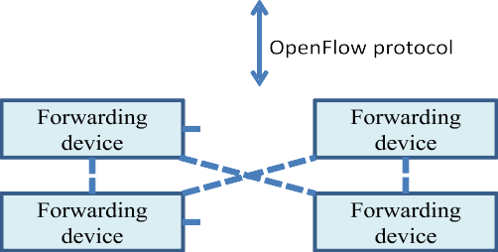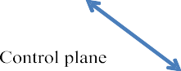

Fig. 1.SDN network architecture.

Utilizing SDN technology has some benefits, such as:
- Directly programmable: Because the control plane and forwarding plane are separated, SDN networks are directly programmable.
- Agile: Network traffic can be easily managed.
- Centrally controlled: As previously mentioned, there is a centralised device known as "controller" that serves as the network's brain.
- Open standards-based: The majority of SDN controllers are not vendor-specific and are open-source, making it simple to programme them and get a broad view of the network.
1.3 RELATED WORK AND LITERATURE REVIEW
The concept of programmable networks and the resulting SDN paradigm were developed many years ago [6]. To address the concept of network programming, solutions such as SOFTNET, Active Networking , OPENSIG and GSMP, the IEEE P1520 Standards Initiative in 1998, the 4D Project and the SoftRouter architecture in 2004, and finally NETCONF, Ethane, and SANE [16] in 2006 were proposed. As a prototype, SANE was created, and it was viewed as a logical server that handled all access control decisions. Identity-based accessing is used by Ethane to provide policy and security after separating the controller and switch. However, in 2010, ForCES (Forwarding and Control Element Separation)was introduced by the IETF. “While OF physically separates the controller and network elements from one another, ForCES assumed that the network architecture would not change and that the controller and network elements would instead be located in a single device. There have been a number of SDN-related initiatives up to this point[17]. The Software Defined Networking Research Group (SDNRG), which was defined by the Internet Research Task Force (IRTF) [18], was created to examine potential SDN strategies and difficulties. Additionally, provides a Home for SDN researchers[19]. Over the past few years, a number of surveys have been carried out that broadly focus on different facets of the IoT ecosystem using SDN. The current research examines SDN-based IoT management issues for 2022.
2. Potential Application of Open SDN
The campus network's experimental innovation is where SDN got its start. In the early stages of SDN development, the application scenarios are mainly focused on: data centre network, interconnection between data centres, government and enterprise networks, telecom carrier networks, and Internet company business deployment. The research team led by Professor Nick McKeown of Stanford University proposed the concept of Openflow , which promoted the birth of SDN; SDN succeeded in Google's B4 network.The potential novel applications of Open SDN are discussed in this CHAPTER, which also builds an SDN network model for different applications. The article will describe SDN's initial use as well as some creative application scenarios in later stages.
1. SDN APPLICATION IN B4- WIDE AREA NETWORS(B4-WAN)
The, one of the first and largest SDN/OpenFlow deployments, suggests a software-defined WAN architecture B4. This is both the first application case for SDN-based distributed controllers and the first publicly available commercial case for SDN-based data centre interconnection.This structure has the switch hardware layer, the site controller’s layer, and the global layer make up the three layers of this network's architecture. Google switches are used in the switch's hardware layer. The switches support new services like centralised TE, which is primarily in charge of traffic forwarding, and run the OpenFlow protocol. OpenFlow Control (OFC) and Network Control Server make up the site controller layer (NCS). On the NCS, the OFC cluster runs, and the OFC maintains network status in accordance with switch events and network control application directives. An SDN gateway and a central traffic engineering server make up the global layer, which is in charge of providing centralised and unified network control. The TE Server receives the link information abstracted by the SDN gateway from the OFC in order to learn the global path information. The SDN Gateway translates the forwarding entry data produced by the TE server and sends it to the underlying switch via the OFC.

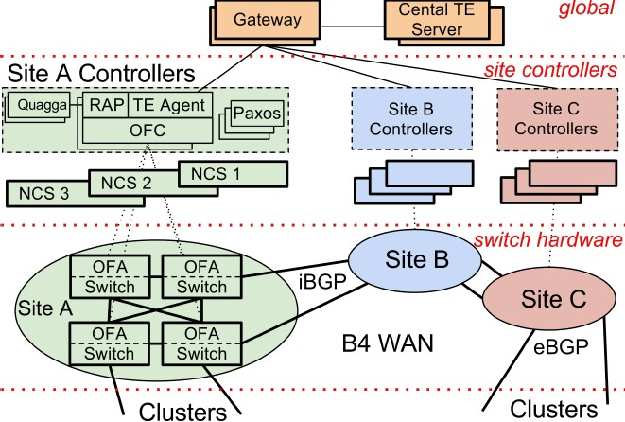
Fig.2. Wide Area Networs(B4-WAN) B4 architecture overview
According to the level of demand and priority, the architecture's centralised traffic engineering distributes bandwidth. The link's bandwidth is now being used more than three times as much and almost entirely over the long term, which significantly lowers the cost of the link. This demonstrates the viability of applying SDN to massive networks linked by data centres. It also discusses some research-related lessons learned and possible future research directions. B4, a private WAN connecting Google's data centres around the world, is being implemented and evaluated. B4 has several distinctive qualities, including:
1.Huge bandwidth demands spread across a small number of sites, elastic traffic demand aiming to increase average bandwidth, and
2. complete control over the network and edge servers, allowing for rate limiting
2. SDN Application in CellularNetworks
The present designed an SDN-based architecture of the programmable control plane in cellular network and examined how the introduction of the SDN architecture can better solve the issues of the cellular network, such as reducing the extra equipment in the network. They are more limitations of the current cellular network. Cellular providers can efficiently track traffic at various granularities; SDN will offer standard control protocols for use with various cellular technologies, simplifying mobility management and lowering latency; SDN can implement distributed firewall and QoS policies based on network-wide views; it can also schedule traffic through multi-hop QoS classes in the network; and it can support network virtualization.According to its own requirements, the mobile virtual operator can sign up for the corresponding service; the SDN supports centralised base station control and has a global view of the station.
Radio resources can be distributed by the SDN controller more effectively to accommodate additional users. Four different perspectives are suggested for the scalability of controllers, switches, and base stations:
1. The architecture uses user packet processing rules of IP addresses and network locations to convert policies automatically.
2. The controller should instruct the switch to run a software agent that can carry out basic local operations.
3. The cellular network will support message-based control, deep packet inspection, and header compression.
4. The architecture virtualizes base station resources and grants control over radio resource management, admission control, and mobility control to each controller's "slice" of controllers.

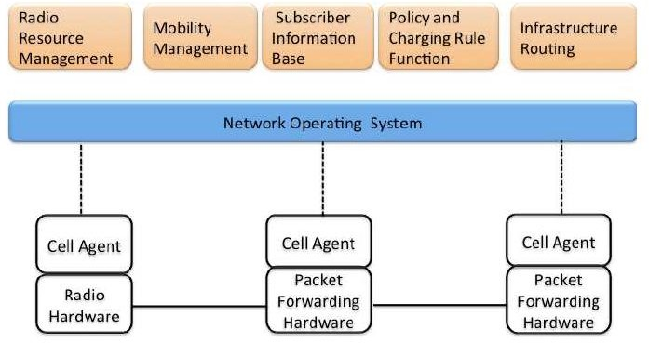

Fig. 3. Cellular SDN architecture
3.SDN APPLICATIONS In Mobile Cloud
Different wireless technologies are used for the control plane and data plane. The high bandwidth wireless connection is used for Wi-Fi in the data plane while the remote wireless connection is used for LTE in the control plane. The flow table of the SDN wireless node is filled in by the global SDN controller, which is the primary intelligent element of the architecture and is in charge of managing how traffic flows through the network. The switch in the SDN network is analogous to the SDN wireless node.
Each SDN wireless node has a backup local SDN controller to maintain network connectivity in the event of a global controller issue. Both a continuously connected global SDN controller and an intermittently connected global SDN controller are two examples of connections between the global SDN controller and the SDN wireless node. Each SDN wireless node in the MANET system builds a node connection graph by exchanging beacon messages, and the SDN controller can use general algorithms or flow-based routing information to make intelligent routing decisions based on the path information provided by the node connection graph. The mobile cloud instance based on SDN frequency selection is also discussed in the article. The wireless node can be classified into two categories based on the interface frequency configuration: wireless nodes with wireless interfaces set to specific frequencies and wireless nodes with reconfigurable wireless interfaces. In addition, wireless network virtualization, reserved traffic, and frequency hopping are three possible application scenarios.

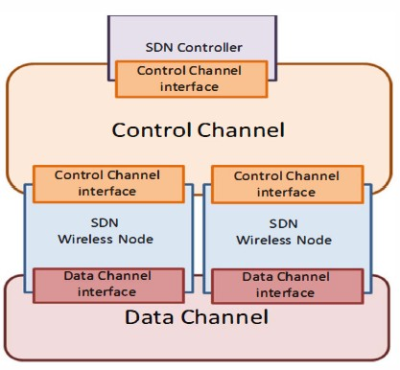
Fig. 4. SDN-based mobile cloud overview

4.SDNApplicatiom in Vehicular AD-HOC Networks(VANET)
The essential for safety and security of travellers on the road has been a major concern so need for automation effective delivery of services is essential. Vehicular Ad Hoc Networks (VANETs) can play an significant role in recognizing and implementing such concept, by supporting safety, comfort and services. Traditional Vehicular Ad-hoc Networks (VANETs) can efficiently be supplemented with the software-defined networking(SDN)

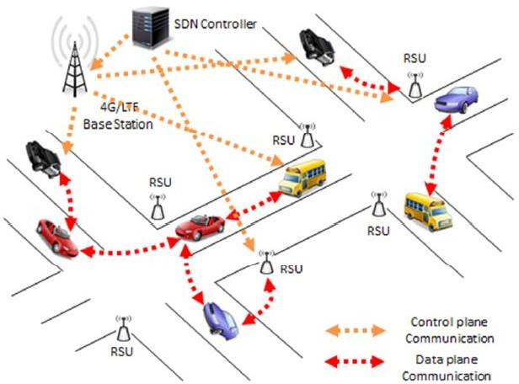
Fig. 5. Software-Defined VANET Communications

The architecture is broken down into three different control modes: centralised control mode, distributed control mode, and hybrid control mode. The following three benefits of the architecture are examined:
1) Path selection: The SDN controller can start a rerouting process to increase network utility and relieve congestion when it detects that data traffic may become unbalanced.
2) Frequency/Channel Selection: An SDN-based VANET can dynamically coordinate the channel and frequency that SDN wireless nodes use when a variety of wireless interfaces are available.
3) Power selection: Because SDN-based VANETs are aware, they can dynamically modify the wireless interface's power and transmission range in accordance with perception. Finally, simulation is used to compare SDN-based routing to conventional MANET/VANET routing protocols, demonstrating the viability of software-defined networking.
5. Air-Space-Ground Integration Network SDN Applications
The SDN architecture serves as the foundation for the integrated space and terrestrial network architecture. Several spatial tasks make up the application layer. The network operating system in the logical architecture represents the control plane, which is made up of the controller nodes of the space base and the ground. The control plane, which is at the centre of the network, is responsible for managing and controlling the entire spatial information network as well as making routing decisions. The primary functions of the data plane, which is made up of satellite nodes, are data processing and forwarding.
A three-layer structure made up of an air-based network layer, a space-based network layer, and a ground-based network layer makes up the SDN-based air-ground integration network. Each layer is connected and functions independently. The satellites make up the majority of the space-based network layer. UAV Ad-hoc network makes up the air-based network layer. Many cellular networks and digital cluster systems make up the ground-based network layer. The other two layers of the network are equipped with SDN controllers in addition to the space-based system to implement unified centralised control at each layer.Each cluster head in the UAV Ad-hoc network is outfitted with a micro SDN controller and has access to real-time global information about the cluster network. As a result, other UAVs do not need to carry any processing or decision-making equipment, greatly enhancing the UAV Ad-hoc network's endurance capacity. The master controller for the entire UAV Ad-hoc network can be the ground station controller. The ground-based satellite relay can be used to get in touch with the ground station if the link between the UAVs and the ground station breaks down. The three network layers working together ensures the smooth operation of the whole system. The delay is used as an indicator to simulate how well the AODV, OLSR, and DSR routing protocols perform. Simulated comparisons are made between the conventional air-space-ground integrated network and the SDN-based air-space-ground integrated network. The outcomes demonstrate that the end-to-end delay is shorter, the overall performance is better, and the transmission of the SDN-based air-space-ground integrated network is better.

SoftwareDefinedSpace-Air-GroundIntegratedVehicularNetworks
ApplicationVehicularservices
layer
Networkmanagement

Mobilitymanagement
Northboundinterfaces(NBIs)
Northboundinterfaces(NBIs)
Controllayer

East/Westboundinterfaces
East/Westboundinterfaces
SpacesegmentSDNcontroller
AirSegmentSDNcontroller
GroundsegmentSDNcontroller
Southboundinterfaces(SBIs)
Southboundinterfaces(SBIs)
Infrastructurelayer
Space-air-groundresourcepool
Spacesegment
Networkslicing
Airsegment
Networkslicing
Groundsegment
Networkslicing
Physicalsystems
Communication: Control/manage: Provision:
Upper-tierSDNcontrollers
Resourcesets
Resourcesets
Resourcesets
Legacytasks
Legacytasks
Legacytasks
Groundsegmentavailableresource
Airsegmentavailableresource
Spacesegmentavailableresource
Datatraffic
classification
Network
hypervisor
Trafficmonitoring
/management
Emergency
management
Infortatinment
Datatraffic
engineering
Automateddriving
Safety
Fig:6 Air-Space-Ground Integration Network SDN
6.SDN Application in Satellitenetwork

It illustrates the three planes that make up a software-defined satellite network: the management plane, the control plane, and the data plane. Three GEO satellites that cover the entire planet make up the control plane; the data plane is primarily made up of terminal routers and satellite infrastructure. The management plane is composed of network operations and control centres. The SDN Southbound Interface (SBI) connects the data plane and the control plane, while the SDN Northbound Interface (NBI) connects the management plane and the control plane (CDPI). The control plane, which has a global topology view, is in charge of keeping track of the state of the network and communicating dynamic network data to the management plane. Functional modules like routing policy, user management, virtualization, security, resource utilisation, and network management can be offered by the management plane (NOCC). Through the use of information from the entire network, the management plane creates a new flow table and transmits it to the data plane via the control plane. Only the forwarding of the data packet in accordance with the flow table needs to be finished by the data plane. We can forecast changes in the entire network using the corresponding prediction-based algorithms because the satellite's motion is periodic (such as neural networks). OpenSAN saves satellite node resources, overcomes the challenge of satellite network closure and expansion, provides effective and fine control, and supports the flexibility of future advanced technologies by decoupling the data plane and control plane.
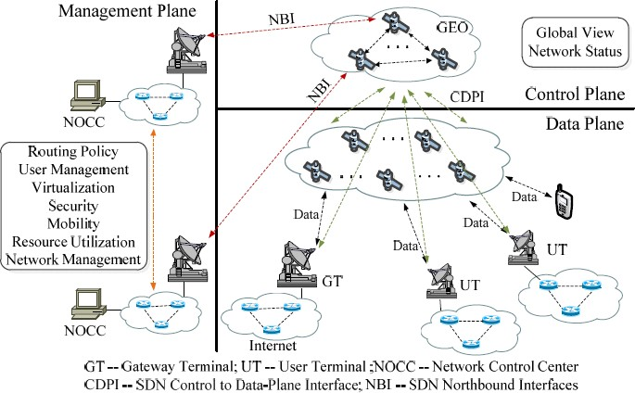
Fig. 7. The Architecture of OpenSAN

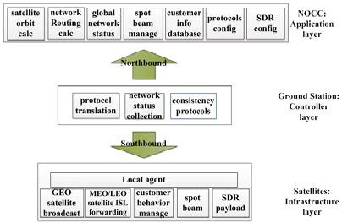
Fig. 8. The SDSN architecture
7.SDNApplication in Unmaned Aerial (UAV)network
A framework for an SDN-based UAV backbone network was created. A UAV controller and an SDN controller are both part of the control core. Information such as flight control, location, battery storage, etc. are managed by the UAV controller. The management of network information falls under the purview of the SDN controller. The SDN controller and the UAV controller can cooperate and exchange information to help each other make the best decisions possible.
An SDN controller monitoring platform with four modules—monitoring display, traffic management, link management, and strategy—is suggested based on the two central problems of information management and resource management of UAVs. In order to fully utilise the UAV network resources and uphold the desired network traffic balance, a load balancing algorithm is additionally proposed in the policy module based on the analysis findings of the monitoring platform.
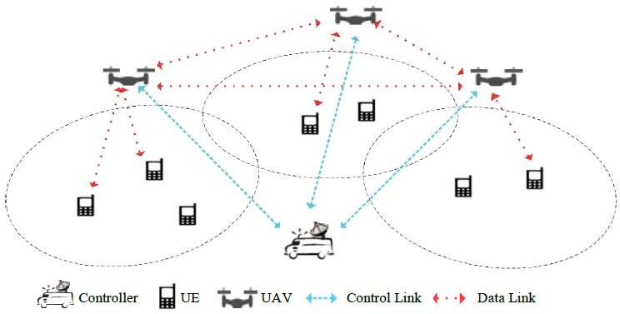
Fig. 8. SDN-based UAV network with model diagram

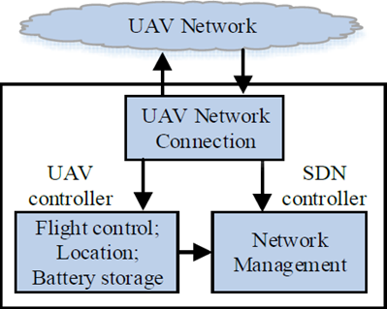
Fig. 9.UAVFunctional architecture of network
9.SDN Application In IOT -Enabled Healthcare Systems
The SDN with IOT are evolving as a growing technology fortified with sensors and control the network connectivity separately.SDN is a novel infrastructure network using in Healthcare with IoT can improve controllable networking in order to resolve the several challenges.
The suggested SDN architecture based on IoT healthcare Network is illustratedIn Fig 10. It can be seen network is comprised of further multiple networks of different hospitals. These hospitals are further linked to the subnet works in which data exchange from severalIoT devices,The data that comes from severalassociated devices such as medical images, Smart Continuous Glucose Monitoring (SCGM), insulin pens, connected inhalers, ingestible sensors, Connected contact lenses, Apple watch app that monitors depression,asthma monitor and many others. This huge amount of data stored and processed at some datcenters. The underlying network infrastructure used by these data centers lays the foundation of SDN [31]. clinical records, patient’s data, etc. is achieved. The data centers at which all the related data is stored is centrally placed. The networking used at this data center is consist of a three-layered architecture. The first layer is the networking layer in which the network topologies such as physical configuration, networking devices (switches, router) are located at this layer. The second and the upper layer to this is the main and controlling layer which further constitutes the centrally located SDN controller. This SDN controller has a global view of the entire network and manages the overall functionality.The parting of the controlling layer from the fundamental networking layer is the main idea behind SDN.

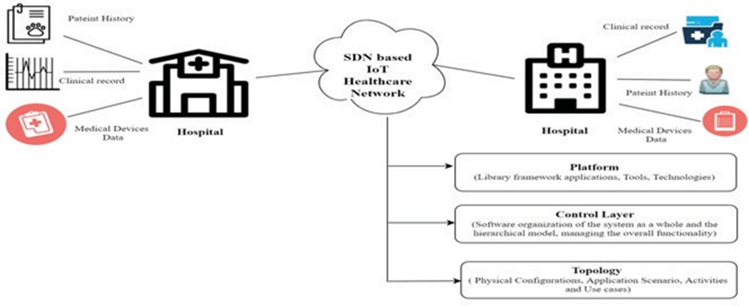
Fig. 10. SDN based IoT healthcare Network

The making use of these applications in an SDN based network enhances the security and cost-effectiveness in the functionality.With the help of SDN not only the manageability of the whole network has become easy but it also eliminates the manual command-line interface as well.By just a few clicks, you are able to manage the traffic flow from defined source to destination.

9.SDN Network Security And Access control For Cloud And Big Data
The challenge of dynamic network topology brought by the widely used virtualization technology will be faced when implementing SDN in multi-tenant public clouds, enterprise networks, or carrier networks. SDN's dynamic, virtual logical boundaries take the place of the internal network's original static, natural physical boundaries.Therefore, with the dynamic deployment and management of the security policy and components, as well as the decision-making process and response to network traffic, network security in the cloud becomes more difficult. New network security models are possible thanks to SDN's separation of the control plane.

New SDN security models are being developed, and SDN attack tracking is also being worked on. It is common knowledge that many network attacks begin with IP and port scanning.To achieve IP address mutation for service IP protection, the OpenFlow Random Host Mutation (OF-RHM) technology is suggested. Traditional networks struggle to accomplish the following two objectives, but this technology does: Address mutations for application networking in clouds are transparent to the service-level model. Its three layers—network model and APIs layer (or abstract API layer), network orchestration layer, and network driver layer—are inspired by the SDN architecture. Network operators can use connectivity between virtual servers based on application logic and global data thanks to the abstract API layer, which offers network interfaces for applications to interact with the network.
This design has been expanded by Resonance to a new security framework. It incorporates a monitoring subsystem into the SDN control plane's network operating system so that network administrators can implement security policies .without the need for interactions between individual devices, from a broad perspective. It not only makes it easier to implement security policies, but it also makes more features and more granular control possible.

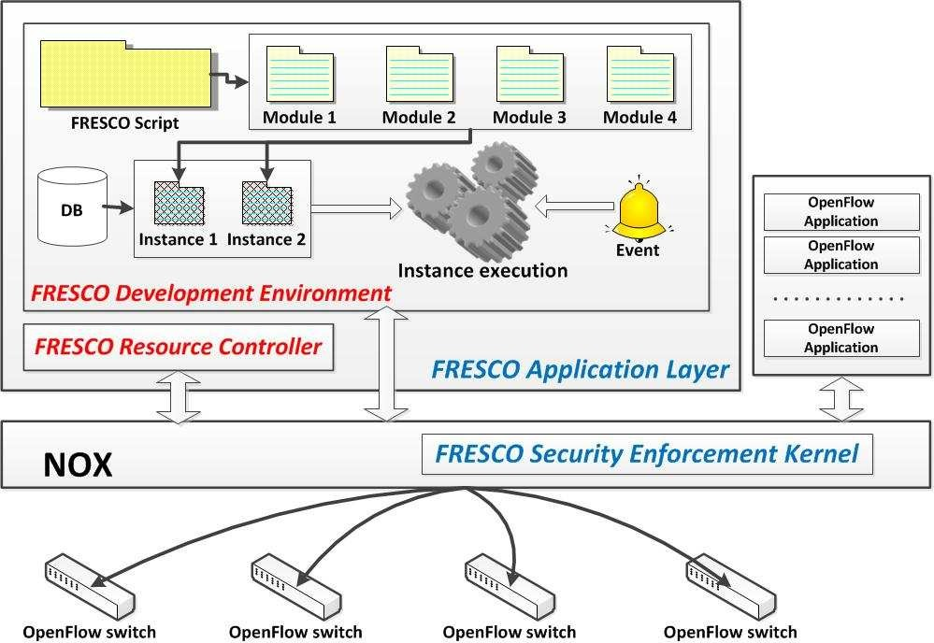
Figure 11. FRESCO architectureFor SDN Network Security and Access Control
FRESCO is a proposed framework for developing SDN network security applications. It enables the sharing and deployment of security application modules by network security researchers. The framework offers APIs and a library of reusable modules that can be used to create different threat detection and security surveillance logics. It consists of a security enforcement kernel and an application layer. Along with a resource controller in charge of the underlying resource management, the application layer offers a development environment. When an input event is received by FRESCO, the instance is triggered, and the outcomes are sent to the security kernel.
There is sufficient randomness in address mutations. In OF-RHM, the controller is in charge of coordinating the configuration of network address mutations for the entire network, while the subnet gateway converts between true and false addresses. To efficiently coordinate mutation, the logical centralised controller of SDN can change the OpenFlow switch rules, including managing active connections and updating DNS.
Sudden spikes in network traffic can also cause service outages or performance degradation on a data centre or cloud platform. Once active flows have been found using OpenFlow control messages, suspicious flows are found using a multi-dimensional flow aggregation algorithm that automatically selects the best possible set of flow clusters. Finally, a toxin-antitoxin mechanism is employed to automatically cap the data rate.
.
10.SDN in Other Networks
With more options for network connectivity, integration and interconnection of heterogeneous networks are becoming more and more important. Different network architectures, hardware components, protocols, transmission latencies, and throughputs characterise heterogeneous networks. Integration improves network scalability and coverage. Additionally, integration makes use of already-existing network resources to cut costs and boost competition (such as the integration of SDN and current power grid ). The diverse user needs in future networks are also met by the integration of heterogeneous networks. The packet network domains and optical circuit network domains can be integrated using the conventional method of network integration and interconnection, which is incredibly difficult, time-consuming, and error-prone.
SDN controllers and optical switches have also been studied for use in big data applications. In this design, run-time network configuration for big data jobs requires more significant and frequent changes in comparison to traditional SDN application scenarios. If the flow tables of network switches are empty, the first packet received is sent to the extended OpenFlow controller. In order to calculate an optical flow's light path to its destination, the controller determines the flow's end point and sends it to the GMPLS controller. The extended OpenFlow controller updates the flow tables of the ingress and egress switches to forward the remaining optical flows once the GMPLS controller has finished its task.

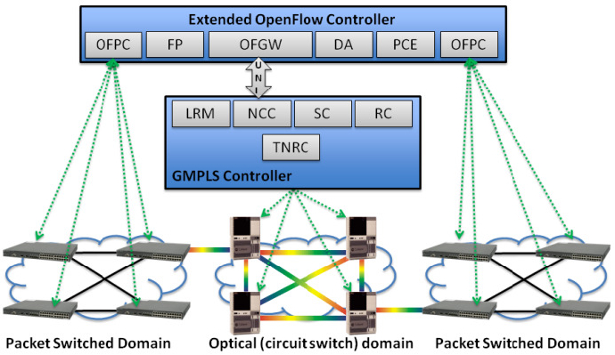
The long-term objective is to create a software-defined cellular infrastructure by designing a programmable wireless data plane that consists of base stations, network switches/routers, and gateways.
According to HuaWei, the network changes brought on by SDN will significantly alter business and telecommunications networks. According to their SoftCOM strategy for SDN, which is based on reconstructing four areas—architecture, network, service, and operation—the telecom industry will be rebuilt.
III .Research Directions of SDN
Research Directions of SDN Currently SDN has been deployed in campus networks [8, 9], enterprise data centers (such as Google) and even some carrier networks. The adoption of SDN accelerates in recent years. The idea of separating control and data plane is not new, but there are inherent reasons for such network architecture to be deployed until now. First of all, the mass-production of multi-core technology not only lowers the cost of network equipment, but also enable the option to utilize general-purpose CPU for network policy computation and packet forwarding. Secondly, the growing number of heterogeneous networks (IPv6, optical networks, A Survey on Software Defined Networking and its Applications 5 wireless) with different functions requires flexible network devices for interoperability. Thirdly, the booming of virtualization and cloud computing has raised new demands in network management, including flow monitoring as well as traffic scheduling. With the open and standard features from SDN, applications can fully utilize the network processing power, monitor network status precisely, and automatically manage network operations to meet the current network trends of mobility and virtualization. There are two main research directions on SDN: 1) the design of SDN network structure and its basic components; 2) web applications based on SDN
IV .Conclusions and Outlook
Traditional networks have given the Internet a vibrant life but have also hindered the longer-term development of the Internet. The new dynamic network architecture of SDN has successfully transformed traditional networks into diverse application-oriented platforms. By decoupling the control plane and data plane in the network architecture, the hardware cost of the network equipment can be effectively reduced, so that the network can be flexibly large-scale programming and simplified management like the computer infrastructure; the centralized control logic can make the network have a global view information can be globally optimized and resource-adapted. The deployment and maintenance of network nodes will be more agile; open and programmable network can promote more business network service innovation. However, the current SDN technology is not fully mature, including the standardization and unification of various interfaces, the compatibility of heterogeneous networks, multi-controller coordination and some security issues. The expansion of SDN applications is also facing more challenges. In this paper surveyed 10 different architecture models with application areas to analyze SDN-based scenarios. The "SDN+" architecture provides a new way of thinking for networks with different applications, expanding the intelligence of the network and achieving maximum optimization.
The application of SDN is no longer limited to the campus network, the WAN network between data centers, but has a broader space, not just the ground network, and even some good application ideas have been made in space-based networks. In the future, we will focus on exploring more application scenarios of "SDN+" and optimized routing algorithms that are more suitable for SDN architecture. Despite great enthusiasm and efforts from the academic and industry, SDN technology still faces many challenges in the design, deployment and acceptance. In this paper we summarize the current research status, goals and corresponding solutions of SDN. We also analyze the future research trends of SDN: 1) Network standardization work determines the success of SDN; 2) It is important to develop application development tools; 3) SDN enables new security model; 4) The expansion of heterogeneous network promotes multi-network integration; 5) Build the future Internet based on SDN technology.

4.References
[1].Open Networking Fundation , "Software-defined Networking: The New norm for Networks.", ONFWhitePaper,(2012),availableonline:https://www.opennetworking.org/images/stories/downloads/sdn-resources/white-papers/wp-sdn-newnorm.pdf, last visit:18.10.2014
[2]. B. N. Astuto, M. Mendonça, X. N. Nguyen, K. Obraczka and T. Turletti, “A Survey of Software-Defined Networking: Past, Present, and Future of Programmable Networks”, hal-00825087,(2013), available online: http://hal.inria.fr/hal-00825087, last visit:18.10.2014
[3]. K. Bakshi, "Considerations for Software Defined Networking (SDN): Approaches and Use Cases", IEEE Aerospace Conference, (2013), pp:19.
[4]. T. D. Nadeau and K. Gray, Software Defined Networks, CA: O' Reilly, (2013).
[5]. F. Hu, "Network Innovation through OpenFlow and SDN: Principles and Design", CRC Press, (2014). http://dx.doi.org/10.1201/b16521.
[6]. B. A. A. Nunes, M. Mendonca, X. N. Nguyen, K. Obraczka, and T. Turletti, "A Survey of Software-Defined Networking: Past, Present, and Future of Programmable Networks", IEEE Communications Surveys and Tutorials, Vol.16, No.3, (2014), pp. 1617-1634, available online: http://dx.doi.org/10.1109/SURV.2014.012214.00180, last visit: 18.10.2014.
[7]. J. Zander and R. Forchheimer, "The SOFTNET Project: a Retrospect", Electrotechnics, 1988. Conference Proceedings on Area Communication, EUROCON 88., 8th European Conference on, (1988), pp.343-345, available online: http://dx.doi.org/ 10.1109/EURCON.1988.11172, last visit:18.10.2014.
[8] N. Feamster, J. Rexford, and E. Zegura, "The Road to SDN," Queue, Vol.11, No.12, (2013), p.20, available online: http://dx.doi.org/10.1145/2559899.2560327 , last visit:18.10.2014.
[9] .A. T. Campbell, I. Katzela, K. Miki, and J. Vicente, "Open Signaling for ATM, Internet and Mobile Networks (OPENSIG'98)," ACM SIGCOMM Computer Communication Review, Vol.29, No.1, (1999), pp.97-108, available online: http://dx.doi.org/10.1145/505754.505762, last visit:18.10.2014.
[10]. A. Doria, F. Hellstrand, K. Sundell, and T. Worster, "General switch management protocol (GSMP) V3," RFC 3292, (2002), available online: https://www.ietf.org/rfc/rfc3292.txt, last visit:18.10.2014
[11] J. Biswas, A. A. Lazar, J.-F.Huard, K. Lim, S. Mahjoub, L.-F. Pau, et al., "The IEEE P1520 standards initiative for programmable network interfaces," Communications Magazine, IEEE, Vol.36, No.10, (1998), pp.64-70, available online: http://dx.doi.org/64-70,10.1109/35.722138, last visit:18.10.2014.
[12]. The 4D Project,”Clean Slate Architectures for Network Management”, available online: http://www.cs.cmu.edu/~./4d/#csamp, last visit:18.10.2014.
[13]. T. Lakshman, T. Nandagopal, R. Ramjee, K. Sabnani, and T. Woo, "The softrouter architecture," Proceedings of ACM SIGCOMM Workshop on Hot Topics in Networking, (2004), available online: http://conferences.sigcomm.org/hotnets/2004/HotNetsIII%20Proceedings/lakshman.pdf, last visit:18.10.2014.
[14]. R. Enns, M. Bjorklund, and J. Schoenwaelder, "NETCONF configuration protocol," RFC 6241, (2011), available online: https://tools.ietf.org/html/rfc6241, last visit:18.10.2014.
[15] M. Casado, M. J. Freedman, J. Pettit, J. Luo, N. McKeown, and S. Shenker, "Ethane: Taking control of the enterprise," ACM SIGCOMM Computer Communication Review, Vol.37, No.4, (2007), pp.1-12, available online: http://dx.doi.org/ 10.1145/1282427.1282382, last visit:18.10.2014.
[16]. M. Casado, T. Garfinkel, A. Akella, M. J. Freedman, D. Boneh, N. McKeown, et al., "SANE: A protection architecture for enterprise networks," Proceedings of the 15th conference on USENIX Security Symposium, Vol.15, No.10, (2006), pp.137–151, available online: https://www.usenix.org/legacy/event/sec06/tech/full_papers/casado/casado_html/, , last visit:18.10.2014.
[17]. A. Doria, R. Gopal, H. Khosravi, L. Dong, J. Salim, and W. Wang, "Forwarding and control element separation (ForCES) protocol specification," RFC 5810, (2010), available online: http://tools.ietf.org/html/rfc5810, last visit:18.10.2014.
[18].SushengZheng and Shengxue Yang Jiangxi University of Technology, Nanchang 330098, ChinaResearch Article“Application of SDN Network Traffic Prediction Based on Speech Recognition in Educational Information Optimization Platform”Hindawi Computational Intelligence and Neuroscience Volume 2022, Article ID 5716698, 11 pages https://doi.org/10.1155/2022/5716698
[19]. M. I. Hamed, B. M. ElHalawany, M. M. Fouda, and A. S. Tag Eldien, “A New Approach for Server-based Load Balancing Using Software-Defined Networking”, Proceedings of the 2017 IEEE International Conference on Intelligent Computing and Information Systems (ICICIS 2017), Cairo, Egypt, December 5-7, 2017.
[20].Diego Kreutz， Fernando M. V. Ramos, Paulo EstevesVerı´ssimo, et al, “Software-Defined Networking:A Comprehensive Survey,” IEEE, vol. 103, issue 1 ,2015.
[21].Software-Defined Mobile Cloud: Architecture, Services and Use Cases,” IEEE CAMAD, 2015.
[22]Ian Ku, You Lu, and Mario Gerla, “Towards Software-Defined VANET: Architecture and Services,” in Proc. 13th Annual Mediterranean Ad Hoc Networking Workshop, pp. 103-110, 2014.
[23].C Chen ， SS Xie， XX Zhang, ZY Ren “A new space and terrestrial integrated network
architecture aggregated SDN,” Journal of China Academy of Electronics and InformationTechnology, vol. 10, issue 5, 2015.
[24].FM Xu, ZJ Tong, CL Zhao, ZC Qin, “Architecture, Technology and Challenges of Software Defined Integrated Space and Terrestrial Network” ZTE TECHNOLOGY JOURNAL, Vol. 24, issue 2, 2018.
[25].Xiao Zhang, Haijun Wang and Haitao Zhao, “An SDN Framework for UAV Backbone Network towards Knowledge Centric Networking,” IEEE Conference on
[26].Miao Y, Cheng Z, Li W, et al., “Software Defined Integrated Satellite-Terrestrial Network: A Survey.” International Conference on Space Information Network.Springer, Singapore, 2016.
[27].FM Xu, ZJ Tong, CL Zhao, ZC Qin, “Architecture, Technology and Challenges of Software Defined Integrated Space and Terrestrial Network” ZTE TECHNOLOGY JOURNAL, Vol. 24, issue 2, 2018.
[28].JinzhenBao, Baokang Zhao, WanrongYu,et al, “OpenSAN: A Software-defined Satellite Network Architecture,” AcmSigcomm Computer Communication Review, 2014.
[29].Zhu Tang ;Baokang Zhao ; Wanrong Yu, et al, “Software Defined Satellite Networks: Benefits and Challenges,” IEEE Computers, Communications and IT Applications Conference, 2014.
[30].Xiao Zhang, Haijun Wang and Haitao Zhao, “An SDN Framework for UAV Backbone Network towards Knowledge Centric Networking,” IEEE Conference on Computer Communications Workshops, 2018.
[31.Bhardwaj, S., & Panda, S. N. (2020).A Study on Noninvasive Body Wearable Sensors.In Intelligent Communication, Control and Devices (pp. 345-351).Springer, Singapore.

