**Chapter 5 : SUSTAINABLE MEDICAL EQUIPMENT AND TECHNOLOGY**

Khush Jain 1 Nilofer Neshat 2

1Assistant Professor Parul Institute of Paramedical and Health Sciences Parul university .

2 Assistant Professor Parul Institute of Paramedical and Health Sciences Parul university .

( Email ID ; [Khushjain028@gmail.com](mailto:Khushjain028@gmail.com))

( Email ID : [Neshat758@gmail.com](mailto:Neshat758@gmail.com) )

In healthcare, Sustainability emphasizes development and usage of medical equipment in ways that reduce environmental impact while ensuring safety, efficacy, and resource efficiency. These practices are becoming more crucial as concerns about the waste and carbon footprint of the healthcare equipment industry intensify.

## **Sustainable Medical Equipment**

Sustainable medical equipment prioritizes environment friendly materials, energy efficiency and minimized impact to the lifestyle from design and manufacturing to use and disposal, aiming to use of fewer resources, less waste generation and limited harmful emissions throughout its lifespan.(1,2) Incorporating recyclable, biodegradable, or renewable materials into sustainable medical devices decrease environmental harm and promote patient safety.(3,4) Additionally, Energy-efficient devices also contribute to reduction in the operating expenses and carbon emission, aligning with global efforts to combat climate change.(2,5)

## **Importance of Sustainability in Healthcare**

The healthcare sector is increasingly embracing sustainability due to its significant environmental impact, regulatory compliances, cost efficiency and social responsibility. (Figure 1) Hospitals and health care facilities produce significant amount of waste each year, particularly from single-use. Adopting sustainable practices can significantly reduce this waste.(2,5) As environmental regulations evolve; healthcare providers and manufacturers must integrate eco-friendly principles into product design and manufacturing.(4,6)

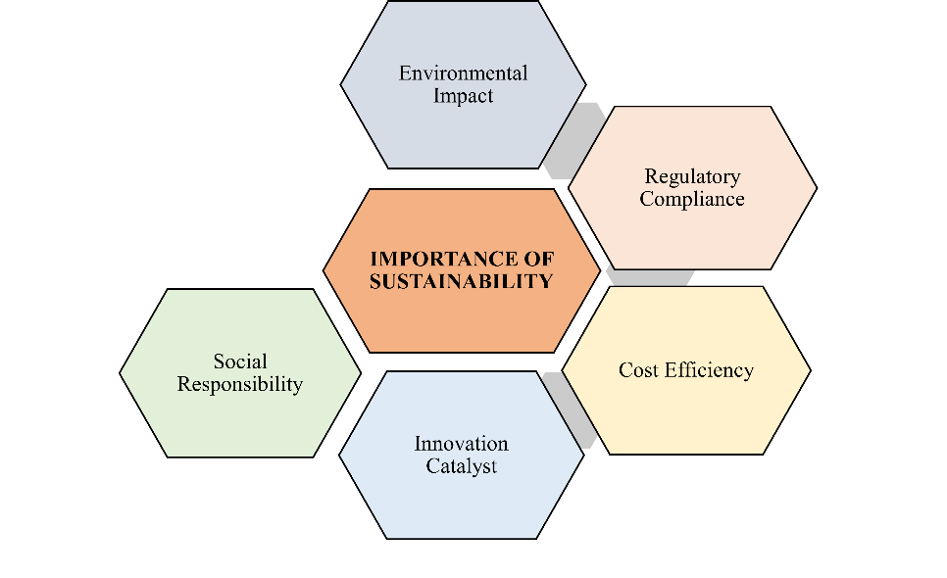

Figure 1: Key Aspects Highlighting the Importance of Sustainability in Healthcare

Sustainable operations can lead to long-term cost reductions, lower resource consumption, decreased energy use, and minimized waste management costs, benefitting the healthcare facilities financially.(5,6) Furthermore, sustainability drives innovation within the medical technology sector, encouraging the development of advanced, efficient solutions reducing environmental impact.(2,4) With growing public interest in eco-conscious healthcare, adopting sustainable practices strengthens the healthcare providers reputation and increase patient trust.(6)

# **Current Challenges in Medical Equipment Sustainability**

The path toward sustainability in the medical equipment sector is complex, with numerous challenges to overcome. Although there is a growing importance on eco-friendly practices, several key challenges hinder the progress. This section examines significant issues facing sustainable medical equipment, drawing from recent insights and reports. (Table 1)

Table 1: Key Challenges in Sustainable Medical Equipment

|  |  |  |
| --- | --- | --- |
| **Sr. No** | **Challenge** | **Description** |
| **1.** | Maintaining Sterility(7) | Maintaining sterility throughout a device's lifecycle is crucial for preventing infections. However, Strict sterility regulations frequently call for non-biodegradable materials, putting safety before the environment. |
| **2.** | Use of Recycled Materials(7,8) | Regulatory guidelines, particularly in sterile settings, restrict the integration of recycled components into medical devices because of traceability requirements. Expanding the use of recycled materials is still challenging in the absence of specific rules and regulations. |
| **3.** | Recyclability of Packaging(7,9) | Although it is ideal for packaging to be recyclable, healthcare packaging is often considered polluted after use, which makes recycling more difficult. Technically recyclable products can yet result in more waste due to practical constraints. |
| **4.** | Waste Generation from Single-Use Devices(8,10) | Single-use devices contribute to greenhouse gas emissions due to considerable amount of waste generation, which are often disposed by incineration. Safety concerns and complicated regulatory requirements for reprocessing hinder the shift to reusable devices. |
| **5.** | Lifecycle Management and Assessment(8,11) | Lifecycle assessments, or LCAs, are essential for comprehending how a device affects the environment from manufacture to disposal. Sustainable lifecycle management is difficult for many manufacturers, though, because they lack the necessary resources or expertise to conduct comprehensive LCAs. |
| **6.** | Regulatory Compliance and Evolving Standards(9,10) | Adherence to changing regulations such as the EU Medical Device Regulation (MDR) necessitates substantial financial investments. Medical device manufacturers must simultaneously be compliant and evolve sustainably as regulations evolve. |

## **Resource Depletion and Waste Generation**

The depletion of natural resources and increasing waste generation are critical environmental concerns. The rising demand for resources, combined with unsustainable waste practices, threatens ecosystems and public health. This section explores the relationship between resource depletion and waste generation, emphasizing the need for sustainable practices and the adoption of a circular economy framework to address these issues.

### ***Understanding Resource Depletion***

Resource depletion occurs when a resource is consumed at a rate that exceeds its natural replenishment. This is particularly acute for non-renewable resources such as fossil fuels, minerals, and some water sources. Since 1970, global raw material extraction has tripled, reaching approximately 60 billion tons per year, equating to about 22 kg per person daily. Such extensive extraction leads to biodiversity loss and increased carbon emissions, with raw material extraction accounting for roughly half of human-generated carbon emissions and 90% of biodiversity impacts. If current trends continue, these figures are projected to double by 2060.(12)

### ***Trends in Waste Generation***

Waste generation is increasing globally at an alarming rate. For instance, approximately 2.2 billion tons of waste are produced in the European Union each year, comprising 27% municipal waste.(12) According to World Bank estimates, Sub-Saharan Africa's garbage output might quadruple to 174 million tons annually by 2050 due to the region's rapid development and population expansion.(13) Waste management is a problem in many lower- and middle-income countries, which often resort to ineffective and environmentally damaging disposal techniques such open dumping and uncontrolled incineration.(14)

### ***The Role of the Circular Economy***

The Circular Economy (CE) offers a promising approach to reduce resource depletion and waste. CE encourages the 3R principles—reduction, reuse, and recycling—by considering waste as an invaluable resource.(13) A circular system instead of a linear one allows for the recovery of valuable materials from waste, which lowers greenhouse gas emissions linked to conventional disposal.(13,15)

### ***Health and Environmental Impacts***

Inadequate waste management contributes to significant environmental pollution and public health risks. Poorly managed solid waste contributes to greenhouse gas emissions, degrades land, and pollutes the air and water. Limited garbage collection, sometimes as low as 10%, places marginalized communities at greater risk for waterborne illnesses and respiratory infections linked to pollution in many developing nations.(14) These effects can be minimized by improving public health through sustainable waste management that prioritizes recycling and energy recovery.

### ***Policy Implications***

Robust policy frameworks are crucial to advancing a circular economy. By enacting laws that promote sustainable resource usage and waste management, governments may play a crucial role in fostering circular practices. Investment in technology for resource recovery can be encouraged by comprehensive policies, which are beneficial for the economy and the environment.(13)

# **Innovative Technologies for Sustainable Medical Equipment**

The medical device industry is progressively integrating sustainability – focused innovations, addressing the environmental challenges while maintaining high patient care standards. This shift involves using innovative technologies that enhance sustainability across the medical equipment lifecycle, from initial design through manufacturing, use and disposal.

## **Overview of Key Innovations in Sustainable Medical Equipment**

Sustainable medical device manufacturing heavily relies on material selection, with an importance on eco-friendly options like biodegradable polymers and recycled metals to minimize their environmental impact.(16,17) Energy-efficient manufacturing techniques, particularly 3D printing, are essential for reducing the carbon emission associated with device production.(8,18) With strategies aimed at reducing packaging waste and encouraging recycling, waste reduction is also crucial. Additionally, products are being designed simple to disassemble, which aids in the post-lifecycle recycling or reuse of individual components.(1,8)

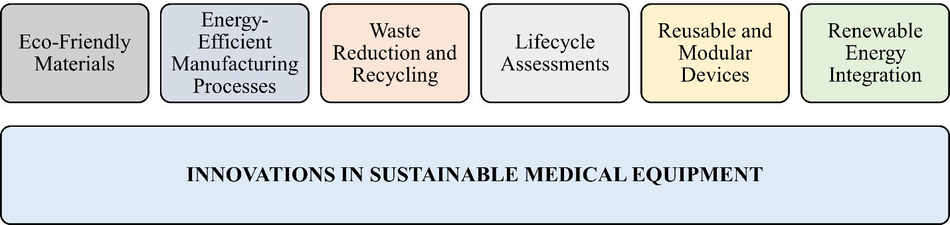

Figure 2: Illustration showcasing various innovations in sustainable medical equipment

Lifecycle assessments (LCAs) are emerging as a standard in the industry, enabling manufacturers to gauge environmental impact across a device’s lifespan.(1,8) Reusable and modular designs, such as sterilizable surgical instruments and modular patient monitors, are gaining momentum as hospitals look to cut back on single-use plastics and non-degradable components.(17,18) Renewable energy sources are increasingly being adopted in manufacturing facilities to lower carbon emission further.(18) (Figure 2)

## **Emerging Challenges and Opportunities**

The transition to sustainable medical equipment involves challenges such as navigating regulatory framework, high initial investments, and market acceptance. Compliance with safety and efficacy regulations can slow adoption, while initial investments can lead to long-term savings through efficiency gains and brand differentiation are notable benefits. As companies focus on sustainability, their brand reputation grows, particularly appealing to environmentally conscious consumers, thus turning these challenges into opportunities for innovation.(1,11)

## **Biodegradable Materials in Medical Devices**

Biodegradable materials represent a substantial advancement in sustainable healthcare, offering patient-centered benefits while reducing environmental impact. This section explores the types, applications, benefits, and challenges of biodegradable materials in medical devices.

### ***Types of Biodegradable Materials***

Biodegradable materials are an evolving field in medical technology, with numerous types catering to various applications. (Figure 3)

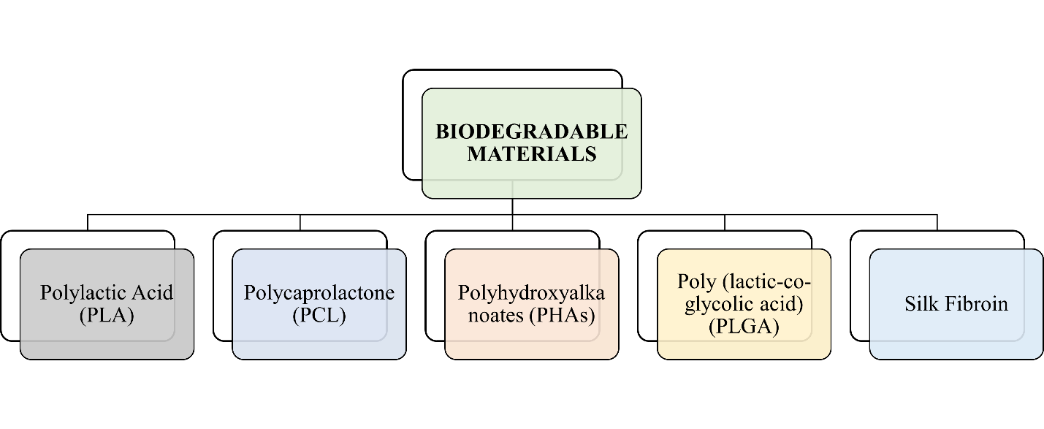

Figure 3: Illustrating the Types of Biodegradable Materials

* Polylactic Acid (PLA): Derived from renewable resources like corn starch, PLA is highly biocompatible and decomposes into lactic acid, making it suitable for sutures, stents, and drug delivery systems.(19)
* Polycaprolactone (PCL): It is known for flexibility and slower degradation compared to PLA; PCL is widely used in tissue engineering and regenerative medicine.(19)
* Polyhydroxyalkanoates (PHAs): These versatile, biocompatible plastics degrade at controlled rates, fitting a range of applications from wound dressing to bone plates.(19)
* Poly(lactic-co-glycolic acid) (PLGA): A copolymer of PLA and glycolic acid that supports tissue scaffolding and drug delivery due to tunable degradation rates.(20)
* Silk Fibroin: Derived from silkworms, this natural material offers strong mechanical properties and biocompatibility for sutures and tissue engineering applications.(21)

### ***Applications of Biodegradable Materials***

Biodegradable materials serve various purposes in medical devices:

* Sutures and Wound Dressings: Biodegradable sutures eliminate the need for surgical removal, reducing patient discomfort and the risk of infection.
* Implants: Biodegradable implants offer temporary structural support allowing natural healing processes.(20)
* Drug Delivery Systems: Biodegradable polymers can be engineered to release controlled drug over time, improving treatment outcome, minimizing the side effects.(19)
* Tissue Engineering: Used as Scaffolds, these materials support cell growth and tissue regeneration, eventually breaking down as new tissue develops.(20)

### ***Advantages of Biodegradable Materials***

Using biodegradable materials in medical devices has numerous advantages:

* Environmental Impact Reduced: These materials ease plastic waste issues by breaking down naturally.(22,23)
* Patient Safety: They reduce the risks associated with surgical removal and minimize chronic inflammatory responses.(20,24)
* Sustainability: Utilizing renewable resources contributes to a more sustainable healthcare system.(22,23)

### ***Challenges of using biodegradable Materials***

Despite their advantages, biodegradable materials present challenges:

* Mechanical Properties: Balancing strength and biodegradability for specific applications can be challenging.
* Degradation Rate Control: Adjusting the degradation rates to synchronize the healing process requires advanced engineering.
* Regulatory Approval: Meeting stringent safety and efficacy standards prolongs the development process but it also ensures patient safety.(21)

# **Regulatory Frameworks and Standards for Sustainable Medical Technology**

As the medical technology sector acknowledges the crucial importance of environmental sustainability, regulatory framework and standards are adapting to ensure that medical devices are designed, manufactured, and disposed of in eco- friendly ways. This section discusses the key regulatory frameworks and standards shaping sustainable medical technology, highlighting their implications for manufacturers and healthcare providers.

## **Overview of Key Regulatory Frameworks**

In an effort to reduce its negative effects on the environment and increase resource efficiency, the medical equipment sector is progressively adopting sustainability criteria. Key standards like ISO 14001, ISO 13485, and ESRS provide frameworks for companies to manage their environmental responsibilities while maintaining high-quality production practices. (Table 2)

Table 2: Key Regulatory Frameworks

|  |  |  |
| --- | --- | --- |
| **S.No.** | **Regulation** | **Description** |
| **1** | European Union Medical Device Regulation (MDR)(2,9) | MDR (2017/745) governs the safety and performance of medical devices in the EU. It requires manufacturers to design products with sustainability in mind, including safe disposal methods and minimizing environmental impact. Documentation of disposal methods and recyclability is mandatory. |
| **2** | Resource Conservation and Recovery Act (RCRA)(2) | In the U.S., the RCRA regulates hazardous waste management, including medical waste, emphasizing safe disposal practices to protect human health and the environment. Manufacturers must ensure waste treatment minimizes environmental harm in compliance with RCRA guidelines. |
| **3** | National Environmental Policy Act (NEPA)(2) | NEPA mandates federal agencies to assess the environmental impacts of proposed actions. For medical tech companies with federal projects, compliance includes evaluating environmental effects and incorporating sustainable practices into operations. |
| **4** | Clean Air Act and Clean Water Act (2) | These U.S. acts regulate air emissions and water discharges from industrial processes, including healthcare manufacturing. Medical device manufacturers must comply to reduce their ecological footprint during production. |

## **Sustainability standards in medical equipment**

As environmental responsibility becomes a growing priority, sustainability standards in the medical equipment sector are evolving to address these needs. Standards such as ISO 14001, ISO 13485, and ESRS provide essential frameworks that guide manufacturers in reducing environmental impact while maintaining quality and regulatory compliance. (Table 3)

Table 3: Key Sustainability Standards

|  |  |  |
| --- | --- | --- |
| **S.No.** | **Standard** | **Description** |
| **1** | ISO 14001: Environmental Management Systems(25) | ISO 14001 provides a structured framework for managing environmental responsibilities. It helps medical device manufacturers improve environmental performance by enhancing resource efficiency and reducing waste. |
| **2** | ISO 13485: Quality Management Systems for Medical Devices(26) | ISO 13485 focuses on quality management for medical devices, also encouraging consideration of environmental impacts. It ensures compliance with regulatory requirements while promoting sustainable improvements in manufacturing practices. |
| **3** | European Sustainability Reporting Standards (ESRS)(25) | Part of the EU’s sustainability agenda, ESRS requires companies to disclose environmental impacts, including carbon emissions from product use and disposal. This transparency is key for stakeholders demanding accountability in sustainability. |

## **Challenges and Opportunities in Regulations**

Integrating sustainable practices within regulatory frameworks introduces unique challenges and opportunities for the medical device industry

### ***Challenges***

* Complex Regulations: The intricate nature of existing regulations can make compliance difficult for manufacturers seeking to innovate sustainably.(27,28)
* Cost Implications: Transitioning to eco-friendly materials and processes may involve significant initial costs, which can hinder smaller companies’ ability to implement sustainable practices.(1,29)
* Market Readiness: Adoption of sustainable technologies varies by market readiness, affecting the speed at which new innovations are embraced.
* Lack of Established Guidelines: Difficulty in creating specific regulatory guidelines for biodegradable materials, causing product development and market entry delays.(28)
* Supply Chain Complexity: Diverse regulations and practices across global supply chains complicate sustainability.(1,29)
* Balancing Safety and Sustainability: The need to ensure patient safety while pursuing sustainability limits the adoption of new sustainable technologies.(1,27)

### ***Opportunities***

* Innovation Catalyst: Sustainability can drive innovation in the medical technology sector by developing eco-friendly materials and processes.(1,27)
* Market Differentiation: Successful implementation of sustainable practices can enhance brand reputation and attract environmentally responsible consumers.(1,29)
* Regulatory Harmonization: Simplifying compliance across markets can facilitate faster innovation in sustainable technologies.(28,29)
* Modular Design and Maintenance: The trend towards modular components in medical devices extends product life cycles and minimizes waste.(27,29)
* Increased Investment in Sustainable Practices: Increased environmental awareness can lead to advancements in biodegradable materials and energy-efficient devices.(1,30)

# **Case Studies in Sustainable Healthcare Innovation**

Innovative strategies in sustainable healthcare are crucial to overcoming the environmental challenges posed by traditional practices. These case studies highlight several initiatives in healthcare, emphasizing the reduction of waste, improvement of resource efficiency, and enhancement of patient care. (Table 4)

Table 4: Overview of Innovative Initiatives in Sustainable Healthcare

|  |  |  |  |
| --- | --- | --- | --- |
| **Sr. No** | **Initiative** | **Overview** | **Impact** |
| **1.** | MediShout: Operational Efficiency in Healthcare(31) | MediShout is an app designed to streamline communication among healthcare staff for operational issue reporting and resolution, enhancing overall efficiency within healthcare settings. | Reduced delays in patient care, optimized resource allocation, minimized wasted time, improved operational workflows, and contributed to sustainable healthcare by reducing resource consumption and enhancing staff productivity. |
| **2.** | CVD ACTION: Smart Data Tool for Cardiovascular Prevention(31) | CVD ACTION is a smart data tool developed for GP practices to enhance cardiovascular disease prevention, using data analytics to identify at-risk patients and streamline preventive care strategies. | Enhanced early detection and management of cardiovascular risks, improved patient outcomes, reduced long-term costs of advanced disease management, and contributed to sustainability by reducing the need for extensive medical interventions in later stages. |
| **3.** | Decarbonizing Healthcare: Global Initiatives(32) | Health Care Without Harm documented 38 case studies from 17 countries focusing on reducing carbon emissions in healthcare systems through measures like reducing anesthetic gases, energy efficiency, and renewable energy. | Collective efforts aiming for net-zero emissions by 2050; various strategies like energy-saving technologies and sustainable waste management practices provide insights into effective methods for reducing the carbon footprint in global healthcare operations. |
| **4.** | Philips’ Commitment to Sustainability(3) | Philips has incorporated sustainability into its business strategy, with eco-friendly innovations in medical devices aimed at reducing the carbon footprint and promoting environmental and human well-being. | Development of energy-efficient medical devices, implementation of sustainable manufacturing processes, positioning Philips as a leader in sustainable healthcare technology, demonstrating that sustainability can align with business success. |
| **5.** | Stryker’s Reprocessing Program(3) | Stryker established a program to reprocess single-use medical devices, addressing medical waste concerns while maintaining safety and efficacy standards. | Extended lifespan of medical devices, significant reduction in material consumption and waste generation, cost savings for healthcare facilities, and alignment with global sustainability efforts to minimize environmental impact. |
| **6.** | Solar-Powered Medical Devices(33) | The innovation of solar-powered medical devices aims to promote sustainability in healthcare, especially beneficial for areas with limited access to electricity. | Improved accessibility of diagnostic and portable medical devices in underserved areas, reduced reliance on non-renewable energy sources, enhanced patient care in areas with limited resources, and alignment with environmental sustainability through the use of renewable energy. |

# **Conclusion**

In conclusion, as the healthcare sector deals with increasing environmental and regulatory challenges, it is critical to embrace sustainability, particularly in the design and usage of medical equipment. By incorporating sustainable methods, such as lifecycle impact assessments, recyclable and biodegradable material selection, and energy-efficient manufacturing, medical technology may address environmental issues without sacrificing patient safety or quality. Given the large number of single-use items and hazardous materials produced by hospitals worldwide, sustainable medical equipment is crucial for lowering waste and the carbon footprint of the healthcare industry.

Technological developments like biodegradable polymers, reusable medical equipment, and environmentally friendly materials present encouraging answers in spite of these difficulties. Initiatives utilizing solar-powered gadgets and case studies from businesses like Philips that include sustainability into product design show that sustainable healthcare technologies can have positive effects on the environment and operations. In addition to cutting waste and carbon emissions, these initiatives improve patient trust in healthcare providers who place a high priority on environmental responsibility, brand recognition, and cost effectiveness.

The path to a completely sustainable healthcare sector offers chances for innovation as well as obstacles. The healthcare industry is advancing toward a future where patient care, economic viability, and environmental concern live together by investing in sustainable practices and adhering to changing regulatory norms. This change is necessary to create a robust healthcare system that can fulfill the global sustainability objective.

# **References**

1. ⁣Sustainability as a challenge for medical technology? [Internet]. [cited 2024 Oct 30]. Available from: https://www.seleon.com/en/sustainability-as-a-challenge-for-medical-technology/

2. Exclusives Archive - Medical Product Outsourcing [Internet]. [cited 2024 Oct 30]. Available from: https://www.mpo-mag.com/exclusives/

3. Top 10: Sustainable Healthcare Device Manufacturers | Sustainability Magazine [Internet]. [cited 2024 Oct 30]. Available from: https://sustainabilitymag.com/top10/top-10-sustainable-healthcare-device-manufacturers

4. Medical Devices and Sustainability [Internet]. [cited 2024 Oct 30]. Available from: https://www.complianceandrisks.com/blog/medical-devices-and-sustainability/

5. Five top tips for making sustainable medical devices [Internet]. [cited 2024 Oct 30]. Available from: https://www.medicaldevice-network.com/features/sustainable-medical-devices/

6. Designing Eco-Friendly Medical Devices - IEEE Pulse [Internet]. [cited 2024 Oct 30]. Available from: https://www.embs.org/pulse/articles/designing-eco-friendly-medical-devices/

7. Sustainability in Medical Device Packaging: The Challenges - Elos Medtech [Internet]. [cited 2024 Oct 30]. Available from: https://elosmedtech.com/sustainability-in-medical-device-packaging-the-challenges/

8. Eco-Conscious Innovations in Healthcare Technology: Paving the Way for a Sustainable Tomorrow - [Internet]. [cited 2024 Oct 30]. Available from: https://www.micelabs.in/eco-conscious-innovations-in-healthcare-technology-paving-the-way-for-a-sustainable-tomorrow/

9. From Linear to Circular-Sustainability in the Medical Device Industry From Linear to Circular-Sustainability in the Medical Device Industry Document Classification-KPMG Public.

10. Medical Devices and Sustainability [Internet]. [cited 2024 Oct 30]. Available from: https://www.complianceandrisks.com/blog/medical-devices-and-sustainability/

11. Sustainable Innovations in Medical Devices | Report | Life Sciences | FutureBridge [Internet]. [cited 2024 Oct 30]. Available from: https://www.futurebridge.com/industry/perspectives-life-sciences/sustainable-healthcare-innovations-in-medical-devices/

12. Elroi H, Zbigniew G, Agnieszka WC, Piotr S. Enhancing waste resource efficiency: circular economy for sustainability and energy conversion. Front Environ Sci. 2023;11.

13. Clube RKM, Hazemba M. From waste to resource: demystifying the policy challenges and identifying opportunities for a circular economy in Zambia. Frontiers in Sustainability. 2024;5.

14. Abubakar IR, Maniruzzaman KM, Dano UL, AlShihri FS, AlShammari MS, Ahmed SMS, et al. Environmental Sustainability Impacts of Solid Waste Management Practices in the Global South. Vol. 19, International Journal of Environmental Research and Public Health. MDPI; 2022.

15. Velenturf APM, Purnell P. Resource recovery from waste: Restoring the balance between resource scarcity and waste overload. Sustainability (Switzerland). 2017 Sep 8;9(9).

16. Sustainable Innovations in Medical Devices | Report | Life Sciences | FutureBridge [Internet]. [cited 2024 Oct 30]. Available from: https://www.futurebridge.com/industry/perspectives-life-sciences/sustainable-healthcare-innovations-in-medical-devices/

17. Eco Health Tech: Sustainable Medical Innovations [Internet]. [cited 2024 Oct 30]. Available from: https://businessabc.net/sustainable-healthcare-gadgets-eco-friendly-innovations-in-medical-technology

18. Eco-Innovation: Improving sustainability in medical devices - Medical Device Network [Internet]. [cited 2024 Oct 30]. Available from: https://www.medicaldevice-network.com/sponsored/eco-innovation-improving-sustainability-in-medical-devices/

19. Biodegradable Polymers in Healthcare | IEEE Climate Change [Internet]. [cited 2024 Oct 30]. Available from: https://climate-change.ieee.org/news/biodegradable-polymers/

20. Hosseini ES, Dervin S, Ganguly P, Dahiya R. Biodegradable Materials for Sustainable Health Monitoring Devices. ACS Appl Bio Mater [Internet]. 2021 Jan 18 [cited 2024 Oct 30];4(1):163–94. Available from: https://pubs.acs.org/doi/full/10.1021/acsabm.0c01139

21. Degradable electronic medical devices power up [Internet]. [cited 2024 Oct 30]. Available from: https://cen.acs.org/materials/electronic-materials/Degradable-electronic-medical-devices-sensors/101/i34

22. The role of biodegradable materials in reducing medical plastics waste - Medical Plastics News [Internet]. [cited 2024 Oct 30]. Available from: https://www.medicalplasticsnews.com/medical-plastics-industry-insights/medical-plastics-sustainability-insights/the-role-of-biodegradable-materials-in-reducing-medical-plas/

23. Ulery BD, Nair LS, Laurencin CT. Biomedical Applications of Biodegradable Polymers. J Polym Sci B Polym Phys [Internet]. 2011 Jun 15 [cited 2024 Oct 30];49(12):832. Available from: https://pmc.ncbi.nlm.nih.gov/articles/PMC3136871/

24. The Advantages and Challenges of Biodegradable Electronic Components [Internet]. [cited 2024 Oct 30]. Available from: https://resources.pcb.cadence.com/blog/2021-the-advantages-and-challenges-of-biodegradable-electronic-components

25. How Europe’s ESG Rules Can Benefit Medtech | BCG [Internet]. [cited 2024 Oct 30]. Available from: https://www.bcg.com/publications/2024/how-europe-esg-rules-benefit-medtech

26. Medical Technology Regulations - MedTech Europe [Internet]. [cited 2024 Oct 30]. Available from: https://www.medtecheurope.org/new-medical-technology-regulations/

27. In the cycle of progress: sustainable medical technology and the challenges facing the sector [Internet]. [cited 2024 Oct 30]. Available from: https://www.medteclive.com/en/c/in-the-cycle-of-progress-sustainable-medical-technology-and-the-challenges-facing-the-sector.49758

28. Tornabene F, Moshkbid E, Cree DE, Bradford L, Zhang W. Biodegradable Alternatives to Plastic in Medical Equipment: Current State, Challenges, and the Future. Journal of Composites Science 2024, Vol 8, Page 342 [Internet]. 2024 Sep 1 [cited 2024 Oct 30];8(9):342. Available from: https://www.mdpi.com/2504-477X/8/9/342/htm

29. 4 key challenges in sustaining compliance in the medical device industry - Today’s Medical Developments [Internet]. [cited 2024 Oct 30]. Available from: https://www.todaysmedicaldevelopments.com/news/4-key-challenges-medical-devices-medtech/

30. Medical Devices and Sustainability [Internet]. [cited 2024 Oct 30]. Available from: https://www.complianceandrisks.com/blog/medical-devices-and-sustainability/

31. Case Studies Archive - The Health Innovation Network [Internet]. [cited 2024 Oct 30]. Available from: https://thehealthinnovationnetwork.co.uk/case_studies/

32. 38 case studies, 17 countries, 1 goal: Decarbonize health care | GGHH [Internet]. [cited 2024 Oct 30]. Available from: https://greenhospitals.org/news/38-case-studies-17-countries-1-goal-decarbonize-health-care

33. Eco Health Tech: Sustainable Medical Innovations [Internet]. [cited 2024 Oct 30]. Available from: https://businessabc.net/sustainable-healthcare-gadgets-eco-friendly-innovations-in-medical-technology