**IoT Protocols and Standards: Key to Interoperability and Communication**

1. **Introduction**

The Internet of Things is regarded as a very expansive network comprising different interconnected devices that communicate and exchange data. Various protocols and standards have been developed to ensure smooth and seamless communication between these devices and to ensure interoperability. We will discuss in this chapter the various important protocols and standards for IoT, their importance, and how it can make different devices from various manufacturers work efficiently together. We will also point out the challenges and future trends in IoT communication.

1. **Importance of IoT Protocols and Standards**

Protocols and standards in the IoT are crucial for many reasons, such as ensuring interoperability between devices from different manufacturers and scalability in terms of the number of connected devices. They also provide security in terms of data transmission and device authentication, and efficiency with regard to power consumption and bandwidth usage.

**Key IoT protocols and standards**

1. **MQTT—Message Queuing Telemetry Transport**

This is a light-weight messaging protocol designed for low-bandwidth and high-latency environments.

This protocol features a publish/subscribe model, with very low power consumption and reliability.

Use Cases: Smart home devices, remote monitoring systems.

1. **CoAP (Constrained Application Protocol)**

**Overview:** A web transfer protocol for constrained devices and networks.

**Features:** RESTful API, low overhead, efficient communication.

**Use Cases**: Industrial IoT, smart agriculture.

1. **HTTP/HTTPS**

**Overview:** Standard web protocols used for IoT devices with more computational power.

**Features:** Ubiquitous, secure-HTTPS-and easy to implement.

**Use Cases**: IoT gateways, data aggregation services.

1. **AMQP (Advanced Message Queuing Protocol)**

**Overview:** A protocol for message-oriented middleware.

**Features:** Robust, supports a variety of messaging patterns, and reliable.

**Use Cases:** Financial services, enterprise messaging systems.

**5. Zigbee**

**Overview:** Low-power, low-data-rate wireless network protocol.

**Features:** Mesh Networking, low power consumption, secure.

**Use Cases:** Home automation, Industrial control systems.

**6. Bluetooth Low Energy (BLE)**

**Overview:** Wireless personal area network technology.

**Features:** Low energy consumption, short-range communication, low cost.

**Use Cases:** Wearable devices, health monitoring systems.

**7. LoRaWAN (Long Range Wide Area Network)**

**Overview:** Low-power, wide-area networking protocol.

**Properties:** Long-distance, low power consumption, secure. Use Cases: Smart cities, environmental monitoring.

**IoT Protocols Flowchart**

Here's a flowchart showing the decision process for selecting an IoT protocol based on application requirements:

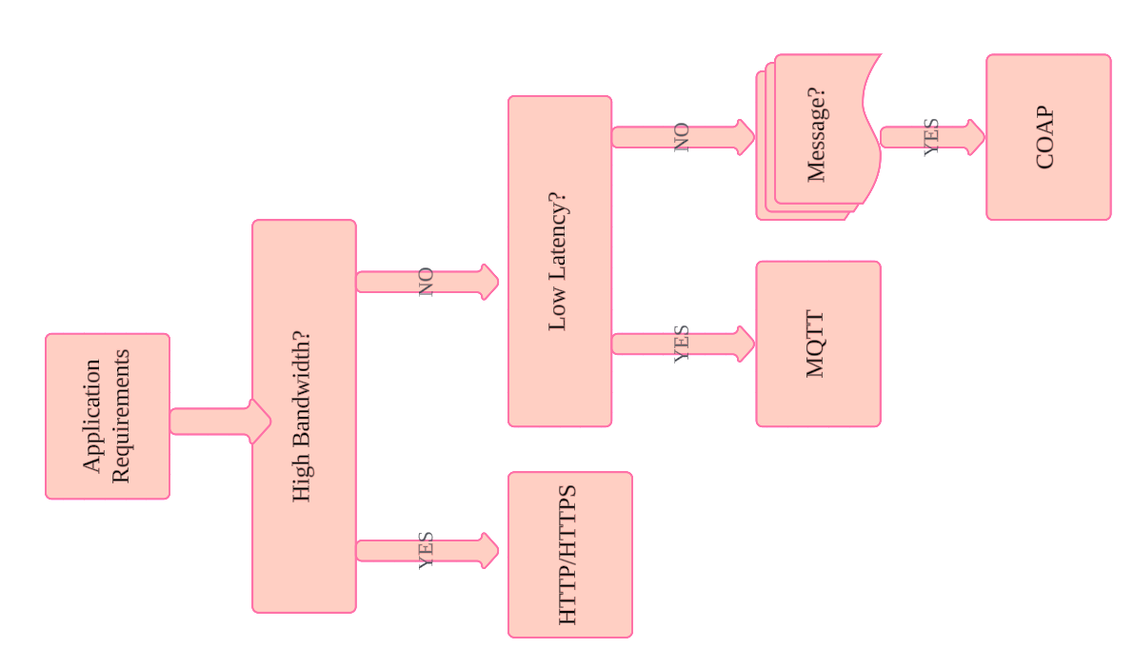

***Figure: - Internet of Things protocol***

**Explanation of the Flowchart**

1. **Application Requirements**
   * The decision process begins with understanding the specific application requirements of the IoT system.
2. **High Bandwidth?**
   * **Yes**: If the application requires high bandwidth, **HTTP/HTTPS** is a suitable protocol due to its widespread use and support for large data transfers.
   * **No**: If high bandwidth is not required, proceed to the next decision point.
3. **Low Latency?**
   * **Yes**: If low latency is crucial for the application (e.g., real-time communication), **MQTT** is chosen due to its lightweight messaging and efficiency.
   * **No**: If low latency is not a primary concern, proceed to the next decision point.
4. **Message-Based Communication?**
   * **Yes**: If the application involves message-based communication, **MQTT** is suitable due to its publish/subscribe model.
   * **No**: If message-based communication is not required, **CoAP** is a suitable choice due to its efficiency in constrained environments.

**IoT Communication Layers Diagram**

Here’s a diagram representing the layered architecture of IoT communication protocols:

**Overview of the IoT Communication Layers**

**Application Layer:** This includes protocols that define how data is formatted, processed, and presented to the end-users or other systems. Common protocols in this layer are HTTP/HTTPS, MQTT, and CoAP.

**Transport Layer:** This layer deals with end-to-end communication. It ensures that data is reliably and efficiently transferred. The key protocols in this layer are TCP and UDP.

**Network Layer:** This is the layer where IP addressing and routing across a network occur. The key protocols are IPv4, IPv6, and 6LoWPAN.

**Data Link Layer:** This defines how data packets will be framed, addressed, and error-checked. Primary protocols include Ethernet, Wi-Fi, Zigbee, Bluetooth, and LoRaWAN.

**Physical Layer:** This layer deals with the actual connection of devices; it considers signals at the electrical, optical, and radio levels. Some protocols are IEEE standards, like 802.3 for Ethernet, 802.11 for Wi-Fi, 802.15.4 for Zigbee, and 802.15.1 for Bluetooth. LoRa is also one of them.

These tables and brief descriptions should at least provide an understanding of the flowchart based on how an IoT protocol would be chosen based on the application requirement, and how IoT communication protocols work on a layered architecture.

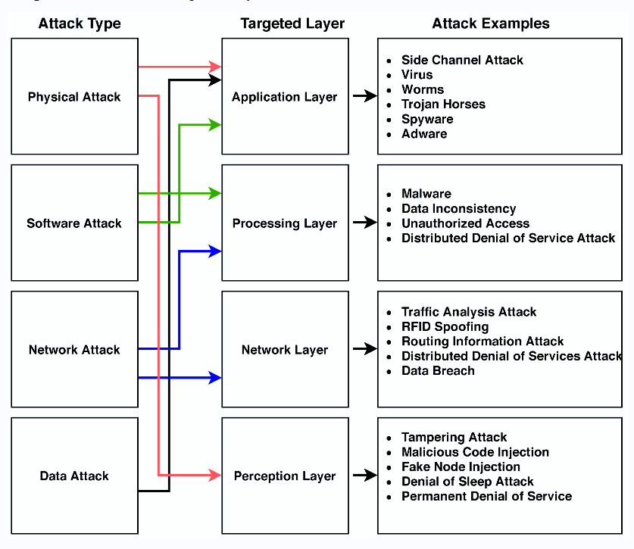

***Figure 2: - Overview of the IoT Communication Layers***