GIARDIA LAMBLIA
Giardia was observed by Leeuwenhoek in 1681 in his own stool and named after Professor A. Giard and Professor F. Lambi in 1859.
Classification
Giardia can be differentiated to various species based on the origin of the host.
G. lamblia infects human and other mammals, G. muris in mice, G.agilis in amphibians, G. psittaci in birds & G. microti in voles.
G. lamblia can be further be differentiated into seven genotypes from A to G, out of which genotype A & B usually infect humans.
Epidemiology
Giardia is cosmopolitan parasite. The highest prevalence of G. lamblia occurs in tropics and subtropics where sanitation is poor. Travelers to tropical Africa, Mexico, Russia, Southeast Asia and Western South America are at a high risk of acquiring giardiasis. Giardia infects 200 million people worldwide and may produce symptoms in 500000 individuals every year. Infections seem to be more common in children than adults.
Habitat
Duodenum and upper part of jejunum.
Morphology
It exits in two forms:
- Trophozoite
- Cyst

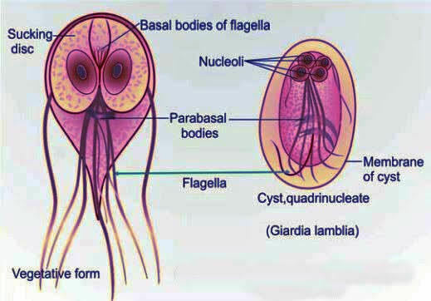
Trophozoite
The trophozoite has a falling leaf like motility.
In front view, it is pear shaped/tear drop/tennis racket shaped with rounded anterior end and pointed posterior end.
It is convex dorsally while the ventral surface has a concavity bearing a bilobed adhesive disc. It appears as sickle shaped in lateral view.
It measures 10-20 µm in length and 5-15 µm in width.
The dorsal surface is convex while on the ventral surface it has a shallow posteriorly notched cavity (suckling disc) that embrace anterior half of the organism. It acts as an organelle of attachment.
It is bilaterally symmetrical; on each side from the midline it bears:
- One pair of nuclei
- Pair of median bodies
- Four pairs of basal bodies or blepharoplast (from which the axoneme arises)
- Four pairs of flagella- two lateral, one ventral and one caudal pair of flagella
- Pair of parabasal bodies (connected to basal bodies through which the axoneme passes)
- Pair of axoneme or axostyle (the intracellular portion of the flagella).
Cyst
Mature cyst is oval in shape and measures 11-14 µm X 7-10 µm in size. It has two pairs of nuclei which may remain clustered at one end or lie in remains at opposite poles. The remains of the flagella and margins of the suckling disc may be seen inside the cytoplasm of the cyst.
It is the infective form as well as the diagnostic form of the parasite.
Life Cycle
It passes its life cycle in a single host, the man. No intermediate host is required.
Mode of transmission- man acquires infection by ingestion of food and water contaminated with mature cysts or rarely by sexual routes (mainly in homosexuals). Infection may occur through ingestion of as few as 10-25 cysts.
Excystation- Two trophozoites are released from each cyst in the duodenum within 30 minutes of entry.
Multiplication- Trophozoites multiply by longitudinal binary fission in the duodenum.
Adhesion- trophozoites adhere to the duodenal mucosa by the bilobed adhesive ventral disc. This is achieved by the microtubules of median bodies, contractile proteins and lectins present on the surface of adhesive disc that bind to the intestinal receptors (sugar molecules). In active stage of the disease, sometimes the trophozoites are excreted in diarrhea stool.
Encystation- Gradually when the trophozoite pass down to large intestine, encystation begins. Promoting factors of encystation are the
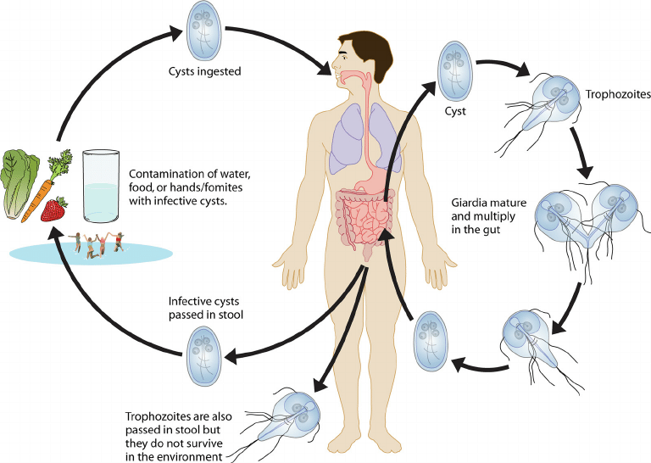

conjugated bile salts, alkaline pH and cholesterol starvation. Encystation Specific Vesicles appear in the cytoplasm that helps in processing and transportation of the cyst wall protein antigens to the exterior of the plasma membrane to synthesize the cyst wall. Encystation begins the retraction of the flagella followed by condensation of the cytoplasm and finally formation of the cyst wall.
On maturation, nuclei divide to become four. The mature cysts excreted in feces can survive better in the environment and are infective to man.
Pathogenicity
Children are commonly infected. Other high-risk groups are elderly debilitated persons and patients with cystic fibrosis, poor hygiene and immunodeficiency syndromes such as common variable hyperglobulinemia. However, association with AIDS patients is not been confirmed yet.
Several pathogenic mechanisms have been postulated that include:
- Trophozoite adhere to the duodenal mucosa and cause disruption of the intestinal epithelial brush border that leads to increase permeability and malabsorption. Very rarely, elaboration of enterotoxin such as cystein rich surface protein 136 (CRP-136).
- Malabsorption
There could be various type which include:
- Malabsorption of vitamin B12 and folic acid
- Protein loosing enteropathy
- Malabsorption of fat (Steatorrhea)
- Lactose intolerance
Clinical feature
- Asymptomatic carriers- Most infected persons are asymptomatic harboring the cysts and spreading the infections.
- Acute giardiasis- Incubation period varies from 1-3 weeks. Symptoms may develop suddenly or gradually. Common symptoms include diarrhea, abdominal pain, bloating, belching, flatus and vomiting. Diarrhea is often foul smelling with fat and mucus but no blood. This stage lasts for 1 week but usually resolves spontaneously.
- Chronic giardiasis- It may present with or without a previous acute symptomatic episode. Symptoms are intermittent and recuring. Common symptoms include recurrent episodes of foul-smelling diarrhea, foul flatus, sulfurous blenching with rotten egg taste and profound weight loss leading to growth retardation. Uncommon symptoms such as- fever, presence of blood & mucus in stool and colitis. Extraintestinal manifestation have been described such as urticaria, anterior uveitis and arthritis.
Laboratory Diagnosis
1.Stool examination
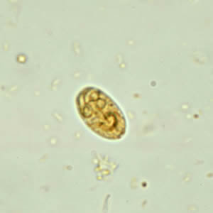
Giardiasis can be diagnosed by identification of cysts of G. lamblia in the formed stool and the trophozoites of the parasite in diarrheal stool by normal saline and iodine preparation. Demonstration of the trophozoite with falling leaf like motility by saline mount indicates active stage of disease. Giardia adheres firmly to the duodenal mucosa by adhesive disc leading to intermittent shedding. Hence, repeated stool examination (at least three) should be done.
Concentration techniques like zinc sulfate flotation or formalin ether sedimentation methods are employed to increase the chance of detection.
2.Entero-test
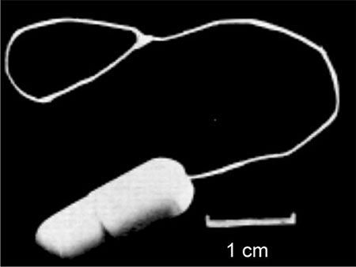
It uses a gelatin capsule attached to a thread. One end of the thread is attached to the inner aspect of the patient’s cheek and then, the capsule is swallowed. Capsule gets dissolved in the intestine releasing the thread which is kept there for 4-6 hrs to take the duodenal fluid. Later, the thread is withdrawn and shaken in saline to release trophozoites which can be detected microscopically. The entero-test is also useful in the search for other upper intestinal parasites such as Storangyloides stercoralis.
3.Antigen detection in stool (Copro-antigen)
The ELISA and direct fluorescent antibody tests are available using labeled monoclonal antibodies against cyst wall protein antigens.
Both the tests are highly sensitive and specific. They are very useful in microscopy negative samples and also in outbreak situations.
Immune chromatographic test (Triage parasite panel)
It has been simultaneously detect antigens of Giardia, Entamoeba and Cryptosporidium with sensitivity and specificity like ELISA. It is simple, easy to perform and can be done at peripheral laboratory.
4.Biopsy
Duodenal sampling or biopsy should be processed when stool and entero-test are negative. Biopsy from multiple duodenal and jejunal sites may confirm the diagnosis od giardiasis. Touch preparations can be air dried, fixed in methanol and stained with Giemsa stain. Routine histological procedures should also be performed, but trophozoites are very difficult to see and may be present in very few of the sections.
5.Immunological tests
ELISA test has been developed for the detection of Giardia antigen in feces. Anti-Giardia antibodies in patient’s serum may be detected by IFA and ELISA. However, these may indicate present or past infection. Hence, serology is only helpful for epidemiological purpose for estimating the prevalence of infection.
6. Antigenic Variation
G. lamblia is known to undergo surface antigenic variation. The antigens involved belong to a group of variant specific surface proteins that are unique cystine rich zinc finger proteins. This may provide a mechanism enabling the organism to escape the host’s immune response.
7.Culture
Giardia can be grown axenically in Diamond’s medium, the medium also used for axenic cultivation of E. histolytica.
8.Molecular methods
Detection of Giardia nucleic acid by PCR or by gene probes is highly sensitive and specific.
9.Radiological findings
X-ray after barium meal is generally non-specific and may be positive in 20% of cases.
Barium meal may also interfere with the stool examination, so stool samples should be collected before the barium meal.
Treatment
Metronidazole is usually affective in more than 90% of cases. Single dose of tinidazole probably is superior to metronidazole for treatment of giardiasis. Furazolidone is given to children and paromomycin can be given in pregnancy.
Prevention
Giardiasis is prevented by:
- Improved food and personal hygiene
- Proper storage of food and water
- Treatment of symptomatic and asymptomatic individuals
- No vaccine is currently available

