An Economic Analysis on Health Indicators and Gross Domestic Product of India
________________________________________________________________
Arun Venkatesh.D, Research Scholar, Department of Economics, Bharathidasan University, Tiruchirappalli
Siby.B, Research Scholar, Department of Economics, Bharathidasan University, Tiruchirappalli

Abstract
The study aims at establishing the relationship between macroeconomic variables such as GDP and macro health indicators like birth rate, infant mortality rate, neo-natal mortality rate. The data used for the study goes for two decades and the study will be done for India. The paper will assess the potential effects of health care policies that affect the macro health indicators. The techniques applied for the study are trend analysis and OLS regression model which will be used to analyse the empirical relationship between the selected variables. The findings and suggestion of the studies are presented in detail in the paper.
Introduction:
“It is health that is real wealth and not a piece of gold and silver”
-Mahatma Gandhi
Health contributes to better well-being across a society. A healthier work force is expected to contribute to increased productivity as well as less absenteeism compared to an unhealthy workforce. The increased life expectancy brings about changes in expenditure and savings decisions, thus resulting in increased saving rates which in turn boost investment and economic growth rates. Health can impact economic growth indirectly via education, where healthier children tend to have higher school attendance rates, hence improving the overall quality of the labour force, once again resulting in enhanced output. In this manner, health and economic growth are interrelated.
In theory, health care tends to be classified as an economic good since the resources for it, such as human capital, are limited. However, society’s needs and wants are infinite. The consumption and production of health care can only be increased by diverting resources from other sectors in the economy towards the health care system. Such decisions are based on the ‘opportunity cost’ concept; which would represent the benefits foregone if the resources were utilized for the next best alternative. Grossman (1972) suggested that people both demand and produce health. Health care has a ‘derived demand’ from health since people purchase goods such as health care to meet their needs, thus indirectly purchasing health improvements. In Grossman’s model, health is considered as a capital good since it can affect a person’s ability to work, hence the linkage between health and economic growth.
Health
According to World Health Organization “Health” is defined as “State of complete Physical, Mental and Social wellbeing, not merely the absence of disease or infirmity”.
“Health is multifaceted. It defies simple definition, and no single variable summarizes it, especially at the aggregate level” Arora, S. (2002, May 22).
In fact, the studies discussed below include a number of different health indicators to try to capture the overall effect of health. The most commonly used indicators are as follows,
Birth Rate: According to World Health Organization “Birth Rate” is defined as “The ratio between the number of live births in a population during a given year and the total mid-year population for the same year, usually multiplied by 1000”.
Infant Mortality Rate: It indicates the number of mortalities amongst infants and is usually expressed as a number per 1000 live births. According to World Health Organization “Infant mortality rate is the probability of a child born in a specific year or a period dying before reaching the age of one, if subject to age-specific mortality rates of that period. Infant mortality rate is strictly speaking not a rate (i.e. the number of deaths divided by the number of population at risk during a certain period of time) but a probability of death derived from a life table and expressed as rate per 1000 live births”.
Neo-Natal Mortality Rate: It indicates the number of deaths of new born within 28 days. According to World Health Organization, “Number of deaths during 28 days of life per 1000 live births in a given year or other period. Neo-Natal deaths (deaths among live births during the first 28 completed days of life) may be subdivided into early neonatal deaths, occurring after the 7th day but before the 28th day of life”.
Health Expenditure: Total expenditure on health is the sum of general government health expenditure and private health expenditure in a given year, calculated in national currency units in current prices.
Health spending consists of health and health-related expenditures. Expenditures are defined on the basis of their primary or predominant purpose of improving health, regardless of the primary function or activity of the entity providing or paying for the associated health services.
Health-related expenditures include expenditures on health-related functions such as medical education and training, and research and development. Public health expenditure consists of recurrent and capital spending from government (central and local) budgets, external borrowings and grants (including donations from international agencies and nongovernmental organizations), and social (or compulsory) health insurance funds. Total health expenditure is the sum of public and private health expenditure. It covers the provision of health services (preventive and curative), family planning activities, nutrition activities, and emergency aid designated for health but does not include provision of water and sanitation.
Health expenditure, as a total percentage of GDP of India was 4.69 as of 2014. Its highest value over the past 19 years was 4.69 in 2014, while its lowest value was 3.90 in 1996. From this, the public Health expenditure (% of GDP) in India was 1.41 as of 2014 and private Health expenditure (% of GDP) in India was 3.28 as of 2014. A recent report says that India's health spending is a measly 3.9 per cent of GDP. Of this, public spending is just 1.15 per cent, which the government aims to raise to 2.5 per cent by 2025.

Objective of the study:
- To analyze the relationship between GDP and the selected Macro health indicators.
- To identify the relationship between the selected Macro health indicators and GDP.
Methodology:
Methodology will be used in the form of Secondary data. Secondary data has been obtained from various sources for the study. For the study, secondary data obtained from journals, articles, reports and from other government websites have been used. Statistical tools such as Correlation, Regression with OLS have been used in the study including various tables and charts have also been used where ever necessary.

Table: 1
Year | Health Expenditure(Billion)
2000 | 3.82632168
2001 | 3.73719061
2002 | 3.67565856
2003 | 4.11719685
2004 | 4.50721688
2005 | 5.56846623
2006 | 6.06210023
2007 | 7.49355412
2008 | 8.57171899
2009 | 9.80957714
2010 | 11.82685003
2011 | 14.03344591
2012 | 13.69979178
2013 | 12.94719751
2014 | 13.50609052
2015 | 15.10636847
2016 | 16.26476444
2017 | 18.96377172
2018 | 18.12649097
2019 | 20.90209403
Source: World Bank

Chart: 1

Health Expenditure: The above table and chart represent the health expenditure over the years. This shows that there has been continues increase in the health expenditure by the government over the year, which will possibly increase in the future.
Birth Rate: The data on Birth Rate has been showed below from the year 2001 to 2020.
Table: 2
Year | Birth Rate (thousands)
2001 | 17.3
2002 | 18.5
2003 | 16.89
2004 | 17.1
2005 | 16.5
2006 | 16.2
2007 | 15.8
2008 | 16.0
2009 | 16.3
2010 | 15.9
2011 | 15.7
2012 | 15.5
2013 | 15.4
2014 | 15.2
2015 | 15.1
2016 | 14.9
2017 | 14.8
2018 | 14.6
2019 | 14.5
2020 | 14.3
Source: NITI AYOG

Chart: 1.1
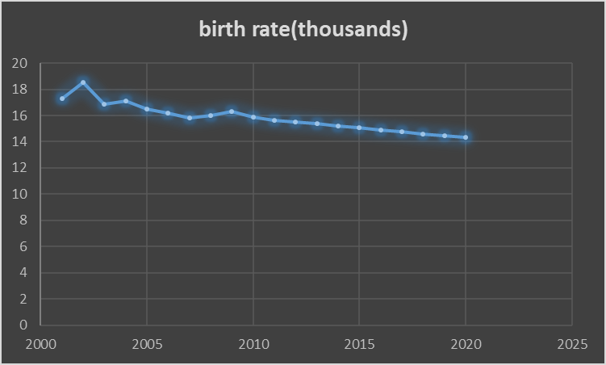

The above table and chart shows the birth rate in India over the years from 2001 to 2020, there has been a gradual decrease in the birth rate over the years which can be seen from the above data. The data has also been pictorially represented by way of a line chart which shows the gradual fall of birth rate over the years. This shows that over the years due to transitional development there has been a gradual fall in the birth rate, which may further fall as there in development.

Table: 3

Year | GDP at Current Prices (crores) | Birth Rate(thousands)
2001 | 148,861 | 17.3
2002 | 158155 | 18.5
2003 | 175371 | 16.88
2004 | 219,003 | 17.1
2005 | 257,833 | 16.5
2006 | 310,526 | 16.2
2007 | 350,819 | 15.8
2008 | 401,336 | 16.0
2009 | 479,733 | 16.3
2010 | 584,896 | 15.9
2011 | 667,202 | 15.7
2012 | 744,859 | 15.5
2013 | 854238 | 15.4
2014 | 976703 | 15.2
2015 | 928,073 | 15.1
2016 | 991535 | 14.9
2017 | 1054996 | 14.8
2018 | 1118458.11 | 14.6
2019 | 1197183.122 | 14.5
2020 | 1274341.92 | 14.3
Source: World Bank

Chart: 3.1
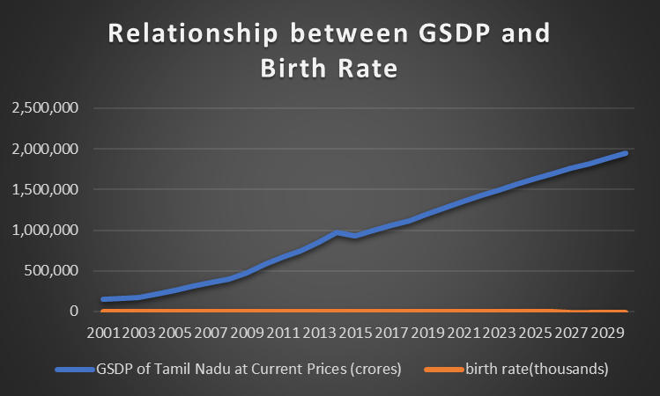

Table: 3.1
Correlations
 |  | GDP | Birthrate
GDP | Pearson Correlation | 1 | -.979**
 | Sig. (2-tailed) |  | .000
 | N | 30 | 30
birthrate | Pearson Correlation | -.979** | 1
 | Sig. (2-tailed) | .000
 | N | 30 | 30
**. Correlation is significant at the 0.01 level (2-tailed).

Table: 3.2
Variables Entered/Removedª
Model | Variables Entered | Variables Removed | Method
1 | birthrate^{b} | . | Enter
a. Dependent Variable: GDP
b. All requested variables entered.

Table: 3.3
Model Summary
Model | R | R Square | Adjusted R Square | Std. Error of the Estimate
1 | .979ª | .959 | .958 | 54878.54755
a. Predictors: (Constant), birthrate

Table: 3.4
ANOVAª
Model |  | Sum of Squares | Df | Mean Square | F | Sig.
1 | Regression | 1977473580311.991 | 1 | 1977473580311.991 | 656.607 | .000^{b}
 | Residual | 84326339466.486 | 28 | 3011654980.946
 | Total | 2061799919778.476 | 29
a. Dependent Variable: GDP
b. Predictors: (Constant), birthrate

Table: 3.5
Coefficientsª
Model |  | Unstandardized Coefficients |  | Standardized Coefficients | T | Sig.
 |  | B | Std. Error | Beta
1 | (Constant) | 3310109.968 | 107778.355 |  | 30.712 | .000
 | Birthrate | -182703.987 | 7130.095 | -.979 | -25.624 | .000
a. Dependent Variable: GDP

From table 3 we can see the data on GDP and birth rate from the years 2001 to 2020. The data shows that there has been a gradual decrease in birth rate as the GDP increases. This has been shown in a graphical format in chart 2.1, where it is clear that birth has been falling over the years, for a much clear look correlation analysis has been used. In table 2.2 the correlation table shows that with every 1 percent increase in GDP there has been -0.979 percentage fall in birth rate, which shows the correlation is significant at 0.01 level. The above table it is clear that there is an inverse relationship between GDP and Birth rate. From the above table 2.6 we can see that with 1 crore increase in GDP there -182703.987 fall in birth rate, with R value of 0.979 and R² value 0.959 and adjusted R² value 0.958.

Table: 4

Year | GDP | Infant Mortality rate
2001 | 148,861 | 49
2002 | 158155 | 44
2003 | 175371 | 43
2004 | 219,003 | 41
2005 | 257,833 | 37
2006 | 310,526 | 37
2007 | 350,819 | 35
2008 | 401,336 | 31
2009 | 479,733 | 28
2010 | 584,896 | 24
2011 | 667,202 | 22
2012 | 744,859 | 21
2013 | 854238 | 21
2014 | 976703 | 20
2015 | 928,073 | 19
2016 | 991535 | 17
2017 | 1,054,996 | 16
2018 | 1118458.11 | 15
2019 | 1197183.12 | 14.5
2020 | 1274341.92 | 14.3
Source: NITI AYOG, World Bank
Chart: 4.1
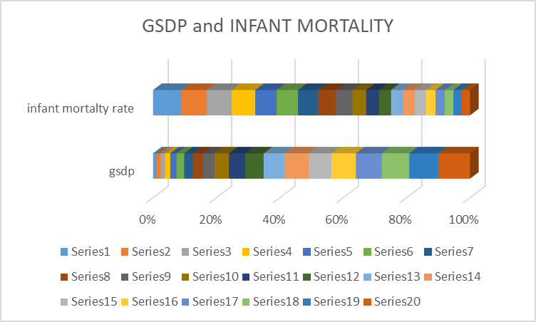
Table: 4.1
Descriptive Statistics
 | Mean | Std. Deviation | N
Infant mortality | 26.9944 | 11.86088 | 20
GDP | 644706.1076 | 382617.86965 | 20

Table 4.2
Correlations
 |  | Infant mortality | GDP
Pearson Correlation | Infant mortality | 1.000 | -.970
 | GDP | -.970 | 1.000
Sig. (1-tailed) | Infant mortality | . | .000
 | GDP | .000 | .
N | Infant mortality | 20 | 20
 | GDP | 20 | 20

Table 4.3
Variables Entered/Removedª
Model | Variables Entered | Variables Removed | Method
1 | gdp^{b} | . | Enter
a. Dependent Variable: infantmortality
b. All requested variables entered.

Table 4.4
Model Summary
Model | R | R Square | Adjusted R Square | Std. Error of the Estimate
1 | .970ª | .940 | .937 | 2.97444
a. Predictors: (Constant), gdp

Table 4.5
ANOVAª
Model |  | Sum of Squares | Df | Mean Square | F | Sig.
1 | Regression | 2513.676 | 1 | 2513.676 | 284.118 | .000^{b}
 | Residual | 159.251 | 18 | 8.847
 | Total | 2672.927 | 19
a. Dependent Variable: infantmortality
b. Predictors: (Constant), gdp

Table 4.6
Coefficientsª
Model |  | Unstandardized Coefficients |  | Standardized Coefficients | T | Sig.
 |  | B | Std. Error | Beta
1 | (Constant) | 46.375 | 1.328 |  | 34.913 | .000
 | gdp | -3.006E-5 | .000 | -.970 | -16.856 | .000
a. Dependent Variable: infantmortality

The relationship between GDP and infant mortality is shown in the table 4 and pictorially in the chart 4.1, which shows inverse relationship. This is also shown in the table 4.2 descriptive statistics, the mean and standard deviation values of infant mortality are 26.9944 and 11.86088 respectively, same way the mean and Standard deviation value of GDP are 644706.1076 and 382617.86965 respectively. The GDP and infant mortality was found to have inverse relationship. When GDP increases by one percent the infant mortality rate falls by -0.970, this shows they are negatively correlated. The regression results are also significant which shows one percent increase in GDP there is -3.006 percent fall in infant mortality rate, with r square value of 0.970.
Table: 5
Year | GDP(Crores) | Neo-Natal Mortality Rate
2000 | 148,861 | 44.7
2001 | 158155 | 43.3
2002 | 175371 | 41.9
2003 | 219,003 | 40.5
2004 | 257,833 | 39.1
2005 | 310,526 | 37.9
2006 | 350,819 | 36.6
2007 | 401,336 | 35.4
2008 | 479,733 | 34.3
2009 | 584,896 | 33.1
2010 | 667,202 | 31.8
2011 | 744,859 | 30.6
2012 | 854238 | 29.4
2013 | 976703 | 28.2
2014 | 928,073 | 27
2015 | 991535 | 25.9
2016 | 1054996 | 24.8
2017 | 1118458.11 | 23.7
2018 | 1197183.12 | 22.7
2019 | 1274341.92 | 21.4
2020 | 1349141.17 | 20.3
Source: NITI AYOG and World Bank
Chart: 5.1
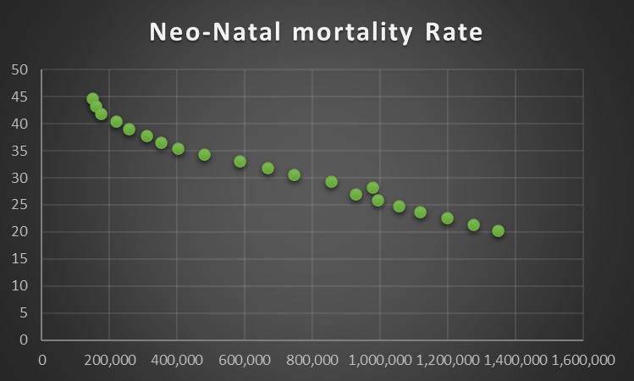

Table 5.2
Descriptive Statistics
 | Mean | Std. Deviation | N
Neo natal mortality | 32.0286 | 7.50181 | 21
Gdp | 678250.6343 | 403369.00371 | 21

Table 5.3
Correlations
 |  | neonatalmortality | gdp
Pearson Correlation | Neonatalmortality | 1.000 | -.989
 | Gdp | -.989 | 1.000
Sig. (1-tailed) | Neonatalmortality | . | .000
 | Gdp | .000 | .
N | Neonatalmortality | 21 | 21
 | Gdp | 21 | 21

Table 5.4
Variables Entered/Removedª
Model | Variables Entered | Variables Removed | Method
1 | gdp^{b} | . | Enter
a. Dependent Variable: neonatalmortality
b. All requested variables entered.

Table 5.5
Model Summary
Model | R | R Square | Adjusted R Square | Std. Error of the Estimate | Change Statistics
 |  |  |  |  | R Square Change | F Change | df1 | df2 | Sig. F Change
1 | .989ª | .978 | .977 | 1.14444 | .978 | 840.367 | 1 | 19 | .000
a. Predictors: (Constant), gdp

Table 5.6
ANOVAª
Model |  | Sum of Squares | Df | Mean Square | F | Sig.
1 | Regression | 1100.658 | 1 | 1100.658 | 840.367 | .000^{b}
 | Residual | 24.885 | 19 | 1.310
 | Total | 1125.543 | 20
a. Dependent Variable: neonatalmortality
b. Predictors: (Constant), gdp

Table 5.7
Coefficientsª
Model |  | Unstandardized Coefficients |  | Standardized Coefficients | T | Sig. | 95.0% Confidence Interval for B
 |  | B | Std. Error | Beta |  |  | Lower Bound | Upper Bound
1 | (Constant) | 44.502 | .498 |  | 89.449 | .000 | 43.461 | 45.544
 | Gdp | -1.839E-5 | .000 | -.989 | -28.989 | .000 | .000 | .000
a. Dependent Variable: neonatalmortality

The relationship between GDP and Neo-Natal Mortality has been shown in the Table-5. The table shows with the increase in GDP there has been a fall in the Neo-Natal Mortality. The relationship has been graphically shown in the chart 5.1, which shows there is a fall in the Neo-Natal Mortality with the increase in GDP. It can be seen from table 5.1the mean value of Neo-Natal Mortality is 32.0286 and standard deviation 7.50181. The mean value of GDP is said to be 678250.6343 and standard deviation is 403369.00371. The correlation between GDP and Neo-Natal Mortality is -0.989, which shows inverse relationship between the two components. The regression value -1.839 with independent variable GDP and dependent variable Neo-Natal Mortality, Both the correlation and regression values show negative relationship, which means with increase in GDP there is a fall in the Neo-Natal Mortality. This shows that there has been a gradual development over the years, in the health sector and health infrastructure, which results in the fall in the Neo-Natal Mortality.
Major findings from the study are as follows:
- There has been major changes and improvements in the field of health sector in the State of Tamil Nadu.
- There has been an inverse relationship between GDP (Gross Domestic Product) and Birth Rate over the years which indicate there has been a demographic transition and development in minds of the people.
- This can be seen by the negative correlation between GDP and Birth Rate, which has been -0.979.
- The Regression results also showed negative relationship between GDP and Birth Rate -182703.987, with R value of 0.979ª and R² value of 0.959.
- There has been an inverse relationship GDP and Infant Mortality rate.
- This is shown by the descriptive statistic with mean value Infant Mortality rate 26.9944 and Standard deviation value to be 11.86088.
- There has been a negative correlation between GDP and Infant Mortality rate by
-0.970.
- The regression results show negative relationship between GDP and Infant Mortality rate -3006, with R value of 0.970 and R² value of 0.940.
- There has been an inverse relationship between GDP and Neo-Natal Mortality, with the correlation value to be -0.989.
- The descriptive statistic shows the mean and standard deviation values of GDP to be 678250.6343 and 403369.00371respectively, same way the mean and standard deviation of Neo-Natal Mortality rate are 32.0286 and 7.50181 respectively.
- The regression coefficient also shows negative relationship with GDP and Neo-Natal Mortality rate by -1.839, with R value of 0.989 and R² value of 0.978.

Conclusion:
The above findings show that there has been a development in the health sector in the state over the years. We can see that there has been a fall in the infant mortality rate and neo-natal mortality with the increase in the GDP which shows inverse relationship. From the above study we can conclude that there has been a good development in the health sector in the state. The study expects that there will be an increase in the development in the sector in the following years.

References:
- Grossman (1972), The Demand for Health A Theoretical and Empirical Investigation, Colombia University Press.
- Arora, S. (2001), "Health, human productivity, and long-term economic growth", Journal of Economic History, vol. 61, no. 3, pp. 699-749.
- Crude Birth Rate, Indicator Meta Data Registry List, Global Health Observatory, World Health Organization.
- Infant Mortality Rate, Indicator Meta Data Registry List, Global Health Observatory, World Health Organization.
- Neo-Natal Mortality Rate (0 to 27 days) per live births)(SDG3.2.2) Indicator Meta Data Registry List, Global Health Observatory, World Health Organization.
- Arora, S (2002, May 22) Health, Human Productivity, and Long-Term Economic Growth, The Journal of EconomicHistory, Cambridge Core.
- World Health Organization Global Health Expenditure database.
- https://www.cambridge.org/core/journals/journal-of-economic history/article/abs/health-human-productivity-and-longterm-economic-growth/FB66D1E2A5F2E80557ED3E3287EB0CA9
- IndicatorMetadataRegistryDetails.Https://Www.Who.Int/.https://www.who.int/data/gho/indicator-metadata-registry/imr-details/3138, world health organization.
- Https://Www.Who.Int/about/Governance/Constitution.https://www.who.int/about/governance/constitution
- https://www.who.int/about/governance/constitution
- https://Www.Who.Int/Data/Gho/Indicator-Metadata-Registry/Imr-Details/67
- https://apps.who.int/nha/database
- (2018, May 18). Live Updates, News, Headlines, Videos And More. https://www.newindianexpress.com/, The New Indian Express.
- http://www.newindianexpress.com

