EXPLORING THE IMPACT OF TOXIC HEAVY METALS ON THE ANALYTICAL POTENTIAL OF MEDICINAL PLANTS

Deepak Singh¹ and Manoj Kumar Sharma^{1*}
¹Department of Botany, J.V. College, Baraut, Baghpat, Uttar Pradesh, India
*Corresponding author: mbhardwaj1501@gmail.com
*https://orcid.org/0000-0001-9245-9158

ABSTRACT
Present studies toxic heavy metal accumulation in has increased dramatically in recent years due to agricultural and industrial activities leading to pollution of natural sources and widely distributed in the environment due to the anthropogenic human activities. It is recognized that heavy metals due to their toxicity, long persistence in nature can accumulate in the trophic chain and cause organism dysfunction. They are essential for many biological processes but can also be toxic to humans when present in high concentrations. Medicinal plants, which are used for their therapeutic properties. Although the popularity of plants medicine is rapidly increasing all over the world heavy metal toxicity has a great impact on medicinal plants and poses a significant risk to human health. Consequently, affects the quality of plant parts raw materials, extracts, the safety and marketability of drugs. It is possible for to be present homeopathic and ayurvedic materials. At the same time, it focused on the quality’s applications of medicinal plants as well as the dangers associated with in conventional therapies. Adequate regulatory measures and quality control qualities of nature medicinal plant products for toxic heavy metals are required. In this scientific article tries to address related in medicinal plants regard to case studies, regulation aspects, toxic heavy metals accumulation, management phytoremediation strategies, ecological consequences and toxic human health.
Keywords: Heavy metals, Chemoaccumulation, Toxic abiotic stress, Health risk, Medicinal plants

- INTRODUCTION

In modern times, heavy metals containing medical treatments are poisoning individuals all over the world. Pharmaceutical plant materials derived from anthropogenic sources such as industrial waste, agricultural and natural sources may include heavy metals. There is evidence that pollutants were intentionally inserted in a number of ethnic groups in the hope that they would have some kind of therapeutic advantage. Heavy metals poisoning of medicinal plant items has been associated with numerous harmful health outcomes, including heart, kidney, and liver problems as well as death. Globally recognised, natural plant-based products have advanced to the point where, in order to supposedly provide medical benefits, they now blend various synthetic components. This evaluation was focused on the effects of heavy metals on plants, heavy metals sources, gathering medicinal samples, and identification methods, particularly for samples of therapeutic plants. Additionally, it concentrates on the applications of heavy metals in society and the risks involved with using them in traditional therapy. Because dangerous heavy metals are so common, proper regulation and monitoring procedures for natural supplements must be put in place.¹ For living cells to keep their balance, heavy metals were necessary. This survey was concentrated on the issue of contaminated medicinal plants as a result of airborne hazardous chemical deposition and environmental pollution caused by various industrial activities. Since plants readily absorb organic and inorganic substances from the air, soil, and water, this analysis is crucial because these substances can then move up the trophic chain to reach humans. Because they were widely employed for their therapeutic benefits and played a big role in traditional medicine, medicinal plants were interesting for research.² Recent years a sharp rise in the accumulation of heavy metals in medicinal plants as a result of industrial and agricultural activities that pollute natural sources. The concentration of heavy and trace elements was the main focus of this investigation.³ The possibility of heavy metal contamination of medicinal plants due to global threats is a major worry. Four heavy metals (Al, Pb, As, and Cd) were quantitatively evaluated in relation to commonly sold medicinal plants in Iranian markets. Mentha piperita L. and Zataria multiflora L. two medicinal plants were chosen from six different herbalists in six distinct Shiraz, Iran, regions. The sample's dissolution was carried out.⁴ In the many countries, the use of medicinal plants to treat illnesses, including cancer, is recognised and accepted. Plant materials contaminated with heavy metals may be harmful to human health, especially for populations that was already at risk. In this study, the amounts of toxic heavy metals in samples of medicinal plants used to cure skin cancer are measured, and the health risks associated with toxic heavy metal exposure are assessed. Our results confirm that potential heavy metal concentrations in medicinal plants purchased by patients from medicinal shops need to be closely monitored.⁵ There is a rising fear that traditional medicinal treatments may include heavy metal contamination, as there has been a tendency toward their use. The investigation assessed the levels of heavy metals in medicinal plants. It measured the concentration of specific many heavy metals and determines the corresponding health risk.⁶ Medicinal plants were a major global source of medications for thousands of years. However, the quality and safety of medicinal plants was recently severely impacted by heavy metal pollution. Ingesting medicinal plants contaminated with heavy metals including Pb, Hg, and Cu poses a serious risk to consumers' health. Controlling the amounts of heavy metals in medicinal plants is necessary to handle this scenario.⁷ Consuming medicinal herbs can lead to the accumulation of heavy metals, which can have detrimental effects on health. Thus, the purpose of this focused-on knowledge gaps on heavy metal stress in medicinal plants, plant responses, and hazards to human health.⁸ Naturally occurring substances that are present in soil and water are known as heavy metals. Although they are necessary for many biological functions, at large doses they can be harmful to humans. Due to their therapeutic qualities, medicinal plants have the potential to accumulate heavy metals in the soil. Because medicinal plants are widely used as nutritional supplements or herbal medicines, the buildup of heavy metals in these plants presents a serious risk to human health. Lead (Pb), mercury (Hg), cadmium (Cd), and arsenic (As) are examples of heavy metals that can cause long term exposure and lead to major health issues such kidney damage, cancer, neurological damage, and developmental difficulties.⁹ Therefore, the aim of this article was focused on many objectives’ qualities, a short investigation on the toxic effects caused by heavy metals contamination for medicinal plants and human health, and to review the existing techniques used in the determination of heavy metals from medicinal plant part product.¹⁰
The purpose of this study was to determine the concentrations of several heavy metals, including lead, mercury, arsenic, cadmium, and cooper, in both packaged and wild-growing samples of many commonly used medicinal herbs and spices in Romania. All heavy metal concentrations in the examined plant samples, with the exception of lead and mercury, were within allowable bounds.¹¹ Medicinal herbs indigenous to many places are employed in the treatment of many ailments. Some, nevertheless, may have a negative impact on your health. In their many medicinal herbs were hazardous heavy matals elements Al, Pb, As, and Cd were examined.¹² Medicinal plants are tainted by environmental contaminants, particularly heavy metals, which provide serious health hazards when exposed over an extended period of time. In order to ascertain the levels of the three most prevalent and hazardous heavy metals lead, cadmium, and arsenic in many regularly used medicinal plants in the many places, this experiment was done.¹³ Particularly interesting for human health are medicinal plants. This study aims to ascertain the levels of heavy metals Pb, Cd, and Hg in therapeutic plants derived from spontaneous flora, specifically Chelidonium majus L, Crataegus monogyna L., Artemisia absinthium L, and Hypericum perforatum L. The possible health risk to consumers posed by the trophic transfer of harmful heavy metals in medicinal plants necessitates a methodical control.¹⁴ There was a report of heavy metal poisoning associated with traditional medicine use all throughout the world. Contaminated agricultural resources and subpar production methods can introduce heavy metals into items made from therapeutic plants. In several cultural groups, the intentional addition of heavy metals for purported medical purposes has been documented. Heavy metal poisoning in medicinal plant products has been linked to numerous health problems, including kidney and liver failure and even death. Natural plant-based products from Africa have developed to include different manmade compounds, like heavy metals, for purported therapeutic benefits. The primary areas of industry and agriculture where contamination may occur are highlighted in this review. It was drawn attention to the cultural applications of heavy metals in traditional treatments and the associated poisonings.¹⁵
- A FEW INCIDENTS OF RENOWNED MEDICINAL PLANTS
Some popular medicinal plants that are valued for their therapeutic properties were chosen.¹³
Table 1: List of medicinal plants with their traditional uses
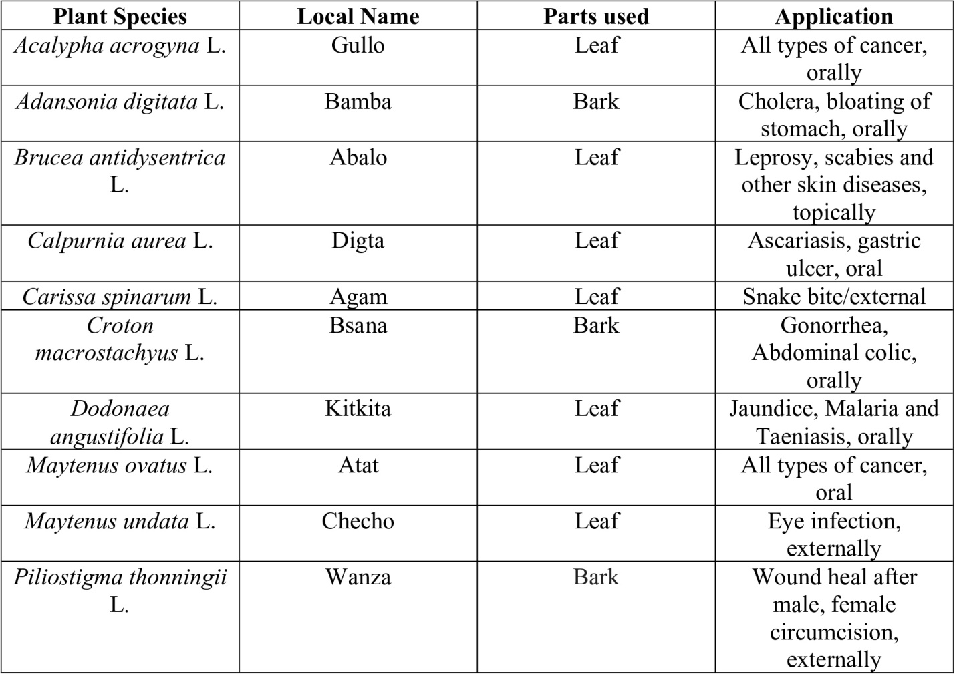
- DIGESTION OF MEDICINAL PLANTS
An advanced technique was used to digest both cleaned and unwashed parts of the therapeutic plants. For the digesting process, about 0.5 g of each sample both cleaned and unwashed from each plant were used. For the digesting procedure, 4.0 ml of nitric acid (69.0% HNO₃) and 2.0 ml of hydrogen peroxide (30% H₂O₂) were utilized. Using a 3000-microwave sample preparation system, the maximum temperature reached was 125⁰C for 40 minutes, with a total pressure of 20 bar. For the analysis, the digested solution was prepared up to 10 ml and then diluted 10-fold with deionized water.¹⁶
- APPLIED METHOD TO MEASURE OF HEAVY METALS
The many heavy metals concentrations (Al, Pb, As, Cd, and other) in the digested sample solutions were determined using (Thermo Fisher Scientific iCAP Q ICP-MS) system. Samples were examined in duplicate, both cleaned and unwashed. The following are the operating conditions for (Thermo Fisher Scientific iCAP Q ICP-MS). Power is 1550 W, cold gas flow is 14.1 L/min, nebulizer gas flow is 0.94 L/min, and auxiliary gas flow is 0.79 L/min. The total time for each sample measurement is 3 minutes. The dwell time is 0.01 seconds, and the peristaltic pump speed is 40 rpm.¹⁷
- QUALITY CONTROL
Every day before analysis, the (ICP-MS) performance was examined, (B iCAP) tune solution including U, In, Li, and Co for the standard mode background signal and sensitivity, each element having a concentration of 1 µg/L in 2.0% HNO₃ and 0.5% HCl. thermo fisher qtegra software, For the limits of detection (LODs) pertaining to the many measured elements from scientific, waltham, was utilized. LODs (µg/L) for the following elements were found: Al (5.387), Pb (0.080), As (0.008), and Cd (0.01). Quality control (QC) tests were conducted using a continuous calibration verification (CCV) method for every run. Following each set of five runs, a mixed standard containing all measured elements was tested at a concentration of 20 µg/L. Three recoveries for each element in a single the following session after five runs: Pb (90.57%), As (86.10%), Cd (90.47%), and Al (86.37%).
- UPTAKE OF HEAVY METALS IN MEDICINAL PLANTS
The primary source of pollution is the soil and other terms, from which heavy metals can reach the surface of the roots by ion exchange or diffusion between the soil and water on the root surface (Fig.1).
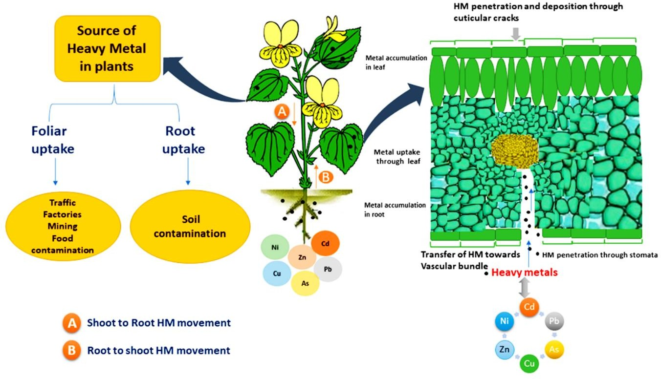

Figure 1: Absorption of Sources heavy metals by organs uptake
Essential metals are assimilated by plants through active absorption, but they can also absorb other harmful substances present in the soil.
Heavy metals have the ability to transport via cationic channels in the cell membrane at the same time. Although they are not physiologically significant to living organism, heavy metals like (As), (Pb), (Cd), (Al) and other can have harmful consequences and interfere with an organism ability to develop. Because of this, a variety of heavy metals must to be regarded as possible hazards to both human health and medicinal plants. Plants can absorb and transport metals from contaminated soil by a variety of methods, including rhizofiltration, phytoextraction, phytostabilization, and phytovolatilization, which can alter the plant.¹⁸
- HEAVY METALS ACCUMULATION IN MEDICINAL PLANTS
Growing in their native environments, many therapeutic plants can collect heavy metals. By producing metal-binding peptides known as phytochelatin, certain plant species that absorb high quantities of metals have evolved the capacity to detoxify them. These plants nonetheless have a high potential to transfer metals from the soil to biomass that they consume. Plants roots absorb heavy metal ions, which are then transported to aerial plant parts and bioaccumulated.¹⁹ Exclusion and accumulation strategies mostly rely on physiological processes that necessitate the maintenance of intracellular heavy metal ions by the cells, although in a harmless form. When leaf fall later removes any stored heavy metal ions or complexes, exclusion takes place. The properties of the soil, atmosphere, and plants themselves all have an impact on the build-up of heavy metals in plant tissues. According to medicinal plants do indeed accumulate significant levels of heavy metals. These distinctly show that heavy metals, which is prevalent in numerous studied species and is typically found in therapeutic, medicinal plants. These reports also show that various plant species have different quantities of metals that are non-essential to human health.²⁰
- IMPACT OF HEAVY METALS IN MEDICINAL PLANTS
The primary contributors to heavy metal contamination are human activities. Various type of heavy metals disturbs the activities of photosynthesis, pigmentation, transpiration, genetic material, bioactive compounds and nitrogen fixation. These heavy metals were shown in numerous studies to negatively affect antioxidant qualities and secondary metabolites. An extensive examination into the risks of metal contamination in therapeutic medicinal is necessary. The precise methodology of the study has made it evident that more guidelines for medication dose and screening are needed. This study investigated the dangers associated with various pollutant levels, especially those found in pharmaceuticals. Future research on exogenous pollutants, universal criteria, and preventative measures can build on the findings. Studies on the subject have produced recommendations for quickly reducing or eliminating the presence of heavy metals in active medicinal components.²¹
- IMPACT ON MEDICINAL PROPERTIES BY HEAVY METALS
Plants under stress from heavy metals exhibit a range of therapeutic qualities. Whether using in vitro assays to screen medicinal plants is the best method for validation is up for debate. However, so grate medicinal plants in present have an identifiable active ingredient that can be found through simple screening of extracts from these plants. Certain secondary metabolites, antioxidant, antifungal, antiseptic and antiallergic qualities were however these on elements potentially negatively impact how they are regulated.²² However, as noted not much research has been done on heavy metals affect the ultramorphological traits and medicinally active components of medicinal plant parts. When plants experience abiotic stress, metallo-enzymes inactive in and either partially or completely offset the stress. However, oxidative stress happens when the stress brought on by these heavy metals is main enough to throw off the redox equilibrium, which lowers the antioxidant value of the therapeutic plants.²³
- MEDICINAL SOURCES OF HEAVY METALS IN HUMAN RISK
Traditional cultures have a rich history of using and preparing herbs, which has been passed down from generation to generation through decades of trial and error. The roots of allopathic medicine today can be found in this ancient society. There are several ways to make medicinal, decoctions cooked tea, tinctures alcohol and water, infusions hot teas, and macerated tea (obtained by cold soaking). Plant derived materials are becoming very popular because of their many uses. In conventional drug systems, medicinal plants are the most abundant source of pharmaceuticals. They are utilised in contemporary drugs, as chemical constituents in synthetic drugs, and as dietary supplements. Because traditional herbal medicines are inexpensive and widely trusted. The herbal medicines are prepared according to standardized methods in traditional systems, which differ based on the type of plant used and the ailment being treated. The heavy metals that are present in medicinal plants after they are prepared for use enter the body and can lead to problems with the brain, liver, lungs, heart, kidneys, and central nervous system.²⁴ There may be health hazards for consumers who employ medicinal herbs as ingredients in cosmetics. These days, cosmetics with active ingredients derived from medicinal plants are more appealing than ever because they are thought to be safer for human health than goods made by synthesis. But as these goods are frequently made from aromatic and medicinal plants, they may include heavy metals most frequently that are then transferred to cosmetics shampoos, creams, and makeup items. The systemic harmful effects of heavy metals on the skin.²⁵
- EVALUATION OF HEAVY METALS IN MEDICINAL PLANTS WITH CASE STUDIES
Due to their fewer negative effects and rising appeal, medicinal plants are becoming more and more necessary. It is declared that medicinal plants are safe, pure, and healthful. However, as several variations show, some medicinal plants may absorb heavy or harmful metals.²⁶ The scientific community main objective is to assess the medicinal plants capacity to collect various heavy metals and the potential health risks to humans. We could identify and pinpoint the geographic regions of herbs based on their tissue’s capacity for absorption. As demonstrated by a previous study, the content of heavy metals (Pb, Cd, Cr, and Ni) varied alarmingly depending on the locality in which the samples were gathered. The samples were taken from a number of randomly selected medicinal plants, industrial areas, and residential areas. Certain heavy metal elements displayed varied results in different areas, for instance, heavy metals were greatest in medicinal plants root from heavy traffic area locations. Following an assessment of the levels of heavy metals in ten different locations across India, it was determined that market was medicinal more contaminated. Using the advanced techniques, analysis of elevated hazardous heavy metals concentrations was conducted using medicinal plants crude kinds. Evidence from several nations suggests that harmful heavy metals and unreported prescription pharmaceuticals in medicinal remedies could be a major health concern.²⁷
- ECOLOGICAL CONSEQUENCE OF HEAVY METALS
The parent material that a soil was formed from is the most significant and primary source of heavy metals. Sedimentary rocks make up around 5% of the earth crust, while rocks make up the remaining 95%. Heavy metals are found in higher concentrations in basaltic rocks, which belong to the former category. On the other hand, shales that are generated from fine sediments with both organic and inorganic origins have higher concentrations of heavy metals. Most soils include these heavy metals in the form of carbonates, sulphides, oxides, or salts. Every metal's predominant mineral might differ from one soil to the next. Many heavy metals are not necessary for plants to utilise as vital micronutrients for healthy plant growth, although these heavy metals are harmful to plants and can lead to growth restriction, food chain disturb, demand energy flow, degradation of the air quality, low quality medical products, and pollution react even pose a risk to human and animal health. However, some heavy metals are fundamentally heavy metals and have no recognised biological function in plants. Heavy metals, as was previously mentioned, anthropogenic and natural sources, can in risk the agroecosystem.²⁸ In this case, the use of materials containing heavy metals as well as tainted fertilizers and biosolids are also relevant. Some metals, especially other phosphatic are sprayed foliarly on the leaves of plant. The added to the soil as necessary micronutrients for sustained crop production. The various chemicals, such as herbicides, fungicides, and insecticides, are used extensively to control insect pests and diseases. The ecological system disturbance in this section was discussed. Furthermore, emissions from automobiles using many fuels are responsible for heavy metals accumulation in soils near road traffic sides.²⁹
- PHYTOREMEDIATION STRATEGIES OF HEAVY METALS (TRADITIONAL CONCEPT)
Using green plants and related microbes to reduce the harmful effects of possible contaminants in the environment is known as phytoremediation. Greek term phyto, which means "mean plant," and Latin word remedium, which means "to correct or remove an evil," are the sources of the phrase "phytoremediation." This method can be applied to heavy metal cleanup. The idea of employing green plants to remove heavy metals is becoming more and more popular as a good substitute for physical and chemical remediation methods when it comes to the removal of harmful metals and metalloids. It is crucial to talk about the following phytoremediation methods order to remove heavy metals from soil.³⁰
13.1 PHYTOSTABILIZATION
The term "phytostabilization" or "phytoimmobilization" describes the use of plants that have the capacity to reduce a metal's mobility and bioavailability through a variety of mechanisms, such as adsorption by roots, precipitation, or complexation in the root zone, in order to stop it from leaching into ground water or entering the food chain.³¹
13.2 PHYTOVOLATALIZATION
Another strategy is called phytovolatalization, in which metal is transformed into a volatile form and released into the atmosphere via stomata. This method works well for mercury since it converts the mercuric ion into an element that is comparatively less hazardous. This method offers a stopgap fix for the issue since precipitation has the potential to return the volatile form of mercury that has been released into the atmosphere to the soil.³²
13.3 PHYTOEXTRACTION
The most crucial method of phytoremediation is phytoextraction. For the extraction of metals and metalloids from water, sediments, biosolids, and polluted soils. When it comes to commercial applications, it is more appropriate than other phytoremediation methods. Several The characteristics of the concerned plant, metal speciation, metal availability to plants, and soil qualities all have an impact on the effectiveness of phytoextraction. According to plants that are chosen for phytoextraction should have a variety of qualities, such as increased biomass production, hyperaccumulator heavy metal, widespread distribution, ability to transfer metal from root to shoot, tolerance for the harmful effects of heavy metal, resistance to pathogens and pests, and lack of attraction to herbivores.³³
- CONCLUSION
Due to the possible risk toxic heavy metal poisoning in polluted medicinal plants is currently a major environmental and health concern. Risks associated with heavy metal in medicinal plants over 70% of people worldwide are thought to utilize herbs to treat various ailments. The Can pose a risk to human health and ecosystems because to exposure to various harmful heavy metals found in plants and absorbed from the environment. One cause of stress in medicinal plant species is the accumulation of heavy metals. A wide range of organisms, tissues, and organs are susceptible to the deleterious consequences of toxic metal bioaccumulation. The heavy metals obstruct biological processes such apoptosis, cellular damage repair, health, and medicinal plants qualities. Toxicants in a range of pharmaceutical products, considering the specifics of the production process and the allowable limits of heavy metals in medicinal plant materials. The risk of consuming too many heavy metals in the human body will be decreased by using indicators that evaluate the environmental purity of plant raw materials or plant-based medicines depending on frequency and dose. A safer environment can be achieved by geographic authentication and protection of raw materials.
- FUTURE PERSPECTIVES
The pure medicine can be made by removing the dangers related to heavy metals. To disinfect, further modern phytoremediation strategies such as microbial assisted phytoremediation and chemical assisted phytoextraction may be employed. Hyperaccumulator plants are a useful tool for removing high levels of harmful metals and other organic and inorganic contaminants from soil. Therefore, using genetic engineering to create transgenic plants with traits like high biomass production, increased metal accumulation, resistance to metal toxicity, and excellent climate adaptation may be more advantageous in this regard. The policy support and the subsequent establishment of pertinent rules and regulations to meet the development needs of the new era will be important in the future.
- ACKNOWLEDGEMENT
The authors would like to express their gratitude to the Department of Botany at J.V. College, Baraut, Baghpat, Uttar Pradesh, India, for providing the lab facilities that were required for this work. The authors would also like to express their gratitude to the Department staff, who were instrumental in assisting with several of the analyses.
- POTENTIAL FOR CONFLICT OF INTEREST. Exactly zero

- REFERENCES

- Vinogradova, N., Glukhov, A., Chaplygin, V., Kumar, P., Mandzhieva, S., Minkina, T., & Rajput, V. D. (2023). The Content of Heavy Metals in Medicinal Plants in Various Environmental Conditions: A Review. Horticulturae, 9(2), 239.

- Meriem, D., Sekia, I., Ameni, D., Ikessoulen, T., & Baghiani, A. (2023). Impact of toxic heavy metals and their concentration in Zygophyllum species, Mentha longifolia L. and Thymus vulgaris L. traditional medicinal plants consumed in Setif Algeria. European Journal of Biology, 82(1), 109-123.

- Karahan, F. (2023). Evaluation of trace element and heavy metal levels of some ethnobotanically important medicinal plants used as remedies in Southern Turkey in terms of human health risk. Biological Trace Element Research, 201(1), 493-513.

- Shahkarami, S., Goudarzi, F., Amiri-Ardekani, E., & Dehghani, S. (2023). Heavy metals contamination in two species of medicinal plants in the Iranian market. International Journal of Environmental Analytical Chemistry, 103(19), 8532-8541.

- Oladeji, O. M., Kopaopa, B. G., Mugivhisa, L. L., & Olowoyo, J. O. (2023). Investigation of heavy metal analysis on medicinal plants used for the treatment of skin cancer by traditional practitioners in Pretoria. Biological Trace Element Research, 1-9.

- Kohzadi, S., Shahmoradi, B., Ghaderi, E., Loqmani, H., & Maleki, A. (2019). Concentration, source, and potential human health risk of heavy metals in the commonly consumed medicinal plants. Biological trace element research, 187, 41-50.

- Guo, C., Lv, L., Liu, Y., Ji, M., Zang, E., Liu, Q., & Li, M. (2023). Applied analytical methods for detecting heavy metals in medicinal plants. Critical Reviews in Analytical Chemistry, 53(2), 339-359.

- Hlihor, R. M., Roșca, M., Hagiu-Zaleschi, L., Simion, I. M., Daraban, G. M., & Stoleru, V. (2022). Medicinal plant growth in heavy metals contaminated soils: Responses to metal stress and induced risks to human health. Toxics, 10(9), 499.

- Ahandani, E. A., Rafeie, F., Alizadeh-Tarpoei, Z., Hajipour, S., Selamoglu, Z., & Heidari-Bazardehy, S. S. (2022). An attitude towards the effects of heavy metals in medicinal plants. Bioengineering Studies, 3(2), 1-7.

- Zaleschi, L. H., Apostol, M., Simion, I. M., Cara, G. I., Teliban, G. C., Stavarache, M., & Hlihor, R. M. (2021). Short Overview of Heavy Metals Effects for Plants and Human Health and Their Determination in Medicinal Plants. International Conference on e-Health and Bioengineering EHB pp. 1-4.

- Marinescu, E. L. I. S. A. B. E. T. A., Elisei, A. M., Aprotosoaie, A. C., Cioanca, O. A. N. A., Trifan, A., Miron, A., & Hancianu, M. O. N. I. C. A. (2020). Assessment of heavy metals content in some medicinal plants and spices commonly used in Romania. Farmacia, 68(6), 1099-1105.

- Brima, E. I. (2017). Toxic elements in different medicinal plants and the impact on human health. International journal of environmental research and public health, 14(10), 1209.

- Atinafu, T., Mekonnen, T., & Somasundaram, J. (2015). Determination of some toxic heavy metal accumulation in medicinal plants commonly used in Gondar area district, Northwestern Ethiopia. International Journal of Pharmacy and Analytical Research, 4(4), 399-405.

- Badea, D. N. (2015). Determination of potentially toxic heavy metals (Pb, Hg, Cd) in popular medicinal herbs in the coal power plant area. Rev. Chim, 66(8), 1132-1136.

- Street, R. A. (2012). Heavy metals in medicinal plant products—An African perspective. South African Journal of Botany, 82, 67-74.

- Brima, E. I. (2016). Determination of metal levels in shamma (smokeless tobacco) with inductively coupled plasma mass spectrometry (ICP-MS) in Najran, Saudi Arabia. Asian Pacific Journal of Cancer Prevention: Apjcp, 17(10), 4761.

- Sharma, I. (2020). ICP-OES: An advance tool in biological research. Open J Environ Biol, 5(1), 027-033.

- Diaconu, M., Pavel, L. V., Hlihor, R. M., Rosca, M., Fertu, D. I., Lenz, M., & Gavrilescu, M. (2020). Characterization of heavy metal toxicity in some plants and microorganisms—A preliminary approach for environmental bioremediation. New Biotechnology, 56, 130-139.

- Maiga, A., Diallo, D., Bye, R., & Paulsen, B. S. (2005). Determination of some toxic and essential metal ions in medicinal and edible plants from Mali. Journal of Agricultural and Food Chemistry, 53(6), 2316-2321.

- Maharia, R. S., Dutta, R. K., Acharya, R., & Reddy, A. V. R. (2010). Heavy metal bioaccumulation in selected medicinal plants collected from Khetri copper mines and comparison with those collected from fertile soil in Haridwar, India. Journal of Environmental Science and Health Part B, 45(2), 174-181.

- Pirhadi, M., Shariatifar, N., Bahmani, M., & Manouchehri, A. (2022). Heavy metals in wheat grain and its impact on human health: A mini-review. Journal of Chemical Health Risks, 12(3), 421-426.

- Nasim, S. A., & Dhir, B. (2010). Heavy metals alter the potency of medicinal plants. Reviews of Environmental Contamination and Toxicology, 139-149.

- Zandi, P., & Schnug, E. (2022). Reactive oxygen species, antioxidant responses and implications from a microbial modulation perspective. Biology, 11(2), 155.

- Nafiu, M. O., Hamid, A. A., Muritala, H. F., & Adeyemi, S. B. (2017). Preparation, standardization, and quality control of medicinal plants in Africa. Medicinal spices and vegetables from Africa, 171-204.

- Brima, E. I. (2018). Levels of essential elements in different medicinal plants determined by using inductively coupled plasma mass spectrometry. Journal of Analytical Methods in Chemistry.

- Sutkovic, J., Yildirim, A., Karic, L., Glamoclija, P., & Sabanovic, K. (2023). Comparative Cadmium correlated gene expression in domestic vs. hybrid kale varieties from Bosnia and Herzegovina. In Book of Proceeding.

- Alinia-Ahandani, E., Alizadeh-Terepoei, Z., Sheydaei, M., & Peysepar-Balalami, F. (2020). Assessment of soil on some heavy metals and its pollution in Roodsar-Iran. Biomed J Sci & Tech Res, 28(5), 21977-21979.

- Seth, C. S. (2012). A review on mechanisms of plant tolerance and role of transgenic plants in environmental clean-up. The Botanical Review, 78(1), 32-62.

- Rehim, A. (2014). Phosphorus and zinc application improves rice productivity. Pakistan journal of science, 66(2).

- Wang, H. Q., Zhao, Q., Zeng, D. H., Hu, Y. L., & Yu, Z. Y. (2015). Remediation of a magnesium‐contaminated soil by chemical amendments and leaching. Land Degradation & Development, 26(6), 613-619.

- Ali, H., Khan, E., & Sajad, M. A. (2013). Phytoremediation of heavy metals—concepts and applications. Chemosphere, 91(7), 869-881.

- Erakhrumen, A. A., & Agbontalor, A. (2007). Phytoremediation: an environmentally sound technology for pollution prevention, control and remediation in developing countries. Educational Research and Review, 2(7), 151-156.

- Ghosh, M., & Singh, S. P. (2005). A review on phytoremediation of heavy metals and utilization of it’s by products. Asian J Energy Environ, 6(4), 18.

