Monograph

Reforms in the assessment of medical undergraduate students

INDEX
Sr no | Headings | Page no
1 | Importance and relevance | 3
2 | Brief history | 4-6
3 | Origin and initial experience | 7-16
4 | Current literature on the topic- pros and cons or merits and demerits, Results of previous studies abroad | 18-38
5 | Implementation in the Indian situation,  If already done, where and what are the results  If not, what are the constraints; how can we implement | 39-46
6 | Conclusions | 47
7 | References | 49-71

Reforms in the assessment of medical undergraduate students

1 Importance and relevance

With introduction of CBME and NEP, year 2019 and 2020 has seen major policy decisions in the field of education in India. Both policies aim to transform medical education and higher education by institutional restructuring, holistic and multidisciplinary approach of education , optimal learning environments and support for students, transforming the culture of assessment through continuous, formative assessments and and transforming the regulatory systems. [1, 2]

Competency based education uses objectives mapped to framework of competencies to know the outcome of medical education training [3]. Assessment focuses on the phase subject (sub) competencies, which are in turn mapped to the global competencies in the graduate medical education regulations. The Indian Medical Graduate [IMG] is expected to function in the roles of a clinician, leader , communicator, lifelong learner and the professional. Since in CBME, achieving of competency is the end point of educational process, it needs ongoing continuous, contextual assessments with the formative feedback for learners to know the progress and achievement of expected competencies. NEP-2020 also focuses also on formative and competency-based assessment, promoting learning and development of students and testing higher-order skills.

As India is shifting from traditional medical education to CBME, rest of world is moving to the integrated curriculum, spiral integration and authentic assessments in work places using EPA as framework.[4]

In view of these major changes implemented in India, in the field of higher education specially the medical education, this article aims to trace the changes in the assessment approaches, tools which shaped the reforms of present day and what are the changes that Indian medical undergraduate curriculum assessment has incorporated in comparison to other countries.

2 Brief history

2.1 Global scenario
Undergraduate medical training traditionally, involved initial pre-clinical subject-based courses and a subsequent clinical component of patient care and management followed by supervised clinical practice in the form of internship or residency. [5,6]

Flexner’s report marks the beginning of reforms in medical education by identifying the loopholes as lack of standardization in curricula, lack of connect between curriculum and clinical experiences and differences in student achievements and unqualified faculty [7]. To curb differences in student achievements, accreditation process for medical schools and matching of learning outcomes through assessment of competencies was recommended by Carnegie Foundation for the Advancement of Teaching in 1910 [8].

Osler’s recommendation of bedside teaching and direct training by faculty in real patient context was guided by principles suggested by Flexner.[9]
Achievement of Competencies in authentic settings was primary to inter-professional education and teamwork, formal explicit training in ethics, assessment on professionalism and student support through mentoring and advising, feedback, reflective opportunities [10]. General professional education of the physician (GPEP) Report (1984) stressed on importance of purpose of clinical education and developing criteria for evaluation and supervision. It is recommended to reassess the importance of clinical practice to help medical students master the basic skills of medicine before graduation. These include clinical observation, interviewing, physical examination, and problem-solving skills.[11]

The Edinburgh declaration was the final document of the world conference on medical education held in Edinburgh from August 7 to 12, 1988, suggested to build both curriculum and examination systems to ensure the achievement of professional competence and social values [12]. Initial implementation in post- Flexner reform involved integration across basic and clinical sciences. Health care delivery had changed drastically over past 20 -30 years owing to changes in social determinants of health, inequities in care, changing trends of non-communicable, life style related chronic health care needs. This led to medical education to see the health care as a changed system aimed to achieve patient safety, patient-centered, team-based services. [13-15]. So the curriculum content constituting health systems science was a new addition to medical education with equal importance as basic and clinical medical sciences [16-20] demanding training as integrated curriculum across time and across disciplines [21, 22].

2.2 Indian context

Different committee worked post-independence in India from 1943 to 2020 to ensure the need-based changes in medical education. Initial committee reports focused on needs of larger section of society, provision of basic Infrastructure, rural health care needs, control of infectious diseases and social security [23].

Bhore committee, introduced 3 months of social and preventive medicine into the medical curriculum and aimed for strengthening primary health centres in rural areas, public health reforms related to provide preventive, curative and rehabilitative services to entire urban as well as rural population. Health education was focus of Shrivastava committee (1975) and Bajaj committee (1983). National education policy of 1986 emphasised on setting up autonomous colleges and universities and establishing equity in weaker section of society through scholarships & incentive schemes, residential schools and hostel facilities.[29].

In terms of assessment in undergraduate medical education, Recommendation of Radhakrishnan commission (1948-1949) was reform of assessment- “if there is one thing to be reformed in education, it is the examination system” [23]. National policy on education (NEP)1968 recommended a shift in the focus of evaluation from certification to improvement in learning, NEP 1986 suggested elimination of excessive element of chance and subjectivity, ed-emphasizing memorization, introduction of continuous and comprehensive evaluation (CCE), use of grades in place of marks and introduction of semester system from secondary 2 stage in a phased manner. [24]

Today, the New Education Policy 2020 (NEP-2020) brings a change in assessment with a focus on regular, standardized, and effective assessments and testing high intelligence for student learning and development.[1]

The transition is expected from a discipline- and knowledge-based curriculum to an integrated, system and competency-based curriculum. Key changes include in curriculum of competency based medical education [CBME] include vertical and horizontal curriculum integration; student-centered approach, small group teaching, explicit teaching learning activities related to attitude, ethics, communication and professionalism [AETCOM] ,early clinical exposure and inclusion of community-based practice; self-directed learning demanding more of formative and performance-based assessment; and just-in-time faculty feedback to improve [25].

3 Origin and initial experience

3.1 Trends in the assessment frameworks

Education is defined as a continuous process, that brings about desirable changes in the behavior of learners on a relatively permanent basis by way of increasing knowledge, improving skills, and developing attitudes / values / communication [26]. These desirable behavioural changes in education are called the objectives /specific learning objectives. Education, seen as a system aims at "Constructive alignment” of the objectives, process of teaching-learning activities and output as summative student performance [27], which is corresponding to Tyler’s rationale of education - viz educational purpose, organization of educational experiences to attain purpose and determination of attainment of purpose [28]. The outcome of this entire process is seen in evaluation which can serve as feedback to all stages.

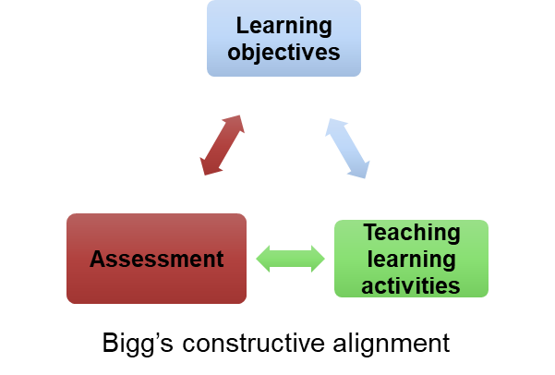
Fig 1- Constructive Alignment

To evaluate student performance objectively, Bloom and his associates proposed to classify the educational objectives in hierarchical progression of three domains [29-31]. [cognitive domain by Bloom et al 1956, psycho-motor domain by Simpson et al 1972, affective domain by Krathwohl et al 1973]

The educational objectives in Bloom’s taxonomy were classified in domains and arranged progressively from simpler to complex stages.

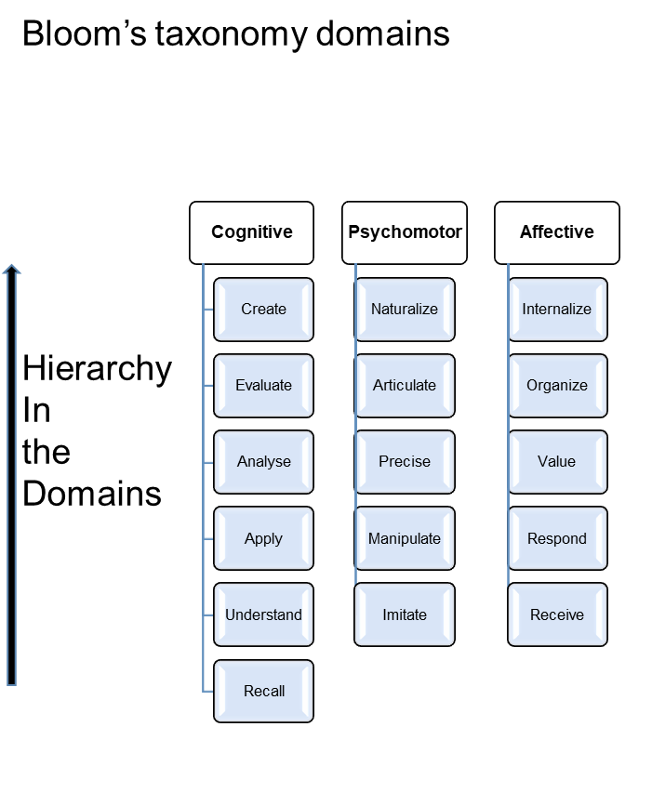
Fig 2-Bloom’s taxonomy

It served as a framework for selecting the appropriate T –L Method and Medium, by mapping the learning objectives on the continuum of learning. Bloom’s taxonomy also served to identify the relevant level of assessment tool in medical education by deconstructing competence into individual domain specific objectives. By virtue of being specific, measurable, attainable, relevant and time bound – Specific learning objectives [SLOs] served to the objectivity and reliability of assessments. Similar simpler framework of three levels of progression for each domain was proposed by Guibert [32].

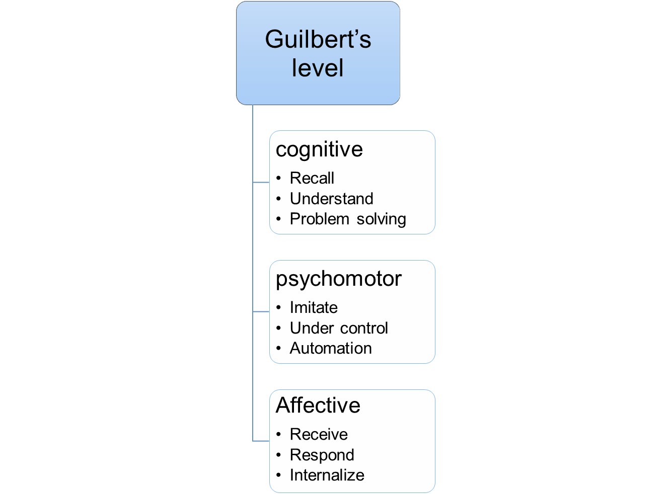
Fig 3- Guilbart’s taxonomy

But successful performance in individual domains does not mean that student will be able to integrate all domains in practice and this framework misses the workplace setting of assessment for achieving professional competence.

Gorge Miller’s pyramid [1990] suggested a layered framework at different levels- knows, knows how, shows how and does - which suggest the importance of cognitive component underlying the skills and difference in performance under standard setting [shows how] and real situations [does] referred as a skill and competency respectively [33].

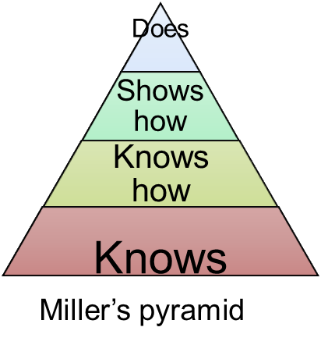
Fig 4- Miller’s pyramid

Similar approach was described by Pangaro 1999 [34] as RIME model for clinical setting in medical education included roles as Reporter, Interpreter, Manager, and Educator, which reflect stepwise professional activities in clinical setting and patient care as - accurate and relevant clinical information gathering,interpreting clinical findings, developing diagnostic and therapeutic plans, self improvement and guiding the sub ordinates.

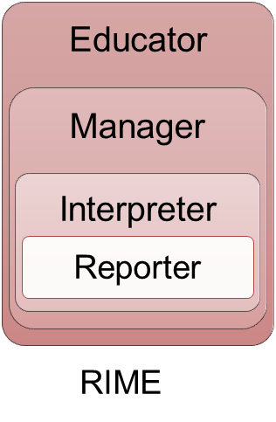
Fig 5- RIME model

In this framework the professional keeps performing the roles of lower level even if he is moving to higher roles. In this aspect this model differs from developmental frameworks, in which the professional roles do not fall back once achieved /progressed to next level as in Dreyfus and Dreyfus model [35] shown below.

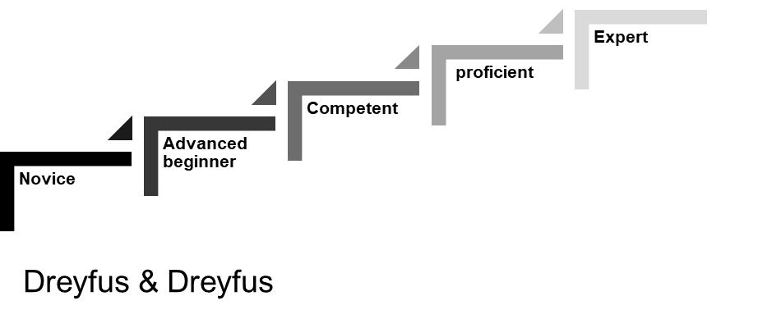
Fig 6 - Dreyfus and Dreyfus model of competency acquisition

In this model learning is mapped on a longitudinal timeline for achieving expertise. This has five stages of learning from novice-advance beginner-competent-proficient-expert. Beginner” phase, students follow established rules and plans, as they have little or no experience. Advanced Novice refers to limited “situational awareness.” They can formulate general principles, but no holistic understanding. They try to complete the task but have trouble solving the problem. Competent and proficient can develop and work with conceptual domain models. Activities converge against the background of information accumulation. They can solve new problems and effectively seek expert advice, show careful planning from experience. Expert take a holistic view of a situation. They reflect and review past work. From the previous skill level, they are constantly looking for better ways to do things.

IMG framework of competence for INDIA

The undergraduate medical education program is designed with a goal to create an “Indian Medical Graduate” (IMG) possessing requisite knowledge, skills, attitudes, values and responsiveness, so that she or he may function appropriately and effectively as a physician of first contact of the community while being globally relevant” [25].

IMG framework expects Indian medical graduate [IMG] to play five roles as clinician, leader, communicator, lifelong learner and professional. Subject related

competencies match with role related competencies. Subject related competencies are achieved by framing Specific learning objectives and Millers pyramid for teaching learning and assessments [25].

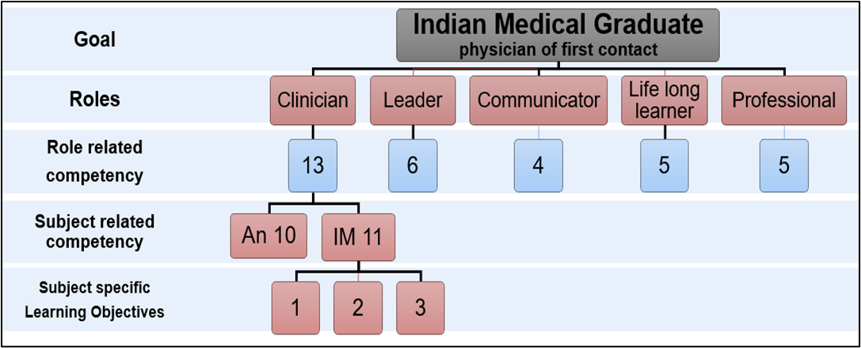
Fig 7- Indian Medical Graduate framework

Overall
Bloom’s taxonomy model focus on the final objectives and with assumption that competence can be measured discretely under domains and will be equal to competence. While Miller’s pyramid and RIME model are based on need of multiple domains applied by the learner simultaneously in real and complex contexts. In CBME, a professional task /activity - should be a unit of assessment rather focusing on domain specific objectives.
Many aspects of professional competence need identification of progress and developmental stages in the progress as milestones. Dreyfus and Dreyfus 1980 [35] developed a model of five stages (novice, advanced beginner, competent, proficient, and expert) Dreyfus & Dreyfus applied as a developmental framework for medical training [36]. In this model after achievement of permissible minimum competency, a certain duration of sustained practice is necessary, to achieve same competency in different complexities of contexts to move to proficient level and usually modification and economization of steps, intuitive alignment of all domains and situational responses becomes inherent to expert level [36, 37].

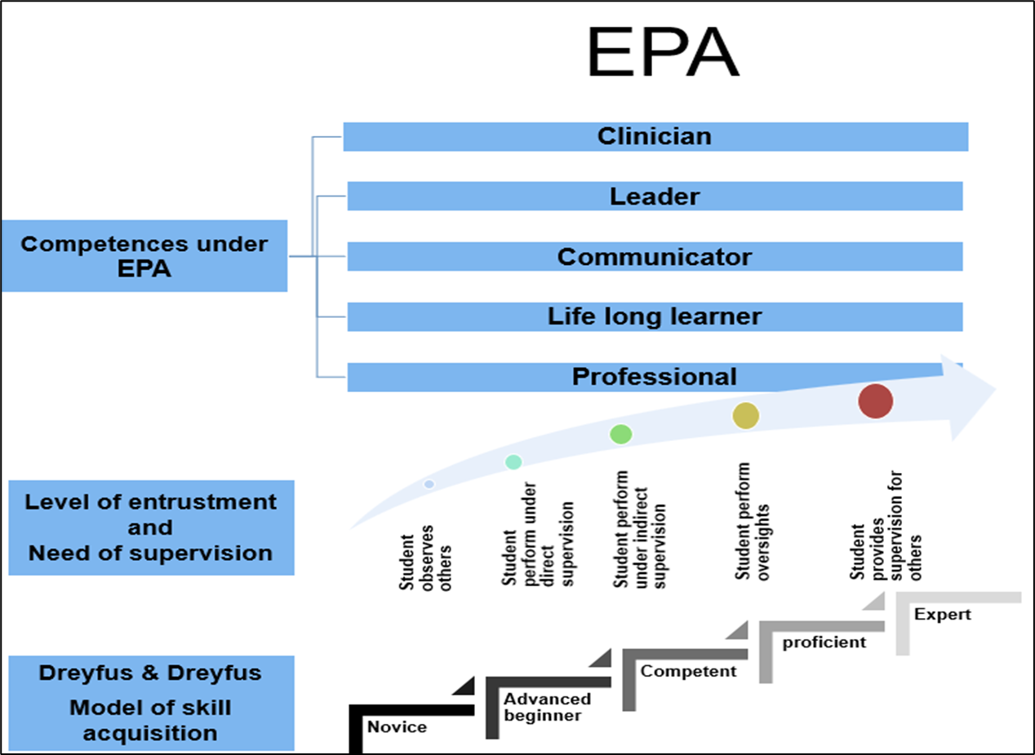
Fig 8 - Correlation of IMG framework, Dreyfus & Dreyfus model and EPA

With continuous tapered monitoring, corrective feedback and work place assessments of trainees performance -at the proficient and expert levels of professional activities a summative entrustment decisions are made. [38]

The certification of EPA is beyond competency certification in CBME as it declares that trainee can handle unknown future situations and can be trusted upon for unsupervised practice in different and complex contexts. Also important difference in competency and EPA is that COMPETENCY is attribute of a person but EPA are descriptions of professional task/activities hence contextual and more relevant to professional training [39, 40]

If we observe these frameworks, trend has shifted as assessments of segregated domains -analytic approach using SLOs as basis, units of activities requiring different domains to be applied same time- synthetic approach using competencies as units of assessment frameworks which help us to make entrustment decisions - developmental in nature ,using EPA as units of assessment [41].

3.2 Learning theories and assessment frameworks

The purpose of assessment in a competency-based curriculum is to help the teachers decide if the students have acquired the desired competencies and to help the students acquire and improve competencies. Assessment greatly drives learning. Assessments used traditionally impacted the learning by behaviorist's mechanism of stimulus-response or by operant conditioning through the reinforcement and punishment mechanisms, with minimal feedback and formative aspects hardly contributing to the decision-making process of summative assessments [42,43]

Learning is more complex than simple behaviorist mechanisms. Complex cognitive processes such as attention, understanding, analysis, and meaning-making, relating to our own experiences and negotiation of meaning with others and surroundings are different aspects of learning. [cognitivism constructivism] [44 ,45] .

Owing to an exhaustive amount of information to be understood, processed, and applied in the medical field, cognitive learning theory is the inevitable basis of teaching-learning. Metacognitive goals and tasks and experiences are used in problem-solving and monitoring the efficacy of strategies [46].

Referring to assessment frameworks- competence of clinician, we can say lower levels of frameworks /domains can be taught and assessed by low context and large group methods. But as we progress to higher levels of frameworks involving critical thinking and creativity- the teaching-learning methods as well as the assessment methods must be highly contextual, small group /even personalized involving elements of feedback and formative aspects. For other competencies as the leader, professional, and communicator the learner needs to understand and internalize the norms with the guidance of teachers who make the professional norms from latent to explicit and back to latent once internalized [47]. In this way, the learner completes the journey from unconscious incompetence -conscious incompetence -conscious competence -unconscious competence as “Four Stages for Learning Any New Skill”, theory developed by Gordon Training International [48].

Professionalism can be interpreted differently by learners in different socio-cultural settings, mostly learned by modeling the behaviors and attitudes of a senior or teacher. The social learning theory advocates the interplay of cognitive frameworks and behavioral interpretations of others whom learners wish to follow. [49, 50] It is similar to zone of proximal development provided by more knowledgeable others [teacher, mentor, peer] which helps the learner to the best of his ability under guidance initially and independently in the subsequent phase of learning [51]. The learner thus slowly engages from just participatory to more central activities in the patient care system as argued in situated learning theory [52] reflected in RIME framework of assessment.

Cognitivism, constructivism, social learning theory, zone of proximal development, and situated learning theory support the frameworks [Bloom’s, Miller, Dreyfus, RIME, Competence, and EPA] used for assessments. To cross the zone of proximal development - instructional strategies, and scaffolding should be provided by the facilitator mainly in the form of feedback. This helps the learner to develop skills of self-assessment, by identifying the gap between expected standard performance and his present performance [53] leading to the use of assessment for learning.

Students can assess others or be assessed by peers to gain complex and authentic experiences of evaluating [54]. ‘Sustainable assessment’ was coined to suggest the next level of the purpose of assessment on students' ability to identify and satisfy future learning needs’ [55], learners create the framework for developing assessment skills for own future learning [56] which is quite similar to entrustment decisions made by assessors over time.

4 Current literature on the topic- pros and cons or merits and demerits

4.1 Assessment as measurement

Measurement, quantifies the scores/results of tests using set of procedures and the principles. Some examples are raw scores, percentile ranks, derived scores, standard scores, etc. [57, 58]

Van der Vleuten in 1996 [59] introduced the concept of the Utility Index for evaluating the quality of an assessment method or tool- as Utility = Rw X Vw X Aw X eiw X Cw
Where R = reliability, V = validity, A = acceptability, EI = educational impact, and C = cost.
As per the utility index, Assessment tools earlier used were based on Test psychology and the measurement needed valid, reliable, and objective methods of assessments to reduce the subjectivity, which was perceived as a limitation. More structured assessments were devised to improve objectivity and reliability of assessments. To differentiate the performance of competent and non-competent performer, [facility and discrimination] indices were used to validate the construct of assessment. As in test psychology individual attributes were assumed to be generic and independent, so tested separately across different domains. Later this notion was questioned, Traits could not be measured independent of each other with different forms of assessments. Clinical reasoning and problem solving were dependent on background clinical knowledge [60-62] so performance does generalize well across assessment formats [60] not generalize well across content [ 63]

Blue printing was used for content selection based on the perceived must know areas and important health conditions derived from national health policies. In assessment, the overall performance was considered for pass where low performance in one aspect or item can be compensated by better performance on another item. So each item was meaningful to the extent to which it contributes numerically to the total score and not indispensable to achieve competency on each must know /must do items [as in written assessments and OSCE stations with conjunct overall scoring [64,65].

Standard setting was advocated to decide expected level of performance mainly of borderline students to differentiate them into pass and fail [66].
Test-centered methods are the Angoff method [67] (and its modifications), the Ebel method, and the Nedelsky [68] consider probability of borderline students answer an item correctly, so pass cut off varies with the change in the expert group. While in student-centered Methods [borderline, borderline contrast method], the pass mark is based on students’ actual performance, varies with the cohort of test takers [69].

In the process to standardize the assessment as a measurement, the human judgement which was perceived as a limitation could not be eliminated completely as many aspects of standardization are based on human judgement as perception of important areas to be mastered, perceived health problems in policy decision of nation or even the acceptable level of performance for the stage of learner.As understanding grew about the factors leading to unreliability were poor sampling, and lack of clarity on what was tested [70 -73] and there is no one perfect way to assess particular competency led to change in perception that human judgement is not a limitation but actually complementary to the objective methods used in deciding /grading the overall performance of learner.

Trends in the purpose of Assessment moved from Summative process [to certify the learner at the end of course completion, to differentiate competent from in competent or as a need to select of few students from large numbers as a placement testing] to formative process. Competencies as used in many frameworks [communicator, professionalism, leader, lifelong learner] cannot be evaluated at one point as summative but have progressive nature. Similarly, Assessment as a process need to value the learning and monitor the progress of learning in achieving the competence, in professional training. So assessment must help in for monitoring of learning and giving corrective feedback for learners to improve.

Earlier concept of measurement included testing when decision-making is done through the use of “a specific sample of behavior” using mostly quantitative methods [74], can be applied for some competence framework as medical knowledge. Extended view of the relationship among evaluation, measurement and testing by Bachman 1990 [75] which includes alternate testing methods can be used for communicator, professionalism, leader .lifelong learner competences of IMG.

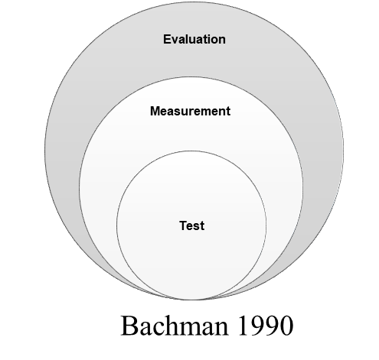
Fig 9 -relationship among evaluation, measurement, and testing

Competencies as communicator, professionalism, leader, lifelong learner cannot be evaluated at using quantitative methods only, an approach suggested for language testing can be extended to assessing these competences. Evaluation /assessment of these can include alternative methods of assessments as -
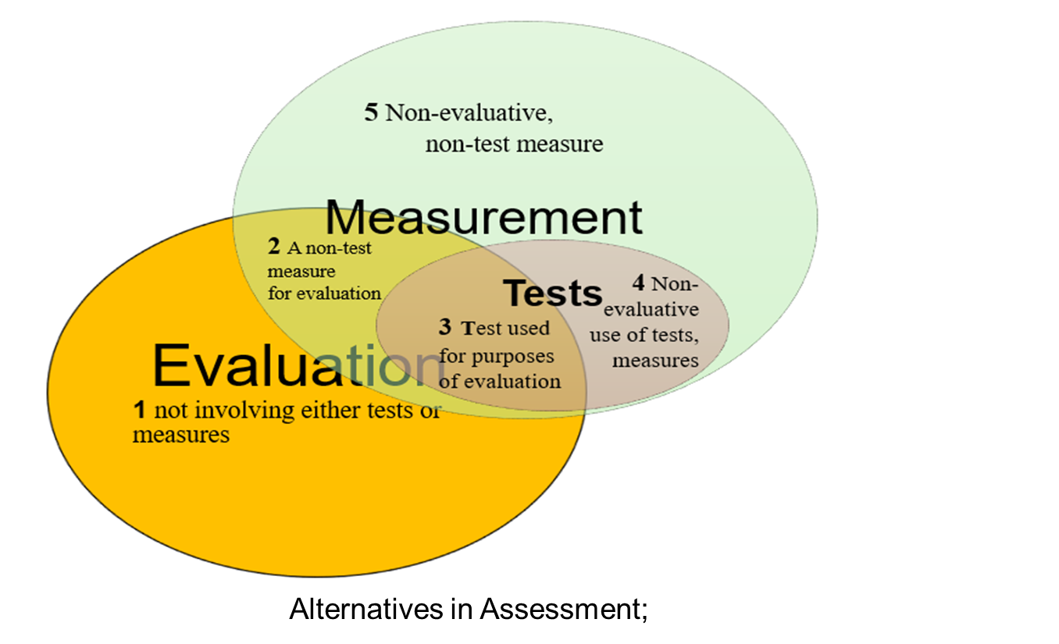
Fig 10- evaluation, measurement and testing intersections providing alternatives in the assessment of students

1- Evaluation not involving either tests or measures- the use of qualitative descriptions of student performance.
2- A non-test measure for evaluation- teacher ranking used for assigning grades, paper presentation, seminar, workshop
3- A test used for purposes of evaluation- achievement test -OSCE, simulations
4- non-evaluative use of tests and measures for research purposes - ICMR
5- Non-evaluative non-test -helping in review of literature, paper presentation by learners

Mastery testing is 100% of the items are measured correctly against predetermined criteria [criteria referenced tests] to determine whether students have attained a mastery level of achievements. Giving corrective feedback on individual items is possible only if acceptable performance [ criterion-reflected tests] for individual item and acceptable combination of items for total scoring is also standardized. [as in OSCE stations]
Measurement in assessment started as individual examiner’s judgement with little clarity on what is assessed [LAQ, Long case], moved to objective assessments with domain specifications and checklists [OSCE, SAQ, MCQ, SEQ] minimizing role of human judgement and now to more wholesome approach with combination of competencies into an entrust able professional activities at workplace settings , using descriptive rubrics and global ratings done by multiple assessors based on direct observations of performances for entrustment decisions.

4.2 Assessment as judgement

Major changes in the perceptions of assessment over time included-
perception of assessment from psychology tests assessing individual traits to competency to be learned and mastered [76].

Standardization and objectivity were not the main reasons for lesser reliability, but the improper, insufficient sampling was. So, for good reliability of assessment, good sampling is required, demanding to shift to contextual settings of learning and assessments. This led to the possibility of assessing multiple aspects of competency -such as professionalism, ethics, and decision-making [77] and Acknowledgment of human judgement in the assessment process in the form of inclusion of assessment for learning, crucial steps of performance contributing to satisfactory performance, and overall decision-making about competence [78].

The paradigm shifted to assessment considered more important as a judgement than as a measurement. Inclusion of Work place-based assessment tools [CWS – Clinical work sampling; COT – Consultation observation tool; CEPS – Clinical examination and procedural skill; CEC – Clinical encounter card; CSR – Clinical supervisor report; mini-CEX- mini-clinical evaluation exercise] was more authentic than standard assessment setting tools as OSCE. Conducting assessments in the workplace does not offer inherent validity to the assessments but the examiner's role as an evaluator is more important [79-81].

The professional aspects of health care providers such as professionalism, ethics, communication, and empathy where content is not defined, do not have prescribed formats of satisfactory skills and performances. Involvement of patients, standardized patients, and stakeholders to develop criteria of skills and performances, including cultural sensitivity, equality, and diversity is necessary to improve the validity and authenticity of workplace assessment [82].

The examiners should consider the complexity of the workplace as interaction with patients, relatives, other health professionals, technical settings, and multidisciplinary facets of the health care system and real-world practices while making the decision on assessed competencies and standard setting. This kind of practices help students to develop learning trajectories and mastery, capacities, and lifelong learning [53, 83-86].

As an examiner, observation, and interpretation of such complex situations of competencies in a real setting demand expertise to differentiate, and discriminate from a range of performances into competent/satisfactory, and incompetent. Cognitive and affective processes in ‘diagnosing competence’ of students are like diagnosing disease and need training, practice, and feedback for examiners [87-90].

Assessment literacy of examiners reduces inter-assessor variability by correcting the differences in frame of references, application of criteria, and forming shared mental models of subjectivity and leniency bias. Faculty development programs also help faculty to address unconscious biases and to be aware of cultural differences [91-94].

4.3 assessment as a system

With the realization of the complexity of education and the factors involved in assessment and decision-making, the focus shifted to formative aspects. Similarly, changes occurred in the system of assessment - as a system of observing process of problem-solving with a whole system approach from a method-focused system for judgment decisions [95]. Rather than adopting a pass/fail type of binary, reductionist systems of decision-making of competence, multiple data sources from different assessment methods and assessors gained popularity [96-98]. This way strengths and limitations of one tool and/or the assessor are balanced by another. Competence generalizes better across the formats than content. Quarter model of assessment is proposed in this direction, the contribution of each assessment to final marks, assessment tool, and assessor’s marks to each student is not more than 25% [99].

Other approaches are holistic integrated assessments with an attempt to recreate the complexity of competency, constructive and interlinked tasks [100]. Continuous /programmatic assessment aims to generate enough observational data regarding students' performances throughout the course to make judgment decisions that can be defended easily [101].
The choice-based credit system, academic credit banks, and transferability across different countries are steps toward making the system more flexible and global.

After considering the trends in assessment as measurement, judgment, and system, we can conclude that

The reforms in the assessments of medical undergraduates include the shift to competency-based education, competence frameworks of references for professionals, outcome-based assessments on competency achievements through EPA and rubrics to monitor the progress of learners. Use of continuous longitudinal formative assessments and feedback for learners, use of multiple tools of WPBA, the inclusion of non-evaluative, non-measure tests for holistic and integrated evaluation of competence, selection, and training of faculty to improve assessment literacy, question bank, standard setting and defensibly of documentation of student performances, use of technological interventions and inclusion of emerging competencies [as -AI, COVID], flexible and transparent students centered system.

- CBME, EPAs, milestones & rubrics

In last 30-40 years competency-based framework has gained popularity. Many well-known competency frameworks are The Accreditation Council for Graduate Medical Education (ACGME) in the United States, The General Medical Council (GMC) UK The Canmeds framework in Canada in 1996 [102] The Assessment of Clinical Performance (ACP) in Australian medical training, Canmeds- NL [103] Framework for Netherland.

The use of Entrustable Professional Activities (EPA) in competency frameworks for medical undergraduates is a relatively new development. Few countries as Canada, Netherlands, Singapore, United States, have incorporated EPA, bench marking- milestones, and rubrics into their medical education frameworks for assessments [102-105].

Statement of clear learning outcomes, EPAs, and assessments designed [milestones and rubrics] to measure the extent to which students have achieved these outcomes is useful in knowing the practice readiness of the students at the end of training. As opposed to assessment based on SLOs which is the expected result at the end of training. EPAs, milestones development, and the use of descriptive rubrics are ways to achieve competencies. The assessor can decide the tools of assessment depending upon the level of supervision needed, and the expected performance level on skill achievement [106-108].

The Accreditation Council for Graduate Medical Education (ACGME) is a flag-bearer in this area, and has described the competency framework for residency, the Milestones Projects describe the learner’s progress toward competence within each domain [109]. 40 national and multi-institutional studies about the milestones have been completed, and a bibliography of milestone research is available on the ACGME website [110-111].Many institutions and countries USA, Canada, New Zealand, Australia and Scotland are developing subject-specific milestones and EPA for undergraduate medical training and assessment and a small proportion of studies are conducted on assessment or implementation of EPAs [112-123].Based on a pilot study on 10 schools the AAMC proposed 13 Core EPAs expected from a new resident, to promote ease of transit to a medical residency [124]. Other Asian countries promoting CBME are India, China, Malaysia, Sri Lanka, and Bangladesh.

Use of descriptive rubrics for giving learner-specific feedback and knowing what constitutes good performance, critical components of good performance and competence level is well established across different disciplines. Rubrics are used to assess clinical skills, grade assignments, and analyze presentation portfolios. Rubrics provide consistency in evaluation, reduce subjectivity, and high inter-rater reliability [125-135].

- Continuous, longitudinal, formative assessments and feedback for learners

Continuous assessment enhances student motivation [136] better performance in internal assessment and final summative examination [137,138]. Programmatic assessment is used in medical education [139-141] aims to continually collect, analyze and make learner aware of his/her competence progress, periodically reviewed by an assessment committee and for high-stakes decisions at the end [142].

Formative assessments also known as assessments for learning - aim to provide guidance to individual learner to improve and not usually graded/ranked to know position in class, is strongly recommended [WFME]. Formative assessments and feedback go hand in hand, should be monitored, and feedback forms a part of systems in many countries [143- 145]. Formative assessments serve the purpose of competency achievement in CBME and the mechanism of quality assurance in medical education.

Some Asian countries [India, Bangladesh, Pakistan] use assessments that contribute 10-20% to the summative assessment scores [usually misunderstood as formative assessment] are internal assessments and can be formative if there is feedback to students on their performances based on predetermined criteria.

Use of a variety of activities, various tools, and techniques, a non-threatening and supportive environment, diagnostic and remedial, and the formal and informal approaches of assessment are characteristics of formative assessment. Student projects, Concept Mapping, Constructed Response Questions (CRQ), Critical reading papers, rating scales, extended matching items, tutor reports, portfolios, short case and long case assessments, log book, trainer’s reports, audits, simulated patient surgeries, video assessment, simulators, self-assessment, peer assessment, and standardized patients. Virtual Patient Simulations are some innovative formative assessment tools in medical undergraduate assessment [ 146-147]

Feedback has the most impact on student learning and accomplishment [148,149], by providing “feed forward” on the next performances, creating meaningful, constructive learning experiences by developing self-assessment and reflection.

- Use of OSCE

OSCE developed by Dr. Harden in 1970, consist of scenario based 10-20 stations, used to assess clinical skills, communication, empathy, and sensitivity with a standard checklist within fixed time frame for all students. OSCE are valid [avoids chance assessment] objective, reliable and consistent [owing to use of checklist and number of stations covering wide range of content area] [151,152]. As opposed to traditional unstructured clinical assessments as long cases. OSCEs serve to measure outcomes and allow very specific feedback. Blueprinting and Criterion Referenced Standard setting enhances validity and defencibility in decision making of competence. OSCE is most utilized tool in most of countries in formative as well as summative assessments in undergraduate and license examinations [153,154].

OSCE compartmentalizes a candidate's skills, knowledge and assesses different components of competency separately [155]and it is performance in a controlled setting, does not necessarily assure competence in real world, have poor generalizability [156]. Need of a greater number of assessors on observation stations, cost and tome in planning and implementation of OSCE are limiting factors

- WORK PLACE BASED ASSESSMENT TOOLS

Are tools of collecting data on observed behavior at the time of actual performance, patients encounter and by using multiple observers and occasions. These include observation tools and discussion tools [157]. Based on a review of 180 articles, 67 WPBA tools are classified as Short-practice observations, Long-practice observations, Case-based discussion, Simulation tests, Product evaluation tools [158]. Commonly used tools of WPBA are as-

    - Mini-CEX (Mini-Clinical Evaluation]

Developed by the American Board of Internal Medicine (ABIM) in the 1990s. It is a 9-point rating scale of each encounter for about 15-25 minutes, including the time spent on observing students and the feedback given. Evaluator records the complexity of the patient's problem; type of visit (new or revisit); setting, focus of the visit (data gathering, diagnosis, therapy, or counselling). Mini CEX is a good real setting, contextual tool to assess different levels of performance [159], reliable tool with minimum 4-6 encounters [160].

Formative use to provide feedback and improve trainee performance, is advocated. While opportunities to make it reliable for summative use may not be feasible. However, some countries have incorporated Mini-CEX into their summative undergraduate assessment programs United State, Canada, Australia, United Kingdom [161-166]. Interviewing, examination, communication, professionalism, organization, overall competence, and various task-specific skills are commonly assessed. Mini-Clinical Evaluation Exercise (Mini-CEX) for feedback and to make entrustment decisions in postgraduate assessment [158].

    - Direct Observation of Procedural Skills -DOPS

Is like mini CEX- a scale for assessing and providing feedback on procedures done by learners. Need multiple encounters, with different patients, procedures to collect evidence about a student's competency in technical skills. Portfolio entries of DOPS are used for formative assessments. Multiple sessions of DOPS results in improved skills and confidence of students. In modified DOPS- correlations are seen between the first and second scores of doing the same procedure and the scores of the two individual examiners when observing the same procedure [168-169].

Direct feedback, motivation to students and acceptable validity and reliability are advantages of DOPS. Stressful evaluation, time limitation, and bias between assessors, variability of feedback are the main limitations [169,170]. DOPS and modified DOPS are successfully used as a formative and summative assessment tool during their clinical postings in undergraduate assessments.

- Clinical work sampling

Depending on the context of patients, in different situations-Four performance rating forms (Admission Rating Form, Ward Rating Form, Multi-disciplinary Team Rating Form, and Patient’s Rating Form) are used. Admission Rating Forms collect data on communication skills, physical examination skills, diagnostic accuracy, management skills, and global performance.
Ward Rating Form: included as part of the process of patient billing. Seven content domains assessed include therapeutic strategies, communication skills, consultation skills, management skills, inter-personal behaviors, continued learning skills, and health advocacy skills as well as a global rating of over-all performance.
Multi-disciplinary Team Rating Form uses therapeutic strategies, communication skills, consultation skills with nurses and other health care providers, management of resources, discharge planning, and interpersonal relations as well as a global rating of overall performance.
Patient’s Rating Form: To capture input from patients, a seven-item evaluation form outlined four content domains; communication skills, collaboration skills, health advocacy skills and professionalism as well as a global rating of overall performance.
With sufficient encounters for reliability, coefficients were high for the Ward Form and the Admission Form [171]. In a review CWS is strongly advocated owing to the high reliability, validity, feasibility, and better educational impact [172].

- Case-based Discussion [CbD]
In CbD after a clinical encounter or procedure of 10-15 minutes, clinical competence, clinical reasoning, and clinical decision-making is assessed by interviewing the learner. The discussion and feedback should take less than 30 minutes. Before choosing the CbD, trainees must inform the clinical details to assessor and find the case to three capability areas to be assessed. CbD can be used for formative assessments, supplemented with feedback, both quantitative and qualitative. However, training in the process of conducting discussion and delivering effective feedback is necessary [173-176].

- 360 evaluations

Frequency of observable behavior such as communication skills, interpersonal relationship work habits, team work, and interpersonal sensitivity is marked using a rating scale (e.g.,1=frequently, 5=never). The observation is done by the supervising physicians, peers, other members of the clinical team and patients. 360 Degree Evaluation is proposed as a learning framework itself. Health team, peer and patients’ evaluation promotes team-working and collaborative leadership skills, supporting own learning process, patient centered care philosophy, respectively [177] Assessment of actual performance of students in authentic setting is done but data collection and analysis from many raters is difficult.

- Portfolio
Portfolios provide a holistic and longitudinal self-assessment and reflection of various experiences during course of learning and career [178-180] portfolio differ from logbooks, by having reflection, evidence of learning- of how learning happened [181- 186] through those activities. While logbook is mainly documentation of patient care and learning experiences. Portfolio use has shown improved communication skills, professionalism, experiential learning, and better achievements at the post graduate studies [187,188]. Use of portfolio assessment led to enhancement of knowledge- ability to integrate theory with practice and understanding, self-awareness, reflection, and the ability to learn independently and improves feedback to students [189]. Need of training of faculty and learners is required in view of purpose of portfolio, authenticity of the material presented in the portfolio [190]. Reyes D and colleagues [191] from Chile introduced portfolio-based Learning for clinical cases for 4th year medical students.

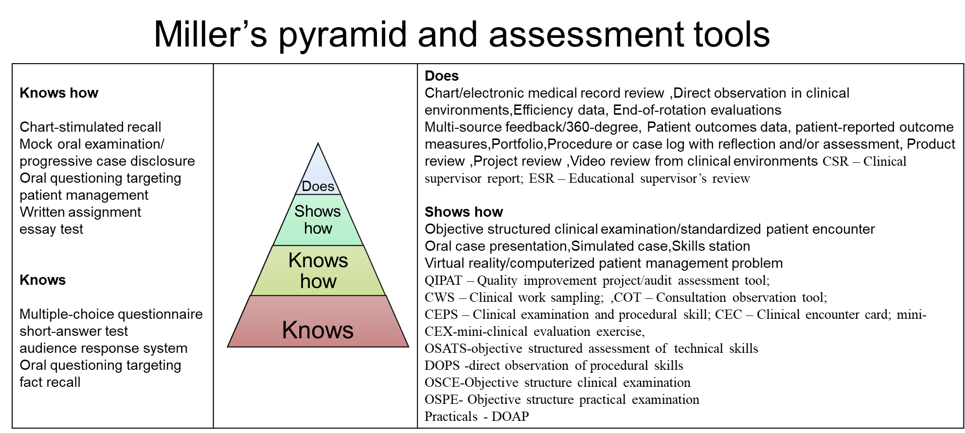
Fig 11-Mapping of tools of assessments and Miller’s pyramid

Advantages and disadvantages of WPBA

WPBA ultimately uncovers real opportunities to improve education and patient care. These assessment methods require observation, provide opportunities for feedback. Research data on assessment and feedback show that it is an effective way to change students' and students' behavior.

Feasibility-is main issue,
clinicians are already overwhelmed and they need to give time to training and evaluation for individual student on multiple occasions. Expertise is important in providing feedback on performance appraisal, which is consistent with trainees’ requirement and on crucial aspect of performance. courses and training in appraisal methods and techniques are required.

- The inclusion of non-evaluative, non-measure tests for holistic and integrated evaluation of competence
Tests are conducted to sample the performance of a test-takers in a specific domain. For holistic and integrated evaluation of competence, assessment should encompass all the instances of teacher students’ interactions, observations may be in formal /non formal setting [192]. The characteristics of non-evaluative, non-measure tests, also named as alternative tests are mainly described in relation to language assessments in schools [193-196]. Alternative tests/ non-test instruments are testing instruments in addition to learning achievement tests. These assessment tools, include observation or observation sheets (such as diaries, portfolios, life skills), attitude test instruments, interests, interview techniques, questionnaire. For construction of non-test tools, tests of attitude scale, learning interest test, achievement motivation test, creativity test, learning stress test can be used [197,198]. Use of these tests justify the varying abilities of students and domains of multiple intelligence [as verbal-linguistic, mathematical-logical, musical, visual-spatial, kinesthetic, interpersonal, intrapersonal, naturalist, and existential] tapping into multiple intelligence [199].
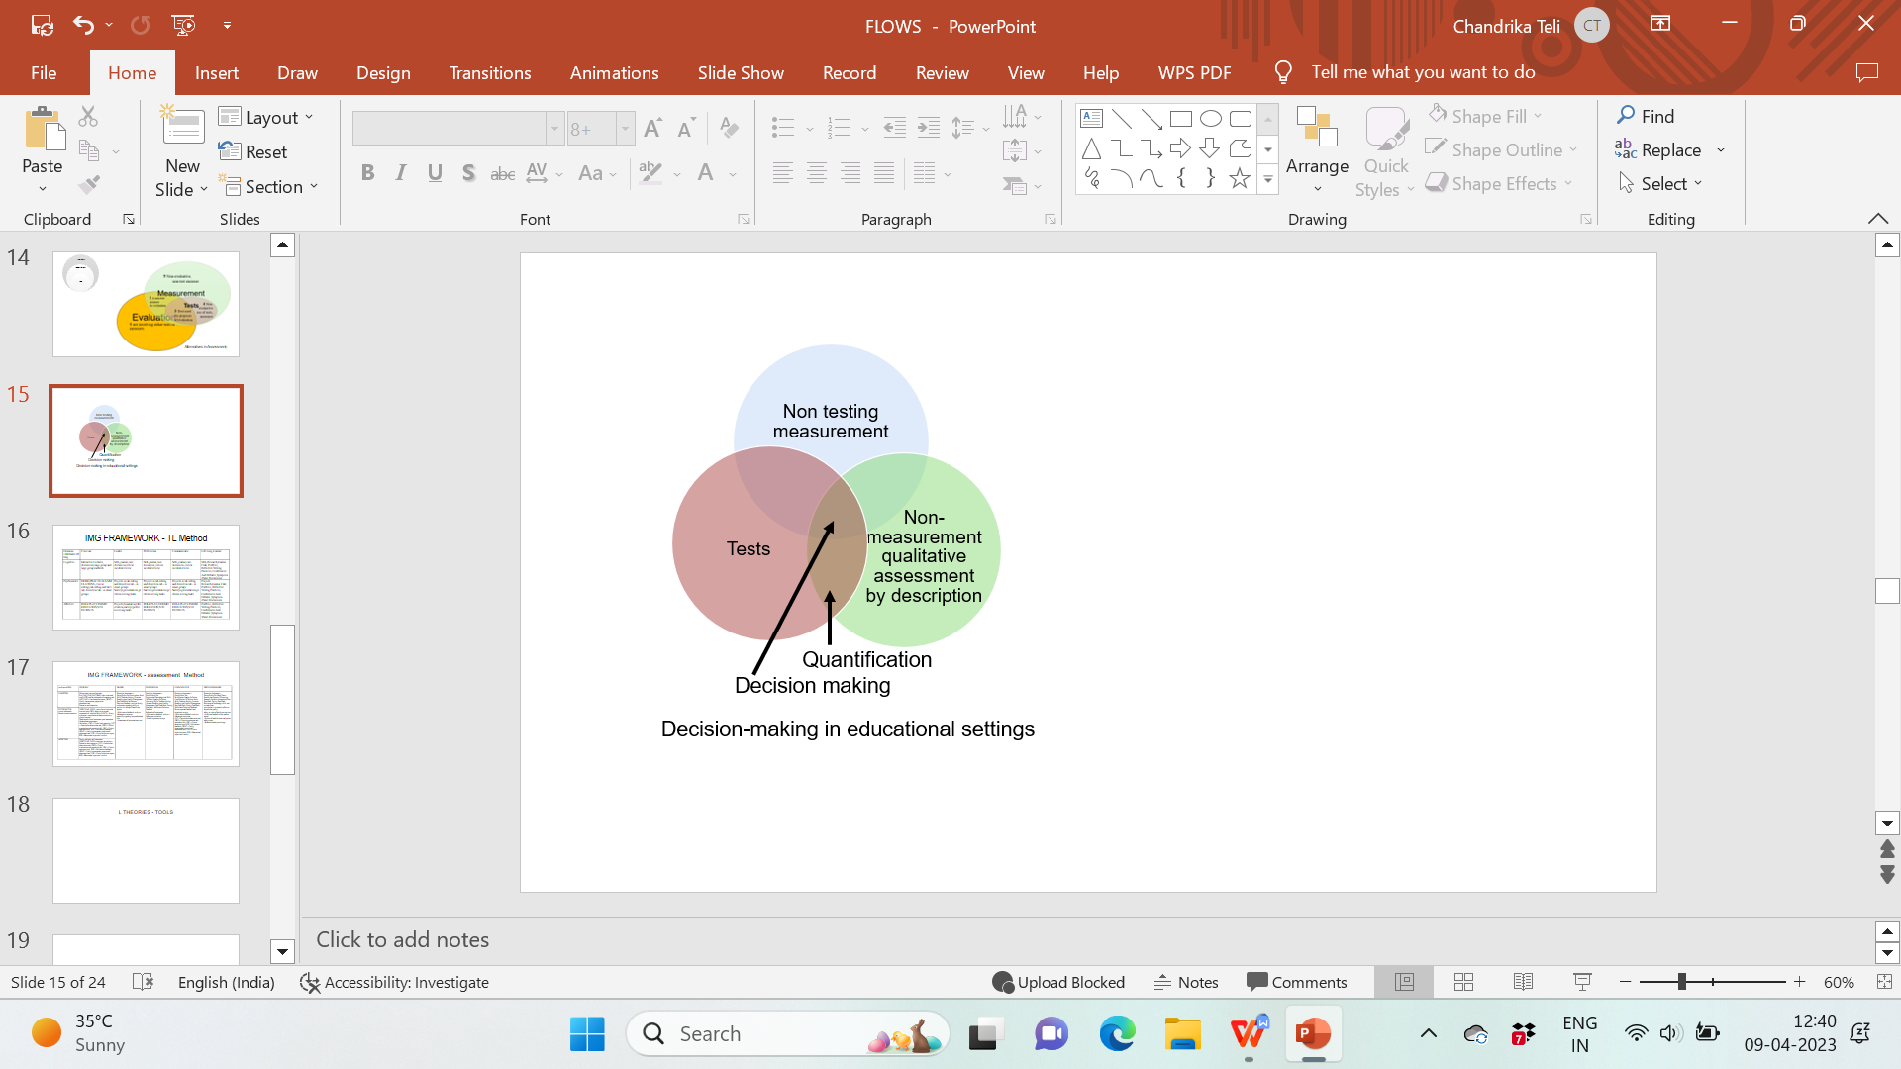
Fig 12-Summative decision-making aspects

These assessments can be alternative to the end-of-semester exam if aligned to the learning outcomes/competencies assessed. Observation, social projects, Oral Assessment, Portfolio, Participation in teaching learning, patient surveys , creative writing, models, maps, charts, and graphs, concept maps, debate, journal reading ,presentations, demonstrations in small group in practical /clinical settings , role plays, conferences /CME presentations, organization ,preparation of resources , critical analysis of resources , reflective writing ,quizzes ,case study, annotated bibliography are different tools which can be in line with assessment of communication, lifelong learner and leader roles of medical undergraduate. These non-evaluative -non test measures which include daily activities must be considered in decision making- there is a great possibility of identifying potential administrators, leaders in health care.

- Selection, and training of faculty to improve assessment literacy

Infrequent curriculum review, lack of standardized assessments,
inadequate training in medical education, and lack of faculty development programs are reported [200- 203]. Expertise in the subject & years of teaching experience are common criteria set out by professional and accrediting bodies for selecting the assessors. Selection of Examiner is expected to be based on expertise and experience in the design and delivery of assessment. Examiners should be aware of expected standard of students and curriculum changes [204]. The examiners are expected to review assessment strategies, processes, and systems. Knowledge of assessment tools, fair and impartial and objective assessment, analysis of performance and giving constructive feedback, standard setting and awareness of policies, cultural, social, and religious backgrounds are different aspects of assessor’s roles.
As an examiner, observation and interpretation of such complex situations of competencies in a real setting demand expertise to differentiate, and discriminate from a range of performances into competent/satisfactory, and incompetent. [205-206].
Assessment literacy of examiners reduces inter-assessor variability by correcting the differences in frame of references, application of criteria, and forming shared mental models of subjectivity and leniency bias. Faculty development programs also help faculty to address unconscious biases and to be aware of cultural differences [91-93].

- Question bank

Increased use of question banks prepared by students /universities, available online is reported with increased performance of students [207]. A question bank should include questions from different difficulty levels, with proven reliability that cover all the learning objectives throughout the program. Questions included in bank should be mapped to Bloom’s taxonomy and learning outcomes- to create good achievement test, with 60% moderate questions, 20% easy questions and 20% difficult questions and good discrimination range. It should include from must to know[core] and desirable to know areas. Based on blueprint, mapped course outcome, automated question paper setting is preferred than manual method. Some colleges have prepared question banks for use of faculty and students [208-210].

- Standard setting and defensibility

With the appropriate panelists for standard-setting processes, institutions are accountable for use of standard setting methods in relation the assessment methods used. Standard setting Angoff and borderline group scoring are most appropriate proven methods of standard setting in clinical assessments as OSCE [211-212].

- Use of technological interventions and inclusion of emerging competencies

Because of technological advances, transition of traditionally pen and paper testing to electronic exam and use of digital assessment formats commonly tablet-based is on rise [213- 219]. Multiple choice questions (Type-A) and long questions Pick-N, Kprime and Freetext, modified essay questions, and portfolios are different tools used in written electronic exam. OSCE, simulation and simulators, virtual patients are used for performance-based assessment. Media like picture, video and audio and combinations of text, picture and video are utilized in questions [220-221].

5 Implementation in the Indian
5.1 situation, if already done, where and what are the results If not, what are the constraints; how can we implement
As per The Medical Council of India (MCI) guidelines, all the medical colleges have implemented CBME with an aim to produce Indian Medical Graduate (IMG) who is physician of first contact. Competence frameworks of references for IMG include clinician, leader, communicator, professional and lifelong learner. Outcomes in CBME are measured through EPA and rubrics/milestones to monitor the progress of learners. EPAs are not developed at policy level yet. Some institutes are using subject-specific milestones in undergraduate medical assessment in India [222-225].
However, the MCI /NMC has provided with three volumes of curriculum with recommended topics, core and non-core areas, areas of integration, teaching- learning and assessment methods & list of 40 certifiable skills is provided. Use of continuous longitudinal formative assessments based on blueprint and feedback for learners is recommended, use of multiple tools of WPBA, [226] the inclusion of non-evaluative, non-measure tests for holistic and integrated evaluation of competence are suggested. Tools suggested include Informal assessments during teaching learning activities, use of techniques like clickers, one-minute papers and muddiest point, SNAPPS technique is advocated for the teachers on a day-to-day basis.[227]
For training of faculty to improve assessment literacy- The Regional Centres conduct Basic Course Workshop (BCW) in Medical Education Technologies, Attitude, Ethics and Communication Module (AETCOM), and Curriculum Implementation Support Program (CISP). In addition to these three trainings, Nodal Center runs the Advanced Medical Education Course (ACME). As of December 2018, MCI has funded 904 pre-revised Basic Course Workshops, 520 revised Basic Course Workshops and 273 workshops on Attitude, Ethics and Communication module. Totally, 44,932 faculty have been trained in these Workshops. [228]
5 year of teaching experience after post-graduation is eligibility for undergraduate internal /external examiners. Creation of Question bank, requirements of psychometric analysis of assessment tools, standard setting and defensibility of documentation of student performances -these aspects of assessment are not addressed in the policy by MCI/NMC, neither it is mentioned that universities /institutes are accountable for these parts of assessment system. Use of technological interventions as computer-based assessments can be used in formative assessments. Simulations and skill labs are made mandatory for all institutes.

5.2 what are the constraints, how can we implement
Some key features of the new curriculum are: horizontal and vertical integration, Early clinical exposure, Student doctor method of clinical training, electives, skill development and training, secondary hospital exposure, attitude, ethics and communication (AETCOM) module [229-234].
The expectation of CBME is achievement of competencies by IMG, but it retains the existing discipline-based format, which is limiting factor. There is not much change in the content of the curriculum, though it is arranged in large volumes of curriculum. MCI has followed The Research, Development and Diffusion (RD&D) Model of Curriculum Innovation due to large scale of implementation. The Problem Solving (PS) Model of curriculum, with problem-based curriculum would be ideal to implement CBME, which would enhance integration, knowledge application, problem solving and self-directed learning [235, 236]
EPAs and milestones need to be developed in India as per contextual needs. In present situation major structural change in system of institutions is not possible because of large number [more than 530 presently] and variety [in terms of infrastructure, management-government/private, cohort of students, faculty strength ] of institutions in India. Individual disciplines at the national organization level or even at university level can take up the responsibility of framing EPAs, milestones and modifications can be done over the time as per context of institutes. Periodic revision of content and policies with respect to assessments should be allowed- considering feedback from faculty, subject associations, students after every academic year and at the end of course, and other stakeholders. This would allow inclusion of emerging competencies [as -AI, COVID]
Curriculum Implementation Support Program was conducted by MCI through faculty development programs. But monitoring by the departments, MEU, curricular committee, IQAC, academic section at Institutions levels must be in place. Identification and motivation, utilization of correct resources is important for long term monitoring. To handle added responsibility, enough number of faculty and materialistic resources must be provided by institutes.
Certification of competencies-competencies need to be observed during learning and can be only certified by faculty in respective departments. For competencies that require ‘Show How’, or ‘Perform’ level of competence, provision of a learning experience that allows skills practice repeatedly under supervision is critical. Considering the requirements of the skills module and competency-based assessment module, some challenges which can be anticipated are:
1.the number of skills need to be taught and assessed is not proportional in the guidelines to the duration of training in the respective subjects. Some subjects are missing the certifiable skills [237]
2. Since 50-60 students are posted in major departments a time, teaching and assessing one skill every week for a group of 30 students each, in skill labs in groups of 6-8 students would exceed the availability of faculty in many instances. Smaller departments like dermatology psychiatry etc. May have only one faculty available for this purpose most of the times.
3. Formative processes demanding feedback for individual students like DOAP, OSCE, mini CEX cannot be implemented in the given time frame.
4. This practice of teaching, assessing, and certifying would be required for all the days round the year which would be taxing for the faculty. The skills that need not be certified but need to be assessed also need to be included in teaching.
In such a situation faculty are likely to revert to what was done earlier where certification was required only a in a log book. Besides there is a chance that skill assessment and certification may become opportunistic instead of systematic, due to lack of available resources and clinical material.

Suggestions for overcoming the above issues
Since the CBME batch has just entered third year, we have to be prepared.
1. Faculty and resources required for skill labs need to be recruited and ensured
2. The time allotted for clinical postings and skills learning need to be increased according to the number of certifiable skills and skills expected to be taught and need not be certified. This however is within regulatory domain and needs to be addressed by them. Alternatively similar skills listed under different departments may need to be clustered together for training and assessment.
3. Training of faculty for implementing new T/ L methods and use of assessment tools, preparation of OSCE, OSPE stations, checklists etc. Should be started through meus of colleges, monitored by regional centers. Clinical faculty should take advantage from feedback and help of the first- and second-year faculty to anticipate and overcome difficulties of implementation since they have already experienced the new curriculum for at-least two batches. The regulatory agency should provide guidance and dissemination of T/L and Assessment materials across all institutions for ensuring uniformity.
4. Possibility of training nursing and Allied Health Sciences staff for implementing new T/ L methods and use of assessment tools, preparation of OSCE, OSPE stations checklists should be considered. They should also be trained in giving and receiving feedback, receive and analyze data obtained from formative assessments and maintain records.

Use of OSCE, OSPE, WPBA
OSCE, OSPE are not used in summative examinations even in post graduate [MD, MS] assessments except very few instances [DNB] very few institutes are using these tools in formative assessments recently [238] Recently OSCE is added in some universities as assessment tool, but it is still in developing phase. RGUHS has 3,4 OSCE stations in summative exams which is not a good sample size for reliability of OSCE. Other tools of WPBA are not utilized to its fullest advantages.
Contribution of formative assessment to summative assessment and pass /fail decisions
Formative assessments and feedback is greatly emphasized in implementation of CBME. Successful completion of certifiable skills is mandatory to appear for university examinations. 20% of marks contributing to internal assessments are from attendance, part completion tests, professionalism, participation in early clinical exposure. Remaining 80 % IA contributed by average of internal theory and practical examinations during the course. [239]
Theory and practical internal assessment average should be at least 50% with minimum score of 40% in each- to appear for university /summative examination. So IA including formative performances is only serving as an eligibility criteria and not contributing to summative assessment, which is contrary to the promise of CBME.[239]
Proportion of Internal evaluation (IE) to External Evaluation (EE) should be specified for UG (30:70) and for PG (40:60), can be raised progressively in a phased manner to 50% depending on the outcome of the experience. Prior to CBME, Internal assessment contribution to final examination was 20% [240]. To pass the summative examination in CBME, student have to score 50 % marks in theory and practical separately in summative examination. Student must score minimum 50 % average if 2 theory papers, with minimum of 40% score in each paper [239].
Flexible system of assessments
CBME does not support concept of time-based training and promises flexibility in learning time and assessments. Presently, in India flexibility of learning and assessments time is not possible as the time frames for summative examinations are fixed and minimum 3 internal assessments [theory and practical] are to be conducted before the summative examinations. Only one remedial examination is allowed prior to summative examinations if student is not scoring the eligibility of average 50%. If a student fails in summative, supplementary examinations are conducted within 1 month from results. Maximum 4 attempts allowed for passing any subject, but student should pass first year in 4 academic year and pass complete course in maximum of 10 years from admission.[238]
So technically the assessment system is very tight and does not allow much flexibility for students. Also, there is no fall-back system / multiple exit points during the course of MBBS. If a student cannot continue /fails to complete the course, he/she is not offered any qualifications.

Choice-based credit system
Choice-based credit system can be included in health profession, would require modification of content to be delivered in a particular sequence and pattern, mostly system-based approach would be better suited for purpose. Content can also be modified as essential for undergraduate -core, supplementary within subject content and supplementary area related to other subjects.
CBCS, grading and competency certifications together will serve the purpose of flexibility, credit bank and transfer across the universities.
Question banks
are usually collections of question papers of previous year provided on university websites or compiled by some students/authors which are available for students. These are not question banks referred inn assessment systems. Some institutes are having question banks developed but it is not mandatory aspect of assessment yet. Psychometric analysis of questions used in the university exam papers is cannot reliably commented upon. Standard setting, also is not followed in university assessments in India at present. Lack of time, infrastructure and expertise may be limiting factors.

Use of technology
Technology is mainly in helping the process of administration and management of assessment as - registration of students, filling up of examination form, seat numbers, admit cards/hall tickets allocation, documentation of list of paper setter, online distribution of question papers, bar-code system for answer books, digitization of answer scripts and onscreen evaluation of answer sheets, Marks submission through online software, declaration results and mark sheets through online system. It can be extended for use of LMS assessments, assignments, simulations, portfolio generation, evaluation, and data collection of continuous assessments.

6.Conclusion

India has initiated the pivotal change in medical education by implementing CBME curriculum. Release of curriculum in three volumes, detaining the content, TL Methods, core areas, possible integration areas and level of performance expected as per the Millers pyramid. NMC/MCI has also started new welcoming changes as inclusion of foundation course, AETCOM, Early Clinical exposure, guidelines on assessments in CBME, Pandemic and online learning module for inclusion of newer competencies.

The revision of content and structure is worth appreciating. Similar changes are expected in the assessment domain of curriculum. Revision of certifiable competencies, logistic arrangements in the training schedule, feasibility of formative training, feedback and assessments of all global competencies [including-communicator, professional, lifelong learner and leader], assessment of competencies which need not be certified, inclusion of more WPBA, standardization of assessment methods and provision of enough resources -faculty, infrastructure, training and continued support for faculty is necessary

Creating the list of subject related EPAs, milestones -and frequent revisions, implementation of formative assessments to be monitored, students and faculty feedback regarding difficulties in implementation and possible areas of improvements should be considered. A positive step to psychometric analysis - formation of standard question bank, standard setting methods at university level is necessary.

A change which is initiated with CBME can be completed with a second thought on these areas by changing the assessment system seriously.

7. References

- Https://www.education.gov.in/sites/upload_files/mhrd/files/nep/he/nep_2019_hi.pdf accessed on 16.03.2023
- Medical council of India. Assessment module for undergraduate medical education training program, 2019: Pp 1-29.
- Frank JR, Snell LS, Cate OT, Holmboe ES, Carraccio C, Swing SR, Harris P, Glasgow NJ, Campbell C, Dath D, Harden RM, Iobst W, Long DM, Mungroo R, Richardson DL, Sherbino J, Silver I, Taber S, Talbot M, Harris KA. Competency-based medical education: theory to practice. Med Teach. 2010;32(8):638-45. doi: 10.3109/0142159X.2010.501190. PMID: 20662574.
- Ten Cate O, Carraccio C, Damodaran A, Gofton W, Hamstra SJ, Hart DE, Richardson D, Ross S, Schultz K, Warm EJ, Whelan AJ, Schumacher DJ. Entrustment Decision Making: Extending Miller's Pyramid. Acad Med. 2021 Feb 1;96(2):199-204. Doi: 10.1097/ACM.0000000000003800. PMID: 33060399.
- Brauer DG, Ferguson KJ. The integrated curriculum in medical education: Amee guide no. 96. Med teacher. 2015; 37:312–22.
- Wijnen-Meijer M, Burdick W, Alofs L, Burgers C, ten Cate O. Stages and transitions in medical education around the world: clarifying structures and terminology. Med Teach. 2013 Apr;35(4):301-7. doi: 10.3109/0142159X.2012.746449. Epub 2013 Jan 29. PMID: 23360484.
- Flexner A. Medical education in the United States and Canada: A report to the carnegie foundation for the advancement of teaching. Bulletin no. 4. Boston, mass: Updyke; 1910.
- Irby, David M, Cooke, Molly MD; O'Brien, Bridget C. Calls for Reform of Medical Education by the Carnegie Foundation for the Advancement of Teaching: 1910 and 2010. Academic Medicine 85(2): p 220-227, February 2010. | DOI: 10.1097/ACM.0b013e3181c88449
- Ryan TJ. Osler and his teaching: relevant today Postgraduate Medical Journal 2015; 91:540-541
- Jessica L. Stadick, The relationship between interprofessional education and health care professional's attitudes towards teamwork and interprofessional collaborative competencies, Journal of Interprofessional Education & Practice, Volume 19,2020,100320,ISSN 2405-4526, https://doi.org/10.1016/j.xjep.2020.100320
- Muller S. Physicians for the twenty-first century. Report of the Project Panel on the General Professional Education of the Physician and College Preparation for Medicine. J Med Educ. 1984;59(11 Pt. 2)
- Goić A. La declaración de Edimburgo [The Edinburgh Declaration]. Rev Med Chil. 1989 Jan;117(1):78-80. Spanish. PMID: 2577096.
- Lucey C, Souba W Perspective: The problem with the problem of professionalism. Acad med.2010; 85(6):1018–1024.
- Lucey C Medical education: Part of the problem and part of the solution. Jama intern med. 2013; 173:1639–1643.
- Skochelak SE. A decade of reports calling for change in medical Education: What do they say? Acad med2010; 85: S26–s33.
- Brauer DG, Ferguson KJ. The integrated curriculum in medical education: Amee guide no. 96. Med teacher. 2015; 37:312–22.
- Skochelak S E, Hawkins RE, Lawson JE, Starr SR, Borkan JM, Gonzalo JD. Health systems science. Philadelphia: Elsevier; 2017. P. 228.
- Fred H, Gonzalo J D. Re-framing medical education. Texas heart inst j. 2018; 45:123–5.
- Gonzalo J D, Caverzagie K J, Hawkins R E, Lawson l, Wolpaw D R, Chang A. Concerns and responses for integrating health systems science into medical Education. Acad med. 2018; 93:843–9.
- Brauer DG, Ferguson KJ. The integrated curriculum in medical education: Amee guide no. 96. Med teacher. 2015; 37:312–22.
- Gonzalo JD, Chang A, Wolpaw DR. New educator roles for health systems Science: Implications of new physician competencies for US medical school Faculty. Acad med. 2019; 94:501–6
- Borkan JM, Hammoud MM ,Nelson E, Oyler J, Lawson L, Starr JR & Gonzalo J D health systems science education: The new Post-flexner professionalism for the 21st century, medical teacher,2021; 43:Sup2, s25-s31, doi: 10.1080/0142159x.2021.1924366
- (1) TOPIC A MONOGRAPH ON EDUCATIONAL REFORM & POLICY IN INDIA: STRUGGLES AND CHALLENGES IN NEW EDUCATION POLICY 2020 DEPARTMENT: DEPARTMENT OF COMMERCE | Shefali Shukla - Academia.edu accessed on 20.03.2023.
- NPE-1968.pdf (education.gov.in) accessed on 20.03.2023.
- Medical Council of India, Competency based Undergraduate curriculum for the Indian Medical Graduate, 2018. Vol. 1, 2, 3.
- WHO - Education Definition & Meaning | Dictionary.com accessed on 20.03.2023.
- Biggs J. Enhancing teaching through constructive alignment. Higher Education, 1996; 32(3), 347–364]
- Tyler RW. 1949. Basic principles of curriculum and instruction. Chicago: University of Chicago Press.
- Krathwohl DR. A revision of Bloom’s taxonomy: An overview. Theor Pract 2002; 41(4):212–218.
- Krathwohl DR, Bloom BS, Masia BB. Taxonomy of educational objectives, the classification of educational goals. Handbook II: Affective domain. 1973 New York: David mckay Co, Inc.
- Simpson EJ. The classification of educational objectives in the psychomotor domain. 1972 Washington, DC: Gryphon House.
- Guilbert JJ. Educational Handbook for Health Personnel. 1998 WHO Publications, Geneva]
- Miller GE Assessment of clinical skills/competence/performance. Academic Medicine 1990; 9:63–7.
- Pangaro LA new vocabulary and other innovations for improving descriptive in-training evaluations. Acad Med 1999; 74(11):1203–1207.
- Dreyfus SE, Dreyfus, Hubert. (1980). A Five-Stage Model of the Mental Activities Involved in Directed Skill Acquisition. Distribution. 22.
- Carraccio CL, Benson BJ, Nixon LJ, Derstine PL From the educational bench to the clinical bedside: Translating the Dreyfus clinical skills. Acad Med 2008; 83(8):761–767.
- Ten Cate O, Snell L, Carraccio C. Medical competence: The interplay between individual ability and the health care environment. Med Teach 2010; 32(8):669–675.
- Ten Cate O, Hart D, Ankel F, Busari J, Englander R, Glasgow N et al. Entrustment Decision Making in Clinical Training. Academic Medicine. 2016 Feb;91(2):191-198. Doi: 10.1097/ACM.0000000000001044
- Olle Ten Cate, Taylor DR. The recommended description of an entrustable professional activity: AMEE Guide No. 140, Medical Teacher, 2021; 43:10, 1106-1114, DOI: 10.1080/0142159X.2020.1838465
- Ten Cate O, Schumacher, DJ. Entrustable professional activities versus competencies and skills: Exploring why different concepts are often conflated. Adv in Health Sci Educ 27, 491–499 (2022). Https://doi.org/10.1007/s10459-022-10098-7
- Pangaro L & Olle Ten Cate Frameworks for learner assessment in medicine: AMEE Guide No. 78 Medical Teacher, 2013; 35: e1197–e1210 DOI:10.3109/0142159X.2013.788789
- Harrison CJ., Könings KD, Schuwirth, Wass V, & Van der Vleuten C. Barriers to the uptake and use of feedback in the context of summative assessment. Advances in Health Sciences Education,2015; 20(1), 229–245.
- Harrison CJ, Könings KD, Dannefer E F, Schuwirth LWT, Wass V, & Van der Vleuten CPM Factors influencing students’ receptivity to formative feedback emerging from different assessment cultures. Perspectives on Medical Education 2016, 5, 276–284
- Cilliers FJ, Schuwirth LWT, Adendorf HJ, Herman N, & Van der Vleuten CPM. The mechanisms of impact of summative assessment on medical students’ learning. Advances in Health Sciences Education, 2010; 15, 695–715.
- Cilliers F J, Schuwirth LWT, Herman N, Adendorf HJ, & Van der Vleuten CPM. A model of the pre-assessment learning effects of summative assessment in medical education. Advances in Health Sciences Education, 2012; 17, 39–53.
- Flavell JH. Metacognition and cognitive monitoring. A new area of cognitive development inquiry. American Psychologist.1979; 34 (10): 906–911
- Shepard LA. The Role of Assessment in a Learning Culture. Educational Research. 2005; Vol 29, No 7, pp 4 – 14
- Adams L. Learning a new skill is easier said than done. Www.gordontraining.com. Gordon Training International. Retrieved on
- Bandura A. Social Learning Theory. Englewood Cliffs: Prentice-Hall; 1977.
- Fryling M J, Johnston C, Hayes L J. Understanding Observational Learning: An Interbehavioral Approach. Anal Verbal Behav. 2011;27(1):191-203. Doi:10.1007/bf03393102
- Vygotsky LS. Mind and society: The development of higher mental processes. Cambridge, MA: Harvard University Press.1978
- Lave J. Cognition in Practice: Mind, mathematics, and Culture in everyday life. Cambridge, UK: Cambridge University Press.1988
- Sadler DR. Beyond feedback: developing student capability in complex appraisal. Assessment & Evaluation in Higher Education, 2010; 35(5), 535–550. Https://doi.org/10.1080/02602930903541015
- Nicol D & Macfarlane-Dick, D.. Formative assessment and self-regulated learning: a model and seven principles of good feedback practice.
Studies in Higher Education, 2006;31(2),199 218.https://doi.org/10.1080/03075070600572090.
- Boud, D. Sustainable assessment: rethinking assessment for the learning society. Studies in Continuing Education,2000; 22(2), 151–167.
- Boud D, Falchikov N. Developing assessment for informing judgement. In D. Boud & N. Falchikov (Eds.), Rethinking assessment in higher education: learning for the longer term 2007 (pp. 181–197). London: Routledge.
- Bachman LF. Fundamental Considerations in Language Testing. Oxford: Oxford University Press. 1990
- Ary D, Jacobs LC, Razavieh A. Introduction to Research in Education. New York: Harcourt Brace College Publishers. 1996
- Van Der Vleuten CP. The assessment of professional competence: Developments, research and practical implications. Adv Health Sci Educ Theory Pract. 1996 Jan;1(1):41-67. Doi: 10.1007/BF00596229. PMID: 24178994.
- Norman G, Tugwell P, Feightner J, Muzzin L, & Jacoby L. Knowledge and clinical problemsolving. Medical Education,1985; 19, 344–356.
- Norman GR. Problem-solving skills, solving problems and problem-based learning. Medical Education,1988; 22, 270–286.
- Van der Vleuten CPM, Van Luyk SJ, Beckers H J M. A written test as an alternative to performance testing. Medical Education, 1988; 22, 97–107
- Swanson DB, Norcini JJ, Grosso LJ. Assessment of clinical competence: Written and computer-based simulations. Assessment and Evaluation in Higher Education, 1987; 12(3), 220–246.
- Cronbach, L. J. What price simplicity? Educational Measurement: Issues and Practice,1983; 2(2), 11–12
- Ebel RL. The practical validation of tests of ability. Educational Measurement: Issues and Practice,1983; 2(2), 7–10.
- Kolen M. Scaling and norming. In: Brennan R, editor. Educational measurement. Westport (CT): American Council on Education.2006
- Angoff WH. Scales, norms, and equivalent scores. In R. L Thorndike (Ed.), Educational measurement1971 (pp. 508-600) Washington, DC: American Council on Education.
- Nedelsky L. Absolute grading standards for objective tests. Educational and Psychological Measurement, 1954; 14, 3-19.
- CPM Van der Vleuten, J Cohen-Schotanus In: Patil, N. & Chan, L.K. (Eds) Assessment in medical and health sciences education. Hong Kong: Li Ka Shing Faculty of Medicine (pp. 62-71).
- Swanson D B. A measurement framework for performance-based tests. In I. Hart & R. Harden (Eds.), Further developments in Assessing Clinical Competence1987 (pp. 13–45). Montreal: Can-Heal Publications.
- Swanson DB, Norcini, J. J. Factors infuencing reproducibility of tests using standardized patients. Teaching and Learning in Medicine, 1989; 1(3), 158–166.
- Eva KW, Neville AJ, Norman GR. Exploring the etiology of content specificity: Factors influencing analogic transfer and problem solving. Academic Medicine, 1998; 73(10), s1–s5.
- Eva K. On the generality of specificity. Medical Education, 2003; 37, 587–588.
- Lynch BK. Rethinking assessment from a critical perspective. Language Testing, 2001; 18(4): 351–372
- Bachman LF. Fundamental Considerations in Language Testing. Oxford: Oxford University Press.1990
- Hager P, Gonczi A. What is competence? Medical Teacher, 1996; 18(1), 15–18.
- Norcini J, Blank LL, Arnold GK, Kimball HR. The mini-CEX (clinical evaluation exercise- a preliminary investigation. Annals of Internal Medicine, 1995; 123(10), 795–799.
- Epstein RM, Hundert EM. Defining and assessing professional competence. The Journal of the American Medical Association,2002; 287(2), 226–235.
- Cronbach LJ, Meehl PE. Construct validity in psychological tests. Psychological Bulletin,1955; 52(4), 281–302.
- Kane MT Validation. In R. L. Brennan (Ed.), Educational measurement 2006 (Vol. 1, pp. 17–64). ACE/Praeger: Westport.
- Swanson DB. A measurement framework for performance-based tests. In I. Hart & R. Harden (Eds.), Further developments in Assessing Clinical Competence 1987 (pp. 13–45). Montreal: Can-Heal Publications.
- Burford B, Rothwell C, Vance G, Beyer F, Tanner L Best Practice in the Assessment of Competence: A Literature Review School of Medical Education Newcastle University September 2018 gmc-assessment_pdf-76143619.pdf (gmc-uk.org)
- Nicol D. Resituating feedback from the reactive to the proactive. In D. Boud & E. Molloy (Eds.), Feedback in higher and professional education: understanding and doing it well 2013 (pp. 34–49). Milton Park:Routledge.
- Nicol D Guiding principles for peer review: unlocking learners’ evaluative skills. In C. Kreber, C.Anderson, N. Entwistle, & J. Mcarthur (Eds.), Advances and innovations in university assessment and feedback 2014 (pp. 197–224). Edinburgh: Edinburgh University Press.
- Nicol D, Macfarlane-Dick D. Formative assessment and self-regulated learning: a model and seven principles of good feedback practice. Studies in Higher Education, 2006; 31(2), 199–218. Https://doi.org/10.1080/03075070600572090.
- Boud D, Molloy, E. Rethinking models of feedback for learning: the challenge of design. Assessment & Evaluation in Higher Education, 2013; 38(6), 698–712. Https://doi.org/10.1080/02602938.2012.691462.
- Kienle GS, Kiene H. Clinical judgement and the medical profession. J. Eval. Clin. Pract 2011; 17, 621–627. Doi: 10.1111/j.1365-2753.2010.01560.x
- Berendonk C, Stalmeijer RE, Schuwirth LWT. Expertise in performance assessment: Assessors’ perspectives. Advances in Health Sciences Education,2013; 18(4), 559–571.
- Govaerts MJB, Schuwirth L W T, Van der Vleuten CPM, Muijtjens AMM. Workplace-based assessment: Effects of rater expertise. Advances in Health Sciences Education, 2011; 16(2),151–165.
- Govaerts MJB, Wiel MWJ, Schuwirth LWT, VleutenCPM, Muijtjens AMM. Workplace-based assessment: Raters’ performance theories and constructs. Advances in Health Sciences Education,2012; 18, 1–22.
- Popham WJ Assessment literacy for teachers: Faddish or fundamental? Theory Into Practice,2009; 48,4–11.
- Berendonk C, Stalmeijer RE, Schuwirth LWT. Expertise in performance assessment: Assessors’ perspectives. Advances in Health Sciences Education,2013; 18(4), 559–571.
- Cook DA, Kuper A, Hatala R, Ginsburg S. When assessment data are words: Validity evidence for qualitative educational assessments. Academic Medicine, 2016; 91(10), 1359–1369.
- Ginsburg S, Regehr G, Lingard L, Eva K. Reading between the lines: Faculty interpretations narrative evaluation comments. Medical Education, 2015; 49, 296–306.
- Ulrich W. Critically systemic discourse: a discursive approach to reflective practice in information systems design The Journal of Information Technology Theory and Application (JITTA), 2001; 3, No. 3, 2001, pp. 85-106.
- Van der Vleuten CP, Schuwirth LW. Assessing professional competence: from methods to programmes. Med Educ. 2005 Mar;39(3):309-17. Doi: 10.1111/j.1365-2929.2005.02094.x. PMID: 15733167.
- Van der Vleuten CP, Schuwirth LW, Driessen EW, Dijkstra J, Tigelaar D, Baartman LK, van Tartwijk J. A model for programmatic assessment fit for purpose. Med Teach. 2012;34(3):205-14. Doi: 10.3109/0142159X.2012.652239. PMID: 22364452.
- Van Der Vleuten CPM, Schuwirth LWT, Driessen EW, Govaerts MJB, Heeneman S. Twelve Tips for programmatic assessment. Med Teach. 2015 Jul;37(7):641-646. Doi: 10.3109/0142159X.2014.973388. Epub 2014 Nov 20. PMID: 25410481.
- Singh T, Anshu, Modi J N The Quarter Model: A Proposed Approach for In-training Assessment of Undergraduate Students in Indian Medical Schools Indian Pediatr 2012;49: 871-876
- Meyers N, Nulty D. How to use (five) curriculum design principles to align Authentic learning environments, assessment, students' approaches to thinking and learning outcomes. Assessment & Evaluation in Higher Education, 2009; 34(5), 565-577.
- Lambert WT, Schuwirth, Cees PM Van Der Vleuten Programmatic assessment: From assessment of learning to assessment for learning medical teacher 2011 ; 33: 478–485
- Frank JR, Snell L, Sherbino J, editors. CanMEDS 2015 Physician Competency Framework. Ottawa: Royal College of Physicians and Surgeons of Canada; 2015
- Canmeds-NL Framework. Https://www.canmeds.nl/english/canmeds-nl-framework. accessed on 15.04.2023
- Undergraduate Medical Education (UME21). Https://www.nus.edu.sg/medicine/education/ume21.accessed on 15.04.2023
- Ten Cate O, Chen HC, Hoff RG, et al. Curriculum development for the workplace using Entrustable Professional Activities (epas): AMEE Guide No. 99. Medical Teacher. 2015;37(11):983-1002. Doi:10.3109/0142159X.2015.1060308.
- Ten Cate O. Entrustability of professional activities and competency-based training. Med Educ. 2005; 39:1176-7.
- Ten Cate O. Nuts and bolts of entrustable professional activities. J Grad Med Educ. 2013;5;157-8.
- Dhaliwal, Gupta And Tejinder Singh Entrustable Professional Activities: Teaching and Assessing Clinical Competence INDIAN PEDIATRICS 2015; 52,591-597.
- Holmboe ES, Edgar L, Hamstra SJ. The Milestones Guidebook. Chicago, IL: Accreditation Council for Graduate Medical Education; 2016.http://www.acgme.org/Portals/0/milestonesguidebook.pdf?Ver¼2016-05- 31-113245-103. Accessed 16 april 2023 Competency-Based Training (acgme.org)
- Sangha S, Hamstra SJ. Milestones Bibliography. June 2018. Http://www.acgme.org/Portals/0/pdfs/Milestones/ milestonesbibliographyjune2018.pdf?Ver¼2018-05-14- 154849-297. Accessed May 22, 2018.
- Kathryn M. Andolsek, M. Douglas Jones, Halah Ibrahim, Laura Edgar; Introduction to the Milestones 2.0: Assessment, Implementation, and Clinical Competency Committees Supplement. J Grad Med Educ 1 April 2021; 13 (2s): 1–4. Doi: https://doi.org/10.4300/JGME-D-21-00298.1
- O’Dowd E, Lydon S, O’Connor P, Madden C, Byrne D. A systematic review of 7 years of research on entrustable professional activities in graduate medical education, 2011-2018. Med Educ. 2019;53:234–249.
- Swing SR, Beeson MS, Carraccio C, Coburn M, Iobst W, Selden NR, Stern PJ, Vydareny K. Educational milestone development in the first 7 specialties to enter the next accreditation system. J Grad Med Educ. 2013 Mar;5(1):98-106. Doi: 10.4300/JGME-05-01-33. PMID: 24404235; PMCID: PMC3613328.
- Kimberly D. Lomis, Regina G. Russell, Mario A. Davidson, Amy E. Fleming, Cathleen C. Pettepher, William B. Cutrer, Geoffrey M. Fleming & Bonnie M. Miller Competency milestones for medical students: Design, implementation, and analysis at one medical school, Medical Teacher,2017; 39:5, 494-504, DOI: 10.1080/0142159X.2017.1299924
- Amin AN, Wang NE, Bacon O, Ten Cate O, O'Sullivan PS. Use of entrustable professional activities (epas) to assess internal medicine residents' performance on an outpatient rotation. Academic Medicine. 2019;94(2):276-282. Doi: 10.1097/ACM.0000000000002486.
- Bandiera G, Sherbino J, Frank JR. The canmeds assessment tools handbook: An introductory guide to assessment methods for the canmeds competencies. Ottawa: The Royal College of Physicians and Surgeons of Canada; 2006.
- Bullen R, Young L, Williams J, Robertson G, Zamora J. Developing entrustable professional activities in undergraduate medical education: A design-based approach at the University of Otago. BMC Medical Education. 2019;19(1):160. Doi: 10.1186/s12909-019-1587-5.
- Mclean M, Cavanagh M, Duff J, et al. Developing a curriculum framework for the undergraduate surgical clerkship based on entrustable professional activities (EPAs): A Delphi study. Journal of Surgical Education. 2019;76(5):1266-1275. Doi: 10.1016/j.jsurg.2019.02.017.
- Pinilla S, Lenouvel E, Strik W, Klöppel S, Nissen C, Huwendiek S. Entrustable Professional Activities in Psychiatry: A Systematic Review. Acad Psychiatry. 2020 Feb;44(1):37-45. doi: 10.1007/s40596-019-01142-7. Epub 2019 Nov 15. PMID: 31732885.
- Zaeri R, Gandomkar R. Developing entrustable professional activities for doctoral graduates in health professions education: obtaining a national consensus in Iran. BMC Med Educ. 2022 Jun 2;22(1):424. Doi: 10.1186/s12909-022-03469-6. PMID: 35655194; PMCID: PMC9164418.
- Bramley A, Forsyth A, mckenna L. Development and evaluation of Entrustable Professional Activities embedded in an e-portfolio for work-based assessment in community and public health dietetics. Health Soc Care Community. 2022 Nov; 30(6):e5445-e5456. Doi: 10.1111/hsc.13967. Epub 2022 Aug 8. PMID: 35942519; PMCID: PMC10087043.
- Streng Paats T V, Masud T, Huwendiek S, Blundell A, Vassallo M, Stuck AE, Geriatric medicine learning objectives and entrustable professional activities in undergraduate medical curricula: a scoping review, Age and Ageing, Volume 51, Issue 5, May 2022, afac100, https://doi.org/10.1093/ageing/afac100
- Amare EM, Siebeck M, Sendekie TY, Fischer MR, Berndt M. Development of an Entrustable Professional Activities (EPA) Framework to Inform Surgical Residency Training Programs in Ethiopia: A Three-round National Delphi Method Study. J Surg Educ. 2022 Jan-Feb;79(1):56-68. doi: 10.1016/j.jsurg.2021.06.023. Epub 2021 Jul 20. PMID: 34294572.
- -https://store.aamc.org/core-entrustable-professional-activities-for-entering-residency-summary-of-the-10-school-pilot-2014-2021.html accessed on 18/04/2023.-abstract
- Blommel ML, Abate MA. A Rubric to Assess Critical Literature Evaluation Skills. American Journal of Pharmaceutical Education,2007; 71(4), 63.
- Boateng BA, Bass LD, Blaszak R T, Farrar H.C. The Development of a Competency-Based Assessment Rubric to Measure Resident Milestones. Journal of Graduate Medical Education,2009; 1(1), 45–48.
- Burghart G, Panettieri CC. Faculty Guide to Rubrics: Radiol Technol. 2009; 80:266-268.
- Daggett LM. Evaluation: A Rubric for Grading or Editing Student Papers. Nurse Educator,2008; 33(2), 55-56.
- Goodrich H. Understanding rubrics. Educational Leadership,1997; 54(4), 14-17.
- Isaacson J J & Stacy A S. Rubrics for clinical evaluation: Objectifying the subjective experience. Nurse Education in Practice, 2009; 9(2), 134-40.
- Kathie L. Clinical judgment development: Using simulation to create an assessment rubric. Journal of Nursing Education, 2007; 46(11), 496-503.
- Leise C & Sayed ME. Using Rubrics for Course Assignments. International Journal of Process Education,2009; 1(1), 11-18.
- Mertler CA Designing scoring rubrics for your classroom. Practical Assessment, Research & Evaluation, 2001; 7(25).
- Montgomery K. Class room rubrics: systematizing what teachers do International Journal of Advanced Research (2015), Volume 3, Issue 5, 423-428
- O‟Brien CE, Franks AM, Stowe C D. Multiple Rubric-based Assessments of Student Case Presentations. American Journal of Pharmaceutical Education,2008; 72(3), 58.
- Truemper CM. Educational innovations. Using scoring rubrics to facilitate assessment and evaluation of graduate-level nursing students. Journal of Nursing Education 2004; 43, no. 12: 562-564
- Aftab MT, Tariq MH. Continuous Assessment as a Good Motivational Tool in Medical Education. Acta Med Acad. 2018 May;47(1):76-81. Doi: 10.5644/ama2006-124.216. PMID: 29957973.
- Turner J, Briggs G. To see or not to see? Comparing the effectiveness of examinations and end of module assessments in online distance learning. Assessment & Evaluation in Higher Education, 2018; 43(7), 1048–1060.
- Chaudhuri A, Adhya D. A study to assess the effects of continuous weekly assessment along with providing feedback on the final performance in examination of first MBBS students in Physiology. International Journal of Research and Review. 2019;6(1):176-182
- Norcini JJ, Anderson B. (2016). Educational program evaluation: Why, what, and how. Medical teacher, 38(7), 715-720.
- Cusimano MD, Cohen R, Tucker WC, Delva D. (2014). Programmatic assessment in undergraduate medical education: a follow-up study. Advances in health sciences education, 19(3), 377-389.
- van der Vleuten CP, Schuwirth LW, Scheele F, Driessen EW, Hodges B. The assessment of professional competence: building blocks for theory development. Best Pract Res Clin Obstet Gynaecol. 2010 Dec;24(6):703-19. doi: 10.1016/j.bpobgyn.2010.04.001. Epub 2010 May 26. PMID: 20510653.
- Schuwirth LWT, Van der Vleuten CPM. Programmatic assessment: from assessment of learning to assessment for learning. Med Teach. 2011; 33:478–85.
- International standards in medical education: assessment and accreditation of medical schools'--educational programmes. A WFME position paper. The Executive Council, The World Federation for Medical Education. Med Educ. 1998 Sep;32(5):549-58. doi: 10.1046/j.1365-2923.1998.00302.x. PMID: 10211301..
- The Quality Assurance Agency for Higher Education. UK Quality Code for Higher Education: Part B: Assuring and enhancing academic quality.2018
The UK Quality Code for Higher Education (qaa.ac.uk) accessed on 14.04.2023
- Higher Education Academy. (2012). A Marked Improvement: Transforming assessment in higher education. A Marked Improvement | Advance HE (advance-he.ac.uk) accessed on 24.04.2023
- Cook DA. The value of virtual patients in medical education: A review of the literature. Simulation in Healthcare, 2014; 9(5), 317-327.
- Novak JD, Cañas AJ. The theory underlying concept maps and how to construct and use them. Technical Report IHMC cmaptools,2008; 2006-01.
- Rushton A. Formative assessment: a key to deep learning? Med Teacher 2005; 27:509-13.
- Hattie JA. Identifying the salient factors of a model of student learning: a synthesis of meta-analyses.Int J educres 1987; 11: 187-212
- Reimann N, Sadler I. Personal understanding of assessment and the link to assessment practice: The perspectives of higher education staff. Assessment & Evaluation in Higher Education,2017; 42(5), 724–736
- ACGME Outcome Project. Accreditation Council For Graduate Medical Education (ACGME) and American Board Of Medical Specialist (ABMS). (2001) Toolbox of assessment methods, version 1.1. Web address www.acgme.org/Outcome/assess/Toolbox.pdf (last accessed December 2005).
- Newble D & Swanson DB. Psychometric characteristics of the objective structured clinical test, Med. Edu.1988; 22(4): 325-334
- Wass V, Roberts C, Hoogenbaum R, Jones R, Van der Vleuten, C. . Effect of ethnicity on performance in a final OSCE examination:qualitative and quantitative study. British Medical Journal,2003; 326: 800-803
- Roberts C, Wass V, Jones R, Sarangi S, Gillert, A. A discourse analysis of ‘good’and ‘poor’ communication in an OSCE: a proposed new framework for teaching students. Medical Education, 2003; 37: 192-201
- Smee S. Skill based assessment, BMJ 2003; 326: 703-706. Web address: http://bmj.bmjjournals.com/cgi/reprint/326/7391/703 (last accessed December 2005).
- Colliver JA, Willis MS, Robbs RS, Cohen DS, Swartz M.H. Assessment of empathy in a standardized-patient examination, Teaching and Learning in Med. 1998; 10: 8-11.
- Norcini J, Burch V. Workplace-based assessment as an educational tool: AMEE Guide No. 31. Med Teach. 2007 Nov;29(9):855-71. Doi: 10.1080/01421590701775453. PMID: 18158655.
- Chantal C.M.A. Duijn, Emma J. Van Dijk, Mira Mandoki, Harold G.J. Bok, Olle Th.J. Ten Cate. Assessment Tools for Feedback and Entrustment Decisions in the Clinical Workplace: A Systematic Review JVME 2019 ; 46(3) 340-352
- Holmboe ES, Huot S, Chung J, Norcini J, Hawkins RE. Construct validity of the mini-clinical evaluation exercise (mini-CEX), Acad. Med. 2003; 78(8): 826-830.
- Norcini JJ, Blank LL, Arnold GK, Kimball HR Mini-CEX (clinical evaluation exercise) A preliminary investigations, Ann. Inter. Med. 1995; 123(10): 795-799.
- Duffy FD, Gordon GH, Whelan G, Cole-Kelly K, Frankel R, Buffone N, Lofton S, Wallace M, Goode L, Langdon L; Participants in the American Academy on Physician and Patient's Conference on Education and Evaluation of Competence in Communication and Interpersonal Skills. Assessing competence in communication and interpersonal skills: the Kalamazoo II report. Acad Med. 2004 Jun;79(6):495-507. doi: 10.1097/00001888-200406000-00002. PMID: 15165967.
- Eva KW, Cunnington JP, Reiter HI, Keane DR, Norman GR. How can I know what I don't know? Poor self-assessment in a well-defined domain. Adv Health Sci Educ Theory Pract. 2004;9(3):211-224.
- Wilkinson TJ, Frampton CM, Thompson-Fawcett MW, Egan TG. Objectively assessing registrars' clinical performance in real-time: an evaluation of the mini-Clinical Evaluation Exercise (mini-CEX). Med Educ. 2003;37(6): 524-537.
- Boyd A, Yudkin JS, Harrison S. Evaluation of the mini clinical evaluation exercise as a method of assessing clinical performance in the UK. Med Teach. 2010;32(6): e235-e241
- Singh, T., & Wiskin, C. (2013). Mini-CEX as a workplace-based assessment tool for undergraduate medical students: a UK-wide survey. Medical Teacher, 35(11), 919-920.
- Khan M A, Irfan FB. Evaluation of Mini-Clinical Evaluation Exercise (Mini-CEX) as a formative assessment tool for undergraduate medical students. Journal of Ayub Medical College Abbottabad, 2016; 28(3), 498-502
- Profanter C, Perathoner A. DOPS (Direct Observation of Procedural Skills) in undergraduate skills-lab: Does it work? Analysis of skills-performance and curricular side effects. GMS Z Med Ausbild. 2015;32(4):Doc45. DOI: 10.3205/zma000987, URN: urn:nbn:de:0183-zma0009879
- Farajpour A, Amini M, Pishbin E, Mostafavian Z, Akbari Farmad S. Using modified Direct Observation of Procedural Skills (DOPS) to assess undergraduate medical students. J Adv Med Educ Prof. 2018;6(3):130-136
- Shahgheibi S, Pooladi A, bahramrezaie M, Farhadifar F, Khatibi R.Evaluation of the Effects of Direct Observation of Procedural Skills (DOPS) on Clinical Externship Students’ Learning Level in Obstetrics Ward of Kurdistan University of Medical Sciences. J. Med. Educ. 2009;13(1,2):29-33.
- Erfani Khanghahi M, Ebadi Fard Azar F. Direct observation of procedural skills (DOPS) evaluation method: Systematic review of evidence. Med J Islam Repub Iran. 2018(3 June);32:45. Https://doi.org/10.14196/mjiri.32.45
- Turnbull J, Macfadyen J, Barneveld C. Van, Norman G. Clinical work sampling a new approach to the problem of in-training evaluation, /. Gen. Inter. Med.2000; 15: 556-561.
- Shrivastava SR, Shrivastava PS. Employing clinical work sampling tool for monitoring the clinical competence among medical students. Med J DY Patil Vidyapeeth 2022;15:666-9.
- Primhak R, Gibson N. Workplace-based assessment: how to use case-based discussion as a formative assessment. Breathe 2019; 15: 163–166.
- Brittlebank A, Archer J, Longson D, et al. Workplacebased assessments in psychiatry: evaluation of a whole assessment system. Acad Psychiatry. 2013;37(5):301–7
- Johnson G, Booth J, Crossley J, et al. Assessing trainees in the workplace: results of a pilot study. Clin Med (Lond). 2011;11(1):48–53. Https://doi.org/10.7861/ clinmedicine.11-1-48. Medline:21404785
- Bark H, Cohen R. Use of an objective, structured clinical examination as a component of the final-year examination in small animal internal medicine and surgery. J Am Vet Med Assoc. 2002;221(9):1262–5. Https://doi.org/10.2460/javma.2002.221.1262. Medline:12418690 59
- González-Gil, M., Parro-Moreno, A., Oter-Quintana, C., González-Blázquez, C., Martínez-Marcos, M., Casillas-Santana, M., Arlandis-Casanova, A., & Canalejas-Pérez, C. (2020). 360-Degree evaluation: Towards a comprehensive, integrated assessment of performance on clinical placement in nursing degrees: A descriptive observational study. Nurse Education Today, 95, 104594. Https://doi.org/10.1016/j.nedt.2020.104594
- Dalton CL, Wilson A, Agius S. Twelve tips on how to compile a medical educator’s portfolio. Med Teach. 2018;40(2):140-145.
- Sidhu NS. The teaching portfolio as a professional development tool for anaesthetists. Anaesth Intens Care 2015;43(3):328-334.
- Goliath CL. Diffusion of an e-portfolio to assist in the self-directed learning of physicians: An exploratory study. Dissert Abstract Int Sec A: Hum Soc Sci 2010;70(10-A):3729
- Izatt S. Educational perspectives: portfolios: the next assessment tool in medical education? Neoreviews. 2007; 8(10):e405-e408.
- Thomas JV, Sanyal R, O’Malley JP, Singh SP, Morgan DE, Canon CL. A guideto writing academic portfolios for radiologists. Academic Radiology, 11 Oct 2016, 23(12):1595-1603
- Kuhn GJ. Faculty development: the educator’s portfolio: its preparation, uses,and value in academic medicine. Acad Emerg Med 2004;11(3):307-311.
- Shinkai K, Chen CF, Schwartz BS, et al. Rethinking the educator portfolio: aninnovative criteria-based model. Acad Med 2018;93(7):1024-1028.
- Ingrassia A. Portfolio-based learning in medical education. Adv Psychiatr Treat 2013;19(5): 329-336.
- Lawson M, Nestel D, Jolly B. An e-portfolio in health professional education. Med Educ 2004;38 (5):569-570.
- Ahmed M H. Reflection for the undergraduate on writing in the portfolio: where are we now and where are we going Journal of advances in medical education & professionalism,2018; 6(3), pp. 97–101
- Shah, N. Singh, T The promising role of the logbook and portfolio in the new competency driven medical curriculum in India.South-East Asian Journal of Medical Education 2021 Vol.15, no. 1 ,18-25 Available from: https://www.researchgate.net/publication/355300959_The_promising_role_of_the_logbook_and_portfolio_in_the_new_competency_driven_medical_curriculum_in_India [accessed Apr 20 2023].
- Sharon Buckley, Jamie Coleman, Ian Davison, Khalid S Khan, Javier Zamora, Sadia Malick, et al The educational effects of portfolios on undergraduate student learning: A Best Evidence Medical Education (BEME) systematic review. BEME Guide No. 11, Medical Teacher,2009; 31:4, 282-298, DOI: 10.1080/01421590902889897 abstract
- Kumar SB, Shastri D. Portfolio in Competency Based Medical Education A Review of the Current Technology for Future Trends. NJBMS,2018; 9 (1), pp. 50-60.
- Reyes D, Isbej L, Uribe J, Ruz C, Pizarro M, Walker R, Pérez-Cruz, Maldonado A. Robles C, Latorre G, Ivanovic-Zuvic D, Figueroa C, González A, Cotoras P, Núñez C, Labarca J, Riquelme A. Portafolio en pregrado de Medicina: impacto educacional a 10 años de su implementación [Educational impact after 10 years of implementation of a portfolio for undergraduate medical students]. Revista medica de Chile, 2019; 147(6), pp 790–798.
- Buddhika Abeywickrama& Saeed Mojarradi Chapter 6 Beyond Tests: Alternatives in assessment in Book : Language Assessment Principles and Classroom Practices, 2017 available from (14) (PDF) Chapter 6 Beyond Tests: Alternatives in assessment Book name: Language Assessment Principles and Classroom Practices - Summarized by: Saeed Mojarradi (researchgate.net) accessed on 24.04.2023
- Aschbacher PR. Performance Assessment: State Activity, Interest, and Concerns. Applied Measurement in Education,1991; 4, 275-288.
- Herman J L, Aschbacher P R, Winters LA practical guide to alternative assessment. Alexandria, VA: Association for Supervision and Curriculum Development.1992 available from ED352389.pdf accesssed on 24.04.2023.
- Huerta-Macías, A. Alternative assessment: Responses to commonly asked questions TESOL Journal 1995; 5(1) 8-11.
- Brown JD, Hudson T. The alternatives in language assessment. Tesol Quarterly, 1998; 32, 653-675
- Huerta-Macías A. (1995) Alternative forms of assessment | Teach Anywhere (uvic.ca) accessed on 22/04/2023
- Winarno, Yudi Muhtadi, Much Alvin Aldiya Application of Learning Management Using Non-test Instrument to Improve the Quality of Education, ATM,2019 Vol 3, No. 1, 46-56. E-ISSN: 2622-6804 p-ISSN: 2622-6812
- Gardner H. (1999). Intelligence reframed. Basic Books. [Google Scholar] cited in Brown J, Liepolt W, (2004)Retrieved May, 15, 2005 [Google Scholar]
- Matsika A, Nathoo K, Borok M, Mashaah T, Madya F, Connors S, Campbell T, Hakim JG. Role of Faculty Development Programs in Medical Education at the University of Zimbabwe College of Health Sciences, Zimbabwe. Ann Glob Health. 2018 Apr 30;84(1):183-189. doi: 10.29024/aogh.5. PMID: 30873802; PMCID: PMC6748263.
- Mubuuke AG, Mwesigwa C, Maling S, Rukundo G, Kagawa M, Kitara DL, Kiguli S. Standardizing assessment practices of undergraduate medical competencies across medical schools: challenges, opportunities and lessons learned from a consortium of medical schools in Uganda. Pan Afr Med J. 2014 Dec 16;19:382. Doi: 10.11604/pamj.2014.19.382.5283. PMID: 25995778; PMCID: PMC4430042.
- Wilkerson L and Irby DM. Strategies for improving teaching practices: a comprehensive approach to faculty development. Acad Med. 1998; 73(4): 387–96. DOI: https://doi.org/10.1097/00001888-199804000-00011
- Kamel AM. Role of faculty development programs in improving teaching and learning. Saudi J Oral Sci. 2016; 3(2): 61. DOI: https://doi. Org/10.4103/1658-6816.188073
- [https://www.educationalpolicy.admin.cam.ac.uk/files/general_board_guidance_on_the_arrangements_for_ee.pdf Assessment in undergraduate medical education (gmc-uk.org)accessed on 22/04/2023
- Berendonk C, Stalmeijer RE, Schuwirth LW. Expertise in performance assessment: assessors' perspectives. Adv Health Sci Educ Theory Pract. 2013 Oct;18(4):559-71. doi: 10.1007/s10459-012-9392-x. Epub 2012 Jul 31. PMID: 22847173; PMCID: PMC3767885.
- Govaerts MJ, Schuwirth LW, Van der Vleuten CP, Muijtjens AM. Workplace-based assessment: effects of rater expertise. Adv Health Sci Educ Theory Pract. 2011 May;16(2):151-65. doi: 10.1007/s10459-010-9250-7. Epub 2010 Sep 30. PMID: 20882335; PMCID: PMC3068251.
- Harris BH, Walsh JL, Tayyaba S, Harris DA, Wilson DJ, Smith PEA. Novel student-led approach to multiple-choice question generation and online database creation, With Targeted Clinician Input. Teach Learn Med. 2015;27(2):182–8]
- Medical School Question Bank | American College of Lifestyle Medicine accessed on 22/04/2023
- Jozefowicz RF, Koeppen BM, Case SP, Galbraith R, Swanson DP, Glew RHP. The Quality of In-house Medical School Examinations. Academic Medicine. 2002;77(2):156-61.
- Adrian C.C. Gooi & Connor S. Sommerfeld (2015) Medical school 2.0: How we developed a student-generated question bank using small group learning, Medical Teacher, 37:10, 892-896, DOI: 10.3109/0142159X.2014.970624
- Miriam Friedman Ben-David (2000) AMEE Guide No. 18: Standard setting in student assessment, Medical Teacher, 22:2, 120-130, DOI: 10.1080/01421590078526
- GMC. 2010. Standards for curricula and assessment systems. GMC Education standards, guidance and curricula - GMC (gmc-uk.org) accessed on 25.04.2023.
- Freeman A, Nicholls A, Ricketts C, Coombes L. Can we share questions? Performance of questions from different question banks in a single medical school. Med Teach. 2010; 32:464–6.
- Bennett RE. Technology for Large-Scale Assessment. In: Peterson P, Baker E, mcgaw B, editors. International encyclopedia of education. 3rd ed. Oxford: Elsevier; 2010. P. 48–55. Https://doi.org/10.1016/B978-0-08-044894-7.00701-6.
- Csapó B, Ainley J, Bennett RE, Latour T, Law N. Technological issues for computer-based assessment. In: Griffin P, Care E, mcgaw B, editors. Assessment and teaching of 21st century skills. Dordrecht: Springer; 2012. P. 143–230. Https://doi.org/10.1007/978-94-007-2324-5_4.
- Redecker C, Johannessen Ø. Changing assessment - towards a new assessment paradigm using ICT. Eur J Educ. 2013;48:79–96. Https://doi.org/10.1111/ejed.12018.
- Björnsson J, Scheuermann F. The transition to computer-based assessment: new approaches to skills assessment and implications for large-scale testing. Luxembourg: OPOCE; 2009.
Ridgway J, Mccusker S, Pead D. Literature Review of E-assessment. 2004. Hal-00190440. 2004. Https://telearn.archives-ouvertes.fr/hal-00190440/document. Accessed 19 Mar 2020.
- Washburn S, Herman J, Stewart R. Evaluation of performance and perceptions of electronic vs. Paper multiple-choice exams. Adv Physiol Educ. 2017;41:548–55. Https://doi.org/10.1152/advan.00138.2016.
- Hochlehnert A, Schultz J-H, Möltner A, Tımbıl S, Brass K, Jünger J. Electronic acquisition of OSCE performance using tablets. GMS Z Med Ausbild. 2015;32:Doc41
- Egarter, S., Mutschler, A., Tekian, A. Et al. Medical assessment in the age of digitalisation. BMC Med Educ 20, 101 (2020). Https://doi.org/10.1186/s12909-020-02014-7
- Moran J, Briscoe G, Peglow S. Current Technology in Advancing Medical Education: Perspectives for Learning and Providing Care. Acad Psychiatry 42, 796–799 (2018). https://doi.org/10.1007/s40596-018-0946-y
- Thomas T, Eapen A, Thomas A, Joseph S. Development and implementation of entrustable professional activities for undergraduate medical education in India. BMC Medical Education. 2021;21(1):36. Doi:10.1186/s12909-021-02469-4.
- Chakravarthy KB, Bhat PS, Adkoli BV. Implementing entrustable professional activities in undergraduate nursing education: A mixed-methods study. Journal of Education and Health Promotion. 2021; 10:71. Doi: 10.4103/jehp.jehp_139_20.
- Pai PG, Menezes RG, Mudgal J, et al. Entrustable professional activities: A novel concept for competency-based assessment in the globalized era. Education in Medicine Journal. 2020;12(2):31-35. Doi: 10.21315/eimj2020.12.2.4.
- Apte S, Karmarkar A, Tilve K, et al. Competency-based medical education: Implementation and perception of faculty and residents in a tertiary care hospital in Mumbai, India. Indian Journal of Medical Sciences. 2019;71(1):17-22. Doi: 10.4103/ijms.IJMS_28_18.]
- Medical Council of India. Assessment Module for Undergraduate Medical Education Training Program, 2019: pp 1-29.
- Medical Council of India. 12. Examination regulations, (2) Internal Assessment, Regulations on Graduate Medical Education. (Amended up to July 2017). Ch. 4. Medical Council of India; 1997. P. 60-1. Available from: https://www.mciindia.org/CMS/rules-regulations/graduate-medical-education-regulations-1997. [Last accessed on 2018 May 14]
- Medical Council of India. Faculty Development initiatives for the Undergraduate Medical Education Program, ten years’ experience –status report, 2020: pp 1-24
- Medical Council of India. Electives for the Undergraduate Medical Education Training Program, 2020: p 1- 30
- Medical Council of India. Skills Training Module for Undergraduate Medical Education program, 2019: pp 1-49
- Medical Council of India. Alignment and Integration Module for Undergraduate Medical Education Program, 2019: pp 1- 34
- Medical Council of India. Early Clinical Exposure for the Undergraduate Medical Education Training Program, 2019: pp 1-43.
- Medical Council of India. Foundation Course for the Undergraduate Medical Education Program, 2019: pp 1-46.
- Medical Council of India: Attitude, Ethics and Communication (AETCOM) for the Undergraduate Medical Education Program, 2019: pp 1-96
- Https://oer.pressbooks.pub/curriculumessentials/chapter/chapter-curriculum-innovations/ accessed on 23/04/23
- Ananthakrishnan N 2000 in medical education – principles and practice Second Edition, 2000 NTTC, JIPMER.
- Ananthakrishnan N (2018). Competency based undergraduate curriculum for the Indian Medical Graduate, the new MCI curricular document: Positives and areas of concern SBV Journal of Basic, Clinical and Applied Health Science - Volume 1 | Issue 1 | October - December 2018, 35-42
- Ananthakrishnan N (1993). Objective structured clinical/practical examination (OSCE/OSPE). Journal of Postgraduate Medicine. 3(2):82 -4.
- Https://www.nmc.org.in/wp-content/uploads/2017/10/GME_REGULATIONS-1.pdf GMER 2019- getdocument (nmc.org.in) accessed on 20/4/23
- Medical Council of India. 12. Examination regulations, (2) Internal Assessment, Regulations on Graduate Medical Education. (Amended up to July 2017). Ch. 4. Medical Council of India; 1997. P. 60-1. Available from: https://www.mciindia.org/CMS/rules-regulations/graduate-medical-education-regulations-1997. [Last accessed on 2023 April,14].

