Millets: Post harvest processing machinery
Er. Rina Sabalpara
Ph.D. scholar
Department of Processing and Food Engineering,
College of Agricultural Engineering and Technology,
Junagadh Agricultural University, Junagadh, Gujarat, India.
Dr. S. P. Cholera
Post-Harvest Engineer
Department of Renewable Energy Engineering,
College of Agricultural Engineering and Technology,
Junagadh Agricultural University, Junagadh, Gujarat, India.
Abstract:
The processing of millets involves a systematic sequence of operations that ensures the grains are adequately prepared for consumption and utilization in various products. The process begins with Primary Processing Machinery, which includes cleaning and grading equipment to remove impurities and classify the millets based on size and quality. Following this, Secondary Processing Machinery is employed, featuring dehulling machines to remove the outer husks, polishing machines to enhance the appearance and texture and milling machines to grind the grains into flour or other forms. Finally, Tertiary Processing Machinery is used, incorporating advanced packaging machinery to ensure the millets are securely packed for distribution and specialized machinery for producing a variety of millet-based products, catering to diverse culinary and nutritional needs. This comprehensive processing sequence not only maintains the quality and integrity of millets but also maximizes their market value and consumer appeal.
Keywords
Millets, Processing machinery, Primary processing, Post-harvest, Secondary processing
  - INTRODUCTION
Post-harvest processing is a critical stage in the millet value chain, influencing product quality, shelf life and market value. Efficient and appropriate processing machinery can significantly enhance the post-harvest handling of millets, reducing losses and improving the quality of the final product. This chapter explores the various types of machinery used in the post-harvest processing of millets.Post-harvest processing for millets can be broadly categorized into primary, secondary and tertiary processing stages, each involving specific machinery and technologies. These stages encompass a series of activities that transform freshly harvested millets into a final product ready for consumption or industrial use.
The processing of millets involves a systematic sequence of operations designed to ensure that the grains are adequately prepared for consumption and utilization in various products. The journey begins with primary processing machinery, which plays a crucial role in the initial stages of preparation. This phase includes cleaning equipment that effectively removes impurities such as dirt, stones and other foreign materials that may be present with the raw millets. Following the cleaning process, grading machines are employed to classify the millets based on size and quality, ensuring that only the best grains move forward in the processing chain. This primary processing step is essential for maintaining the hygiene and overall quality of the millets, setting the foundation for subsequent stages.
Following the primary processing, the millets undergo secondary processing to further refine and prepare the grains. Secondary processing machinery includes dehulling machines, which are used to remove the tough outer husks of the millet grains, making them more palatable and easier to cook. After dehulling, the grains are polished using specialized polishing machines. This step not only enhances the appearance of the millets but also improves their texture, making them more appealing to consumers. Finally, milling machines are employed to grind the polished grains into flour or other forms, depending on the intended use of the product. This secondary processing phase is critical for transforming raw millets into versatile ingredients suitable for a wide range of culinary applications.
The final stage in the processing sequence involves tertiary processing machinery, which ensures that the processed millets are ready for the market. This phase includes advanced packaging machinery designed to securely pack the millets for distribution, protecting them from contamination and extending their shelf life. Additionally, this stage incorporates specialized machinery for producing various millet-based products, such as snacks, cereals and health foods, catering to diverse consumer preferences and nutritional needs. By integrating these advanced technologies, the tertiary processing phase not only maintains the quality and integrity of the millets but also maximizes their market value and consumer appeal. This comprehensive processing sequence ensures that millets are transformed from raw grains into high-quality, market-ready products that meet the demands of modern consumers.
This chapter explores the types, functions, advantages and challenges of post-harvest processing machinery for millets across these three stages. It also discusses technological advancements, innovations and best practices that contribute to enhancing efficiency, quality and sustainability in millet processing. By understanding these processes and machinery, stakeholders can make informed decisions to improve the efficiency and profitability of millet processing operations.The machinery used for these processes can vary based on the scale of operations and the specific type of millet. Here is a detailed look at the common post-harvest processing machinery for millets:
  - PRIMARY PROCESSING MACHINERY
    - Cleaning equipments
Cleaning equipment for processing millets is designed to remove impurities and ensure the grains are clean before further processing steps like dehulling, polishing and milling.Choosing the right cleaning equipment for processing millets is crucial to ensure the quality and safety of the grains. Investing in a combination of pre-cleaners, fine cleaners, aspirators, destoners, magnetic separators and specific gravity separators can significantly enhance the efficiency and effectiveness of the cleaning process. This step lays a strong foundation for subsequent processing stages, ensuring the production of high-quality millet products.Here are the primary types of cleaning equipment used in millet processing:
      - Pre-cleaners
Pre-cleaning machinery in millet processing is essential for removing larger impurities like straw, leaves, and large stones. These machines often use vibrating or oscillating screens combined with air aspiration to efficiently separate lighter materials. Different types of pre-cleaners, such as scalpers and drum cleaners, are designed to handle specific debris. Scalpers are specifically engineered to eliminate larger impurities, including sticks, stones, and substantial debris from harvested millets, using screens or sieves with larger openings. On the other hand, drum cleaners utilize a rotating drum with perforated screens to remove both large and small impurities from the grains. Prominent examples of this equipment include the TQLZ series vibrating cleaner and the AGROSAW series pre-cleaners, both well-regarded in the industry for their efficiency and effectiveness in the initial cleaning stages. These machines are crucial for ensuring that millets are free from unwanted materials, thereby improving the quality of the final product.

      - Fine cleaners (Secondary cleaning machine)
Secondary cleaning machinery in millet processing is designed to remove smaller impurities such as dust, small stones and weed seeds. These machines typically integrate multiple stages of sieving with air blowing systems to ensure comprehensive cleaning. Among the different types of secondary cleaners are vibratory screens and rotary screens. Vibratory screens utilize vibration to sift out smaller impurities like dust, chaff and small stones, employing multiple layers of screens with varying mesh sizes to achieve thorough cleaning. Similarly, rotary screens use a rotating mechanism to pass the grains through different screen sizes, effectively removing smaller debris. Notable examples of such equipment include the FQFD series combined cleaner and AGROSAW fine cleaners, both of which are highly effective in ensuring the purity of the millet grains. These secondary cleaners are essential in the millet processing chain, ensuring that the final product is free from fine impurities, thus enhancing the quality and safety of the millets for consumption and further processing.
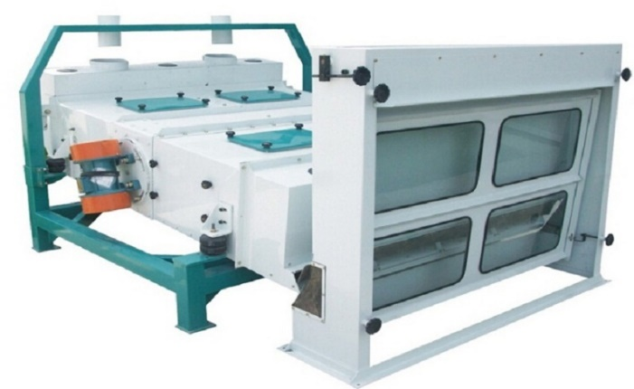  Fig.15.1 Pre-cleaners | 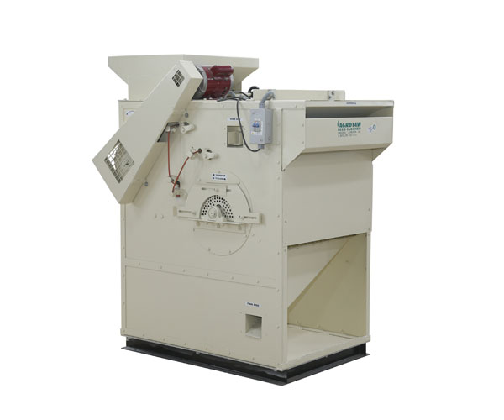  Fig.15.2 Fine cleaners
      - Aspirators
Air aspirators play a crucial role in millet processing by separating lighter impurities such as dust, small stones, weed seeds and other lightweight particles from millet grains. These machines employ controlled airflow to lift and remove lighter impurities from the grains, with adjustable air intensity to optimize separation efficiency based on the millet's specific characteristics. There are two main types of air aspirators: vertical and horizontal. Vertical aspirators leverage gravity to aid in the separation process as the millet and impurities descend through screens, while a controlled upward airflow lifts lighter impurities for removal. In contrast, horizontal aspirators pass the millet and impurities horizontally across sieve trays, where the upward airflow effectively separates the impurities from the millet grains. A notable example of such equipment is the AGROSAW air aspirator, which is widely recognized for its effectiveness in achieving clean and pure millet grains. These aspirators are essential for ensuring the quality and purity of millet, making them a vital component in the millet processing industry.
      - Destoners
A destoner is a machine specifically designed to remove stones and heavy impurities from grains. It utilizes differences in weight to effectively separate stones from lighter grains. There are two main types of destoners: gravity destoners and pressure destoners. Gravity destoners operate on the principle of gravity and vibration to achieve separation. In this process, grains are fed onto a vibrating deck where the heavier stones are moved to one side and the lighter grains to the other. On the other hand, pressure destoners employ air pressure to lift the lighter grains while heavier impurities like stones are separated out. An example of a gravity destoner is the TQSF series and another well-known model is the AGROSAW destoner. These machines are essential in ensuring that grains are free from stones and heavy impurities, thus improving their quality and safety.
      - Gravity separator
A gravity separator is a machine designed to separate grains based on their density, effectively removing lighter impurities and damaged grains. This process involves an inclined vibrating deck that sorts grains according to their specific gravity. One common type of gravity separator is the gravity table, which separates millets based on their specific weight. As the grains move over a perforated vibrating deck, air is blown through the deck, causing grains of different densities to separate. An example of a gravity separator is the 5XZ series, with the AGROSAW gravity separator being another well-known model. These machines play a crucial role in enhancing grain quality by ensuring that only grains with the desired density are retained.
    - Grading machines
Grading machines are essential in millet processing to sort the grains based on size, shape, weight and quality. Proper grading ensures uniformity, improves the quality of the final product and enhances market value.Grading machines are vital in the millet processing chain to ensure that the final product meets the desired quality standards. The choice of grading machines depends on the specific requirements of the processing facility and the type of millet being processed. Investing in the right grading equipment enhances efficiency, improves product quality and increases the overall profitability of millet processing operations. Here are the primary types of grading machines used in millet processing:
      - Screen graders
Screen graders are essential equipment in the postharvest processing of millets. They are used to separate grains based on size, ensuring uniformity and quality in the final product. There are two different types of screen graders are used for grading of millets based on size.
        - Rotary screen graders
The system functions by using vibration to sift out smaller impurities such as dust, chaff and small stones. It comprises cylindrical screens that rotate to facilitate separation. In operation, millets enter the rotating drum and pass through screens with varying mesh sizes. The rotation of drum causes the grains to tumble, which helps ensure that impurities are effectively sifted out. This process ensures a thorough cleaning of the millets as they move through the different screens, with each stage progressively removing smaller contaminants.
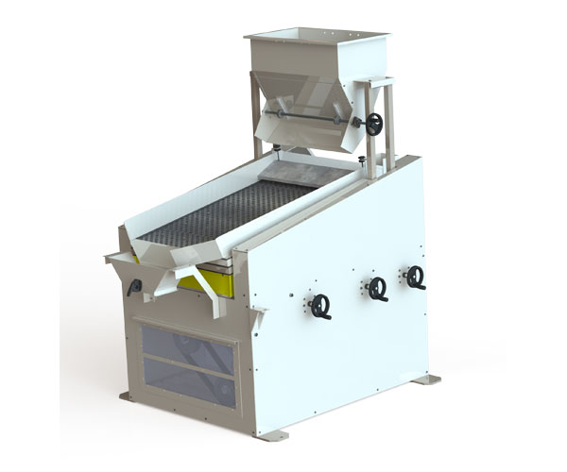  Fig.15.3 Destoner | 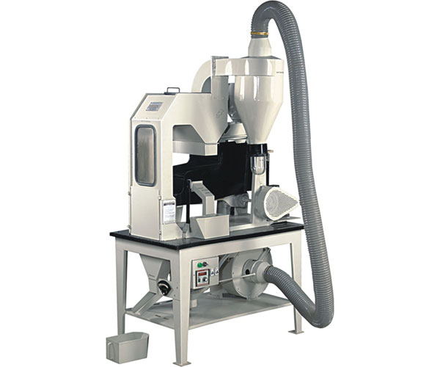  Fig.15.4 Aspirator | 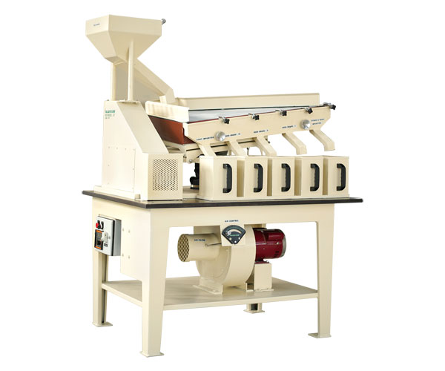  Fig.15.5 Gravity separator
        - Vibratory screen graders
The vibratory screen graders functions by using vibration to sift out smaller impurities such as dust, chaff and small stones. It comprises multiple layers of screens with varying mesh sizes. During operation, millets are fed onto the vibrating screens, which facilitate the movement of grains across the surface. As the millets move, smaller impurities fall through the finer mesh layers, leaving cleaner millets on top. This layered and vibrating mechanism ensures that the millets are thoroughly cleaned as they pass through each screen, effectively removing contaminants and enhancing the quality of the final product.
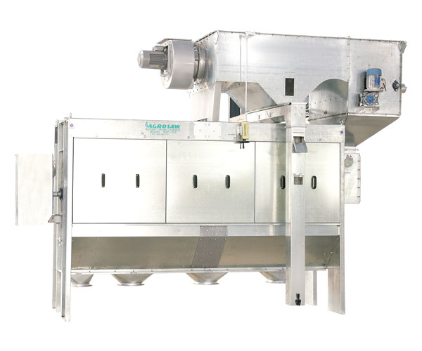  Fig.15.6 Rotary screen grader | 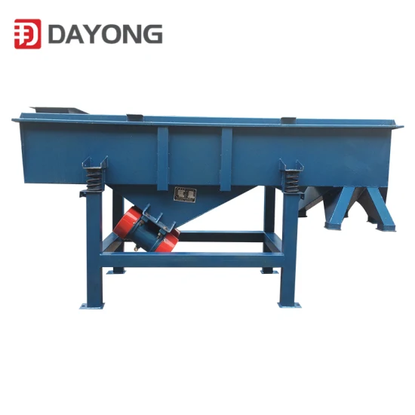  Fig.15.7 Vibratory screen grader
      - Indented cylinder graders
Indented cylinder graders, also known as indented cylinder separators or trieurs, are machines used in the agricultural and grain processing industries to sort and separate grains, seeds and other particulate materials based on their length. This equipment plays a crucial role in ensuring the quality and uniformity of the processed products.The core component of the machine is a rotating cylinder with indents (or pockets) on its inner surface, designed to capture particles of a specific size. The material to be sorted is fed into the cylinder as it rotates. During this separation process, the indents pick up particles that fit into them, while particles that are too long or too short to fit fall off and are directed to different outlets. The particles captured in the indents are carried along with the rotation of cylinder until they reach a specific point, where they are discharged into a separate collection area.
      - Magnetic separators
Magnetic separators are critical in the processing of millets, as they help remove ferrous contaminants and ensure the purity and quality of the product. These separators come in various forms and can be integrated into different stages of the milling process.The function of this system is to remove ferrous metals from bulk materials such as millets. It features a rotating drum positioned at the discharge end of a conveyor or beneath a feed hopper, which attracts ferrous metals while allowing non-magnetic materials to continue moving forward. Alternatively, flat magnetic plates can be used to attract and hold ferrous contaminants from millets on conveyor belts or within chutes and ducts. This ensures that ferrous impurities are effectively separated from the millets, enhancing the purity and quality of the final product.
      - Electronic graders
Electronic graders for postharvest processing of millets are specialized machines designed to sort and grade millets based on various criteria such as size, weight, color andquality. These graders are crucial in ensuring the millets meet market standards and consumer preferences. Various sorting criteria that are kept in mind while performing a grading process using electronic graders.
Electronic graders utilize several advanced technologies to ensure precise sorting of grains, integrating multiple sophisticated systems for optimal results. Sensitive scales are employed to separate grains by weight, allowing for the differentiation of grains based on density and mass. Optical sensors play a crucial role in detecting discoloration, spots, or other visible defects, ensuring that only high-quality grains pass through. Shape recognition algorithms are applied to sort grains with irregular shapes, maintaining consistency in the final product. The graders commonly use high-resolution cameras and image processing software for optical and camera-based sorting, providing detailed analysis and accurate categorization of each grain. Laser and infrared sensors are utilized to detect both internal and external quality parameters, offering a non-invasive method to assess the grains' integrity. X-ray technology is implemented to identify hidden defects or impurities that are not visible through other methods, ensuring comprehensive quality control. Additionally, air jet ejection systems are employed to swiftly remove defective grains, enhancing the efficiency and speed of the sorting process. This combination of technologies results in a thorough and efficient sorting mechanism, guaranteeing high-quality output and consistency in grain selection.
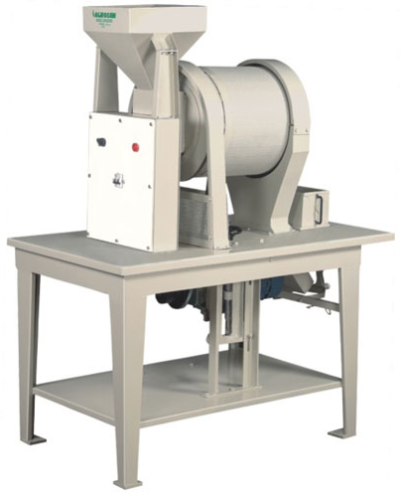  Fig.15.8 Indented cylinder grader | 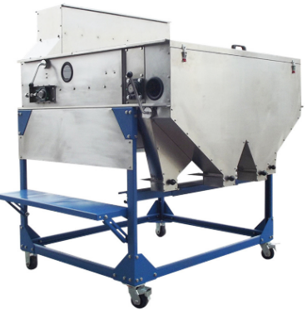  Fig.15.9 Magnetic grader | 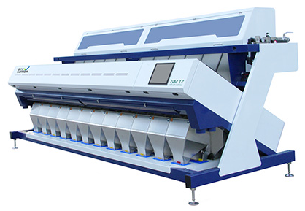  Fig.15.10 Electronic grader
  - SECONDARY PROCESSING MACHINERY
    - Dehulling machines
Dehulling is a crucial step in the processing of millets, where the outer husk or hull of the grain is removed. Different types of dehulling machines are used depending on the type of millet and the scale of the operation.Investing in the right dehulling machine is essential for ensuring the quality and efficiency of millet processing. Each type of dehulling machine offers specific advantages and the choice should be based on the type of millet, processing scale and desired quality of the final product. Proper dehulling not only improves the edibility and marketability of millets but also enhances overall processing efficiency.Here’s an overview of the various types of dehulling machines used in millet processing:
      - Under-runner disc shellers
The operation of under-runner disc shellers utilizes abrasive surfaces on discs that rotate in opposite directions to effectively remove the hulls from the grains. Specifically, under-runner disc shellers, which are a key component in this process, consist of two horizontal abrasive discs. One disc remains stationary while the other rotates at high speed in the opposite direction, creating friction that carefully abrades and separates the hulls from the grains without damaging the kernels. This system is particularly suitable for small to medium-scale operations and can handle various types of millets effectively, ensuring versatility and adaptability across different production environments. Under-runner disc shellers are designed with simplicity in mind, featuring a straightforward mechanism that is easy to operate and maintain. Additionally, they are relatively low cost compared to more complex dehulling machinery, making them an economical choice for producers. The combination of a simple design, wide-ranging effectiveness for different millet types and cost-efficiency makes this system an ideal solution for dehulling grains, providing a balance of performance and affordability for small to medium-scale operations.
      - Roller hullers
This system operates using pairs of horizontal rollers with abrasive surfaces to gently shear the hulls off the grains. It is specifically suitable for delicate millets that require gentle handling to avoid damaging the grains. The horizontal rollers rotate towards each other, creating a shearing action that carefully removes the hulls while minimizing damage to the kernels. This method is particularly effective for millets with softer hulls, preserving the grain's integrity and quality. One of its primary advantages is its gentle dehulling process, which helps maintain the nutritional value and appearance of the grains. Additionally, the system features adjustable settings for different grain sizes, ensuring versatility and allowing for precise control over the dehulling process. This makes it an ideal choice for producers looking to achieve consistent and high-quality results across various types of millets.
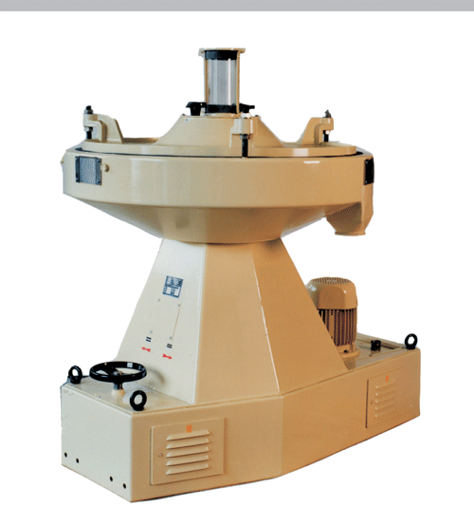  Fig.15.11 Under-runner disc shellers | 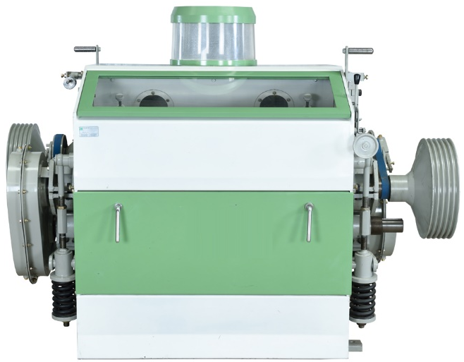  Fig.15.12 Roller hullers
      - Impact dehullers (Centrifugal dehullers)
Impact dehullers operate using centrifugal force to effectively dehull grains by propelling them against a hard surface, causing the hulls to crack and separate from the grain. This technique is particularly well-suited for high-capacity processing and can handle various types of millets, making it highly versatile. The system's design enables it to manage large volumes of grains efficiently, making it ideal for large-scale operations that require high throughput. The use of centrifugal force ensures consistent and effective cracking of the hulls, resulting in a highly efficient dehulling process. Moreover, the robustness and reliability of this method make it a preferred choice for operations needing both speed and volume handling capabilities. The combination of high efficiency, suitability for large-scale operations, and the ability to manage high throughput makes this system an excellent solution for industrial-scale grain processing, ensuring consistent and high-quality output.
      - Abrasion dehullers (Pearlers)
The process involves using abrasive stones or surfaces to remove the hulls from grains as they move through the machine. This method is well-suited for most types of millets, especially those with tougher hulls that are difficult to remove by other means. One of the significant advantages of this method is its versatility and effectiveness in dealing with tough hulls, ensuring a thorough hull removal. Moreover, this process can also polish the grains to some extent, improving their appearance and potentially their market value. Overall, using abrasive stones or surfaces for hulling millets is a robust method that combines effective hull removal with the potential for grain polishing, making it a versatile choice in millet processing.

      - Friction dehullers
Friction dehullers utilizes friction to remove hulls by rubbing the grains either against each other or against a rough surface. It is particularly suitable for millets with softer hulls that can be easily removed through abrasion. The process is known for its efficiency in hull removal, achieving a good balance between effectiveness and minimal grain breakage. It is well-suited for small to medium-scale operations, providing a practical solution for processing millets without requiring extensive equipment. This method ensures that the grains are cleaned efficiently while maintaining their integrity, making it a preferred choice in environments where resources and space are limited. Overall, employing friction for hulling millets is a straightforward and effective method that can be applied with relative ease in various processing settings.
      - Rubber roller shellers
This method employs rubber-coated rollers to apply gentle pressure and shear forces to remove hulls from millets. It is particularly suitable for millets that are sensitive to abrasion and impact, ensuring the grains remain intact during the hulling process. The rubber-coated rollers allow for adjustable pressure, which can be tailored to the specific requirements of different types of millets, minimizing breakage and ensuring efficient hull removal. One of the main advantages of this method is its gentle treatment of grains, which helps preserve their quality and nutritional value. This makes it a preferred choice for processing millets in environments where maintaining grain integrity is crucial. Overall, using rubber-coated rollers for hulling millets combines effective hull removal with careful grain handling, making it a reliable method for producing high-quality millet products.
    - Polishing machines
Polishing machines play a crucial role in millet processing by removing the bran layer and giving the grains a shiny, appealing finish. This step not only improves the visual appeal of millets but also enhances their cooking quality and shelf life.Polishing machines are essential for enhancing the quality and marketability of millets. The choice of machine depends on the type of millet, the desired level of polish and the scale of processing. Investing in the right polishing equipment can significantly improve the final product, making millets more appealing to consumers and increasing their market value.Here’s an overview of the types of polishing machines used in millet processing:

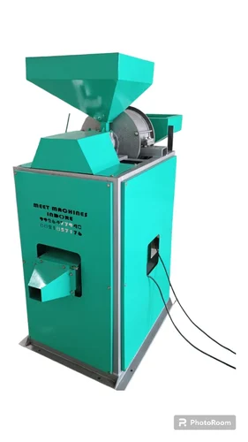  Fig.15.13 Impact dehuller | 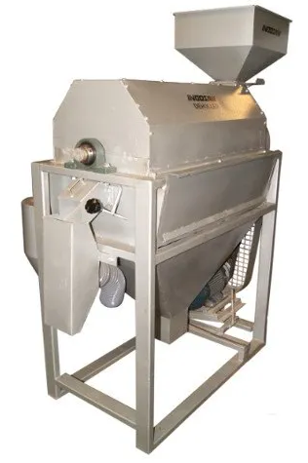  Fig.15.14 Abrasion dehuller | Fig.15.15 Rubber roller sheller
      - Abrasive polishers
This method involves using abrasive surfaces, such as emery stones, to rub off the outer bran layer from millets as they pass through the machine. It is suitable for various types of millets, especially those with a tough bran layer that requires significant abrasion for removal. The process is highly effective at removing bran, which not only improves the appearance of the grains but also enhances their marketability. Horizontal and vertical abrasive polishers are examples of machines used for this purpose in the industry. They are designed to ensure thorough bran removal while minimizing damage to the grains. Overall, this method is widely used due to its effectiveness, reliability and ability to produce high-quality millet products suitable for various culinary and industrial applications.
      - Friction polishers
This system utilizes friction generated by rubbing the grains against each other or against a rough surface to remove the bran layer from millets. It is particularly suitable for millets that require a gentler polishing process to avoid excessive grain breakage. The process is gentle on grains, reducing the likelihood of breakage while effectively removing the bran. It can also produce a smoother finish on the grains, enhancing their appearance. Vertical and horizontal friction polishers are examples of machines used for this purpose, each designed to apply the necessary friction to achieve the desired polishing effect. Overall, employing friction for bran removal in millets is a practical method that balances effectiveness with grain preservation, making it suitable for producing high-quality millet products with a polished appearance.
      - Water jet polishers
Water jet polishers utilizes high-pressure water jets to remove the bran layer from millets, while simultaneously cleaning the grains. It is particularly suitable for millets that benefit from a wet polishing process, improving both cleanliness and appearance. The high-pressure water jets effectively strip away the bran layer, ensuring thorough bran removal without damaging the grains. Additionally, the water helps in cleaning the grains by removing dust and other contaminants, further enhancing the quality of the final product. Continuous flow water jet polishers are commonly used for this purpose in the industry, designed to maintain a consistent and efficient process. Overall, this method offers efficient bran removal, improves grain cleanliness and reduces dust, making it a preferred choice for producing high-quality, polished millet grains suitable for various culinary and industrial uses.
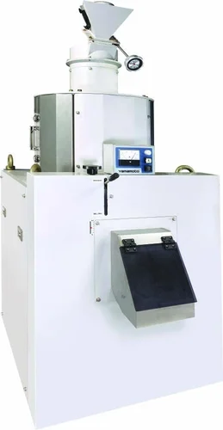  Fig.15.16 Friction polisher | 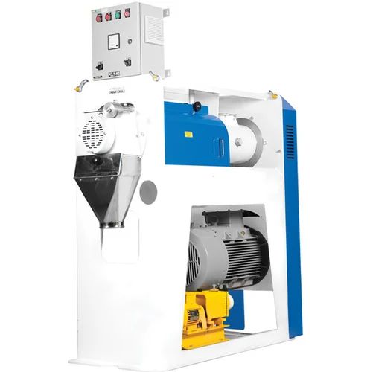  Fig.15.17 Water jet polisher
    - Milling machines
Milling machines are integral to the processing of millets, transforming cleaned and dehulled grains into flour, grits, or other desired forms. The selection of milling machines depends on the type of millet, the desired end product and the scale of processing.Selecting the right milling machine is critical for optimizing the quality and efficiency of millet processing. Whether producing fine flour, coarse grits, or specialty products, the choice of milling equipment impacts the final product's quality, nutritional value and market appeal. Investing in appropriate milling technology ensures that millet processors can meet diverse consumer needs and maintain high standards in their products.Here’s a detailed overview of the types of milling machines used in millet processing:
      - Hammer mill
The operation ofhammer mill utilizes rotating hammers to pulverize grains against a perforated screen, with the size of the final product being adjustable by changing the screen size. This method is particularly effective for producing fine millet flour or coarse grits. One of the primary advantages of this approach is its versatility; it is capable of handling a variety of grain types, making it suitable for diverse milling needs. Additionally, the design of the equipment is relatively simple, which enhances its appeal for both small-scale and large-scale operations. This straightforward design contributes to ease of use and maintenance, ensuring consistent performance. Examples of equipment that utilize this milling method include standard hammer mills and high-speed hammer mills, both of which are widely used in the industry for their efficiency and reliability. These mills exemplify the practical application of this pulverizing technique, demonstrating its effectiveness in producing a range of grain-based products with varying textures.
      - Roller mill
The milling operation of roller mill employs pairs of horizontal rollers that crush and grind grains into finer particles, with the gap between the rollers adjustable to control the fineness of the output. This method is particularly suitable for producing uniform and fine millet flour. One of the significant advantages of using roller mills is their ability to produce consistent particle sizes, ensuring uniformity in the final product. Additionally, roller mills are efficient in their operation and generate less heat compared to hammer mills, which helps in preserving the nutritional quality of the grains. This efficiency and reduced heat generation make roller mills an excellent choice for processes where maintaining the integrity of the grain is crucial. Examples of equipment that utilize this method include single pair roller mills and double pair roller mills, both of which are designed to enhance the milling process by providing precise control over the particle size. These mills are widely used in the industry for their ability to produce high-quality, fine flour consistently and efficiently.
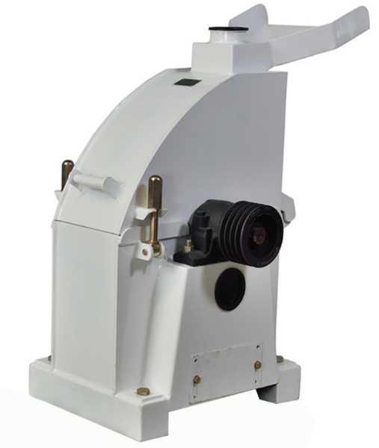  Fig.15.18 Hammer mill | 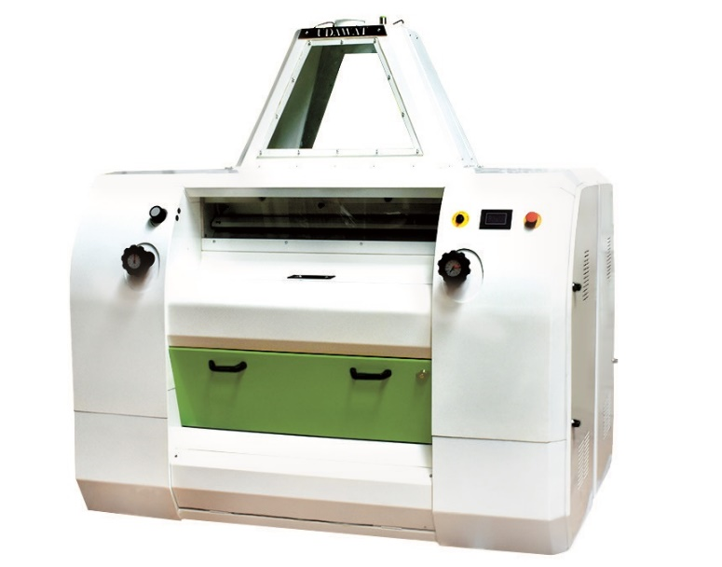  Fig.15.19 Roller mill
      - Stone mill
The milling operation of this machine utilizes large, rotating stones to grind grains. The grains are fed between these stones, which rotate against each other to crush and grind them into flour. This traditional method is particularly suitable for artisanal milling and is ideal for producing whole grain flour with a distinctive texture. One of the main advantages of using stone mills is the gentle milling process, which helps to preserve the nutritional content of the grains. This method not only maintains the integrity of the grain but also enhances the flavor and texture of the final product, resulting in flour that has a unique and rich taste. Additionally, stone milling is known for producing flour with a characteristic coarseness that is often sought after in traditional baking and cooking. Examples of equipment that use this method include manual stone mills and electric stone mills, both of which are valued for their ability to produce high-quality, nutritious flour. These mills are favored in settings where the quality and character of the flour are of utmost importance, providing a link to traditional milling techniques while meeting contemporary needs.
      - Impact mill
The milling operation of impact mill employs high-speed rotors equipped with impact blades that strike the grains, causing them to shatter into fine particles. This method is particularly suitable for producing fine flour or pulverized millets. One of the key advantages of using impact mills is their efficiency in producing fine and ultrafine flour, making them an excellent choice for applications requiring a high degree of fineness. Additionally, the fast processing capability of these mills significantly enhances productivity, allowing for the rapid production of large quantities of flour. The impact milling process is highly effective in breaking down grains quickly and thoroughly, ensuring a consistent and high-quality output. Examples of equipment that utilize this method include universal impact mills and classifier impact mills, both of which are designed to optimize the milling process through precise and efficient grain pulverization. These mills are widely recognized for their ability to deliver fine flour quickly and efficiently, making them valuable assets in both industrial and smaller-scale milling operations where speed and fineness are critical.
      - Pin mill
The milling operation utilizes two discs with pins on their surfaces, where one disc rotates while the other remains stationary. Grains are fed into the center and are ground into fine particles through the combined impact and shear forces generated by the rotating disc. This method is particularly suitable for the fine grinding of millets to produce superfine flour, making it ideal for specialty products that require a high degree of fineness. One of the primary advantages of using pin mills is their ability to produce exceptionally fine flour, meeting the demands of specific culinary and industrial applications. Additionally, pin mills are highly efficient for fine grinding, ensuring that the processing time is minimized while achieving the desired particle size. Examples of equipment that employ this technique include vertical pin mills and horizontal pin mills, both designed to optimize the milling process through precise control over the grinding action. These mills are valued for their capability to deliver consistent, superfine flour, making them essential in settings where the quality and fineness of the flour are paramount.
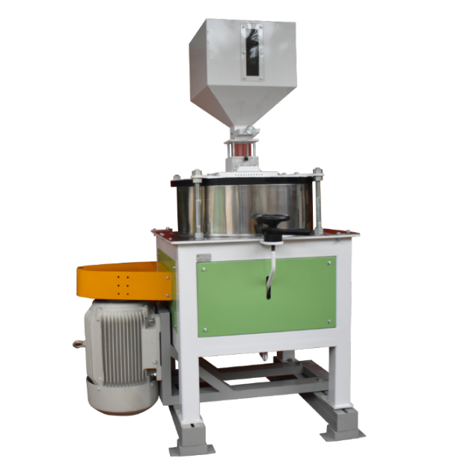  Fig.15.20 Stone mill | 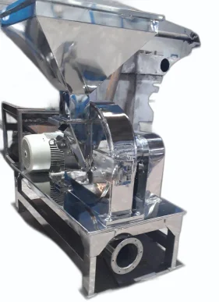  Fig.15.21 Pin mill
  - TERTIARY PROCESSING MACHINERY
    - Packaging machinery
Packaging machinery is a critical component in the processing of millets, ensuring that the final product is properly sealed, labeled and protected for distribution and sale. The type of packaging machinery used depends on the packaging format (e.g., bags, pouches, bulk packaging), the scale of operation and the specific requirements of the product.Investing in the right packaging machinery is essential for ensuring the quality, safety and marketability of millet products. The choice of packaging equipment should be based on the type of millet product, packaging format, production scale and specific requirements. Proper packaging not only preserves the quality of the millets but also enhances their appeal and compliance with regulatory standards, ultimately contributing to the success of the millet processing operation.Here are the primary types of packaging machinery used in millet processing:
      - Foam-fill seal (FFS) machine
The foam-fill seal machine uses automated machines to form, fill and seal pouches or bags, ideal for packaging millets into small to medium-sized pouches. These machines, including VerticalForm-Fill-Seal (VFFS) and Horizontal Form-Fill-Seal (HFFS) types, handle large volumes efficiently, enhancing speed, consistency and versatility, making them essential for modern packaging needs.
      - Bagging machine
The bagging machine fills and seals pre-made bags, ideal for bulk formats holding 10 kg, 25 kg, or more. These high-speed machines enhance productivity and reliability in large-scale packaging. Examples include open-mouth bagging machines, valve bagging machines and bulk bag fillers, essential for efficiently managing large product volumes.
      - Vacuum packaging machine
The vacuum packaging machine removes air before sealing, extending product shelf life and preventing spoilage, ideal for millets needing protection from oxidation. This vacuum-sealing process preserves nutritional quality and flavor. Chamber vacuum sealers suit industrial use, while external vacuum sealers are for smaller operations, both essential for maintaining product quality and longevity.

      - Pouch filling and sealing machine
The packaging operation fills and seals pre-made pouches, ideal for flexible formats like stand-up pouches. It offers versatility for various pouch types and high precision for consistent results. Examples include rotary machines for high-speed lines and linear machines for precise, smaller-scale operations, both crucial for efficient, accurate packaging.
      - Automatic weighing and filling machine
Automatic weighing and filling machine involves accurately weighing products before packaging, ensuring precise portion control and minimizing waste. This method is ideal for industries requiring consistency and accuracy. Multihead weighers suit high-speed lines, while linear weighers are flexible for smaller operations. Both types ensure efficient, accurate packaging, meeting consumer expectations and reducing overfilling costs.
      - Sealing machine
The sealing machine involves accurately weighing products before packaging, ensuring precise portion control and minimizing waste. This method is ideal for industries requiring consistency and accuracy. Multihead weighers suit high-speed lines, while linear weighers are flexible for smaller operations. Both types ensure efficient, accurate packaging, meeting consumer expectations and reducing overfilling costs.
      - Labeling machine
The operation of labeling machine involves applying labels to packaged products, providing essential information like brand, nutritional details and expiry dates. This ensures regulatory compliance and consumer clarity. High-speed labeling enhances productivity, with options like pressure-sensitive, sleeve and print-and-apply labelers ensuring uniform appearance across various packaging types, essential for retail and distribution.
      - Cartooning machine
The operation involves packaging filled and sealed bags or pouches into cartons for bulk distribution, enhancing product protection during transport. This method is crucial for secondary packaging in industries needing additional product protection and organized distribution. Cartooning machines streamline the process with automated systems, reducing manual labor and errors. Horizontal and vertical cartooning machines accommodate different carton formats and product sizes, ensuring secure packaging and customer satisfaction throughout the distribution chain.
      - Shrink wrap machine
The operation of shrink wrap machine involves enclosing products in shrink film and applying heat to tightly shrink the film around them, providing additional protection and bundling. Shrink wrapping is crucial in various industries for product integrity, tamper evidence and protection against dust and moisture. Equipment like shrink tunnels and heat guns ensure effective packaging, enhancing product presentation and appeal.
    - Machinery for production millets based products
Unit operations on grain, whether directly or after primary processing and secondary processing, transform the grain into consumable products. These processes are typically conducted away from the farm, within either unorganized or organized sectors.This systematic approach not only improves food quality and safety but also adds value to the agricultural produce, supporting both the industry and consumers. Here gives some processing machinery of tertiary category for development of value added products from various millets:
- Twin Screw Extruder Machine
- Flaking Machine
- Grain Roaster
- Pasta Machine
- Food Blender
  - REFERENCES:
- Balasubramanian S, Chakraborty SK, Kotwaliwale N, Kate A and Dawn CP Ambrose. Entrepreneurship Opportunities in Nutri-Cereal Processing Sector. Indian Food Industry Mag. 2021;3(1):29-38.
- Birania S, Rohilla P, Kumar R, & Kumar N. Post-harvest processing of millets: A review on value added products. International Journal of Chemical Studies. 2020; 8(1):1824-1829.
- Chapke RR, Shyam Prasad G, Das IK, Hariprasanna K, Singode A, Kanthi Sri BS, et al. Latest millet production and processing technologies. Booklet, ICAR-Indian Institute of Millets Research, Hyderabad, India, 2020, pp. 500-030, 82. (ISBN: 81-89335-90-X).
- DattaMazumdar S, Priyanka D, &Akhila Y. Emerging Technologies in Millet Processing. Handbook of Millets-Processing, Quality and Nutrition Status. 2022; 231-263.
- Deshpande S, Tripathi MK, Mohapatra D &Jadam RS. Product Development from Millets in Millets and Millet Technology. Kumar A, MK Tripathi, Dinesh Joshi, Vishnu Kumar (eds.), 2021, pp. 143-160. Springer publication ISBN: 978-981-16-0676-2.
- Kaur KD, Jha A, Sabikhi L and Singh AK. Significance of coarse cereals in health and nutrition: a review. Journal of Food Science and Technology, 2012;51(8):1429-1441.
- Sahay, K. M., & Singh, K. K. (1996). Unit operations of agricultural processing (pp. xii+-340).
- Tonapi VA, Bhat BV, Kannababu N, Elangovan M, Umakanth AV, Kulkarni R, et al. Millet seed technology: seed production, quality control & legal compliance. Hyderabad, India: Indian Institute of Millets Research. 2015;5(3):24-34.

