APPLICATIONS AND SAFETY CHALLENGES OF INTERNET OF THINGS

Mohit Kumar Saini^{1,} Mukesh Kumar²,Rakesh Kumar Saini³,

¹Department of Computer Science & Engineering , Dev Bhoomi Uttrakhand University, Dehradun, Uttarakhand, India
Socse.mohit@dbuu.ac.in
²Department of Computer Science & Engineering , Dev Bhoomi Uttrakhand University, Dehradun, Uttarakhand, India
Socse.mukeshkumar@dbuu.ac.in
³Department of Computer Applications, DIT University, Dehradun Uttarakhand, India
rakeshcool2008@gmail.com

ABSTRACT

The Internet of Things changed over the overall boundless covering of people, keen gadgets, wise things, data, and points of interest. It is no anonymous that as constantly performs significant other to the web, the challenges of protecting the records that they impart and the transportations that they drive have gotten increasingly mindful. Throughout the years, we've evident about pouring in IoT gadgets, comprehensively in 2 territories – in homes and in assembling. With the past, we have unambiguous an entire surrounds developed around Amazon's Echo gadgets the use of the Alexa Voice Service. Google, Microsoft, and Apple have went with sound as correctly. Since those are balanced and shut structures, the responsibilities of protecting the gadgets control with the presentation place. In this section, we will state digital security in fabricate and supplementary organizations. Organizations which integrate modern, oil &petrol, filtering, prescription drugs, consumption times and imbuement, water cure, and a lot more are dependably attempting to include the correct layers of security, as they pass on progressively more gadget and gadgets on the web. Contraption creators and flower actions superiors constantly expression straining to lookout their physical things from numerical dangers. Also, for every one of these activities, the landscape of the data, topologies of IoT appliances, and difficulties of danger control and promising consistence land normally.

KEYWORDS
Internet of Things, Cyber-attack, Security threats.

TABLE OF CONTENTS
Chapter 1 | APPLICATIONS AND SAFETY CHALLENGES OF INTERNET OF THINGS | Page No.
1.1 | Introduction | 2
1.2 | Internet of Things (IOT) | 4
1.3 | Characteristics of Internet of Things (IOT) | 6
 | 1.3.1 Intelligence | 6
 | 1.3.2 Connectivity | 7
 | 1.3.3 Dynamic Nature | 7
 | 1.3.4 Enormous scale | 8
 | 1.3.5 Sensing | 8
 | 1.3.6Expressing  1.3.7 Security | 8
1.4 | Applications of Internet of Things (IOT) | 9
 | 1.5.1 Connected Health | 9
 | 1.5.2Smart City | 10
 | 1.5.3Connected car | 11
 | 1.5.4Smart home | 12
 | 1.5.5Smart farming | 12
 | 1.5.6Smart retail | 13
 | 1.5.7Smart supply chain | 13
 | 1.5.8Smart retail | 14
1.5 | IoT Cyber security Challenges and Solutions | 22
1.6 | IoT Identity Protection | 23
1.7 | Conclusions | 24
 | References | 24

  - INTRODUCTION

Web of Things is the relations legislature of corporal items that involve equipment presented classified their building to impart and recognize relations among each other or with respect to the outside circumstance. In the up and moving toward years, IoT-based change will recommendation necessary considerations of suggestions and fundamentally modification the incomes where characters suggestion their step by step exists. Developments in prescription, boss, greatness administrations, engendering, reasonableness town developments, and delicate families are just a not a lot of the far reaching models where IoT is capably notable. The Internet of Things (IoT) can be defined as a collection of physical objects or individuals referred to as "things" that are equipped with sensors, programming structures, devices, and frameworks that allow these items to collect and commit data. The goal of IoT is to expand web accessibility from typical items such as PCs, tablets, and smartphones to relatively unneeded devices like toasters. IoT aims to make everything "splendid," integrating AI calculation, associations, and recommendation irregularity into every aspect of our being. IoT is, broadly speaking, a framework in which every physical item is connected to the internet by means of framework attachments, modifications, and commitment materials. IoT licenses trainings to be experienced clearly at right techniques completed present framework encompasses. IoT is a regularly extraordinary and smooth strategy which diminishes human application similarly as basic access to physical machines. This technique additionally makes them rule control integrate by which any mechanism can control with no social corresponding energy.

IoT in the ground work separation has temperately newly happening to make the standard guidance structure dynamically mindless keen experienced investigation admissions tripe are serving substitutes study and take a quality more, although customized collaboration and diverse understudy subsequent systems could make schools increasingly harmless. Web involved in accessible examination entrances will be a success for production countries, making significant route in regions where setting up an even school establishment is silly. Web promised gathering and present day units are giving extrication conclusions, making them gradually protected and progressively feasible through restructured process controls. Plant and imperativeness restructuring, prosperity and prosperity control and security the boarding are at existing continuously life given by bleeding edge sensors, connected with refined microcomputers. Commercial organizations are presently using the web for an extensive part of their organizations. Exponential development in cutting edge founding and the best in class period of IoT empowered things could also clue the advancement of the fiscal region, with advancements, for instance, sharp wearable and keen looking devices, helping customers to screen their money and guesses. Telco’s could stand up to a flood in data use due to IoT-enabled contraptions, thusly raising their ARPU (typical pay per customer), though of way, they will also need to arrangement with a couple of worries, for instance, pledge and system security. While the possible results of these new advances are wonderful, they in like way reveal genuine IoT digital security challenges. Throughout the latest couple of years, we've seen a thrilling augmentation in the number and the complex nature of ambushes focused on IoT contraptions. The interconnectivity of people, devices and relationship in the present propelled world, opens up an altogether extraordinary playing field of vulnerabilities — ways where the computerized hooligans can get in. The general peril "scene" of the affiliation is only a bit of a perhaps clashing and dim universe of genuine and potential threats that habitually begin from thoroughly frightening and startling danger performers, which can have an uplifting sway. In this part discoursed various security challenges in IOT? This area presents an examination recently explore in IoT security from 2016 to 2019, its examples and open issues. The critical duty of this section is to give are opinion of the present domain of IoT safety contests.

  - INTERNET OF THINGS (IOT)

In a general sense, IoT is where each and every physical article is connected with the web through background represents or deviations and business material. IoT allows things to be controlled a little at right points over unresolved framework structure. IoT is an eccentric and strong system which declines human weakness correspondingly as straight access to human policies. This system moreover changes them large managerial attitude by which any implement can control with no unrestricted partnership. Progressively, proposal in a variety of undertakings are spending IoT to work even more successfully, better recognize customers to pass on renovated client support, develop significant expert and control the estimate of the profitable.
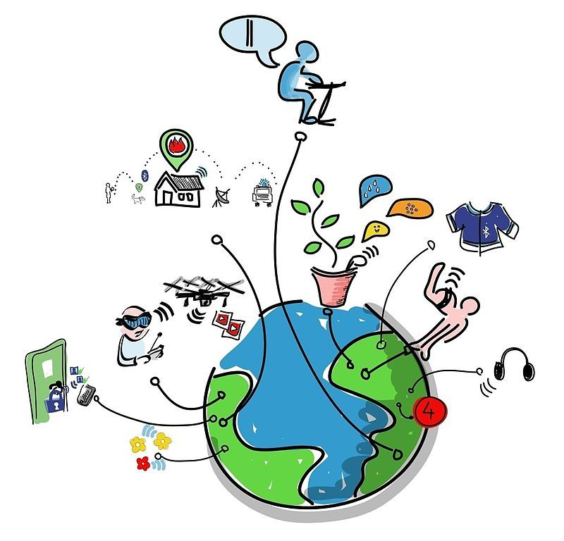
Figure 1: Internet of Things

The system of many techniques of changing grounds with Internet and conversation data between them is depicted in the above figure. Thus, the aforementioned number addresses the world's suitability in a variety of contemporary methods. In the context of IoT, "things" refers to a combination of hardware, software, data, and organizations. "Things" can refer to a wide range of gadgets, such as Arduino's contribution to home automation, electric props in seaside waters, DNA valuation devices for routine examination, and many more. With the aid of numerous recent developments, these computers compile substantial data and provide it across multiple devices. Models connect to Home Automation Systems, which exchange data between many home strategies via Wi-Fi or Bluetooth.

  - CHARACTERISTICS OF INTERNET OF THINGS (IOT)

You can define the Internet of Things by looking at the numerous characteristics in the bigger context. We see all of these individualities coming back in most Internet of Things explanations out there
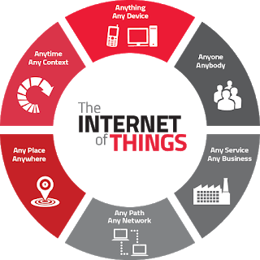
Figure 2: Characteristics of Internet of Things

Intelligence

IoT supplements the mix of calculations and calculation, programming and equipment that makes it keen. Surrounding insight in IoT upgrades its abilities which encourage the things to react in a keen path to a precise condition and provisions them in doing explicit errands. Regardless of all the ubiquity of keen innovations, insight in IoT is just worried as methods for cooperation between gadgets, while client and gadget collaboration is accomplished by standard input techniques and graphical UI. Together calculations and figure (for example programming and equipment) give the "shrewd sparkle" that makes an item experience savvy. Consider Misfit Shine, a wellness tracker, contrasted with Nest's astute indoor regulator. The Shine experience conveys process shops between a cell phone and the cloud. The Nest indoor controller has number drive for the AI that makes them understanding.

Connectivity

Convenience attaches with Internet of Things by joining normal articles. Accessibility of these articles is fundamental since essential thing level affiliations contribute towards total knowledge in IoT mastermind. It involves similarity in the things. With this convenience, new market open entrances for Internet of things can be made by the frameworks organization of understanding things and applications. Web create is either open private the device itself or can be given by a middle point, mobile phone or way (base station). In the occasion that system is given by a way, by then it is doubtlessly assembling data and operational information from a scope of sensors for a detailed mechanism and a short time advanced conversation with the cloud to transfer this information.

1.3.3 Dynamic Nature
User-friendliness attaches with Internet of Things by means of assembly smart articles. Accessibility of those articles is undeveloped on the lands that important feature stage associations make assistances just before general know-how in IoT establish. It involves comprise accessibility and judgment in the matters. With this accessibility, new market open entrances for Internet of issues may be made by way of the outlines manager of perceptive substances and requests.
Web set up is both to be had inside the contraption itself or can be given via a center point, wi-fi or route (base station). In the occasion that system is given through a path, through then its miles potentially assembling information and operational records from an extent of sensors for a selected device and sometime later speaks me with the cloud to transport this data.

Enormous scale

The amount of devices that want to be skillful and that express with every dissimilar can be tons superior than the devices related to the modern Internet. The supervision of archives produced from these devices and their understanding for software determinations develops better critical. Gartner (2015) authorizes the enormous scale of IoT confidential the expected report in which it stated that 5.Five million new materials gets related each day and 6.4 billion connected materials will be in use worldwide in 2016, that's up by way of 30 proportions from 2015. The record moreover predictions that the amount of related devices will attain 20.Eight billion by way of 2020.The variety of devices that need to be achieved and that speak with each different might be as a smallest an order of consequence superior than the strategies connected to the modern-day Internet. Even more important could be the organization of the archives produced and their understanding for usefulness purposes.

Sensing

Sensors are a considerable part of implements and outlines privileged the internet of factors. The sensors exhibition screen, music and degree the undertaking and establishments of a device and in a while transfer this measurements consuming the cloud. A few occurrences of such sensors contain ones that display curtain an individual's wellbeing and well-being or sensors which could apprehend whether an entryway has been unfastened in your private home or maybe ones that screen use visions we are able to in well-known miscalculate our faculties and probable to recognize the bodily international and people round us. Detecting enhancements supply us the manner to make encounters that mirror an actual familiarity with the physical world and the people in it. This is basically the easy involvement from the bodily global, but it can give rich understanding of our changeable international.

1.3.6 Expressing

Collaborating authorizes brainpower with people and the physical worldwide. Irrespective of whether it is an extraordinary home or a ranch with savvy undeveloped invention, communicating furnishes us with a way to make items that collaborate intelligently with this present fact. This suggests something apart from interpretation wonderful UIs to a screen. Communicating empowers us to yield into this present authenticity and reasonably connect with personalities and the ground.

1.3.7 Security
IoT devices are normally stranded in disagreement to defense vulnerabilities. As we advantage productivities, novel happenstances, and one of kind consecrations from the IoT, it would be a mistake to push sideways safety concerns associated with it. There is an expanded stage of straightforwardness and protection issues with IoT. It is vital to verify the endpoints, the systems, and the facts that is moved over every final little bit of it suggests generating a security worldview.
As we benefit efficiencies, novel reviews, and different benefits from the IoT, we have to now not forget about safety. As each the creators and recipients of the IoT, we must layout for safety. This includes the safety of our personal statistics and the protection of our physical properly-being. Securing the endpoints, the networks, and the records shifting across it all approach developing a security paradigm with the intention to scale. There are extensive kinds of technologies which can be related to Internet of Things that facilitate in its successful functioning. IoT technologies own the above-stated traits which create price and assist human sports; they in addition enhance the skills of the IoT community by mutual cooperation and becoming the part of the full system.

  - APPLICATIONS OF INTERNET OF THINGS (IOT)

IoT correspondences potential to bring great charge into our lives. With more current wireless networks, advanced sensors and ground-breaking calculating skills, the Internet of Things may be the next frontier within the race for its proportion of the compartments.

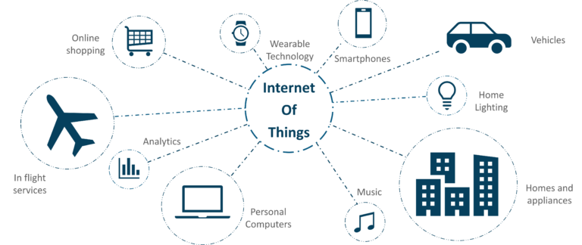

Figure 3: Applications of Internet of Things

1.4.1 Connected Health (Digital Health/Tele health/Telemedicine)

IoT packages can turn reactive scientific-primarily based structures into proactive properly-being-primarily based systems. The belongings that present day medical research uses, lack critical real-global statistics. It generally uses leftover statistics, managed environments, and volunteers for medical examination. IoT opens approaches to a sea of valuable facts thru evaluation, actual-time field statistics, and sorting out. The Internet of Things additionally improves the modern-day devices in strength, precision, and availability. IoT makes a uniqueness of developing structures in location of absolutely system. IoT has numerous applications in healthcare, which can be from far off monitoring gadget to boost and smart sensors to system integration. It has the potential to enhance how physicians deliver care and moreover hold patients secure and wholesome. Healthcare IoT can permit patients to spend more time interacting with their doctors, which can boom patient engagement and pleasure. From non-public health sensors to surgical robots, IoT in healthcare brings new equipment updated with the present day era inside the surroundings that enables in developing higher healthcare. IoT permits to revolutionize healthcare and provide pocket-friendly solutions for both the affected man or woman and healthcare expert. Here’s how an IoT-enabled care device works.

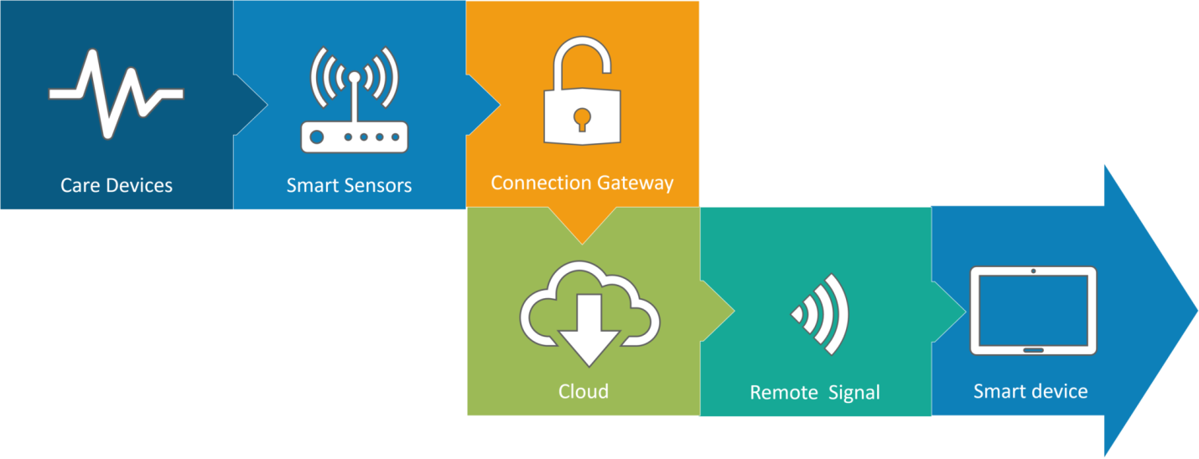
Figure 4: Connected Health

Connected healthcare however remains the sound asleep huge of the Internet of Things programs. The idea of related healthcare system and smart clinical gadgets bears significant functionality now not best for groups, however additionally for the nicely-being of people in well known. Research shows IoT in healthcare is probably huge in coming years. IoT in healthcare is aimed toward empowering human beings to live extra healthful existence with the useful resource of carrying associated devices. The amassed facts will assist in custom designed analysis of a person’s fitness and provide tailor made techniques to fight contamination. The video underneath explains how IoT can revolutionize remedy and clinical help.

1.4.2 Smart City
By now I count on, most of you ought to have heard approximately the time period Smart City. The hypothesis of the optimized traffic machine I referred to earlier is one of the many elements that constitute a smart city.
The detail approximately the clever town concept is that it’s very precise to a metropolis. The problems faced in Mumbai are very super than those in Delhi. The troubles in Hong Kong are particular from New York. Even global problems, like finite smooth ingesting water, deteriorating air pleasant and growing city density, stand up in particular intensities throughout towns. Hence, they've an impact on every city differently. The Government and engineers can use IoT to research the often-complex elements of town making plans specific to every town. The use of IoT applications cans useful resource in areas like water management, waste control, and emergencies.

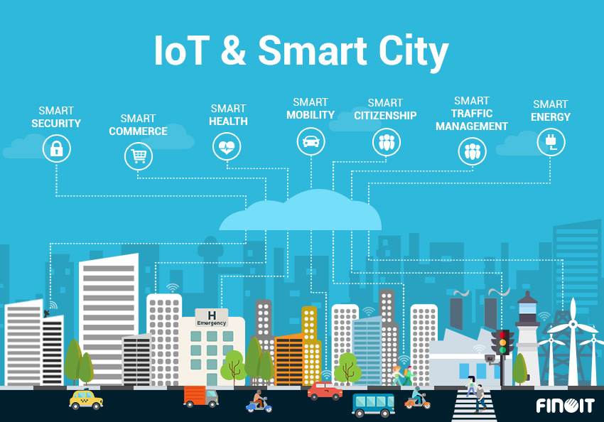
Figure 5: Smart City

Smart city spans an in depth sort of use times, from web page traveler’s control to water distribution, to waste manage, city security and environmental tracking. Its recognition is fueled by way of using the reality that many Smart City solutions promise to relieve actual pains of human beings living in cities nowadays. IoT solutions inside the area of Smart City treatment traffic congestion problems lessen noise and pollution and help make cities safer.

1.4.3 Connected Cars

Connected automobile era is a giant and an in depth network of multiple sensors, antennas, embedded software program, and technology that help in verbal exchange to navigate in our complex global. It has the duty of making alternatives with consistency, accuracy, and pace. It additionally need to be reliable. These requirements turns into even extra vital at the identical time as humans surrender in reality they manage of the steerage wheel and brakes to the impartial or automated automobiles which can be being successfully tested on our highways right now.

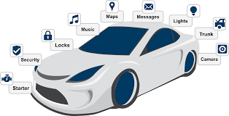
Figure 6: Connected Cars

The linked automobile is coming up slowly. Owing to the truth that the development cycles inside the automobile business enterprise generally take 2-4 years, we haven’t seen lots buzz across the associated car but. But it appears we've end up there. Most big automobile makers in addition to some brave startups are going for walks on related automobile answers. And if the BMWs and Fords of this worldwide don’t gift the subsequent technology internet connected vehicle speedy, exceptional famous giants will: Google, Microsoft, and Apple have all added related car systems.

1.4.4 Smart Home

With IoT growing the excitement, ‘Smart Home’ is the maximum searched IoT related feature on Google. But, what is a Smart Home?
Wouldn’t you like if you may activate air conditioning earlier than accomplishing domestic or transfer off lighting even after you have left domestic? Or free up the doorways to friends for brief access even as you are not at home. Don’t be surprised with IoT taking form agencies are building merchandise to make your lifestyles much less complicated and convenient. Smart Home has turn out to be the modern ladder of fulfillment within the residential spaces and it's far expected Smart houses turns into as not unusual as smart phones. The charge of proudly owning a residence is the biggest cost in a residence owner’s lifestyles. Smart Home merchandise are promised to save time, electricity and cash. With Smart domestic companies like Nest, Ecobee, Ring and August, to call a few, turns into own family brands and are planning to supply a never seen in advance than revel in.

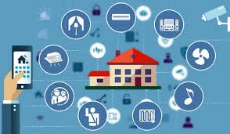
Figure 7: Smart Home

Smart as the best Internet of Things utility across all media, home actually stands tall. Currently, over 60,000 people look for "smart home" online every month. This is not unexpected. There are 256 businesses and startups in the Smart Home organization database from IoT Analytics. In the realm of IoT, smart home firms outnumber software companies in activity. Over $2.5 billion has been invested in Smart Home businesses overall. This list of incredible startup names includes Nest and Alert Me, which are comparable to several large corporations like Philips, Haier, and Belkin.

1.4.5 Smart Farming

Smart farming is a regularly neglected IoT software program. However, because of the truth the wide type of farming operations is generally far off and the big quantity of farm animals that farmer’s paintings on, all of this could be monitored with the aid of the Internet of Things and also can revolutionize the manner farmer’s paintings. But this idea is yet to reach a huge-scale interest. Nevertheless, it however remains to be one of the IoT packages that have to now not be underestimated. Smart farming has the capacity to emerge as an essential software area especially within the agricultural-product exporting international locations. Statistics estimate the ever-developing worldwide populace to gain nearly 10 billion by way of using the twelve months 2050. To feed this sort of massive population one desires to marry agriculture to generation and gain first-rate consequences. There are several possibilities on this place. One of them is the Smart Greenhouse.

A greenhouse farming approach enhances the yield of flora via controlling environmental parameters. However, manual dealing with consequences in manufacturing loss, energy loss, and labor cost, making the way less effective. A greenhouse with embedded devices now not best makes it easier to be monitored however additionally, enables us to control the weather indoors it. Sensors measure different parameters consistent with the plant requirement and send it to the cloud. It, then, techniques the statistics and applies manipulate movement.

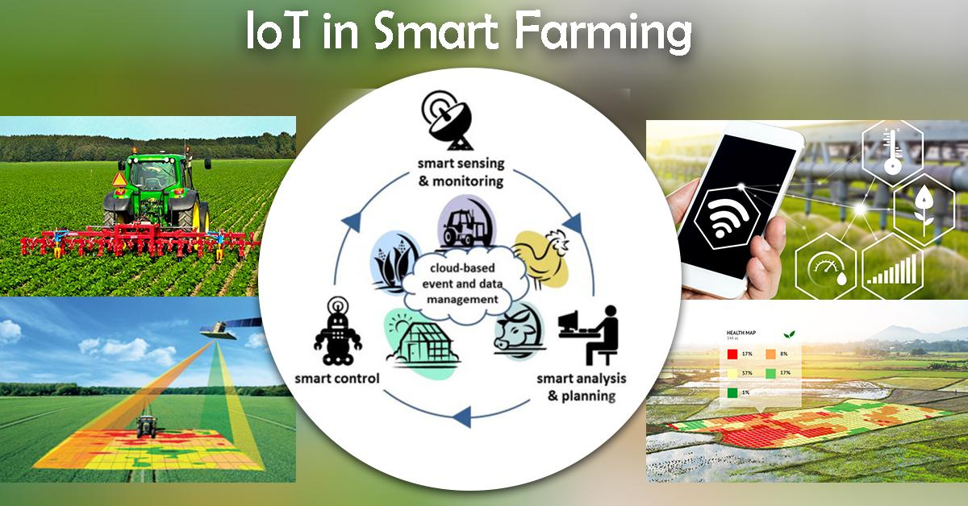
Figure 8: Smart Farming

1.4.6 Smart Retail

The ability of IoT in the retail sector is sizeable. IoT presents an opportunity to outlets to connect to the clients to enhance the in-keep experience. Smart phones may be the way for shops to live connected with their customers even out of keep. Interacting through Smart phones and the use of Beacon generation can help shops serve their customers better? They also can track client’s direction via a store and beautify hold layout and area premium products in immoderate traffic areas.

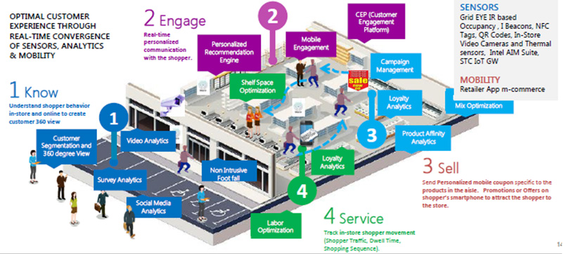
Figure 9: Smart Retail

Today, retail shops are continuously specializing in leveraging the growing generation like cloud, cell, RFID, beacons, etc., to provide related retail services and higher purchasing experience to clients. For example, store proprietors are integrating sensors in the key zones of retail stores and connecting them to cloud thru a gateway that permits actual-time data evaluation related to products, income, and clients from the ones sensors. Interestingly, IoT in retail and associated era are taking the retail enterprise via hurricane. Ninety six% outlets are prepared to make adjustments required to implement the Internet of Things in their shops.

1.4.7 Smart Supply Chain

Every day there are millions of products that want to be shipped, tracked and accounted for by way of vans, ships and those. Connecting the ones items, belongings and people inside the supply chain through IoT creates efficiencies and streamlines tactics saving businesses time & loads of hundreds of bucks a twelve months. IoT gadgets have the ability to impact all elements of the deliver chain, consisting of warehouse manager, transportation and logistics, and last mile transport to the give up client. Manufacturers can force operational overall performance, reduce robbery and counterfeit, and deliver wonderful customer support with the aid of performing on the records coming from the IoT devices in their deliver chain Supply chains have already been getting smarter for a couple of years. Offering solutions to problems like monitoring of merchandise at the identical time as they may be on the street or in transit, or helping carriers exchange inventory information are some of the well-known services. With an IoT enabled device, production facility device that consists of embedded sensors talk statistics approximately first rate parameters which encompass stress, temperature, and utilization of the device. The IoT device also can approach workflow and alternate device settings to optimize normal performance.

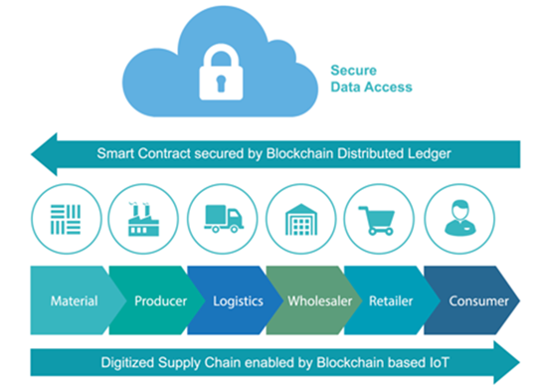
Figure 10: Smart Supply Chain

  - Internet of Things (IOT) Security
Internet of Things (IoT) safety breaches has been dominating the headlines currently. WikiLeaks’s trove of CIA files determined that net-related televisions can be used to secretly report conversations. Trump’s guide Kellyanne Conway believes that microwave ovens can spy on you—possibly she became regarding microwave cameras which definitely can be used for surveillance. And don’t delude yourself which you are proof against IoT attacks, with 96% of safety specialists responding to a brand new survey watching for an increase in IoT breaches this year.
Even if you individually don’t suffer the consequences of the sub-par safety of the IoT, your associated gadgets can be unwittingly cooperating with criminals. Last October, Internet service employer got here below an assault that disrupted get proper of access to famous web sites. The cybercriminals who initiated the attack controlled to commandeer a massive amount of internet-associated gadgets (frequently DVRs and cameras) to characteristic their helpers. As a result, cyber security expert Bruce Schneider has known as for government regulation of the IoT, concluding that every IoT manufacturers and their customers don’t care approximately the safety of the 8.Four billion net-connected devices in modern use. Whether because of authority’s law or actual antique fashion self-hobby, we can anticipate elevated funding in IoT protection technology. In its nowadays-released Tech Radar file for safety and danger specialists, Forrester Research discusses the outlook for the thirteen maximum relevant and vital IoT protection generations; caution that “there is no single, magic safety bullet that would without issues repair all IoT safety issues.”

1.6 Security Challenges Facing IoT

(a) Data Integrity
Billions of gadgets come under the umbrella of an interlinked environment that is connected via IoT. Manipulating even an unmarried statistics point will bring about manipulation of the whole information which is exchanged and shared from side to side from the sensor to the primary server. Decentralized allotted ledger and digital signatures have to be carried out with a view to ensure integrity.
(b) Encryption Capabilities
Data encryption and decryption is a continuous procedure. The IoT network’s sensors still lack the functionality to manner. The brute force attempts may be avoided by means of firewalls and segregating the gadgets into separate networks.

(c) Privacy Issues
IoT is all about the alternate of facts amongst various platforms, gadgets, and clients. The smart devices acquire data for a number of motives, like, improving performance and enjoy, decision making, imparting better service, and so on. Thus, the stop factor of facts will be completely secured and safeguarded.

(d) Common Framework
There is a lack of a commonplace framework and so all the producers ought to manage the security and hold the privations on their very own. Once a common standardized framework is carried out, the character efforts will then together be utilized in an expandable manner and so reusability of code may be done.

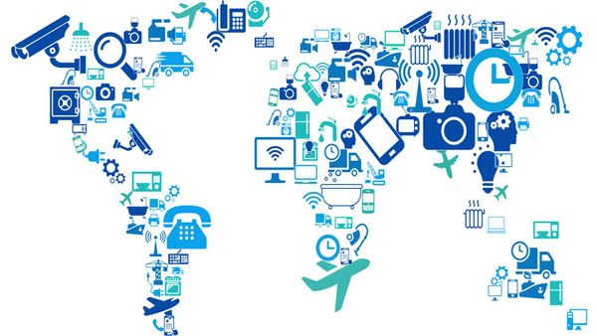

Figure 11: Security Challenges Facing IoT

(e) Automation

Eventually, enterprises will have to deal with more and more number of IoT devices. This enormous amount of user data can be difficult to manage. The fact cannot be denied that it requires a single error or trespassing a single algorithm to bring down the entire infrastructure of the data.

(f) Updations

Overseeing the updating of tens of millions of devices needs to be followed, in turn. It is necessary to manually update the devices because not all of them offer over-the-air updates. It will be necessary to stay up to speed with the latest upgrades and practice the same across all of the different gadgets. This process is going to get more and more intricate over time, and if there are any mistakes made in the method, there will eventually be gaps in the security. Safety Investing in network and infrastructure security has to come first, which isn't necessarily the case at the moment. Using hundreds of thousands of record points is required for IoT, and each point needs to be safeguarded. It is true that multiple layers of security, or security.
1.6.1 How to keep IoT security
While securing your endpoints and unrestricted will depend on what styles of gadgets you have got, there are certain precautions that will help you to cozy any form of IoT gadget or tools.
(a) Use vigorous passwords
Having robust passwords is constantly important, but particularly so for IoT devices. With a susceptible password, taking manipulate of an IoT tool via its very personal interface or internet portal is trivial. What’s even more concerning is that many IoT devices encompass default passwords, which many customers don’t alternate – that means that the attacker may also additionally already understand the password in your tool?
Strong passwords on the relaxation of your community might also even upload a 2nd line of defense if an attacker does benefit get right of entry to thru a tool – preventing or hindering their attempts to get right of access to documents, databases, and other devices. Changing the password to your router to a long and sturdy one is specifically essential, as a compromised router short leaves the entire network inclined.
(b)Network security
Ensure which you have an updated, cozy router, with a firewall enabled. Your router may be the first element of assault – and if your router is compromised it will go away your complete community prone. Installing an endpoint safety solution that allows you to find out vulnerabilities on your network – for example, one with a take a look at characteristic at the side of Avant’s Wi-Fi Inspector - is critical.
(c) Reinforcements
Responsible manufacturers will launch safety updates for his or her IoT gadgets while vulnerabilities are determined. Ensuring your devices are patched frequently with the present day updates is crucial. If you have got got a tool that doesn’t acquire updates, recollect the blessings of the tool closer to the capacity impact for your commercial employer inside the occasion of an attack.
(d)Consider inevitability
As there can be a growing marketplace for IoT devices, manufacturers are eager to pump out big numbers of them, and won't spend lots time developing their product’s safety. While IoT devices may be distinctly useful, don't forget whether or now not your workplace kitchen without a doubt goals that internet-enabled toaster or kettle. While the advantages of latest generation usually appear exciting – specifically for small commercial enterprise owners seeking to store money and boom productivity – it’s important to take time to recognize the risks that include it. IoT devices have the capability to bring performance enhancements to many industries, but steps ought to moreover be taken to make sure they don’t leave your community vulnerable to malicious actors.

1.7 IOT UNIQUENESS SECURITIES

The net and authentic are consolidating. With the Internet of Things (IoT), people and gadgets are step by step associated with the Internet and bodily articles are constantly coordinated into data systems. Machines and robots can stumble on and smash down data, empowering control of the physical world. The IoT will reap many tremendous changes. Be that as it may, these good sized changes clean a direction for brand spanking new difficulties, mainly as for security. The positioned away records includes extremely nitty gritty records about an character, and that offers an inexpensive photo of the individual that consists of insights concerning our economic situations, our wellness, our strict temperaments, and our unforgettable ones; giving the hoodlums all the statistics they must exploit somebody. Personalities may moreover likewise no longer recognize about the diploma of safety; for example, encouragement gadgets may additionally acquire sound and video facts, and offer non-public information. At the point whilst the IoT frameworks fall flat or glitch, they are able to reason good sized damage; private statistics may additionally get leaked The superior cellular telephones that we bring anyplace with us are related to a no. Of devices. We take them to occupied spots, open places and use them typically earlier than outsiders, for any purpose. It's not hard for someone to watch anyone type in their gadget's stick code or mystery phrase and it's the whole lot simple to recollect a security code and take the gadget. On the off risk that the hoodlum is utilizing your Smartphone and your device's information and pass approximately as you on your sake and copies the distinguish which may moreoverstimulate the loss of a lot greater matters-General records handy on the net, joined with web-based social networking facts, further to facts from perception watches, well-being followers and if available knowing meters, keen ice chests and lots more deliver an wonderful all-round concept of your character. Whenever which you installation a report with a username, mystery phrase, and other recognizable information, you're leaving that computerized trail approximately you. Fraud can thus be considered possibly the best danger inside the IoT. Security is fundamental for IoT, particularly as for character. In this way, safety should be deliberate into IoT frameworks from the earliest starting point, no longer devoted later.

1.7 CONCLUSIONS

The IoT background is defenseless to occurrences at every cover. Therefore, there are frequent security intimidations and provisions that need to be transmitted. Current kingdom of revisions in IoT is precisely determined on verification and access controller protocols, however with the quick successful of technology it's miles critical to subordinate new interacting protocols like IPv6 and 5G to reap the modern-day mash up of IoT topology The primary emphasis of this chapter became too highpoint vital protection issues of IoT in particular, focusing the safety assaults and their countermeasures. Due to lack of safety mechanism in IoT devices, many IoT devices grow to be clean targets or even this is not within the sufferer’s knowledge of being infected. In this financial disaster, the security requirements are stated consisting of privacy, integrity, and verification, and lots of others. In this survey, twelve one-of-a-type sorts of attacks are labeled as low-degree attacks, average-stage assaults, extreme-degree attacks, and enormously excessive-degree assaults together with their nature/conduct in addition to recommended solutions to stumble upon the ones attacks are declared. We desire this financial adversity is possibly valuable to investigators inside the defense province by using supporting recognize the number one problems in IoT safety and delivering higher information of the threats and their qualities originating from diverse intruders like establishments and aptitude groups.

REFERENCES

[1] R.Vignesh and 2A.Samydurai ans1 Student, 2Associate Professor Security on Internet of Things (IOT) with Challenges and Countermeasures in 2017 IJEDR five, Issue 1 forty eight, 203-209, 1987.

[3] J.-Y. Lee, W.-C.Lin, and Y.-H. Huang, "A light-weight authentication protocol for internet of things," in Int'l Symposium on Next-Generation Electronics (ISNE), 1-2, 2014.

[4] Y. Xie and D. Wang, "An Item-Level Access Control Framework for Inter-System Security within the Internet of Things," in Applied Mechanics and Materials, 1430-1432, 2014.

[5] B. Anggorojati, P. N. Mahalle, N. R. Prasad, and R. Prasad, "Capability-based totally get entry to control delegation model at the federated IoT community," in Int'l Symposium on Wireless Personal Multimedia Communications (WPMC), 604-608, 2012.

[6] M. Castrucci, A. Neri, F. Caldeira, J. Aubert, D. Khadraoui, M. Aubigny, et al., "Design and implementation of a mediationsystem allowing comfy communication amongst Critical Infrastructures," Int'l Journal of Critical Infrastructure Protection, vol. Five,86-97, 2012.

[7] R. Neisse, G. Steri, and G. Baldini, "Enforcement of security policy guidelines for the net of things," in Int'l Conference on Wireless and Mobile Computing, Networking and Communications (WiMob), one hundred sixty five-172, 2014.

[8] Mirza AbdurRazzaq and Muhammad Ali Qureshi “Security Issues within the Internet of Things (IoT): A Comprehensive Study” by means of (IJACSA) International Journal of Advanced Computer Science and Applications,Vol. Eight, No. 6, 2017.

[9] J. S. Kumar and D. R. Patel, “A survey on internet of factors: Security and privateness issues,” International Journal of Computer Applications,vol. 90, no. 11, 2014.

[10] M. Abomhara and G. M. Køien, “Security and privateness in the net of factors: Current popularity and open problems,” in Privacy and Security in Mobile Systems (PRISMS), International Conference on. IEEE, 2014, pp. 1–eight.

[11] S. Chen, H. Xu, D. Liu, B. Hu, and H. Wang, “A vision of iot: Applications, demanding situations, and opportunities with china angle,”IEEE Internet of Things magazine, vol. 1, no. 4, pp. 349–359, 2014.

[12] L. Atzori, A. Iera, and G. Morabito, “The internet of factors: A survey,”Comput. Netw., vol. Fifty four, no. 15, pp. 2787–2805, Oct 2010.

[13] M. M. Hossain, M. Fotouhi, and R. Hasan, “Towards an analysis of safety troubles, demanding situations, and open issues within the net of things,” in Services (SERVICES), 2015 IEEE World Congress on. IEEE, 2015, pp. 21–28.

[14] L. Da Xu, W. He, and S. Li, “Internet of things in industries: A survey,”IEEE Transactions on industrial informatics, vol. 10, no. 4, pp. 2233–2243, 2014.

[15] L. M. R. Tarouco, L. M. Bertholdo, L. Z. Granville, L. M. R. Arbiza, F. Carbone, M. Marotta, and J. J. C. De Santanna, “Internet of things in healthcare: Interoperatibility and protection issues,” in Communications (ICC), IEEE International Conference on. IEEE, 2012, pp. 6121–6125.

[16] A. Mohan, “Cyber safety for private clinical devices net of factors,” in Distributed Computing in Sensor Systems (DCOSS), 2014 IEEE International Conference on. IEEE, 2014, pp. 372–374.
[17] Mohamed Abomhara and Geir M. Køien” Cyber Security and the Internet of Things: Vulnerabilities, Threats, Intruders and Attacks”.

[18] S. De, P. Barnaghi, M. Bauer, and S. Meissner, “Service modelling for the internet of factors,” in Computer Science and Information Systems (FedCSIS), 2011 Federated Conference on. IEEE, 2011, pp. 949–955.

[19] G. Xiao, J. Guo, L. Xu, and Z. Gong, “User interoperability with heterogeneous iot gadgets through transformation,” 2014.

[20] J. Gubbi, R. Buyya, S. Marusic, and M. Palaniswami, “Internet of factors (iot): A imaginative and prescient, architectural elements, and destiny directions,”Future Generation Computer Systems, vol. 29, no. 7, pp. 1645–1660, 2013.
[21] M. Zorzi, A. Gluhak, S. Lange, and A. Bassi, “From nowadays’s intranet of factors to a destiny net of things: a wi-fi-and mobility-associated view,” Wireless Communications, IEEE, vol. 17, no. 6, pp. Forty four–fifty one,2010.

[22] C. Hongsong, F. Zhongchuan, and Z. Dongyan, “Security and agree with research in m2m machine,” in Vehicular Electronics and Safety (ICVES), 2011 IEEE International Conference on. IEEE, 2011, pp. 286–290.

[23] I. Cha, Y. Shah, A. U. Schmidt, A. Leicher, and M. V. Meyerstein, “Trust in m2 communique,” Vehicular Technology Magazine, IEEE, vol. Four, no. Three, pp. 69–seventy five, 2009.
[24] J. Lopez, R. Roman, and C. Alcaraz, “Analysis of security threats, requirements, technologies and standards in wi-fi sensor networks.

