Present Status, problems and scope of aquaculture
Dr. Debabrata Das¹ and Dr. Pampi Ghosh²
¹Associate Professor and Head, Department of Botany, GGDC Lalgarh, Jhargram, W.B.
²Assistant Professor & Head, Department of Botany, Seva Bharati Mahavidyalaya, Kapgari, Jhargram, W.B.
Abstract:
Aquaculture is a scientific culture of aquatic species including habitat management for the betterment of the environment nay society. According to Britannica it is the propagation and husbandry of aquatic plants, animals, and other organisms for commercial, recreational, and scientific purposes. Aquaculture is an approximate aquatic equivalent to agriculture i.e., the rearing of certain marine and freshwater organisms to supplement the natural supply. This includes production for supplying other aquaculture operations, for providing food and industrial products, for stocking sport fisheries, for supplying aquatic bait animals, for stocking fee-fishing operations, for providing aquatic organisms for ornamental purposes, and for supplying feedstocks to the pharmaceutical and chemical industries.
Many lands are marshy and aquatic that is used for aquaculture naturally by the local inhabitants. On the other hand, lands or habitats artificially created for aquatic organisms are regarded as aqua-environment and the culture of many organisms in this created environment is under such kind. Roof top tank or house ponds are used some special purpose may be used for fish, crab, frog, duck and prawn culture. But in contrary, some people are well aquatinted to cultivate many aquatic plants in addition to fish or similar organisms. These are Nelumbo, Euryale, Nymphaea, Ipomoea, Enhydra, Colocasia, Marsilea, Glenus etc. due to its medicinal properties. Many people cultivate colorful fish for their ornamental value. So, the scope and the status of aquaculture is diverse and its prospects and problems are too diverse that are infinitive. In this article we are trying to discuss some aspects of aquaculture on the basis of their mode of origin in Indian scenario basis.
Keywords: Aquaculture, present status, scopes, problems, prospects and management.
Introduction:
According to literature and understanding in between organizations and faming units it is a technique for breeding, culturing, rearing and raising fish stock, shellfish and or aquatic plant species to make them as commercial product without harming the wild stock. It may be the freshwater or marine organisms for their utmost production in a specific condition after rearing them with technology-based approach. It also refers the technique to the cultivation of aquatic organisms in controlled aquatic environment for any commercial, recreational or public purpose. The habitats chosen may be small tank or pond or large reservoir in which controlling system always in regulatory condition. The overall environment may be designed for a specific purpose. It may be ponds or rivers or lakes even the ocean and man-made closed system based on land. Sometimes, polythene mad container is raised on land and used for fish, crab, prawn, indigenous or colorful foreign fish culture and raring for different aquatic and semiaquatic plants. In this article we are going to discuss some aspects of aquaculture with special reference to prawn and fish culture in a temporary basis field under paddy cultivation as case study.
Present status:
Aquaculture reflects many direct and indirect benefits. It is a menace to production of various plants and animals for commercial value. Not only that it includes the conservation through properly managed propagation of plants and nourishment of animals and their population rise due to required requisite value-based study. Research and extension on aquaculture lead to develop many varieties and many races of species even to summarizes the widely distributed taxa in a local place for productive study and resource management even to solve many problems lead to balance the ecological processes. So, the scope of the aquaculture leads to qualify the following points:
- Biomass production for human consumption and bioresource management in a small area basis.
- Habitat management or restoration of vulnerable species.
- Enhancement of population of wild cultivars even wild species over time.
- Mixed production of both plants and animals due to composite culture.
- Manifestation of species conservation mainly threatened and endangered species in ex-situ condition.
- Production of batfish and similar organisms as secondary output.
- Production of biofertilizers and organic manure time to time.
- Production of indigenous fish and carps including crabs for zoos and for aquarium.
- Vegetable and green leafy vegetable production under hydropincs.
- Use of resource both water and biomass for agriculture, horticulture, dairy, pigary, goatary and apiculture purpose.
- Rhizomatous stocks and similar species culture under aquaculture in ribs and in pits.
- Use of secondary outputs and their reuse in production of many spices and condiments.
- Training to students and scholars even extension to the non-trained people for expansion of same over the globe.
Many problems have been raised during the aquaculture in a small or large area under different units. These are given below:
In marine aquaculture, water quality and their management are a critical theme which need special supervision every time. Oceanic species need marine environment but certain species need specific factorial need to grow better or living under specific situation. Example oyster, clams, mussels, shrimps, salmon and marine algae (members of phaeophyta or rhodophyta).
In fresh aquaculture, in foreign countries mainly catfish and trout are cultivated but in our Indian country we see many indigenous fishes under controlled aquaculture field. These are climbing perch (Anabas testudineus), elongate glass-perchlet (Chanda nama), Indian glassy fish (Chnada ranga), walking catfish (Clarius batrachus), banded gourami (Colisa fasciata), dwarf gourami (Colisa lalia), flying barb (Esomus danricus), tank goby (Glossogobius giuris), stinging catfish (Heteropneustes fossilis), Indian tengra (Mystus tengara), stripped dwarf catfish (M. vittatus), bronze featherback (Notopterus notopterus), pabdah catfish (Ompok pabda), rosy barb (Puntius conchonius), spotted sail barb (P. phutunio), olive barb (P. sarana), pool barb (P. sophore), ticto barb (P. ticto), large razorbelly minnow (Salmostoma bacaila) and freshwater garfish (Xenentodon cancila). Now a days hybrid fishes are under the aquaculture and raised for better growth and economic yield. During cultivation other large and big fishes destroy them and make the environment congenial for them. In some cases, grass carp and similar carps destroy weeds that harms the snails and slugs and lead to change the aquatic environment. Therefore, it is urgent need to satisfy the environment to culture proper species in a scientific way. Now a day, freshwater habitats are repeatedly used for paddy cultivation and land leachates change the water quality due to heavy use of chemical fertilizers and chemical pesticides that change to natural environment and change the population of indigenous fish and similar species. Death and disease are the common features associated with this type of environment. Plants species like Ipomoea aquatica, Nymphaea rubra, N. nouchalii, N. pubescens, Nelumbo nucifer and Euryale ferox are unable to grow such water body that inhibit the migratory visitors like some birds and others. So, degradation of natural habitat and loss of species locally cause loss of indigenous fish and similar species including plant species.
Prospects:
Various research papers revealed that there is a tremendous prospect of aquaculture in the forthcoming decades. Routh and Sarkar studied (2022) and opined that India's fisheries and aquaculture sector's growth trajectory. To arrive at the conclusion, a multiple variate regression model has been applied by them. Analysis reveals that the population of vegetarians has decreased, and government investment has increased leads to growth in productivity. However, research also demonstrates that the current administration has no influence because growth has been constant over the last two decade.
Ariyamuthu (2021) opined that climate change’s potential impact in India will hamper the productivity in agriculture. Extreme heat will affect the yield. India’s climate has already begun to overheat. Unusual and unexpected hot weather spells are predicted to occur more frequently and across a broader area. Under 4-degree centigrade rise, the west coast and southern India are expected to change to new, high temperature climate regimes, posing serious agricultural challenges. This would cause to change rainfall pattern, high drought and ground water loss even earthquakes frequently. So, aquaculture and its equivalent are urgently required to fulfil the need of our goal. Not only that there are tremendous scope of research and applications on field to generate more productive crops in aquatic bodies that may be confined or wide.
Case Study :
Case study was taken from coastal West Bengal. Here people use low lying land and inundated land for aquaculture. People collect seeds of different prawns from coastal canal system using fine nylon mess. During May each year in a fresh water low land they cultivate these seeds of prawn and harvest the same during October. So, as a fish meal they use husks and bran of rice and small dusts of coconut cake.
During monsoon some people use small low-lying land as paddy field and planted indigenous stock. In the same site they use different carps including indigenous small fish. Naturally during flowering of rice, pollens get back to water surface and used as fish meal. So, within 4 to 5 months the fish gets maturity as the yield ready for marketing. In the same land they cultivate green vegetables like Marsilea sp., Ipmoea aquatica, Enhydra fluctuens etc. Many water plants and water birds found inside the site. These birds act as biopesticides. In the same site nocturnal birds like owls, owlets and thick knees are available. Some people use ducks inside the aquaculture field and in the same field small snails are used for the feed of the duck. Therefore, it is said to be a autogenerated aquaculture in in-situ sites as the indigenous people use the same technique from their forefather. This preserves the techniques and conserves the bioresources.
Management:
Aquaculture provides many aspects to develop yield of plants and animals. Not only it provides culture in aquatic condition but it involves partially culture at aqua-environment and other parts at semi or dry situations. A large group of algae, weeds, fishes may be obtained from aquaculture or watery condition. The rest of the part up to drying or processing may be made at the convenient condition under machine or under the sun shine in open dry situations. Dry fish meal, algal biomass, bio-compost from aquatic weeds may be used largely and that could be used in a further way to process the fine products. Agricultural species, horticultural species, crop varieties and trend may differ from situations to situations but the need is prior importance to get the ultimate yield. Water lilies, makhanas, lotus, water chestnut, Schoenoplectiella etc. may be used along with other aquatic fishes in a natural habitat for better result. Roof top harvesting in a small tank may be incorporated in all houses to cultivate carps and indigenous fish including water hyacinth or water chest nut.
Conclusion:
Aquaculture is a prehistoric culture though technology-based approach is used now-a -day to get more benefit and zero emission of green-house gases in nature. The design and infrastructure used by farmers in a big scale are required and transfer of yield from field to sink site is urgent need. Indigenous people and local people till date using local technique though the output is same but productivity is different. In many areas people planted green and leafy vegetables inn their garden and commonly incorporated duckery, fishery, goatery, dairy, piggery, osteoculture, aviary and apiary to get productivity-based income. In low lying land, people use indigenous varieties of rice that can tolerate flood, stress of brine water and stress of different kinds. In such case, the output of yield and productivity is low but due to resistant wild type the genotypes are used as recurrent gene widely used by them. One hand it protects the natural calamities and other hand their products are used by local people as feed for small fishes and water birds in aqua-pond. The production of organic manure, yield of plant products, valuable medicinal plants make them resistant against hostile situations that can grow in same field. The biodiversity conservation and species proposition take place in the same site while the technique is too old. New technology and new hybrid stocks are introduced by scientists globally and research and extension work are going on continuously. Training and management also providing by the Govt. time to time to get more benefit from such culture. Various agencies and universities also working on many species to culture individually for fortification everywhere. Hope that very soon every sector will initiate the technique individually for specific setup. Believe or not, it's our duty is to promote the aquaculture technique among the people in every corner of the country to get easily available vegetable and non-veg products.
Figures:
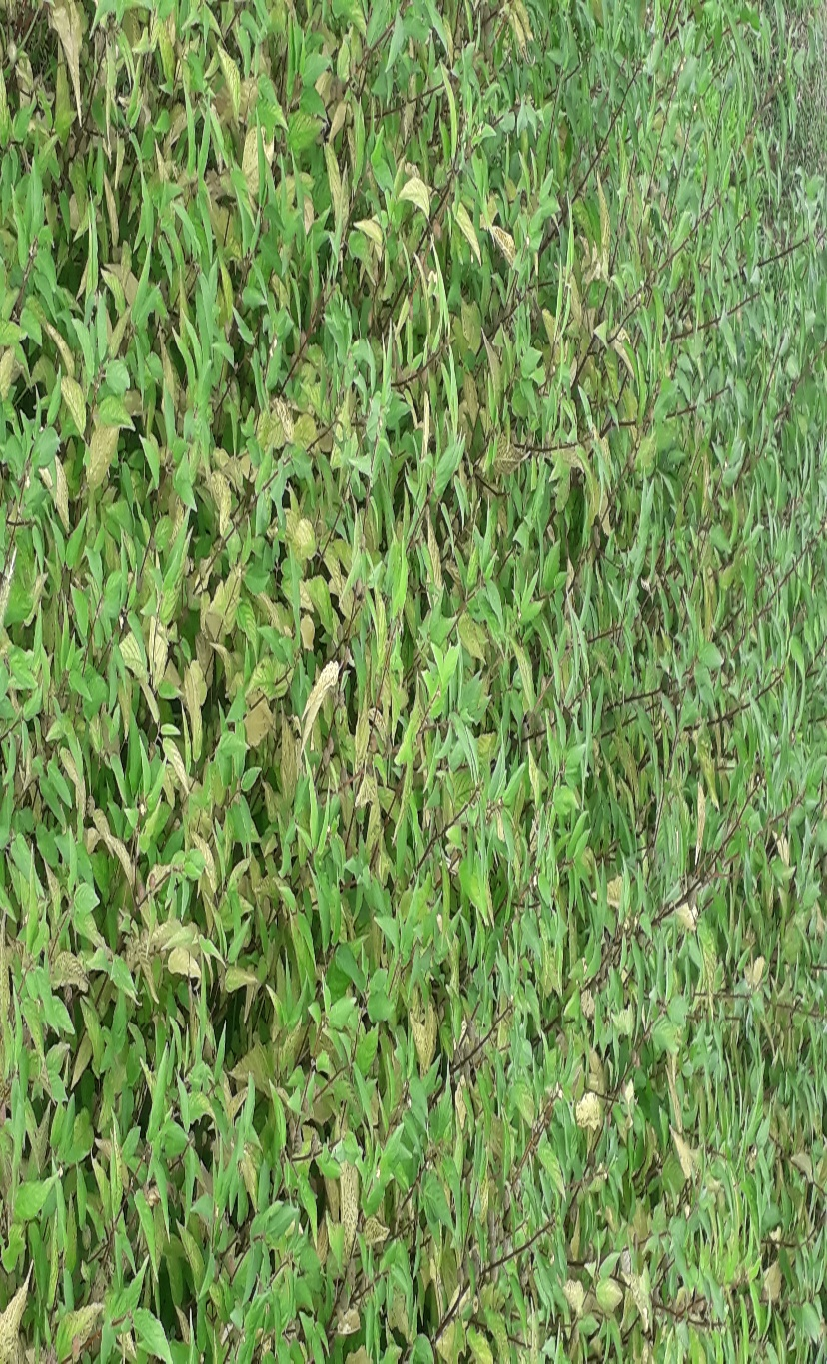
Fig. 1 Green vegetable (Corchorus sp.) in aquaculture field.
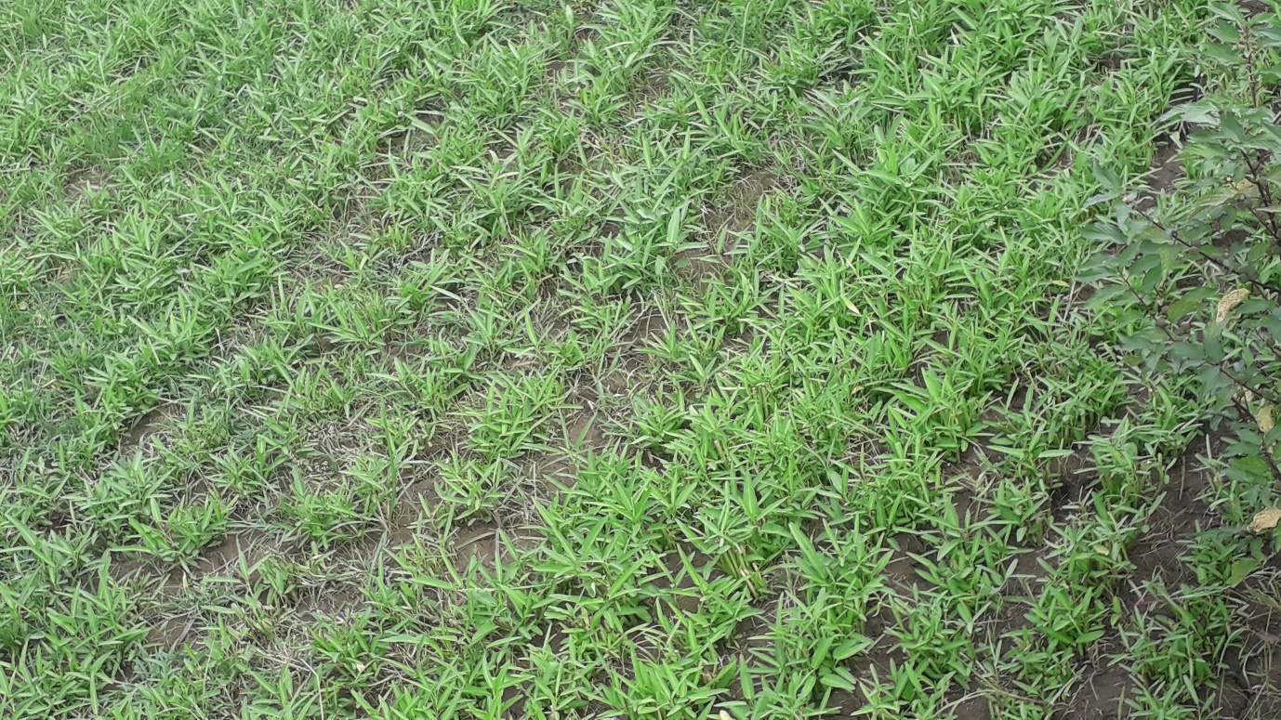
Fig. 2 Aquaculture and green leafy vegetable (Ipomoea aquatica) cultivation on the land.
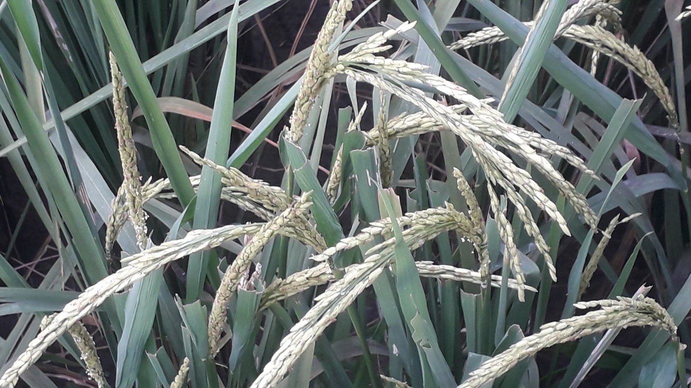
Fig. 3 Cultivation of flood tolerant paddy (flood resistant long rice variety) in inundated flood plain in coastal area of West Bengal.

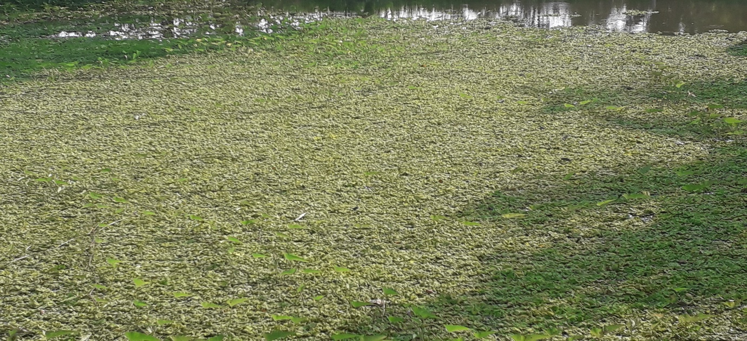
Fig. 4 Aquaculture in a small pond (freshwater) for indigenous fish and green vegetable culture, Same site used to grow water plant to prepare organic manure.

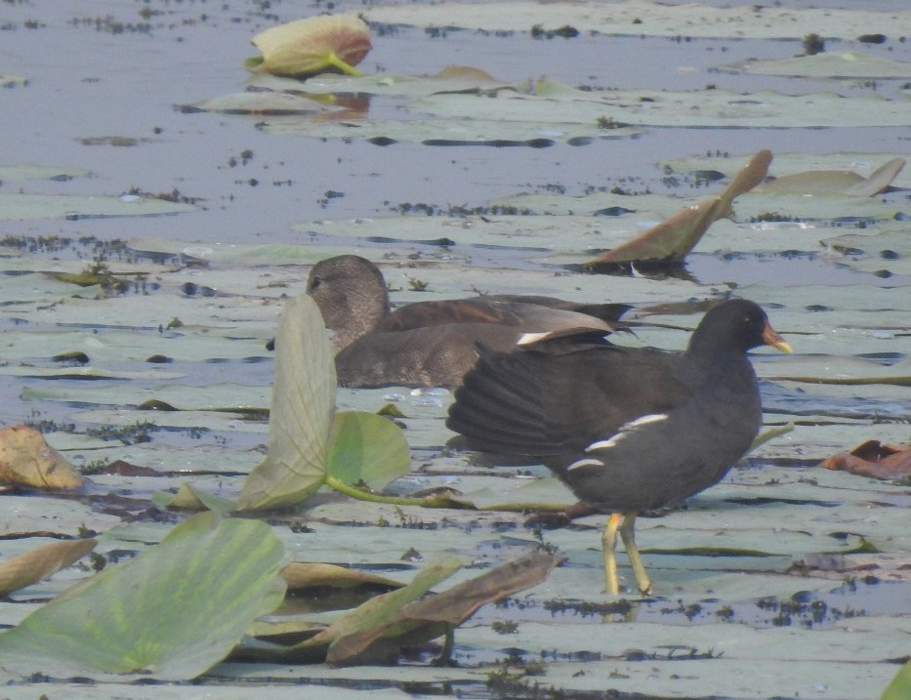
Fig. 5 Aquaculture habitat: A composite pool for aquatic birds, water lotus, aquatic animals including fishes
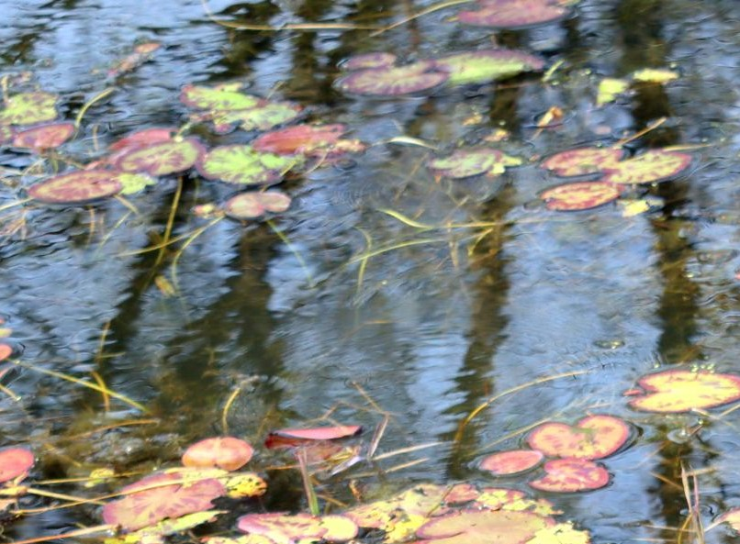
Fig. 6 Aquaculture tank with water plant (Nymphoides sp.) along with green algae for fish culture.
Acknowledgements:
We acknowledge local people and experts of BSI and ZSI, Govt. of India for their help. Principal, SBM, Kapgari, Jhargram and OIC, GGDC Lalgarh, Jhargram are well acknowledged.

References:
- Ariyamuthu, R. 2021. Climate Change-Global warming-Indian Scenario, In: Environment and Development (An Integrated Approach), eds. Das, D; Ghosh, P; Maheswari, G and De, J K, ISBN: 978-93-90847-17-4, pp. 126-138. Kripa Drishti Publications, Pune.
- CSIR India. 1962. Fish and Fisheries, Vol. IV, p132.
- Froehlich, H.E., Gentry, R.R. & Halpern, B.S. 2018. Global change in marine aquaculture production potential under climate change. Nature Ecology & Evolution, 2: 1745–1750.
- Hoq, E. 2006. Bangladesher Chhoto Mach, published by Graphic Sign, 8 GKMC Shah Road, Chhoto Bazar, Mymensingh 2200. P. 20.
- Kiefer, D.A., Rensel, J.E., O'Brien, F.J., Fredriksson, D.W., & Irish, J. (2011). NOAA Marine Aquaculture Initiative Program. Final Report. NOAA Award #NA08OAR4170859, Washington, DC. 181.
- Prain, D. 1963. Bengal Plants, Vol. I & II, Bishen Singh and Mahendra Pal Singh, Dehradun.
- Rahman, AKA. 2005. Freshwater Fishes of Bangladesh, 2nd Edition, Zoological Society of Bangladesh, Department of Zoology, University of Dhaka, Dhaka-1000, pp. 1-263.
- Routh, B and Sarkar, S. 2022. Indian Fisheries and Aquaculture Growth trend: An Economic Analysis, Quest Journal of Research in Agriculture and Animal Science, 9(9): 6-11.
- Troell, M; Kautsky, N; Beveridge, M; Henriksson, PJG; Primavera, J; Ronnback, P; Folke, C and Jonell, M. 2017. Aquaculture, In: Reference Module in Life Sciences, Elsevier, doi.: 10.1016/B978-0-12-809633-8.02007-0
- Vikas, P.A and Subramannian, S. 2023. Multistakeholder partnership in implementing cage fish culture as a livelihood venture for rural youth: A case study in Kerala State, south India, Indian J. Fish, 70(4): 173-177.
- WWW: Britannica: https://www.britannica.com/topic/aquaculture

