Alkaptonuria, a black urine disease, is an extremely uncommon genetic condition

Souvik Ganguly¹, Souvik Chattaraj¹, Sriparna Maity^{1#}, Riya Sarkar^{1*}
¹Department of BMLT, Dr. B. C .Roy Academy of Professional Courses, Formally known as Dr. B.C. Roy Engineering College, Durgapur, Pin-713206, West Bengal, India

#Corresponding author:
Sriparna Maity
Assistant Professor
Department of BMLT, Dr. B. C. Roy Academy of Professional Courses, Durgapur, Pin-713206, West Bengal, India
Email: sri.maity93@gmail.com
Phone: +91 8145623170

*Corresponding author:
Dr. Riya Sarkar
Assistant Professor
Department of BMLT, Dr. B. C. Roy Academy of Professional Courses, Durgapur, India, West Bengal, Pin-713206
Email: rsriyasarkar01@gmail.com/ riya.sarkar@bcrec.ac.in
Phone: +91 8250467900

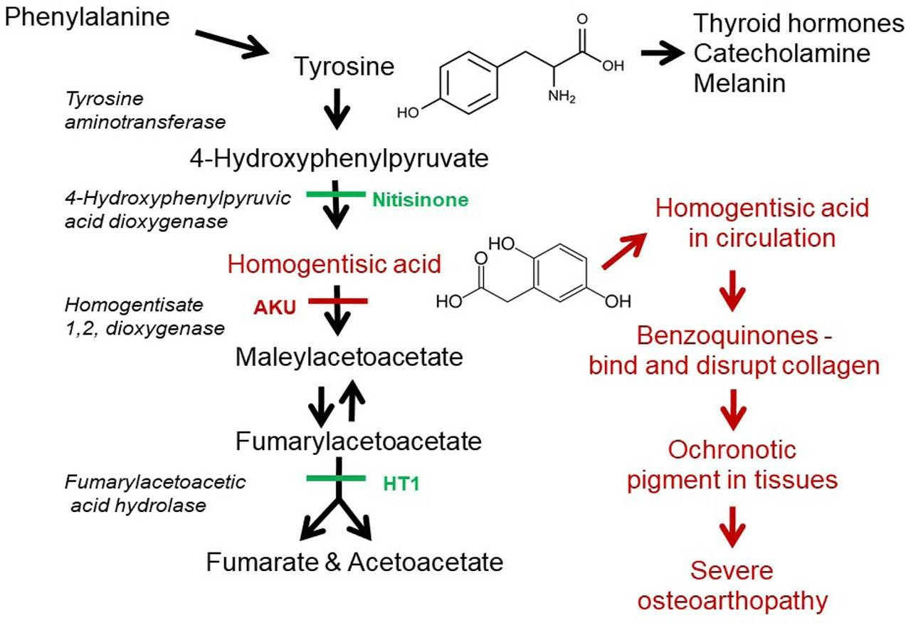
Graphical abstract:

Figure 1: Mechanism of Alkaptonuria

Abstract:
Osteoarthritis (OA) is one of the major causes of disability and pain worldwide, yet despite a massive international research effort, no effective disease-modifying drugs have been identified to date. In this study, we put forward the proposition that greater focus on rarer forms of OA could lead to a better understanding of the pathogenesis of more common OA. We have investigated the severe osteoarthropathy of the ultra-rare disease alkaptonuria (AKU). In addition to the progress made in finding a treatment for AKU, our research has revealed important lessons for more common OA, including the identification of high-density mineralized protrusions (HDMPs), new pathoanatomical structures which may play an important role in joint destruction and pain in AKU and in OA. AKU is an inherited disorder of tyrosine metabolism, caused by genetic lack of the enzyme homogentisate 1,2 dioxygenase (HGD), which leads to failure to break down homogentisic acid (HGA). While most HGA is excreted over time, some of it is deposited as a pigment in connective tissues, a process described as ochronosis.
Ochronotic pigment alters the mechanical properties of tissues, leading to inevitable joint destruction and frequently to cardiac valve disease. Until recently, there was no effective therapy for AKU, but preclinical studies demonstrated that upstream inhibition of tyrosine metabolism by nitisinone, a drug previously used in hereditary tyrosinemia 1 (HT1), completely prevented ochronosis in AKU mice.
Keywords : Genetic disorder, Homogentisate 1,2-dioxygenase deficiency, Homogentisic acid accumulation, Ochronosis, Connective tissue pigmentation, Joint degeneration, Spine degeneration, Urine discoloration.

Introduction:
Alkaptonuria is a rare genetic disorder characterized by the body's inability to break down certain amino acids properly. Specifically, it affects the breakdown of the amino acids phenylalanine and tyrosine, leading to the accumulation of a compound called homogentisic acid in the body. This buildup can cause urine to turn dark when exposed to air and can also lead to various health problems, including joint and connective tissue problems. Alkaptonuria is inherited in an autosomal recessive pattern, meaning that a person must inherit two copies of the defective gene (one from each parent) to develop the condition. Symptoms typically appear in early childhood but can vary widely in severity from person to person (Introne et al., 2003)
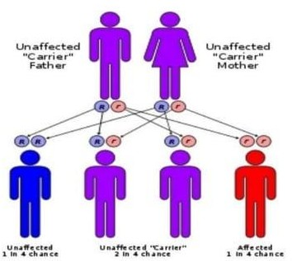
Causes: Alkaptonuria is caused by a deficiency of homogentisic acid oxidase, which results in the build-up of homogentisic acid in the body. This build-up leads to ochronosis, which is characterized by dark-colored urine, ochronotic arthropathy, and darkening of the ear. Other symptoms include arthritis (especially of the spine) that gets worse over time and dark spots on the white of the eye and cornea (Figure 2) (Srsen et al., 2002).

Figure 2: Alkaptonuria Affected by genes

Symptoms:
Symptoms of alkaptonuria include:
- Brown or black spots on the whites of the eyes
- Thickening of ear cartilage that may look blue, grey, or black
- Urine that turns a dark brownish-black color when exposed to air
- Arthropathy of major joints
- Calcification of cartilaginous tissue
- Deterioration of cardiac valves and etc (Keller et a.,

Signs:

Some signs of alkaptonuria include (Figure 3):
- Darkening of urine: One of the first signs noticed by parents of children with alkaptonuria. Urine may darken when standing for a long time or appear as dark stains on diapers.
- Ochronosis: A thickening of ear cartilage that may appear blue, gray, or black. Many adults with alkaptonuria have this sign.
- Brown or black spots on the whites of the eyes: A symptom of alkaptonuria.
- Arthritis: Arthritis, especially in the spine, that worsens over time etc. (Olive & Alnajar, 2019)

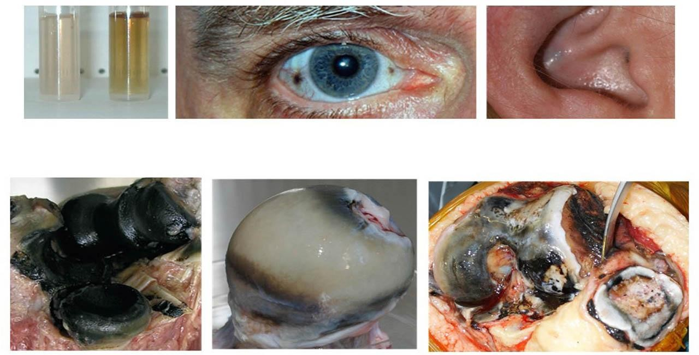

Figure 3: Signs of Alkaptonuria

Complications:

Long-term accumulation of HGA frequently leads to other comorbidities, the most common of which is osteoarthritis. This affects the joints, causing them to lose their protective features and ultimately reduces bone density and strength.

Secondary Amyloidosis is another possibility that may affect those with AKU later in life. HGA depositions in the blood vessels, heart wall and lungs can cause cardiomyopathy and breathing problems.

The risk of Parkinson’s Disease and Depression may be increased in those receiving treatment for AKU due to faulty tyrosine metabolism, which can affect dopamine synthesis and utilization.

Causes of black urine disease:

Black urine disease is caused by a specific gene mutation to the HGD gene located on chromosome 3. HGD stands for homogentisate 1,2-Dioxygenase, which is the enzyme responsible for the breakdown of HGA. There are more than 100 different mutations on the HGD gene that can cause Alkaptonuria.

In the usual scenario, HGA is broken down with HGD into maleylacetoacetate, which goes on to form fumarate, an intermediate involved in energy and protein metabolism. In AKU, HGD is ineffective, causing HGA to be excreted into urine or to buildup in the system. When oxidized, it is converted to benzoquinone acetic acid, which is responsible for the blue-black discoloration of the bones, joints, skin and eyes, as well as other symptoms and complications (Skinsnes,1948).
Diet for alkaptonuria:
A protein-controlled diet can be useful in reducing the risk of potential side effects when taking nitisinone for alkaptonuria during adulthood. Your doctor or dietitian will assess and advise you about this.
Exercise:
If alkaptonuria causes pain and stiffness, you may think exercise will make your symptoms worse. But regular gentle exercise can actually help by building muscle and strengthening your joints.
Exercise is also good for relieving stress, losing weight and improving your posture, all of which can ease your symptoms.
But avoid exercise that puts additional strain on the joints, such as boxing, football and rugby. Gentle exercise such as yoga and pilates might help in the early stages, while cycling, walking and swimming may be more suitable for advanced alkaptonuria (Taylor et al., 2010).

Treatment & management:
Treatments for alkaptonuria include:
Alkaptonuria Treatment and Management
There is no cure for Alkaptonuria. Researchers are currently looking to develop novel therapeutics that aim to replace HGD or inhibit HGA oxidation. Due to the rarity of the disease, research efforts are slow.
Nitisinone is a drug recently approved to inhibit the enzyme that converts tyrosine to HGA, thus reducing the amount of HGA in the body. It has been shown to lower HGA levels by as much as 95% and improve urine color in people with Alkaptonuria. Nitisinone can cause side effects such as eye inflammation and skin light sensitivity. It may also increase the risk of depression and Parkinson’s disease (Zatkova, 2011).

Other treatment for Alkaptonuria includes:
Low Tyrosine Diet: Reducing the intake of foods that contain tyrosine or phenylalanine (another amino acid that can be converted to tyrosine) can help lower the production of HGA and slow down its accumulation in the body. As tyrosine is found in many foods such as cheese, meat, nuts, and soy, this suggestion may be difficult to follow, although patients usually benefit from restricting protein-heavy foods. No dietary changes have been proven sufficient to prevent bone and cartilage damage in later life (Ranganath et al., 2013).
Antioxidant Supplementation: Taking antioxidant supplements such as Vitamin C, zinc, selenium, and cysteine may help reduce the oxidation of HGA and prevent its deposition in the tissues. However, there is very little research available to support the effectiveness of these supplements.
Symptom Relief: Some with Alkaptonuria require medications to combat transient symptoms associated with the condition, such as over-the-counter painkillers, anti-inflammatories, sleeping pills, and antidepressants.
Joint and Valve Replacement Surgery: For people with severe arthritis and joint damage caused by Alkaptonuria, joint replacement surgery may be an option to restore function and mobility. If amyloidosis develops, patients may go on heart medication and eventually require valve replacement surgery (Davison et al., 2019).

Prognosis:
AKU is not usually a life-threatening disease and those with the condition generally have a normal life expectancy.
The disease may begin to catch up with them during their 40s and 50s, affecting the bones and joints and lowering the quality of life. They may require walking aids at younger ages than most individuals with osteoarthritis and could contract heart or lung comorbidities earlier than most as well (Fisher & Davis, 2004).

Conclusion:
Alkaptonuria is a rare disease that illustrates how a single gene mutation can have profound effects on the body. While not life-threatening, Alkaptonuria can lead to osteoarthritis and other diseases at earlier ages, which can greatly detract from the quality of life. Nitisinone is currently used to treat the condition with great success, alongside dietary changes and symptom management.

References:
Davison, A.S., Norman, B.P., Ross, G.A., Hughes, A.T., Khedr, M., Milan, A.M., Gallagher, J.A., Ranganath, L.R. (2019). Evaluation of the serum metabolome of patients with alkaptonuria before and after two years of treatment with nitisinone using LC-QTOF-MS. Journal of Inherited Metabolic Disease . 48(1), 67-74.
Fisher, A.A., Davis, M.W. (2004). Alkaptonuric ochronosis with aortic valve and joint replacements and femoral fracture: a case report and literature review. Clinical Medicine & Research. 2(4), 209-215.
Introne, W.J., Perry, M., Chen, M., Adam, M.P., Feldman, J., Mirzaa, G.M., Pagon R.A., Wallace, S. E., Bean, L.JH., Karen W Gripp K.W., Amemiya, A. (2003). In: Adam MP, Feldman J, Mirza GM, Pagon RA, Wallace SE, Bean LJH, Gripp KW, Amemiya A, editors. University of Washington, Seattle, pp1993–2024
Keller, J.M., Macaulay, W., Nercessian, O.A., Jaffe, I.A. (2005). New developments in ochronosis: review of the literature. Rheumatology International. 25(2), 81-85.
Olive, J.K., Alnajar, A., Gnanashanmugam, S., Lamelas, J. (2019). Transcatheter Aortic Valve Replacement for Alkaptonuria-Associated Aortic Stenosis. The Annals of Thoracic Surger. 108(6), 377-379.
Ranganath, L.R., Jarvis, J.C., Gallagher, J.A. (2013). Recent advances in management of alkaptonuria (invited review; best practice article). Journal of Clinical Pathology. 66(5), 367-373.

Skinsnes, O.K.(1948). Generalized ochronosis; report of an instance in which it was misdiagnosed as melanosarcoma, with resultant enucleation of an eye. Archives of pathology (Chic)
. 45(4), 552-558.
Srsen, S., Muller, C.R., Fregin, A., Srsnovak. (2002). Alcaptonuria in Slovakia; 32 years of research on phenotype & geno type. Molecular Genetics and Metabolism Reports. 75(4), 353-359.
Taylor, A.M., Wilson, P.J., Ingrams, D.R., Helliwell, T.R., Gallagher, J.A., Ranganath, L.R. (2010). Calculi and intracellular ochronosis in the submandibular tissues from a patient with alkaptonuria. Journal of Clinical Pathology.63(2), 186-8.
Zatkova, A. (2011). An update on molecular genetics of Alkaptonuria (AKU). Journal of inherited metabolic disease. 34(6), 1127-1136.

