Forecasting Dogecoin Price Changes with Artificial Neural Networks

¹ Tharmalingam Gunasekar,
Department of Mathematics,
Vel Tech Rangarajan Dr. Sagunthala R&D Institute of Science and Technology,
Chennai, Tamil Nadu, India.
tguna84@gmail.com.

³ S.C.Premila,
Department of Mathematics,
Saveetha Engineering College, (Autonomous) Thandalam, Chennai, Tamil Nadu, India.
premilac@saveetha.ac.in

⁵ S. Sumaiya Banu,
Department of Mathematics,
Vel Tech Rangarajan Dr. Sagunthala R&D Institute of Science and Technology,
Chennai, Tamil Nadu, India.
sumaiyabanu279@gmail.com
.
.
² Charles Sagayaraj A C,
Department of Mathematics Rajalakshmi Engineering College Chennai,
Tamil Nadu, India.
accharlez@gmail.com

⁴ Prabakaran Raghavendran,
Department of Mathematics,
Vel Tech Rangarajan Dr. Sagunthala R&D Institute of Science and Technology,
Chennai, Tamil Nadu, India.
rockypraba55@gmail.com

ABSTRACT
This study delves into the increasing demand from investors, traders, and governmental bodies for precise predictions of Dogecoin prices. Being a trailblazing cryptocurrency, Dogecoin has garnered attention, partly due to its assurance of liberation from centralized governmental oversight. Our approach utilizes state-of-the-art artificial neural networks (ANN) to forecast Dogecoin prices. The pivotal advantage lies in the adaptability of these networks to grasp the dynamic and frequently erratic patterns inherent in cryptocurrency markets. To refine forecast accuracy and promptness, we explore various lag configurations within defined time intervals, showcasing the model's efficacy through resultant outcomes. Our predictions undergo rigorous validation, with a primary focus on evaluating the root mean square error as a critical performance measure. Remarkably, the outcomes derived from our proposed artificial neural network model consistently outshine traditional prediction methods, offering invaluable insights for individuals, industries, and governmental entities navigating the intricate realm of cryptocurrencies.

Keywords— Artificial Neural Network, Dogecoin Price, Prediction Model, Optimal Lag

INTRODUCTION

In recent years, the cryptocurrency market has undergone a notable transformation, evolving into a dynamic and lucrative arena that captivates investors, researchers, and enthusiasts alike. Given its inherent volatility and complexity, robust forecasting methodologies are imperative for guiding investment decisions effectively. Artificial Neural Networks (ANNs) have emerged as potent tools for predicting cryptocurrency prices, harnessing their ability to discern intricate patterns within data. This study delves into the application of artificial neural networks, building upon a substantial body of research dedicated to financial forecasting.
Dogecoin, as a trailblazing cryptocurrency, has emerged as a central focus in financial forecasting due to its significant influence and market dominance. As the pioneer decentralized digital currency, Dogecoin has garnered global attention and sparked widespread interest among investors, traders, and researchers. Its decentralized architecture, limited supply, and underlying blockchain technology have contributed to unparalleled volatility and price fluctuations, presenting both challenges and opportunities for forecasters.
A comprehensive survey conducted by Charandabi and Kamyar [3] offers an extensive overview of literature pertaining to predicting cryptocurrency price indices using Artificial Neural Networks, emphasizing their prevalence and significance in this domain. Furthermore, Struga and Qirici [4] delve specifically into Dogecoin price prediction utilizing neural networks, enriching our understanding of the applicability of these models to individual cryptocurrencies.
Building upon prior research, this study extends its scope to encompass the broader realm of time series prediction. Wang et al. [5] introduce a novel approach that combines singular spectrum analysis with support vector machine regression to forecast failure time series, introducing an additional dimension to the explored methodologies.
Additionally, pioneering work by Kiran and Ravi [6] in software reliability prediction employing soft computing techniques, along with influential contributions by Haykin [7] on neural networks, lays the theoretical groundwork for the application of artificial neural network methodologies. Lakshmanan and Ramasamy [8] make a significant contribution by implementing an artificial neural-network-based approach to model software reliability growth, highlighting the versatility of artificial neural networks across various domains.
Furthermore, Haykin's enduring contributions to the field of Neural Networks [9] serve as a comprehensive reference for understanding the underlying principles and applications. Finally, Dhiman and Kumar [10] propose an innovative approach utilizing the Spotted Hyena Optimizer to tackle complex engineering problems, showcasing the dynamic and evolving landscape of optimization techniques.
In 2023, Almeida and Gonçalves [11] conduct a systematic literature review on investor behavior within cryptocurrency markets, providing valuable insights into this dynamic area. Additionally, Zheng et al. [12] analyze the relationship between cryptocurrency transaction behavior and electricity consumption in 2023, shedding light on the environmental implications of cryptocurrencies. Filippou, Rapach, and Thimsen's [13] research in the same year employs machine learning to explore the predictability of cryptocurrency returns, offering valuable insights for investors and financial analysts.
This study aims to synthesize and extend the current body of knowledge on Dogecoin prediction, leveraging the collective insights of these diverse methodologies. By harnessing the adaptability and learning capabilities of artificial neural networks, our objective is to contribute to the ongoing discourse on effective forecasting strategies in this dynamic and evolving market.

METHODOLOGY FOR PROPOSED MODEL

Artificial neural networks, also referred to as connectionist systems, are computational models inspired by the biological neural networks present in human physiology, albeit not exact replicas. In contrast to rule-based programming, these networks acquire knowledge from examples, with the goal of producing an output pattern corresponding to an input pattern. Their unique characteristic resides in their parallel and distributed structure, comprising numerous units known as neurons, and their interconnectedness [9].
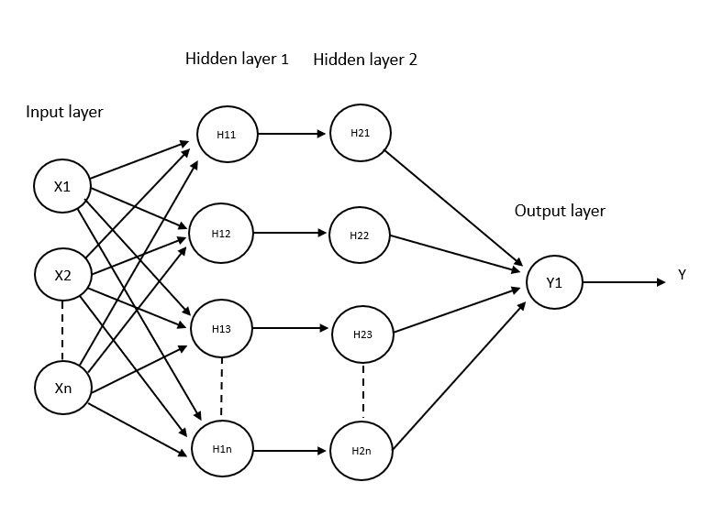
Fig. 1. Design of the Artificial Neural Network Structure

We utilize the back-propagation learning method, which involves propagating the error signal backward through the network. This iterative process entails refining and adjusting the network's weights to enhance its effectiveness until it achieves the desired outputs [8].

The steps involved in developing the artificial neural network model for our prediction are as follows:
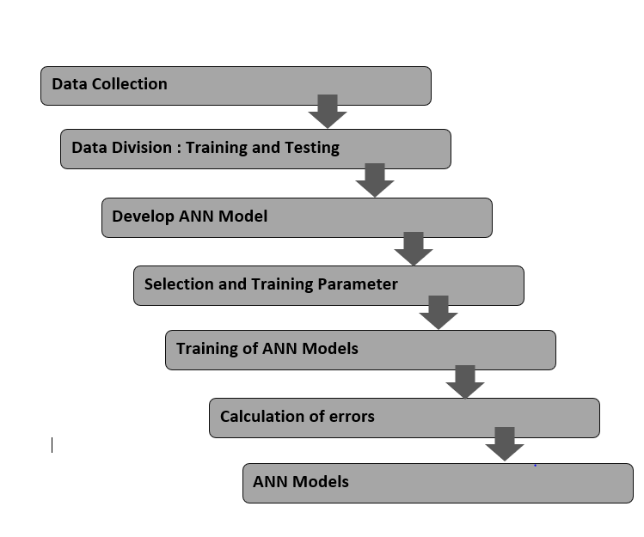
Fig. 2. Diagram of Model Development

In the proposed model, our focus lies on a single dependent variable: the closing price of Dogecoin. Since this variable represents a time series, we have followed a traditional time series forecasting model for our experiments, outlined as follows [10]:
$K_{t}=h(x^{'})$
The set $\left\{x_{t-1},x_{t-2},…,x_{t-p}\right\}$represents a series of delayed variables, illustrated in Figure 1 as the input parameters. The primary objective is to approximate the function [10]. This approximation is achieved through an iterative process that includes modifying the weights during the modeling process. The visual representation of the suggested model can be located in Figure 2.

To clarify the development of our proposed predictive model, we've segmented the process into four distinct phases:
(a) Data Collection: We gathered Dogecoin price data from investing.com, spanning a period of 4 years, totaling approximately 2500 records. Specifically, we collected data on the open, high, and low prices of Dogecoin.

(b) Data Normalization: Prior to commencing the training process, we conducted data normalization. The closing price was scaled to fit within the range of [0.01, 0.05] using the following equation:
$$A^{'}=\frac{l-Min}{Max-Min}\left(m-n\right)+n$$

In this context, $A'$ stands for the normalized value, $l$ denotes the value undergoing normalization, $min$ signifies the minimum value within the series subject to normalization, $max$ represents the maximum value within the series being normalized, $n$ indicates the minimum value of the target range, and $m$ signifies the maximum value of the target range [10].

(c) Activation Function: The activation function, also known as the transfer function, establishes the relationship between input nodes and output nodes in a neural network. In our model, we utilized the sigmoid function, defined as:

$$h(x)=\frac{1}{1+e^{-x}}$$

(d) The training process of a neural network is a intricate task, involving a sophisticated form of unconstrained nonlinear optimization. It entails continuously adjusting the network's weights to minimize the mean squared error between the intended and observed output values for all input patterns. To accomplish this, we utilized the Back-Propagation (BP) algorithm, which employs the steepest descent gradient approach. This algorithm was applied to train the model and minimize errors. The error function, denoted as E, is defined as:

$$E=\frac{1}{2N}\sum_{l=1}^{n}{{(k_{l}-{k_{l}}^{d})}^{2}}$$
In this context, $k_{l}$ represents the network's output, while ${k_{l}}^{d}$ stands for the desired output for the $l^{th}$ input pattern. We employ the steepest descent gradient methodology, and the partial derivatives are calculated using the chain rule. The updated rules for adjusting the weights and biases of this model are determined using the following equations:

$${w_{j}}^{new}={w_{j}}^{old}+ ∆w_{j}$$
$${g_{j}}^{new}={g_{j}}^{old}+ ∆g_{j}$$
Where $∆w_{j}=-ζ\frac{dE}{dw_{j}}$
$$=-ζ\frac{1}{n}\sum_{l=1}^{n}{(\left(k_{l}-{k_{l}}^{d}\right){ k}_{l}(}1-k_{l})\frac{y}{w_{j} x_{j}+g_{j}} x_{j})$$
$$∆b_{j}=-ζ\frac{dE}{db_{j}}$$
$$=-ζ\frac{1}{n}\sum_{l=1}^{n}{(\left(k_{l}-{k_{l}}^{d}\right){ k}_{l}(}1-k_{l})\frac{y}{w_{j} x_{j}+g_{j}} x_{j})$$
Here, $ζ$ serves as the learning parameter, controlling the convergence speed of the model.

RESULTS AND DISCUSSIONS

The proposed model’s assessment focuses on predicting the price of Dogecoin specifically the closing prices. The effectiveness of the proposed model is assessed using the Root Mean Square Error (RMSE) measure, defined in the subsequent manner:
$$RMSE=\sqrt{\frac{1}{n}{\left(k_{j}-\hat{k_{j}}\right)}^{2}}$$
In this equation, $k_{j}$ represents the actual open price, $\hat{k_{j}}$ denotes the predicted price, and $n$ is the total number of observations [10]. This evaluation method offers valuable insights into the model's predictive accuracy for crypto currency prices.

Table 1: The following presents RMSE values associated with various delay (lag) settings.

LAG | RMSE VALUE
2 | 7489.26
3 | 6253.42
4 | 4611.71
5 | 3444.65

The dataset has been partitioned into two sets, with 70% allocated for instructional training and 30% reserved for testing. The training set is utilized to ascertain the most effective lag value for our proposed model. Through a systematic adjustment of the lag value, we extract outcomes and pinpoint the lag value that results in the lowest RMSE values. Table 1 displays the RMSE values corresponding to lag values 2, 3, 4, and 5. Noteworthy is the observation that the RMSE reaches its nadir at a lag value of 4, which subsequently forms the foundation for our prediction.

Fig. 3. Actual and Forecasted Closing Prices Over Time

CONCLUSION

This study highlights the efficacy of artificial neural network models in predicting Dogecoin price trends, particularly in identifying optimal lag configurations. The neural network model demonstrates strong performance in delivering accurate short-term forecasts, providing valuable guidance for investors in their decision-making processes. It's crucial to acknowledge the inherent unpredictability of Dogecoin within cryptocurrency markets, influenced by a myriad of known and unknown factors. While our research primarily concentrates on closing prices, it's apparent that Dogecoin values are influenced by various elements, such as shifts in supply and demand, economic variables, and media-driven events. The adaptability of our approach to evolving price patterns is a significant advantage. In future endeavors, the incorporation of fundamental indicators and market trends into the model shows promise for enhancing its performance and relevance in the dynamic landscape of Dogecoin within cryptocurrency markets.

REFERENCES

- Kang, C.Y., Lee, C.P., & Lim, K.M. (2022). Cryptocurrency Price Prediction with Convolutional Neural Network and Stacked Gated Recurrent Unit. Data, 7(11), 149.
- Biswas, S., Pawar, M., Badole, S., Galande, N., & Rathod, S. (2021, March). Cryptocurrency price prediction using neural networks and deep learning. In 2021 7th international conference on advanced computing and communication systems (ICACCS) (Vol. 1, pp. 408-413). IEEE.
- Charandabi, S.E., & Kamyar, K. (2021). Prediction of cryptocurrency price index using artificial neural networks: a survey of the literature. European Journal of Business and Management Research, 6(6), 17-20.
- Struga, K., & Qirici, O. (2018, November). Dogecoin Price Prediction with Neural Networks. In RTA-CSIT (pp. 41-49).
- Wang, X., Wu, J., Liu, C., Wang, S., & Niu, W. (2016). A hybrid model based on singular spectrum analysis and support vector machines regression for failure time series prediction. Quality and Reliability Engineering International, 32(8), 2717-2738.
- Kiran, N.R., & Ravi, V. (2008). Software reliability prediction by soft computing techniques. Journal of Systems and Software, 81(4), 576-583.
- Haykin, S. (2009). Neural networks and learning machines (3rd ed.). Pearson Education India.
- Lakshmanan, I., & Ramasamy, S. (2015). An artificial neural-network approach to software reliability growth modeling. Procedia Computer Science, 57, 695-702.
- Haykin, S. (1999). Neural Networks. Tom Robbins.
- Dhiman, G., & Kumar, V. (2019). Spotted hyena optimizer for solving complex and non-linear constrained engineering problems. In Harmony Search and Nature Inspired Optimization Algorithms: Theory and Applications, ICHSA 2018 (pp. 857-867). Springer Singapore.
- Almeida, J., & Gonçalves, T. C. (2023). A systematic literature review of investor behavior in the cryptocurrency markets. Journal of Behavioral and Experimental Finance, 100785.
- Zheng, M., Feng, G. F., Zhao, X., & Chang, C. P. (2023). The transaction behavior of cryptocurrency and electricity consumption. Financial Innovation, 9(1), 1-18.
- Filippou, I., Rapach, D., & Thimsen, C. (2023). Cryptocurrency Return Predictability: A Machine-Learning Analysis. In Cryptocurrency Return Predictability: A Machine-Learning Analysis: Filippou, Ilias| uRapach, David| uThimsen, Christoffer. [Sl]: SSRN.

