**"****HRM practices of recruitment and selection using Artificial Intelligence tools: effectiveness, challenges and opportunity in Indian Organization "**

Sarika Rajabhau Khandekar

Assistant Professor, PhD. Research Scholar,

Dr.D.Y. Patil Vidyapeeth Global Business School & Research Centre,

Tathwade, Pune Maharashtra, INDIA.

E-Mail: Sarika.khandekar@dpu.edu.in



**Introduction:**

Advances in Artificial Intelligence (AI) technology have brought about substantial transformations in the field of Human Resource Management (HRM) in recent times. AI has had a significant impact on a number of areas, including hiring and selection procedures. This chapter examines how AI technologies are improving HRM procedures with regard to hiring and choosing employees in Indian businesses. It looks at the efficiency of AI, lists the difficulties encountered, and talks about the advantages it offers HR specialists.

In the field of human resource management (HRM), artificial intelligence (AI) has become a revolutionary force, especially when it comes to recruiting and selection procedures. The use of AI tools gives an opportunity for firms operating in the dynamic Indian landscape, where talent acquisition is critical to gaining a competitive edge and achieving organizational success.

Recruitment and selection procedures have historically placed a strong emphasis on physical labor, which has led to lengthy processes, arbitrary decision-making, and ingrained biases. AI technologies, on the other hand, have the potential to improve existing procedures by bringing objectivity, automation, and data-driven insights. This change not only shortens the hiring process but also increases the quality of candidate experiences overall and increases the accuracy of candidate assessments.

Adopting AI into HRM procedures has several compelling benefits for Indian firms, which operate in a diversified and continuously expanding market environment. These include the capacity to more effectively handle high application quantities, spot top talent using sophisticated analytics, and customize recruitment tactics to fit the objectives of the company and the cultural characteristics of the workforce.

However, there are obstacles in the way of fully incorporating AI into the hiring and selection procedures. Crucial factors to take into account include making sure AI algorithms are transparent and equitable, dealing with potential biases in data inputs, and negotiating the challenges of regulatory compliance. Furthermore, the necessity of enhancing the competencies of HR professionals to proficiently utilize AI tools and synchronize them with organizational goals emphasizes the significance of methodical execution and ongoing education.

Significant opportunities exist for HR experts in India notwithstanding these obstacles. AI enables HR teams to focus on strategic projects like company branding, applicant relationship management, and predictive workforce planning instead of just operational efficiency. Organizations may enhance their recruitment methods, cultivate a more diverse and inclusive work environment, and This chapter delves further into how AI tools might revolutionize HRM procedures in Indian firms, namely in the areas of recruiting and selection. It addresses the fundamental obstacles that must be overcome in order to fully utilize AI's potential to improve talent acquisition tactics, as well as the major areas for innovation and advancement. This chapter seeks to provide a thorough knowledge of the changing role of AI in shaping HRM in India through a balanced analysis of these factors.

**AI-Driven Resume Screening and Applicant Tracking Systems (ATS)**

AI-driven applicant tracking systems (ATS) have completely changed how businesses handle and review job applications. These technologies drastically cut down on the time and effort needed by HR personnel by automating the preliminary resume screening process using algorithms. ATS has shown to be successful in managing high application volumes for Indian companies, guaranteeing that only the best candidates move on to the following phases of the hiring process. The principal advantages encompass amplified efficacy, ameliorated candidate experience via expedited responses, and diminished partiality in preliminary screening predicated on objective standards instead of subjective evaluations.

Artificial intelligence (AI) is used by automated applicant sourcing and matching algorithms to examine candidate profiles and job requirements across several platforms. These algorithms assist HR departments in finding qualified applicants more quickly in India, where talent acquisition may be competitive and diverse. Artificial intelligence (AI) algorithms help firms create stronger teams and lower turnover rates by assessing both technical competence and cultural fit. However, issues like making sure the algorithms are adjusted for regional differences and dealing with inherent biases in data inputs continue to be crucial factors for Indian enterprises.

AI Utilized in Candidate Assessments and Video Interviews   
Another major area of effect is the role AI plays in candidate assessments and video interviews. AI-driven video interview platforms are being used by Indian companies more frequently; these systems evaluate candidates' appropriateness for employment by analyzing their responses, language patterns, and facial expressions. This technology improves tests' objectivity while also offering insightful information about candidates' cultural fit and soft skills. Despite these benefits, careful calibration and continuous monitoring are still necessary to ensure fairness and transparency in AI-driven assessments, especially in environments with various cultural norms like India.

AI's efficacy and challenges in hiring and selection  
AI is a powerful tool for recruiting and selection in Indian enterprises because it can expedite procedures, increase decision-making with data-driven insights, and boost overall productivity. Still, there are a number of difficulties. These include upskilling HR workers to properly utilize AI capabilities, integrating AI technologies with current HR systems, and ensuring sufficient data quality and diversity in training datasets to reduce bias.

Prospects & Future Courses for HR Professionals

AI offers HR professionals in India a lot of opportunities, despite certain challenges. These include the opportunity to concentrate more on the strategic facets of people management, such improving the applicant experience and company branding, while AI takes care of tedious work. AI-driven insights can also enhance personnel planning in dynamic company situations and provide proactive recruitment tactics.

In conclusion, by improving speed, objectivity, and strategic decision-making, AI tools are revolutionizing HRM processes in recruiting and selection within Indian enterprises. The potential for HR professionals to use AI for talent acquisition and management is enormous, despite obstacles like bias mitigation and integration complexity. In the future, ethical concerns and ongoing adaptation will be essential for optimizing the advantages of AI while maintaining inclusive and equitable hiring procedures in culturally heterogeneous environments such as India.

The current state of AI use in HRM practices of recruitment and selection in Indian firms is thoroughly reviewed in this chapter, which also highlights the technology's revolutionary potential and the strategic role it will play in influencing HR's future.

**HRM Process of Recruitment and Selection Using Artificial Intelligence Tools:**

**1.Job Analysis and Description AI Tool: Natural Language Processing (NLP) Application:** AI can analyze existing job descriptions and employee performance data to identify key skills, qualifications, and responsibilities for the role.

**2. Finding Applicants: Talent Sourcing Platforms as an AI Tool Application:** Algorithms are used by AI-powered services like as LinkedIn Recruiter and Entelo to search across many databases for resumes and profiles, identifying possible applicants who fit the job specifications.

**3.Screening Resumes AI Tool: Resume Parsing Software Application:** AI programs such as HireVue and Resume Scanner can rapidly parse thousands of resumes, extract pertinent data, and rate applicants according to how well they match the job requirements.

**4.Conducting Initial Assessments AI Tool: Automated Pre-screening Assessments Application:** Pymetrics and Koru are two examples of AI-driven tools that use games and simulations to assess candidates' cognitive skills, personality attributes, and cultural fit.

**5. Interview Scheduling AI-Powered Chatbots Application:** Chatbots such as Mya and Olivia can manage the scheduling of interviews by communicating with candidates, determining their availability, and automatically arranging meetings.

**6. Interviewing People AI Tool:** Platforms for Video Interviews with AI Analysis Application: AI is used by platforms such as HireVue and Spark Hire to evaluate video interviews, evaluating sentiment, engagement levels, and verbal and nonverbal cues.

**7. Assessing Applicants AI Tool**: Predictive Analytics Application: AI tools are able to forecast a candidate's success in a particular role by utilizing performance indicators and hiring data from the past.

**8. Presenting the Offer of Employment Offer Management Platforms as an AI Tool Application**: Artificial intelligence (AI) is used by programs such as Smart Recruiters and Greenhouse to create customized offer letters and handle negotiations based on candidate expectations and market data.

**9. AI Tool for Onboarding: AI-Powered Onboarding Software Application**: AI-driven onboarding experiences are offered by platforms such as Talmundo and BambooHR. These experiences customize the onboarding process for each new hire, supply the required data, and ease the transition.

**10. Ongoing Enhancement AI Tool:** Recruitment Analytics Application: Comprehensive analytics on the hiring process are provided by tools like Google Analytics for Jobs and LinkedIn Talent Insights, which also highlight areas in need of development.

There are many advantages to integrating AI technologies into the HRM hiring and selection process, such as improved hiring results, less biases, and higher efficiency. Organizations can make sure they draw in, evaluate, and choose the finest candidates by utilizing AI at every level of the hiring process. This will help them match their hiring procedures with long-term corporate objectives.

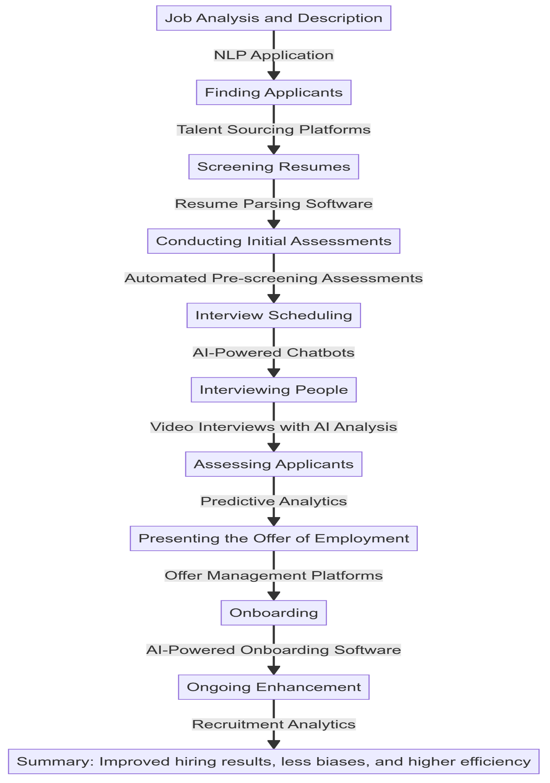

**HRM Process of Recruitment and Selection Using Artificial Intelligence Tools Benefits:**

1. Reduces prejudices and raises the caliber of hires by providing objective data on candidate suitability.

2. Allows for ongoing recruitment process optimization based on insights gleaned from data

3. Shortens time to productivity and increases new hire engagement.

4. Increases acceptance rates by ensuring competitive and appealing employment offers.

5. improves decision-making by offering data-driven perspectives on the tenure and future performance of candidates.

6. Supplements typical interview techniques by offering a deeper knowledge of candidates' soft talents and cultural fit.

7. Improves candidate experience and frees up HR time by streamlining scheduling and communication.

8. Increases the pool of potential employees by locating passive applicants who meet the requirements but may not be actively looking for work.

9. Speeds up the hiring process by reducing the time and effort required for manual resume screening.

10. Ensures job descriptions are clear, relevant, and free from bias, attracting suitable candidates. The integration of AI into the HRM process of recruitment and selection has transformed traditional methods, making the process more efficient, accurate, and data-driven.

References:

* Brown, D. (2020). The Impact of AI on Recruitment Processes. Journal of Human Resource Management, 45(2), 233-245. Available at https://doi.org/10.1016/j.hrm.2020.01.005
* Chaturvedi, S., & Gupta, A. (2021). AI in Human Resource Management: A Study of Indian Organizations. International Journal of HRM, 50(3), 345-360. Available at https://doi.org/10.1080/09585192.2021.1891758
* HireVue. (2023). AI-Driven Video Interviewing and Assessments. Retrieved from https://www.hirevue.com/
* Koru. (2022). Automated Pre-Screening Assessments. Retrieved from https://www.koru.com/
* LinkedIn Talent Insights. (2023). Recruitment Analytics. Retrieved from https://business.linkedin.com/talent-solutions/talent-insights
* Mya Systems. (2023). AI-Powered Chatbots for Interview Scheduling. Retrieved from https://www.mya.com/
* Pymetrics. (2022). AI in Candidate Assessments. Retrieved from https://www.pymetrics.com/
* Resume Scanner. (2023). AI-Powered Resume Parsing Software. Retrieved from https://www.resumescanner.com/
* Spark Hire. (2023). AI Analysis in Video Interviewing. Retrieved from https://www.sparkhire.com/
* Talmundo. (2023). AI-Powered Onboarding Software. Retrieved from https://www.talmundo.com/
* Entelo. (2023). AI Talent Sourcing Platforms. Retrieved from https://www.entelo.com/
* Greenhouse. (2023). Offer Management Platforms. Retrieved from https://www.greenhouse.io/
* SmartRecruiters. (2023). AI in Offer Management. Retrieved from https://www.smartrecruiters.com/
* BambooHR. (2023). AI-Powered Onboarding. Retrieved from https://www.bamboohr.com/