Alkaptonuria, a black urine disease, is an extremely uncommon genetic condition

Manas Mandal¹, Sriparna Maity^{1#}, Riya Sarkar^{1*}
¹Department of BMLT, Dr. B. C. Roy Academy of Professional Courses, Formally known as Dr. B.C. Roy Engineering College, Durgapur, Pin-713206, West Bengal, India

#Corresponding author:
Sriparna Maity
Assistant Professor
Department of BMLT, Dr. B. C. Roy Academy of Professional Courses, Durgapur, Pin-713206, West Bengal, India
Email: sri.maity93@gmail.com
Phone: +91 8145623170

*Corresponding author:
Dr. Riya Sarkar
Assistant Professor
Department of BMLT, Dr. B. C. Roy Academy of Professional Courses, Durgapur, India, West Bengal, Pin-713206
Email: rsriyasarkar01@gmail.com/ riya.sarkar@bcrec.ac.in
Phone: +91 8250467900

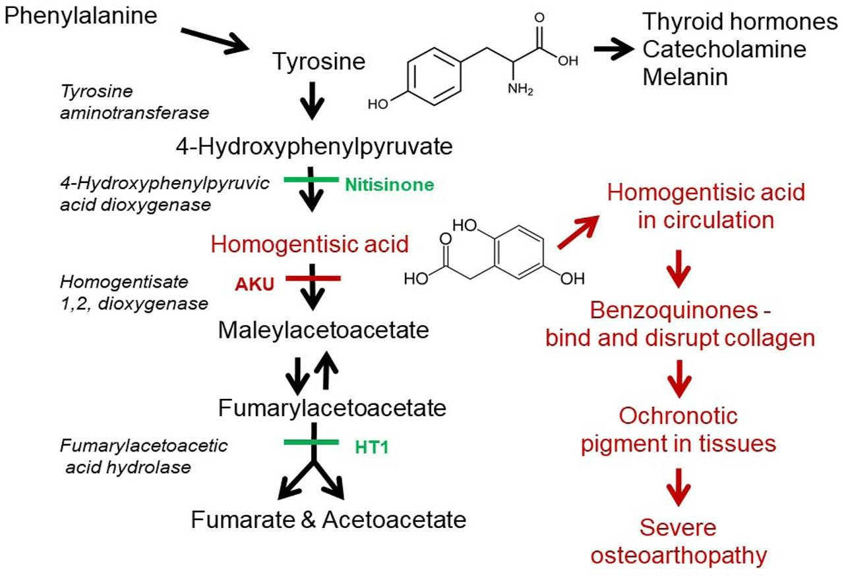
Graphical abstract:

Figure 1: Mechanism of Alkaptonuria

Abstract:
A rare hereditary condition known as alkaptonuria is caused by a lack of the homogentisate 1,2-dioxygenase enzyme, which causes the body to accumulate homogentisic acid. This is an autosomal recessive disorder that mostly affects connective tissues and results in urine turning dark when exposed to air. Ochronosis, which is marked by dark pigmentation and gradual deterioration, is caused over time by homogentisic acid accumulation in cartilage, tendons, and other tissues. In clinical terms, alkaptonuria presents as musculoskeletal complaints, including stiff joints, arthritis, and back discomfort. Furthermore, there may be eye symptoms, renal stones, and heart problems. The confirmation of homogentisate 1,2-dioxygenase gene mutations through genetic testing, urine screening for homogentisic acid, and clinical suspicion are the three main diagnostic tools. The goal of management is to alleviate symptoms, as there is yet no permanent treatment. Research is ongoing to develop targeted therapies for alkaptonuria. Experimental treatments, such as nitisinone, have shown promise in reducing the production of homogentisic acid by inhibiting an enzyme in the metabolic pathway. However, further studies are needed to determine their long-term safety and efficacy.
Keywords : Alkaptonuria, Genetic disorder, Ochronosis, Urine discoloration, homogentisic acid.

Introduction:
Alkaptonuria is a genetic condition marked by the body's difficulty in metabolizing particular amino acids efficiently. In greater detail, it disrupts the metabolism of phenylalanine and tyrosine amino acids, culminating in the accumulation of homogentisic acid within the body. This buildup can cause urine to turn dark when exposed to air and can also lead to various health problems, including joint and connective tissue problems (Zatkova et a., 2012). Alkaptonuria follows an autosomal recessive inheritance pattern, requiring the individual to inherit two copies of the faulty gene, one from each parent, to manifest the condition. Symptoms typically appear in early childhood but can vary widely in severity from person to person (Introne et al., 2003). Alkaptonuria arises from a scarcity of the enzyme homogentisate 1,2-dioxygenase (HGD), a condition rooted in genetic mutation. The mutated HGD gene results in insufficient HGD activity. Individuals with alkaptonuria experience HGA buildup due to the deficient HGD enzyme. This enzyme typically facilitates the conversion of homogentisic acid (HGA) into maleylacetoacetate (MAA). Excessive HGA oxidizes and polymerizes, forming ochronotic pigment, which manifests as a dark hue (Phornphutkul et al., 2002).
Causes: Alkaptonuria arises due to a deficiency in the enzyme homogentisic acid oxidase, leading to the accumulation of homogentisic acid within the body. This build-up leads to ochronosis, which is characterized by dark-colored urine, ochronotic arthropathy, and darkening of the ear. Additional symptoms may manifest as progressive arthritis, particularly affecting the spine, alongside the development of dark spots on the sclera and cornea. (Srsen et al., 2002). (Figure 2)

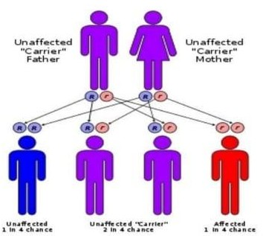

Figure 2: Alkaptonuria Affected by genes
Symptoms:
Symptoms of alkaptonuria include:
- Brown or black spots may manifest on the sclera, which is the white portion of the eyes.
- The thickening of ear cartilage may exhibit a blue, grey, or black hue.
- When exposed to air, urine may darken to a shade of deep brown or black.
- Arthropathy of major joints
- Calcification of cartilaginous tissue
- Deterioration of cardiac valves and etc (Keller et al., 2005)

Signs:

Some signs of alkaptonuria include (Figure 3):
- Darkening of urine: One of the first signs noticed by parents of children with alkaptonuria. Urine may darken when standing for a long time or appear as dark stains on diapers.
- Ochronosis: A thickening of ear cartilage that may appear blue, gray, or black. Many adults with alkaptonuria have this sign.
- Eyes color: The presence of brown or black spots on the sclera (white part) of the eyes indicates a symptom of alkaptonuria..
- 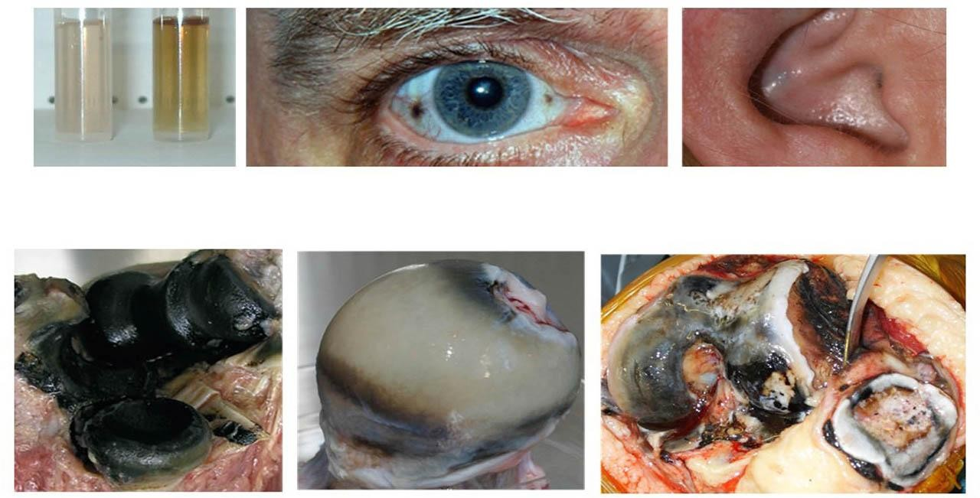Arthritis: Arthritis, especially in the spine, that worsens over time etc. (Olive & Alnajar, 2019)
- Figure 3: Signs of Alkaptonuria

Complications:

Long-term accumulation of HGA frequently leads to other comorbidities, the most common of which is osteoarthritis. This affects the joints, causing them to lose their protective features and ultimately reduces bone density and strength.

Secondary Amyloidosis is another possibility that may affect those with AKU later in life. HGA depositions in the blood vessels, heart wall and lungs can cause cardiomyopathy and breathing problems (Mistry et al., 2013).

The risk of Parkinson’s Disease and Depression may be increased in those receiving treatment for AKU due to faulty tyrosine metabolism, which can affect dopamine synthesis and utilization.

Causes of black urine disease:

Alkaptonuria, commonly known as black urine disease, stems from a specific gene mutation in the HGD gene found on chromosome 3. HGD, short for homogentisate 1,2-dioxygenase, is the enzyme responsible for breaking down HGA. There are more than 100 different mutations on the HGD gene that can lead to Alkaptonuria.

In the usual scenario, HGA is broken down with HGD into maleylacetoacetate, which goes on to form fumarate, an intermediate involved in energy and protein metabolism. In AKU, HGD is ineffective, causing HGA to be excreted into urine or to buildup in the system. When oxidized, it is converted to benzoquinone acetic acid, which is responsible for the blue-black discoloration of the bones, joints, skin and eyes, as well as other symptoms and complications (Skinsnes,1948).

Management of alkaptonuria:
- Diet for alkaptonuria:
Alkaptonuria is a rare hereditary disease requiring a diet high in low-protein foods free of phenylalanine and tyrosine, which are building blocks of the metabolite homogentisic acid (HGA). This diet requires that high-protein foods like meat, dairy, and some legumes be avoided in favour of low-protein foods like fruits, vegetables, and grains. Dietary protein should be restricted to that which is minimally needed for physiological processes and should be augmented with therapeutic meals free of phenylalanine and tyrosine. Hydration is also essential for facilitating the renal excretion of HGA. To reduce the danger of HGA accumulation and related problems, such as ochronosis and joint degeneration, monthly dietitian consultations are crucial for monitoring dietary adherence (Judd et al., 2020).
- Exercise for alkaptonuria:
While alkaptonuria may induce pain and stiffness, one might assume that exercise could exacerbate symptoms. However, engaging in regular, mild exercise can be beneficial as it aids in muscle development and reinforces joint strength. Exercise serves as a valuable tool for stress reduction, weight management, and posture enhancement, all of which can alleviate alkaptonuria symptoms. However, it's important to steer clear of activities that place excessive strain on the joints, such as boxing, football. In the initial stages, gentle activities like yoga and pilates could offer assistance, while cycling, walking, and swimming might be preferable for those with more advanced alkaptonuria. (Taylor et al., 2010).

Treatment of alkaptonuria:
There is no cure for Alkaptonuria. Researchers are currently looking to develop novel therapeutics that aim to replace HGD or inhibit HGA oxidation. Due to the rarity of the disease, research efforts are slow.

Nitisinone is a drug recently approved to inhibit the enzyme that converts tyrosine to HGA, thus reducing the amount of HGA in the body. It has been shown to lower HGA levels by as much as 95% and improve urine color in people with Alkaptonuria. Nitisinone can cause side effects such as eye inflammation and skin light sensitivity. It may also increase the risk of depression and Parkinson’s disease (Zatkova, 2011).

Other treatment for Alkaptonuria includes:
- Low Tyrosine Diet: Reducing the intake of foods that contain tyrosine or phenylalanine (another amino acid that can be converted to tyrosine) can help lower the production of HGA and slow down its accumulation in the body. As tyrosine is found in many foods such as cheese, meat, nuts, and soy, this suggestion may be difficult to follow, although patients usually benefit from restricting protein-heavy foods. No dietary changes have been proven sufficient to prevent bone and cartilage damage in later life (Ranganath et al., 2013).
- Antioxidant Supplementation: Taking antioxidant supplements such as Vitamin C, zinc, selenium, and cysteine may help reduce the oxidation of HGA and prevent its deposition in the tissues. However, there is very little research available to support the effectiveness of these supplements.
- Symptom Relief: Some with Alkaptonuria require medications to combat transient symptoms associated with the condition, such as over-the-counter painkillers, anti-inflammatories, sleeping pills, and antidepressants.
- Joint and Valve Replacement Surgery: For people with severe arthritis and joint damage caused by Alkaptonuria, joint replacement surgery may be an option to restore function and mobility. If amyloidosis develops, patients may go on heart medication and eventually require valve replacement surgery (Davison et al., 2019).

Prognosis:
AKU is not usually a life-threatening disease and those with the condition generally have a normal life expectancy.
The disease may begin to catch up with them during their 40s and 50s, affecting the bones and joints and lowering the quality of life. They may require walking aids at younger ages than most individuals with osteoarthritis and could contract heart or lung comorbidities earlier than most as well (Fisher & Davis, 2004).

Conclusion:
Alkaptonuria is a rare disease that illustrates how a single gene mutation can have profound effects on the body. While not life-threatening, Alkaptonuria can lead to osteoarthritis and other diseases at earlier ages, which can greatly detract from the quality of life. Nitisinone is currently used to treat the condition with great success, alongside dietary changes and symptom management.

References:
Davison, A.S., Norman, B.P., Ross, G.A., Hughes, A.T., Khedr, M., Milan, A.M., Gallagher, J.A., Ranganath, L.R. (2019). Evaluation of the serum metabolome of patients with alkaptonuria before and after two years of treatment with nitisinone using LC-QTOF-MS. Journal of Inherited Metabolic Disease . 48(1), 67-74.
Fisher, A.A., Davis, M.W. (2004). Alkaptonuric ochronosis with aortic valve and joint replacements and femoral fracture: a case report and literature review. Clinical Medicine & Research. 2(4), 209-215.
Introne, W.J., Perry, M., Chen, M., Adam, M.P., Feldman, J., Mirzaa, G.M., Pagon R.A., Wallace, S. E., Bean, L.JH., Karen W Gripp K.W., Amemiya, A. (2003). In: Adam MP, Feldman J, Mirza GM, Pagon RA, Wallace SE, Bean LJH, Gripp KW, Amemiya A, editors. University of Washington, Seattle, pp1993–2024.
Judd, S., Khedr, M., Milan, A.M., Davison, A.S., Hughes, A.T., Needham, A., Psarelli, E.E., Shenkin, A., Ranganath, L.R. (2020). The nutritional status of people with alkaptonuria: An exploratory analysis suggests a protein/energy dilemma. Journal of Inherited Metabolic Disease. 53(1), 45-60.
Keller, J.M., Macaulay, W., Nercessian, O.A., Jaffe, I.A. (2005). New developments in ochronosis: review of the literature. Rheumatology International. 25(2), 81-85.
Mistry, J.B., Bukhari, M., Taylor, A.M. (2013). Alkaptonuria. Rare Diseases. e27475. doi: 10.4161/rdis.27475.
Olive, J.K., Alnajar, A., Gnanashanmugam, S., Lamelas, J. (2019). Transcatheter Aortic Valve Replacement for Alkaptonuria-Associated Aortic Stenosis. The Annals of Thoracic Surger. 108(6), 377-379.
Phornphutkul, C., Introne W.J., Perry, MB, Bernardini, I, Murphey, M.D., Fitzpatrick, D.L, Anderson, P.D., Huizing, M., Anikster, Y., Gerber, L.H., Gahl, W.A. (2002). Natural history of alkaptonuria. The New England journal of medicine. 347(26), 2111-2121.
Ranganath, L.R., Jarvis, J.C., Gallagher, J.A. (2013). Recent advances in management of alkaptonuria (invited review; best practice article). Journal of Clinical Pathology. 66(5), 367-373.
Skinsnes, O.K.(1948). Generalized ochronosis; report of an instance in which it was misdiagnosed as melanosarcoma, with resultant enucleation of an eye. Archives of pathology (Chic). . 45(4), 552-558.
Srsen, S., Muller, C.R., Fregin, A., Srsnovak. (2002). Alcaptonuria in Slovakia; 32 years of research on phenotype & geno type. Molecular Genetics and Metabolism Reports. 75(4), 353-359.
Taylor, A.M., Wilson, P.J., Ingrams, D.R., Helliwell, T.R., Gallagher, J.A., Ranganath, L.R. (2010). Calculi and intracellular ochronosis in the submandibular tissues from a patient with alkaptonuria. Journal of Clinical Pathology.63(2), 186-188.

Zatkova, A. (2011). An update on molecular genetics of Alkaptonuria (AKU). Journal of inherited metabolic disease. 34(6), 1127-1136.

