Advanced Magnetic Materials

C. S. Munnolli  Department of Physics,  HKE’s A. V. Patil Degree College, Aland  Kalburgi, KA, India  Shekharm.345@gmail.com |  | R. H. Kadam  Department of Physics,  Materials Science Research Laboratory,  Shrikrishna Mahavidyalaya, Gunjoti, Dharashiv  ram111612@yahoo.co.in

Outline: Advanced Magnetic Materials

- Introduction
1.1 Historical perspective on the development of magnetic materials.
1.2 Importance of advanced magnetic materials in modern technology.
- Fundamental Magnetism
2.1 Magnetism
2.2 Fundamentals
2.3 Origins of magnetic moments
2.4 Types of magnetic materials
2.4.1. Diamagnetism and paramagnetism
2.4.2. Ferromagnetism
2.4.3. Antiferromagnetism and ferrimagnetism
2.4.4. Antiferromagnetism
2.4.5. Ferrimagnetism
- Domain Theory of Ferromagnetism
- Spontaneous Magnetization to Saturation
- Domain Walls
- Random Orientations and Net Magnetic Moment
- Thermal Impact on Magnetic Properties
7.1Domain dynamics and Hysteresis
7.2 Deciphering Complexity
- Classification of Advanced Magnetic Materials
8.1 Soft magnetic materials
8.2 Hard magnetic materials
8.3 High-Energy Hard Magnetic Materials
8.3.1. Samarium–Cobalt Magnets
8.3.2. Neodymium–Iron–Boron Magnets
- Magnetic Nanomaterials
9.1 Application of Magnetic Nanomaterials
9.1.1. Industrial applications
9.1.2. Biomedical applications
9.1.3. Transitioning to in vitro applications
9.1.4. Diagnostic Applications
- Multiferroic Materials
10.1. Magnetoelectric effect
10.2. Electrical polarization
10.2.1. Dielectrics
10.2.2. Non-ferroelectric materials
10.2.3. Orientational Polarization (Dipolar Polarization)
- Ferroelectrics
11.1 Hysteresis behavior
11.2. Synthesis and Fabrication Technique
11.3. Characterization Techniques
- Applications of Advanced Magnetic Materials
Conclusions

Abstract

The Chapter on "Advanced Magnetic Materials" provides a comprehensive exploration of the historical development and contemporary significance of magnetic materials in modern technology. The introductory section delves into the historical evolution of magnetic materials, highlighting their pivotal role in technological advancements. Second section, "Fundamental Magnetism," explores the basics of magnetism, magnetic moments, and various types of magnetic materials, such as diamagnetism, paramagnetism, ferromagnetism, antiferromagnetism, and ferrimagnetism. The subsequent sections delve into domain theory of ferromagnetism, spontaneous magnetization to saturation, and the intriguing world of domain walls, unraveling the complexities of magnetic phenomena. The Section further elucidates the impact of thermal dynamics on magnetic properties, including domain dynamics and hysteresis, while exploring the intricacies of random orientations and net magnetic moment.A significant portion of the Section is dedicated to the classification of Advanced Magnetic Materials (AMM), including soft magnetic materials, hard magnetic materials, and high-energy hard magnetic materials like Samarium–Cobalt and Neodymium–Iron–Boron magnets. The exploration of magnetic nanomaterials constitutes another pivotal section, discussing their applications in various domains such as industry, biomedicine, in vitro applications, and diagnostics. The Section extends its focus to multiferroic materials, shedding light on the magnetoelectric effect and the interplay of electrical polarization in dielectrics, non-ferroelectric materials, and orientational polarization. Ferroelectrics take center stage in the penultimate section, addressing hysteresis behavior, synthesis, fabrication techniques, and characterization methods.The concluding section presents a thorough examination of the diverse applications of Advanced Magnetic Materials, emphasizing their pivotal role in modern technology. The Section provides a valuable resource for researchers, engineers, and students interested in delving into the intricate world of advanced magnetic materials and their multifaceted applications

Key points:Ferromagnetism, Antiferromagnetism, XRD,TEM, VSM, CVD, PVD

- Introduction
Recent progress in magnetic materials has attracted considerable attention, particularly in the realm of performance improvements for various applications. A primary focus is on enhancing information storage and processing capabilities, with the development of advanced magnetic materials aimed at improving the efficiency and compactness of data storage devices, notably magnetic random-access memory (MRAM)[1]. MRAM's utilization of magnetic properties for data storage provides advantages in terms of speed, durability, and energy efficiency compared to conventional memory technologies.Beyond data storage, significant strides have been made in the development of magnetic sensors and medical devices. Magnetic materials play a crucial role in magnetic resonance imaging (MRI), and ongoing research aims to improve the sensitivity and resolution of these imaging techniques[2]. Furthermore, there are endeavors to leverage magnetic nanoparticles for targeted drug delivery in healthcare, utilizing their magnetic properties for precise navigation and localization of therapeutic agents. In the field of electronics, there is a growing exploration of integrating magnetic materials into spintronic devices. Spintronics, which leverages both the charge and spin of electrons for information processing, relies on magnetic materials for components such as spin valves and magnetic tunnel junctions. These components have the potential to revolutionize electronics by providing faster and more energy-efficient devices[3]. Research in magnetic materials also extends to sustainable energy applications, with a focus on more efficient energy conversion and storage. Exploring the use of magnetic materials in advanced magnetic refrigeration systems offers a potentially eco-friendly alternative to traditional refrigeration technologies. Across diverse technological applications, magnetic materials play a critical role, influencing the efficacy and functionality of devices in various industries. With unique properties enabling the generation, storage, and response to magnetic fields, these materials are indispensable in information storage, electronics, telecommunications, medical diagnostics, and energy conversion[4]. They form the foundation of hard disk drives, contribute to efficient power transmission in transformers and inductors, enhance accuracy in navigation systems and consumer electronics through magnetic sensors[5], and enable stable magnetic fields in MRI machines for detailed and non-invasive imaging[2]. The significance of magnetic materials in technology is undeniable, driving innovation, enhancing efficiency, and shaping the technological landscape across various sectors. Ongoing research in material science continues to spotlight magnetic materials as a focal point for augmenting existing technologies and unlocking new possibilities for the future.This chapter is organized as follows: in the first section, Historical development and importance of the AMM in modern technology and Fundamental magnetism and its types, in second section, AMM and its types

  - Historical perspective on the development of magnetic materials.
A journey into the historical context unveils pivotal developments. Magnetism's recognition dates back to ancient times, with meticulous documentation by the Greeks, Chinese, and Indians of naturally occurring magnetic minerals like lodestone[6], showcasing their ability to attract iron. The 12th-century invention of the compass in China marked a turning point, leveraging magnetic properties and transforming sea travel and exploration[7]. The Renaissance era witnessed substantial contributions, with scientists like William Gilbert laying the groundwork for systematic magnetism studies in his influential treatise "De Magnete" (1600), introducing the concept of the Earth as a giant magnet[8]. The 19th century saw a surge in experimental work and mathematical formulations related to magnetism, including Hans Christian Ørsted's discovery of the link between electric current and magnetism and Michael Faraday's laws of electromagnetic induction. Exploring milestones in magnetic materials research reveals key breakthroughs. Pierre Curie's identification of the Curie point in 1895 marked a significant stride in understanding the temperature-magnetism relationship. Advances in metallurgy and materials science in the 20th century led to the creation of durable permanent magnets, like Alnico and rare-earth magnets[10], essential in applications such as electric motors and generators. The 1930s focused on comprehending magnetic domains and the behavior of ferromagnetic materials, enriched by Louis Néel's exploration of antiferromagnetism and ferrimagnetism[11]. The discovery of Giant Magnetoresistance (GMR) in 1988 by Albert Fert and Peter Grünberg revolutionized magnetic data storage technology, paving the way for smaller and more efficient computer hard drives[12]. The 2000s witnessed the emergence of spintronics, leveraging the intrinsic spin of electrons for information processing and storage, resulting in innovations like spintronic devices and magnetic random-access memory (MRAM)[13]. Today, magnetic materials research continues its progression, finding applications in diverse fields such as electronics, energy, and medicine. A comprehensive understanding of the historical context and milestones in this field establishes a robust foundation for ongoing advancements in the science and technology of magnetic materials.

  - Importance of advanced magnetic materials in modern technology.
Human development, both globally and particularly in India, has resulted in the depletion of natural energy resources and the onset of unpredictable climate changes. To tackle future challenges in our industrial society, there is an increasing demand for innovative energy concepts that focus on improving electricity transmission and utilization efficiency. This shift is accompanied by a gradual transition from oil-based fuels to electric motors in transportation.Functional magnetic materials, including advanced hard and soft magnets, magnetic refrigerants, magnetic MEMS, magnetic shape memory alloys, and magneto-rheological fluids and elastomers, are positioned to play a crucial role in advancing these technologies. This analysis seeks to emphasize the indispensable role of magnetic materials in various energy applications, such as motors, generators, transformers, and actuators. The enhancement of magnetic materials is expected to have a significant impact alongside other noteworthy initiatives in "hot" energy materials like hydrogen storage and batteries.The subsequent sections will highlight key technology sectors, such as transportation, electric power generation and conversion, and refrigeration, where magnetic materials can drive significant advancements. Electric motors, crucial for technological progress, are now ubiquitous, finding use in offices, households, transportation, and industrial drives.
In the context of scientific research, the electricity consumption distribution in a developing country like India reveals distinct patterns across sectors, with the industrial sector utilizing 41.16%, agriculture consuming 17.67%, and residential areas accounting for 25.77%. Electric vehicle drives contribute approximately 8.29% to the overall consumption (Data taken from investindia from 2022). A comparison with a developed nation such as the USA shows that the industrial sector consumes nearly 26% of electricity, residential consumption stands at 38.44%, and commercial and electric vehicle drives contribute around 36.02% (Data taken EIA.Gov from 2023) to the total consumption. In both developing and developed nations, a noticeable reliance on thermal energy for electricity generation is observed, leading to increased CO₂ emissions. Addressing these emissions necessitates the adoption of alternative and environmentally friendly methods of electricity production.The significance of permanent magnets and soft magnets in powering compact and lightweight electric motors is crucial for scientific advancements in transportation and actuation applications. Global electricity consumption, estimated at 24,398 terawatt-hours (TWh) in 2022, is broken down regionally in Table A. Notably, the USA consumed 4082 TWh, while India consumed 1392 TWh in 2022, and this figure is projected to increase from 34% to 56% by 2022. Despite strides in green energy, the demand for power quality and total electrical power continues to rise in modern lighting, consumer electronics, and transportation. With the anticipated surge in electric transportation demand worldwide, mitigating losses becomes even more critical. Annual electric losses, growing at a rate exceeding the annual increase in electricity consumption by more than 40% (2022 estimates), are illustrated in Figure 1 (right).Electricity, constituting 20% of global energy consumption, plays a pivotal role in daily life and extends into new end-uses like electric vehicles (EVs) and heat pumps. The electricity sector's impact on global energy sources is substantial, accounting for 59.57% of coal usage, 34% of natural gas, 4% of oil, 52% of renewables, and nearly 100% of nuclear power in 2021. Moreover, it contributed over one-third of all energy-related CO₂ emissions in the same year. The increasing demand for energy efficiency and sustainability requires cutting-edge advancements in high-efficiency motors, generators, and power converters through scientific research. Recognizing that improving existing infrastructure alone is insufficient, there's a significant surge in dedicated research and development. The focus on sustainable, renewable, or alternative energy sources anticipates a substantial integration of new electricity generation methods into the grid in the next decade. This transformation necessitates substantial investments in energy-efficient power generation methods, especially in areas like wind power and transportation, which require not only higher efficiency but also reduced size and weight of materials. Achieving higher energy efficiency in power conversion aligns with sustainable electricity generation. Utilizing advanced permanent and soft magnet materials becomes pivotal, offering high efficiency, reliability, and compact, cost-effective solutions for various renewable energy technologies, including wind turbines, hydroelectric generators, and wave power buoys. As the energy sector moves towards greater sustainability, the development and implementation of these magnetic materials are poised to play a crucial role in meeting evolving energy demands.

Table A. World total electricity consumers (Data’s Adopted from ECW-2022)
Country | Electricity Consumed (TWh)
USA | 4082
Europian Union | 5825
China | 8090
Japan | 939
Russia | 979
India | 1392

- Fundamental magnetism:
  - Magnetism
Phenomenon associated with magnetic fields, which arise from the motion of electric charges. This motion can take many forms. It can be an electric current in a conductor or charged particles moving through space, or it can be the motion of an electron in an atomic orbital. Magnetism is also associated with elementary particles, such as the electron, that have a property called spin.

  - Fundamentals
Basic to magnetism are magnetic fields and their effects on matter, as, for instance, the deflection of moving charges and torques on other magnetic objects. Evidence for the presence of a magnetic field is the magnetic force on charges moving in that field; the force is at right angles to both the field and the velocity of the charge[14]. This force deflects the particles without changing their speed. The deflection can be observed in the torque on a compass needle that acts to align the needle with the magnetic field of Earth. The needle is a thin piece of iron that has been magnetized—i.e., a small bar magnet. One end of the magnet is called a north pole and the other end a south pole. The force between a north and a south pole is attractive, whereas the force between like poles is repulsive. The magnetic field is sometimes referred to as magnetic induction or magnetic flux density; it is always symbolized by B. Magnetic fields are measured in units of Tesla (T). (Another unit of measure commonly used for B is the gauss, though it is no longer considered a standard unit. One gauss equals 10⁻⁴ Tesla.)A fundamental property of a magnetic field is that its flux through any closed surface vanishes. (A closed surface is one that completely surrounds a volume.) This is expressed mathematically by div B = 0 and can be understood physically in terms of the field lines representing B[15]. These lines always close on themselves, so that if they enter a certain volume at some point, they must also leave that volume. In this respect, a magnetic field is quite different from an electric field. Electric field lines can begin and end on a charge, but no equivalent magnetic charge has been found in spite of many searches for so-called magnetic monopoles.
The most common source of magnetic fields is the electric current loop. It may be an electric current in a circular conductor or the motion of an orbiting electron in an atom. Associated with both these types of current loops is a magnetic dipole moment, the value of which is iA, the product of the current i and the area of the loop A. In addition, electrons, protons, and neutrons in atoms have a magnetic dipole moment associated with their intrinsic spin; such magnetic dipole moments represent another important source of magnetic fields[16]. A particle with a magnetic dipole moment is often referred to as a magnetic dipole. (A magnetic dipole may be thought of as a tiny bar magnet. It has the same magnetic field as such a magnet and behaves the same way in external magnetic fields.) When placed in an external magnetic field, a magnetic dipole can be subjected to a torque that tends to align it with the field; if the external field is not uniform, the dipole also can be subjected to a force.
All matter exhibits magnetic properties to some degree. When placed in an inhomogeneous field, matter is either attracted or repelled in the direction of the gradient of the field. This property is described by the magnetic susceptibility of the matter and depends on the degree of magnetization of the matter in the field [17]. Magnetization depends on the size of the dipole moments of the atoms in a substance and the degree to which the dipole moments are aligned with respect to each other. Certain materials, such as iron, exhibit very strong magnetic properties because of the alignment of the magnetic moments of their atoms within certain small regions called domains. Under normal conditions, the various domains have fields that cancel, but they can be aligned with each other to produce extremely large magnetic fields. Various alloys, like NdFeB (an alloy of neodymium, iron, and boron), keep their domains aligned and are used to make permanent magnets[18]. The strong magnetic field produced by a typical three-millimetre-thick magnet of this material is comparable to an electromagnet made of a copper loop carrying a current of several thousand amperes. In comparison, the current in a typical light bulb is 0.5 ampere. Since aligning the domains of a material produces a magnet, disorganizing the orderly alignment destroys the magnetic properties of the material[19]. Thermal agitation that results from heating a magnet to a high temperature destroys its magnetic properties.

  - Origins of magnetic moments
The magnetic essence of materials on a large scale emerges from the magnetic moments linked to individual electrons. While delving into these notions involves quantum-mechanical principles, this discussion opts for simplicity by omitting certain intricacies. Within an atom, each electron boasts magnetic moments stemming from two distinct sources.
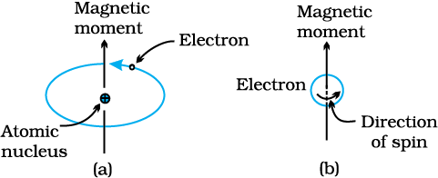

Figure 1. Demonstration of magnetic moment associated with (a) an orbital electron and (b) a spinning of electron

Firstly, the electron's orbital motion around the nucleus creates a visual narrative akin to a moving charge a miniature current loop begetting a subtle magnetic field. This results in a magnetic moment along its rotational axis, artistically depicted in Figure 1 (a).
Secondly, the magnetic moment arises from the electron's spin as it twirls around an axis, captured in the visual storytelling of Figure 1 (b). The spin magnetic moment may adopt an "up" or an antiparallel "down" orientation. Consequently, each electron can be envisioned as a petite magnet adorned with enduring orbital and spin magnetic moments. The Bohr magneton takes center stage as the foundational magnetic moment, denoted by μ_{B}. For every electron, the spin magnetic moment embraces positivity (for spin up) or negativity (for spin down). Additionally, the orbital magnetic moment contribution aligns with the magnetic quantum number of the electron [20].
At the atomic level, the cancellation dance occurs where certain electron pairs' orbital moments and spin moments elegantly neutralize each other. A ballet of cancellation, exemplified by the offsetting of a spin-up electron's moment by a spin-down counterpart, forms the net magnetic moment for an atom. This composite considers both orbital and spin contributions and the delicate art of moment cancellation[21].Atoms flaunting brimful electron shells or sub-shells revel in the tranquility of total cancellation—both orbital and spin moments find harmony. Consequently, materials crafted from such atoms, encompassing inert gases (He, Ne, Ar, etc.) and select ionic materials, defy the allure of permanent magnetization. The magnetic tapestry unfolds with diverse types of magnetism—diamagnetism, paramagnetism, and ferromagnetism each a brushstroke painted by electron and atomic magnetic dipoles interacting with an external magnetic field. As the magnetic masterpiece evolves, additional nuances emerge in the form of antiferromagnetism and ferrimagnetisms, considered as subclasses of the overarching ferromagnetic narrative. Every material plays a part, showcasing at least one type of magnetism, with their conduct choreographed by the interplay of electron and atomic magnetic tales within the external magnetic realm.

  - Types of magnetic materials
    - Diamagnetism and paramagnetism
Diamagnetism is a magnetic property exhibited by certain materials, characterized by its weak and non-permanent nature, only becoming evident in the presence of an external magnetic field. This behavior originates from alterations in the orbital motion of electrons induced by an applied magnetic field. The resulting magnetic moment is extremely small and opposes the direction of the applied field, leading to a relative permeability slightly below unity and a negative magnetic susceptibility. The volume susceptibility for diamagnetic solids is generally low.
A practical example of diamagnetism is observed when diamagnetic materials, such as bismuth or graphite, are placed between the poles of a strong electromagnet. In this scenario, these materials are drawn toward regions with weaker magnetic fields, demonstrating their weak repulsion from the applied magnetic field.
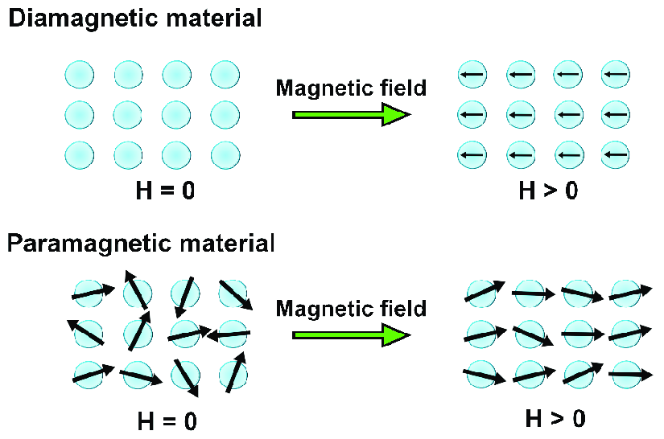

Figure 2. The atomic dipole configuration for a diamagnetic materialwith and without a magnetic field.

In theabsence of an external field, no dipoles exist in the presence of a field, dipoles are induced that are aligned opposite to the fielddirection. (b) Atomic dipole configuration with and without an external magnetic field for a paramagnetic material.Figure 2. (aand b) schematically illustrates the atomic magnetic dipole configurations of a diamagnetic and paramagnetic materials both in the absence and presence of an external magnetic field. The arrows in the figure represent atomic dipole moments. The magnetic field dependence on the external field strength (H) for materials exhibiting diamagnetic behavior is further elucidated in Figure 2. Despite being a universal property present in all materials, the feebleness of diamagnetism makes it observable only when other forms of magnetism are entirely absent, making it practically insignificant in many contexts.
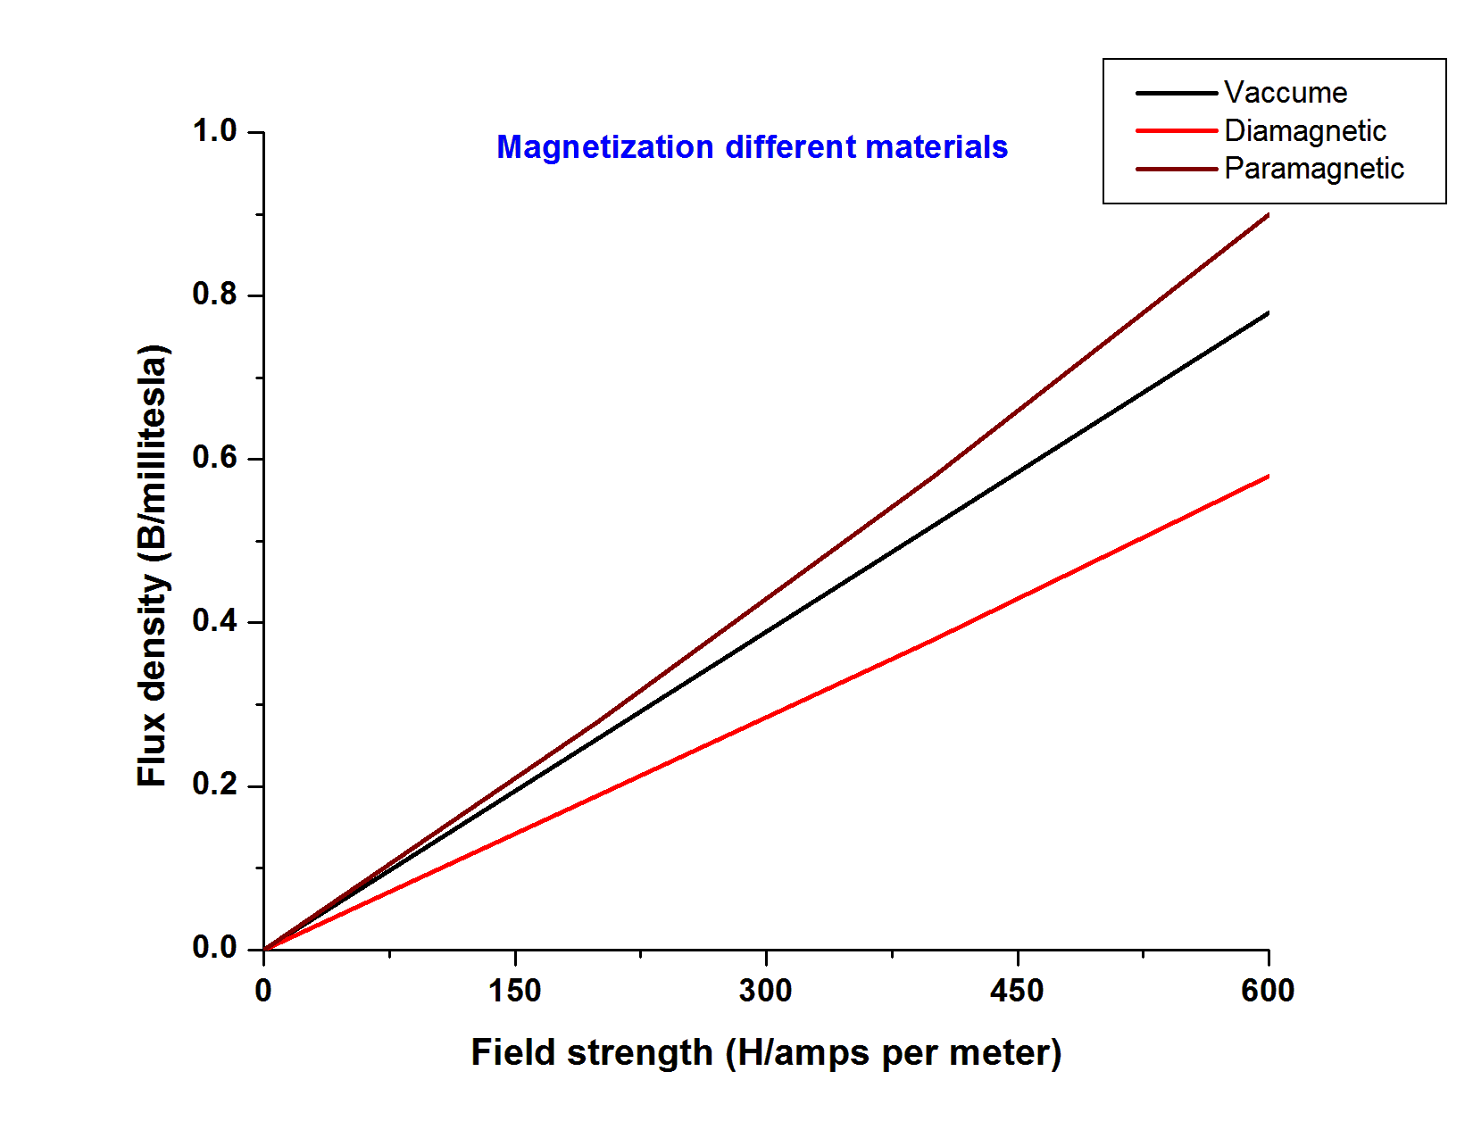
Figure.3. Schematic representation of the flux density B versus the magnetic field strength H for diamagnetic andparamagnetic materials.

In contrast, paramagnetism is observed in certain solid materials where each atom possesses a permanent dipole moment due to incomplete cancellation of electron spin and/or orbital magnetic moments. In the absence of an external magnetic field, the orientations of these atomic magnetic moments are random, resulting in no net macroscopic magnetization. Paramagnetism becomes evident when these atomic dipoles, capable of free rotation, align preferentially with an external magnetic field[22]. Common examples of paramagnetic materials include aluminum and platinum.Both diamagnetic and paramagnetic materials are categorized as nonmagnetic because they only exhibit magnetization in the presence of an external magnetic field. The flux density B within these materials closely resembles that in a vacuum, emphasizing their dependence on external magnetic influences for magnetic behavior as shown in figure (3).

    - Ferromagnetism
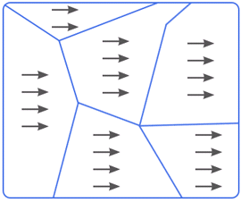

Figure.4:Schematic illustration of the mutual alignment of atomicdipoles for a ferromagnetic material, which will exist even in theabsence of an external magnetic field.

Ferromagnetism is a property exhibited by specific metallic materials, wherein they possess a permanent magnetic moment even in the absence of an external magnetic field, resulting in substantial and enduring magnetizations. This distinctive behavior is observed in transition metals like iron (in the form of BCC ferrite), cobalt, nickel, and certain rare earth metals such as gadolinium (Gd). Ferromagnetic materials can attain remarkably high magnetic susceptibilities, as expressed in Equation 1[23]
χ _{magnetic} = $\frac{M}{H}$ -----------------1
Here, M represents the magnetization.
The permanent magnetic moments in ferromagnetic materials arise from atomic magnetic moments due to uncancelled electron spins, a consequence of the electron structure. Additionally, there is a small contribution from the orbital magnetic moment, though it is overshadowed by the spin moment. Within a ferromagnetic material, coupling interactions cause the net spin magnetic moments of adjacent atoms to align, even in the absence of an external magnetic field. This alignment is schematically depicted in Figure 4. While the precise origin of these coupling forces is not fully understood, it is believed to stem from the electronic structure of the metal. This mutual spin alignment occurs over relatively large volume regions of the crystal referred to as domains
The saturation magnetization of a ferromagnetic material represents the maximum achievable magnetization when all the magnetic dipoles in a solid piece align with the external magnetic field. This state is accompanied by a corresponding saturation flux density[24]. The saturation magnetization is calculated as the product of the net magnetic moment for each atom and the number of atoms present. For iron, cobalt, and nickel, the net magnetic moments per atom are 2.22, 1.72, and 0.60 Bohr magnetons, respectively.

    - Antiferromagnetism and ferrimagnetism

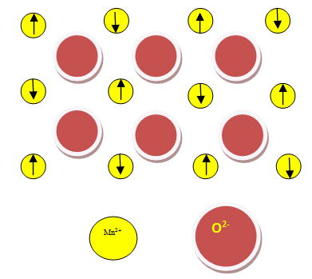
Figure. 5:Schematic representation of antiparallel alignment of spin magnetic moments for antiferromagnetic manganese oxide.
    - Antiferromagnetism
Antiferromagnetism is a magnetic phenomenon observed in materials distinct from ferromagnetic ones, where the magnetic moments of adjacent atoms or ions are coupled in an antiparallel alignment. In simpler terms, the spin moments of neighboring atoms or ions point in exactly opposite directions. An example of a material exhibiting antiferromagnetism is manganese oxide (MnO), which is a ceramic material with both Mn²⁺ and O²⁻ ions. In the case of manganese oxide, the O²⁻ ions do not contribute to a net magnetic moment since their spin and orbital moments cancel each other out. On the other hand, the Mn²⁺ ions possess a net magnetic moment primarily originating from their spin. The arrangement of these Mn²⁺ ions in the crystal structure is such that the magnetic moments of adjacent ions are antiparallel, meaning they point in opposite directions[25]. This arrangement is visually represented in Figure 5.Due to the antiparallel alignment of magnetic moments, the opposing magnetic forces effectively cancel each other out. As a result, the material as a whole does not exhibit a net magnetic moment. This behavior is characteristic of antiferromagnetic materials, where the cancellation of magnetic moments within the structure prevents the material from displaying an overall magnetic field.

    - Ferrimagnetism
Ferrimagnetism is a phenomenon observed in certain ceramics, characterized by the presence of permanent magnetization. Although ferromagnets and ferrimagnets share macroscopic magnetic properties, their distinction lies in the origin of the net magnetic moments. This concept is exemplified through the study of cubic ferrites, particularly ionic materials represented by the chemical formula MFe₂O₄, where M denotes various metallic elements. A common example of a ferrite is MFe₃O₄, known as magnetite or lodestone.
The chemical formula for magnetite (Fe₃O₄) can be expressed as Fe²⁺ O²⁻ - (Fe³⁺)₂ (O²⁻)₃. In this formulation, Fe ions exist in both 2 and 3 valence states at a ratio of 1:2[26]. Each Fe²⁺ and Fe³⁺ ion possesses a net spin magnetic moment equivalent to 4 and 5 Bohr magnetons, respectively. Importantly, the O²⁻ ions are magnetically neutral. The interaction between Fe ions involves antiparallel spin-coupling, resembling antiferromagnetism. However, the ferrimagnetic moment arises due to the incomplete cancellation of spin moments.
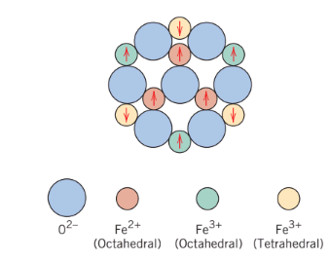
Figure 6: Schematic diagram showing the spin magnetic moment configuration for Fe²⁺ and Fe³⁺ ions in Fe₃O_{4.} (Adopted from Richard A. Finn and paul K. Tojan, Engineering materials and Their applications,4th edition. Copyright @ 1990 by John wiley & sns. Inc, Adapted by permission of john willey &sons,Inc.)[27].

Cubic ferrites exhibit an inverse spinel crystal structure with cubic symmetry, The inverse spinel crystal structure plays a crucial role in facilitating ferrimagnetism. This structure involves antiparallel spin-coupling interactions among Fe ions, leading to a net magnetic moment those results from the partial cancellation of spin moments. Understanding ferrimagnetism in cubic ferrites contributes to our knowledge of magnetic materials and their applications in various fields. The structure of the material can be conceptualized as resulting from the arrangement of closely packed planes of O²⁻ ions. Two types of positions are available for the iron cations, as depicted in Figure 6. In one type, the coordination number is 4 (tetrahedral coordination), meaning each Fe ion is surrounded by four nearest oxygen neighbors[28]. In the other type, the coordination number is 6 (octahedral coordination). In the inverse spinel structure, half of the trivalent Fe³⁺ ions occupy octahedral positions, while the other half are in tetrahedral positions. Divalent Fe²⁺ ions are exclusively located in octahedral positions[29].
The critical factor is the arrangement of the spin moments of the Fe ions, as shown in Figure 6 and Table 1. The spin moments of all Fe³⁺ ions in octahedral positions align parallel to each other, while those in tetrahedral positions align oppositely. This results from the antiparallel coupling of adjacent iron ions, causing the spin moments to cancel each other out and not contribute to the solid's magnetization. In contrast, all Fe²⁺ ions have their moments aligned in the same direction, contributing to the net magnetization.
The chemical formula for the ferrite is M²⁺ O^{2—}(Fe³⁺)₂(O²⁻)₃, where M²⁺ represents divalent ions like Ni²⁺, Mn²⁺, Co²⁺, and Cu²⁺, each with a different net spin magnetic moment[30]. By adjusting the composition, ferrite compounds with varying magnetic properties can be produced. For instance, nickel ferrite has the formula NiFe₂O₄, and mixed ferrites, such as (Mn, Mg)Fe₂O₄, can be created by varying the Mn²⁺:Mg²⁺ ratio.Beyond cubic ferrites, other ferrimagnetic ceramic materials include hexagonal ferrites and garnets. Hexagonal ferrites share a crystal structure similar to inverse spinel but with hexagonal symmetry. Their chemical formula is represented as AB₁₂O₁₉, where A is a divalent metal and B is a trivalent metal. Examples include Pb Fe₁₂O₁₉ and SrFe₁₂O₁₉[31].
Garnets, with the general formula M₃Fe₅O₁₂, have a complex crystal structure. M represents a rare earth ion such as samarium, europium, gadolinium, or yttrium[32]. Yttrium iron garnet (YIG or Y₃Fe₅O₁₂) is a common material of this type.While the saturation magnetizations of ferrimagnetic materials are not as high as ferromagnets, ferrites serve as good electrical insulators due to their ceramic nature. This low electrical conductivity makes them desirable for certain magnetic applications like high-frequency transformers[33].

Table .1:The Distribution of spin magnetic moments for Fe²⁺ and Fe³⁺ ions a Unit cell Fe₃O₄
Cation | Octahedral lattice site | Tetrahedral Lattice site | Net magnetic moment
Fe³⁺ |  |  | Complete cancellation
Fe²⁺
:- Arrows represents the magnetic moment orientation for one of the cations.

Table .2:Net magnetic moments for six cations
Cations | Net magnetic moment
Cu²⁺ | 1
Mn²⁺ | 5
Co²⁺ | 3
Fe²⁺ | 4
Ni²⁺ | 2
Fe³⁺ | 5

- Domain theory of ferromagnetism
Weiss's domain theory, proposed in 1907, has been substantiated by a wealth of scientific studies and experimental evidence, providing a comprehensive insight into the microscopic magnetic behavior of ferromagnetic materials[34]. The following sections elaborate on each aspect of Weiss's domain theory, supported by relevant diagrams:
  - Domain Structure and Saturation Magnetization:
    - Magnetic Imaging Techniques:Research studies in this context utilize magnetic imaging techniques such as Magnetic Force Microscopy (MFM) and Scanning Tunneling Microscopy (STM). These techniques are crucial in providing a detailed understanding of the magnetic properties of materials at a microscopic level[35].
    - Observation of Domain Structures: Magnetic imaging techniques like MFM and STM enable scientists to directly observe domain structures within ferromagnetic materials. These structures refer to the spatial arrangement of magnetic domains within a material.
    - Domains in Ferromagnetic Materials: Ferromagnetic materials are characterized by the presence of small regions known as domains. Each domain exhibits spontaneous magnetization up to saturation. In simpler terms, within a ferromagnetic crystal, there are regions where the magnetic moments of atoms are aligned in a particular direction, creating a domain. These domains play a crucial role in the overall magnetic behavior of the material[36].
    - Spontaneous Magnetization to Saturation:The term "spontaneous magnetization" indicates that within each domain, the magnetic moments align without the need for an external magnetic field. Saturation magnetization refers to the maximum magnetization that a material can achieve when all its magnetic moments are aligned. In other words, each domain reaches its maximum magnetic strength, and further increase in the external magnetic field does not lead to additional magnetization.

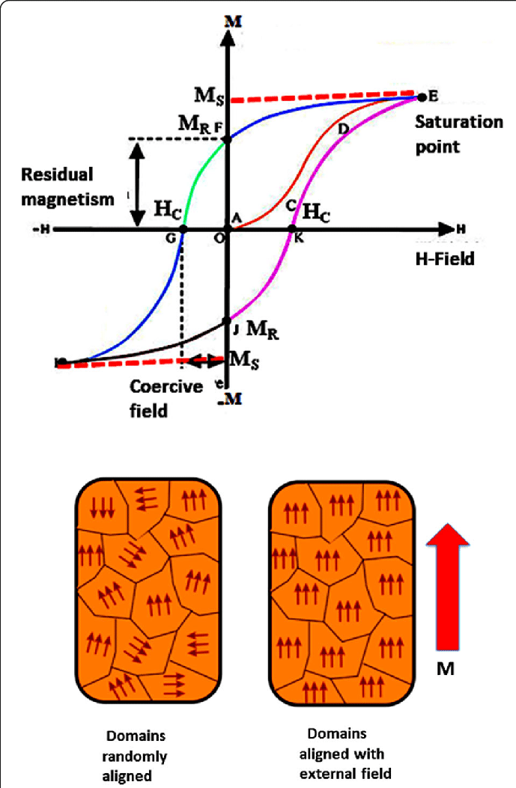
Figure 7: Domain Structure and Saturation Magnetization

  - Domain Walls
    - Advanced Microscopy Techniques and X-ray Diffraction Studies:Advanced microscopy techniques, when combined with X-ray diffraction studies, have played a pivotal role in unraveling the intricacies of domain walls. Microscopy methods such as Lorentz Transmission Electron Microscopy (LTEM) provide the capability to investigate structures at the nanoscale, while X-ray diffraction studies offer insights into the crystallographic aspects of materials[37]. Together, these techniques contribute to a comprehensive understanding of domain walls in ferromagnetic materials.
    - Definition of Domain Walls: Domain walls refer to the interfaces or boundaries between adjacent magnetic domains within a ferromagnetic material. At these interfaces, the orientation of magnetic moments undergoes a transition from one domain to the next. Understanding the properties of domain walls is crucial for comprehending the dynamics and behavior of ferromagnetic materials.
    - Lorentz Transmission Electron Microscopy (LTEM): Lorentz Transmission Electron Microscopy is a specialized technique that allows scientists to directly observe the magnetic domain structure with high spatial resolution. It exploits the deflection of electrons by magnetic fields, providing contrast based on the local magnetic induction[37]. This enables researchers to visualize and study the details of domain walls, including their thickness, structure, and mobility.
    - Observations Confirming Domain Wall Characteristics: Direct observations using Lorentz Transmission Electron Microscopy have confirmed key characteristics of domain walls. This includes verifying the thickness of the domain walls, understanding their structural features, and assessing their mobility within the material. These observations serve to validate the existence of domain walls as distinct entities within the overall magnetic structure of ferromagnetic materials.
    - Random Orientations and Net Magnetic Moment:
    - Experimental Measurements: Experimental measurements, specifically magnetic susceptibility studies and magnetization curves, have been employed to investigate the magnetic behavior of materials. These experiments provide quantitative data that can be analyzed to understand how magnetic properties change under different conditions.
    - Weiss's Assertion: The information refers to Weiss's assertion, which likely relates to the work of French physicist Pierre-Ernest Weiss. Weiss proposed a model to explain ferromagnetism, introducing the concept of spontaneous magnetization and the existence of magnetic domains. In the absence of an external magnetic field, Weiss suggested that these domains have random orientations.
    - Random Orientations of Domains: According to Weiss's model, in the absence of an external magnetic field, the magnetic domains within a ferromagnetic crystal exhibit random orientations. This means that the magnetic moments of the atoms in different domains are not aligned in any particular direction.
    - Cancellation of Magnetic Moments: The consequence of random orientations is that the magnetic moments of the domains tend to cancel each other out. When some magnetic moments point in one direction, others point in opposite directions, leading to a partial or complete cancellation of the overall magnetic effect.
    - Net Magnetic Moment of Zero: As a result of the cancellation of magnetic moments due to random orientations, the entire crystal, on average, possesses a net magnetic moment of zero in the absence of an external magnetic field. This implies that the material, as a whole, does not exhibit any macroscopic magnetization when no external magnetic influence is applied.
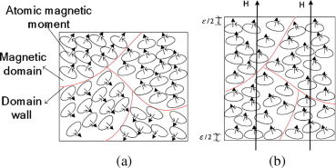
Figure 8: Random Orientations and Net Magnetic Moment:

The impact of external magnetic fields on the behavior of magnetic domains within materials has been systematically investigated through the application of advanced scientific techniques, specifically magnetic resonance and magnetometry methods. The findings of these studies have been visually represented in Figure 8 to enhance comprehension.
Magnetic resonance and magnetometry techniques enable precise and detailed examination of the response of magnetic domains to external magnetic fields. The results consistently indicate that the introduction of an external magnetic field induces significant alterations in domain behavior [38]. Specifically, observations reveal dynamic processes wherein domain walls undergo movement, and magnetic domains actively rotate. This reorientation of domains is a direct response to the external magnetic field, signifying a pronounced influence on the overall magnetization of the material.The movement of domain walls and the rotational adjustments of magnetic domains are integral mechanisms through which materials respond to external magnetic fields. This behavior is pivotal in understanding the intricate dynamics governing magnetic properties within materials. The alignment of domains with the external magnetic field contributes synergistically to the material's magnetization, elucidating a fundamental aspect of magnetism [39].These scientific insights hold broad implications for diverse applications, ranging from magnetic data storage to magnetic resonance imaging. The ability to control and manipulate the alignment of magnetic domains under external magnetic influence is foundational for the development and optimization of materials for specific technological purposes. The integration of research outcomes from magnetic resonance and magnetometry studies enhances our understanding of the nuanced interplay between external magnetic fields and domain behavior, paving the way for advancements in materials science and magnetic technology.

- Thermal Impact on Magnetic Properties
Raising the temperature of materials has a significant impact on their magnetic properties as a result of increased thermal vibrations of atoms. This heightened thermal motion enables atomic magnetic moments to rotate freely, leading to the randomization of initially aligned moments. In ferromagnetic, antiferromagnetic, and ferrimagnetic materials, the amplified thermal motions counteract coupling forces between adjacent atomic dipole moments, inducing misalignment even in the absence of an external field. This results in a reduction of saturation magnetization for both ferro- and ferrimagnets[40]. Saturation magnetization reaches its peak at 0 K when thermal vibrations are minimal, gradually decreasing as temperature rises and abruptly reaching zero at the Curie temperature (Tc). Beyond Tc, mutual spin coupling forces are completely disrupted, causing ferromagnetic and ferrimagnetic materials to become paramagnetic. The Curie temperature varies for different materials; for example, iron, cobalt, nickel, and Fe₃O₄ have respective values of 768, 1120, 335, and 585°C[41]. Fig 8. Antiferromagnetism is also influenced by temperature, ceasing at the Néel temperature, after which antiferromagnetic materials transition to paramagnetic states Fig 8.
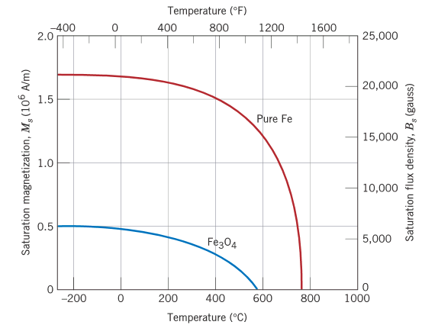
Figure. 9. Plot of saturation magnetization as a function of temperature for iron and [Adapted from J. Smit and H. P. J.Wijn, Ferrites. Copyright © 1959 by N. V. Philips Gloeilampenfabrieken, Eindhoven (Holland).Reprinted by permission

    - Domain dynamics and Hysteresis
Below a specific temperature, a ferromagnetic or ferrimagnetic material exhibits small-volume regions wherein all magnetic dipole moments align uniformly, as depicted in Figure 9 These regions, referred to as domains, showcase saturation magnetization, and they are separated by domain boundaries or walls. Across these boundaries, the direction of magnetization gradually undergoes changes, as illustrated in Figure 9. Typically microscopic in size, domains may exist within each grain of a polycrystalline specimen. Consequently, a macroscopic piece of material comprises numerous domains, each with diverse magnetization orientations. The overall magnetization field (M field) for the entire solid is the vector sum of individual domain magnetizations, with each domain's contribution weighted by its volume fraction. In the case of an unmagnetized specimen, the appropriately weighted vector sum of domain magnetizations equals zero.
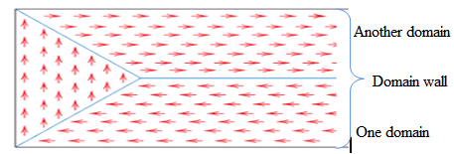
Figure. 10. Schematic depiction of domains in a ferromagnetic or ferrimagnetic material; arrows represent atomic magnetic dipoles. Within each domain, all dipoles are aligned, whereas the direction of alignment varies from one domain to another.

For ferromagnets and ferrimagnets, the relationship between flux density (B) and field intensity (H) is non-linear. In the initial absence of magnetization, the B-versus-H curve, illustrated in Figure 10, originates at the origin. With an increase in H, the B field undergoes gradual, then rapid, growth before plateauing and becoming independent of H. The maximum B value represents the saturation flux density (B_{s}), corresponding to the saturation magnetization (Ms) mentioned earlier [42]. The permeability (µ) from Equation, representing the slope of the B-versus-H curve, changes with and depends on H. Occasionally, the slope of the B-versus-H curve at H=0 is specified as a material property known as the initial permeability (µ_{i}), as indicated in Figure 10.

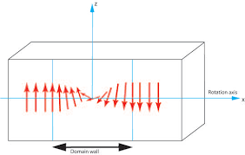
Figure 11:The gradual change in magnetic dipole orientation across a domain wall.[43]
Applying an H field induces changes in the shape and size of domains through the movement of domain boundaries. Schematic representations of domain structures, labeled U through Z, are inset at various points along the B-versus-H curve in Figure 11. Initially, constituent domains have randomly oriented moments, resulting in no net B (or M) field (inset U). As the external field is applied, domains favorably oriented or nearly aligned with the applied field grow at the expense of those unfavorably oriented (insets V through X).
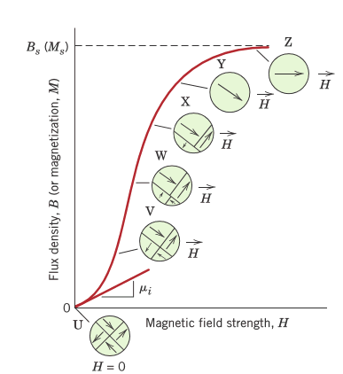

Figure 12: The B-versus-H behavior for a ferromagnetic or ferrimagnetic material that was initially unmagnetized. Domain configurations during several stages of magnetization are represented. Saturation flux density magnetization and initial permeability are also indicated. (Adapted from O. H.Wyatt and D. Dew-Hughes,Metals, Ceramics and Polymers, Cambridge University Press, 1974.)
This process continues with increasing field strength until the macroscopic specimen becomes a single domain, nearly aligned with the field (inset Y). Saturation occurs when this domain, through rotation, aligns with the H field (inset Z). The alteration of the domain structure with a magnetic field for an iron single crystal is visually demonstrated in the chapter-opening photographs. Beyond saturation (point S in Figure 12), as the H field is reduced by reversing its direction, the curve does not retrace its original path. This creates a hysteresis effect, where the B field lags behind the applied H field or decreases at a lower rate. At zero H field (point R on the curve), a residual B field, known as remanence or remanent flux density, persists, indicating that the material remains magnetized in the absence of an external H field.
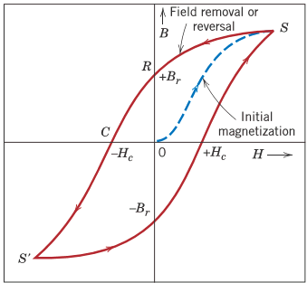

Figure 13: Magnetic flux density versus the magnetic field strength for a ferromagnetic material that is subjected to forward and reverse saturations (points S and S’). The hysteresis loop is represented by the solid curve; the dashed curve indicates the initial magnetization. The remanence B_{r} and the coercive force H_{c} are also shown

Hysteresis behavior and permanent magnetization can be elucidated by examining the motion of domain walls. When the field direction is reversed from saturation (point S in Figure 13), the process of altering the domain structure reverses as well. Initially, the single domain rotates with the reversed field, followed by the formation and growth of domains aligned with the new field, displacing the former domains. A crucial aspect of this explanation is the resistance encountered by domain walls in response to the increase in the magnetic field in the opposite direction, causing the lag of B with H, known as hysteresis. Even when the applied field returns to zero, there remains a net volume fraction of domains oriented in the former direction, explaining the existence of remanence (B_{r})[44].
To reduce the B field within the specimen to zero (point C on Figure 13), an H field of magnitude (-H_{c}) must be applied in the opposite direction to the original field (H_{c}); this is termed coercivity, or sometimes coercive force. Continuing the applied field in this reverse direction ultimately leads to saturation in the opposite sense, corresponding to point S'. A second reversal of the field to the point of the initial saturation (point S') completes the symmetrical hysteresis loop, resulting in both a negative remanence (-B_{r}) and a positive coercivity (+H_{c}).
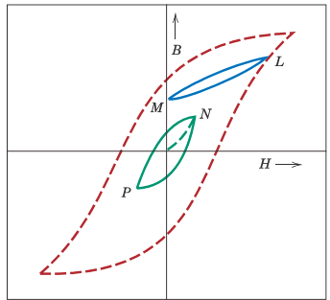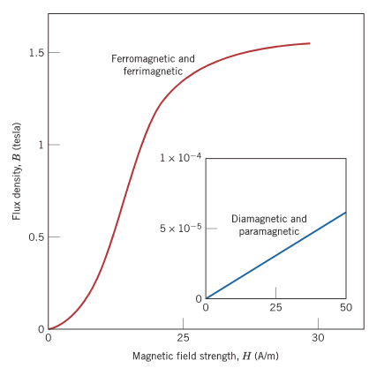
Figure 15: Comparison of B-versus-H behaviors for ferromagnetic/ferromagnetic and diamagnetic/ paramagnetic materials (inset plot). Here it may be noted that extremely small B fields are generated in materials that experience only diamagnetic/ paramagnetic behavior, which is why they are considered to be nonmagnetics.
Figure 14: A hysteresis curve at less than saturation (curve NP) within the saturation loop for a ferromagnetic material. The B–H behavior for field reversal at other than saturation is indicated by curve LM.

Figure 13depicts the B-versus-H curve, showcasing a hysteresis loop taken to saturation. It is essential to recognize that saturating the H field before reversing its direction is not mandatory. Figure 14. Introduces loop NP, representing a hysteresis curve at less than saturation. Moreover, the reversal of the field direction is feasible at any point along the curve, giving rise to various hysteresis loops. An example is evident in Figure 14, where loop LM on the saturation curve illustrates the reversal of the H field to zero. To demagnetize a ferromagnet or ferrimagnet, a method involves cyclically subjecting it to an H field that alternates direction and diminishes in magnitude.Figure.15. provides a comprehensive comparison of the B-versus-H behaviors for paramagnetic, diamagnetic, and ferromagnetic/ferrimagnetic materials. The small inset plot emphasizes the linearity observed in paramagnetic and diamagnetic materials, contrasting with the nonlinear tendencies of typical ferromagnetic/ferrimagnetic substances. Additionally, the comparison of B scales on the vertical axes in both plots at an H field strength of 50 A/m reinforces the distinction between paramagnetic and diamagnetic as nonmagnetic materials, while the flux density for ferromagnetic/ferrimagnetic materials is approximately 1.5 tesla, significantly higher than the order of 5×10⁻⁵ T for paramagnetic and diamagnetic materials.

  - Deciphering Complexity
The intricate shapes of magnetic hysteresis curves, delved into in the previous section, are a result of a myriad of influencing factors. These factors encompass whether the material under examination is a single crystal or polycrystalline, the potential presence of preferred grain orientation in polycrystalline structures, the existence of pores or second-phase particles, and other variables such as temperature and, if applicable, the application of mechanical stress. Take, for instance, the B (or M) versus H curve for a single crystal of a ferromagnetic material. Its contour is intricately tied to the crystallographic orientation in relation to the applied H field direction. This intriguing phenomenon is vividly showcased in Figure 15, featuring single crystals of nickel (FCC) and iron (BCC), where the magnetizing field aligns with [100], [110], and [111] crystallographic directions[45]. Similarly, the magnetic behavior of cobalt (HCP) in [0001] and [1010] directions [46] is visually depicted in Figure 16. This reliance on crystallographic orientation is termed magnetic, or occasionally magnetocrystalline, anisotropy.

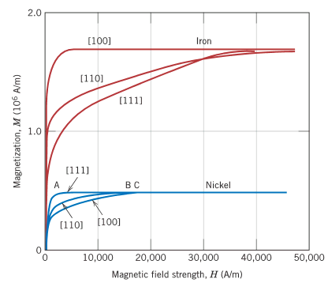

Figure.16. Magnetization curves for single crystals of iron and nickel. For both metals, a different curve was generated when themagnetic field was applied in each of [100], [110], and [111] crystallographic directions. [Adapted from K. Honda and S. Kaya, “On the Magnetisation of Single Crystals of Iron,” Sci. Rep. Tohoku Univ., 15, 721 (1926); and from S. Kaya, “On the Magnetisation of Single Crystals of Nickel,” Sci. Rep. Tohoku Univ., 17, 639 (1928).

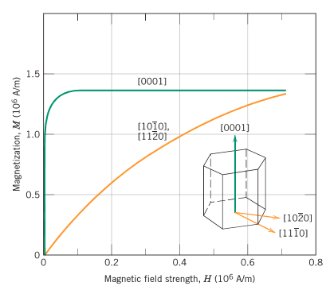

Figure.17. Magnetization curves for single crystals of cobalt. The curves were generated when the magnetic field was applied in [0001] and crystallographic directions. [Adapted from S. Kaya, “On the Magnetisation of Single Crystals of Cobalt,” Sci. Rep. Tohoku Univ., 17, 1157 (1928).

Each material involved unveils a crystallographic direction where magnetization is most facile, leading to saturation at the lowest H field—a phenomenon termed the direction of easy magnetization. For example, in nickel (Figure 16), this direction is [111], marked by saturation at point A. Conversely, for [110] and [100] orientations, saturation points align with points B and C. Correspondingly, easy magnetization directions for iron and cobalt are [100] and [0001], respectively (Figures 16 and 17). In contrast, a hard crystallographic direction poses a challenge for saturation magnetization. In the case of nickel, iron , and cobalt, these hard directions are [100], [111], and [1010], [1120], respectively.
The insets of Figure 17, as witnessed in the prior section, provide a visual narrative of domain configurations at distinct stages along the B (or M) versus H curve during the magnetization process of ferromagnetic/ferrimagnetic materials. Within these insets, each arrow symbolizes a domain's direction of easy magnetization. Domains aligned closely with the H field direction flourish at the expense of those diverging (insets V through X). Additionally, the magnetization of the solitary domain in inset Y aligns with an easy direction. Saturation is accomplished as the direction of this domain pivots away from the easy direction into alignment with the applied field (inset Z).

- Classification of advanced magnetic materials
Integral to a diverse array of contemporary technologies, ranging from electronic devices to medical applications, advanced magnetic materials assume a pivotal role. Possessing distinctive magnetic properties, these materials have become indispensable across various industries. Below is a brief overview of key categories within the realm of advanced magnetic materials:

  - Soft magnetic materials
The dimensions and shape of the hysteresis curve in ferromagnetic and ferrimagnetic materials are of practical significance, particularly concerning magnetic energy loss during magnetization–demagnetization cycles. This loss is reflected in the enclosed loop area, leading to heat generation within the magnetic specimen and the possibility of a temperature rise [47]. Both ferromagnetic and ferrimagnetic materials are categorized as either soft or hard based on their hysteresis characteristics. Soft magnetic materials are essential for devices exposed to alternating magnetic fields, with transformer cores serving as a common example. Consequently, these materials must possess a hysteresis loop with a small relative area, characterized by thin and narrow dimensions, as depicted in Figure 18. This necessitates high initial permeability and low coercivity.
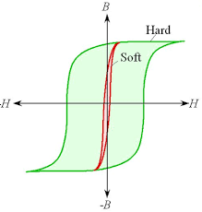
Figure. 18: Schematic magnetization curves for soft and hard magnetic materials.

Table 3. Typical properties of Soft magnetic materials
Material | Composition in wt % | Initial permeability (µ_{i}) | Saturation flux density B_{s} Tesla (gauss) | Hysteresis loss /cycle (erg/cm³) | Resistivity ρ (Ω-m)
Silicon iron | 97 Fe, 3Si | 1400 | 2.01 | 40 | 4.7$×$ 10⁻⁷
45 Permalloy | 55Fe, 45 Ni | 2500 | 1.60 | 120 | 4.5 $×$ 10⁻⁷
Supermalloy | 79Ni, 15Fe, 5Mo, 0.5Mn | 75000 | 0.80 | - | 6.0$×$ 10⁻⁷
Ferroxcube A | 48MnFe₂O_{4,} 52ZnFe₂O₄ | 1400 | 0.33 | 40 | 2000
Ferroxcube B | 36NiFe₂O_{4,} 64ZnFe₂O₄ | 6500 | 0.36 | 35 | 10⁷
Source: Adapted from Metals Handbook: Properties and Selection: Stainless Steels, Tool Materials and Special- Purpose Metals, Vol. 3, 9th edition, D. Benjamin (Senior Editor), American Society for Metals, 1980.

The saturation magnetization or field is solely determined by the material's composition. For instance, in cubic ferrites, replacing Fe²⁺ with a divalent metal ion like Ni²⁺ in FeO-Fe₂O₃ alters the saturation magnetization. However, susceptibility and coercivity (H_{c}), which influence the shape of the hysteresis curve, depend on structural variables rather than composition. Structural defects, such as nonmagnetic phase particles or voids, can impede domain wall motion and increase coercivity. Therefore, soft magnetic materials should ideally be free of such defects. Additionally, electrical resistivity is a crucial factor for soft magnetic materials. In addition to hysteresis losses, energy losses due to eddy currents induced by a varying magnetic field are significant. To minimize these losses, electrical resistivity is increased in ferromagnetic materials through solid solution alloys like iron–silicon and iron–nickel alloys. Although ceramic ferrites are commonly used for soft magnetic applications due to their intrinsic electrical insulation, their utilization is somewhat restricted due to relatively small susceptibilities. Table 3, illustrates the properties of a variety of soft magnetic materials. The hysteresis characteristics of these materials can be improved for certain applications through appropriate heat treatment in the presence of a magnetic field. This technique can produce a desirable square hysteresis loop, particularly useful in magnetic amplifier and pulse transformer applications. Furthermore, soft magnetic materials find application in generators, motors, dynamos, and switching circuits.

  - Hard magnetic materials
Resilient permanent magnets crucial for diverse applications heavily rely on the unique characteristics of hard magnetic materials. In-depth exploration of hysteresis behavior indicates that these materials showcase exceptional remanence, coercivity, and saturation flux density, coupled with low initial permeability and heightened hysteresis energy losses. Figure 18, provides a comparative analysis, highlighting the distinctive hysteresis features of hard versus soft magnetic materials. Crucial factors for practical application emerge in the form of coercivity and the "Energy product" ((B_{H})_{Max).} The metric (B_{H})Max, measured in kJ/m³, quantifies the energy needed to demagnetize a permanent magnet, serving as a magnetic hardness indicator[48]. The hysteresis curve, illustrated in Figure 16 visually represents this parameter by delineating the largest area within the B-H rectangle. Furthermore, the ease of magnetic domain boundary movement is intricately linked to hysteresis behavior. Elevated coercivity and susceptibility, achieved by impeding domain wall motion, mandate a substantial external field for demagnetization, a characteristic deeply embedded in the material's microstructure. Notably, hard magnetic materials find application in permanent magnets that demand high resistance to demagnetization. Characterized by high remanence, coercivity, and saturation flux density, along with low initial permeability and elevated hysteresis energy losses, these materials manifest their magnetic properties in the hysteresis curve, as depicted in Figure 18. The two pivotal characteristics for practical applications are coercivity and the energy product (BH)_{Max}, the latter representing the energy required for demagnetization[49]. A larger (BH)_{Max} value signifies greater magnetic hardness, as illustrated in Figure 19.
Hysteresis behavior is intricately tied to the movement of domain walls, influenced by the final microstructure encompassing the size, shape, and orientation of crystal domains and impurities. The processing method plays a vital role in determining the microstructure. To prepare hard magnetic materials, magnetic substances undergo controlled heating followed by rapid cooling through immersion in a cold liquid. Purposeful introduction of impurities in hard magnetic materials impedes domain wall movement, increasing coercivity and decreasing susceptibility, ultimately requiring a substantial external field for demagnetization.

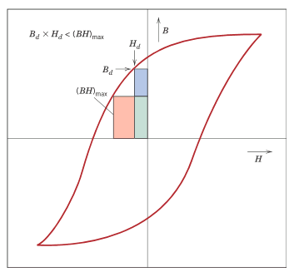
Figure 19: Schematic magnetization curve that displays hysteresis.Within the second quadrant are drawn two B–H energy product rectangles; the area of that rectangle (B_{H})_{Max} labeled is the largest possible, which is greater than the area defined by Bd–Hd

  - High-Energy Hard Magnetic Materials
These are materials that possess a permanent high magnetic energy, and they are identified by having energy products exceeding about 80 kJ/m³(10 MGOe). These materials fall into the category of high-energy permanent magnetic materials. They are essentially recently developed intermetallic compounds with various compositions. Notably, two of these compounds, namely SmCo₅ and Nd₂Fe₁₄B, have gained commercial traction[50]. To delve into their magnetic characteristics, Table 4 offers a comprehensive overview of the relevant properties of these materials.

Table 4: Typical properties of Hard magnetic materials
Material | Composition in wt % | Remanance (B_{r}) Tesla (gauss) | Coercivity (H_{c}) (O_{e}) | Curie Temperature (T_{c}) | (B_{H})_{Max} in MGO_{e} | Resistivity ρ (Ω-m)
Tungesten Steel | 92.8 Fe, 6W, 0.5C, 0.5 Cr | 0.95 | 74 | 760 | 2.6 | 3.0 $×$ 10⁻⁷
Cunife | 20Fe,20Ni, 60Cu | 0.54 | 550 | 410 | 12 | 1.8 $×$ 10⁻⁷
Sintered Alnico | 34 Fe, 7Al, 15 Ni, 35Co, 4Cu, 5Ti | 0.76 | 1550 | 860 | 36 | -
Cobalt rare earth 1 | SmCo₅ | 0.92 | 9000 | 725 | 170 | 5.0 $×$ 10⁻⁷
Sintered neodymium iron-boron | Nd₂Fe₁₄B | 1.16 | 10600 | 310 | 255 | 1.6 $×$ 10⁻⁶
Adapted from ASM Handbook, Vol. 2, Properties and Selection: Nonferrous Alloys and Special-Purpose Materials. Copyright 1990 by ASM International. Reprinted by permission of ASM International, Materials Park, OH

    - Samarium–Cobalt Magnets
SmCo magnets are known for their strong magnetic power and durability, making them widely used in industries like electronics and aerospace. An exciting advancement involves using 3D printing to create these magnets, a departure from traditional methods[51]. This innovative approach brings more flexibility in design, reduces material waste, and allows for intricate shapes. The process includes developing a specialized SmCo alloy for 3D printing, creating a fine powder, and using techniques like selective laser sintering to build the magnet layer by layer with an external magnetic field for alignment. Post-processing involves heat treatment to optimize magnetic performance. A notable application is in medical devices, specifically in crafting micro-scale magnetic actuators. By shaping tiny, biocompatible SmCo magnets, 3D printing enables the construction of complex structures. For instance, a micro-scale magnetic actuator for targeted drug delivery involves attaching the magnet to a drug-loaded microcarrier. Guided by an external magnetic field, these microcarriers navigate the body, ensuring precise drug delivery to specific tissues or cells. This application highlights the transformative potential of innovative manufacturing in delivering advanced, tailored solutions for critical fields like medicine, emphasizing precision and targeted therapeutic interventions[51].

    - Neodymium–Iron–Boron Magnets
Samarium is a rare and expensive element, and cobalt's costs can be unpredictable and sources unreliable. This led to the preference for Nd₂Fe₁₄B alloys in many applications requiring strong magnets, as they have competitive qualities like coercivity and energy products comparable to samarium–cobalt alloys (Table 20.6). The behavior of these materials when magnetized or demagnetized depends on domain wall mobility, influenced by the final microstructure, including the size, shape, and orientation of crystals or grains, and the presence of second-phase particles. Microstructure is affected by how the material is processed. Two main techniques for making Nd₂Fe₁₄B magnets are powder metallurgy (sintering) and rapid solidification (melt spinning)[52]. Powder metallurgy is similar to the method used for SmCo₅ materials, while rapid solidification involves quickly cooling the molten alloy to produce either amorphous or fine-grained solid ribbons. These ribbons are then crushed, shaped, and heat-treated. Despite being more complex, rapid solidification is continuous, while powder metallurgy is a batch process. These strong magnetic materials are used in various devices across different fields, with motors being a common application. Permanent magnets, like those made from Nd₂Fe₁₄B alloys, are favored over electromagnets because they maintain their magnetic fields without needing electrical power and don't generate heat during operation[54]. Motors using permanent magnets are smaller and widely used in cordless drills, screwdrivers, automobiles (starting, window winder, wiper, washer, and fan motors), audio and video recorders, clocks, speakers, lightweight earphones, hearing aids, and computer peripherals.

- Magnetic Nanomaterials
Understanding tiny materials, especially magnetic ones, is crucial for several reasons. When materials are really small, their properties change a lot, especially in magnetic materials. This is because of quantum effects and the fact that they have a big surface compared to their volume. Knowing this is important for customizing these tiny materials for specific uses. Quantum effects, which are really noticeable at the tiny scale, create interesting behaviors like super-paramagnetism. This is important in things like magnetic storage and sensing. Controlling the size, shape, and composition of these tiny magnetic particles is key to making them useful in different ways, from medical imaging to delivering drugs.
In medicine, these tiny magnetic materials are used in things like MRI scans, targeted drug delivery, and treating cancer with heat. They also improve electronics and data storage, making things work better and smaller[55]. Being good at working with these tiny materials is important for making them consistently and safely. As we use more of these materials, it's crucial to think about safety and the environment, guiding us to create secure and sustainable uses for them. Studying magnetic tiny materials brings together experts from different fields like physics, chemistry, materials science, and engineering. This collaboration helps find new and creative solutions to problems. Nanoscience is an important part of current research, with nanotechnology leading the way[56]. It allows scientists and engineers to explore really small things, pushing advancements in life sciences and healthcare. Tiny particles, especially magnetic ones, have a lot of potential uses in areas like biotechnology, materials science, engineering, and the environment. While we're still figuring out how to use them in life sciences, their unique properties suggest a bright future.
In industries, magnetic tiny particles find uses in magnetic recording and medical tools like MRI contrast agents and cancer treatments[57]. Each use requires specific properties, like stable magnetic states for data storage or superparamagnetism for medical applications. In medicine, it's important to make sure these particles remain stable in the body, so choosing the right materials is crucial. Non-toxic materials like iron oxide nanoparticles are preferred. Using really small particles, especially those smaller than 100 nanometers, has benefits like larger surface areas and better diffusion. However, creating these tiny materials poses challenges in making sure they have the right size, shape, and properties. Recent efforts are focused on making 'monodispersed colloids,' which means particles that are all the same size and shape. These efforts have applications in various fields, from research to creating products in medicine, catalysis, and ceramics.

  - Application of Magnetic nanomaterials
    - Industrial applications
Magnetic iron oxides, specifically hematite (Fe₂O₃) and magnetite (Fe₃O₄), are commonly employed as synthetic pigments in ceramics, paints, and porcelain due to their distinct color properties. Hematite appears red-brown, while magnetite has a black color. Beyond their aesthetic applications, these magnetic materials exhibit noteworthy potential when encapsulated, influencing diverse aspects of life and various industrial sectors. Scientific studies, as referenced in publications [58, 59], indicate that the exploration of magnetic iron oxides is intriguing from both a fundamental material science perspective and for their practical applications. The encapsulation of these materials enhances their functionalities and opens avenues for their utilization in a wide range of applications.In the field of catalysis, hematite and magnetite have demonstrated their effectiveness as catalysts in several key reactions, supported by scientific data. For instance, they play a crucial role in the synthesis of ammonia (NH₃), a reaction with significant importance in the production of fertilizers. Studies also show their involvement in the desulfurization of natural gas, an essential process in reducing sulfur content for environmental and industrial reasons.
Moreover, these magnetic oxides exhibit catalytic activity in the water-gas shift reaction at high temperatures. This reaction is vital for the production of hydrogen and is integral to processes such as fuel cell technology and industrial hydrogen production. Scientific literature [60-62] provides evidence of the involvement of hematite and magnetite in additional catalytic reactions. These include their role in the Fischer-Tropsch synthesis for hydrocarbon production, the dehydrogenation of ethylbenzene to styrene, the oxidation of alcohols, and the large-scale synthesis of butadiene, a key component in the production of synthetic rubbers. The versatility of magnetic iron oxides is further emphasized by their integration into various industrial processes, showcasing their significance in advancing chemical reactions with practical implications. The scientific data supports the multifaceted utility of these materials, ranging from aesthetic applications to catalyzing crucial chemical transformations across different sectors.

Biomedical applications
Magnetic nanoparticles have found extensive applications in biomedicine, delineated into in vivo and in vitro categories. In the domain of in vitro applications, their primary utilization centers around diagnostic purposes, specifically in separation, selection, and magnetorelaxometry. Conversely, in vivo applications can be further categorized into therapeutic functions, such as hyperthermia and drug targeting, as well as diagnostic applications like nuclear magnetic resonance (NMR) imaging [63-65]. In the realm of in vivo applications, the efficacy of magnetic nanoparticles is intricately linked to particle size and surface functionality. Even in the absence of specific targeting ligands, the biodistribution of superparamagnetic iron oxide nanoparticles (SPIOs) in vivo is significantly influenced by their diameters. Particles falling within the 10 to 40 nm range, including ultra-small SPIOs, play a pivotal role in extending blood circulation. These nanoparticles can permeate capillary walls and are frequently engulfed by macrophages, leading to their accumulation in lymph nodes and bone marrow [66].

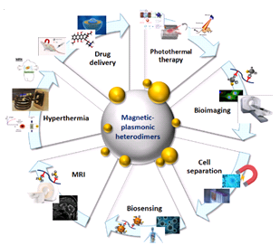
Figure 20: Biomedical Application Chart

- Therapeutic Applications – Hyperthermia: The introduction of superparamagnetic iron oxide into alternating current (AC) magnetic fields induces random changes in magnetization direction, resulting in heat generation referred to as hyperthermia. This property is harnessed in vivo to raise tumor tissue temperatures, selectively eradicating pathological cells. Tumor cells exhibit heightened sensitivity to temperature increases compared to healthy cells. Studies have demonstrated the effectiveness of magnetite cationic liposomal nanoparticles and dextran-coated magnetite in elevating tumor cell temperatures for hyperthermia treatment. Magnetic hyperthermia offers the advantage of localized heating, especially when employing nanometer-sized particles, which absorb more power at tolerable AC magnetic fields [67,68]. The synthesis of uniform particles through well-defined routes is essential for precise temperature control.
- Drug Delivery: Combining magnetic nanoparticles with an external magnetic field and/or magnetizable implants facilitates targeted drug delivery. This approach enables the delivery of particles to specific target areas, where they can be localized, releasing medication precisely (magnetic drug targeting). Surface modifications with organic polymers and inorganic materials enhance biocompatibility, allowing further functionalization with bioactive molecules. Magnetic drug targeting relies on the interplay between forces exerted by the blood compartment and magnetic forces generated by the magnet, with the aim of eliminating side effects and reducing required dosages [69-71].
- Diagnostic Applications: NMR Imaging: The advancement of nuclear magnetic resonance (NMR) imaging for clinical diagnosis necessitates a new category of pharmaceuticals known as magneto-pharmaceuticals. These substances aim to enhance image contrast between normal and diseased tissues or indicate organ functions and blood flow status upon administration to patients.

  - Transitioning to in vitro applications:
    - Diagnostic Applications:
- Separation and Selection: Solid-phase extraction (SPE) is gaining prominence as a method for isolating and preconcentrating components from sample matrices. Magnetic solid-phase extraction (MSPE) becomes crucial in this context, offering stability against sedimentation in the absence of an applied magnetic field. Iron oxide magnetic nanoparticles hold particular advantages over microparticles in this application. Notably, commercial products are already available, emphasizing the practicality and market presence of MSPE [72-74].
- Magnetorelaxometry serves as a valuable method in assessing immunoassays [75]. This technique gauges magnetic viscosity, specifically the relaxation of the collective magnetic moment in a system of magnetic nanoparticles following the removal of a magnetic field [76]. Two distinct relaxation mechanisms are observed: Néel relaxation and Brownian relaxation [77,78]. Néel relaxation involves the internal magnetization vector of a nanoparticle relaxing along the easy axis within the core. On the other hand, Brownian relaxation occurs as particles undergo rotational diffusion in a carrier liquid. The differentiation between Néel and Brownian relaxation lies in their distinct relaxation times [79].It is noteworthy that Brownian relaxation exclusively occurs in liquids, while Néel relaxation remains independent of nanoparticle dispersion. The dependence of magnetorelaxometry on core size, hydrodynamic size, and anisotropy enables the discrimination between free and bound conjugates based on their distinct magnetic behaviors. Consequently, this technique proves to be an analytical tool for evaluating immunoassays [80]. The advantages of reducing particle size to the nanometer scale for this application mirror those described in separation and selection processes.
- Magnetic Resonance Imaging (MRI) stands at the interface of nanomaterials and medical diagnostics, where superparamagnetic iron oxide nanoparticles (NPs) emerge as a novel class of probes with applications in cellular and molecular imaging, both in vitro and in vivo. Notably, superparamagnetic contrast agents, such as these iron oxide NPs, offer an advantage over paramagnetic ones by inducing enhanced proton relaxation in MRI. This enhanced efficiency implies that lower quantities of superparamagnetic iron oxide (SPIO) agents are required for dosing the human body compared to paramagnetic alternatives. Integration of SPIO into a biocompatible and biodegradable carrier facilitates its use as an MRI contrast agent. Recent comprehensive reviews, such as the one by Muller et al. [81], delve into the diverse applications of superparamagnetic iron oxide NPs in contrast agent technology.
While MRIs are powerful diagnostic tools, they lack the convenience of in situ monitoring. Hence, there is a demand for a sensitive and straightforward technique to monitor NPs within living cells. Nanometer-sized fluorescence probes present advantages over conventional organic probes, including heightened photo stability and fluorescence intensity. However, challenges arise in cell imaging using these probes due to susceptibility to background noises from cells, matrix, and nonspecific scattering lights, making achieving a high signal-to-noise (S/N) ratio challenging.
In the realm of bioseparation within biomedical studies, the isolation of specific biological entities, such as DNAs, proteins, and cells, from their natural environment becomes crucial for analysis. Superparamagnetic colloids, with their magnetization on-off nature in the presence or absence of an external magnetic field, prove ideal for this purpose. In bioseparation procedures, biological entities are labeled with superparamagnetic colloids and then separated using an external magnetic field [82]. Nanometer-sized magnetic particles, like superparamagnetic iron oxide particles, find extensive use in the separation and purification of cells and biomolecules in bioprocesses [83-84]. Their small size and high surface area contribute to superior characteristics, including good dispersability, rapid and effective biomolecule binding, and reversible and controllable flocculation. An emerging trend involves magnetic separation using antibodies to offer highly precise binding to matching antigens on the targeted species' surface.

- Multiferroic Materials
  - Overview of materials exhibiting both magnetic and ferroelectric properties.
Multiferroic materials constitute a class of substances distinguished by their concurrent possession of multiple fundamental ferroic properties, specifically ferroelectricity, ferromagnetism, and ferroelasticity [85]. In contemporary scientific discourse, the term "multiferroic" characterizes materials that exhibit both ferroelectric and magnetic characteristics, encompassing various magnetic features such as ferro-, ferri-, and antiferromagnetism, and even ferrotoroidicity . These materials have garnered considerable attention due to their potential applications in cutting-edge technologies, including magnetoelectric random-access memories, sensors, actuators, energy harvesting devices, and spintronics [87]. Figure 21 provides graphical representations elucidating the distinctive attributes of multiferroic materials. Ferromagnetic materials manifest discernible hysteresis loops when subjected to external magnetic fields, as depicted in blue in Figure 21. Conversely, ferroelectric materials exhibit analogous hysteresis behavior under the influence of applied electric fields, illustrated in yellow in Figure 21. Multiferroic materials uniquely demonstrate an electrical response when subjected to an electric field and vice versa, illustrating a coupled behavior highlighted in green in Figure 21 [87].
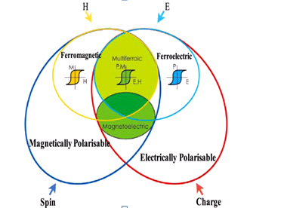
Figure: 21:Schematic diagram of Multiferroics

Ferroelectricity refers to the phenomenon where the inherent electric polarization of a material can be altered by applying external electric field.This concept shares similarities with ferromagnetism, a well-established idea predating the discovery of ferroelectricity. Ferromagnetism is a phenomenon marked by spontaneous magnetization, which can be modified by an external magnetic field and reaches saturation along the direction of that field, typically occurring below a critical temperature. It is noteworthy that the definition of multiferroics now includes antiferromagnetism as well. Materials displaying antiferromagnetism are characterized by ordered magnetic moments arranged in a regular pattern, with neighboring moments canceling each other out completely within a single magnetic unit cell.
Ferroelasticity, a phenomenon characterized by the spontaneous strain response of a material under the influence of mechanical stress, entails the transformation of a ferroelastic specimen from its initial phase to an equally thermodynamically stable phase, characterized by distinct crystallographic structures or orientations. This transformation event precipitates the emergence of spontaneous strain within the material. The inception of ferroelectric-ferromagnetic materials can be traced back to the discovery of Nickel Iodine Boracite (Ni₃B₇O₁₃I) as the inaugural member within this category [88]. Following this milestone, numerous multiferroic Boracite compounds were successfully synthesized. The quest to amalgamate both ferromagnetic and ferroelectric characteristics within a single system was initiated during the 1960s by two Russian research groups: Smolenskii and Venevsev, situated in St. Petersburg and Moscow, respectively[89]. This pursuit adopted a strategic approach involving the substitution of B-site d⁰ cations with magnetic dn cations within ferroelectric perovskite structures to engender novel ferroelectric-ferromagnetic compounds. Utilizing this technique, researchers unveiled two distinct phenomena, namely ferroelectric,anti-ferromagnetic Pb(Fe_{0.5}N_{0.5})O₃ and ferroelectric-ferromagnetic Pb(Fe_{0.6}W_{0.3})O₃, in which the coexistence of ferroelectricity and magnetism was established. The presence of mutual interactions between these two ferroic orders is recognized as magneto-electric coupling, a pivotal facet of multiferroics.

  - Magnetoelectric effect:
Multiferroic magnetoelectric materials can be categorized into two types, single-phase and composite-phase multiferroics, depending on the constituent materials employed. Single-phase multiferroics found in nature are rare but exhibit spontaneous magnetization and polarization due to intrinsic magnetoelectric (ME) effects. However, most single-phase multiferroics display weak ME effects at room temperature, limiting their practical applications because of their low critical temperature and limited ME coupling strength. This has led to the exploration of alternative materials, resulting in the development of ME composites by combining magnetic and piezoelectric components. These composites achieve desired ME properties through precise compositions of magnetostrictive and piezoelectric phases. ME composites have gained more attention than single-phase multiferroics due to their significantly enhanced ME coupling. Composites may demonstrate either sum or product properties. The product property is particularly intriguing as it is absent in the constituent phases but present in the composites. The concept of ME effect as a product tensor property in composites was originally proposed by Van Suchtelen[90]. Boomgard et. al. [91] outlined several prerequisites for achieving higher ME coupling in these composites:
- Both constituent phases of the composites must be in equilibrium.
- The magnetostriction and piezoelectric coefficients of the ferrite and ferroelectric phases should be high.
- The ferrite phase should have high resistivity to prevent charge leakage.
The ME effect in these composites can be described as the product of the magnetostrictive effect in the ferrite phase and the piezoelectric effect of the ferroelectric phase, representing a coupled electrical and magnetic phenomenon mediated by elastic interactions. ME coupling is an extrinsic effect reliant on the microstructure of the composites and the coupling interactions at the interface of the constituent phases . The ME effect in composites has two distinct types, as described by equations (2) and 3.

Direct ME effect =$\frac{Magnetic}{Mechanical}×\frac{Mechanical}{Electrical}$………..2

Converse ME effect$=\frac{Electrical}{Mechanical}×\frac{Mechanical}{Magnetical}$…..….3
The induction of electric polarization on application of external magnetic field is known as direct ME effect and vice versa is known as converse ME effect. In direct ME effect ferrite phase changes its shape magnetostrictively on application of magnetic field, the strain produced in ferrite phase is transferred to ferroelectric phase via elastic interaction resulting in electric polarization due to piezoelectric effect. In converse ME effect, electric field induces strain in the strain in the ferroelectric phase ascribed to inverse piezoelectric effect. This strain is then mechanically transferred to ferrite phase, inducing a change in magnetization through piezomagnetic effect . The mechanism of direct ME effect is described in Fig.1.4

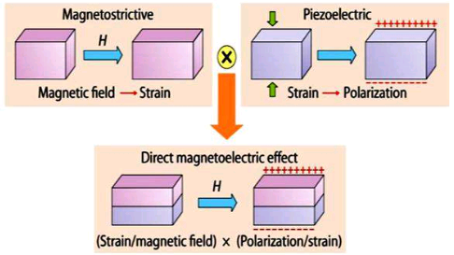
Figure 22:Illustrate of strain mediated ME effect in a composite with an applied magnetic field H having magnetic layer and ferroelectric layer

Electrical polarization and magnetism are most important phenomena associated with the multiferroics, composite materials and ME effect. In the next section we will discuss about these electrical and magnetic properties in details.

  - Electrical polarization
Electrical polarization in materials arises due to arrangement of electrical dipole moments which is determined by the crystal symmetry of a material, mainly lack of centre of inversion symmetry [92]. In the following section we will discuss about the different classes of materials exhibiting electrical polarization.

    - Dielectrics
Dielectric materials, being electrically insulating in nature, demonstrate polarization under the influence of an electric field. Essentially, all dielectrics are insulators, and when an electric field is applied, it leads to the displacement of positive and negative charge centers, resulting in the emergence of a net dipole moment. This phenomenon is commonly referred to as polarization. Owing to their ability to polarize, dielectric materials have widespread applications in various devices, such as filters, data processors, and storage systems. The capacity for energy storage depends on the specific properties of the material, encompassing both intrinsic and extrinsic factors that impact the polarization process. Dielectric materials can be broadly classified into two main categories: non-ferroelectric and ferroelectric materials.

    - Non-ferroelectric materials
Non-ferroelectric materials, when subjected to an external electric field, exhibit a phenomenon known as electric polarization. This polarization can be understood through three primary intrinsic mechanisms, each of which responds to the frequency of the applied electric field. These mechanisms are electronic polarization, ionic polarization, and orientational polarization, the latter also known as dipolar polarization.

- Electronic Polarization: Electronic polarization occurs when an external electric field distorts the electron cloud surrounding an atom. This distortion results in the displacement of electrons within the atom, creating a separation of charge and an induced electric dipole moment. This type of polarization is particularly effective within a high-frequency range, typically between 10¹² to 10¹⁵ Hz. It is a consequence of the electronic response of the material to the applied field.
- Ionic Polarization: Ionic polarization arises when the positive and negative ions within the material shift their positions relative to each other in response to the applied alternating electric field. The movement of ions leads to the development of a net electric dipole moment in the material. Ionic polarization is dominant within a lower frequency range, typically between 10⁹ to 10¹² Hz. It is a manifestation of the ionic mobility within the material.

    - Orientational Polarization (Dipolar Polarization):
Orientational polarization, often referred to as dipolar polarization, is a consequence of the alignment of permanent dipoles present in the material. When subjected to an external electric field, these dipoles orient themselves in the direction of the field, resulting in the creation of an overall electric dipole moment. This type of polarization is effective within a lower frequency range, typically between 10⁶ to 10⁹ Hz. It is commonly observed in materials that possess permanent dipoles, such as certain types of molecules or crystals.

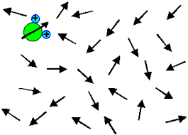
Figure 23. Orientational Polarization
It is important to note that all these polarization processes originate from the response of bound charges within the material system to the applied electric field. The choice of mechanism and its effectiveness depend on the nature of the material and the frequency of the applied electric field. Understanding these mechanisms is crucial for various applications, including the design of electronic devices and materials with specific electrical properties. Figure 23, that depicts different polarization mechanisms and mentions the existence of extrinsic polarization contributions, specifically space charge polarization and polarization within grains and grain boundaries, with reference to a source. In the realm of magnetoelectric composites, a common observation is the presence of multiple temperature-dependent relaxation phenomena occurring within the frequency range of 10 to 10⁶ Hz [93]. Furthermore, these composites exhibit losses exceeding unity, and these losses notably escalate as temperatures rise, particularly at lower frequencies. The interplay between permittivity and temperature in these composites unveils an intriguing anomaly in proximity to the ferro-paraelectric transition within the non-magnetic phase. This anomaly serves as empirical evidence affirming the enduring ferroelectric characteristics within the composite material. Typically, this anomaly manifests as a broad peak, attributed to localized compositional variations and the presence of mechanical stresses, culminating in a wide spectrum of local Curie temperatures. It is noteworthy that in select composites, this peak may precisely coincide with the ferroelectric Curie temperature, while in others; it may shift towards either higher or lower temperature regimes.Size-related factors have a substantial impact on the properties of ferroelectrics. For instance, V. Buscaglia and colleagues' research has demonstrated that barium titanate samples boasting grain sizes surpassing 300 nm maintain a tetragonal unit cell structure, whereas their nanocrystalline counterparts, characterized by grain sizes at or below 100 nm, adopt a cubic unit cell structure[94].
As previously mentioned, dielectric properties are exquisitely sensitive to microstructural attributes. Elevation in dielectric losses and the observation of multiple relaxation phenomena are predominantly attributed to factors such as inadequate homogeneity, heightened porosity stemming from constraints in sintering temperatures, and the existence of cracks arising from the co-sintering of phases possessing disparate thermal expansion coefficients. Enhancement in microstructural integrity can lead to a reduction in dielectric losses, although the overarching dielectric relaxations typically endure. These phenomena, emanating from extrinsic influences, are frequently ascribed to the Maxwell-Wagner effect. In this context, charge defects, including A-site vacancies within perovskite ABO₃ materials and mobile space charge electrons, have the capacity to migrate within the material when subjected to an electric field, contingent upon the material's conductivity at elevated temperatures. These mobile charge carriers may subsequently become entrapped at the interfaces between materials characterized by differential conductivity and permittivity, culminating in the emergence of interfacial polarization. This phenomenon assumes particular significance in the domain of magnetoelectric composites where a dielectric matrix accommodates inclusions composed of more conductive materials.

- Ferroelectrics
The inception of the Ferroelectric effect can be traced back to its initial observation by Valasek in 1921, a significant milestone that occurred in the study of Rochelle salt. The term "ferro" finds its etymological roots in the Greek word "ferum," denoting iron. It is important to clarify that despite its nomenclature, ferroelectrics do not inherently contain iron; rather, the nomenclature draws an analogy to ferromagnetism due to shared characteristics. Ferroelectrics represent a class of materials distinguished by their propensity to exhibit spontaneous polarization, a quality that can be reversed through the application of an electric field . A pivotal characteristic of ferroelectric materials lies in their non-centrosymmetric crystal structure, indicating the absence of a center of inversion. Notably, a majority of ferroelectric materials conform to the perovskite crystal structure, characterized by the general formula ABO₃.
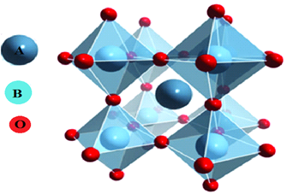
Figure:24 Schematic representation of perovskite structureFeatures of Ferroelectricity

  - Hysteresis behavior
Ferroelectric materials are dielectrics characterized by the presence of spontaneous polarization in the absence of an external electric field. These materials possess a polarized state, and the orientation of this polarization can be altered through the application of an external electric field. One of the defining features of ferroelectric materials is their ability to undergo polarization reversal when subjected to an electric field. This phenomenon is a hallmark of their behavior. Hysteresis loops observed in ferroelectrics reveal that the electric flux density (D) in these materials is not solely determined by the applied electric field but is also influenced by their prior history. In macroscopic crystals, the direction of spontaneous polarization is not uniform; instead, it comprises numerous domains. Each domain has a specific orientation of polarization, which can vary from one domain to another. Initially, when no electric field is applied, the overall polarization of the ferroelectric material is zero because the vector sum of the dipole moments within constituent domains cancels out. Upon the application of an external electric field, the polarization components associated with domains aligned with the field direction grow at the expense of domains with anti-parallel polarization. This process leads to an increase in polarization (represented by the segment OA in the polarization vs. electric field hysteresis loop). In the region represented by AB in the hysteresis loop, domains with unfavorable polarization orientations begin to switch in the direction of the applied field as the magnitude of the applied field increases. This switching results in a nonlinear increase in polarization. When all the domains within the material become uniformly oriented along the direction of the applied electric field (represented by segment BC), the polarization reaches saturation. This state signifies that the crystal behaves as a single domain material with a maximum polarization value.
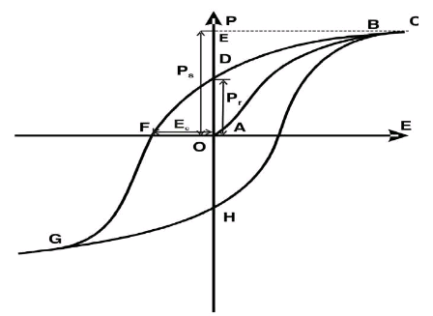
Figure 25. Schematic of P-E hysteresis loop for a ferroelectric material [37]

Linear extrapolation of the Barkhausen coefficient (BC) to zero magnetic fields allows us to determine the magnitude of saturation polarization (PS, denoted as AP). Upon the diminishment of the magnetic field magnitude, the saturation polarization, while declining, does not reach a complete null state. This residual polarization is characterized as remnant polarization (PR, designated as AD). To nullify the polarization entirely, it necessitates the application of an electric field in the opposing direction, and this electric field strength is defined as the coercive field (EC).

  - Synthesis and Fabrication Techniques
The synthesis of ceramic oxides poses an enduring challenge for materials scientists, owing to the pivotal roles these compounds play in diverse technological applications. Of particular significance is the synthesis of magnetic oxides, which has garnered considerable attention due to their critical functions in fields such as electronics, data storage, and energy conversion. Over time, scientists have devised an array of methodologies to address this challenge, each method offering distinct advantages and exerting a discernible influence on the resultant material's properties. The selection of a particular synthesis method is far from arbitrary, as it profoundly shapes the composition, structure, and performance of the resulting magnetic oxide material. The attainment of high-quality, single-phase materials necessitates meticulous consideration of several pivotal factors, including temperature, cooling rate, synthesis parameters, and reaction conditions. The achievement of desired material properties hinges on the precise control and optimization of these influential parameters.
Various methodologies are employed in the preparation of magnetic oxide materials, each possessing unique merits:

- Physical vapor deposition
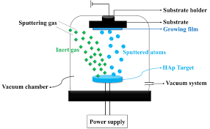
Figure: 26. Schematic of a fundamental physical vapor deposition system

Physical vapor deposition (PVD) is a sophisticated vaporization coating technique employed for depositing thin films of materials such as metals, ceramics, and semiconductors onto surfaces. Operating in a vacuum, PVD shares similarities with chemical vapor deposition (CVD) but distinguishes itself by utilizing a solid precursor instead of a gas-phase precursor. The PVD process involves four key stages: material evaporation or precursor using a high-energy source like an electron beam, vapor transport to the substrate, reaction between substrate atoms and a reactive gas, and ultimately, the deposition of the coating onto the substrate surface. In a study conducted by Sanath Kumar Honnali et al., thermoelements were manufactured on glass substrates. The substrate underwent a meticulous cleaning process, including wet chemical cleaning and steam degreasing. A crucial step involved loading the chamber with O₂ for a 15-minute plasma cleaning, adjusting the pressure from 8 × 10⁻² mbar to 1 × 10⁻¹ mbar. This plasma treatment enhanced Si–O functional groups, thereby improving the adhesion of thin films on the substrate. The actual deposition of ZnO occurred through cathodic sputtering with pure zinc as the target, maintaining a substrate-reactive distance of 5 cm. The chamber was evacuated to a base pressure of 2 × 10⁻⁵ mbar to minimize background impurities. Multiple deposition cycles, with varying oxygen partial pressures (ranging from 9 × 10⁻⁴ mbar to 3 × 10⁻³ mbar), were executed, maintaining a total working pressure (O₂ + Ar) of 8 × 10⁻³ mbar for each cycle. Utilizing a power of 16 W, a deposition rate of 10 nm/min, and a deposition time of 10 min, the study achieved a film thickness of 100 ± 10 nm.

- Chemical vapor deposition
Chemical Vapor Deposition (CVD) is a technique that shares the fundamental principle with Enriched Chemical Vapor Deposition (PECVD). However, the key distinction lies in the use of precursors in a plasma gas that can ionize them in PECVD, while CVD introduces chemical precursors directly into the reaction chamber. These precursors thermally decompose to generate solid films without the involvement of plasma . In a study conducted by Hui Kun et al. [95], the experimental setup for CVD consists of six components, as illustrated in Figure 9: a gas device, a high-temperature furnace, a graphite reaction chamber, a carbon layer sample, a vacuum pump, and a tail gas treatment device. The gas system is bifurcated into two parts, one for argon and the other for propylene, each equipped with a flow meter. The graphite reaction chamber includes a front graphite channel, a front reaction chamber, a rear reaction chamber, and a rear graphite channel. This design ensures the complete passage of the reaction gas through the porous structure of the carbon layer sample. The reported temperature inside the furnace in Hui Kun et al.'s study is 1600 °C, maintained for 30 minutes, with the temperature in the graphite reaction chamber approximately 50 °C lower than that of the furnace. To mitigate mass loss in the carbon layer due to high-temperature chemical reactions, comparative experiments are conducted to minimize errors. The CVD process involves four stages. Initially, the furnace is evacuated using the vacuum pump, followed by the introduction of argon until the pressure exceeds atmospheric pressure. Once reached, the outlet valve is opened, and the furnace is heated to the reaction temperature using the reaction gas. At this point, the argon valve is closed. After the completion of the reaction, the reaction gas valve is closed, and the argon valve is reopened.

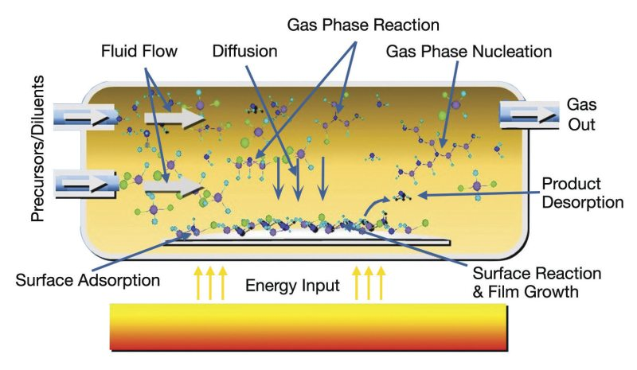

Figure : 27. Chemical Vapor deposition

- Sol-Gel Method: Pioneered by Pechini in 1967 , this technique for producing nano-sized oxide powders, along with its subsequent modifications, centers on dissolving reagent salts in appropriate solvents. An organic compound (comprising citric acid, ethylene glycol, and ethanol) is introduced, forming polymerizable complex precursors with the cationic elements in solution. Subsequent heating facilitates solvent evaporation and polyesterification, leading to an amorphous gel. This intermediate resin undergoes calcination, ultimately transforming into fine powder oxides (see figure 27).
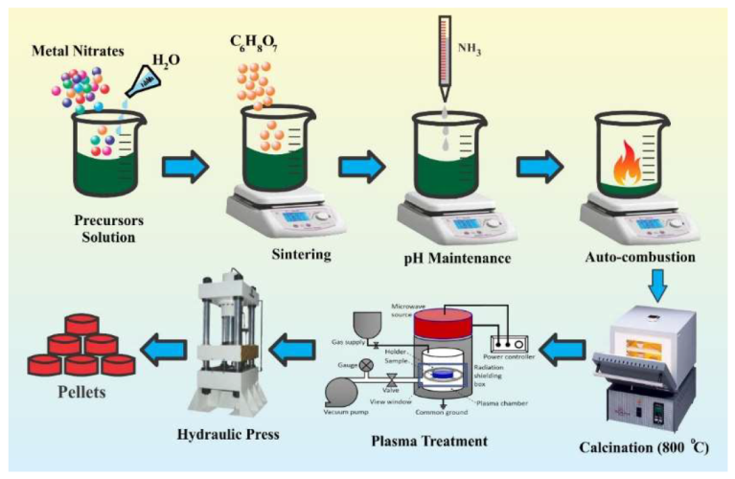
Figure:28.Schematic diagram of the synthesis of Nano particles using Sol-gel method.

  - Characterization Techniques
    - X-Ray Diffraction (XRD)
X-ray diffraction arises when incident X-ray beams interact and interfere with atomic planes within a crystal. This phenomenon serves as a swift and effective analytical method, primarily employed for the identification of crystalline phases and the determination of unit cell dimensions.
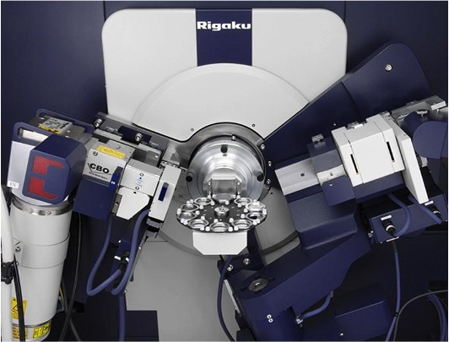
Figure .29. X-ray Diffractometer

The X-rays are initially founded by the Scientist Roentgen in 1895. In 1912 scientist Von Laue logically proved that X-rays are EM radiations, and can be used to study the crystal structure. X-ray diffraction technique is an extremely helpful procedure to study the structural properties of prepared samples. They are utilized to recognize the multiphase In the sample and as well as amorphous and crystalline content. XRD patterns additionally used to evaluate lattice parameter, particle size, S-ray density, porosity, specific surface area etc. From the most intense peak the particular wavelengths of incident-ray radiations are characteristic for the target material (Mo, Cr, Cu). Copper is the most famous target material for single crystal diffraction, with Cu-K_{α} radiation having wavelength 1.5418$\dot{A}$. These X-rays are collimated in a single direction and directed towards sample. As the sample and detector rotated, the intensity of the reflected X-rays will be recorded. When the geometry of the incident X- ray impinging the sample satisfies the Bragg’s equation, constructive interference occurs and a peak in intensity occurs. A detector records and processes this X-ray signal and converts the signal to account rate which is then output to a device.
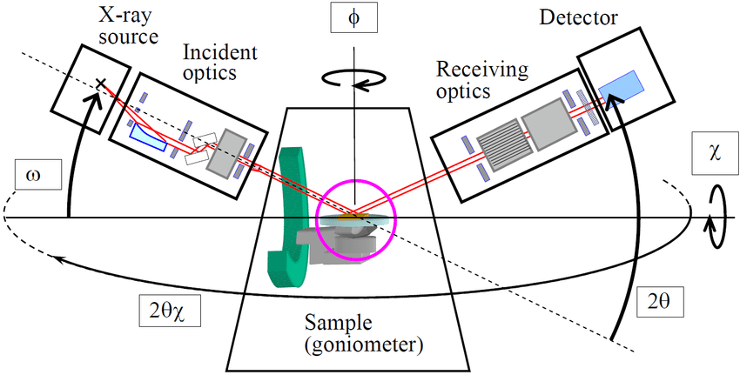
Figure.30.Schematic diagram of X-ray diffractometer

The experimental arrangement of an X-ray diffractometer shown in Fig.30 is such that the sample rotates in the path of the collimated X-ray beam at an angle θ and the detector mounted on an arm to collect the diffracted X-rays rotates at an angle of 2θ. The instrument used to measure the angle and rotates the sample termed as Goniometer (Fig.30). For typical powder patterns, data will be at 2θ from 10⁰ to 80⁰ angles that are presented in the X-ray scan.

- HR-TEM
The Transmission Electron Microscope (TEM) is the first type of EM developed in 1931 which is a versatile instrument, capable of characterizing the internal structure of materials with a wide range of imaging and analytical methods. It uses diffraction of electrons to image materials. Schematic diagram of a TEM is shown in Fig 31.
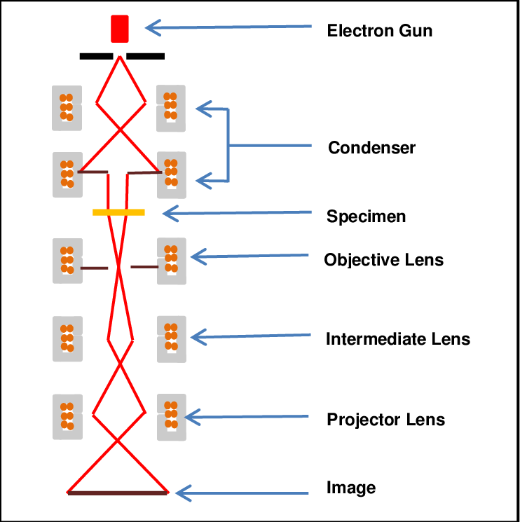

Figure.31. Schematic Diagram of HR-TEM

In TEM, a beam of electrons (with a typical wavelength of less than 1Å) is sent through a thin specimen without any interaction occurring inside the specimen. A fraction of the electrons in the beam get either elastically or in elastically scattered. One is the scattered (diffracted beam) electrons by atoms in the specimen in an elastic fashion (no loss of energy). Thus, while passing through the specimen, in case of crystalline samples the electron beam undergoes diffraction according to Bragg's law. Here, the incident electrons have the same energy (thus wavelength) and enter the sample normal to its surface. All electrons that are scattered by the same atomic spacing will have same scattering angle. These scattered electrons can be collated using magnetic lenses to form a pattern of spots, each spot corresponding to a specific atomic spacing (or crystalline plane). This pattern can then yield information about the orientation, atomic arrangements and phases present in the area of the sample being examined. Another is unscattered electrons (transmitted beam) which produce a two dimensional image of the sample. The transmission of these unscattered electrons is inversely proportional to the specimen thickness. Areas of the specimen that are thicker will have fewer transmitted unscattered electrons and so will appear darker, conversely the thinner areas will have more transmitted and thus will appear lighter. This mode of operation to create contrast in image is known as bright field imaging mode. In order to take microscopic images of ferromagnetic nanowires (NWs), we place them on carbon grids (ne two dimensional mess of copper covered with carbon) that are specially made for TEM imaging purpose. Standard TEM grid has typical diameter of 3.05 mm with a thickness of few micrometer and mesh size ranging from a few to 100 µm. Pretreatments of the NWs are done before placing them on carbon grid.

- Vibrating Sample Magnetometer (VSM)

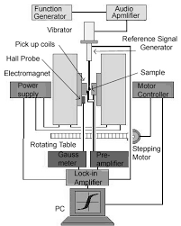
Figure: 32. Schematic Diagram of Vibrating sample magnetometer

Vibrating sample magnetometer (VSM) is a very sensitive and versatile instrument which can measure a very low magnetic moment up to a order of 10⁻⁵ emu. Vibrating sample magnetometer (VSM) is based on the flux change in a coil due to the vibration of a magnetized sample near it. Faraday's law of induction states that an electromotive force (EMF), `V' will be generated in a coil if there is a change in flux, B linking the coil. For a tightly wound coil of wire, composed of N identical loops and a cross-sectional area of A, the induced EMF in the coil can be written as,
$$V=-ηA\frac{dB}{dt}$$
The direction of the EMF is given by Lenz's law. If the coil is positioned in a constant
magnetic field H, the flux around it is given by,
$B=μ_{0}H$…………..4
where,$μ_{0}$ is permeability of vacuum. Now if we place a magnetic sample having magnetization M near the coil, then the fux will be,
$$B=μ_{0}(H+M)$$
Thus the corresponding flux change is given by,
$$ΔB=μ_{0}M$$
The induced EMF in pick-up coils expressed at the beginning thus can be rewritten as
$Vdt={-NAμ}_{0}M$……………………….5
The above equation implies that the output signal of the coil is proportional to the magnetization M of the sample and independent of the magnetic field in which the magnitude of M is to be determined. Schematic diagram of a VSM is shown in Figure.14.In a VSM, the sample to be measured is centered in the region between the poles of an electromagnet which can generate a uniform magnetic field H₀. A thin vertical nonmagnetic sample rod (made of plastic/quartz) connects the sample holder with a transducer assembly located above the magnet. The transducer converts a sinusoidal signal as drive signal (generated by an oscillator/amplifier circuit) into a sinusoidal vertical vibration (of frequency$ν$) of the sample rod. The sample is thus subjected to a sinusoidal motion in the magnetic field H₀. The oscillating magnetic field of the vibrating sample induces an alternative EMF in the detection coils or pick up coil (made of copper and mounted on the poles of the magnet) whose magnitude is proportional to the magnetization of the sample. This alternative EMF is amplified using a lock-in amplifier. However, though the EMF signal in the pick-up coil at a vibration frequency v is proportional to the magnitude of the moment of the sample, it is also proportional to the vibration amplitude and frequency. Thus the moment readings taken simply by measuring the amplitude of the signal are subject to errors due to variation in amplitude and frequency of vibration. In order to avoid this difficulty, a nulling technique is introduced employing a vibrating capacitor for generating a reference signal that varies with moment, vibration amplitude and frequency in the same manner as the signal from the pickup coils. When these two signals are processed in an appropriate manner, it is possible to eliminate the effects of vibration amplitude and frequency shifts.

11. Applications of Advanced Magnetic Materials
Advanced magnetic materials, characterized by their unique magnetic properties, play a pivotal role in a myriad of applications across diverse fields. The distinctive features of these materials, such as high coercivity, high permeability, and controlled magnetic anisotropy, make them invaluable in various technological advancements. The following sections delve into the scientific basis and applications of advanced magnetic materials in specific domains.

1. Data Storage: Hard Disk Drives (HDDs) and Solid State Drives (SSDs):Thin films of magnetic alloys with tailored magnetic anisotropy are employed as recording media. This anisotropy allows for stable storage of binary information through the alignment of magnetic domains.
Applications:These materials are crucial for data storage in HDDs and SSDs, enabling the recording and retrieval of digital information.
2. Electronics: Magnetic Sensors: Magnetoresistive sensors utilize the phenomenon of giantmagnetoresistance (GMR) or tunnel magnetoresistance (TMR) in multilayer structures, which exhibit resistance changes in response to an applied magnetic field.
Applications: Used in automotive sensors, position sensors, and magnetic field sensors, these sensors provideprecise detection of magnetic fields in electronic devices.
3. Magnetic Random Access Memory (MRAM):MRAM relies on the manipulation of magnetization states using advanced magnetic materials, offering non-volatility and high-speed operation based on spin-transfer torque or spin-orbit torque.
Applications: MRAM serves as non-volatile memory in electronic devices, combining speed and reliability.
4. Medical Applications: Magnetic Resonance Imaging (MRI):Superconducting magnets, often made from advanced magnetic materials, generate strong and stable magnetic fields essential for nuclear magnetic resonance imaging.
Applications: Crucial in MRI machines, these materials facilitate high-resolution imaging for medical diagnostics.
5. Drug Delivery:Magnetic nanoparticles are designed with specific coatings to ensure biocompatibility and are manipulated using external magnetic fields for targeted drug delivery.
Applications: Used in drug delivery systems, these nanoparticles can be directed to specific sites in the body for enhanced therapeutic efficacy.
6. Energy Generation and Storage:Magnetic Generators:Advanced magnetic materials contribute to the development of generators where mechanical energy is converted into electrical energy through the principles of magnetic induction.
Applications: These generators find application in various energy conversion systems.
7. Energy Storage:Magnetic materials are integral to emerging technologies like magnetic energy storage andflywheel energy storage systems, contributing to efficient energy storage and retrieval.
Applications: These systems hold promise for advanced energy storage solutions.
8. Electromagnetic Devices:Transformers and Inductors:Soft magnetic materials with low coercivity and high permeability are utilized in transformers and inductors to efficiently transfer electrical energy through magnetic induction.
Applications: Found in power distribution systems, these materials enhance the efficiency of energy transfer.
9.Microwave Devices: Ferrites, a class of magnetic materials, are employed in microwave devices like circulators and isolators due to their unique magnetic properties.
Applications: Enhancing the functionality of microwave systems, these materials find application incommunication and radar technologies.
10. Automotive Applications:Electric Motors, Permanent magnets, often made from advanced magnetic materials like rare-earth magnets, are essential components in high-performance electric motors, ensuring efficient energy conversion.
Applications: These motors are integral to electric and hybrid vehicles, contributing to improved efficiency and performance.
11. Sensors:Magnetic sensors in automotive systems utilize the Hall effect or magnetoresistance to detect changes in magnetic fields, providing crucial data for control systems.
Applications: Used in speed sensors and position sensors, these devices enhance the safety and performance of automotive systems.
12. Environmental Remediation:Water Purification, Magnetic materials, particularly magnetic nanoparticles, are employed in magnetic separation processes to remove contaminants from water.
Applications:This technology offers a promising approach to water purification, addressing environmental concerns.
13. Aerospace Industry:Navigation Systems: Advanced magnetic materials are utilized in the development of magnetic sensors and systems for navigation in aerospace applications, providing accurate and reliable orientation data.
Applications: Essential for navigation in aircraft and spacecraft, these materials contribute to the safety and precision of aerospace systems.
14. Robotics: Actuators, Magnetic materials in actuators leverage the interaction between magnetic fields and the material properties to convert electrical energy into mechanical motion.
Applications: Crucial in robotics, these actuators enable precise and controlled movement in various applications.

Conclusions
The chapter on "Advanced Magnetic Materials" delves extensively into the historical evolution and contemporary significance of these materials in modern technology. Beginning with an exploration of the fundamentals of magnetism, magnetic moments, and various types of magnetic materials, the chapter provides a comprehensive overview. It also addresses domain theory and thermal dynamics, offering a wide-ranging examination of the subject. The classification of Advanced Magnetic Materials, such as magnetic nanomaterials, multiferroic materials, and ferroelectrics, is discussed, emphasizing their applications in diverse domains.
Shifting focus to the realm of electric power consumption, the analysis in the chapter highlights global patterns and the escalating demand for sustainable electricity generation methods. The association between the widespread use of thermal energy for global electricity generation and elevated CO₂ emissions is underscored. The chapter emphasizes the crucial role of permanent magnets and soft magnets in powering compact and lightweight electric motors, particularly for scientific advancements in transportation and actuation applications.Looking ahead, the significance of magnetic materials in addressing challenges related to electricity consumption, losses, and emissions becomes evident. The chapter anticipates a surge in demand for electric transportation, making the mitigation of losses in electricity transmission even more critical. Prioritizing sustainability and renewable energy sources, the development and implementation of advanced magnetic materials are poised to play a pivotal role in meeting evolving energy demands.The presented data, including the breakdown of electricity consumption across countries, emphasizes the global impact of these trends and underscores the necessity for continuous research and development in the field of magnetic materials. In conclusion, the chapter emerges as a valuable resource for researchers, engineers, and students seeking to navigate the intricate world of advanced magnetic materials and comprehend their multifaceted applications in modern technology. The potential impact of these materials on shaping a sustainable and efficient technological future is evident, highlighting the ongoing need for research and development in this dynamic field.

References
- Bhatti, Sabpreet, Rachid Sbiaa, Atsufumi Hirohata, Hideo Ohno, Shunsuke Fukami, and S. N. Piramanayagam. "Spintronics based random access memory: a review." Materials Today 20, no. 9 (2017): 530-548.
- Tirotta, Ilaria, Valentina Dichiarante, Claudia Pigliacelli, Gabriella Cavallo, Giancarlo Terraneo, Francesca Baldelli Bombelli, Pierangelo Metrangolo, and Giuseppe Resnati. "19F magnetic resonance imaging (MRI): from design of materials to clinical applications." Chemical reviews 115, no. 2 (2015): 1106-1129.
- Grollier, Julie, Damien Querlioz, and Mark D. Stiles. "Spintronic nanodevices for bioinspired computing." Proceedings of the IEEE 104, no. 10 (2016): 2024-2039.
- Su, Meng, and Yanlin Song. "Printable smart materials and devices: strategies and applications." Chemical Reviews 122, no. 5 (2021): 5144-5164.
- Niu, Songyan, Haiqi Xu, Zhirui Sun, Z. Y. Shao, and Linni Jian. "The state-of-the-arts of wireless electric vehicle charging via magnetic resonance: principles, standards and core technologies." Renewable and Sustainable Energy Reviews 114 (2019): 109302.
- Dusek, Val. The holistic inspirations of physics: The underground history of electromagnetic theory. Rutgers University Press, 1999.
- Suarez, Thomas. Early mapping of Southeast Asia: the epic story of seafarers, adventurers, and cartographers who first mapped the regions between China and India. Tuttle Publishing, 2012.
- Sander, Christoph. "Magnetism in renaissance science." In Encyclopedia of Renaissance Philosophy, pp. 2025-2030. Cham: Springer International Publishing, 2022.
- Murphy, Kieran. "Induction after Electromagnetism." Literatur-und Naturwissenschaften (2021): 179.
- McCallum, R. W., Laura H. Lewis, Ralph Skomski, M. J. Kramer, and I. E. Anderson. "Practical aspects of modern and future permanent magnets." Annual Review of Materials Research 44 (2014): 451-477.
- Coey, John MD. Magnetism and magnetic materials. Cambridge university press, 2010.
- Thompson, Sarah M. "The discovery, development and future of GMR: The Nobel Prize 2007." Journal of Physics D: Applied Physics 41, no. 9 (2008): 093001.
- Ranjan, Ashish. "Energy-efficient Memory System Design with Spintronics." PhD diss., Purdue University Graduate School, 2019.
- Newcomb, William A. "Motion of magnetic lines of force." Annals of Physics 3, no. 4 (1958): 347-385.
- Cullity, Bernard Dennis, and Chad D. Graham. Introduction to magnetic materials. John Wiley & Sons, 2011.
- Coey, John MD. Magnetism and magnetic materials. Cambridge university press, 2010.
- Schenck, John F. "Physical interactions of static magnetic fields with living tissues." Progress in biophysics and molecular biology 87, no. 2-3 (2005): 185-204.
- Li, Jiangnan, Hossein Sepehri-Amin, Taisuke Sasaki, Tadakatsu Ohkubo, and Kazuhiro Hono. "Most frequently asked questions about the coercivity of Nd-Fe-B permanent magnets." Science and Technology of Advanced Materials 22, no. 1 (2021): 386-403.
- Kapitza, P. "Further developments of the method of obtaining strong magnetic fields." Proceedings of the Royal Society of London. Series A, Containing Papers of a Mathematical and Physical Character 115, no. 772 (1927): 658-683.
- Wilson, Mick, Kamali Kannangara, Geoff Smith, Michelle Simmons, and Burkhard Raguse. "Nanotechnology: basic science and emerging technologies." (2002).
- Schenck, John F. "The role of magnetic susceptibility in magnetic resonance imaging: MRI magnetic compatibility of the first and second kinds." Medical physics 23, no. 6 (1996): 815-850.
- Raĭkher, Yuri L., and Mark I. Shliomis. "The effective field method in the orientational kinetics of magnetic fluids and liquid crystals." Advances in chemical physics: relaxation phenomena in condensed matter 87 (1994): 595-751.
- Domb, Cyril, and Martin F. Sykes. "On the susceptibility of a ferromagnetic above the Curie point." Proceedings of the Royal Society of London. Series A. Mathematical and Physical Sciences 240, no. 1221 (1957): 214-228.
- Krishnan, Kannan M. Fundamentals and applications of magnetic materials. Oxford University Press, 2016.
- Klepov, Vladislav V., Kristen A. Pace, Anna A. Berseneva, Justin B. Felder, Stuart Calder, Gregory Morrison, Qiang Zhang, Melanie J. Kirkham, David S. Parker, and Hans-Conrad Zur Loye. "Chloride Reduction of Mn3+ in Mild Hydrothermal Synthesis of a Charge Ordered Defect Pyrochlore, CsMn2+ Mn3+ F6, a Canted Antiferromagnet with a Hard Ferromagnetic Component." Journal of the American Chemical Society 143, no. 30 (2021): 11554-11567.
- Crichton, Robert, J. R. Boelaert, V. Braun, K. Hantke, M. Marx, M. Santos, and R. Ward. "Solution chemistry of iron in biological media." Inorganic biochemistry of iron metabolism. John Wiley, New York (2001): 1-14.
- Flinn, Richard Aloysius, and Paul K. Trojan. Engineering materials and their applications. Houghton Mifflin, 1975.
- Tereshchenko, Ivan V., Dmitry A. Aksyonov, Oleg A. Drozhzhin, Igor A. Presniakov, Alexey V. Sobolev, Andriy Zhugayevych, Daniil Striukov, Keith J. Stevenson, Evgeny Antipov, and Artem M. Abakumov. "The role of semilabile oxygen atoms for intercalation chemistry of the metal-ion battery polyanion cathodes." Journal of the American Chemical Society 140, no. 11 (2018): 3994-4003.
- Okube, Maki, Taro Oshiumi, Toshiro Nagase, Ritsuro Miyawaki, Akira Yoshiasa, Satoshi Sasaki, and Kazumasa Sugiyama. "Site occupancy of Fe2+, Fe3+ and Ti4+ in titanomagnetite determined by valence-difference contrast in synchrotron X-ray resonant scattering." Journal of synchrotron radiation 25, no. 6 (2018): 1694-1702.
- Xu, Yaolin, Jennifer Sherwood, Ying Qin, Robert A. Holler, and Yuping Bao. "A general approach to the synthesis and detailed characterization of magnetic ferrite nanocubes." Nanoscale 7, no. 29 (2015): 12641-12649.
- Duell, Brett A. "Cation Substitution Effects in Complex Transition Metal Oxides." (2020).
- Patron, Luminita, Oana Carp, Ioana Mindru, Gabriela Marinescu, Nicolae Stanica, and Ioan Balint. "Polynuclear coordination precursors compounds for M3Fe5O12 garnets (M= Y, Eu, Gd and Er), Part I: Synthesis of the precursors." Journal of the Serbian Chemical Society 70, no. 8-9 (2005): 1049-1056.
- Kazimierczuk, Marian K. High-frequency magnetic components. John Wiley & Sons, 2009.
- Hill, Nicola A. "Density functional studies of multiferroic magnetoelectrics." Annual Review of Mater. Res. 32, no. 1 (2002): 1-37.
- Grütter, Peter, H. J. Mamin, and D. Rugar. "Magnetic force microscopy (MFM)." In Scanning Tunneling Microscopy II: Further applications and related scanning techniques, pp. 151-207. Berlin, Heidelberg: Springer Berlin Heidelberg, 1992.
- Goldman, Alex. Handbook of modern ferromagnetic materials. Vol. 505. Springer Science & Business Media, 2012.
- Honecker, Dirk, Mathias Bersweiler, Sergey Erokhin, Dmitry Berkov, Karine Chesnel, Diego Alba Venero, Asma Qdemat et al. "Using small-angle scattering to guide functional magnetic nanoparticle design." Nanoscale Advances 4, no. 4 (2022): 1026-1059.
- Nisticò, Roberto, Federico Cesano, and Francesca Garello. "Magnetic materials and systems: Domain structure visualization and other characterization techniques for the application in the materials science and biomedicine." Inorganics 8, no. 1 (2020): 6.
- Falicov, L. M., Daniel T. Pierce, S. D. Bader, R. Gronsky, Kristl B. Hathaway, Herbert J. Hopster, David N. Lambeth et al. "Surface, interface, and thin-film magnetism." Journal of Materials Research 5, no. 6 (1990): 1299-1340.
- Krawczyk, Maciej, and D. Grundler. "Review and prospects of magnonic crystals and devices with reprogrammable band structure." Journal of physics: Condensed matter 26, no. 12 (2014): 123202.
- Nguyen, Anh Tue. "Synthesis and characterization of crystalline iron nanoparticles from zerovalent iron sandwich complexes." PhD diss., Purdue University, 2014.
- Hellwig, Olav, Andreas Berger, Jeffrey B. Kortright, and Eric E. Fullerton. "Domain structure and magnetization reversal of antiferromagnetically coupled perpendicular anisotropy films." Journal of Magnetism and Magnetic Materials 319, no. 1-2 (2007): 13.
- Amin, O. J., S. Reimers, F. Maccherozzi, S. S. Dhesi, V. Novák, R. P. Campion, K. W. Edmonds, and P. Wadley. "Electrical control of 180° domain walls in an antiferromagnet." APL Materials 11, no. 9 (2023).
- Issa, Bashar, Ihab M. Obaidat, Borhan A. Albiss, and Yousef Haik. "Magnetic nanoparticles: surface effects and properties related to biomedicine applications." International journal of molecular sciences 14, no. 11 (2013): 21266-21305.
- Kleibert, Armin, Wolfgang Rosellen, Mathias Getzlaff, and Joachim Bansmann. "Structure, morphology, and magnetic properties of Fe nanoparticles deposited onto single-crystalline surfaces." Beilstein journal of nanotechnology 2, no. 1 (2011): 47-56.
- Takahashi, Minoru, and Takao Suzuki. "Temperature dependence of magnetic domain structures in HCP cobalt single crystals." Japanese Journal of Applied Physics 18, no. 6 (1979): 1071.
- Fish, Gordon E. "Soft magnetic materials." Proceedings of the IEEE 78, no. 6 (1990): 947-972.
- Kumar, Yogendra, Alfa Sharma, Md A. Ahmed, Sawanta S. Mali, Chang Kook Hong, and Parasharam M. Shirage. "Morphology-controlled synthesis and enhanced energy product (BH) max of CoFe 2 O 4 nanoparticles." New Journal of Chemistry 42, no. 19 (2018): 15793-15802.
- Zhao, Guoping, Xuefeng Zhang, and François Morvan. "Theory for the coercivity and its mechanisms in nanostructured permanent magnetic materials." Reviews in Nanoscience and Nanotechnology 4, no. 1 (2015): 1-25.
- Svoboda, Jan. Magnetic techniques for the treatment of materials. Springer Science & Business Media, 2004.
- Gundogdu, Tayfun, and Guven Komurgoz. "The Impact of the selection of permanent magnets on the design of permanent magnet machines-a case study: permanent magnet synchronous machine design with high efficiency." Przeglqd Elektrotechniczny R89 (2013): 103-108.
- Alzoubi, Lorca, Alaa AA Aljabali, and Murtaza M. Tambuwala. "Empowering precision medicine: the impact of 3d printing on personalized therapeutic." AAPS PharmSciTech 24, no. 8 (2023): 228.
- Herbst, J. F. "Structural Characteristics and Rapid Solidification of Nd2Fe14B-Type Permanent Magnet Materials." In Supermagnets, Hard Magnetic Materials, pp. 69-94. Dordrecht: Springer Netherlands, 1991.
- Degri, Malik John Jamaji. "The processing and characterisation of recycled NdFeB-type sintered magnets." PhD diss., University of Birmingham, 2014.
- Kumar, Challa SSR, and Faruq Mohammad. "Magnetic nanomaterials for hyperthermia-based therapy and controlled drug delivery." Advanced drug delivery reviews 63, no. 9 (2011): 789-808.
- Hutchison, James E. "Greener nanoscience: a proactive approach to advancing applications and reducing implications of nanotechnology." ACS nano 2, no. 3 (2008): 395-402.
- Cardoso, Vanessa Fernandes, António Francesko, Clarisse Ribeiro, Manuel Bañobre‐López, Pedro Martins, and Senentxu Lanceros‐Mendez. "Advances in magnetic nanoparticles for biomedical applications." Advanced healthcare materials 7, no. 5 (2018): 1700845.
- Jun YW, Choi JS, Cheon J. Shape control of semiconductor and metal oxide nanocrystals through nonhydrolytic colloidal routes. Angew Chem Int Ed. 2006;45(21):3414–3439. doi: 10.1002/anie.200503821.
- Nunez NO, Tartaj P, Morales P, Pozas R, Ocana M. et al. Preparation, characterization, and magnetic properties of Fe-based alloy particles with elongated morphology. Chem Mater. 2003;15(18):3558–3563. doi: 10.1021/cm031040f.
- Park SJ, Kim S, Lee S, Khim ZG, Char K. et al. Synthesis and magnetic studies of uniform iron nanorods and nanospheres. J Am Chem Soc. 2000;122(35):8581–8582.
- Dumestre F, Chaudret B, Amiens C, Fromen MC, Casanove MJ. et al. Shape control of thermodynamically stable cobalt nanorods through organometallic chemistry. Angew Chem Int Ed. 2002;41(22):4286–4289. doi: 10.1002/1521-3773(20021115)41:22<4286::AID-ANIE4286>3.0.CO;2-M.
- Dumestre F, Chaudret B, Amiens C, Renaud P, Fejes P. Superlattices of iron nanocubes synthesized from Fe[N(SiMe3)(2)](2) Science. 2004;303(5659):821–823. doi: 10.1126/science.1092641.
- Piao Y, Kim J, Bin Na H, Kim D, Baek JS. et al. Wrapbake-peel process for nanostructural transformation from beta-FeOOH nanorods to biocompatible iron oxide nanocapsules. Nat Mater. 2008;7(3):242–247. doi: 10.1038/nmat2118. [PubMed] [CrossRef] [Google Scholar]
- Liu C, Wu XW, Klemmer T, Shukla N, Weller D. Reduction of sintering during annealing of FePt nanoparticles coated with iron oxide. Chem Mater. 2005;17(3):620–625. doi: 10.1021/cm0403457. [CrossRef] [Google Scholar]
- Park JI, Cheon J. Synthesis of ''solid solution'' and ''core-shell'' type cobalt-platinum magnetic nanoparticles via transmetalation reactions. J Am Chem Soc. 2001;123(24):5743–5746. doi: 10.1021/ja0156340. [PubMed] [CrossRef] [Google Scholar]
- Lu AH, Salabas EL, Schuth F. Magnetic nanoparticles: Synthesis, protection, functionalization, and application. Angew Chem Int Ed. 2007;46(8):1222–1244. doi: 10.1002/anie.200602866.
- Jeong U, Teng XW, Wang Y, Yang H, Xia YN. Superparamagnetic colloids: Controlled synthesis and niche applications. Adv Mater. 2007;19(1):33–60. doi: 10.1002/adma.200600674.
- Hyeon T. Chemical synthesis of magnetic nanoparticles. Chem Commun. 2003;8:927–934.
- Kwon SG, Piao Y, Park J, Angappane S, Jo Y. et al. Kinetics of monodisperse iron oxide nanocrystal formation by ''heating-up'' process. JamChemSoc. 2007;129(41):12571–12584. doi: 10.1021/ja074633q.
- Gupta AK, Naregalkar RR, Vaidya VD, Gupta M. Recent advances on surface engineering of magnetic iron oxide nanoparticles and their biomedical applications. Nanomedicine. 2007;2(1):23–39. doi: 10.2217/17435889.2.1.23.
- Wu XY, Liu HJ, Liu JQ, Haley KN, Treadway JA. et al. Immunofluorescent labeling of cancer marker Her2 and other cellular targets with semiconductor quantum dots. Nat Biotechnol. 2003;21(1):41–46. doi: 10.1038/nbt764.
- Dubertret B, Skourides P, Norris DJ, Noireaux V, Brivanlou AH. et al. In vivo imaging of quantum dots encapsulated in phospholipid micelles. Science. 2002;298(5599):1759–1762. doi: 10.1126/science.1077194.
- Gao XH, Cui YY, Levenson RM, Chung LWK, Nie SM. In vivo cancer targeting and imaging with semiconductor quantum dots. Nat Biotechnol. 2004;22(8):969–976. doi: 10.1038/nbt994.
- Pellegrino T, Manna L, Kudera S, Liedl T, Koktysh D. et al. Hydrophobic nanocrystals coated with an amphiphilic polymer shell: a general route to water soluble nanocrystals. Nano Lett. 2004;4(4):703–707. doi: 10.1021/nl035172j.
- Murthy N, Robichaud JR, Tirrell DA, Stayton PS, Hoffman AS. The design and synthesis of polymers for eukaryotic membrane disruption. J Controlled Release. 1999;61(1-2):137–143. doi:
- Sun EY, Josephson L, Weissleder R. ''Clickable''nanoparticles for targeted imaging. Mol Imaging. 2006;5(2):122–128.
- White MA, Johnson JA, Koberstein JT, Turro NJ. Toward the syntheses of universal ligands for metal oxide surfaces: controlling surface functionality through click chemistry. J Am Chem Soc. 2006;128(35):11356–11357. doi: 10.1021/ja064041s.
- Philipse AP, Vanbruggen MPB, Pathmamanoharan C. Magnetic silica dispersions preparation and stability of surface-modified silica particles with a magnetic core. Langmuir. 1994;10(1):92–99. doi: 10.1021/la00013a014.
- Caruso F. Nanoengineering of particle surfaces. Adv Mater. 2001;13(1):11–22. doi: 10.1002/1521-4095(200101)13:1<11::AID-ADMA11>3.0.CO;2-N.
- Stober W, Fink A, Bohn E. Controlled growth of monodisperse silica spheres in micron size range. J Colloid Interface Sci. 1968;26(1):62–69. doi: 10.1016/0021-9797(68)90272-5
- Lu Y, Yin YD, Mayers BT, Xia YN. Modifying the surface properties of superparamagnetic iron oxide nanoparticles through a sol-gel approach. Nano Lett. 2002;2(3):183–186. doi: 10.1021/nl015681q.
- Vestal CR, Zhang ZJ. Synthesis and magnetic characterization of Mn and Co spinel ferrite-silica nanoparticles with tunable magnetic core. Nano Lett. 2003;3(12):1739–1743. doi: 10.1021/nl034816k.
- Yi DK, Selvan ST, Lee SS, Papaefthymiou GC, Kundaliya D. et al. Silica-coated nanocomposites of magnetic nanoparticles and quantum dots. Jam Chem Soc. 2005;127(14):4990–4991. doi: 10.1021/ja0428863.
- Yi DK, Lee SS, Papaefthymiou GC, Ying JY. Nanoparticle architectures templated by SiO2/Fe2O3 nanocomposites. Chem Mater. 2006;18(3):614–619. doi: 10.1021/cm0512979.
- Saravanan, Ramachandran. "Multiferroic Materials." Materials Research Forum LLC, 2023.
- Wang, Shuren, Junjie Xu, Wei Li, Shengnan Sun, Song Gao, and Yanglong Hou. "Magnetic nanostructures: Rational design and fabrication strategies toward diverse applications." Chemical Reviews 122, no. 6 (2022): 5411-5475.
- Gao, Min. "Structure-Property Relations on Strain-Mediated Multiferroic Heterostructures." PhD diss., Virginia Tech, 2019.
- Ascher, Edgar, Harry Rieder, Hans Schmid, and H. Stössel. "Some properties of ferromagnetoelectric nickel‐iodine boracite, Ni3B7O13I." Journal of Applied Physics 37, no. 3 (1966): 1404-1405.
- Fiebig, Manfred, Thomas Lottermoser, Dennis Meier, and Morgan Trassin. "The evolution of multiferroics." Nature Reviews Materials 1, no. 8 (2016): 1-14.
- Wang, Yao, Jiamian Hu, Yuanhua Lin, and Ce-Wen Nan. "Multiferroic magnetoelectric composite nanostructures." npg asia materials 2, no. 2 (2010): 61-68.
- Van den Boomgaard, J., D. R. Terrell, R. A. J. Born, and H. F. J. I. Giller. "An in situ grown eutectic magnetoelectric composite material: Part I Composition and unidirectional solidification." Journal of Materials Science 9 (1974): 1705-1709.
- Resta, Raffaele. "Electrical polarization and orbital magnetization: the modern theories." Journal of Physics: Condensed Matter 22, no. 12 (2010): 123201.
- Chchiyai, Zakaria, Fatima El Bachraoui, Youssef Tamraoui, Lahcen Bih, Abdelilah Lahmar, Mimoun El Marssi, Jones Alami, and Bouchaib Manoun. "Effect of cobalt doping on the crystal structure, magnetic, dielectric, electrical and optical properties of PbTi1− xCoxO3-δ perovskite materials." Journal of Alloys and Compounds 927 (2022): 166979.
- Buscaglia, Vincenzo, and Clive A. Randall. "Size and scaling effects in barium titanate. An overview." Journal of the European Ceramic Society 40, no. 11 (2020): 3744-3758.
- Hui, Kun, Le Wang, Zixuan Lei, Jian Yang, Hongjian Qu, Jiang Li, and Ning Yan. "The synergistic and reinforcement mechanism of SiC nanostructures on the ablation properties of silicone rubber composites." Journal of Reinforced Plastics and Composites (2023): 07316844231208262.

