Derivatives Of Indole

Himanshu Tyagi, Tushar,
Department of Chemistry, N A S P G College, Department of Chemistry, N A S P G College,
Chaudhary Charan Singh University, Chaudhary Charan Singh University,
Meerut, India Meerut, India
moon2003tyagi@gmail.com tusharkumarg5151@gmail.com

ABSTRACT-
The heterocyclic section serves as a superb foundation for the successful attachment of pharmacophores to generate medicine. Nitrogen-based heterocycles have been studied among other heterocyclic compounds since they are the primary structural components of many molecules with biological significance. Indole’s adaptability has made it a highly ‘privileged motif’ for the target-oriented creation and design of various types of drugs. Indole is used in making various types of drugs such as anticancer agents (For example- 5,6,7 – tribromoisatin), anti-diabetic agents (For example- a, N, N, N- trimethyl tryptophan betaine), anti-malarial agents (TCMDC-134281), anti- tubercular agents(indole-3-thiosemicarbazone), anti-HIV agents (Umifenovir analogues), anti-fungal agents (Ketoconazole) etc. And many more applications of indole are there. Indole can be derived chemically (by BARTOLI INDOLE SYNTHESIS, BISCHLER INDOLE SYNTHESIS, FISCHER INDOLE SYNTHESIS) and naturally (from Apocynaceae, Rubiaceae, Nyssaceae, and Loganiaceae plants).

A preferred heterocyclic nucleus that exists in a variety of natural compounds, endogenous chemicals, and pharmaceuticals is called an indole. Even though it operates as an anti-inflammatory drug in an array of ways (Indomethacin, Tenidap). Indole acted as an accelerator for the production of numerous bioactive heterocyclic and smoothed an avenue for the creation of therapeutic targets.
In this, we will discuss indole derivatives used in the treatment of cancer, diabetes, HIV (Human Immunodeficiency Virus), malaria, and tuberculosis (TB).
- INTRODUCTION –
Indole is a benzo (Pyrrole formed by the alliance of benzene ring). It is the first segregated by the zinc dust pyrolysis of oxindole. The oxindole was initially acquired by the reduction of Isatin, which in turn was acquired by the oxidation of indigo. Indigo is a blue dye manufactured in India, which is why it is named indole commercially it is materialized from coal tar. Indole is the most universally scattered heterocyclic compound.
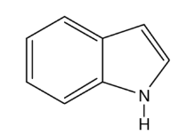
Figure 1- Indole
Indole is a basic part of thousands of naturally raised alkaloid drugs and other compounds.
For example –
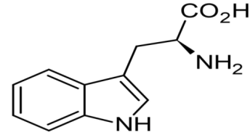
Figure 2- Tryptophan
Tryptophan is metabolized by the body to produce Scortin and Melatonin. Serotonin is intended to govern hunger, sleep, attitude or mood, and pain or anxiety. Melatonin modulates the sleep-wake cycle. TATP is also used by the liver.
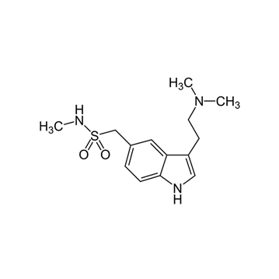
Sumatriptan
1. It is medicine for migraines.
2. It is used to cure minor migraines in adults.
- PROPERTIES OF INDOLE

A. ANTI – CANCER PROPERTIES –
The derivative of indole shows anti-cancer activities. The tested derivatives of 3-indolylmethylene-2-indolinone derivatives show anti-tumor activities.
There are two types of indole derivatives present here -
1. Pyridine derivatives
2. Piperazine derivatives
Piperazine lacked the pyridine derivatives' effectiveness. The derivatives of bis indole indicate substantial effectiveness against human cancer cell lines, including those from the breast, ovarian, colon, and lungs [6].
Among the synthesis series of 2,4-disubstituted furo [3,2-b] indole derivatives the (5-(12-(hydroxymethyl)-4H-furo [3,2-b] indole-4yl) methyl) furan-2-yl)-methanol (figure 3).
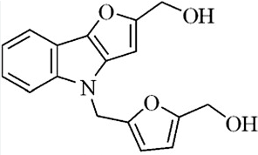
Figure 3- (5-(12-(hydroxymethyl)-4H-furo [3,2-b] indole-4-yl) methyl) furan-2-yl)-methanol
It was found to show highly selective anti-cancer activity against human tumour (NCI-60) cell lines and significant inhibitory activity against A498 renal cancer cells.
The pyrido [3,4-b] indoles show cell growth inhibiting tendency against human cancer lines comprising colon, breast, lungs, and prostate cancer cell lines [6].
An assortment of indole hybridized diazenyl derivatives has been generated by condensing diazotized p-aminoacetophenone with indole or nitro indole, then performing a reaction with various aromatic heteroatomic amines. The cytotoxicity of each of these derivatives has been assessed against conventional and human lung cancer cell lines.
1H – INDOLE – 2,3 – DIONE Derivatives -
Because of these compounds' outstanding biological properties—such as their anti-viral, anti-HIV, anti-cancer, and antioxidant properties—they gained significant scrutiny. It originates by oxidizing indigo dye with chromic acid and HNO3. It can also be found in plants about the genus Isatis and Calanthe. Because there are different reaction centres, it conducts a variety of reactions. Compounds about the 1H-INDOLE-2,3-DIONE group are capable of participating in N-alkylation, N-acylation, and Michael and Mannich reactions by merit of the -NH group. It is well-established that its mannich and Schiff bases have an assortment of pharmacological traits such as antiviral, anti-HIV, anti-bacterial, and anti-convulsant impacts [4].
Anti-cancer activity of 1H – INDOLE – 2,3 – DIONE derivatives -
The range of replaced 1H – INDOLE – 2,3 – DIONE (isatin) shows cytotoxicity against human monocyte–like histiocytic lymphoma (U937) cell lines.
These compounds exhibit high selectivity towards blood cancer (leukaemia) and lymphoma cells over breast, prostate, and colorectal carcinoma cell lines. the most active compound is 5,6,7-tribromoisatin (figure 4) [13].
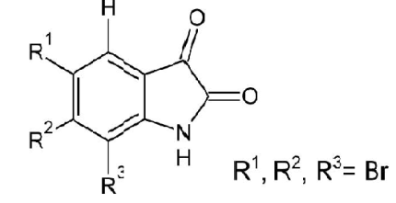
Figure 4- 5,6,7-tribromoisatin
A series of di or tri-substituted isatin-descendants were derived and assessed for anti-cancer activities against human T-lymphocyte cells. SAR (structure-activity relationship) study put forward that the alliance of 1-benzyl and 5-[trans-2-(methoxycarbonyl) ethen-1-yl] replacement greatly enhanced their cytotoxic activities.
A series of 5 or 7 substituted 3-{4-(5-mercapto-1,3,4-oxadiazol-2-yl) phenylimino}-indolin-2-one derivatives (figure 5) shows anti-cancer activity against HeLa (derived from the first two letters of HENRIETTA LACKS first and last name) cancer cell lines [4].
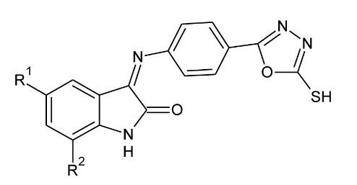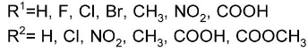
Figure 5- A series of 5 or 7 substituted 3-{4-(5-mercapto-1,3,4-oxadiazol-2-yl) phenylimino}-indolin-2-one derivatives.
The 3,3-diindolyl oxindole derivatives (figure 6) oppose a panel of five human cancer lines and most of them displayed potent cytotoxicity.
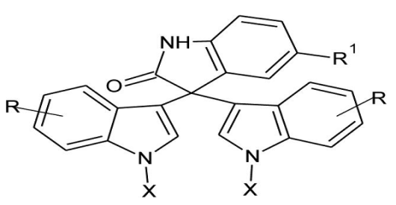
Figure 6- 3,3-diindolyl oxindole derivatives.
Figure 7 highlights the inhibitory activity of several types of 4/3-((4-oxo-5-(2-oxoindolin-3-ylidene) thiazolidine-2-ethylidene) amino) benzene sulfonamides against the MCF-7 breast cancer and the Caco-2 colorectal cancer cell lines [16].
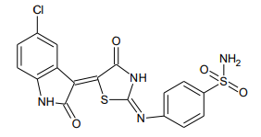
Figure 7- 4/3-(4-oxo-5-(2-oxoindolin-3-ylidene) thiazolidine-2-ylidene) amino) benzene sulfonamides derivative.
A selection of triazole-linked 3-benzylidene isatin hybrids have been investigated against cancer cell lines comprising HeLa (cervical), DU145, PC-3 (prostate cancer cells), MDA-MB-231, BT549 (breast cancer cell), & A549 (lung).
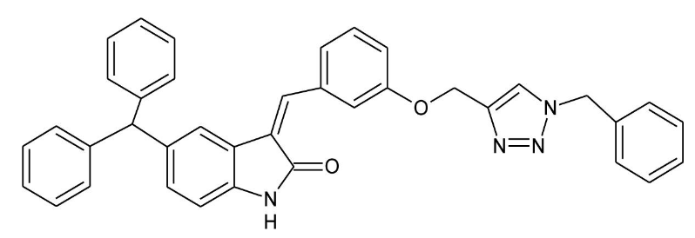
Figure 8- 3-benzylidene Isatin hybrid
A sequence of Isatindescendants of Podophyllotoxin shows cytotoxic activity against human blood cancer K562 cells [13].
The sixteen synthesized coumarins bearing hydride-hydrazone section show anti-cancer activities against pancreatic carcinoma cells. Bromo coumarins were found to be the most active anti-tumor agent against drug-resistant pancreatic carcinoma cells.

Figure 9
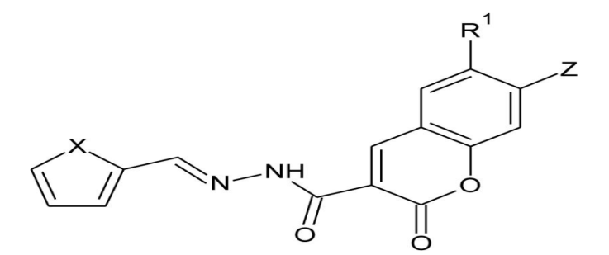

Spiro-indole derivatives (indole substituted with heterocyclic rings at the 3- position) –
It was obtained that different alkaloids and compounds we get from marine molluscs and shell fish are heterocyclic cyclic compounds having a spiro system at the 3rd position of the 2 indolinone skeleton.
Spiro-indole, with C3 as the spiro, is now well-known for having several distinct rings, including a ring system to a three-ring system. Plus, derivatives of spiro oxindole retain an exclusive spot in chemical and medicinal chemistry [4].
Example-
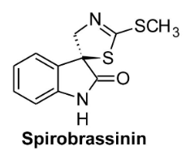- 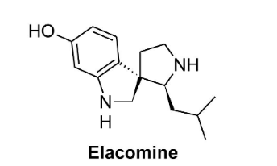
Figure-10 and 11
Anti-cancer activity of spiro indole derivatives –
Of the trial chemicals, 5'Z-5'-(Benzylidene) 4-chlorophenyl-3'- 3H-indole -3,2'-thiazolidine spiro [ Figure 12a shows -2,4'(1H)-Dione, and (5'Z) (4-chlorophenyl)-3'- [4-(1-methyl ethyl) -benzylidene]-5'-spiro [2'-thiazolidine, 3H-indole]-2,4'(1H)-Dione, visible in figure 12b. were preferable to other analogues and might be taken into the discussion if they include a 4-thiazolidinone group.
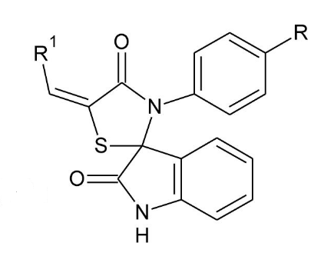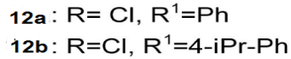
Figure 12a- (5'Z)-5'-(benzylidene) -3'- (4-chlorophenyl) spiro [3H-indole -3,2'- thiazolidine] -2,4'(1H)-Dione
12b - (5'Z)-3'-(4-chlorophenyl)-5'- [4- (1-methylethyl) - benzylidene] spiro[3H-indole3,2'-thiazolidine]-2,4'(1H)-Dione.
The anti-cancer activity of Spiro[pyrrolidine-3,3’-oxindole] descendants (figure 13) was tried out on Huh7, MV, HCT116, and MCF7 cancer cell lines.
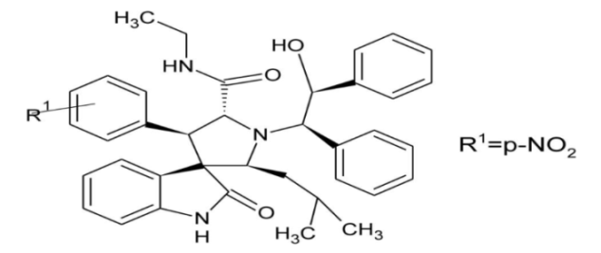
Figure 13 - Spiro[pyrrolidine-3,3’-oxindole] descendant.
It was found that the above-exhibited compound shows the most potent inhibitory activity.
The Spiro[indole-3,5′-isoxazolidin]-based 3'-spirocyclic-oxindole compounds Figure 14 depicts the 2′H-spiro [indole-3,6′-[1,3] oxazinone], or -2(1H)-one. The 2′H-spiro[indoline-3,3′-pyrrolo[1,2-c] [1,3′] oxazine] and the -2,2′(1H)-Dione (figure 15) Figure 16 illustrates heterocyclic compounds -1′,2(1H)-Dione. On cancer lines, two of these demonstrate substantial cytostatic activity.
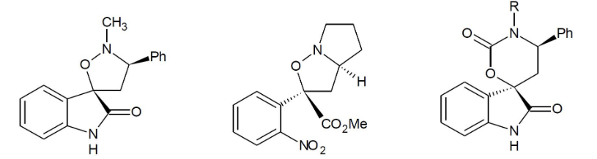
Figure- 14,15 and 16
The repressive capability of the Spiro oxindole hybrids against colon cancer HCT116, hepatocellular carcinoma (HepG2), and prostate cancer (PC3) has been explored in vitro.
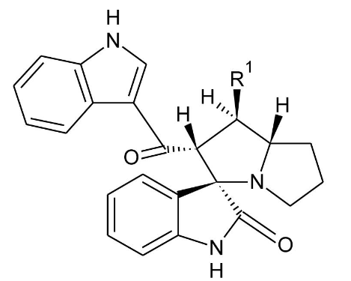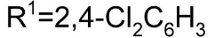
Figure 17- Spiro oxindole hybrid.
The above-depicted compound regains high cytotoxic activity and is judicious against colon cancer HCT116.
As the most viable anti-tumour drug, a series of spiro oxindole-O-naphthoquinone-tetrazolo[1,5-a] pyrimidine composites were synthesized and analysed. The cytotoxic activity of these hybrids against the cancer cell lines HepG2 isn't too strong.
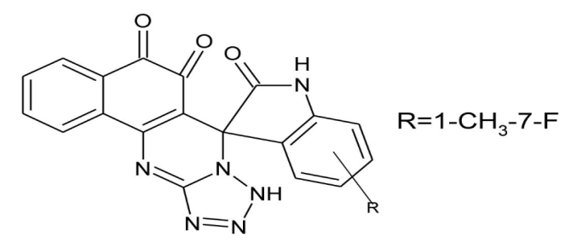
Figure 18- Spiro oxindole-O-naphthoquinone-tetrazolo[1,5-a] pyrimidine hybrid.
This is the most active Anti-cancer agent.
A new series of heterocycles having spiro oxindole and pyrrolidine rings were evaluated against breast cancer cell lines (MCF7) and leukaemia (K562) [16,13].
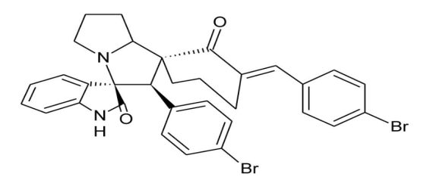
Figure 19
This compound proved to be the most potential anti-cancer agent against breast cancer cells.
B. ANTI-DIABETIC PROPERTIES-
High blood glucose and dyslipidemia are the hallmarks of diabetes mellitus (DM), which can be either chronic or incurable. There are two types of DM: primary (also known as 1-primary) and secondary (also known as 2-secondary). The former is composed of two types: non-insulin-dependent diabetes mellitus (NIDDM) and insulin-dependent diabetes mellitus (IIDM), among which over 90% of patients are affected. Over time, the therapeutic value of all oral anti-diabetic medications naturally shrinks in patients who have it. Hence, there is an ongoing necessity to develop new antidiabetic pharmaceuticals, especially given that diabetes is becoming an internationally recognized health issue [5].

Indole compounds –
Simple indole compounds –
Carboline compounds –
Semi-terpenoid indole compounds –
Mono-terpenoid indole compounds –
Bis-indole compounds –
Carbazole compounds –

Simple indole compounds– they contain only one indole ring. Some of them are derived from natural sources, mainly from plants. In comparison, most of the others are chemically synthesized.
An a-N, N, N-Trimethyl tryptophan betaine (figure 20) named hypophora isolated from erythrina hypophora seeds. This also serves as a sleep-promoting agent.
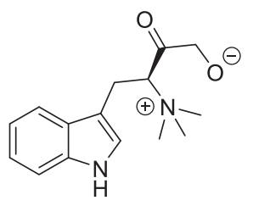
Figure 2- a-N, N, N-Trimethyl tryptophan betaine.
13 components are derived from Chinese black ant out of which 4-((1H-indole-3yl) methyl) nicotinamide (figure 21).it is believed that this compound has the potential to treat diabetes nephropathy (DN) in the upcoming time.
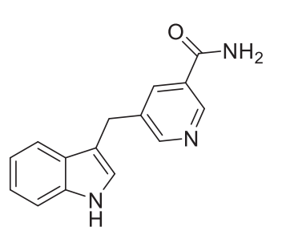
Figure 21- 4-(1H-indole-3yl) methyl) picolinamide.
Some of the indole alkaloids are derived from sweet potato leaves and are believed to possess α-glucosidase inhibitory activity.
The freshly derived indole descendant, 1-(4-chlorobenzene)-5-hydroxy-2-methyl-3-indoleacetic acid (figure 22) was certified to have the potential against diabetes.
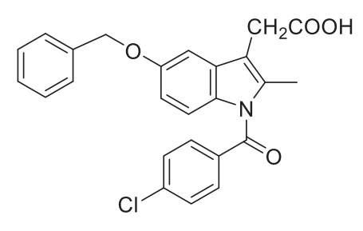
Figure 22- 1-(4-chlorobenzene)-5-hydroxy-2-methyl-3-indoleacetic acid.
According to SAR study, it has been found that the indole compound 9-(5-bromo-1H-indol-3-yl)-6-methoxy-3,3-dimethyl-2,3,4,9-tetrahydro-1H-xanthen-1-one (figure 23) was the most potent inhibitor of alpha-glucosidase.
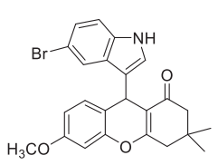
Figure 23- 9-(5-bromo-1H-indol-3-yl)-6-methoxy-3,3-dimethyl-2,3,4,9-tetrahydro-1H-xanthen-1-one.
GRP119 is a member of the G protein-coupled receptor and has become an attractive drug target these years in drug discovery.
In recent times, β-methyltryptophan has drawn more and more attention in medical chemistry as a potential diabetic agent.
Various activities of benzoxazine glycones were noted using some molecular techniques. Among all the derived benzoxazine only six of them show the most potent activity against diabetes.
An N-$β$-D-xylosylindole descendant 4-chloro-3-(4-cyclopropylbenzyl)-1-($β$-D-xylo pyranosyl)-1H-indole (figure 24) was derived and noted for its antidiabetic activity.
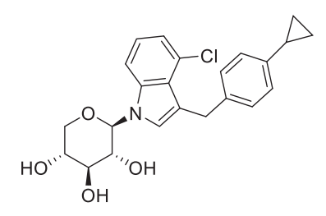
Figure 24- Descendant 4-chloro-3-(4-cyclopropylbenzyl)-1-($β$-D-xylo pyranosyl)-1H-indole.
The antidiabetic attributes of thiazole compounds have generated a lot of interest lately. α-glucoside was blocked by the substituted pyrazole derivatives that were synthesized successfully and encompassed the indole and thiazole heterocycles 2-(5-(1H-indol-3-yl)-3-phenyl-1H-pyrazol-1-yl)-4-(4-bromo phenyl) thiazole (figure 25).
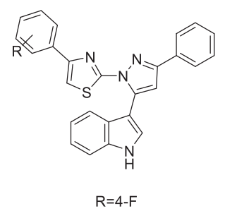
Figure25- 2-(5-(1H-indol-3-yl)-3-phenyl-1H-pyrazol-1-yl)-4-(4-bromo phenyl) thiazole.
Figures 26(a-b)–28(a-b) illustrate the three collections of staurosporine descendants that were generated. These compounds were assessed for their PKC beta-selective inhibitory attributes, with the JTT010 (figure 29) series revealing the most powerful inhibitory impact. It is projected that it would be employed for diabetic neuropathy and nephropathy owing to its good curative features.
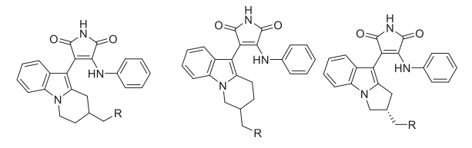
Figure 26a-28a –R=N(CH₃)₂
Figure 26b-28b –R=OH
Figure 26-28- Staurosporine descendants.
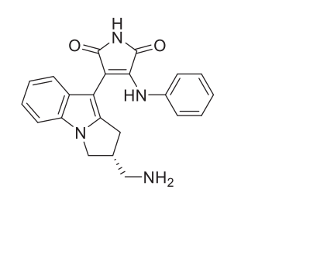
Figure 29- JTT010.

Carboline compounds are types of compounds identified by the presence of pyrido indoles in the structure. The carboline compounds are divided into four categories and $β$-carboline compounds cover most of the carboline compounds portion. They are mainly derived from marine organisms and plants.
e.g.- Indoloquinoline compounds were derived from cryptolepissanguinolent.

Semiterpenoid indole compounds- They are mainly derived naturally, and few were synthesized chemically. They are also known as ergot alkaloids because of their distribution in Calviceps purpurea.
A dopamine D2 receptor ligand that has been turned into a popular diabetic drug in clinical practice is bromocriptine (Figure 30).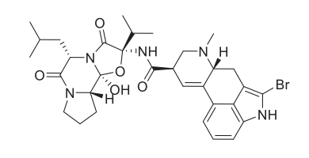[6]
Figure 30- Bromocriptine.
Another dopamine agonist that has been proven to be beneficial for glycemic control is cabergoline (figure 31).
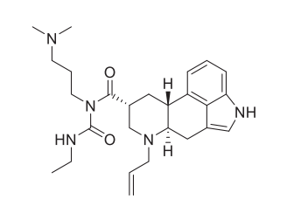
Figure 31- Cabergoline.

Monoterpenoid compounds - like semiterpenoid compounds they are also obtained naturally.
For eg - DHIM (16,17-dihydro-17b-hydroxy isomitraphylline) (figure 32) was derived from the leaves of Mitragyanaparvifolia.
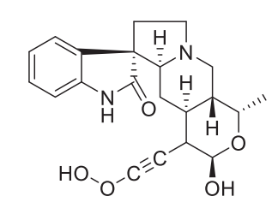
Figure 32- DHIM.
Strictosamide (figure 33) was derived from Uncariarhynchophlly. Later it was discovered in Sarcocephaluspobeguinii.
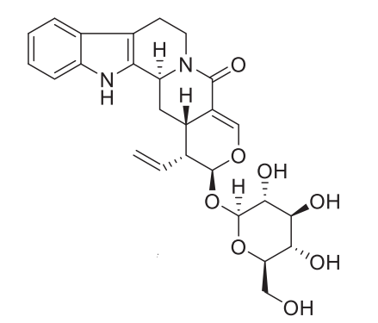
Figure 33- Strictosamide.
Vincamine (figure 34) is derived from Madagascar periwinkle.
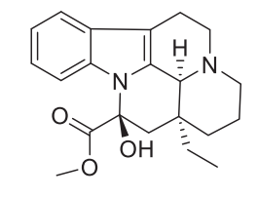
Figure 34- Vincamine.
The above-listed examples are used in the treatment of diabetes.

Bis-indole compounds-
Two molecular monoterpenoid indole molecules coalesce to create bis-indole compounds, which have an intricate molecular structure. They are chopped off from plants as well. For example, cruciferous plants were employed to generate 3,3'-diindolylmethane (figure 35) which was then made from indole-3-carbinol. According to the study, the bis-indole chemical substances cited above may be able to alleviate the manifestations and signs of both diabetic nephropathy and Type 1 Diabetes.
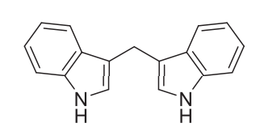
Figure 35- 3,3’-diindolylmethane.
Conophylline (figure 36) indicated success in treating an array of metabolic ailments, such as obesity, steatohepatitis, diabetes, and dementia. It originated from Ervatamia micophylla leaves.
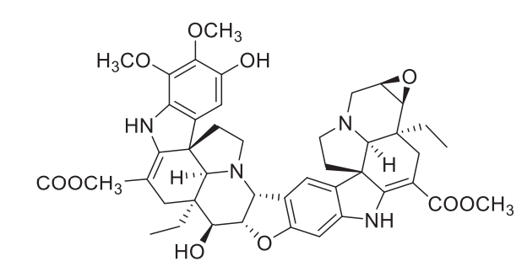
Figure 36- Conophylline.
The most efficacious derivative in this group, a type of 3,3-bisindole (figure 37), revealed inhibitory activity on α-glucosidase with a 2-flurobenzyl group in its structure.
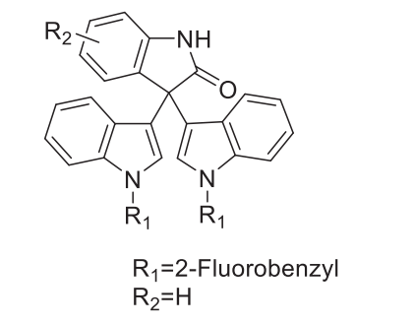
Figure 37- 3,3-bisindole derivative.
Demethylasterriquinone B1 (DAQ B1) (figure 38), we got this from Aspergillus terreusand pseudomassaria fungi exhibited antidiabetic effects in clinical trials.
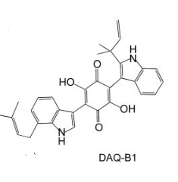
Figure 38

Carbazole compounds - These compounds are not found easily in nature. These compounds are very rare in nature, so they are derived by various methods. In the carbazole compounds class, they exhibit potent hypoglycemic activity along with insulin weakening or softening effects. It also reduces total cholesterol and serum triglyceride levels [5].
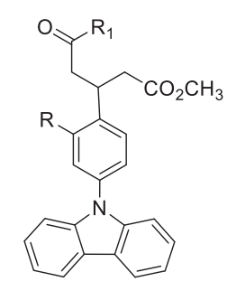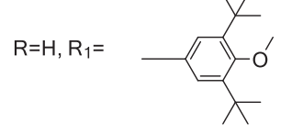
Figure 39

C. ANTI-INFLAMMATORY PROPERTIES –
The most commonly advised drugs for the management or amelioration of pain and inflammation are NSAIDs or non-steroidal anti-inflammatory pharmaceuticals. It is a multimodal process with different endogenous compounds implicated. NSAIDs are in several functional groups sorts, and it ought to be done meticulously to knock out the Indomethacin cyclooxygenase enzyme [6].
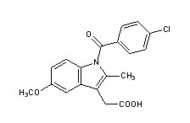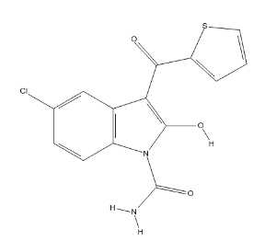

Figure 40- Indomethacin and Tenidap

Indole and its Anti-inflammatory activities of indole -
The cyclooxygenase enzyme's responsiveness was determined by modulating the substituents at the indole ring's N-1 and C-3 loci. The outcomes revealed that each chemical was more successful against the COX-2 enzyme than the COX-1 enzyme. Significant COX-2 inhibition is demonstrated by compound 1-benzoyl-3- [(4-trifluoromethyl phenylamino) methyl] indole (figure 41) [1].
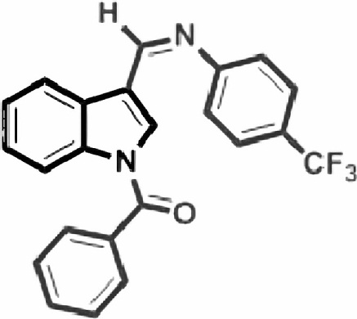
Figure 41- 1-benzoyl-3- [(4-trifluoromethyl phenylimino) methyl] indole.
The compound having trifluoro methyl substituent exhibits significant anti-inflammatory activity.
Numerous chalcones, pyrazolines, and azo compounds were used to fill in the indole in the third position. These compounds were found to have anti-inflammatory attributes. A threshold of 47% anti-inflammatory efficacy is displayed by the molecule in contrast to other compounds rallied at different stages. Pyrazolines are more productive than chalcones and azo-compounds (Pyrazolines>Azo-compounds>Chalcones), which is how the relative venture can be clarified [1].
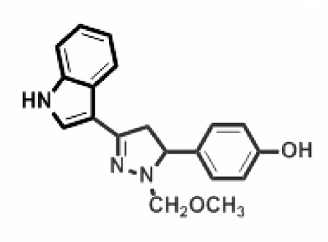
Figure 42
The anti-inflammatory attributes of a chain composed of distinctive 1,2,4-triazole and 1,3,4-oxadiazole strands that had the indole ring swapped at position C-3 were revealed. All of the compounds had astounding activity, but the compound (figure 43) outpaced the others.
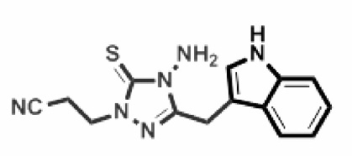
Figure 43
The ramifications of adjusting the 4-octyl remaining and carboxylic acid's bio isosteric replacement in 1- [3-(4-octyl phenoxy)-2 oxopropyl] Figure 44: Indole-5-carboxylic acid A large portion of the compound studied, a double inhibitor of fatty acid amide hydrolase (FAAH) and cytosolic phospholipase A2α (cPLA2α), is influential against both enzymes. This points to that dual inhibition of enzymes, as opposed to selective inhibition, can produce an anti-inflammatory agent [1].
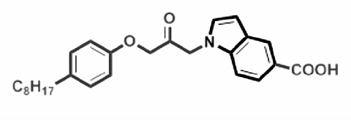
Figure 44- 1-[3-(4-octylphenoxy)-2 oxopropyl] indole-5-carboxylic acid.
[2- {(6 or 5-substituted)-1H-indole-3-yl] carbonyl} -(4-substituted-pyridin-2-yl) The cognate of acetic acid (figure 45) was extracted. More of all the chemicals showed up in response to COX-2 than COX-1. The substances exhibited strong COX-2 enzyme activity [1].
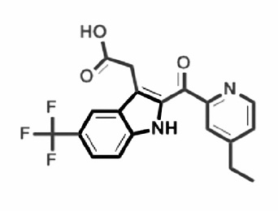
Figure 45- [2-{[(4-substituted-pyridin-2-yl] carbonyl} -(6 or 5-substituted)-1H-indole-3-yl] acetic acid cognate.
The ester prodrug creation alleviated the gastro toxicity mediated by the close association of acidic drugs, which includes indomethacin. In comparison to the standard medicine indomethacin, the prodrug molecule (figure 46) showed similar anti-inflammatory action and a low ulcer gauge [1].
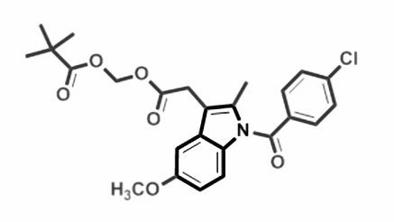
Figure 46
Substantial anti-inflammatory activity emerged for pyrano(2,3-c) pyrazole nucleus swapped at the third position of the indole area (figure 47), and the incorporation of a halogen atom had a greater impact on the venture than the other compound [20].
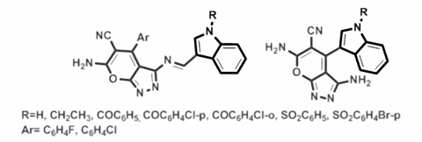
Figure 47
After discussing the implications of the nitro group on the anti-inflammatory activity, it came to light that the chlorophenyl section often displays anti-inflammatory activity and (figure 48) possesses the 6-nitro group [1].
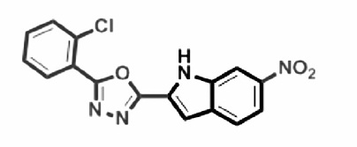
Figure 48

D. ANTI-TUBERCULAR PROPERTIES-
The bacterium Bacillus mycobacterium tuberculosis (Mtb) is the triggering agent of the infectious illness tuberculosis (TB). When tuberculosis (TB) emerged in 2017, the World Health Organization (WHO) proclaimed it to be a high priority. The inaugural drug to be found to be efficient at treating tuberculosis was streptomycin, and the subsequent introduction of thioacetone and para-amino-salicylic acid onto the market strengthened the disease's cure rate. New anti-tubercular medications like isoniazid (INH), pyrazinamide, cyclomerize, ethionamide, rifampicin, and ethambutol have been made available as a result of streptomycin battle [6].

Indole-based anti-tubercular compounds -
2-hydroxy-4-(4-nitro-1,3-dioxoisoondolin-2-yl) benzoic acid (IDDB40), an iso-indole-based drug (figure 49), exhibits strong efficacy against all strains of MTB with mycolic acid suppression. In a review of research on mycolic acid inhibition, it was shown that the 2-hydroxy-4-(4-nitro-1,3-dioxoisoindolin-2-yl) benzoic acid (IDDB40) molecule had isoniazid activity and may be an appealing anti-tubercular agent.

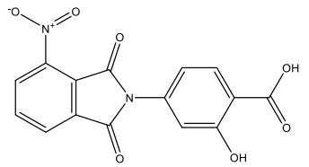
Figure 49- 2-hydroxy-4-(4-nitro-1,3-dioxoisoondolin-2-yl) benzoic acid (IDDB40).
Enoyl acyl carrier protein reductase inhibitors: Fatty acid synthase type (I) and type II are the two major extension systems that drive the production of mycolic acid. The reduction of the double bond at the second position of the enlarging fatty acid strand was vital for the catalysis of NADH by the FAS II system's enoyl acyl carrier protein reductase [2].
Anti-TB medications could potentially be made from the Mtb ENR. InhA from Mtb may be inhibited by the succinimide and indole platform that contains the homologous 3-(9H-fluoren-9-yl)-1-(1H-indol-5-yl carbonyl)-2,5-pyrrolidine-dione (figure 50) [2].
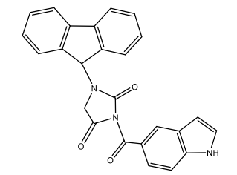
Figure 50- GEQ analogue 3-(9H-fluoren-9-yl)-1-(1H-indol-5-yl carbonyl)-2,5-pyrrolidinone.
The derived complexes of indol-3-thiosemicarbazone,5-methoxy indole-3-thiosemicarbazone (figure 51), and indole-N1-methyl-3-thiosemicarbazone with copper (I) and silver (I) have been noted for their binding affinity by docking against ENR.
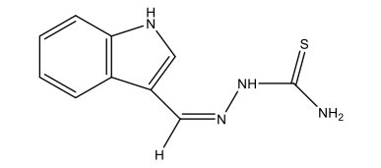
Figure 51- Indol-3-thiosemicarbazone.
A broad spectrum of 1,3,4-oxadiazole compounds based on indole and pyridine have been explored for their anti-TB proficiency against Mtb H37 and mycobacterium bovis BCG in both active and inactive forms. A few of them showed remarkable anti-TB proficiency [2].

Decaprenylphosphoryl-$β$-D-ribose 2’-epimerase inhibitor-
A crucial enzyme in the derivation of the cell wall in Mycobacterium is the target DprE1.It is also indispensable in the synthesis of lipoarabinomannan and arabinogalactan. Because the 1,4-azaindoles block DprE1 non-covalently, they are very likely to be operational therapeutic candidates for fighting tuberculosis [2].
A conjugate molecule of triazole and diindolylmethane (figure 52) has been encountered to exhibit significant action against Mtb H37Ra.
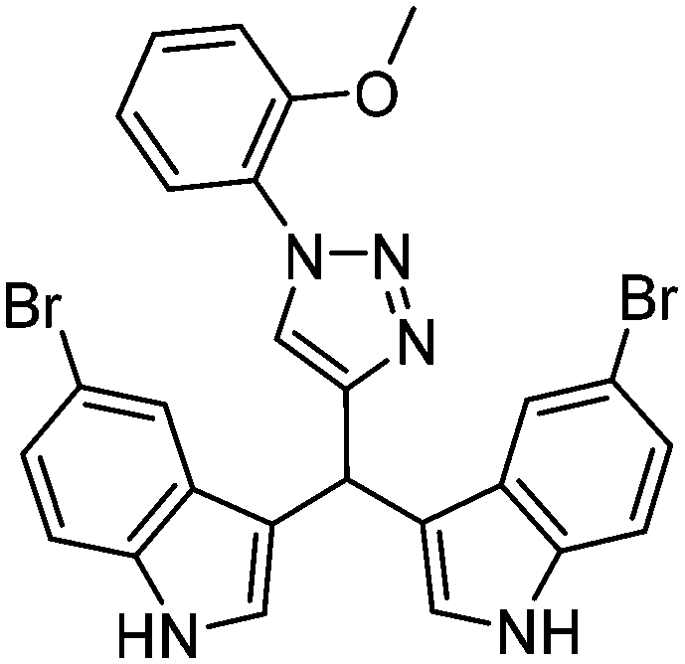
Figure 52- triazole-diindolylmethane conjugates.

β-ketoacyl ACP synthase I (KasA) inhibitor - One of the three β-ketoacyl synthase encrypted alleles in the Mtb genome is KsaA. To optimize D167, the JSF-3285 (figure 53) has been collected. The H37Rv strain of Mtb is blocked by Mtb indole chalcones, with a MIC of 210µM, to show favoured binding toward KsaA [2].
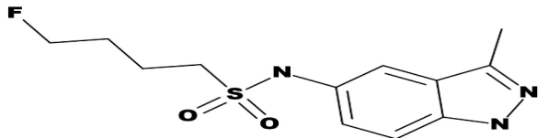
Figure 53- JSF-3285

Chorismate mutase (CM) inhibitor - The transition from the form of chorismite to prephenate is brought about by the Mtb chorismate mutase. At nanomolar medications, some isatin inhibitors have been reported to have probable CM-blocking activity [2].
A novel indole carrying an o-(RSO2) C6H4 group at C-2 (figure 54) has been assessed for MtbH37Rv CM inhibitor activity.
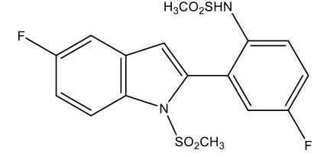
Figure 54- O-(RSO2) C6H4 group at C-2.
By unifying the structural characteristics of the quinoxaline and indole chunks into a single molecule, 2-chloro-3-(5,6-difluoro-1H-indol-3-yl) quinoxaline, a promising CM prohibitive drug has been formed (figure 55).
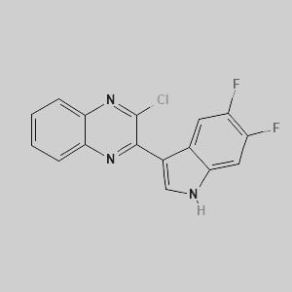
Figure 55- 2-chloro-3-(5,6-difluoro-1H-indol-3-yl) quinoxaline.

DNA gyrase inhibitor-
DNA gyrase is the only medically accepted target of fluoroquinolones, which resist replication and are used to cure multi-drug inhabitant TB.
A series of 2-(1H-indol-3-yl) ethyl thiourea (figure 56) descendants have been derived and noted for their antimicrobial activity against gram cocci, gram-negative rods, and fungi [2].
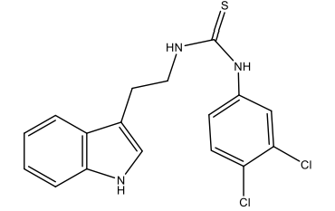
Figure 56- 2-(1H-indol-3-yl) ethyl thiourea.

Dihydrofolate reductase (DHFR) inhibitor-
A crucial enzyme responsible for the production of tetrahydrofolate, which is needed for bacterial sustainability, is DHFR.
A structural comparison of Mtb-DHFR human DHFRs illustrates that 4-(3-acetyl-1-benzyl-2-methyl-1H-indol-5-yl) oxy) butanoic acid specifically and powerfully hampers Mtb-DHFR. Bio isoteric substitution of these compounds results in a new series of 1-(1-benzyl-2-methyl-5-((1-phenyl-1H-1,2,3-triazol-4-yl) methoxy) ethyl 1-benzyl-2-methyl-5-(1-phenyl-1H-1,2,3-triazol-4-yl) and ethanone (1H-indol-3-yl) compounds of -1H-indole-3-carboxylate, some of which offer excellent efficacy and selectivity against Mtb-DHFR [2].
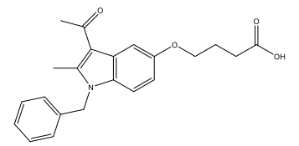
Figure 57- 4-(3-acetyl-1-benzyl-2-methyl-1H-indol-5-yl) oxy) butanoic acid.

E. ANTI-MALARIAL PROPERTIES-
Among the most fatal illnesses in the world is malaria. Both in the past and the present, it devastated millions of lives. People's lives are today being tirelessly influenced by this illness. Two hundred twenty-eight million cases of malaria have been documented in 2018 compared to 2010, according to reports, which is convincing evidence that the drop in malaria prevalence has halted after several years of decline.
After so much research some anti-malarial drugs have been developed some anti-malarial drugs are currently under trial [6].

Scaffolds in currently available Anti-malarial agents-
The first pharmaceutical that was effectively antimalarial was quinine (figure 58), a substance derived from the bark of the Cinchona calisaya tree. Non-natural descendants of quinoline antimalarials, such as chloroquine, which was utilized as the first-line anti-malarial medication internationally, influenced the field. A significant spike in resistance is leading the clinical usage of chloroquine to drop more quickly [3].
The primary method of treatment for mild cases of malaria is currently endoperoxide scaffold artemisinin-based combination remedies [3].
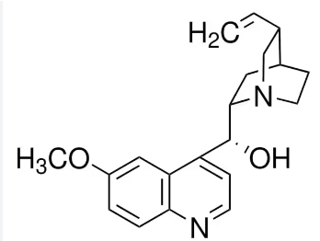
Figure 58- Quinine.

Propitious indole-anti-plasmodium agents –
Piperidine Indoles
Bis-indole
Spiro indoles
Conjugated indole analogs
Indole-3-glyoxylic tyrosine derivative
Prenylated indole alkaloids

Piperidine indoles-
A piperidine indole descendent, TCMDC-134281, was uncovered by screening the recently released Tres Cantos set (TCAMS) of gsk (figure 59). The shift boosted the drug-likeness by cutting the molecular weight and net lipophilicity [3].
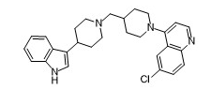
Figure 59 - TCMDC-134281.

Figure 60- Improved TCMDC-134281 drug-likeness.

Bis-indoles-
Various compounds that have bis-indole sections implemented or fixed within them were found to have strong plasmodial characteristics. Strychnos usambaresis yields dihydrousambarensine (figure 61), which exhibits a higher effectiveness against CQ-resistant organisms than CQ-sensitive strains [3].
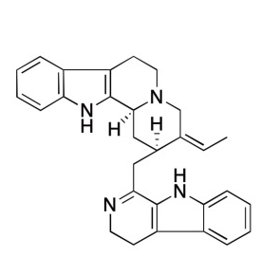
Figure 61- Dihydrousambarensine.
S.icsja is a local remedy for malaria fever used by Cameroonian pygmies. From flindersia acuminata, a novel bis-indole alkaloid called flinderole was produced.

Spiro-indoles-
They are the youngest class of antimalarial drugs and go by the name spiro tetrahydro-β-carbolines. The process of action of spiro indoles is separate from that of pharmaceutical antimalarial drugs because they block PfATP4, a plasmodium plasma membrane.
The structural adjustments of racemic spiro-azirine indole in Spiro indoles culminated in the derivation of NITD609, which was later renamed as KAE609 and is now sold as Cipargamin (figure 62) [2].
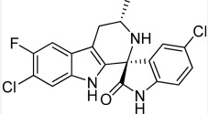
Figure 62- Cipargamin.

Conjugated indole analogue –
In herbal remedies and pharmaceuticals, Isatin, also known as 1H-indole-2,3-dione, is the most ubiquitous indole descendent. The anti-plasmodial act was shown to be triggered by a replacement of the isatin at the C-5 position and the length of the alkyl spacer in the chain of 1H-1,2,3-triazole-tied isatin-7-chloroquinoline and piperazine-tied isatin-7-chloroquinoline [3].
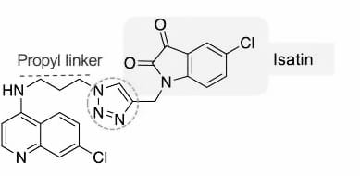
Figure 63
Most active anti-malarial derivative of this series.
Some other conjugated indole analogues –
Cryptolepine (figure 64) is an indolequinoline derived from the root of Cryptolepis sanguinolent.
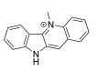
Figure 64
Ellipticine (figure 65) was derived from the bark of the Amazonian tree Aspidosperma vargasii.
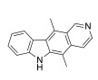
Figure 65
Tryptanthrin (figure 66) is derived from different plant sources
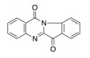
Figure 66

Indole-3-glyoxylic Tyrosine derivative-
They show the anti-plasmodium properties against the 3D7 strain of malaria.
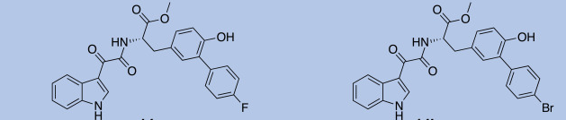
Figures 67a and 67b
Compound (b) (figure 67b) exhibits potential plasmodium activity against 3D7 strain [3].

Prenylated indole Alkaloids-
They are descended from Flindersia, F. acuminate, and F. ambobosinensis plants. They are the source of the quinoline and indole sorts of antimalarial alkaloids. Pimentelamine is an intriguing class of indole alkaloids that stems from Flindersia pimenteliana and is biosynthetically generated via 2-prenyl-N, N-dimethyltryptamine cyclized with a radical of semi-dehydroascorbic acid [3].
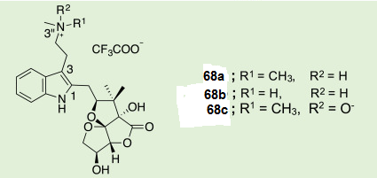

F. ANTI-HIV PROPERTIES-
Heterocyclic ingredients including benzimidazole, oxadiazole, and thiazoles have been leveraged to formulate well-organized therapeutic molecules on the base of antiviral agent drug design. Because indoles form an array of enticing pharmacological drugs, scientists are working to boost the antiviral efficacy of indole derivatives [6].
Indole as HIV resistor-
HIV assaults a person's immune system and encourages a potentially fatal opportunistic infection to circulate. Treatment for HIV/AIDS typically entails using many antiretroviral medications. The effects and quick emergence of pharmacological inhibitors are barriers that have impeded the ongoing discovery of novel anti-HIV drugs notwithstanding antiretroviral therapy [30]. It has been established that the Umifenovir correlatives (figure 690) have broad-spectrum antiviral activity. Though they appear to have increased anti-HIV value, cyclopropyl correlatives fall short of rac-MC-1501, the reference molecule [11].

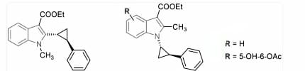
Figure 69- Umifenovir analogues
Dimethyl phenyl ring halogenated carbazole scaffolds are made to evaluate anti-HIV efficacy against NL4.3X4 and Bal R5 subtypes. 2,5-dimethyl carbazole analogues associated with 7-choro groups have demonstrated weak anti-HIV activity features, but 8-chloro carbazole without a –NO2/NH2 group exhibited average opposition activity and greater Bal R5 resistance potency [30].
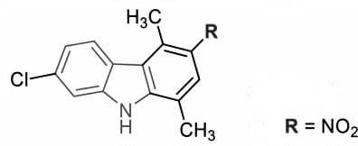
Figure 70
This compound with R=NO2 exhibits great potency against HIV as compared to all of its derivatives.
By experimenting with a wide range of structural variants into compounds a chain of indole–based HIV-1 attachment resistors are produced out of which some show great resistance against HIV, and some are less potent. Some selected compounds have been tested for their ability to resist HIV. Most of the compounds exhibited poor activity. Whereas 5,6-dihydroxyindole carboxamide (figure 71) descendants have exerted stronger HIV inhibition potency [30].
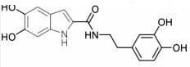
Figure 71- 5,6-dihydroxyindole carboxamide.
Considering electron acceptor groups such as halogen (X) only 4-bromoaniline (figure 72) correlatives represent HIV-1- inhibitor activity [30].
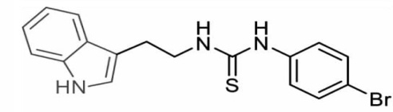
Figure 72- 4-bromoaniline.

G. ANTI-MICROBIAL PROPERTIES-
Drug inhibition, which ensues when microorganisms involving bacteria, viruses, fungi, and parasites defy a medication that is supposed to eradicate the infection, is sometimes referred to as antimicrobial animosity [23]. Many types of hazardous diseases, including pneumonia, endocarditis, and skin and soft tissue infections necessitating in-depth or critical care units, were initially recognized as being caused by methicillin-resistant Staphylococcus aureus (MRSA). The embryonic products of indole possess profitable antibacterial properties against MRSA. NorA efflux is the sole grantor. Numerous medications with diverse structures can be imported by NorA efflux, including acrylamide, benzalkonium chloride, cetrimide, ethidium bromide, fluoroquinolones, and tetraphenylphosphonium bromide [24]. Azole contains the widely used antifungal drugs fluconazole, ketoconazole, and itraconazole (figure 73). Fluconazole, however, did not affect Candida Krusei.

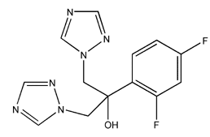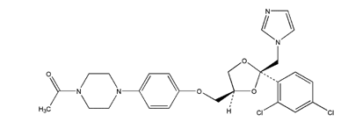
Fluconazole Ketoconazole
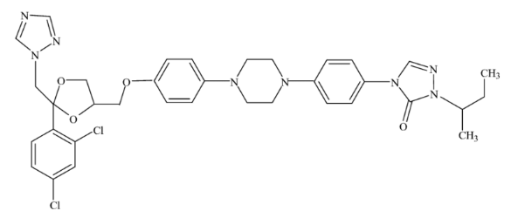
Itraconazole

REFERENCE –
- Indole as a Core Anti-Inflammatory Agent- A Mini Review K. Hemalatha, G. Madhumitha a, Selvaraj Mohana,
- Indole: A promising scaffold for the discovery and development of potential anti-tubercular agents- Nilesh Gajanan Bajad a, Sudhir Kumar Singh b, Sushil Kumar Singh a, Tryambak Deo Singh c, Meenakshi Singh
- Indole-based antimalarial compounds targeting the melatonin pathway: Their design, synthesis and biological evaluation- Tania Luthra a, 1, Akshay Kumar Nayak b, 1, Sarpita Bose d, Saikat Chakrabarti d, Ashish Gupta b, Shubhabrata Sen
- INDOLE DERIVATIVES AS POTENTIAL ANTICANCER AGENTS: A REVIEW HARSHITA SACHDEVA, JAYA MATHUR AND ANJALI GULERIA.
- Research progress of indole compounds with potential antidiabetic activity- Yuqian Zhu a, Jinran Zhao a, Longbiao Luo a, Yang Gao a, He Bao b, Pengfei Li c, Hailong Zhang
- A brief review of the biological potential of indole derivatives Sunil Kumar and Ritika
- Analysis of Antioxidant Consumption, Body Mass Index and the Waist-Hip Ratio in Early Postmenopause Carlos A. Jiménez-Zamarripa 1,2, Liliana Anguiano-Robledo 1, Patricia Loranca-Moreno 1,3, M. Esther Ocharan-Hernández 1 and Claudia C. Calzada-Mendoza 1, 1 Instituto Politécnico Nacional-ESM.
- Synthesis and Biological Evaluation of Indole-2-Carboxamides with Potent Apoptotic Antiproliferative Activity as EGFR/CDK2 Dual Inhibitors- Lamya H. Al-Wahaibi 1, Yaser A. Mostafa 2, Mostafa H. Abdelrahman 3, Ali H. El-Bahrawy 4, Laurent Trembleau 5 and Bahaa G. M. Youssif 2, 1
- Synthesis and Biological Evaluation of Indole-2-Carboxamides with Potent Apoptotic Antiproliferative Activity as EGFR/CDK2 Dual Inhibitors Lamya H. Al-Wahaibi 1, Yaser A. Mostafa 2, Mostafa H. Abdelrahman 3, Ali H. El-Bahrawy 4, Laurent Trembleau 5 and Bahaa G. M. Youssif 2,
- Antiviral Activity of an Indole-Type Compound Derived from Natural Products, Identified by Virtual Screening by Interaction on Dengue Virus NS5 Protein Leidy Lorena García-Ariza 1, Natalia González-Rivillas 1, Cindy Johanna Díaz-Aguirre 1, Cristian Rocha-Roa 2, Leonardo Padilla-Sanabria 1, and Jhon Carlos Castaño-Osorio
- Antiviral Activity of Umifenovir In Vitro against a Broad Spectrum of Coronaviruses, Including the Novel SARS-CoV-2 Virus Irina Leneva 1, Nadezhda Kartashova 1, Artem Poromov 1, Anastasiia Gracheva 1, Ekaterina Korchevaya 1, Ekaterina Glubokova 1, Olga Borisova 1, Anna Shtro 2, Svetlana Loginova 1, Veronika Shchukina 1, Ravil Khamitov 3 and Evgeny Faizuloev 1
- 3-Indoleacetonitrile Is Highly Effective in Treating Influenza A Virus Infection In Vitro and In Vivo Xuejin Zhao 1, †, Lianzhong Zhao 2,3,4, †, Ya Zhao 2,3,4, Kun Huang 2,3,4, Wenxiao Gong 2,3,4, Ying Yang 2,3,4, Li Zhao 1, Xiaohan Xia 1, Zaiyun Li 5, Feng Sheng 1, Xuezhu Du 1, and Meilin Jin 2,3,4
- Recent Advances in Therapeutic Approaches for Adult T-cell Leukemia/Lymphoma Koji Kato and Koichi Akashi
- Antifungal Activity of Glucosinolate-Derived Nitriles and Their Synergistic Activity with Glucosinolate-Derived Isothiocyanates Distinguishes Various Taxa of Brassicaceae Endophytes and Soil Fungi Zsolt Sz ˝ucs 1,2, Tamás Plaszkó 1,3, Eszter Bódor 1, Hajnalka Csoma 4, Lajos Ács-Szabó 4, Attila Kiss-Szikszai 5, Gábor Vasas 1 and Sándor Gonda 1,
- Anticancer Evaluation of Novel Benzofuran–Indole Hybrids as Epidermal Growth Factor Receptor Inhibitors against Non-Small-Cell Lung Cancer Cells Yechan Lee 1, †, Sunhee Lee 1, †, Younho Lee 1, Doona Song 2, So-Hyeon Park 1, Jieun Kim 1, Wan Namkung 1, and Ikyon Kim 1,
- Discovery of Potent Indolyl-Hydrazones as Kinase Inhibitors for Breast Cancer: Synthesis, X-ray Single-Crystal Analysis, and In Vitro and In Vivo Anti-Cancer Activity Evaluation Eid E. Salama 1, Mohamed F. Youssef 1, Ahmed Aboelmagd 1, Ahmed T. A. Boraei 1, Mohamed S. Nafie 1,2, Matti Haukka 3, Assem Barakat 4, and Ahmed A. M. Sarhan 5
- Profiling Analysis of Tryptophan Metabolites in the Urine of Patients with Parkinson’s Disease Using LC-MS/MS So Hyeon Chung 1, Dallah Yoo 2, Tae-Beom Ahn 2, Wonwoong Lee 3, and Jongki Hong 1
- Indole-Based and Cyclopentenyl indole-Based Analogues Containing Fluorine Group as Potential 18F-Labeled Positron Emission Tomography (PET) G-Protein Coupled Receptor 44 (GPR44) Tracers Runkai Yin 1, Kelly X. Huang 1, Lina A. Huang 1, Melinda Ji 1, Hanyi Zhao 1, Kathy Li 1, Anna Gao 1, Jiaqi Chen 1, Zhixuan Li 1, Tianxiong Liu 1, John E. Shively 2, Fouad Kandeel 1,* and Junfeng Li 1,
- Design, Synthesis, In Silico Studies and In Vitro Evaluation of New Indole- and/or Donepezil-like Hybrids as Multitarget-Directed Agents for Alzheimer’s Disease Violina T. Angelova 1, Borislav Georgiev 2, Tania Pencheva 3, Ilza Pajeva 3, Miroslav Rangelov 4, Nadezhda Todorova 2, Dimitrina Zheleva-Dimitrova 5, Elena Kalcheva-Yovkova 6, Iva V. Valkova 1, Nikolay Vassilev 4, Rositsa Mihaylova 7, Denitsa Stefanova 7, Boris Petrov 7, Yulian Voynikov 1 and Virginia Tzankova 7
- In Vitro Analyses of the Multifocal Effects of Natural Alkaloids Berberine, Matrine, and Tabersonine against the O’nyong-nyong Arthritogenic Alphavirus Infection and Inflammation Anne-Laure Sandenon Seteyen 1, Pascale Guiraud 1, Philippe Gasque 1,2, Emmanuelle Girard-Valenciennes 3 and Jimmy Sélambarom 1,
- Design, Synthesis, and Biological Evaluation of Indole-2-carboxamides as Potential Multi-Target Antiproliferative Agents Lamya H. Al-Wahaibi 1, Anber F. Mohammed 2, Mostafa H. Abdelrahman 3, Laurent Trembleau 4, and Bahaa G. M. Youssif 2,
- Indol-3-ylglyoxylamide as Privileged Scaffold in Medicinal Chemistry Elisabetta Barresi 1, †, Marco Robello 2, †, Emma Baglini 1, Valeria Poggetti 1, Monica Viviano 3, Silvia Salerno 1, Federico Da Settimo 1 and Sabrina Taliani 1,
- Indole-Acrylonitrile Derivatives as Potential Antitumor and Antimicrobial Agents—Synthesis, In Vitro and In Silico Studies Anita Kornicka 1, Karol Gzella 1, Katarzyna Garbacz 2, Małgorzata Jarosiewicz 2, Maria Gdaniec 3, Joanna Fedorowicz 1, Łukasz Balewski 1, Jakub Kokoszka 1 and Anna Ordyszewska
- Structure-Activity Relationship Studies of Indolglyoxyl-Polyamine Conjugates as Antimicrobials and Antibiotic Potentiators Melissa M. Cadelis 1,2, Tim Liu 1, Kenneth Sue 1, Florent Rouvier 3, Marie-Lise Bourguet-Kondracki 4, Jean Michel Brunel 3 and Brent R. Copp 1,
- Alkaloid from Geissospermum sericeum Benth. & Hook. f. ex Miers (Apocynaceae) Induce Apoptosis by Caspase Pathway in Human Gastric Cancer Cells Mirian Letícia Carmo Bastos 1,2,†, João Victor Silva-Silva 3,†, Jorddy Neves Cruz 2, Amanda Roberta Palheta da Silva 4, Alexandre Augusto Bentaberry-Rosa 4, Gisele da Costa Ramos 5, José Edson de Sousa Siqueira 5, Márlia Regina Coelho-Ferreira 6, Sandro Percário 1, Patrícia Santana Barbosa Marinho 5, Andrey Moacir do Rosario Marinho 5, Marcelo de Oliveira Bahia 7 and Maria Fâni Dolabela 1,2,4,8,
- N-Derivatives of (Z)-Methyl 3-(4-Oxo-2-thioxothiazolidin-5- ylidene)methyl)-1H-indole-2-carboxylates as Antimicrobial Agents—In Silico and In Vitro Evaluation Anthi Petrou 1, Athina Geronikaki 1, Victor Kartsev 2, Antonios Kousaxidis 1, Aliki Papadimitriou-Tsantarliotou 3, Marina Kostic 4, Marija Ivanov 4, Marina Sokovic 4, Ioannis Nicolaou 1 and Ioannis S. Vizirianakis 3,5
- Indole-3-Carbinol Stabilizes p53 to Induce miR-34a, Which Targets LDHA to Block Aerobic Glycolysis in Liver Cancer Cells Yuehua Qi 1,2, †, Chunjing Zhang 3, †, Di Wu 1,2, Yue Zhang 1, Yunfeng Zhao 4, and Wenjuan Li 1,2
- Concept of Hybrid Drugs and Recent Advancements in Anticancer Hybrids Ankit Kumar Singh 1, †, Adarsh Kumar 1, †, Harshwardhan Singh 1, Pankaj Sonawane 1, Harshali Paliwal 1, Suresh Thareja 1, Prateek Pathak 2, Maria Grishina 2, Mariusz Jaremko 3, Abdul-Hamid Emwas 4, Jagat Pal Yadav 5,6, Amita Verma 5, Habibullah Khalilullah 7 and Pradeep Kumar 1,
- Synthesis and Biological Evaluation of Indole-2-Carboxamides with Potent Apoptotic Antiproliferative Activity as EGFR/CDK2 Dual Inhibitors Lamya H. Al-Wahaibi 1, Yaser A. Mostafa 2, Mostafa H. Abdelrahman 3, Ali H. El-Bahrawy 4, Laurent Trembleau 5 and Bahaa G. M. Youssef.
- Indole – A promising antiviral pharmacophore in recent drug discovery Atukuri Dorababu.

