**SUSTAINABILITY PRACTICES IN PATIENT CARE**

**Priyanka Singh1**

**Ph.D. Scholar, Teerthanker Mahaveer University Moradabad**

**Email-** [**priyankasingh.nov.26@gmail.com**](mailto:priyankasingh.nov.26@gmail.com)

**Mamta Verma2**

**Assistant Professor, Teerthanker Mahaveer University Moradabad**

**Email- mv926431**[**@gmail.com**](mailto:priyankasingh.nov.26@gmail.com)

**Varsha Rajput3**

**Assistant Professor, Teerthanker Mahaveer University Moradabad**

**Email- varsharajput52010**[**@gmail.com**](mailto:priyankasingh.nov.26@gmail.com)

**Abstract-** Improving patient outcomes, sustainability, and healthcare efficiency all depend on reducing waste in clinical settings. Waste in healthcare includes excessive material use, ineffective procedures, needless resource use, and preventable patient problems. Adopting technology to improve workflows, embracing lean management concepts, and putting evidence-based strategies into practice are some ways to tackle this issue. Reduced usage of single-use plastics, improved inventory control, improved care coordination, and internet integration to cut down on unused trips are important strategies. Fostering a sustainable culture requires the involvement and education of healthcare workers. Carefully reducing waste can help healthcare companies save costs, improve the quality of care they offer, and lessen their environmental effect. This abstract highlights the importance of a multidisciplinary approach in achieving waste reduction and its implications for a more sustainable healthcare future.

**Keywords- Environmental Health and Safety, clinical waste, sustainable, Waste Resources Action Programme, HVAC, HIS, HER, SCM, TBL**

* 1. **Introduction**

In a world that is changing quickly, what sustainability means is always changing. The Burtland Report, which was released by the United Nations in 1987, contained one of the earliest formal definitions of sustainable development. Sustainable development, according to the statement, is "development that meets the needs of the present without compromising the ability of future generations to meet their personal needs." However, because this definition is fundamentally vague, it has been hard to come to a consensus on the topic of sustainability. A more useful definition was put out by Swedish scientist Karl-Henrik Robert. An ideal society, in his opinion, would aim to minimize the use of minerals and other natural resources.**[1]**

The demand to follow the 2030 Agenda for Sustainable Development, which was approved by every member of the UN in 2015, and to overcome the negative effects of global issues like population aging, climate change, environmental degradation, discrimination, and inequality has increased pressure on all economic actors, but particularly on healthcare sector organizations. Therefore, the work of healthcare organizations is crucial because it directly affects the process of achieving the 17th **Sustainable Development Goals (SDGs)** in general and in relation to issues like gender equality, cheap and clean energy, clean water and sanitation, and good health and well-being in particular.**[2]**

* 1. **Definition-** Sustainability, the ability of a group of people, a system of social institutions, or a social activity to endure over the long term. Generally speaking, sustainability is viewed as a type of intergenerational ethics whereby the economic and environmental decisions made by current individuals do not reduce the chances for future generations to experience comparable degrees of prosperity, usefulness, or welfare.

The general public, governments, and the healthcare system all place a high priority on sustainability. Historically, environmental degradation has been closely associated with the term sustainability. Sustainability's importance has changed in recent years and is now linked to other factors like patient, healthcare worker, and community well-being. Accordingly, a sustainable building is one that guarantees resource preservation, is feasible from an ecological, social, and economic standpoint, and satisfies the needs of various stakeholders. Despite the abundance of studies describing methods for improving sustainability in healthcare systems, there is still no consensus on practical strategies for implementing the recommended sustainability measures in clinical laboratories, despite a number of possible.**[3] [4]**

**1.2 Aim of sustainability practices-**

* Encourage the health and vitality of the environment, people, and economy.
* Maintain a balance between social justice, economic vigor, and ecological health.
* Minimize adverse effects on the environment
* Encourage the welfare of all living things
* Preserve the equilibrium of natural processes.
* Combine ecological purity and economic viability.**[5]**

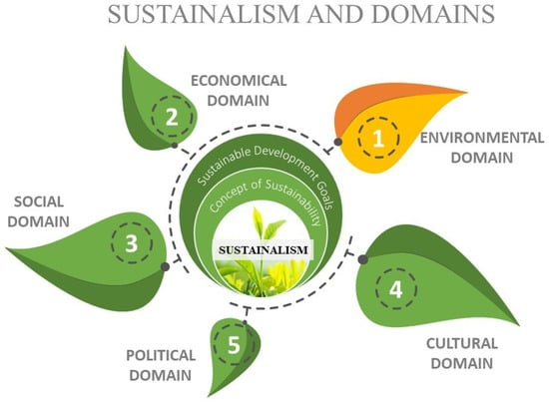

**Figure: 1** **shows the different areas of sustainability**

* 1. **Aspects of sustainable practices in healthcare**

**2.1 Sustainable healthcare infrastructure-** Hospitals, clinics, and labs are examples of infrastructure that needs to be properly stocked, dispersed, and run. Strong telemedicine capabilities are also included in this. Building **Health Information Systems (HIS)** or **Electronic Health Record (EHR)** systems, optimizing healthcare logistics through **Supply Chain Management (SCM)** solutions, and creating smart hospitals are essential. The ideal routes are home or local care options that collaborate in a network with specialized clinics, since hospitals are the most resource-intensive treatment options. Hospitals will rely on energy efficiency with better-monitored infrastructure technology, with a particular emphasis on security, flexibility, and heating and cooling. They will also rely on optimized information delivery and monitoring from a cockpit perspective that is customized for each user role, from patients and technical staff to hospital managers and doctors.**[6] [7]**

Hospitals are already working to implement green and sustainable practices. The pandemic was a contributing factor in hastening this adoption process.

One crucial area for investigation and optimization is healthcare infrastructure, which is recognized as one of the most resource-intensive and hidden spaces. Some common themes in this field include planning for occupant health and well-being in the face of rising temperatures, humidity, and air pollution, as well as designing for the economics and environment, which includes reducing the energy footprints of the infrastructure. Second, health fairness and the welfare of the community should be a clear priority in the design of sustainable healthcare.**[8]**

**2.2 Waste management and recycling-** The infographic illustrates one of the main effects of poor solid waste management.

Diseases may spread as a result of insects and mosquitoes developing in stagnant water pools on disposal sites as well as in canals and rivers that are obstructed or restricted by waste.  
• Workers and local neighbors may be at risk for health problems brought on by scavenger animals, insects, flies, and vermin.  
• The presence of insects and odors is becoming a nuisance in the area.   
• The dumpsite's greenhouse gas emissions exacerbate environmental deterioration.   
• When runoff is released into streams or natural drains during the rainy season, water bodies may become contaminated.   
• Pollution from GW.**[9]**

* **Benefits of Recycling-**The process of recycling involves turning waste materials into new goods. To make new products, waste materials must be gathered, sorted, and processed. Recycling lessens the quantity of garbage that ends up in landfills, conserves natural resources, and lowers greenhouse gas emissions. The process of recycling involves turning waste materials into new goods. To make new products, waste materials must be gathered, sorted, and processed. Recycling lessens the quantity of garbage that ends up in landfills, conserves natural resources, and lowers greenhouse gas emissions.**[10]**

1. **Preservation of Natural Resources** - Recycling contributes to the preservation of natural resources like minerals, water, and lumber. For instance, recycling paper lessens the need to cut down trees to produce new paper. Likewise, recycling metals lessens the requirement for fresh resource mining.**[11]**
2. **Decrease in Waste in Landfills**- Recycling leads to less waste ending up in landfills. One major cause of contamination in the environment is landfills. They contribute to climate change by releasing greenhouse gases like carbon dioxide and methane. Recycling lowers the quantity of waste dumped in landfills, which in turn lowers the quantity of greenhouse gases discharged into the environment.**[12]**

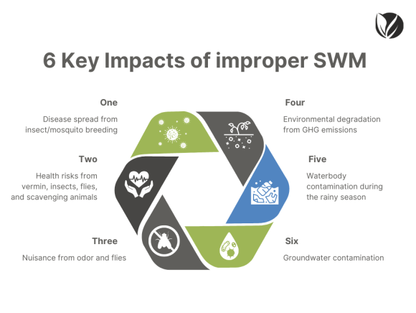

**Figure 2- Effects of sustainable waste management in improper way**

1. **Conserving Energy**- Recycling helps with energy conservation as well. Energy consumption is lower when new items are made using recycled materials as opposed to raw materials. As an example, recycling aluminum cans uses 95% less energy than using raw resources to make new metal cans. **[13]**  
   **D. Financial Gains**- Recycling provides financial advantages as well. Recycling lowers garbage disposal costs and generates jobs in the recycling sector. Since recycled materials are frequently less expensive than raw materials, it also helps to lower the cost of creating new items.

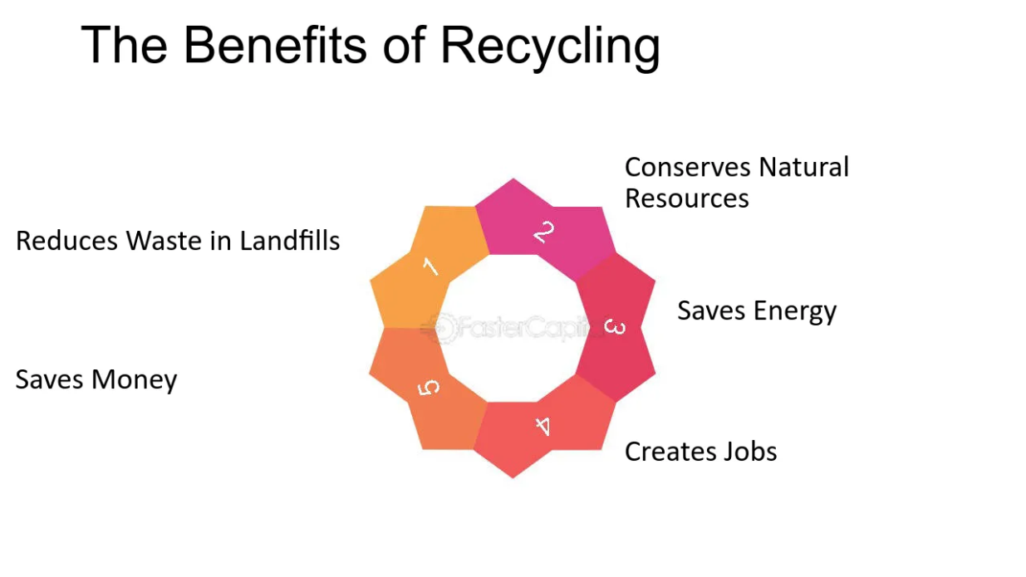

**Figure 3- Various advantages of recycling the wastes in proper methods**

**2.3 Sustainable procurement practices**

Procurement is essential to sustainability since rules and procedures must encompass an organization's whole supply chain. Procurement decisions should take into account the environmental, economic, and social aspects of the **Triple Bottom Line (TBL)**, according to sustainability guidelines. From a supply chain standpoint, procurement must also examine how actions pertaining to suppliers affect the TBL. In order to ensure that procurement procedures and decision-making still satisfy stakeholder criteria, sustainable procurement incorporates environmental, governance, and social aspects of corporate responsibility. It strives for the best social outcomes and the least amount of environmental effect.**[14]**

* **Common framework of Sustainable procurement**

## People, planet, and profit (3P’s)

Environmental considerations have been the primary focus of eco-friendly procurement. This movement, also referred to as "green sourcing" and "green procurement," aims to replace one substance with one that is more environmentally friendly. Consider paper straws as an alternative to plastic ones. However, there is more to sustainable procurement than that.

Industries are starting to address sustainability in a more comprehensive way. They take into account social, economic, and environmental aspects collectively.**[15]**  
  
**II. Triple Bottom Line (TBL)**

According to an economic concept known as the **triple bottom line (TBL),** organizations should report on more than just their financial performance. Additionally, their reporting to shareholders should include information on the social and environmental impact.   
Businesses that embrace sustainability are moving toward generating value for all parties involved, including clients, partners, staff, and community members. The triple bottom line in procurement addresses a number of issues, including environmental protection, waste and hazardous materials, human rights, compliance, anti-bribery, fair labor, equality, diversity, employee well-being, education and development, and freedom of association (Fig- 4).**[16]**

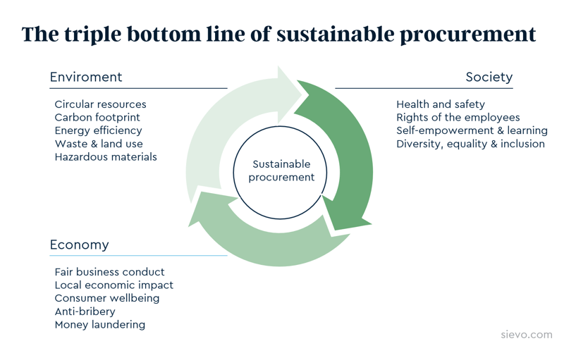  
  
**Figure 4 – the process of sustainability through TBL**

* **Example of Sustainable procurement**

1. **Single use plastic (SUP) -** Single-Use Plastics (SUP) Directive is one new law that affects sustainable procurement. Promoting the shift to a circular economy and preventing and lessening the effects of plastic products are its objectives.

The directive targets following products-

* Bud sticks made of cotton
* Stirrers, straws, plates, and cutlery
* Stirrers, straws, plates, and cutlery
* Containers for food
* Cups for drinks
* Containers for beverages
* Butts from cigarettes
* Bags of plastic
* Wrappers and packets
* Sanitary products and wet wipes

Metal straws could be used instead of plastic ones. Although a metallic straw may cost more per unit than a throwaway plastic one, it will last longer and generate less trash. Although plastic is inexpensive, metallic straws may end up being more cost-effective in the long run because they are bought and discarded less frequently.**[17]**

* **Benefits of sustainable procurement-**

**Environmental Benefits**

* Cutting waste and increasing the effectiveness of resources
* Cutting back on energy use and carbon emissions
* Reducing the adverse effects of buying from uncertified sources
* Ensuring adherence to environmental regulations

**Economic benefits-**

* Using a life-cycle cost (TCO) approach to cost control
* Observing rules and relevant legislation
* Ensuring supply security and continuity
* Reducing business hazards
* Developing a competitive edge
* Controlling consumer impressions and reputation
* Making capital more accessible

**Social benefits**-

* Making a constructive impact on the communities where they work
* Paying a living wage and ending child labor
* Employee participation in community initiatives
* Putting money into initiatives that raise citizens' standard of living.**[18]**

**2.4 Reducing Carbon Footprint-**

**Introduction**- The **total quantity of carbon dioxide (CO2) emissions** from a person or other entity's activity (e.g., building, corporation, country, etc.). Direct emissions, including those from burning fossil fuels for transportation, heating, and manufacturing, are included, as are emissions needed to generate the power needed to run the goods and services that are consumed. Furthermore, the idea of the carbon footprint frequently incorporates emissions of additional greenhouse gases, such nitrous oxide, methane, or chlorofluorocarbons (**CFCs**).

The idea of the ecological footprint, which was developed in the early **1990s at the University of British Columbia by Swiss regional planner Mathis Wackernagel** and **Canadian ecologist William Rees**, is connected to and evolved from the concept of the carbon footprint. The entire amount of land needed to support a population or activity is known as the ecological footprint. Water use and the quantity of land needed for food production are two examples of its effects on the environment. A carbon footprint, on the other hand, is typically stated as a weighted amount, such as tons of CO2 or CO2 equivalent annually.

**Reduction process of carbon footprint**- It is well known that hospitals and other healthcare institutions use a lot of energy and produce a lot of carbon emissions from transportation, waste disposal, and energy use. Healthcare institutions can lessen their carbon footprint by implementing energy-efficient procedures, utilizing renewable energy sources, and cutting waste. This can improve the quality of the air and water, reduce greenhouse gas emissions, and lessen the effects of climate change.

Many actions can be taken by both individuals and businesses to lessen their carbon footprints and so help mitigate the effects of climate change. They can partially or completely offset their carbon footprint by investing in carbon-reducing activities or technologies, or by buying carbon offsets. They become carbon neutral if they make enough purchases to balance their carbon footprint. Changing lifestyles and buying patterns, as well as increasing energy efficiency, can all help reduce carbon footprints? Changing how one uses energy and transportation can affect key carbon footprints. When compared to driving, for instance, taking public transit, including buses and trains, lowers a person's carbon footprint. By utilizing renewable energy sources to provide the electricity they need, installing energy-efficient lighting, or adding insulation to buildings, both individuals and organizations can lessen their individual carbon footprints. For instance, there are no direct carbon emissions when electricity is generated using wind power. Reducing meat consumption and changing to products that need less carbon emissions to generate and transport are two other lifestyle choices that can reduce an individual's secondary carbon footprint.**[19]** **[20]**



**Figure 5- ecological carbon footprint**

**Some actions to reduce carbon emission in healthcare-**

1. For patient meals, organizations should look into ways to source locally sourced, sustainable food.
2. Give equipment and consumables that are unused or expired to other institutions or healthcare sectors, such as simulation labs, colleges, universities, or research centers.
3. Make certain that every healthcare professional, including clinicians, is aware of and complies with the proper disposal of clinical and general trash, which includes sorting recyclable and compostable garbage.
4. Companies should make sure there are suitable and secure containers available to support proper waste separation.
5. Lower energy use by being mindful of "plug load," the significance of shutting off or lowering lights in areas with little traffic or non-essential use, and the prompt use of sleep mode or gadget power down.
6. Implement the stairs initiative; it will improve the health of patients and employees and save energy by reducing the usage of elevators and similar devices.
7. Recycling by selecting organizations to contribute bottle tops and lids for recycling and reuse, as well as ways to donate patient water bottles using funds to a charity or strengthen the facility's recycling program.
8. Minimize the amount of energy used for laundry (while ensuring infection prevention and control).
9. Rethink treatment plans: Is it possible to receive care at home? Reduce traveling costs by optimizing virtual care models.
10. "Do not open" guidelines in cardiac catheterization lab and operating room settings. Cut down on wasteful spending.
11. Reduce needless carbon emissions from transportation by making the most of virtual or hybrid conferences and meetings.**[21]**

**2.5 Sustainable water management-** Individual facilities can set short- and long-term water saving goals with the use of water management strategies.

* Educate employees and patients by posting signs, explaining water management guidelines, and giving them advice on how to use water more efficiently.
* **Install water-efficient fixtures-** Install water displacement devices in toilet tanks and swap out inefficient toilets and urinals for low-flow alternatives.
* Reduce the amount of water used in laundry by installing a rinse water reclamation system, using less soap, and minimizing the number of wash and rinse stages.
* **Recycle wastewater**- To repurpose water for non-potable uses like landscape irrigation and toilet flushing, install a wastewater treatment facility.
* **Rainwater harvesting**- Gather and use rainfall for gardening.
* **Reuse grey water**- Clean sink and shower water for use in cooling systems or toilet flushing.
* Make water supply systems more efficient. Before returning effluent water to the environment, treat it.
* **Equipment upgrade**- Replace or refit water-intensive equipment, such as laundry, sterilizing, and dishwashing machines.
* **Create maintenance schedules**- Create routine maintenance schedules for boiler and pipe systems.
* **Utilize technology**- Reduce travel and carbon emissions by using telemedicine. To cut down on paper, use **electronic health records**, or EHRs.

**2.6 Promoting preventive care and public Healthcare**- A fundamental component of sustainable healthcare is this. Because it is more economical and produces better health effects, efforts should be focused on preventing illnesses and encouraging healthy lives. Effective strategies to educate and modify behavior can be effectively researched in smaller populations, as Iceland has shown. A program designed specifically for teenagers decreased the number of 15–16-year-olds who smoked from 23% to 3% and the percentage who drank alcohol from 42% to 5% over the course of 20 years.

The most significant effects on health prevention strategies are well understood. Some of the main causes of "civilization diseases" like heart attacks, strokes, diabetes, and lung cancer are excessive consumption of unhealthy foods (such as processed foods high in sugar, fat, and salt), lack of exercise, smoking, and alcohol. These diseases are costly to both individuals and society. Nothing will ever be as long-lasting as prevention. For the required behavioral adjustments to be supported, education and technology will be essential.   
It's a serious problem, in this regard, it is projected that the number of people with diabetes would rise by 51% globally by 2045, from 463 million (9.3%) to 700 million (10.9%), primarily in metropolitan areas and industrialized countries.**[22]**

**2.7 Education for Sustainability development (ESD) -** Education is the key to achieving all of the global development goals, according to Education for Sustainable Development (ESD). It teaches people how to alter society and save the environment by making wise decisions and acting both individually and collectively. It gives people of all ages the information, abilities, values, and skills they need to address problems that affect the planet's and people's well-being, like biodiversity loss, climate change, resource overuse, and inequality.

* **ESD promotes education that is-**
* **Cognitive**- Enhancing our ability to reason and comprehend data.
* **Socio-emotional**- Developing emotional intelligence, empathy, and social skills.
* **Behavioral**-Promoting constructive acts and conduct.

ESD, which addresses what we learn, how we learn it, and the environment in which we learn it, is a potent tactic to change education. It is an essential component of a high-quality education and a process of lifelong learning.**[23]**

**2.8 Accessible Care-** Everyone should have access to healthcare so that nobody is left behind. This involves giving care to people who are most in need as well as those who reside in isolated or underdeveloped locations. In order to increase overall life expectancy, low-level primary care is far more crucial from a population health standpoint than expensive specialty treatment. Low-cost drugs, including those for high blood pressure, can be used to treat a variety of illnesses. Therefore, having basic care that is easily accessible is essential for identifying and treating a wide range of common health issues. AI, sensors, and testing are examples of technology that will greatly aid in reducing costs and improving access to care.

**2.9 Affordable care-** Many people find that the cost of healthcare is a significant obstacle. It should be possible for everyone to afford sustainable healthcare, regardless of their financial situation. Regardless of how well-designed the health system is, additional diseases will become treatable and even cured as science advances, which will drive up expenses. Making the "biggest bang for the buck," or putting criteria in place to help think through the best ways to distribute limited resources, is still a struggle. Since new therapies are always more costly, pharmaceutical companies must have enough money to spend in more research. This frequently entails making a trade-off between temporary cost increases and maybe better therapies that will become more inexpensive once the patent expires.**[24]**

Pharmaceutical firms profit from "blockbuster" pharmaceuticals for a period, but this is followed by the development of low-cost generics that can help everyone in need of healthcare. Certain situations, including novel genetic therapies that could treat illnesses like sickle cell disease, may have high short-term expenses but great long-term potential. The best outcomes come from a combination of competitive factors and governmental initiatives, demonstrating unequivocally that free trade by itself cannot be effectively implemented in the healthcare industry.**[25]**

**2.10 Healthcare workforce-** Having a well-trained, driven, and dispersed healthcare workforce is essential. This covers physicians, nurses, and other medical specialists. One of the main obstacles is that healthcare job is frequently more difficult and pays less than other professions. Because daily job is less appealing, there is a shortage of healthcare workers in the majority of countries. Even though the healthcare industry has a great reputation, employee satisfaction is frequently well below sustainable norms. A better work-life balance is frequently what individual’s desire instead of having to make seemingly unavoidable compromises, such working more than 50 hours a week, as 50% of US doctors do. There are numerous ways to handle this issue. Better working plans, process enhancements, telemedicine, and artificial intelligence are desperately needed to cut down on non-patient-related labor, which takes up the majority of the day schedule.

**2.11** **Innovation in Technology**- Digital technologies, artificial intelligence, and data analytics can enhance supply chain management, patient monitoring, illness management, and diagnostics. Big Data for epidemiological research, Internet of Things (IoT) devices for remote patient monitoring, and Artificial Intelligence (AI) for precision treatment are just a few examples of how technology will improve healthcare's efficiency and sustainability.**[26]**

**3**. **5 C's of Sustainability**   
Merely being environmentally sensitive is no longer sufficient in the pursuit of a sustainable future. A comprehensive strategy that incorporates all facets of our life is required. The "5 C's of Sustainability"- Clean, Community, Culture, Care, and Corporate Governance offer a thorough framework to direct us toward a future in healthcare that is more sustainable.

**3.1 Clean-** The initial "C" stands for "Clean," which acknowledges our duty to preserve and care for our planet. Promoting sustainable energy, cutting waste, and lowering our carbon footprint are all part of this. We must move toward renewable energy sources like wind, solar, and hydroelectric power as we work to create a cleaner planet. Additionally, promoting eco-friendly behaviors like composting, recycling, and water conservation can greatly lower pollution levels in the environment. Sustainability ultimately rests on a clean earth, and it is our collective responsibility to make this a reality.

**3.2 Community-** 'Community' is what the second "C" represents. Sustainability requires group effort; it cannot be achieved alone. Mutual support, inclusivity, and shared values are encouraged in a resilient, sustainable community. Communities may address global issues like social inequity, food shortages, and climate change locally by banding together. The importance of community in our quest for a sustainable future cannot be overstated, whether it is through local sustainability programs, co-housing projects, or community gardens.

**3.3 Culture-** Embracing diversity and cultivating a sustainable culture are the goals of culture, the third "C". It's about changing our collective perspective from one of exploitation to one of appreciation, from consumption to conservation. Local knowledge, customs, and cultural legacy can all be very important in this. Our cultural mosaic can be enhanced and sustainable solutions can be provided by maintaining traditional farming methods, indigenous knowledge, and regional arts. A society that promotes long-term well-being over immediate advantages, respects nature, and cherishes diversity is essentially one that is sustainable.

**3.4 Care-** The fourth "C" care" is crucial to sustainability. It includes taking care of one another, the environment, and future generations. This entails taking into account how our actions affect the environment, encouraging empathy and compassion in our relationships, and making choices that will leave the earth in good condition for next generations. Recognizing our interdependence with all living things and responding with compassion and accountability are key components of care.

**3.5 Corporate Governance-** "Corporate Governance" is the last "C" and emphasizes how important companies are to sustainability. Businesses need to implement sustainable measures in their operations, like cutting back on waste, lessening energy consumption, and encouraging ethical labor practices. Ethical decision-making, accountability, and transparency are further components of corporate governance. Businesses may support sustainable development and make money at the same time by implementing a stakeholder strategy.**[27]**

**4. Importance of sustainability practices**

* 1. **Prevention of Infections- Infections and diseases can be stopped from spreading by properly managing hospital trash. Biomedical waste presents a serious danger of infection transmission since it contains materials tainted with blood or other body fluids. Proper biological waste segregation, treatment, and disposal reduces the risk of infection for patients, healthcare professionals, and the general public.**
  2. **Environmental Protection**- Hazardous materials, drugs, and other potentially dangerous materials are among the many waste types produced by hospitals. Water pollution, soil contamination, and environmental degradation can result from poor waste management. Hospitals can help protect ecosystems, biodiversity, and the general health of the environment by adhering to appropriate waste management procedures.
  3. **Regulatory Compliance**- In addition to being required by law, waste management policies and procedures is crucial to preserving healthcare institutions' accreditation and standing. Specific guidelines are established by regulatory agencies for the handling, disposal, treatment, and segregation of various hospital waste kinds. Compliance guarantees that medical facilities conduct themselves morally and responsibly.
  4. **Occupational Safety-** Medical waste is generated, handled, and disposed of directly by healthcare personnel. Adopting appropriate waste management procedures safeguards hospital employees' safety and occupational health. This involves actions like developing procedures for safe waste handling, offering personal protective equipment, and providing training on waste segregation.
  5. **Welfare of the Community**- The effects of hospital waste on the local communities can be profound. Diseases are less likely to spread outside of hospital walls when trash is managed properly. Because ethical waste management procedures show a dedication to the general public's health, they help increase community trust in healthcare organizations.
  6. **Sustainability and Resource Conservation**- Paper, plastics, and glass are among the recyclable materials frequently found in hospital waste. Recycling initiatives that are implemented as part of waste management help to save resources and advance sustainability. By implementing procedures that minimize trash production and maximize recycling efforts, hospitals can lessen their environmental impact.
  7. **Public Perception and Trust**- Healthcare organizations' reputations are enhanced by efficient waste management. Hospitals that put public health and environmental responsibility first are valued and trusted by patients and the general public. Exhibiting a dedication to appropriate waste management improves the institution's reputation and cultivates goodwill throughout the community.
  8. **Preventing Accidents and Injuries**- Improper handling of medical waste, especially sharps like needles and syringes, can result in accidents and injuries. Strict waste management procedures, such as safe sharps disposal techniques, help shield the public, waste handlers, and healthcare professionals from unintentional harm.**[28] [29]**

**5**. **Challenges of implementing Sustainable Healthcare**

Despite the multiple benefits of sustainable healthcare practices in the medical field, putting them into practice can be difficult. One of the main obstacles is the cost and technological barriers: adopting green practices necessitates large investments in new equipment and technologies, which can be costly for healthcare providers. Furthermore, cultural and political barriers can make it difficult for healthcare providers to adopt sustainable healthcare practices; some may be reluctant to change, while others may encounter regulatory barriers that prevent them from doing so. Nonetheless, the advantages of sustainable healthcare methods make the work worthwhile. We can enhance the environment and encourage better health outcomes for patients and staff by cutting down on waste and pollution in hospitals. Finding chances for innovation and cooperation amongst healthcare professionals, legislators, and other stakeholders is essential to promoting sustainable healthcare practices.**[30]**



**Figure 6- shows difficulties during implementation of healthcare sustainability**

**5.1 Barriers related to cost and technology-** Cost and technology obstacles are two of the biggest obstacles to adopting sustainable healthcare practices. The majority of hospitals don't have the money to make investments in modern, environmentally friendly infrastructure and technology. Likewise, the medical sector frequently adopts new technology slowly because of worries about their efficacy and safety. But given the advantages of sustainable healthcare practices—such as decreased waste and pollution, better air quality, and lower operating costs—we must figure out how to get beyond these barriers.

By tackling these issues, we can build a more sustainable healthcare system that benefits patients and the environment. Governments and private organizations can offer financial incentives and support to healthcare facilities so they can invest in sustainable technologies and infrastructure. Healthcare professionals can collaborate to identify and implement best practices for promoting sustainability and reducing waste in their facilities.**[31]**



**Figure 7- shows how barriers influence the innovative technology in sustainability**

**5.2 Limited Awareness and Education-** For many patients, administrators, and healthcare professionals, sustainable healthcare is a relatively new idea. Adoption of sustainable methods may be hampered by a lack of knowledge and instruction regarding their advantages and real-world application. Providing training programs, workshops, and educational materials can assist increase awareness and give healthcare stakeholders the skills and information they need to adopt sustainable practices.**[32]**

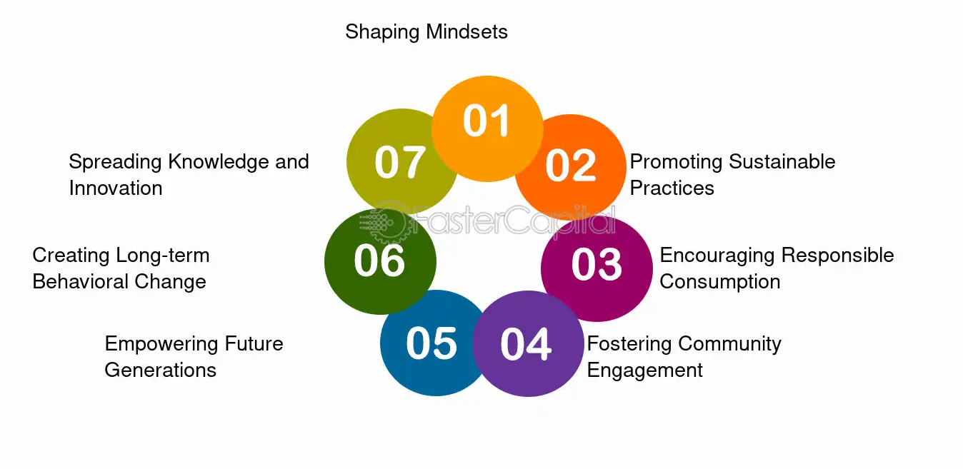

**Figure 8- Role of education and awareness in sustainability practice**

**5.3 Fragmented Supply Chain-** Waste management firms, medical gadget providers, and pharmaceutical manufacturers are just a few of the many parties involved in the healthcare sector. It can be difficult to coordinate sustainability initiatives throughout this disjointed supply chain. In order to guarantee sustainable resource usage, waste management, and procurement, healthcare providers must cooperate with suppliers and contractors. Standardization of sustainable processes and honest communication among stakeholders can overcome this difficulty.**[33]**

**5.4** **Measurement and Metrics-** For ongoing improvement, it is essential to measure the effects and advancements of sustainable healthcare practices. However, it can be difficult to set up suitable indicators and gauge sustainability results. Setting goals, identifying pertinent indicators, and creating reliable monitoring systems are all necessary for healthcare businesses to precisely assess their sustainability performance.**[34]**



**Figure 9- Advance measurement in sustainability**

**6.0 The Environmental Effects of Sustainable Healthcare-** One of the biggest advantages of sustainable healthcare is that it reduces waste and pollution in hospitals through the adoption of green practices, which not only benefits the environment but also improves the health of patients and staff by reducing exposure to harmful chemicals and pollutants. Another important impact of sustainable healthcare is improved air quality. With concerns about climate change and environmental degradation growing, the medical industry has a crucial role to play in reducing its carbon footprint.

**6.1 Hospital Waste and Pollution Reduction-** One of the most important components of sustainable healthcare is hospital waste and pollution reduction. Hazardous materials, medications, and medical equipment are among the many waste products produced by hospitals. To avoid contamination and safeguard the environment, these materials must be disposed of properly. Hospitals can drastically cut waste and pollution by using green practices. Hospitals can cut waste, for instance, by recycling paper and plastics, employing reusable medical equipment, and putting a waste management plan into place. Hospitals can also lessen pollution by utilizing eco-friendly cleaning supplies and cutting back on electricity use.

In addition to helping the environment, these policies also enhance the air quality for employees and patients, which improves health results. Nevertheless, financial, technological, cultural, and political restrictions might make it difficult to adopt sustainable healthcare practices. Hospitals must prioritize the advantages of green activities, get beyond these barriers, and look for chances to adopt sustainable practices if they want to grow the use of sustainable healthcare practices.



**Figure10- Pollution and waste reduction in healthcare sector**

**6.2 Better Air Quality for Employees and Patients**- A vital aspect of sustainable healthcare practices is better air quality. Hospital personnel and patients spend a lot of time there, and poor air quality can cause respiratory disorders and other health concerns. Hospital air quality can be greatly enhanced by implementing green practices such adopting energy-efficient ventilation systems, using fewer hazardous chemicals, and routinely maintaining Heating, Ventilation, and Air Conditioning (**HVAC**) systems. Moreover, putting money into green areas like gardens and green roofs can help clean the air and give employees and patients a peaceful setting. Despite potential upfront expenses and technological obstacles, the long-term advantages for staff and patient health, as well as the environment, make these practices an essential investment for the medical sector. The healthcare sector must move immediately to prioritize sustainable healthcare practices and enhance air quality.



**Figure11- Air quality for staff and patients**

**6.3 Efficient Resource Use-** Efficient resource use is given priority in sustainable healthcare practices through reduced waste output, appropriate procurement, and water management. Using low-flow toilets and faucets is one example of a sustainable water management technique that can drastically cut down on water usage. Healthcare operations can reduce their environmental impact by using ethical procurement methods, such as acquiring eco-friendly goods and supplies. Reducing waste creation can also lessen the requirement for landfill space and advance the ideas of the circular economy through appropriate waste segregation and recycling.

**6.4 Removal of Dangerous Substances-** The usage of different chemicals and materials in the healthcare sector might have negative effects on the environment and public health. Sustainable healthcare practices encourage the adoption of eco-friendly substitutes and the removal of dangerous substances. To lessen the harmful effects of healthcare operations, for example, mercury-containing equipment should be removed, plastic bottles and bags should be phased out, and better alternatives should be used.**[35] [36]**

**7. Conclusion-**

In conclusion, sustainability has grown into a multifaceted concept that balances economic, social, and environmental concerns while emphasizing intergenerational responsibility. The healthcare industry is crucial to advancing the United Nations' 2030 Agenda for Sustainable Development, especially in sectors such as clean energy, sanitation, and health equity. Sustainable techniques in healthcare infrastructure and waste management, such as energy-efficient design, recycling, and resource conservation, are critical for minimizing environmental effect while boosting economic benefits and community well-being. However, the lack of universally acknowledged implementation methodologies creates a problem, emphasizing the importance of collaborative and inventive solutions. Prioritizing sustainability allows healthcare systems to maintain resilience and make a meaningful contribution to a more sustainable future for everyone.

**References:**

1. Mosca I, van der Wees PJ, Mot ES, Wammes JJG, Jeurissen PPT. 2017; Sustainability of long-term care: puzzling tasks ahead for policy-makers. Int J Health Policy Manag. 6:195–205. DOI: [10.15171/ijhpm.2016.109](https://doi.org/10.15171/ijhpm.2016.109). PMID: [28812803](http://www.ncbi.nlm.nih.gov/pubmed/28812803). PMCID: [PMC5384982](http://www.ncbi.nlm.nih.gov/pmc/articles/PMC5384982).
2. Biason KM, Dahl P. Strategic steps to sustainability in healthcare - Sustainable Operations. <https://healthcarefacilitiestoday.com/posts/Strategic-steps-to-sustainability-in-healthcare--13629>. Updated on Oct 2016.
3. Allen, T. F., & Hoekstra, T. W. (1993). Toward a definition of sustainability. Sustainable ecological systems: implementing an ecological approach to land management. Rocky Mountain Forest and Range Experiment Station, Fort Collins, Colorado, 98-107.
4. Moore, Julia E., et al. "Developing a comprehensive definition of sustainability." Implementation Science 12 (2017): 1-8.
5. Ahmadi-Gh, Z., & Bello-Pintado, A. (2022). Why is manufacturing not more sustainable? The effects of different sustainability practices on sustainability outcomes and competitive advantage. Journal of Cleaner Production, 337, 130392.
6. AlJaberi, O. A., Hussain, M., & Drake, P. R. (2020). A framework for measuring sustainability in healthcare systems. International journal of healthcare management.
7. Guenther, R., & Vittori, G. (2008). Sustainable healthcare architecture. John Wiley & Sons.
8. Luxon, L. (2015). Infrastructure–the key to healthcare improvement. Future Healthcare Journal, 2(1), 4-7.
9. Klangsin P, Harding AK. 1998; Medical waste treatment and disposal methods used by hospitals in Oregon, Washington, and Idaho. J Air Waste Manag Assoc. 48:516–26. DOI: [10.1080/10473289.1998.10463706](https://doi.org/10.1080/10473289.1998.10463706). PMID: [9949738](http://www.ncbi.nlm.nih.gov/pubmed/9949738).
10. <https://fastercapital.com/topics/the-benefits-of-recycling.html>
11. Minteer, B. A., & Corley, E. A. (2007). Conservation or preservation? A qualitative study of the conceptual foundations of natural resource management. Journal of Agricultural and Environmental Ethics, 20, 307-333.
12. Bookter, T. J., & Ham, R. K. (1982). Stabilization of solid waste in landfills. Journal of the Environmental Engineering Division, 108(6), 1089-1100.
13. Berger, R. J., & Phillips, N. H. (1995). Energy conservation and sleep. Behavioural brain research, 69(1-2), 65-73.
14. Meehan, J., & Bryde, D. (2011). Sustainable procurement practice. Business strategy and the environment, 20(2), 94-106.
15. Kuhlman, T., & Farrington, J. (2010). What is sustainability?. Sustainability, 2(11), 3436-3448.
16. Alhaddi, H. (2015). Triple bottom line and sustainability: A literature review. Business and Management studies, 1(2), 6-10.
17. Walker, H., Miemczyk, J., Johnsen, T., & Spencer, R. (2012). Sustainable procurement: Past, present and future. Journal of purchasing and supply management, 18(4), 201-206.
18. Renukappa, S., Akintoye, A., Egbu, C., & Suresh, S. (2015). Sustainable procurement strategies for competitive advantage: An empirical study. Proceedings of the Institution of Civil Engineers-Management, Procurement and Law, 169(1), 17-25.
19. Wiedmann, T., & Minx, J. (2008). A definition of ‘carbon footprint’. Ecological economics research trends, 1(2008), 1-11.
20. Pandey, D., Agrawal, M., & Pandey, J. S. (2011). Carbon footprint: current methods of estimation. Environmental monitoring and assessment, 178, 135-160.
21. Carvalho, M., de Santana Freire, R., & de Brito, A. M. V. G. (2016). Promotion of sustainability by quantifying and reducing the carbon footprint: new practices for organizations. Energy, transportation and global warming, 61-72.
22. Hedelin, B. (2007). Criteria for the assessment of sustainable water management. Environmental Management, 39, 151-163.
23. Koehn, P. H., & Uitto, J. I. (2014). Evaluating sustainability education: lessons from international development experience. Higher Education, 67, 621-635.
24. Kocher, R., Emanuel, E. J., & DeParle, N. A. M. (2010). The Affordable Care Act and the future of clinical medicine: the opportunities and challenges. Annals of internal medicine, 153(8), 536-539.
25. Maniadakis, N., Holtorf, A. P., Otávio Corrêa, J., Gialama, F., & Wijaya, K. (2018). Shaping pharmaceutical tenders for effectiveness and sustainability in countries with expanding healthcare coverage. Applied health economics and health policy, 16, 591-607.
26. Brooks, H. (1992). Sustainability and technology. Science and Sustainability, 30.
27. Soni, M. (2022, November). 5 C's of Social Responsibility: A Study for Sustainable Development. In 2022 International Conference on Electrical, Computer, Communications and Mechatronics Engineering (ICECCME) (pp. 1-3). IEEE.
28. Bejjanki H, Mramba LK, Beal SG, Radhakrishnan N, Bishnoi R, Shah C, et al. 2018; The role of a best practice alert in the electronic medical record in reducing repetitive lab tests. Clinicoecon Outcomes Res. 10:611–8. DOI: [10.2147/CEOR.S167499](https://doi.org/10.2147/CEOR.S167499). PMID: [30323637](http://www.ncbi.nlm.nih.gov/pubmed/30323637).
29. Amjad, F., Abbas, W., Zia-Ur-Rehman, M., Baig, S. A., Hashim, M., Khan, A., & Rehman, H. U. (2021). Effect of green human resource management practices on organizational sustainability: the mediating role of environmental and employee performance. Environmental Science and Pollution Research, 28, 28191-28206.
30. Markard, J., Geels, F. W., & Raven, R. (2020). Challenges in the acceleration of sustainability transitions. Environmental Research Letters, 15(8), 081001.
31. Gupta, H., Kusi-Sarpong, S., & Rezaei, J. (2020). Barriers and overcoming strategies to supply chain sustainability innovation. Resources, Conservation and Recycling, 161, 104819.
32. Rustam, A., Wang, Y., & Zameer, H. (2020). Environmental awareness, firm sustainability exposure and green consumption behaviors. Journal of Cleaner Production, 268, 122016.
33. Park, A., & Li, H. (2021). The effect of blockchain technology on supply chain sustainability performances. Sustainability, 13(4), 1726.
34. Mio, C., Costantini, A., & Panfilo, S. (2022). Performance measurement tools for sustainable business: A systematic literature review on the sustainability balanced scorecard use. Corporate social responsibility and environmental management, 29(2), 367-384.
35. Sherman, J. D., Thiel, C., MacNeill, A., Eckelman, M. J., Dubrow, R., Hopf, H., ... & Bilec, M. M. (2020). The green print: advancement of environmental sustainability in healthcare. Resources, Conservation and Recycling, 161, 104882.
36. AlJaberi, O. A., Hussain, M., & Drake, P. R. (2020). A framework for measuring sustainability in healthcare systems. International journal of healthcare management.