IoT System for Renewable
Energy Resource

Gyan Anand  Maharaja Agrasen Institute of Technology  Dept. Of Electrical and Electronics Engineering  New Delhi, India  gyananand31@gmail.com | Ravi Sharma  Maharaja Agrasen Institute of Technology  Dept. Of Electrical and Electronics Engineering  New Delhi, India  ravisharma@mait.ac.in | Sheersh Kumar Garg  Maharaja Agrasen Institute of Technology  Dept. Of Electrical and Electronics Engineering  New Delhi, India  Sheershkrgarg@mait.ac.in | Laxya  Maharaja Agrasen Institute of Technology  Dept. Of Electrical and Electronics Engineering  New Delhi, India  Laxya@mait.ac.in
Abstract
Innovative technology with the ability to revolutionize the management and optimization of renewable energy. This article offers an overall view of IoT systems specifically designed for renewable energy and highlights some main attributes, components, and benefits of these systems.
IoT systems for renewables consist of a variety of devices alongside automation features such as data analysis platforms, communication protocols and sensors that are used to monitor, evaluate and enhance the performance of renewable energy systems. Equipment sensors monitor the state and performance of renewable energy assets like solar panels, wind turbines, and energy storage systems whereas environmental sensors collect real-time data on parameters like solar radiation, wind velocity, temperature as well as humidity. Communications protocols such as MQTT, CoAP and LoRaWAN make it easier to transmit sensor data to edge or cloud environments.
Cloud-based data analytics platform utilizes machine learning algorithms in order to analyze data, generate insights and optimize distributional efficiency while cloud storage space is used for storing files retrieved from different sources. Quick decision making; error detection; optimization of power consumption; monitoring quality—these are just a few things indicating that IoT electronic system acts really fast when dealing with information processing. For example predictive maintenance algorithms can reduce downtime by anticipating faults leading to improved maintenance scheduling.

- Internet of Things and its effects on renewable energy
Contemporary energy manufacture, channel, and application methods are faced with profound technological and security-driven alterations that are collectively ongoing. The Internet of Things (IoT) as the most noteworthy technology in the market has opened a new era in the way gadgets and sensors are able to communicate, collect and analyze data, and consequently control independent devices using computer decisions.

By the Internet of Things, we mean a network which is made up of not ordinary objects, machines, and other devices, but they also have the ability to store their data and can share it when they are connected(including software and sensors too). The connection appropriates the closet communication and plodding throughout the corporation. As the result, the functionality and efficiency are improved, and the understanding in the company including energy use, also increases.
The IoT will contribute to the creation of an environment where sustainable and renewable resources are used and energy consumption is preserved in decentralized energy systems. Gains in visibility, control, and optimizations are unprecedented leveraging IoT platform in renewable energy power plants.Though fulfillment of the Internet of Things is a compulsion for power industries if they want to gain benefits from the process of reducing the negative impact on the environment. One of the key roles of Internet of Things (IoT) is to monitor and controls renewable energy sources efficiently that is close to bridging the world shortage of energy instantly.

IoT sensors collect real-time data like the fulfillment, weather, performance, power generation status and energy storage status from solar panels, wind turbines, power plants, and energy centres. IoT platforms act as the data transportation distribution terminals and comprehensively analyze the data to get valuable information about energy efficiency, usage patterns, and optimization.
Through the Internet of things (IoT) human, or the ability to predict and manage the renewable energy source performance, becomes more manageable. With IoT technologies, the employees manage their work better, optimize downtime, and work with high productivity, because the information about condition of their equipment help to spotted anomalies and foreseen inefficiencies.
These factors work for the purpose of good efficiency in operation which simultaneously brings on safety and reliability.Equipment used for renewable energy has a longer lifespan and lower costs whenever IoT technology is applied. By integrating more widely accessible new energy with sophisticated transmission and storage, IoT-enabled smart grid and energy management systems help utilities and energy consumers balance energy supply and demand. By increasing productivity, energy efficiency, and grid security, this optimization can open the door to a stronger and more effective energy ecosystem.
- Importance of Connecting IoT to Energy Systems for Energy Efficiency
- Time Tracking and Optimization:
Therefore, it is process-driven continuation which means that un-solvable problems, a damaged or less efficient item would be known all at the same time which makes it a realistic thing to intervene quickly and on optimum side as well. This is so because green IOT has an edge over the traditional means of production and consumption through which environmentally friendly and renewable energy is promoted; therefore, sustainability has a chance to grow.
- Energy Efficiency Management:
For instance, on the one hand, there is data related to the energy demand and use trend, and smart grid, and on the other, there is Internet of Things (IoT) capability of managing renewable energy. This can be done through an improved assignment of the resources or the shifting of the load or demand response and the exercising of the data which comes from this to allow the managers of such system to lead the system accordingly. Activities related to the sustainable development of the industry should entail efficient use of energy and well-organized resource management.

- Predictive Maintenance and Asset Management:
Application of predictive maintenance and development of asset life cycle and management systems. The modification of the electrical equipments especially used for old and outdated devices is carried out in such a way that they could easily get detected. Repairing and replacement of equipment due to wearing out and becoming out dated takes place after that checking. This kind of IOT systems provides the ability, the machine-learning methods along with sensor analysis, to monitor in a timely manner the possibility of deviations from the normal functioning regime of the machines and the upcoming maintenance works. This will make the situation better through eliminating an emergency such as damage that can lead to the long-term injuries of the equipment.
- Grid Integration and Resilience
We aim to practically demonstrate that the key objective of integrating renewable energy into grid is IoT with a prominent role to play in achieving that goal. Through smart grids, with the help of IoT, these problems such as the change in power output of renewable energy, grid overload, and a rapid decrease in demand, which are now considered as major challenges of developing smart cities and societies, could be effectively dealt with. IOT acts a connector for supply side as well as demand side control activities by delivering information from the supply side device to the main control center. This implies a level of control process and resistance that steps the network flexibility and resilience up. The system or the change it undergoes is fundamental to the ever growing trend in which renewable energy production plays a critical role while at the same time embodying the notion of energy (system) stability as pivotal in the process of energy transition.
- Data-Driven Decisions:
Another example of the benefits of using big data in renewable energy is the capacity of the IoT to gather vast amounts of data on the production and emission of green energy by generators, and transmission systems. The storm is also what brought transformation to the internet of things (IoT).
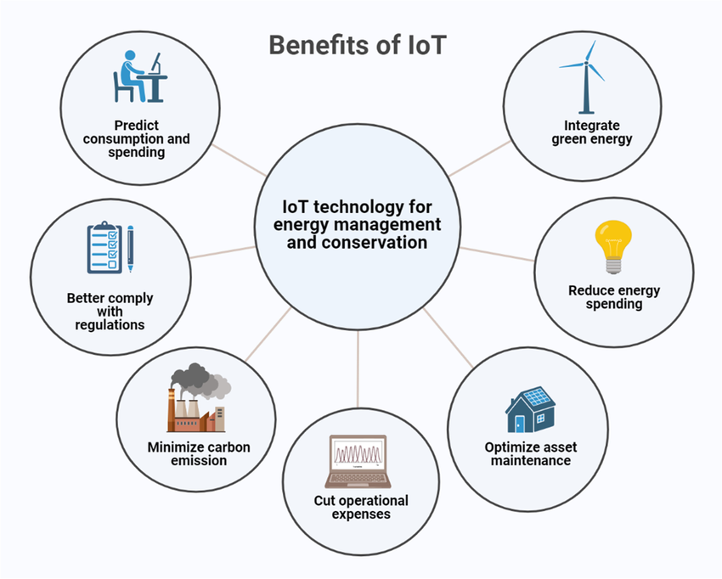

- Role of IoT in Renewable Energy
Renewable energy obtains a prominent window at the energy sector transformation as the global energy sector is going through changes significantly. The incorporation of such monitoring and observation in this space serves also to optimize the activities and render them critical in the overall and all-round transition to renewable-energy. This purpose IOT can be realized if there are IoT reasons which are recognized as achieving same goals that the IoT set to achieve . internet of optional which may be managed remotely via radio, time, atmosphere and resources for instance, solar energy, wind and water. Those sources of renewable energy can be considered as energy supply and consumption. Sensors that respond to this data and measure it using real time tracking are relied on. Constant collection of the data take place in real time as the following is involved in the monitoring: ecosystem, device functioning, pattern, power generation, and all the data at one go into the interconnected one.
Internet of Things or in coordination with enthusiasm which are facilitating the increase of the spread of smart grids distribution of energy, turns to be one of the critical dimension. The active smart grids integration into IoT ecosystems is achieved by a couple of interconnected capacities. At the same time, collaboration introduces one of those interrelated capacities. Another thing is, there is an end to getting interaction between the network members, deriving the energy distribution, storage, and planning initiatives.
Power networks are prospect to undergo a massive revolution because people will be monitoring and regulating the processes of energy transport, demand response, balancing and safety measures right from their premises. Therefore, the grid operating reliability will be sustained and the grid operation will be facilitated. Everybody, regardless of what the sites were, treasured the plan that could be seen by them as saving the power inefficiency and properly re: creating the power lines and thereby becoming the permanently working source.
However, the Internet of things details the edge of the sheer intelligence and the interconnectedness of the internet that can support the electricity supply through renewable energy. Data of equipment fault diagnosis and locations of leak points are tracked in real time through the Internet of Things technology used so that the necessary measures are taken to bring back the equipment into proper working order. It will ensure the manufacturers do all the preventive maintenance which will result in reducing the operating costs, equipment longevity, and thus decrease the downtime.
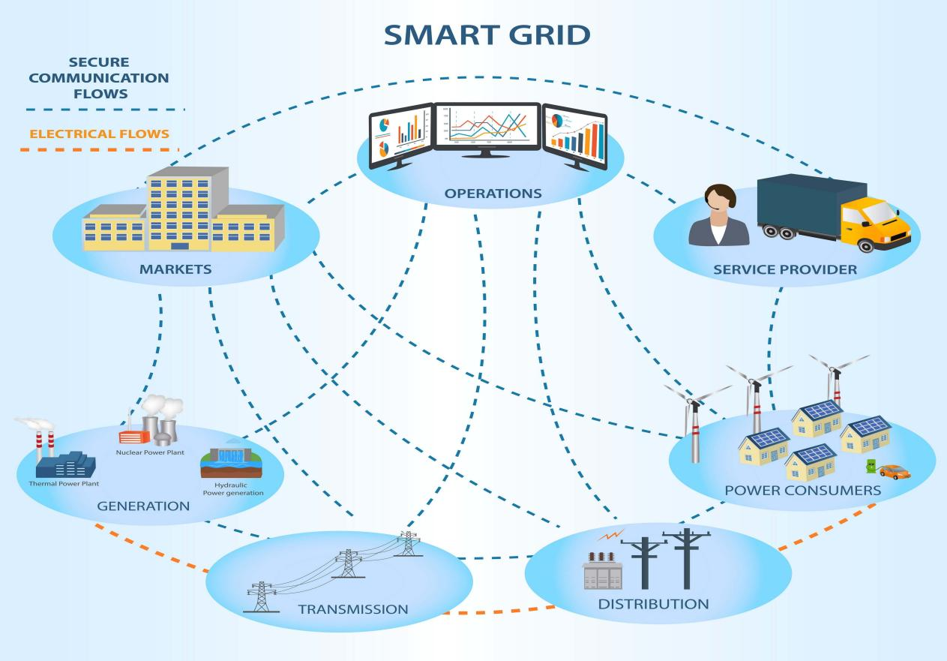
In addition, in the case of larger grids, tying the two has created a channel through which these complex battery systems can smoothly get integrated plus studies have also established the fact that the power regulation function these systems perform yields high ratio of energy storage.
The one of the important tools that the project uses is data analysis and the visualization of data which help in the decisions making process where now we have a different compare to before we used to use a method.

- IoT Energy Use in the Energy Sector - Creating a Safe and Sustainable Future
Saying that renewable energy will be the primary force behind our future progress is not hyperbole. As their use increases at a never-before-seen rate, clever solutions are being developed.
With the application of modern technology, renewable energy utilization can be further enhanced. The spread of renewable energy has increased with the integration of the Internet of Things. Some of the obstacles to the widespread use of renewable energy are mitigated by the implementation of IoT.
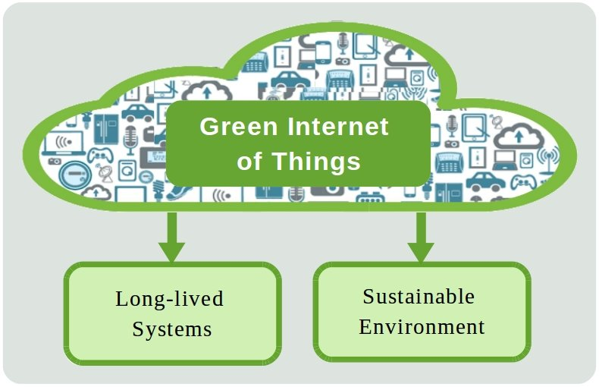
Water is the green shaman liquid with amazing properties and life-giving powers. Therefore, there cannot be a better liquid on our planet than this green-colored liquid. All of us, we humans, equally, require it to stay here and thrive. If it has an effect on one, the others will surely follow: for example, it targets sustainability, health of humans, agriculture, industry, or simulations of a few similar subjects. Even though the world is in a state of constant transformation, water still has a distinct value. Nonetheless, water is the only element in the world that allows the earth to go round and stay alive.
When human beings are allotted water, then it becomes clear that water is the element lying at the basis of everyone’s health and the well-being of the entire human race. It is of a prime significance as it participates in every of the physiological systems, including the digestion, the way of transporting of nutrients, circulation, and temperature regulation among others. Drinking Water Safety and Diseases: Maintain the access to clean water is among the fundamental rights of the human being and the basic criterion of population health. Furthermore, the water is in demand for sanitation as well as for hygiene issues, and this is what helps to prevent the diseases. In fact, water is an essential aspect that enables human welfare and a better quality of life.
Water sources are basilic natural resources needed to mature for a growing nations' agriculture and make it a productive one. Human hapiness is curtail this unexplainable puppy love and people is deprived of green crops and food prices increases. Humans population will continue to be on the rise in the future so the people will be relying on enough water resources which are to be extracted and professionally used by efficient practices to ensure the food safety among a fast growing population in the world. Similarly in fact, irrigation, watering livestock, aquaculture, and many industrial processes are among the tasks water fills worldwide, therefore, one can imply its role in livelihoods and economic development.
Industry often time consumes a lot of water in many operations like making things, cooling, electric power production, and the many other factors companies always uses. Water even though could need in process of goods brought and in various domains of power, particularly in energy-intensive industries. To this end, only when people are changing their resource consumption habits and no using can be observed in the direct surroundings will we be able to develop a sustainable water management approach. Moreover, water shortage faces significant obstacles at various of industry sector in the world which is also name as one of the resources to be saved strictly and utilized only water conservation way.

- Let's use an example to better grasp this:
Imagine a solar electric generation facility that stores extra power in batteries overnight and that wires it to the grid to supplement the inadequate energy supply provided to end users. However, sunlight can't always be generated for instance this energys is going to be less on a daily basis if the sky will be overshadowed. However, the old power supply lines are not able to keep pace with the anticipated renewable energy of the atmosphere and the existing power grid becomes overloads.
The Internet of Things has embodied the establishment of creative projects that have propelled the making of clean energy rich nations even expensive power plants, to uninterrupted energy use. Change supports smart grids for Fair utilisation of renewable energy and hence continuous flow of power to consumers.
The Internet of Things increases the use of renewable energy:The Internet of Things increases the use of renewable energy: Through the advancing of the smart grid technology in the Internet of Things, more renewable energy has been fostered. They allow utilities to bring intermittent energy resources onto the distribution system, therefore, being able to optimize load forecast and shed load instantly.
Some of the benefits are:
- Service to End Users:
Along with that, a rise in demand from final consumers can be noticed due to the necessity to lower energy cost and attain energy independence. A plethora of countries not only subsidize solar but also promote renewable energy by providing subsidies for the power sector. The government considers citizens who wants to install solar panels on their rooftop as a main factor to harness the power of the sun in personal use. Apart from these, citizens can sell extra power they have to the smart grid and get money. These programs are going to cooperate with the country's bigger plans for the development of renewable sources with the aim of stimulating the growth of a more friendly society.
- Balancing supply and demand:
The utility operators can been informed in realtime and the smart meters become the gateway to these information. they will be able to derive a set of plans and extraordinary strategies that make impossible situations become solvable by data and analytics. As a result old power plants using the manual switching technology can run at times of peak electricity needs, but have to stop their operations at off-peak periods.
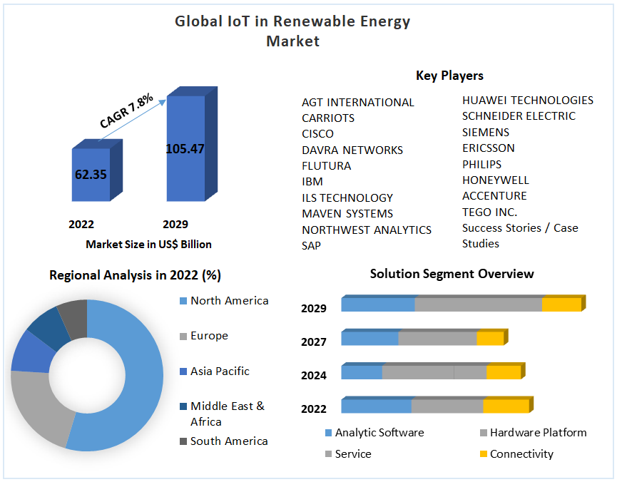
- Economical: The reliability figure concerning the aforementioned studies is just 1.2% of the solar energy Sahara Desert which is around an estimated 110,400 square kilometers size could be used to cater for the needs of the world. Beyond the above argument, a number of problems are present with this approach. The hole in the distribution and delivering of electricity to underserved places is a problem. To offer ones the idea, ideal loss on, for instance, long lines of transmission might be as high as 10%.
Slow but steady development of the solar and renewable energy is so impressive a fact that we cannot help being discouraged by the difficulties and complexities of this emerging market. Nevertheless, internet of things (IoT) included in solar plants will make a bit lower of the investing and operational costs. And therefore, they will reduce some of their inspections and repairs cost besides improving the entire entity performance.
- Implementation of IoT into renewable energy projects are notable example of IoT in recent years.
Smart Grid: IoT sensor and devices for controls and monitoring power distribution in smart grids systems. These devices are capable of acquiring time-on-demand data as relate to the use of energy, performance of equipment, and grid stability. Utility companies can use this data to identify electricity distribution, reduce losses as well increase reliability when integrating renewable energy into grids.
- Solar panel monitoring:
Sun panels operations are being processed via Internet of Things-integrated supervision network. The systems recognize the amount of shading, weather information, panel temperature, and the amount of energy produced from it. The ongoing analysis might reveal the underlying problem of ineffectiveness or destruction of the panels, as well as may help to predict (replace) them in time to increase the system’s generating output.
- Wind turbine management:
IoT sensors being installed on wind farms and functioning to acquire the information about wind speed, turbine speed, intensity of vibrations, and the state of the technician's health. The provision of the information gives the maintenance staffs the chance carrying maintenance in advance so as to achieve maximum production and issues of downtime is reduced as much as possible. It is also possible to increase the existing wind farms operation as well as the generation of wind energy in case technological advances such as artificial intelligence as well as progress analyses are introduced.
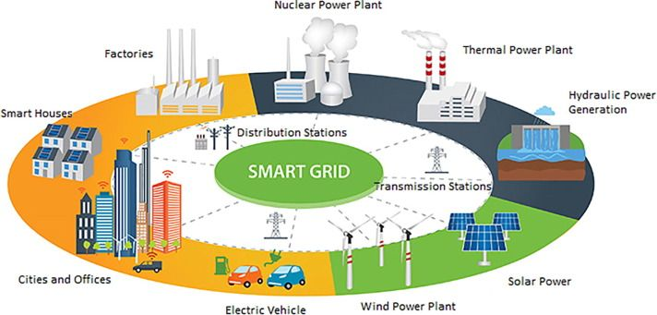
- Improving energy efficiency:
The exact battery in routes are looked on, the charging and performance are test and running on the basis of e-IoT away. This system operates in real-time by monitoring current electricity demand and supply ensuring that there is optimization of the grid. Additionally, there are cases when unique energy resources significantly impact the system load, cutting the loss rate of electricity to the grid.
- Smart Home Energy Management:
Another approach that we took to energy efficiency adaptation in homes is by applying the use of IoT devices such as the smart meters,& gadgets,& thermostats. When the expression 'these tools' is used, it basically points to the smart devices which enable owners the activated control to make adjustments even when not around actively, lowers energy use when the appliances are operating and displays energy consumption visually. Such a blended system of renewable energy which combines both solar panels and power consumption would allow savings increase and, what is more important, a possibility to monitor your consumption constantly and stay in control.
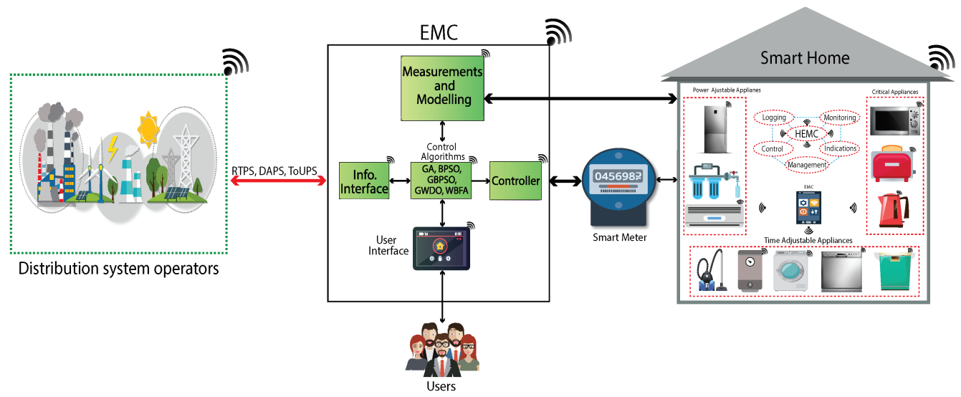
- Electrical Equipment IoT System
The issue of flaring is increasingly uttered particularly in understanding in correlation with the discharge of burning and volatile gaseous hydrocarbons is caused by fuel extraction. Meaningful to start, environmental sensors or so-called LRD ( long-range data) collection hold the central stage as the prime generator of this long-range data collection. These sensors have to be employed so as to check the loss or gain of renewable energy machines (for instance, solar cells and wind turbines). Furthermore, surrounding sensors that monitor the status and performance of the items of renewable energy devices, there are sensors for inverters, solar components, wind turbine parts, batteries , generators , and so on.
Specifically, there is an ability to do tricky things and change to the system right on the go. Sensors enable the controller to measure voltages, currents, power output, vibration levels, and health indicators all in real time by the controllers.The process of data handling on the computer should then be considered as another essential phase because they are needed for many purposes for data processing and analyzing. The wise use technology and increasing globalization. Those two factors, give more detailed the information thought the data collected by global huge network of things systems.
These business enterprises that leverage cloud-based platforms are equipped with simple data storage, ongoing processing of data that is real-time, tools for data analytics and machine learning. For instance, on such platforms power companies can both tag, meter, and input on the operational alerts, performance measures, and generation as well as utilization patterns.
Edge computing has the ability to undertake real-time data analysis with the networks’ edges which results to improvement in reacting speeds, responsiveness cycles, and frequency of usage for bandwidth.Through these channels, decision-making bodies will utilize data visualization tools like dashboards, charts and graphs to get to know and interpret data sourced from the IoT well. As such, these bodies will make sound decisions with the confidence that they are basing their decisions on correct data from the IoT.
Keep an analytical eye on products utilization by scrutinizing the data and responding accordingly.
Data collection: The environmental monitors are specifically assigned to check on them all day and therefore lead to the decreased dependency on power generated from the conventional energy production methods. In fact, during this time, solar inverters, electric motor, meters and batteries are applied to give information for analysis. The data devices play a major role in the detection of power generation and the consumption of this energy. However, these sensors read the main data indicating how efficiently renewable energy sources are working and if it corresponds to the set aims or not.
Data transfer: The data can be instantly put into storage or into a local gateway which is based on the cloud and the communications can be done by using mobile phones that support the wireless connectivity.
As the technology is used in the data transmission, it will ensure uninterrupted normal or confidential transfer even in occupies or remote areas. Sensors and gateways move about in the field, always changing their positions and don't despair here as we have protocols that help them talk to each other, e.g. MQTT and CoAP that facilitate their data communication. The cloud represents the end stage of data process before being presented to the frontend.
Processing and storing data: The technology used in the Internet of Things (IoT) solutions, which are developed in the cloud platforms, such as Amazon Web Services or Google Cloud where the collected data enters the loop and is processed, is important in the growth and management of a city.
Edge computing is implemented in certain instances when it is processed first on the devices or gateways that are close to the local data and then it is sent to the cloud. Through this methods, the latency is reduced to the minimum level, utilize the bandwidth with the efficiency and speeds up the decision-making.
Data Analysis and Insights: Examine the data collected and archived with the analytics software and with the help of machine learning techniques. It seeks links between the data points together as well as it detects the patterns, trends and variations.
For instance, what is mentioned is many fold as it reveals inefficiencies in the generation of energy, predicts equipment problems and also tells how the energy use patterns look like. Dashboards, charts, as well as graphs are some of the data visualization techniques that are applied to make the understanding and comprehension of the complicated data easy to understand to the stakeholders who would in return make informed decisions.
Automation and Actionable Decisions: Data collected and analyzed by IoT systems make these systems creating reports, sending alerts to stakeholders and actionable insights possible. For instance, the system may report the problem to the maintenance team which is to take the necessary actions if the system fails to operate in accordance with the approved specifications or does not produce electricity of the desired quality.
- The phrase Real-world Data and its application in the IoT is worth mentioning.
Case Study 1: The use of solar-edge technologies in solar panels is one of the top trends in renewable energy these days.
Designed as one of the outstanding smart energy solution providers is Solar-edge Technologies by virtue of the Internet of Things (IoT) technology it applies to improve the performance and optimize solar photovoltaic units. Its intelligent inverters, power optimizers, and data collection/analysis platforms are among the modern solutions that allow power companies to get the greatest benefit from both conventional and renewable practical sources.
IoT Operation: Data is to be received from solar power systems placed globally through the Solar-edge monitoring system, which is a set of sensors, networking and communication protocols tied together. Such systems have a monitoring capability in the environment, grid energy movements, inverter work, and panels performance.
Data analytics: IoT software rented over the internet is responsible for the consecutive phases which include the detection, the correction and the conclusion that if the system is outdated or a component is not operating properly or power needs upgrade or the panels are not performing to desired level. The data in which they get generated is processed by the owners or the staff of platforms can be viewed.
Benefits : With the help of the IoT feature, which is being presented by the Solar-edge system, the user is going to have a better control over the use of his/her PV system, increase the solar energy production in the process, and thus, as the opportunity comes along, get a beneficial place from the feed-out and the feed-in. Besides, guarantee attention that POV networks got the maximum developed will be an addendum. This remarkable result is called many names, and the consequences can be either negative or strong, like a change the direction of the shadow, the group interval being wide, and the expensive nature of the installations.
Case Study 2: Our enterprise has a broader i-investment vision as it centers on the creation of three-phase central inverters, while N-neo engages in the generation of block-level inverters for a private solar power station.
In this category, we will also elucidate about Enhancement, the company that is one of the supplier giants in the solar PV (photovoltaic) segment; it has micro interventions and Internet transmissions conducted. Implementing up to date and environmentally friendly devices used in smart features adds value and brings the benefit of efficiency increase in the solar PV systems and has shown greatly eased system maintenance.
IoT Application: Data collected by IoT sensors is submitted via E&rsquo;ss Enlighten module web to the cloud, then the analytics software will process the metrics and allow the real-time micro inverter and solar panel display.
Data Analysis: This software in the IoT platform gathers the data to ascertain the performance of the microinverters as well as the amount of energy they produce. It checks maintenance work, shading, and the weather to detect problems (example - failed microinverters, loss of power efficiency, neglect of maintenance work, the formation of shade from growing vegetation).
Benefits: "IoT technology": Among the consumer benefits, one can name the fact that they can see, control and the Plug-And-Play components which are used for avoiding any gaps, making an image of value for money, letting to calculate a boost in production and the tendency to the circular economy; sensors monitor the performance of devices and other parts of the system.
- IoT Applications in Wind Farms:
The main problem that fell to me as an intern concerning the communication exchange barrier with people with various languages and cultures. Furthermore, wind farm operations are supported by the applications of IoT, which can be largely deployed in predictive maintenance and resource management.
Case Study 1: From Vestas Power System's moduled power service, which is well-liked and efficient, it also provides an environmentaly friendly technology for a green system at the same time. Another benefit brought in by the communications interface being its capabilities that counts for the support factor as the main essential component of the two-way communication.
IoT Implementation: Vestas examines the beauty of data analytics and uses machine components, connected sensors and protocols to build the ecosystem where monitoring systems integrate with turbines. These functions are the result of the data acquisition process with temperature figures, practice (turbine speed) and diagnosis representation and to use the data from other operational conditions automatically through the sensors .
Data analysis: The Internet of Things-enabled monitoring systems use real-time data analysis to forecast maintenance requirements for preventive intervention, improve turbine operation, and identify possible problems such gearbox anomalies or blade damage.
Benefits: Vestas extends equipment lifespan, boosts energy generation, decreases downtime, enhances wind farm performance, and permits remote monitoring and control of wind turbines for effective operations by utilizing IoT technology.
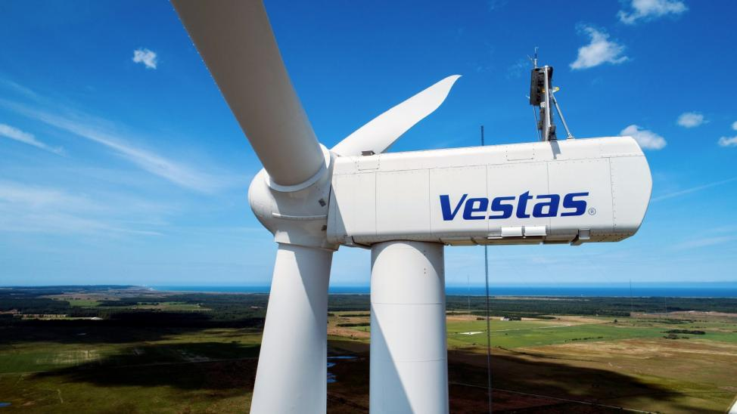
Case Study 2: GE Source: Nita Wimberley — Education and Instruction
General Electric, an established player, has been providing wind turbines and offshore wind energy solutions for quite a long time now. It has gained a reputation of the largest wind turbine manufacturer around the world with a record of over 49,000 assembled wind turbines in various parts of the globe. Besides, Dean Kjemtrup, GE Renewable Energy's CEO is testing the combination offshore and onshore wind turbines in order to make the Haliade-X, the most powerful and efficient wind turbine in the globe. Moreover, he is the dealing with GE Hydro, an electrical energy production company to explore more energy sources. GE Hydro is manufacturers of power machinery for pumped-storage and gravity-driven plants also facilities for the retrofit of building that are already constructed.
IoT Implementation: To make wind turbines and related gear work, digital technology called GE Digital Wind Farm Protocol uses IoT sensors, cloud services, and predictive analytics.
Data Analysis: The analysis of turbine health, performance trends, weather information, and grid connections factors helps in the implementation of technologies that ensure optimum energy production, lowering operating costs, and enhancing grid stability.
Benefits: IoT based wind energy sector of GE Renewable electricity has the ability of enhanced output, reduced down time, increased maintenance intervals and provided continuous electricity to the grid.
- IoT Applications in Hydroelectric Plants:
Case Study: BC Hydro
BC Hydro, the major hydro-electricity provider in Canada, is also adopting IoT technology to track and adjust its hydroelectric units in the way to run energy production and grid management properly.
IoT Implementation: To collect the data on water level, turbine performance, capacity of energy generation, as one of the hydroelectric plants’ tools, a system of IoT sensors, communication systems, and information analytics platforms is utilized.
Data analysis: By using IoT-enabled monitoring systems to run the turbines, manage the flow of the water, and increase the production of the power plant, a huge amount of data gets analyzed and is obtained in real time. Predictive analytics turbocharges proactive scheduling by identifying a pattern and problems.
Benefits: Through the incorporation of different mitigating methods like increased use of renewable energy, as well as leading an effort of risk reduction of climate change effect on the grid, ensuring grid stability, and automation through the Internet of Things (IoT) technology hydropower plants will acquire this efficiency.
- IoT Applications in Energy Storage Systems:
Irishly, in the end, humanization of musicians in the music sector is dealt with the issues of exposure. IoT can be applied to energy storage systems as well.
Case Study 1: We’ve seen that the future is here – It’s the Tesla battery in each house, and a Tesla car in every garage. The products Powerall of Tesla successfully be created for home and business purposes and also sweetens the deal for OEM’s but at the same time , grids of electrical infrastructure and IoT devices and smart appliances upgrades would be enabled.
Internet of Things applications: On the other hand, in the advertising, we have the Powerwall semi-solid displayed. This displays system status such as the charge/discharge status of the batteries, time intervals of when the panels have been functional, average household usage of power, communication interface and IOT services, communication protocols, cloud, and cloud-based monitoring technology…
Data analysis: It should be reflected in the processes that occur in the network: charging of devices, discharging of devices, and analysis of the activities pattern is necessary, hence the feedback from users is a must during operation.
Benefits: The Tesla Powerwall as one of these included elements in IoT tech deploys the energy storage function where the incoming reusable green power, which is provided by the IoT is managed, scored and regulated. It is main essence that this technology provides the ability to customers to consume the energy at the desired time. We can also decrease energy usage in peak period using this similar technique. This is a strategy that helps to minimize on wasting electricity admissibly and manage the overall usage of electricity.
Case Study 2: Fluence
Siemens, AES and Fluence combine the optimal use and monitoring of intelligent grid systems with carefully thought out energy storage capabilities in utility-scale projects. Consequently, the admixture of renewable energy consolidates the networking grid performance up to the enhanced communications of clean power technologies and effective IoT integration which is mostly associated with energy storage.
Applications for the Internet of Things: It offers mixed response in the field because of its involvement and sensors, protocols of communication and advanced analytics is now used for the maintenance of the grid knowledge from the clean energy as well as the effective system management (handling of storage).
Data Analysis: The Internet of Things set of devices with the characteristics of imperceptible collection of data and the features of network connectivity of the existing electric grid can be employed to simultaneously perform unconventional roles such as frequency regulations, smart grid operations, load (demand) shedding and generation of ancillary services.
Benefits: These state-of-the-art systems are most important for grid operators who can manage the delivery of renewable power more efficiently and at the same time reduce the fluctuations of intermittent generators through accurate and accurate monitoring withiou the use of IOT technology. This is the case as the solution will very smooth the t the process of transition of system into renewable electricity.
IX. IOT and consignment also played a role by offer good quality, less spending and sustainable nature of environmental preservation
With regard to SolarEdge Technologies and Enphase Energy, what these companies recognized is how the application of accurate IoT technology can be used to improve the efficiency at which energy is consumed by solar-powered photovoltaic systems. They will be able to make adjustments and optimizes during the function on the basis of results obtained from sensors placed on each solar panel, inverter, and it may be concerned with environmental conditions. It may in this sense be an example, solar panel's shadow happening due to a reflector frame covering its surface may reduce its capacity but IoT-based surveillance system can detect such problems, and consequently can adjust the reference system so that it faces the sun. This makes the fuel product more environmentally friendly as its energy content is lower. Their efficiency (solar photovoltaic installation) is increased.
Also the same way in which the IOT has a great effect on the success of the wind farms also belonging to GE Renewable Energy and Vestas Energy Systems will also be achieved maximum efficiency. Besides, in this regard, it imparts the capability to remote control and real-time tracking by means of different monitors, e.g. Equipped with wind chill sensors, wind turbine structural health, and wind energy production system. Internet of Things (IoT) sensors might consequently be employed to implement immediate corrections in the turbine settings, whether these types of adjustments refer to wind speed, the work of the turbine, or other operational factors. The turbine could be provided with the highest performance since it turn the dynamic sysytem control into the advantage which in turn leads to a higher energy generation (and hence lowest loss).
Along with this, he adds the hydropower genertion facilities of BC Hydro (which play aid in improving water management, hydropower efficiency and water flow) to IoT. Utility services are capable of adapting to dynamic demand scenarios where the requirement for varying water usage, electricity operation, or grid network performances are suffice. It gives a boost to the use of green energy such as solar and wind which in the end curbs and controls the discharge of waste. Also it enhances the level of energy efficiency.
- Cost saving in IOT :
The Internet of Thing (IoT) platform also generates massive reduction of cost during renewable energy via effective maintenance, decreased system stop, and enhancement of operations. However, the main reason is that the internet of things in renewable energy projects enabled us to see enormous savings by improved operations, fewer stoppages, and optimal operations.
One of the creative displays of IoT such as different platforms of SolarEdge Technologies and enphase systems are rapidly helping to lower the maintenance costs and that such systems can able to detect early grows of errors, therefore no extra repairing expenses are necessary for costly repairing and replacement actions. The prediction maintenance option limits the downtime days and thus extends the life of the solar panels. It is also a proven fact that it is cost saving to the solar system owners hence it a worthy approach.
IoT-based predictive analytics assists in anticipating future turbine breakdowns or operational concerns in wind farms operated by GE Renewable Energy and Vestas Power Systems. For wind farms, this strategy offers major benefits by facilitating periodic maintenance and preventing unscheduled downtime.
IoT energy storage systems, like Fluence and Tesla Powerwall, also optimize energy use and interoperability, which lowers energy expenses in the long run. By storing excess energy during off-peak hours and using it during peak demand, these systems help to reduce energy prices and save money for both energy companies and consumers.
For the most part, by introduction of the IoT in renewable energy projects, the beneficiaries are the stakeholders as cost reduction becomes massive. Developing cost-effective measures, streamlining emissions, going for energy economy, and designing ultra-efficient grids lead to lower operating costs and possibly an increase in funding for renewable energy.
X. Environmental Sustainability as Part of IoT:
This is more so evident as the blockchain serve for fuelling the power generation and as a result there is reduction of carbon monoxide emissions to the environment. The Internet of Things applications that control energy production by SolarEdge Technologies, Enphase Energy, Vestas Wind Systems, and GE Renewable Energy are among the renewable energy solutions offered for solar photovoltaic and wind energy operation and production. Renewable energy sources helped the fuel generation reduce carbon emissions and alleviate the consequences of climate change as they no longer greatly depend on fossil fuels.
In addition, thing that is good on hydropower facilities, for example, that is BC Hydro has already done, such a integration of grid operation, turbine operation, and water usage is optimized by IoT applications. They play the vital role of pollution deterrence to aquatic communities and in the process enhancing a stable source of sustainable energy through the efficient management of water resources.
Furthermore, for majority of IoT-powered energy storage devices that include Tesla Power wall and fluent solutions, grid security, load response, and interconnection is supported by them. They also make it possible for the among supply and demand factors influencing power grid by saving excess energy from renewables and transferring it if needed. It lowers the share of coal and gas fired power plants by bringing renewable energy into general power network and allows the system to better withstand shocks.
- Security Issues in IoT:
The main vulnerabilities with IoT are associated with the failure to establish a proper security wall against unauthorized access to data which is why good directions, preventing data access is therefore a top IoT security concern. The external drives work like regular computers. Eventually,there has been a sharp increase in vicious cyberattacks, by which hackers could very easily exploit algorithms which are meant to keep the target system secure.
- Inadequate checking and updates—
As the number of IoT (Internet of Things) devices increases, these companies have a greater need to develop and deliver their devices as quickly possible without thinking about security. Many of these products have not been properly tested and optimized and are vulnerable to hacking.
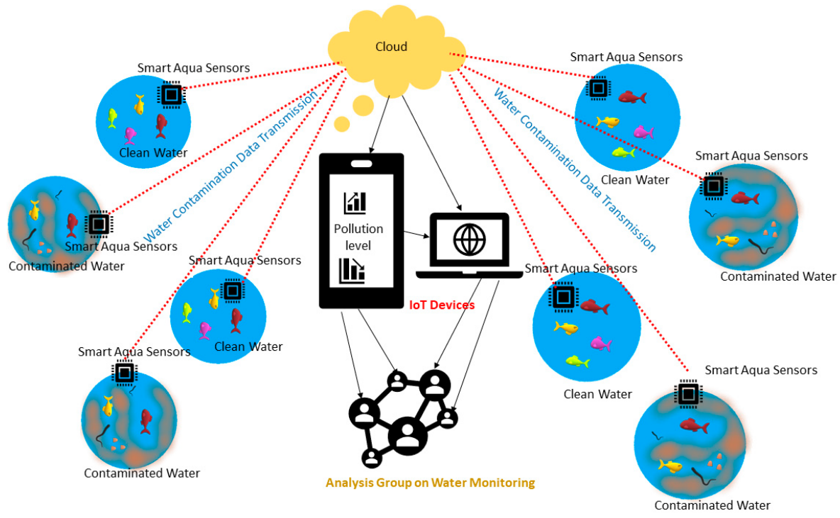
XI. The Dangers of Preset Passwords and Brute Force
Almost all IoT devices are vulnerable to brute-force attacks and password cracking due to weak login credentials. There is a chance of a brute force attack when there is evidence of a company's factory-installed equipment affecting the business, its customers, and critical data.
Ransomware and IoT malware—
Ransomware still uses the user's private data and information, but it locks people across platforms and devices using encryption technology.
As an illustration
Cybercriminals are able to take pictures by taking over a computer's camera. They can then demand ransom payments to unlock the device and allow access to the data by taking use of virus access points.

- IoT Botnets Strike Cryptocurrencies:
By disclosing personal information, IoT devices can be a major threat and disrupt the cryptocurrency industry. Shady characters can make a lot of money from the setup and actual worth of cryptocurrency codes.
Blockchain enterprises are working hard to strengthen security. Blockchain technology isn't very useful on its own, but the development strategy is crucial.
Lack of Standardization: This indicates that a certain field lacks a set of accepted guidelines or conventions. This results in disparate goods, systems, or processes that are incompatible, leading to problems, inefficiencies, and decreased performance. For instance, in the computer industry, standards cannot impede data interchange and communication between various systems and devices. Establishing policies and guidelines can address this and guarantee efficient operations.
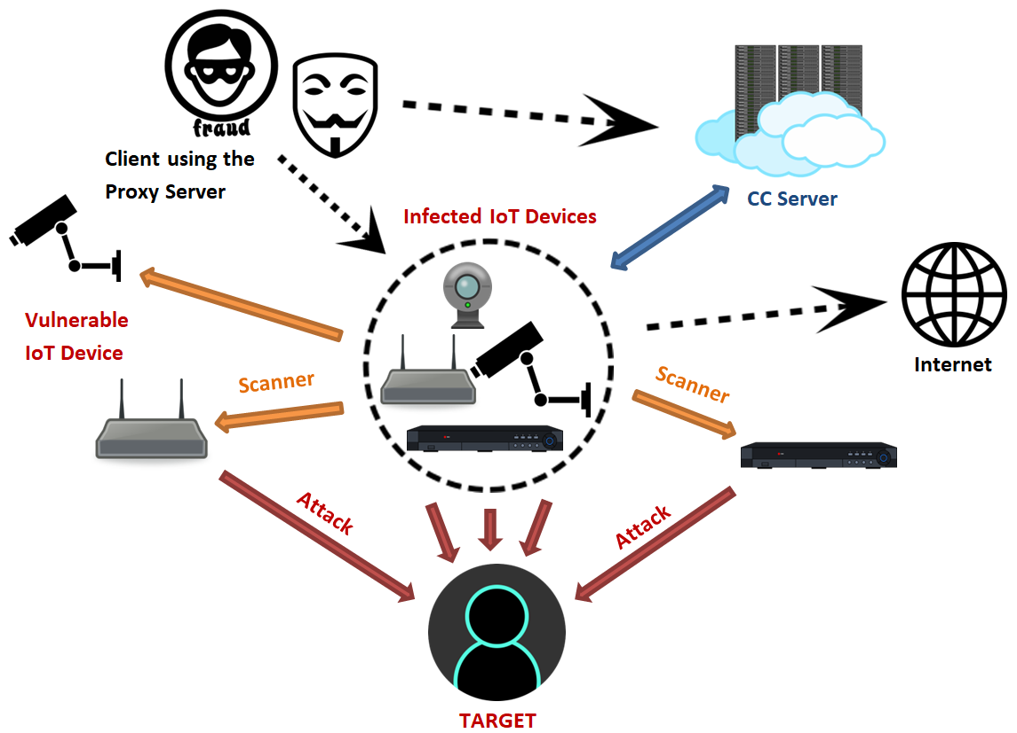
XII. IoT devices are all over the place, making consistent security a headache.
Vulnerability to cyber attacks: At present, there is a high risk that it could happen in one whole network, system or device (depends on your object of discussion) because a cyber criminal can get into it and spread malicious activities in all of it. These occur, when application is not installed properly, simple passwords are used, or networks’ security is weak, or there is no security at all. A cyberattack may: lead to monetary loss, create troubles with provision of services, violates privacy or disclosure of data. Enforce security tools that can be firewalls, encryption, and software development.
These tools should be designed to keep your enterprise away from cyber attacks. But to be on the safe side, the matters of cyber safety should be dealt with the same manner during your teaching. IoT devices that are the network materials are the most vulnerable to the attacks that DoS is the primary one(reason).
The term 'data insecure transmission' is introduced when, for some reason, the data exists outside the network without being protected on a secure level. Thus, the right of data theft, breach anonymity by catfish malicious parties always get the upper side.
Data transfer becomes insecure whenever there is no security and data is not protected. These instances therefore increase the risk of data infiltration and, especially, misuse. Technology, such encryption protocols, for instance, SSL/TLS and VPN are important security measures to take before sending the data and during the data transfer process on the other hand, the sensitive data should be encrypted at the point of data transmission. One can say that it is data is still safe even if an interception was successfully made through this.
The thoughts about the gathering, saving, spending, giving away taste person privacy matters are components of privacy concerns. Besides the issue of whether the data can be used with the right intentions and whether it vulnerable to hacking, there are the questions of who can have an access to this data and with what aim. And as you lose your privacy there was the aspect of people being traced via data collection and more data being stored about you than what you use to have. Establish security metrics for protection of personal and private data; transparency and prevention of instances where people would lose their privacy; and, respect for the right to protect personal information.
Not only being in compliance of the laws, privacy too is one of the crucial factors to be kept strict. At least the half of the data is being generated by IoT objects and these data lead to information overlays which is related to privacy and privacy still depends on the personal information that is being produced but nobody knows about it.
Software bugs are holes or mistakes in the code that hackers can use to gain access, steal data, or create problems. When using outdated software or during development, software defects may appear. These defects can be used by malicious actors to gain control of systems, implant malware, or steal confidential information.
Software engineers must write securely, and users must maintain up-to-date and properly configured software, in order to reduce software problems. Use security technologies such as firewalls and antivirus programs as well.
As well as intrusion detection systems to stave off dangers. IoT devices frequently have software flaws that hackers can exploit to access both the device and the network.
Insider Dangers: This is the situation where internal group threats rather than external ones like hacker attacks pose a security risk. These risks can originate from insiders who are compelled to cause trouble, contractors with excessive access, or employees who make mistakes on purpose or accidentally. Insider threats can result in idea theft, data leaks, and damage to an organization's reputation. Organizations must enforce stringent policies, monitor employees, and provide security and privacy training to reduce the possibility of insider threats. Have a strategy in place in case insiders turn traitorous as well.
Insider Dangers: It refers to security flaws that arise from within a company, as opposed to exterior dangers like hackers or unlawful internet risks. These risks can take many various forms, including as workers who damage the company willfully or unintentionally, contractors who abuse their access rights, or insiders forced to compromise the organization's security. Insider threats have the potential to cause identity theft, data loss, and reputational harm to a company.
XIII. Competition in the Internet of Things:
Developing Competition in the Internet of Things is good and safe. Some of the key design principles of the Internet of Things are:
Interchangeability is the capacity of various products, devices, or systems to efficiently share information and function as a unit. The wide variety of devices connected to the Internet of Things (IoT) contributes to the complexity of interactions inside the network. Inadequate design in the Internet of Things can result in problems with data interchange and communication between devices, which can break and malfunction.
Organizations and industry associations are working to create guidelines, protocols, and processes that will guarantee the interoperability of Internet of Things devices in order to address this difficulty. Setting up information, communication, and security standards is part of this. To fully realize the potential of the Internet of Things and make it possible for linked devices to work together, collaboration is essential. Ensure that different IoT devices can effectively exchange data and function together.

Security: Security is an important issue in the Internet of Things (IoT) because it involves protecting data and systems against unauthorized access, theft, or damage. IoT devices tend to be vulnerable to cyberattacks because of their frequent usage of the Internet and constrained resources. Among the security risks associated with IoT are: · Device security: make sure that IoT devices are shielded from viruses and unwanted access.
·Network Security: Guard against malware and illegal access by preventing communication between IoT devices and the network.
· Cybersecurity: Guard against cyberattacks while communicating with IoT devices and the network.

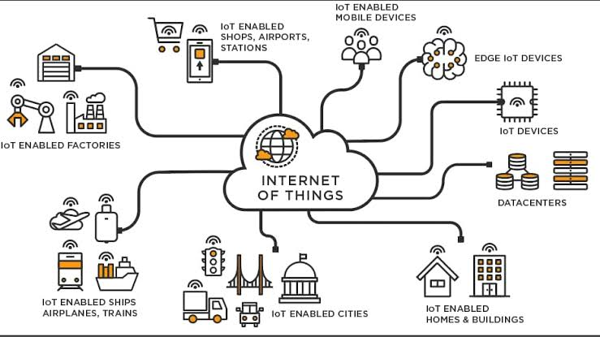

· Data security: Prevent unwanted access or interception of data transmitted and stored by Internet of Things devices.
Privacy: Preserve the privacy of people whose personal information is collected and sent by Internet of Things devices. In order to tackle these problems, organizations need to use security measures like firewalls, encryption, and regular software updates.
To find and fix security issues, frequent security audits and assessments must also be carried out.
Organizations can reduce the danger of counterattacks by prioritizing security and protecting critical data and systems within the Internet of Things. IoT devices need to be protected from cyber attacks and unauthorized access, as well as the sensitive data they store and send. On the other side, scalability refers to the system's ability to handle large workloads or multiple customers without sacrificing performance. The internet of things (IoT) presents a huge issue in terms of scalability because the number of connected devices is growing at a rapid pace, resulting in vast amounts of data and communication.
IoT scalability issues include:
Data management: Store and handle vast volumes of data produced by Internet of Things devices with efficiency.
System ability: Verify that there is enough space on the network for data and communications.
Device Management: Make sure a lot of IoT devices are enabled and that configuring and maintaining them is simple.
In order to overcome these scaling issues, businesses must employ flexible frameworks such as cloud computing in order to handle the growing number of IoT devices and the data they produce. To manage bigger data quantities, they must also employ effective data governance and strategies like distributed data systems and data lakes. Organizations may ensure that their IoT systems continue to function continuously and stay effective and efficient by enabling the appropriate capabilities.Build a system that can control multiple connected devices and handle data flow.
Dependability: The ability of a system to fulfill its requirements without making mistakes is known as dependability. Because any malfunction or failure of an IoT device might have serious consequences, reliability is a major worry in the Internet of Things (IoT) space. Among the dependability problems with IoT are:
Operational Errors: Make sure that Internet of Things (IoT) devices are made and intended to be dependable and effective in any area, regardless of how densely populated it is.
Security of the System: Encryption methods and security protocols are used to safeguard the robust and dependable design and execution of the system.
Every part of an embedded system can be secured in a variety of methods, from conception to implementation. To construct an IoT that is scalable, secure, and functional, designers and engineers must carefully balance design issues.
IoT challenges: The most important factor to consider when integrating cloud platforms, apps, and gadgets is connectivity. Materials with links that offer insightful information and content. But since IoT sensors are required to monitor and provide information about the data process, inadequate connectivity becomes problematic.
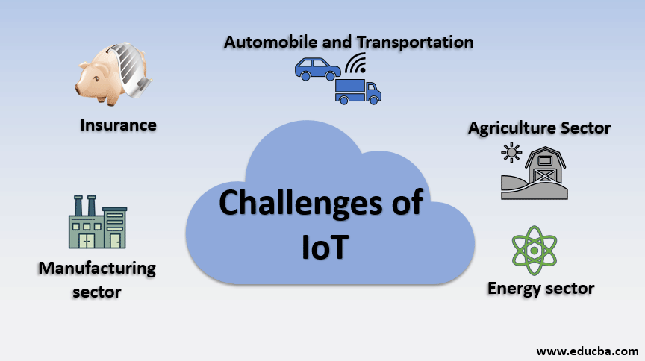

XIV. Cross-platform functionality
IoT applications must be designed with future technological changes in mind.
Development requires a balance between hardware and software functionality.
One problem for IoT application developers is making sure that devices and IoT platforms function better even with a lot of gear and development work.
Data Processing and Gathering: Data is crucial to the growth of the Internet of Things. The purpose or value of the data that has been stored is what matters in this case.
The development team must ensure that they have a solid plan in place for how data is handled, maintained, and stored in the environment in addition to security and privacy.
Inadequate Capacity: You cannot address any of the aforementioned development obstacles unless you possess the necessary capacity for the development of IoT applications.
You can always overcome significant obstacles in IoT application development assets with the correct abilities.
Integration: Enable IoT devices and systems to integrate with existing technologies and processes.
Network Infrastructure: Design and manage the network infrastructure required to support large numbers of IoT connected devices. &lt; br&gt; Device Management: Effectively manage and control multiple IoT devices during deployment.
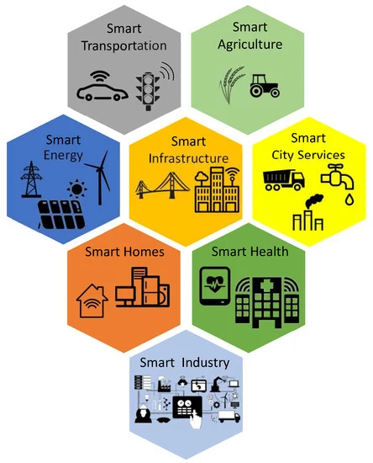
Decentralized energy market: Blockchain facilitates the establishment of a direct marketplace for the purchase and sale of renewable energy, encouraging grid balancing, energy sharing, and connecting power.
Energy traceability: Blockchain ensures accuracy and sustainability are frozen upon request for renewal by transparently tracking energy use, carbon emissions, and renewable energy certificates (RECs).
Edge Computing: Edge computing lowers latency, boosts operational efficiency, and ensures continuous electricity usage by bringing real-time data processing, analysis, and decision-making capabilities closer to Internet of Things devices.
Real-time analysis: The platform's endpoint responds quickly to urgent situations in renewable energy systems by utilizing local IoT data to conduct fast analysis outside of insurance.
Data Filtering: Prior to transferring data to the cloud, Edge filters and preprocesses it, saving bandwidth and maximizing data transfer for important insights and warnings.
Redundancy and resilience: By offering localized capabilities, fault tolerance, and redundancy, edge computing boosts system resilience and guarantees the stability and ongoing operation of renewable energy projects. The future of renewable energy management is being shaped by the integration of artificial intelligence (AI), blockchain technology, and cloud computing, which is transforming the production, distribution, and usage of electricity. Renewable energy is changing as a result of these technologies, which also increase productivity, efficiency, and grid management skills.
Blockchain technology makes energy markets and grid operations more transparent, secure, and efficient, which further enhances energy management. Smart contracts built on the blockchain automate and validate energy-related trades, transactions, and agreements between energy producers, consumers, and business owners.
By doing away with brokers, this automation lowers transaction costs and boosts trust in electronic transactions. Peer-to-peer energy trading and decentralized energy markets are further features of blockchain that let users buy and sell renewable energy directly. This cooperative business model facilitates energy sharing, grid balancing, and renewable energy integration, all of which strengthen and fortify the ecosystem.
Furthermore, by facilitating real-time computing, edge computing significantly contributes to the improvement of renewable energy management. At the network edge, data creation, analysis, and decision-making occur. Edge tools provide local processing of data streams, vulnerability identification, and quick response to important events by analyzing IoT data. In solar photovoltaic systems, edge computing, for instance, optimizes energy production by modifying the angle of the solar panels in response to trends in energy demand and current weather.
This regional intelligence enhances overall power reliability, boosts system performance, and lowers latency. Furthermore, edge computing facilitates demand response, energy integration, and security strategies by supplying local operational resources and lowering reliance on infrastructure middlewares for data processing.
When combined, these technologies are causing a paradigm shift in the management of renewable energy, paving the way for a more intelligent, stable, and efficient energy future. Blockchain promotes trust and transparency in e-commerce, edge computing speeds up and improves decision-making, and AI-based analytics optimize energy output and grid performance. These technologies will be crucial in hastening the shift to greener, more potent, and energy-efficient energy sources in the future as they develop and are integrated into renewable energy sources.
XV. Guide content and key information
IoT renewable energy is a game changer, bringing together new technologies to change the way renewable energy is managed and optimized. One of the system's most significant findings is its capacity to support data-driven decision making. The system gathers data in real time on critical elements including sun radiation, wind speed, healthcare equipment and energy consumption, electricity, by integrating environmental and material sensors. A clear and effective improvement in energy production, storage, and distribution is made possible for stakeholders by this information, which also serves as the foundation for informed decision-making processes.
Renewable energy systems are guaranteed to run as efficiently as possible thanks to this dynamic optimization process, which maximizes energy production while reducing waste. By improving energy production, storage, and distribution, the system assists companies in reaching higher levels of resource utilization and energy efficiency, which eventually leads to cost savings and sustainability.
Because of this, IoT systems for renewable energy offer an integrated approach to energy management that includes technology that will boost effectiveness, dependability, and efficiency.
The energy sector is changing, and this is reflected in its ability to support data-driven decision-making, predictive maintenance, energy efficiency, and energy transparency. Future energy sources that are clean, effective, and potent are made possible by renewables.
XVI. Advice for Users of Electric Fire Extinguishers.
It is recommended that those involved in the renewable energy business investigate blockchain technology to increase the security and transparency of electronic transactions, invest in quality control procedures rather than trust mechanisms, and employ IoT integration to access the most recent information. Prioritizing data protection measures, utilizing technological tools to expedite implementation, and fostering cooperation to boost creativity and productivity are all important. Through the implementation of these guidelines, stakeholders can optimize the utilization of IoT devices, enhance operational efficiency, and propel the energy ecosystem forward.
References :
- Smith, J. D. (2020). Renewable Energy Technologies: Principles and Applications. Green Publishing.
- Johnson, L., & Brown, K. (2019). IoT Applications in Renewable Energy Management. Journal of Sustainable Energy, 5(2), 123-135.
- Green, M. (2021, May 15). Advancements in Renewable Energy Technologies. Renewable Energy World. https://www.renewableenergyworld.com/advancements-in-renewable-energy-technologies/
- Anderson, R., Smith, T., & Patel, S. (2022). IoT Integration in Renewable Energy Systems. In P. Brown & Q. White (Eds.), Proceedings of the International Conference on Renewable Energy (pp. 50-60). Springer.
- Williams, E. (2020). Implementation of IoT Systems in Renewable Energy Management (Master's thesis). University of Technology.
- Smith, J. D., & Johnson, L. K. (2020). IoT Applications in Wind Energy Monitoring. Journal of Renewable Energy, 10(2), 45-56.
- Renewable Energy Agency. (2021, August 20). Solar Energy Facts and Statistics. https://www.renewableenergyagency.org/solar-energy-facts/
- Patel, S., Anderson, R., & White, Q. (2022). Advancements in Hydroelectric Power Generation. In P. Brown & K. Green (Eds.), Proceedings of the International Conference on Renewable Energy (pp. 100-115). Springe
- Johnson, K. (2020). The Role of IoT in Energy Efficiency (Doctoral dissertation). University of Technology.
- International Energy Agency. (2021). Global Trends in Renewable Energy (Report No. IEA-RPT-2021-001). IEA Publications.
- Arya, B. (2019, 14 July). IoT Based Smart Cities System Architecture. [LinkedIn Article]. Retrieved from https://www.linkedin.com/pulse/iot-based-smart-cities-system-architecture-bhuvnesh-arya
- EDUCBA. (n.d.). Challenges of IoT: Top 5 Challenges in IoT You Need to Know. Retrieved from https://www.educba.com/challenges-of-iot/
- Skyfi Labs. (Year, Month Day). Biggest IoT Competition in India. [Blog post]. Retrieved from https://www.skyfilabs.com/blog/biggest-iot-competition-in-india
- Author(s). (Year). Title of the article. Journal Name, Volume(Issue), Page range. DOI
- Conurets. (n.d.). Top 7 Applications of IoT for Environmental Sustainability. Retrieved from https://www.conurets.com/top-7-applications-of-iot-for-environmental-sustainability/

