Chapter 03
Microencapsulation in Pharmaceutical Science: Definition, Benefits, Drawbacks, Methods, and Applications of Microspheres, Microcapsules, and Microparticles

Priya Thakur ¹, Pooja Kumari ², Shital Mahendra Sonawane ^{3,*}, Avinash Kumar Rao ⁴

¹ Associate Professor, LR Institute of Pharmaceutical Sciences, Solan HP
² Associate professor, Affiliation: Institute of Pharmaceutical Sciences Bhaddal, Ropar, Punjab
³ Assistant Professor, Swami Vivekanand Sansthas Institute of Pharmacy, Mungase, Malegaon, Nashik, Maharashtra
⁴ Assistant Professor, Department of Pharmacy, Sharda Devi Mahavidyalay, Badlapur, Jaunpur, Uttar Pradesh, India.

*Corresponding Author:
Shital Mahendra Sonawane
Assistant Professor, Swami Vivekanand Sansthas Institute of Pharmacy, Mungase, Malegaon, Nashik, Maharashtra

ABSTRACT
Microencapsulation, a crucial technique in the field of pharmaceutical science, involves enclosing active pharmaceutical ingredients (APIs) within microspheres, microcapsules, or microparticles. This study systematically explores the various facets of microencapsulation, encompassing its definition, advantages, disadvantages, methodologies, and diverse applications in the pharmaceutical sector. The definition section delves into the fundamental concept of microencapsulation, elucidating the process that protects APIs within a protective matrix. The research uncovers advantages such as improved drug stability, extended release, enhanced bioavailability, and minimized side effects. Concurrently, it critically examines potential drawbacks, including formulation challenges and scalability issues, providing a comprehensive perspective to optimize pharmaceutical applications. Methodologically, the study thoroughly reviews different microencapsulation techniques like spray drying, coacervation, and solvent evaporation. An evaluative analysis of their merits and limitations is presented, providing insights crucial for tailoring microencapsulation processes to specific drug characteristics and therapeutic requirements. The extensive realm of microencapsulation applications in pharmaceuticals is explored, ranging from controlled drug delivery and targeted therapy to taste masking and protecting sensitive compounds. The research meticulously scrutinizes these diverse applications, highlighting the transformative potential of microencapsulation in drug development and delivery. Through an in-depth analysis of microspheres, microcapsules, and microparticles, this research contributes valuable insights into their unique properties and applications in pharmaceutical formulations. The ultimate goal of this book chapter is to investigate the advance drug delivery systems, paving the way for more effective and patient-friendly pharmaceutical products. This comprehensive resource aims to benefit researchers, pharmaceutical scientists, and industry professionals, enhancing their understanding of microencapsulation's pivotal role in shaping the future of pharmaceutical science.
KEYWORDS: Microencapsulation, pharmaceutical, solvent, microcapsule, microparticles

- BACKGROUND STUDY

1. Rising Significance of Microencapsulation:
- The introduction of microencapsulation is presented as a crucial method within the realm of pharmaceutical science.
- Confronting issues in conventional drug delivery approaches, such as ensuring stability and managing controlled release.

2. Evolution of Microencapsulation:
- Recognition of the growing focus and investigation within the field.
- Acknowledgment of microencapsulation's role as a revolutionary instrument for enhancing drug delivery systems.

3. Limitations of Conventional Drug Delivery:
- Obstacles associated with the stability, bioavailability, and controlled release aspects in conventional pharmaceutical delivery.
- There is a requirement for inventive methods to improve therapeutic results and encourage patient adherence.

4. Versatility of Microencapsulation:
- Summary of the adaptability of microencapsulation in protecting active pharmaceutical ingredients (APIs).
- Capability to finely regulate the kinetics of drug release for enhanced therapeutic effectiveness.
5. Strategic Role of Microencapsulation:
- Emphasizing microencapsulation as a strategic approach for achieving prolonged drug release.
- Dealing with concerns such as concealing taste, focused therapy, and safeguarding delicate compounds.

- RATIONALE STUDY

- Overcoming constraints through thorough examination.:
  - The justification for exploring microencapsulation to overcome significant drawbacks in conventional drug delivery approaches.
  - Contributing to the ongoing advancement of drug delivery systems to improve patient care.

- In-Depth Exploration of Methods:
- Highlighting the thorough examination of microencapsulation techniques, including spray drying, coacervation, and solvent evaporation.
- The significance of comprehending these techniques to customize drug formulations according to specific characteristics and therapeutic needs.

- Balanced Perspective on Benefits and Drawbacks:
- Acknowledgment of the necessity for a well-rounded viewpoint regarding the advantages (improved drug stability, extended release) and disadvantages (formulation challenges, scalability issues).
- Providing guidance to researchers and pharmaceutical scientists in optimizing the applications of microencapsulation.

- Diverse Applications of Microencapsulation:
- Investigating a range of applications, such as controlled drug delivery, targeted therapy, taste masking, and safeguarding sensitive compounds.
- Shedding light on the potential of microencapsulation to cater to diverse pharmaceutical requirements.

- Foundation for Future Development:
- The research serving as a basis for the creation of pharmaceutical products that are more efficient and user-friendly for patients.
- Contributing to the progression of drug delivery systems and influencing the trajectory of pharmaceutical science in the future.

- RECENT ADVANCEMENTS

1. Nanotechnology Integration:
- Integrating nanotechnology into microencapsulation procedures to enhance precision and efficiency in drug delivery.
- Utilizing nanocarriers within microspheres or microcapsules to improve targeted drug delivery.

2. Biodegradable Polymers:
- Progress in employing biodegradable polymers in microencapsulation, contributing to the development of environmentally friendly and sustainable drug delivery systems.
- Creating new biocompatible materials to enhance safety and decrease the long-term environmental footprint.

3. Personalized Medicine Applications:
- Incorporating microencapsulation techniques into the realm of personalized medicine to enable customized drug release profiles according to individual patient requirements.
- Progress in tailoring microspheres and microcapsules for particular patient demographics.

4. Controlled and Sustained Release Systems:
- Enhancing controlled and sustained release systems through microencapsulation, allowing for extended therapeutic effects with reduced administrations.
- Integrating materials responsive to stimuli for drug release on-demand, triggered by specific physiological conditions.

5. Advances in Coating Technologies:
- Advancement of cutting-edge coating technologies to enhance the stability and shelf-life of microencapsulated pharmaceuticals.
- Investigation of novel coating materials to provide improved protection for active ingredients.

6. 3D Printing and Microencapsulation:
- Combining 3D printing methods with microencapsulation for the creation of drug delivery systems tailored to individual patients.
- Utilizing 3D printing to generate intricate structures, enabling exact control over the characteristics of microspheres and microcapsules.

7. Combination Therapies:
- Investigation of microencapsulation for administering combination therapies, encompassing multiple drugs or therapeutic agents.
- Achieving synergistic effects by concurrently delivering various therapeutic compounds within a unified microencapsulated system.

8. Improved Analytical Techniques:
- Progress in analytical methods for characterizing microspheres, microcapsules, and microparticles.
- Employment of high-resolution imaging and spectroscopy techniques for in-depth analysis of microencapsulated structures.

9. Scale-Up and Manufacturing Technologies:
- Advancements in scale-up and manufacturing technologies for the mass production of microencapsulated pharmaceuticals.
- Adopting continuous manufacturing processes to enhance efficiency and cost-effectiveness.

10. Regulatory Considerations:
- Continued endeavors to establish precise regulatory guidelines for the development and approval of microencapsulated pharmaceuticals.
- Enhanced collaboration among researchers, industry stakeholders, and regulatory bodies to guarantee the secure and efficient utilization of microencapsulation in drug development.

These advancements collectively contribute to the evolving landscape of microencapsulation in pharmaceutical science, offering promising solutions for improved drug delivery, therapeutic efficacy, and patient outcomes.

- KEY QUESTIONS
  - What is the fundamental definition of microencapsulation in the context of pharmaceutical science?
  - How does microencapsulation differ from traditional drug delivery methods?
  - What are the key benefits associated with microencapsulation in pharmaceutical formulations?
  - In what ways does microencapsulation contribute to enhanced drug stability and prolonged release?
  - What challenges and drawbacks are associated with the application of microencapsulation in pharmaceuticals?
  - How do formulation challenges and scalability issues impact the widespread adoption of microencapsulation?
  - What are the main methods used in microencapsulation, such as spray drying, coacervation, and solvent evaporation?
  - How do these methods differ in terms of their application and effectiveness?
  - In what specific areas of pharmaceuticals can microencapsulation be applied for controlled drug delivery?
  - How does microencapsulation contribute to taste masking and the protection of sensitive compounds?
  - Can a comparative analysis be conducted on the merits and limitations of microencapsulation methods?
  - How do microspheres, microcapsules, and microparticles differ in their properties and applications?
  - What are the anticipated future developments in microencapsulation within the pharmaceutical field?
  - How might advancements in microencapsulation contribute to the evolution of drug delivery systems?
  - How is microencapsulation being explored for the delivery of biological molecules, peptides, and proteins?
  - What role does microencapsulation play in biotechnological applications, such as cell encapsulation?
  - What regulatory considerations are important for the approval and use of microencapsulated pharmaceuticals?
  - How do regulatory guidelines influence the development and commercialization of microencapsulation technologies?
  - How is microencapsulation integrated with other emerging technologies, such as 3D printing, in pharmaceutical research?
  - Can digital technologies and artificial intelligence contribute to the optimization of microencapsulation processes?

INTRODUCTION
One of the most innovative areas of research that greatly benefits human healthcare is controlled drug delivery technology, which calls for a multidisciplinary approach. Enhanced efficacy, decreased toxicity, better patient compliance, and convenience are just a few benefits that these delivery methods have over conventional dose forms. These methods allow the application of hitherto difficult treatments, frequently by using macromolecules as drug carriers. Recent years have seen a fast expansion and diversification of the controlled release pharmaceutical technology industry. It might be difficult for non-experts in the field to comprehend the origins of controlled release techniques and the range of novel polymers. When it comes to documented dose forms, nanoparticles and microparticles have become more well-known, especially because of their propensity to gather in inflammatory bodies parts. Given their appealing characteristics, nano and microparticles have a special place in medication delivery technology. The present tendencies in this developing topic will be examined in this discussion (1-3).
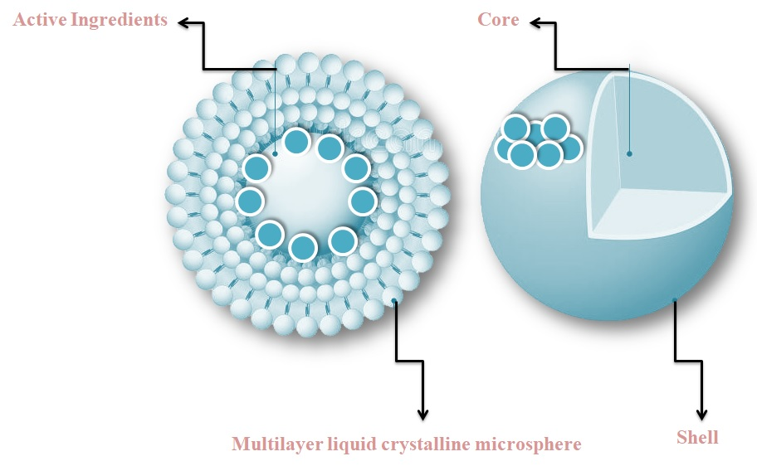
Figure 1: Components of a multiparticulate drug delivery system: Microencapsulation
For individuals unfamiliar with the field, the nomenclature used to characterise formulations containing microparticles can be ambiguous and potentially misleading. A "microparticle" is, essentially, any particle that has a diameter between 1 and 1000 μm, independent of its particular internal or exterior structure. In the more general categorization of microparticles, "microspheres" refer to spherical microparticles in particular, while "microcapsules" are subclassifications of microparticles that have a core and are encased in a substance that is not the same as the core. The actual core itself could be gaseous, liquid, or solid 4-6. Researchers frequently have a tendency to use the phrases interchangeably, which confuses readers despite the obvious and logical distinctions. A formulation is generally considered to consist of a relatively homogenous blend of polymer and active ingredient when it is labelled as a microsphere. On the other hand, it is presumed that microcapsules possess the active agent in at least one discrete region, and occasionally multiple ones. A few variations in the architectures of microparticles are shown in Figure 1. Microcapsules become microparticles when the active agent domains and subdomains inside of them shrink in size (7–9). A spherical particle with a core substance that ranges in size from 50 nm to 2 mm is referred to as a "microcapsule". Strictly speaking, empty spherical particles are called microspheres. Nevertheless, microspheres and microcapsules are often used synonymously. Furthermore, some terms that are related are used interchangeably; for example, "microbeads" and "beads" might be used interchangeably. Additionally, the phrases "sphere" and "spherical particles" are used, particularly in reference to bigger sizes and more rigorous formalisms. It makes sense to look at the uses of microspheres and microcapsules in formulations for controlled drug release, given their many uses and enticing qualities (1,6,7).
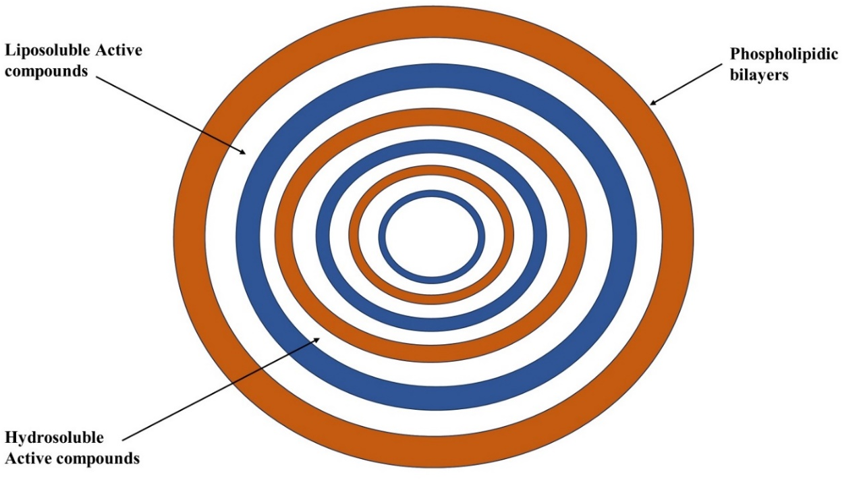
Figure 2: Microencapsulation process
Although "capsule" refers to a structure consisting of a core and shell, "microcapsules" includes dispersion inside a solid matrix without a clear exterior wall phase, as well as intermediate forms, in addition to particles or droplets surrounded by a membrane. Usually ranging from 2 to 2000 μm in size, their size differentiates them from smaller nanoparticles or nanocapsules. The intricate and varied structural characteristics of microcapsules have been uncovered by scanning electron microscopy (SEM). As shown in Figure 2a, the walled prototype may be mononuclear, or it may have several cores. Furthermore, there might be two or more concentric coverings. Figure 2b illustrates the substantial variability in size and shape of aggregated microcapsules, which may also have an extra exterior wall. Liquid cores can be used to create flawless microcapsules, or the microcapsules can be formed as a liquid dispersed phase prior to solidification. Although SEM is able to identify the membrane's and the interior's microstructure on surfaces or sections (Figure 2c), it is difficult to quantitatively characterise the microcapsules' porosity, tortuosity, and crystallinity. However, some progress has been achieved, and current efforts are focused on determining porosity and permeability using dimensions, densities, and core/wall ratios in addition to release data. Only lately has the impact of size and form dispersion been studied (8–10).
The last way that microcapsules are delivered to patients is as liquid suspensions, soft gelatin capsules, or enteric-coated hard gelatin capsules. When released, these formulations allow the individual microcapsules to disperse. Because of the advantages of microparticulate delivery systems and their comparatively simple design and formulation processes, microcapsules remain a topic of great interest in the controlled release field. These benefits include prolonged release from every single microcapsule, which offers improved consistency and repeatability. The use of microcapsules provides an extra safety element in the event of a burst or damaged unit in divided dosage forms, as opposed to monolithic systems with numerous doses. Finally, dispersion of different particle systems across the gastrointestinal tract may lead to: (a) lower local concentrations, which could result in less toxicity or irritation; and (b) less variation in transit time and absorption rate (11–13).
1. Microspheres Overview [16, 17, 18, 19]
While oral drug delivery is often preferable, many medicines' therapeutic potential is limited by their short circulation half-life and limited absorption within a particular segment of the gut. Achieving the intended therapeutic impact often requires frequent dosing due to this pharmacokinetic restriction. A logical approach to improve bioavailability and optimise the pharmacokinetic and pharmacodynamic characteristics is to release the medication in a regulated, site-specific fashion. Microspheres are free-flowing, spherical particles made of synthetic polymers or biodegradable proteins, and their sizes range from 1 μm to 1000 μm. Microspheres come in two varieties: micromatrices, in which the entrapped material is distributed throughout the matrix, and microcapsules, in which the entrapped material is clearly encircled by a capsule wall. Microparticles are another name for microspheres. A variety of synthetic and natural materials can be used to make them. When it comes to increasing the absorption of traditional medications while reducing side effects, microspheres are essential. Microspheres should have the following ideal properties [18, 19].

1. The ability to incorporate medication concentrations that are somewhat high.
2. The formulation's post-synthesis stability, which preserves a clinically suitable shelf life.
3. Controlled dispersibility and particle size in aqueous solutions intended for injection.
4. The active agent's regulated release under strict supervision over an extended period of time.
5. Compatibility with reasonably managed biodegradability living organisms.
6. Susceptibility to changes in composition.

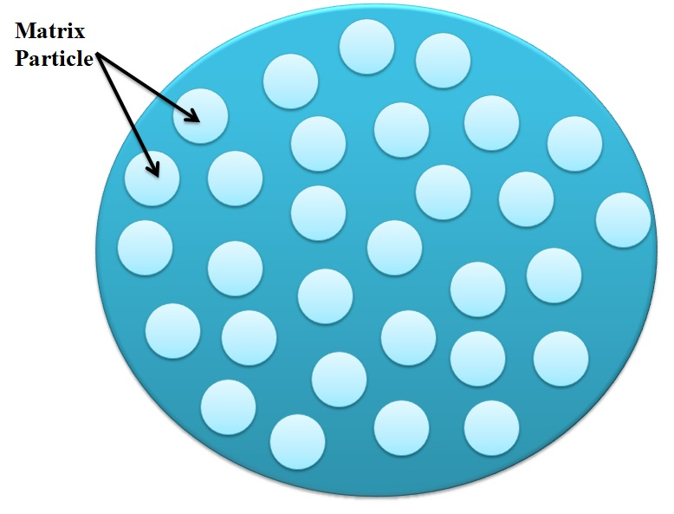
Figure 3: Microsphere
Microsphere benefits: [19]
1. Reduce particle size to improve poorly soluble medication solubility.
2. Offer a long-lasting and reliable therapeutic impact.
3. To increase patient compliance, keep the blood concentration of the medication steady.
4. Reduce toxicity and dose.
5. Protect the medication from photolytic and enzymatic cleavage, which makes it especially appropriate for protein drug delivery.
6. Lower the frequency of dose, which will improve patient compliance.
7. Better use of medications to increase bioavailability and lessen the frequency or intensity of side effects.
The shape of the microsphere allows for controlled variations in medication release and breakdown.
9. Convert a liquid into a solid and cover up the bitter flavour.
10. Prevent the drug's irritating effects on the gastrointestinal system.
11. Compared to big polymer implants, biodegradable microspheres offer the benefit of not requiring surgical procedures for placement and removal.
12. The use of biodegradable microspheres with controlled release minimises harmful side effects and does away with the hassle of numerous injections.
Limitation: The following shortcomings were noted [18]:
1. Compared to ordinary formulas, the costs of ingredients and processing for controlled release preparations are significantly greater.
2. The polymer matrix's effects on the environment and their effects.
3. How polymer additives like fillers, stabilisers, plasticizers, and antioxidants affect the environment.
4. Reproducibility is less consistent.
5. A number of process parameters, including temperature, pH, solvent addition, and agitation/evaporation, might impact how stable the core particles are to be enclosed.
6. The effects on the environment of degradation products from the polymer matrix that are produced in reaction to solar radiation, heat, hydrolysis, oxidation, or biological agents.
Materials utilised for Microsphere preparation: [15, 21]
Microspheres are often made of polymers and fall into two categories:
1. Natural polymers come from a variety of sources, including proteins and carbohydrates. These include chemically modified proteins like gelatin, collagen, and albumin, and chemically modified carbohydrates like polydextran and polystarch.
2. There are two kinds of synthetic polymers. Lactides, glycolides, and their copolymers, as well as poly anhydrides and poly alkyl cyanoacrylates, are examples of biodegradable polymers. Polymethyl methacrylate (PMMA), glycidyl methacrylate, acrolein, and epoxy polymers are examples of non-biodegradable polymers.

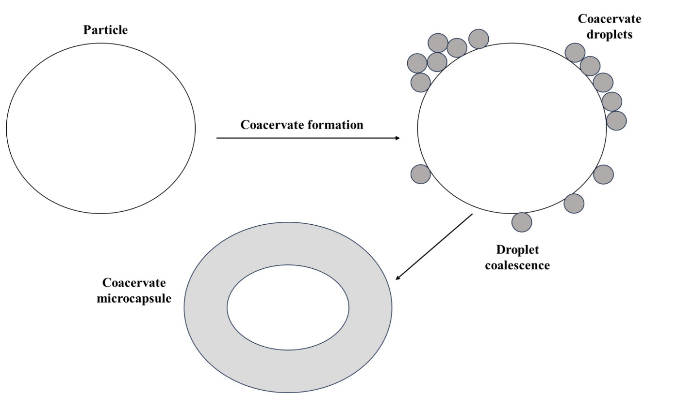
Figure 4: Illustrative depiction of the coacervate formation encircling a core material.
THE PHARMACEUTICAL INDUSTRY'S USE OF MICROSPHERES: [20,21, 22]
1. Ophthalmic Drug Delivery: Microspheres made of polymers have unique physico-chemical features, bioadhesion, and permeability-enhancing qualities that make them advantageous biologically for the development of ocular drug delivery vehicles. Gelatin, alginate, and chitosan are a few examples.
2. Oral Drug Delivery: By forming films, polymer-containing microspheres can be used to make film dosage forms as an alternative to conventional pharmaceutical tablets. Because of their sensitivity to pH and the reactivity of primary amine groups, microspheres are a good choice for applications involving oral medication delivery. Gelatin and chitosan are two examples.
3. Gene Delivery: Because of their adhesion and transport qualities in the gastrointestinal system, microspheres have the potential to be used as oral gene carriers. Polycation complexes, cationic liposomes, viral vectors, chitosan, and gelatin are a few examples.
4. Nasal Drug Delivery: Drug bioavailability and residence time in the nasal channel are improved by polymer-based drug delivery methods, such as microspheres, liposomes, and gels, which show advantageous bioadhesive properties and easy swelling upon contact with nasal mucosa. Examples include albumin, starch, dextran, and chitosan and gelatin together.
5. Intratumoral and Local Drug Delivery: Paclitaxel is delivered to the tumour location in therapeutically relevant quantities using polymer films. A combination of medications appears promising for regulated oral administration. PCL, PLGA, gelatin, and chitosan are a few examples.
6. Drug Delivery via the Buccal Route: Polymers, especially Sodium Alginate and Chitosan, are a great option for drug delivery through the buccal route because of their muco/bioadhesive qualities and capacity to improve absorption.
7. Gastrointestinal Drug Delivery: Deacidified polymer granules with interior voids float in neutral and acidic liquids to deliver drugs with controlled release. Eudragit, ethyl cellulose + carbopol BSA, and gelatin are a few examples.
8. Transdermal Drug Delivery: Film cross-linking and membrane thickness determine how drugs are released from devices using film-forming polymers such PLGA, chitosan, and alginate.
9. Chitosan is used specifically to transport insulin to the colon in the context of colonic drug delivery.
10. Vaginal Drug Delivery: Mycotic infections of the genitourinary tract are commonly treated using polymers that have had primary amino groups changed by the addition of thioglycolic acid, such as chitosan, gelatin, and PLGA.
11. Targeting with Microparticulate Carriers: Extrusion/spheronization technology is used to make pellets made of polymers, which are then used as microparticulate carriers. Chitosan and microcrystalline cellulose are two examples.
1. Introduction to Microencapsulation
A developing technique called microencapsulation is intended to protect different food ingredients or functional components from different processing environments. By encasing them in a polymeric or non-polymeric substance, controlled release under particular circumstances is made possible. Additionally, this technology enhances sensory qualities by masking off unwanted flavours, scents, and tastes. Furthermore, it improves food safety by inhibiting the growth of microorganisms (23, 24). To satisfy expanding consumer needs, a variety of bioactive substances, such as vitamins, phenolic compounds, carotenoids, omega-3 and omega-6 fatty acids, and carotenoids, are being used more and more in the creation of goods with a range of functional qualities. However, these substances can become unstable when they come into contact with certain elements including light, heat, acidity, and oxygen. As a result, microencapsulation provides a means of protecting these substances from adverse environments encountered in the food processing industry. Many food ingredients that are enclosed include probiotic bacteria, vitamins, lipids, antioxidants, essential oils, and flavourings (25). Different coating materials are selected according to their rheological properties, ability to efficiently retain the active compound, inertness towards the active compound, and capacity to disseminate and stabilise the active molecule. Coating materials include, for example, lipids like wax, paraffin, beeswax, and diacylglycerols; gums like gum acacia, agar, and carrageenan; proteins like gluten, casein, and gelatine; and carbohydrates like starch, maltodextrin, modified starch, cyclodextrin, and cellulose. Microencapsulation is a technical technique used to protect fragile and important nutrients (26), by forming a barrier that allows for their release under particular circumstances. For example, as mentioned earlier (27), the flavours that are encapsulated in chewing gums are only released when the gum is chewed. In the last several years, the food business has presented complex food formulas, such adding specialised volatile flavours to quick mixes and fatty acids to dairy products, which are especially prone to auto-oxidation. Microencapsulation may be able to help in these situations (28, 29). There are many ways to microencapsulate, including freeze drying, coacervation, liposome entrapment, fluidized bed coating, spray chilling, and spray cooling.Different kinds of capsules are made depending on the chemical and physical characteristics of the core, the material composition of the shell, and the technique of microencapsulation used. These include basic spheres coated in wall material, irregularly cored capsules, numerous unique cores coated continuously in wall material, microcapsules with multiple walls, and core particles embedded in the matrix of wall material. The methods used to create microcapsules are influenced by the coating material selection, which results in differences in the characteristics of the capsules, including their size, shape, porosity, hygroscopicity, hydrophobicity, surface tension, and thermal behaviour. Comprehending the features of these capsules is essential to understanding how they behave within any given food system. These characteristics are intimately related to the regulated release of the encapsulated core, which is essential to the microencapsulation process' efficacy and range of uses. The composition of the core material, the ratio of the core to the encapsulant, the properties of the encapsulant, and the interaction between the two are important elements that affect core release. The present review offers a critical evaluation of fundamental ideas related to microencapsulation, including the need for microencapsulation in food, the characteristics of coating materials, and the kinds of core materials on which they might be used. It also looks at numerous ways to encapsulate materials, investigates the physical, mechanical, thermal, and functional features of microcapsules, and clarifies various core release strategies. The review emphasises how important microencapsulation technology is to the food industry.

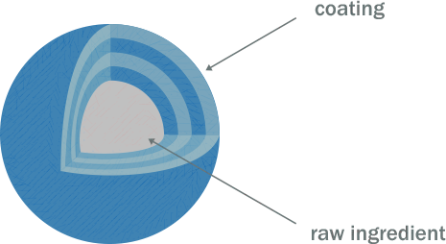
Figure 5: Microencapsulation
Microencapsulation Benefits:
1. Controlled Release: One of the main benefits of microencapsulation for the pharmaceutical industry is its ability to release the encapsulated material gradually and regulatedly. This is notably useful for prolonged medication delivery.
2. Protection of Active Ingredients: It envelops the core substance in a barrier to keep it safe from outside influences like light, air, and moisture. This preservation method helps maintain the encapsulated substance's stability and efficacy.
3. flavour and Odour Masking: Microencapsulation is used in products like pharmaceuticals and dietary supplements to improve the acceptability or palatability of certain chemicals by masking their flavour or smell.
4. Increased Stability: By encasing sensitive or reactive products, the encapsulation process can increase their stability, extending their shelf life and preserving their general quality.
5. Targeted Delivery: One of the main benefits of microencapsulation is that it allows the encapsulated substance to be precisely delivered to certain parts of the body. This is especially useful for medicine delivery systems.
6. Handling Ease: Microencapsulated materials are generally easier to handle and incorporate into a variety of formulas, making them more user-friendly across a range of sectors.
Drawbacks of Microencapsulation
1. Cost: Since microencapsulation requires specialised tools and supplies, it can be an expensive operation. This cost could prevent it from being widely adopted, especially in financially constrained businesses.
2. Complexity Challenge: The microencapsulation procedure can be complex, requiring a thorough comprehension of the materials and encapsulation methods involved. This complexity could cause problems for large-scale manufacturing.
3. Capsule Breakage Risk: During processing or handling, there is a chance that a capsule can break, causing the encapsulated contents to leak prematurely. This can have a negative impact on microencapsulation's overall effectiveness.
4. Loading Capacity Limitation: When trying to encapsulate high quantities of active chemicals, microcapsules may have a limited capacity for loading specific compounds.
5. Uniformity Concerns: It can be difficult to achieve consistency in the size and distribution of microcapsules, and variations in these parameters may affect how well the encapsulated substance performs.
6. Considering the Environment: Concerns regarding environmental impact may arise from the materials used in microencapsulation, especially the coatings. Certain coating materials might not biodegrade easily, which could have negative effects on the environment.
Methods for producing microcapsules
1. Physical techniques
1.1 Air-suspension coating
It is a flexible, regulated method of coating particles with solutions or melts. A perforated plate with different hole patterns inside and outside of a cylindrical insert supports the particles in an upward-moving air stream. To make the settling particles more fluid, just the right amount of air is permitted to rise through the outer annular region. The bulk of the rising air—which is frequently heated—flows inside the cylinder, which accelerates the particles' ascent. The particles return to the outer bed at the top when the air stream slows and diverges, then descend to begin the cycle again. Particles can go through the inner cylinder several times in a matter of minutes because to this process. For microencapsulation, the air suspension method offers a wide variety of coating material possibilities. With equipment capacities ranging from one pound to 990 pounds, the process can apply coatings in the form of solvent solutions, aqueous solutions, emulsions, dispersions, or hot melts. Although encasing core materials made of micron or submicron particles with air suspension techniques works well, it usually causes particle agglomeration, which results in a bigger size [4].
1.2 Coating of pans
One of the first industrial processes for creating tiny, coated particles or tablets is the pan coating process, which has been around for a while and is frequently used in the pharmaceutical sector. In this procedure, the coating substance is applied gradually while the particles are turned or tipped in a pan or other similar apparatus. It is generally accepted that in order to provide an efficient coating in the context of microencapsulation, solid particles must be larger than 600 microns. The manufacture of controlled-release beads is one area in which this technique has found widespread use. Generally, pharmaceuticals are layered onto a variety of spherical substrates, such nonpareil sugar seeds, and then covered in layers of distinct polymers for protection. Essentially, the coating is applied as an atomized spray or as a solution to the selected solid core material within the coating pans. To remove the coating solvent, heated air is usually blown over the coated materials in the coating pans during application. In certain cases, a drying oven is used to remove the solvent completely [2]. In order to control the product temperatures and evaporation rates inside the dryer, airflow is essential to the drying process. Three different kinds of interaction are present here:
1.3 Concurrent: In this drying configuration, the particles and drying air go through the drying chamber simultaneously and in parallel. The product temperatures are lower than the exhaust air temperature when they are released from the dryer. This setting works especially well for things that need to be dried by heat. The air disperser creates a lot of air rotation when using a rotary atomizer, which keeps the drying chamber at a constant temperature. However, an alternate non-rotating airflow is frequently used with equal effectiveness in tower or FILTERMAT®-type spray dryers that use nozzle atomizers.
1.4 In the counter-current drying setup, the drying air and particles move in different directions through the drying chamber. Products that require a specific degree of heat treatment during the drying process are ideally suited for this mode. When the powder comes out of the dryer, its temperature is usually higher than that of the exhaust air.
1.5 Particle movement through the drying chamber in the mixed-flow drying configuration combines co-current and counter-current phases. This mode necessitates the employment of nozzle atomizers that spray upward into an incoming airflow and is suitable for heat-stable materials with coarse powder specs. Because the air inlet and outlet are located at the top of the drying chamber and the atomizer sprays droplets downward towards an integrated fluid bed, it is also appropriate for heat-sensitive items. The research on the spray-dried microencapsulation of lycopene [8] provides an illustration of its use.
2. The chemical method
2.1 Evaporation of Solvents
To create microcapsules, businesses such the NCR Company, Gavaert Photo - Production NV, and Fuji Photo Film Co., Ltd. have used this technique. The production medium is liquid during the processes. A volatile solvent that is immiscible with the liquid manufacturing medium phase is used to dissolve the microcapsule coating. The coating polymer solution dissolves or disperses the core material that is going to be microencapsulated. To achieve the appropriate microcapsule size, the mixture of coating material and core material is distributed in the liquid manufacturing medium phase through agitation. If needed, the mixture is then heated to remove the solvent from the polymer. The polymer compresses around the core if the core material is distributed throughout the polymer solution. A matrix-type microcapsule is generated if the core material dissolves in the covering polymer solution. If necessary, the temperature of the liquid medium is lowered to room temperature while stirring doesn't stop once the polymer solvent has completely evaporated. At this point, the microcapsules can be separated as powders, coated onto substrates, or used in suspension form. Water-soluble or water-insoluble liquid and solid core materials can be produced using the flexible solvent evaporation method for microcapsule manufacturing. As demonstrated in the article "Evaluation of Sucrose Esters as Alternative Surfactants in Microencapsulation of Proteins by the Solvent Evaporation Method [9]," a variety of film-forming polymers can be used as coatings.
2.2. The process of polymerization
1. Interfacial Polymerization: Two reactants in a polycondensation process come together at an interface and react quickly in an interfacial polymerization reaction. This process is based on the traditional Schotten Baumann reaction, in which an amine or alcohol interacts with an acid chloride to create polyesters, polyurea, or polyurethane. The reaction is mediated by an active hydrogen atom. At the interface, thin, flexible walls form quickly under the right conditions. An aqueous solution comprising an amine and a polyfunctional isocyanate is added after the insecticide and diacid chloride solution has been emulsified in water. Condensed polymer walls form instantly at the interface of the emulsion droplets because a base is present to neutralise the acid generated during the reaction.
2. In situ: The process of polymerization A single monomer can directly polymerize on the particle surface in certain microencapsulation procedures. For example, cellulose fibres are submerged in dry toluene and then enclosed in polyethylene. The coating thickness varies from 0.2 to 75 µm, with typical deposition rates of about 0.5 µm/min. Even on sharp protrusions, the coating is consistent.
3. Matrix Polymer: During the creation of the particles, a core material is embedded in a polymeric matrix in a number of procedures. Spray-drying is a straightforward technique in which the solvent evaporates from the matrix material to create the particle. A chemical shift may also cause the matrix to solidify. Chang provides an illustration of this by preparing protein solutions in microcapsules by integrating the protein into the aqueous diamine phase. The ability to convert blood urea to ammonia using this approach has demonstrated permselectivity, with the enzyme staying within the microcapsules when integrated into an extracorporeal shunt system. Numerous research groups, such as the National Lead Corporation and Eurand America, are using polymerization techniques for microencapsulation [4].

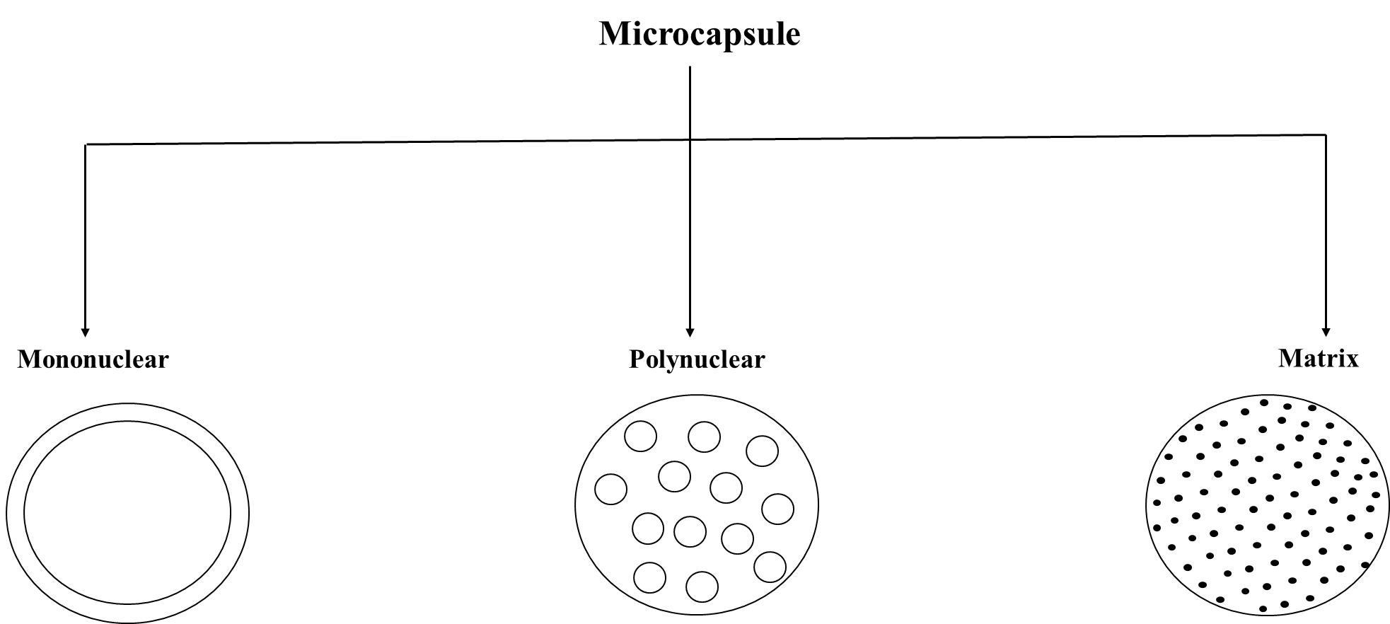
Figure 6: Types of microcapsules

APPLICATION [10-11]
1. Immobilisation of Cells: Used in continuous fermentation operations, plant cell cultures, and the development of bio-artificial organs from human tissue.
2. The Production of Drinks
3. Preserving Molecules from Coming into Contact with Other Substances
4. Pharmaceutical Delivery: Utilised in Drug Delivery Systems with Controlled Release.
5. Ensuring Environmental, Agricultural, and Food Sector Quality and Safety
6. Inoculation of Soil
7. Use in Textiles: Acting as a way to supply finishing.
8. Keeping Liquid Crystals Safe.
Microparticles

INTRODUCTION
In the pharmaceutical industry, the use of micro- and nanoscale technology to develop novel therapeutic choices has grown dramatically. It is possible to design polymeric systems intended for regulated drug release within these size ranges [37, 38]. These systems display size-dependent structural differences: microscale refers to particle diameters between 1 and 1000 µm [39] and nanoscale to particle diameters between 1 and 100 nm [40]. Micro- and nanoparticles can be used in a variety of situations since, in addition to size variations, they differ in other aspects as well [41]. These features include crystallisation, solubility, melting point, vitreous transition temperature, dissolution, etc.

Figure 7: Illustration depicting the structure of polymeric microparticles produced through both single- and double-emulsion methods, along with the internal dispersion of drugs possessing diverse physicochemical characteristics.

Among the benefits of microparticles over nanoparticles include their inability to pass through the interstitium when carried by lymph, which makes them more effective locally when their size surpasses 100 nm [39]. Furthermore, microparticles have a superior skin retention profile [42]. Another benefit of the pulmonary administration route is that particles smaller than 10 µm can enter the pulmonary alveolar area, which has strong gas exchange and tissue permeability. Furthermore, macrophages have the ability to phagocytose particles smaller than 20 µm once they enter the bloodstream [43]. It is important to note that results from animal models may not accurately represent how humans would react to these particles due to anatomical variations [44].
Benefits of Microparticles Particles:
Compared to nanoparticles, microcarriers have an advantage in that they can be carried by lymph and have a localised effect because they do not cross the interstitium at sizes larger than 100 nm [45]. Toxic chemicals can also be solidly enclosed within microcarriers to increase their stability and safety. Protecting medications against enzymatic cleavage can be achieved by encasing them in polymers, particularly when using suitable drug delivery methods.
a. Giving patients more medication can improve their outcomes.
b. Lowering the dosage and related dangers.
c. Better drug use can increase bioavailability and lessen the frequency or severity of adverse effects.
d. Helps protect the gastrointestinal system against stressors that cause opioids.
f. Patient survival rates increase with a shorter dose duration.
f. Reducing size increases surface area and improves the solubility of difficult-to-dissolve substances.
g. Converting liquids to solids can help cover up bad flavours [46].
Microparticles' drawbacks
The amount of food consumed and the degree of intestinal absorption are two examples of variables that may affect the regulated dose's release rate. Variations in flow rates may transpire among distinct dosages. Any problems with drug release could provide difficulties because the release-administration formulation calls for greater doses.
1. There could be risks associated with this type of drug.
2. It is not to be chewed or crushed [47].
By using the emulsion solvent, suspended microparticles containing active medications were created. In the evaporation procedure, 1g of the medication was dissolved in an acetone and ethanol (8:2) solvent mixture containing a 10% w/v solution of cellulose acetate phthalate. After ensuring that the combination had completely dissolved, the resultant solution was gently and steadily poured through a 250 ml beaker that held 100 ml of liquid paraffin. Metronidazole microparticles formed as a result of 4 hours of stirring the system at room temperature to allow the solvent to evaporate. Filtration was used to gather the created microparticles, which were then dried at room temperature and cleaned with cyclohexane to get rid of any leftover liquid paraffin. The procedure was carried out in accordance with references, and the dried microparticles were filtered and kept in a closed container. [48, 49]
Microparticle types
Microparticles that are magnetic: To deliver the medication only to the exact area impacted by the illness, magnetic microparticles are used. As seen in Figure 2, these microparticles, which are made of polymers like chitosan and dextran, respond magnetically. The integrated material's magnetic properties are harnessed by the magnetic carrier, which transfers it in reaction to a magnetic field. With the help of this novel strategy, large amounts of freely dispersed medications can be replaced with smaller amounts of magnetically directed medications, improving drug delivery precision [50, 51].
Microparticles made of polymers
The following categories apply to the polymer microparticles depicted in Figure 3:
Synthetic polymer-based microparticles have shown biocompatibility and safety in a range of medical applications, such as medication delivery, bulk agents, and embolic particles. The propensity of these microparticles to move from the injection site, increasing the risk of embolism and tissue injury, is a noteworthy disadvantage [52].
1. Polymers that degrade naturally: Starch and other biodegradable polymers are biocompatible, biodegradable, and bioadhesive. When these polymers come into contact with mucosal surfaces, they cause gel formation and have a considerable swelling capacity in watery settings, which prolongs their shelf life. The amount and pace of drug release can be adjusted by adjusting the polymer's concentration and the drug release profile. Drug loading into biodegradable microparticles, however, presents a difficulty that affects drug release efficiency and presents challenges for medical applications [53].
2. The capacity of bioadhesive microparticles to stick to a membrane is referred to as adhesiveness; it is the result of the particles' attaching to a water-soluble polymer. Bioadhesion is the word used to describe the drug carrier's attachment to mucous membranes such as the buccal, axillary, nasal, or rectal mucosa. As seen in Figure 4, these microparticles stay at the application site for an extended period of time, forming tight contact with the absorption site and improving pharmacological efficacy [54, 55, 56].
3. Because they are less dense than gastric fluid, floating microparticles, as seen in Figure 5, float in the stomach. The medicine is gradually released as the entire system moves with the contents of the stomach, which helps with improved gastric emptying and changes in plasma concentration. This method reduces the required dosage while extending the therapeutic effect. The absorbed particles spread over a larger absorption area during subsequent stomach emptying cycles, increasing the likelihood of drug absorption and affecting the diffusion profile. Furthermore, the likelihood of dose slippage is reduced when each dose is divided into many components [57–59].
4. A therapy method called radiofrequency immobilisation (RFI) uses radio waves to render patients immobile. When 10–30 nm-diameter microparticles enter a capillary, they interact with the capillary bed. An injection of oxygen and nutrients is given to the tumour through an artery. Under these conditions, the radioactive microparticles depicted in Figure 4 accurately deliver targeted radiation doses to particular regions without endangering nearby healthy tissue. Different kinds of radioactive microparticles are divided into three categories: emitters of α, β, and γ [60, 61].
Utilising microparticles
To protect vaccinations from bacteria or other dangerous substances, vaccine microparticle distribution is essential. The perfect vaccination should have features including affordability, effectiveness, safety, and ease of use. It might be difficult to strike a balance between safety and reducing negative reactions. The induced antibody response and safety issues are strongly related to the treatment plan. The goal of parenteral immunisation with biodegradable vaccine systems is to mitigate the shortcomings of traditional vaccinations [62].
1. The administration of genetic therapeutics via viral vectors, nonionic liposomes, polycation complexes, and microcapsules is known as gene delivery through microparticles. Because viral vectors may target a wide variety of cells, they are exceedingly effective at delivering genes. However, using them in vivo may have negative effects including immunological reactions. Non-viral gene therapy delivery strategies have been investigated in an effort to get over these restrictions. Benefits of non-viral methods include simple preparation, targeting of cells and tissues, immunosuppression, plasmid sizing flexibility, and repeatable large-scale production. In gene delivery applications, polymers are used as DNA carriers [63–66].
2. A new idea in medication therapy that emphasises precision is targeted distribution, often known as targeted drug delivery. The ability of a medicine to bind and interact with particular target receptors is essential for the efficacy of therapeutic therapy. By guaranteeing a precise, dependable, and effective distribution to the desired destination, the use of transporter systems improves drug action [67].
3. Using a technique intended at particular site targeting, monoclonal antibodies made to target microparticles are known as immunological microparticles. Despite their limited applicability, monoclonal antibodies are essential to this strategy. With the aid of highly specific monoclonal antibodies, bioactive chemicals enclosed within microparticles can be accurately guided to specific areas (MAbs). By attaching to amines, free aldehydes, or hydroxyl groups on the surface of microparticles, monoclonal antibodies (MAbs) can directly form a covalent bond to them. There are several ways to bind antibodies to microparticles: reagent coupling, live coupling, and non-specific and non-selective adsorption [67].
4. One particularly intriguing delivery method for anticancer medications is the use of microparticles. Given the increased vascular permeability and endocytic activity, their use is essential. Coating makes soluble polyoxymethylene microparticles opaque. Once released, these microparticles gather in the Reticuloendothelial System (RES), offering a different way to treat cancer [68, 69].
The market is currently filled with a variety of microencapsulated pharmaceutical items, including as progesterone, theophylline, aspirin and its derivatives, antihypertensive medications, and potassium chloride for stomach problems. Microencapsulated potassium chloride is specifically used to alleviate gastrointestinal issues associated with its ingestion. One of the most important ways to lower the danger of increased saline concentrations—which can cause consequences like bleeding, ulceration, and perforation—is by regulated ion release and microcapsule encapsulation. Additionally, suggestions for microparticle-based injectable and inhalation therapy have been made. The number of items that are now on the market falls short of the potential advantages of this technology, despite the significant study that has been done in this area. Cost factors have a big impact on how common microencapsulated medication items are. While some processes—like spray or drum coatings and spray dryers—are easier to access because of the equipment already in place, many microencapsulation techniques are protected by patents, which raises the bar and adds value to the industry [63].

CONCLUSION
In summary, the field of microencapsulation presents a promising avenue for advancing drug delivery systems, leveraging the encapsulation of substances within microspheres, microcapsules, or microparticles. Its advantages, including enhanced stability and prolonged release, offer solutions to conventional drug delivery challenges. While acknowledging complexities in formulation and potential drawbacks, a nuanced comprehension is essential for optimization. A comprehensive exploration of microencapsulation techniques, spanning from spray drying to coacervation, underscores the diverse methods crucial for tailoring drug formulations. This understanding is pivotal for researchers aiming to unlock the full potential of microencapsulation. The broad spectrum of microencapsulation applications, ranging from controlled drug delivery to taste masking, showcases its versatility in shaping drug development. Looking forward, anticipated advancements in targeted medicine, combination therapies, and smart materials present exciting prospects for more precise pharmaceutical interventions. The continuous refinement of microencapsulation techniques, coupled with emerging technologies, holds the promise of revolutionizing drug delivery. In essence, this study not only clarifies current definitions, benefits, drawbacks, methods, and applications but also lays the foundation for future innovations. By addressing challenges and optimizing methodologies, microencapsulation emerges as a cornerstone in the ongoing evolution of pharmaceutical science. Researchers and professionals are well-positioned to leverage these insights for enhanced therapeutic outcomes.

FUTURE SCOPE
- Targeted and Personalized Medicine:
  - Advancements in microencapsulation techniques to enable precise and targeted drug delivery, addressing individual patient characteristics and requirements.
  - Integration of personalized medicine principles to customize microsphere, microcapsule, and microparticle formulations for specific patient groups.
- Combination Therapies and Multi-Drug Delivery:
  - Continued exploration of microencapsulation for delivering combination therapies, allowing the simultaneous release of multiple drugs or therapeutic agents.
  - Development of sophisticated multi-drug delivery systems within a single microencapsulated platform for synergistic therapeutic effects.
- Incorporation of Smart Materials:
  - Integration of smart or responsive materials in microencapsulation for on-demand drug release triggered by specific physiological conditions.
  - Development of intelligent microcarriers capable of responding to disease markers or environmental stimuli for optimized therapeutic outcomes.
- Enhanced Bioavailability and Stability:
  - Ongoing efforts to enhance the bioavailability of poorly soluble drugs through advanced microencapsulation methods.
  - Research into novel materials and techniques to improve the stability of microencapsulated pharmaceuticals, ensuring efficacy throughout their shelf life.
- Biological and Biotechnological Applications:
  - Expansion of microencapsulation beyond traditional pharmaceuticals to include biological molecules, peptides, and proteins.
  - Application of microencapsulation in biotechnological processes, such as cell encapsulation for cell therapy and tissue engineering.
- 3D Printing and Microencapsulation Integration:
  - Further integration of 3D printing technologies with microencapsulation for creating complex, patient-specific drug delivery systems.
  - Advancements in 3D printing techniques to precisely control the architecture and composition of microencapsulated structures.
- Improved Analytical Techniques:
  - Continued development of high-resolution analytical techniques for characterizing microspheres, microcapsules, and microparticles.
  - Integration of advanced imaging, spectroscopy, and monitoring methods for real-time assessment of microencapsulated formulations.
- Environmental Sustainability:
  - Growing emphasis on environmentally sustainable microencapsulation materials and processes.
  - Exploration of green and biodegradable polymers to reduce the environmental impact of microencapsulated pharmaceuticals.
- Digitalization in Drug Development:
  - Integration of digital technologies and artificial intelligence in designing and optimizing microencapsulated drug formulations.
  - Use of computational modeling and simulation for rapid prototyping and predicting microencapsulation outcomes.
- Regulatory Framework Development:
  - Establishment of more comprehensive and tailored regulatory guidelines for approving microencapsulated pharmaceuticals.
  - Collaboration between researchers, industry, and regulatory bodies to address challenges and ensure the safe and efficient use of microencapsulation in drug development.

The upcoming developments in microencapsulation within the field of pharmaceutical science are anticipated to bring about groundbreaking solutions to current challenges, paving the way for the creation of innovative drug delivery systems. The active involvement of researchers and industry experts is expected to be instrumental in pushing the limits of microencapsulation technology, leading to progress in patient care and therapeutic interventions.

References

- Birnbaum, D. T., & Brannon-Peppas, L. (2004). Microparticle drug delivery systems. In Drug delivery systems in cancer therapy (pp. 117-135). Totowa, NJ: Humana Press.
- Singh, M. N., Hemant, K. S. Y., Ram, M., & Shivakumar, H. G. (2010). Microencapsulation: A promising technique for controlled drug delivery. Research in pharmaceutical sciences, 5(2), 65.
- Benita, S., & Donbrow, M. (1982). Effect of polyisobutylene on ethylcellulose-walled microcapsules: wall structure and thickness of salicylamide and theophylline microcapsules. Journal of pharmaceutical sciences, 71(2), 205-210.
- Berkland, C., Kipper, M. J., Narasimhan, B., Kim, K. K., & Pack, D. W. (2004). Microsphere size, precipitation kinetics and drug distribution control drug release from biodegradable polyanhydride microspheres. Journal of Controlled Release, 94(1), 129-141.
- Brazel, C. S., & Peppas, N. A. (2000). Modeling of drug release from swellable polymers. European journal of pharmaceutics and biopharmaceutics, 49(1), 47-58.
- Chemtob, C., Chaumeil, J. C., & N'Dongo, M. (1986). Tablets of metronidazole microcapsules: release characteristics. International journal of pharmaceutics, 29(1), 83-92.
- Chien, Y. W. (1992). Novel drug delivery systems. Drugs and the pharmaceutical sciences, 50.
- Connick, J. R., Walker, W. R., & Goynes Jr, W. R. (1983). Sustained release of mycoherbicides from granular formulations. 10th Int. In Symp. Controlled Release Bioactive Materials. San Francisco (Vol. 283).
- Costa, P., & Lobo, J. M. S. (2001). Modeling and comparison of dissolution profiles. European journal of pharmaceutical sciences, 13(2), 123-133.
- Davis, S. S., Hardy, J. G., Taylor, M. J., Whalley, D. R., & Wilson, C. G. (1984). A comparative study of the gastrointestinal transit of a pellet and tablet formulation. International journal of pharmaceutics, 21(2), 167-177.
- Deasy, P. B. (1984). Microencapsulation and related drug processes. Drugs and the pharmaceutical sciences, 20.
- Donbrow, M. (1987). Recent advances in microcapsule delivery systems. Topics in pharmaceutical sciences. Amsterdam: Elsevier Science, 33-45.
- Fravel, D. R., Marois, J. J., Lumsden, R. D., & Connick Jr, W. J. (1985). Encapsulation of potential biocontrol agents in an alginate-clay matrix. Phytopathology, 75(7), 774-777.
- Patel, N. R., Patel, D. A., Bharadia, P. D., Pandya, V., & Modi, D. (2011). Microsphere as a novel drug delivery. International Journal of Pharmacy & Life Sciences, 2(8).
- Singh, C., Purohit, S., Singh, M., & Pandey, B. L. (2013). Design and evaluation of microspheres: A Review. Journal of drug delivery research, 2(2), 18-27.
- Thota, S., Kusuma, B., Rarevati, M., Narendra, P., & Babu, S. M. (2021). Formulation and Evaluation of ethyl cellulose microspheres containing diclofenac sodium. International Journal of Research in Pharmaceutical Sciences and Technology, 2(4).
- Rina Parveen, H., Siva, P., & Reshma Fathima, K. (2017). Indian Journal of Pharmaceutical Science & Research. Indian Journal of Pharmaceutical Science & Research, 7(2), 54-59.
- Yogaraj, R., Kulkarni, G. S., Krishnababu, K., & Paarakh, P. M. (2023). Microspheres in Pharmaceutical Science. Journal of Multidisciplinary Cases (JMC) ISSN 2799-0990, 3(02), 1-9.
- Sahil, K., Akanksha, M., Premjeet, S., Bilandi, A., & Kapoor, B. (2011). Microsphere: A review. Int. J. Res. Pharm. Chem, 1(4), 1184-98.
- Kumar, B. P., Chandiran, I. S., Bhavya, B., & Sindhuri, M. (2011). Indian Journal of Pharmaceutical Science & Research. Indian Journal of Pharmaceutical Science & Research, 1(1), 19-37.
- Mali, D. S., Talele, S. G., Mogal, R., & Chaudhari, G. (2014). Review on nasal microspheres. Am. J. Pharm Tech Res, 4(1), 97-111.
- Hasanvand, E., Fathi, M., Bassiri, A., Javanmard, M., & Abbaszadeh, R. (2015). Novel starch based nanocarrier for vitamin D fortification of milk: Production and characterization. Food and Bioproducts Processing, 96, 264-277.
- Sengupta, A., Nielsen, K. E., Barinshteyn, G., & Li, K. (2001). U.S. Patent No. 6,248,364. Washington, DC: U.S. Patent and Trademark Office.
- Azeredo, H. M. C. (2005). Encapsulation: Applications to food technology. Alimentos e Nutrição, 16, 89-97.
- Meyer, A. S., Heinonen, M., & Frankel, E. N. (1998). Antioxidant interactions of catechin, cyanidin, caffeic acid, quercetin, and ellagic acid on human LDL oxidation. Food Chemistry, 61(1-2), 71-75.
- Kaushik, P., & Kaushik, D. (2019). Medicated chewing gums: Recent patents and patented technology platforms. Recent patents on drug delivery & formulation, 13(3), 184-191.
- Gharsallaoui, A., Saurel, R., Chambin, O., & Voilley, A. (2012). Pea (Pisum sativum, L.) protein isolate stabilized emulsions: a novel system for microencapsulation of lipophilic ingredients by spray drying. Food and Bioprocess Technology, 5, 2211-2221.
- Khan, S. A., Ahmad, M., Kousar, R., & Murtaza, G. (2011). Nimesulide-Serratiopeptidase Sustained Release Microparticles–Combined Formulation and In Vitro Characterization. Advances in Clinical and Experimental Medicine, 20(5), 605-611.
- Roberts, D. D., & Taylor, A. J. (2000). Flavor release: A rationale for its study.
- Jackson, L. S., & Lee, K. (1991). Microencapsulation and the food industry. Lebensm. Wiss. Technol, 24(4), 289-297.
- Lachman, L., Lieberman, H. A., & Kanig, J. L. (1976). The theory and practice of industrial pharmacy (pp. 210-212). Philadelphia: Lea & Febiger.
- http://www.niroinc.com
- Youan, B. C., Hussain, A., Nguyen, N.T., “AAPS Pharma Sci.”, 2003, 5(2).
- Garg, A., Chhipa, K., & Kumar, L. (2018). Microencapsulation techniques in pharmaceutical formulation. European Journal of Pharmaceutical and Medical Research, 5(3), 199-206.
- Tarai, M., Verma, M., & Saini, N. (2023). Microencapsulation in Textile Industry.
- Alexander, A., Patel, R. J., Saraf, S., & Saraf, S. (2016). Recent expansion of pharmaceutical nanotechnologies and targeting strategies in the field of phytopharmaceuticals for the delivery of herbal extracts and bioactives. Journal of controlled release, 241, 110-124.
- Frent, O. D., Vicas, L. G., Duteanu, N., Morgovan, C. M., Jurca, T., Pallag, A., ... & Marian, E. (2022). Sodium alginate—Natural microencapsulation material of polymeric microparticles. International Journal of Molecular Sciences, 23(20), 12108.
- Lengyel, M., Kállai-Szabó, N., Antal, V., Laki, A. J., & Antal, I. (2019). Microparticles, microspheres, and microcapsules for advanced drug delivery. Scientia Pharmaceutica, 87(3), 20.
- Zahin, N., Anwar, R., Tewari, D., Kabir, M. T., Sajid, A., Mathew, B., ... & Abdel-Daim, M. M. (2020). Nanoparticles and its biomedical applications in health and diseases: special focus on drug delivery. Environmental Science and Pollution Research, 27, 19151-19168.
- Otto, D. P., Otto, A., & De Villiers, M. M. (2015). Differences in physicochemical properties to consider in the design, evaluation and choice between microparticles and nanoparticles for drug delivery. Expert opinion on drug delivery, 12(5), 763-777.
- Dwipayanti, K. S., Azhar, M., Rahman, L., Pakki, E., Himawan, A., & Permana, A. D. (2022). Enhanced skin localization of metronidazole using solid lipid microparticles incorporated into polymeric hydrogels for potential improved of rosacea treatment: An ex vivo proof of concept investigation. International Journal of Pharmaceutics, 628, 122327.
- Gokce, E. H., Tanrıverdi, S. T., Eroglu, I., Tsapis, N., Gokce, G., Tekmen, I., ... & Ozer, O. (2017). Wound healing effects of collagen-laminin dermal matrix impregnated with resveratrol loaded hyaluronic acid-DPPC microparticles in diabetic rats. European Journal of Pharmaceutics and Biopharmaceutics, 119, 17-27.
- Fröhlich, E., & Salar-Behzadi, S. (2014). Toxicological assessment of inhaled nanoparticles: role of in vivo, ex vivo, in vitro, and in silico studies. International journal of molecular sciences, 15(3), 4795-4822.
- Wang, B. H., & Hu, L. (2016). TJS Drug Delivery to the Lymphatic System. Drug Delivery Principles and Applications; Wang, B., Longquin Hu, TJS, Eds, 509.
- Boyer, R. F. (1977). Transitions and relaxations. " Encyclopedia of Polymer Science and Technology", 2, 745-839.
- Prasad, B. S., Gupta, V. R., Devanna, N., & Jayasurya, K. (2014). Microspheres as drug delivery system-a review. J Glob Trends Pharm Sci, 5(3), 1961-72.
- Lamprecht, A., Torres, H. R., Schäfer, U., & Lehr, C. M. (2000). Biodegradable microparticles as a two-drug controlled release formulation: a potential treatment of inflammatory bowel disease. Journal of Controlled Release, 69(3), 445-454.
- Jameela, S. R., Suma, N., & Jayakrishnan, A. (1997). Protein release from poly (ε-caprolactone) microspheres prepared by melt encapsulation and solvent evaporation techniques: a comparative study. Journal of Biomaterials Science, Polymer Edition, 8(6), 457-466.
- Dutta, P., Sruti, J., Patra, C. N., & Rao, M. B. (2011). Floating Microsphere: Recent Trends in the Development of Gastro Retentive Floating Drug Delivery System. International Journal of Pharmaceutical Sciences and Nanotechnology, 4(1), 1296-1306.
- Mahale, M. M., & Saudagar, R. B. (2019). Microsphere: a review. Journal of drug delivery and therapeutics, 9(3-s), 854-856.
- Trivedi, P., Verma, A. M. L., & Garud, N. (2008). Preparation and characterization of aceclofenac microspheres. Asian Journal of Pharmaceutics (AJP), 2(2).
- Elagamy, H. (2022). Microspheres as a platform for drug delivery. Delta University Scientific Journal, 5(2), 122-126.
- Kumar, A., Mahajan, S., & Bhandari, N. (2017). Microspheres: a review. World J Pharm Pharm Sci, 14(6), 724-40.
- Meghna, K. S., Pillai, K., Giridas, S., Sreelakshmi, C., & Vijayakumar, B. (2017). Microsphere a drug delivery system–a review. International Journal of Novel Trends in Pharmaceutical Sciences, 7(4), 109-118.
- Khamanga, S. M., & Walker, R. B. (2012). In vitro dissolution kinetics of captopril from microspheres manufactured by solvent evaporation. Dissolution technologies, 19(1), 42-51.
- Desai, S., & Bolton, S. (1993). A floating controlled-release drug delivery system: in vitro-in vivo evaluation. Pharmaceutical research, 10, 1321-1325.
- Cameroni, R. (1998). Air compartment multiple-unit system for prolonged gastric residence. Part I. Formulation study. International Journal of Pharmaceutics, 1(174), 47-54.
- Shaji, J., & Shinde, A. (2012). Design and in vitro characterization of floating pulsatile microspheres of aceclofenac for rheumatoid arthritis. Int J Pharm Pharm Sci, 4, 374-9.
- Todea, M., Frentiu, B., Turcu, R. F. V., Berce, P., & Simon, S. (2012). Surface structure changes on aluminosilicate microspheres at the interface with simulated body fluid. Corrosion science, 54, 299-306.
- Vyas, S. P., & Khar, R. K. (2004). Targeted & controlled drug delivery: novel carrier systems. CBS publishers & distributors.
- Kawashima, Y., Niwa, T., Takeuchi, H., Hino, T., Itoh, Y., & Furuyama, S. (1991). Characterization of polymorphs of tranilast anhydrate and tranilast monohydrate when crystallized by two solvent change spherical crystallization techniques. Journal of pharmaceutical sciences, 80(5), 472-478.
- Katekar, V. A., Kothari, P. P., Nahar, A. A., Salve, P. A., Shendurkar, H. H., & Adhau, S. A. (2023). A review on recent advantages and evaluation of microparticles and their applications. GSC Biological and Pharmaceutical Sciences, 24(2), 297-307.
- Raj, H., Sharma, S., Sharma, A., Verma, K. K., & Chaudhary, A. (2021). A novel drug delivery system: Review on microspheres. Journal of Drug Delivery and Therapeutics, 11(2-S), 156-161.
- Hossain, K. M. Z., Patel, U., & Ahmed, I. (2015). Development of microspheres for biomedical applications: a review. Progress in biomaterials, 4, 1-19.
- Kedzierewicz, F., Thouvenot, P., Lemut, J., Etienne, A., Hoffman, M., & Maincent, P. (1999). Evaluation of peroral silicone dosage forms in humans by gamma-scintigraphy. Journal of controlled release, 58(2), 195-205.
- Nair, R., Reddy, B. H., Kumar, C. A., & Kumar, K. J. (2009). Application of chitosan microspheres as drug carriers: a review. Journal of pharmaceutical sciences and research, 1(2), 1.
- Kreuter, J., Nefzger, M., Liehl, E., & CzokR, V. R. (1983). Microspheres–A Novel Approach in Drug Delivery System. J Pharm sci, 72, 1146.
- Vyas, S. P., & Khar, R. K. (2004). Targeted & controlled drug delivery: novel carrier systems. CBS publishers & distributors.
- Prajapati, S. K., Tripathi, P., Ubaidulla, U., & Anand, V. (2008). Design and development of gliclazide mucoadhesive microcapsules: in vitro and in vivo evaluation. Aaps Pharmscitech, 9, 224-230.

