Solar Energy Revolution: Advances and Applications in Renewable Power
Prerna Mehta^{1*}, Dr. Neema S Balan²
¹*Department of Biotechnology, GD Rungta College of Science & Technology Bhilai-490024, Chhattisgarh, India
²Department of Management, GD Rungta College of Science & Technology Bhilai-490024, Chhattisgarh, India
Corresponding author: prernamehta326@gmail.com

Introduction
Solar energy, a remarkable fusion of photons and technology, stands at the forefront of the sustainable energy revolution with unparalleled finesse. Its journey from innovation to indispensability has been marked by the evolution of photovoltaic marvels that seamlessly blend efficiency with affordability. Whether adorning residential rooftops or spanning expansive utility-scale projects, solar energy emerges as a dynamic force adaptable to diverse energy requirements. Beyond its technical prowess, solar power serves as a custodian of our planet, boasting a minimal carbon footprint that contributes significantly to mitigating climate change. As we delve into the cosmic intricacies of solar energy, we uncover a story of ingenuity and cooperation—a tale where sunlight transforms into electricity, guiding us towards a future where sustainability and energy needs converge harmoniously.
The adaptability of solar solutions, ranging from intimate residential installations to the vast tapestry of utility-scale ventures, underscores its transformative potential in reshaping our energy landscape. Solar energy not only powers our present but also illuminates a radiant path for our future energy aspirations. With its gentle touch upon the planet, solar power emerges as an emissary in our collective endeavor to combat climate change and reduce our reliance on finite fossil fuels. This narrative invites readers to witness the celestial theater where solar energy, as both protagonist and catalyst, assumes a central role in our relentless pursuit of a sustainable energy paradigm—a paradigm where technological progress and ecological responsibility intertwine to shape a brighter tomorrow.

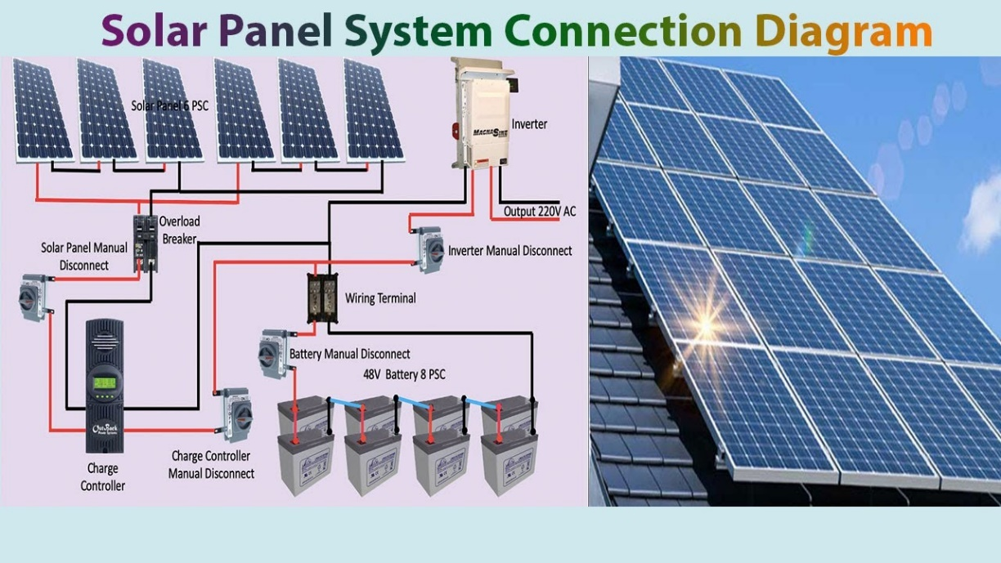

Figure 1: Solar Panel Grid Connection Layout.

Significance in Sustainable Energy Sources
The importance of solar power in the realm of sustainable energy mirrors a guiding light amidst the constellation of ecological balance. Serving as a pivotal force in the shift towards cleaner energy sources, solar energy emerges as a cornerstone in reshaping our energy framework. In contrast to finite resources, solar power draws from an infinite and reliable source—the sun. Its integration into the array of sustainable energy sources isn't merely about meeting current energy demands but about sculpting a future where the pursuit of power harmonizes seamlessly with environmental preservation. Solar energy's position in the renewable spectrum is highlighted by its intrinsic environmental advantages. The capture and utilization of sunlight result in minimal pollution and contribute negligibly to the carbon footprint, contrasting sharply with traditional fossil fuel practices. In this context, solar energy serves as an emblem for sustainable approaches, showcasing the transformative influence of tapping into nature's infinite energy. Furthermore, as technological advancements drive down expenses and improve efficiency, solar power becomes more accessible. This widening access to energy production empowers individuals, communities, and nations to actively engage in the renewable energy revolution. The significance of solar energy in the realm of sustainable resources, therefore, surpasses immediate environmental concerns; it signifies a paradigm shift towards a future where clean, abundant energy is a shared and attainable objective.
Solar Energy and Advanced Grids
Solar energy's evolution encompasses not only photovoltaic breakthroughs but also advancements in energy storage and smart grid technologies. These developments are critical for overcoming the intermittent nature of solar power, ensuring a reliable renewable energy ecosystem. Energy storage systems have improved significantly, focusing on enhancing capacity and efficiency. Lithium-ion batteries lead the way, offering higher energy density and longer cycle life. Emerging technologies like solid-state batteries and flow batteries show promise in addressing scalability and environmental concerns. Smart grids optimize electricity flow, enhance grid reliability, and accommodate solar power's variability. Advanced sensors and real-time data analytics enable dynamic responses to fluctuations in energy generation and consumption. The synergy between energy storage and smart grids is vital for creating a more adaptive and efficient energy infrastructure, where renewable energy plays a central role in meeting global energy demands.
Energy Storage Technologies
Energy storage systems have undergone significant advancements to address the intermittency challenges of solar power. The focus has been on enhancing both capacity and efficiency. Lithium-ion batteries, as a result of ongoing research and development efforts, have emerged as the dominant technology in the energy storage landscape. They offer higher energy density and longer cycle life compared to traditional options. Additionally, emerging technologies like solid-state batteries and flow batteries hold promise in addressing scalability issues and environmental concerns associated with energy storage.
Integration of Smart Grids
The integration of smart grids has revolutionized the management and distribution of energy. Smart grids leverage digital communication and control technologies to optimize the flow of electricity. They enhance grid reliability and accommodate the variable nature of solar power generation. Advanced sensors and real-time data analytics enable grid operators to respond dynamically to fluctuations in energy generation and consumption, thus ensuring a more efficient and resilient energy infrastructure.
Synergy Between Energy Storage and Smart Grids
The synergy between energy storage and smart grids is pivotal in creating a more adaptive and efficient energy ecosystem. Energy storage systems provide the capability to store excess energy generated during periods of high solar irradiance for use during peak demand periods or grid outages. This enhances grid stability and reliability while also reducing stress on the electricity grid during peak periods. Smart grids, on the other hand, facilitate the seamless integration of renewable energy sources like solar power into the grid by intelligently managing electricity flows and balancing supply and demand in real-time.
Decentralization and Community Empowerment
The advancements in energy storage and smart grid technologies empower individuals and communities to take control of their energy usage and production. Residential solar installations coupled with home energy storage systems enable homeowners to store excess energy for use when needed, reducing reliance on the grid and lowering electricity costs. Furthermore, community-based energy storage projects allow local communities to share resources and optimize energy usage collectively, promoting sustainability and resilience at the grassroots level.
Future Implications and Sustainability
The integration of energy storage and smart grid technologies not only enhances the reliability and efficiency of the energy infrastructure but also paves the way for a more sustainable and decentralized energy future. By mitigating the challenges associated with solar energy integration and enhancing grid flexibility and reliability, these technologies play a crucial role in reducing greenhouse gas emissions and promoting renewable energy adoption on a global scale. As solar energy generation continues to expand, the synergy between energy storage and smart grids will be instrumental in shaping a more resilient, efficient, and environmentally friendly energy landscape for future generations.
Conclusion
The evolution of solar energy, coupled with advancements in energy storage and smart grid technologies, represents a transformative shift towards a sustainable and decentralized energy future. Energy storage systems, including lithium-ion batteries and emerging technologies like solid-state batteries and flow batteries, have significantly enhanced capacity and efficiency, addressing the intermittency challenges inherent in solar power generation. Moreover, the integration of smart grids has revolutionized the management and distribution of energy by leveraging digital communication and control technologies. Smart grids optimize electricity flow, enhance grid reliability, and accommodate the variable nature of solar power, ensuring a more efficient and resilient energy infrastructure. The synergy between energy storage and smart grids is pivotal in creating an adaptive and efficient energy ecosystem. These technologies empower individuals and communities to take control of their energy usage and production, fostering sustainability and resilience at both the individual and community levels.
Looking ahead, the integration of energy storage and smart grid technologies will play a crucial role in reducing greenhouse gas emissions, promoting renewable energy adoption, and shaping a more sustainable future. As solar energy generation continues to expand, the collaboration between energy storage and smart grids will be essential in building a resilient, efficient, and environmentally friendly energy landscape for generations to come.

References

Abir, S. M. A. A., Anwar, A., Choi, J., & Kayes, A. S. M. (2021). IoT-Enabled Smart Energy Grid: Applications and Challenges. IEEE Access, 9, 50961–50981. https://doi.org/10.1109/ACCESS.2021.3067331
Aditya Sharma, G. S. (2018). Optimal site selection and efficiency for Solar PV power plant.
Agarwal, U., Rathore, N. S., Jain, N., & Kumawat, M. (2022). A Review on India’s Solar Energy Prospective: Potential, Environmental Protection and Policies Framework. Journal of The Institution of Engineers (India): Series A, 103(4), 1299–1313. https://doi.org/10.1007/s40030-022-00664-y
Alipour, M., Salim, H., Stewart, R. A., & Sahin, O. (2021). Residential solar photovoltaic adoption behaviour: End-to-end review of theories, methods and approaches. Renewable Energy, 170, 471–486. https://doi.org/10.1016/j.renene.2021.01.128
Arvizu, D., Balaya, P., Cabeza, L. F., Hollands, K. G. T., Jäger-Waldau, A., Kondo, M., Konseibo, C., Meleshko, V., Stein, W., Tamaura, Y., Xu, H., Zilles, R., Aberle, A., Athienitis, A., Cowlin, S., Gwinner, D., Heath, G., Huld, T., James, T., … Schmid, J. (2011). Direct Solar Energy. In Renewable Energy Sources and Climate Change Mitigation (pp. 333–400). Cambridge University Press. https://doi.org/10.1017/CBO9781139151153.007
Baldinelli, A., Barelli, L., Bidini, G., & Discepoli, G. (2020). Economics of innovative high capacity-to-power energy storage technologies pointing at 100% renewable micro-grids. Journal of Energy Storage, 28, 101198. https://doi.org/10.1016/j.est.2020.101198
Barkhouse, D. A. R., Gunawan, O., Gokmen, T., Todorov, T. K., & Mitzi, D. B. (2012). Device characteristics of a 10.1% hydrazine‐processed Cu ₂ ZnSn(Se,S) ₄ solar cell. Progress in Photovoltaics: Research and Applications, 20(1), 6–11. https://doi.org/10.1002/pip.1160
Boukortt, N. E. I., Patanè, S., AlAmri, A. M., AlAjmi, D., Bulayyan, K., & AlMutairi, N. (2023). Numerical Investigation of Perovskite and u-CIGS Based Tandem Solar Cells Using Silvaco TCAD Simulation. Silicon, 15(1), 293–303. https://doi.org/10.1007/s12633-022-01960-9
Čuček, L., Klemeš, J. J., & Kravanja, Z. (2015). Overview of environmental footprints. In Assessing and Measuring Environmental Impact and Sustainability (pp. 131–193). Elsevier. https://doi.org/10.1016/B978-0-12-799968-5.00005-1
de Freitas Viscondi, G., & Alves-Souza, S. N. (2019). A Systematic Literature Review on big data for solar photovoltaic electricity generation forecasting. Sustainable Energy Technologies and Assessments, 31, 54–63. https://doi.org/10.1016/j.seta.2018.11.008
Deshpande, R. A. (2021). Advances in Solar Cell Technology: An Overview. Journal of Scientific Research, 65(02), 72–75. https://doi.org/10.37398/JSR.2021.650214
Dixit, S. (2020). Solar technologies and their implementations: A review. Materials Today: Proceedings, 28, 2137–2148. https://doi.org/10.1016/j.matpr.2020.04.134
Fazal, M. A., & Rubaiee, S. (2023). Progress of PV cell technology: Feasibility of building materials, cost, performance, and stability. Solar Energy, 258, 203–219. https://doi.org/10.1016/j.solener.2023.04.066
Gautam, A. K., Chauhan, R. K., Pandey, J. P., & Verma, K. S. (2021). A Survey on Solar Power for Present and Future Perspective in Indian Market (pp. 119–130). https://doi.org/10.1007/978-981-33-4080-0_12
Govinda R. Timilsina Lado Kurdgelashvili Patrick A. Narbel The World Bank Development Research Group Environment and Energy Team October 2011 WPS5845 Public Disclosure Authorized Public Disclosure Authorized Public Disclosure Auth. (2011). A Review of Solar Energy Markets, Economics and Policies.
Grewal, A., Kataria, H., & Dhawan, I. (2016). Literature search for research planning and identification of research problem. Indian Journal of Anaesthesia, 60(9), 635–639. https://doi.org/10.4103/0019-5049.190618
Islam, M. T., Nabi, M. N., Arefin, M. A., Mostakim, K., Rashid, F., Hassan, N. M. S., Rahman, S. M. A., McIntosh, S., Mullins, B. J., & Muyeen, S. M. (2022). Trends and prospects of geothermal energy as an alternative source of power: A comprehensive review. Heliyon, 8(12), e11836. https://doi.org/10.1016/j.heliyon.2022.e11836
Luo, F. L. (2011). Design of solar-panel energy system. 2011 6th IEEE Conference on Industrial Electronics and Applications, 2304–2309. https://doi.org/10.1109/ICIEA.2011.5975976
Maka, A. O. M., & Alabid, J. M. (2022). Solar energy technology and its roles in sustainable development. Clean Energy, 6(3), 476–483. https://doi.org/10.1093/ce/zkac023
Mohanty, S., Patra, P. K., Sahoo, S. S., & Mohanty, A. (2017a). Forecasting of solar energy with application for a growing economy like India: Survey and implication. Renewable and Sustainable Energy Reviews, 78, 539–553. https://doi.org/10.1016/j.rser.2017.04.107
Rajasundrapandiyanleebanon, T., Kumaresan, K., Murugan, S., Subathra, M. S. P., & Sivakumar, M. (2023). Solar Energy Forecasting Using Machine Learning and Deep Learning Techniques. Archives of Computational Methods in Engineering, 30(5), 3059–3079. https://doi.org/10.1007/s11831-023-09893-1
S., P., & P., T. (2013). Thin Film Solar Cells Using Earth-Abundant Materials. In Solar Cells - Research and Application Perspectives. InTech. https://doi.org/10.5772/51734
Sahoo, S. K. (2016). Renewable and sustainable energy reviews solar photovoltaic energy progress in India: A review. Renewable and Sustainable Energy Reviews, 59, 927–939. https://doi.org/10.1016/j.rser.2016.01.049
Schwartz, M. (1969). Glucocorticoids in allergic diseases. Acta Medica Scandinavica. Supplementum, 500, 43–48. https://doi.org/10.1111/j.0954-6820.1969.tb16722.x
Shin, B., Gunawan, O., Zhu, Y., Bojarczuk, N. A., Chey, S. J., & Guha, S. (2013). Thin film solar cell with 8.4% power conversion efficiency using an earth‐abundant Cu ₂ ZnSnS ₄ absorber. Progress in Photovoltaics: Research and Applications, 21(1), 72–76. https://doi.org/10.1002/pip.1174
Solak, E. K., & Irmak, E. (2023). Advances in organic photovoltaic cells: a comprehensive review of materials, technologies, and performance. RSC Advances, 13(18), 12244–12269. https://doi.org/10.1039/D3RA01454A
Talwar, S., Kaur, P., Fosso Wamba, S., & Dhir, A. (2021). Big Data in operations and supply chain management: a systematic literature review and future research agenda. International Journal of Production Research, 59(11), 3509–3534. https://doi.org/10.1080/00207543.2020.1868599

