**ARNT2 Protein associated in Cancer:**

**Homology Modelling, Validation, Virtual**

**screening & Molecular Docking**

Manan Bhargavi1*

1*Department of Chemistry, St. Francis College for Women, Begumpet, Hyderabad.

Telangana, India, 500016

[**thakurbhargavi@sfc.ac.in**](mailto:thakurbhargavi@sfc.ac.in)

CH. Divyasree2

2*Department of Chemistry, St. Francis College for Women, Begumpet, Hyderabad.

Telangana, India, 500016

[chilukadivyasree1211@gmail.com](mailto:chilukadivyasree1211@gmail.com)

**ABSTRACT**

Transcription factor ARNT2 forms a complex with hypoxia inducible factor-1 subunit α or β (HIF-1). The ARNT2-HIF complex responsible for the cell proliferation, and survival, contributing to tumor growth and progression. ARNT2 protein 3D model was built with homology modelling and validated for virtual screening. The resulting ligand molecules were then employed for molecular docking experiments and Prime MM-GBSA calculations for energy. Docking score and free energy value of Prime MM-GBSA depicting the complex formed between ligand and ARNT2 protein is stable, less energetic and the ligand molecules were docked are promising drug candidates for the suppression of cancer.

**Keywords**- Cancer; Query protein (ARNT2); BLAST; Template protein (5NJ2); Modelling; Model validation and Verification Virtual screening, molecular docking; Prime MM-GBSA.

**I. INTRODUCTION**

Cancer is a leading cause of death and a major obstacle to increasing life expectancy in all nations worldwide [1]. Aryl hydrocarbon receptor nuclear translocator 2 (ARNT2) is a member of the basic helix-loop-helix period-ARNT-single-minded protein (bHLH/PAS) transcription factor family [2]. The function of ARNT2 (Aryl Hydrocarbon Receptor Nuclear Translocator 2) in the genesis and progression of cancer is becoming more well acknowledged, especially in cases of glioblastoma and oral squamous cell carcinoma (OSCC). This transcription factor has a role in a number of cellular functions, such as cancer and hypoxia responses [3].

ARNT2, a transcription factor, forms a heterodimer with HIF-1α or HIF-2α during hypoxic conditions. The ARNT2-HIF complex then attaches to target genes' hypoxia response elements (HREs), initiating transcription. Upregulation of HIF target genes enhance angiogenesis, cell proliferation, and survival, which contribute to tumor growth and progression [2] [4]. ARNT2 can potentially form a heterodimer with NPAS4, a transcription factor. The NPAS4-ARNT2 complex preferentially binds to promoter areas and modulates gene expression in response to excitatory postsynaptic potentials. This relationship could contribute to the brain regulation of tumor angiogenesis [5]. Target genes are directly transcribed by ARNT2 when it forms heterodimers with other bHLH/PAS members in response to various physiological and environmental cues [6]. For instance, researchers hypothesised that ARNT2 might be p53's direct target, allowing for tumour angiogenesis [7]. Hypoxia-inducible factor-1-controlled metabolism allows ARNT2 to influence breast cancer growth [8, 9]. However, there was some inconsistency in earlier research on the function of ARNT2 in various cancers: In glioblastoma, ARNT2 was regarded as a key tumorigenic factor, and PM2 dramatically enhanced it.5's link to lung cancer [10, 11].

The prognosis of breast cancer is positively connected with ARNT2 mRNA expression levels, and the presence of ARNT2 was found to be highly associated with decreased tumoral diameters and the 5-year survival rate after breast cancer diagnosis. After resection 20, a high intra tumoral ARNT2 level was strongly associated with extended overall survival and a reduced risk of tumour recurrence in hepatocellular carcinoma. These prospective findings suggest that ARNT2 may play a role in the initiation, progression, and prognosis of oral squamous cell carcinoma (OSCC), despite the fact that many of the activities of ARNT2 remain unclear [12].

ARNT2 is a complex transcription factor that promotes cancer growth through interactions with HIFs and NPAS4. ARNT2 is a viable target for cancer research and therapy since it regulates hypoxia response pathways and angiogenesis, as well as having predictive significance in cancer.

**II. MATERIALS AND METHODS**

One method of computational structure prediction used to determine the three-dimensional structure of proteins based on their amino acid sequence is homology modeling. It is regarded as the most accurate of the computational structure prediction approaches. It comprises of several uncomplicated and simple stages. For homology modelling, there are numerous tools and services available. There is no single modelling programme or server that is superior to others in every way. It is crucial to optimize the quality of homology modeling since the model's utility depends on the caliber of the protein 3D structure that is produced. Homology modelling has a wide range of uses in the drug discovery process [13]. Homology modelling is a multistep procedure that includes sequence retrieval, alignment, model development, and model validation.

A. **Sequence Retrieval**

The 3D structure of the Aryl Hydrocarbon Receptor Nuclear Translocator 2 (ARNT2) protein has not been reported in the Protein Data Bank using electron spectroscopy, NMR, or X-ray crystallography. ARNT2 (query protein) fasta sequence retrieved from Uniport KB database with accession number Q86TN1 and it comprises of 217 amino acids.

B. **Template Selection**

The most widely used template selection server is BLAST (Basic Local Alignment Search Tool). A BLAST search against the database for the best local alignments with the query returns a list of known protein structures that match the sequence [14]. The template is chosen using BLAST against the FASTA sequence of the query protein, which was obtained from the UniProtKB database (UniProt ID: ARNT2_HUMAN). Query Coverage, Percentage Identity, and e value are a few parameters for Template protein selection, and the template protein chosen is PDB ID: 5NJ8 based on the above parameters. Following the download of the template protein from the PDB database, the desired template protein chain 5NJ8_B is retrieved using the SWISS PDB Viewer.

C. **Sequence Alignment**

A specific amino acid sequence chain that is comparable to the query residue by insertions and deletions allows for improved sequence alignment and the generation of a better protein model [15].

D. **Clustal X2**

This programme is designed to do numerous alignments, and based on the results, the alignment process can be improved. Clustal X2 constructs the alignment using a method known as pairwise progressive sequence alignment. This programme generates aln, dnd, and pir files among others. The pir file is critical to run MODELLER to build models for proteins.

E. **Homology Modeling**

Creating a 3D model of the target protein using homology modeling is crucial for understanding its biochemistry, structural characteristics, and molecular interactions for docking studies and lead discovery. A technique for building 3D model structures from empirically solved structures of well-known templates is called homology modeling. Since the ARNT2 protein's experimental structure is not listed in the Protein Data Bank (PDB), the homology modeling approach and MODELLER software—which employs MOLPDF (Molecular Probability Density Function) as the scoring function—were used to create the 3D model of the protein [17]. Before model built ClustalW server was used to align the sequence of 5NJ8 with ARNT2 protein, producing atomic coordinates of similarity and identity that are then imported into MODELLER 9.13 to create the 3D model of the ARNT2 protein.

F. **Model Validation**

The homology modeling technique involves a series of interdependent steps. Therefore, model validation and protein evaluation are required since errors could be inadvertently introduced and spread. SAVES v6.0 and ProSA web (Protein Structure Analysis) Model Validation and Verification is an expansion of the standard ProSA programme used for the refining and validation of experimental protein structures, as well as structure prediction and modelling. The model validation and verification were carried out using the Validation of ARNT2, and the overall quality score of the model is determined by the ProSA Web server. MODELLER 9.13 generated a model that was visualised with PyMOL and saved as a picture. A programme called PROCHECK uploaded the created model to the SAVES server.

PROCHECK is used to investigate the stereochemistry stability of a predicted molecule as well as to evaluate the protein's quality. This is accomplished through the use of a Ramachandran plot generated by a web server, which describes the feature of Psi (ψ) and Phi (φ) angle of orientation. The overall quality factor of the protein was established by ERROT plot which distinguishes correctly and wrongly calculated protein structure areas based on distinctive atomic interactions [18][19].

**III VIRTUAL SCREENING AND MOLECULAR DOCKING**

Virtual screening (VS) is a computational method for searching libraries of small molecules to find the structures that have the highest probability of binding to a target for a drug, usually an enzyme or protein receptor [20]. Virtual screening is automatically analysing massive libraries of compounds using computer programs to reduce the enormous chemical space down to a manageable number that can be produced, acquired, and tested [21].

A. **Protein Preparation**

Structure-based drug design requires a well-defined, optimal starting structure in order to successfully identify potential lead compounds through docking data. To prepare the protein for docking and virtual screening experiments, the protein structure was produced. The OPLS_2005 force field was utilized in the Maestro Schrodinger suite's protein preparation wizard (Impref module) to create the ARNT2 protein structure [22]. The process of preparing proteins includes the addition of hydrogen atoms, bond order assignment, hydrogen bond optimization, and formal charge assignment [23].

B. **Ligand Preaparation**

The MS Spectrum library provided the small compounds that were used in the virtual screening and docking investigations that target the ARNT2 receptor. Two thousand MS Spectrum ligand molecules in SDF file format were chosen in total for the structure-based virtual screening. Using the Schrodinger suite's LigPrep module, the ligands from the MS Spectrum ligand database were ready for the docking process. The ionization/tautomeric states of ligands were generated using the LigPrep module and computed in units of kcal/mol, a directly well-matched metric to assess the Glide score utilized for the docking. With an applied force field, ligprep produces the less energetic orientations of ligand molecules, including the formation of tautomers and ionization states of potential conformers appropriate to a pH of 7 ± 2 [24].

C. **Active site Prediction**

Structure-based medication design involves identifying binding sites and docking chemical compounds to block the therapeutic target's biological role in the disease. The target structure's binding site has been found by literature investigations, SCF Bio, and manual correlation analysis [25].

D. **Manual Correlation**

The new multiple sequence alignment tool CLUSTAL Ω uses seeded guide trees and HMM profile-profile methods to create alignments between three or more sequences. It produces a range of biologically significant sequence alignments of divergent sequences [16]. To carry out Multiple Sequence Alignment, Query and Template protein’s fasta sequences must be submitted. The Clustal Ω server was used to manually correlate the active site residues of template 5NJ8 with those of the target protein in order to determine the active site residues of the ARNT2 protein.

E. **MOLECULAR DOCKING**

Molecular docking is a key tool in virtual screening, which may be used to rank molecules from a chemical structure dataset and find possible drug candidates contrary to biological targets. Virtual screening at the TRIB3 protein's receptor region was performed using the GLIDE module on the MS Spectrum-fragments library of 4245 output minimized small molecule conformers from ligand synthesis. High Throughput Virtual Screening (HTVS), Standard Precession (SP), and Extra Precession (XP) docking modes were employed in the Maestro Schrodinger suite's virtual screening workflow. In each step, ligand molecules with low energy conformation are screened to yield high-scoring final hits. The XP visualizer program was used to assess the molecular interactions of the final hits [26].

F. **Calculation of Binding free energies from Prime MM/GBSA**

Prime MM-GBSA provides accurate free energy predictions for proteins and ligands. Prime MM-GBSA produces descriptors for receptors and ligands using a pose viewer file (pv.maegz). Prime MM-GBSA takes into account both the receptor and conformer following docking in Glide. The equation for calculating the protein binding energy (ΔG bind) with ligand is as follows.   
In the formula ΔGbind = G complex – (G protein + G ligand), the ideal free energies for the protein-ligand complex, free protein, and free ligand are represented by G complex, G protein, and G ligand, respectively [27].

G. **Prediction of ADME Properties**

The main cause of the majority of medications failing at the clinical stage is their poor Absorption, Distribution, Metabolism, and Excretion (ADME) qualities, which have an impact on the time and cost of the drug discovery process. Adhering to the acceptable physicochemical and pharmacokinetic qualities (ADME) should make a medication more drug-like. Reducing the failure rate in successful drug development is achieved by evaluating the ADME features of discovered leads [28]. The pharmacokinetic properties and druggability of lead compounds were assessed using the Schrodinger suite's QikProp [29] panel. This was done based on the final hits from the XP docking studies that showed specific binding with the ARNT2 protein.

**IV. RESULTS AND DISCUSSION**

A. **Sequence Retrieval of ARNT2**

The first step was to discover the human ARNT2 (Accession number Q86TN1) protein FASTA sequence from UniProtKB having 217 amino acid residues.

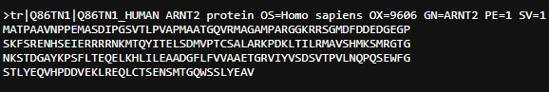

**Figure 1: Fasta sequence of ARNT2**

B. **Template Selection and Sequence Alignment**

Using BLAST [28], the templates were chosen according to statistical e-value, sequence similarity, and query coverage. The selected template protein 5NJ8 has 74% query coverage, statistical e value 8e-97 and percentage of identity 83.23 with query protein ARNT2 protein.

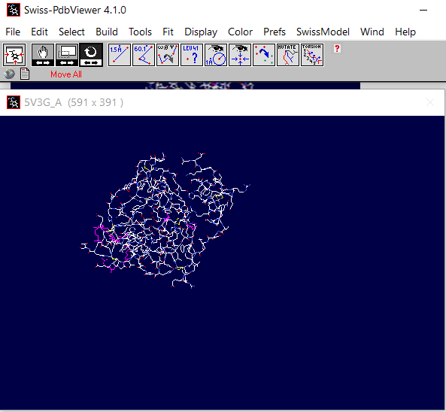

**Figure 2: Query protein ARNT2 from SWISS PDB Viewer**

C. **Clustal X2**

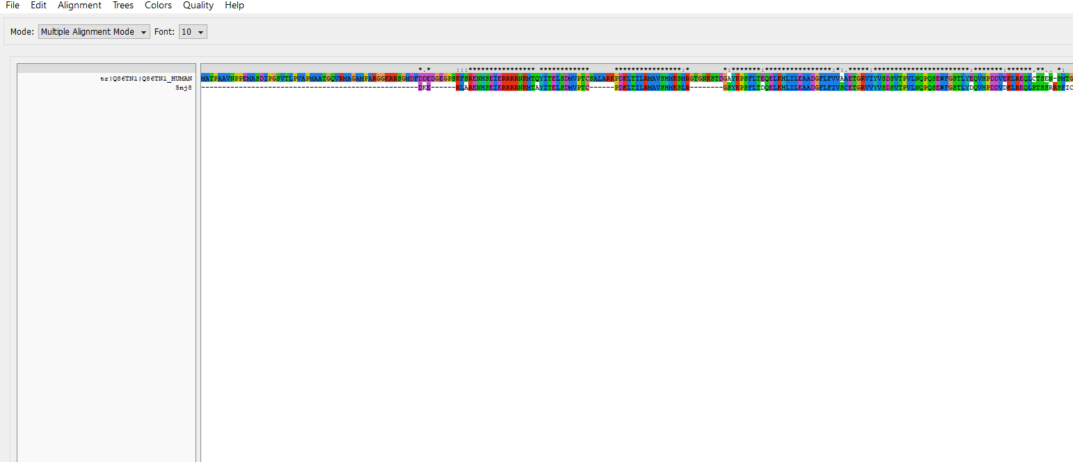

**Figure 3: Sequence alignment of Query and Template Protein from Clustal X**

D. **Molecular Modelling**

Molecular modelling is a programme that generates protein models from an alignment sequence. Among the models generated by MODELLER9.3, the model 14 with the least energy is selected and viewed, and other essential information about the stable structure is obtained in the subsequent modelling processes, which are energy minimization, validation, and verification.

E. **Model Validation and Verification**

SERVER SAVES6.0, PROCHECK validates and checks the quality of the prepared protein structure by analysing residue-by-residue geometry and overall structure geometry, as well as verifying the parameters of the Ramachandran plot, and the plot analysis revealed that 90.3% (168) of the residues were in the most preferred region, 7.5% (14) in the additional allowed region, and 1.6% (3) in the generally allowed region, for a total of 217 residues.

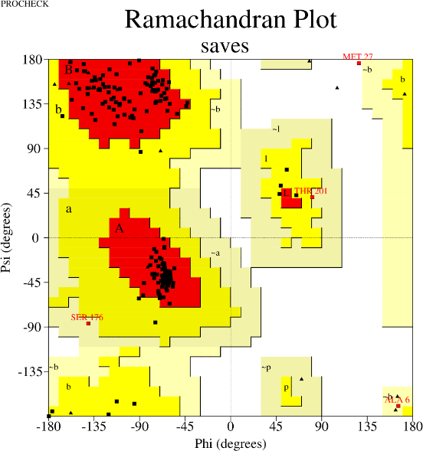

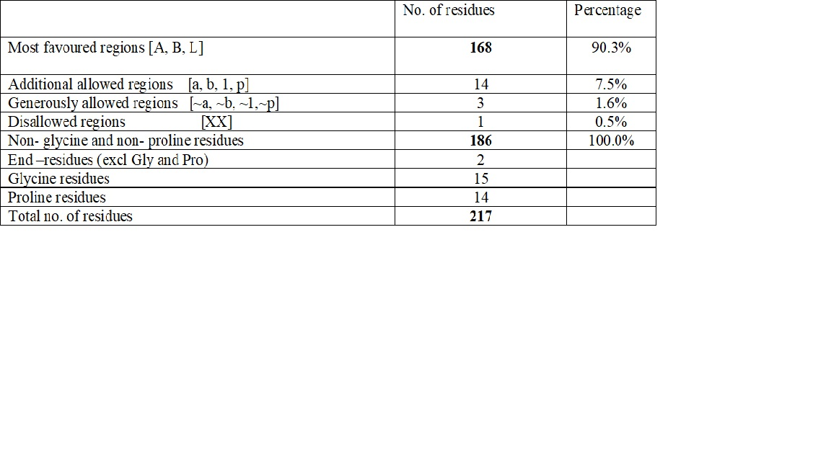

**Figure 4: Ramachandran contour plot stereochemical analysis of ARNT2 protein using the PROCHECK server**

F. **Errat Plot**

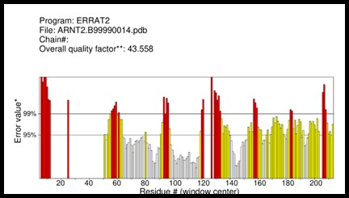 Analyzes the statistics of non-bonded interactions between different types of atoms and plots the value of the error function versus the location of a 9-residue sliding window, as calculated by comparing statistics from highly refined structures. The obtained overall quality factor of ARNT2 target protein is 43.558.

**Figure 5: ERRAT plot of ARNT2 protein from SAVES server**

G. **Verify 3D Plot**

Based on the energetic and empirical approaches, VERIFY-3D generates an averaged 3D-1D score for every residue in order to assess the quality of the homologous protein structure. Protein structures with a score of >0.2 and more than 80% residues are regarded as good quality.

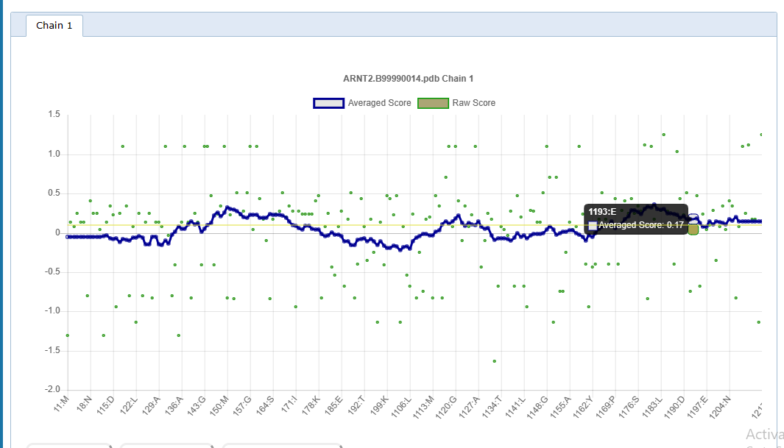

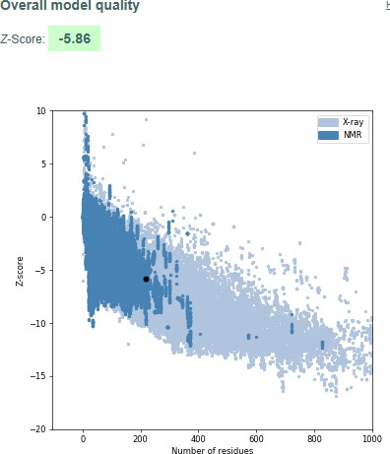**Figure 6: Verify 3D plot from SAVES 6.0 server**

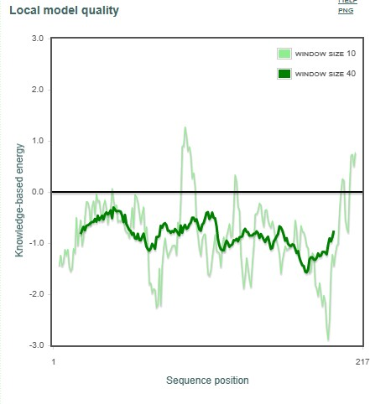

**Figure 7: A ProSA energy plot evaluation of the local model quality of the ARNT2 protein with regard to amino acid sequence**

**B. The negative z-score (-5.86) represents the overall good quality model of the ARNT2 protein when compared to amino acids of similar length deposited in the PDB**

H. **ProSA Validation of Structure**

The quality of a local model is illustrated in Plot A by plotting energy against the position of the amino acid sequence. The light line depicts the energy analysis of the minimum (10) number of amino acids, while the dark line depicts the energy analysis of the highest (40) number of amino acids. The positive zone contains the greatest quantity of amino acids. The verified protein's amino acid residues all lie within the negative area, which indicates a more stable model of ARNT2.

I. **Active site Prediction**

Identifying binding sites in target structures is crucial for structure-based drug design. The target receptor's binding cavity is often a concave pocket that contains hydrogen bond donors and acceptors . Structure-based medication design involves identifying binding sites and docking chemical compounds to block the therapeutic target's participation in the disease. Through manual correlation and literature reviews, the target structure's binding site was identified.

J. **Sequence Alignment** 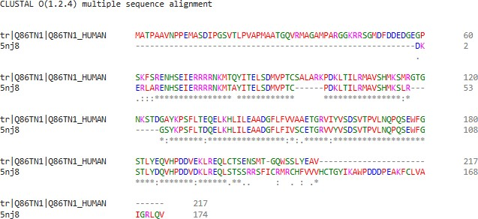

**Figure 8:** CLUSTAL OMEGA server generated multiple sequence alignment of ARNT2 and 5NJ8 sequences. Identical and comparable amino acids are denoted by (*) and (:), respectively, whereas nearly identical amino acids are denoted by (.).

K. **Virtual Screening and Molecular Docking**

Virtual screening was carried out utilizing 4525 ligand molecules obtained from ligprep of 2000 ligands of MS Spectrum database. These ligands were then subjected to flexible docking in HTVS mode, yielding 465 ligand molecules with the optimal docked location. 50% of the 465 ligand molecules obtained via the HTVS mode yielded 93 high-accuracy SP docking ligands. 50% of the 93 ligand molecules discovered using SP docking were subsequently used for XP docking, resulting in 19 compounds. The chemical molecules generated with the lowest glide score value are the best docked poses for probable lead compounds.

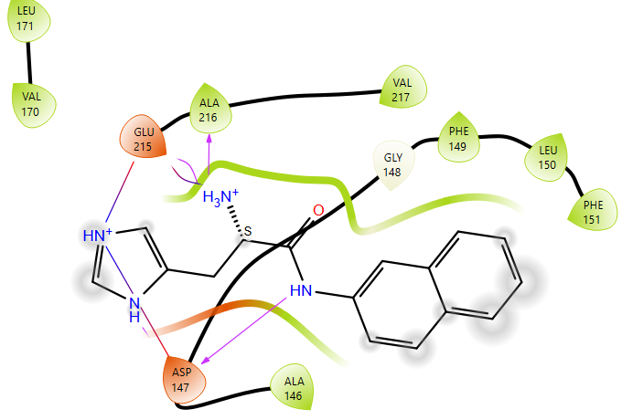 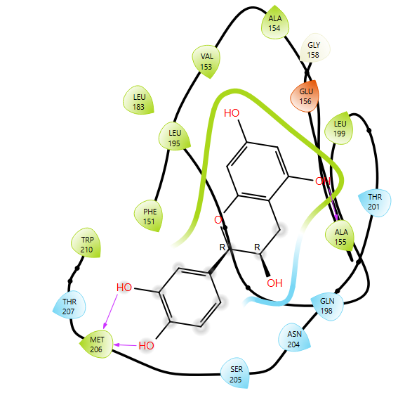

**Molecule 1:** 1502217 **Molecule 2:** 200010

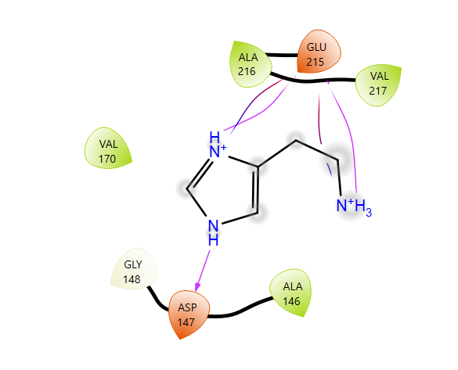

**Molecule 3:** 1500331

**Figure 9: Binding interactions of prioritised ligand molecules with ARNT2 protein- 2D representation**

Prime MM/GBSA was used to estimate binding affiliations for docked complexes. The Qikprop tool was used to predict ADME properties of docked molecules. The docked complexes were ranked based on glide score, glide energy, binding free energies, and bioavailability (Table 1).

**Table 1: ADME properties, Glide score, glide energy and Prime MMGBSA energy values**

|  |  |  |  |  |  |  |  |  |  |
| --- | --- | --- | --- | --- | --- | --- | --- | --- | --- |
| **S. No** | **Glide score** | **Glide energy** | **Prime MMGBSA** | **Donar HB** | **Accept HB** | **Qplog**  **Po/W** | **%HOB** | **RO3** | **RO5** |
| 1502217 | -9.38 | -48.95 | -34.48 | 4 | 5 | 1.568 | 73.06% | 0 | 0 |
| 0200010 | -8.95 | -48.91 | -71.74 | 5 | 4.5 | 0.626 | 62.29% | 1 | 0 |
| 1500331 | -8.00 | -32.93 | -24.70 | 3 | 3.0 | -0.503 | 65.05% | 0 | 0 |

The permitted ranges are as follows: Donor HB: (0.0-6.0); Accept HB: (2.0-20.0); QPlogPo/w: (-2.0-6.5); Rule of three; %Human oral absorption: <25% low, >80% high; Rule of five.

**V. CONCLUSION**

A comprehensive cancer control strategy must include a plan for cancer identification and treatment. Its main goal is to guarantee a high quality of life for cancer patients by either curing them or greatly extending their lives. For a diagnosis and treatment plan to be effective, they must never be created separately. To ensure that cases are found early, when treatment is more successful and the likelihood of recovery is higher, it must be connected to an early detection program. Many computational methods are employed in drug development, one of which is homology modelling, which is a homologue to the desired target sequence that can be used as a template protein to prepare the structure of the desired target.

The current work used Modeller to create a 3D structure of the target, and validated using online SAVES sever. In this paper, the model was validated using ProSA, Ramachandran plot, and ERRAT. The validation and assessment findings of the 3D model of protein ARNT2 reveal that the created model is stable and has the most residues in the preferred region. Virtual screening, molecular docking and Prime MMGBSA studies of ligand database with ARNT2 protein was performed and the generated chemical substances with a lower glide score value, least binding energy represent the best docked pose for potential lead compounds.

**REFERENCES**

[1] Sung, H., Ferlay, J., Siegel, R. L., Laversanne, M., Soerjomataram, I., Jemal, A., & Bray, F. (2021). Global Cancer Statistics 2020: GLOBOCAN Estimates of Incidence and Mortality Worldwide for 36 Cancers in 185 Countries. *CA: A Cancer Journal for Clinicians*, *71*(3), 209–249.

[2]. Kimura, Y., Kasamatsu, A., Nakashima, D., Yamatoji, M., Minakawa, Y., Koike, K., Fushimi, K., Higo, M., Endo-Sakamoto, Y., Shiiba, M., Tanzawa, H., &Uzawa, K. (2016). ARNT2 Regulates Tumoral Growth in Oral Squamous Cell Carcinoma. *Journal of Cancer*, *7*(6), 702–710.

[3] Bogeas, A., Morvan-Dubois, G., El-Habr, E. A., Lejeune, F.-X., Defrance, M., Narayanan, A., Kuranda, K., Burel-Vandenbos, F., Sayd, S., Delaunay, V., Dubois, L. G., Parrinello, H., Rialle, S., Fabrega, S., Idbaih, A., Haiech, J., Bièche, I., Virolle, T., Goodhardt, M., … Junier, M.-P. (2017). Changes in chromatin state reveal Arnt2 at a node of a tumorigenic transcription factor signature driving glioblastoma cell aggressiveness. *Acta Neuropathologica*, *135*(2), 267–283.

[4] Hankinson, O. (2008). Why does Arnt2 behave differently from arnt? *Toxicological Sciences*, *103*(1), 1–3.

[5] Sun, X., Jing, L., Li, F., Zhang, M., Diao, X., Zhuang, J., Rastinejad, F., & Wu, D. (2022). Structures of NPAS4-arnt and NPAS4-ARNT2 heterodimers reveal new dimerization modalities in the bhlh-pas transcription factor family. *Proceedings of the National Academy of Sciences*, *119*(46).

[6]. Huang, S., Chen, G., Li, J., Qin, L., Huang, Z., Huang, S., Lu, W., Zeng, J., Mo, B., Dang, Y., Wei, Z., & Luo, J. (2022). Potential Molecular Mechanism of Upregulated Aryl Hydrocarbon Receptor Nuclear Translocator 2 in Nasopharyngeal Carcinoma. *Computational and Mathematical Methods in Medicine*, *2022*, 1–20.

[7] Rahim, T., Becquart, P., Baeva, M., &Quandt, J. A. (2018). Expression of the neuroprotective protein aryl hydrocarbon receptor nuclear translocator 2 correlates with neuronal stress and disability in models of multiple sclerosis. *Journal of Neuroinflammation*, *15*(1).

[8] Garritano, S., Inga, A., Gemignani, F., &Landi, S. (2013). More targets, more pathways and more clues for mutant p53. *Oncogenesis*, *2*(7), e54.

[9] Qin, F., Zhou, H., Li, J., Liu, J., Wang, Y., Bai, R., Liu, S., Ma, M., Liu, T., Gao, F., Du, P., Lu, X., & Chen, C. (2021). Hypoxia and ph co-triggered oxidative stress amplifier for tumor therapy. *European Journal of Pharmacology*, *905*, 174187.

[10] Samuel, D., Wei, F., Yoshinaga, J., Yonemoto, J., Tanokura, M., & Sone, H. (2011). siRNA-mediated knockdown of aryl hydrocarbon receptor nuclear translocator 2 affects hypoxia-inducible factor-1 regulatory signaling and metabolism in human breast cancer cells. *FEBS Letters*, *585*(20), 3310–3315.

[11] Bogeas, A., Morvan-Dubois, G., El-Habr, E. A., Lejeune, F., Defrance, M., Narayanan, A., Kuranda, K., Burel-Vandenbos, F., Sayd, S., Delaunay, V., Dubois, L. G., Parrinello, H., Rialle, S., Fabrega, S., Idbaih, A., Haiech, J., Bièche, I., Virolle, T., Goodhardt, M., . . . Junier, M. (2018). Changes in chromatin state reveal ARNT2 at a node of a tumorigenic transcription factor signature driving glioblastoma cell aggressiveness. *Acta Neuropathologica*, *135*(2), 267–283.

[12] Chen, Z., Ji, N., Wang, Z., Wu, C., Sun, Z., Li, Y., Hu, F., Wang, Z., Huang, M. L., & Zhang, M. (2018). Fine Particulate Matter (PM2.5) Promoted the Invasion of Lung Cancer Cells via an ARNT2/PP2A/STAT3/MMP2 Pathway. *Journal of Biomedical Nanotechnology*, *14*(12), 2172–2184.

[13] Waterhouse, A., Bertoni, M., Bienert, S., Studer, G., Tauriello, G., Gumienny, R., Heer, F. T., de Beer, T. A. P., Rempfer, C., Bordoli, L., Lepore, R., &Schwede, T. (2018). SWISS-MODEL: homology modelling of protein structures and complexes. *Nucleic Acids Research*, *46*(W1).

[14] Bordoli, L., &Schwede, T. (2011). Automated Protein Structure Modeling with SWISS-MODEL Workspace and the Protein Model Portal. *Methods in Molecular Biology*, 107–136.

[15] Chatzou, M., Magis, C., Chang, J.-M., Kemena, C., Bussotti, G., Erb, I., &Notredame, C. (2015). Multiple sequence alignment modeling: methods and applications. *Briefings in Bioinformatics*, *17*(6), 1009–1023.

[16] Sievers,F.,Wilm, A.,Dineen,D.,Gibson,T.J.,Karplus, K.,Li,W.,Lopez,R.,McWilliam, H.,Remmert,M.,Söding,J., Thompson,J.D.,& Higgins,D.G.(2011).Fast,scalable generation ofhigh‐quality protein multiple sequencealignments usingClustalOmega. MolecularSystems Biology,7(1), 539.

[17] Sali, A., & Blundell, T. L. (1993). Comparative protein modelling by satisfaction of spatial restraints. *Journal of Molecular Biology*, *234*(3), 779–815.

[18] Janson, G., Grottesi, A., Pietrosanto, M., Ausiello, G., Guarguaglini, G., & Paiardini, A. (2019). Revisiting the “satisfaction of spatial restraints” approach of modeller for protein homology modeling. *PLOS Computational Biology*, *15*(12). https://doi.org/10.1371/journal.pcbi.1007219

[19] Wiederstein, M., &Sippl, M. J. (2007). ProSA-web: interactive web service for the recognition of errors in three-dimensional structures of proteins. *Nucleic Acids Research*, *35*(Web Server). <https://doi.org/10.1093/nar/gkm290>

[20] Gimeno, A., Ojeda-Montes, M. J., Tomás-Hernández, S., Cereto-Massagué, A., Beltrán-Debón, R., Mulero, M., Pujadas, G., & Garcia-Vallvé, S. (2019). The light and dark sides of virtual screening: What is there to know? *International Journal of Molecular Sciences*, *20*(6), 1375. https://doi.org/10.3390/ijms20061375

[21] How high-throughput medicinal chemistry can expedite lead discovery, lead optimization, and beyond. (2008). *High-Throughput Lead Optimization in Drug Discovery*, 161–174.

[22] Elokely, K. M., & Doerksen, R. J. (2013). Docking Challenge: Protein sampling and Molecular Docking Performance. *Journal of Chemical Information and Modeling*, *53*(8), 1934–1945.

[23] Protein Prep Wizard, Schrodinger, LLC, New York, NY, 2005.

[24] LigPrep, Schrodinger, LLC, New York, NY, 2005.

[25] Laskowski, R. A., Jabłońska, J., Pravda, L., Vařeková, R. S., & Thornton, J. M. (2017). PDBsum: Structural summaries of PDB entries. *Protein Science*, *27*(1), 129–134.

[26] GHOSH, S., NIE, A., AN, J., & HUANG, Z. (2006). Structure-based virtual screening of chemical libraries for drug discovery. *Current Opinion in Chemical Biology*, *10*(3), 194–202.

[27] Molecular docking, MM-GBSA, and molecular dynamics approach: 5-MEO-DMT analogues as potential antidepressants. (2023). *Archives of Razi Institute*, 1603–1614.

[28] Butina, D., Segall, M. D., & Frankcombe, K. (2002). Predicting ADME properties in silico: Methods and Models. *Drug Discovery Today*, *7*(11).

[29] QikProp, Schrodinger, ¨ LLC, New York, NY, 2005.