Bacterial Aspect of Sexually Transmitted Infections
Author: Dr. Aditya Rana
Senior Resident, Department of Microbiology at Dr. R. P. Govt. Medical College, Kangra at Tanda(Himachal Pradesh)

Bacterial agents causing sexually transmitted diseases (STDs) are a significant public health concern in both developed and developing countries. They include Neisseria gonorrhoeae (causing gonorrhea), Chlamydia trachomatis (causing chlamydial infections), Treponema pallidum (causing syphilis), Klebsiella granulomatis (formerly known as Calymmatobacterium granulomatis, causing granuloma inguinale or donovanosis), Haemophilus ducreyi (causing chancroid), and certain species of Mycoplasma and Ureaplasma, which occasionally lead to consequential sexually transmitted infections (STIs).
Sexually transmitted diseases (STDs) are still carrying a larger burden. According to the World Health Organization (WHO), it's estimated that in 2020, there were 374 million new infections of four common STIs, which means nearly 1 million new STIs every day. The most common STI is Chlamydia, with 129 million new infections each year. Gonorrhea follows with 82 million new infections annually, and syphilis with 42 million new infections per year.
Bacterial STDs can manifest as severe or life-threatening conditions like syphilis, or they can result in debilitating syndromes with long-term consequences, such as pelvic inflammatory disease, endometritis, ectopic pregnancy, and infertility. Less severe presentations like self-limiting urethritis, cervicitis, and fever are also associated with bacterial STIs.
Generally, the development of bacterial sexually transmitted diseases (STDs) involves both microbial factors and the host's inflammatory responses to the infection. Some common characteristics of bacterial STDs include a higher prevalence among adolescents compared to older adults, suggesting that immune resistance may strengthen in adults over time.
When detected early, these infections are treatable with effective antimicrobials but may lead to irreversible consequences. Bacterial STDs can also increase the risk of acquiring viral STD like human immunodeficiency virus (HIV). Transmission typically occurs through direct genital mucosal contact, and currently, there are no available human vaccines.
This chapter provides information on the burden of infection, causative agents, clinical presentation, microbiology, pathogenesis (involving both microbial and host contributions to disease onset and progression), diagnosis, and treatment.

H. ducreyi(Chancroid)

Ducrey (1890) demonstrated the presence of this bacterium in chancroid lesions and successfully transmitted the lesion through several generations by inoculating it into the skin on the forearm.

Introduction:
Haemophilus ducreyi causes chancroid (or soft chancre), an STI characterized by painful genital ulceration that easily bleeds. The surrounding skin has no inflammation, but enlarged, tender inguinal lymph nodes (bubo) are common.

After infection, there's an incubation period of around one week. Following this, individuals may experience the development of painful, reddish bumps on the external genitalia, progressing into pustules and eventually eroding into non-indurated, hemorrhagic ulcers(fig.1). These lesions often multiply, appearing on adjacent skin surfaces like the thigh or scrotum in men and the labia, vagina, and perianal areas in women. Suppurative inguinal lymphadenopathy, occasionally forming fluctuant buboes, is also typical. There's no acquired immunity post-infection, though hypersensitivity might develop.
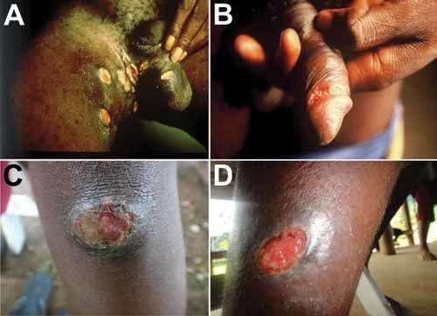

Fig. 1: Ulcers caused by infection with Haemophilus ducreyi. A, B) Genital ulcers in adult patients from (Source: David Mabey). C, D) Skin ulcers (Source: Oriol Mitjà).

Haemophilus ducreyi produces a potent 'cytolethal distending toxin' that likely contributes to ulcer formation and delays in their healing process.
The histological analysis of chancroid genital ulcers reveals perivascular and interstitial infiltrations of macrophages, CD4+, and CD8+ T lymphocytes, indicative of a delayed-type hypersensitivity, cell-mediated immune response. The presence of CD4+ T cells and macrophages in the ulcer may partly explain the increased facilitation of HIV transmission in chancroid patients.

Epidemiology:
Chancroid is a prevalent cause of genital ulcers in developing nations. It is primarily transmitted heterosexually, with a male-to-female ratio ranging from 3:1 to 25:1. Chancroid can increase both the transmission efficiency and susceptibility to HIV infection.

Laboratory Diagnosis:
Specimens obtained from ulcer exudate or the ulcer edge and lymph node aspirates are useful for diagnosis.
Gram Staining:
H. ducreyi appears as a pleomorphic gram-negative coccobacillus, often in groups or parallel chains. It commonly exhibits bipolar staining, described as resembling a 'school of fish' or a 'railroad track’ appearance.(fig.2).
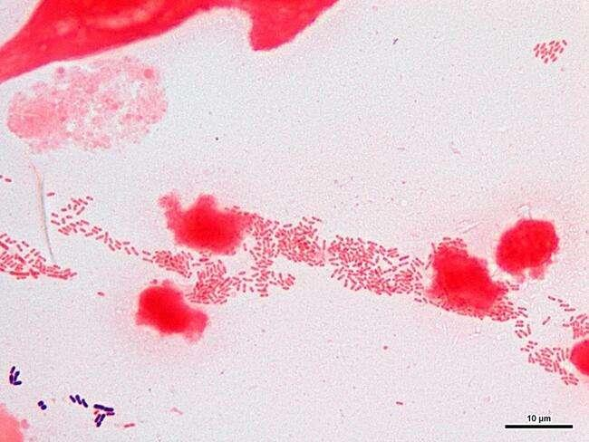
Fig. 2: H. ducreyi gram stain(School of fish) Source(hit-micrscopewb)
Culture:
H. ducreyi necessitates factor X (hemin) for growth but not factor V. Primary isolation is challenging and requires specific conditions such as growth on rabbit blood agar or chocolate agar enriched with 1% isovitalex and made selective by adding vancomycin. Alternatively, it may grow on the chorioallantoic membrane of the chick embryo. Optimum growth conditions include 10% CO2, high humidity, and incubation at 35°C for 2 to 8 days. The growth surrounding the X disk can aid in presumptive diagnosis.(fig. 3)
Fig. 3: H. ducreyi around X and XV factor disc. Source(Universe84a)

Colony Morphology:
Colonies are typically small, grey, translucent, and measure 1-2 mm in size within 2-3 days. H. ducreyi displays biochemical inertness.

Slide Agglutination Test:
H. ducreyi is antigenically homogeneous, and cultures can be confirmed through agglutination with antiserum.

Treatment:
The recommended treatments include azithromycin 1g PO stat, ceftriaxone 1g IM stat, ciprofloxacin 500mg PO stat, ciprofloxacin 500mg bd PO for 3 days, or erythromycin 500mg qds PO for 7 days (recommended for HIV-infected patients).
Lymphogranuloma venereum(LGV)

Introduction:
LGV is a sexually transmitted infection caused by specific strains of C. trachomatis, including L1, L2, L2b, and L3 serovars. Acute LGV typically involves a temporary primary genital lesion followed by multilocular suppurative regional lymphadenopathy.

Epidemiology:
LGV is relatively rare in North America but more common in regions such as Africa, Asia, and South America. Its prevalence is increasing in Europe, particularly among homosexual males. The highest incidence of LGV occurs during the second and third decades of life, correlating with peak sexual activity.

Clinical Presentation:
Asymptomatic infection in women is common and can serve as a reservoir for transmission.
First Stage:
A painless papule, ulcer, or vesicle may appear on the penis or vulva, usually 3 days to 6 weeks after exposure.(fig. 4)
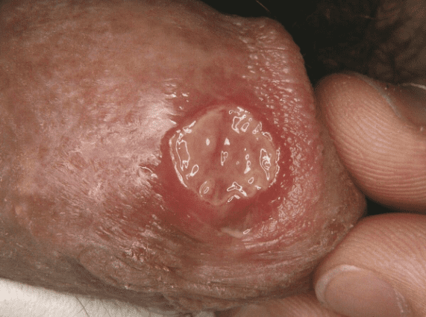
Fig. 4: LGV Ulcer. Source(Altmeyer Encyclopedia)

Second Stage:
Enlargement, tenderness, and softness of the inguinal lymph nodes (referred to as buboes) occur. Fistulae may form and discharge externally, leading to chronic fistulae. Systemic symptoms like fever, headache, and myalgia may also manifest.(fig. 5)
Fig. 5: Buboes in the second stage of LGV. Source(Springer Atlas of STD)

Third Stage:
Untreated cases, especially in women and homosexual men, may result in complications such as rectal stricture, and rectovaginal or rectal fistulae. Edematous granulomatous hypertrophy of the vulva, scrotum, or penis (known as 'esthiomene') might occur.(fig. 6)
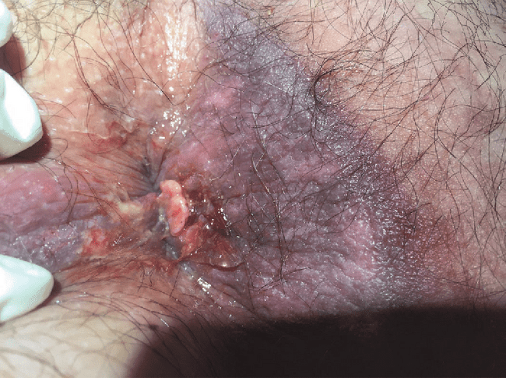
Fig. 6: Rectal fistulae in the third stage of LGV. Source(B. Mlakar)
Laboratory Diagnosis:
Diagnostic methods include scraping samples from the ulcer base, lymph node aspirates, direct detection (EIA and DIF), and culture.
While EIA is sensitive and quick, it lacks specificity and often needs confirmation via NAAT or DIF.
Gram staining poorly stains chlamydiae; alternative stains like Castaneda, Machiavello, or Gimenez methods are more effective.
Microscopic diagnosis has low sensitivity for detecting Miyagawa’s granulocorpuscles in LGV.(fig. 7)
Fig. 7: Miyagawa’s granulocorpuscles in LGV. Source (Medizzy)
Chlamydia isolation via intracerebral inoculation has been replaced by cell cultures, with various recommended cell lines for C. trachomatis.
Choice of the cell line depends on the species: C. trachomatis recommended cell lines are McCoy, HeLa 229, buffalo, green monkey, and baby hamster kidney (BHK-21) cell lines
Serology:
Serologic tests include complement fixation using LPS antigen (group-specific but not species-specific), ELISA with recombinant LPS antigen, and Microimmunofluorescence (MIF) with species and serovar-specific MOMP antigen. MIF can detect IgM and IgG separately but is technically demanding.
A single high titer of 1:512 is diagnostic, but a fourfold rise in titer over 2-3 weeks is more significant.
Histology
Histologically, infected nodes initially show small stellate abscesses surrounded by histiocytes, which then coalesce into large, necrotic, suppurative foci.

Treatment:
Doxycycline 100mg bd PO or erythromycin 500mg qds PO for 21 days is the recommended treatment for LGV.

Granuloma inguinale (donovanosis)

Introduction:
Donovanosis is a chronic, progressive bacterial infection primarily transmitted through sexual contact. It's also known as granuloma inguinale or granuloma venereum. The disease is caused by Klebsiella granulomatis, previously referred to as Calymmatobacterium granulomatis. Polymerase chain reaction (PCR) studies show a close relationship between its phoE gene and genes found in Klebsiella pneumoniae, K. rhinoscleromatis, and K. ozaenae.
The disease was initially documented in Calcutta by McLeod in 1882, and the characteristic pathological "Donovan bodies" in genital lesions were identified by Charles Donovan in Madras in 1905. Donovanosis is prevalent in regions like India, Brazil, Papua New Guinea, and parts of South Africa, and is linked to risk factors such as poor hygiene, lower socioeconomic status, and multiple sexual partners. Despite a global decrease, it remains a significant cause of genital ulcers in certain areas.

Epidemiology:
Donovanosis is a major contributor to genital ulcers in various regions, including India, Papua New Guinea, the Caribbean, Australia, and parts of South America. While primarily sexually transmitted, other modes of transmission might exist. Its infectivity is presumed to be low since sexual partners of infected individuals often don't contract the infection immediately or may require multiple exposures to become infected. Transmission can occur through non-sexual contact, leading to extragenital skin lesions or even autoinoculation in infants born to infected mothers.

Clinical Features:
The incubation period ranges from 1-3 months, possibly extending to 6 months. The disease progresses slowly, with painless papules evolving into beefy red ulcers that bleed easily upon contact(fig. 8). Genital involvement is common, affecting specific regions like the prepuce, frenum, glans in men, and the labia minora in women. Lymph node involvement is rare, though pseudobuboes can sometimes appear in the inguinal region due to subcutaneous abscess.
Fig. 8: Beefy Red Ulcer in Donovanosis. Source(Medscape)

Laboratory Diagnosis:
Specimen collection involves swabbing ulcerated areas or using granulation tissue for examination. Microscopic examination using stains like Giemsa or Wright's can reveal Donovan bodies—large, cyst-like macrophages filled with encapsulated bacilli displaying a safety-pin (bipolar) appearance.(fig. 9)
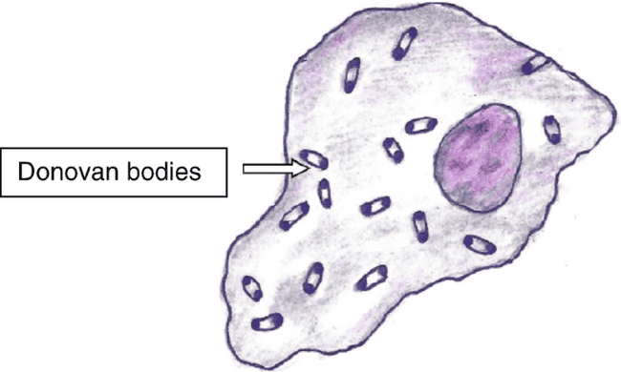
Fig. 9: Bipolar(Safety Pin Appearance)Wright’s staining. Source(Springer nature)
On gram staining they are non-motile, capsulated, and gram-negative bacilli.
Culture methods like on egg yolk medium and HEp-2 cell lines are done and molecular techniques like PCR aid in identifying the specific bacteria involved.

Treatment:
Antibiotics such as azithromycin, doxycycline, erythromycin, or ciprofloxacin are recommended for a minimum of 3 weeks or until lesions heal. Various antibiotic regimens, including aminoglycosides, might be necessary for patients not responding to initial therapy, particularly in HIV-positive individuals, as recommended by the CDC guidelines.

Syphilis(Treponema Pallidum)

Schaudinn and Hoffmann (1905) discovered Treponema pallidum, the causative agent of syphilis, in the chancres and inguinal lymph nodes of syphilitic patients. The name "pallidum" denotes its pale staining.
Epidemiology
Syphilis is primarily acquired through sexual contact involving infectious lesions like chancres, mucous patches, skin rashes, or condylomata lata. Other, less common modes of transmission include nonsexual personal contact, transmission from mother to fetus (in utero), blood transfusion, and organ transplantation.
The bacterium T. pallidum causes venereal syphilis, transmitted through sexual contact. Venereal syphilis presents a complex and varied clinical picture, often resembling various other diseases. It's categorized into stages: incubating, primary, secondary, early nonprimary nonsecondary syphilis, unknown duration or late syphilis, and tertiary syphilis.
Pathogenesis
Syphilis has been recognized as an ancient sexually transmitted infection since the fifteenth century. Its name originated from a renowned poem in 1530 recounting the story of Syphilus, a shepherd boy who suffered from the disease. Transmission occurs primarily through sexual contact, but non-venereal modes like direct contact, blood transfusion, or transplacental transmission are also possible. T. pallidum, the causative bacterium, swiftly penetrates minute skin or mucosal abrasions. Within hours, it enters the lymphatic system and bloodstream, causing systemic infection and spreading to distant sites before the appearance of primary lesions. Blood remains infectious even during the incubation period or early stages of syphilis. The incubation period varies from 9 to 90 days, inversely related to the number of infecting organisms. In humans, the median incubation period is around 21 days, correlating with an average inoculum of 500-1000 infectious organisms
Clinically
Primary syphilis typically manifests after an incubation period of 14 days to 3 months with the development of a painless, reddened papule. This evolves into a painless, 'punched-out' ulcer known as a chancre, mainly found on the genitalia (rarely on the mouth, hands, or anus), often accompanied by local lymph node swelling.(fig. 10) Multiple chancres might arise, particularly in HIV-infected individuals. They are highly contagious and typically heal on their own within 1–2 months.
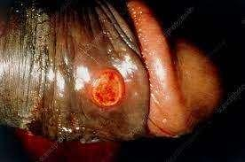
Fig. 10: Painless penile Ulcer in primary Syphillis. Source(Science Photo library)

Secondary syphilis emerges 1–6 months later as the infectious organisms disseminate from the chancre. Symptoms may include a rash—appearing as localized or diffuse skin lesions that can be macular, papular, pustular, or a mix thereof—spanning the trunk, limbs, palms, and soles. Mucosal ulcers might develop. Condylomata lata, highly infectious lesions, can appear in warm, moist areas (e.g., skin folds).(fig. 11) Early neurosyphilis, more common in HIV-positive individuals, may present with varied symptoms such as syphilitic meningitis, meningovascular syphilis, headache, limb paralysis, stroke, and various other features like fever, sore throat, mouth ulcers, lymph node swelling, malaise, hepatitis, periostitis, iritis, arthritis, and glomerulonephritis.
Fig. 11: Mucoculatenous patch on tongue, Condylomata lata & Rashes on hand in Secondary Syphillis. Source (CDC)

Latent syphilis follows the resolution of secondary symptoms and can span from 3 to 12 weeks. Patients are asymptomatic during this latent phase, and infectivity is low. However, up to one-quarter of patients may experience a recurrence of the disease. Early latent syphilis occurs within 2 years of the primary infection, while late latent syphilis manifests after this period.

Late or tertiary syphilis, although rare, emerges after a latent period of 2–20 years. It is marked by chronic inflammation and can present in various forms: gummatous syphilis—granulomatous lesions impacting the skin, mucous membranes, bone, or organs, leading to local destruction; cardiovascular syphilis—endarteritis of the aorta, potentially causing aortic regurgitation or aneurysm formation; late neurosyphilis—which can manifest as general paresis of the insane or tabes dorsalis, with symptoms like confusion, hallucinations, cognitive impairment, ataxia, sensory loss, and more.

Congenital syphilis can occur in two forms: early congenital syphilis within 2 years of birth, presenting with various symptoms including rash, condylomata lata, mucous patches, and late congenital syphilis occurring after 2 years, characterized by distinct features like interstitial keratitis, Hutchinson's incisors, mullbery deafness, and neurological or gummatous involvement.(fig. 12)
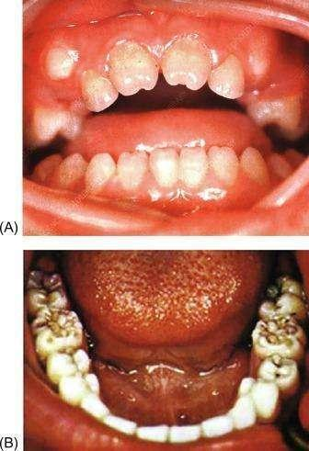
Fig. 12: a.) Hutchinson’s teeth b.) Mullbery deafness . Source(Science Direct)
Laboratory Diagnosis
Collecting samples for syphilis testing requires careful attention to prevent contamination and ensure accurate results:
Ulcers and Lesions: Samples should be devoid of blood, microorganisms, or tissue debris. Cleanse the site with sterile saline-moistened gauze. Place the sample on a clean glass slide and cover it.
PCR Samples: Use a sterile Dacron or cotton swab and place it in a cryotube with nucleic acid transport medium or universal transport medium.
Tissue or Needle Aspirates of Lymph Nodes: Preserve these in 10% buffered formalin at room temperature. For congenital syphilis testing, collect a small section of the umbilical cord and fix it in 10% buffered formalin.
Serum and Plasma: Serum is the preferred specimen for serology, but plasma can be used in some tests. Perform testing on plasma within 24 hours to prevent false-positive results. Capillary draws of whole blood, serum, or plasma are suitable for rapid syphilis tests.
Maternal and Infant Serum: Maternal serum can be used for screening congenital syphilis. For IgM-specific tests, use infants' serum to avoid contamination from maternal blood in cord blood specimens.

Storage Guidelines: Maintain serum, plasma, and cerebrospinal fluid (CSF) at 4°C if testing is delayed up to 4 hours. For delays exceeding 4 hours, store at -20°C. Samples intended for PCR, like unfixed tissue, ulcer exudate, CSF, or whole blood in EDTA, should be stored at -80°C if testing is delayed.

Diagnosis
Syphilis diagnosis involves various methods:
Microscopy: Dark-field or immunofluorescence microscopy examines samples from chancre exudates for organism detection.(fig. 13)
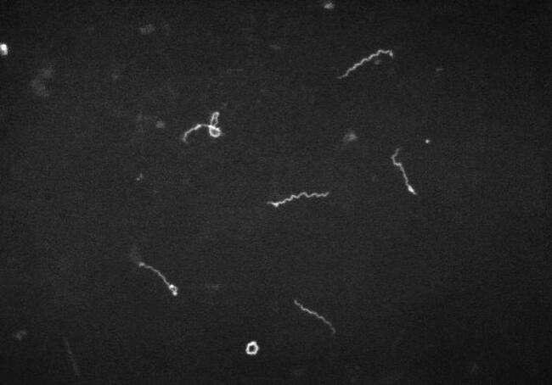
Fig. 13: Dark ground microscopy of Treponema Pallidum. Source(CDC)

PCR-Based Tests: Confirm diagnosis or test samples from oral lesions, which might have commensal spirochaetes, like Treponema macrodentium and Treponema microdentium.
Serology: Two types of tests, specific treponemal and non-treponemal/cardiolipin tests, are used. Specific tests like treponemal EIAs, TPHA, TPPA, and FTA-ABS detect IgM and IgG, typically positive in secondary and early latent syphilis. Non-treponemal tests like VDRL/RPR aid in staging and treatment monitoring.(fig. 14)
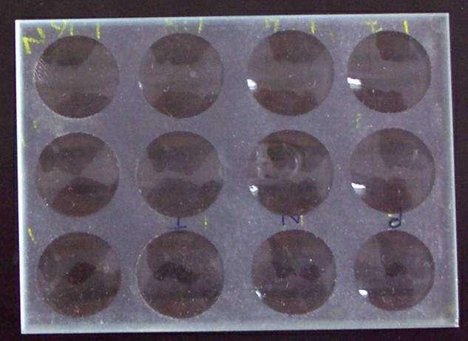
Fig. 14: VDRL Plate. Source(Wikipedia)
CSF Findings: In neurosyphilis, asymptomatic cases exhibit pleocytosis, low glucose, raised protein, and positive VDRL (might be negative in HIV). Symptomatic patients show severe CSF changes, and VDRL is almost always positive.

Syphilis Stages and Tests:
Primary Syphilis: Dark-field microscopy, PCR-based tests, VDRL (75% positive), TPHA (90% positive).
Secondary Syphilis: VDRL (almost 100% positive), TPHA (100% positive), usually positive CSF-VDRL in early neurosyphilis.
Latent Infection: VDRL decreases over time but doesn't rule out infection; TPHA remains positive.
Tertiary Syphilis: Gummatous syphilis shows positive VDRL and TPHA; syphilitic aortitis and late neurosyphilis might have weakly positive or negative VDRL but positive TPHA.
Congenital Syphilis: Neonatal serum's IgM presence confirms congenital syphilis, distinguishing it from passively transferred maternal antibodies. Various tests detect IgM; parallel maternal and neonatal tests or serial testing help confirm the diagnosis.
Diagnostic Procedures: Perform a chest X-ray in late latent syphilis or if aortic disease signs are present. Neurological imaging is recommended for individuals with neurological symptoms or signs

Treatment
In managing syphilis:
Screening: Test all patients for other sexually transmitted infections (STIs) and HIV.
Early Syphilis Treatment:
Benzathine benzylpenicillin: 2.4 million IU IM stat as two separate injections, or Doxycycline: 100mg bd for 14 days, or Erythromycin: 500mg qds for 14 days.
Late Syphilis Treatment:
Benzathine benzylpenicillin: 2.4 million IU IM as two separate injections weekly for 3 weeks, or Doxycycline: 100mg bd PO for 28 days.
Neurosyphilis Treatment:
Benzylpenicillin: 3–4 million IU IV 4-hourly for 14 days, or Procaine benzylpenicillin G: 2.4 million IU IM daily with probenecid 500mg PO qds for 14 days, or Ceftriaxone: 2g IV od for 14 days, or Doxycycline: 200mg PO bd for 28 days.
Congenital Syphilis Diagnosis:
IgM presence in neonatal serum confirms congenital syphilis, distinguishing it from maternal antibody transfer. Various techniques like FTA-ABS, TPHA, EIA, and VDRL tests help in IgM detection. When specific tests aren't available, parallel testing of maternal and neonatal sera or serial testing aids in confirming congenital syphilis. The VDRL test becomes negative within three months due to the rapid decrease in passively transferred antibody titers.
Treatment Monitoring:
Assess treatment success based on symptoms and repeat VDRL. In neurosyphilis, perform a repeat lumbar puncture at 3–6 months and then every 3 months until CSF normal and CSF VDRL non-reactive. Lack of resolution by 2 years requires retreatment.

Vulvovaginitis
Vulvovaginitis indicates inflammation in the vaginal mucosa, known as vaginitis, and the external genitalia, the vulva, known as vulvitis. It stands as the most prevalent genital tract infection in females.
Women typically experience vaginal symptoms, including abnormal discharge with or without a foul odor, or itching.
The three primary causes of vaginitis in premenopausal women are trichomoniasis, bacterial vaginosis, and vaginal candidiasis.
Bacterial Vaginosis
Introduction
Bacterial vaginosis (BV) leads to vaginal discharge in fewer than half of symptomatic women, as other causes like vulvovaginal candidiasis and trichomoniasis can also result in similar symptoms. Instead of being attributed to a single organism, BV arises from intricate shifts in the balance of the microbiological flora within the vagina.
Epidemiology
The prevalence of bacterial vaginosis (BV) globally varies between 11% to 48% among women of reproductive age.
Factors contributing to its acquisition include having new or multiple sexual partners, practicing vaginal douching, and smoking. Notably, BV can develop in women who have never engaged in vaginal intercourse.
Pathophysiology
This condition involves an imbalance in the typical vaginal flora, characterized by:
- Lactobacilli play a crucial role by producing hydrogen peroxide (H2O2), which helps maintain a lower pH in the vagina. When these organisms decrease, the pH rises, leading to an overgrowth of anaerobic bacteria in the vaginal environment. These anaerobes produce enzymes that break down vaginal peptides, resulting in the formation of malodorous substances. Additionally, they contribute to increased discharge and shedding of the epithelial layers.

- This imbalance involves a decrease in the typically dominant lactobacilli and an increase in other organisms such as Gardnerella vaginalis, Prevotella species, Porphyromonas species, Bacteroides species, Peptostreptococcus species, Mycoplasma hominis, Ureaplasma urealyticum, and Mobiluncus species.
Clinical Features
Around 50 to 75% of cases exhibit no symptoms.
Symptoms, when present, include a thin, white, fishy-smelling discharge, particularly noticeable after intercourse.
It might coincide with cervicitis, which can occur with or without concurrent chlamydial or gonococcal infections.
Vaginal pain or irritation of the vulva is rare.
Complications associated with BV include a higher risk of preterm delivery in pregnant women. Additionally, it's linked to conditions like endometritis, post-partum fever, and infections post-gynecological surgeries. BV serves as a risk factor for acquiring and transmitting HIV, as well as for acquiring HSV-2, Chlamydia, and gonorrhea.
Diagnosis
A diagnosis of bacterial vaginosis can be established if at least three of the following four criteria are met according to Amsel's criteria:
- Presence of profuse thin (low viscous), white homogeneous vaginal discharge uniformly coating the vaginal wall.
- Vaginal discharge pH exceeding 4.5.
- Heightened distinct fishy odor (arising from volatile amines like trimethylamine) immediately upon mixing vaginal secretions with a 10% solution of potassium hydroxide (Whiff test).
- Identification of clue cells: These are vaginal epithelial cells covered with coccobacilli, presenting a granular appearance and having blurred edges when observed on a wet mount.(fig. 15)
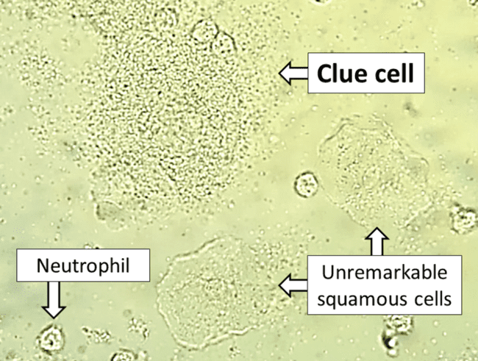
Fig. 15: Clue cell(epithelial cell covered with bacteria) in bacterial vaginosis. Source(CDC)

Laboratory Diagnosis
Nugent's score: It is a scoring system followed for the diagnosis of bacterial vaginosis; done by counting the number of Gardnerella vagina/is, Mobiluncus, and lactobacilli present in the Gram-stained smear of vaginal discharge. A score of more than or equal to 7 is diagnostic.

Culture
G. vaginalis necessitates enriched media like chocolate agar or BHI broth with serum for culture. This gram-negative (appearing gram-variable in smears), nonmotile, small pleomorphic rod showcases metachromatic granules. It forms small hemolytic colonies when incubated aerobically under 5% CO2 on blood agar for 24-48 hours.

Identification can be performed using conventional biochemical tests or automated systems like MALDI-TOF or VITEK based on the colonies formed.
For identification through broad-range PCR amplification of 16S rRNA in vaginal fluid, subsequent methods are employed to pinpoint specific bacterial species.
Treatment
In about one-third of cases, bacterial vaginosis resolves on its own without treatment. Treating the infection might decrease the risk of acquiring other sexually transmitted diseases.
Here are guidelines for treatment:
Who to treat:
All symptomatic women should receive treatment. Oral treatment is considered safe during pregnancy without adverse fetal effects.
Asymptomatic women undergoing abortion or hysterectomy benefit from treatment, lowering the risk of post-operative infection.
Asymptomatic pregnant women with a history of preterm delivery might also benefit from treatment. While studies haven't significantly proven that treating BV reduces preterm birth rates, it's associated with fewer cases of preterm prelabour rupture of membranes and low-birthweight babies in these women. Screening women with a history of preterm labor for BV might be considered.
Treatment regimens:
Metronidazole: 500mg twice daily orally for 7 days or 5g of 0.75% metronidazole gel intravaginally once daily for 5 days. Metronidazole shows high early cure rates (>90%) and 80% cure rates at 4 weeks.
Clindamycin: 300mg twice daily orally for 7 days or 100mg clindamycin ovules intravaginally once daily for 3 days. However, clindamycin usage might be linked to acquiring clindamycin-resistant anaerobes. Metronidazole has not shown resistance.
Other agents like tinidazole, secnidazole, and probiotics have been utilized.
Recurrence:
Around 30% of patients experience a recurrence within 3 months. Prolonged or alternative treatment courses might be necessary for these patients. Some individuals experiencing multiple relapses may benefit from a long-term maintenance regime, like twice-weekly intravaginal metronidazole gel. Clindamycin isn't recommended for long-term maintenance.
Treating partners hasn't shown consistent effectiveness in reducing recurrence. Sexual intercourse seems to influence disease activity. Some studies suggest decreased recurrence rates when male sexual partners consistently use condoms or when women remain abstinent.

Trichomonas Vaginalis
Trichomoniasis stands as the most prevalent parasitic sexually transmitted infection (STI) caused by a flagellated parasite known as Trichomonas vaginalis. This parasite solely exists in the trophozoite stage, lacking a cyst stage. Within this stage, two forms are observed:
Flagellated trophozoite: This form is both infective and diagnostic in identifying the infection.
Amoeboid trophozoite: It represents the actively replicating form, encountered during the tissue feeding stage of the life cycle
Epidemiology
Trichomoniasis is primarily transmitted through sexual contact, with higher incidence rates seen in women with multiple sexual partners or those already infected with other sexually transmitted infections like HIV. There's a possibility of vertical transmission during childbirth.
While rare, non-sexual transmission, such as through contact with contaminated linens in institutional settings, can occur but is infrequent.
Lifecycle
Asymptomatic females act as reservoirs for trichomoniasis. When humans contract this infection through sexual activity, flagellated trophozoites enter the body and transform into amoeboid forms. These amoeboid forms then multiply within the genital tract, causing infection. Later, they revert to the flagellated trophozoite form, which is then discharged in vaginal or urethral secretions, contributing to the spread of the infection
Clinically
In trichomoniasis, about 25-50% of individuals remain asymptomatic but can still harbor the trophozoites, capable of transmitting the infection. Others may develop symptoms after an incubation period lasting 4-28 days.
Acute Infection (Vulvovaginitis): Adhesin proteins facilitate attachment to the vaginal epithelium. Females predominantly experience vulvovaginitis, marked by thin, profuse, foul-smelling, purulent vaginal discharge.
The discharge might be frothy (seen in 10% of cases) with a yellowish-green hue, mixed with pus cells.
A "strawberry" appearance (Colpitis macularis) on the vaginal mucosa occurs in about 2% of patients, characterized by small hemorrhagic spots on the vaginal and cervical mucosa.
Additional symptoms include dysuria and lower abdominal pain.
In males, common features are non-gonococcal urethritis and, less frequently, epididymitis, prostatitis, and penile ulcerations.
Chronic Infection: During the chronic stage, the disease tends to be milder, with symptoms such as itching and discomfort during intercourse. Vaginal discharge is typically scanty and mixed with mucus
Trichomoniasis can lead to rare complications, including conditions like pyosalpinx (pus in the fallopian tubes), endometritis (inflammation of the inner lining of the uterus), infertility, low birth weight in newborns, and cervical erosions. Moreover, it heightens the risk of transmitting HIV and HSV-2 infections.
Lab Diagnosis
For diagnosing trichomoniasis in the laboratory, various sample types like vaginal and urethral discharge, urine sediment, and prostatic secretions can be examined.
Direct Microscopy: A wet (saline) mount of fresh samples needs to be examined within 10-20 minutes of collection. This method demonstrates the characteristic jerky, motile trophozoites of the parasite along with pus cells.(fig. 16) Sensitivity ranges from 40-80%, while specificity can reach up to 100%.
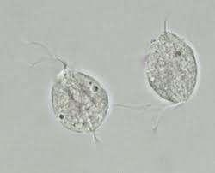
Fig. 16: Wet mount of Trichomonas Vaginalis. Source(University of California, San Francisco – Department of Laboratory Medicine)
Other Staining Methods: Additional staining techniques include permanent stains like Giemsa and Papanicolaou stains, acridine orange fluorescent stain, and the direct fluorescent antibody test (DFA).(fig. 17) The DFA test exhibits higher sensitivity (70-90%) compared to wet-mount examination.
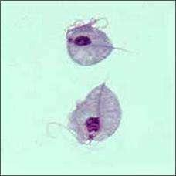
Fig. 17: Trichomonas Vaginalis in Giemsa staining. Source(CDC)
To diagnose trichomoniasis, immediate processing of specimens into media like Lash’s cysteine hydrolysate serum media is recommended. Special containers such as "InPouch TV" facilitate sample collection and culture.
Culture: Specimens should be cultured and incubated for 3-7 days. The culture fluid is then examined to demonstrate the presence of trophozoites.
Antigen Detection in Vaginal Secretions: Antigen detection methods, like rapid ICT (Immunochromatographic Test) and ELISA, are more sensitive than microscopy and provide indications of recent infection. They utilize monoclonal antibodies.
Antibody Detection: ELISA techniques using whole-cell antigen preparations or aqueous antigenic extracts detect antitrichomonal antibodies in serum and vaginal secretions. However, these antibodies persist over time, making it difficult to differentiate between current and past infections.
Molecular Methods: Highly sensitive molecular techniques targeting specific genes of T. vaginalis, such as the beta-tubulin gene, have replaced culture techniques.

Other Supportive Tests:
Elevated vaginal pH (>4.5) is observed, but it's not specific as it can also be elevated in bacterial vaginosis. In vaginal candidiasis, the pH remains normal.
Positive "whiff test": A fishy odor intensifies when 10% KOH is added to vaginal discharge due to amine production. This test is positive in over 75% of trichomoniasis cases and is also positive in bacterial vaginosis.
Increased pus cells on wet mount examination are seen in over 75% of trichomoniasis cases.

Treatment
Metronidazole or tinidazole serves as the primary drugs of choice for treating trichomoniasis.
Standard Therapy: A single 2g dose is typically effective. This dosage is considered the standard treatment.
Treatment of Both Partners: It's crucial to treat both sexual partners simultaneously to prevent reinfection, especially considering that males may be asymptomatic carriers.
Resistance and Treatment Failure: Resistance to metronidazole is rare but reported in some cases (2.5-10%). If standard therapy fails, a repeated treatment course, typically lasting 5 days, might be considered.

Gonococcal Urethritis
Neisseria gonorrhoeae is a gram-negative bacterium, often observed in kidney-shaped pairs (diplococci). It is the causative agent of gonorrhea, a sexually transmitted infection (STI). Gonorrhea commonly presents with manifestations like cervicitis (inflammation of the cervix), urethritis (inflammation of the urethra), and conjunctivitis (inflammation of the conjunctiva in the eye).
Epidemiology
Neisseria gonorrhoeae infection is prevalent worldwide. In developing countries, perinatal transmission and neonatal eye infections are significant concerns.
Peaks occur in males aged 20–24 years and females aged 16–19 years, with higher rates noted in deprived urban areas. There's a concentration of infection among men who have sex with men (MSM)
Recent increases in its incidence and the rise of antimicrobial resistance have elevated it to a major public health concern. This combination of increased prevalence and growing resistance to antibiotics makes combating gonorrhea a significant challenge in terms of public health.
Clinically
The incubation period for gonorrhea spans 2–5 days. Lower genital tract infections can be asymptomatic or lead to urethritis in men, causing purulent discharge and dysuria. In women, it can result in endocervicitis with symptoms like vaginal discharge, itch, and dysuria.(fig. 18)
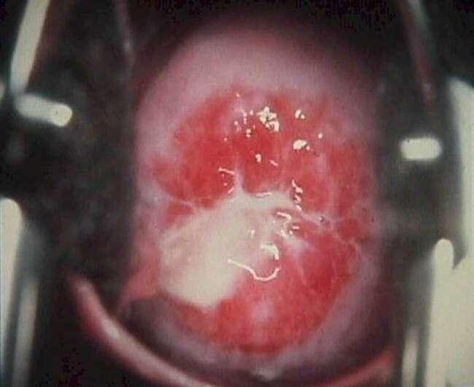
Fig. 18: Purulent discharge in endocervical gonococcal infection.Source(Health Jade)

Although infection of the female urethra, pharynx, and rectum—more common in homosexual men—usually doesn't present symptoms and tends to be asymptomatic. Retrograde spread might lead to severe complications such as salpingitis/endometritis, pelvic inflammatory disease (PID), and tubo-ovarian abscesses in about 20% of women with cervicitis. In rare cases, frank peritonitis or perihepatitis (Fitz-Hugh–Curtis syndrome) can occur. In men with gonococcal urethritis, complications like epididymitis or epididymo-orchitis may develop.(fig. 19)
Fig. 19: Gonococcal Urethritis mucopurulent discharge in males. Source(Cambridge University Press)

Disseminated gonococcal infection follows approximately 1% of genital infections, with 75% occurring in women. The risk is higher during menstruation or pregnancy if mucosal infection takes place. Its features include rash, fever, joint pain (arthralgias), migratory polyarthritis, septic arthritis, endocarditis, and meningitis.

Neonates acquiring gonorrheal infection during birth can manifest ophthalmia neonatorum and disseminated infection. Conjunctivitis can also occur in adults through direct bacterial contact, potentially leading to blindness.
Laboratory Diagnosis
Laboratory diagnosis of gonorrhea involves specific specimen collection and various testing methods:

Specimen Collection:
For men, urethral swabs are preferred, collected by cleaning the urethral meatus with saline-soaked gauze and gathering discharge.
Dacron or rayon swabs are recommended as cotton and alginate swabs inhibit gonococci growth.
In cases of minimal discharge in chronic urethritis, prostatic massage or collecting the morning secretion is advised.
Transport specimens immediately or use charcoal-coated swabs in specific transport media like Stuart’s or Amies medium, or utilize commercial transport devices.
Microscopy:
Gram staining of urethral exudates reveals characteristic gram-negative intracellular kidney-shaped diplococci. It's highly specific and sensitive in symptomatic men but less reliable in women due to the presence of similar Neisseria species.(fig. 20)
Fig. 20: Gram-negative N.gonorrhoeae. Source(Wikipedia)
Culture:
Endocervical culture, using selective media like Thayer Martin medium, shows a sensitivity of 80–90%.
Blood and synovial fluid cultures are essential in suspected cases of Disseminated Gonococcal Infection (DGI).
Identification:
Species identification is crucial to distinguish gonococci from other Neisseria species. Gonococci are catalase and oxidase positive and ferment glucose but not maltose or sucrose.
Automated systems like MALDI-TOF can aid in identification.
Molecular Methods:
Nucleic acid amplification tests (NAATs) such as PCR targeting specific genes (like 16s or 23s rRNA) are available for detecting N. gonorrhoeae in clinical specimens. These tests are highly sensitive and specific.

Treatment
Treatment for gonorrhea is recommended in various scenarios:
Indications for Treatment:
Presence of Gram-negative intracellular diplococci on genital tract smear microscopy.
Positive culture or nucleic acid amplification test (NAAT) results for N. gonorrhoeae from any site.
Recent sexual partners of confirmed gonococcal infection cases.
Consideration based on epidemiological grounds in sexual assault cases.
Antibiotics:
First-line therapy typically comprises ceftriaxone 500mg as a single intramuscular (IM) dose combined with azithromycin 1g orally, also taken as a single dose.
Alternative regimens include cefixime 400mg orally as a single dose (although treatment failures have been reported), spectinomycin 2g as a single IM dose, cefotaxime 500mg as a single IM dose, cefoxitin 2g as a single IM dose (with probenecid 1g orally), cefpodoxime 200mg orally as a single dose, and quinolones (e.g., ciprofloxacin 500mg orally as a single dose) not recommended except for confirmed sensitive infections.

References
- Torok, E., Moran, E., & Cooke, F. (2016). Oxford handbook of infectious diseases and microbiology. Oxford University Press.
- Kasper, D., & Fauci, A. (2013). Harrison’s infectious diseases, 2/E (2nd ed.). McGraw-Hill Professional Publishing.
- Sastary A, Bhat S. (2019). Essential of Medical Microbiology, 2/E (2nd ed.).Jaypee Brother Medical Publishers
- Jayaram Paniker, R. A. C. (2020a). Ananthanarayan and Paniker’s textbook of microbiology. Universities Press.

