**INTERDISCIPLINARY RESEARCH ON SUSTAINABILITY OF BUSINESS:**

* **Encourage reuse, recycling, and waste management:**

***Munaganuru Sai Greeshma, MBA (1st year), Telangana Mahila Viswavidyalayam (formerly UCW), Koti, Hyderabad, Telangana, India.***

***Padamati Sai Pooja Reddy, Audit Analyst, Deloitte Touche Tohmatsu Limited, Hyderabad, Telangana, India.***

* **Abstract:**

Integrating reuse, recycling, and waste management practices in business operations is pivotal for advancing sustainability and fostering long-term viability. This approach mitigates environmental impact by conserving natural resources, reducing landfill waste, and also enhances economic performance through cost savings and operational efficiency. As global awareness of circumstances issues rises, consumers increasingly favor businesses committed to sustainable practices. By adopting effective waste management strategies, companies can improve their brand image, comply with regulatory requirements, and cultivate customer loyalty. This paper explores the multifaceted benefits of implementing reuse and recycling initiatives, highlighting their role in driving innovation, creating new market opportunities, and positioning businesses as responsible. Ultimately, prioritizing sustainability through these practices is essential for occupations aiming to thrive in a competitive and environmentally conscious marketplace.

* ***Keywords:***

*Environmental sustainability, Ecological footprint, Natural resource conservation, circular economy, waste reduction, recycling technologies, green initiatives, sustainable practices.*

1. **Reuse:**

* **Introduction:**

"Reuse" refers to extending the life cycle of products and materials by finding new uses rather than discarding them after their initial purpose. As businesses face increasing pressure to reduce their environmental footprint and respond to consumer demand for sustainable practices, the concept of reuse emerges as a vital component of a circular economy. By integrating reuse into their operations, companies can minimize waste, lower production costs, and enhance their brand reputation. This approach encourages innovation in product design, promotes resource efficiency, and fosters customer loyalty through sustainable practices.

* **Definitions:**

According to the EPA (U.S. Environmental Protection Agency), reuse is "using an item again for the same or a different purpose" and its role in waste reduction and resource conservation. (U.S. EPA, 2021).

According to the European Commission, reuse is "using a product again for the same purpose or for a different purpose" to minimize waste generation (European Commission, 2020).

According to The Ellen MacArthur Foundation, reuse is a critical aspect of the circular economy, where products are designed for longevity and multiple uses, thereby reducing environmental impact (Ellen MacArthur Foundation, 2019).

* **Types of Reuse:**

- Direct Reuse: Using an item for its original purpose without modifications (e.g., refilling a water bottle).

- Repurposing: Adapting an item for a different use (e.g., using glass jars for storage).

- Donation: Giving items to others for use (e.g., donating clothes to charity).

- Sharing: Participating in community sharing programs (e.g., tool libraries or car-sharing services).

* **Components of Reuse:**

- Product Design: Creating durable and easily repairable to facilitate reuse.

- Community Programs: Initiatives such as swap meets, thrift stores, and donation centers that encourage the reuse of goods.

- Educational Campaigns: Programs aimed at raising awareness about the benefits of reuse and how to implement it in daily life.

- Policy Frameworks: Legislation that supports reuse practices, such as incentives for businesses that promote product longevity.

* **Dimensions of Reuse:**

- Environmental Dimension: Reduces waste and conserves resources by extending the lifespan of products.

- Economic Dimension: Saves costs for consumers and businesses by minimizing the need for new products and materials.

- Social Dimension: Promotes community engagement and social responsibility through sharing and donation practices.

* **Factors for Reuse:**

- Consumer Awareness: Understanding the benefits and methods of reuse encourages participation.

- Product Design: Items designed for durability and repairability facilitate reuse.

- Infrastructure Availability: Access to donation centers, repair shops, and community sharing programs supports reuse efforts.

- Cultural Attitudes: Societal norms and values regarding consumption and waste influence reuse behaviors.

* **Real-time example of reuse:**

Example: IKEA’s Take Back Program:

- Description: IKEA has implemented a take-back program where customers can return used furniture for reuse or recycling. The company refurbishes or resells items, extending their lifecycle and reducing waste.

- Impact: This initiative promotes a circular economy by encouraging customers to think about the lifecycle of their purchases.



* **Reference:**

IKEA (2021). IKEA’s Circular Strategy: The Future of Furniture.

1. **Recycle:**

* **Introduction:**

Recycling is a critical component of sustainability that involves converting waste materials into new products, thereby reducing the consumption of raw materials and minimizing environmental impact. As global awareness of environmental issues increases, consumers sustainability practices from companies. By adopting recycling initiatives, businesses can demonstrate their commitment to sustainability, attract eco-conscious customers, and differentiate themselves in a competitive market. Recycling also helps companies comply with regulatory requirements and avoid potential penalties associated with waste management.

* **Definitions:**

According to the U.S. Environmental Protection Agency, recycling is "the process of collecting and processing materials that would otherwise be thrown away as trash and turning them into new products" (U.S. EPA, 2021).

The European Commission describes recycling as "the process of converting waste materials into new materials and objects," emphasizing its role in waste management and resource conservation (European Commission, 2020).

According to the Ellen MacArthur Foundation, recycling is an element of the circular economy that involves "transforming waste into new materials and products," thus promoting sustainability (Ellen MacArthur Foundation, 2019).

* **Types of Recycling:**

- Mechanical Recycling: Physically processing materials into new products (e.g., shredding plastic bottles).

- Chemical Recycling: Breaking down materials at a molecular level to create new raw materials (e.g., converting plastics back to monomers).

- Organic Recycling: Composting organic waste to create nutrient-rich soil amendments.

- E-Waste Recycling: Specialized recycling of electronic waste to recover valuable metals and components.

* **Components of Recycling:**

- Collection Systems: Infrastructure for the collection of recyclable materials, including curbside pickup and drop-off centers.

- Sorting Facilities: Facilities that separate recyclable materials from waste to ensure proper processing.

- Processing Technologies: Equipment and methods to convert recyclable materials into new products (e.g., shredders, balers).

- Market Development: Creating demand for recycled materials through partnerships with manufacturers and businesses.

* **Dimensions of Recycling:**

- Environmental Dimension: Decreases landfill waste and reduces pollution by reprocessing materials into new products.

- Economic Dimension: Creates jobs in the recycling industry and reduces costs associated with raw material extraction and processing.

- Technological Dimension: Involves advancements in recycling technology and innovation in material recovery processes.

* **Factors for Recycling:**

- Collection Systems: Effective and convenient collection methods increase recycling rates.

- Market Demand: The economic viability of recycled materials drives investment in recycling technologies.

- Public Policy: Legislation and incentives can promote recycling initiatives and infrastructure development.

- Education and Outreach: Programs that inform the public about recycling practices enhance participation.

* **Real-time example of Recycling:**

Example: Coca-Cola’s World Without Waste Initiative

- Description: Coca-Cola launched a global initiative to recycle a bottle or can for every one sold by 2030. The company is investing in recycling infrastructure and promoting recycled materials in its packaging.

- Impact: This program aims to improve recycling rates and reduce plastic waste, significantly contributing to a more sustainable beverage industry.

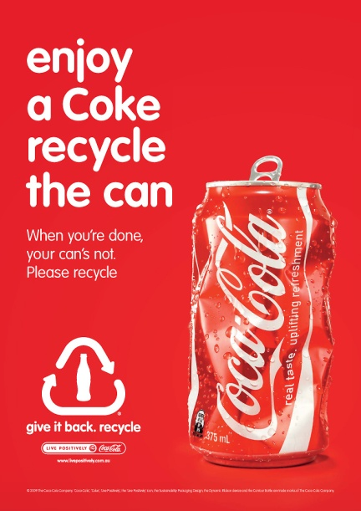

* **Reference:**

Coca-Cola (2020). World without Waste: Our Commitment to Recycling.

1. **Waste Management:**

* **Introduction:**

“Waste management” refers to the systematic approach to handling waste materials, encompassing their collection, transportation, treatment, and disposal. In sustainability, effective waste management is essential for businesses aiming to minimize their environmental impact and promote resource efficiency. As stakeholders increasingly prioritize sustainability, companies are to implement comprehensive waste management strategies that reduce landfill contributions, enhance recycling efforts, and educate the responsible disposal of hazardous materials. Effective waste management can improve operational efficiencies and reduce disposal fees. By minimizing waste generation and maximizing resource recovery, businesses can lower their overall environmental footprint while enhancing their bottom line.

* **Definitions:**

The U.S. Environmental Protection Agency (EPA) defines waste management as the collection, transport, processing, recycling, or disposal of waste materials, emphasizing its importance in protecting public health and the environment (U.S. EPA, 2021).

According to the World Health Organization (WHO), waste management activities and actions to manage waste from its inception to its final disposal highlight the need for effective systems to safeguard health and the environment (WHO, 2020).

The United Nations Environment Programme defines waste management as the activities that provide for the collection, transportation, treatment, and disposal, aiming to minimize its impact on the environment and human health (UNEP, 2019).

* **Types of Waste Management:**

- Landfill: The disposal in designated areas managed to minimize environmental impact.

- Incineration: Burning waste at high temperatures to reduce volume and generate energy.

- Composting: Biological decomposition of organic materials to create compost.

- Waste-to-Energy (W2E): Converting non-recyclable waste materials into usable forms of energy, such as electricity or heat.

- Source Reduction: Strategies aimed to reduce the waste generation at the source (e.g., designing products for longevity).

* **Components of Waste Management:**

- Waste Collection: Systems for the waste from households and businesses.

- Transportation: Logistics involved in moving waste to treatment or disposal facilities.

- Treatment Facilities: waste is processed, including recycling centers, composting sites, and incinerators.

- Disposal Methods: Strategies for the final disposal of waste, including landfills and waste-to-energy facilities.

- Regulatory Frameworks: Laws and regulations that govern waste management practices to ensure safety and environmental protection.

* **Dimensions of Waste Management:**

- Environmental Dimension: Aim to minimize the ecological footprint of waste through effective disposal and treatment methods.

- Economic Dimension: Involves cost-effective waste management solutions that generate revenue through recycling and waste-to-energy processes.

- Regulatory Dimension: Encompasses laws and policies that govern waste management practices to ensure compliance and environmental protection.

* **Factors for Waste Management:**

- Regulatory Frameworks: Laws and regulations shape waste management practices and compliance requirements.

- Technological Advancements: Innovations in waste processing and treatment technologies improve efficiency and effectiveness.

- Economic Considerations: Cost-benefit analyses influence the choice of waste management strategies.

- Community Engagement: Involvement of local communities in waste management initiatives can enhance program success.

* **Real-time example of Waste Management:**

Example: Singapore Integrated Waste Management Facility (IWMF)

- Description: Singapore has developed the IWMF, which combines waste-to-energy facilities with advanced recycling systems. The facility processes waste, recovers recyclables, and generates energy from non-recyclable waste.

- Impact: This integrated approach effectively reduces landfill dependency, enhances recycling rates, and generates renewable energy, showcasing a comprehensive model for urban waste management.

These examples highlight effective practices in sustainability management, demonstrating how organizations can implement reuse, recycling, and waste management strategies to minimize environmental impact and promote sustainable development.

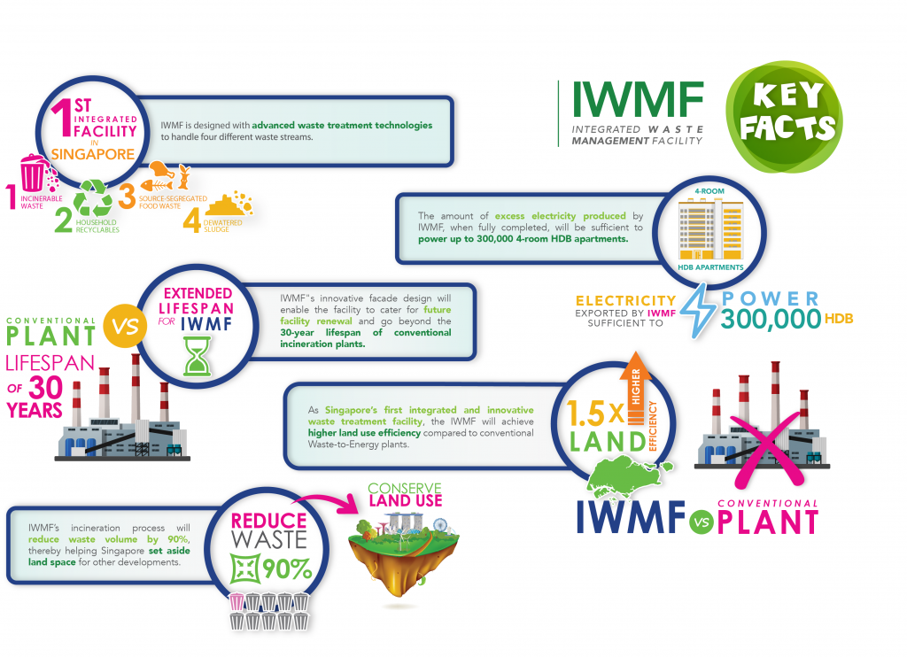

* **Reference:**

National Environment Agency (NEA) Singapore (2021). Integrated Waste Management Facility (IWMF).

**Impact of investing in reuse, recycling, and waste management in businesses:**

Investing in reuse, recycling, and waste management offers several compelling benefits for businesses:

1. **Cost Savings:**

- Reduced Disposal Costs: Efficient waste management can lower expenses associated with waste disposal and landfill fees.

- Resource Recovery: Recycling and reusing materials can reduce the need to purchase new raw materials, leading to significant cost savings.

1. **Enhanced Brand Image:**

- Corporate Social Responsibility (CSR): Demonstrating a commitment to sustainability improves the company's reputation and attracts environmentally conscious consumers.

- Competitive Advantage: Businesses that reuse and recycle can stand out in the market, appealing to customers who value sustainable practices.

1. **Regulatory Compliance:**

- Avoiding Fines: Many regions have strict regulations regarding disposal and recycling.

- Effective waste management helps ensure compliance and avoids potential penalties.

1. **Operational Efficiency:**

- Streamlined Processes: Implementing reuse and recycling programs can lead to more efficient operations, reducing waste and improving overall productivity.

- Employee Engagement: Involving staff in sustainability initiatives fosters a culture of responsibility and can boost morale.

1. **Environmental Impact:**

- Resource Conservation: Reuse and recycling reduce the demand for new materials, conserving natural resources and minimizing environmental degradation.

- Lower Carbon Footprint: Effective waste management practices can significantly reduce greenhouse gas emissions associated with waste disposal and production.

1. **Market Opportunities:**

- New Revenue Streams: Businesses can explore opportunities for recycled materials or refurbished products, creating additional income sources.

- Innovation: Investing in sustainable practices can drive innovation in product design and business models, leading to new market opportunities.

1. **Customer Loyalty:**

- Building Trust: Customers are more likely to support businesses that demonstrate environmental responsibility, leading to increased loyalty and repeat business.

1. **Long-Term Sustainability:**

- Future-Proofing: As global awareness of environmental issues grows, businesses that invest in sustainable practices are better positioned to adapt to changing market demands and regulations.

Investing in reuse, recycling, and waste management contributes to environmental sustainability and enhances a business's operational efficiency, brand image, and bottom line.

**Conclusion:**

Incorporating reuse, recycling, and waste management into business practices is essential for promoting sustainability and ensuring long-term success. These strategies minimize environmental impact by conserving resources, minimizing waste, and significant economic advantages. By investing in sustainable practices, businesses can achieve cost savings, enhance their brand reputation, and comply with regulatory requirements while fostering a culture of responsibility and innovation.

As consumers increasingly prioritize sustainability, companies that engage in these practices position themselves as leaders. Embracing reuse, recycling, and effective waste management contributes to a healthier planet, operational efficiency, and customer loyalty. Ultimately, businesses that use sustainability will be better equipped to navigate future challenges and seize new opportunities in an evolving marketplace.

Reuse, recycling, and waste management are integral components of sustainability that collectively contribute to reducing environmental impact, conserving resources, and promoting economic efficiency.

* **References:**

• U.S. Environmental Protection Agency (EPA) - 2021. (https://www.epa.gov/sustainable-management-materials).

• European Commission - 2020. (https://ec.europa.eu/environment/waste/recycling.htm).

• United Nations Environment Programme (UNEP) - 2019. (https://www.unep.org/resources/report/global-waste-management-outlook).