Innovative Materials exploring AI-Enhanced Applications
Ms. Disha Tuteja¹, Ms. Raman Dhand² and Ms. Neetu Singh³
^{1&2}Assistant Professor Department of Electronics and Communication Engineering, Guru Tegh Bahadur Institute of Technology, G-8 Area , Rajouri Garden, New Delhi-110064
³Assistant Professor,Department of Information Technology, Bharati Vidyapeeth’s College of Engineering, New Delhi- 110063 India

Abstract:
The field of materials science is undergoing a paradigm shift with the integration of Artificial Intelligence (AI). This work explores the exciting potential of AI-enhanced materials, a new generation possessing properties tailored to specific applications. By leveraging AI's ability to analyze vast datasets, identify patterns, and optimize processes, researchers are creating materials with unprecedented functionalities. The abstract will delve into key areas where AI is transforming materials: Material Design, Predictive Capabilities and Process Optimization. This abstract will highlight a few examples of innovative AI-enhanced materials, showcasing their potential to revolutionize various industries, from aerospace to medicine. It will conclude by discussing the challenges and future directions of this burgeoning field, emphasizing the transformative impact of AI on the future of materials science.
Keywords: Material Science, Artificial Intelligence, Machine learning Algorithms.
1.Introduction
Innovation has always been at the forefront of progress, driving advancements across various industries. In recent years, the synergy between artificial intelligence (AI) and material science has escorted in a new world of opportunities. This convergence has paved the path for the introduction of innovative materials with enhanced properties and functionalities, revolutionizing traditional manufacturing processes and opening avenues for groundbreaking applications. The integration of AI in material science has significantly accelerated the discovery, development, and deployment of novel materials. By applying machine learning algorithms, researchers can effectively analyze vast datasets, predict material behaviors, and even design custom materials tailored to specific requirements [1]. This data-driven approach not only expedites the research process but also enables the exploration of unconventional material compositions and structures that were previously inaccessible. Artificial intelligence, with its capacity to analyze vast datasets and derive complex insights, has revolutionized the landscape of material discovery and development. Gone are the days of laborious trial and error; AI algorithms now serve as invaluable tools, accelerating the identification of novel materials with tailored properties and functionalities. This fusion of AI and material science has not only expedited the innovation cycle but has also unlocked avenues for exploration that were previously inaccessible. The applications of AI in material science are as diverse as they are profound. From the molecular level to macroscopic structures, AI facilitates the optimization of material properties and the prediction of performance under varying conditions. Through machine learning algorithms, researchers can navigate the vast chemical space, uncovering compositions and structures optimized for specific applications [2]. This predictive capability not only streamlines the research process but also fosters creativity, enabling the design of materials with unprecedented characteristics.
1.1 AI Technologies
One of the most notable applications of AI-enhanced materials is in the field of advanced manufacturing. By incorporating intelligent algorithms into additive manufacturing processes such as 3D printing, engineers can optimize material usage, minimize waste, and achieve intricate geometries that were once deemed impractical[3,4]. Moreover, AI is revolutionizing the design and optimization of materials for various industries, including aerospace, automotive, healthcare, and electronics. For instance, AI-driven simulations enable engineers to simulate material behaviors under different conditions, facilitating the development of lightweight and durable materials for aircraft and automotive components. In the healthcare sector, smart materials equipped with AI-enabled sensors can monitor patient health in real-time, offering personalized diagnostics and treatment options. In manufacturing, AI-driven processes have evolved in a new era of efficiency and precision. Additive manufacturing, in particular, has been revolutionized by AI algorithms, enabling the production of intricate geometries and complex structures with unparalleled accuracy. Furthermore, AI-powered quality control mechanisms ensure the integrity of manufactured components, minimizing defects and maximizing reliability. The result is a manufacturing landscape characterized by agility, sustainability, and cost-effectiveness. Beyond manufacturing, AI-enhanced materials are poised to reshape industries ranging from healthcare to energy. In healthcare, smart materials imbued with AI-enabled sensors offer real-time monitoring and diagnostics, revolutionizing patient care. In energy, AI optimization algorithms drive the development of next-generation materials for solar cells, batteries, and energy storage systems. Furthermore, AI is reshaping the field of renewable energy through the development of next-generation materials for solar cells, batteries, and energy storage systems [5]. By harnessing AI algorithms to optimize material properties such as conductivity, transparency, and stability, researchers can enhance the efficiency and longevity of renewable energy technologies, driving the transition towards a sustainable future. As we stand on the cliff of this technological revolution, the potential of AI-enhanced materials is boundless. From enhancing everyday products to solving global challenges, the convergence of AI and material science holds the promise of a brighter, more innovative future. Through continued exploration and collaboration, we can unlock the full potential of this transformative synergy, entering in a new world of discovery, progress, and possibility
1.2 Overview
The integration of artificial intelligence in material science has unleashed a wave of innovation, propelling the introduction of novel materials with unprecedented properties and functionalities. From advanced manufacturing to renewable energy, AI-enhanced applications are reshaping industries and driving progress at an unprecedented pace. As we continue to explore the synergies between AI and materials science, the possibilities for future advancements are limitless, promising a world where innovation knows no bounds. This chapter gives a broad introduction starting with challenges in traditional material design and establishes a framework that unifies many common algorithms. The basic framework which needs to be followed is shown in figure1.
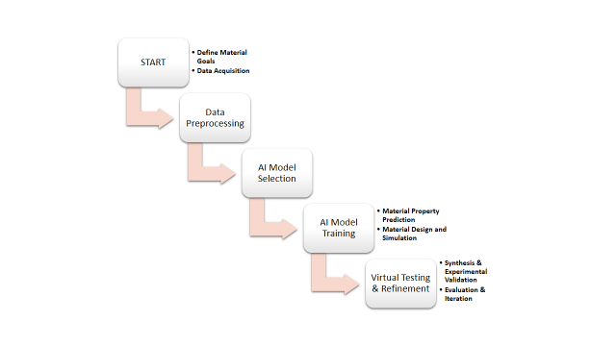
Fig1:Basic flowchart for the process
2. Challenges in Traditional Material Design:
Traditional material design processes have long been constrained by various challenges that hinder innovation and optimization. These challenges, while diverse, often revolve around limitations in technology, resources, and methodology. It is very important to take measures to understand for advancing material science and unlocking new frontiers of discovery. Some of the key challenges include:
  - Trial and Error Approach: Historically, material design has relied heavily on a trial and error approach, where researchers iterate through numerous experiments to find optimal material compositions and properties. This method is time-consuming, resource-intensive, and often yields suboptimal results.
  - Limited Understanding of Structure-Property Relationships: The complex relationship between material structure and properties is not fully understood for many materials. This lack of understanding hampers the ability to predict and engineer materials with desired characteristics accurately.
  - High Cost and Time Investment: Traditional material design processes involve extensive experimentation, analysis, and testing, which can be costly and time-consuming. This limits the exploration of a wide range of materials and slows down the pace of innovation.
  - Resource Constraints: Many traditional material design efforts are limited by access to resources such as specialized equipment, materials, and expertise. This can restrict the scope of research and impede progress, particularly in resource-limited settings.
  - Environmental Impact: Traditional material synthesis methods often involve hazardous chemicals and energy-intensive processes, contributing to environmental pollution and resource depletion. Addressing sustainability concerns in material design is becoming increasingly important.
  - Scaling Up Production: Transitioning from laboratory-scale synthesis to large-scale production presents significant challenges, including maintaining consistency, optimizing process efficiency, and ensuring cost-effectiveness.
  - Multifunctional Material Design: Designing materials with multiple functionalities, such as mechanical strength, conductivity, and biocompatibility, poses significant challenges due to the inherent trade-offs between different properties.
  - Regulatory Compliance and Safety: Meeting regulatory standards and ensuring the safety of new materials is a complex and time-consuming process. Adhering to regulations adds an additional layer of challenge to the material design process.
To tackle these challenges requires a multidisciplinary approach that leverages advances in computational modeling, data science, and materials characterization techniques. Emerging technologies such as artificial intelligence, machine learning, and high-throughput experimentation offer promising solutions to overcome these hurdles and accelerate the pace of material innovation.[5] By tackling these challenges head-on, researchers can unlock the full potential of materials and drive progress across diverse industries.

2.1 How AI offers a powerful toolkit to overcome these challenges
AI offers various algorithms and accelerate material innovation. Here's how:
- Machine Learning (ML) Algorithms: These algorithms can analyze massive datasets of existing materials, identifying patterns and relationships between composition, structure, and performance.
- Predictive Modeling: ML models can predict the properties of new materials based on their chemical makeup or atomic arrangement. This allows scientists to virtually explore vast design spaces and identify promising candidates without physical experimentation.
- Material Recommendation: AI can recommend entirely new material compositions with tailored properties for specific applications. This opens doors to materials with functionalities never before imagined.

2.2 Machine Learning algorithms:
In the realm of innovative material design, Machine Learning (ML) algorithms play a starring role. They act as the intelligent assistants, sifting through vast amounts of data and uncovering hidden connections to propel material science forward.[2] Here's a breakdown of some key ML algorithms used in this exciting field. Figure 2 shows various categories ofMachine Learning Algorithms
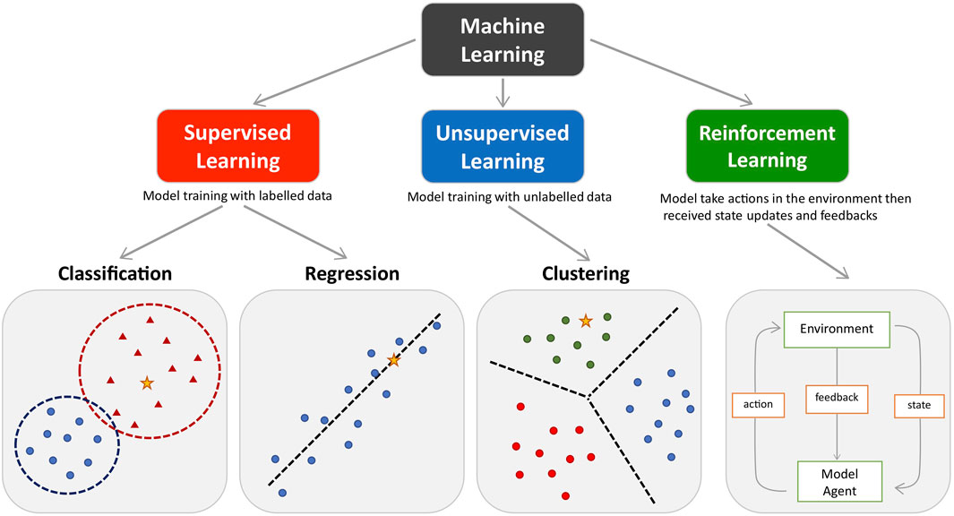
Fig2: Various ML Algorithms
2.2.1. Supervised Learning
Imagine a meticulous student learning from labeled examples. Supervised learning algorithms function similarly[3]. They are trained on a dataset where materials already have known properties (labels). By analyzing these relationships, the model learns to predict properties of new materials based on their composition or structure.
Figure 3 shows the basic workflow of supervised learning:
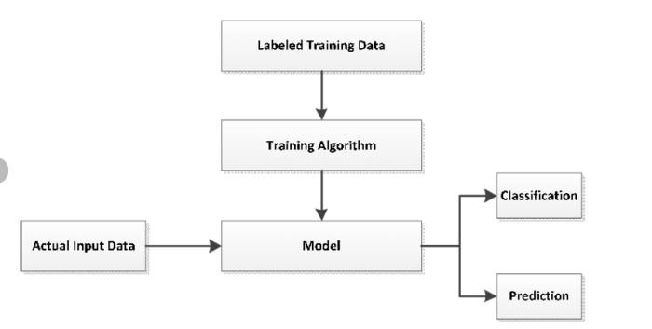
Fig 3: workflow of supervised learning
The explanation of the diagram are as follows:
- Data Collection: The first step is to collect a dataset that is relevant to the task you want the model to perform. This data should be labeled, meaning that each data point has a corresponding label or output value. For example, if you are training a model to classify images of cats and dogs, your dataset would need to include images of cats and dogs, each labeled as either "cat" or "dog".
- Data Splitting: Once you have collected your data, you will need to split it into two sets: a training set and a testing set. The training set is used to train the model, and the testing set is used to evaluate the model's performance.
- Model Training: The training data is fed into the machine learning model. The model learns to identify patterns in the data and to map the input data to the desired output.
- Model Evaluation: Once the model has been trained, it is evaluated on the testing set. The model's performance is measured by how well it can predict the correct output for the data points in the testing set.
- Model Tuning: If the model's performance is not satisfactory, you may need to tune the model's hyperparameters. Hyperparameters are settings that control the learning process of the model. By tuning the hyperparameters, you can improve the model's performance.
a)Prediction: Once the model is trained and evaluated, it can be used to make predictions on new, unseen data.
b)Classification: Data can be classified according to similar properties.

2. 2.2. Unsupervised Learning:
Unlike supervised learning, unsupervised algorithms don't have a teacher with pre-defined labels. Instead, they explore the data on their own, uncovering hidden patterns and relationships. This can be particularly useful when dealing with uncharted territories in material design.
Common algorithms include:
Principal Component Analysis (PCA): Identifies underlying patterns and reduces data complexity, allowing for efficient exploration of material properties.
K-Means Clustering: Groups materials with similar properties into clusters, revealing hidden trends and potential starting points for novel material design.
2.2.3. Reinforcement Learning:
This approach mimics a learning-by-doing strategy. The algorithm interacts with a simulated environment (representing material design space) and receives rewards for desirable outcomes (materials with specific properties). Through trial and error, the model refines its decision-making, leading to the discovery of optimal material designs.
Beyond the Algorithms:
These algorithms are powerful tools, but their effectiveness hinges on high-quality data. Material datasets encompassing information on composition, structure, processing methods, and performance characteristics are crucial for training accurate and reliable models.
The future of ML-driven material design looks bright. As these algorithms become more sophisticated, and data continues to grow, we can expect the discovery of revolutionary materials with properties that push the boundaries of what's possible. From ultra-strong and lightweight composites to self-healing polymers and materials with tailored functionalities, the possibilities are endless.
2.3 Predictive modelling:
Predictive modeling in materials science involves the application of statistical and machine learning techniques to predict material properties, behavior, and performance based on data from experiments, simulations, and literature [7]. Here are some key areas where predictive modeling is applied in materials science:
- Material Property Prediction: Predictive modeling techniques are used to predict various material properties, such as mechanical strength, thermal conductivity, electrical resistivity, and optical properties. Machine learning algorithms trained on datasets of material compositions, structures, and properties can predict the behavior of new materials with high accuracy, enabling researchers to design materials with specific properties for different applications.
- Material Structure-Property Relationships: Predictive modeling helps establish relationships between material structure, composition, and properties. By analyzing structural features, such as crystal structure, grain size, and atomic arrangement, predictive models can elucidate how these factors influence material properties. Understanding structure-property relationships facilitates the rational design and optimization of materials with desired characteristics.
- Materials Discovery and Design: Predictive modeling accelerates the discovery and design of new materials with tailored properties for various applications. Machine learning algorithms analyze large materials databases, computational simulations, and chemical databases to identify promising material candidates with desired properties. Predictive models guide researchers in selecting and synthesizing novel materials with improved performance and functionality.
- High-Throughput Screening: Predictive modeling enables high-throughput screening of materials by rapidly assessing the properties of a large number of candidate materials. Automated machine learning algorithms analyze experimental and computational data to prioritize materials for further experimentation or synthesis. High-throughput screening accelerates materials discovery and optimization processes, leading to faster innovation and development cycles.
- Computational Materials Design: Predictive modeling complements computational materials science by providing accurate predictions of material properties and behaviors. Machine learning algorithms trained on computational simulations can predict material properties across different length and time scales, bridging the gap between atomistic simulations and macroscopic properties. Computational materials design enables the virtual screening and optimization of materials with specific functionalities for diverse applications.
- Materials Informatics: Predictive modeling is integral to materials informatics, which involves the systematic analysis and interpretation of materials data to extract knowledge and insights. Machine learning algorithms analyze diverse datasets[7], including experimental measurements, computational simulations, and literature data, to uncover patterns, correlations, and trends in materials properties and behaviors. Materials informatics accelerates materials research and innovation by guiding experimental and computational efforts towards promising material candidates and design strategies.
- Materials Property Optimization: Predictive modeling helps optimize material properties for specific applications or performance requirements. Machine learning algorithms employ optimization techniques to search for material compositions, structures, or processing conditions that maximize desired properties while minimizing undesirable characteristics. Materials property optimization enables the design of materials with enhanced performance, reliability, and sustainability for various technological, industrial, and societal applications.
In summary, predictive modeling is a powerful tool in materials science for predicting material properties, understanding structure-property relationships, accelerating materials discovery and design, and optimizing material performance for diverse applications. By leveraging data analytics and machine learning techniques, predictive modeling drives innovation and advancement in materials research, enabling the development of new materials with superior properties and functionalities[7]. The figure shows the steps of predictive modelling:
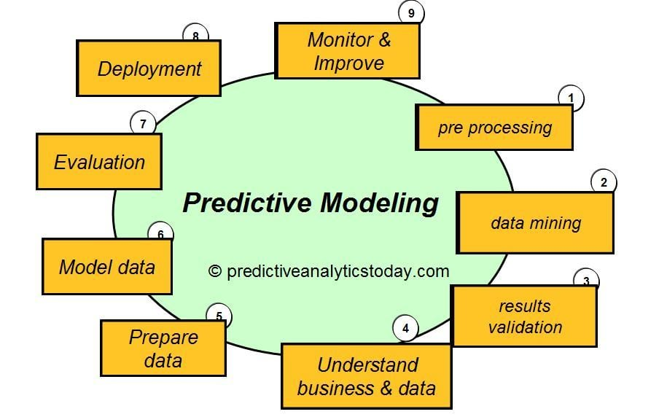
Fig4:Steps of predictive modelling
2.4 Material recommendation
Material recommendation systems using AI leverage machine learning algorithms to provide personalized suggestions for materials based on user preferences, requirements, and historical interactions. These systems are valuable tools in various industries, including manufacturing, construction, aerospace, and healthcare, where selecting the right materials is critical for achieving desired outcomes[8]. Here's how material recommendation systems using AI typically work:
- Data Collection: The first step involves gathering data related to materials, including properties, compositions, applications, and performance metrics. This data can come from various sources, such as materials databases, scientific literature, product specifications, and user feedback.
- Feature Extraction: Next, relevant features or descriptors of materials are extracted from the collected data. These features may include structural properties, chemical compositions, mechanical characteristics, thermal conductivity, and environmental sustainability metrics.
- User Profiling: Material recommendation systems often incorporate user profiling to capture individual preferences, constraints, and application requirements. Users provide input regarding their specific needs, preferences, budget constraints, and performance criteria for materials selection.
- Model Training and Evaluation: The recommendation model is trained using historical interaction data, including user-material interactions and feedback. Various evaluation metrics, such as precision, recall, and mean average precision, are used to assess the performance of the recommendation system and fine-tune the model.
- Real-Time Recommendations: Once the recommendation model is trained and validated, it can be deployed to generate real-time material recommendations for users. As users interact with the system and provide feedback on recommended materials, the model continuously learns and adapts to improve the quality of future recommendations.
- Feedback Loop: Feedback mechanisms are essential for refining the recommendation model over time. Users can provide feedback on recommended materials, indicating whether the suggestions meet their needs and preferences. This feedback is used to update the recommendation model and enhance the accuracy and relevance of future recommendations.
- Integration with Applications: Material recommendation systems can be integrated into various applications and platforms used by engineers, designers, procurement professionals, and researchers[8,9]. These systems provide seamless access to a curated selection of materials tailored to specific use cases, projects, or applications.
Overall, material recommendation systems using AI leverage machine learning algorithms to deliver personalized suggestions for materials, helping users make informed decisions and streamline the materials selection process in diverse industries and applications.
3) The Process of exploring AI Enhanced innovative material
- Identify Application Needs: Begin by identifying industries or sectors where innovative materials can make significant improvements [9]. This involves understanding market demands, technological trends, and areas requiring material advancements.
- Market Analysis: Conduct a thorough market analysis to identify specific challenges and opportunities within target industries. This helps in understanding the requirements for innovative materials.
- Material Requirements: Based on the identified needs and market analysis, determine the essential characteristics and properties required for the innovative materials to address the identified challenges effectively.
- Select Material Candidates: Select potential material candidates that possess the desired properties to meet the identified requirements. This step involves researching existing materials and considering novel approaches to material design.
- Material Characterization: Conduct comprehensive characterization studies on the selected material candidates to analyze their physical, chemical, and mechanical properties[10]. This step provides crucial insights into the material's behavior and performance.
- Material Testing: Perform rigorous testing on the selected material candidates to evaluate their performance under various conditions and environments. This step helps in assessing the suitability of materials for specific applications[11].
- Analyze Test Results: Analyze the test results to identify strengths, weaknesses, and areas for improvement in the material candidates. This analysis guides the refinement process and informs further material selection decisions.
- Iterate & Refine: Use the insights gained from the analysis to iterate and refine the material design and development process. This iterative approach helps in continually improving the material candidates to better meet the application needs.
- Select Final Materials: Based on the iterative refinement process, select the final material(s) that demonstrate the most promising performance and suitability for the targeted applications [12].
- Market Introduction: Introduce the selected material(s) to the market, either through partnerships with manufacturers or direct commercialization efforts.
- Gather Feedback: Collect feedback from users, manufacturers, and other stakeholders regarding the performance and usability of the introduced materials in real-world applications.
- Assess Performances Evaluate the performance of the introduced materials based on the feedback received and compare it against the initial requirements and expectations.
Conclude the process after assessing the performance of the introduced materials. If necessary, the process can loop back to earlier stages for further refinement or for the development of new materials[13]. The figure 5 shows the process to be taken :
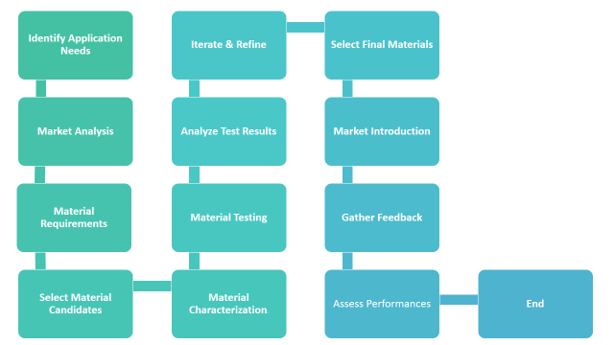
Fig 5:The process of exploring AI Enhanced innovative material

4) Benefits of AI-powered Material Design:
Benefits of AI-powered Material Design[14] are as follows:
- Accelerated Discovery Process: AI algorithms can analyze vast amounts of data and predict material properties with unprecedented speed and accuracy. This accelerates the discovery process by rapidly identifying promising material candidates and reducing the need for time-consuming trial and error experiments.
- Optimized Material Properties: AI-driven optimization algorithms can tailor material compositions and structures to achieve desired properties for specific applications. By leveraging machine learning techniques, researchers can design materials with enhanced mechanical strength, conductivity, flexibility, and other targeted characteristics.
- Cost and Resource Efficiency: AI-enabled material design reduces the need for extensive experimental testing, thereby saving time, resources, and costs associated with traditional trial and error approaches. By streamlining the research process, AI helps researchers allocate resources more efficiently and focus on the most promising avenues of exploration.
- Enhanced Understanding of Structure-Property Relationships: AI algorithms can uncover complex correlations between material structure and properties that may not be immediately apparent to human researchers. By analyzing large datasets and identifying hidden patterns, AI-powered models provide insights into the underlying mechanisms governing material behavior, leading to a deeper understanding of structure-property relationships.
- Customized Material Solutions: AI-driven material design allows for the customization of materials to meet specific requirements and constraints. Whether it's developing materials for lightweight aerospace components, high-performance electronics, or biocompatible implants, AI enables the creation of tailored solutions that address diverse application needs.
- Improved Manufacturing Processes: AI-enhanced material design can optimize manufacturing processes, leading to increased efficiency, quality, and scalability. By integrating AI into additive manufacturing, for example, researchers can optimize printing parameters, reduce material waste, and achieve complex geometries with greater precision.
- Cross-Disciplinary Collaboration: AI-powered material design fosters collaboration between different fields, including materials science, computer science, and engineering. By bringing together experts from diverse disciplines, AI facilitates interdisciplinary research and innovation, leading to novel solutions that transcend traditional boundaries.
- Sustainability and Environmental Impact: AI-driven material design can contribute to sustainability efforts by optimizing material synthesis processes, reducing energy consumption, and minimizing waste. By designing materials with improved recyclability, biodegradability, and eco-friendliness, AI helps mitigate the environmental impact of manufacturing and consumption.
- Innovative Applications: AI-powered material design opens up new possibilities for innovative applications across industries. From advanced electronics and energy storage systems to biomedical devices and sustainable infrastructure, AI-driven materials are driving progress and unlocking new frontiers of technology[15].
5) The Future of Materials Science:
The future of material science holds immense promise and potential, driven by ongoing technological advancements, interdisciplinary collaboration, and a growing emphasis on sustainability[16]. Several key trends and developments are shaping the trajectory of material science in the coming years:
- Advanced Materials: The development of advanced materials with unprecedented properties will continue to be a focal point of research. This includes materials with enhanced strength, conductivity, flexibility, and other tailored characteristics. Emerging materials such as graphene, metamaterials, and biomimetic materials hold promise for diverse applications across industries.
- Nanotechnology: Nanomaterials and nanotechnology will play a pivotal role in the future of material science. By manipulating materials at the nanoscale, researchers can unlock unique properties and functionalities, revolutionizing fields such as electronics, healthcare, and energy storage. Nanomaterials offer opportunities for miniaturization, enhanced performance, and novel applications.
- Sustainability and Green Materials: With increasing awareness of environmental issues, there is a growing emphasis on developing sustainable and eco-friendly materials. Green materials derived from renewable sources, such as bioplastics, bio-based composites, and recycled materials, are gaining traction as alternatives to traditional petroleum-based materials. Sustainable manufacturing processes and circular economy principles will also shape the future of material science.
- Artificial Intelligence and Machine Learning: The integration of artificial intelligence (AI) and machine learning (ML) into material science will continue to drive innovation. AI algorithms can accelerate material discovery, optimize properties, and predict material behavior with unprecedented accuracy. ML models trained on large datasets enable researchers to uncover hidden patterns and relationships, leading to breakthroughs in materials design and characterization[17].
- Additive Manufacturing: Additive manufacturing, or 3D printing, will play an increasingly prominent role in material science and manufacturing. This technology enables the fabrication of complex geometries and customized components with high precision. Advancements in additive manufacturing techniques, materials, and process optimization will unlock new possibilities for design freedom, efficiency, and scalability.
- Multifunctional Materials: The development of multifunctional materials capable of serving multiple purposes simultaneously will be a key focus area. These materials integrate diverse functionalities such as mechanical, electrical, thermal, and optical properties into a single material platform. Multifunctional materials have applications in fields ranging from aerospace and automotive to healthcare and electronics[18].
- Bioinspired Materials: Drawing inspiration from nature, bioinspired materials mimic natural structures and processes to achieve desired properties and functionalities. Biomimetic materials, such as self-healing polymers, superhydrophobic surfaces, and bioactive coatings, offer innovative solutions for various applications. Bioinspired design principles will continue to inspire the development of novel materials with remarkable capabilities[19].
- Smart and Responsive Materials: Smart materials capable of sensing, responding, and adapting to environmental stimuli will play a transformative role in material science. These materials exhibit properties such as shape memory, self-healing, and stimuli-responsive behavior, enabling applications in areas such as robotics, sensors, actuators, and wearable devices[20].
6) Conclusion
AI-powered material design offers a myriad of benefits, ranging from accelerated discovery and optimized properties to cost efficiency, sustainability, and innovative applications. By harnessing the power of artificial intelligence, researchers can revolutionize the field of materials science and pave the way for transformative advancements in technology and industry.The future of material science is characterized by innovation, sustainability, and interdisciplinary collaboration. By leveraging advancements in nanotechnology, AI, additive manufacturing, and biomimicry, researchers will continue to push the boundaries of material design and unlock new possibilities for technology and society.

The integration of AI in material design is still in its early stages, but it holds immense promise for the future. As AI capabilities continue to evolve, we can expect even more groundbreaking discoveries and the development of materials that will revolutionize various fields, from energy and healthcare to aerospace and construction.

References:
1. Silvia Badini, Stefano Regondi, and Raffaele Pugliese, “Unleashing the Power of Artificial Intelligence in Materials Design” PubMed Central, DOI: 10.3390/ma16175927
2. Chaochao Gao, Xin Min, Minghao Fang,China University of Geosciences (Beijing)
Tianyi Tao,Chinese Academy,“Innovative Materials Science via Machine Learning”
WILEY October 2021,DOI:10.1002/adfm.202108044
3. Fábio Gama, Stefano Magistretti,”Artificial intelligence in innovation management: A review of innovation capabilities and a taxonomy of AI applications”First published: 26 September 2023 https://doi.org/10.1111/jpim.12698
4. Naomi Haefner, Joakim Wincent ,Vinit Parida ,Oliver Gassmann, “Artificial intelligence and innovation management: A review, framework, and research agenda”,Technological Forecasting and Social Change,Volume 162, January 2021, 120392
5. BL DeCost, JR Hattrick-Simpers, Z Trautt, AG Kusne, E Campo and ML Green1,”Scientific AI in materials science: a path to a sustainable and scalable paradigm”Published on14 July 2020 by IOP Publishing Ltd,Machine Learning: Science and Technology, Volume 1, Number 3
6. Mohammed Sani Haruna, Nile University of Nigeria,”Materials in artificial intelligence development”, Conference: 2017 Special Materials Lecture at Materials Science and Technology Society of Nigeria.DOI:10.13140/RG.2.2.27160.93440
7. Bogdan. Da, Moscow State University,”Role of artificial intelligence in material science”
ResearchGate,https://www.researchgate.net/publication/343814293_Role_of_artificial_intelligence_in_material_science.
8. Don Monroe,”Artificial Intelligence for Materials Discovery” Communications of the ACM Volume 66,Issue 4 pp 9–11,https://doi.org/10.1145/3583080
9.Jiali Li , Kaizhuo Lim , Haitao Yang , Zekun Ren , Shreyaa Raghavan , PoYen Chen , Tonio Buonassisi , Xiaonan Wang ,” AI Applications through the Whole Life Cycle of Material Discovery”,Volume 3, Issue 2, 5 August 2020, Pages 393-432

10.Ioannis Papadimitriou, Ilias Gialampoukidis, Stefanos Vrochidis, Ioannis Kompatsiaris,” AI methods in materials design, discovery and manufacturing: A review”, Computational MaterialsScience,Volume 235, 15 February 2024, 112793
11. Behzad Ghasemi Parvin, Ataturk University, Leila Ghasemi Parvin, Ankara,” Enhancing Mechanical Properties of Materials Using Artificial Intelligence” July 2023 Conference: The fourth international conference on science, engineering, and the role of technology in new businesses,DOI:10.6084/m9.figshare.25180352.
12. Jiazhen Cai , Xuan Chu , Kun Xu , Hongbo Li , Jing Wei , Machine learning-driven new material discovery,Sciencedirect, Nanoscale Advances,Volume 2, Issue 8, 11 August 2020, Pages 3115-3130, https://doi.org/10.1039/d0na00388c
13 Philip Ball,” Using artificial intelligence to accelerate materials development”
Published online by Cambridge University Press: 09 May 2019
14. Science News from research organizations “New AI tool accelerates discovery of truly new materials “September 21, 2021Source: University of Liverpool
15.M. Welling,” Artificial Intelligence versus Intelligence Engineering”, Harvard Data Science Review, 1(1)(2019).
16.R. R. Nadikattu,” The emerging role of artificial intelligence in modern society” International Journal of Creative Research Thoughts, 4 (2016) 906-911.
17.R. R. Nadikattu, The Supremacy of Artificial intelligence and Neural Networks”, International “Journal of Creative Research Thoughts, 5 (2017) 950-954.
18.H.S. Rogers, “ Cheering Artificial Intelligence Leader: Creative Writing and Materializing Design Fiction, “Leonardo, 53 (2020) 58-62.

19. Yayun Wang , Steven E. Naleway , Bin Wang, “Biological and bioinspired materials: Structure leading to functional and mechanical performance Bioactive Materials”,Sciencedirect
Volume 5, Issue 4, December 2020, Pages 745-757.
20. Kutay Sagdic , Ismail Eş , Metin Sitti , Fatih Inc,”Smart materials: rational design in biosystems via artificial intelligence”,Sciencedirect,Trends in Biotechnology, Volume 40, Issue 8, August 2022, Pages 987-1003

