**CHAPTER**

**Behind the infections a nanoworld:**

***Pathometabolism***

During infections, metabolic alterations occur in the tissues of the affected organs. They always refer to the host's systems. Cells generally respond induced by bacterial products: enzymes, toxins or the presence of foreign molecules. The innate immune system is alerted and response processes begin through phagocytosis, for example. The release of intermediates such as cytokines then appears as a need for the body to reject the aggressors.

However, we must highlight that the microorganisms' own metabolism is capable of inducing these changes and causing even greater damage.

The so-called pathometabolism combines molecular, biological, immunological and metabolic criteria that aim to explain and understand the mechanisms of the disease caused by various diseases, including microorganisms and their interaction with the host.

We will refer particularly to bacteria

Their relationship with the guest includes three groups:

|  |
| --- |
| 1-extracellular  2-potential or facultative intracelular  3-obligate intracellular |

**Extracellular bacteria**

Pathogen infections are recognized by the immune system, which consists of an innate immune response and an antigen-specific adaptive immune response. The adaptive immune system, which is mediated by T and B cells, recognizes pathogens with high affinity through the reorganization of certain receptors.

However, the establishment of this adaptive immune response is often not rapid enough to eradicate pathogens but rather the host defense system is provided by the innate immune system.

Cells have receptors, as we have explained, that recognize the structures that bacteria possess, whether structural, derived from their metabolism or product of bacterial secretion systems.

The bacterial factors are:

**-structural,**

**-metabolic products**

**-bacterial secretions**

The main structural factors were already mentioned in chapter 1 and will be expanded in the explanation of the pathogenicity models.

We will now look at metabolic products as virulence factors. Among these are the enzymes that participate in bacterial life, the secreted products that serve to acquire what it cannot synthesize, such as siderophores and other secretions such as toxins, proteins that have diverse behaviors and ultimately constitute one of the pillars of each infectious process.

**There is bacterial-host metabolic interaction**

The essential infrastructure of metabolism becomes more complex during bacterial infection as one organism thrives by extracting nutrients from the other.

In the host cell, many nutrients essential for bacterial growth are enclosed within complex molecules such as proteins and glycolipids that are not easily accessible.

Furthermore, depending on the particular niche colonized by the pathogen or

State of local inflammation, nutrient supply can vary greatly during the course of infection.

Therefore, nutritional restriction by the host is an important aspect of innate immunity against pathogens.

From a bacterial perspective, the mammalian host is a vast ecosystem, with some regions, such as the intestine, densely populated with competitors, while other niches are open for exploitation.

To appreciate how bacterial metabolism shapes infection, it is important to consider the localized host environment where the bacteria replicate, as well as the metabolic capacity of the pathogen. The host environment is not simply a food source for bacteria. Rather, host cells constantly control their own metabolic function, utilizing available nutrients and removing waste products1.

Bacterial pathogens maintain energy metabolism within cells and tissues. These mechanisms are multiple. It can be said that among the main ones are:

1-The arsenal of microbial degrading enzymes

2-Exploitation of host processes to provide food and use them for benefit

What does it depend on? Surely the area in which the invading pathogen establishes itself and the food sources available within that niche will determine whether or not that microbe can successfully establish itself.

Various methods are used to analyze virulence genes.

1. Direct gene inactivation

2. Global gene inactivation

3. Genetics Complementation

4. Antisense methods

Some pathogens, such as invasive streptococci, Salmonella enterica and Brucella abortus, can feed their “sweet tooth” during infection by acquiring specific carbohydrates; while the "low-carbohydrate" pathogen Mycobacterium tuberculosis prefers to feed on energy-rich fatty acids during chronic infection

Both gram-positive and negative bacteria carry out a dynamic ritual to try to establish themselves first, remain and trigger their pathology.

These bacteria establish themselves on the extracellular surfaces of the host, such as in human nasopharyngeal tissues or in dental biofilms.

Streptococcus mutans, a major cause of dental caries, is distinguished from the resident non-pathogenic oral microbiota by having a broad and flexible metabolic range with respect to nutrient acquisition.

As the human diet has changed over time to become richer in carbohydrates (especially sucrose), the physiological capacity of S. mutans has also evolved. This microorganism has become a more common resident of the human oral cavity as a result of this change in diet, especially in modern postindustrial times2.

It has an important range of genes for carbohydrate metabolism, which are multienzymes, especially the permease and phosphotransferase system (PTS) together with the protein repression system (CCR). This makes it a highly flexible microorganism to produce infections depending on the environmental conditions.

These systems efficiently fulfill their roles and are also observed in Streptococcus pyogenes and Streptococcus pneumoniae, for example. Based on them we can mention the production of Streptolysin S in *S.pyogenes* and the acquisition of iron in pneumococcus.

Let's briefly analyze the importance of metabolic pathways in the development of infection.

This was seen in early studies of bacteria, in which media constituents, growth conditions such as anaerobiosis, and growth stage influenced toxin accumulation.

It is hoped that a detailed understanding of these interactions can assist in the design of more effective therapies for infections caused by staphylococci and other gram-positive pathogens.

**Metabolic pathways**

***Glycolysis***

It is important to emphasize the fundamental role that the glycolysis pathway plays within the metabolic infrastructure of the cell. This central pathway participates in a variety of activities including:

1-provide the pyruvate molecule to the TCA cycle during aerobic or anaerobic respiration.

2-being a single anaerobic energy-producing pathway called “fermentation”, which has a lower energy yield than respiration.

3-provide most of the enzymes for gluconeogenesis, which is a glucose generation pathway that is basically "reverse glycolysis."

So, considering the above finding that glycolysis and glucose are of primary importance for intracellular salmonellae, one might ask what role the glycolysis pathway plays for the bacteria.

Again, using a systematic series of metabolically inactive strains, it has been shown that *S. Typhimurium* requires a completely intact TCA cycle within its host, in this case the BALB/c mouse, for full virulence3.

In facultative intracellular bacteria, good use of metabolism allows them to infect and replicate within macrophages. This is observed in S. Typhimurium and Brucella abortus, both capable of generating a persistent chronic infection within these cells4.

***Lipid metabolism***

Lipids are complex organic compounds made up of carbon, oxygen and hydrogen. These play a diverse and intricate role in cellular processes such as membrane trafficking, protein sorting, signal transduction, and bacterial infections.Lipid metabolism is believed to play a key role in the pathogenicity of several intracellular bacteria. Lipolytic enzymes appear to be potential candidates for the development of new therapies targeting lipid metabolism to control *M. tuberculosis* and other intracellular pathogenic bacteria.

Bacterial lipolytic enzymes hydrolyze host cell lipids to release free fatty acids that are used as an energy source and building blocks for cell envelope synthesis and also to modulate host immune responses5.

Both gram-positive bacteria (*Staphylococcus* spp., *Listeria monocytogenes*, etc.) and gram-negative bacteria (*Salmonella* spp., *E. coli*, etc.) or intracellular bacteria such as *Chlamydia* spp, can sequester the various lipids of the host and use them both structurally and functionally to mount a successful infection.

Pathogens can be deployed with various arsenals to exploit host membrane lipids and lipid-associated receptors as an accessory for anchoring toxins or facilitating their entry into the host cellular niche. *Mycobacterium tuberculosis* is one of the species to modulate the host's lipid metabolism to obtain its carbon source6.

Precisely in this bacteria, it is particularly important. Lipolytic enzymes such as triacylglycerols, in vivo, are present, forming inclusion bodies, in tubercle bacilli located in the lung. It has a lipase (Lip) gene family, which is differentially expressed and regulated under a variety of in vitro conditions. *A better understanding of lipolytic enzymes in mycobacteria would lead to the development of new strategies for the treatment of tuberculosis.*

In a work by Gurdyal Singh et al. the importance of *Mycobacterium* lipolytic enzymes and their involvement in virulence and pathogenicity is analyzed7.

***Metal acquisition***

Transition metals, including iron, zinc, manganese, and copper, among others, are nutrients necessary for many biological processes. These metals have a unique redox potential as they can undergo changes in their oxidation state and serve as essential cofactors for many enzymes.

In bacteria, it is estimated that 30 to 45% of enzymes require a metal cofactor to function. However, at high concentrations, these metals are toxic to cells as they perturb cellular redox potential and can drive the production of highly reactive hydroxyl radicals.

Therefore, all organisms possess biochemical systems to detect and regulate metal levels, and mammals have developed strategies to sequester free metal ions to limit toxicity and also to restrict the availability of these metal ions to invading microorganisms.

This concept of restricting growth by limiting access to essential metals is called nutritional immunity. Pathogens have developed numerous mechanisms for the absorption or efflux of metals to evade nutritional immunity.

***Siderophores***

The most important and well-known metal acquisition systems are the siderophores. As we already explained (chapter 1, figure 9), the siderophores acquire Fe bound to the host proteins that possess it such as transferrin, ferritin, lactoferrin and hemin. .

Iron is the second most abundant metal on earth and is one of the essential micronutrients for practically all living beings. It can adopt any of the two positively charged ionic forms, Fe2+ and Fe3+, whose redox potentials vary enormously depending on the molecule to which it is attached. They specifically recognize Fe+++-containing molecules and sequester it but are unable to sequester it from hemoproteins8.

These molecules fulfill various functions in biological systems, from serving as sources of iron storage, functioning as oxygen transporters or being part of enzymes involved in oxidation-reduction reactions, 11 participating in essential cellular functions such as electron transport, synthesis of DNA, amino acids, etc10, 11.

**Figure 1**. Structure of some bacterial siderophores reported in (Crosa and Walsh, 2002). Enterobactin (E. coli). Vibriobactin (*V. cholerae*). Anguibactin (V. anguillarum). Mycobactin (*M. tuberculosis*). Yersiniabactin (*Y. pestis*). Pioquelina (*P. aeruginosa*)9.

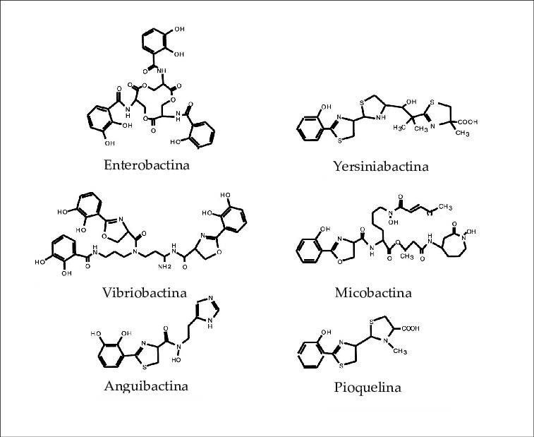

There are two classes of siderophores:

A) CATECHOLS

B) HYDROXAMATES

Both have the same property. The siderophores are excreted into the environment and then the iron-siderophore complex is taken up by special siderophore receptors located on the bacterial surface. Upon internalization, the iron-siderophore complex is cleaved and the iron molecule is released inside the bacteria.

|  |
| --- |
| They are bacterial iron-transporting molecules.  There are several classes and some of them are more effective than others for this function.  Catecholates  Hydroxamates  Hydroxycarboxylates  They are distinguished by the structure of the Fe+++ bond functionality.  Bacteria with one type or several |

**Figure 2A and 2B.** Siderophores in Gram-positive and Gram-negative bacteria



**ABC transporter**

**Protein**

**Siderophore**

**Oxigen**

**B**

**A**

**OM**

**Oxigen**

|  |
| --- |
| Primary siderophores of Enterobacteriaceae: Enterobactin and Aerobactin (*E.coli, Shigella* spp, *Salmonella* spp, *Klebsiella* spp and *Yersinia* spp)  Enterobactin: has also been isolated from gram-positive species (*Streptomyces* spp).  Ferrioxamine siderophores: are produced by garmpositive and negative species.  Fungal siderophores: they are generally hydroxamates |

|  |
| --- |
| GRAM NEGATIVE  Fe-siderophores are recognized by specific receptors on the outer membrane (EM)  They bind and are then transported across the EM by binding to the periplasmic protein-ABC-dependent permease.  GRAM POSITIVE  The siderophore-Fe complex is recognized by specific proteins anchored in the inner membrane  They are then transported by the ABC-dependent permease complex. |

In gram-negative bacteria, bioavailable iron must cross the outer membrane to the periplasm and from there be internalized to the cytoplasm. To do this, the bacteria has

receptors on the outer membrane and an energy complex to be transported, called the Ton complex. They enter the periplasmic space through type III porinic channels (there are three types of porinic channels: I, II and III)

In gram-positive bacteria, mycobacteria and mycoplasmas, the Ton complex or the receptors described do not exist, since they do not have an external membrane. In these bacteria, iron-binding proteins are lipoproteins anchored to the cytoplasmic membrane.

Regarding the uptake of hemin/hemoproteins, two basic mechanisms have been described in gram-negative bacteria:

a-the most common is based on the direct binding and processing of the hemin of the hemoprotein by a tonB-dependent outer membrane receptor and then passes to the cytoplasm through another transport system.

b-the other system has a soluble protein, HEMOPHORUS, which interacts with hemoproteins and brings hemin to the cell surface and there it interacts with a tonB-dependent receptor12.

**Figure 3**. Hemohorus

**Siderophore**

**Transferrin**

**Fe+++**

**Receptor**

**ABC System**

**Hemophorusoro**

**Receptor**

**Hb**

There are some pathogens that are capable of degrading iron transport proteins using proteases. Others produce hemolysins that lyse erythrocytes, releasing their contents and thus generating free hemoglobin.

As for gram-positive bacteria, there may exist, as in *S.aureus*, a system of several proteins that are responsible for binding hemoglobin and transporting iron linked to hemin through the bacterial wall.

Siderophores play such an important role that antibacterials have been designed using them as transport. Although it is not a directly antivirulence system, it uses the mechanism that bacteria use to incorporate these ions.

**Figure 4.** Cefiderocol molecule and action mechanism

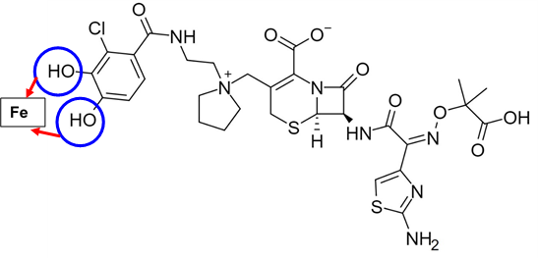

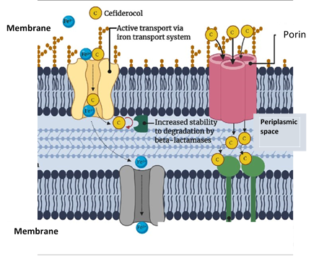

**Secretion systems can act as invasins**

The innate immune system recognizes secretion systems, which transforms them into true factors to block to avoid infection.

|  |
| --- |
| * Recognizes unique patterns of pathogenic bacteria by recognizing their secretion systems * Components of the secretion system * Perception of different mechanisms * Pore formation * Aberrant translocation of molecules in the cytosol of host cells * Presence of effector proteins and their activities |

**Figure 5.** Secretion systems in bacteria

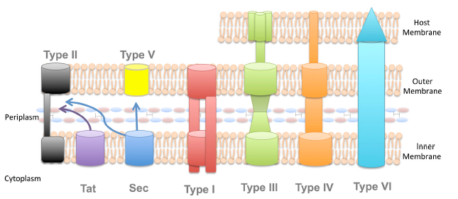

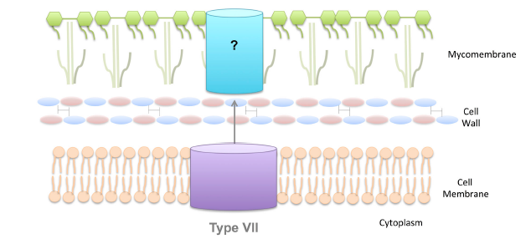

***Intracellular bacteria***

New technologies are beginning to provide us with information about the in vivo metabolism of microorganisms, especially in host cell compartments that are colonized by intracellular bacterial pathogens.

Intracellularity is an important mechanism both for the evasion of microorganisms from the immune system and for the persistence of infection.

There are necessarily intracellular bacteria such as *Chlamydia* spp, *Chlamydophila* spp, *Ricketssia* spp, *Coxiella* sp, and others that are facultatively intracellular such as *Listeria monocytogenes, Shigella* spp, *Mycobacterium tuberculosis.*

Bacteria use their flagellum and adhesins to adhere to and invade the host cell. They often cause a rearrangement of the actin filaments in order to enter properly.

After internalization, several effects occur through multiple secretion systems which inhibit fusion with the lysosome, thus preventing the formation of the phagolysosome that would cause the destruction of the bacteria. This replicates in the phagosome depending on environmental conditions and/or enters the cytosol.

The intracellular pathogen is released by exocytosis or lysis of the host cell and thus initiates another intracellular cycle.

We will take as prototypes of the importance of bacterial metabolism in the pathology produced by intracellular bacteria Mycobacterium tuberculosis (facultative intracellular) and Coxiella burnetii and Chlamydia trachomatis (obligate intracellular).

**Facultative intracellular**

***Mycobacterium tuberculosis***

Pathogenic mycobacteria survive in phagocyte host cells primarily as a result of their ability to prevent fusion of their vacuole with lysosomes, thus avoiding a bactericidal environment. The molecular mechanisms to establish and maintain this replication compartment are not well understood.

Through molecular and microscopic combination it has been shown that after phagocytosis, the main factor is the generation of F-actin in the vacuole of the mycobacteria, WASH or depolymerization of F-actin is interrupted and leads to the accumulation of V-ATPase Proton pumping occurs around the vacuole of the mycobacteria, its acidification and reduction in the viability of intracellular mycobacteria.

This effect is observed for M. marinum in the Dictyostelium phagocyte (Dictyostelium discoideum is an amoeba, a unicellular eukaryotic organism that lives in the soil, feeds on bacteria and reproduces simply by bipartition) but also for M. marinum and M. tuberculosis in mammalian phagocytes.

Pathogenic mycobacteria subvert the actin polymerization activity of WASH to prevent acidification and maturation of the phagosome, as a prerequisite for generating and maintaining replication13.

Recall that active movement of cells or within cells is driven by the dynamics of cytoskeletal elements, such as actin filaments and microtubules, together with associated molecular motors.

Monomeric globular actin polymerizes into linear or branched filamentous actin structures. Some linear actin cytoskeletons, for example, stress fibers, can exert contractile forces through associated myosins, but branched actin structures also generate pushing forces by their mere polymerization14.

The synthesis of fatty acids is essential for the survival and virulence of this pathogen. Gramajo and Buschiazzo were able to analyze the protein called FasR, which made it possible to establish the molecular mechanism by which it exerts its regulatory function on said process. If FasR could be inhibited, tuberculosis could be efficiently controlle

***Obligate intracellular***

It is logical to think that intracellular microorganisms try to preserve the viability of the host cell in order to survive, multiply or persist. To do this, they use various strategies that overcome and modulate all these sophisticated cell death mechanisms, prolonging the longevity of their hosts.

The main mechanisms of regulation of cell death are:

|  |
| --- |
| 1-Apoptosis  2-Pyroptosis  3-Oxidative stress  4-Lysosome dependent |

**Figure 6**.Types of cell death (adapted from16)

**Necrosis**

**Piroptosis**

**Apoptosis**

**Otherss**

**Autophagya**

**MPNA**

**MPA**

MPA: apoptotic programmed death; MPNA: programmed non-apoptotic death

***1-Apoptosis***

1. The intrinsic pathway is initiated by cellular stress or stimuli that alter the expression and/or function of BCL-2 family proteins, including pro-apoptotic (BAX, BAK1 and BOK) and anti-apoptotic (BCL2, BCL2L1/BCL-XL) proteins. .Proteins of the proapoptotic group directly cause mitochondrial outer membrane permeabilization (MOMP) and the release of proteins from the mitochondrial intermembrane space
2. The extrinsic pathway of apoptosis is induced when one of the tumor necrosis factor (TNF) family receptors is activated. Upon activation, the intracellular portion of this receptor recruits the adapter molecule FADD (Fa-associated protein), which in turn recruits and activates the initiator caspase-8.

***2-Pyroptosis***

Pyroptosis is a regulated cell death caused by an inflammatory caspase that results in the formation of pores in the plasma membrane and the release of proinflammatory cytokines.Consequently, cells become permeable to small molecular weight markers such as propidium iodide (PI), in contrast to apoptotic cells that remain intact and do not stain with PI 17, 18,19, 20, 21.

***3-Oxidative stress***

Oxidative stress occurs when there is an imbalance between the production of free radicals and the so-called reactive oxygen species together with the body's ability to neutralize them. When these reactive species exceed cellular capacity, cellular deterioration occurs that can affect any tissue.

The strategy of intracellular bacteria is to neutralize reactive oxygen species to prevent cell death.

They use different mechanisms, some not entirely known. Let's briefly analyze what happens with *Coxiella burnetii,* an obligate intracellular bacteria.

*Coxiella burnetiii* uses several mechanisms in prevention.

|  |
| --- |
| I. prevents membrane assembly of the cytosolic components of NADPH oxidase p47 (phox) and p67 (phox), thus minimizing ROS production22.  .  II. produces its own enzymes superoxide dismutase and catalase to combat the formation of oxygen and H2O2 free radicals, respectively  lll. activates the host leucine transcription factor, nuclear erythroid-related factor 2 (Nrf2), which within the nucleus binds to antioxidant response elements. This causes the transcription of cytoprotective genes and antioxidant enzymes23. |

***4-Lysosome dependent***

*C. burnetii* not only survives within lysosomes or similar environment but also modulates different cell death pathways24.

Let's see what happens with these intracellular survival mechanisms in *Chlamydia trachomatis* and *Chlamydophila pneumoniae*, which are the main intracellular species that infect epithelial cells in humans. The first represents the most common sexually transmitted bacteria (sexually transmitted infections-STIs), especially in the young population, and the second is the cause of approximately 10% of community-acquired pneumonia25, 26.

It is evident that in order to trigger the infection, whether in the genital, ocular or pulmonary tract, cell death must be inhibited, since the cell is its habitat to reproduce.

During the early stages of infection, *Chlamydia* has an antiapoptotic effect that helps maintain the metabolic activities of the infected cell.

*C. trachomatis* was shown to have an antiapoptotic effect on epithelial cells and macrophages by blocking the release of cytochrome c 27.

*C. pneumoniae* also inhibited apoptosis through an additional activity that was described as blocking caspase activation by cytochrome c in a cell-free system 28.

Activation of the apoptotic pathways of the host cell can facilitate the dispersal of bacteria and initiate an inflammatory response of the host.

The interaction of Bcl-2 protein subfamilies with BH3-only proteins plays a decisive role. This action possibly blocks apoptosis 29. Du et al.30 demonstrated another way in which inhibition of apoptosis involves activation of the Raf/MEK/ERK survival pathway.

The interaction of *Chlamydia* species with host cell death and survival pathways remains an active and stimulating field of research, which will ultimately lead to the identification of processes that could be exploited for an anti-infective strategy. (Byrne and Ojcius 2004; Schwarzenbacher et al. 2004; Elwell, Mirrashidi and Engel 2016). There is a virulence factor, Pgp3 that is essential for intracellular survival 31, 32.

***In summary, the provocation of cell death is an important virulence factor. There are infectious processes that entail effective cell death that triggers a series of processes that facilitate persistence, dissemination and/or an intense inflammatory response*33*.***

**Bibliography**

1. Passalacqua KD, Charbonneau ME, O'Riordan MXD. Bacterial Metabolism Shapes the Host-Pathogen Interface. Microbiol Spectr. 2016 4:10.1128/microbiolspec.VMBF-0027-2015. doi: 10.1128/microbiolspec.VMBF-0027-2015. PMID: 27337445; PMCID: PMC4922512

2. Adler CJ, Dobney K, Weyrich LS, Kaidonis J, Walker AW, Haak W, Bradshaw CJ, Townsend G, Soltysiak A, Alt KW, Parkhill J, Cooper A. Sequencing ancient calcified dental plaque shows changes in oral microbiota with dietary shifts of the Neolithic and Industrial revolutions. Nat Genet. 2013; 45:450–455, 455e451.

3. Tchawa Yimga M, Leatham MP, Allen JH, Laux DC, Conway T, Cohen PS. Role of gluconeogenesis and the tricarboxylic acid cycle in the virulence of Salmonella enterica serovar Typhimurium in BALB/c mice. Infect Immun. 2006; 74:1130–1140.

4. Xavier MN, Winter MG, Spees AM, den Hartigh AB, Nguyen K, Roux CM, Silva TM, Atluri VL, Kerrinnes T, Keestra AM, Monack DM, Luciw PA, Eigenheer RA, Baumler AJ, Santos RL, Tsolis RM . PPARgamma-mediated increase in glucose availability sustains chronic *Brucella abortus* infection in alternatively activated macrophages. Cell Host Microbe. 2013; 14:159–170.

5. Rameshwaram NR, Singh P, Ghosh S, Mukhopadhyay S. Lipid metabolism and intracellular bacterial virulence: key to next-generation therapeutics. Future Microbiol. 2018; 13:1301-1328. doi: 10.2217/fmb-2018-0013. Epub 2018 PMID: 30256124.

6. Ritika Chatterjee, Atish Roy Chowdhury, Debapriya Mukherjee & Dipshikha Chakravortty (2021) Lipid larceny: channelizing host lipids for establishing successful pathogenesis by bacteria, Virulence, 12:1, 195-216, DOI: 10.1080/21505594.2020.1869441

7. Singh G, Singh G, Jadeja D, Kaur J. Lipid hydrolizing enzymes in virulence: Mycobacterium tuberculosis as a model system. Crit Rev Microbiol. 2010; 36:259-69. doi: 10.3109/1040841X.2010.482923.

8. Ferreras Julian Development of a strong binding inhibitor of siderophore synthesis in "Yersinia pestis" and "Mycobacterium tuberculosis" Doctoral thesis Autonomous University of Madrid, Faculty of Sciences, Department of Molecular Biology. 2007

9. Crosa, J. H. and Walsh, C. T. "Genetics and assembly line enzymology of siderophore biosynthesis in bacteria." Microbiol. Mol. Biol. Rev. 2002; 66: 223-249.

10. Griffiths, E. Iron in biological systems. Iron and Infection. J. Bullen and E. Griffiths, John Wiley & Sons Ltd. (1999).

11. Wandersman, C. and Delepelaire, P. "Bacterial iron sources: from siderophores to hemophores." Annu. Rev. Microbiol. 2004; 58: 611-647

12. Garrido Ocaña, María Elena. Characterization of the iron and zinc uptake systems of the animal pathogen *Pasteurella multocida*. Thesis, Autonomous University of Barcelona, Spain, 2005

13. Kolonko, M., Geffken, A. C., Blumer, T., Hagens, K., Schaible, U. E., and Hagedorn, M. (WASH-driven actin polymerization is required for efficient mycobacterial phagosome maturation arrest. Cell. Microbiol. 2014; 16: 232–246. doi:10.1111/cmi.12217

14. Fokin AI, Gautreau AM. Assembly and Activity of the WASH Molecular Machine: Distinctive Features at the Crossroads of the Actin and Microtubule Cytoskeletons. Front Cell Dev Biol. 2021;1;9:658865. doi: 10.3389/fcell.2021.658865. PMID: 33869225; PMCID: PMC8047104

15. Lara J, Diacovich L, Trajtenberg F, Larrieux N, Malchiodi EL, Fernández MM, Gago G, Gramajo H, Buschiazzo A. *Mycobacterium tuberculosis* FasR senses long fatty acyl-CoA through a tunnel and a hydrophobic transmission spine. Nat Commun 2020; 11: 3703.

16. Carranza-Aguilar CJ, Ruiz-Quiñonez AK, González-Espinosa C, Cruz-Martín-del-Campo SL. Types of cell death and their clinical implications. The Resident. 2020; 15:3: 97-112. https://dx.doi.org/10.35366/95960

17. Jorgensen I, Miao EA. Pyroptotic cell death defends against intracellular pathogens. Immunol Rev 2015; 265: 130–42

18. Gao M, Yi J, Zhu J et al. Role of mitochondria in ferroptosis. Mol Cell 2019; 73:354–63. e3

19. Green DR. The coming decade of cell death research: five riddles. Cell 2019; 177:1094–107

20. Legrand AJ, Konstantinou M, Goode EF et al. The diversification of cell death and immunity: memento mori. Mol Cell 2019; 76:232–42.

21. Tang D, Kang R, Berghe TV et al. The molecular machinery of regulated cell death. Cell Res 2019; 29:347–64

22. Siemsen DW, Kirpotina LN, Jutila MA et al. Inhibition of the human neutrophil NADPH Oxidase by *Coxiella burnetii*. Microbes Infect 2009; 11:671–9

23. Winchell CG, Dragan AL, Brann KR et al. *Coxiella burnetii* Subverts p62/Sequestosome 1 and Activates Nrf2 Signaling in Human Macrophages. Infect Immun 2018; 86:1–12

24. Newton P, Thomas DR, Reed SCO et al. Lysosomal degradation products induce Coxiella burnetii virulence. Proc Natl Acad Sci 2020; 117:6801–10

25. Bachmann NL, Polkinghorne A, Timms P. Chlamydia genomics: providing novel insights into chlamydial biology. Trends Microbiol. 2014; 22:464–472.

26. Elwell C, Mirrashidi K, Engel J. *Chlamydia* cell biology and pathogenesis. Nat Rev Microbiol. 2016;14: 385-400. doi: 10.1038/nrmicro.2016.30. Epub 2016 Apr 25. PMID: 27108705; PMCID: PMC4886739.

27. Fan T, Lu H, Hu H, Shi L, McClarty GA, Nance DM, Greenberg AH, Zhong G Inhibition of apoptosis in chlamydia-infected cells: blockade of mitochondrial cyto‐ chrome c release and caspase activation. J. Exp. Med. 1998; 187: 487-496.

28. Fischer SF, Schwarz C, Vier J, Häcker G. Characterization of antiapoptotic activities of *Chlamydia pneumoniae* in human cells. Infect Immun. 2001; 69:7121-9. doi: 10.1128/IAI.69.11.7121-7129.2001. PMID: 11598088; PMCID: PMC100101.

29. Bouillet P, Strasser A BH3-only proteins-evolutionarily conserved proapoptot‐ ic Bcl-2 family members essential for initiating programmed cell death. J. Cell. Sci. 2002; 115: 1567-1574.

30. Du K, Zheng Q, Zhou M, Zhu L, Ai B, Zhou L Chlamydial antiapoptotic activity involves activation of the Raf/MEK/ERK survival pathway. Curr. Microbiol. 63(4): 341-346.of *Chlamydia pneumoniae* in human cells. Infect. Immun. 2011); 69: 7121-7129.

31. Pathogens and Disease, 79, 2021, ftab052 [https://doi.org/10.1093/femspd/ftab052 Advance Access Publication 2021](https://doi.org/10.1093/femspd/ftab052%20Advance%20Access%20Publication%202021); Minireview

32. Shu M, Lei W, Su S, Wen Y, Luo F, Zhao L, Chen L, Lu C, Zhou Z, Li Z. Chlamydia trachomatis Pgp3 protein regulates oxidative stress via activation of the Nrf2/NQO1 signal pathway. Life Sci. 2021;15;277:119502. doi: 10.1016/j.lfs.2021.119502. PMID: 33891941.

33. Farinati Alicia y cols. Detrás de las infecciones: Un nanomundo. *Modelos de patogénesis bacteriana.*  Primera edición, 2023. Ed: ASCUNE, Buenis Aires, Argentina. ISBN 978-987-82947-0-4