Challenges and opportunities in RF MEMS for IoT applications
Dr.M.Subbulakshmi¹ , Dr.E.A.Mohamed Ali²,Dr.A.Ahila³ and S.Selvarathi Ponmalar⁴
¹AP LIII, Dept. Of AIDS, Bannari Amman Institute of Technology, Sathyamangalam 9003777449
²Assistant Professor, Dept. of ECE, JP College of Engineering, Tenkasi, 9842671027
³Associate Professor, Dept of ECE, Sri Sairam College of Engineering, Anekai, Bangalore, 8903919496
⁴Assistant Professor, Dept of ECE, Dr.G.U. Pope College of Engineering, Nazareth, 9944887994
¹subbulakshmi@bitsathy.ac.in
²ea_mdali2003@yahoo.co.in
³ahilaamarnath27@gmail.com
⁴rathidany@gmail.com
Abstract:
Unveiling the Potential - Challenges and Opportunities of RF MEMS in IoT RF MEMS technology, with its unique blend of miniaturization, tunability, and low power consumption, presents a compelling solution for enhancing the future of the Internet of Things (IoT). However, its widespread adoption faces challenges like cost, fabrication complexity, and ensuring long-term reliability.
This abstract explores the diverse applications of RF MEMS in IoT, ranging from smart sensors and wearables to connected infrastructure and next-generation wireless networks. It highlights specific use cases, such as MEMS switches enabling efficient power management in wearables, and MEMS resonators facilitating precise timing in smart cities [5].
Emerging trends like novel materials, advanced fabrication techniques [29], and innovative device architectures paint a promising picture for the future of RF MEMS. Piezoelectric materials offer energy harvesting capabilities, while 3D printing revolutionizes design possibilities. Reconfigurable MEMS and MEMS-based metamaterials hold immense potential for dynamic functionality and novel signal processing applications.
The discussion underscores the need to address reliability concerns, standardize design and testing, and promote eco-friendly fabrication practices. By overcoming these challenges and capitalizing on emerging trends, RF MEMS technology has the potential to revolutionize the future of the IoT, opening doors for diverse applications that improve our lives and create a more connected and efficient world.

- Introduction to RF MEMS:
RF MEMS (Micro-Electro-Mechanical Systems) devices leverage the principles of microfabrication and microelectronics to create miniaturized mechanical and electromechanical components. These devices typically operate in the radio frequency (RF) range and are used in various applications, including wireless communications, radar systems, and sensors. Here are some basic principles of RF MEMS:
Microfabrication: RF MEMS devices are fabricated using techniques similar to those used in the semiconductor industry. This includes processes such as photolithography, etching, and deposition to create intricate microstructures on a silicon substrate.
Mechanical Structures: RF MEMS devices consist of mechanical structures that can move or deform in response to external stimuli, such as electrical or magnetic fields. Common mechanical structures in RF MEMS include cantilevers, membranes, and bridges.
Actuation: RF MEMS devices often require actuation mechanisms to control the movement of their mechanical structures. This can be achieved using electrostatic, electromagnetic, or piezoelectric actuation methods.
RF Operation: RF MEMS devices are designed to operate in the RF range, typically from a few megahertz to several gigahertz. They are used in RF applications due to their low insertion loss, high linearity, and ability to handle high power levels.
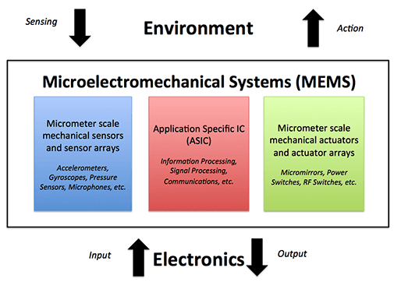
Fig 1.1 Functionality of a MEMS device
Switching and Tuning: Two common applications of RF MEMS are switching and tuning. RF MEMS switches can be used to route RF signals in a circuit, while RF MEMS tunable capacitors or resonators can be used to adjust the frequency of an RF circuit [9]. RF MEMS devices offer several advantages over traditional RF components, including low insertion loss, high isolation, low power consumption, and high linearity. They are also highly compatible with standard semiconductor manufacturing processes, allowing for integration with other electronic components on a single chip.
- FABRICATION TECHNIQUES
Surface Micromachining: In surface micromachining, thin films of various materials (e.g., polysilicon, silicon nitride) are deposited and patterned on a substrate to create the desired mechanical and electrical structures. This technique is suitable for creating simple, planar structures and is commonly used for RF MEMS switches and capacitors [17].
Bulk Micromachining: Bulk micromachining involves selectively etching the substrate to create three-dimensional structures. This technique is used to create more complex mechanical structures, such as membranes, beams, and cantilevers. Bulk micromachining can be performed using wet or dry etching techniques.
LIGA (Lithography, Electroplating, and Molding): LIGA is a technique used to fabricate high-aspect-ratio structures. It involves using X-ray lithography to pattern a thick resist layer, electroplating to deposit a metal structure, and molding to replicate the structure in other materials. LIGA is used for creating RF MEMS components with intricate 3D shapes.
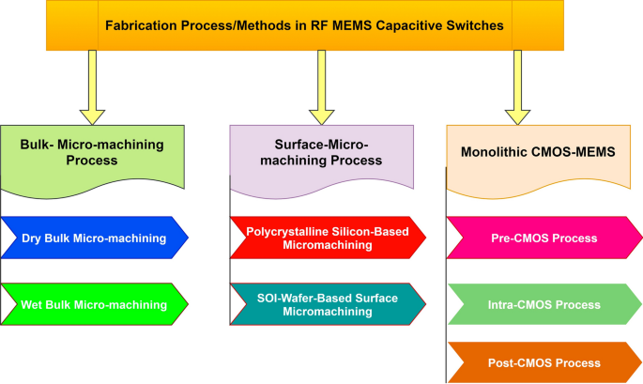
Fig 2.1 Fabrication techniques of RF MEMS
Wafer Bonding: Wafer bonding is used to create sealed cavities or encapsulate RF MEMS devices. It involves bonding two or more wafers together using various techniques such as anodic bonding, fusion bonding, or adhesive bonding. Wafer bonding is often used in conjunction with other fabrication techniques to create fully functional RF MEMS devices [32].
Release and Packaging: After the mechanical and electrical structures of an RF MEMS device are fabricated, they are released from the substrate using sacrificial layers. The released structures may then be packaged to protect them from environmental factors and to provide electrical connections.
- RF MEMS DEVICES
RF MEMS, also known as Radio Frequency Microelectromechanical Systems, represent a fascinating intersection of microfabrication and radio frequency technology. These miniature devices utilize mechanical actuation for signal processing within the radio frequency spectrum, offering unique advantages over traditional counterparts. Let's delve into three prominent RF MEMS devices: switches, varactors, and resonators, exploring their characteristics and potential applications[19].
3.1. RF MEMS Switches
Function: They control signal flow by physically switching between "on" and "off" states. Imagine a microscopic bridge opening and closing a circuit.
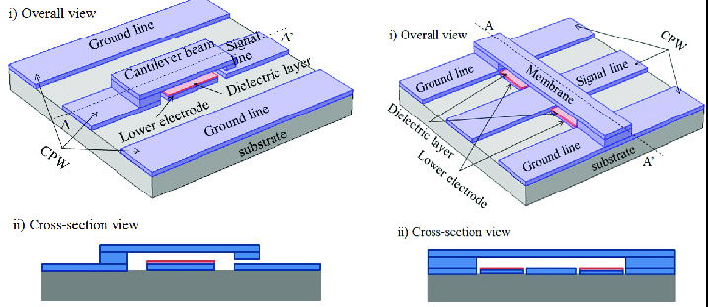
Fig 3.1 (a) Series type Fig.3.1 (b) Shunt type

Characteristics of RF MEMS Switches:
High Isolation: Excellent attenuation between "off" states, significantly reducing unwanted signal leakage.
Low Insertion Loss: Minimal signal power reduction in the "on" state, ensuring efficient transmission.
Fast Switching Speed: Capable of rapid switching between states, catering to high-frequency applications.
Compact Size: Tiny footprint compared to conventional switches, ideal for miniaturization.
Types: Cantilever switches, membrane switches, ohmic contact switches, etc.
Applications: Mobile phones, base stations, tunable filters, beamforming in phased-array antennas, etc.
3.2 RF MEMS Varactors
Function: They electronically tune capacitance by varying the gap between movable MEMS structures, like a miniature version of a variable capacitor.
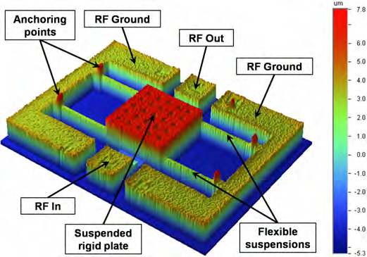
Fig 3.2 RF MEMS Varactors
Characteristics:
Wide Tuning Range: Significant capacitance variation achieved through mechanical actuation.
Low Power Consumption: Compared to electronic alternatives, they require less power for tuning.
High Linearity: Offer predictable change in capacitance over the tuning range.
Types: Parallel-plate varactors, interdigitated comb varactors, etc.
Applications: Voltage-controlled oscillators (VCOs), tunable filters, power amplifiers, antenna tuning, etc.
3.3 RF MEMS Resonators
Function: They vibrate at specific frequencies, acting as tiny tuning forks, and can filter or generate desired frequencies.
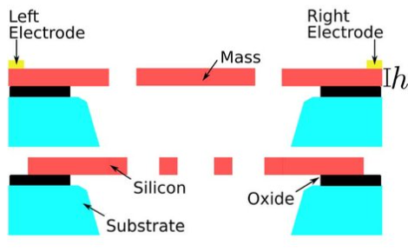
Fig 3.3 RF MEMS Resonators
Characteristics:
High Q Factor: Low energy loss during resonance, resulting in sharp frequency selectivity.
Temperature Stability: Minimal frequency drift despite thermal fluctuations.
Compact Size: Miniature footprint enabling integration into diverse systems.
Types: Micro mirror resonators, cantilever beam resonators, disk resonators, etc.
Applications: Filters, oscillators, timing circuits, sensors, gyroscopes, etc.
While RF MEMS devices offer distinct advantages, certain challenges remain. Manufacturing costs can be higher compared to conventional technologies, and reliability in harsh environments needs further improvement. Ongoing research and development efforts are addressing these challenges, leading to advancements in materials, fabrication techniques, and device design. The future of RF MEMS holds immense potential, particularly in areas like 5G communication, adaptive radio systems, and miniaturized wireless devices.
- INTEGRATION OF RF MEMS WITH IOT SYSTEMS
The miniaturization, adaptability, and low power consumption of RF MEMS devices make them attractive for integration into the ever-evolving landscape of IoT applications. However, several challenges stand in the way of widespread adoption. Here's a breakdown:
Challenges:
Cost: While fabrication costs are decreasing, they remain higher than conventional components, especially for low-volume applications.
Packaging: Protecting delicate MEMS structures from environmental factors like moisture and shock requires specialized packaging, adding complexity and cost.
Power Consumption: While generally lower than traditional alternatives, some MEMS devices, like actuators, can add to the overall power footprint of an IoT device.
Integration Complexity: Integrating MEMS devices with other electronic components on a single chip poses technical challenges due to different fabrication processes and material properties.
Standardization: Lack of standardized design and testing methods can hinder interoperability and scalability across different systems.
Strategies:
Cost Optimization: Exploring alternative fabrication techniques, leveraging economies of scale, and focusing on high-volume applications can decrease costs.
Advanced Packaging: Utilizing hermetic packages with integrated environmental sensors and microfluidic channels can protect MEMS structures and enhance reliability.
Low-Power Design: Employing energy-efficient actuation mechanisms, optimizing control circuits, and utilizing power management techniques can minimize power consumption.
Co-Integration Technology: Utilizing heterogeneous integration techniques like System-in-Package (SiP) can combine MEMS with CMOS circuits on a single chip, simplifying design and reducing size.
Standardization Efforts: Industry collaborations and initiatives like the MEMS Industry Group (MIG) are working towards establishing standard design guidelines and testing procedures.
Security: As MEMS devices play a critical role in data acquisition and communication, robust security measures are crucial to protect against vulnerabilities.
Reliability: Long-term reliability under diverse environmental conditions needs to be addressed, especially for mission-critical applications.
Application-Specific Optimization: Tailoring RF MEMS device selection and integration strategies to specific applications and their unique requirements is key for successful implementation. Integrating RF MEMS with IoT systems presents exciting opportunities, but overcoming the challenges requires collaborative efforts from researchers, engineers, and industry leaders. By addressing cost, power consumption, packaging, and standardization, RF MEMS can unlock their full potential and revolutionize the future of the connected world.
- RF MEMS TESTING AND RELIABILITY
Ensuring the functionality and long-term reliability of RF MEMS devices is crucial for their successful integration into IoT applications. Here's a breakdown of testing methods and strategies:
Testing Methods:
DC Electrical Testing: Measuring parameters like actuation voltage, contact resistance, and leakage current to assess basic functionality and potential failure mechanisms.
RF Performance Testing: Evaluating insertion loss, isolation, return loss, and bandwidth at the intended operating frequencies to ensure signal integrity.
Switching Speed Testing: Measuring the time it takes the device to switch states, critical for high-frequency applications.
Life Cycle Testing: Subjecting the device to repeated switching cycles, temperature variations, and other environmental stresses to simulate real-world conditions and identify potential wear-out mechanisms.
In-Situ Monitoring: Integrating sensors or built-in self-testing features to monitor key parameters like actuation voltage, capacitance, and resonance frequency during operation, enabling early detection of degradation.
Reliability Strategies:
Material Selection: Utilizing materials with low stress, good fatigue resistance, and compatibility with the fabrication process.
Design Optimization: Employing design techniques like stress relief structures, fatigue-resistant microstructures, and hermetic packaging to minimize wear and tear.
Process Control: Implementing stringent quality control measures during fabrication to ensure consistent material properties and device integrity.
Environmental Controls: Protecting devices from harsh environments like extreme temperatures, humidity, and mechanical shock through proper packaging and encapsulation.
Data-Driven Maintenance: Utilizing in-situ monitoring data to predict potential failures and implement preventive maintenance before critical issues arise.
5.1 Challenges And Solutions RF MEMS Testing And Reliability
Standardization: Lack of standardized testing methods and reliability metrics can complicate comparisons and data sharing. The MEMS Industry Group (MIG) works towards addressing this challenge.
Cost-Effective Testing: Balancing the need for comprehensive testing with the cost constraints of IoT devices requires innovative testing methodologies and data-driven approaches.
Long-Term Reliability Prediction: Accurately predicting wear-out and failure modes over extended periods remains a challenge, requiring advanced modeling and machine learning techniques. Testing and reliability assurance are critical aspects of integrating RF MEMS into IoT applications. By employing various testing methods, implementing design and material optimization strategies, and leveraging data-driven maintenance, we can unlock the full potential of these versatile devices and ensure their robust performance in the connected world.

- ADVANTAGES OVER TRADITIONAL TECHNOLOGIES
RF MEMS (Micro-Electro-Mechanical Systems) offer several advantages over traditional technologies in RF (Radio Frequency) applications. Here are some key advantages:
Miniaturization: RF MEMS devices can be fabricated on a small scale, enabling the miniaturization of RF components. This is particularly beneficial for portable and handheld devices where space is limited.
Low Insertion Loss: RF MEMS switches and other components can have lower insertion loss compared to traditional technologies like semiconductor diodes or mechanical relays. This results in improved signal quality and efficiency in RF circuits [21].
High Linearity: RF MEMS devices typically exhibit high linearity, which is important for maintaining signal integrity and reducing distortion in RF systems.
Low Power Consumption: RF MEMS devices can operate at low power levels, making them suitable for battery-powered devices and energy-efficient systems.
High-Quality Factor (Q Factor): RF MEMS resonators and filters can have a high Q factor, which is desirable for achieving narrow bandwidths and high selectivity in RF circuits.
High Power Handling Capability: Some RF MEMS switches and components can handle high power levels, making them suitable for high-power RF applications [22].
Wide Frequency Range: RF MEMS devices can operate over a wide frequency range, from a few megahertz to several gigahertz, making them versatile for various RF applications.
Compatibility with CMOS Technology: RF MEMS can be integrated with CMOS (Complementary Metal-Oxide-Semiconductor) technology, allowing for the integration of RF MEMS components with digital and analog circuits on a single chip.
- APPLICATIONS OF RF MEMS IN IOT
The unique attributes of RF MEMS - miniaturization, tunability, and low power consumption - make them highly attractive for various applications in the ever-evolving world of IoT. Here are some exciting use cases and examples:
7.1 Smart Sensors and Wearables:
RF MEMS switches: Enable efficient signal routing and power management within sensors, optimizing energy consumption and extending battery life. Example: Smartwatches utilizing MEMS switches for seamless switching between different sensors like GPS and heart rate monitor [24].
RF MEMS varactors: Allow on-demand tuning of sensor antennas, enhancing signal reception and improving data accuracy. Example: Wearable health monitors dynamically adjusting their antennas to optimize connectivity to different medical devices.
7.2. Connected Infrastructure and Industrial Automation:
RF MEMS resonators: Serve as miniaturized filters and oscillators, ensuring reliable data transmission and precise timing in smart cities and factories. Example: Smart meters equipped with MEMS resonators for accurate time synchronization within a large-scale energy grid.
RF MEMS switches: Facilitate dynamic beamforming in phased-array antennas used for long-range communication and radar applications. Example: Industrial robots leveraging MEMS switches for improved communication and object detection within complex environments [26].
7.3. Next-Generation Wireless Networks:
RF MEMS phase shifters: Enable beam steering and adaptive beamforming in 5G and beyond, increasing network capacity and improving signal coverage. Example: 5G base stations utilizing MEMS phase shifters for more efficient and targeted signal transmission.
RF MEMS tunable filters: Allow on-the-fly adjustments to filter characteristics, facilitating dynamic spectrum allocation and enhancing spectrum efficiency. Example: Smartphones equipped with MEMS filters adapting to different frequency bands in real-time, optimizing connection quality and power consumption.
7.4. Smart Homes and Consumer Electronics:
RF MEMS varactors: Enable tunable antennas for smart home devices, adapting to different radio protocols and improving communication flexibility. Example: Smart doorbells dynamically adjusting their antennas to connect seamlessly with various Wi-Fi networks.
RF MEMS switches: Facilitate power management and signal routing within smart speakers, optimizing energy efficiency and enhancing audio processing capabilities. Example: Smart speakers utilizing MEMS switches to efficiently manage power consumption between different audio components [27].
Developing miniaturized, low-power, and versatile communication modules for diverse IoT applications. Enhancing the security and privacy of data transmission through advanced filtering and encryption capabilities. Enabling real-time monitoring and control of devices and systems within the IoT ecosystem. Cost optimization and manufacturability need further improvement. Standardization across different device types and applications is crucial. Ensuring long-term reliability and robustness in diverse environments is key for widespread adoption.
- FUTURE TRENDS AND OPPORTUNITIES
The exciting world of RF MEMS is constantly evolving, with new materials, fabrication techniques, and device designs pushing the boundaries of what's possible. Here are some emerging trends and opportunities that pave the way for significant advancements in the IoT domain:
8.1. Material Innovations:
Piezoelectric and ferroelectric materials: Enabling new functionalities like energy harvesting and enhanced tuning capabilities.
Microfluidic integration: Allowing for real-time chemical sensing and manipulation within RF MEMS devices.
Biocompatible materials: Opening doors for applications in wearable health monitors and implantable devices.
8.2. Fabrication Breakthroughs:
3D printing of MEMS structures: Revolutionizing design possibilities and enabling rapid prototyping.
Integration with CMOS technology: Facilitating cost-effective co-fabrication of MEMS and electronics on a single chip.
Nano-scale MEMS: Pushing the boundaries of miniaturization for even more compact and energy-efficient devices.
8.3. New Device Architectures:
Reconfigurable RF MEMS: Devices that can dynamically change their functionality based on environmental conditions or user needs.
MEMS-based metamaterials: Tailoring material properties at the subwavelength scale for novel filtering and signal processing applications.
Integrated MEMS microfluidic systems: Combining MEMS with microfluidic channels for lab-on-a-chip functionalities within IoT devices.
8.4. Potential Future Applications:
Cognitive radio communications: Dynamically adapting spectrum usage and network protocols based on real-time conditions.
Intelligent sensor networks: Micro-drones equipped with MEMS sensors for environmental monitoring and disaster response.
Implantable medical devices: MEMS-based biosensors for continuous health monitoring and drug delivery.
Enhanced security and privacy: MEMS-based encryption and authentication mechanisms for secure data transmission in the IoT.
Addressing reliability and long-term performance over extended operating conditions. Developing standardized design and testing methodologies for wider adoption. Enhancing the sustainability and environmental friendliness of fabrication processes. By overcoming these challenges and leveraging emerging trends, RF MEMS technology has the potential to revolutionize the way we interact with the world around us, ushering in an era of truly interconnected and intelligent environments. This technology holds immense promise for shaping the future of the IoT, offering exciting possibilities for diverse applications that improve our lives and create a more connected and efficient world.
- CONCLUSION
While RF MEMS technology boasts immense potential for revolutionizing the Internet of Things (IoT), several hurdles stand in the way of its widespread adoption. Cost optimization, intricate fabrication processes, and ensuring long-term reliability remain key challenges demanding innovative solutions.
Despite these obstacles, the future of RF MEMS in IoT shines bright. Emerging trends like advanced materials, revolutionary fabrication techniques, and groundbreaking device architectures offer exciting possibilities. Piezoelectric materials promise energy harvesting, 3D printing unlocks design freedom, and reconfigurable MEMS and metamaterials pave the way for dynamic functionality and novel applications.
To bridge the gap between promise and reality, collaborative efforts are crucial. Addressing reliability concerns through advanced testing and design optimization is paramount. Standardizing design and testing methodologies will facilitate wider adoption and data sharing. Additionally, focusing on eco-friendly fabrication practices will ensure sustainable development.
By capitalizing on these opportunities and tackling the existing challenges, RF MEMS technology holds the potential to unlock a wave of advancements in the IoT landscape. From smart sensors and wearables to connected infrastructure and next-generation networks, the possibilities are endless. Embracing this technology can shape a future where diverse applications enhance our lives, fostering a more connected, efficient, and intelligent world.
This conclusion emphasizes the collaborative effort needed to overcome challenges and highlights the potential impact of RF MEMS on the future of IoT.
REFERENCES
- Ansari, Hamid Reza, and Saeed Khosroabadi. "Design and simulation of a novel RF MEMS shunt capacitive switch with a unique spring for Ka-band application." Microsystem technologies 25.2 (2019): 531-540.
- R. La Rosa, N. Aiello, and G. Zoppi, “RF remotely-powered integrated system to nullify standby power consumption in electrical appliances,” in IECON Conference of the IEEE Industrial Electronics Society, 2016, pp. 1162–1164.
- R. L. Rosa, C. Trigona, G. Zoppi, C. A. Di Carlo, L. Di Donato, and G. Sorbello, “RF energy scavenger for battery-free wireless sensor nodes,” in IEEE International Instrumentation and Measurement Technology Conference (I2MTC), 2018, pp. 1–5.
- V. V. Zhirnov and R. K. Cavin, “Future microsystems for information processing: Limits and lessons from the living systems,” IEEE Journal of the Electron Devices Society, vol. 1, no. 2, pp. 29–47, 2013.
- Shen, S.-C.; Feng, M. Low actuation voltage RF MEMS switches with signal frequencies from 0.25 GHz to 40 GHz. In Proceedings of the International Electron Devices Meeting 1999, Washington, DC, USA, 5–8 December 1999; pp. 689–692.
- Rebeiz, G.M. RF MEMS: Theory, Design, and Technology, 1st ed.; John Wiley & Sons: Hoboken, NJ, USA, 2003.
- Iannacci, J. RF-MEMS Technology for High-Performance Passives: The Challenge of 5G Mobile Applications, 1st ed.; IOP Publishing: Bristol, UK, 2017; pp. 1–166.
- Dubuc, D.; Grenier, K.; Iannacci, J. RF-MEMS for smart communication systems and future 5G applications. In Smart Sensors and MEMS, 2nd ed.; Nihtianov, S., Luque, A., Eds.; Woodhead Publishing: Cambridge, UK, 2018; pp. 499–539. [
- Zahr, A.H.; Zhang, L.Y.; Dorion, C.; Deveautour, A.; Beneteau, A.; Stefanini, R.; Blondy, P. RF-MEMS Switches for Millimeter-Wave Applications. In Proceedings of the European Microwave Conference in Central Europe (EuMCE), Prague, Czech Republic, 13–15 May 2019; pp. 336–338.
- Iannacci, J. RF-MEMS technology as an enabler of 5G: Low-loss ohmic switch tested up to 110 GHz. Elsevier Sens. Actuators A Phys. 2018, 279, 624–629.
- Kim, M.; Hacker, J.B.; Mihailovich, R.E.; DeNatale, J.F. A DC-to-40 GHz four-bit RF MEMS true-time delay network. IEEE Microw. Wirel. Compon. Lett. 2001, 11, 56–58.
- Nguyen, C.T.-C. Microelectromechanical Devices for Wireless Communications. In Proceedings of the MEMS 98, IEEE Eleventh Annual International Workshop on Micro Electro Mechanical Systems. An Investigation of Micro Structures, Sensors, Actuators, Machines and Systems, Heidelberg, Germany, 25–29 January 1998; pp. 1–7.
- Nguyen, C.T.-C. RF MEMS for wireless applications. In Proceedings of the 60th DRC Digest Device Research Conference, Santa Barbara, CA, USA, 20–22 June 2012; pp. 9–12
- Nguyen, C.T.-C. MEMS technology for timing and frequency control. IEEE Trans. Ultrason. Ferroelectr. Freq. Control. 2007, 54, 251–270.
- Nguyen, C.T.-C. MEMS-based RF channel selection for true software-defined cognitive radio and low-power sensor communications. IEEE Commun. Mag. 2013, 51, 110–119.
- Karthick, R.; Babu, S.P.K. Review on Radio Frequency Micro Electro Mechanical Systems (RF-MEMS) Switch. In Proceedings of the International Conference on Communication, Computing and Electronics Systems, Coimbatore, India, 21–22 October 2020; Springer: Berlin/Heidelberg, Germany, 2020; pp. 437–453.
- Cao, T.; Hu, T.; Zhao, Y. Research Status and Development Trend of MEMS Switches: A Review. Micromachines 2020, 11, 694.
- Kurmendra, K.R. A review on RF micro-electro-mechanical-systems (MEMS) switch for radio frequency applications. Microsyst. Technol. 2021, 27, 2525–2542.
- Tian, W.; Li, P.; Yuan, L.X. Research and Analysis of MEMS Switches in Different Frequency Bands. Micromachines 2018, 9, 185.
- Dubuc, D.; Grenier, K.; Iannacci, J. RF-MEMS for smart communication systems and future 5G applications. In Intelligent Devices and Microsystems for Industrial Applications, A Volume in Woodhead Publishing Series in Electronic and Optical Materials, 2nd ed.; Woodhead Publishing: Sawston, UK, 2018; pp. 499–539
- Ma, L.-Y.; Soin, N.; Daut, M.H.M.; Hatta, S.F.W.M. Comprehensive Study on RF-MEMS Switches Used for 5G Scenario. IEEE Access 2019, 7, 107506–107522.
- Saleem, M.M.; Nawaz, H. A Systematic Review of Reliability Issues in RF-MEMS Switches. Micro Nanosyst. 2019, 11, 11–33.
- Iannacci, J. RF-MEMS for high-performance and widely reconfigurable passive components—A review with focus on future telecommunications, Internet of Things (IoT) and 5G applications. J. King Saud Univ. Sci. 2017, 29, 436–443.
- Giacomozzi, F.; Calaza, C.; Colpo, S.; Mulloni, V.; Collini, A.; Margesini, B.; Vietzorreck, L. Development of high con coff ratio RF MEMS shunt switches. Rom. J. Inf. 2008, 11, 143–151.
- Angira, M.; Sundaram, G.M.; Rangra, K.; Bansal, D.; Kaur, M. On the investigation of an interdigitated, high capacitance ratio shunt RF-MEMS switch for X-band applications. TechConnect Briefs 2013, 2, 189–192. [Google Scholar]
- Park, J.Y.; Kim, G.H.; Chung, K.W.; Bu, J.U. Monolithically integrated micromachined RF MEMS capacitive switches. Sens. Actuators Phys. 2001, 89, 89–94. [Google Scholar] [CrossRef]
- Persano, A.; Quaranta, F.; Cola, A.; Taurino, A.; De Angelis, G.; Marcelli, R.; Siciliano, P. Ta₂O₅ thin films for capacitive RF MEMS switches. J. Sens. 2010, 2010, 487061. [Google Scholar] [CrossRef] [Green Version]
- Kim, M.W.; Song, Y.H.; Yang, H.H.; Yoon, J.B. An ultra-low voltage MEMS switch using stiction-recovery actuation. J. Micromech. Microeng. 2013, 23, 1–7. [Google Scholar] [CrossRef]
- Dai, C.I.; Hsu, H.M.; Tsai, M.C.; Hsieh, M.M.; Chang, M.W. Modeling and fabrication of a microelectromechanical microwave switch. Microelectron. J. 2007, 38, 519–524. [Google Scholar] [CrossRef]
- Aghaei, S.; Abbaspour-Sani, E. A low voltage vertical comb RF MEMS switch. Microsyst. Technol. 2010, 16, 919–924.
- Angira, M.; Rangra, K. Performance improvement of RF-MEMS capacitive switch via asymmetric structure design. Microsyst. Technol. 2015, 21, 1447–1452.
- Lin, C.Y.; Hsu, C.C.; Dai, C.I. Fabrication of a micromachined capacitive switch using the CMOS-MEMS technology. Micromachines 2015, 6, 1645–1654.
- Shekhar, S.; Vinoy, K.J.; Ananthasuresh, G.K. Surface-Micromachined capacitive RF switches with low actuation voltage and steady contact. J. Microelectromechanical Syst. 2017, 26, 643–652.
- Yongjaeand, I.; Filipovic, D. ANN based electromagnetic models for the design of RF MEMS switches. IEEE Microw. Wirel. Components Lett. 2005, 15, 823–825.
- Peyrou, D.; David, P.; Fabio, C.; Hikmat, A.; Fabienne, P.; Patrick, P.; Robert, P. Modeling and Simulation: A New Methodology for RF MEMS Simulation; IntechOpen: London, UK, 2008; pp. 433–452.
- Ducarouge, B.; Ducarouge, B.; Dubuc, D.; Melle, S.; Grenier, K.; Mazenq, L.; Bary, L.; Plana, R. Efficient Topology and Design Methodology for RF MEMS Switches. In Proceedings of the SPIE 5836, Microtechnologies for the New Millennium, Sevilla, Spain, 9–11 May 2005; Volume 5836, pp. 535–539.
- Lysenko, I.; Tkachenko, A.; Sherova, E.; Nikitin, A. Analytical approach in the development of RF MEMS switches. Electronics 2018, 7, 415.
- Lysenko, I.; Tkachenko, A.; Ezhova, O.; Konoplev, B.; Ryndin, E.; Sherova, E. The Mechanical Effects Influencing on the Design of RF MEMS Switches. Electronics 2020, 9, 207.
- Tkachenko, A.; Lysenko, I. High capacitance ratio radio-frequency micromechanical switch. Probl. Adv.-Micro-Nanoelectron. Syst. Dev. 2020, 3, 237–243.
- Lysenko, I.; Tkachenko, A.; Ezhova, O.; Naymenko, D. Designing high-performance radio-frequency micromechanical switches. Nanoindustriya 2020, 13, 527–541.
- Lysenko, I.; Tkachenko, A.; Ezhova, O. Research of the microelectromechanical switch with different materials of metal membrane. In Proceedings of the SPIE 11022, International Conference on Micro- and Nano-Electronics, Zvenigorod, Russia, 1–5 October 2018; Volume 10226, pp. 1–12.
- Sun, Z.; Bian, W.; Zhao, J. A zero static power consumption bi-stable RF MEMS switch based on inertial generated timing sequence method. J. Microsyst. Technol. 2022, 28, 973–984.

