Chapter 1: Basics of viruses
In the complex microscopic world, viruses emerge as mysterious beings, small but powerful, capable of changing the fabric of life. Outside the visible spectrum, virus represents a class of entities that straddle the line between living and non-living things without the cellular apparatus necessary for autonomous living, these molecular architects of illness possess an amazing capacity to enter the cellular environments of every living thing, ranging from the smallest bacterium to the most intricate multi-cellular beings, such as humans. However, despite the threat they pose, viruses have also become important tools in biotechnology and scientific discovery, revealing unexpected opportunities for treatment, disease and technological developments.
Some of the Key features of the virus are-
1. Size-
- Viruses are too small (about 20 to 300 nm in diameter) to be seen under the light microscope, hence called as ‘ultramicroscopic’.
- The amount and arrangement of the proteins and nucleic acid of viruses determine their size and shape.
- Although viruses thought to be smaller than the bacteria, certain strains of Mycobacteria can be 10 times smaller than the viruses. Most phages range in size from 24-200 nm in length (Figure 1; Table 1).

Virus size
Types | Small |  | Large
Animal viruses | Picornaviridae (Smallest animal virus, about 20-30 nm) |  | Poxvirus (Largest animal virus, around 250 to 300 micron)
Plant viruses |  | Tobacco necrosis satellite virus (smallest  plant virus-18 nm | Recently discovered very large viruses that  infect amoebas:  Megavirus-400 nm  Mimivirrus-750 nm  Pandoravirus-Elliptical or ovoid, 1000 nm  Citrus tristeza (positive sense ssRNA, largest plant virus)

Bacteriophage (25-200 nm)

Bacterium (2-3 µm)
Mimiviruses (750 nm)
Poxaviruses (250-300 nm)
Human cell (10-30 µm)
Picornaviruses (20-30 nm)

Figure 1: Virus and cell size comparison. Human viruses can vary in size but are generally in the range of 20–200 nm in diameter. In comparison, bacteria are generally 2–3 μM in length, and an average human cell is 10–30 μM.

2. Genetic material-
- Genome contains only a single type of nucleic acid (RNA or DNA). Genomes can be double (ds) or single (SS) stranded.
- A typical virus genome falls in the range of 7000–20,000 base pairs (7–20 kilobase pairs).
- While most viruses do not contain much nucleic acid, some dsDNA viruses have very large genomes: herpesviruses have genomes that are 120–200 kb in total, and the very large pandoraviruses mentioned previously have the largest genomes: up to 2.5 million bases.
- Sense and anti sense-The terms "sense" and "antisense" are relative only to the particular RNA transcript in question, and not to the DNA strand as a whole. In other words, either DNA strand can serve as the sense or antisense strand (Table 2).

Table 2: Genetic materials of viruses
Positive sense | Negative sense (antisense or minus strand) | Ambi-sense
- Positive-sense (5′-to-3′) viral RNA.  - viral RNA genome can be considered viral mRNA, and can be immediately translated by the host cell  - Eg: Coronaviridae Therefore, in positive-sense RNA viruses, the. | - Negative-sense (3′-to-5′) viral RNA  - Eg: Influenza virus.  - Complementary to the viral mRNA.  - A positive-sense RNA must be produced by an RNA-dependent RNA polymerase from it prior to translation. | - Single-stranded genome that is used in both positive-sense and negative-sense capacities  - Eg: Bunyaviruses have (3 ssRNA), arenaviruses (3 negative snese ssRNA except for part of the 5′ ends of the large and small segments of their genome).

3. Obligate intracellular parasite-
Viruses are called so since they are completely dependent upon the internal environment of the cell to create new infectious virus particles, or virions.
4. Structure-
The structure of the viruses can be determined by - X-ray crystallography, X-ray fiber diffraction, cryo-electron microscopy (cryoEM) and cryo-electron tomography (cryo-ET). The virus must be released from the host cell before it can infect other cells and individuals. Regardless of the type of nucleic acids (dsDNA, ssDNA, dsRNA, or ssRNA), the virus must protect their genomes. When exposed to external environment, the virus may experience enzymatic breakdown, physical stress (air or fluid movement that can cause nucleic acid degradation) and may be susceptible to ultraviolet radiation or electric damage. If neuclic acid undergo any of this damages, it is unable to produce new virions.
Capsid- To protect the delicate nucleic acid from the hostile environment, the virus wraps it with a protein shell known as the capsid (Figure 2), derived from the Latin capsa, which means "box." The capsid is made up of one or more different types of proteins that repeat themselves to build the whole capsid, much as how numerous bricks join together to form a wall. This repeated arrangement results in a robust but slightly flexible capsid. The capsid's tiny size makes it physically tough to break open and adequately protects the nucleic acid inside. The nucleic acid and capsid constitute the nucleocapsid of the virion. The capsid consists of a finite number of protein subunits referred to as capsomeres, typically associating with or being in close proximity to the nucleic acid within the virion. Virus capsids predominantly come in two shapes: helical and icosahedral.

Genome nucleic acid

Nucleocapsid (Capsid+Nucleic acid)

Capsid proteins

Figure 2: Virus structure of virus - Viral genome nucleic acid is protected by protein capsid. Nucleocapsid consists of both the capsid and nucleic acid.
i. Helical- In helical capsids (Figure 3), the capsomers are arranged in a helical or spiral pattern around the viral genetic material, which is often a single-stranded RNA. The entire structure resembles a helix. Examples of viruses with helical capsids include the tobacco mosaic virus (rod-shaped virus), rabies virus (bullet-shaped virus) and influenza virus (spherical shaped virus). Helical viruses can be enveloped (for eg. influenza virus, measles virus, mumps virus, rabies virus, and Ebola virus) or naked (plant virus). By far the best-studied example of a helical rod-shaped virus is the tobacco mosaic virus, which was crystallized by Wendell Stanley in 1935. The length of the helical virus capsid is determined by the length of the nucleic acid molecule, which is the framework for the assembly of the capsid protein.
Coat protein subunit

DNA

Capsid

Figure 3: Helical capsid structure
ii. Icosahedral-
- The capsomers are symmetrical, 20-sided polyhedron known as an icosahedron. This is a geometric shape with 20 equilateral triangle faces, 12 vertices, and 30 edges.

- Icosahedral viruses (Figure 4) can be naked (human papillomavirus, rhinovirus, adenovirus) or enveloped (herpesvirus, hepatitis B, influenza virus) as well. The virions have three axes of fivefold, threefold, and twofold rotational symmetry (2–3–5 symmetry).

- Viral proteins constitute the faces of the icosahedral capsid, each face being a small triangle. A face is created by assembling at least three viral protein subunits (identical or different) and forms the structural unit. This repeats to construct the complete capsid of the virion.

- The repetition of the structural unit creates larger icosahedron sides, and the number of structural units forming each side is known as the triangulation number (T). This term refers to the units shaping the triangular face of the icosahedron. In a T = 1 virus, one unit forms each face, while in a T = 4 virus, four units contribute to the face. In instances like T = 3 viruses, three units form the face, overlapping into six half-units that span adjacent faces. Similarly, T = 7 virus units are slightly skewed compared to the triangular face.

- In icosahedral viruses, capsomeres generally take the form of pentons (containing five units) or hexons (containing six units) that form a visible pattern on the surface of the icosahedrons.
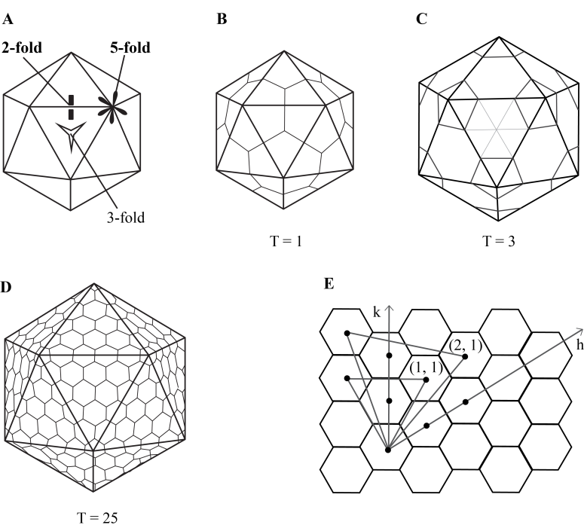
Figure 4: Icosahedral virus structure. A) An icosahedron, B) a T=1 capsid, C) a T=3 capsid, D) a T=25 capsid. E) The geometric principle for the formation of surface lattices for icosahedral structures (Karhu, 2006).
iii. Complex capsid structure-
- Some viruses have a more complex capsid structure that does not fit strictly into the helical or icosahedral categories. These viruses may have additional features, such as tails, fibers, or other irregular shapes. Examples include bacteriophages (Figure 5A & B), which infect bacteria.
- A complex capsid is a combination of helical and icosahedral shapes. Poxviruses, geminiviruses, and many bacteriophages are examples of viruses with complex structure.
- Complex capsid viruses exhibit more intricate and varied shapes. The complexity of their capsids allows for greater flexibility in accommodating genetic material and may contribute to their ability to infect a diverse range of hosts. Poxviruses, including the viruses that cause smallpox or cowpox, are large oval or brick-shaped particles 200–400 nm long. Inside the complex virion, a dumbbell-shaped core encloses the viral DNA and is surrounded by two “lateral bodies”.
Head (Icosahedral))
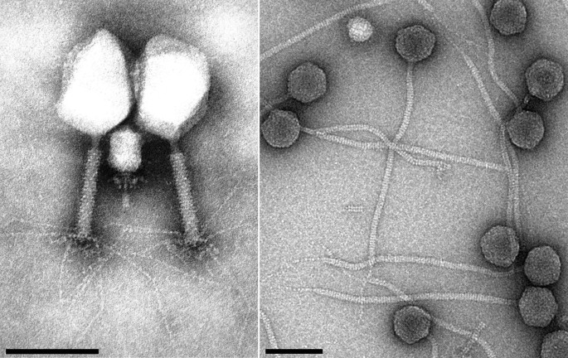
Tail fiber
Collar
Tail (Helical)
A B

Figure 5: Complex structure of bacteriophage. A. Bacteriophage under electron microscopy B. Complete structure of bacteriophage (both the icosahedral and helical forms are present).
Functionally, the capsid plays three essential roles:
- It functions as a protective barrier, shielding the genetic material from the effects of digestive enzymes.
- Utilizing specific sites within its structure, the capsid facilitates attachment to the host cell membrane.
- The capsid contains enzymes or proteins that enable the virion to penetrate host cell membranes and transport the nucleic acid into the host cells.

Envelope-
- The majority of viruses possess protective lipid membrane around the capsid, called as envelope. The envelope originates from cell membranes, typically the plasma membrane, through budding, consist of phospholipids and neutral lipids, predominantly cholesterol.
- It may also derive from endoplasmic reticulum, Golgi complex, or the nuclear membrane, depending upon virus. The envelope is connected to the capsid by matrix protein. Lipoprotein envelopes form unit membranes comprising two lipid layers interspersed with proteins (lipoprotein bilayer).
- Some of the Viruses lack the presence of envelope and are known as non-enveloped or naked virus.
- A virus attachment protein (causes the docking of the virus to the plasma membrane to facilitate virus entry) embedded in its outer-most layer and is found in the capsid (naked virus; Figure 6A), or the envelope (enveloped virus; Figure 6B).
- Example of enveloped viruses are influenza, human cytomegalovirus, HIV, respiratory syncytial virus, vaccinia virus and SARS-CoV-2; and non-enveloped viruses are adenovirus, human papillomavirus, polyomavirus.

Capsid (protein shell)
Genome
Genome

Capsid (protein shell)
Envelope
A B
B
A

Figure 6: Comparative structure of naked and enveloped virus. A. Naked virus B. Enveloped virus

Chemical properties of virus-
A. Nucleic acids-
- All viral genomes are haploid, i.e., they contain only one copy of each gene, except for retrovirus genomes, which are diploid. Viral DNA or RNA can be double-stranded (ds) or single-stranded (ss).
- By 1985, the largest genome of Epstein Barr virus was sequenced completely consisting of 172,000 base pairs (172 kilobase pairs).
- The (+) sense RNA of retroviruses is not infectious, because replication of the RNA occurs only after the production of a DNA provirus by a virion-associated reverse transcriptase.
- The genome of all DNA viruses consists of a single molecule, which is double-stranded except in the case of the parvoviruses, and may be linear or circular. The DNA of papovaviruses and hepadnaviruses is circular.
- Within the virion, the circular DNA of the papovaviruses, like that of mitochondria and bacterial plasmids, is a supercoiled circle, known as a superhelix.
- The linear dsDNA of some herpesviruses (and the linear ssRNA of retroviruses) contains repeat sequences at the ends of the molecule. The DNA of certain iridoviruses (genus Ranavirus) contains a high proportion of 5-methylcytosine instead of cytosine.
- The size of viral DNA genomes ranges from 4.5 kilobases (kb) toover 200 kbp.
- The size of ssRNA viral genomes varies from 7.5 to 22 kbp RNA, can also be defined according to its sense or polarity and is already discussed earlier.
- Certain techniques are used to extract nucleic acid- (i) organic extraction (phenol-chloroform). ii) inorganic extraction (proteinase K and salting out). iii) NCM/Nylon membrane i.e. kit method (collection, storage and isolation)
B. Protein-
1. Structural proteins: Structural proteins are the part of the virion and provide protections to the viral genome. Targeting structural proteins can disrupt the ability of virus to infect host cells and are essential for developing antiviral drugs and vaccines. These proteins are crucial for virus attachment and entry to the host cell. They are consists of:
- Capsid Proteins- Provide outer protective coat to the genetic material. It gives structural integrity. The capsid proteins are assembled in the virion to form the capsomers visible in electron micrographs. Examples of capsid proteins are-p24 of HIV, HBcAg of Hepatiis B virus, VP5 of herpes simplex virus, VP1-VP4 of poliovirus.

- Envelope Proteins- The viral envelope proteins are made up of glycoproteins (proteins with attached carbohydrate molecules) and are the smallest structural proteins. Glycoproteins promote viral fusion with the host cell membranes during cellular infection. Glycoproteins make up the peplomers projecting from the envelope. Examples are-Influenza viruses have surface glycoproteins Hemagglutinin (HA) and Neuraminidase (NA), gp120 and gp41 of HIV, L1 glycoprotein of human papillomavirus.

- Matrix (Membrane) Proteins- Enveloped viruses contain matrix proteins (most abundant protein) beneath their viral envelope. Matrix proteins connect envelope to the capsid and stabilize virus structure.. M1 protein of influenza, p17 of HIV, M protein of paramyxovirus and coronavirus.

- Spikes or Peplomers- These proteins are protruding structures on the surface of the virus, usually composed of glycoproteins. They help in attachment of the virus with host cell receptors on the cell surface and facilitates virus entry into the host cell. Spike (S) protein of SARS-CoV-2 binds to the angiotensin-converting enzyme 2 (ACE-2) receptor of human cell to facilitate virus entry. Rabies virus has 400 peplomers on its surface.

2. Non-structural proteins (NSPs): Viruses encode non-structural protein but they are not a part of mature virion particles. NSPs are multifunctional and play crucial role in virus replication, transcription, and evasion of the host immune response. Here are some common examples:

- Polymerases- Some of the viruses encode their own RNA-dependent RNA polymerases (RdRp) or DNA polymerases as non-structural proteins. These are essential for replicating the viral genome. Example- NS5 of flaviviridae, NSP12 of coronaviridae.

- Proteases- Proteases cleave viral polyproteins into functional units. This in turn helps in maturation of the virus and its ability to replicate. Examples- 3c and 2A of picornaviridae, NS3 of flaviviridae.

- Helicases- Helicases unwind the double-stranded nucleic acid during replication or transcription. Examples- NS3 of togaviridae, NSP13 of coronaviridae.

- Methyltransferases- Many viruses encode methyltransferases that modify viral RNA to evade host detection or improve translation efficiency. Examples-NSP13 of coronaviridae, VP39 of herpesviridae.

- RNA Capping Enzymes- Certain viruses have non-structural proteins responsible for adding a 5' cap structure to viral RNA. This modification is essential for the stability and translation of the viral RNA. Examples-PB2 of orthomyxoviridae, NSP14 of coronaviridae.

- Modulators of Host Immune Response- Some non-structural proteins interfere with the host cell's antiviral response. For example, they may inhibit interferon production or interfere with the host's immune signaling pathways. Examples- NS3/4A of hepatitis C virus, Vif of HIV.

C. Lipid-
In enveloped viruses, approximately 30-35% of the dry weight comprises lipids, as the envelope is derived from cellular lipids. Therefore, the lipid composition depends on the cellular membrane lipid. Phospholipid constitutes about 50-60% of the lipid and remaining are made up of cholesterol. HIV, poxviruses, influenza virus contain cellular lipid in their envelopes.

D. Carbohydrate-

While carbohydrates are commonly linked with the nucleic acid of viruses, they can also constitute components of glycoproteins. These glycoproteins consist of peplomers, with their hydrophobic ends embedded in the lipid bilayer of the envelope, while their glycosylated hydrophilic ends extended into the surrounding medium. Examples- Poxviruses incorporate internal glycoproteins within the core membrane and glycosylation can be observed in the outer capsid of rotaviruses.

Resistance:

A. Temperature- In general viruses are heat labile, inactivated within seconds at 55-60⁰C and are stable at low temperature. Therefore, viruses can be kept at -70⁰C for long term storage or can be lyophilised or freeze dried at -196⁰C. Polioviruses cannot withstand freeze drying. Enveloped viruses are susceptible to heat than non-enveloped viruses. Respiratory syncytial virus, inactivates by freezing and subsequent thawing, due to disruption of the virion by ice crystals.

B. pH- Viruses disrupt under alkaline condition. In general, viruses thrive an isotonic environment at a physiological pH. Although enveloped viruses loose their viability at pH 5-6 adenoviruses, picornaviruses and enteroviruses are resistant to acidic pH of stomach.

C. Radiations-

- UV radiation (UV-C, 200-280 nm range) has germicidal activity and is effective against viruses. It damages genetic material of viruses to prevent replication. UV-C acts as disinfection in water treatment, air purification, and on surfaces.

- Ionizing radiations (X-rays, Gamma rays) posses penetrating effect and damage genetic material of viruses. Microwave radiation is not effective against viruses.

- Solar radiation inactivates viruses naturally. Infrared does not have direct impact on virus destruction rather it can induce thermal effect which in turn can denature viral protein.

D. Disinfectants and Lipid solvents-

- The lipid bilayer of enveloped viruses are disrupted by lipid solvents (ether, chloroform, bile salts), whereas non-enveloped viruses are resistant to lipid solvents.
- Soaps and detergents can breakdown lipid membrane of enveloped viruses.
- Oxidizing agents such as hydrogen peroxide, potassium permanganate, hydrochlorites are the most effective virucidal.
- Phenolic disinfectants are weakly effective against viruses.
- Formaldehyde and beta propiolactone are virucidals used to prepare killed virus vaccine. 2% formalin can inactivate all the viruses.
- An incubation of 30 mins. at 27⁰C can kill all the enveloped and non-enveloped viruses.

Viral Multiplication:
In order to invade the host cell, the virus must attach itself to the host cell surface. Upon entering into the cell, the virus undergo uncoating that exposes its genetic material. This process allows the virus to initiate transcription and translation using host machinery. The complete steps of virus replication is described below:

1. Attachment- Viruses require specific host cell receptors (Table 3) to bind onto the cell surface. For example, presence of hemagglutinin on the surface of influenza virus that binds with the glycoprotein receptor of respiratory epithelium. Receptor destroying enzyme (RDE) prevents viral adsorption by destructing receptor binding sites. In case of SARS-CoV-2, spike protein attaches with the human angiotensin-converting enzyme 2 (ACE-2) receptors. Adequate concentration of ions are necessary to diminish electrostatic repulsion yet unaffected by temperature and energy. A cell's susceptibility is constrained by the presence of suitable receptors, and not every cell within an otherwise susceptible organism exhibits these receptors. For example, human kidney cells lack receptors for poliovirus within the organ, but receptors become apparent when renal cells are cultivated in cell culture. The presence of neuraminidase on the surface of orthomyxoviruses and paramyxoviruses can elute viruses from their receptors.

Table 3: Viral receptors

Type | Virus | Entry protein | Receptor
DNA Virus | Adenovirus | Fiber, Penton base | CAR*, integrin
 | HSV-1 | Glycoprotein D (IgD) | HveA**, nectin-1
 | Polyoma virus [Simian Virus 40 (SV40)] | VP1 | GM1 gangliosides
 | Epstein Barr virus (EBV) | gp350 | CD21
 | Parvo virus (Adeno-associated virus) | CAP*** | HSPG# (FGFR##, integrin)
RNA virus | Influenza A | Hemagglutinin | Salic acid
 | SARS-CoV-2 | Spike protein (S1) | ACE-2###
 | HIV-1 | gp160/gp120 | CD4
 | Poliovirus | Capsid shell (Vp1-Vp3) | CD155
 | Rhino virus | Capsid shell (Vp1-Vp3) | ICAM-1^{σ}
 | Rabies virus | G protein | NCAM-1^{σσ}/CD56
 | Dengue virus | E glycoprotein | DC-SIGN^{θ}
 | Reo virus | Spike protein S1 | JAM-A^{θθ}
 | Hepatitis B virus | Pre-S1 | NTCP@
 | Measles | Hemagglutinin protein | CD46, CD150
 | Vesicular stomatitis virus | G protein | Phosphatidyl serine
 | Human papilloma virus | L1 protein | Heparan sulfate, integrins
*CAR-Coxsackievirus and adenovirus receptor; ** HveA- Herpesvirus entry mediator A; ***CAP-Catabolite activator protein; #HSPG-Heparan sulfate proteoglycan; ##FGFR-Fibroblast growth factor receptor; ###ACE-2- Angiotensin-converting enzyme 2;; σICAM-1- Membrane-bound intercellular adhesion molecule-1; σσNCAM-1-Neural cell adhesion molecule 1; θDC-SIGN- dendritic cell-specific ICAM-grabbing non-integrin; θθJAM-A-Junctional Adhesion Molecule-A ; @NTCP-Sodium taurocholate–cotransporting polypeptide
;

2. Penetration-

Viruses enter into the cell through phagocytosis (Table 4) and the process is called viropexis. Penetration involves three steps:
- Virus particle moves through the plasma membrane.
- Virion enters by endocytosis and accumulates inside the cytoplasmic vacuoles
- Virus envelope fuses with cell membrane.
The first two steps are observed in the non-enveloped virus. For example, while transported through plasma membrane, the capsid of the poliovirus undergoes modification and loss of integrity. In case of enveloped viruses, the virion particles fuse with host cell membrane and release the nucleocapsid into the cytoplasm.
Table 4: Host cell entry pathway of viruses

Type of penetration (entry) | Virus
Clathrin-mediated endocytosis | Dengue virus, hepatitis C virus, reovirus, adenovirus, parvovirus B19, West Nile virus
Caveolin-mediated endocytosis | Human papillomavirus, SV40, hepatitis B virus
Fusion | HIV, influenza, respiratory syncytial virus, herpes simplex viruses, dengue virus, Ebola virus

3. Uncoating- After penetration, viral genetic material is released from its outer protective coat capsid into the cell. The nucleocapsid of some viruses (adenovirus, herpesvirus, papillomavirus) transported to the nuclear pore and the genome (DNA) is released directly into the nucleus. In orthomyxoviruses, the particle is internalized within an endocytic vesicle. An ion channel present in viral envelope induces acidification of the virus particle, causing a modification in the hemagglutinin structure. This modification facilitates the fusion of the viral envelope with the vesicular membrane, leading to the release of viral ribonucleoprotein (RNP) into the cytoplasm. In case of reoviruses, only a part of the capsid is removed and genome expressed its functions although it is not released completely from the capsid. The uncoating of the poxvirus genome occurs in two phases: during the initial stage, host enzymes remove the outer covering, while the subsequent release of viral DNA from the core seems to depend on the involvement of viral gene products produced after infection.

4. Replication- In this stage, virus regulatory proteins are synthesized, hindering normal cellular metabolism and providing instructions for the sequential production of viral components. DNA viruses synthesize nucleic acids within the host cell nucleus (excluding poxviruses, which carry out synthesis in the host cell cytoplasm). RNA viruses produce their components in the cytoplasm (with the exception of orthomyxoviruses, paramyxoviruses, and retroviruses, which partly synthesize components in the nucleus). Viral proteins are exclusively synthesized in the cytoplasm. Synthesis occurs through the following steps:

- Transcription of messenger RNA.
- Translation of mRNA into early proteins. These non-structural early proteins initiate and sustain the synthesis of viral components and activate measures to hinder host machinery.
- Replication of viral nucleic acid.
- Production of late or structural proteins, which constitute the components of daughter virion capsids.

5. Assembly- After the synthesis viral components undergo assembly to produce immature virion particles. Assembly takes place either in nucleus or cytoplasm. Non-enveloped DNA viruses typically assemble in the nucleus, utilizing nuclear pores for protein import. Larger DNA viruses may traverse the nuclear envelope, induce cell lysis, or trigger apoptosis for nucleus escape. Enveloped viruses often assemble at the plasma membrane. Helical viruses protect their nucleic acid genome with repeating capsid proteins, allowing simultaneous wrapping. Icosahedral viruses may complete capsid assembly before genome insertion. Larger icosahedral viruses, like herpesviruses and adenoviruses, utilize scaffolding proteins to orchestrate assembly.

6. Maturation- Virus maturation is a dynamic process involving conformational changes in assembled virion particles to acquire infectivity. Enveloped viruses obtain their envelope by budding from the host cell membrane, which is modified by incorporating virus-specific antigens. For instance, myxoviruses bud from the cell surface, and their envelope is derived from the altered cytoplasmic membrane.Viruses can also bud from rough endoplasmic reticulum, Golgi complex, or the nuclear envelope. The capsid encapsulates the viral genetic material, safeguarding it from external factors. Assembled virions are positioned in specific regions of the host cell, such as the cytoplasm or cellular membranes, depending on the virus type.

7. Release- This is the final stage of virus replication cycle where newly assembled mature virion particles are released from the host cell to initiate infection to the neighbouring cells. Bacterial viruses release progeny virions through infected bacterium lysis, while animal viruses typically exit cells without causing lysis. Enveloped viruses may also exit via exocytosis. Lytic viruses disrupt the plasma membrane, leading to cell lysis and the release of nascent virions for infecting new cells. Numerous non-enveloped human viruses are released through cell lysis as well. Therefore, the processes of assembly, maturation, and release are intricately connected, each essential for generating infectious progeny virions that can perpetuate the infection cycle.

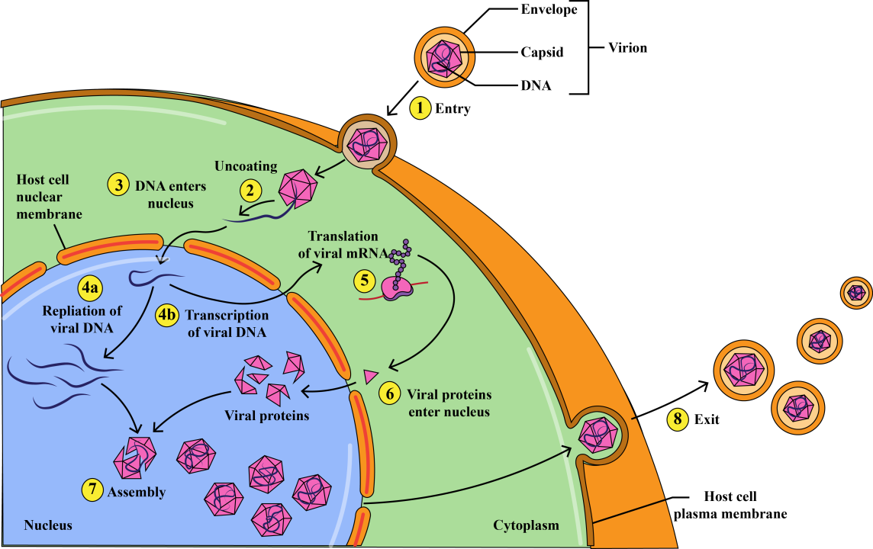

Figure 7: Virus replication

References:

Fenner, F., Bachmann, P.A., Gibbs, E.P.J., Murphy, F.A., Studdert, M.J., White, D.O., 1987. Structure and Composition of Viruses, in: Veterinary Virology. Elsevier, pp. 3–19. https://doi.org/10.1016/B978-0-12-253055-5.50005-0
Foster, J.E., Mendoza, J.A., Seetahal, J., 2018. Viruses as Pathogens, in: Viruses. Elsevier, pp. 157–187. https://doi.org/10.1016/B978-0-12-811257-1.00007-3
Karhu, N., 2006. The genome packaging machinery of dsDNA bacteriophage PRD1.

