Chapter 2 – Yeasts and Yeast-like Organisms of Medical Importance
Objectives:
Upon completion of this chapter, the reader should be able to:
- Describe the general characteristics and structures of yeast and yeast-like organisms.
- Describe risk factors for diseases caused by yeast.
- Discuss candidiasis, cryptococcosis, a disease caused by opportunistic and unusual yeasts, infection with Geotrichum candidum, Pneumocystis jirovecii infection, protothecosis, infection with Nakaseomyces glabrata, tinea nigra, tinea versicolor, and trichosporonosis.
- Identify the clinical media and culturing techniques used to process specimens from patients with suspected yeast infections (refer to the previous chapter).
- Identify the various direct tests, direct stains, media, biochemical tests, and molecular methods used to identify yeast.
- Describe the appearances of the various yeasts on corn meal-Tween, Sabdex, and CHROMagar Candida agar.
- Identify the key characteristics and crucial test results to identify and diagnose the clinically significant yeasts.
- Identify a laboratory plan to identify clinically significant yeast.

Chapter 2 – Yeasts and Yeast-like Organisms of Medical Importance
Medically significant yeast and yeast-like organisms
Yeasts are ubiquitous and will be present in various types of patient specimens and patient populations. This chapter includes the most common yeasts that cause human disease and also yeast-like fungal organisms that may cause human disease. Examination of yeast preparations will show round to oval budding cells (blastoconidia). Some cells may be elongated, forming pseudohyphae, and a few species will show actual arthroconidia and true hyphae (Geotrichum and Trichosporon). Cryptococcus spp. or Rhodotorula spp. may produce capsules. Yeasts are best grown at 25 to 30ᴼC on Sabauraud's dextrose or Sabhi agar and often grow on primary bacteriological media without inhibitors. The addition of cycloheximide will inhibit many yeast strains. Yeast typically grows as cream-colored but may be white, tan, red, orange, or dematiaceous (brown or black pigment). The two most medically common and significant yeasts are Candida albicans and Cryptococcus neoformans. Candida auris is now a top concern for hospitalized patients due to its excellent resistance to antifungal medications.
Yeasts are associated with many different fungal infections in various body sites. They cause skin, hair, and nail infections, mucous membrane infections, upper and lower respiratory infections, kidney and urinary tract infections, wounds, abscesses, disseminated fungemia, meningitis, and more. Their ubiquitous nature is a big part of why they make up three of the four top critical priorities of the 2022 first-ever fungal pathogens priority list of the WHO. (1)
Candida albicans and candidiasis
Candida albicans is global and the most frequent yeast that causes candidiasis. This gave it a critical ranking in significance in the recent WHO fungal pathogens list (#4). Generally, candidiasis is well-known to be related to milder topical skin, nail, or mucous membrane infections. But this yeast is also capable of causing severe, even life-threatening, invasive disease, as well as disseminated disease, including hematogenous route spread, candidemia, or meningitis. C. albicans is the most common cause of invasive fungal disease worldwide, currently caused by yeast. This is more common in immunocompromised and elderly hosts. In these cases, antifungal therapy must be initiated immediately to save lives. This necessitates speedy detection and identification.
On Sabaraud's Dextrose agar, C. albicans has cream-colored, smooth, waxy colonies on culture with narrow-based budding spherical to ovoid budding blastoconidia, pseudohyphae, and true hyphae. CHOMagar Candida is a differential culture medium that facilitates the isolation and presumptive identification of C. albicans and other common clinically significant yeast species. Colonies of C. albicans and C. dubliniensis appear lighter and darker green, respectively, on CHROMagar Candida. Once this yeast is first isolated, a germ tube test is performed. If the germ tube test is positive, some laboratories stop there and call the yeast Candida albicans, but to differentiate it from C. dubliensis, which is also germ tube positive, include a test for growth at 42ᴼC. C. albicans grows at 42ᴼC, and C.dubliensis does not. Both yeasts are also chlamydospore formers on corn meal/tween agar.
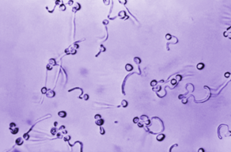
Figure 2-1. Caption: Germ tubes. This photomicrograph revealed Candida albicans fungal spores that had been suspended in animal serum specimens and allowed to grow, giving rise to filamentous germ tubes. The specimen was unstained. PHIL image library, public domain. Image: CDC/ Dr. Lucille K. Georg 1967.

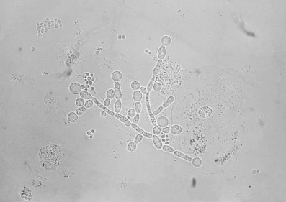
Figure 2-2. Summary: ID#9812This photomicrograph depicts Candida albicans chlamydospores present in a sputum specimen. Chlamydospores are the round terminal asexual conidia. C. albicans is a yeast that is the etiologic agent responsible for "Candidiasis." The clinical features of candidiasis depend upon whether the condition is oropharyngeal, vulvovaginal, or systemic. 2016. CDC. https://www.cdc.gov

Candida auris
Candida auris infection is challenging to control and eradicate because of the multi-resistance of this organism. It is monitored in intensive care units worldwide because of this significant resistance problem. It is a global pathogen despite just arriving on the scene when first recognized in 2009. This accounts for its critical ranking significance (#2) in the recent WHO fungal pathogens list despite the relatively low number of patient deaths currently.
C. auris is difficult to identify with phenotypic and biochemical tests or commercial biochemical identification kits. On most traditional chromogenic media, C. auris colonies usually appear white or pink, but some colonies may look red or purple. New chromogenic media have been developed that can further facilitate the detection of C. auris. This yeast is a pale cream color with a distinctive blue halo that diffuses into the surrounding agar. on CHROMagar Candida. C. auris can grow on blood or chocolate agar, so mycology-specific media are unnecessary if the laboratory does not have them. CDC and some state public health laboratories can assist with C. auris isolate identification. The appearance and color of C. auris colonies in culture may aid in species identification but cannot be used as the only identification method for C. auris. Candida auris can only be distinguished from other more common species of Candida by using other methods described below. C. auris is a budding yeast that rarely forms short pseudohyphae and does not form germ tubes. Some strains form aggregates of cells, but others do not. C. auris grows at 40–42º C unlike most other Candida species.
Currently, the most reliable way to identify C. auris is to use a diagnostic device based on matrix-assisted laser desorption/ionization time-of-flight (MALDI-TOF) that can differentiate C. auris from other Candida species. Be aware that not all the reference databases included in MALDI-TOF devices allow for detection, so verify that yours does if using this method. Molecular methods based on sequencing the D1-D2 region of the 28s rDNA or the Internal Transcribed Region (ITS) of rDNA can also be used to identify C. auris. The GenMark ePlex Blood Culture Identification Fungal Pathogen (BCID-FP) Panel and BioFire FilmArray BCID2 have been FDA-approved as molecular tests for C. auris identification in positive blood cultures. (2)
All Candida auris isolates should undergo antifungal susceptibility testing according to CLSI guidelines. Although C. auris is commonly multidrug-resistant, levels of antifungal resistance can vary widely across isolates. There are currently no established C. auris-specific susceptibility breakpoints. Therefore, breakpoints are defined based on those established for closely related Candida species and on expert opinion. See the CDC website for additional information. (3)
Figure 2-3. Caption: This image depicted a frontal view of a Petri dish culture plate containing an unknown growth medium inoculated with a strain of Candida auris fungal organisms. CDC/ NCEZID; DFWED; MDB. 2016. Shawn Lockhart. PHIL image library, public domain image.

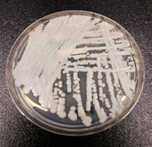
Candida dubliensis
Candida dubliensis is similar to C. albicans and can also be germ-tube-positive. It is more temperature sensitive, though, and cannot grow at 42ᴼC, while C. albicans can grow at this higher temperature. Colonies of C. albicans and C. dubliniensis appear lighter and darker green, respectively, on CHROMagar Candida. C. dubliniensis has been linked to oral candidiasis in AIDS patients, and it has recently been associated with invasive disease. (4)
Pichia kudriavzevii (formerly Candida kruseii)
Pichia kudriavzevii is clinically significant as the fifth most common cause of candidemia. However, it is most known for its innate resistance to the antifungal agent fluconazole and somewhat reduced susceptibility to other drugs. Pichia kudriavzevii (formerly Candida krusei) belongs to the group of candidiasis etiological agents. Although it is not isolated as frequently as other Candida species, the infections caused by this organism are particularly relevant in the clinical setting because of its intrinsic resistance to fluconazole. It is a yeast that inhabits the mucosal membrane of healthy individuals. However, this yeast can cause life-threatening infections in immunocompromised patients, with hematologic malignancy patients and those using prolonged azole prophylaxis being at higher risk. The risk factors for fungemia due to C. krusei include the recent surgery report (< 30 days), artificial implants, splenectomy, neutropenia, the presence of oncological conditions such as solid tumors, acute leukemia, or lymphoma as an underlying disease; bone marrow or stem cell transplantation,
Because of its strong biofilm-forming capability, C. krusei forms a pellicle on the broth surface in stationary liquid cultures. On agar media, the colonies often appear wrinkled and flat. Physiologically, C. krusei can grow on vitamin-free media and differs from other Candida spp. in several properties. The colonies of C. krusei appear pink and have a dry, rough texture with a light border on CHROMagar Candida. Corn meal/tween media reveals conidia that typically elongate, reaching 20-25 µm in length, and are said to take on a "match-stick" like appearance. It also is capable of forming true hyphae. (5)
Candida parapsilosis
Candida parapsilosis is a significant cause of life-threatening candidemia in individuals at high risk, such as ICU patients and premature neonates. It is found in younger populations as well as the elderly. The number of cases of infections with this organism is growing each year. (1,10) This pathogen has strong biofilm-forming capabilities, which give it increased tolerance to echinocandins. A significant concern with this yeast is the progressing spread of fluconazole-resistant strains, which cause outbreaks in hospitals with elevated mortality rates. The prevalence of fluconazole-resistant strains varies greatly globally, with higher rates in southern Europe, South Africa, and South America, where the rates of this resistance exceed 20%. (1) It has a high ranking and significance in the recent WHO fungal pathogens list because of its global prevalence (#11). As an opportunistic human pathogen, Candida spp. causes fungal infection in different parts of the body, known as candidiasis. Candidemia is one of the most severe known infections caused by different Candida species. Major clinical forms of candidiasis are cutaneous, mucosal, and disseminated (which can also be called invasive or systemic candidiasis). It is a severe infection that can infect blood, eyes, brain, and liver and cause disseminated disease. Immuno-compromised patients are susceptible to these infections).
Colonies of this yeast are shiny, creamy, moist, and wrinkled on Sabouraud dextrose agar. It turns rust color with age. C. parapsilosis colonies appear white to pale pink on CHROMagar Candida. Corn meal/tween agar at 25°C after 72 hours produces blastospores that are typically single or in short chains at distal ends of cells; the pseudohyphae are elongated and sometimes larger and are called "giant cells." Satellite spider colonies have a sagebrush appearance.
Candida tropicalis
Candida tropicalis is a fungus that can cause serious infections in people with weakened immune systems. Candida tropicalis is a yeast form of fungi known to be pathogenic in neutropenic hosts and disseminating through the bloodstream to peripheral organs. (6) It is closely related to Candida albicans in pathogenicity and clinical features. It is a common systemic fungus affecting persons with immune-compromised and immune-suppressed systems. The standard treatment therapies for invasive infection of Candida tropicalis are amphotericin B, echinocandins, and broad-spectrum triazole antifungals. It is also known to cause infections when the normal microbiota in the human host has been compromised by the intake of antimicrobial agents such as antibiotics or when the blood sugar levels are high in the patient. Candida tropicalis has been obtained from seawater, sea sediments, mudflats, marine fish intestines, mangrove plants, marine algae, and shrimps. It is widely distributed in tropical and subtropical marine environments. It is also found in the human gut, fruit surfaces, various foods, and soil. C. tropicalis is a more common Candida causing human disease in tropical countries. The frequency of invasive disease with C. tropicalis varies by geography, causing 3-66% of candidemia, depending on your location. Candida tropicalis is seen in cancer patients and leukemia patients with prolonged granulocytopenia. C. tropicalis is particularly virulent in neutropenic hosts. Hematogenous spread to peripheral organs is fairly common, with dissemination and eventual fungemia. Amphotericin B or an echinocandin are generally recommended as first-line treatment, with extended-spectrum triazoles acceptable alternatives for candidemia and invasive candidiasis. (7) It has a high ranking in significance in the recent WHO fungal pathogens list because of its global prevalence (#10)
On Sabouraud dextrose agar, C. tropicalis are dull, dry, semi-white, or cream-colored with a slightly mycelial border. On CHROMagar Candida, C. tropicalis colonies appear dark blue to metallic blue. On corn meal/tween agar at 25°C after 72 hours of incubation, oval blastospores are seen sparsely anywhere along hyphae in small irregular clusters. C. tropicalis can produce true hyphae. Chlamydosphores are extremely rare.
Other Candida species and other yeasts of medical importance
This chapter is in no way a comprehensive list of all the yeasts reported to be associated with candidiasis or other yeast infections. Many other Candida species, in particular, and other yeast species have been reported in mucocutaneous infections, candidiasis, and even serious invasive infections. This points to the value of speciating the yeasts you isolate in these cases to monitor medical and epidemiological trends. Generally, the methods covered here for identification can also identify these other yeasts.
Cryptococcus species
Cryptococcus neoformans causes cryptococcosis and has considerable pathology. That accounts for its critical ranking and significance in the recent WHO fungal pathogens list. (#1) This global pathogen is found in pigeons or other bird droppings and throughout nature. These yeasts are frequently inhaled and may cause a mold, subclinical primary pulmonary infection. People with chronic lung diseases like bronchitis or bronchiectasis may become asymptomatic carriers of Cryptococcus spp. Patients with symptomatic disease manifest with cough, fever, and single or multiple nodules in the mid-to-lower-lung fields on chest radiographs. (8) Many patients have dense infiltrate in single lung segments. About 18% of untreated patients develop dissemination in immune-competent patients, with the remainder demonstrating healed or "walled-off" granulomas. In patients with compromised immunity, other underlying disease, or under systemic steroid therapy, the infection disseminates more often. Meningitis is a complication in 40 to 80% of these disseminated cases, and symptoms develop rapidly in immunosuppressed patients. (1) Symptoms include a dull headache, confusion, stupor, nausea, vomiting, stiff neck, loss of balance, fever, decreased visual acuity, possible swelling of the optic nerve, and hydrocephalus. (1) CSF is clear with increased protein and decreased glucose, and typically, lymphocytes predominate, but occasional polymorphonuclear predominance happens. Dissemination can also involve hepatosplenic infection, osteomyelitis, subcutaneous infection, skin nodules, and prostatitis. The average survival of AIDS patients after a Cryptococcus diagnosis is only six months.
The two main species of cryptococcal pathogens are Cryptococcus neoformans and Cryptococcus gattii. Both are significant pathogens, and C. gattii has a high ranking as a priority in the recent WHO fungal pathogens list (#16) (C. neoformans is rated a critical priority #1). In people living with HIV, C. gattii infection has an estimated mortality rate of 10-43%, and C. neoformans has a mortality rate of 20-61%. C. neoformans infection has a mortality rate of 8-50% in patients without HIV. C. gattii, however, has a greater incidence of neurological sequelae and reconstitution inflammatory syndrome post-infection.
On Sabauraud dextrose, agar media cultures are generally mucoid or slimy in appearance. Young colonies of most species are usually non-pigmented and appear cream in color. However, red, orange, or yellow carotenoid pigments may be produced in older cultures. Bird seed agar plates can show brown colonies of C. neoformans and white colonies of Candida albicans. Cryptococcus is characterized by globose to oval yeast cells or blastoconidia that reproduce by narrow-necked budding. Pseudohyphae are usually absent or rudimentary. Most species are encapsulated, and the extent of capsule formation depends on the medium.
Laboratory testing for Cryptococcus spp. includes many rapid tests, as starting treatment rapidly is crucial. These include serodiagnostic cryptococcal antigen tests. A direct mount of the specimen in India Ink may show the classic capsules of Cryptococcus spp. Many labs include caffeic or bird seed (Niger) agar in the direct specimen setup to save time in identifying Cryptococcus spp. as dark colonies on this media. A rapid urease test on the initial growth may also be helpful. Traditional or commercial biochemical testing products, matrix-assisted laser desorption/ionization time-of-flight (MALDI-TOF), and molecular methods like PCR are available.

Figure 2-5. Summary: This photomicrograph depicts Cryptococcus neoformans using a light India ink staining preparation. Life-threatening infections caused by the encapsulated fungal pathogen Cryptococcus neoformans have been increasing steadily over the past 10 years because of the onset of AIDS, and the expanded use of immunosuppressive drugs. Русский: Cryptococcus neoformans под микроскопом.1969. Public domain. Link: http://commons.wikimedia.org/. Obtained via Picryl.
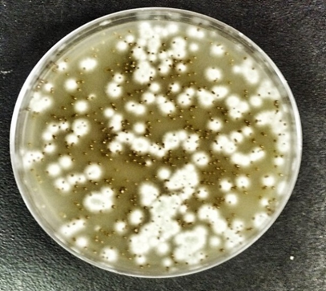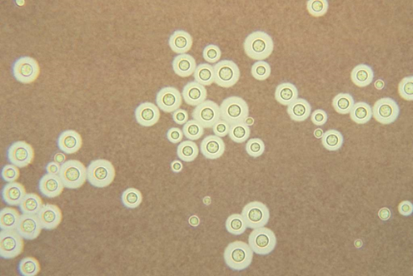
Figure 2-4. Pigmented (melanized) yeast colonies of Cryptococcus gattii (dark smaller colonies) and an unidentified mold (white) on Niger seed agar. Photo: Djspring. Creative Commons Attribution-Share Alike 3.0 license. 31 December 1969. [[File:Cryptococcus gattiiselection.jpg|Cryptococcus_gattii_selection]] Obtained from Wikimedia Commons.
Geotrichum candidum
Yeast-like Geotrichum candidum occasionally causes vaginal, oral, bronchial, and rarely fungemia and systemic disease, mainly in the immune deficient. Direct preparations of Geotrichum candidum reveal fragmented hyphae with continuous, non-alternating rectangular arthroconidia with rounded edges. (Note: To differentiate, Coccidioides immitis has alternating arthroconidia.) (8) It looks like yeast but lacks blastoconidia and is often grouped with the molds.
Hortaea wernecki (formerly Phaeoannellomyces wernecki or Exophilala wernecki)
Hortaea wernecki is a dematiaceous (black) yeast found in halophilic (salt-containing) environments. It is the etiological agent of tinea nigra, a human and animal superficial cutaneous mycosis involving either the palms of the hands or the soles of the feet. Oval yeast and branching and septate hyphae are seen in the superficial layers of the stratum corneum. It tends to infect children and young adults, predominantly females. It is found in those living in warm climates or those who have visited the tropics or the subtropics of Central and South America, Africa, and Asia. It can cause serious infections in the immunocompromised. (9)
The colonies are olivaceous to black and smooth, slimy, and yeast-like. Hyphae, conidia, and chlamydospores can be seen in wet preps. (9)

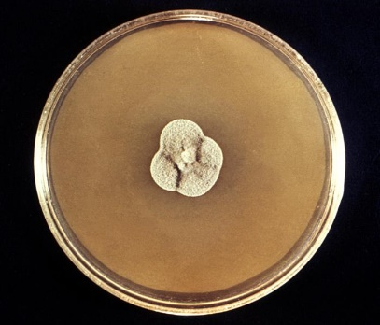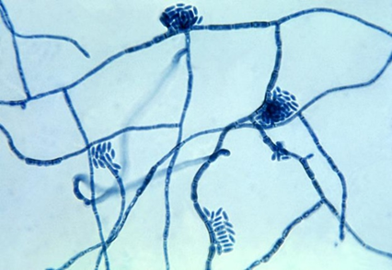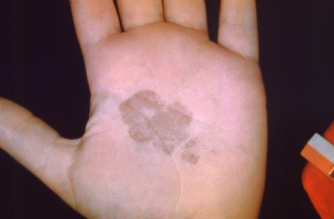
Figure 2-6. Caption: Sabouraud dextrose agar with a colony of H. werneckii. H. werneckii are slow-growing, initially mucoid, yeast-like, and shiny black at maturity. This causes tinea nigra, a superficial skin infection affecting the stratum corneum in humans. CDC/ Dr. Lucille K. Georg, 1969. PHIL image library, public domain.
Figure 2-8.Caption:The palm of this patient’s left hand shows a brown discolored, irregularly-shaped patch of skin, which was diagnosed as tinea nigra. This was caused by the fungus, H. werneckii. This condition, a form of ringworm or dermatophytosis, usually affects the superficial layers of skin on the palms and soles of the feet. These patches are smooth, with brownish coloration, and painless. CDC/ Dr. Lucille K. Georg, 1965. PHIL image library, public domain.

Figure 2-7.Caption: Under magnification of 475X, this photomicrograph of a slide culture specimen revealed some of the ultrastructural morphology exhibited by the fungal organism, Hortaea werneckii, the causative agent of tinea nigra. CDC/ Dr. Lucille K. Georg, 1964. PHIL image library, public domain.

Malassezia species

Malassezia species are lipid-loving yeasts that infect the skin and cause tinea versicolor. Tinea versicolor is a superficial skin infection that produces patchy lesions or scaling of skin with varying pigmentation changes. In light skin, the patches look a little darker, and in dark skin, they look lighter. These tinea versicolor lesions may be on the face, chest, trunk, and abdomen. See Figures 2-9, 2-10, and 2-11) Tinea versicolor infections may be related to squamous cell turnover rates as there is a higher incidence among people receiving corticosteroid therapy, decreasing the squamous cell turnover rate. Others have reported that genetic factors, hygiene, or excess sweating may also contribute to this condition. M. furfur has been implicated in disseminated infections in patients receiving lipid replacement therapy and those who are immune deficient. Malassezia also is a common endogenous skin colonizer. It has the greatest presence worldwide in hot, humid, and tropical regions.
This organism requires lipids in the media to grow. Agar plates are covered with sterile olive oil. Colonies are cream-colored, moist, and smooth. Malessezia spp. can be identified in tinea versicolor lesions by its classic "spaghetti and meatballs" appearance on direct KOH wet mount preparation or by observing the golden yellow fluorescence of the lesions under the Woods lamp during a screening examination. The fungus appears as round budding yeast and short, septate, sometimes branched hyphae in the direct KOH wet mount.
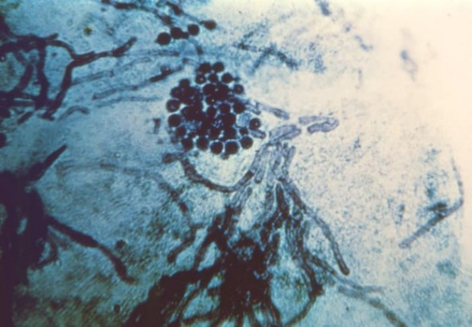
Figure 2-9. Caption: This photomicrograph revealed the histopathology exhibited by a skin scraping sample, which had been affected by a dermatophytic fungal organism, causing a condition known as tinea versicolor, also known as dermatomycosis furfuracea, or tinea flava. Note the presence of spherical, yeast-like fungal cells and short hyphae. (“Spaghetti and meatballs” appearance) Usually, tinea versicolor is caused by Malassezia spp. including M. globosa, M. furfur, and other Malessezia spp. CDC/ Dr. Lucille K. Georg 1964. PHIL library image, public domain.
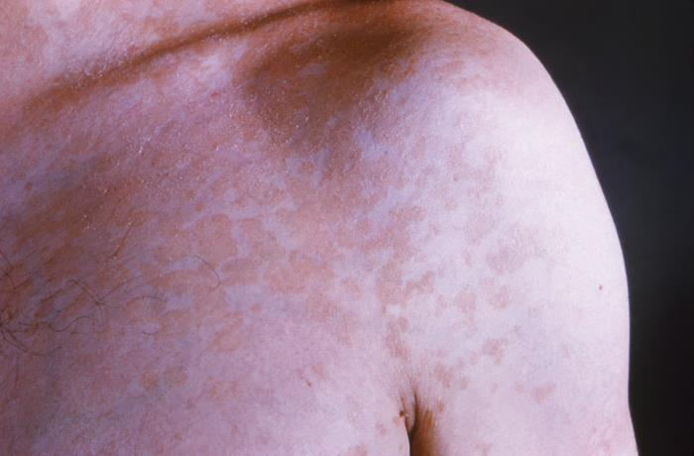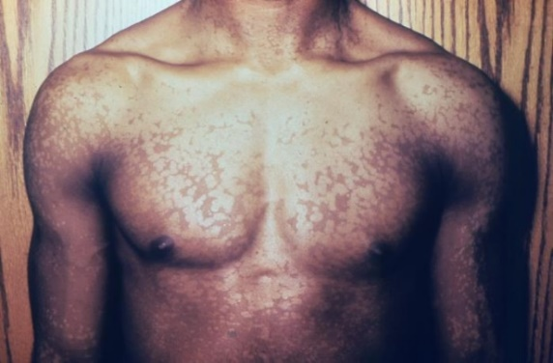
Figure 2-11. Caption: The chest of this male patient displayed a mosaic pigmentation pattern, which had been caused by a dermatophytic fungal organism, and is known as tinea versicolor. In this case, the specific dermatophyte was not disclosed, but the pattern covered his chest, upper arms, and upper abdominal regions. CDC/ Dr. Gavin Hart. PHIL image library, public domain.
.
Figure 2-10. Caption: This photograph depicted an anterior view of a patient’s left shoulder, revealing a plaque-like, blotchy, erythematous rash, that was diagnosed as a case of tinea versicolor, caused by the fungal organism, Malassezia furfur, formerly known as Pityrosporum ovale. CDC/ Dr. Lucille K. Georg. 1964. PHIL image, public domain.

It is usually cultured if found in blood cultures and more serious infections. It can be identified using special media, PCR, some strains with Maldi-Tof mass spectrophotometry, and other molecular techniques. The best media to initially grow Malassezia spp. is Dixon agar. M. pachydermatis is the only species that grows on lipid-free Sabdex. Additional media that help to speciate the Malessezia spp. are CHROMagar Malassezia medium, EL slants with castor oil, and TE slants with tween 60 and esculin for esculin hydrolysis; the catalase test is also used for speciation. (10)

Nakaseomyces glabrata (formerly Candida glabrata, before that Torrulopsis glabrata)
Nakaseomyces glabrata is a global opportunistic fungus that usually affects the debilitated. It has a high ranking and significance in the recent WHO fungal pathogens list because of its global prevalence. (#5) N. glabrata may be the second or third most common Candida strain, with its prevalence growing since the 1990s. N. glabrata infections are most likely to affect the urinary tract, from the urethra to the bladder and the kidneys, the genitals, the mouth, and the bloodstream, in the case of specific at-risk groups. This yeast usually infects the lungs and the kidneys, although it can disseminate through the blood and cause fungemia and septic shock. It is the second most common yeast isolated from blood cultures worldwide (19% for N. glabrata versus 65% for Candida albicans, 7% for Candida parapsilosis, 4% for Candida dubliniensis, 3% for Candida tropicalis, and 2% for Pichia kudriavzevii, and other yeast. Another concern with N. glabrata is its increasingly reduced susceptibility to fluconazole and echinocandins. It also is increasingly prevalent in developed countries and the immunocompromised. (11)
N. glabrata colonies on Sabouraud dextrose agar at 25°C are whitish, smooth, glossy, and glistening. On CHROMagar Candida, C. glabrata produces colonies that appear pink to purple. It can grow at 42ºC; the addition of cyclohexamide inhibits its growth. Microscopically,
it does not form pseudohyphae or hyphae (He et al., 2006). Only blastoconidia are observed on corn meal/tween agar after 72 hours of incubation at 25°C. Cells are tiny, varying from 2.5-4.0 x 3.0-6.0 μm as compared to C. albicans, which is 3.5-6.0 x 4.0-8.0 μm. (12) Direct preparations and histology stains of lung tissue may show many budding yeast cells inside of macrophages resembling Histoplasma capsulatum. The isthmus between the budding yeast cells of N. glabrata is wider than in Histoplasma spp. N. glabrata, however, is not a dimorph.
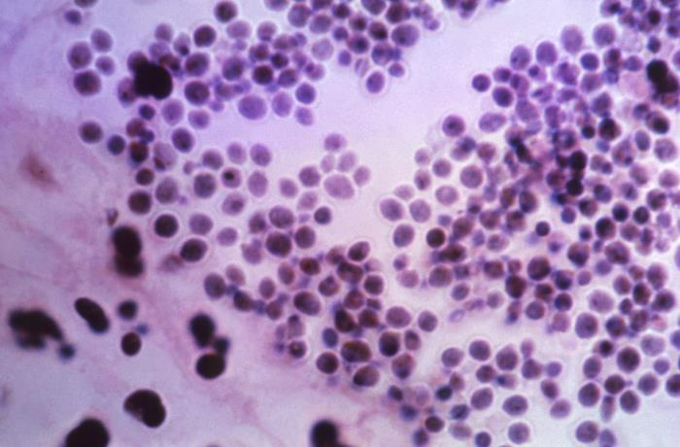
Figure 2-12. Caption: This photomicrograph of a hematoxylin-eosin (H&E)-stained sample of human kidney tissue, revealed the presence of clusters of classic yeast cells of the fungus, Nakaseomyces glabrata, (formerly Candida glabrata, and before that, Torulopsis glabrata). N. glabrata are a bit smaller than Candida spp.,CDC/ Dr. Lucille K. Georg, 1967. PHIL library, public domain.

Pneumocystis jirovecii (formerly Pneumocystis carinii)

HIV-positive patients were significantly affected by Pneumocystis jiroveci. Immunofluorescent stains via monoclonal antibodies to Pneumocystis jirovecii have a higher sensitivity and specificity than conventional stains. Sensitivity ranges from 48% to 100%, and specificity from 82% to 100%. ii in the past, but effective treatment has alleviated this situation. In the last few years, P. jirovecii pneumonia has become an important opportunistic pathogen in the immunosuppressed, especially among kidney transplant recipients and those with vasculitis. P. jirovecii pneumonia causes more than 500,000 cases annually, with 175,000 deaths. (1) P. jirovecii was ranked as a medium-priority fungal pathogen in the recent WHO report (#18). Some feel this pathogen should be moved up in the WHO list due to its disease burden, evolving epidemiological shift to immunosuppressed patients, and its treatment challenges. (1)
Pneumocystis jirovecii is challenging to culture in vitro, so the diagnosis has traditionally relied upon clinical symptoms, radiographic findings, and observing the organisms on staining of lung specimens such as bronchoalveolar lavage fluid or induced sputum. However, these staining methods have been shown to have poor sensitivity for detecting Pneumocystis pneumonia. Immunofluorescent stains via monoclonal antibodies to Pneumocystis jirovecii have a higher sensitivity and specificity than conventional stains and can be used with flow cytometry. Sensitivity ranges from 48% to 100%, and specificity from 82% to 100%. (11) New molecular methods, including polymerase chain reaction (PCR), loop-mediated isothermal amplification (LAMP), and antibody-antigen testing on less invasive samples, have been developed for the diagnosis of Pneumocystis pneumonia and show improved sensitivity or specificity. The impact of genetic variation on molecular diagnosis due to genetic polymorphisms in the organism may result in specific molecular methods, such as PCR or LAMP, being less effective for detection in certain geographic subpopulations. The impact of genetic variation on molecular diagnosis has yet to be demonstrated in the literature and needs to be researched. (13)

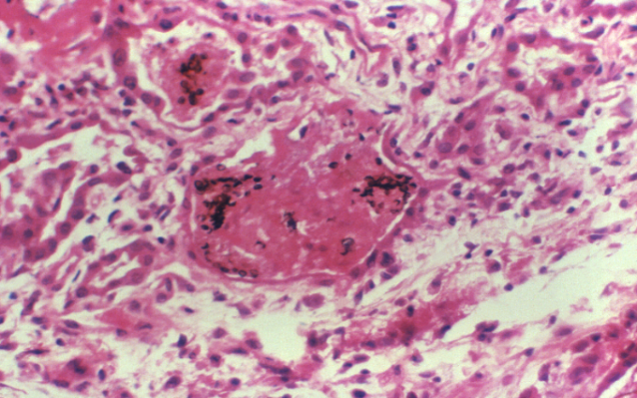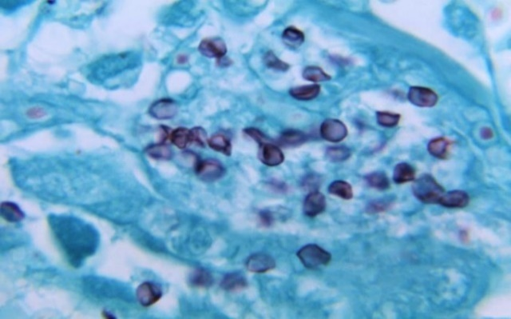
Figure 2-14. Caption: Under a magnification of 1150X, this photomicrograph of a silver stained human lung tissue specimen, revealed histopathology encountered due to a case of Pneumocystis pneumonia (PCP), caused by the fungus Pneumocystis jirovecii, formerly known as P. carinii. In this view, numerous darkly-stained cysts are visible, while intracellular bodies are not visible. CDC/ Lois Norman, M.S., 1968. PHIL image library, public domain.
Figure 2-13. Caption: Processed using a combination of the histologic stains, hematoxylin-eosin (H&E) and Grocott's methenamine silver (GMS), this photomicrograph of a human lung tissue specimen, which had been extracted from a patient ill with pulmonary pneumocystosis, revealed the presence Pneumocystis jirovecii, formerly Pneumocystis carinii, fungal organisms within the intra-alveolar spaces. CDC/ Dr. Francis Chandler. 1976. PHIL image library, public domain.

Prototheca species (yeast-like algae that can infect people)

Prototheca species are unique spherical unicellular organisms that are green algae that have lost their chloroplasts but resemble yeast when grown on agar plates. They are not yeasts or even fungi. The few Prototheca species capable of invading animals and humans and causing disease (protothecosis) are Prototheca zopfii and Prototheca wickermamii. Most human infections are caused by Prototheca wickermamii. They cause skin infections and bursitis; in immunocompromised patients, they can disseminate to cause more severe diseases. They grow on Sabdex and mold-inhibitory agar plates and grow yeast-like colonies. The characteristic "spoke-and-wheel" sporangia can be seen on direct wet slide prep with lactophenol cotton blue stain and wet mount with calcofluor white stain. Matrix-assisted laser desorption ionization-time of flight (MALDI-TOF) mass spectrometry or molecular techniques like DNA sequencing of the ribosomal internal transcribed spacer, D2 targets of the large-subunit ribosomal DNA, or 16S ribosomal RNA gene are the preferred method of identification. Identification by sequencing of mitochondrial DNA ctyb gene has been proposed as the "new gold standard" in diagnostics of protothecal infections. Prototheca spp. stain well with Gridley fungus stain, Grocott's modification of Gomori methenamine silver. Histopathology is also used to diagnose protothecosis. Tissue sent for histopathologic examination often reveals necrotizing granulomatous inflammation with organisms morphologically consistent with Prototheca. Periodic acid-Schiff stains them well, but hematoxylin and eosin–stained smears may not.(14)

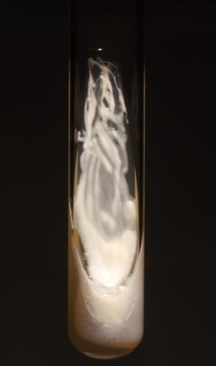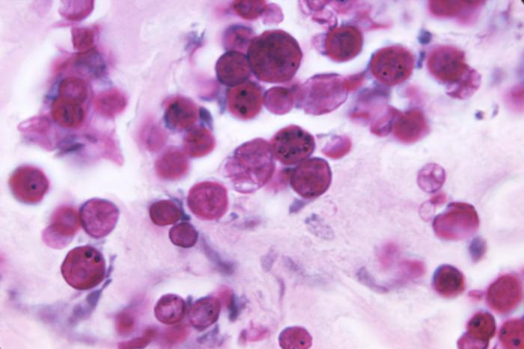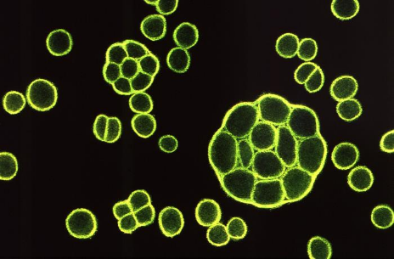
Figure 2-16. Caption: At a magnification of 1850X, this photo of a periodic acid-Schiff (PAS)-stained tissue sample, reveals the histopathology in a protothecosis case, caused by a green algae of the genus Prototheca. Though taxonomically an alga, Prototheca lack chlorophyll, and so are saprophytes, consuming dead organic matter. Prototheca spp. resemble a fungal organism when identifying these algae. CDC/Dr. Kaplan, 1971. PHIL, public domain.
Figure 2-15. Caption: This image is a Sabouraud’s dextrose agar (SDA) slant culture, which had cultivated a colony of achlorophyllic, Prototheca stagnora algal organisms. This alga lacks the presence of plastids, and is therefore, achlorophyllous. CDC, 1971. PHIL library, public domain.
Figure 2-17. Caption: This illustration depicts how use of the fluorescent antibody (FA) staining technique, used upon a tissue sample, revealed the presence of the achlorophyllic algal organism, Prototheca wickerhamii. CDC/ M. Sudman, 1972. PHIL library, public domain.

Rhodotorula species
Rhodotorula species are known for their bright salmon-pink color. They are urea-positive and have a capsule. They are not common disease agents but have been known to cause opportunistic infection rarely and can be plate contaminants.
Saccharomyces species
Saccharomyces is a genus of fungi that includes many species of yeasts. Saccharomyces species are not common agents of disease. They have been associated with pulmonary infections, oropharyngeal infections, endocarditis, fungemia, pneumonia, peritonitis, vaginitis, urinary tract infections, skin infections, and esophagitis, especially in the immunocompromised. It is now considered an opportunistic pathogen. There are a small number of cases of Saccharomyces invasive infection. Predisposing factors were similar to invasive candidiasis, with intravascular catheter and antibiotic therapy being the most frequent. Blood was the most frequent site of isolation. In most reported cases, S. boulardii accounted for a little over half of fungemias and was exclusively isolated from blood. Patients infected with S. bulardii were more frequently immunocompetent and had a good prognosis. Removing intravenous lines or doing some diligence in changing these lines is helpful. Saccharomyces invasive infection was clinically indistinguishable from an invasive candidiasis. (15)
On Sabaroud dextrose agar, they are flat or domed, smooth, moist, glistening or dull, and cream in color. The Saccharomyces produce ascospores, especially when grown on V-8 medium or ascospore agar. These ascospores are globose and located in asci. Each ascus contains 1–4 ascospores. Asci do not rupture at maturity. Ascospores can be stained with Kinyoun stain or Gram stain, where ascospores appear gram-negative and vegetative cells appear gram-positive. They do not use nitrate, but fermentation of various carbohydrates is a typical characteristic of Saccharomyces. Yeast with blastoconidia (cell buds) are observed. The yeast are unicellular, globose, and ellipsoid to elongate in shape. Multilateral (multipolar) budding is typical. Pseudohyphae, if present at all, which is unusual, are rudimentary. Hyphae are absent.
Trichosporon species (now some species are in two new genera, Apiotricum species and Cutaneotrichsporon species as well)
This group of yeasts is known for superficial skin conditions, infecting the skin and causing allergic reactions. Still, a few strains also can cause life-threatening invasive fungal disease and fungemia. Trichosporon species are pathogenic yeasts that colonize and proliferate in different parts of the human body, including the gastrointestinal tract, respiratory tract, and skin. Invasive Trichosporon infections are almost exclusively in immunosuppressed patients, such as those with hematological malignancies. Invasive trichosporonosis can be challenging to diagnose and treat. The global incidence of trichosporonosis is increasing. This group has had many new reclassifications, which can confuse the literature. The first Trichospron spp. reported was T. beigelli (now T. asahii), which causes the superficial white piedra on external hair shafts. Scientists realized that several species were being identified as T. beigelli, and they felt that many similar fungal species could cause white piedra. The most common strains causing white piedra now are Trichosporon ovoides, Trichosporon inkin, Trichosporon asahii, Trichosporon mucoides, Trichosporon asteroides, and Trichosporon cutaneum. (16) T. asahii and other Trichosporon species can also cause invasive disease in the immunocompromised.
The colonies are usually raised and have a waxy appearance, which develop radial furrows and irregular folds. Most are urease-positive. These yeasts are characterized by the unique development of hyaline, septate true hyphae that fragment into oval or rectangular arthroconidia. Some blastoconidia are also usually seen. (8)

Exophiala dermatitidis (formerly Wangiella dermatitidis)

Exophiala (formerly Wangiella) dermatitidis is a pathogen of humans that causes a disease known as phaeohyphomycosis. (8,9) Phaeohyphomycosis can be caused by many dematiaceous fungi, including Bipolaris, Cladophialophora, Cladosporium, Exophiala, Fonsecaea, Phialophora, Ochronosis, Rhinocladiella, and Wangiella. Some of these fungi may be true pathogens, but most have been recognized as opportunists; almost all cases of widely disseminated infection occur in immunosuppressed patients. Dematiaceous fungi rarely cause fatal infections in patients with intact host defense mechanisms, although some may cause brain abscesses in immunocompetent patients. Clinical syndromes include invasive sinusitis, sometimes with bone necrosis, subcutaneous nodules, abscesses, keratitis, lung masses, osteomyelitis, mycotic arthritis, endocarditis, brain abscess, and disseminated infection. Although typically referred to as a black yeast, this fungus is, in fact, a conidiogenous mold in the Ascomycota.

The yeast phases of the dimorphic fungi

The yeast phases of the systemic fungi will be considered along with the dimorphic fungi in the following chapter.

Yeast species culture, identification, and susceptibility testing

Yeast are round to oval and appear as budding cells (asexually producing blastoconidia). Some yeast form yeast blastoconidia only, and some (Candida spp.) will form cells that are elongated, forming pseudohyphae, and a few species will show actual arthroconidia and true hyphae (Geotrichum and Trichosporon spp.). Yeasts are best grown at 25 to 30ᴼC on Sabauraud's dextrose or Sabhi agar and often grow on primary bacteriological media without inhibitors. Cycloheximide will inhibit many yeast strains. Malessezia requires an agar overlay of sterile olive oil or special media. Yeast typically grows as cream-colored but may be white, tan, red, orange, or dematiaceous (brown or black pigment). First, the fungus is recognized as yeast or mold by microscopy and appearance. Yeast are unicellular organisms with no capability or minimal capability of mycelial growth. Yeasts reproduce asexually by blastoconidia formation (budding). Then, look at the other structures. The germ tube test can help differentiate Candida albicans, which form germ tubes when incubated in serum or anticoagulated rabbit plasma at 37ºC. Cryptococcus spp. or Rhodotorula spp. usually produce capsules, which helps in their rapid identification. Both of these yeasts are also urease positive. Cryptococcus spp. grows on birdseed or caffeic agar and turns black, as does Rhodotorula spp. Rhodotorula usually has a salmon-pink color on fungal media, so their appearance helps with initial identification. As Cryptococcus spp. can potentially cause serious infections such as meningitis, direct antigen detection, and serological tests are available to assist in rapid identification.
Malassezia spp. can be recognized easily if the patient's skin has the typical tinea versicolor lesions and the direct KOH prep shows the classic "spaghetti and meatballs" appearance. (See figure 1). These lesions also fluoresce under a Woods lamp upon patient examination. Please see Figure 2-1 for a standard preliminary fungal identification flowchart.
For further identification, CHROMagar Candida and biochemical testing can help speciate the Candida spp. Biochemical testing (See Table 2-1) can also help in their identification. Maldi-tof mass spectrophotometry, PCR, fluorescent antibody stains, and serological exoantigen testing can rapidly and accurately identify yeast species.
Susceptibility testing for yeasts
The Clinical Laboratory Standards Institute (CLSI) has released four publications with accepted methods for standardized fungal yeast and mold susceptibility testing and testing results for clinical laboratories. A standardized inoculum of your fungus suspension is made per recommended procedures and swabbed uniformly onto a susceptibility agar media. Mueller-Hinton agar is used. Antifungal-impregnated Kirby-Bauer disks are tamped on the media surface aseptically, and then the plate is allowed to grow. After growth is present, any zone of inhibition by the antibiotic is measured and evaluated by its identified species to establish susceptibility and resistance to the desired antifungal agent. Please refer to these published guidelines to ensure standardized results.
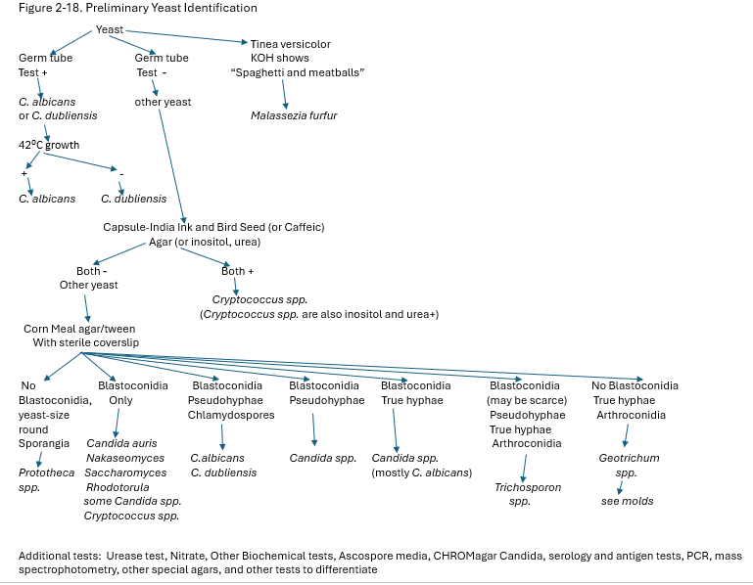

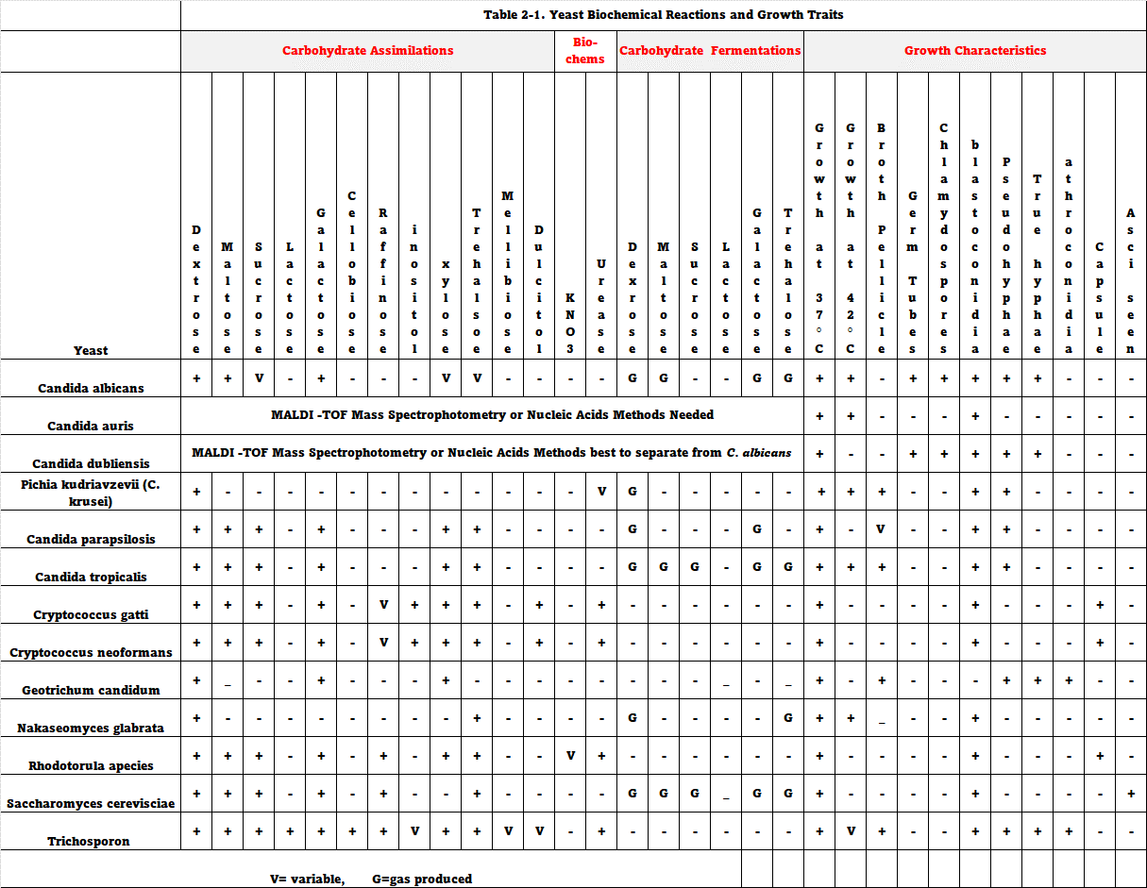
Case Study 2-1- Invasive Candidiasis with Candida albicans

A 61-year-old woman with end-stage renal disease (ESRD) presented to the ER with a fever and a rash on her wrist. She came with her blood culture report indicating yeast growth the day before this ER visit. The patient stated that she had shortness of breath, a progressively increasing cough with a production of white sputum without blood for two weeks prior, fever and chills, lung nodules, and lung cavitary lesions on a chest computed tomography (CT). She also reported pain upon urination. The patient had been receiving hemodialysis through a right-arm arteriovenous graft. Her co-morbidities were hypertension and diabetes. The yeast in her blood cultures was later identified as Candida albicans. The dialysis center sent her to the ER upon getting the report of yeast in her blood.

Physical examination revealed an obese female who was alert. She was febrile at 101 °F, her blood pressure was 162/88 mmHg, and her oxygen saturation was 97% on room air. The right-arm arteriovenous graft had good blood flow, although it had a slight swelling, and further skin exam revealed 1-mm macular lesions on the ventral aspect of her right wrist. Crackles were heard upon respiration and normal heart sounds. A urine sample was collected for culture, and it later grew >100,000 colonies/ml of C. albicans. Other results from the physical examination were unremarkable. An ultrasound image showed fluid collection around the patent arteriovenous graft. Fine needle aspiration was done under ultrasound guidance, and culture grew Candida albicans. The vascular surgeon excised the infected arteriovenous graft and placed a temporary catheter for hemodialysis. Later, when blood cultures were negative, the patient had a permanent permacath implanted. A bronchoscopy revealed white exudate and a transbronchial biopsy grew Candida albicans. Coexisting aspergillosis was ruled out due to a negative test for Aspergillus fumigatus and Aspergillus niger precipitins in this test.
The infectious disease team recommended that the patient be started on fluconazole. Repeat blood cultures were ordered and are now negative. The patient was released from the hospital with an order to complete six weeks of parenteral fluconazole therapy during hemodialysis. The patient completed antifungal treatment as an outpatient and is being followed in the dialysis center. She is currently without symptoms.

Candidiasis usually first presents as colonization, not infection. Risk factors for developing a candidiasis infection include immunosuppression, neutropenia, hematologic malignancy, long-term antibiotic use, sepsis, and total parenteral nutrition. Candidemia is the fourth most common cause of hospital-acquired bloodstream infections in the United States. (18) Invasive candidiasis is associated with high mortality in adults. Invasive candidiasis occurs when C. albicans or another Candida species enters the blood and spreads to other body sites. Risk factors for invasive candidiasis are prolonged central venous catheter placement, renal failure, surgical procedures, immunosuppression neutropenia, hematologic malignancy, long-term use of antibiotics, sepsis, and total parenteral nutrition. Radiologic presentation varies from pneumonia, nodules, micro-abscesses, miliary patterns, ground-glass opacity, thickening of the bronchial wall, pleural effusion, and rarely cavitary lesions in Candida infections in the lung.

This case was diagnosed as disseminated, invasive candidiasis because C. albicans grew in the patient's blood cultures, arteriovenous graft fluid, skin lesions, and urinary tract, and because of chest CT findings. The negative precipitin test, which looks for IgG, IgE, and IgM antibodies in the blood, rules out Aspergillus infection. (19) So, an invasive and common fungal lung infection caused by Aspergillus was excluded. Delayed initiation of therapy for invasive candidiasis will result in a significantly higher risk of death. Prompt diagnosis of disseminated and invasive candidiasis and initiation of appropriate antifungal treatment is crucial to clear the infection.

Figure 2-20. Caption: This photograph depicts a frontal view of a Petri dish culture plate, that contained a growth medium of Sabouraud dextrose and brain heart infusion (SabHI) agar, which had been inoculated with the fungus, Candida albicans, and incubated for an unknown time period, at a temperature at 20°C. These small, round colonies resulted on the medium surface. CDC/ Dr. William Kaplan. Public domain, Phil image library.
Figure 2-19. Under a low magnification of 125X, this photomicrograph of a Grocott-Gömöri’s (or Gömöri) methenamine silver (GMS)-stained lung tissue sample revealed the histopathology caused by the Candida albicans fungal organisms. A specimen harvested from a pulmonary candidiasis. CDC/Dr. Hicklin,1964. Public domain, Phil image library.

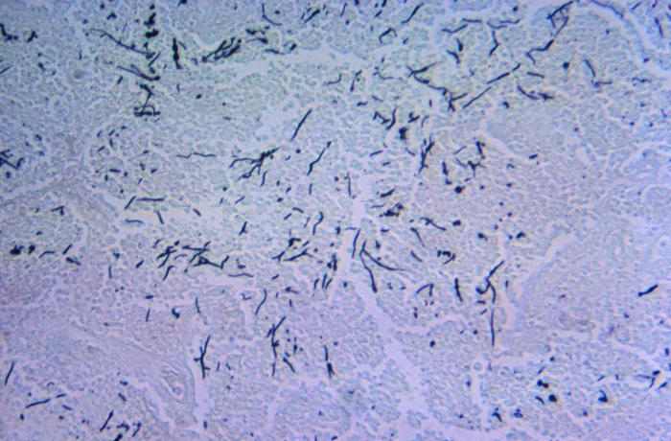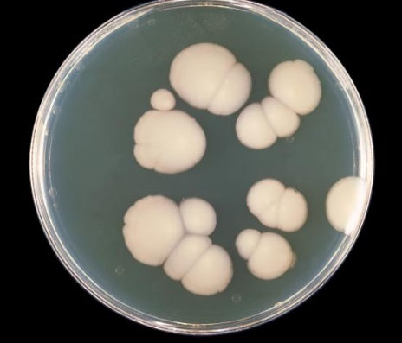

References:

- Giacomo Casalini, MD, Andrea Giacomelli, MD, Prof Spinello Antinori, PhD. The WHO fungal priority pathogens list: a crucial reappraisal to review the prioritization.
- The Lancet Microbe. Open AccessPublished:April 09, 2024DOI:https://doi.org/10.1016/S2666-5247(24)00042-9.
- https://www.cdc.gov/fungal/candida-auris/fact-sheets/fact-sheet-lab-staff.html
- https://www.cdc.gov/fungal/candida-auris/c-auris-antifungal.html
- Gutiérrez J, Morales P, González MA, Quindós G. Candida dubliniensis, a new fungal pathogen. J Basic Microbiol. 2002;42(3):207-27. doi: 10.1002/1521-4028(200206)42:3<207::AID-JOBM207>3.0.CO;2-C. PMID: 12111748.
- Cletus P. Kurtzman, Jack W. Fell and Teun Boekhout, eds.. The Yeast, Fifth Edition. 2011. The Yeasts (Fifth Edition) 2011, Pages 9-19. Elsevier Science. ISBN 978-0-444-52149-1. Yeasts Pathogenic to Humans - ScienceDirect.
- Chai LY, Denning DW, Warn P. Candida tropicalis in human disease. Crit Rev Microbiol. 2010 Nov;36(4):282-98. doi: 10.3109/1040841X.2010.489506. PMID: 20883082.
- Zuza-Alves DL, Silva-Rocha WP, Chaves GM. An Update on Candida tropicalis Based on Basic and Clinical Approaches. Front Microbiol. 2017 Oct 13;8:1927. doi: 10.3389/fmicb.2017.01927. PMID: 29081766; PMCID: PMC5645804.
- Kern, M. and Blevins, K. Medical Mycology, 2nd ed. 1997. F.A. Davis.
- Deanna A. Sutton, Michael G. Rinaldi, Stephen E. Sanche, CHAPTER 14 - Dematiaceous fungi, Editor(s): Elias J. Anaissie, Michael R. McGinnis, Michael A. Pfaller, Clinical Mycology (Second Edition), Churchill Livingstone, 2009, Pages 329-354, ISBN 9781416056805, https://doi.org/10.1016/B978-1-4160-5680-5.00014-1. (https://www.sciencedirect.com/science/article/pii/B9781416056805000141)
- Kaneko T, Makimura K, Abe M, Shiota R, Nakamura Y, Kano R, Hasegawa A, Sugita T, Shibuya S, Watanabe S, Yamaguchi H, Abe S, Okamura N. Revised culture-based system for identification of Malassezia species. J Clin Microbiol. 2007 Nov;45(11):3737-42. doi: 10.1128/JCM.01243-07. Epub 2007 Sep 19. PMID: 17881545; PMCID: PMC2168522.
- Lindberg E, Hammarström H, Ataollahy N, Kondori N. Species distribution and antifungal drug susceptibilities of yeasts isolated from the blood samples of patients with candidemia. Sci Rep. 2019 Mar 7;9(1):3838. doi: 10.1038/s41598-019-40280-8. PMID: 30846717; PMCID: PMC6405987.
- Koehler, A. P., Chu, K.-C., Houang, E. T. S., & Cheng, A. F. B. (1999). Simple, reliable, and cost-effective yeast identification scheme for the clinical laboratory. Journal of Clinical Microbiology, 37(2), 422–426.
- Bateman M, Oladele R, Kolls JK. Diagnosing Pneumocystis jirovecii pneumonia: A review of current methods and novel approaches. Med Mycol. 2020 Nov 10;58(8):1015-1028. doi: 10.1093/mmy/myaa024. PMID: 32400869; PMCID: PMC7657095.
- Cullen GD, Yetmar ZA, Fida M, Abu Saleh OM. Prototheca Infection: A Descriptive Study. Open Forum Infect Dis. 2023 Jun 6;10(6):ofad294. doi: 10.1093/ofid/ofad294. PMID: 37389225; PMCID: PMC10300632.
- Adela Enache-Angoulvant, Christophe Hennequin, Invasive Saccharomyces Infection: A Comprehensive Review, Clinical Infectious Diseases, Volume 41, Issue 11, 1 December 2005, Pages 1559–1568, https://doi.org/10.1086/497832
- Gaurav V, Grover C, Das S, Rai G. White Piedra: An Uncommon Superficial Fungal Infection of Hair. Skin Appendage Disord. 2022 Jan;8(1):34-37. doi: 10.1159/000517807. Epub 2021 Aug 5. PMID: 35118127; PMCID: PMC8787612.
- O'Donnell, L. E., Robertson, D., & Ramage, G. (2015). Candida virulence factors. https://doi.org/10.1007/978-3-662-47194-4_2
- Arshad, H., Garcia, S., & Khaja, M. (2017). Case report of invasive, disseminated candidiasis with peripheral nodular cavitary lesions in the lung. https://doi.org/10.1016/j.rmcr.2016.11.003

