Bordetella
Bordetella species were previously grouped into family bordetellaceae in order Rickettsiales. Bordetellaceae was removed from this order because of extensive differences.
Bartonella are short, gram negative, pleomorphic, rod shaped, facultative, intracellular & fastidious organism.
Bordetella comprises of several species:
- B. pertussis- It causes wooping cough in children (cough ending in a high-pitched inspiratory sound as ‘wooph’)
- B. parapertussis- Milder form of wooping cough.
- B. bronchiseptica- Pahthogen of domestic animal.
- B. avium- It causes respiratory disease in Turkeys
- B. hinzi & B. hominis- Occasionally cause bacteremia in immunocompromised persons.
Bordetella pertussis
It causes a virulent paroxysmal productive cough, wooping cough or days fever.
Virulence factors
It produces toxins and biologically active products. These products are important in pathogenesis and immunity.
Toxins
- Pertussis toxin (PT)- Most important virulence factor which possesses the gene coding for PT. PT is composed of A & B subunits. B subunit is pentameric, acts as binding fragment and helps in inserting of A fragment in cytoplasm. A subunit is active subunit, which cause ADP ribosylation of G protein. It activates adenylyl cyclase and leading to increase in cAMP concentration; which responsible for producing a variety of biological effects.
- Tracheal cytotoxin- It is part of cell wall peptidoglycan which cause damage of respiratory epithelial cell.
- Adenylate cyclase toxin- This toxin activates cAMP, which impairs the host immune system.
- Dermonecrotic toxin- It contributes in damaging of respiratory mucosa.
- Endotoxin- This toxin is similar to the toxin of other GN bacteria.
- Adhesins- It helps in bacterial attachment.
Clinical Manifestation
Wooping cough
Incubation period- 5-7 days
It passes through three stages:
- Catarrhal phase-
- last for 1-2 weeks
- highly infectious stage
- common cold like non-specific symptoms (low grade fever, mild cough, coryza, lacrimation, malaise)
- culture & smear are positive
- paroxysmal phase-
- less infectious
- specific symptoms like wooping cough
wooping cough-
- 5-10 repetitive violent spasmodic cough and every single expiration ends with an audible sound or wooph (due to rapid inspiration against a closed glottis at the end of the paroxysm)
- Frequency varies widely, from several per hour to 5-7/day
- Episodes are worst at night
- Convalescent stage-
- Frequency and severity of coughing is gradually decrease.
- Antibodies may appear in serum.
Complication
- Common in infants than among children and adults
- Pneumonia
- Neurological complication
- Pressure effect during coughing (hemorrhage, pneumothorax, rib fracture & petechiae of face and body)
Epidemiology
It is a human disease; no animal reservoir is there.
There is marked decline of disease in India after use of vaccine under Universal Immunization Programme.
- Source- Early cases are main source of infection
- Age- Below 5 years (Preschool children); Maternal antibodies are not protective; infants remain most vulnerable group. Countries with high vaccination coverage; pertussis is shift from infants to older children.
- Mode of transmission- Inhalation of droplets and rarely by direct contact
Laboratory diagnosis
1.Specimen collection
- 6 swabs with 1-20days interval to achieve maximum yield.
- Nasopharyngeal secretion by nasopharyngeal aspiration (best method)
- Nasopharyngeal secretion by nasal swab
- Throat and sputum sample are unacceptable
Swab use for collection-alginate swab followed by decron or rayon swab.
Cotton swab is not satisfactory however charcoal impregnated cotton swab (Stuart’s) may be useful.
2.Direct microscopy
Immunofluorescence test with fluorescent labelled polyclonal or monoclonal antibodies is used for this.
3.Culture
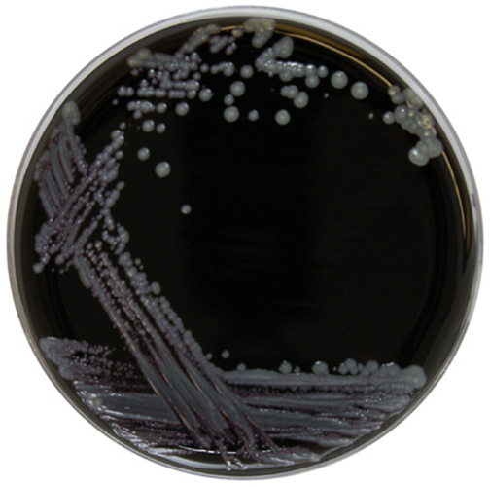
(Image: Colonies on Regan and Lowe medium)
Gold standard method of diagnosis.
It is strict aerobe, fastidious requires special medium for growth.
Medium require for growth are:
- Regan and Lowe medium
- Bordet-Gengou glycerine-potato-blood agar
- Stainer-Scholte synthetic medium
- Jones Kendrick agar
Colonies grow after 3 to 5 days which are greyish white, convex with shiny surface (mercury drop or bisected pearl)
Culture is positive in catarrhal stage and becomes negative within 5 days of starting antibiotics.
4.Culture smear
Gram’s staining is done, in which small ovoid coccobacilli arrange in loose clumps (Thumb print appearance).
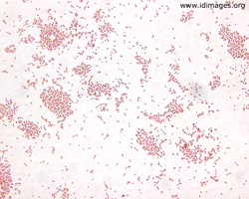
5.Molecular methods
- PCR
6.Serological diagnosis
EIA for detection of IgG antibodies in paired sera or IgA or IgM antibodies in patient’s serum.
Treatment
- It is toxin mediated so antibiotics are less useful.
- Macrolides and Cotrimoxazole is used.
Prevention
Vaccine:
- DPT Vaccine
- Acellular Pertussis Vaccine

