Polymer Quenching of EN9 Carbon Steel

¹Dr T R Vijayaram
¹Professor, Department of Mechanical Engineering, School of Mechanical Engineering, BIST, BIHER, Selaiyur, Chennai 600073, Tamil Nadu, India
E-mail: vijayaram.mech@bharathuniv.ac.in
Mobile: 0091 9205855280

²Mr.S. Nithish

Assistant Professor, Department of Mechanical Engineering, Bharath Institute of Higher Education and Research, Chennai 600073, Tamil Nadu, India

ABSTRACT
EN9 type of steels is selected to process the heat treatment by quenching to increase the hardenability of a material. EN9 steel is cut into small work samples with diameter 25mm and length 15mm to analyze. Then they are polished the cut surface in a fine manner. Microstructure and hardness are to be found for EN9 work pieces before heat treatment at different locations like at origin, 2.5 mm, 5 mm, 7.5 mm and 10 mm from origin. The cut work pieces are then placed in muffle furnace and heated at 810º - 840º, predetermined temperature range with soaking time 40 minutes. Then once they are heated, immediately they are quenched in a polymer quenchant (PVA) at different concentrations in a vessel by using tongs. Then, the microstructure and hardness is compared for EN9 material before heat treatment and after heat treatment with polymer quenching media to obtain the result. Graphs like location Vs hardness and polymer quenching media Vs average hardness were drawn.

Keywords: EN9, Heat treatment, Polymer quenchant, Poly Vinyl Alcohol, carbon steel
INTRODUCTION
EN9 steel is also known as C55 carbon steel. EN9 is one of the plain carbon steel having 0.5% - 0.60% of carbon in its composition. So, it is called as medium carbon steel. Medium carbon steel contains 0.3%-0.6% of carbon content. The hardening temperature of this material ranges between 810 – 840ºC. Table 1 shows the standard chemical composition of EN9 product. The percentage of EN9 material's chemical composition [1]
Table 1 standard chemical composition of EN9 product
Material | C | Si | Mn | S | P | Fe
EN9 | 0.50 - 0.60 | 0.05 - 0.60 | 0.50 - 0.80 | 0.060 max | 0.060 max | rest

HEAT TREATMENT PROCESS

The process of heat treatment is a technique used to modify the microstructure and, consequently, mechanical properties of metals and alloys by heating them above their critical temperature and cooling them at predetermined rates. Through the process of heat therapies, metals and alloys can acquire desirable qualities. The needed qualities are typically achieved in a straightforward and affordable manner using heat treatment. However, negligent, or inadequate heat treatment can cause additional damage than good. To achieve the best outcomes, mechanical specialists must thus have a thorough understanding with heat treatment and how it relates to other manufacturing methods[2].

Purpose of heat treatment
- To relieve internal
- To provemachinability.
- To refine grain size.
- To increase hardness.
- To improve mechanical properties (like tensile strength, hardness, ductility shock resistance, etc.).
- To improve magnetic and electricalproperties
- To increase resistance to wear, heat and corrosion.
- To improve ductility and toughness.
- To change the chemical composition[3].

QUENCHING:
Quenching refers to accelerated cooling. The hardening process is the process of heat-treating steel to make it harder by freezing it. Hardness often denotes the results of heat-treating processes that provide completely or mostly martensitic microscopic structures[4].
PURPOSE OF HARDENING
The main purposes of hardening are:
- To harden the steel toresist wear.
- To enable it to cut other metals.

INTRODUCTION TO QUENCHANTS
A controlled way of dissipating heat from items that are hot is achieved with quenchant media. The physical value of cooling durations and the resulting cooling rate, which is very easy to measure, are utilized to quantify this fundamental demand. This number can be used to calculate the precise cooling rate needed to produce the necessary hardness, or micro-crystalline structure. The various kinds of quenching medium include monomer quenchants, water, oil, and saltwater solution[5].
Water:
Quenchants that dissolve in water can be used in dip-bath and spray treatments. The components to be treated are lowered into a tank containing the quenchant in dip-bath lines. Usually, propellers or circulation pumps keep the quenchant moving. This movement should ideally be in the shape of a flow that makes use of the whole layer of the element in question[6].
Oil:
Applications using dip-baths are the main purpose for quenching oils. The oils are kept in quenching storage containers, which are used to decrease the components for treatment. This can happen in batches on support frames, as loose parts coming off a conveyor belt, or mechanically or manually. Quenching oils are often utilized at temperatures ranging from 40 to 90 °C. It is even possible to heat some types of oils to 200 °C or higher. The use of quenching oils carries an inherent risk of fire[7]. Additionally, freezing with oils may produce fumes that are harmful to health, whatever the product's quality. If preserved properly, dampening oils have an almost infinite service life, in contrast to water-miscible quenchants.
Brine solution: It refers to aqueous solutions containing different percentages of salts, such as sodium chloride or calcium chloride.
POLYMER QUENCHANTS:
Polyvinyl Alcohol (PVA) : The use of aqueous solutions of polyvinyl alcohol (PVA) as quenching media was first described in U.S. Patent 2,600,290, issued in 1952. It may be regarded as an early forerunner of contemporary plastic quenchants. Hydrolyzed forms of PVA also have been used as lubricants for special purposes and as a sizing, coating for glass fiber products[8].
The type of vinyl resin used and the intended rate of cooling during the quenching process will determine the concentration of vinyl resin in the aqueous quench liquid. The amount present in the form of vinyl resin will typically be between 0.1 and 10% by weight. It is possible to significantly mimic the cooling properties of the several widely used quenching oils by properly adjusting the vinyl resin component of the quench solutions. It is also possible to reduce the cooling rate of the quenched liquid to less than a liter of oil by raising the vinyl resin concentration to 3% or more. In a comparable vein it may be possible to make the liquid cool more quickly than the oil by reducing the vinyl resin percentage to a range of around 0.1 to 1% by weight[9].
The heat-treating procedure for steel involves first heating it to the level at which it begins to become stronger, and then immersing it in an aqueous liquid that contains between 0.5 and 3% by weight of hydrophilic resin(Table 2).
Table: 2. PVA density and PVA concentration relationship

PVA (%) | PVA Concentration (g/L)
0.1 | 1
0.2 | 2
0.5 | 5
1 | 10
1.5 | 15
2 | 20
3 | 30

HARDNESS TEST:
The test of hardness is used to determine how resilient a material is to scratching and penetration. This test technique works well with machined or completed items with basic forms[10].
SEM
After completing polishing and etching the samples were taken for microstructure study of the surface characteristics of the metal. After preparation of metallography specimen, the polished samples of both untreated and treated specimens were taken for microstructure determination using Scanning Electrical Microscope as shown in the below (Fig 24). Using SEM the microstructure is seen and captured the grain growth of the above polished samples with a magnification of 100X.
RESEARCH OBJECTIVES
- To determine the mechanical property like hardness of EN9 material in the as-cast conditions.
- To subject the steel to suitable heat treatment ie. Heating in muffle furnace with a pre-determined temperature around 810º - 840ºC with predetermined time or soaking time 40 minutes.
- To carry out the quenching process in a polymer quenching media (polymer quenchant, PVA) with different concentration.
- To carry out hardness test on as-bought conditions and heat-treated conditions.
- To study the micro constituent phase identification using Optical Microscope (OM) or Scanning Electronic Microscope (SEM) and study the microstructure on heat treated samples and in as-bought condition.
- To compare the hardness values before heat treatment and after heat treatment.
- To check whether the polymer quenching gives uniform results or not[11].
RESEARCH METHODOLOGY
1. Selection of material.
2. Preparation of work samples.
3. Preparation of polymer quenchant.
4. Heat treatment of work samples.
5. Mechanical testing or Hardness testing before heat treatment and after heat treatment.
6. Metallography.
Selection of material:
The EN9 material is chosen for investigation. EN9 is one of the plain carbon steel having 0.50 – 0.60 % of carbon in its composition. So, it is called as Medium Carbon Steel. The standard chemical composition of EN9 material (table 3)
Table 3. Chemical composition of EN9 material in %
Material | C | Si | Mn | S | P | Fe
EN9 | 0.50 - 0.60 | 0.05 - 0.60 | 0.50 - 0.80 | 0.060 max | 0.060 max | rest

Preparation of work samples:
The material that we procured from the vendor was of EN9 material in the form of long rod. It is cut into small pieces of following size(fig.1,2).
Diameter of each sample = 25mm
Length of each sample is = 15mm
Total number of samples = 14 units
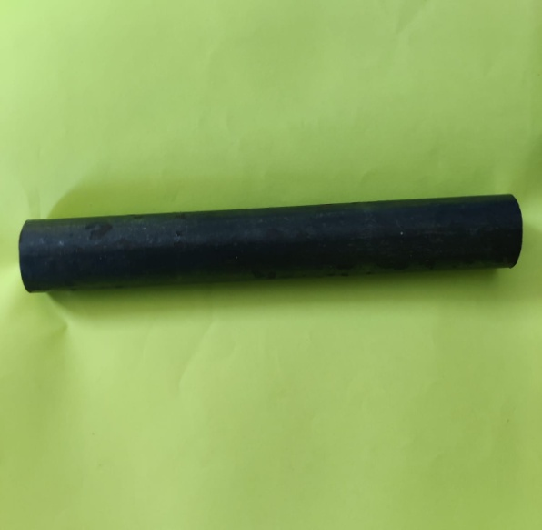
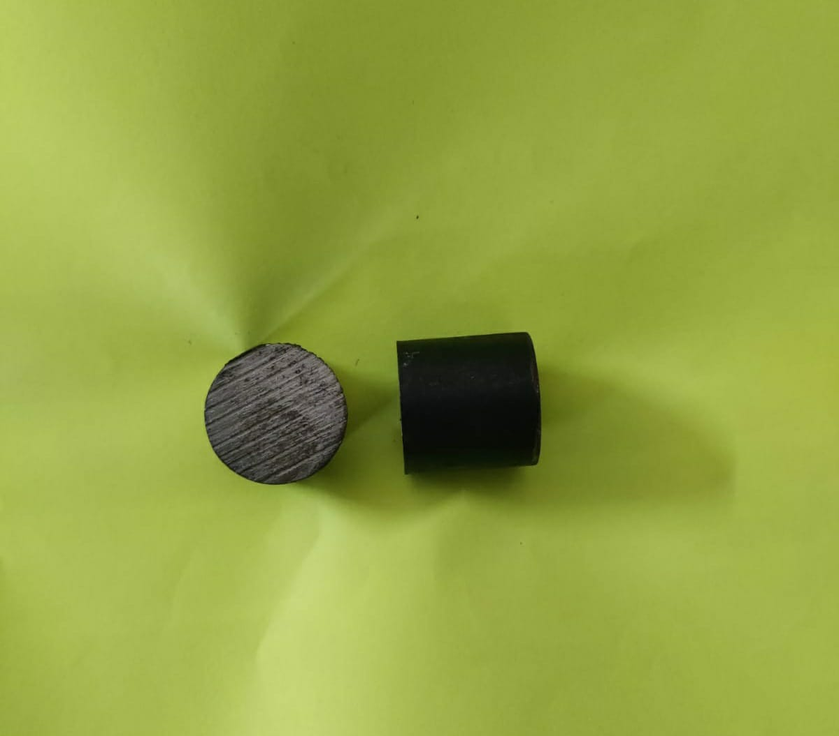
Fig 1.EN9 rod Fig 2.EN9 work samples
Preparation of Quenchants:
The polymer quenching medium chosen is PolyVinyl Alcohol. Polymer quenchant is prepared by selecting the concentrations(table 4).
- Polymer quenchant with different concentration – 5 litres ( PVA + Water)9fig.3)
Table 4. Preparation of polymer quenchant (PVA + Water)
Sample | PVA (%) | PVA concentration (g/L) | PVA concentration (g/5L)
1 | 0.1 | 1 | 5
2 | 0.2 | 2 | 10
3 | 0.5 | 5 | 25
4 | 1 | 10 | 50
5 | 1.5 | 15 | 75
6 | 2 | 20 | 100
7 | 3 | 25 | 150

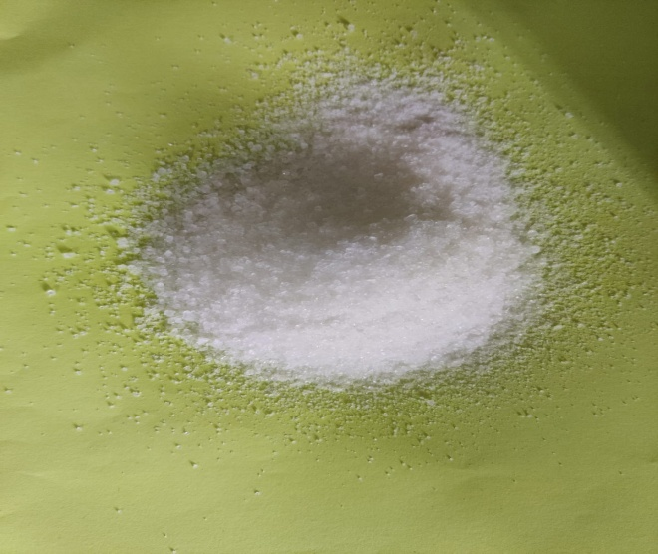
Fig 3. PVA powder
Heat treatment of work samples
The cut work pieces or samples are placed in a muffle furnace (Fig 4) for heating at a predetermined temperature of 810ºC - 840ºC over a period of predetermined time 40 minutes, which is also known as soaking time. Once the samples reaches maximum temperature of 840ºC with 40 minutes soaking time, they are taken out from the furnace by tongs and then they are quenched immediately in polymer quenchant with different concentration (Fig 5,6,7,8,9) in a vessel at room temperature. After quenching, samples are marked (Fig 10).
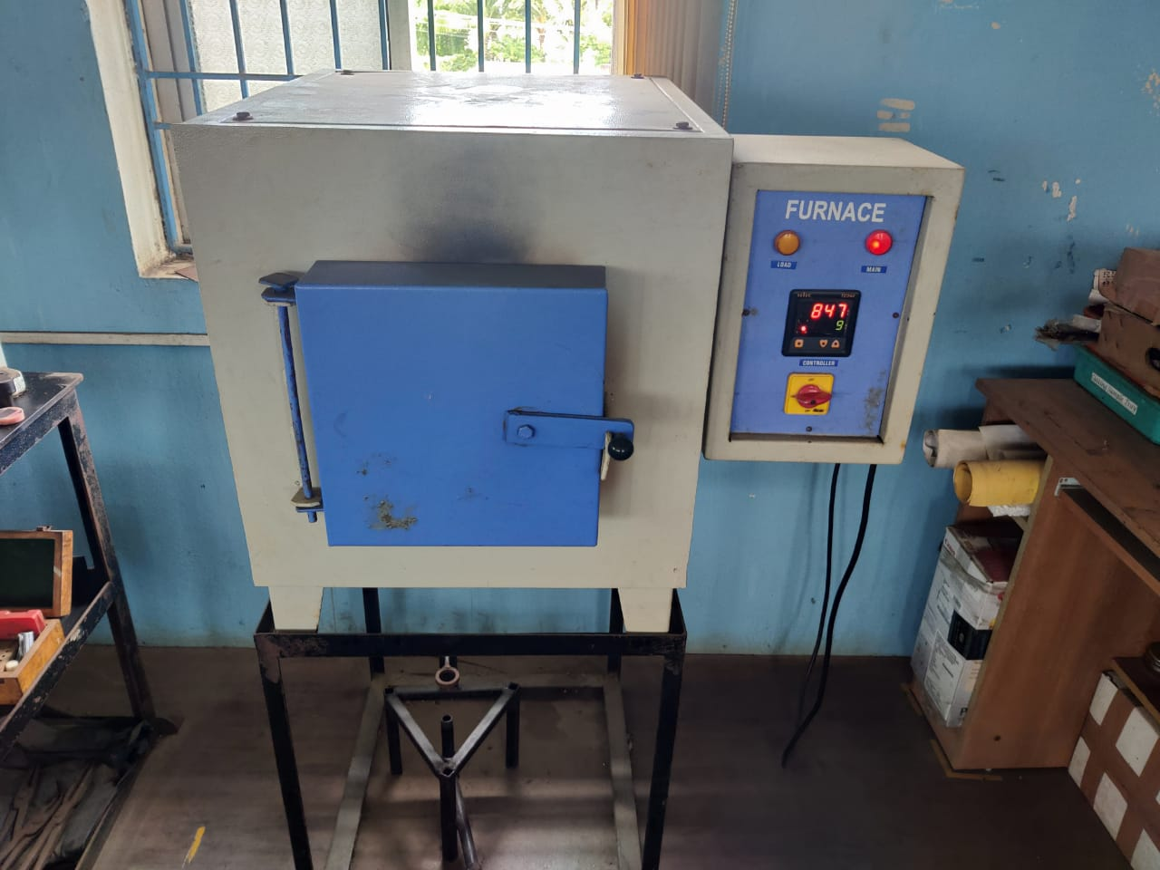 | 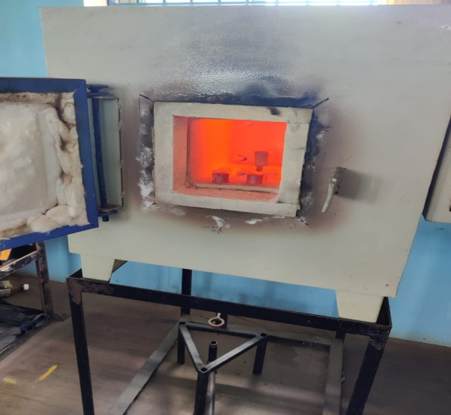
Fig 4.Muffle furnace
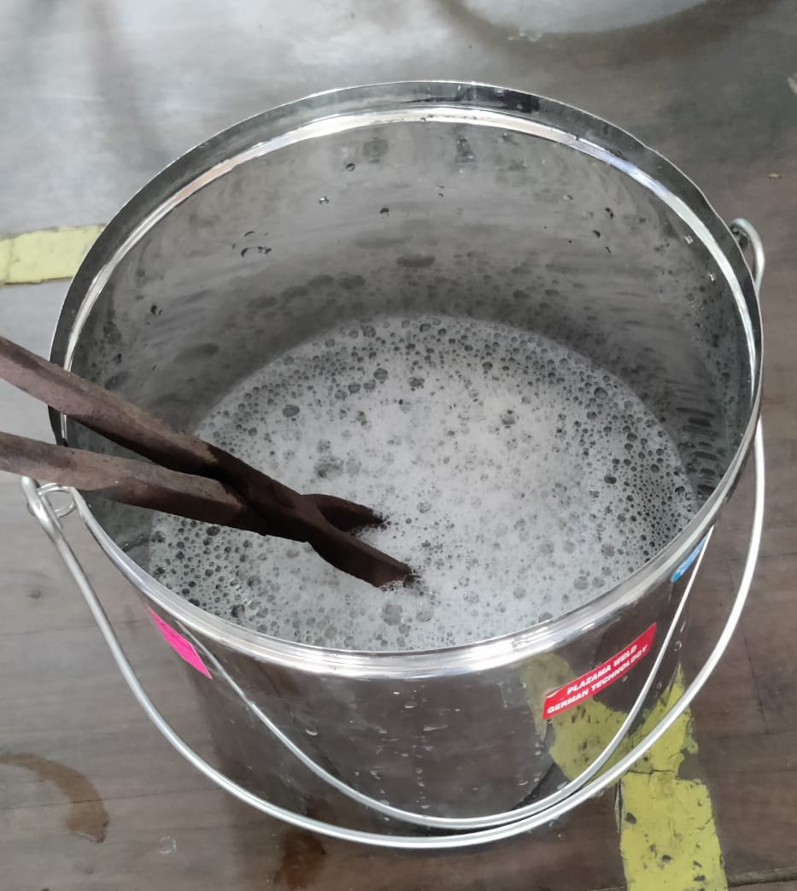  Fig5. PVA 0.5% | 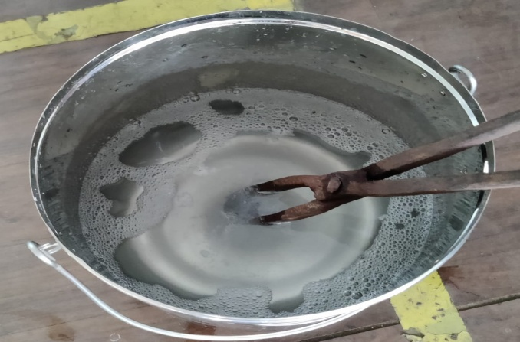  Fig6. PVA 1%
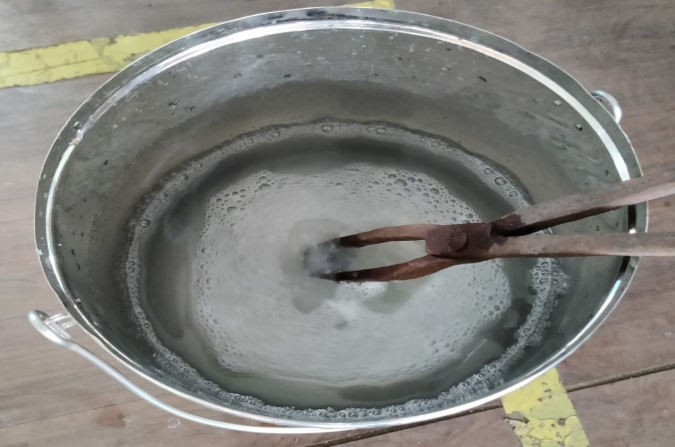  Fig 7. PVA 1.5% | 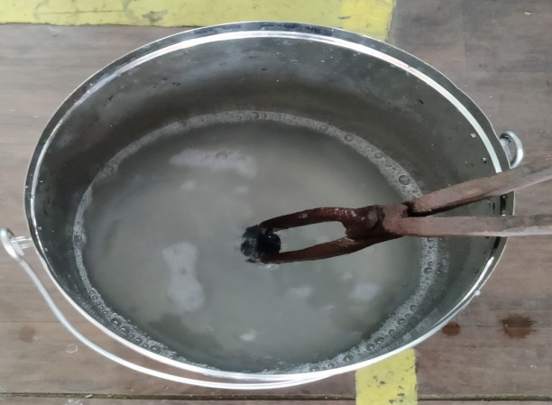  Fig 8. PVA 2%
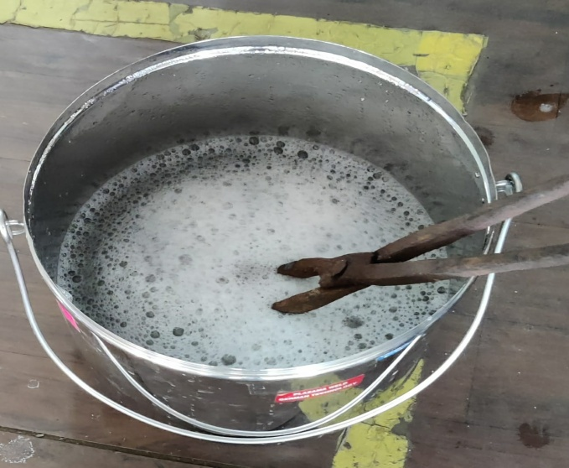  Fig 9. PVA 3% | 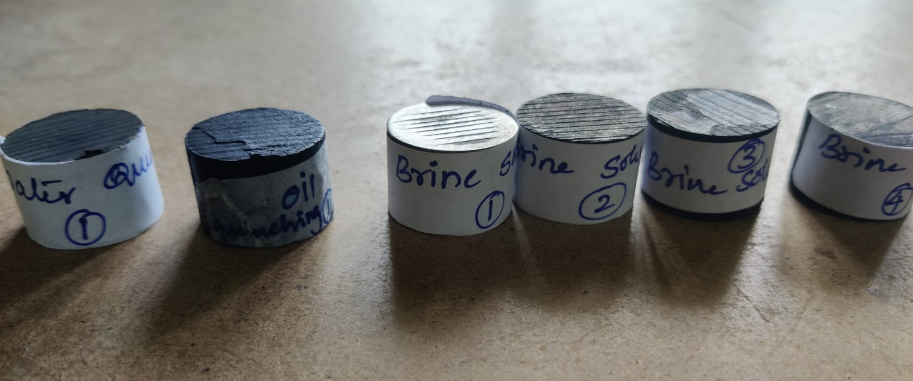  Fig 10. Sample marking

MECHANICAL TESTING
Initially the hardness test was performed for the base material or parent material or untreated material sample. The hardness test performed is Rockwell hardness testing machine (Fig 11). The hardness test is performed on work samples in different locations. The above procedure is followed for all the work samples to determine the hardness at different locations for untreated and heat treated work samples. The hardness test is done on the work samples at location origin ie. Mid point 0,2.5mm, 5mm, 7.5mm, 10mm from the origin on a circular face of a work samples.

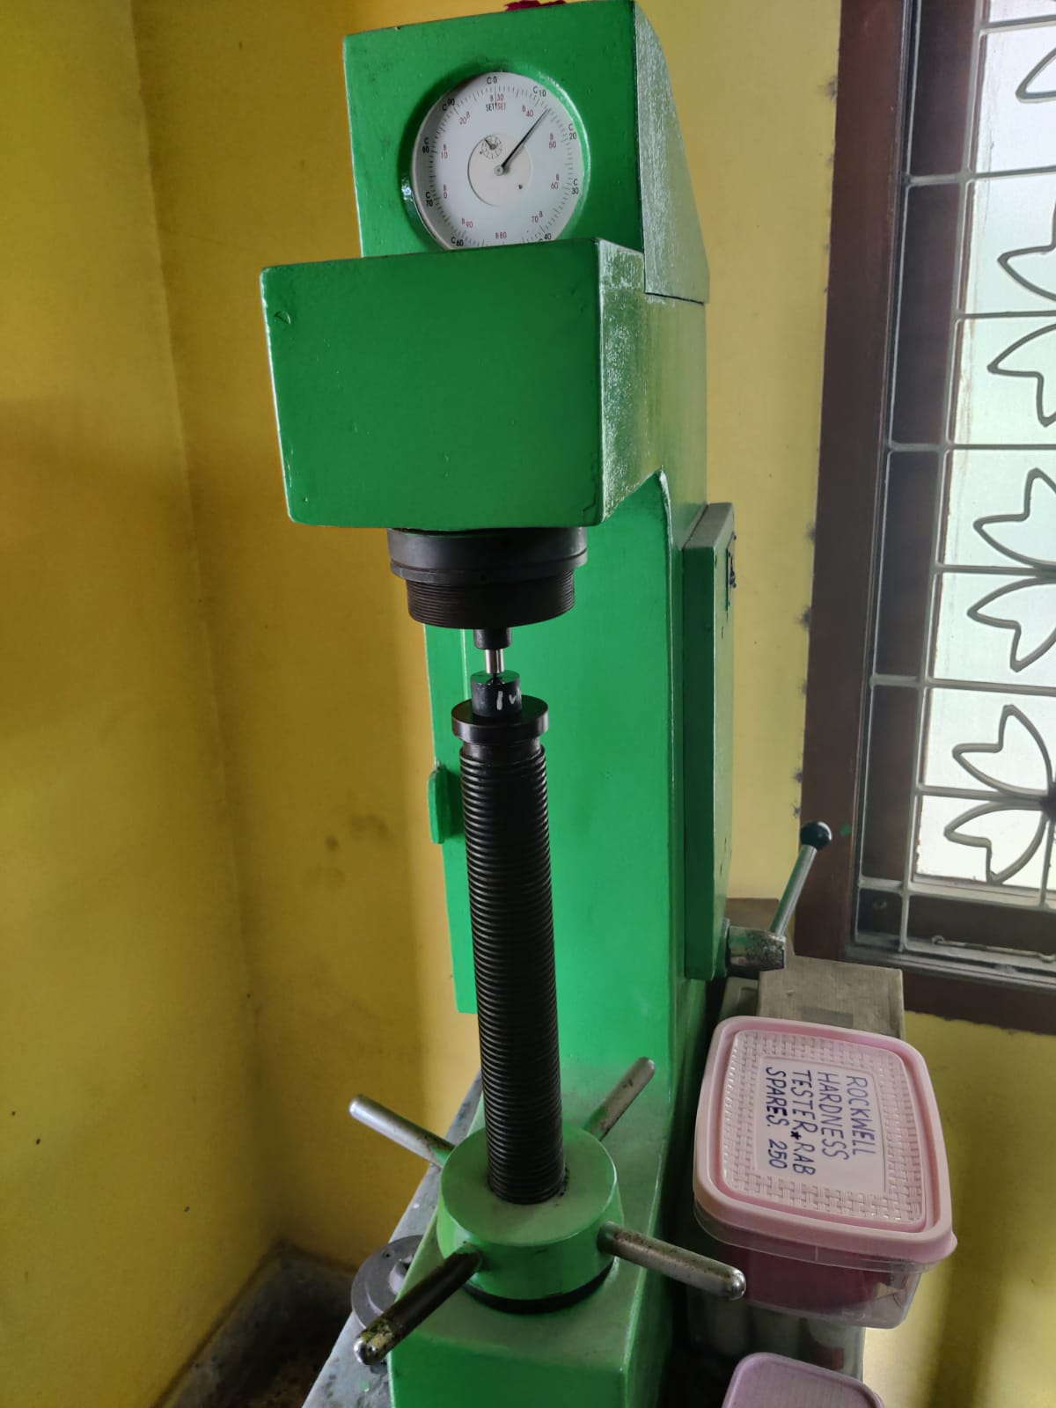

Fig 11. Rockwell hardness testing machine

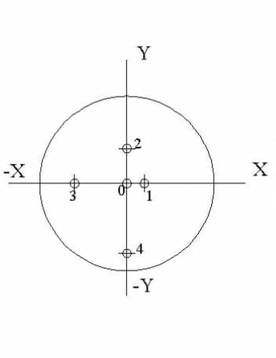
Fig 12. Hardness testing location
At point 0 - 0mm
At pont 1 - 2.5 mm from 0
At point 2 - 5mm from 0
At point 3 – 7.5mm from 0
At point 4 – 10mm from 0
The hardness test is performed at these locations as shown in the (Fig 12) and values are to be noted.
Metallography :
After successful heat treatment operation the heat treated specimens of untreated sample, polymer quenchant higher concentration quench sample were taken for the polishing and etching. The polishing is done by 60, 180,240,320,400,600,1200,2000 grid emery polished and 1/0, 1/1,1/2,1/3,1/4,1/5 alumina dry paper polished. After that velvet polishing and water polishing is done by abrassive and alumina polishing machines as shown below (Fig 13). After completing polishing, etching is done for the work samples by combination of Nitric acid and Ethyl alcohol ie. 2% Nitol solution.
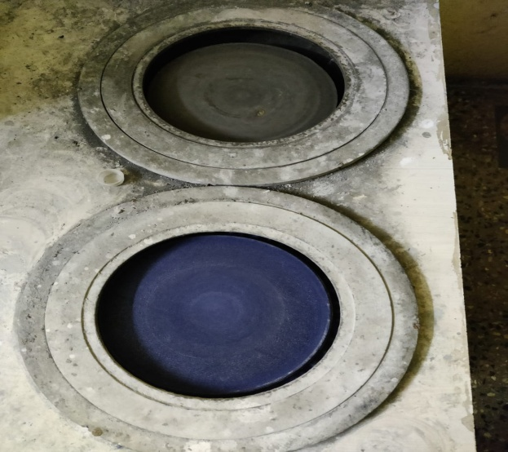  Fig 13. Polishing machine | 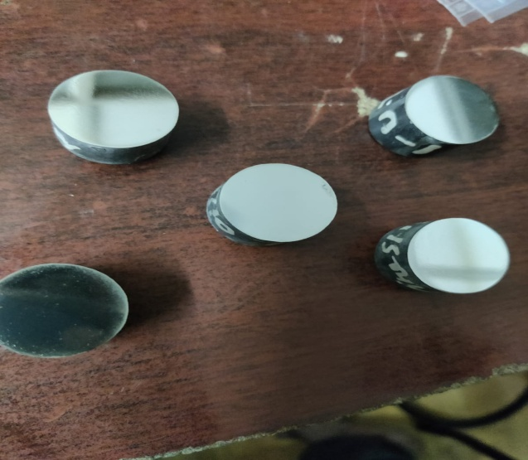  Fig14. Polished samples

After completing polishing and etching the samples were taken for micro structure study of the surface characteristics of the metal. After preparation of metallography specimen, the polished samples as shown in the above (Fig 14) both untreated and treated specimens were taken for microstructure determination using Scanning Electrical Microscopeas shown in the below (Fig 15). Using SEM the microstructure is seen and captured the grain growth of the above polished samples with a magnification of 100x.
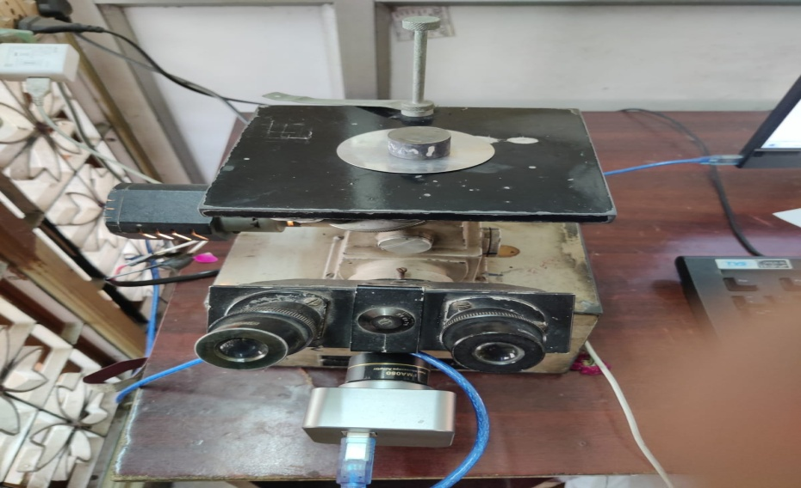
Fig 15. SEM
RESULTS AND DISCUSSION
The mechanical property ie., Hardness is found as a function of different location or points on circular surface of untreated and heat treated samples. Also the hardness is found as a function of polymer quenching media with different concentrations.
Hardness testing results for untreated sample :
The hardness property of untreated sample is measured using Rockwell hardness testing machine at various locations from origin or mid point on the circular surface . The results obtained from testing a specimen is shown in below(Table 6) and (Fig.16).
Table 6. Untreated sample HRC | 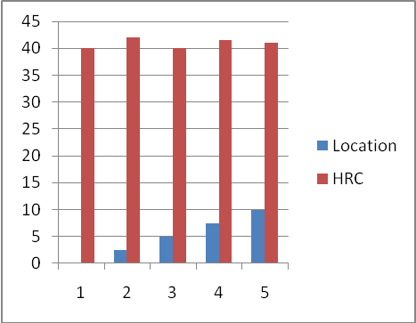  Fig.16. Untreated sample
  Point | Location from origin | HRC
  0 | 0 | 8
  1 | 2.5 | 8
  2 | 5 | 9
  3 | 7.5 | 9
  4 | 10 | 7

Hardness testing results for heat treated polymer quenched work samples :
The hardness of heat treated sample is measured using Rockwell hardness testing machine at various locations from origin or mid point on the circular surface .
PVA 0.1% quench sample :
The hardness of PVA 0.1% quenched sample is measured and the values are noted as shown in below (Table 7) and (Fig.17).
Table 7. PVA 0.1% sample HRC | 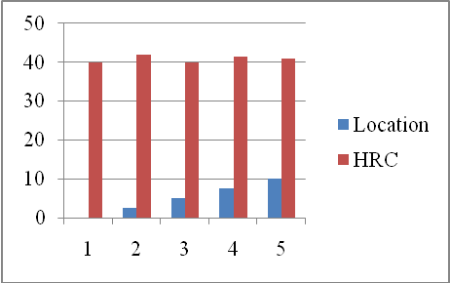  Fig.17. PVA 0.1% sample
  Point | Location from origin | HRC
  0 | 0 | 33
  1 | 2.5 | 38
  2 | 5 | 42
  3 | 7.5 | 51
  4 | 10 | 45

From the above table and graph it is observed that the maximum hardness 51 HRC occurs at point 3 ie. At 7.5 mm from origin.
PVA 0.2% quench sample :
The hardness of PVA 0.2% quenched sample is measured and the values are noted as shown in below (Table 8) and (Fig.18).
Table 8. PVA 0.2% sample HRC | 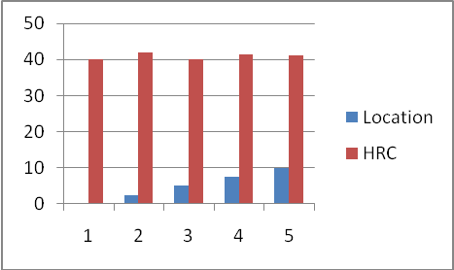  Fig.18. PVA 0.2% sample
  Point | Location from origin | HRC
  0 | 0 | 38
  1 | 2.5 | 39
  2 | 5 | 40
  3 | 7.5 | 44
  4 | 10 | 40.5

From the above table and graph it is observed that the maximum hardness 44 HRC occurs at point 3 ie. At 7.5 mm from origin.
PVA 0.5% quench sample :
The hardness of PVA 0.5% quenched sample is measured and the values are noted as shown in below (Table 9) and (Fig.19).
Table 9. PVA 0.5% sample HRC | 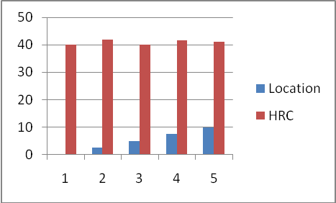  Fig.19. PVA 0.5% sample
  Point | Location from origin | HRC
  0 | 0 | 40
  1 | 2.5 | 39
  2 | 5 | 39.5
  3 | 7.5 | 52
  4 | 10 | 40.5

From the above table and graph it is observed that the maximum hardness 52 HRC occurs at point 3 ie. At 7.5 mm from origin.
PVA 1% quench sample :
The hardness of PVA 1% quenched sample is measured and the values are noted as shown in below (Table 10) and (Fig.20).
Table 10. PVA 1% sample HRC | 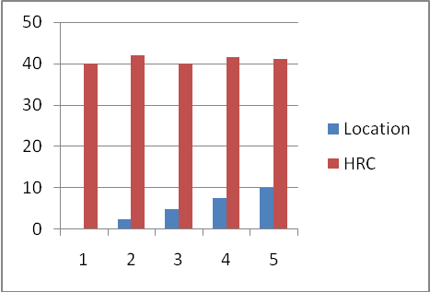  Fig.20. PVA 1% sample
  Point | Location from origin | HRC
  0 | 0 | 39
  1 | 2.5 | 38
  2 | 5 | 40
  3 | 7.5 | 44
  4 | 10 | 42

From the above table and graph it is observed that the maximum hardness 44 HRC occurs at point 3 ie. At 7.5 mm from origin.
PVA 1.5% quench sample :
The hardness of PVA 1.5% quenched sample is measured and the values are noted as shown in below (Table 11) and (Fig.21).
Table 11. PVA 1.5% sample HRC | 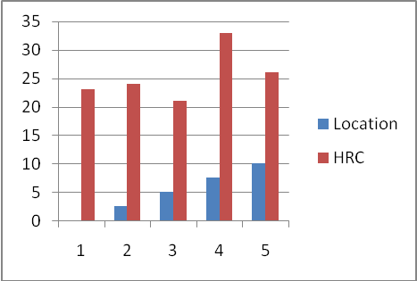  Fig.21. PVA 1.5% sample
  Point | Location from origin | HRC
  0 | 0 | 37.5
  1 | 2.5 | 39
  2 | 5 | 40
  3 | 7.5 | 40.5
  4 | 10 | 40

From the above table and graph it is observed that the maximum hardness 40.5 HRC occurs at point 3 ie. At 7.5 mm from origin.
PVA 2% quench sample :
The hardness of PVA 2% quenched sample is measured and the values are noted as shown in below (Table 12) and (Fig.22).
Table 12. PVA 2% sample HRC | 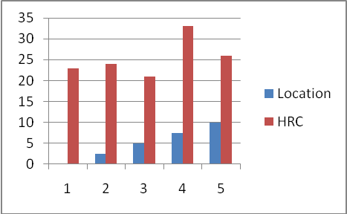  Fig.22. PVA 2% sample
  Point | Location from origin | HRC
  0 | 0 | 40
  1 | 2.5 | 42
  2 | 5 | 40
  3 | 7.5 | 41.5
  4 | 10 | 41

From the above table and graph it is observed that the maximum hardness 41.5 HRC occurs at point 3 ie. At 7.5 mm from origin.
PVA 3% quench sample :
The hardness of PVA3% quenched sample is measured and the values are noted as shown in below (Table 13) and (Fig.23).
Table 13. PVA 3% sample HRC | 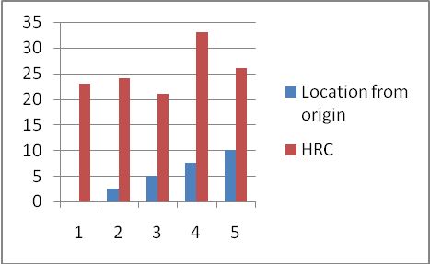  Fig.23. PVA 3% sample
  Point | Location from origin | HRC
  0 | 0 | 23
  1 | 2.5 | 24
  2 | 5 | 21
  3 | 7.5 | 33
  4 | 10 | 26

From the above table and graph it is observed that the maximum hardness 33 HRC occurs at point 3 ie. At 7.5 mm from origin.
It is observed that an uniform quenching has taken place in polymer quenching by looking at the highest hardness values at point 3 of different concentrations.
Comparision of EN9 before and after heat treatment :
The average hardness is found and tabulated for all the work samples with irrespective of locations with different concentration of polymer quenching media. The comparison graph is drawn between quenching media and hardness before and after heat treatment.
X- Axis ---- Quenchant media
Y- Axis ---- Average HRC
Table 14. Average HRC values for various quenching media
Sl no | Quenchant | Average HRC
1 | Untreated | 8.2
8 | PVA 0.1% | 41.8
9 | PVA 0.2% | 40.3
10 | PVA 0.5% | 42.2
11 | PVA 1% | 40.6
12 | PVA 1.5% | 39.4
13 | PVA 2% | 40.9
14 | PVA 3% | 25.4

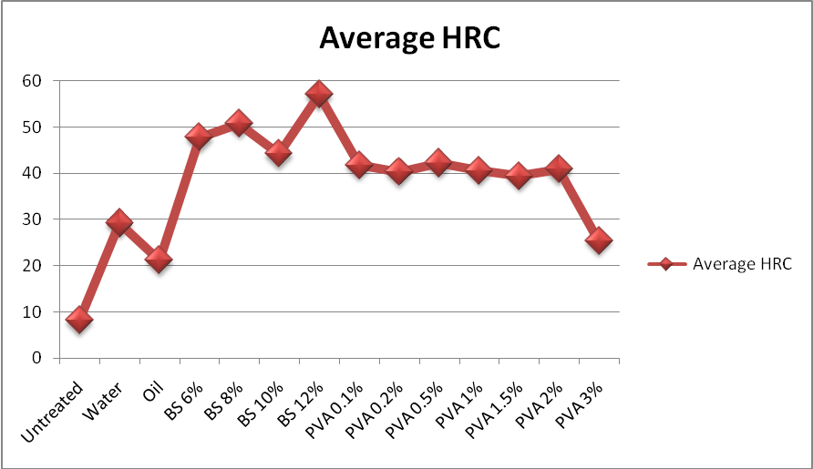
Fig.24. Quenching media vs Average HRC
From the above Fig.24 and table 14 we can say that an uniform quenching has taken place in polymer quenching by observing average hardness values from the table and graph progression.
Metallography Results :
Scanning Electronic Microscope (SEM) is used to scatter the different phases present in the surface of EN9 material for both before and after heat treated conditions.The microstructure is seen at different locations of work samples and the images are scattered with range 100X magnification. The different locations are the location where the hardness test is performed ie.
At point 0 - 0mm
At pont 1 - 2.5 mm from 0
At point 2 - 5mm from 0
At point 3 – 7.5mm from 0
At point 4 – 10mm from 0
Untreated sample or Base material :
The images 25(a,b,c,d.e) shows the microstructure present in EN9 material before heat treatment.
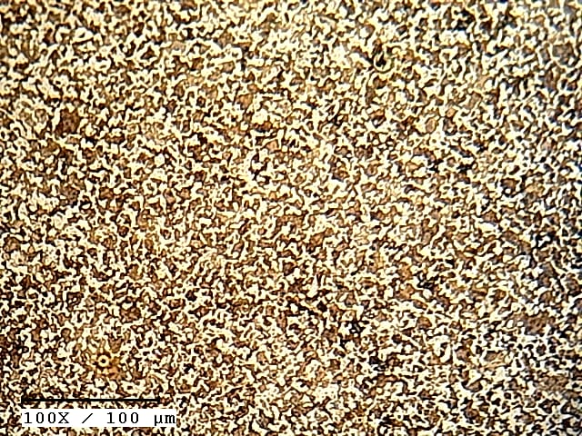  Fig 25 (a). BM at point 0 | 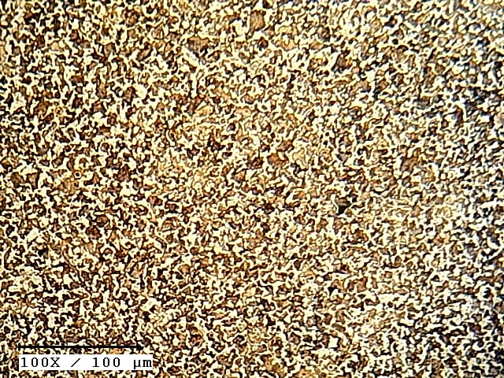  Fig 25 (b). BM at point 1
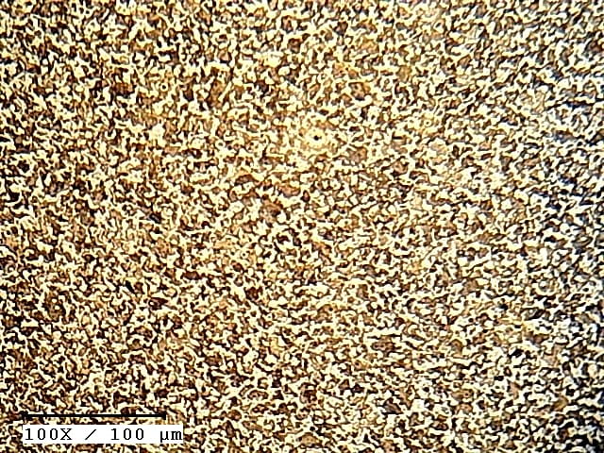  Fig 25 (c). BM at point 2 | 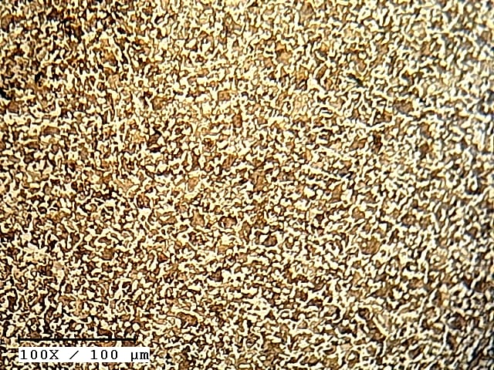  Fig 25 (d). BM at point 3
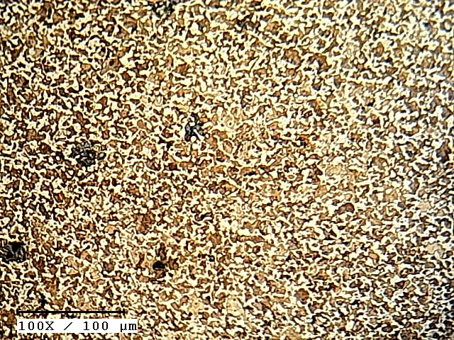
Fig 25 (e). BM at point 4

At point 0 : 50% Pearlite + 50% Ferrite
At point 1 : 50% Pearlite + 50% Ferrite
At point 2 : 75% Pearlite + 25% Ferrite
At point 3 : 75% Pearlite + 25% Ferrite
At point 4 : 40% Pearlite + 60% Ferrite
PVA 3% quench sample:
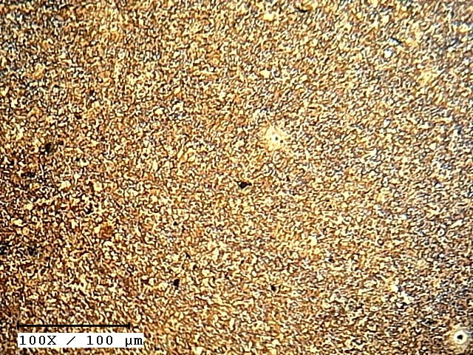  Fig 26 (a). PVA 3% at point 0  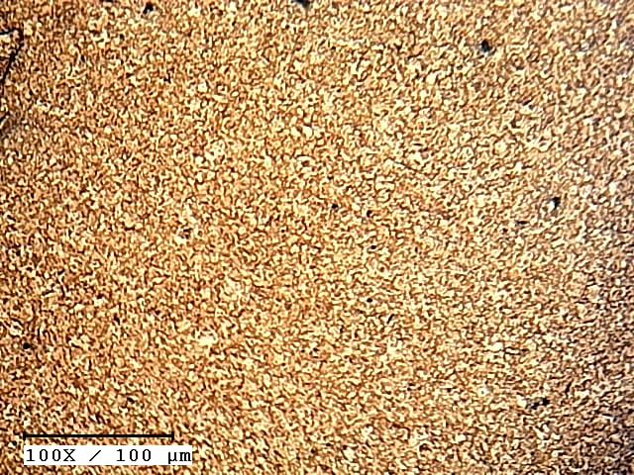  Fig 26 (c). PVA 3% at point 2 | 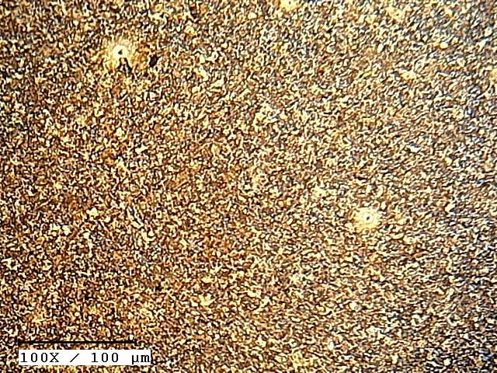  Fig 26 (b). PVA 3% at point 1  Fig 26 (d). PVA 3% at point 3
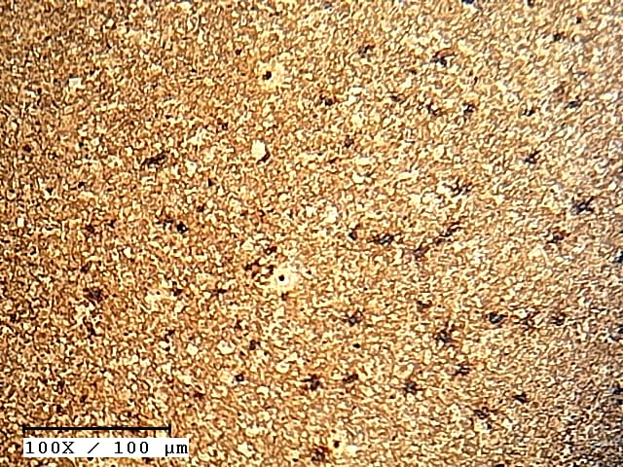
Fig 26 (e). PVA 3% at point 4

At point 0 : 70% Martensite + 30% Pearlite
At point 1 : 75% Martensite + 25% Pearlite
At point 2 : 65% Martensite + 40% Pearlite
At point 3 : 80% Martensite + 20% Pearlite
At point 4 : 75% Martensite + 25% Pearlite
By analyzing the microstucture and hardness at same points, it can be stated that hardness is increased with increase in martensite phase, hardness is moderate with increase in pearlite phase and hardness is decreased with increase in ferrite phase(fig.26 a,b,c,d,e).
CONCLUSION
According to the study, utilizing monomer quenchants as the medium for quenching enhances the mechanical characteristics of steels that have not been handled. In polymer quenching no visible cracks are found, micro and macro cracks are also not found on the surface of quenched sample. Cost effective is high for polymer quenching where as other mediums are low. This research study shows that polymer quenching takes place uniformly in all the polymer quenched samples even though the concentration is changed. Therefore uniform quenching reduces time. So, it can be used in industrial applications for heat treatment in hardening and tempering.
REFERENCES
- Dossett, J., & Totten, G. E. (2013). ASM handbook. volume 4A, Steel Heat Treating Fundamentals and Processes, ASM.
- Dziubek, M., & Grygier, D. (2022). Comparative analysis of construction materials used for fastening elements of six-point safety belts in rally cars. Combustion Engines, 61.
- Munk, S. A., Lai, R. K., Burke, J. E., Arasasingham, P. N., Kharlamb, A. B., Manlapaz, C. A.,& Garst, M. E. (1996). Synthesis and pharmacologic evaluation of 2-endo-amino-3-exo-isopropylbicyclo [2.2. 1] heptane: a potent imidazoline1 receptor specific agent. Journal of medicinal chemistry, 39(6), 1193-1195.
- Miracle, D. B., Donaldson, S. L., Henry, S. D., Moosbrugger, C., Anton, G. J., Sanders, B. R., & Scott Jr, W. W. (2001). ASM handbook (Vol. 21, pp. 107-119). Materials Park, OH: ASM international.
- Tuna, B. A., Tinar, E., & Rockwell, D. (2013). Shallow flow past a cavity: globally coupled oscillations as a function of depth. Experiments in fluids, 54, 1-20.
- Application of Polymeric Quenchants in Heat treatment of Steel.M.Eshraghi-kakhi, M.A.Soltani, K.Amini, et.al, International journal of ISSI, Vol.6 (2009) , No.1 , pp. 34-38
- Gopalkrishna, G., Gurumurthy, R. B., & Davanageri, M. (2019, March). Heat treatment and mechanical characterization of En8 steel. In AIP Conference Proceedings (Vol. 2080, No. 1). AIP Publishing.
- Zainulabdeen, A. A., Mahmood, N. Y., & Mohmmed, J. H. (2018, December). The effect of polymeric quenching media on mechanical properties of medium carbon steel. In IOP Conference Series: Materials Science and Engineering (Vol. 454, No. 1, p. 012053). IOP Publishing.
- Chandan, B. R., & Ramesha, C. M. (2017). Evaluation of mechanical properties of medium carbon low alloy forged steels quenched in water, oil and polymer. J. Mater. Sci. Eng, 6(2), 1-5.
- Ahaneku, I. E., Kamal, A. R., & Ogunjirin, O. A. (2012). Effects of heat treatment on the properties of mild steel using different quenchants. Frontiers in Science, 2(6), 153-158.
- Iqbal, A. (2023). See discussions, stats, and author profiles for this publication at: https://www. researchgate. net/publication/323614212 Ovarian Leiomyoma Associated with Serous Cystadenoma-A Case Report of an Uncommon Entity Ovarian Leiomyoma Associated with Serous Cystadenoma-A Case Report of an Uncommon Entity.

