The effects of melatonin on stomach ulcers caused by non-steroidal anti-inflammatory drugs: research on extracellular matrix remodeling and angiogenesis

Krishnendu Ganguly ^{1*}, Snehasikta Swarnakar ², Krishnendu Adhikary ¹

¹Department of Medical Lab Technology, Paramedical College Durgapur, West Bengal 713212, India
² Infectious Diseases and Immunology Division, CSIR's Indian Institute of Chemical Biology;, Kolkata,West Bengal 713212, India

Running Title: Melatonin's Gatroprotective Effects

*Corresponding mail: gangkrish1977@gmail.com

Abbreviations:

CAM (chick chorioallantoic membrane), BSA (bovine serum albumin), AP-1 (activator protein-1), BM (base membrane), and bp terms such as cDNA, DNA, ECM, EDTA, EMSA, eNOS, and ERK are all used to describe proteins that are involved in transporting information inside cells. Interleukin (IL), hydrogen peroxide (H2O2), glyceraldehyde-3-phosphate dehydrogenase (GAPDH), ribonucleic acid (mRNA), matrix metalloproteinase (MMP), myeloperoxidase (MPO), nuclear factor kappa beta (NF-κB), and interleukin (GI) are all proteins that are involved in the gastrointestinal tract. NSAID nonsteroidal anti-inflammatory drug; O2.- superoxide radical; OH. hydroxyl radical; PAGE polyacrylamide gel electrophoresis; PBS phosphate buffer saline; PCR polymerase chain reaction; PG prostaglandin; RNA ribonucleic acid; ROS reactive oxygen species; RT-PCR reverse transcritase polymerase chain reaction; SOD superoxide dismutase; TIMP tissue inhibitor of metalloproteinase; TNF tumour necrosis factor; Vascular endothelial growth factor (VEGF).

Abstract

Both developed and developing countries consider the prevalence of hyperacidity and ulcers as a universal human suffering. In addition to excruciating, never-ending pain, people who had it also risked gastrointestinal bleeding or ulcers, which might be fatal. Due to a rise in incidence rates over the past 20 years, about 10% of the global population will have this illness at some time in their life (Cullen et al., 1997; Kunturek et al., 2005). According to Koelz et al. (1978), the proton-pumping H+-K+-ATPase enzyme found in the parietal cells of the stomach mucosa secretes an excessive quantity of hydrochloric acid into the gastric lumen, which is the most common cause associated with gastric ulcers. Gastric ulcers may form in two places: the epithelial border and the granulation tissues, which include fibroblasts, macrophages, and proliferating endothelial cells (Konturek et al., 1994; Yoshikawa and Naito, 2000). According to previous research (Konturek et al., 1994; Maity et al., 2003), the primary causes of stomach ulcers were stress, reckless use of NSAIDs, excessive smoking, and alcohol use. Helicobacter pylori, a spiral-shaped bacterium, have been recognized as the principal culprit responsible for around 60% of cases of gastritis, stomach ulcers, and gastric cancer ever since its discovery. Natural killer cells suppress cyclooxygenase (COX), which decreases prostaglandin (PG) synthesis; this is believed to explain why nonsteroidal anti-inflammatory drugs (NSAIDs) cause around 26% of stomach ulcers (Wallace, 1997). Acid (Brzozowski et al., 2006) and reactive oxygen species (ROS), especially hydroxyl radical, have been shown to cause mucosal oxidative damage in gastric ulcers of different types (Brzozowski et al., 2001; Naito & Yoshikawa, 2006). As a result of better medical treatment, the prevalence of H. pylori-induced ulceration is declining in the Western world, but NSAID use is on the rise among older populations suffering from pain syndromes and arthritis, leading to an increase in gastric ulcers (Bombardier et al., 2000). Stress from medical conditions or injuries like burns, pneumonia, or an H. pylori infection may also lead to gastric ulcers (Konturek & Konturek, 1994). Some factors that were believed to induce ulcers up until the late 20th century actually have a very little impact on the development of peptic ulcers; these factors include heavy alcohol use, tobacco use, and others. Gastric tissues are structurally supported by extracellular matrix (ECM), which plays an essential role in controlling cell proliferation, apoptosis, migration, and differentiation as well as in gastric ulceration and healing (Ernst et al., 1995; Gillessen and Domschke, 1994). Reports indicate that matrix metalloproteinases (MMPs) are vital in regulating several extracellular matrix (ECM) components that promote the proper functioning of gastric tissues (Ernst et al., 1995; Gillessen & Domschke, 1994). Jones et al. (1999) added that in order for stomach ulcers to heal, there must be angiogenesis in the granulation tissue at the ulcer's base, replication of epithelial cells at the ulcer's margins, and finally, return of glandular architecture. To rephrase, the healing process is controlled by a delicate balance of molecules that promote angiogenesis and those that inhibit it, as well as by the collaboration of growth factors, transcription factors, and cytokines (Tarnawski, 2005; Tarnawski et al., 2001). When an ulcer heals, matrix remodeling takes place first and foremost. A lack of clarity surrounds the role of matrix metalloproteinases (MMPs) in the healing and damage processes in the stomach caused by nonsteroidal anti-inflammatory drugs (NSAIDs) (Swarnakar et al., 2005; Ganguly et al., 2006). Altun and Ugur-Altun (2007) cite substantial research on the effects of melatonin (N-acetyl-5-hydroxytryptamine), the principal hormone secreted by the pineal gland, on immune system function, on anticarcinogenesis, on seasonal reproduction, on circadian rhythmicity, on reducing jet lag, and on antioxidant properties. The release of extra pineal melatonin by eneterochromaffin cells of the gastrointestinal system, together with its production by the liver, eyes, and other tissues, helps to maintain homeostasis throughout the day (Maestroni, 2001; Konturek et al., 2007).
STOMACH
In the second phase of digestion, the muscular, hollow organ shaped like a J is at work in the digestive tract. The atmosphere is very acidic because stomach acid is produced and released. A variety of factors, including species, diet, time of day, and medication use, determine the luminal pH, which may vary from 1 to 2 (Anthea, 1993; Anne & Moore, 2007). These conditions, when coupled with digestive enzymes, may eventually reduce the size of large molecules to a form that the small intestine can absorb. The enzyme pepsinogen, released into the bloodstream by chief cells, is required for protein digestion and converts into pepsin at low pH levels (Anthea, 1993; Anne & Moore, 2007). Absorption of vitamin B12 requires its conjugation with intrinsic factor, a glycoprotein produced by the parietal cells of the stomach, on its way from the small intestine to the rest of the body. Iron, alcohol, and other fat-soluble substances are absorbed in considerable quantities by the stomach, whereas water, electrolytes, and food are absorbed relatively slowly.

Stomachs are located on the left side of the abdomen, sandwiched between the esophagus and the duodenum, the first section of the small intestine. Two sphincters, which are smooth muscle valves, keep the contents of the stomach where they should be. Two examples are the pyloric sphincter and the esophageal sphincter, both of which are positioned in the heart region and serve to separate the digestive system (Anthea, 1993). In a human stomach, there are four distinct sections: the antrum, the lower, funnel-shaped part; the fundus, the upper, more expanded part; the pylorus, the narrowing where the small intestine meets the stomach; and the cardiac opening, the opening from the stomach into the esophagus (Figure. 1, Anthea, 1993). Enzymes and hydrochloric acid secreted by tiny gastric glands that are tightly placed over the thick mucous membrane of the walls partly degrade lipids and proteins. Muscles contract at regular intervals to transform food into a semifluid mixture called chyme, which is subsequently passed into the small intestine and pylorus by means of regular peristaltic waves. Stomach movements and secretions are controlled by the vagus nerve and the sympathetic nervous system (Anne & Moore, 2007).

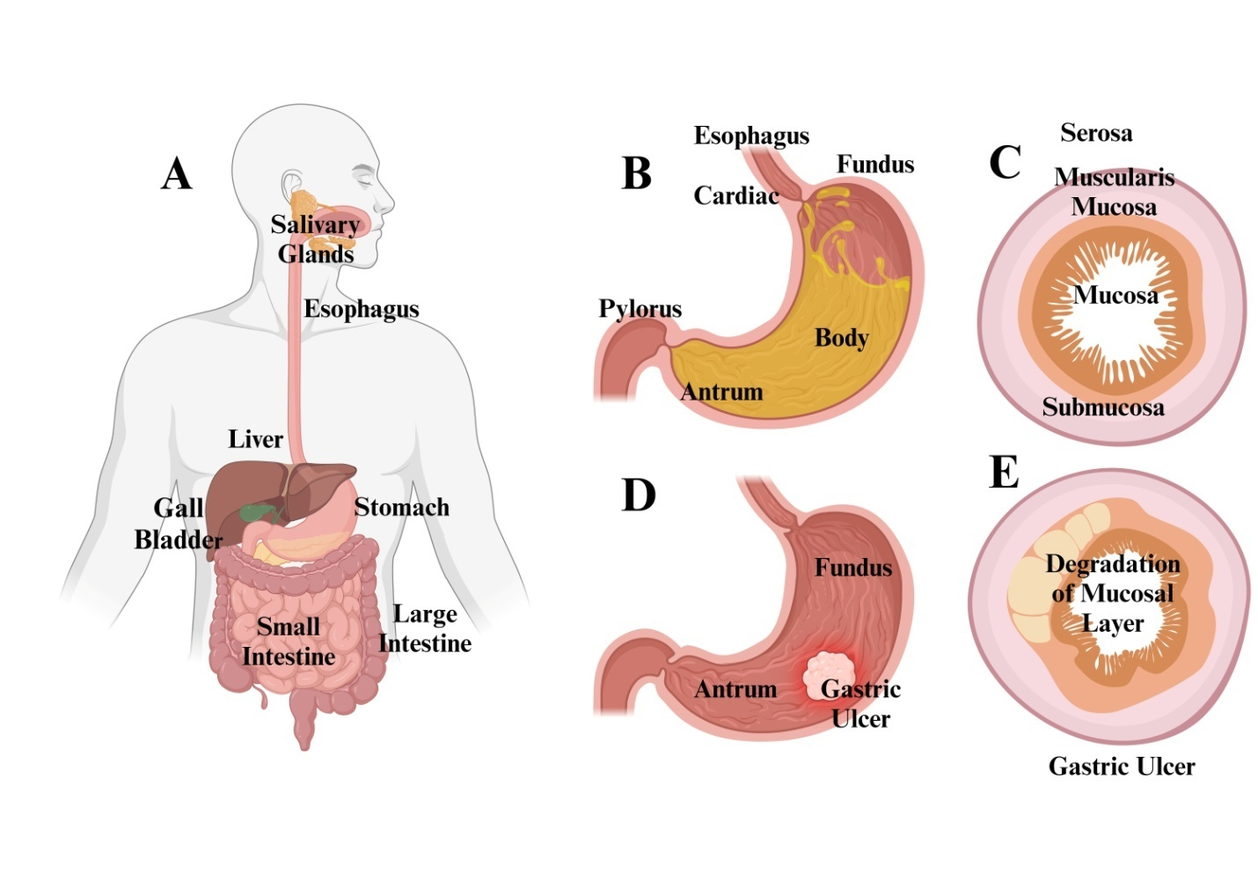
Figure 1. The human stomach's structures are shown in the figure. The four separate parts of a human stomach are the fundus, body, antrum, and pylorus. The duodenum and stomach are both accessible via the pyloric sphincter. The peristaltic motion that happens during digestion is supported by the three layers of muscle that make up the stomach: an inner oblique layer, a middle circular layer, and an exterior longitudinal layer. These layers work together. Each inner lining consists of four layers: the muscularis mucosa, submucosa, mucosa, and serosa. The cells that create hydrochloric acid, digesting enzymes, and mucus are located in the tightly packed gastric glands on the mucosa (Encyclopedia Britannica, Inc., 2003).

Surgical analysis
Similar to the rest of the gastrointestinal system, the stomach walls (Figure 1) are composed of the following layers organized from inside to outside: A thin layer of smooth muscle called the muscularis mucosae and the underlying lamina propria make up the deepest layer, which is called the mucosa. Layer under the mucosa that separates it from the layer below it is the submucosa, which is composed of fibrous connective tissue. Seen in this stratum is the Meissner's plexus. In contrast to other gastrointestinal organs, the stomach's muscularis externa has three layers of smooth muscle underneath the submucosa. The inner oblique layer is responsible for the physical breakdown of the meal by churning. Out of all the parts of the digestive system, this one is unique. Stronger contractions and thicker skin cell walls characterize the antrum in comparison to the fundus. In the center, there is a strong muscular wall that encircles the pylorus. A tonically constricted wall provides a functional pyloric sphincter that controls the pylorus's migration into the duodenum, even though it is not visually distinct. The location of Auerbach's plexus lies between the outer longitudinal layer and the middle circular layer. A layer of connective tissue that lies under the muscularis externa and is continuous with the peritoneum is known as the serosa (Anthea, 1993; Anne & Moore, 2007).

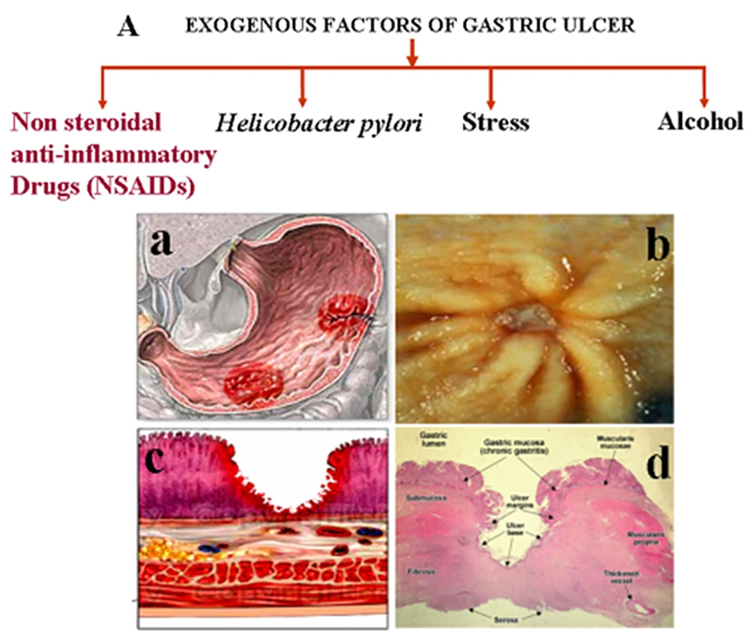

Figure 2: Factors linked to gastric ulceration. Indiscriminate NSAID usage, Helicobacter pylori infection, psychological stress, and alcohol use are the main causes of stomach ulcers (A). A human stomach ulcer as seen both under the microscope and under the microscope (B). The fundus-antrum junction is a common site for stomach ulcers (Ba). A stomach ulcer in a person (Bb) as seen via an endoscope. When an ulcer develops, a necrotic lesion spreads over the stomach's mucosal thickness and even into the muscularis mucosa (Bc). The acid-pepsin aggression causes a gastric ulcer, which is a mucosal defect that penetrates the muscularis mucosae and muscularis propria. The ulcer edges indicate persistent gastritis and are perpendicular. There are four distinct areas at the ulcer's base: fibrinoid necrosis, granulation tissue, fibrous tissue, and inflammatory exudate. Veins with a thicker wall or thrombosis (Bd) may be present in the fibrous ulcer base.

Cell types
The several layers of these glands include many cell types: Throughout the stomach and in close proximity to the gland's isthmus are mucous cells. They prevent erosion of the stomach by secreting a mucus layer and having a neutral stain. Located in the stomach, near the gland's neck, are parietal (oxyntic) cells. In addition to producing stomach acid, their acidophilic nature allows them to release endogenous compounds that aid digestion. The fundic region, close to the gland's base, is the only location of chief (zymogenic) cells. They aid digestion by emitting pepsinogen and rennin; they are basophilic. Cells that produce enteroendocrine hormones are found all along the base of the stomach's glands. In addition to regulating the paracrine and autocrine systems, they produce hormones such as somatostatin.

According to Anne and Moore (2007), a gastric ulcer is defined as a lesion or wound on the stomach wall that may sometimes reach the muscularis mucosae or the complete thickness of the mucosa in an area of the stomach that is 0.5 cm or bigger (Figure 2). A stomach H. pylori infection has been associated with as many as 60% of ulcers (Konturek & Konturek, 1994). Characteristic of chronic gastritis are ulcers with perpendicular borders. Granulation tissue, fibrous tissue, fibrinoid necrosis, and inflammatory exudate are the four zones that may be seen at the base of an ulcer during its active phase (Arista-Nasr, 2005). Thrombosed or thickened-walled veins may be seen in the fibrous ulcer base. About four percent of stomach ulcers are caused by malignant tumors. Containment is the main characteristic of stomach ulcers.

Associated factors with gastric ulceration (Figure 3): The most common causes of stomach ulcers are alcohol intake, psychological stress, H. pylori infection, and the careless use of nonsteroidal anti-inflammatory medicines (NSAIDs) (A). A human stomach ulcer as seen both under the microscope and under the microscope (B). The fundus and antrum (Ba) intersection is a common site for stomach ulcers. This is an endoscopic picture of a stomach ulcer in a person (Bb). A necrotic ulcer lesion might reach the muscularis mucosa (Bc) by penetrating the whole thickness of the stomach's mucosal lining. A gastric ulcer is a perforation in the mucosal lining of the stomach that develops as a result of acid-pepsin aggression. Chronic gastritis is shown with perpendicular ulcer edges. Inflammatory exudate, fibrinoid necrosis, fibrous tissue, and granulation tissue are the four zones seen at the ulcer's base. Peptic ulcers may be either acute or chronic, with the former characterized by regularity and the latter by raised margins and an inflammatory environment. Because of the scarring in the parietal area, the surrounding mucosa may show radial folds (Arista-Nasr, 2005). The slight curvature of the stomach is the most common location for gastric ulcers.

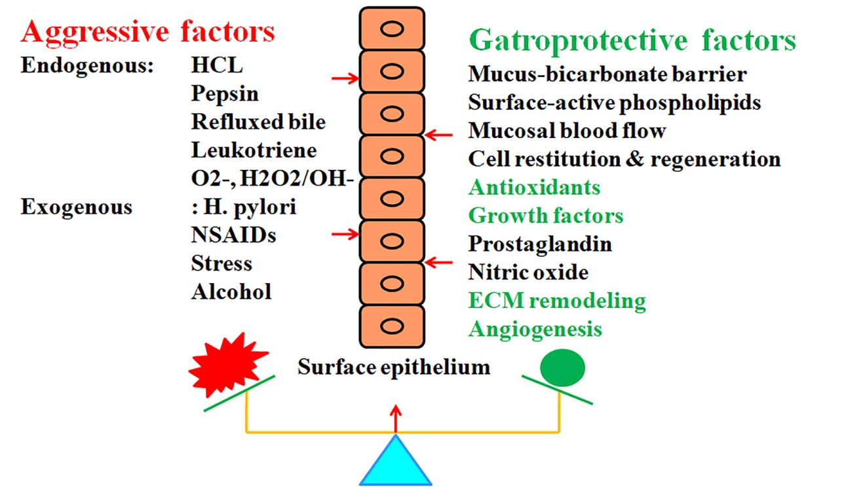

Figure 3: Aggressive and defensive elements play a central role during stomach ulceration. The imbalance between aggressive and gastroprotective forces is the root cause of gastric ulcers. Both internal and external sources might contribute to the aggressive factors. Hydrochloric acid, pepsin, reflusked bile, leukotrienes, and reactive oxygen species (ROS) are the key endogenous contributors. Factors beyond of one's control include things like long-term alcohol use, psychological stress, H. pylori infection, and NSAID use. Gastroprotection against these harmful factors is provided by the mucosal defense, which consists of the following: the mucus-bicarbonate barrier, surface active phospholipids, mucosal blood flow, cell restitution and regeneration, prostaglandins, nitric oxide, growth factors, antioxidant enzymes and cellular antioxidants, remodeling of the extracellular matrix (ECM), and angiogenesis.
The signs of Gastric Ulcer:
Gastric ulcer symptoms might include nausea, excessive vomiting, lack of appetite, rapid production of saliva to neutralize acid in the throat after regurgitation, stomach discomfort, and other similar symptoms. Gastric ulceration and the roles of aggressive and defensive variables (Figure 3): Gastrectomy is the outcome of an unbalanced interaction between the aggressive and gastroprotective components. Exogenous and endogenous forces are the two main categories of aggressive factors. Mainly produced inside the body, hydrochloric acid, pepsin, reflusked bile, leukotrienes, and reactive oxygen species (ROS) may be found. External factors include things like long-term alcohol usage, psychological stress, infections with H. pylori, and nonsteroidal anti-inflammatory medication (NSAID) use. Some of the mucosal defense mechanisms that offer gastroprotection against these harmful factors include the mucus-bicarbonate barrier, surface active phospholipids, mucosal blood flow, cell restitution and regeneration, prostaglandins, nitric oxide, specific growth factors, antioxidant enzymes and antioxidants within cells, remodeling of the extracellular matrix (ECM), and angiogenesis. Ulcers may very rarely cause a stomach perforation. This has to be operated on immediately since it is quite painful. However, H. pylori-induced ulcers are 3–6 times more common in patients with late-stage stomach cancer (Arista-Nasr, 2005; Konturek & Konturek, 1994).

Gastric ulcer mechanism
Stomach ulcers may have many different causes. An imbalance between certain aggressive and gastroprotective elements might lead to gastric ulcers. Exogenous and endogenous aggressive effects are two types of influences. Some examples of external factors include long-term alcohol use, psychological stress, health conditions such as H. pylori infection, and the use of NSAIDs. According to Wallace (1997) and Konturek et al. (2005), the primary endogenous contributions are hydrochloric acid, pepsin, refluxed bile, leukotrienes, and reactive oxygen species (ROS) such as O2, H2O2, and •OH. Figure 3; Maity et al., 2003; Massarrat, 2008 lists the various mucosal defenses that offer gastroprotection against these aggressive factors. These defenses include the mucus-bicarbonate barrier, surface active phospholipids, mucosal blood flow, cell restitution and regeneration, prostaglandins, nitric oxide, specific growth factors, antioxidant enzymes and antioxidants within cells, ECM remodelling, and angiogenesis. The chronic inflammation is mostly caused by Helicobacter pylori, according to Cullen et al. (1997). This bacteria lives in the antral mucosa. The reckless use of nonsteroidal anti-inflammatory drugs is another factor (Wallace, 1997). Consistent blood flow and mucus production are maintained when prostaglandins work correctly in the stomach mucosa. By blocking the action of COX-1, NSAIDs avoid prostaglandin syntesis. Peptic ulcer formation may be influenced by psychological stress caused by burns or head trauma. The development of ulcers caused by ischemia is accelerated when smoking causes atherosclerosis and vascular spasms, according to Konturek & Konturek (1994). Peptic ulcers have also been linked to the excessive use of laxatives. There seems to be a familial relationship between duodenal ulcers and blood type O. Rare gastrinomas (Zollinger Ellison syndrome) are tumors that secrete gastrin and may cause a variety of complications during ulcer repair. According to research (Cullen et al., 1997; Konturek & Konturek, 1994), stomach ulcers are more likely to occur in people who suffer from chronic stress and who also have trouble sticking to a regular eating schedule. Essential to the inflammatory process generated by NSAIDs are these few key regulators.

Cytokines: Factors that enhance the production of inflammatory cytokines include stress, nonsteroidal anti-inflammatory drugs (NSAIDs), and Helicobacter pylori infection (Konturek et al., 2005). A frequent contributing factor to ulcer recurrence may therefore be cytokines. Inflammatory cytokines, which promote leukocyte stimulation and increase expression of adhesion molecules, are primarily produced by monocytes and macrophages. According to Langman et al. (1991), one important step in the development of stomach injury caused by NSAIDs is neutrophil adherence to the vascular endothelium. The development of gastritis and stomach ulcers associated with NSAIDs is thought to be necessitated by cytokines, which play a significant role in the pathogenesis of mucosal inflammation (Langman et al., 1991). The amount of stomach mucosal erosion increased as a function of both time and dosage when various NSAIDs were administered. (Wallace, 1997) found that this led to an increase in TNF-levels and a reduction in prostaglandin E2. The secretion of more mucosal inflammatory cytokines, including LT B4, IL-1, IL-2, IL-6, IL-7, and IL-8, is another characteristic of gastric ulcers.

Effect of nonsteroidal anti-inflammatory drugs on gastric ulcer development and prostaglandin production (Figure 4): By influencing paracrine and autocrine communication, prostaglandins—bioactive molecules that mimic hormones—are engaged in several physiological and pathological processes. They are mostly made from arachidonic acid, which is a byproduct of membrane phospholipids, by use of two rate-limiting enzymes called phospholipases and cyclooxigenases (COXs). Two enzymes, COX-1 and COX-2, have the potential to transform arachidonic acid into prostaglandins that either irritate or protect cells, or even leukotrienes. The inhibition of cyclooxygenases (COXs) by NSAIDs prevents the production of prostaglandins, which in turn causes stomach ulcers. Cytokines that promote inflammation (IL-1β and TNF-α) and cytokines that inhibit inflammation (IL-10), when produced, lead to the failure of ulcer healing. Two COX viral isoforms, COX-1 and COX-2, have had their activity inhibited by nonsteroidal anti-inflammatory drugs (NSAIDs). The PGs produced by COX-1 mediate "housekeeping" functions such as regulating renal blood flow, protecting the gastric mucosa from cytoprotection, preventing platelet aggregation, and maintaining kidney perfusion (Gudis & Sakamoto, 2005; Vane & Botting, 1998; Fiorucci & Antonelli, 2001). Conversely, most normal tissues do not have COX-2. Nevertheless, COX-2 expression is induced rapidly by both mitogenic and inflammatory stimuli, leading to an increase in prostaglandin (PG) synthesis in inflammatory tissues.

The release of activated oxygen radical from mitochondria during ordinary oxidative respiration is likely the primary source of reactive oxygen species (ROS) in aerobic organisms under normal conditions (Seis & Cadenas, 1985; Stadman, 1992). According to Shiva et al. (2004) and Stadtman (1992), it is crucial to maintain a balance between the generation and consumption of reactive oxygen in order to maintain good cellular homeostasis. During the inflammatory phase of gastric ulceration, reactive oxygen species (ROS) play an important role. A number of cell types, including resident macrophages, epithelial cells, neutrophils, and lymphocytes, get activated in inflammatory disorders. The production of superoxide (O2) occurs when inflammatory cells are activated. Using the Fenton reaction and the superoxide-driven Haber-Weiss reaction, superoxide dismutase (SOD) quickly converts this O2 to hydrogen peroxide (H2O2) or hydroxyl radical (.OH) (Shiva et al., 2004). When oxygen and NADPH oxidase are combined, they form superoxides as well. Imlay (2003) and McCord and Fridovich (1969) include xanthine oxidase and cytochromes P450 as other enzymes that may produce superoxide. Enzymatic antioxidants such as sulfiredoxin and the peroxiredoxins have received little research attention. Seis and Cadenas (1985) included paraoxonase, aldehyde dehydrogenases, glutathione-S transferases, and other enzymes as having antioxidant capabilities. Research has shown that reactive oxygen species (ROS) in stomach ulcers may lead to glutathione depletion, protein oxidation, and damage to membrane lipid peroxidation. Recent research suggests that in reaction to various physiological stresses, some reactive oxygen species (ROS), notably superoxide anion (H2O2), may linger within cells for extended periods at relatively high concentrations and act as signal transduction messengers.

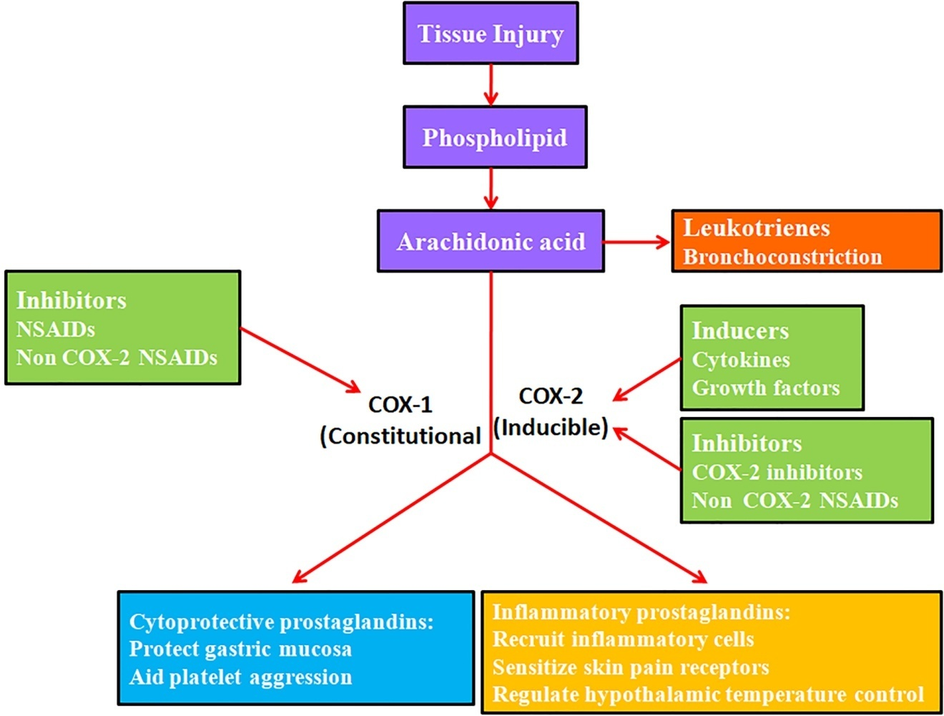

Figure 4: The Impact of Nonsteroidal Anti-Inflammatory Drugs on Gastric Ulcer Development and Prostaglandin Biosynthesis In several physiological and pathological processes, prostaglandins mediate autocrine and paracrine communication. These bioactive molecules are similar to hormones. Phospholipases and cyclooxigenases (COXs) are the two rate-limiting enzymes that primarily isolate arachidonic acid from membrane phospholipids. In the presence of COX-1 and COX-2 enzymes, arachidonic acid might be transformed into cytoprotective prostaglandins or inflammatory prostaglandins, or it could even generate leukotrienes. Nonsteroidal anti-inflammatory drugs (NSAIDs) cause stomach ulcers by inhibiting cyclooxygenases (COXs), which in turn reduces prostaglandin synthesis.
1.4. NON-STEROIDAL ANTI-INFLAMMATORY DRUG
Among the many pharmacological groups used to alleviate pain, inflammation, and fever, nonsteroidal anti-inflammatory drugs (NSAIDs) rank high. Many inflammatory conditions, including rheumatoid arthritis, osteoarthritis, acute gout, headaches, dysmenorrhea, migraines, postoperative pain, back pain, sciatica, sprains, strains, rheumatism, dental pain, kidney stone pain, fever, and other painful conditions are treated with nonsteroidal anti-inflammatory drugs (NSAIDs), according to Wallace (1997). Another purpose for some NSAIDs is to lower blood coagulation and protect high-risk patients from cardiovascular events including heart attacks and strokes. According to Wallace (1997), Yoshikawa and Naito (2000), and Konturek et al. (1994), these drugs work well when used with other analgesics to treat certain neuropathic pain syndromes.

14.1. Nonsteroidal Anti-Inflammatory Drugs
Below are some examples of nonsteroidal anti-inflammatory drugs (NSAIDs).
Aspirin, Amoxiprin, Benorilate, Faislamine, Methyl salicylate, Magnesium salicylate, Choline salicylate, Diflunisal, and Salicyl salicylate are alkaloids. Acemetacin, Diclofenac, Acelofenac, Etodolac, Indomethacin, Nabumetone, Sulindaca, and Tolmetin are all arylalkanoic acids. Ibuprofen, Carprofen, Fenbufen, Fenoprofen, Fluurbiprofen, Ketoprofen, Ketorolac, Oxaprosin, Tiaprofenic acid, and Suprofen are all examples of arylpropionoic acid, which is often known as a profen. Fenamic acid, also known as N-arynalthranicic acid, is available in two forms: mefenamic acid and meclofenamic acid. Sulphynpyrazone, Phenylbutazone, Azapropazone, Metamizole, and Oxyphenbutazone are pyrazolidine derivatives. Examples of oxicams include piroxycam, lornoxicam, meloxicam, and tenoxicam. The following drugs are COX-2 inhibitors: Celecoxib, Etoricoxib, Lumiracoxib, Parecoxib, Rofecoxib, and Valdecoxib. The sulphonanilide class includes the nimesulide species. (Patterson, et al., 2008): Licofelone and Omega-3 fatty acids are additions.

1.4.1. Action Process
Nonsteroidal anti-inflammatory drugs (NSAIDs) block the production of prostaglandins (PG), which are hormone-like bioactive molecules that induce inflammation and discomfort (Figure. 4). There are many physiological and pathological functions for PGs, which are bioactive substances that resemble hormones. They make it easier for autocrine and paracrine signals to travel short distances (Green, 2001). A2 phospholipase is responsible for the release of arachidonic acid from cell membranes, which is the primary source of PGs (PLA2). Following its release from phospholipids, free intracellular arachidonic acid may be further degraded by lipooxygenase, cytochrome p-450 monooxygenase, and PGG/H synthase, also called cyclooxygenase. According to Vane (2000), Green (2001), and Vane and Botting (1998), the enzyme COX is an essential but slow-moving step in the production of PG. Two distinct COX isoforms have been discovered so far. Various cell types are able to use it to facilitate the conversion of arachidonic acid into PGG2, PGH2, thromboxane A2 (TXA2), and so on (Vane, 2000; Green, 2001). In the 1970s, it was shown that inflammation produces a substantial amount of primary prostanoids, such as prostaglandin D2 (PGD2), prostaglandin E2, prostaglandin F2, prostaglandin I2, and thromboxane A2. References: (Moncada et al., 1973; Velo et al., 1973). Since its introduction to the market in 1899, the aspirin-like anti-inflammatory drug acetylsalicylic acid has blocked the synthesis of these prostanoids (Figure. 4; Collier & Flower, 1971; Vane & Botting, 1998; Vane, 2000). Among nonsteroidal anti-inflammatory drugs (NSAIDs), acetylsalicylic acid has been around the longest. It deactivates COX-2 in a particular way, and it does so permanently and covalently (Kalgutkar et al., 1998). Domethasone is a popular nonsteroidal anti-inflammatory drug (NSAID) that inhibits cyclooxygenase-1 and -2 with delayed reversibility, potency, and lack of selectivity (Mitchell et al., 1993). Some of indomethacin's side effects may have little to do with COX-inhibition, and the medication's ulcerogenic impact might be due to the fact that it and bile both disturb the mucosal barrier (Lichtenberger, 2001).

Acidic chemicals immediately irritate the stomach mucosa, and NSAIDs inflict a second blow by inhibiting COX-1, which decreases quantities of pro-inflammatory prostaglandins. This leads to gastrointestinal illnesses. Anthera (1993) and Anne and Moore (2007) listed a number of common gastrointestinal disorders, including stomach pain, nausea, vomiting, diarrhea, dyspepsia, loss of appetite, gastric ulcers, and bleeding. Ulceration is more likely to occur with higher doses and with treatments that last longer. Also, different drugs have different chances of producing gastrointestinal problems. Konturek and Konturek (1994) found that piroxicam and indomethacin seemed to have the greatest frequency of stomach troubles, whereas ibuprofen, aspirin, and diclofenac seemed to have lower rates.

1.5. NSAID-INDUCED GASTRIC ULCERS

Different nonsteroidal anti-inflammatory drugs (NSAIDs) such aspirin, ibuprofen, pyroxicam, and indomethacin induce harm to the gastrointestinal system via unique morphologic, ultrastructural, and functional changes (Shahin et al., 1997). Animals such as rats, mice, rabbits, hamsters, gerbils, dogs, and cats have been used in experiments to study mucosal damage caused by NSAIDs (Okabe & Amagase, 2003). Based on the duration of the trials and the dosage of NSAIDs, the ulcer models are categorized into two primary groups: acute gastric ulcer models and chronic gastric ulcer models. The duration and persistence of the stimulus determine whether this reaction is acute or chronic. In regards to cellular activation and the synthesis of inflammatory mediators, these phases have some similarities while also displaying substantial differences.

1.5.1. Models for acute stomach ulcers
The inflammatory response is the body's effort to mend damaged tissue, restore the stomach lining's integrity, and speed up the healing process after a detrimental and destructive assault. A rapid inflammatory response may be triggered by a wide variety of damaging stimuli, such as chemical or mechanical injury, very high or low temperatures, lack of oxygen, nutritional deficits, or microbes. This first, inherent response to an external stimulus is universal and often follows the same pattern in all vascularized tissues. The phagocytizing cells are drawn to the site of inflammation for a variety of reasons, including the activation of the coagulation system, kallikrein-kinin cascades, plasma complement, and the production of cytokines (such as IL-8) and leukotriene B4 (LTB4) by active, wounded, or dying inflammatory or tissue cells. As a first line of defense against pathogens and other pathogen-causing substances, the vascular wall is fortified with neutrophil granulocytes in response to various chemotactic cues. Local inflammatory mediators promote neutrophil emigration and inflammatory edema by widening and increasing the permeability of postcapillary venules, leading to the production of heat and hyperemia. An acute inflammatory response is intensified by the release of cytokines, lipid mediators, and chemotactic chemicals by activated phagocytes, which release large amounts of reactive oxygen and nitrogen species and employ bactericidal agents (such as hypochlorous acid from myeloperoxidase) and proteolytic enzymes (like elastase) for defense. The classic symptoms of inflammation, such as reddening, swelling, heat, pain, and functional impairment, are present in acute inflammation. An endogenous anti-inflammatory response may be achieved by the production of chemicals by tissue cells that inhibit the activity of oxygen radicals, proteases, and pro-inflammatory cytokines. This group of mediators consists of cytokines (such as IL-4 and IL-10), enzymes (such as antiproteases and superoxide dismutases), and cytokine antagonists (such as soluble TNF-α receptor and IL-1 receptor antagonist). The reaction ends on a positive note when the innate inflammatory response subsides, foreign material is eliminated, and healing takes place via fibrosis or regeneration. It may also progress into an abscess, chronic inflammation, or a more severe response (Okabe & Amagase, 2003; Arista-Nasr, 2005).

The majority of research on gastrointestinal ulcers caused by nonsteroidal anti-inflammatory drugs (NSAIDs) has relied on animal models, such as rats and mice. Housed in a controlled environment with a temperature of 22 ± 1°C, humidity of 65-70%, and a 12:12 light/dark cycle, male Sprague-Dawley or Whister rats (180-220g) or Balb/c mice are maintained. Their upbringing usually consists of a standard laboratory meal and the provision of tap water. In order to induce acute injury within the gastrointestinal tract, rats are given a 24-hour fast and free access to water before being injected orally or intraperitoneally with a variety of NSAIDs (40-60 mg/kg b.w.). Mice are administered 70-80 mg/kg b.w. of NSAIDs orally after a six-hour fast in order to cause acute gastric ulcers. After four hours, the animals are slaughtered. The ulcers on the fundic mucosa, which are found in the stomach, are then measured and transformed into an ulcer index (Okabe & Amagase, 2003).

1.5. 2. Models for chronic stomach ulcers:
Inflammation goes through a chronic phase after the acute phase ends, during which it ensures that the initial stimulus is still there. After the acute response sets the scene, the neutrophil-granulocyte dominance of acute inflammation is countered by increased infiltration and activation of monocytes and macrophages. The adaptive immune system, sometimes called the "second line" of defense, mounts a prolonged inflammatory reaction that, unlike the acute response, is usually targeted more accurately against components of the original assault. This kind of specificity requires the clonal expansion of a particular fraction of lymphocytes with the ability to recognize the foreign antigen and initiate a cytotoxic, immunomodulatory, or antibody secretory response. There is a decline in neutrophils and an activation of immunological effector activities by phagocytic cells during the chronic period. Their functions are regulated by T-helper cells and B-cells, which secrete cytokines and antibodies, respectively. Activating cytokines such as IL-1, IL-6, or TNF-α improve several cell-mediated immune processes, whereas inhibitory cytokines such as IL-4, IL-10, or transforming growth factor beta limit them. Regeneration or scarring-based healing is the ideal outcome of chronic inflammation. Many chronic inflammatory illnesses are characterized by granulomatous inflammation, which is a collection of lymphocytes around a cluster of active macrophages (Arista-Nasr, 2005; Okabe & Amagase, 2003). To induce chronic stomach ulcers, rats are orally administered indomethacin at a dose of 24 mg/kg b.w. twice day, with a 12-hour interval between each dose (Ganguly et al., 2006). An effective dosage for generating a chronic ulcer in BALB/c mice was found to be 10 mg/kg b.w., and this dose was administered orally for five days in a row (Yamagiwa et. al., 2001). Szelenyi et al. (1982) demonstrated that the potent NSAID indomethacin inhibited the healing process of experimental stomach ulcers in mice. In addition, Okabe and Amagase (2003) found that indomethacin, when administered repeatedly at doses of 1 to 3 mg/kg once day or 1 mg/kg twice daily for 2 or 4 weeks, reliably delayed the healing of acetic acid ulcers. Odabore and Amagase (2003) found that aspirin, like indomethacin, may damage the stomach mucosa and delay the healing of ulcers in both animals and people.

1.6. REMODELING OF EXTRACELLULAR MATRIX (ECM):
According to Aumailley and Gayraud (1998) and Zagris (2001), glycoproteins, proteoglycans, and glycosaminoglycans make up the extracellular matrix (ECM). It is a fibrillar meshwork with a high degree of organization that allows cells to adhere to and migrate through. Additionally, ECM acts as a barrier, preventing cells from migrating, preserving tissues, and controlling the transit of molecules and the transmission of stimuli. Understanding cell behavior also requires an understanding of the dynamic cellular environment that ECM generates (Boudreau & Bissell, 1998; Streuli, 1999). In addition to forming the basis of tissues, extracellular matrix regulates cell migration, proliferation, death, and differentiation. Ovulation, implantation, angiogenesis, tissue morphogenesis and development, bone remodeling, wound healing, and involution of tissues are all processes that involve the extracellular matrix (ECM), and proteinases play an essential role in these activities (Zagris, 2001; Sternlicht and Werb, 2001). Numerous clinical conditions, including scleroderma, arthritis, periodontitis, and chronic wounds, have been linked to either insufficient or excessive proteolysis (Birkedal-Hansen, 1995; Sternlicht & Werb, 2001). Based on whether the target proteins have an internal or terminal cleavage site, proteases are categorized as endo- or exo-peptidases, respectively (Woessner, 1998). The catalytic activity and function of endopeptidases are dictated by their amino acid sequences and cofactors. The primary classes of these enzymes include serine, cysteine, aspartic, and metalloproteinases. Metzincins are members of the matrix metalloproteinases (MMPs) subfamily of metalloproteinases. These subfamilies have been linked to a wide range of clinical disorders, including inflammation, rheumatoid arthritis, and tumor development in its entirety (Aumailley & Gayraud, 1998).

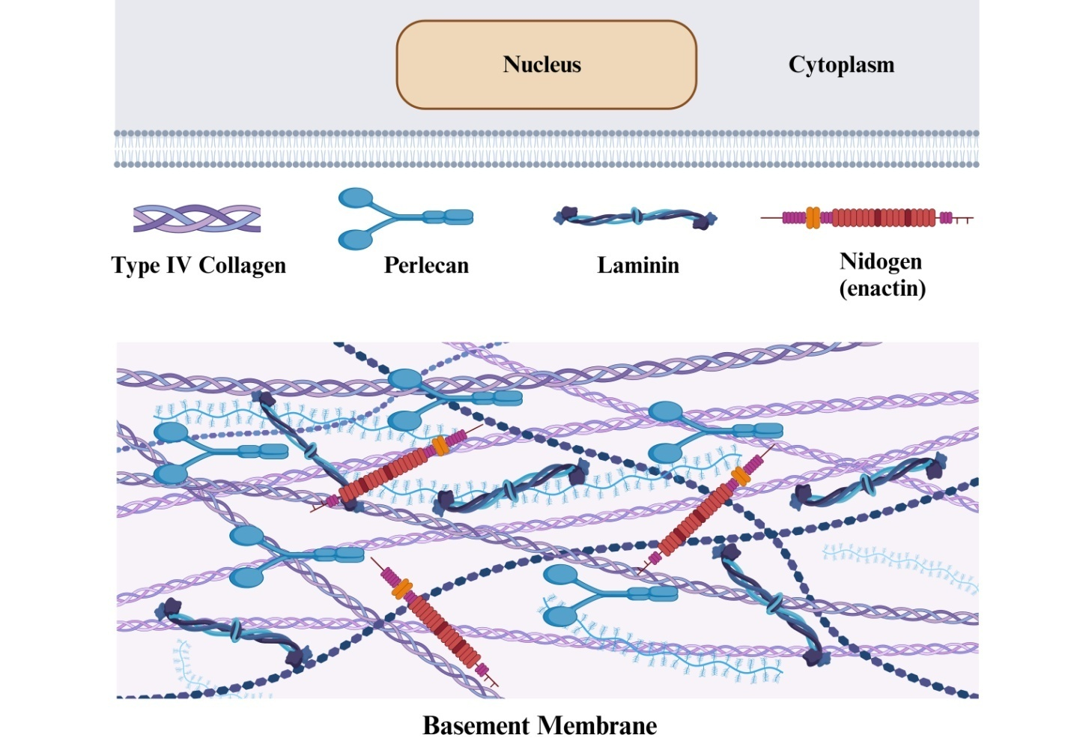

Figure 5: A basement membrane (BM) structure may be seen outside of the cell in a schematic illustration: A variety of basement membranes (BM) are produced by the vast majority of cells, with the exception of immune cells. (a) Within the cell, nidogen/entactin, perlecan, type IV collagen promoters, and laminin trimers are assembled and secreted as functional units of BM. (b) Around the basolateral surface of cells, laminin polymerization is thought to start the construction of the BM scaffold. Integrins and dystroglycans are receptor proteins that bind it to cells. (C) The type IV collagen network becomes associated with this polymer upon its deposition. While some research has shown that the laminin polymer and type IV collagen network may interact directly, nidogen/entactin acts as a bridge between the two. In order to form a functioning BM on the basolateral side of cells, the other BM components engage with the laminin polymer and the type IV collagen network (Tryggvason, 1987; Kalluri, 2003).

1.6.1. Membrane between cells:
Macrophages, chondrocytes, fibroblasts, and osteoblasts are some of the connective tissue cells that surround and create the interstitial matrix. It is made up of a network of protein fibers containing an amorphous glycosaminoglycan/proteoclycan material, as stated by Aumailley and Gayraud (1998). Matrix compositions and molecular structures vary between tissues. The dermis, ligaments, tendons, bone, and parenchymal organ stroma are all examples of such tissues. According to Prockop and Kivirikko (1995) and Aumailley and Gayraud (1998), collagens make up the majority of the structural components of the interstitial extracellular matrix (ECM) in all tissues. Types I, II, III, V, and XI fibrillar collagens are the primary molecules responsible for imparting mechanical strength. The triple-helical structure of a collagen makes it very resistant to proteolysis. This polymer consists of three α-chains that have Gly-X-Y triplet sequences that are sequential. Fibrils are formed when two molecules of collagen, each only a nanometer thick, combine. Covalent crosslinking helps to stabilize these fibrils so that they may further combine to create fibers. The principal component of collagen fibrils seen in many tissues is type I collagen, a heterotrimer composed of two β1(I) and one γ2(I) chain. Type II collagen, a component of cartilage, is mostly composed of homotypy 1(II)3. In soft connective tissues, type I collagen forms heterotypic fibrils with types III [μ1(III)3] and V. Prockop and Kivirikko (1995) and Aumailley and Gayraud (1998) both note the great diversity within the class of non-fibrollar collagens. Types IX, XII, XIV, XVI, and XIX FACIT collagens and other fibril-associated collagens with disrupted triple-helices are connected to collagen fibrils. In the majority of stromal connective tissues, type VI collagen is responsible for producing microfibrils. It is believed that elastic fibers are responsible for the elasticity of some tissues, including the dermis, the lungs, and the main blood arteries (Aumailley & Gayraud, 1998). Elastin, the principal protein component of elastic fibers, is hydrophobic, strongly crosslinked, and resistant to the majority of proteinases in addition to extreme physical treatments. Debelle and Tamburro (1999) found that elastic fibers interact with microfibrils composed of proteoglycans, different glycoproteins, and fibrillins. Glycoprotein: Glycoproteins are intracellular ECMs. Fibronectin and vitronectin, two structural ECM glycoproteins also present in plasma, aid cell attachment to the ECM (Tryggvason et al., 1987). Fibronectins are glycoproteins with a high molecular weight (235-270 kDa) that assemble into fibrillar structures and dimers linked by disulfides. There is a connection between fibronectins and integrin receptors on the surface of cells. Furthermore, they attach to a wide range of matrix components, including proteoglycans, collagen, and fibrin. Reduced synthesis and enhanced proteolytic degradation cause fibronectins at the cell surface and ECM to be downregulated during cell transformation (Tryggvason et al., 1987; Vartio et al., 1983). The disassembly of focal contact structures and the mediating of adhesive and anti-adhesive contacts may be facilitated by thrombospondins, tenascins, and SPARC (Murphy-Ullrich, 2001). The fibrous component of the interstitial extracellular matrix (ECM) consists of proteoglycans (PGs) and glycosaminoglycans (GAGs). Chondroitin sulfate, keratan, heparan, or dermatan O-linked glycosaminoglycan (GAG) chains connected to serine and threonine residues make up PGs (Iozzo, 1998). PGs build structural frameworks and operate on matrix organizations. Because of their hydrophilic nature, they are essential for the preservation of tissue volume and water retention. Adhesion, invasion, and cell proliferation are just a few of the many biological processes that PGs impact (Iozzo, 1998). Several ECM-associated growth factors, such as VEFG and FGF family members, bind to heparan sulphate proteoglycans (Lu, 2000). Extracellular matrix (ECM) components may be bound to by tiny, leucine-rich proteoglycans like decorin and fibromodulin, which aid in the regulation of collagen fibrillogenesis and matrix architecture.

1.6.2. Basement Membrane:
Basement membranes (BMs) are specialized sheets of extracellular matrix that, as stated by Tryggvason et al. (1987; Yurchenco & O'Rear, 1994), divide the collagenous stroma cells from the layers of epithelial and endothelial cells. Distributed cells on each side of the BM are responsible for their production and assembly. The primary proteoglycans found in bone marrow are chondroitin sulfate, entactin/nidogen, heparan, and type IV collagen. Since growth hormones like VEFG and FGF-2 may bind to perlecan, the primary BM heparan sulfate proteoglycan, proteoglycans are present in all BM structures and may play a role in charge-dependent molecular sieving and immobilization (Yurchenco & O'Rear, 1994; Iozzo, 1998). Fibulin, SPARC (secreted), multiplexin collagen types XV and XVIII, and other components are connected, according to the evidence.

1.7. Matrix Metalloproteases:
After the Human Genome Project was finished, researchers discovered that between twenty thousand and twenty-five thousand human genes included more than two percent proteases or protease inhibitors. In a number of processes, including development, reproduction, host defense, inflammatory illnesses, neurological disorders, and cancer, this discovery emphasizes the importance of regulated macromolecule breakdown (Pozo et al., 2005). All twenty-one components of the extracellular matrix (ECM) may be degraded by a family of 23 endopeptidases called matrix metalloproteinases (MMPs), and the list of non-ECM substrates that MMPs can degrade is continually expanding (Lopez-Otin & Overall, 2002). In addition to their involvement in the breakdown and remodeling of the extracellular matrix (ECM), matrix metalloproteinases (MMPs) play an essential role in controlling the actions of various physiologically active substances, such as growth factors, proinflammatory cytokines, chemokines, and serine proteinase inhibitors (Vu & Werb, 2000). Many physiological and pathological processes include matrix metalloproteinases (MMPs), including inflammation, immunity, chronic wounds, arthritis, periodontitis, cancer, and cardiovascular disease (Parks & Mecham, 1998; Vu and Werb, 2000; Stamenkovic, 2003). The majority of cultured cell types and all processes associated to repair and remodelling include matrix metalloproteinases (MMPs), but they are often absent from normal, healthy tissue (Parks & Mecham, 1998). The majority of cultured cell types and all processes associated to repair and remodelling include matrix metalloproteinases (MMPs), but they are often absent from normal, healthy tissue (Parks & Mecham, 1998). The most important naturally occurring inhibitors for precise proteolysis during typical tissue remodeling are tissue inhibitors of metalloproteinases, or TIMPs. Multiple pathways at the levels of gene transcription, messenger RNA stability, enzyme secretion and binding, zymogen activation, and endogenous inhibitor inhibition govern matrix metalloproteinase (MMP) activity (Nagase & Woestner, 1999). Many different mechanisms may regulate MMP activity, including mRNA stability, translational efficiency, autolysis, substrate targeting, shedding, oligomerization, cellular absorption and internalization, and enzyme compartmentalization and secretion. Taken as a whole, these methods restrict MMP expression and activity to the targeted regions.

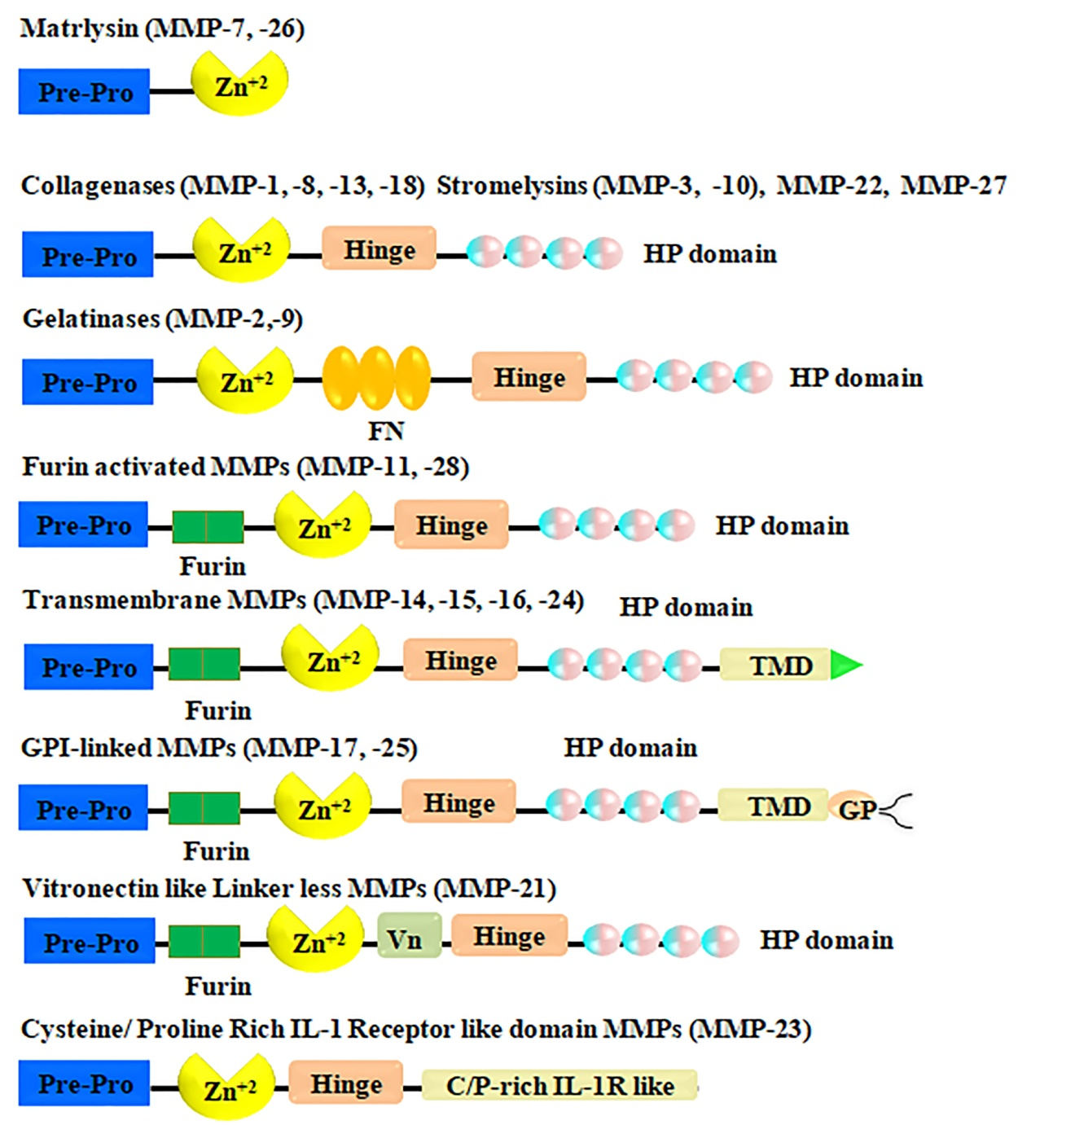

Figure 6. Matrix metalloproteinases. Five of the matrix metalloproteinases (MMPs) are secreted, whereas three are MT-MMPs, for a total of eight structural subgroups. The minimal-domain matrix metalloproteinases (MMPs) have a zinc-binding site (Zn) in their catalytic domain, an amino-terminal signal sequence (Pre), and a propeptide (Pro) that interacts with zinc via a thiol (SH) group. The hemopexin-containing simple MMPs mediate interactions with tissue inhibitors of metalloproteinases (TIMPs), cell-surface molecules, and proteolytic substrates via a hinge (H) that connects the hemopexin-like domain to the catalytic domain. A disulfide bond (S-S) connects the first and final of the four repetitions in the hemopexin-like domains. Certain matrix metalloproteinases (MMPs) include inserts that have resemblance to fibronectin type II repeats (Fi), which bind gelatin. The secreted MMPs that have been furinactivated have a recognition motif between their propeptide and catalytic domains that intracellular furin-like serine proteinases (Fu) may use to activate them. This pattern is shared by membrane-type MMPs (MT-MMPs) and vitronectin-like insert (Vn) MMPs. Multi-talented MMPs Glycosylphosphatidylinositol (GPI)-anchored matrix metalloproteinases (MT-MMPs) and transmembrane matrix metalloproteinases (TM-MMPs) with a carboxy-terminal, single-span TM and a very short Cy domain are two examples. Another kind of matrix metalloproteinase (MMP) that is attached to a cell membrane is MMP-23. It is a type II transmembrane matrix metalloproteinase because of the N-terminal signal anchor (SA) that binds it to the cell membrane. The distinct Cysteine array (CA) and immunoglobulin (Ig)-like domains of MMP-23 are other features of this protein (Egeblad & Werb, 2002).

1.7.1. Structure
The fundamental domain structure that all MMPs share consists of a signal peptide that guides secretion, a propeptide with a cysteine residue that preserves latency by ligating the catalytic zinc ion, and a catalytic domain with the zincbinding site (Birkedal-Hansen, 1993, Nagase & Woessner, 1999). While MMP-7, -23, and -26 lack the carboxy-terminal hemopexin-like domain and hinge region, the vast majority of MMPs possess these features. Moreover, certain domains, such the gelatin-binding domains present in the catalytic domain of MMP-2 and MMP-9 gelatinases, are unique to particular subgroups of matrix metalloproteinases. Enzyme binding to gelatin is facilitated by the presence of fibronectin motif repeats in these domains. The transmembrane domain is present in four out of the six membrane type matrix metalloproteinases (MT-MMPs) (MMP-14, -15, -16, and -24). Modulation of matrix metalloproteinase (MMP) expression and activity at multiple levels: Soluble factors, extracellular matrix-cell interactions (ECM), and cell-cell contacts are some of the regulatory signals that can activate MMPs by binding to specific receptors on cell surfaces. Both extracellular secretion of these matrix metalloproteinases (proMMP) and surface localization of these proteins to cells (MT-MMPs) are possible. Many events have the potential to activate proMMPs. Activated matrix metalloproteinases (MMPs) have a role in a number of cancer-promoting activities, such as cell proliferation, invasion, and angiogenesis; they may also impede the induction of cell death and the host immune response to tumors. It is also possible to impede the initiation of these cellular effects by using MMP autolysis or inhibitors.

1.7.2. Categories of Matrix Metalloproteinases
Based on their structural properties and substrate specificity, MMPs are classified into six subgroups: membrane type MMP (MT-MMP)s (MMP-14, MMP-15, MMP-16, MMP-17, MMP-24, MMP-25), other MMPs (MMP-12, MMP-19, MMP-20, MMP-21, MMP-23, MMP-27, MMP-28), collagenases (MMP-1, MMP-8, and MMP-13), gelatinases (MMP-2 and MMP-9), stromelysins (MMP-3, MMP-10, and MMP-11), matrilysins (MMP-7 and MMP-26), and other MMPs (MMP-12, MMP-19, MMP-20, MMP-21, MMP-23, MMP-27, MMP-28) (Birkedal-Hansen, 1993; Nagase & Woessner, 1999) (Figure. 8). Deleting the C-terminal region from collagenase renders it unable to break natural collagen (Nagase & Woessner, 1999). Despite sharing certain sequence similarities with other MMPs, the newly cloned MMP-23 stands out with its unique domain structure, brief prodomain, absence of hemopexin-like repeats in the Cterminal domain, and mystery signal sequence (Velasco et al., 1999).

The subfamily of collagenases described by Stolow et al. (1996) has three members: matrix metalloproteinase-1 (collagenase-1), matrix metalloproteinase-8 (neutrophil collagenase-2), and matrix metalloproteinase-13 (collagenase-3). The ¾- and ¼-fragments are created when collagenases cleave the native fibrillar collagen types I-III. The α1 chain's glysine-isoleusine (Gly-Ile) and the α2 chain's glysine-leu (Gly-Leu) residues are exactly where the cleavage occurs, leading to the formation of three helical pieces that, when heated to body temperature, denature to produce gelatin that is randomly coiled. Additional breakdown of the smaller fragments is carried out by gelatinases and proteinases (Birkedal-Hansen, 1993; Sternlicht & Werb, 2001). Different collagenases have different substrate specificities and functional roles. The matrix metalloproteinase MMP-1 preferentially breaks down collagen III, while matrix metalloproteinase MMP-8 favors type I collagen (Birkedal-Hansen, 1993; Figure. 8; Knauper et al., 1996).

The gelatinase group consists of two enzymes, gelatinase-A (MMP-2) and gelatinase-B (MMP-9), which have a same basic structure and substrate selectivity (Figure. 8). For binding and cleaving, especially of denatured collagen and elastin, gelatinases need three head-to-tail cysteine-rich repeats within their catalytic domain. These extensions resemble the collagen-binding type II repeats seen in fibronectin. Both gelatinases have the potential to dissolve partially denatured collagens of any genetic type after the first breakage by collagenases (Nagase & Woessner, 1999). Researchers found that matrix metalloproteinase-2 (MMP-2) in the basement membrane of a malignant melanoma tumor in mice were a powerful enzyme that degraded type IV collagen (Salo et al., 1991). Upon activation, the latent 72 kDa MMP-2 is liberated and undergoes a conformational shift to a 59-62 kDa variant. Collagen types I, II, IV, V, VII, X, and XI, as well as BM components and gelatins, are cleaved by matrix metalloproteinase-2 (Aimes & Quigley, 1995; Takagi et al., 1998; Sternlicht & Werb, 2001). Although it does not affect MMP-2 binding to collagen, the hemopexin domain is necessary for the early cleavage of type I collagen's triple helical structure, much like collagenases (Takagi, 1998). This is according to Sternlicht and Werb (2001). Activation of this secreted, latent 72-kD form mostly occurs. MMP-2, matrix metalloproteinase-1 (MT1-MMP), and tissue inhibitor of metalloproteinase-2 (TIMP-2) form a molecular complex that binds to and activates MMP-2 on cell surfaces. Once ProMMP-2 is in its active, proximate state, MMP-14 cleaves it into its 64-kD intermediate form. According to Murphy-Ullrich (2001), the fully active 62-kD variant is produced from this intermediate form by autoproteolytic cleavage at a second site. Cell movement, invasiveness, and metastasis are all correlated with MMP-2 overexpression in cancer. According to Liotta & Stetler-Stevenson (1990), Nagase & Woessner (1999), and Sternlicht & Werb (2001), MMP-2 is engaged in several processes that need ECM remodeling.

The original source of matrix metalloproteinase-9 was found in human macrophages (Nagase & Woessner, 1999), but it is now known to be produced by a wide range of cells, such as plasma cells, fibroblasts, vascular smooth muscle cells, osteoclasts, macrophages, PMNs, migrating keratinocytes, T-lymphocytes, monocytes, and macrophages (Leppert et al., 1995; Wucherpfennig et al., 1994; Parks & Mecham, 1998). When MMP-9 forms a significant complex with TIMP-1, it not only forms a 200-kD homodimer but is also ejected from cells as 92-kD proMMP-9 (Parks & Mecham, 1998). Consequently, some of the released MMP-9 binds to the surface of the cell and becomes very resistant to the inhibition of TIMP-1 (Parks & Mecham, 1998). Inflammation, wound healing, and cancer invasion may cause an increase in MMP-9 expression, which is typically mild and confined in normal tissues. Although MMP-9's substrate selectivity is similar to that of MMP-2, it does not degrade type I-III collagens to the same extent. The resorption of collagen during bone remodelling and growth is critically aided by MMP-9, as stated by Sternlicht and Werb (2001) and Parks and Mecham (1998). Inflammatory responses in lung and periodontal diseases have also been associated with its overexpression. According to Liotta and Stetler-Stevenson (1990) and Parks and Mecham (1998), MMP-9 is linked to tumor cells, their ability to metastasize, and cell invasion. According to Parks and Mecham (1998), the level of MMP-9 is greater in chronic wounds.

In the family of stromelysins, we will find MMP-3, MMP-10, and MMP-11, also known as stromelysin-1, -2, and -3. Similarities exist between the domain structures of stromelysins and collagenases. But natural fibrillar collagens are unbreakable. In addition to ProMMPs-1, -3, -7, -8, -9, and -13, MMP-3 is activated by tryptase, chymase, plasmin, and kallikrein (Nagase & Woessner, 1999; McCawley & Materisian, 2001). According to Liotta and Stetler-Stevenson (1990) and Parks and Mecham (1998), stromelysin-3 does not interact with many components of the extracellular matrix (ECM), but it has the ability to cleave insulin-like growth factor binding protein, proteinase inhibitors, β2-magroglobulin, and β1-PI. In contrast to other secreted matrix metalloproteinases, it has a proprotein convertase recognition area between its pro- and catalytic domains. According to Birkedal-Hansen (1993), it is expressed by fibroblasts, keratinocytes, and epithelial cells. One of the several ECM-related proteins that MMP-3 has the potential to degrade is proteoglycans (Parks & Mecham, 1998). According to Nagase and Woessner (1999) and Parks and Mecham (2004), MMP-10 is activated by plasmin, elastase, and cathepsin G, and it also activates proMMPs-1, -2, -7, -8, and -9. It degrades a wide variety of proteins involved with the extracellular matrix, including laminin1, fibronectin, proteoglycans, globular type IV and IX collagens, and others (McCawley & Materisian, 2001). Keratinocytes reveal MMP-10 expression in both in vivo and in vitro settings (Parks & Mecham, 1998). In contrast to other secreted matrix metalloproteinases, it has a proprotein convertase recognition area between its pro- and catalytic domains.

1.7.4. Control of transcription: Though normally expressed at a low rate, matrix metalloproteinases (MMPs) may be rapidly synthesized and activated in response to their need. Furthermore, the signal-transduction pathways that enable MMP transcriptional activators to exert their effects are quite diverse. One example is the p38 mitogen-activated protein kinase (MAPK), which may either enhance or decrease MMP synthesis in different cell types (ERK1, ERK2). Figure 9; Overall & Lopez-Otin, 2002 shows that several extracellular signals and signal-transduction pathways converge on the transcription factor AP1, which has a binding site in the promoter region of the majority of MMP genes. One possible general mechanism for the increase of MMP expression in malignant tumors is the presence of members of the FOS and JUN family of oncoproteins in AP1. Overall and Lopez-Otin (2002) and Parks and Mecham (1998) found that MMPs may be inducible by various agents or even the same agent in different kinds of tumor cells. This variation is likely due to additional nuclear factors that regulate MMP expression. These include the ETS family of oncoproteins, which bind PEA3 sites that are present in MMP gene promoters26; nuclear factor of ƙB (NF-ƙB), which induces MMP-1, 3, 9, 13 and 14 (Overall & Lopez-Otin, 2002; Parks & Mecham, 1998); signal transducers and activators of transcription (STATs), which mediate the effects of interferons (IFNs) on MMP gene expression; T-cell factor 4 (TCF4) and CAS-associated zinc-finger protein (CIZ), which activate the expression of MMP-1, 3 and 7 (Overall & Lopez-Otin, 2002; Parks & Mecham, 1998); p53,which modulates the transcription of MMP-1, 2 and 13 (Overall & Lopez-Otin, 2002); and core-binding factor A1 (CBFA1),which forms part of a regulatory cascade that controls MMP expression in both normal and tumour cells. Figure 9 shows that in addition to AG-rich element (AGRE) and TGF-β inhibitory element (TIE), the promoters of additional MMP genes also include negative regulatory elements. A1 (CBFA1), a regulator of matrix metalloproteinase (MMP) synthesis in normal and cancerous cells. Negative regulatory elements, such the AG-rich element (AGRE) and the TGF-β inhibitory element (TIE), have also been found in the promoters of additional MMP genes (Fig. 10). Growth factors, cytokines, oncogenes, hormones, extracellular matrix components, and cell-to-cell interactions regulate MMP expression at the transcriptional level.

Elements regulating the expression of human matrix metalloproteinase genes (Figure 9): The regions within the boxes that bind transcription factors, the 5'-3' promoters, and the transcription start sites (shown by the bent arrow). Some examples of locations that bind transcription factors are: AG-rich element (AGRE), activator proteins (AP)-1 and -2, core-binding factor 1 (CBFA1), cyclic AMP response-element binding protein (CREB), early growth response-1 (EGR1), immortalization-sensitive elements (ISE)-1 and -2, keratinocyte differentiation factor responsive element (KRE), nuclear factor of əB (NF-əB) site, polyomavirus enhancer-A binding-protein-3 (PEA3) site, retinoic-acid response element (RARE), retinoblastoma control element (RCE), stromelysin-1 platelet-derived growth factor-responsive element (SPRE), and signal transducer and activator of transcription (STAT). According to Parks and Mecham (1998), TGF-β affects transcription by means of a distinct mechanism that involves a TGF-β inhibitory element (TIE) found in many MMP genes. A variety of external stimuli may elicit varying responses from various cell types and MMP genes. A number of cytokines, including IL-1 and TNF-α, increase the inducible MMP production (MMP-1, MMP-3, MMP-7, MMP-8, MMP-9, MMP-13, and MMP-14) in various cell lines, in contrast to the mostly suppressive effects of TGF-β, glucocorticoids, IFN-ά, and retinoid acid. In keratinocytes, TGF-β promotes the production of MMP-2, MMP-9, and MMP-13; in glioma cells, it influences the creation of MMP-7; however, in fibroblasts, it hinders the development of MMP-1 and MMP-3 (Overall & Lopez-Otin, 2002). High levels are produced by the epidermal growth factor (EGF), TGF-β, and IL-1α. According to Saarialho-Kere et al. (1996), hormones, certain ECM proteins, bacterial cells and products, and cell-to-cell adhesion proteins may all promote MMP production and release. The effects of transcriptional regulation on the synthesis of matrix metalloproteinases 2 and 14 are small (Birkedal-Hansen, 1995; Saarialho-Kere et al., 1996). The complex process of transcriptional regulation of matrix metalloproteinase (MMP) production is clearly a result of regulating not only MMP production in cells but also the synthesis, degradation, and trans-activating activities of transcription factors.

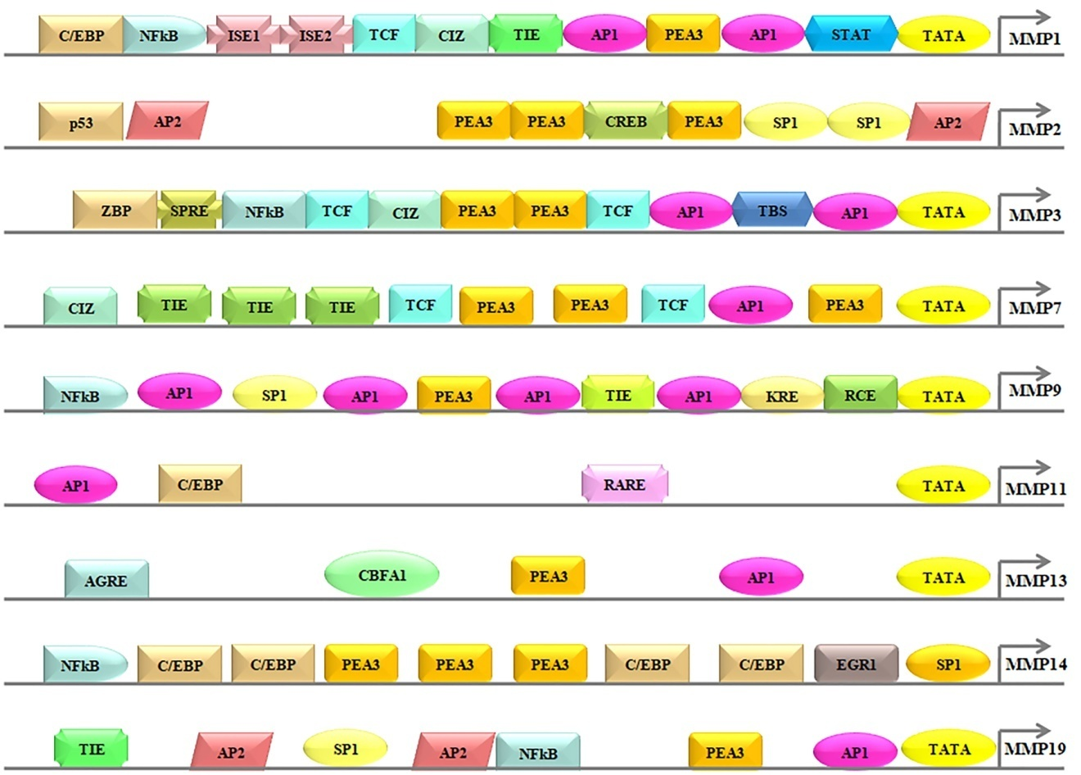

Figure 7: The promoter regions of human MMP genes include regulatory elements The 5'-3' promoters, the bent arrow indicating the transcription start sites, and the boxes containing the transcription factor binding sites. Transcription-factor-binding sites include: the AG-rich element (AGRE), the activator proteins (AP)-1 and -2 site, the core-binding factor 1 (CBFA1) site, the CCAAT/ enhancer-binding protein (C/EBP) site, the CAS-interacting zinc-finger protein (CIZ) site, the cyclic AMP response-element binding protein (CREB) site, the early growth response-1 (EGR1) site, the immortalization-sensitive elements (ISE)-1, and -2, the keratinocyte differentiationfactor responsive element (KRE), the nuclear factor of κB (NF-κB) site, the polyomavirus enhancer- A binding-protein-3 (PEA3) site, the retinoic-acid response element (RARE), the retinoblastoma control element (RCE), the stromelysin-1 platelet-derived growth factor-β responsive element (SPRE), the signal transducer and activator of transcription (STAT) site, the TATA-box (TATA), the TEL (translocation-ETS-leukaemia) binding site (TBS), the T-cell factor (TCF) site, the transforming growth factor-β inhibitory element (TIE) site, and the binding site for 89-kDa zinc-binding protein (ZBP-89) (Overall & Lopez-Otin, 2002).

One transcription factor is NF-̙ƙB, which is a group of proteins. According to Gilmore (2006), almost every kind of animal cell has NFƙ-̙B, and this protein is essential for cell response to stress, cytokines, free radicals, ultraviolet radiation, and bacterial or viral antigens. Collistar and Albensi (2005) found that NF-ƙB is associated with synaptic plasticity and memory processes. When an inflammatory response is stimulated, the NF-ƙB cytoplasmic site becomes active (Bussolino et al., 1996). The assembly of the five mammalian Rel proteins, p65, c-Rel, p50/NF-ƙB1, p52/NF-ƙB2, and RelB, in almost any configuration, forms the dimer NF-ƙB. A kind of cytoplasmic inhibitor known as inhibitors of NF-̫B (IkB's) forms a complex with NF-B in dormant cells. The activation of the IkB kinase complex (IKK complex) is a result of signaling pathways that are initiated by the stimulation of certain intracellular stimuli. The IKK complex includes scaffold proteins including IKKg (NEMO) and two functionally redundant kinases, IKKa (IKK1) and IKKb (IKK2). The IkBs are phosphorylated at a particular amino acid by the active IKK complex.

The activation protein-1 (AP-1) pathway is often involved in the cascade of growth factors and cytokines that promote matrix metalloproteinase (MMP) synthesis. To increase MMP synthesis, extracellular stimuli activate AP-1 transcription factor complexes, which then attach to the MMP gene's AP-1-binding site. In addition to regulating development, differentiation, and proliferation, AP-1 transcription factors regulate genes involved in stress responses, inflammation, and tumor formation (Figure 11; Angel & Karin, 1991). Homo- and hetero-dimers include AP-1 complexes, which include proto-oncogene families Fos (c-Fos, FosB, Fra-1, and Fra-2), Jun (c-Jun, JunB, and JunD), and ATF (ATF2, ATF3/LRF1, and B-ATF). These DNA-binding proteins are known as bZIPs, after the basic region leucine zipper. The proteins remain dormant in dormant cells but are swiftly awakened in response to several external stimuli, such as cytokines, growth factors, and signs of cellular stress (Whitmarsh & Davis, 1996; Angel & Karin, 1991). The cellular Fos and Jun proteins may also undergo neoplastic transformation when their expression is aberrant, unregulated, or overexpressed (Angel & Karin, 1991). The rate of tumor development is increased when both c-fos and c-jun are expressed simultaneously. According to research by Saez et al. (Saez et al., 1995), c-Fos is essential for the development of skin cancers that advance to a malignant stage. A "master switch" of cell proliferation and differentiation, c-Fos is shown in Figure 11. MAP kinase pathways regulate AP-1 activity post-transcriptionally and during transcription (Whitmarsh & Davis, 1996). After activation, the AP-1 complex attaches to the TRE motif, which is short for TPA responsive element, and triggers the transcription of many genes, one of which is MMPs. Polyomavirus enhancer A binding protein 3 (PEA-3) is a sequence that often accompanies the AP-1 binding site. Oncogene, growth factor, and phorphol ester-responsible elements activate the PEA binding site in the majority of MMP genes (Gutman & Wasylyk, 1990). During tumor growth, MMP regulation involves the simultaneous activation of MMP-genes via the AP-1 and PEA sites (Whitmarsh & Davis, 1996). A key component in the pathophysiology of NSAID-induced stomach ulceration, according to recent research, is the activation of AP-1.

1.8. The Healing Process of the Gastric Ulcer
The natural regenerative process of submucosal and mucosal tissue occurs during ulcer healing or repair. Ulceration is the result of a well-coordinated cascade of complicated metabolic reactions that occur to fix the damage. Although these processes do occur simultaneously, they may be arbitrarily divided into three distinct stages: inflammation, proliferation, and maturation/remodeling (Stadelmann et al., 1998; Qin & Benveniste, 1999).

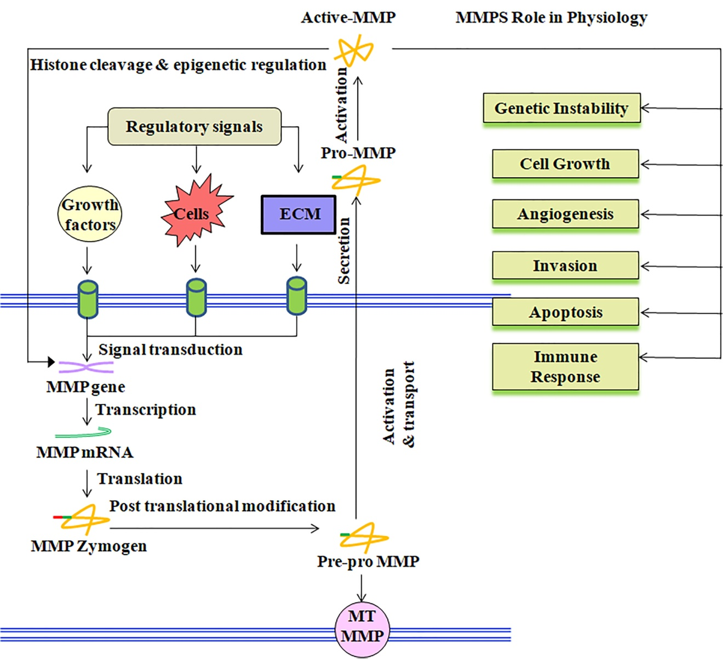
Figure 8: MMP expression and activity levels regulated Multiple regulatory signals, including soluble factors, ECM interactions, or cell-cell contacts, bind to specific receptors on cell surfaces. This sets in motion a series of events that results in the production of functional matrix metalloproteinases (MMPs), either secreted to the extracellular medium (proMMP) or localized to the cell surface (MT-MMPs). Various circumstances trigger the activation of ProMMPs. The red boxes indicate the many ways in which these active matrix metalloproteinases (MMPs) contribute to the progression of cancer. These pathways include enhancing genetic instability, cell proliferation, angiogenesis, and invasion. Both the host immunological response to tumors and the process of inducing cell death are obstructed by these substances. The induction of these cellular effects may be disrupted by MMP autolysis or inhibitors. Cell responses to regulatory cues, signal transduction, transcription induction, post-transcriptional processing, MMP activation and transport, and secretion are all levels of MMP regulation that might be targets for therapeutic interventions; they are shown in orange boxes (Overall & Lopez-Otin, 2002).

1.8.1: Inflammation
Obtaining hemostasis requires blood clotting, which in turn triggers the release of many substances that entice phagocytic cells. These cells then eat debris and injured tissues, paving the way for the proliferative phase of ulcer healing to begin. Platelets have a disproportionately large impact in this context because they release fibrin-fibronectin plugs that allow proteins and particles to aggregate, express glycoproteins on cell membranes, and initiate the induction of several factors (including cytokines, growth factors, prostacyclins, serotonin, bradykinin, prostaglandins, histamine, and prostacyclins). Granulation tissue and, subsequently, collagen, replaced this block when it dissolved. Inflammatory cells such as macrophases and leukocytes (polymorphonuclear neutrophils, PMNs) may enter the ulcerated region more easily because histamine aids in vasodilation while thromboxanes and prostaglandins enhance vasoconstrictin. By releasing proteases and free radicals, neutrophils phagocytize debris and break down injured tissues. Leukocytes such as macrophases and helper T cells release cytokines that stimulate the proliferation of T cells and increase vascular permeability and vasodilation. The low oxygen tension in the ulcerated region also stimulates macrophages, which in turn create substances that promote angiogenesis. In addition, they provoke cells to reepithelialize the wound, produce granulation tissue, and establish a fresh extracellular matrix. Macrophages play a crucial role in advancing wound healing to the next stage by secreting these substances (Martin & Leibovich, 2005).

1.8.2. Proliferative Stage
The proliferative phase begins two or three days after stomach wounds occur, when fibroblasts begin to infiltrate the ulcerated location, even before the inflammatory phase ends. The proliferative and inflammatory phases do not happen sequentially but rather share some time. Angiogenesis, collagen deposition, granulation tissue development, lialization, and ulcer wound contraction are the hallmarks of the proliferative phase (Lorenz & Longaker, 2003). The formation of new blood vessels from already-existing ones is known as angiogenesis, and it is a physiological process (Fig. 12). Muscular smooth muscle wall and pericytes form a structure with a thin wall that is lined with endothelium during angiogenesis. Signals from various cell types of the stomach mucosa, some of which produce pro- and antiangiogenic chemicals, interact in a balanced way to regulate angiogenesis. The ulcerated region undergoes granulation tissue development, which forms the foundation of the healing ulcer. This tissue is composed of epithelium and connective tissue (collagen), and it later transforms into blood vessels. In order to move, endothelial cells need plasminogen activator and collagenases to break down the ECM and the clot. The basement membrane and ECM are digested by MMPs here, allowing cell proliferation and angiogenesis to take place. Fibronectin on the fibrin scab and growth factors secreted by other cells both draw endothelial cells to the wound site. Stadelmann et al. (1998) and Midwood et al. (2004) found that endothelial cells are chemotactically attracted to low-oxygen environments by angiogenic substances produced by macrophages and platelets. Growth factors including vascular endothelial growth factor (VEGF), transforming growth factor (TGF), fibroblast growth factor (FGF), collagen, and proteases, particularly matrix metalloproteinases (MMPs), are angiogenic mediators. There is a lack of knowledge on the regulation of matrix metalloproteinases (MMPs) and growth factors during the healing of ulcers in humans and other animals (Shahin et al., 2001; Baragi et al., 1997). During the healing process of an ulcer, endothelial cells multiply in response to the beneficial effects of VEFG and TGFβ, eventually forming a network of microvessels and capillaries. Evidence suggests that VEFG plays a significant role in angiogenesis, the process by which a network's capillary density increases. Goto et al. (1993) found that basic fibroblast growth factor (bFGF) and vascular endothelial growth factor (VEFG) stimulated cell proliferation and tube structure development in bovine capillary endothelial cells. Endothelial cells will multiply and move in response to VEFG, leading to the formation of tube structures that resemble capillaries; hence, VEFG is an effective activator of angiogenesis, as shown in in vitro experiments (Chang et al., 2004; Prior et al., 2003). Endothelial cells undergo a tremendous signaling cascade when exposed to VEFG.

Blood vessel endothelial growth factor (VEGF) and basic fibroblast growth factor (bFGF) are two examples of the angiogenic growth factors released into neighboring tissues by wounded or inflammatory cells as part of the healing process. Specific endothelial cell (EC) receptors are the sites of binding for these growth agents. Signals are sent to the nucleus and endothelial cells are activated. The release of new growth factors and enzymes, such as matrix metalloproteinases (MMPs), allows the basement membrane that surrounds the blood vessels to develop microscopic holes. The process starts with the proliferation of endothelial cells, which then move to the site of injury. Specialized adhesion molecules, known as 'integrins,' aid in the advancement of the newly sprouting blood artery. As the expanding artery expands, MMPs help spread the tissue throughout its path. In the end, the blood vessel tube is formed by endothelial cells that multiply. Individual vessels may link to create loops that allow blood to flow. Pericytes and specific muscle cells provide structural support to the freshly produced blood vessels. Following blood flow to VEFG receptor-2 (VEGFR-2), a tyrosine kinase signaling cascade is initiated. This cascade stimulates the production of factors that, in turn, stimulate different aspects of blood vessel development, including permeability, proliferation, migration, and differentiation into mature blood vessels. According to Ma et al. (2001), when stomach ulcers were artificially created, VEFG levels in the blood rose but endostatin levels fell. Endothelial cell migration is the first step in VEFG-induced angiogenesis, which ultimately results in the sprouting of blood vessels. According to Brown et al. (1992), VEFG promotes endothelial cell migration and acts as a mitogen for endothelial cells. It also increases microvascular hyperpermeability, which leads to the creation of a fibrin-rich extracellular matrix and ultimately causes angiogenesis. In the treatment of stomach ulcers, angiogenesis and VEFG play crucial roles. Rats with experimental duodenal ulcers heal more faster when given VEFG (Tarnawski et al., 2001). According to Veikkola and Alitalo (1999) and Pepper (2001), angiogenic factors that operate indirectly, such as platelet derive growth factor (PDGF), epidermal growth factor (EGF), tumor necrosis factor (TNF), transforming growth factor beta (TGF-alpha), and interleukin (IL-01). Microvascular endothelial cells in the stomach of rats may be stimulated to express the VEFG gene by PGE2 (Dai et al., 2005). There are nineteen different polypeptide growth factors that make up the FGF family. In order to initiate the angiogenic response, bFGF and its receptor expression rise during stomach ulcer healing (Tarnawski et al., 2001). When administered intravenously or intraperitoneally with an antibody against bFGF, rats have poor ulcer healing quality and a prolonged healing process due to the removal of plasminogen activator (Tarnawski et al., 2001). Improved angiogenesis and wound healing are seen in rats treated with an acid stable recombinant bFGF. By releasing matrix-bound fibroblast growth factor from the stomach mucosa, sucralfate promotes ulcer healing (Ernst et al., 2001).

The inflammatory phase ends two to five days after ulceration, and fibroblasts begin to accumulate in the ulcerated location. Their numbers peak one to two weeks post-ulceration, and granulation tissue development and fibroplasia occur simultaneously with angiogenesis. Fibroblasts are primarily involved in migration and proliferation in the first 48 hours after injury, and they go on to form the primary collagen matrix at the wound site. Fibroblasts first travel over the inflammation phase's fibrin scab, which they attach to fibronectin. In order to migrate, fibroblasts first deposit ground material into the ulcer bed, and subsequently, collagen. In order to traverse the wound, fibroblasts deposit extracellular matrix components such as proteoglycans, glycoproteins, elastin, and fibronectin (Cohen et al., 2006). A big, open incision that penetrates the foundation membrane requires granulation tissue to cover the space. After two or five days after an ulcer has formed, it will start to develop and eventually cover the ulcer bed. A new, temporary extracellular matrix (ECM), myofibroblasts, endothelial cells, fibroblasts, inflammatory cells, and new blood vessels make up the tissue. Provisional extracellular matrix components include glycosaminoglycans, proteoglycans, fibronectin, and collagen; however, their composition differs from that of normal tissue ECM. A hydrated matrix is formed and cell motility is aided by its primary components, fibronectin and hyaluronan. At a later stage, an ECM that is more similar to the one in healthy tissue will replace this temporary matrix. Fibroblasts are encouraged to proliferate, migrate to the wound bed, and produce ECM molecules by fibronectin and growth factors (PDGF, TGF-β) (Stadelmann et al., 1998).

1.8.3. The Evolving and Remodeling Stage: Tissue healing enters its maturity phase when collagen synthesis and breakdown levels balance. Based on the wound's size and whether it was originally closed or left open, the maturation period may last for a year or more. Mulvaney and Harrington (1994) and Eichler and Carlson (2006) state that throughout maturation, type III collagen, which is abundant during proliferation, is progressively broken down and replaced with the stronger type I collagen. The collagen fibers are brought back into order by rearranging, cross-linking, and aligning them along tension lines. During this stage, the tensile strength of the ulcer wound grows; by three months after damage, it approaches 50% of normal tissue strength and eventually reaches as high as 80%. Apoptosis eliminates blood vessels that are no longer required, reducing activity at the wound site and resulting in a less reddening of the scar. According to Mulvaney and Harrington (1994) and Eichler and Carlson (2006), wound healing often occurs in a predictable and timely fashion. However, in cases when this is not the case, the healing process could develop incorrectly, leading to a chronic ulcer wound. In the healing stages of gastric ulcers, matrix metalloproteinases (MMPs) play an essential role in the dysregulation of extracellular matrix remodeling (Parks & Mecham, 1998). We still don't fully understand how MMPs play a part in the healing process of acute gastric ulcers caused by NSAIDs. According to Menges et al. (2000), Lempinen et al. (2000), and Shahin et al. (2001), there is little information available about the role of MMPs and TIMPs in NSAID-induced stomach ulcers. Research on extracellular matrix remodeling by modulating matrix metalloproteinases (MMPs) in vitro and in vivo has shown that MMPs-1, -2, and -9 are involved in indomethacin-induced gastric ulcers (Menges et al., 2000; Lempinen et al., 2000; Shahin, et al., 2001). Acute and chronic ulceration in rats are characterized by differential regulation of matrix metalloproteinases-9 and -2 (Lempinen, et al., 2000). According to Menges et al. (2000), the concentration of MMP-1 is noticeably greater in ulcers caused by H. pylori when contrasted with ulcers caused by nonsteroidal anti-inflammatory drugs. According to Lempinen et al. (2000), MMP-2 may be involved in the normal turnover of the gastric ECM, whereas MMP-9 might play a significant role in the first stages of chronic gastric ulcers caused by indomethacin. The crucial structural and functional role during stomach ulcer healing is played by the early initiation and extended duration of collagen expression, as shown by Shahin et al. (2001). Both active ulceration and extracellular matrix remodeling seem to require MMP-2.

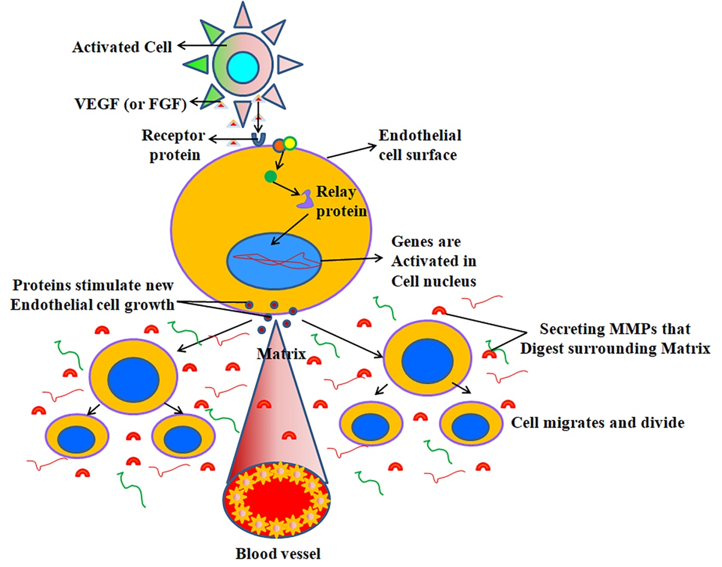

Figure 9. The process of blood vessel formation as an ulcer heals: Blood vessel endothelial growth factor (VEGF) and basic fibroblast growth factor (bFGF) are two examples of the angiogenic growth factors released into neighboring tissues by wounded or inflammatory cells as part of the healing process. Endothelial cells (EC) have particular receptors that these growth factors attach to. Signals are sent to the nucleus and endothelial cells are activated. The release of new growth factors and enzymes, such as matrix metalloproteinases (MMPs), allows the basement membrane that surrounds the blood vessels to develop microscopic holes. A process known as endothelial cell proliferation and migration to the site of injury is facilitated by specific adhesion molecules, or 'integrins,' which aid in the advancement of the newly sprouting blood vessel. Additionally, matrix metalloproteinases (MMPs) help spread the tissue ahead of the expanding artery. In the end, the blood vessel tube is formed by endothelial cells that multiply. Individual vessels may link to create loops that allow blood to flow. Additionally, pericytes and specific muscle cells provide structural support to the freshly created blood vessels. Next, blood starts to flow.

1.9. MEDICAL CARE
Taking a proton pump inhibitor (e.g., omeprazole) or a prostaglandin analogue (misoprostol) at the same time will often lessen the severity of gastrointestinal side effects by reducing acid production. Antacids are often prescribed to younger individuals who exhibit symptoms similar to ulcers. Compounds containing bismuth may have antimicrobial or even clearing properties. Peptic ulcers are a potential adverse effect of nonsteroidal anti-inflammatory drugs (NSAIDs), hence doctors may administer prostaglandin analogues like misoprostol to patients taking these drugs. Combinations of two antibiotics (such as clarithromycin, amoxicillin, tetracycline, or metronidazole) and one proton pump inhibitor (PPI), occasionally in conjunction with a bismuth molecule, are the most effective therapies for H. pylori infection. Peptic ulcers, no matter what caused them, heal faster when acid neutralization or reduction is achieved by the use of medications that directly suppress the stomach's acid production. The typical duration of therapy is four to eight weeks. The idea that eating bland foods may hasten healing or prevent ulcers from returning is unfounded, but bland diets may assist lower acid. However, it is reasonable for individuals to stay away from items that aggravate gas and discomfort. It is also crucial to avoid anything that might irritate the stomach, such alcohol, nicotine, and nonsteroidal anti-inflammatory drugs (Laine et al., 2008; Ramakrishnan & Salinas, 2007).

1.10. MELATONIN:
A hormone called melatonin, which is also known as N-acetyl-5-methoxytryptamine, is present in nature. on the part of the majority of animals, including humans, and even some other forms of life, such as algae In 2003, Caniato et al. A proper control of circadian rhythms depends on it, and its concentration in the bloodstream changes on a regular basis (Reiter, 1993; Redman et al., 1983). Quite a few In order for melatonin to have its biological effects, it must first activate melatonin receptors. however others attribute it to its function as a ubiquitous and potent antioxidant with a unique function in safeguarding mitochondrial and nuclear DNA (Altun & Ugur- Refer to Altun (2007) and Reiter et al. (2001). The pharmacological melatonin may regulate the time of day to environmental cycles and may be useful in therapy by some insomnias (Redman et al., 1983). It may not have much of a therapeutic impact. as a result of its low bioavailability, brief biological half-life, and the abundance of its generally speaking. The fundamental rationale for supplementing with melatonin could work as an all-natural sleep aid (Reiter et al., 1994). Added advantages to Melatonin's antioxidant properties may have a cumulative positive effect on health and wellness. it stimulates the endocrine system and other parts of the immune system. Research from the Massachusetts Institute of Technology in the United States found that supplement tablets containing melatonin had three to ten times the quantity required to generate the optimal physiologic melatonin blood level throughout the night for improvement time spent sleeping. Melatonin levels are raised for a few hours by the dosages. in order to improve the quality of one's slumber, however, some research indicates that lower dosages (such as Just equally helpful in increasing sleep quality are doses of 0.3 mg as are 3 mg.

1.10.1. Biological production
Melatonin is produced by pinealocytes in the pineal gland of higher animals and humans. The gastrointestinal system, the lens, and the retina (in the brain), among other places Sources: Dawson and Encel (1993) and Bubenik et al. (1977). It comes from the natural process of synthesizing the 5-hydroxyindole-amino acid tryptophan (via the production of serotonin) O-methyltransferase is an energetic enzyme. When the pineal gland produces melatonin, it is influenced by of the hypothalamic suprachiasmatic nucleus (SCN), which is responsible for receiving from the retina about the daily cycle of darkness and light. The two SCN Non-image-forming light information influences rhythmicity and melatonin synthesis. Via the retinohypothalamic tract (RHT), this was discovered not long ago. Retinal photosensitive neurons transmit the light/dark signal to the SCN. apart from those ganglion cells, which are innately photosensitive photoreceptor cells contribute to the formation of images. Melanopsin does have a vitamin-like sensitivity. photopigment based on vitamin A that is most sensitive to blue light at 484 nanometers (Reiter, 1993). This light signal triggers the body's natural sleep-wake cycle, which in turn triggers the release of particular "dark"- and "light"-induced endocrine and neuronal signals modulate behavior and the body's natural cycles of day and night. Melatonin may potentially be made by a cells from the periphery, including those found in the bone marrow, lymphocytes, and epithelial cells. Melatonin levels in these cells are often much more than that detected in blood, while it seems to be uncontrolled by the photoperiod (Karasek, 2003).

1.10.3. Use Cases
Melatonin synthesis varies in both time and amount, which is used by many species. like a clock that ticks away the years. It changes the profile of melatonin secretion and synthesis. due to the fact that summer nights tend to be shorter than winter ones. The shift secretion time acts as a biological cue for the planning of photoperiodic seasonal processes, which are reliant on daylength and include reproduction, conduct and coloration for camouflage in animals throughout the year. As a result, seasonal breeders who mate during the extended daylight hours and whose gestation periods are shorter, Their sexual physiology varies with the seasons, which is controlled by the melatonin signal. Progesterone (melatonin) are able to reduce libido by blocking the release of LH and the anterior pituitary gland's follicle-stimulating hormone (FSH), particularly in mammals that have a mating season while daylight hours are lengthy. The replicating Melatonin inhibits the reproduction of short-day breeders and of long-day breeders. According to Maharaj et al. (2007) and Reiter et al. (2007), melatonin is a stimulant for breeders. Melatonin controls the circadian cycle by chemically triggering lethargy and reduced core temperature, however it is the neurological system in particular, the suprachiasmatic nucleus, which regulates the circadian rhythm in rather than melatonin, the majority of the endocrine and paracrine components transmission (Karasek, 1999).

1.10.3. Use in medicine
Cancer, immunological problems, cardiovascular disease, and melatonin have all been the subject of research. disorders, sadness, SAD, circadian rhythm difficulties sleeping and impotence may manifest. According to preliminary studies, melatonin could have a role in important function in regulating the pharmacological effects of cocaine and other narcotics. Circadian rhythm disorders: melatonin, a chronobiotic that is administered externally when taken orally in the late afternoon or early evening, is, in addition to light treatment for delayed sleep phase syndrome, which is typically administered upon waking. associated with sleep-wake cycles that do not adhere to a 24-hour pattern. So far, it seems to be useful in combating other sleep disorders involving the circadian rhythm, including jet lag and issues experienced by those who job shifts that alternate between day and night (Reiter et al., 2007). Disruptions to sleep patterns and jet lag: Traveling great distances causes jet lag. swiftly across east and west time zones. Symptoms such as sleep disruption, loss of appetite, impaired psychomotor efficiency and overall malaise may ensue. The challenge for aircrews on lengthier schedules has been handled with by modifications in sleep habits. Alternating between short naps and longer stretches of sleep is possible. "Zeitgebers" (time givers) are environmental elements that synchronize and aid in maintaining animal throughout its life cycle. Quick travel between several time zones disrupts the regular rhythm. When crossing time zones, circadian rhythms need around one day to adjust. As an example, adjusting to a five-hour time change will take around five days. (Reiter et al., 2007). To alleviate jet lag, all it takes is an oral dosage of melatonin. aircraft crew experience time lag after many overseas flights. A 5-milligram oral dosage of melatonin for trips of five days or more, since it helps with jet lag, mood, and sufferers' lethargy. Shift workers might also be given 5 mg of melatonin during before going to bed, even if they seem quite attentive while they are up. Producing melatonin during night might have a role in the physiological start of sleep, and synthetic melatonin could helpful for the treatment of insomnia. At 6 and 8 o'clock in the evening, near to periods when the body releases its own melatonin and when sleep often begins. There has been melatonin the delayed sleep phase syndrome (5 mg daily for 30 days) was shown to be effective (Reiter et al., 2007).

Conclusion: NSAIDs are among the most prescribed drugs in the treatment of pain and inflammation in many conditions. However, the long-term use of this drug is known to be associated to gastric hyperacidity and ulceration. In particular NSAID cause gastric erosions through inhibition of prostaglandin synthesis, suppression of both cyclooxygenase activities, reduction in cell regeneration, production of ROS and decrease in mucosal blood flow in the ulcer margin (Konturek et al., 1994; Wallace, 1997). Indomethacin is a member of the arylalkanoic acid class of NSAIDs was first discovered in 1963 (Hart & Boardman, 1963) and approved for use in the United States in 1965. Today, a greater proportion of gastric ulcers develop due to increasing use of NSAIDs among individuals having pain syndromes and arthritis found mainly in aging populations (Bombardier et al., 2000). Various models of gastric ulcer were introduced in several experimental animals using NSAIDs (indomethacin, ibuprofen, naproxen, aspirin, and celocoxib), acetic acid, as well as H. pylori infection that resemble the gastric ulcer of human.

The structural integrity for gastric tissues is provided by ECM that plays an important regulatory role for cell proliferation, apoptosis, migration and differentiation during gastric ulceration as well as healing (Sahin et al., 2001; Ernst et al., 1995; Gillessen & Domschke, 1994). It has been reported that MMPs have critical role in modulation of different types of component of ECM that help in proper functioning of gastric tissues (Sahin et al., 2001; Gillessen & Domschke, 1994). MMPs are a family of zincdependent endopeptidases that selectively degrade or remodel most of the ECM components of gastric mucosa including collagen, and other structural molecules (Egeblad & Werb, 2002; Parks & Mecham, 1998). Among the MMP family there are two unique members i.e. gelatinases (MMP-2, 72 kDa and -9, 92 kDa) and stromilysin-1 (MMP-3, 56 kDa) which collectively can cleave type I, IV, V, VII, and XI collagens, elastin, fibronectin and laminin (Parks & Mecham, 1998). MMPs are highly regulated at various levels e.g. induction of gene expression, activation of latent zymogens and inhibition by tissue inhibitors of metalloproteases (TIMPs) (Parks & Mecham, 1998). MMP-2 (72 kd gelatinase) is unique among the MMPs because its expression is constitutive and its activation is associated with the balance between membrane type1- MMP (MT1-MMP) and TIMP-2 (Parks & Mecham, 1998). Activated MMPs are mainly responsible for the modulation of extracellular matrix (Parks & Mecham, 1998). In addition, healing of gastric ulceration requires angiogenesis in the granulation tissue at the base of the ulcer, together with replication of epithelial cells at the ulcer margins and subsequent re-establishment of glandular architecture (Szabo & Vincze, 2000; Jones et al., 1999; Takahashi et al., 1998). Among the phases of ulcer healing, matrix remodeling is the most important event for repair of both acute and chronic gastric ulcer. However, literature is scanty regarding the role of MMPs on remodeling of ECM and angiogenesis during NSAID-induced
gastric injury and healing processes (Swarnakar et al., 2005, Lempinen et al., 1999, Ganguly et al., 2006).

The major objective of NSAID-induced gastric ulceration was to understand the regulation of MMPs in gastric tissues during both acute and chronic phases of gastric ulceration and to investigate the mechanisms in terms of inflammation and molecular signaling. The results show that during NSAID-induced acute and chronic gastric ulceration, total proteolytic activities were increased along with increased MMP-9, -3 and MT1-MMP expression. In this study we found an excessive amount of active MMP-3 during the onset (day 1-5) and significant activation of MMP-9 during the later phases (day 6-9) of chronic gastric ulceration suggesting that active MMP-3 may possibly responsible for the activation of pro-MMP-9 molecules during later phases (day 6-9). The Immunofluorescence and biochemical evidences for the first time prove that the localization of both MMP-9 and -3 were confined especially to gastric mucosal cells at injured sites during the onset of ulceration and their synthesis and secretion were induced with progression of gastric ulcer. We also found that inflammatory cells in submucosa were also responsible for MMP-9 production which was increased with the progression of the disease that ultimately leads to fatal condition. We found an increased expression of proinflammatory molecules like TNF-α, IL-1β and IL-8 with enhanced MPO activity during both acute and chronic stages of gastric ulceration. In addition, both NF-κB and AP-1 signalling pathways were involved during acute and chronic stage of ulceration. However, during the chronic stage the prolongation of nuclear translocation of AP-1 follows the NF-κB translocation hence caused a significant upregulation of both MMP-9 and -3 target genes at transcription levels.

A number of well-known drugs including omeprazole, ranitidine and famotidine are in use for controlling hyperacidity and ulceration (Wallace, 2001), however their long-term use has been shown detrimental to the system. Hence, investigators are trying to identify a potent therapeutic agent, which prevents the gastropathy and ulceration without having adverse effects. The antioxidant properties of melatonin are well known (Beyer et al., 1998; Allegra et al., 2003; Reiter et al., 1994). It is well established that melatonin protects against gastric ulcer through scavenging various ROS (Pieri et al., 1995; Beyer et al., 1998), but no information is available regarding the effect of melatonin on ECM degradation and remodeling during ulceration and its prevention. We explore the regulation of MMPs especially MMP-9 and -3 by melatonin during healing of NSAID-induced acute and chronic gastric ulceration. Herein, melatonin protects excessive inflammation and severe oxidative stress in one hand and significant reduction in MMPs (MMP-9, -2 and -3) expression on the other hand during protection of indomethacin-induced acute and chronic gastric ulcers. Herein, we found that phosphorylation of ERK-1/2 and JNK leads to activation of both NF- κB and AP-1 during development of gastric inflammation, which was parallel to overproduction of ROS, TNF-α, IL-1β and IL-8. These situations were reversed during melatonin pretreatment.

We also studied redox-mediated molecular signaling of MMP-2 during indomethacin-induced acute and chronic gastric ulceration. Effects of antioxidants especially melatonin thereon has also been investigated. ROS generally modulate MMP activity either indirectly through redox-dependent regulation of MMP gene transcription or directly through modification of MMP structure (Nelson, and Melendez, 2004). However, the direct association of ROS with the regulation of MMPs during gastric ulceration is not well studied. We studied H2O2 that acts as a mediator to inhibit MMP-2 gene transcription and MMP-2 activity at the synthesis and the secretory levels in acute gastric ulcer. Herein, we explored the correlation of MMP-2 expression with the levels of MT1-MMP and TIMP-2 expressions during acute gastric injury. To investigate the possible role of H2O2 on MMP-2 transcription, we performed EMSA assay with nuclear extracts of acute and chronic gastric ulcerated tissues. The results shows that during acute gastric ulceration the activation and nuclear translocation of AP-2α transcription factor were reduced which were significantly increased during chronic gastric ulceration. We hypothesize that, during the onset of ulceration, the amount of H2O2 accumulation in gastric mucosa might have a role in the positive regulation of MMP signaling e.g., MMP-9 expression and activity (Figure. 2; Ganguly et al., 2006; Nelson & Melendez, 2004).

We also discussed about the action of melatonin as angiogenic modulator during indomethacin-induced gastric ulcer healing. Histological and immunofluorescence studies proved that during NSAID-induced acute gastric ulcer healing, melatonin accelerates new blood vessel formation. Additionally it enhanced the expression of VEGF and eNOS in gastric mucosa which was suppressed by NSAID-induced gastric ulceration. More importantly, therapeautic potential of melatonin was related to high expression of VEGF followed by MMP-2 activity suggesting its strong proangiogenic capabilities during gastric ulcer healing. Data suggest that upregulation of MMP-2 by melatonin helps in degradation of the basement membrane and allow the endothelial and other cells to invade the surrounding matrix. Further we propose that melatonin exerts preventive action due to its angiogenic nature as well as antioxidant nature. The approach of induction of proangiogenic factors by melatonin may be therapeutically exploited in higher risk individuals by co administering melatonin along with NSAIDS. During healing, melatonin promoted angiogenesis and indueced collagenolysis by upregulating the expression of VEGF, eNOS and MMP-2 and downregulating the expression of TIMP-2 (Ganguly et al., 2010).

Four decades after Gross and Lapiere (1962) first described a collagenolytic activity involved in tail resorption of tadpoles, the role of MMPs in human health and disease has become widely appreciated. It is to be hoped that the new knowledge that has been derived from intense study of these enzymes over the years will lead to the introduction of MMP-inhibition strategies as an essential component of the new generation of molecularly targeted therapies for different diseases including gastric ulceration.

REFERENCES:

1. Cullen, D. J.; Hawkey, G. M.; Greenwood, D. C.; Humphreys, H.; Shepherd, V.; Logan, R. F. and Hawkey, C. J. “Peptic Ulcer Bleeding in the Elderly: Relative Roles of Helicobacter Pylori and Non- Steroidal Anti-Inflammatory Drugs.” Gut, 1997, 41(4), pp. 459-62.

2. Konturek, S. J.; Konturek, P. C.; Brzozowski, T.; Konturek, J. W. and Pawlik, W. W. “From Nerves and Hormones to Bacteria in the Stomach; Nobel Prize for Achievements in Gastrology During Last Century.” J Physiol Pharmacol, 2005, 56(4), pp. 507-30.

3. Koelz, H. R.; Fischer, J. A.; Sachs, G. and Blum, A. L. “Specific Effect of Acetylsalicylic Acid on Cation Transport of Isolated Gastric Mucosal Cells.” Am J Physiol, 1978, 235(1), pp. E16-21.

4. Konturek, P. C. and Konturek, S. J. “Role of Helicobacter Pylori Infection in Gastro-Duodenal Secretion and in Pathogenesis of Peptic Ulcer and Gastritis.” J Physiol Pharmacol, 1994, 45(3), pp. 333-50.

5. Yoshikawa, T. and Naito, Y. “The Role of Neutrophils and Inflammation in Gastric Mucosal Injury.” Free Radic Res, 2000, 33(6), pp. 785-94.

6. Maity, P.; Biswas, K.; Roy, S.; Banerjee, R. K. and Bandyopadhyay, U. “Smoking and the Pathogenesis of Gastroduodenal Ulcer—Recent Mechanistic Update.” Mol Cell Biochem, 2003, 253(1-2), pp. 329-38.

7. Wallace, J. L. “Nonsteroidal Anti-Inflammatory Drugs and Gastroenteropathy: The Second Hundred Years.” Gastroenterology, 1997, 112(3), pp. 1000-16.

8. Brzozowski, T.; Konturek, P. C.; Sliwowski, Z.; Kwiecien, S.; Drozdowicz, D.; Pawlik, M.; Mach, K.; Konturek, S. J. and Pawlik, W. W. “Interaction of Nonsteroidal Anti Inflammatory Drugs (NSAID) with Helicobacter Pylori in the Stomach of Humans and Experimental Animals.” J Physiol Pharmacol, 2006, 57(Suppl 3), pp. 67-79.

9. Brzozowski, T.; Kwiecien, S.; Konturek, P. C.; Konturek, S. J.; Mitis-Musiol, M.; Duda, A.; Bielanski, W. and Hahn, E. G. “Comparison of Nitric Oxide-Releasing Nsaid and Vitamin C with Classic NSAID in Healing of Chronic Gastric Ulcers; Involvement of Reactive Oxygen Species.”Med Sci Monit, 2001, 7(4), pp. 592-9.

10. Naito, Y. and Yoshikawa, T. “Oxidative Stress Involvement and Gene Expression in Indomethacin-Induced Gastropathy.” Redox Rep, 2006, 11(6), pp. 243-53.

11. Bombardier, C.; Laine, L.; Reicin, A.; Shapiro, D.; Burgos-Vargas, R.; Davis, B.; Day, R.; Ferraz, M. B.; Hawkey, C. J.; Hochberg, M. C., et al. “Comparison of Upper Gastrointestinal Toxicity of Rofecoxib and Naproxen in Patients with Rheumatoid Arthritis. Vigor Study Group.” N Engl J Med, 2000, 343(21), pp. 1520-8.

12. Konturek, S. J.; Brzozowski, T.; Stachura, J.; Dembinski, A. and Majka, J. “Role of Gastric Blood Flow, Neutrophil Infiltration, and Mucosal Cell Proliferation in Gastric Adaptation to Aspirin in the Rat.” Gut, 1994, 35(9), pp. 1189-96.

13. Ernst, H.; Grunert, S.; Schneider, H. T.; Beck, W. S.; Brune, K. and Hahn, E. G. “Distribution of Extracellular Matrix Proteins in Indomethacin-Induced Lesions in the Rat Stomach.” Scand J Gastroenterol, 1995, 30(9), pp. 847-53.

14. Gillessen, A. and Domschke, W. “The Significance of Cytokines and Extracellular Matrix for Stomach Ulcer Healing.” Z Gastroenterol, 1994, 32(12), pp. 691-3.

15. Jones, M. K.; Tomikawa, M.; Mohajer, B. and Tarnawski, A. S. “Gastrointestinal Mucosal Regeneration: Role of Growth Factors.” Front Biosci, 1999, 4, pp. D303-9.

16. Tarnawski, A. S. “Cellular and Molecular Mechanisms of Gastrointestinal Ulcer Healing.” Dig Dis Sci, 2005, 50(Suppl 1), pp. S24-33.

17. Tarnawski, A.; Szabo, I. L.; Husain, S. S. and Soreghan, B. “Regeneration of Gastric Mucosa during Ulcer Healing Is Triggered by Growth Factors and Signal Transduction Pathways.” J Physiol Paris, 2001, 95(1-6), pp. 337-44.

18. Swarnakar, S., Ganguly, K., Kundu, P., Banerjee, A., Maity, P., and Sharma, A., V. Curcumin regulates expression and activity of matrix metalloproteinases-9 and -2 during prevention and healing of indomethacin- induced gastric ulcer J. Biol. Chem, 2005 280, pp. 9409-9415.

19. Ganguly, K.; Maity, P.; Reiter, R. J. and Swarnakar, S. “Effect of Melatonin on Secreted and Induced Matrix Metalloproteinase-9 and -2 Activity During Prevention of Indomethacin-Induced Gastric Ulcer.” J Pineal Res, 2005, 39(3), pp. 307-15.

20. Altun, A. and Ugur-Altun, B. “Melatonin: Therapeutic and Clinical Utilization.” Int J Clin Pract, 2007, 61(5), pp. 835-45.

21. Maestroni, G. J. “The Immunotherapeutic Potential of Melatonin.” Expert Opin Investig Drugs, 2001, 10(3), pp. 467-76.

22. Anthea, M. Human Biology and Health. Englewood Cliffs, New Jersey, USA: Prentice Hall, 1993.

23. Anne, M. R.A. and Moore, Keith L. Essential Clinical Anatomy. Hagerstown, MD: Lippincott Williams & Wilkins, 2007.

24. Arista-Nasr, J. “Gastropathies, Acute and Chronic Gastritis and Peptic Ulcer.” Rev Gastroenterol Mex, 2005, 70(Suppl 3), pp. 21-3.

25. Massarrat, S. “Smoking and Gut.” Arch Iran Med, 2008, 11(3), pp. 293-305.
26. Cullen, D. J.; Hawkey, G. M.; Greenwood, D. C.; Humphreys, H.; Shepherd, V.; Logan, R. F. and Hawkey, C. J. “Peptic Ulcer Bleeding in the Elderly: Relative Roles of Helicobacter Pylori and Non- Steroidal Anti-Inflammatory Drugs.” Gut, 1997, 41(4), pp. 459-62.

27. Langman, M. J.; Brooks, P.; Hawkey, C. J.; Silverstein, F. and Yeomans, N. “Non-Steroid Anti- Inflammatory Drug Associated Ulcer: Epidemiology, Causation and Treatment.” J Gastroenterol Hepatol, 1991, 6(5), pp. 442-9.

28. Gudis, K. and Sakamoto, C. “The Role of Cyclooxygenase in Gastric Mucosal Protection.” Dig Dis Sci, 2005, 50(Suppl 1), pp. S16-23.

29. Vane, J. R. and Botting, R. M. “Anti-Inflammatory Drugs and Their Mechanism of Action.” Inflamm Res, 1998, 47(Suppl 2), pp. S78-87.

30. Fiorucci, S. and Antonelli, E. “Cyclo-Oxygenase Isoenzymes. Structural Basis for Selective Inhibition of Cyclo-Oxygenases by Anti-Inflammatory Agents.” Dig Liver Dis, 2001, 33(Suppl 2), pp. S2-7.

31. Sies, H. and Cadenas, E. “Oxidative Stress: Damage to Intact Cells and Organs.” Philos Trans R Soc Lond B Biol Sci, 1985, 311(1152), pp. 617-31.

32. Stadtman, E. R. “Protein Oxidation and Aging.” Science, 1992, 257(5074), pp. 1220-4.

33. Shiva, S.; Moellering, D.; Ramachandran, A.; Levonen, A. L.; Landar, A.; Venkatraman, A.; Ceaser, E.; Ulasova, E.; Crawford, J. H.; Brookes, P. S., et al. “Redox Signalling: From Nitric Oxide to Oxidized Lipids.” Biochem Soc Symp, 2004, (71), pp. 107-20.

34. Stadtman, E. R. “Protein Oxidation and Aging.” Science, 1992, 257(5074), pp. 1220-4.

35. Imlay, J. A. “Pathways of Oxidative Damage.” Annu Rev Microbiol, 2003, 57, pp. 395-418.

36. McCord, J. M. and Fridovich, I. “Superoxide Dismutase. An Enzymic Function for Erythrocuprein (Hemocuprein).” J Biol Chem, 1969, 244(22), pp. 6049-55.

37. Sies, H. and Cadenas, E. “Oxidative Stress: Damage to Intact Cells and Organs.” Philos Trans R Soc Lond B Biol Sci, 1985, 311(1152), pp. 617-31.

38. Yoshikawa, T. and Naito, Y. “The Role of Neutrophils and Inflammation in Gastric Mucosal Injury.” Free Radic Res, 2000, 33(6), pp. 785-94.

39. Patterson, M. K.; Castellsague, J. and Walker, A. M. “Hospitalization for Peptic Ulcer and Bleeding in Users of Selective COX-2 Inhibitors and Nonselective Nsaids with Special Reference to Celecoxib.” Pharmacoepidemiol Drug Saf, 2008, 17(10), pp. 982-988.

40. Green, G. A. “Understanding Nsaids: From Aspirin to COX-2.” Clin Cornerstone, 2001, 3(5), pp. 50-60.
41. Vane, J. R. “The Fight against Rheumatism: From Willow Bark to COX-1 Sparing Drugs.” J Physiol Pharmacol, 2000, 51(4 Pt 1), pp. 573-86.

42. Vane, J. R. and Botting, R. M. “Anti-Inflammatory Drugs and Their Mechanism of Action.” Inflamm Res, 1998, 47(Suppl 2), pp. S78-87.

43. Moncada, S.; Ferreira, S. H. and Vane, J. R. “Prostaglandins, Aspirin-Like Drugs and the Oedema of Inflammation.” Nature, 1973, 246(5430), pp. 217-9.

44. Velo, G. P.; Dunn, C. J.; Giroud, J. P.; Timsit, J. and Willoughby, D. A. “Distribution of Prostaglandins in Inflammatory Exudate.” J Pathol, 1973, 111(3), pp. 149-58.

45. Collier, J. G. and Flower, R. J. “Effect of Aspirin on Human Seminal Prostaglandins.” Lancet, 1971, 2(7729), pp. 852-3.

46. Kalgutkar, A. S.; Crews, B. C.; Rowlinson, S. W.; Garner, C.; Seibert, K. and Marnett, L. J. “Aspirin- Like Molecules That Covalently Inactivate Cyclooxygenase-2.” Science, 1998, 280(5367), pp. 1268-70.

47. Mitchell, J. A.; Akarasereenont, P.; Thiemermann, C.; Flower, R. J. and Vane, J. R. “Selectivity of Nonsteroidal Antiinflammatory Drugs as Inhibitors of Constitutive and Inducible Cyclooxygenase.” Proc Natl Acad Sci U S A, 1993, 90(24), pp. 11693-7.

48. Lichtenberger, L. M. “Where Is the Evidence That Cyclooxygenase Inhibition Is the Primary Cause of Nonsteroidal Anti-Inflammatory Drug (Nsaid)-Induced Gastrointestinal Injury? Topical Injury Revisited.” Biochem Pharmacol, 2001, 61(6), pp. 631-7.

49. Anthea, M. Human Biology and Health. Englewood Cliffs, New Jersey, USA: Prentice Hall, 1993.

50. Shahin, M.; Gillessen, A.; Pohle, T.; Weber, C.; Schuppan, D.; Herbst, H. and Domschke, W. “Gastric Ulcer Healing in the Rat: Kinetics and Localisation of De Novo Procollagen Synthesis.” Gut., 1997, 41(2), pp. 187-94.

51. Okabe, S. and Amagase, K. “An Overview of Acetic Acid Ulcer Models and Their Utility for Drug Screening.” Nippon Yakurigaku Zasshi, 2003, 122(1), pp. 73-92.

52. Okabe, S. and Amagase, K. “An Overview of Acetic Acid Ulcer Models and Their Utility for Drug Screening.” Nippon Yakurigaku Zasshi, 2003, 122(1), pp. 73-92.

53. Yamagiwa, S.; Yoshida, Y.; Halder, R. C.; Weerasinghe, A.; Sugahara, S.; Asakura, H. and Abo, T. “Mechanisms Involved in Enteropathy Induced by Administration of Nonsteroidal Antiinflammatory Drugs (NSAIDs).” Dig Dis Sci, 2001, 46(1), pp. 192-9.

54. Szelenyi, I.; Engler, H.; Herzog, P.; Postius, S.; Vergin, H. and Holtermuller, K. H. “Influence of Nonsteroidal Anti-Inflammatory Compounds on Healing of Chronic Gastric Ulcers in Rats.” Agents Actions, 1982, 12(1-2), pp. 180-2.

55. Aumailley, M. and Gayraud, B. “Structure and Biological Activity of the Extracellular Matrix.” J Mol Med, 1998, 76(3-4), pp. 253-65.

56. Zagris, N. “Extracellular Matrix in Development of the Early Embryo.” Micron, 2001, 32(4), pp. 427-38.

57. Boudreau, N. and Bissell, M. J. “Extracellular Matrix Signaling: Integration of Form and Function in Normal and Malignant Cells.” Curr Opin Cell Biol, 1998, 10(5), pp. 640-6.

58. Sternlicht, M. D. and Werb, Z. “How Matrix Metalloproteinases Regulate Cell Behavior.” Annu Rev Cell Dev Biol, 2001, 17, pp. 463-516.

59. Birkedal-Hansen, H. “Proteolytic Remodeling of Extracellular Matrix.” Curr Opin Cell Biol, 1995, 7(5), pp. 728-35.

60. Woessner, J. F., Jr. “Role of Matrix Proteases in Processing Enamel Proteins.” Connect Tissue Res, 1998, 39(1-3), pp. 69-73; discussion 141-9.

61. Aumailley, M. and Gayraud, B. “Structure and Biological Activity of the Extracellular Matrix.” J Mol Med, 1998, 76(3-4), pp. 253-65.

62. Prockop, D. J. and Kivirikko, K. I. “Collagens: Molecular Biology, Diseases, and Potentials for Therapy.” Annu Rev Biochem, 1995, 64, pp. 403-34.

63. Debelle, L. and Tamburro, A. M. “Elastin: Molecular Description and Function.” Int J Biochem Cell Biol, 1999, 31(2), pp. 261-72.

64. Tryggvason, K.; Hoyhtya, M. and Salo, T. “Proteolytic Degradation of Extracellular Matrix in Tumor Invasion.” Biochim Biophys Acta, 1987, 907(3), pp. 191-217.

65. Vartio, T. “Fibronectin: Multiple Interactions Assigned to Structural Domains.” Med Biol, 1983, 61(6), pp. 283-95.

66. Murphy-Ullrich, J. E. “The De-Adhesive Activity of Matricellular Proteins: Is Intermediate Cell Adhesion an Adaptive State?” J Clin Invest, 2001, 107(7), pp. 785-90.

67. Iozzo, R.V. “Matrix Proteoglycans: From Molecular Design to Cellular Function.” Annu Rev Biochem, 1998, 67, pp. 609-52.

68. Lu, L.; Gunja-Smith, Z.; Woessner, J. F.; Ursell, P. C.; Nissen, T.; Galardy, R. E.; Xu, Y.; Zhu, P. and Schwartz, G. G. “Matrix Metalloproteinases and Collagen Ultrastructure in Moderate Myocardial Ischemia and Reperfusion in Vivo.” Am J Physiol Heart Circ Physiol, 2000, 279(2), pp. H601-9.

69. Yurchenco, P. D. and O’Rear, J. J. “Basement Membrane Assembly.” Methods Enzymol, 1994, 245, pp. 489-518.

70. Pozo, P.; Valenzuela, M. A.; Melej, C.; Zaldivar, M.; Puente, J.; Martinez, B. and Gamonal, J. “Longitudinal Analysis of Metalloproteinases, Tissue Inhibitors of Metalloproteinases and Clinical Parameters in Gingival Crevicular Fluid from Periodontitis-Affected Patients.” J Periodontal Res, 2005, 40(3), pp. 199-207.

71. Lopez-Otin, C. and Overall, C. M. “Protease Degradomics: A New Challenge for Proteomics.” Nat Rev Mol Cell Biol, 2002, 3(7), pp. 509-19.

72. Vu, T. H. and Werb, Z. “Matrix Metalloproteinases: Effectors of Development and Normal Physiology.” Genes Dev, 2000, 14(17), pp. 2123-33.

73. Parks, W. C. and Mecham, R. P. Matrix Metalloproteinases. New York: Academic Press, 1998.

74. Stamenkovic, I. “Matrix Metalloproteinases in Tumor Invasion and Metastasis.” Semin Cancer Biol, 2000, 10(6), pp. 415-33.

75. Nagase, H. and Woessner, J. F., Jr. “Matrix Metalloproteinases.” J Biol Chem, 1999, 274(31), pp.21491-4.

76. Velasco, G.; Pendas, A. M.; Fueyo, A.; Knauper, V.; Murphy, G. and Lopez-Otin, C. “Cloning and Characterization of Human MMP-23, a New Matrix Metalloproteinase Predominantly Expressed in Reproductive Tissues and Lacking Conserved Domains in Other Family Members.” J Biol Chem, 1999, 274(8), pp. 4570-6.

77. Stolow, M. A.; Bauzon, D. D.; Li, J.; Sedgwick, T.; Liang, V. C.; Sang, Q. A. and Shi, Y. B. “Identification and Characterization of a Novel Collagenase in Xenopus Laevis: Possible Roles During Frog Development.” Mol Biol Cell, 1996, 7(10), pp. 1471-83.

78. Birkedal-Hansen, H. “Role of Cytokines and Inflammatory Mediators in Tissue Destruction.” J Periodontal Res, 1993, 28(6 Pt 2), pp. 500-10.

79. Knauper, V.; Lopez-Otin, C.; Smith, B.; Knight, G. and Murphy, G. “Biochemical Characterization of Human Collagenase-3.” J Biol Chem, 1996, 271(3), pp. 1544-50.

80. Salo, T.; Lyons, J. G.; Rahemtulla, F.; Birkedal-Hansen, H. and Larjava, H. “Transforming Growth Factor-Beta 1 up-Regulates Type Iv Collagenase Expression in Cultured Human Keratinocytes.” J Biol Chem, 1991, 266(18), pp. 11436-41.

81. Aimes, R. T. and Quigley, J. P. “Matrix Metalloproteinase-2 Is an Interstitial Collagenase. Inhibitor- Free Enzyme Catalyzes the Cleavage of Collagen Fibrils and Soluble Native Type I Collage Generating the Specific 3/4- and 1/4-Length Fragments.” J Biol Chem, 1995, 270(11), pp. 5872-6.

82. Takagi, M.; Santavirta, S.; Ida, H.; Ishii, M.; Akimoto, K.; Saotome, K. and Konttinen, Y. T. “The Membrane-Type-Matrix Metalloproteinase/Matrix Metalloproteinase-2/Tissue Inhibitor of Metalloproteinase-2 System in Periprosthetic Connective-Tissue Remodeling in Loose Total-Hip Prostheses.” Lab Invest, 1998, 78(6), pp. 735-42.

83. Sternlicht, M. D. and Werb, Z. “How Matrix Metalloproteinases Regulate Cell Behavior.” Annu Rev Cell Dev Biol, 2001, 17, pp. 463-516.

84. Murphy-Ullrich, J. E. “The De-Adhesive Activity of Matricellular Proteins: Is Intermediate Cell Adhesion an Adaptive State?” J Clin Invest, 2001, 107(7), pp. 785-90.

85. Liotta, L. A. and Stetler-Stevenson, W. G. “Metalloproteinases and Cancer Invasion.” Semin Cancer Biol, 1990, 1(2), pp. 99-106.

86. Leppert, D.; Hauser, S. L.; Kishiyama, J. L.; An, S.; Zeng, L. and Goetzl, E. J. “Stimulation of Matrix Metalloproteinase-Dependent Migration of T Cells by Eicosanoids.” FASEB J, 1995, 9(14), pp. 1473-81.

87. Wucherpfennig, A. L.; Li, Y. P.; Stetler-Stevenson, W. G.; Rosenberg, A. E. and Stashenko, P. “Expression of 92 Kd Type Iv Collagenase/Gelatinase B in Human Osteoclasts.” J Bone Miner Res, 1994, 9(4), pp. 549-56.

88. McCawley, L. J. and Matrisian, L. M. “Tumor Progression: Defining the Soil Round the Tumor Seed.” Curr Biol, 2001, 11(1), pp. R25-7.

89. Overall, C. M. and Lopez-Otin, C. “Strategies for Mmp Inhibition in Cancer: Innovations for the Post-Trial Era.” Nat Rev Cancer, 2002, 2(9), pp. 657-72.

90. Saarialho-Kere, U. K.; Vaalamo, M.; Puolakkainen, P.; Airola, K.; Parks, W. C. and Karjalainen- Lindsberg, M. L. “Enhanced Expression of Matrilysin, Collagenase, and Stromelysin-1 in Gastrointestinal Ulcers.” Am J Pathol, 1996, 148(2), pp. 519-26.

91. Gilmore, T. D. “Introduction to NF-KappaB: Players, Pathways, Perspectives.” Oncogene, 2006, 25(51), pp. 6680-4.

92. Collister, K. A. and Albensi, B. C. “Potential Therapeutic Targets in the NF-KappaB Pathway for Alzheimer’s Disease.” Drug News Perspect, 2005, 18(10), pp. 623-9.

93. Bussolino, F.; Albini, A.; Camussi, G.; Presta, M.; Viglietto, G.; Ziche, M. and Persico, G. “Role of Soluble Mediators in Angiogenesis.” Eur J Cancer, 1996, 32A(14), pp. 2401-12.

94. Angel, P. and Karin, M. “The Role of Jun, Fos and the AP-1 Complex in Cell-Proliferation and Transformation.” Biochim Biophys Acta, 1991, 1072(2-3), pp. 129-57.

95. Whitmarsh, A. J. and Davis, R. J. “Transcription Factor AP-1 Regulation by Mitogen-Activated Protein Kinase Signal Transduction Pathways.” J Mol Med, 1996, 74(10), pp. 589-607.

96. Saez, E.; Rutberg, S. E.; Mueller, E.; Oppenheim, H.; Smoluk, J.; Yuspa, S. H. and Spiegelman, B. M. “C-Fos Is Required for Malignant Progression of Skin Tumors.” Cell, 1995, 82(5), pp. 721-32.

97. Gutman, A. and Wasylyk, B. “The Collagenase Gene Promoter Contains a Tpa and Oncogene- Responsive Unit Encompassing the PEA3 and AP-1 Binding Sites.” EMBO J, 1990, 9(7), pp. 2241- 6.

98. Stadelmann, W. K.; Digenis, A. G. and Tobin, G. R. “Physiology and Healing Dynamics of Chronic Cutaneous Wounds.” Am J Surg, 1998, 176(2A Suppl), pp. 26S-38S.

99. Qin, H.; Sun, Y. and Benveniste, E. N. “The Transcription Factors SP1, SP3, and AP-2 Are Required for Constitutive Matrix Metalloproteinase-2 Gene Expression in Astroglioma Cells.” J Biol Chem, 1999, 274(41), pp. 29130-7.

100. Martin, P. and Leibovich, S. J. “Inflammatory Cells During Wound Repair: The Good, the Bad and the Ugly.” Trends Cell Biol, 2005, 15(11), pp. 599-607.

101. Lorenz, H. P. and Longaker, M. T. “In Utero Surgery for Cleft Lip/Palate: Minimizing the “Ripple Effect” of Scarring.” J Craniofac Surg, 2003, 14(4), pp. 504-11.

102. Midwood, K. S.; Williams, L. V. and Schwarzbauer, J. E. “Tissue Repair and the Dynamics of the Extracellular Matrix.” Int J Biochem Cell Biol, 2004, 36(6), pp. 1031-7.

103. Shahin, M.; Konturek, J. W.; Pohle, T.; Schuppan, D.; Herbst, H. and Domschke, W. “Remodeling of Extracellular Matrix in Gastric Ulceration.” Microsc Res Tech, 2001, 53(6), pp. 396-408.

104. Baragi, V. M.; Qiu, L.; Gunja-Smith, Z.; Woessner, J. F., Jr.; Lesch, C. A. and Guglietta, A. “Role of Metalloproteinases in the Development and Healing of Acetic Acid-Induced Gastric Ulcer in Rats.” Scand J Gastroenterol, 1997, 32(5), pp. 419-26.

105. Goto, F.; Goto, K.; Weindel, K. and Folkman, J. “Synergistic Effects of Vascular Endothelial Growth Factor and Basic Fibroblast Growth Factor on the Proliferation and Cord Formation of Bovine Capillary Endothelial Cells within Collagen Gels.” Lab Invest, 1993, 69(5), pp. 508-17.

106. Chang, H. Y.; Sneddon, J. B.; Alizadeh, A. A.; Sood, R.; West, R. B.; Montgomery, K.; Chi, J. T.; van de Rijn, M.; Botstein, D. and Brown, P. O. “Gene Expression Signature of Fibroblast Serum Response Predicts Human Cancer Progression: Similarities between Tumors and Wounds.” PLoS Biol, 2004, 2(2), pp. E7.

107. Prior, B. M.; Lloyd, P. G.; Yang, H. T. and Terjung, R. L. “Exercise-Induced Vascular Remodeling.” Exerc Sport Sci Rev, 2003, 31(1), pp. 26-33.

108. Ma, X.; Zhang, L.; Ma, H. and Yu, R. “Association of Vascular Endothelial Growth Factor Expression with Angiogenesis and Tumor Cell Proliferation in Human Lung Cancer.” Zhonghua Nei Ke Za Zhi, 2001, 40(1), pp. 32-5.

109. Brown, L. F.; Yeo, K. T.; Berse, B.; Yeo, T. K.; Senger, D. R.; Dvorak, H. F. and van de Water, L. “Expression of Vascular Permeability Factor (Vascular Endothelial Growth Factor) by Epidermal Keratinocytes During Wound Healing.” J Exp Med, 1992, 176(5), pp. 1375-9.

110. Tarnawski, A.; Szabo, I. L.; Husain, S. S. and Soreghan, B. “Regeneration of Gastric Mucosa During Ulcer Healing Is Triggered by Growth Factors and Signal Transduction Pathways.” J Physiol Paris, 2001, 95(1-6), pp. 337-44.

111. Veikkola, T. and Alitalo, K. “VEGFs, Receptors and Angiogenesis.” Semin Cancer Biol, 1999, 9(3), pp. 211-20.

112. Pepper, M. S. “Role of the Matrix Metalloproteinase and Plasminogen Activator-Plasmin Systems in Angiogenesis.” Arterioscler Thromb Vasc Biol., 2001, 21(7), pp. 1104-17.

113. Ernst, H.; Grunert, S.; Schneider, H. T.; Beck, W. S.; Brune, K. and Hahn, E. G. “Distribution of Extracellular Matrix Proteins in Indomethacin-Induced Lesions in the Rat Stomach.” Scand J Gastroenterol, 1995, 30(9), pp. 847-53.

114. Cohen, D. B.; Kawamura, S.; Ehteshami, J. R. and Rodeo, S. A. “Indomethacin and Celecoxib Impair Rotator Cuff Tendon-to-Bone Healing.” Am J Sports Med, 2006, 34(3), pp. 362-9.

115. Mulvaney, M. and Harrington, A. Cutaneous Trauma and Its Treatment. 1994.

116. Eichler, M. J. and Carlson, M. A. “Modeling Dermal Granulation Tissue with the Linear Fibroblast- Populated Collagen Matrix: A Comparison with the Round Matrix Model.” J Dermatol Sci, 2006, 41(2), pp. 97-108.

117. Menges, M.; Chan, C. C.; Zeitz, M. and Stallmach, A. “Higher Concentration of Matrix- Metalloproteinase 1 (Interstitial Collagenase) in H. Pylori-Compared to NSAID-Induced Gastric Ulcers.” Z Gastroenterol, 2000, 38(11), pp. 887-91.

118. Lempinen, M.; Inkinen, K.; Wolff, H. and Ahonen, J. “Matrix Metalloproteinases 2 and 9 in Indomethacin-Induced Rat Gastric Ulcer.” Eur Surg Res, 2000, 32(3), pp. 169-76.

119. Shahin, M.; Konturek, J. W.; Pohle, T.; Schuppan, D.; Herbst, H. and Domschke, W. “Remodeling of Extracellular Matrix in Gastric Ulceration.” Microsc Res Tech, 2001, 53(6), pp. 396-408.

120. Laine, L.; Takeuchi, K. and Tarnawski, A. “Gastric Mucosal Defense and Cytoprotection: Bench to Bedside.” Gastroenterology, 2008, 135(1), pp. 41-60.

121. Ramakrishnan, K. and Salinas, R. C. “Peptic Ulcer Disease.” Am Fam Physician, 2007, 76(7), pp. 1005-12.

122. Caniato, R.; Filippini, R.; Piovan, A.; Puricelli, L.; Borsarini, A. and Cappelletti, E. M. “Melatonin in Plants.” Adv Exp Med Biol, 2003, 527, pp. 593-7.

123. Reiter, R. J. “The Melatonin Rhythm: Both a Clock and a Calendar.” Experientia, 1993, 49(8), pp. 654-64.

124. Redman, J.; Armstrong, S. and Ng, K. T. “Free-Running Activity Rhythms in the Rat: Entrainment by Melatonin.” Science, 1983, 219(4588), pp. 1089-91.

125. Altun, A. and Ugur-Altun, B. “Melatonin: Therapeutic and Clinical Utilization.” Int J Clin Pract, 2007, 61(5), pp. 835-45.

126. Reiter, R. J.; Acuna-Castroviejo, D.; Tan, D. X. and Burkhardt, S. “Free Radical-Mediated Molecular Damage. Mechanisms for the Protective Actions of Melatonin in the Central Nervous System.” Ann N Y Acad Sci, 2001, 939, pp. 200-15.

127. Reiter, R. J.; Tan, D. X.; Poeggeler, B.; Menendez-Pelaez, A.; Chen, L. D. and Saarela, S. “Melatonin as a Free Radical Scavenger: Implications for Aging and Age-Related Diseases.” Ann N Y Acad Sci, 1994, 719, pp. 1-12.

128. Dawson, D. and Encel, N. “Melatonin and Sleep in Humans.” J Pineal Res, 1993, 15(1), pp. 1-12.

129. Karasek, M. “Melatonin in Humans-Where We Are 40 Years after Its Discovery.” Neuro Endocrinol Lett, 1999, 20(3-4), pp. 179-88.

130. Maharaj, D. S.; Glass, B. D. and Daya, S. “Melatonin: New Places in Therapy.” Biosci Rep, 2007, 27(6), pp. 299-320.

131. Reiter, R. J.; Tan, D. X.; Terron, M. P.; Flores, L. J. and Czarnocki, Z. “Melatonin and Its Metabolites: New Findings Regarding Their Production and Their Radical Scavenging Actions.” Acta Biochim Pol, 2007, 54(1), pp. 1-9.

132. Hart, F. D. and Boardman, P. L. “Indomethacin: A New Non-Steroid Anti-Inflammatory Agent.” Br Med J, 1963, 2(5363), pp. 965-70.

133. Bombardier, C.; Laine, L.; Reicin, A.; Shapiro, D.; Burgos-Vargas, R.; Davis, B.; Day, R.; Ferraz, M. B.; Hawkey, C. J.; Hochberg, M. C., et al. “Comparison of Upper Gastrointestinal Toxicity of Rofecoxib and Naproxen in Patients with Rheumatoid Arthritis. Vigor Study Group.” N Engl J Med, 2000, 343(21), pp. 1520-8.

134. Shahin, M.; Konturek, J. W.; Pohle, T.; Schuppan, D.; Herbst, H. and Domschke, W. “Remodeling of Extracellular Matrix in Gastric Ulceration.” Microsc Res Tech, 2001, 53(6), pp. 396-408.

135. Ernst, H.; Grunert, S.; Schneider, H. T.; Beck, W. S.; Brune, K. and Hahn, E. G. “Distribution of Extracellular Matrix Proteins in Indomethacin-Induced Lesions in the Rat Stomach.” Scand J Gastroenterol, 1995, 30(9), pp. 847-53.

136. Gillessen, A. and Domschke, W. “The Significance of Cytokines and Extracellular Matrix for Stomach Ulcer Healing.” Z Gastroenterol, 1994, 32(12), pp. 691-3.

137. Egeblad, M. and Werb, Z. “New Functions for the Matrix Metalloproteinases in Cancer Progression.” Nat Rev Cancer, 2002, 2(3), pp. 161-74.

138. Szabo, S. and Vincze, A. “Growth Factors in Ulcer Healing: Lessons from Recent Studies.” J Physiol Paris, 2000, 94(2), pp. 77-81.

139. Jones, M. K.; Tomikawa, M.; Mohajer, B. and Tarnawski, A. S. “Gastrointestinal Mucosal Regeneration: Role of Growth Factors.” Front Biosci, 1999, 4, pp. D303-9.

140. Takahashi, C.; Sheng, Z.; Horan, T. P.; Kitayama, H.; Maki, M.; Hitomi, K.; Kitaura, Y.; Takai, S.; Sasahara, R. M.; Horimoto, A., et al. “Regulation of Matrix Metalloproteinase-9 and Inhibition of Tumor Invasion by the Membrane-Anchored Glycoprotein RECK.” Proc Natl Acad Sci U S A, 1998,95(22), pp. 13221-6.

141. Swarnakar, S.; Ganguly, K.; Kundu, P.; Banerjee, A.; Maity, P. and Sharma, A. V. “Curcumin Regulates Expression and Activity of Matrix Metalloproteinases 9 and 2 During Prevention and Healing of Indomethacin-Induced Gastric Ulcer.” J Biol Chem, 2005, 280(10), pp. 9409-15.

142. Lempinen, M.; Inkinen, K.; Wolff, H. and Ahonen, J. “Matrix Metalloproteinases 2 and 9 in Indomethacin-Induced Rat Gastric Ulcer.” Eur Surg Res, 2000, 32(3), pp. 169-76.

143. Ganguly, K., Maity, P., Reiter, R., J., and Swarnakar, S. Effect of melatonin on secreted and induced matrix metalloproteinase-9 and -2 activity during prevention of indomethacin induced gastric ulcer J. Pineal. Research. (2005): 39, PP307-315.

144. Beyer, C. E.; Steketee, J. D. and Saphier, D. “Antioxidant Properties of Melatonin—an Emerging Mystery.” Biochem Pharmacol, 1998, 56(10), pp. 1265-72.

145. Ganguly, K., Kundu, P., Banerjee, A., Reiter, R.J. and Swarnakar, S. Hydrogen peroxide mediated down regulation of matrix metalloprotease-2 in indomethacin-induced acute gastric ulceration is blocked by melatonin and other antioxidants. Free Rad. Biol. Med. 2006; 41; pp 911-925.

146. Ganguly, K., Sharma, A.V., Reiter, R.J., Swarnakar, S. Melatonin promotes angiogenesis during protection and healing of indomethacin-induced gastric ulcer: role of matrix metaloproteinase-2. J Pineal Res. 2010. 49(2); pp130-140.

