**GENDER BASED VIOLENCE**

Anitha J.

Assistant Professor, Department of Civil Engineering, Sir M Visvesvaraya Institute of Technology, Bengaluru, Karnataka, India

anitha_civil@sirmvit.edu

**ABSTRACT**

Gender-Based Violence (GBV) remains a pervasive issue worldwide, affecting individuals and communities across diverse social, economic, and cultural contexts. This chapter provides an in-depth exploration of the multifaceted nature of GBV, beginning with an overview of its various forms, including physical, psychological, sexual, and economic violence. Through a discussion on gender discrimination, this chapter highlights the structural inequalities that contribute to an environment where GBV can flourish, examining the ways these biases manifest across different settings, particularly in workplaces, marriage, and domestic life. Special attention is given to vulnerability factors within employment contexts, illustrating how power dynamics and social stigma can exacerbate exposure to violence and discrimination for certain groups. Further, the chapter delves into domestic violence and violence in marriage as pervasive expressions of GBV, with a focus on the unique psychological and physical impacts on individuals who face abuse from intimate partners. The cumulative impact of such violence on mental health, well-being, and social cohesion is examined, recognizing the cascading effects on communities and society as a whole. Through detailed analyses, the chapter uncovers the complex, interwoven factors that contribute to the persistence of GBV, including cultural norms, economic dependency, legal inadequacies, and lack of societal awareness. By synthesizing research findings, case studies, and theoretical frameworks, this chapter seeks to enhance understanding of the effects of GBV on both individuals and communities, encouraging a discourse on potential strategies for prevention, support, and societal transformation. This comprehensive approach aims to offer readers insight into the deep-seated challenges of GBV while fostering critical reflections on effective interventions and policy implications

**INTRODUCTION**

The United Nations characterizes violence against women as any form of gender-based violence leading to, or likely to result in, physical, sexual, or mental harm or suffering, encompassing threats, coercion, or arbitrary deprivation of liberty in public or private settings. Gender-based violence (GBV) is a prevalent and socially tolerated issue globally, particularly in India, where it is closely tied to patriarchal norms, asserting that men possess the privilege and power to inflict violence on women. Rooted in women's subordinate status, it is connected to both the patriarchal institution and the concept of masculinity, perpetuating the belief that a 'real man' engages in violence against women. GBV serves as a significant barrier to women's exercise of their human and fundamental rights as outlined by the Indian Constitution.

The United Nations High Commissioner for Refugees (UNHCR) defines GBV as a severe violation of human rights and a life-threatening health and protection concern. Although individuals of any gender can be victims of violence based on their sex or gender, women and girls face heightened risks of physical, sexual, and psychological violence, including rape, sexual abuse, trafficking, and forced prostitution. Globally, one in three women experiences physical and/or sexual violence in their lifetime, often perpetrated by an intimate partner, highlighting the pervasive gender inequality and discrimination against women.

GBV encompasses various forms of harm, including sexual, physical, mental, and economic, occurring in public or private. It also involves threats of violence, coercion, and manipulation, manifesting in intimate partner violence, sexual violence, child marriage, female genital mutilation, and 'honour crimes.' The consequences of GBV are profound, with survivors facing life-long repercussions, including the risk of death.

The United Nations Declaration on the Elimination of Violence against Women (DEVAW, 1993) describes violence against women as any act rooted in gender that causes, or is likely to cause, physical, sexual, or psychological harm or distress. DEVAW underscores that this violence reflects long-standing inequalities in power between men and women, which have fostered male dominance and discrimination against women, thereby obstructing women's full progress and development. Gender discrimination not only contributes to various forms of violence against women and girls but also fosters the widespread acceptance and concealment of such violence, preventing accountability for perpetrators and discouraging survivors from seeking support and speaking out.

**1.1 Gender-Based Violence**

Gender-based violence (GBV) refers to harmful acts directed at individuals or groups based on their gender. These acts can result in physical, sexual, or psychological harm and may involve threats, coercion, or the unjust restriction of freedom. GBV can occur in various settings, such as within families, communities, or work place, and can be perpetrated by relatives, acquaintances, strangers, or intimate partners. While violence affects everyone, GBV is primarily committed by men against women and girls, driven by gender dynamics. This form of violence undermines women's dignity, security, sexuality, reproductive rights, and bodily autonomy, posing significant threats to their physical and mental well-being. The root of GBV lies in power imbalances between genders, which are intensified by socio-economic, cultural, and structural inequalities.



**Fig.1: Gender Based Violence**

The term "gender-based violence" highlights the inequalities between men and women, impacting the health, dignity, security, and autonomy of its victims. Although GBV primarily affects women and girls, men and boys can also be victims, though the extent of its impact on them is less understood, it also affects individuals from marginalized groups, such as those in the LGBTQ community, reflecting societal tensions around gender and sexuality.

**Types of Gender-Based Violence**

In 1994, the UN Special Rapporteur on Violence Against Women identified three main categories of violence directed at women:

* Violence occurring within the family,
* Violence taking place within the community, and
* Inflicted by the state.

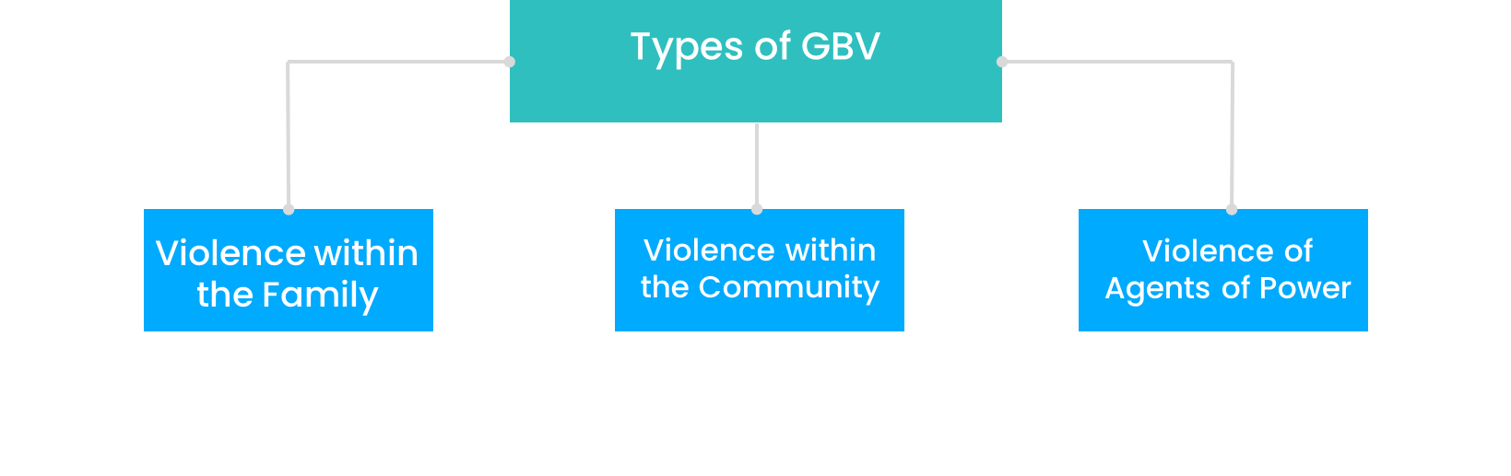

**Fig. 2: Gender Based Violence**

a) **Violence within the Family**: This form of violence basically occurs within the family of the victim. This covers female infanticide, sexual abuse and harassment of children, domestic violence, rape by family members. This also includes violence against lesbian, bisexual, and transgender individuals, any violation of sexual and reproductive rights is also covered.

b) **Violence within the Community**: This involves acts such as rape, sexual abuse, sexual harassment at workplaces and in public spaces, acid attacks, honor killings, trafficking and exploitation of vulnerable groups, including women and children, coerced involvement in prostitution on women with disabilities, and communal violence. It also includes violence specifically targeted at tribal and dalit women.

c) **Violence by Agents of Power**: This encompasses custodial rapes, torture, and killings, gender-based violence during war and conflict situations, violence against migrant women workers, refugees, and communal violence.

These categories are not mutually exclusive; some forms of violence may overlap between them. The interconnectedness of these categories serves to reinforce the systemic oppression of women and undermine their ability to fully enjoy their human rights.

* + 1. **Scale of Gender-Based Violence**

Gender-based violence has often been obscured by a culture of silence and societal acceptance, making it difficult to obtain precise data. The under-reporting of such incidents is largely due to the stigma, shame, and fear of retaliation that victims face. The magnitude of GBV in India can be partially understood through data from the National Crime Records Bureau (NCRB), Government of India. In 2022, National Crime Records Bureau (NCRB), Government of India reported a 4% increase in cases of crimes against women, compared to 2021. Among these, the most common crimes were ‘Cruelty by Husband or His Relatives’, followed by ‘Kidnapping & Abduction of Women’, and ‘Assault on Women with Intent to Outrage her Modesty’.

**Fig. 3: Crime against women**

A report by the Ministry of Statistics and Programme Implementation highlights a steady rise in the number of such crimes, with significant increases noted in cases of rape, kidnapping and abduction, and assaults on women aimed at outraging their modesty.

* + 1. **Forms of Gender-Based Violence in India**

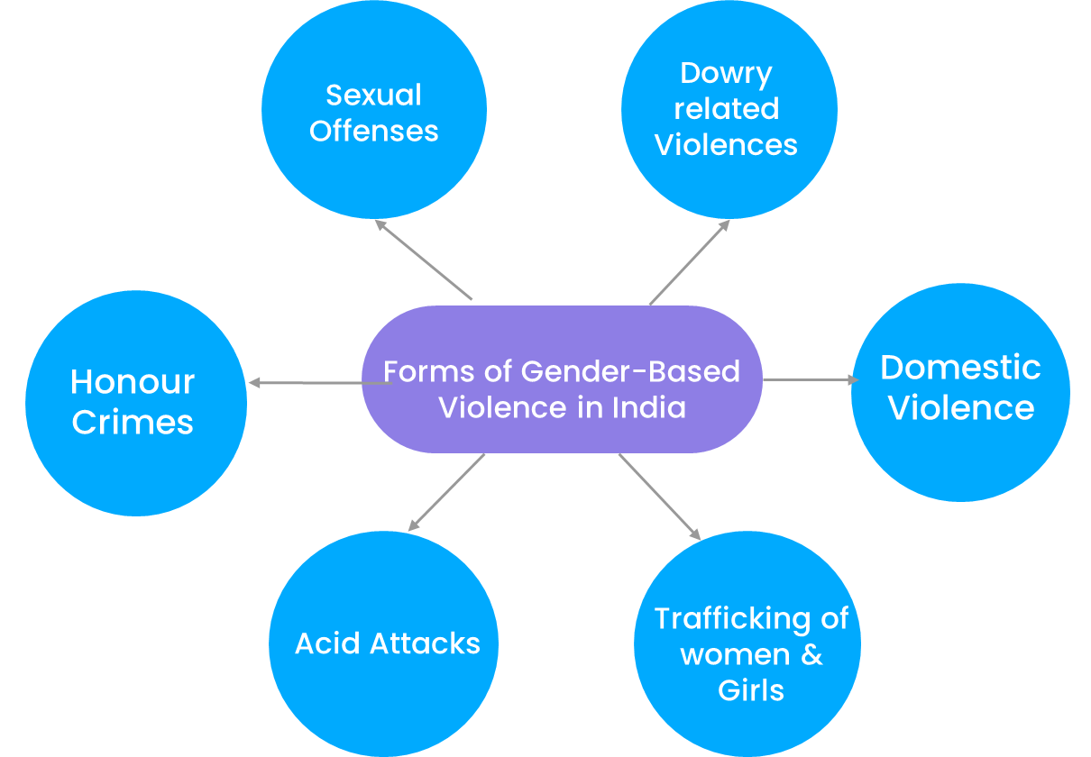

**Fig. 4: Forms of Gender Based Violence**

1. **Sexual Offences**

Women have historically been viewed as the bearers of chastity, modesty, and family honor, which has often led to the justification of patriarchal control over their bodies and lives. This control is frequently enforced through sexual violence, which is used as a tool to humiliate and dominate not only women but also their families and communities. Such violence is often justified under the pretext of protecting familial or communal honor, leading to restrictions on women's freedoms, choices, and even imposing dress codes. Sexual violence, including rape, serves as a means of asserting power and maintaining a societal hierarchy that privileges men over women.

This patriarchal ideology not only shapes family and community structures but also intertwines with broader social issues like casteism and communalism, further perpetuating the subordination of marginalized groups.

**Dowry-related** **Deaths and Harassment**

Dowry-related deaths and harassment remain a grave issue affecting women in many societies, particularly in South Asia. Despite legal measures to combat the dowry system, the practice persists, often leading to severe abuse and, tragically, fatalities. Many women experience harassment, threats, and violence from husbands or in-laws in cases where dowry demands are not met, escalating to physical harm and, in extreme cases, death. The deep-seated cultural acceptance of dowry, combined with societal pressures, places women in vulnerable situations where they face both psychological and physical risks, underscoring the urgent need for social reform and effective enforcement of protective laws.

The ongoing issue of dowry continues to be a significant driver of violence against women, manifesting in alarming rates of homicide, suicide, and harassment. Many of these incidents remain unreported, with some cases being misrepresented as accidental deaths.

The Dowry Prohibition Act of 1961 has been reinforced, and Sections 498A and 304B of the Indian Penal Code have been established to specifically address dowry-related harassment and murders. However, despite these legal measures and continuous campaigns, the incidence of dowry harassment remains high, indicating that these efforts have not been entirely successful in eradicating this crime.

cTop of Form

1. **Domestic Violence**

Domestic violence is a pervasive form of abuse that occurs within intimate or family relationships, impacting individuals across various socio-economic backgrounds. It includes physical, emotional, sexual, and economic abuse, often exerted to control or dominate a partner or family member. Victims of domestic violence frequently face isolation, fear, and a lack of resources, making it difficult for them to seek help or escape abusive environments. The effects of such violence extend beyond the immediate victims, affecting children, families, and communities, and contributing to a cycle of trauma that can persist across generations. Addressing domestic violence requires both supportive interventions and a robust legal framework to protect victims and hold perpetrators accountable.

1. **Trafficking of Women and Girls**

The trafficking of women and girls is a critical human rights issue affecting millions globally, with particularly concerning rates in countries like India. This illegal trade exploits women and girls primarily for forced labor, sexual exploitation, and servitude. Economic vulnerabilities, lack of education, and limited employment opportunities often place individuals at greater risk, while traffickers use coercion, deception, or outright force to trap them. In India, trafficking networks operate both domestically and across borders, targeting marginalized communities and exacerbating existing inequalities. The social and psychological impacts on trafficked women and girls are profound, leading to long-term trauma and undermining their fundamental rights. Comprehensive efforts involving stronger legal measures, cross-border cooperation, and community education are essential to combat this pervasive crime.

Within South Asia, India is the primary destination for trafficking survivors, with 90 percent of trafficking occurring domestically and only 10 percent across international borders.

The most at-risk populations include individuals from the lowest castes and marginalized socioeconomic backgrounds, such as women and girls who are separated from their families, those living in rural poverty, slums, brothels, or on the streets, people with physical or mental disabilities, those stigmatized due to abuse, and those affected by ethnic and communal violence.

Each year, countless women and girls fall victim to coercion, deceit, drugging, abduction, fraud, assault, and forced labor. They endure exploitative conditions resembling servitude or slavery, with little to no power to negotiate their circumstances. This trafficking often involves explicit forms of violence, including rape, torture, deprivation of liberty, forced labor, and forced marriage, particularly targeting girls who attempt to assert their rights.

1. **Acid Attacks**

Acid attacks are a brutal form of gender-based violence that disproportionately affects women and girls worldwide, including in India, where cases have drawn significant public attention. These attacks involve the intentional use of corrosive substances to inflict physical, psychological, and social harm, often as a means of revenge, punishment, or control. Many incidents are rooted in gender-based power dynamics, with perpetrators seeking to "punish" women for rejecting advances, refusing marriage proposals, or asserting independence. The injuries caused by acid attacks are devastating, resulting in disfigurement, blindness, and lifelong health complications, along with severe emotional and social repercussions. Survivors face immense stigma, with limited access to medical care, rehabilitation, and legal support. In India, despite strict legal prohibitions and regulated acid sales, enforcement remains a challenge, and incidents continue to occur. Addressing acid attacks requires comprehensive strategies, including preventive education, effective law enforcement, and strong support systems for survivors to aid their recovery and reintegration into society.

1. **Honour Crimes**

Honor crimes represent a severe form of gender-based violence, affecting individuals, particularly women and girls, across various cultures globally and in India. These acts are often rooted in traditional beliefs around family reputation, where individuals are subjected to violence or even death to "restore" perceived lost honor within a family or community. Women are the primary targets of honor crimes, often punished for actions that challenge social or familial expectations, such as choosing their own marriage partners, seeking divorce, dressing in ways deemed inappropriate, or engaging in relationships outside of accepted norms. In many instances, these crimes are carried out by close family members, who may feel socially justified in using violence to enforce their control over female relatives. Despite laws in place to prevent such atrocities, enforcement can be difficult, especially in regions where social norms and local support for these practices hinder justice for victims. In India, honor crimes have surfaced in various communities, and cases often attract national attention due to their brutal nature and underlying social pressures. Combating honor crimes requires both strong legal action and community-based interventions that challenge harmful cultural norms, promote gender equality, and protect individuals’ rights to personal autonomy and freedom.

Honour crimes are frequently under-reported, with incidents sometimes misclassified as accidents or suicides, complicating efforts to fully understand the scope of the issue in India.

1. **Female Sex Selective Abortions**

India has long faced an imbalanced sex ratio, with a higher male population compared to females, a disparity that has persisted since 1901 (see Table 2 below). This skewed ratio is the result of various harmful practices, including selective abortion of female fetuses, pre-conception male embryo selection, and female infanticide. While public focus often centers on the sex ratio itself, it is a reflection of deeper issues such as gender inequality, systemic discrimination against women, and the low social status of women and girls in India.

The role of a commercially driven and unethical medical sector is crucial in perpetuating this issue. The widespread availability of ultrasound and scanning centers, including mobile sex selection clinics in many villages and neighborhoods, highlights the problem. The devaluation of women creates a demand for technologies that cater to these biases, enabling and reinforcing discriminatory practices.

The deteriorating sex ratio is linked to increased sexual violence against girls and women, a rise in child marriages, higher maternal mortality due to unsafe abortions and early marriages, and trafficking for marriage from other regions. The adverse sex ratio thus contributes to a cycle of violence and exploitation. To address this issue, the Pre-Conception and Pre-Natal Diagnostic Techniques (Prohibition of Sex Selection) Act of 2003 was enacted.

* 1. **Gender Discrimination, Violence and Vulnerability at Work**

Gender discrimination in the workplace is a pervasive issue that significantly contributes to the vulnerability of women and marginalized groups. This discrimination manifests in various forms, including unequal pay for equal work, limited opportunities for advancement, and harassment. Women often face systemic barriers that hinder their professional growth, such as biased hiring practices, a lack of flexible work arrangements, and insufficient support for work-life balance. As a result, they are disproportionately affected by job insecurity and are more likely to occupy lower-paying positions with less job stability. This inequality not only impacts their economic independence but also reinforces societal norms that perpetuate gender-based violence and discrimination.

Violence and harassment in the workplace further exacerbate gender discrimination and vulnerability. Many women experience verbal, physical, or sexual harassment, creating a hostile work environment that can lead to psychological distress and decreased job performance. The fear of retaliation often prevents victims from reporting such incidents, leading to a culture of silence that allows abusive behaviors to persist. Additionally, workplace violence disproportionately affects women in certain sectors, such as domestic work, hospitality, and healthcare, where they may lack adequate legal protections or support systems. Addressing these issues requires comprehensive policies that promote gender equality, implement strict anti-harassment measures, and create safe and inclusive work environments. By fostering a culture of respect and accountability, organizations can help mitigate the risk of violence and discrimination, ultimately empowering all employees to thrive professionally.

Workplace or occupational violence, encompassing threats, physical or verbal abuse, is a significant concern for many workers. Sexual harassment, perpetrated by various individuals such as employers, employees, contractors, and clients, can take subtle or overt forms and may be intentional or unintentional. Harassment ranges from the abuse of authority or position among coworkers and affiliated personnel to inappropriate behavior towards consultants, clients, and members of the public.

Exploitation is often observed in paid domestic work, particularly among female migrant workers in developing countries. These workers may face poor working conditions, long hours, limited access to medical care, and the potential for physical or sexual abuse. Despite these challenges, many domestic workers may feel compelled to remain with abusive employers due to their financial needs.

* 1. **Violence in Marriage**

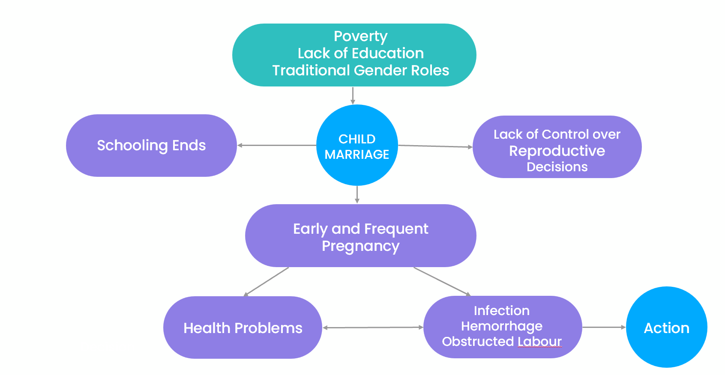

**Fig. 5: Effects of Early Marriage**

Marital violence can manifest in various forms, whether active or passive, overt or covert, and encompassing physical, sexual, and psychological abuse simultaneously. Within the context of marriage in India, violence takes on multiple dimensions, including but not limited to kicking, beating, dragging by hair, cutting, verbal abuse, starvation, forced sex, shouting, scolding, threatening, desertion, restriction of movement, employment constraints, and various other forms of torture.

Several prevalent forms of marital violence in India are highlighted below:

1. **Early Marriage:** Encouraged to control a girl's sexuality, early marriage aims to transition her safely from her natal home to the marital home without risking family honor. This practice results in early pregnancies, posing risks to the mother's health, while also limiting educational and employment opportunities for women.
2. **Dowry:** An age-old practice in India, dowry involves the exchange of wealth from the bride's family to the groom's, including cash, ornaments, land, gadgets, or other assets. Dowry is a major cause of wife battering, with reports of violence, desertion, torture, murder, and burning of wives for additional dowries.
3. **Wife Battering:** Wife battering, a widely practiced and often denied form of domestic violence, encompasses physical, psychological, and sexual abuse inflicted on wives. This complex social phenomenon perpetuates power imbalances within the family, with the subordination of wives socially accepted and rarely interfered with.
4. **Marital Rape:** Marital rape is defined as any unwanted intercourse or penetration obtained through force, threat, or when the wife is unable to consent. This form of sexual violence is an abuse of power, aiming to establish dominance and control over the wife, often seen as the husband's "property." The women's movement has played a crucial role in pushing for legal recognition and legislation against various forms of violence within marriage. While progress has been made, challenges remain, and certain acts, such as marital rape, are yet to be fully recognized as crimes by both the law and society.Top of Form
5. **Divorce**: In numerous societies, divorce has become a socially accepted aspect of marriage, with legal systems universally recognizing the right to divorce for both women and men. Divorce laws have evolved, simplifying the process, particularly with the introduction of mutual consent divorces. While divorced status is normalized in many societies, in India, opting for divorce, especially for women, remains challenging. The country has distinct marriage and divorce laws tailored to different religions, each with its own set of regulations. Grounds for divorce in India encompass various factors such as adultery, desertion, cruelty, impotency, chronic diseases, and conversion into another religion. Despite the enactment of several divorce laws, the procedure in India remains intricate and time-consuming. The judiciary often emphasizes the preservation of marriages, frequently providing extended time spans and recommending marital counselling before proceeding with divorce cases. Divorce is still perceived as a disruption of marriage and family, particularly when initiated by a woman. Women seeking divorce may be labelled as "home breakers," accused of having "loose morals," deemed "selfish," or branded as "bad mothers." The state, society, and communities continue to prioritize the preservation of marriage and family, sometimes at the expense of women's rights to a life of dignity and freedom from violence.
   1. **Domestic Violence: Undermining the notion of family as a safe haven**

Several prevalent forms of domestic violence in India are outlined below. Additional forms will be covered in the upcoming unit on 'Marriage.'

1. **Sex Selection and Female Infanticide:** The act of aborting female fetuses before birth is a pervasive form of violence in Indian society. The decline in the female-male sex ratio over the past decades attests to this phenomenon. The widespread use of techniques like amniocentesis for sex determination has led to female foeticide becoming a common violence against women. This practice is often driven by an ideology that glorifies male children, linked to Hindu beliefs about the son facilitating the passage of parents to the next world.
2. **Unequal Access to Facilities and Resources:** Discrimination against girls based on assumptions of inferiority and vulnerability results in unequal access to basic resources within families. These resources include nutrition, healthcare, education, material assets, and parental attention. Evidence suggests that girls and women are generally less privileged than boys in accessing these resources, contributing to an unjust distribution within households.
3. **Child Abuse:** Children, especially girls, often experience substantial abuse of physical, psychological, and emotional nature. Child sexual abuse, a rampant but rarely discussed form, disproportionately affects girls. The burden of household duties on girls deprives them of a carefree childhood. Sexual abuse is underreported, particularly when perpetrated by family members, and male child sexual abuse also occurs.
4. **Sexual Harassment:** Sexual harassment is not confined to public spaces; it also occurs in domestic settings. Unwelcome sexual advances, requests for sexual favors, and other inappropriate behavior create an atmosphere of fear, compromising the dignity of the woman involved. Men often employ sexual harassment as a tool to enforce patriarchal control.
5. **Sexual Assault or Rape:** Rape, defined as a non-consensual sexual act involving physical force, threats, or intimidation, includes marital rape. Contrary to common beliefs, most rapes happen within homes, perpetrated by family members, acquaintances, neighbors, cousins, and close relatives. Marital rape, occurring within the confines of marriage, is a serious issue that often goes unreported.
6. **Violence against Aged Persons and Widows:** A situation of dependency on the younger generation can lead to neglect, ill-treatment, and various forms of violence against older individuals, especially women. Economic dependence on relatives, including in-laws, sons, daughters-in-law, and other family members, makes widows and aged individuals vulnerable to violence. In patriarchal societies, widows face exploitation, limited movement, and sexual vulnerability, sometimes being forced into prostitution by their in-laws. The LGBTQ community also experiences violence and discrimination due to deviations from heteronormative family ideals. Transgender individuals, such as hijras, may face abandonment or infanticide, while homosexuality is often met with violence, including threats and rape, to enforce conformity to heterosexuality. These instances highlight the family's potential to hierarchize, discriminate, and violate its members, challenging the notion of family as a universally safe and loving space.

**1.5 Effects of Gender-Based Violence on Individuals and Communities**Gender-based violence (GBV) significantly impacts both the immediate and long-term health of survivors. Sexual health consequences may include unintended pregnancies, complications from unsafe abortions, sexual dysfunction, and the transmission of sexually transmitted infections, including HIV. Physical consequences may involve injuries that lead to acute and chronic illnesses affecting various bodily systems. Mental health issues are also common among survivors, including depression, anxiety, substance abuse, post-traumatic stress disorder, and suicidal thoughts. The stigma surrounding GBV can further isolate survivors, leading to ostracism from their communities and exacerbating social and economic disadvantages.

The effects of GBV can significantly impair survivors' overall well-being and hinder their ability to function effectively within personal relationships and broader community interactions. This impact extends to family dynamics and community attitudes, particularly towards children born as a result of rape. LGBTI individuals may face difficulties in proving non-consensual sexual violence to authorities, while male victims might risk legal repercussions under sodomy laws when reporting violence by another man.

GBV can also affect child survival and development, contributing to higher infant mortality rates, lower birth weights, malnutrition, and issues with school attendance. Children exposed to GBV may suffer from disabilities, developmental delays, and long-term mental health problems. The indirect nature of these effects can make it difficult to fully recognize and address the problem. A failure to acknowledge the hidden and extensive impacts of GBV can limit society's ability to recover from such humanitarian crises.

Addressing GBV requires a comprehensive approach that considers contributing factors at the societal, community, and individual levels, as outlined by Heise's ecological model (1998). Although humanitarian emergencies can amplify risks, the root causes are often deeply embedded in gender-based discrimination and inequality. Effective strategies should address immediate needs, promote long-term social and cultural changes towards gender equality, ensure the leadership and active participation of women and girls, advocate for the rights of affected populations, and involve women in all levels of program implementation and leadership.

* 1. **Contributing Factors to GBV**

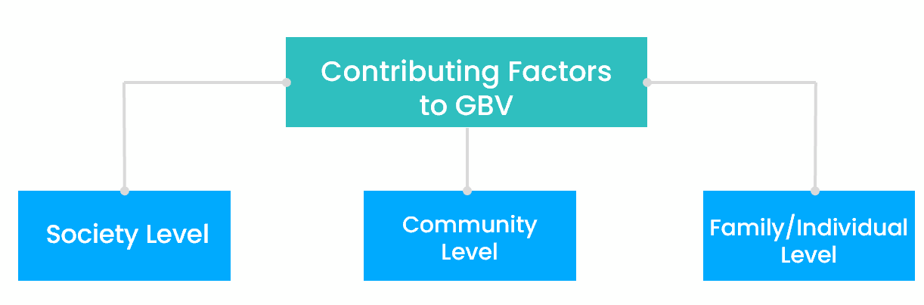

**Fig. 6: Factors Contributing to Gender Based Violence**

**Table 1. Contributing Factors to GBV**

|  |  |
| --- | --- |
| **Society-Level Contributing Factors** | Promotion and rewards for hyper-masculinity, which reinforce violent male norms and behaviours, contribute significantly to the perpetuation of violence. |
| Combat strategies that involve torture or rape as tools of warfare further exacerbate this issue. |
| The lack of effective security and early warning systems, coupled with deep-seated economic, social, and gender inequalities, compounds the problem. |
| Inadequate involvement of women in leadership roles, peacebuilding efforts, and security sector reform limits the effectiveness of responses to violence. |
| The insufficient focus on prosecuting sexual crimes, combined with inadequate efforts to improve access to recovery services and address the long-term impacts on children born from rape—such as stigma and social exclusion—further undermine efforts to combat and address gender-based violence. |
| **Community-Level Contributing Factors** | Restricted access to education for females, particularly for adolescent girls seeking secondary education, poses a significant barrier to empowerment. |
| The shortage of safe shelters for women, girls, and other vulnerable groups further exacerbates their risk. |
| Economic opportunities are often limited for affected populations, especially women, girls, and other at-risk groups, leaving them with few alternatives for economic independence. |
| Absence of robust reporting systems for survivors and individuals at risk of gender-based violence (GBV) and sexual exploitation and abuse by humanitarian workers. |
| Prevailing attitudes that blame victims or perpetuate harmful beliefs about GBV survivors contribute to the problem. |
| Widespread community acceptance of violence reinforces these issues and hinders efforts to address and prevent GBV. |
| **Individual-Level Contributing Factors** | Inadequate access to essential survival needs, such as food, water, shelter, cooking fuel, and hygiene supplies, significantly impacts vulnerable populations. |
| Gender-based disparities in the distribution of family resources further exacerbate these challenges. |
| Parents, especially women and those heading households alone, often struggle with insufficient resources to care for children and elderly family members. |
| Lack of awareness among some individuals regarding acceptable conduct by humanitarian staff and the understanding that humanitarian assistance should be provided free of charge. |
| Harmful use of alcohol and drugs, combined with factors such as age, gender, education, and disability, can compound vulnerabilities. |
| A family history of violence can perpetuate cycles of abuse and disadvantage. |

**CONCLUDING REMARKS**

In this chapter, we have examined both traditional and modern perspectives on women’s roles in the workforce. The essential concepts, including comprehensive explanations and statistical examples of both productive and reproductive labor, as well as distinctions between paid and unpaid work have been introduced. This chapter reviews existing research on gender and employment, and discusses the standards for measuring work. The various topics covered include workplace violence, gender discrimination, and the specific vulnerabilities faced by women in professional settings.

The concept of substantive gender equality acknowledges that men and women require different approaches to achieve true equality. Addressing the initial disadvantages faced by women, particularly those from marginalized groups, is essential. Globally and in India, gender disparities are most prominent in the economic and political spheres, compared to education and health. Additionally, the imbalance in sex ratios at birth is a growing issue worldwide and within India, alongside the high prevalence of gender-based violence against women.

**REFERENCES**

[1]. Heise, L., Ellsberg, M., & Gottmoeller, M. (2002). A global overview of gender-based violence. *International Journal of Gynecology & Obstetrics*, *78*, S5-S14.

[2]. Russo, N. F., & Pirlott, A. (2006). Gender‐based violence: concepts, methods, and findings. *Annals of the new york academy of sciences*, *1087*(1), 178-205.

[3]. Roy, A. S., Sen, N., & Bagchi, S. S. (2021). Gender-Based violence in India in Covid-19 lockdown. *Journal of Comparative Literature and Aesthetics*, *44*(1), 41-55.

[4]. Kethineni, S., Srinivasan, M., & Kakar, S. (2016). Combating violence against women in India: Nari Adalats and gender-based justice. *Women & Criminal Justice*, *26*(4), 281-300.

[5]. Singh, M., Kumar, V., Rupani, R., Kumari, S., Yadav, P. K., Singh, R., & Verma, A. K. (2018). Acid attack on women: A new face of gender-based violence in India. *Indian Journal of Burns*, *26*(1), 83-86.

[6]. Ahmed-Ghosh, H. (2004). Chattels of society: Domestic violence in India. *Violence against women*, *10*(1), 94-118.

[7]. Simister, J., & Makowiec, J. (2008). Domestic violence in India: effects of education. *Indian Journal of Gender Studies*, *15*(3), 507-518.

[8]. Ellsberg, M., Arango, D. J., Morton, M., Gennari, F., Kiplesund, S., Contreras, M., & Watts, C. (2015). Prevention of violence against women and girls: what does the evidence say?. *The lancet*, *385*(9977), 1555-1566.

[9]. Harrell, S., & Dickey, S. A. (1985). Dowry systems in complex societies. *Ethnology*, *24*(2), 105-120.

[10]. Jamatia, P. L. (2022). Dowry System: An Impediment to Women Empowerment. *Journal of Media, Culture and Communication (JMCC) ISSN*, 2799-1245.

[11]. Nour, N. M. (2006). Health consequences of child marriage in Africa. *Emerging infectious diseases*, *12*(11), 1644.

[12]. Raj, A. (2010). When the mother is a child: the impact of child marriage on the health and human rights of girls. *Archives of disease in childhood*, *95*(11), 931-935.

[13]. Mahato, S. K. (2016). Causes and consequences of child marriage: a perspective. *International Journal of Scientific and engineering research*, *7*(7), 697-702.

[14]. Deshpande, N. A., & Nour, N. M. (2013). Sex trafficking of women and girls. *Reviews in Obstetrics and Gynecology*, *6*(1), e22.

[15]. Sanjel, S. (2013). Gender-based violence: a crucial challenge for public health. *Kathmandu University medical journal*, *11*(2), 179-184.

[16]. Cusack, S., & Cook, R. J. (2007). " Honour": Crimes, Paradigms, and Violence against Women. *Human rights quarterly*, *29*(2), 524-533.

[17]. Indira Gandhi National Open University, 2017. *BGSE-001 Gender Sensitization: Society, Culture, and Change*. Publisher.

[18]. United Nations Development Programme. (2024). *About us*. UNDP. Retrieved November 2, 2024, from <https://www.undp.org>