Entamoeba histolytica

Entamoeba histolytica was first described by Losch in 1857. It derives its name from its ability to lyse virtually every tissue in the human body and in the bodies of experimental animals.
E. histolytica is worldwide in distribution but more common in tropical and subtropical countries. The largest burden of disease occurs in tropics of China, Central and South America and Indian subcontinents affecting 10% of the world’s population.
On a global scale, it ranks second after malaria as a cause of death among people with parasitic infections produced by protozoa.
Habitat
Trophozoites of E. histolytica reside in mucosa and submucosa of large intestine of man.
Morphology
The parasite exists in three morphological forms:
- Trophozoite
- Precyst
- Cyst
Trophozoite
It measures 10-60 µm in diameter.
It is the invasive form as well as the feeding and replicating form of the parasite found in the faeces of patients with active disease. It survives only for a few hours.
- Cytoplasm
Cytoplasm is divided into a clear ectoplasm and a granular endoplasm. Granular endoplasm looks as good as ground glass appearance and contains RBC, WBC and food vacuoles containing tissue debris and bacteria. RBC are found only in stage of invasion
Trophozoite are motile with active, unidirectional, rapid progressive and purposeful motility. Ectoplasm in which endoplasm flows, has long finger like projection called as pseudopodia.
- Nucleus
Nucleus is spherical, single, 4-6 µm in diameter. In stained preparations it shows a central dot like compact karyosome which is surrounded by a clear halo. Nuclear membrane is thin and delicate and is lined by a layer of fine chromatin granules. The number of chromosomes varies between 30 & 50. The space between karyosome and the nuclear membrane is traversed by spoke like radial arrangement of achromatic fibrils (cart wheel appearance). Trophozoite is anaerobic parasite, lack mitochondria, ER and Golgi apparatus.
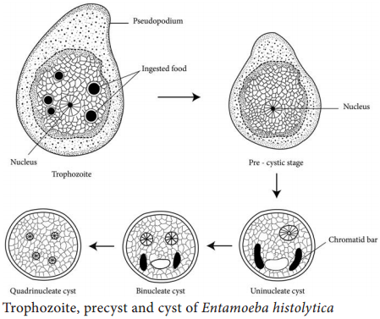

Precyst
Intermediate stage between trophozoite and cyst. It is smaller to trophozoite and larger to cyst (10-20 µm). it is oval with a blunt pseudopodia. Food vacuoles and RBC disappear. Nuclear are same as trophozoite.
Cyst
It is the infective form as well as diagnostic form of the parasite found in carriers and patient with active disease. It is spherical, 10-20 µm in diameter. It is surrounded by a thick chitinous wall which makes it highly resistant to gastric acid , adverse environmental conditions and the chlorine concentration found in potable water. It starts as a uninucleate body, but later the nucleus divides to form two and then four nuclei. Uninucleate and binucleate cysts in addition also possess a glycogen mass, which stains brown with iodine and 1-4 chromatid bars. These do not stain with iodine but appears as a refractile bars with rounded ends in normal saline preparations. With iron-hematoxylin stain they stain black in colour. Cyst are present only in lumen of the colon and in formed faeces. Stools may contain cysts with 1-4 nuclei depending on their degree of maturation.
Life cycle
E. histolytica completes its life cycle in single host, i.e. man. Mature quadrinucleated cyst is the infective form. It can resist chlorination, gastric acidity and desiccation and can survive in a moist environment for several weeks. Trophozoites and immature cysts can also be passed in diarrhoeal stools, but are rapidly destroyed once outside the body, and if ingested would not survive exposure to the gastric environment. in contrast, cyst may remain viable in a humid environment and stay infective for several days. Infection may also be acquired by anal-oral sexual practices among male homosexuals. Flies and cockroaches can also serve as vectors for the transmission of E. histolytica cyst.
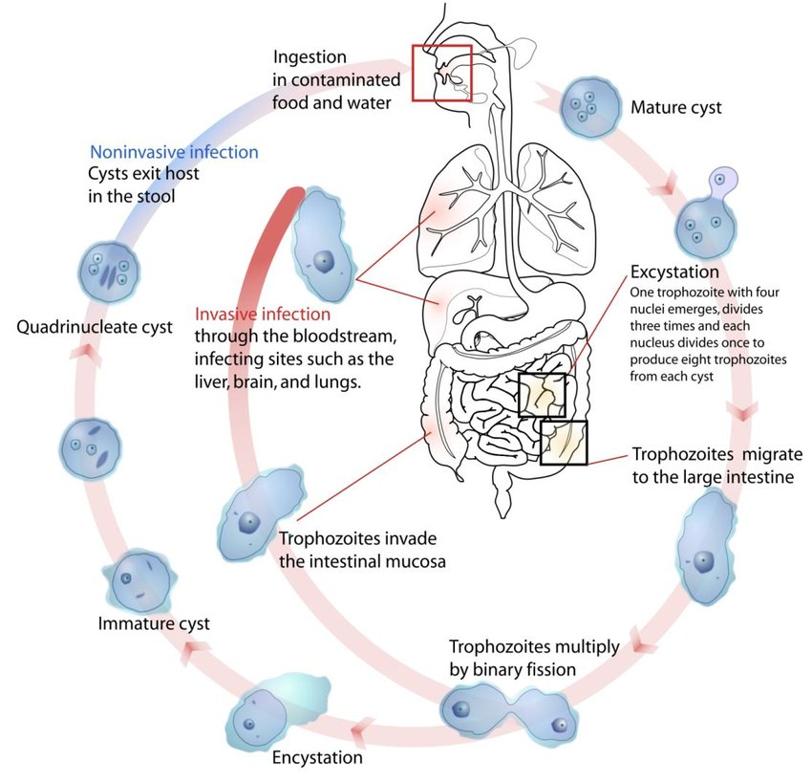
Development in small intestine
Excystation- In small intestine, the cyst wall gets lysed by trypsin and a single tetranucleated trophozoite (metacyst) is liberated which eventually undergoes a series of nuclear and cytoplasmic division to produce eight small metacystic trophozoites. Metacystic trophozoites are carried by the peristalsis to ileocecal region of large intestine and multiply binary fission, and then colonize on the mucosal surface and crypts of large intestine. After colonization, trophozoites show different courses depending on various factors like host susceptibility, age, sex, nutritional status, host immunity, intestinal motility, transit time and intestinal flora.
Asymptomatic cyst passers- in majority of individuals, trophozoites don’t cause any lesion, transform into cysts and are excreted in faeces.
Amoebic dysentery- trophozoites of E. histolytica secrete proteolytic enzymes that cause destruction and necrosis of tissues and produce flask shaped ulcers on intestinal mucosa. At this stage, large numbers of trophozoites are liberated along with blood and mucus in stool producing amoebic dysentery. Trophozoites usually degenerate within minutes.
Amoebic liver abscess- In few cases, erosion and necrosis of small intestine are so extensive that the trophozoites gain entrance into the radicals of portal veins and are carried away to the liver where they multiply causing amoebic liver abscess.
Development in large intestine
Encystation- after some days, when the intestinal lesion starts healing (patient improves) the trophozoite transform into precyst then into quadrinucleated cysts which are liberated in faeces. Encystation occurs only in large gut. Cysts are never formed once the trophozoite are excreted in stool. Factors that induce cyst formation include food deprivation, overcrowding, desiccation, accumulation of waste products and cold temperatures.
Pathogenesis
E. histolytica causes intestinal and extraintestinal amoebiasis.
Intestinal amoebiasis
Intestinal amoebiasis indicates the organism are confined to GI tract. After an incubation period of 1-4 weeks, the amoebae invade the colonic mucosa, producing characteristic ulcerative lesions and a profuse bloody diarrhoea (amoebic diarrhoea). The ulcers may be generalized involving the whole length of the large intestine or they may be localized in the ileo-caecal or sigmoido-rectal region. Ulcers are discrete with intervening normal mucosa. They vary in size from pin-head size to more than 2.5 cm in diameter. They may be superficial or deep. Base of the deep ulcers is generally formed by muscular coat. When destruction is not limited to the submucosa but extends deeper into the muscular layer, the following complications may arise:
- Local peritonitis
- Perforation or pericolic abscess
- Perforation and generalized peritonitis
- Sloughing and gangrene of large gut
E. histolytica may also cause amoebic appendicitis and amoebomas. The latter are pseudotumoural lesions, whose formation is associated with necrosis, inflammation and oedema of the mucosa and submucosa of the colon. Amoebomas are generally single, but occasionally multiple masses usually found in the vertical segments of the large intestine- the caecum, the sigmoido-rectal region of the colon, the ascending colon and the hepatic and splenic angles of the colon. The condition is usually acute with dysentery, abdominal pain and a palpable mass in the corresponding are of the abdomen.
Extraintestinal amoebiasis
About 5% individuals with intestinal amoebiasis, 1-3 months after the disappearance of the dysenteric attack, develop hepatic amoebiasis. Trophozoites of E. histolytica are carried as emboli by the radicles of the portal vein from the base of the amoebic ulcer in the large intestine. The capillary system of the liver act as an excellent filter and holds this parasite. They multiply in the liver and lead to cytolytic action. The amoebae cause obstruction of the portal venules resulting in anaemic necrosis of hepatic cells. The destruction starts here and continues in concentric layers. Necrosis is followed by cytolysis. Small miliary abscesses coalesce to form big liver abscess.
Amoebic liver abscess
It varies greatly in size. It has been reported in patients of all ages, but predominates in adults between 20-60 years. It has a marked preference for the right lobe of the liver ant it is at least three times more frequent in males than in females. The wall of the abscess cavity is ragged with shreds of connective tissue running across the abscess cavity. A section through the margin of the liver abscess can be differentiated into three zones:
- A necrotic centre filled with thick pus with no amoebae.
- An intermediate zone consisting of degenerated liver cells, a few RBC, leucocytes and occasional trophozoites of E. histolytica.
- An outer zone of nearly normal hepatic tissue just being invaded by amoebae.
Pus of liver abscess-
The centre of an amoebic liver abscess contains a viscous red brown (anchovy sauce appearance) or grey yellow fluid consisting of cytolysed liver cells, red blood cells and leucocytes. It is referred to as pus but contains very few pus cells. Since the amoebae actively multiply in the walls of the abscess, the last few drops of pus obtained from the lesion are most likely to yield recognizable trophozoites of parasite.
The sign and symptoms of amoebic liver abscess vary but, in general, the onset is abrupt with pain in the right hypochondrium radiating towards the right shoulder and scapular area. The pain usually increases with deep breathing and coughing. Fever between 30° and 40°C is found in all patients with amoebic liver abscess. On palpation, the liver is soft and smooth in contrast to the rough hard irregular character of the liver in patients with cirrhosis and hepatocellular carcinoma. Jaundice is present in 8% of the patients. When jaundice is severe, multiple abscesses should be suspected.
Complication of amoebic liver abscess:
With the continued lysis of liver tissue, the abscess may grow in various directions coming in contact with neighbouring organs through which its contents may be discharged:
- A right-sided liver abscess may rupture externally. In such cases amoebae may cause infection of the skin leading to granuloma cutis. It may rupture into the lungs into the lungs and the pus containing trophozoites of E. histolytica may be expectorated. It may also rupture into right pleural cavity leading to empyema thoracis, below the diaphragm causing subphrenic abscess and into the peritoneal cavity producing generalized peritonitis.
- A left sided liver abscess may rupture externally through the anterior abdominal wall leading to granuloma cutis, into the stomach leading to haematemesis and into plural cavity and pericardial cavity leading to empyema thoracis and pericarditis respectively.
- A liver abscess situated on the inferior surface may rupture into bowel and peritoneal cavity and the one situated on the posterior surface may rupture into inferior vena cava which is invariably fatal.
From the liver, E. histolytica may enter into general circulation involving other organs of body like lungs, brain, spleen, skin etc. both faecal and sigmoidoscopic examinations for the parasite are negative in approximately half of the patients in extra-intestinal disease.
Clinical feature
Asymptomatic amoebiasis
About 90% of infected persons are asymptomatic carriers and excrete cysts in their faeces. The remaining 10% of people produces a spectrum of diseases varying from intestinal amoebiasis to amoebic liver abscess.
Intestinal amoebiasis
Incubation period varies from 1 to 4 weeks. Intestinal amoebiasis is characterized by four clinical forms:
- Amoebic dysentery- symptoms include bloody diarrhoea with mucus and pus cells, colicky abdominal pain, fever, prostration and weight loss. Amoebic dysentery should be differentiated from bacillary dysentery.
- Amoebic appendicitis- presented with acute right lower abdominal pain
- Amoeboma- it presents as palpable abdominal mass.
- Fulminant colitis- present as intense colicky pain, rectal tensenmus more than 20 motions/ day, fever, nausea, anorexia and hypotension.
feature | Amoebic dysentery | Bacillary dysentery
Macroscopic
Number | 6-8 motions per day | >10 motions per dayd
Amount | Copious | Small
Odour | Offensive | Odourless
Colour | Dark red | Bright red
Reaction | Acidic | Alkaline
Nature | Blood and mucus mixed with faeces | Blood and mucus but no faeces
Consistency | Not adherent to container | Adherent to container
Microscopic
RBCs | In clumps | Discrete or in rouleaux formation
Pus cells | Scanty | Numerous
Eosinophils | Present | Scarce
Macrophages | Very few | Numerous; many of them contains RBCs; hence mistaken of E. histolytica
Ghost cells | Absent | Numerous
Pyknotic bodies | Present | Absent
Charcot-Leyden crystals | Present | Absent
Parasite | Trophozoites of E. histolytica present | Absent
Bacteria | Many motile bacteria | Absent
Table: Difference in stool characters between amoebic dysentery and bacillary dysentery
Amoebic liver abscess
Present with tender hepatomegaly, fever with weight loss, sweating and weakness, rarely jaundice and cough.
Laboratory diagnosis
Intestinal amoebiasis
1.Stool examination
Excretion of cyst in the stool is intermittent, at least three consecutive specimens should be examined. In acute amoebiasis, stool or colonic scrapings from ulcerated areas are examined by macroscopic and microscopic examination.
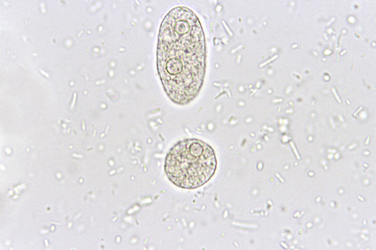
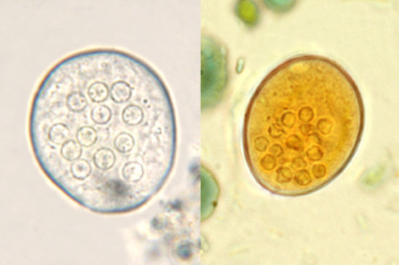
2.Microscopic examination
Stool is picked up with a matchstick or a platinum loop and emulsified in a drop of normal saline on a clean glass slide, cover with coverslip and examined under microscope. This method is specially used for the actively motile trophozoites of E. histolytica.
Trophozoites may also be demonstrated by mixing a small amount of specimen with eosin reagent and examine under microscope. Eosin doesn’t stain living amoebae but provides a pink background which can make the motile amoebae easier to detect.
For demonstration the cyst and dead trophozoites, stained preparation may be required (Iodine stained preparation is commonly used). Stool is emulsified in a drop of five times diluted solution of Lugol’s iodine.
Trichome stain is useful to demonstrate intracellular features of both trophozoite and cyst.
3.Stool culture
Culture methods are not routinely used fir diagnosis. They are useful in research purpose.
- Polyxenic culture- culture media contains bacterial supplement, starch and serum providing nourishment to amoeba. It is used for cultivation of amoeba from stool samples of chronic and asymptomatic carriers passing less number of cysts.
Stool culture shows 50-70% sensitivity and 100% specificity (gold standard).
Various culture media used are:
- NIH (National Institute of Health) media
- Boeck and Drbohlav egg serum media containing Locke’s solution
- Balamuth’s medium
- Nelson’s medium
- Robinson’s medium
- Axenic culture: it lacks bacterial supplement e.g. diamond’s medium. Axenic culture is useful when the bacterial flora interferes with the test result such as:
- Studying pathogenicity of amoeba
- Testing antiamoebic drug sensitivity
- Preparation of amoebic antigen in mass for serological tests
- For harvesting the parasite to determine the zymodeme pattern
4.Stool antigen detection (corporaantigen)
Various test are used to demonstrate amoebic corpora antigen in stool are:
- CIEP
- ELISA
- ICT
Antigen get denatured by stool preservation, fresh or frozen stool is used.
5.Serology
Amoebic antigen-
Amoebic antigen in serum is found only in patients with active infection and disappears after clinical cure, so its presence in serum indicates recent or active infection.
- ELISA- using monoclonal antibody specific for lecithin antigen, serine rich E. histolytica protein, lysine rich surface antigen and lipophosphoglycan
- CIEP
- Coagglutination test
- Slide agglutination test
Amoebic antibody
- ELISA
- IFA
- IHA
6.Isoenzyme (zymodeme) analysis
E. histolytica possess several isoenzymes like malic enzyme, hexokinase, isomerase, phosphoglucomutase.
When isoenzyme subject to electrophoresis, based on the electrophoretic pattern and mobility of the isoenzymes, entamoeba can be speciated. However, zymodeme analysis has a number of disadvantages such as difficulty to performing the test, time-consuming and difficulty in preparing the antigens by culture.
7.Molecular diagnosis
- PCR
8.Nonspecific findings
- Charcot-Leyden crystals in stool
- Moderate leucocytosis
Hepatic amoebiasis
1.Microscopy
Microscopy of liver pus can detect trophozoites (not cyst). However, it confirms the diagnosis but is not useful.
2.Stool culture
It is considered as gold standard but sensitivity is low.
3.Antigen detection
Lectin antigen is absent in stool but can be demonstrate in serum, liver pus & saliva.
4.Antibody detection
- IHA
- IFA
- ELISA
- CIEP
- SAT (Staphylococcal adherence test)
5.Histopathology
Trophozoite in pus aspirate can be demonstrate by histopathological stains e.g. PAS stain.
6.Molecular diagnosis
- PCR
Treatment
- Metronidazole and tinidazole
Prevention
- Avoid intake of food and water contaminated with faeces
- Treatment of asymptomatic persons
- Maintain hygiene

