**Sustainable Business Strategies: Integrating ESG Factors for Long-Term Growth**

***Dr.S.Saileja, Assistant Professor, Department of Commerce and Business Management, University College for Women, (Telangana Mahila Viswavidyalayam), Koti, Hyderabad, Telangana, India.***

***Ms. G. Sri Thanishqa, Student, Quantitative Finance, University of Texas at Arlington, Texas, USA.***

**Abstract**

*Sustainability in business refers to policies and measures taken to reduce the negative environmental and social consequences of operations, which are measured using environmental, social, and governance (ESG) indicators. ESG criteria give a framework for evaluating a business's management of the risks and opportunities associated with these issues. Environmental factors include lowering carbon footprints, using resources more efficiently, managing waste, and decreasing pollution. The social dimensions include fair employee treatment, diversity and inclusion, community participation, and ethical consumer relations. Governance comprises having a diverse and independent board of directors, fair executive remuneration, protecting shareholder interests, and conducting business ethically. Adopting ESG principles improves reputation, operational efficiency, and compliance while also attracting investment and promoting long-term growth. In this chapter, the ESG framework is discussed. This chapter highlights the strong and weak ESG propositions; and also includes* Infosys ESG Roadmap (Vision and Ambitions 2030)*. It also includes the importance of the ESG framework in the business. This chapter concludes that businesses adopting the ESG model have numerous benefits, such as long-term sustainability, saving energy, reducing costs, improving business reputation, treating employees fairly and supporting their well-being, ensuring transparent and honest business practices, etc.*

**Keywords:** *Carbon foot prints, environmental, ethical consumer relations, governance, social, sustainability.*

1. **Introduction**

In 1987, the [United Nations Brundtland Commission](http://www.un-documents.net/our-common-future.pdf) defined sustainability as “meeting the needs of the present without compromising the ability of future generations to meet their own needs.”

Sustainable development requires an integrated approach that takes into consideration environmental concerns along with economic development. Sustainability in business refers to a company's strategy and actions to reduce adverse environmental and social impacts resulting from business operations in a particular market. The integration of sustainability in business can see benefits such as competitive advantage, investor appeal, compliance with regulatory requirements, increased longevity of transformation investments, talent acquisition, and revenue growth. An organization’s sustainability practices are typically analyzed against environmental, social, and governance (ESG) metrics.

Sustainability has evolved from a minor issue to a critical component of company strategy in today's economic world. Companies are rapidly understanding the necessity of incorporating Environmental, Social, and Governance (ESG) issues into their operations, not just to meet expanding legal and social demands, but also to ensure long-term success. Organizations that connect their business processes with ESG principles may reduce risks, improve their reputations, and capitalize on new market possibilities. These initiatives are more than just compliance; they are about transforming business models to provide value for all stakeholders, including shareholders, workers, consumers, and the general public.

The incorporation of ESG considerations into company strategy is fueled by a rising recognition that sustainable business practices are critical to long-term success. Companies that value environmental stewardship, social responsibility, and strong governance structures are better equipped to negotiate the difficulties of the global market. Furthermore, there is growing evidence that organizations with great ESG performance outperform their rivals financially, implying that sustainability is a strategic requirement rather than a moral one. As a result, including ESG issues is more important for gaining a competitive edge in today's market.

1. **Review of Literature**

**Ting-Ting Li et al., (2021)** in the journal **“Sustainability”** in special issue **ESG and Sustainability: A Global Perspective** with paper titled, **“ESG: Research Progress and Future Prospects”** stated that the environmental, social, and governance (ESG) concept must be followed in order for the global economy and society to flourish sustainably. The paper stated that the ESG principle has been developed for 17 years since its official presentation in 2004 and that countries across the world continue to encourage integrated development of the environment, society, and governance in accordance with the ESG principles. This study used the literature analysis tool CiteSpace to highlight the collaboration status, hot areas, and trends in ESG research. This study, based on quantitative analysis results, provides an investigation and thorough description of ESG research development, as well as a systematic literature review. This comprises the theoretical foundation of ESG research, the interaction of ESG aspects, ESG's influence on economic implications, ESG's involvement in risk prevention, and ESG assessment.  Based on a thorough overview of research accomplishments, the study refined the features of ESG research, identified its weaknesses, and proposed a future emphasis for ESG research in order to serve as a reference for academic research and ESG practice. This paper systematically examined and analyzed the research progress of ESG, and the conclusions were drawn. The conclusions drawn are (i) the theoretical basis is centralized and diverse, (ii) ESG research tends to be from the perspective of internal governance, (iii)economic consequences are an important topic in ESG research, and (iv) ESG measurement has limitations.

1. **ESG**

ESG is an acronym that stands for environmental, social, and governance. Environmental, Social, and Governance (ESG) factors are criteria used to evaluate a company's operations and sustainability. ESG is a framework for stakeholders to understand how a firm manages risks and opportunities connected to environmental, social, and governance criteria. ESG offers a holistic approach to sustainability, which includes more than simply environmental challenges. While the term ESG is commonly used in the context of investing, stakeholders include not just the investment community but also customers, suppliers, and workers, all of whom are becoming increasingly concerned with how sustainable an organization's operations are.

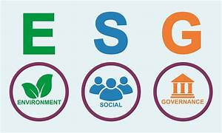

**Figure 1: ESG**

The ESG (Environmental, Social, and Governance) framework is a set of criteria that are used to analyze a company's performance in three key areas: environmental impact, social responsibility, and governance practices. It has become increasingly important for investors, regulators, and other stakeholders as they seek to assess the sustainability and ethical impact of businesses.

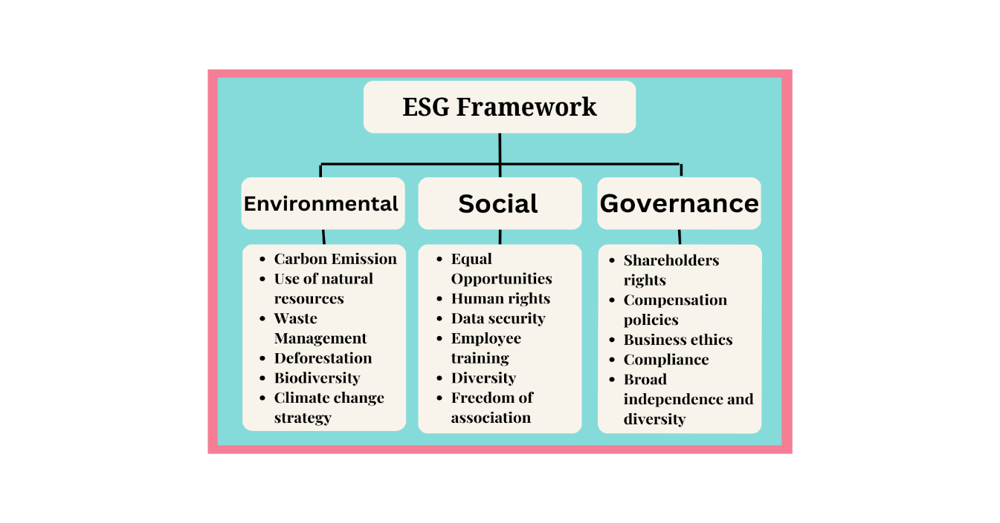

**Figure 2: ESG Framework**

1. **ESG Framework Factors Are as Follows:**
2. **Environmental:** Environmental factors within the ESG (Environmental, Social, and Governance) framework are centered on how companies manage their environmental impact. Climate change mitigation is a key priority, necessitating that businesses reduce their carbon footprint by lowering greenhouse gas emissions and adopting renewable energy sources. Efficient resource utilization is also crucial, ensuring the sustainable use of energy, water, and raw materials to prevent depletion. Waste management practices are vital, with companies aiming to reduce waste generation, enhance recycling, and ensure proper waste disposal. Pollution control is another significant focus, involving efforts to minimize pollution of air, water, and land through advanced technologies and improved processes. Addressing these environmental factors is essential for companies to promote sustainability, improve operational efficiency, and build a positive reputation with stakeholders. Key environmental concerns include climate change, management of natural resources, water scarcity, waste management, energy efficiency, pollution reduction, deforestation, and biodiversity conservation.

**b. Social:** Employee relations aim to ensure fair treatment by offering equal working conditions, competitive salary, and complete benefits. This method makes employees feel appreciated and supported, which leads to higher job satisfaction and retention. Promoting diversity and inclusion is critical because it fosters an environment in which all employees may flourish and contribute productively. This encourages creativity and demonstrates the company's commitment to social equality. The community impact component considers a company's contributions to local communities as well as its environmental implications. This might include charity actions, volunteer work, and attempts to promote local growth and sustainability. Companies that have a good impact on their communities can build stronger relationships with local stakeholders and improve their public image.

Consumer relations emphasize ethical marketing practices that safeguard consumer privacy and ensure product safety. Transparent and honest marketing builds trust, while strong privacy measures and safe products demonstrate a company's commitment to consumer welfare. Excelling in these areas helps businesses build customer loyalty and maintain a positive reputation, which supports long-term growth. Examples of social factors include diversity and inclusion, community impact, labor standards, data privacy, health and well-being, customer satisfaction, employee engagement, human capital development, and human rights.

**c. Governance:** Board composition aims to ensure diversity and independence among directors. A diverse board offers a range of perspectives, enhancing decision-making and driving innovation. Independent directors are crucial for impartial oversight and reducing conflicts of interest. Executive compensation must be equitable and transparent, aligning with the company's performance and ensuring accountability. Transparent compensation practices build stakeholder confidence and promote fair treatment within the organization. Shareholder rights are essential in corporate governance, granting shareholders a say in significant business decisions and access to critical information about the company's performance and strategy. Ethical business practices are fundamental, emphasizing integrity through robust anti-corruption measures and transparent financial reporting. Companies that uphold these governance principles build investor trust, enhance their reputation, and achieve long-term success. Effective governance policies not only protect shareholder interests but also contribute to overall stability and performance in the market. Key governance factors include regulatory compliance, corporate governance, leadership integrity and diversity, business ethics, anti-corruption measures, tax strategy, and lobbying practices.

**5. Strong ESG Proposition**

1. A robust ESG strategy draws in both B2B and B2C customers by providing sustainable product offerings. It appeals to a wide consumer who prioritize environmental and social responsibility, fostering trust and long-term loyalty.
2. It attracts capital and other resources, which are crucial for running the business through strong government relations.
3. A robust ESG strategy conserves ecosystems and biodiversity while lowering energy use.

By reducing the effect on natural resources, it encourages environmental sustainability.

1. It gains strategic flexibility through deregulation, allowing for greater operational freedom. This shift enables the company to explore new and adapt more quickly to market changes and opportunities.
2. It can receive subsidies and government support, which can significantly boost its financial resources. This assistance allows for increased investment in infrastructure and growth opportunities.
3. A robust ESG framework draws top talent by fostering an inclusive and sustainable work environment. Emphasizing social responsibility and environmental stewardship makes the organization more appealing to prospective employees. This commitment to ethical practices enhances overall recruitment and retention.
4. It avoids investments that may take longer time and that may not pay good returns due to environmental, social, and governance issues.
5. Allocating resources optimally, a strong ESG approach increases Returns on Investments.

It guarantees a more economical use of resources, which enhances financial performance.

**6. Weak ESG Proposition**

1. Due to poor sustainability practices, such as the usage of hazardous or unsustainable products, a weak ESG results in a loss of customers. This may harm a brand's reputation and turn off customers.
2. Businesses may lose access to money and other necessary resources as a result of poor labor and community relations. These difficulties could impede development and reduce investment prospects.
3. It faces extra expenses for packaging, as well as potential fines, penalties, and regulatory actions. These costs can strain its financial resources and impact profitability.
4. Advertising and point-of-sale operations are restricted for a weak ESG. This may lessen the company's visibility in the market and make it more difficult for it to efficiently contact clients.
5. Dealing with social stigma can limit the company's ability to attract a diverse range of talent. This restriction can hinder growth and innovation within the organization.
6. A weak ESG approach leads to increased waste production and higher expenses for disposal. This can result in both financial and environmental inefficiencies.

**7. Importance of ESG Model for Business**

1. Customers, investors, and other stakeholders prefer companies with good ESG policies, which improves their business reputation.
2. The ESG model helps the businesses identify risk and come up with solutions related to environmental, social, and governance issues. It also helps in reducing cost through proper use of resources, minimization of waste, and energy savings.
3. ESG performance provides better access to the capital for the businesses as the investors seek sustainable opportunities. Adopting ESG practices helps organizations comply with existing rules and plan for potential legislative changes, lowering the risk of fines and penalties.
4. A commitment to ESG may enhance employee morale, recruit top talent, and minimize turnover by fostering a pleasant and inclusive workplace culture.
5. ESG-focused companies can differentiate themselves from competitors by offering sustainable products and services, meeting the growing demand from conscious consumers.
6. Sustainable business practices promote long-term sustainability and growth by addressing environmental and social issues, resulting in a stable and resilient company model.
7. The ESG model helps in innovation, creating trust and improved performance through sustainable practices.
8. Businesses that implement ESG practices help to achieve global sustainability goals like the United Nations Sustainable Development Goals (SDGs), which promote a healthy planet and society.

**INFOSYS ESG ROADMAP**

**Vision and Ambitions 2030**

**Shape and share solutions that serve the development of businesses and communities**

|  |  |  |
| --- | --- | --- |
| **Environment** | **Factor** | **Ambition** |
| **Climate Change:** Leverage technology to support the transition to a low-carbon world. | Maintaining carbon neutrality across Scope 1, 2 and 31 emissions every year. |
| **Water:** Reduce our water footprint and enhance water availability in the communities where we operate. | Maintaining 100% wastewater recycling every year. |
| **Waste:** Reduce, reuse and recycle to minimize waste, including e-waste. | Ensuring zero waste to landfill |
| **Social** | **Enabling digital talent at scale:** Facilitate skilling to ensure progress for all. | Extending digital skills to 10 Mn+ people, including employees, client's workforce, students, teachers and communities (2025) |
| **Diversity and inclusion:**  Foster diversity and nurture inclusion. | Creating a gender-diverse workforce at Infosys, with 45% women |
| **Energizing local communities:** Enable opportunities for communities locally. | Delivering 33% of work by leveraging flexible/remote work options |
| **Governance** | **Corporate governance:** Be a leader and get benchmarked for world-class corporate governance. | Bringing interests of all stakeholders to the fore through our empowered, diverse and inclusive Board |
| **Data privacy:** Ensure the safety of stakeholder data. | Adopting leading data privacy standards across all global operations |
| **Information management:** Uphold the digital trust of our stakeholders | Being recognized as industry leader in our information security practices |

**Table 1: Infosys ESG Roadmap**

**8. Conclusion**

Incorporating ESG concepts into business operations is vital for ensuring long-term sustainability and profitability. Businesses that prioritize environmental, social, and governance considerations are better positioned to minimize risks and capitalize on possibilities in a constantly changing world. Businesses that focus on environmental considerations such as decreasing carbon footprints, managing resources effectively, and limiting waste and pollution can ensure environmental sustainability and also improve operational efficiency and establish a favorable reputation among stakeholders, resulting in improved trust and loyalty.

Furthermore, the social components of ESG highlight the necessity of fair labor treatment, and ethical customer connections. All these elements are critical for fostering a supportive and inclusive workplace culture that attracts and retains top talent. Businesses that actively connect with their communities and promote ethical interactions with customers can improve their public image and establish long-term partnerships with important stakeholders. This strategy not only promotes a healthy business culture, but it also benefits society as a whole.

The governance part of ESG emphasizes the need for strong corporate governance procedures, such as diverse and independent boards, equitable CEO compensation, and shareholder protection. Ethical company procedures and transparent operations are essential for gaining investor trust and guaranteeing long-term corporate success. Businesses’ that prioritize governance principles are more likely to preserve stability, minimize conflicts of interest, and effectively handle regulatory hurdles, resulting in improved market performance and overall stability.

Implementing an ESG framework has several benefits, such as increased corporate reputation, operational efficiency, regulatory compliance, and long-term growth. Addressing environmental, social, and governance challenges helps firms gain a competitive edge, attract investment, and contribute to global sustainability goals. The strong and weak ESG propositions examined in this chapter highlight the need for incorporating strong ESG principles into company plans. Finally, organizations that commit to ESG practices are better suited to negotiate the complexity of today's market, generate long-term growth and sustainability for future generations.

**References**

1. Freeman, R. E., & Dmytriyev, S. D. (2017). Corporate Social Responsibility and Stakeholder Theory: Learning from Each Other. Symphonya. Emerging Issues in Management, (1), 7-15. <https://doi.org/10.4468/2017.1.02freeman.dmytriyev>

2. Grewal, J., & Serafeim, G. (2020). Research on Corporate Sustainability: Review and Directions for Future Research. Foundations and Trends® in Accounting, 14(3-4), 242-294. <https://doi.org/10.1561/1400000074>

3. Miroshnychenko, I., Barontini, R., & Testa, F. (2021). Green innovation and firm financial performance: The mediating role of environmental performance. Sustainability, 13(21), 11663. <https://doi.org/10.3390/su132111663>

4. R. G., Ioannou, I., & Serafeim, G. (2014). The Impact of Corporate Sustainability on Organizational Processes and Performance. Management Science, 60(11), 2835-2857. <https://doi.org/10.1287/mnsc.2014.1984>

5. Smith, R. (2022). Enhancing employee relations and community impact through sustainable practices. *Journal of Business Ethics, 158*(3), 421-435. <https://doi.org/10.1007/s10551-021-05029-3>

6.https://www.infosys.com/content/dam/infosys-web/en/about/corporate-responsibility/esg-vision-2030/vision-and-ambition-2030.html