**Materials Redefined: Charting the Course for Future Developments: Fabrication and Testing of Flyash and Baggase mixed Aluminium Composite**

Vipin Kumar Sharma

Department of Mechanical Engineering Maharaja Agrasen Institute of Technology Delhi-110086, India [vipin.dtu@gmail.com](mailto:vipin.dtu@gmail.com)

Chirag Gupta

Department of Mechanical Engineering Maharaja Agrasen Institute of Technology Delhi-110086, India

Vansh Gulati

Department of Mechanical Engineering Maharaja Agrasen Institute of Technology Delhi-110086, India

Vaibhav Chawla

Department of Mechanical Engineering Maharaja Agrasen Institute of Technology Delhi-110086, India

Aditya Gosain

Department of Mechanical Engineering Maharaja Agrasen Institute of Technology Delhi-110086, India

Manan Singh Sethi

Department of Mechanical Engineering Maharaja Agrasen Institute of Technology Delhi-110086, India

**ABSTRACT**

Metal matrix composites (MMC) prove to be stronger, lighter and durable materials in relation to the parent materials that make them up. The automotive, aerospace, and related industries make extensive use of metallic alloys and composite materials. The metal matrix selected for the investigation is Aluminium which has been reinforced with fly-ash (an industrial waste) and Bagasse (sugarcane agro-waste) to fabricate the required MMC. Therefore, base metal was selected in accordance to an automobile part like a Piston which experience high friction rate leading to high wear rate. Fly-ash composite is used in construction industry as they are light in weight. In this research three homogenous specimens (of varying compositions) of Aluminium with Fly-ash and Bagasse as reinforcement were fabricated. To maintain the homogeneity stir casting was used. The casted composite had rough surface therefore, finishing operation was performed. When two mating surfaces move relative to one another, wear issues are likely to arise and leads to failure. Although bagasse and fly ash weaken the composite, they save the parent metal from wearing out during relative motion by wearing out ahead of the parent metal. The pin-on-disc test is used to assess wear characteristics by looking at the effects of load, friction, and velocity. The friction coefficient and impact force were calculated, and the corresponding graphs were produced.

**Keywords**—composite, aluminium, coefficient of friction, wear.

**Overview**

In modern engineering, MMCs (metal matrix composites) are a relatively new family of sophisticated materials. They have shown progress in terms of understanding, predictability in design, and performance characteristics, as well as improvements in affordability and availability, which are likely to lead to increased utilization in future designs. The scope of MMCs encompasses all commercially available MMC materials and those under advanced development, as well as those of future design interest. They differ from ordinary metals in the following ways:

a) The nature and type of constituents,

b) The consolidation and processing methods, and

c) The resulting engineering physical and mechanical properties, as well as liabilities.

In addition to information about the kind, volume percentage, and shape of the ceramic reinforcement, MMC systems are commonly recognised by the metal alloy that serves as the matrix. They differ from other types of composites in several  aspects.

1. Unlike polymers or ceramics, the matrix phase of MMCs consists of either pure metal or an alloy.

2. While MMCs’ strength and ductility are lower than that of their corresponding unreinforced metal matrix alloys, they are higher than those of ceramics or Ceramics Matrix Composites (CMCs).

3.Similarly to Polymers Matrix Composites (PMCs), the major purpose of reinforcing in MMCs is to improve strength and modulus; in contrast, the main purpose of reinforcement in CMCs is to improve damage tolerance.

4. MMCs usually have a temperature capability that is lower than that of ceramics and CMCs but higher than that of polymers and PMCs.

5. MMCs with low to moderate reinforcement can be formed using processes commonly associated with unreinforced metals.

Matrix materials play a crucial role in MMCs, with metals being highly versatile engineering materials. When alloy composition and thermomechanical processing techniques are used appropriately, they can display a wide range of properties. Through the development of MMCs, it has become possible to combine properties that are not possible with metals alone, leading to the creation of customised composites with improved wear, increased particular stiffness, and desired thermal properties. Whether the composite is reinforced continuously or discontinuously is one of the elements that determines the choice of matrix alloy for a metal matrix composite (MCCs). Different forms of matrix materials, such as re-melting stock, wrought materials, and powders, are used in manufacturing MMCs. A number of matrix materials, such as copper and aluminium, iron, magnesium, nickel, and titanium, have been utilized in MMCs, each offering specific advantages based on the desired composite properties and applications. For instance, aluminium is widely used in MMCs due to its favourable characteristics like strong heat conductivity and low density, ductility, and malleability. However, it can be susceptible to wear, which can be addressed by incorporating reinforcements like fly ash and sugarcane bagasse. Recent trends in MMCs are closely aligned with industries such as automotive and aerospace, aiming to improve efficiency by reducing weight while maintaining or enhancing mechanical properties and wear resistance. Techniques like stir casting and powder metallurgy are employed to create MMCs with customized properties for specific applications.

Juang et al. [8] created a composite utilising the stir casting method, which included an aluminium alloy and 5% percent weight of fly ash. After that, they processed this composite using multi-path friction stir processing, or MP-FSP. The study looked at the surface fractures of the tensile test specimen and the microscopic makeup of the processed area in order to examine failure mechanisms, grain refinement, and fly ash distribution in the aluminium matrix. The trials’ findings showed that MP-FSP significantly refined the composite’s grain, bringing the fly ash particles’ initial size below 53–106 microns to 10 microns or less. Tensile strength and elongation improved from the 143 Mpa to 227 Mpa and from 1.19% along the stirring direction compared to the ALPHA composite without stir processing respectively. Similarly, the tensile strength went from 143 Mpa to 226 Mpa and the elongation increased from 1.19% to 3.12% when looking at the parameters orthogonal to the stirring direction.

Prakash et al. [9] developed a cost-effective composite using Aluminum 6061 T6 strengthened using powder metallurgical technique using naturally existing rock dust particles. They varied the reinforcement ratio from 0% to 50%, maintaining a constant particle size of 20 μm. There were three distinct pressures applied to the combined powders, that varied between 100 and 200 Mpa. The new composite was coated with an Al2O3 ceramic utilising the Type III Sulfuric Acid Hard Coating technique. The microstructure, microhardness, and wear resistance of the resultant composites were tested. SEM micrograph analysis verified that the reinforcement was distributed uniformly throughout the matrix, and optical microscopic pictures showed a thin layer of hard ceramic coating. Up to 10% more micro-hardness was seen at higher reinforcement levels. Using a Pin on Disc configuration without lubricant, wear attributes were assessed while maintaining constants for loads, sliding motion, and sliding distance. In comparison to other compositions, the investigation revealed that the composite containing 10% rock dust had better wear resistance. Additionally, higher compacting pressures were associated with the rise in hardness and, thus, an improvement in wear resistance. In all compositions and compacting pressure ranges, the coated sample outperformed the uncoated composite samples.

Shin et al. [10] conducted a study on the mechanical characteristics and microstructure of the aluminium alloy (Al2024) treated with composites made of few-layer ehavior (FLG). Hot rolling and ball milling were used to create these composites. Dispersed FLGs with high specified area of surface were added, and this greatly increased the composites’ strength. In particular, the composite with 0.7 vol.% FLGs showed 700 Mpa of tensile strength, which is twice as high as that of pure Al2024, with an elongation to failure of approximately 4%. The strengthening mechanism in these Al2024/FLG composites during plastic deformation is attributed to restricted dislocation activities and the accumulation of dislocations between FLGs.

Alaneme et al. [11] carried out research on the mechanical qualities, wear behaviour, and microstructural features of aluminium matrix hybrid composites that were reinforced with graphite, alumina, and rice husk ash (RHA). Using a two step stir- casting technique, various weight ratios of graphite, RHA, and alumina were combined to create composites with a hybrid reinforcement of 10% Al, Mg, and Si alloys. S electron microscopy (SEM), wear testing, tensile testing, and hardness testing were used to characterise these composites. Their results showed that the durability of the composites declined as the weight ratio of graphite to RHA increased, and that the impact of the graphite on hardness diminished as the percentage of RHA in the composites rose above 50%. Composites with up to 50% RHA and 0.5 weight percent graphite have a better tensile strength than composites without graphite. Furthermore, the toughness ratings of composites with 0.5 weight percent graphite were consistently higher than those without graphite. All of the composites had an elongation percentage between 10 and 13%, and this figure held true independent of the graphite concentration and RHA. All of the composites had a similar tensile fractured surface morphology, as revealed by SEM examination, with reinforcing particles contained within ductile dimples. While wear resistance declined as graphite concentration increased from 0.5 to 1.5 wt%, composites without graphite showed greater wear susceptibility than those with graphite.

Sharma et al. [12] conducted a study and examined how adding graphite particles affected the microstructure of metal matrix composites made of Al6082 using the traditional stir casting method. In steps of 3%, they changed the reinforced material from 0% to 12%. Scanning electron microscopy, or SEM, was used to analyse the microstructures of the produced composites, and elemental mapping was carried out using the Al6082 + 12 percent Gr reinforcing composites to determine the presence of various elements and their amounts. The elements composition of the produced composites was further confirmed by X-ray diffraction (XRD) analysis, which corroborated the results of the elemental map study. This microstructural study’s findings showed that graphite particles were not distributed uniformly throughout all varying percentages of the graphite reinforcement.

Kumar et al. [13] conducted a study to create composites with high ductility and strength that are achieved by maximising a homogeneous, smooth interface to effectively transmit loads and lessen problems such as pull outs, cracking, and agglomerations of reinforcement. They reinforced 2024 aluminium with an extremely strong, high-entropy alloys (ternary) in particle form (HEAp). Using the stir casting procedure, reinforcement particles having an average dimension of 125 μm were dispersed at different weight fractions that varied from 5 to 15% to create the AA 2024-HEAp composite. The billets were then hot extruded into rods with a 14 mm diameter. Every experiment was homogenised for 24 hours at 100°C in an industrial furnace. Tensile, hardness, and resistivity characteristics were used to assess the alloy’s and the composites’ mechanical behaviour. Their findings included a 62% rise in hardness and increased reinforcement contents improved mechanical properties such as yield strength, tensile strength, and Young’s modulus.

Claunch et al. [15] ehavior gluten into, low-molecular-weight proteins, of which a portion self-assembled into fibres with a high modulus and the remainder arranged themselves into a polymer matrix around the fibres to create a composite polymer matrix reinforced by fibres. Upon self-assembly, fibre composites with a the modulus of 266 Mpa were generated at 37°C. Nevertheless, fibre production was reduced by self-assembly at 22°C, resulting in polymer compounds with a significantly lower the modulus of 20 Mpa. Both compounds had an identical beta-sheet content of roughly 50%, according to the FTIR (Fourier transform infrared) data, however the composites made at 37°C had more hydrogen bonding. Because hydrophobic interactions were responsible for driving self-assembly into giant amyloid fibres, they also changed in the 37°C composite. Because the protein completely covered the fibres and there were no cavities seen at the fiber/polymer interface, the S electron microscopy (SEM) investigation demonstrated a satisfactory connection between the fibre and matrix. The presence of fibres and stronger intermolecular contacts in the 37°C composite led to improved stability to heat at higher temperatures, as shown by thermogravimetric analysis (TGA).

Xiong et al. [16] developed granular composites made of nickel (Ni) and aluminium (Al) are common structural energetic materials that have the perfect balance of energy-releasing potential and mechanical qualities. They examined how two additives—Teflon (PTFE) and copper (Cu)—affected the Al/Ni material system’s mechanical qualities as well as the features of shock-induced chemical reaction (SICR). Static pressing was used to manufacture three composites: Al/Ni, Al/Ni/PTFE, and Al/Ni/Cu. All three composites have same volumetric ratio of aluminium powder to Ni powder. The mechanical characteristics and fracture behaviour of these composites were investigated by quasi-static compression tests and scanning electron microscopy (SEM). According to the study, the additives had an impact on the composites’ fracture mode as well as compressive strength. Taking into account pressure histories recorded in the test chamber, impact initiation tests were also carried out to evaluate shock-induced chemical response features. The experimental findings showed that the additions had a considerable impact on post-reaction behaviour, critical starting velocity, reaction rate, and efficiency.

Li et al. [17] examined an aluminium composite’s compressive behaviour. Their findings demonstrated the fact that the quasi-static stress–strain (σ–ε) curve of the aluminium composite and those of aluminium foams were comparable. Nonetheless, the composites’ ideal energy absorption efficiency (I) was greater than Al foams’ within the two strain ranges (ε<0.03 and ε>0.2). In contrast, the I value of the composite was lower than that of Al foams when ε varied between 0.03 and 0.2.

Shen et al. [18] conducted research on the fabrication of composite coatings made of graphite nanoplatelets (GNP), vapour-grown carbon fibre (VGCF), and polypropylene (PP) that are superhydrophobic and conductive. Because surface microstructure is brittle, they tackled the problem of creating super hydrophobic surfaces having mechanical durability. In their report, they primarily discussed the use of hot pressing to produce mechanically durable, superhydrophobic, conductive composite coatings.

Zhang et al. [19] developed two varieties of Cr3C2-Cu composites, each having unique properties. By infiltrating metal into porous Cr3C2 networks, bi-continuous Cr3C2-Cu composites with interpenetrating structures were produced. Conversely, a powder metallurgy method was used to create particle-reinforced Cr3C2-Cu metal matrix composites (MMCs). These composites’ electrical conductivity, wear resistance, and microstructure were all investigated. Although both varieties of composites demonstrated exceptional wear resistance and electrical conductivity, the bi-continuous composites often outperformed MMCs with identical chemical compositions.

Dobrzyn et al. [20] consolidated ehavior metal composites using vacuum hot pressing was used to create atomized Al65Cu20Fe15 particles and elemental Al powder. The cubic s-Al Cu(Fe) phase found in the interdendritic spaces and icosahedral quasi-crystalline dendrites that or cells made up the spherical Al65Cu20Fe15 particles. A range of reinforcement particle contents (20, 40, and 60 weight percent) were used to create composites, and each one showed around 99% density and strong interaction with the Al65Cu20Fe15 nanoparticles and the matrix. After consolidation, the physical form of the atomized particles in the composites containing 20% and 40% additional particles did not change, whereas Al2Cu precipitates developed around the Al/Al65Cu20Fe15 interface and in the matrix of the composite containing 60% Al65Cu20Fe15 particles. The degree of hardness and compressive force of the composite rose with the amount of the fraction of reinforcement, achieving 173 high-voltage0.5 and 370 Mpa, specifically, for 60 percent of Al65Cu20Fe15 nanoparticles. Depending on the composition, there was a modest variation in the friction coefficient between 0.5 and 0.7.

Sharma et al.[21] focused on producing ehavior (AA6082-T6) matrix composites reinforced with varying weight percentages of silicon nitride particles through conventional stir casting. The reinforcement percentage ranged from 0 wt.% to 12 wt.% in increments of 3%. They investigated the microstructures and mechanical properties of these fabricated ehavior matrix composites, identifying the presence and distribution of Si3N4 particles using scanning electron microstructure images and X-ray diffraction techniques.

Kumar et al. [14] created an AA5052/ZrB2 composite by reacting molten AA5052 alloy in-situ at 860°C with two inorganic salts, K2ZrF6 and KBF4, at different volume percentage (0%, 3%, 6%, 9%, and 10%) of ZrB2 particles. They examined the transmission electron characteristics and used established methods to characterise the in-situ composites using X-ray diffraction (XRD), Differential Thermal Analysis (DTA), and Scanning Electron Microscopy (SEM). The morphological investigations showed that the presence of ZrB2, which particles caused the Al-rich phase’s grain size to decrease. The microstructural examination demonstrated a consistent dispersion of second-phase particles, distinct interfaces, strong bonding, dislocations, and ZrB2 particle shape. Although few micron-sized particles were also seen, the majority of ZrB2 particles had hexagonal or rectangular forms and were nanosized. As the amount of reinforcement increased, the composites’ density and hardness also increased. Up to a volume percentage of 9 vol.%, the total tensile strength, with 0.2% yield strength increased steadily; however, the strength declined beyond this composition.

**Manufacturing of Composite**

1. Manufacturing via Stir Casting: The MMC was produced using the Stir Casting Method, ensuring a uniform composition. This process involves a diagram illustrating the setup with a furnace, crucible, and a motor-driven rotor. The molten matrix metal is contained in the crucible, while reinforcement material is added externally. The rotor stirs the materials vigorously to achieve thorough mixing. Stir casting is crucial for eliminating agglomerates and ensuring a homogeneous mixture.

2) Machining for Shape and Size:After manufacturing, various machining processes were employed to shape and size the workpiece according to desired specifications.

3) Mechanical Testing:The fabricated MMC underwent rigorous mechanical testing, including Spectroscopy, Hardness testing, Pin-on-disc analysis, and Universal Testing Machine (UTM) tests. These tests provide insights into the material’s properties, such as its composition, hardness, wear resistance, and mechanical strength.

The experimental procedure for creating the ehavior-based metal matrix composite (MMC) involved several steps:

1. Preparation of Aluminum and Silicon (Si) Powder:

- Aluminum was preheated at 450°C for 3 to 4 hours.

- Silicon powder was heated separately at 900°C.

- Both preheated mixtures were mechanically mixed below their respective melting points.

2. Mixing and Heating in Crucible:

- The metal-matrix Al-Si mixture was poured into a graphite crucible.

- The crucible was placed in a coal-fired furnace at 760°C.

- Finely ground fly ash and sugarcane bagasse were added to the mixture.

3. Melting and Semi-Solid State:

- The furnace temperature was raised to fully melt the ehavior scraps and composite materials.

- The mixture was then cooled slightly to maintain a semi-solid state.

4. Manual Mixing of Silicon Powder:

- Preheated silicon powder was added to the semi-solid mixture.

- Manual mixing was performed as machine or stirrer mixing was challenging in the semi-molten state.

5. Automatic Stirring:

- After manual mixing, automatic stirring was conducted for ten minutes at a normal rate of 400 rpm.

6. Controlled Temperature and Final Mixing:

- The furnace temperature was controlled at 760 ± 10°C during the final mixing process.

7. Casting into Sand Mould:

- Once mixing was complete, the slurry was swiftly poured into a sand mold within thirty seconds.

- The composite was allowed to solidify in the mold.

This detailed procedure ensured the proper preparation, mixing, and casting of the metal matrix composite while maintaining control over temperature and mixing conditions for optimal results.

**Experimentation**

The Pin-On-Disc method is employed to assess the friction and wear properties of various materials under dry or lubricated sliding conditions. It involves rotating a test disc against a stationary pin specimen. Here’s an overview of the method and its experimental procedure:

Method Overview:

- Pin-On-Disc evaluates friction and wear characteristics in materials like metals, polymers, composites, ceramics, lubricants, coatings, etc.

- It provides insights into material wear and lifetime, crucial for applications where wear resistance is critical.

- The test uses a spherical-ended pin to maintain controlled contact conditions, irrespective of any misalignment between the pin and disc axes.

- Pin-on-disc tests are versatile and applicable to various coatings, materials, and thicknesses.

Experimental Procedure:

1. Preparation:

- Two specimens are needed: a cylindrical pin and a flat circular disc.

- The pin is positioned perpendicular to the disc, with the test machine causing either the disc or the pin to revolve around the disc center.

- The sliding path forms a circular pattern on the disc’s surface, which can be oriented horizontally or vertically.

2. Loading and Testing:

- The pin specimen is pressed against the disc at a specified load using a lever with attached weights.

- Wear is measured either by assessing linear dimensions (length change, shape change) of both specimens before and after the test, or by weighing them.

- Linear wear measures are converted to wear volume using geometric relations, while mass loss is converted to volume loss based on specimen density.

3. Data Collection:

- Wear tests are conducted for selected sliding distances, loads, and speeds.

- Wear results are obtained by ehavior the changes in specimen dimensions or mass loss, providing insights into the material’s wear resistance under specific conditions.

Overall, the Pin-On-Disc method offers a reliable way to evaluate friction and wear behaviors, making it valuable for material characterization and performance assessment in various industries.

**Tensile Testing**

The tensile strength test involves using a Universal Testing Machine (UTM) to assess the ehavior of a material under tensile stress. Here’s how the test generally works:

1. Setup: The test sample, often in the form of a standardized specimen such as a dogbone shape, is securely mounted onto the UTM. The machine is capable of applying controlled tensile loads to the specimen.

2. Loading: The UTM applies an ever-increasing tensile force to the specimen, typically at a constant rate, until the material reaches its breaking point. The force applied and the corresponding deformation (strain) are measured throughout the test.

3. Data Collection: As the test progresses, the UTM records the applied force and the resulting elongation or deformation of the specimen. This data is used to plot a stress-strain curve, which shows how the material responds to increasing tensile stress.

4. Analysis: The stress-strain curve provides valuable information about the material’s mechanical properties. Key parameters include:

- Tensile Strength: The maximum stress the material can withstand before fracturing.

- Elongation at Break: The amount of deformation the material undergoes before breaking.

- Modulus of Elasticity (Young’s Modulus): The material’s stiffness or resistance to deformation under tensile stress, measured in the initial linear portion of the stress-strain curve.

- Yield Strength: The stress at which the material begins to deform plastically, usually identified by a deviation from the linear elastic ehavior on the stress-strain curve.

By ehavior the stress-strain curve and extracting these parameters, engineers and researchers can understand how a material behaves under tensile loading, which is crucial for designing and evaluating structural components in various industries.

Hardness Testing

The hardness test is a common method used to assess the resistance of a material to deformation, particularly localized deformation such as indentation or scratching. Here’s an overview of how the hardness test is typically conducted:

1. Types of Hardness Tests:There are various methods to measure hardness, each suited for different materials and applications. Some common hardness tests include:

- Rockwell Hardness Test: Measures the depth of penetration of an indenter under a large load (major load) and a subsequent smaller load (minor load).

- Brinell Hardness Test: Measures the diameter of an impression made by a hardened steel ball under a specified load.

- Vickers Hardness Test: Measures the size of the indentation created by a diamond-shaped indenter under a specified load.

2. Preparation: Before conducting the hardness test, the test surface of the material is typically prepared by grinding or polishing to ensure a smooth and flat surface.

3. Indentation: The test is performed by applying a known force or load to an indenter (which can vary based on the type of hardness test) and pressing it into the material’s surface for a specified duration.

4. Measurement: After the indentation is made, the size or depth of the indentation is measured using specialized equipment such as a microscope or optical measuring device.

5. Calculating Hardness: Depending on the hardness test method used, the hardness value is calculated based on the applied load, the area or diameter of the indentation, and other relevant factors specified by the test method.

6. Interpretation: The hardness value obtained from the test provides information about the material’s resistance to plastic deformation. Higher hardness values typically indicate greater resistance to deformation and are often correlated with material strength.

# Results and Discussion

## Spectroscopy :

The spectroscopy was required to know the silicon content in the specimens. The specimens were compared with the original specimen of piston composition. The silicon content was found out to be nearly as same as that of the original specimen(by adding flyash and baggase).The data is as follows:

## Table No.2 : Silicon percentage in various specimens.

|  |  |  |  |  |
| --- | --- | --- | --- | --- |
| **Material** | **Original** | **High** | **Medium** | **Low** |
| **Silicon percentage(w/w)** | **10** | **10.31** | **10.2** | **9.9** |

The exact composition of the specimens is in appendix xx.

## Pin on disc

The rate of wear, frictional force, and coefficient of friction between two materials can all be measured using pin-on-disk wear testing. This tribological test involved articulating a stationary disc under a continuous applied load against a rotating pin.

Pin-on-disk wear testing is capable of simulating various wear regimes. The computer software WINDUCOM was used to generate values of frictional force and wear**.** The specifications of the various controlling factors (RPM, time , track distance , sliding velocity, mass before and after wear load) has been tabulated.

**Table No. 3: Parameters on pin on disc machine.**

|  |  |  |  |  |  |  |  |
| --- | --- | --- | --- | --- | --- | --- | --- |
| **Material** | **RPM** | **Track Distance(mm)** | **Time(sec)** | **Mass before wear(gm)** | **Mass after wear(gm)** | **Load(kg)** | **Loss in mass** |
| Low | 780 | 100 | 245 | 6.636 | 6.6317 | 2 | 0.0043 |
| Medium | 600 | 130 | 245 | 24.6177 | 24.6139 | 2 | 0.0038 |
| High | 1115 | 70 | 245 | 24.396 | 24.3916 | 2 | 0.0044 |

Data was accumulated for a set of nearly 2500 points and the following graphs and relations were obtained.

Result 1

COMPARISON OF FRICTIONAL FORCE AMONG SPECIMENS

**Frictional force vs Data points(low)**

6

5

4

3

2

1

0

0

500

1000

1500

2000

2500

3000

**a)**



**Frictional force vs Data points(Med)**

6

5

4

3

2

1

0

0

500

1000

1500

2000

2500

3000

**b)**

**Frictional force vs Data points(high)**

6

5

4

3

2

1

0

0

500

1000

1500

2000

2500

3000

-1

**c)**

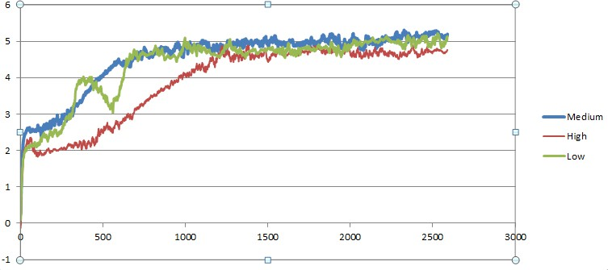

**d)**

**Figure 19 :a)Low , b) Medium , c) High , d) Combined. Frictional force variation with data points.**

As the silicon percentage increased the frictional force kept on decreasing between the pin and the cast iron disc.

This again showed a favourable inverse relationship between silicon and frictional force.

Result 2

COMPARISON OF WEAR RATE AMONG SPECIMENS

**Wear Rate vs Data Points(Low)**

250

200

150

100

50

0

0

500

1000

1500

2000

2500

3000

-50

**a)**

**Wear Rate vs Data Points(Med)**

15

10

5

0

-5 0

-10

-15

-20

-25

-30

500

1000

1500

2000

2500

3000

**b)**

**Wear Rate vs Data Points(High)**

15

10

5

0

-5 0

-10

-15

-20

-25

-30

500

1000

1500

2000

2500

3000

**c)**

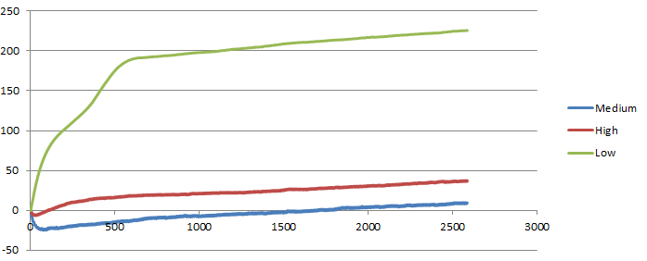

**d)**

**Figure 20 :a)Low , b) Medium , c) High , d) Combined. Wear rate variation with data points.**

As the Silicon percentage increased in the specimens the wear rate of the pins reduced. The silicon levels are inversely proportional to the wear rate.

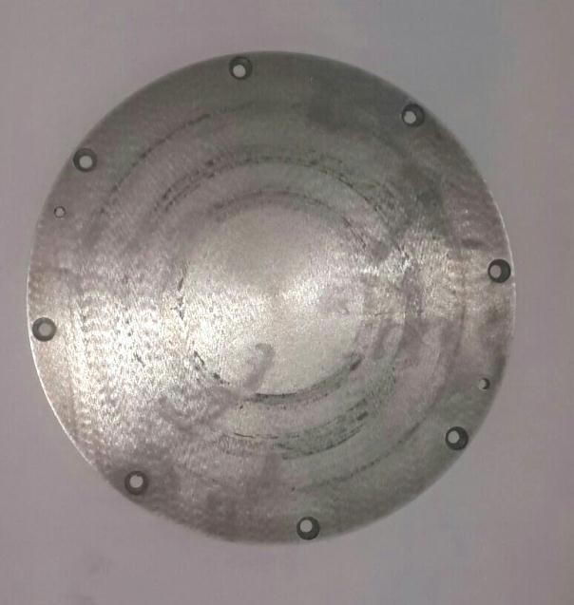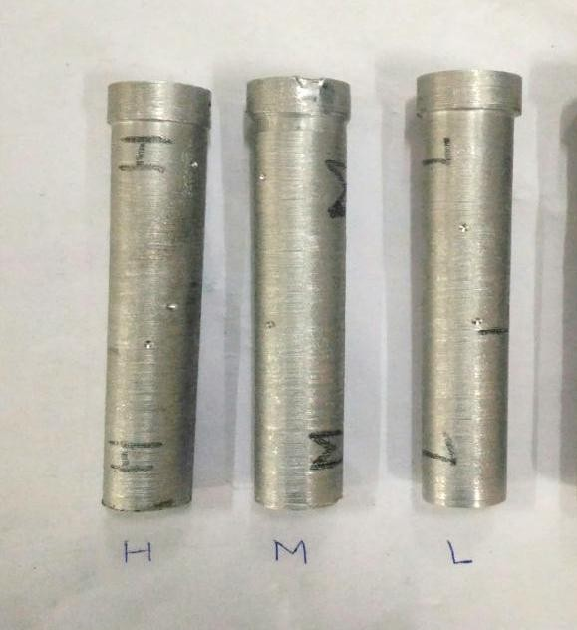

**Figure 21 : Wear on disc after test Figure 22 : Test Specimens (Showing Track Distance of all 3 specimens)**

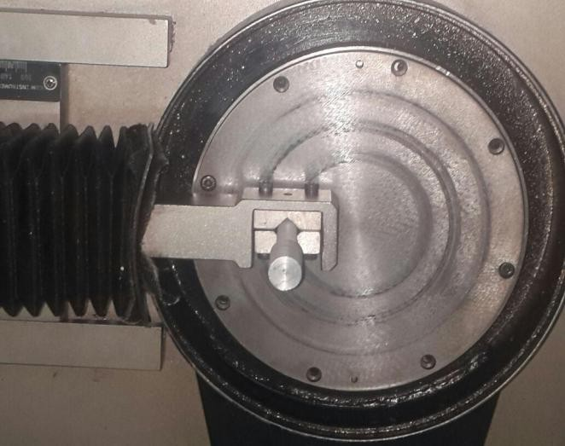

**Figure 23 : Pin-on-Disc setup with specimen**

**sliding on revolving disc**

## Hardness

The Rockwell hardness test measured the depth of indentation produced by an indentor. Two values were taken which are tabulated below along with their average.

**Table No.4 :** Rockwell hardness for different compositions.

|  |  |  |  |
| --- | --- | --- | --- |
| Material | Reading 1 | Reading 2 | Average |
| Low Grade | 37.5 | 39 | 38.25 |
| Medium Grade | 49 | 49.2 | 49.1 |
| High Grade | 57.8 | 54 | 55.9 |

|  |  |  |  |
| --- | --- | --- | --- |
| Pure Grade[22] | 54.9 | 57 | 55.95 |

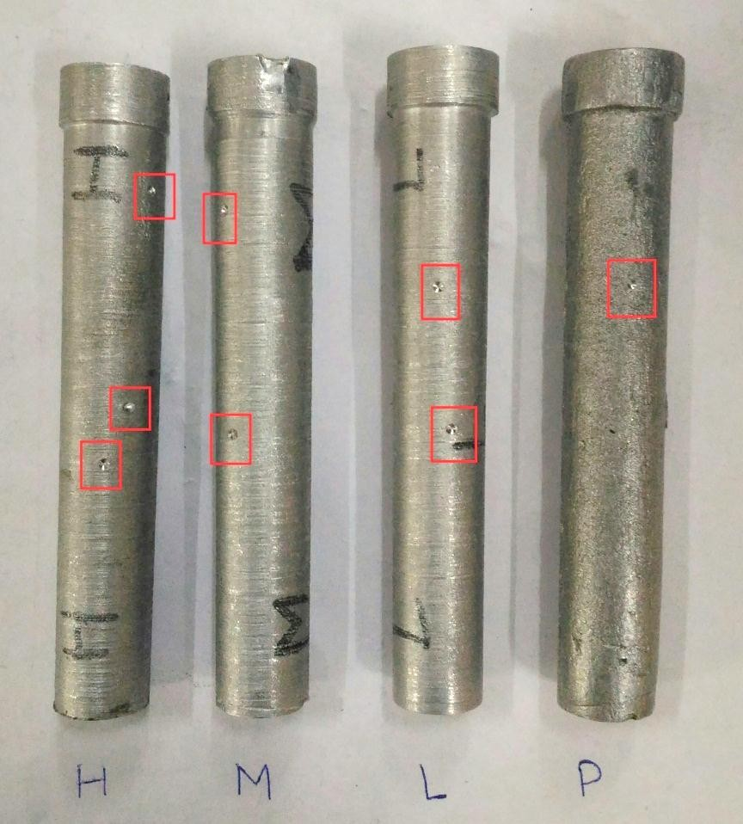

## Figure 24 : Specimen showing indentations.

* 1. **Tensile Test**

The tensile test was performed to test nature of fabricated specimens by observing their surface after fracture by using UTM. It was observed that the surface was perpendicular to the axis of applied tensile force, thus concluding that the material has adopted brittle nature.

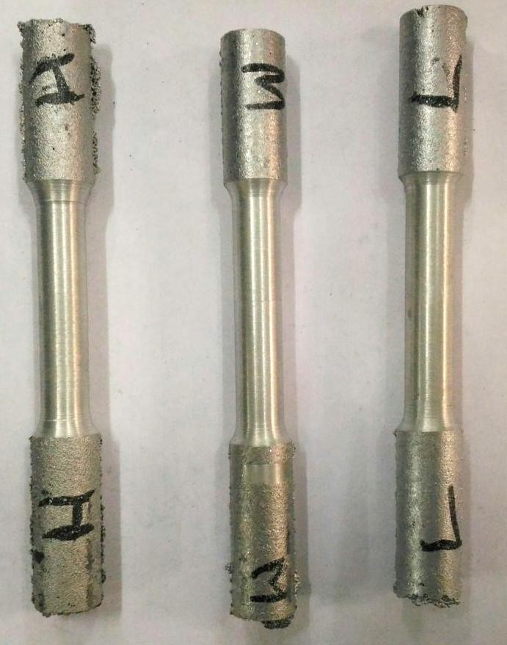

**Figure 25 : The specimens prior tensile test.**

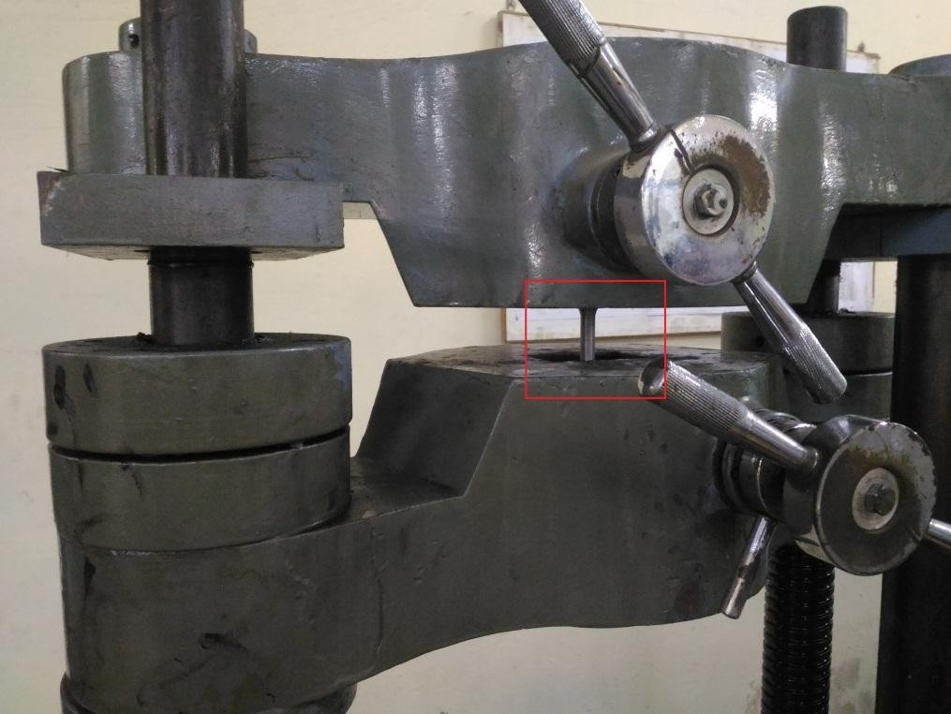

**Figure 26 : Specimen under tensile test.**

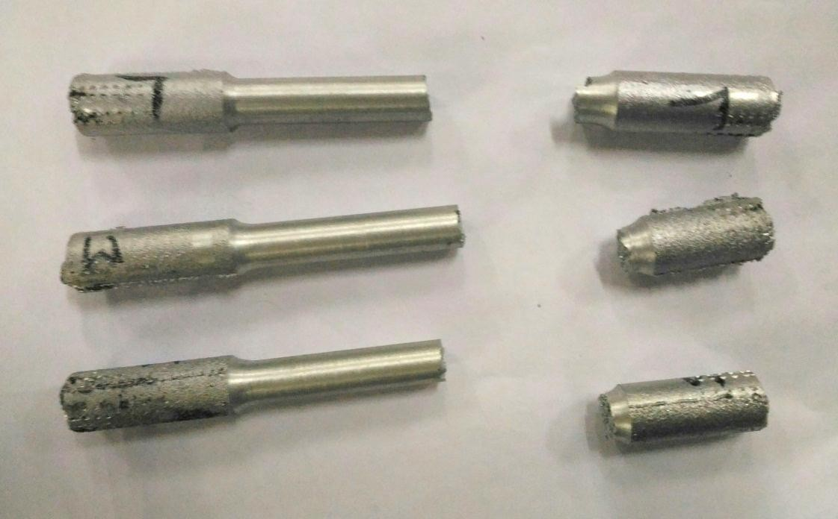

**Figure 27 : Fractured specimen after tensile test.**

# DISCUSSION

In this research work, a new aluminium based metal matrix composite with fly ash and sugarcane baggase as the reinforcing materials has been successfully fabricated.

Three different samples were fabricated by varying the composition of fly ash while that of sugarcane baggase remained fixed in each sample. For fabrication of samples, Stir-Casting process has been used. These samples were used for the study of variation in the microstructure and mechanical properties with the variation of flyash. For analysing the variation in the mechanical properties, the samples were tested on-

* Universal Testing Machine
* Rockwell Hardness Testing Machine
* Pin on Disc machine.

While for analysing the change in microstructure, Spectroscopy was used.

On comparing the results obtained from the microstructure analysis of the samples, following results have been obtained-

Spectroscopy of the samples reveals that the content of silicon increased with increase in the composition of fly ash, although it is comparable to the silicon content of the parent material. Similarly, on comparing the results obtained from the mechanical testing of the samples, following results have been obtained-

1. Pin On Disc wear Test

As the fly ash content increases

* + Wear resistance increases.
  + Frictional force reduces.

1. Universal Testing Machine

By observing the nature of fracture of the specimens, it was found that ductility was compromised as compared to parent material i.e. pure aluminium[22].

1. Rockwell Hardness Test

It has been observed that the hardness of the specimen with highest fly ash content is comparable to the parent material. While for the other specimen, the hardness was found to be reduced.

# References

1. K. Kato, Wear in relation to friction – a review, Wear, vol. 241, pp. 151-157, 2000.
2. A.P. Sannino, H.J. Rack, Dry sliding wear of discontinuously reinforced aluminum composites review and discussion, Wear, vol. 189, pp. 1-19, 1995.
3. M. Singh, D.P. Mondal, Q.P. Modi, A.K. Jha, Two-body abrasive wear behavior of aluminum alloy-sillimanite particle reinforced composite, Wear, vol. 253, pp. 357-368, 2002.
4. N. Kahramana, B. Gulenc, Abrasive wear behavior of powder flame sprayed coatings on steel Substrates, Materials and Design, vol. 23, pp. 721-725, 2002.
5. T. Satoh , N. Koreeda , T. Hayashi , M. Nagai, Fretting fatigue properties of turbine blade/disk joints, Technical Research and Development Institute, Japan Defense Agency Technical Report No. 6687, 1999.
6. Y. Torres, S. Rodriguez, A. Mateo, M. Anglada, and L. Lianes, Fatigue behavior of powder metallurgy high-speed steels, fatigue limits prediction using a crack growth threshold- based approach, Mater. Sci. Engg. A Structure Mater, pp. 387-389, 501-4,2004.
7. J. Takeda, M. Niinomi, T. Akahori, Gunawarman, Effect of microstructure on fretting fatigue and sliding wear of highly workable titanium alloy (Ti-4.5AI-3V-2Mo-2Fe),Toyohashi, Japan 19 December, 2003.
8. Shueiwan H. Juang and Cheng-Shuo Xue, Investigation of mechanical properties and microstructures of aluminium-fly ash composite processed by friction stirring, Materials Science&Engineering A640(2015)314–319.
9. K. Soorya Prakash, R. Sathiya Moorthy, P.M. Gopal and V. Kavimani, Effect of Reinforcement, Compact Pressure and Hard Ceramic Coating on Aluminium Rock Dust Composite Performance, RMHM 4137 S0263-4368(15)30108-6.
10. S.E. Shin and D.H. Bae, Deformation behavior of aluminium alloy matrix composites reinforced with few-layer grapheme, JCOMA 4008 S1359-835X(15)00256-0.
11. Kenneth Kanayo Alaneme and Kazeem Oladiti Sanusi, Microstructural characteristics, mechanical and wear ehavior of aluminium matrix hybrid composites reinforced with alumina, rice husk ash and graphite, Engineering Science and Technology International Journal xxx (2015) 1-7.
12. Pardeep Sharma, Satpal Sharma, and Dinesh Khanduja, A study on microstructure of aluminium matrix composites, Journal of Asian Ceramic Societies xxx (2015) xxx–xxx.
13. K. Praveen Kumar, M. Gopi Krishna, J. Babu Rao and N.R.M.R. Bhargava, Fabrication and characterization of 2024 aluminium – high entropy alloy composites, JALCOM 33704 S0925-8388(15)00806-3.
14. Narendra Kumar, Rakesh Kumar Gautam and Sunil Mohan, In-situ Development of ZrB2 Particles and Their Effect on Microstructure and Mechanical Properties of AA5052 Metal-Matrix Composites, JMAD 7251 S0261-3069(15)00258-7.
15. Elizabeth C. Claunch, Devin M. Ridgley and Justin R. Barone, Completely self- assembled fiber composites, Composites Science and Technology 117 (2015) 1-8.
16. Wei Xiong, Xianfeng Zhang, Yang Wu, Yong He, Chuanting Wang and Lei Guo, Influence of additives on microstructures, mechanical properties and shock-induced reaction characteristics of Al/Ni composites, Journal of Alloys and Compounds 648 (2015) 540e549.
17. Yong-gang Li, Ying-hui Wei, Li-feng Hou, Chun-li Guo and Sheng-qiang Yang, Fabrication and compressive ehavior of an aluminium foam composite, JALCOM 34738 S0925-8388(15)30446-1.
18. Lie Shen, Wenlian Qiu , Wen Wang , Guohua Xiao and Qipeng Guo, Facile fabrication of super hydrophobic conductive graphite nano-platelet/vapor-grown carbon fiber/polypropylene composite coatings, Composites Science and Technology 117 (2015) 39e45.
19. Lei Zhang, AnastasiaEliasb, WeixingChen and KeweiGao for Electrical conductivity and wear ehavior of bi-continuous Cr3C2–Cu composites.
20. L.Lityn´ska-Dobrzyn´ska , J. Dutkiewicz , K. Stan-Głowin´ska, W. Wajda, L. Dembinski, C. Langlade and C. Coddet, Characterization of aluminium matrix composites reinforced by Al–Cu–Fe quasicrystalline particles, Journal of Alloys and Compounds (2014).
21. Pradeep Sharma, Satpal Sharma, Dinesh Khanduja, Production and some properties of Si3N4 reinforced aluminium alloy composites, Journal of Asian Ceramic Societies (2015)
22. Study, preparation and wear testing of Al-Si(10%w/w) alloy, B.tech thesis, MAIT, 2013.
23. Muhammad Hayat Jokhio, Muhammad Ibrahim Panhwar, Mukhtiar Ali Unar, “Manufacturing of Aluminium Composite Material Using Stir Casting Process”, Mehran University Research Journal of Engineering & Technology, Volume 30, No. 1, January, 2011,

ISSN 0254-7821

1. Neelima Devi. C, Mahesh.V, Selvaraj. N, “Mechanical characterization of Aluminium silicon carbide composite”, International journal of applied engineering research, dindigul,

Volume 1, No 4, 2011, ISSN 09764259

1. J.U. Ejiofor, R.G. Reddy, “Developments in the Processing and Properties of Particulate Al-Si Composites”, JOM publication, of The Minerals, Metals & Materials Society (1997)
2. Karl Ulrich Kainer, *“BASICS OF METAL MATRIX COMPOSITES”*, WILEY-VCH

Verlag GmbH & Co. KGaA, Weinheim, (2006).

1. Jain & Jain, *“ENGINEERING CHEMISTRY”*, 15th Edition, Dhanpat Rai Publishing Company, New Delhi (2006).
2. R.K. Jain, *“PRODUCTION TECHNOLOGY”*, 16th Edition, Khanna Publishers, New Delhi (2006).
3. “Development of Aluminium Based Silicon Carbide Particulate Metal Matrix Composite”, Journal of Minerals & Materials Characterization & Engineering, Vol. 8, No.6, Printed in the USA, (2009) , pp 455-467.
4. “Development of Particulate Reinforced Aluminium Metal Matrix Composite”, 2nd International Conference on Engineering Research & Development: Innovations, Benin City, Nigeria, (2008).
5. “Metal matrix composites: production by the stir casting method”, Journal of Materials Processing Technology
6. <http://www.substech.com>
7. [http://www.ipublishing.co.in](http://www.ipublishing.co.in/)
8. <http://www.ethesis.nitrkl.ac.in/1845/1/nigam%26di>