**Improving Medical Data Accuracy Using the Advanced Neuron Faster R-CNN Algorithm for Intelligent Healthcare Applications**

*Sailaja G1, B.Narendra Kumar Rao 2*

*1 Research Scholar, School of Computing, Mohan Babu University, Tirupati, Andhra Pradesh 517102, India*

*2  Professor & Program Head, AIML, School of Computing, Mohan Babu University, Tirupati,Andhra Pradesh 517102,India*

# Abstract

*This study seeks to spark engagement in healthcare, particularly as human lifespans increase in modern society. As numerous patients in hospitals produce vast amounts of medical data—such as EMR, PACS, OCS, HER, MRI, and X-Ray—following treatment, managing both structured and unstructured data formats has become increasingly important*. *However, the interpretation of much medical data is prone to errors, omissions, and inaccuracies, posing significant risks in patient care and occasionally resulting in medical mishaps due to physician misinterpretations. This research addresses these challenges by utilizing a CNN-based intelligent agent within cloud architecture to enhance the accuracy of medical image data interpretation. By implementing a more advanced, faster R-CNN Intelligent Agent Cloud Architecture, the study aims to decrease error rates in the analysis of medical images. The proposed methodology demonstrates a reduction in error rates by over 1.4 times (140%) compared to existing error-prone reading methods. This novel algorithm analyses stored medical data, particularly focusing on human lung examinations, utilizing Conv feature maps through deep ConvNet and ROI Projection techniques. The experimental phase of this study analysed a dataset consisting of around 120,000 medical records, focusing on enhancing processing performance through GPU acceleration. This was achieved using NVIDIA’s SLI technology on multiple operating systems and several Quadro GPUs. The experiment employed a verification dataset randomly sampled from the pool of 120,000 medical records, with approximately 40% of the extracted images subjected to similarity assessments against the original data. Ultimately, the goal is to diminish and validate the error rates associated with medical data interpretation.*

# 1. Introduction

In contemporary society, human lifespans have significantly extended, prompting an increased focus on healthcare. Unfortunately, numerous countries struggle with medical accidents due to inadequate healthcare provision. These factors have underscored the importance of ensuring the accurate interpretation of medical imaging data [1]. With a global interest in health, hospitals worldwide generate extensive health data (including X-Ray,MRI,HER,PACS,EMR etc.) stored in both structured and unstructured formats. However, the interpretation of such data is prone to errors, omissions, and inaccuracies, posing significant risks to patient care and occasionally resulting in medical mishaps due to physician errors. As a result, a study has been launched to evaluate the precision with which existing medical image data can be read using a CNN-based intelligent agent within a cloud architecture. Furthermore, to reduce interpretation errors in medical imaging, the implementation of an enhanced, faster R-CNN Intelligent Agent Cloud Architecture has been suggested.

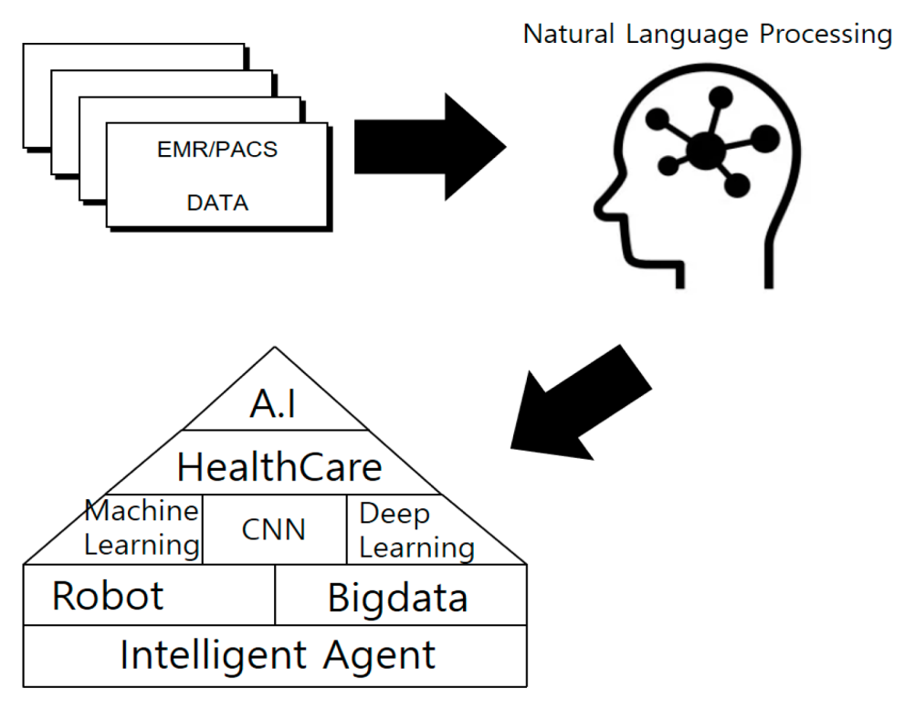

**Figure 1. Conceptual Diagram of Health AI System.**

# We created technique designed to Decrease errors in medical data interpretation. This approach involved using an algorithm to analyse real Health information passing to convolutional Fearture mapping with insight ConvNet & ROI Projections on techniques. Our study examined approximately 120,000 medical records, primarily focusing on chest and lung scans. To support high-performance computing, we set up a test environment optimized for GPU use, utilizing NVIDIA SLI across multiple operating systems and several Quadro GPUs.

# In our testing protocol, we randomly selected verification data from the 120,000 medical records, comparing about 40% of these images for similarity against the original dataset. Most of images were drawn from public health databases, highlighting our emphasis on using publicly accessible data for validation. It is important to recognize that while artificial intelligence systems offer significant potential, they are not fool proof solutions. Objective is to lower the error rates in medical data interpretation and to assess the reliability and potential increase in medical incident rates by examining the Clustering of Health information using AI [2, 3, 4].

# 2. Background Knowledge

#### 2.1. Artificial Intelligence

AI, a method that amalgamates human getting the hang of, thinking, perceptual capabilities, and comprehension of regular language into PC programs, stands at the intersection of software engineering and data innovation.. This field delves into the mechanisms through which computers can replicate human intelligence, empowering them to demonstrate intelligent behaviours [5,6,7].The concept of AI is already applied across various domains, including the medical field [8,11]. However, AI faces several challenges, leading to the utilization of verification algorithms for crucial research purposes.

AI algorithms are extensively employed in medical systems, ranging from surgical procedures to diagnostic readings. Notably, AI-powered robots are employed in China to aid in surgical operations [12, 13, 16]. Moreover, AI has evolved from early systems to encompass machine learning and deep learning techniques, making significant strides in the medical domain .

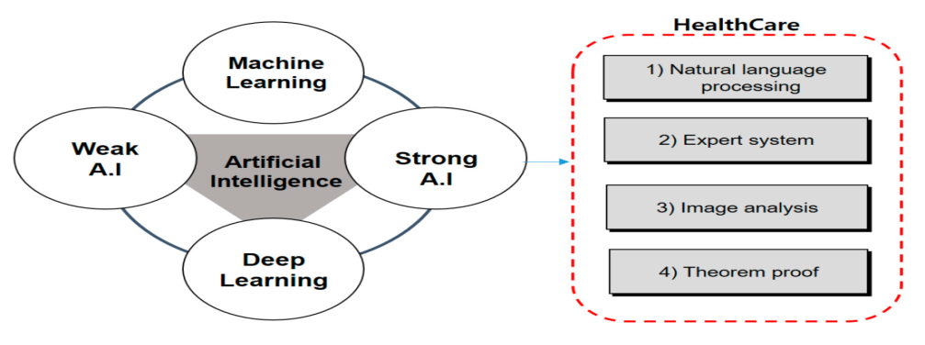

**Figure 2. Interconnection of Healthcare and AI**

1. **Natural Language Processing (NLP):**

NLP has already made practical applications like automatic translation possible. Continued research in this field holds the potential for enabling human-computer conversations and information exchange, ushering in transformative changes in how we interact with technology.

1. **Knowledge-Based Systems:**

Knowledge-Based Systems enable System to carry out a wide range of specialized tasks traditionally performed by humans, including medical diagnoses, mineral reserve assessments, compound structure estimations, and evaluations for damage compensation premiums. This field represents one of the earliest developments in artificial intelligence.

1. **Visual Intelligence:**

The complexity of Visual Intelligence is made feasible through the application of artificial intelligence theories. This includes tasks such as computer-captured video analysis through TV cameras to identify content or converting a person's voice into text. These technologies play a crucial role in tasks such as character recognition, robotics, and associated domains.

1. **Mathematical Proof:**

Mathematical Proof is a crucial Innovation within artificial intelligence, involving the logical deduction and proof of mathematical theorems based on known facts. This discipline holds significant intrinsic value.

1. **Artificial Brain Organization:**

Brain organizing, a somewhat ongoing expansion, veers off from customary numerical rationale. All things considered, it is an organization of various basic processors organized like the human cerebrum. This innovative approach has gained prominence for its applications in various fields.

#### 2.1.1. Weak Artificial Intelligence

Weak artificial intelligence aims to furnish PCs with the capacity to address errands that people can achieve easily, for example, perceiving objects in clinical symbolism like X-rays and X-beams or grasping communicated in language. Unlike the more abstract goal of mimicking human intelligence, weak artificial intelligence aims at practical applications and is often used as a problem-solving tool rather than possessing true intelligence [17,18,19]. It operates within predefined algorithms for analysing and verifying medical data, enabling relatively intelligent decision-making based on extensive datasets. Despite its ability to autonomously identify rules and solve problems, understanding the reasoning behind its solutions can be challenging, limiting its utility in verifying medical data.

Medical artificial intelligence systems have surpassed human capabilities in tasks like surgical and diagnostic data analysis, demonstrating functionalities beyond human capabilities [20]. While not replicating human behaviour, they transcend human abilities and excel in problem-solving tasks, known as medical reinforcement learning. This underscores the notion that the ability to effectively solve specific problems may surpass the broader capabilities of strong artificial intelligence. This aspect remains predictable, as even in the absence of strong artificial intelligence, it is uncertain whether human intelligence universally excels in problem-solving tasks.

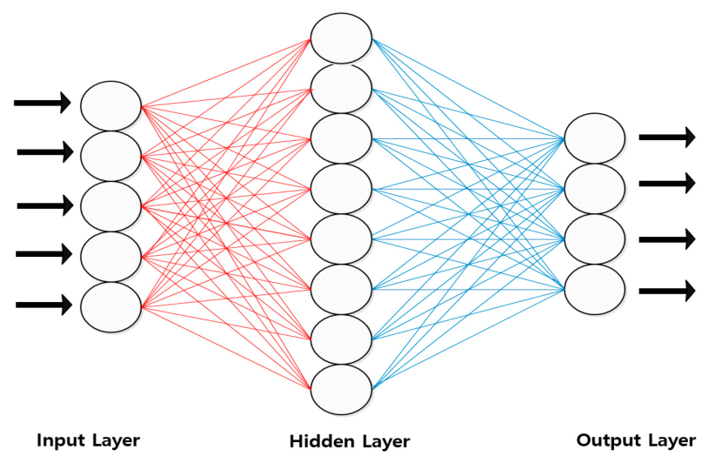

**Figure 3. Weak Artificial intelligence**.

#### 2.1.2 Strong Artificial intelligence

It refers to the capacity of a computer to analyse medical data and potentially mimic human-level intelligence within a medical system. The concept extends to creating computer-generated entities with intelligence comparable to humans, raising various controversial issues [21]. Medical strong artificial intelligence, specifically tailored for medical data analysis [22,25], is pursued due to the realization that human judgment alone cannot safeguard human life [26].While medical devices may achieve similar levels of functionality in the future, significant barriers hinder the development of strong artificial intelligence. Questions persist regarding the consciousness, thoughts, and minds of medical practitioners, as well as whether consciousness can be imbued in artificial entities beyond the brain. This dilemma underscores the dualistic and monistic perspectives on the relationship between the mind and body [27,28].Medical data holds immense significance, as errors or misinterpretations could have fatal consequences. Therefore, the pursuit of strong artificial intelligence in medical contexts is paramount [see Figure 4].

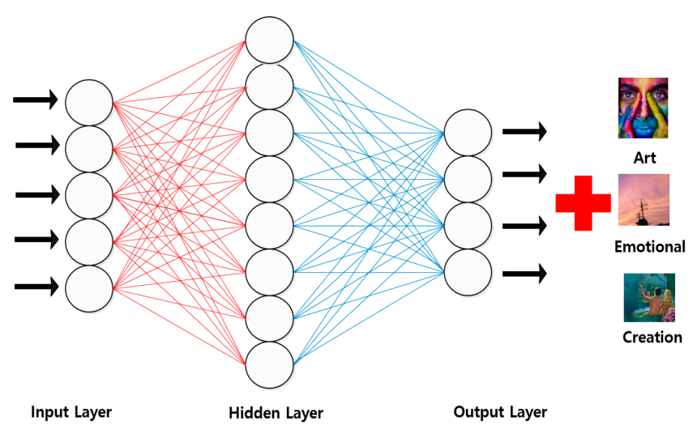

**Figure 4. Strong Artificial intelligence**

#### 2.2 Smart Agents

A Smart agent embodies programs that operate on behalf of individuals, encompassing behaviours and patterns akin to those of medical practitioners conducting surgeries. However, there exists a contrasting view asserting that computer programs cannot fully replicate human agency due to limitations in performing desired tasks. The attributes of medical intelligent agents reflect the cognitive processes of physicians, characterized by autonomy, sociality, mobility, and intelligence.

Autonomy in medical intelligent agents denotes their capacity to make independent judgments and execute tasks without direct instruction or intervention from users or other programs, representing a pivotal feature. Mobility of agents is particularly advantageous in scenarios where continuous contact with mobile or server systems is challenging. Managed agents necessitate collaboration with other agents and entities to analyse inputs and discern user intentions, facilitating more comprehensive service provision compared to independent operation. Intelligence stands as the ultimate aspiration in computer science, representing the pinnacle that all medical programs aspire to attain [29,30].

Intelligence serves as a fundamental trait for intelligent agents, empowering them with autonomy to assess diverse situations. Effective task execution, including collaborative efforts with other agents, demands adeptness in knowledge processing for task planning, performance integration, and division.. Moreover, intelligent agents refine user interactions by learning user tendencies, thereby enhancing user experiences. The capacity to deduce specific tasks from ambiguous requirements and accumulate insights from past experiences underscores an agent's adaptability and learning capability. Augmenting these foundational attributes, qualities such as responsiveness, ethical conduct, honesty, and rational behaviour are deemed essential for agents. While perfection in all aspects may be elusive, researchers emphasize that closer adherence to these traits enhances an agent's completeness. In the realm of artificial intelligence, intelligent agents aim to excel in searching and automating tasks, particularly in domains like healthcare, fostering active and efficient engagement.

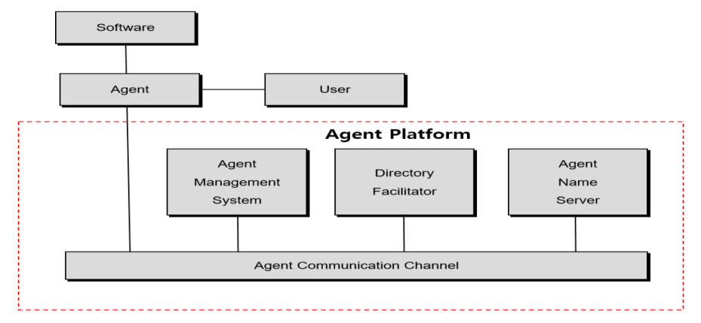

**Figure 5. Smart Agents**

#### 2.3. Health Care in AI

AI has evolved into distinct areas, formerly known as "intelligent agents," and the contemporary domains of "Deep learning and Machine learning." Researchers have extensively explored these fields, aiming to advance the capabilities of AI [8, 11]. This study focuses on analysing the extraction of image data utilized in medical treatments, including EMR, PACS, MRIs, and X-rays. Notably, AI stands out for its unique attribute of initially focused on understanding the brain's functionality, artificial intelligence (AI) has evolved to comprehend its underlying principles, eventually describing them. Early developments in AI healthcare introduced algorithms like 'temporary difference learning,' which assesses proximity to compensation time and iteratively adjusts the workflow instead of overhauling it entirely based on rewards [17]. Furthermore, vigilance regarding technology advancement and security is paramount, especially considering instances where hackers tamper with or misplace image data. While AI cannot overhaul all medical systems, its aim is to mitigate medical errors significantly [19,21,24].

Smart Health Care

The emergence of smart healthcare represents a novel integration of healthcare, Big Data, Artificial Intelligence, Cloud Computing and nanotechnologies. This innovative concept has garnered considerable attention due to its promise of delivering healthcare services conveniently and ubiquitously to individuals, regardless of location. The healthcare landscape has transitioned from traditional hospital-centric models to incorporating Information and Communication Technologies (ICTs) into medical practices, offering diverse and convenient health-related services to a broad spectrum of consumers. Given the rapid expansion of digital technologies like artificial intelligence, IoT, and wearable devices into the medical domain, it is imperative to develop strategy, specialized, and social reaction systems to address these progressions successfully.

Smart healthcare is transitioning away from being solely focused on medical products, instead shifting towards a platform that amalgamates diverse data and services related to personal healthcare. This evolution is driving the development of intelligent healthcare solutions that integrate multiple systems in real-time through organic combinations. The smart healthcare industry represents a convergence of smart device technology, information and communication technology, and medical services and clinical benefits. It is being created across three essential classifications: equipment, programming, and administrations.

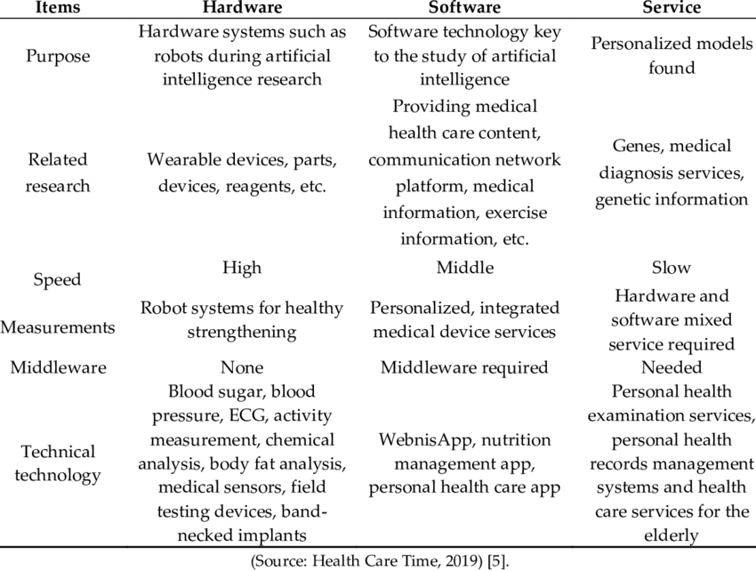

**Table 1. Composed Deals with Clinical consideration: Hardware, Programming, and Organizations**

Smart healthcare emerges as a viable and alternative solution, particularly amid the escalating healthcare costs driven by the rapidly aging population and the rising demand for medical services among chronic patients [26]. Hence, this study introduces a methodology aimed at authenticating individual medical information efficiently by leveraging smart healthcare technologies and intelligent agents powered by artificial intelligence [14,19,6,3].

#### 2.3.1 Intelligent Agent-Based Architecture for Smart Healthcare Applications

**Emerging Concerns**

To enhance healthcare services through smart agents, an examination of the existing smart healthcare landscape is crucial. While the smart healthcare industry holds immense global promise, its growth in Korea faces challenges due to regulatory constraints. One significant obstacle is the limited sharing of medical information, particularly as current laws prohibit the storage of medical data in the cloud. Unlike the United States, where cloud-based medical information services are rapidly developing, Korean regulations mandate the storage of medical data within institutional servers, hindering integration with external systems. Interestingly, the U.S. FDA-supported medical services administrations team up with private insurance agency to store patient clinical and wellbeing data in the cloud, working with proficient information transmission to medical clinics. Japan, confronting a clinical climate similar to Korea's, has proactively started lawful updates to integrate cloud innovation into its medical care industry, growing its cloud-based medical care administrations. Despite the fact that China is in the beginning phases of acquainting cloud administrations with the clinical area, it is an on-going cycle. Besides, the shortfall of thorough perusing and check of clinical information (EMR, PACS, X-ray, PHR, X-beam, and so on) represents a gamble of clinical mishaps. Because of administrative limitations, Korean organizations in the savvy medical care industry, using associated clinical gadgets and wearable terminals, may confront difficulties in worldwide rivalry. Moreover, the absence of standards for anonymzing clinical data for enormous information investigation requires separate assent from data suppliers, as clinical information is delegated touchy individual data. This administrative scene presents intricacies and serious impediments for Korean substances in the advancing domain of shrewd medical care.

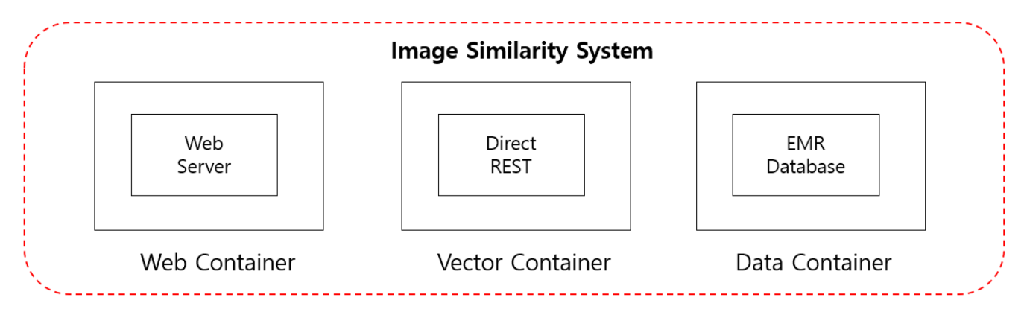

**Figure 6. EMR Data Extraction System Using Image Similarity**

Under the Personal Information Protection Act, utilizing data for research purposes is permissible, permitting the utilization of clinical enormous information from explicit people in a unidentifiable structure for factual and scholastic examination. In any case, existing protection regulation doesn't actually isolate individual identifiers from wellbeing data urgent for research, causing vulnerability about the degree of data requiring anonymization. This study plans to tackle man-made reasoning (artificial intelligence) shrewd specialists to improve the medical services framework. The objective is to make a computer based intelligence framework where individual data is consequently gathered and investigated utilizing savvy specialists, with ensuing conveyance worked with through brilliant gadgets. Nonetheless, current AI services need integration with various healthcare services to gather data through a unified engine. Intelligent agents then utilize this data to establish a standardized architecture, addressing the lack of standardization in existing AI algorithms and facilitating the deep learning of crucial health information.

#### 2.4 Enhancing EMR Interpretation with CNN-Based Intelligent Agent Cloud Architecture

A variety of technologies, such as machine learning, deep learning, imaging, natural language processing, and voice recognition, are incorporated into AI medical devices. Convolutional neural networks (CNNs) are notable among them. CNNs are deep learning algorithms designed to mimic the visual processing of humans, focusing primarily on tasks such as image classification and recognition. Utilizing methods such as convolution and pooling, CNNs excel in identifying objects within images.

Convolution involves the application of multiple filters across different parts of an image, accentuating distinctive features like edges and contrasts. Pooling, on the other hand, aims to reduce the image's size while preserving essential information. These processes collectively enable CNNs to discern objects and patterns within medical images with remarkable accuracy and efficiency.

A CNN-based (Convolutional Neural Network) intelligent agent cloud architecture, designed to improve Electronic Medical Record (EMR) interpretations, leverages state-of-the-art technology to efficiently process and analyse medical data.

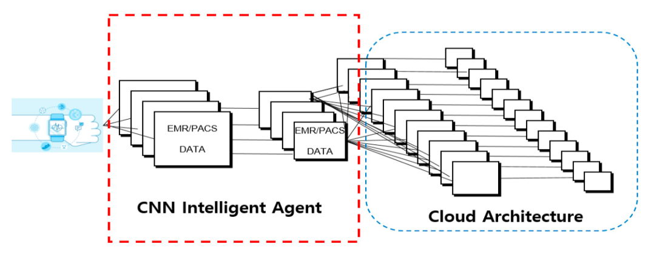

Top of Form

**Figure 7. CNN –Based intelligent Agent Cloud Architecture for Enhancing EMR readings**

**Data Acquisition and Pre-processing**

Within a hospital's EMR system, data is sourced from diverse outlets including patient records, medical imaging devices (e.g., MRI machines, X-ray scanners), and laboratory results. The pre-processing phase involves meticulous data cleansing, noise removal, value normalization, and format standardization to ensure data consistency and accuracy.

**Convolutional Neural Network (CNN)**

A CNN model is trained to examine medical images such as X-rays and MRI scans. For example, the model can be trained to detect abnormalities in the images, such as tumours or fractures. CNN architecture is made up of convolutional layers for feature extraction, pooling layers for dimensionality reduction, and fully connected layers for classification.

**Intelligent Agent:**

An intelligent agent serves as the intermediary between the CNN model and the cloud infrastructure. It orchestrates tasks such as data routing, model deployment, and result retrieval. This agent ensures seamless communication across different components of the architecture, optimizing workflow and resource utilization.

**Cloud Infrastructure**

Leading cloud platforms, like Amazon Web Services (AWS) or Microsoft Azure, provide scalable computing resources to execute the CNN model and store large volumes of EMR data.Cloud services offer flexibility, cost-effectiveness, and accessibility, empowering healthcare providers to analyse EMR readings with efficiency.

**CNN Model Training**

The CNN model undergoes training using labelled EMR data. For instance, it may learn to categorize medical images into classifications such as normal or abnormal, based on predefined criteria. Model training encompasses optimizing parameters, refining network architectures, and fine-tuning hyper parameters to achieve superior accuracy and performance.

**Inference and Prediction**

Post-training, the CNN model is deployed on the cloud infrastructure for inference and prediction tasks. For instance, it may scrutinize new X-ray images to identify abnormalities like pneumonia or fractures. Healthcare professionals leverage the model's predictions to aid in diagnosis, treatment planning, and patient monitoring.

**Feedback Loop and Continuous Improvement**

The architecture incorporates a feedback loop mechanism to evaluate the model's efficacy and integrate new insights. Feedback from healthcare professionals, if the model misclassifies certain medical conditions, is utilized to refine the model and enhance its accuracy over time.

#### In conclusion, the CNN intelligent agent cloud architecture enables healthcare providers to harness cutting-edge technology for accurate and efficient analysis of EMR readings. This advancement leads to improved patient outcomes and elevated standards of healthcare delivery.

#### 2.5 Accelerated R-CNN Intelligent Agent Cloud Filtering Architecture

The Enhanced Recurrent Convolutional Neural Network (R-CNN) architecture enables the flexible configuration of filter sizes, with a specific setting of 5 × 5 in conjunction with an intelligent agent framework. Consequently, a singular value is chosen for each section. Given a filter size of 3 × 3, a total of 9 parameters are engaged, yielding a result designated as 'x' via activation functions like W x +b or RELU (W x +b), contingent upon the correct application of 'W'. With the image dimensions set at 10 × 10, a comprehensive view can be attained through a single application of a 5 × 5 filter.

Essentially, the process can be iterated by continuously shifting the filter either downwards or sideways, requiring a definition of the stride, determining the distance it moves. When the stride is designated as one. Moreover, the weight 'W' remains consistent throughout this process. Each step generates one value, allowing for an overall output of 5 × 5 to be achieved. In practice, the output size can be computed using the formula Size in total: N (that is, N × N × N × N × N). F is the filter size, or F × F × F × F × F. The output size can be expressed as k := (N − F) / stride + 1, where 'k' stands for an engineering factor.Prominent cloud platforms such as Amazon Web Services (AWS) or Microsoft Azure provide scalable computational resources for implementing the CNN model and storing large amounts of EMR data.

In the given example, if we compute k as (10−5)/1 + 1 = 6, where N = 10 and F = 5, and the stride is not an integer, it is disregarded. This resultant output is termed the convolution layer. The process involves assigning one activation per filter, leading to the consolidation layer. Essentially, different filters produce distinct activations, thus generating new convolution layers. For instance, with N = 10 and F = 5, we obtain six 5 × 5 convolution layers, resulting in a 5 × 5 × 10 capacity layer or activation map upon combination. This process, termed convolution, yields activation maps of size 5 × 5 × 6, akin to a new image. This process can be repeated as needed. Typically, the size k of the convolution layer is equal to or less than N, with a stride of 1,1, and F ≥ 1. In such instances, data loss occurs, indicating a reduction in dimensions. For example, the 10 × 10 data is condensed to 5 × 5 after convolution, representing a reduction from 49 to 25 dimensions. Despite this, the aim is to preserve the original 10 × 10 form. To achieve this, zeroes are added to extend the 10 × 10 image, resulting in a 7 × 7 convolution layer. This approach ensures that the convolution layer maintains the desired size, preventing data loss. Total size: N Filter size: F

The stride is represented as s, while the padding size is denoted by p. The size of the consolidation layer after padding can be calculated using the formula:

k = [(N+2p)−F]/s + 1

Moreover, it is valid that K = N if and only if p = [(N−1)(N−1)s+(F−N)]/2. When utilizing the aforementioned formula, it is imperative to ensure its correct application, where F = 3 = 3 = 3 = 3 = 2 = 1. While padding is crucial to mitigate losses during convolution in cloud computing, it is also essential to consider the generation of unnecessary elements. In instances where inadequate padding is applied to the original data, noise may emerge beyond the required 10 × 10 data. Nevertheless, employing padding is preferable to encountering data loss resulting from convolution without paddingThe goal is to improve the accuracy of medical data by refining the direct extraction of EMR data within the framework of the Faster R-CNN intelligent agent cloud filter. With a size of 224 × 224 × 3, the Faster R-CNN intelligent agent cloud filter is impressive. Furthermore, the convolution autoencoder (decoder) data are embedded when using the semantic similarity method and the conversion autoencoder (Encoder) method to embed image data with dimensions of 224 × 224 × 3, demonstrating transfer learning through embedding.

.

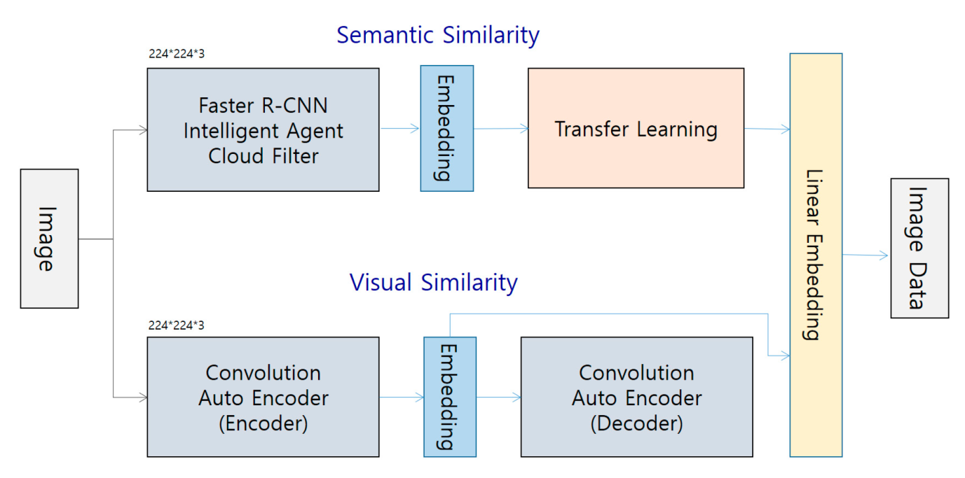

**Figure 8: CNN-Based Intelligent Agent Cloud Architecture for Enhancing EMR Interpretations**

The outlined methodology illustrates the architectural approach adopted in this method, emphasizing both visual and semantic similarities. Both methodologies utilize semantic and visual matching procedures using similarity methods. The given equation functions as a verification equation for the intelligent agent Faster R-CNN. This expression, represented by the letter Hi, is cross-referenced with the adjacent matrix that is tightly controlled. Denoted as Hj.​



Furthermore, the matrix A is designed such that all diagonal components above the top are assigned a value of zero, along with each column Aj.

Furthermore, the H obtained in the previous phase of the Faster R-CNN intelligent agent differs from the one utilized in the current implementation. Another representation of the H matrix is also provided.



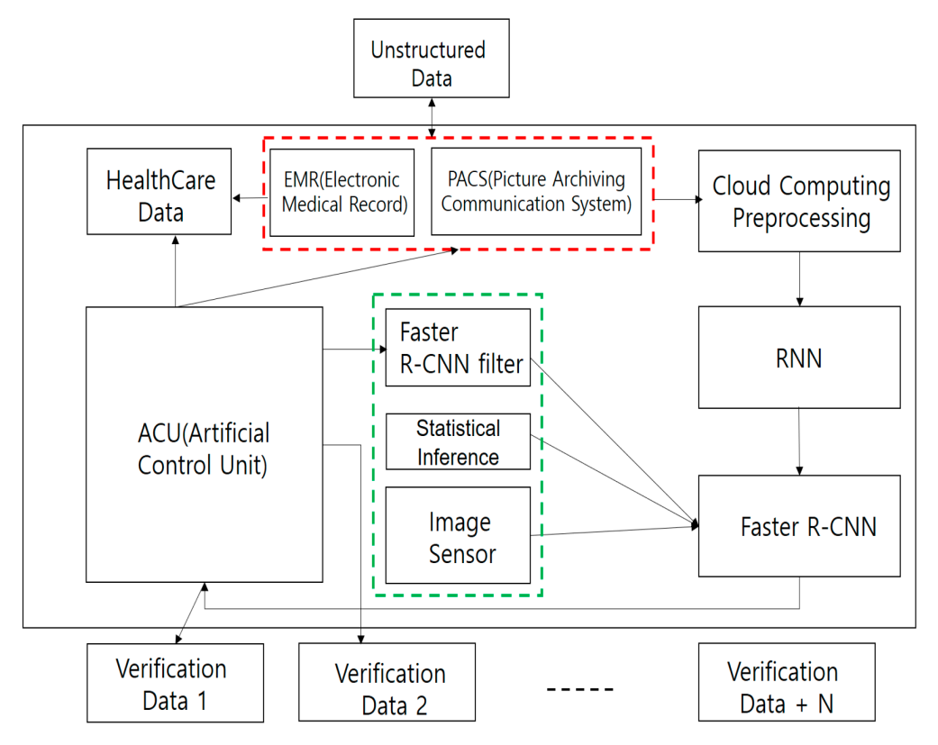

**Figure 9. Architecture of the Faster R-CNN Intelligent Agent Cloud Filter**

2.5.1 Faster R-CNN Detection Technique The Faster R-CNN algorithm

Makes use of a sophisticated detection method that processes the complete image through the application of convolutional neural networks (CNNs). By extracting feature vectors for every candidate object area, it makes tasks like bounding box localization and object recognition possible. Faster R-CNN is used in the medical domain to create image deep learning datasets for Picture Archiving and Communication Systems (PACS) and Electronic Medical Records (EMR). Image analysis in this case is automated by means of the master R-CNN, which finds pertinent images and sends them to the analysis service.

Additionally, the Faster R-CNN algorithm plays a crucial role in designing learning models capable of recognizing characters and identifying object shapes, especially in trademark images. By leveraging Faster R-CNN in conjunction with deep ranking algorithms, these learning models are developed to enhance the efficiency and accuracy of character recognition and object shape identification tasks.

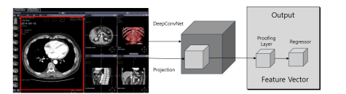

**Figure 10. Architecture of the Faster R-CNN Intelligent Agent Cloud Filtering**

2.5.2 Accelerated R-CNN Intelligent Agent Cloud Pooling Framework

Region of Interest (RoI) pooling within the Faster R-CNN framework is pivotal for object detection, allowing the extraction of fixed-size feature maps from convolutional feature maps tailored for region-based processing. Let's elucidate the functioning of RoI pooling using an illustrative example:

Consider an input image with dimensions 400x300 pixels. The Faster R-CNN algorithm identifies several regions of interest (RoIs) within the image, denoted as follows:

**RoI 1:** Bounding box coordinates (100, 50, 250, 200)

**RoI 2:** Bounding box coordinates (200, 100, 350, 250)

**RoI 3:** Bounding box coordinates (50, 150, 200, 300)

Suppose we possess a convolutional feature map obtained from the CNN backbone, with dimensions 50x40x512 (height x width x channels).Here's a breakdown of how RoI pooling operates for RoI 1:

**Extraction of Region of Interest:**

RoI 1's corresponding region is extracted from the convolutional feature map, delineated by bounding box coordinates (100, 50, 250, 200).

**Grid Subdivision:**

The region is partitioned into a fixed-size grid, assumed to be 3x3 for this demonstration.

**Determine two hyper parameters**

F: Size-based pooling filter   
Output W2 x H2 x D2 (pooling layer) for Strikes   
W2, H2 = (W1, H2 − F)/2 + 1 D2 = D1

**Quantization**

Spatial coordinates of grid cells in the original feature map are aligned with those in the 3x3 grid of the RoI, ensuring proper alignment of features.

**Pooling**

Max pooling is applied to each grid cell, wherein the maximum value from each cell in the original feature map is selected.

**Output**

Following pooling, a fixed-size feature map representing RoI 1 is obtained, hypothetically with dimensions 2x2x512.

**Repetition for Other RoIs**

The same procedure is iterated for RoI 2 and RoI 3, yielding fixed-size feature maps for each RoI. Subsequently, the output feature maps from RoI pooling for all RoIs are channelled into subsequent network layers for object classification and bounding box regression. In essence, RoI pooling guarantees that features extracted from proposed regions maintain alignment and uniform size, empowering the network to proficiently localize objects and precisely classify them.

2.5. 3 Pattern of Faster R-CNN Intelligent Agent Cloud Layers

Stacking convolutional layers with smaller filter sizes, such as 3x3, is often preferred over using larger receptive fields, like 7x7 filters. This strategy enables the extraction of more intricate features and encourages non-linearity within the neural network architecture.

Consider stacking three convolutional layers, each employing a 3x3 filter size, with a nonlinear activation function between each layer. In this setup, each neuron in the initial convolutional layer processes information from a 3x3 area of the input volume. Subsequently, neurons in the second convolutional layer integrate information from a 3x3 area of the feature map produced by the first layer, effectively capturing a 5x5 area of the input volume. Similarly, neurons in the third convolutional layer analyze a 3x3 area of the feature map generated by the second layer, corresponding to a 7x7 area of the input volume.

Using this approach, the neural network benefits from the non-linear transformations introduced by the activation functions between the convolutional layers[7,11,13]. These nonlinearities enable the network to capture complex patterns and relationships within the input data, leading to the extraction of more discriminative features.

On the other hand, simply using a single 7x7 filter in a convolutional layer may result in linear transformations without the intermediary nonlinear activations. This limitation can restrict the network's ability to learn intricate features and may lead to suboptimal performance in tasks requiring complex feature extraction [6,4].

# Time-Variant Learning in Faster R-CNN

A model for examining temporally dynamic healthcare data is the time-variable learning algorithm. Predictive tasks are used in this model to validate the learning of time variables. In time-variable prediction-based instruction learning, the algorithm learns solely from the values observed within healthcare data. Essentially, forecasting mechanisms are adjusted to better match observed results when predictions are generated and outcomes are observed. Time-variable algorithms adjust forecasts to account for other trends in the data as well as to the observations made at that moment.

# 3. Implementation

## 3.1 Sensitivity performance

The research employed artificial intelligence methodologies to conduct sensitivity performance experiments. It used the Faster R-CNN intelligent agent cloud filter Spatial Arrangement architectural design methodology, and part of the source code was released. Moreover, some of the source code for the CNN intelligent agent cloud filter spatial was made public. Additionally, the Faster R-CNN intelligent agent cloud pooling layer was designed and implemented. The fundamental methodology was examined from multiple angles in the context of artificial intelligence technology. Furthermore, the Stanford AI index identified important specific indicators according to technical performance and activity. Academic, industrial, open-source software, and public interest activity levels were measured, and technical performance was evaluated in terms of natural language comprehension, visual processing, proof of concept , as well as the solution of issues. By breaking down technical performance into four categories—visual processing, natural language comprehension, proof of concept, and potential for problem solving—more specificity was attained.

.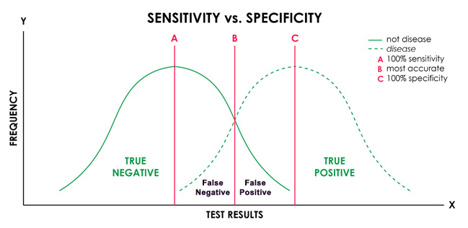

**Figure 11: Models Beyond the Faster R-CNN Intelligent Agent Cloud Architecture**

Visual innovation went through investigation through measurements, for example, object acknowledgment and visual inquiry addressing. Responsiveness investigation additionally investigated regular language cognizance abilities through markers like sentence examination, machine interpretation, question-responding to, and discourse acknowledgment. Outstandingly, there were no particular sub-measurements for evidence of idea and issue goal. Consequently, man-made brainpower ideas without the Quicker R-CNN savvy specialist cloud design might be viewed

as commonly less delicate.

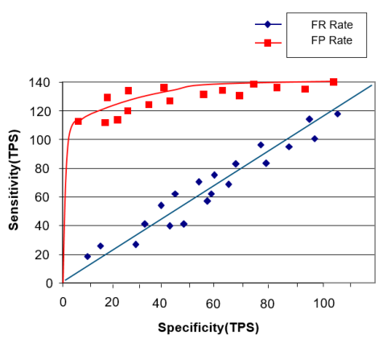

## Figure 12: Model Incorporating Faster R-CNN Intelligent Agent Cloud Architecture

## 3.2 Image Static Performance Testing Procedure

## The procedure for evaluating performance by processing medical image data was as follows:

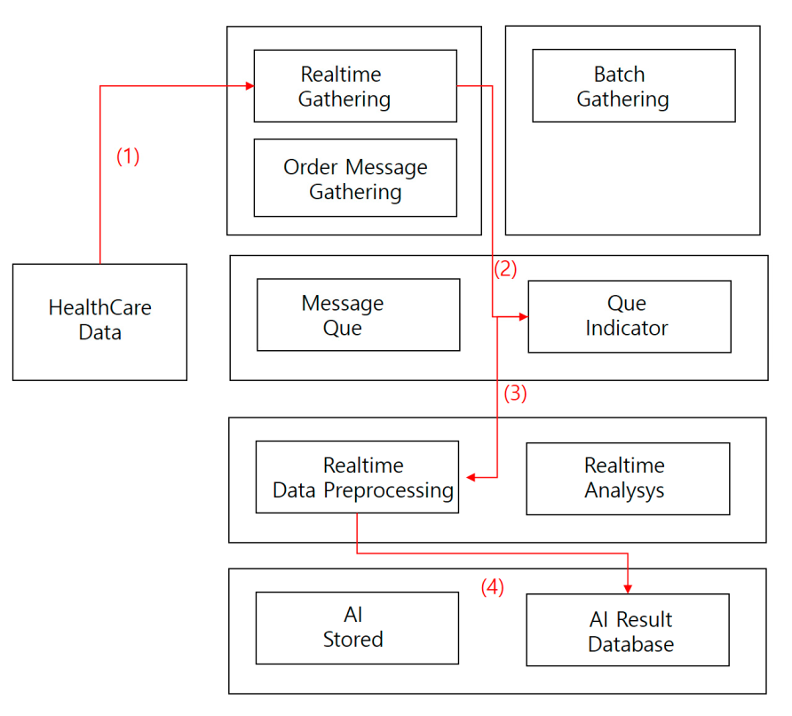

**Figure 13. Image Static Performance Testing Procedure**

# Strategy:

# 1. Collect clinical imaging information progressively.

# 2. Directly store the gathered clinical picture information through continuous handling into a message line.

# 3. Store the procured information in a constant pre-processor.

# 4. Log man-made intelligence results information base information.

# 4. Conclusion

Through the examination of huge datasets, quick R-CNN strategies — which are notable for their adequacy in bringing down mistakes in the perusing of clinical picture information — were utilized in this review to survey the closeness of clinical information To investigate clinical picture information utilizing web and information holder techniques and integrate X, Y, and Z esteems, the engineering plan for picture comparability was created. By confirming semantic and visual likeness, a calculation was made to cross-reference these qualities against COS information and assurance information consistency.

# The control component for all calculations, especially the quick R-CNN calculation designs, assumed a significant part in dissecting vector upsides of pictures through profound ConvNet. A sum of 12,000 clinical imaging information were examined, with roughly 1,000 cases (out of 120,000) recognized as expected incidental effects. Correlations were led among the separated pictures, bringing about 40% being named as regrettable pictures because of dissimilarities with the objective picture. Moreover, changes were made to mark a few pictures as sure in light of fractional modifications to the objective picture. Thusly, half of the extricated pictures were named as negative, while 20% were delegated positive in view of correlations with different pictures. In situations where similitude between the objective and correlation pictures was affirmed, four irregular pages were re-extricated from the clinical imaging picture, with 40% being named as certain.

# Generally speaking, the review gave bits of knowledge into the adequacy of quick R-CNN strategies in examining clinical imaging information and distinguishing expected aftereffects through thorough correlation and examination techniques.

# References

1. Doan, A.H.; Pedro, D.; Alon, Y.H. Reconciling schemas of disparate data sources: A machine-learning approach. In Proceedings of the 2001 ACM SIGMOD International Conference on Management of Data; ACM: New York, NY, USA, 2001.
2. Kim, B.G.; Park, D.J. Novel target segmentation and tracking based on fuzzy membership distribution for vision-based target tracking system. Image Vis. Comput. 2006, 24, 1319–1331.
3. Silver, D.; Huang, A.; Maddison, C.J.; Guez, A.; Sifre, L.; Van Den Driessche, G.; Dieleman, S. Mastering the game of Go with deep neural networks and tree search. Nature 2016, 529, 484.
4. Chen, M.; Shiwen, M.; Yunhao, L. Big data: A survey. In Mobile Networks and Applications; Springer: Oxford, UK, 2014; Volume 19, pp. 171–209.
5. Huh, J.H.; Seo, Y.S. Understanding Edge Computing: Engineering Evolution with Artificial Intelligence. IEEE Access 2019, 7, 164229–164245.
6. Jordan, M.I.; Mitchell, T.M. Machine learning: Trends, perspectives, and prospects. Science 2015, 349, 255–260.
7. Wang, M.; Lu, H.; Liu, S.; Zhu, Z. How to Mislead AI-assisted Network Automation in SD-IPoEONs: A Comparison Study of DRL- and GAN-based Approaches. J. Light. Technol. 2020.
8. DeepMind. Capture the Flag: The Emergence of Complex Cooperative Agents. Available online: https: //deepmind.com/blog/capture-the-flag/ (accessed on 27 March 2020).
9. Mnih, V.; Kavukcuoglu, K.; Silver, D.; Rusu, A.A.; Veness, J.; Bellemare, M.G.; Petersen, S. Human-level control through deep reinforcement learning. Nature 2015, 518, 529–533.
10. Silver, D.; Schrittwieser, J.; Simonyan, K.; Antonoglou, I.; Huang, A.; Guez, A.; Chen, Y. Mastering the game of go without human knowledge. Nature 2017, 550, 354–359.
11. DeepMind. AlphaGo Zero: Learning from the Scratch. Available online: <https://deepmind.com/blog/> alphago-zero-learning-scratch/ (accessed on 27 March 2020).
12. Bengio, Y.; Courville, A.; Vincent, P. Representation learning: A review and new perspectives. IEEE Trans.Pattern Anal. Mach. Intell. 2013, 35, 1798–1828.
13. Wachsmuth, I.; Lenzen, M.; Knoblich, G. Embodied Communication in Humans and Machines; Oxford University Press: Oxford, UK, 2008.
14. Picard Rosalind, W. Computer Learning of Subjectivity; ACM Computing Surveys; ACM: MIT, Cambridge,MA, USA, 1995; Volume 27, pp. 621–623.
15. Darwin, C. The Expression of Emotions in Animals and Man; Murray: London, UK, 1872; p. 11.16. Eckman, J.; Meltzer, J.D.; Latane, B. Gregariousness in rats as a function of familiarity of environment. J.Personal. Soc. Psychol. 1969, 11, 107.
16. Sodhro, A.H.; Pirbhulal, S.; de Albuquerque, V.H.C. Artificial Intelligence-Driven Mechanism for Edge Computing-Based Industrial Applications. IEEE Trans. Ind. Inform. 2019, 15, 4235–4243
17. Wang, Z.; Peterson, J.L.; Rea, C.; Humphreys, D. Special Issue on Machine Learning, Data Science, and Artificial Intelligence in Plasma Research. IEEE Trans. Plasma Sci. 2020, 48, 1–2.
18. Wang, Y.; Kwong, S.; Leung, H.; Lu, J.; Smith, M.H.; Trajkovic, L.; Tunstel, E.; Plataniotis, K.N.; Yen, G.G.; Kinsner, W. Brain-Inspired Systems: A Transdisciplinary Exploration on Cognitive Cybernetics, Humanity,and Systems Science Toward Autonomous Artificial Intelligence. IEEE Syst. ManCybern. Mag. 2020, 6, 6–13
19. Watkins, T. Cosmology of Artificial Intelligence Project: Libraries, Makerspaces, Community and AI Literacy.AI Matters 2020, 4, 134–140.
20. Seo, Y.S.; Huh, J.H. Automatic emotion-based music classification for supporting intelligent IoT applications.Electronics 2019, 8, 164.
21. McCarthy, J.; Hayes, P.J. Some Philosophical Problems from the Standpoint of Artificial Intelligence; Elsevier:Amsterdam, The Netherlands, 1981; pp. 431–450.
22. Watson, D.; Tellegen, A. Toward a consensual structure of mood. Psychol. Bull. 1985, 98, 219–235.
23. Tellegen, A.; Watson, D.; Clark, L.A. On the dimensional and hierarchical structure of affect. Psychol. Sci.1999, 10, 297–303.
24. Patra, B.G.; Maitra, P.; Das, D.; Bandyopadhyay, S. Mediaeval 2015: Music emotion recognition based on feed-forward neural network. In Proceedings of the MediaEval 2015 Workshop, Wurzen, Germany, 14–15 September 2015; Volume 29.
25. Tan, K.C.; Lee, L.H.; Ou, K. Artificial Intelligence Heuristics in Solving Vehicle Routing Problems with Time Window Constraints; Elsevier: London, UK, 2001; pp. 825–837.
26. Chen, S.H.; Lee, Y.S.; Hsieh, W.C.; Wang, J.C. Music Emotion Recognition Using Deep Gaussian Process. In Proceedings of the 2015 Asia-Pacific Signal and Information Processing Association Annual Summit and Conference, Hong Kong, China, 16–19 December 2015; pp. 495–498.
27. Bargaje, M. Emotion recognition and emotion based classification of audio using genetic algorithm an optimized approach. In Proceedings of the 2015 International Conference on Industrial Instrumentation and Control, Pune, India, 28–30 May 2015; pp. 562–567.
28. Malik, M.; Adavanne, S.; Drossos, K.; Virtanen, T.; Ticha, D.; Jarina, R. Stacked convolutional and recurrent neural networks for music emotion recognition. In Proceedings of the 14th Sound and Music Computing Conference, Espoo, Finland, 5–8 July 2017; pp. 208–213.
29. Dewi, K.C.; Harjoko, A. Kid’s Song Classification Based on Mood Parameters Using K-Nearest Neighbor Classification Method and Self Organizing Map. In Proceedings of the 2010 International Conference on Distributed Frameworks for Multimedia Applications, Yogyakarta, Indonesia, 2–3 August 2010; Volume 34, pp. 1–5