**Harnessing Synergy: The Role of Collaboration in Business Sustainability**

***Shikha Jujaray, MBA (1st year), Telangana Mahila Viswavidyalayam (formerly UCW), Koti, Hyderabad, Telangana, India.***

***Abstract:***

*In the dynamic landscape of modern business, sustainability has emerged as a cornerstone of success, influencing not only profitability but also societal impact and environmental stewardship. At its core lies the principle of synergy—the harmonious combination of efforts and resources to achieve greater outcomes. Collaboration in business sustainability goes beyond traditional competitive boundaries, emphasizing goals such as reducing carbon footprints, promoting ethical practices etc. This chapter explores the idea of business sustainability, business collaborations and its types. It even highlights the benefits and drawbacks of business collaboration. Concepts like public-private partnership and brand collaboration is discussed as well.This chapter even throws light on various business collaborations that have inculcated the concept of business sustainability in their business activities.*

*Keywords: Brand, Business collaboration, Business sustainability, Carbon footprints, Ethical Practices, Public-Private partnership, Synergy.*

**Business sustainability:**

**Introduction:**

Business sustainability is defined as the practice of managing a business where it ensures minimizing negative impacts on the environment, society, and economy and also remains profitable in the long term,. It includes integrating environmental, social, and economic considerations into the core strategies, operations, and decision-making processes of the business. It helps in achieving a balance between short- term profitability goals and long-term sustainability goals of the business. Sustainability in business goes beyond focusing on optimizing the well-being of the external world around the organization.

* It encourages responsible resource management
* It focuses on reducing and mitigating wasteful spending by making the procedure more efficient
* It helps the business to become more attractive to customers seeking innovative products and services.

The idea of business sustainability depends on the concept of “Triple bottom line”, which is also known as the 3P’s of sustainability i.e. **People, Planet and Profit.** The “**People**” pillar talks about how to the people related to the organization becomes a part of its success. The “**Planet**” pillar emphasis the need to protect and preserve the environmental resources for the future generations. The “**Profit**” pillar discloses that the idea of how the financial success and sustainability of the business are interdependent. By integrating sustainable practices in the business strategy, the organization can achieve profits.

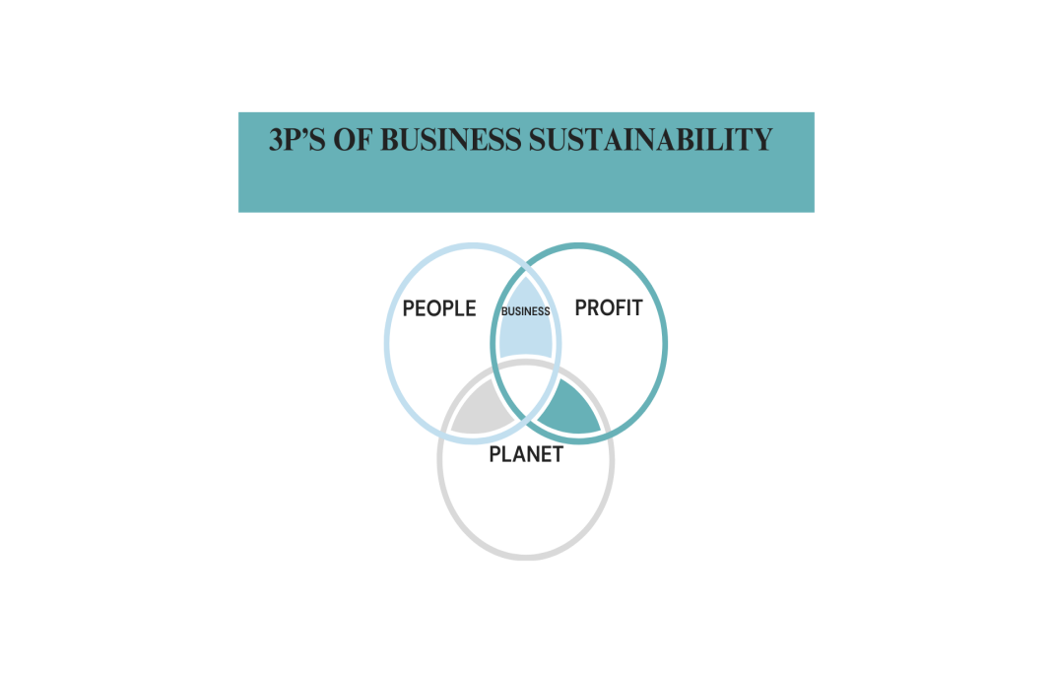

**Business Collaborations and partnership:**

**Introduction:**

Business collaboration is a practice where businesses and teams work together to achieve common goals, solve problems, and create value. It can involve internal or external connections, and can take many forms, including partnerships, joint ventures, strategic alliances etc. Collaborations rely on pooling and sharing skills, resources and experience within a team to achieve goals more competently.

**Types of business collaborative partnership:**

* **Corporate -NGO Partnerships**: The reasons for a company and a NGO’s collaborating can be few specific initiatives such as conservation projects, community development programs, or climate action campaigns. For example, partnerships between clothing brands and environmental NGOs have led to reduction in water wastage in textile industry.
* **Multi-Stakeholder Initiatives**: Multi-stakeholder initiatives bring together businesses, NGOs, government representatives, and other stakeholders to address challenges collectively. For example- The Round table on Sustainable Palm Oil (RSPO), brings together producers, buyers, NGOs, and governments to promote sustainable practices in the palm oil industry. It addresses issues such as deforestation, land rights and labor practices.
* **Public-Private Partnerships:** Governments often collaborate with businesses through public-private partnerships (PPPs) to serve the public with different infrastructure projects, or social programs. PPPs in renewable energy, waste management, and sustainable transportation have helped in pooling up investments and coming up with innovative ideas that help in giving benefit to the society.

**Benefits of business collaboration:**

* **Financial gains:** The primary motive of any business is to earn profits. A successful collaboration can bring significant financial gains for both the parties.
* **Improves employee engagement and well-being:** The employees working in a collaborative setting tend to work more efficiently than an individual worker as they are highly motivated with new energies around them.
* **More creativity and innovation:** Internal collaboration gives employees the freedom to share their diverse perspectives and ideas. This helps creating a creative work environment that sparks fresh, innovative ideas.
* **Improved problem-solving:** With the help of individual expertise and experiences, a team can tackle complex challenges easily and solve the problem faster.
* **Increased efficiency and productivity:** Collaboration keeps team members on the same page and streamlines entire projects from start to finish. This reduces confusion and miscommunication which helps in increasing the productivity.

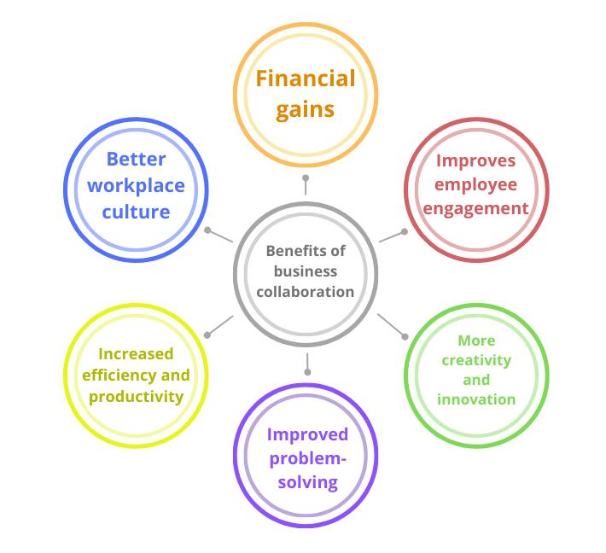

**Drawbacks of business collaboration:**

* **Competitive Concerns**: Collaborating with competitors or industry peers may raise concerns about sharing proprietary information, losing competitive advantage, or inadvertently strengthening rivals.
* **Alignment of Objectives**: Different organizations may have varying priorities or conflicting agendas, making it difficult to align on sustainability goals and strategies. This can lead to inefficiencies and diluted efforts.
* **Complex Decision-Making**: Collaborative efforts often require consensus-building among diverse stakeholders, which can slow down decision-making processes and hinder in responding to the market changes or emerging opportunities.
* **Resource Allocation**: Sharing resources such as funding, technology, or expertise can be challenging when organizations have different capacities or financial constraints. This may create disparities in contributions and benefits within collaborative initiatives.
* **Integration Challenges**: Integrating different organizational cultures, and processes can be complex and time-consuming, potentially leading to friction, misunderstandings, or resistance to change.
* **Risk of Dependence**: Over-reliance on collaborative partners for critical resources or capabilities may create vulnerabilities, especially if partners fail to deliver or withdraw support unexpectedly.
* **Regulatory and Legal Issues**: Collaborative activities may face regulatory scrutiny or legal challenges, particularly regarding antitrust laws, intellectual property rights, or compliance with environmental regulations.

**Public-Private Partnership:**

Public-private partnerships is the collaboration between a government agency and private-sector companies that can be used to [finance, build, and operate projects](https://www.investopedia.com/terms/p/privatefinanceinitiative.asp), such as public transportation networks, parks, and convention centers. Financing a project through a public-private partnership can allow a project to be completed sooner. [Public-private partnerships](https://www.investopedia.com/ask/answers/021715/what-impact-publicprivate-partnerships-have-economic-growth.asp) often involve concessions of tax or other operating revenue, protection from liability. It also provides partial ownership rights over nominally public services and property to private sector, for-profit entities.

**According to David L. Weimer and Aidan R. Vining,** "A P3 typically involves a private entity financing, constructing, or managing a project in return for a promised stream of payments directly from government or indirectly from users over the projected life of the project or some other specified period of time".

**Advantages of PPPs:**

* It provides necessary investments into public sector effective management of public resources.
* It ensures higher quality and timely provision of public services.
* The risk is divided between the government and the private sector.
* A private sector is guaranteed to obtained a long-term remuneration and concession in tax.
* The government remains accountable for the cost and quality of public services.

**Disadvantages of PPPs:**

* Infrastructure or delivering the services could be expensive.
* Private sector aims primarily at profits which may not be desirable in public works.
* Important secrets of the country maybe leaked out to private firms.
* Conflicts between the government and the private firm may cause delay in the completion of crucial projects.
* Private sector profit motives may lead to prioritizing financial gains over public needs.

**Brand collaboration:**

Brand collaborations are strategic alliances between two or more brands for the purpose of creating a product or service that is beneficial to both parties. This type of partnership is often used as a marketing strategy to [increase brand visibility](https://www.justinwelsh.me/article/solopreneur-marketing), reach new audiences, and [enhance the brand's reputation](https://www.justinwelsh.me/article/branding-for-solopreneurs). Brand collaborations can provide an opportunity to grow their business and expand their reach without the need for a large marketing budget.

Brand collaborations can take many forms, from co-branded products and services to joint marketing campaigns, events, and more. The key to a successful brand collaboration is a shared vision and mutual benefit. Both brands should bring something unique to the table and the collaboration should be designed in a way that enhances both brands.

Examples of brand collaboration:

* Bombas and Pixar
* [Kith And Coca-cola](https://www.google.com/search?sca_esv=ab2585b2b0b24f44&cs=0&q=kith+and+coca-cola&stick=H4sIAAAAAAAAAG1Su24TQRTFaIksBIRMXhgQGlkhqVBkSD7Adqw87CQrbGKoors7N_bI4xlrZlb28gtQ8Qnp6PgB-BBS02yBRIdcIGZnI6CgPec-zjn3lmvV0u68tNLQIBmNlRAQKQ2WK2nmN8vnrZPeYe_N-aeglAUrhHQQDdC6K-2jsbQlxllAyP2GGkdgPB7yGegsWLx9d3uwXauxGduVO9JmwWPysDlMoohjUXiUaDCGxzQEPcqCR6SypwzS0wvaVELpoqg7hFSAX93mduixporhmVPq4CWyeJoAp7n2RqqRqSxYJ6shyAHwQucBAjMTiDELlslSiPTEmyu4TSd_k2yETgo94wyoiyFGgbbYfgBapzRU1qL2GrpbUxTCcw0EDVHq7e-rUCs6oy_R4YkQWbBKlrsWdJTEI-OI7kRZfpF6fE9pblWO9iBWbk5ev0CCw3ar7qe9ilB7R_92NY779DXtqIQbepZwa5XMggdk7U8Yjj2OmZIg2Jbxc9ogU_SD6sx5c2CFrPdAD9C65R0uhPOWCG7f5u7cjroQEdfM-B7429NUehTzWGBxEueL9kE7boNU26ng6E5ixmh5XMTWRsnAxXSEUuajq4T2EMxEo7l-nn2NKKdKubg0TrkcXN4io_y-xRNeW_q6ULnx7tv7F_MfX67svadPvv8sP7_s__p8p3z18UP5vy_7G-6q1lLPAgAA&sa=X&ved=2ahUKEwiW9rPvgrGHAxVw3TgGHSnQC-AQ7fAIegUIABC1Ag)
* [Uber and Spotify](https://www.google.com/search?sca_esv=ab2585b2b0b24f44&cs=0&q=uber+and+spotify&stick=H4sIAAAAAAAAAG1Sy24TMRSllakiBLR1W0oAIasq7QpVAfoBSRr1kbQdkdDAqrozvk2sOHZke5QMvwArPqE7dvwAfAhds5kFEjuUBcLx8FqwPefec885dqmyMV_Znc6t1gwozhItJcTagBNa2el86bxx0jnsvDr_QOZyskppC9ECq_rRLlrHGnKYE0qXanoYgw14JCZgcrJ449ZOb6dS4RO-q54pl5MH9F69n8axwGLwKDVgrUhYBGaQk_u0vKctstMLVtdSm2Ko3YdMQjjdFK4fsLpO4LF36uFluniagmAz77XMINc5WadrEageiMLnAQK3I0gwJyt0OUJ2EsIV3Ja3v0U3I2-FnQkOzNeQoERXXD8AYzIWaefQBA_t7TFKGbgagoE4C_H3dWQ0m7Dn6PFUypys0ZW2AxOnycB6oj3STlxkAd_TRjg9QzuQaK8zm1-g5LDZqAa1FzGakOjfrdpxl71kLZ0Ky85S4ZxWOblL7_wpw7PHCdcKJN-2QacJKsMgVOU-mwfLdL0DpofOH28JKX22VAr3epbO36hKGQvDbdiBvzt1bQaJSCQWT-JzsS4Yz23SjWYmBfonsUN0Iilqa6Li4Gs6QqVm0huUdRDsyKD99Xn2DaIaa-3rMjgWqnd5fSn9HdsWsT8vlK-9-fL26fTbpyt3-9HDr99LTy67Pz7eLF29f1f674f9CX_FYynOAgAA&sa=X&ved=2ahUKEwiW9rPvgrGHAxVw3TgGHSnQC-AQ7fAIegQIABBq)
* [Doritos x Taco Bell](https://www.google.com/search?sca_esv=ab2585b2b0b24f44&cs=0&q=doritos+x+taco+bell&stick=H4sIAAAAAAAAAG1Sy24TMRSl1VBFCCh1WkoAISsq7aqqQuEDkjTqI2k7IqGBVXVnfJtYcezI9igZfgFWfEJ37PgB-BC6ZjMLJHYoC4THgwoLtufce-45xy7Vqou13fnCakODZDRWQkCkNFiupJkvls5bJ73D3pvzT8FCFqwS0kE0QOtutI_G0pYYZwEh9xpqHIHxeMhnoLNg-dadncFOrcZm7IV8Lm0WPCYPm8MkijgWg0eJBmN4TEPQoyx4RCp7yiA9vaBNJZQuhrpDSAX4021uhx5rqhi2nVMHr5Dl0wQ4zb03Uo1MZcE6WQtBDoAXPg8QmJlAjFlQJish0hMfruA2nf1NshE6K_SMM6CuhhgF2uL6AWid0lBZi9p76G5NUQjPNRA0RKmPv69CreiMvkSHJ0JkwRopdy3oKIlHxhHdibL8IvX4ntLcqhztQaycTj6_RILDdqvu1V5FqH2if7cax336mnZUwg09S7i1SmbBA3L_ugzHHsdMSRBsy3idNsgUvVCduWwOrJD1HugBWne8w4Vw2RLB7ds8nbtRFyLimhm_A393mkqPYh4LLJ7E5aJ90I7bINV2Kji6JzFjtDwuamujZOBqOkIpc-kqoT0EM9Fo_nyefY0op0q5ujROuRxc3iyz615s3kvkevm6VLnx7tv73fmPL1f27tMn33-Wnl32f32-Xbr6-KH03z_7G5eNpU7RAgAA&sa=X&ved=2ahUKEwiW9rPvgrGHAxVw3TgGHSnQC-AQ7fAIegQIABBE)

**Businesses collaboration:**

**L & T Metro Rail, Hyderabad Limited, Hyderabad, India: [PPP]**

**The Hyderabad Metro** is a rapid transport system constructed in the city of **Hyderabad, Telangana, India.** It is the second longest operational metro network in India after the Delhi metro with 57 stations and the lines are arranged in a circular model. It is funded by a public private partnership with the state government of Telangana holding a minority equity share. A specialty transportation system - **L & T Metro Rail Hyderabad Ltd** was established by the construction company L & T to develop this project under ppp mode. **Mr. N.V.S Reddy** was appointed as the managing director of the Hyderabad Metro Rail and the central government approved financial assistance of ₹1639 crore for this ppp project. L & T invested about ₹13000 crore of the ₹14132 crore elevated metro rail project and the Telangana state government invested more than ₹2300 crore for land acquisition, right of way and the required infrastructure to facilitate the project completion.

The main objective of the metro rail was to provide equal opportunities and socio-economic benefits to all citizens. It is an urban rejuvenation effort, designed with latest technology inputs to transform people of Hyderabad into a green friendly city, eco-friendly stations with natural ventilation, sky walks, ramps, escalators, promotion of gender equality and women empowerment resulting in creation of employment opportunities and creation of many industries in and around Hyderabad.

**Rajiv Gandhi international airport, Hyderabad, India: [PPP]**

**Rajiv Gandhi international airport** (RGIA) is an international airport that is situated in **Hyderabad** the capital city of, **Telangana, India**. It was inaugurated on **23rd March, 2008**. It is named after **Rajiv Gandhi,** who was the former prime minister of India. The RGIA is the sixth busiest airport by passenger traffic in India as per the report of 2019. In November 2000, under the government of **Telugu Desam Party** and under the guidance of **Mr. Chandrababu Naidu** (President of TDP) and the **Airports Authority of India** (AAI) a memorandum of understanding of the Greenfield airport project was signed which led to establishment of a public private partnership. The Public sector and the AAI together hold a stake of 26% in the project while the remaining 74% is allotted to private companies. Through the bidding **process Grandhi Mallikarjuna Rao group** and **Malaysia Airports Holdings** were the holders of the 74% stake in the partnership. This venture consists of public entities such **as Airport Authority of India** (13%), **the government of Telangana** (13%), **GMR group** (63%) and **Malaysia Airports Holding** (11%). The RGIA has various facilities like having a solar power plant that saves the turbine generated electricity, Novotel which is the airport hotel provides lounging services to the passengers as well as the air crew whenever necessary, the airport has a fuel storage which consists of three storage tanks and the cargo terminal facilitates every type of goods transportation especially in the pharmaceuticals industry for the transportation of medical supplies. The development of this infrastructure has brought into India a huge amount of foreign currency and helped in the economic development of Hyderabad as well as India.

**Allbirds and Adidas: [Brand collaboration]**

Adidas which is a global leader in sportswear and is known for the quality of products made by the company has recently come into a collaboration with Allbirds which is known for its sustainable footwear. These two brands came together to design a shoe with an exceptionally low carbon footprint. While a pair of Adidas sneakers has an average carbon footprint of between 10 kg and 15 kg, the new shoes had a lower footprint of only 2.94 kg of CO2 emissions per pair. While both brands are market competitors however they have collaborated together keeping in view to reduce the environmental impact. In this process Allbirds contributed towards the sustainable material and the production process whereas Adidas gave in the ideas related to the design of the sportswear which helped to create a clear margin which became a basis for profit sharing. This innovative invention not only attracted customers but also created a wider scope of market competition to give better quality of goods at best cost to the customers. Such brand collaborations are done through the creation of special purpose vehicles so that the chain businesses of the same promoter group are not affected. The profits earned by the collaboration is reinvested in the chain businesses to expand the same thereby generating wealth and expanding the scope of the business.

**Spotify and Starbucks:[Brand collaboration]**

Spotify is a well-known music application which is a platform for millions of songs and podcasts of various artists from all over the world. This application also has the option of creating our own library and playlist consisting of our favourite music collections. It has free as well as premium options where efficient services are provided to the consumers. It is one of the market leaders in its competitive environment. This famous brand has recently come into a collaboration with a famous brand Starbucks which is a global coffee company and is known for its wide range of coffee drinks, other beverages and food items. The major aim behind this collaboration was to target the consumers by way of providing the Spotify premium experience in the in-store of the Starbucks. Post this collaboration Starbucks initiated a step towards sustainable development by giving take away and food and beverage parcels and orders in paper cups, paper plates and paper bags instead of using plastic. This step plays a major role in environmental protection and safety.

**Spotify and Uber:[Brand collaboration]**

Spotify has also collaborated with the Uber company which is a platform that provides a connection between passengers and drivers that ensures traveller safety and comfort within reasonable and affordable prices. Not only taxi and scooter services but Uber also provides food delivery services by the application of Uber eats. This collaboration aimed towards providing the consumers customized music playlist options so as to explore the Spotify experience. However, this collaboration came to an end due to different priorities of both the companies and shift in technical and logistic channels in maintaining the integration.

**Conclusion:**

In the field of business sustainability, working together is not just a smart choice but a powerful way to deal with complex issues and create real change.The role of collaboration in business sustainability is not just about achieving short-term goals but about creating a resilient and prosperous future for businesses and society at large. By harnessing synergy through collaboration, organizations can pave the way for a sustainable and equitable world.

**References:**

* Academic Journals: **Whelan, G., & Fink, C.** (2016). **“Collaborative governance for sustainable development.”**
* <https://visme.co/blog/business-collaboration>
* <https://www.hypeinnovation.com>
* <https://unglobalcompact.org/>
* <https://www.aspeninstitute.org/>