**Deep Learning Image Enhancement by Lagrange Multipliers Technique**

Digvijay Singh*

Department of Mathematics, MeerutCollege,Meerut, U.P., India-250002

Email- drdigvijay2020@gmail.com

**Abstract**

In the field of image preprocessing, image enhancement is crucial. The most commonly utilizedapproach is called histogram equalisation (HE), which evenly distributes all pixels between 0 and 255 grey levels and produces good contrast. However, this technique can occasionally produce unexpected results and alter the image's mean brightness, making it unsuitable for customer electronics goods where maintaining the original sharpness is crucial to prevent unnatural enhancement. In order to maintain the original sharpness in the form of mean and produce highest entropy, this work fitted certain constraints according to the image using mathematical tools, such as the Lagrange multiplier (LM).

***Keywords: Histogram equalization, Lagrange multiplier***

**1. INTRODUCTION**

To improve images, the histogram equalisation approach is applied.Histogram equalisation (HE)'s primary drawback is its propensity to alter the input image's sharpness and mean. Since the required histogram is smooth and flat, the mean sharpness of the output picture should always be at the mean grey level, without of the input mean. Insome situations where maintaining sharpness is necessary, this is not a desired feature. Using the Lagrangemultiplier, we must create a specific function that satisfies certain image-related requirements, such as the requirement that all images be positive, that their probability density function equals one, and that the image mean also be constant.

**2.HISTOGRAM EQUALIZATION**

One method to improve an image is to use histogram equalisation. The strategy is to create a transformation T(.) so that the output's grey values are consistently spread throughout [0,1].Based on the input picture's histogram, we must create a grey value transformation s = T(r) that will improve the image. An picture whose pixel is (in theory) consistently distributed throughout all grey levels is produced via histogram equalisation.

(i) For 0 < r < 1, T(r) is a monotonically growing function that maintains the order from dark to bright.

(ii) T(r) retains the range of permitted Grey values by mapping [0,1] into [0,1].

It is therefore possible to characterized the grey levels for continuous variables using their probability density functions, p(r) and p(s). The modified grey level's probability density is P(s)=P(r) $\frac{dr}{ds}$ (1)

In order to determine a transformation, let's look at the Cumulative Density Function (PDF), which is just the total of all the Probability Density Functions (PDF) added together.

S=T(r)=; 1 ≥ r ≥ 0; (2)

P(s) = [1] = 1 ;1 ≥ s ≥0;

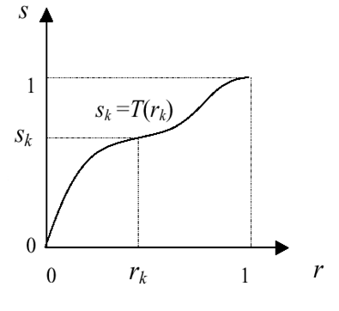

Fig.1

**Advantage of Histogram Equalization:**

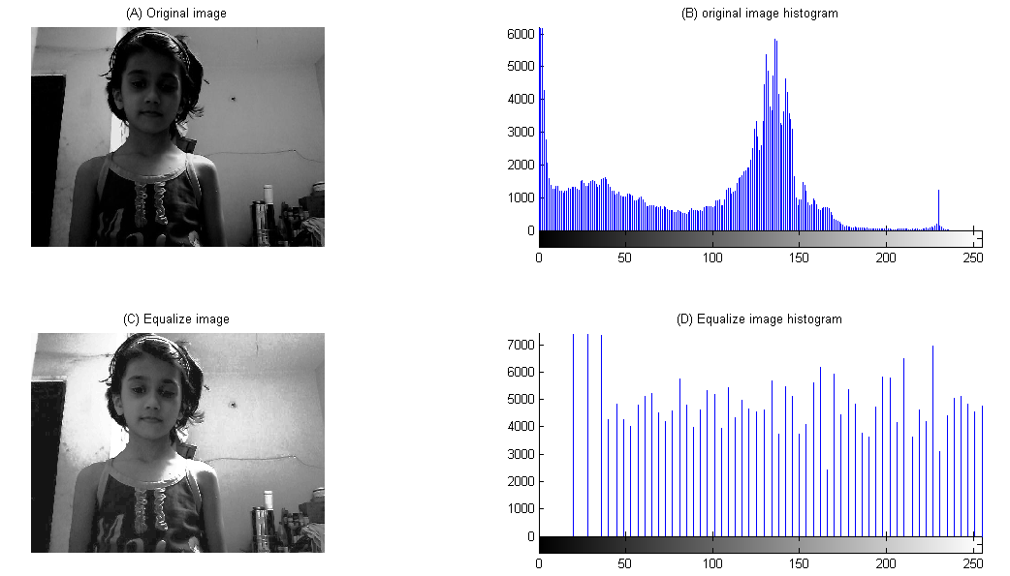

Fig.2Equalization of the histogram for a high contrast picture

**Drawback of Histogram Equalization:**

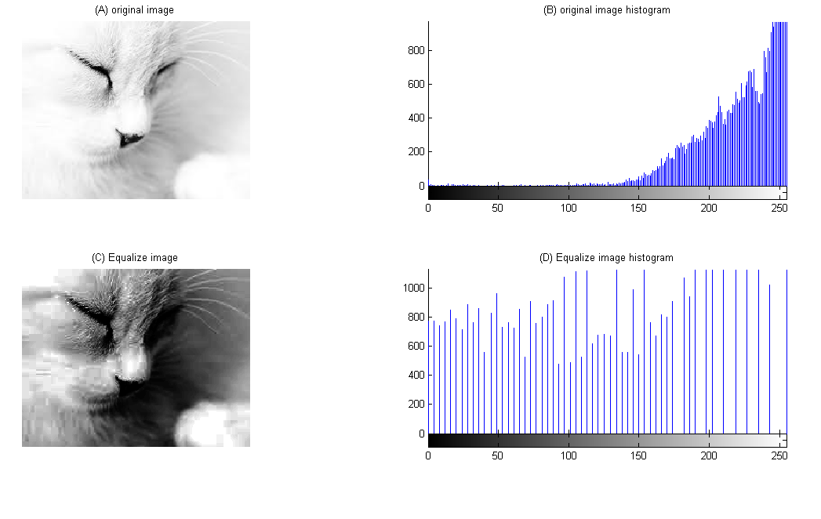

Fig.3During histogram equalization, a cat's color shifts from white to brown

**3. Concept of Mean**

Mean (Image Brightness): Multiplying every potential value of x by its probability P(x) yields the mean of a discrete random variable x. This is done by summing all of the product products. Given by 

**4.Entropy (Information)**

**Definition 1**: Consider the random variable X, whose cumulative distribution function is given by F(x)=Pr(X < x). The random variable is considered continuous if and only if F(x) is continuous. When defining the derivative, let f(x)=F'(x). If,so, f(x) is referred to as X's probability density function (PDF) in such case. The set that has f(x)>0 is referred to as X's support set.

**Definition 2:** For a continuous random variable X with density f(x), the differential entropy h(X) is defined as (3)

The support set for the random variable in this case is denoted by S. Sometimes the differential entropy is represented as h(f) instead of h(X), because it is a convex function over a convex set and depends only on the probability density of the random variable. The degree of chaos (randomness) in a variable X indicates how much information it may contain; the more chaotic (random) the variable, the less predictable it is. The variable is more random the larger the differential entropy. Since we won't be comparing the randomness of continuous and discrete variables, we won't be able to discern between the differential entropy of a continuous variable and the entropy of a discrete variable. Therefore, in the sections that follow, h(X) is also referred to as the entropy of the continuous variable[4].

For discrete Entropy (Information)**:** bits/pixel.

where the chance that the grey level (i) would occur is denoted by p(i).

In terms of mathematics, we wish to maximise h(f) over all probability densities f, subject to the following limitations:

 .......................................Objective (3.1)

such that 

Where s=[0 ,1] set of gray level and ; average brightness of the picture obtained. Since an entire white or black picture is typically not the input image, we presumenow utilizing Lagrange multiplier on it

+  +] (3.2)

λ1 and λ2 are Lagrange multipliers and differentiate w. r .t f(s)

+  +]

(3.3)

Now  then we get,



 (3.4)

From constraint (2) and equation (3.4), now



 ; or 

 (3.5)

From eq.(3.4) and eq.(3.5)

 (3.6)

Now from constraint (3) and eq.(3.6)



(3.7)



 (3.8)



Fig.4 Plot of the lemda2 (λ2) and mean (µr) together

Now when $λ2$ = 0 ;

 (3.9)

; (3.10)

 (3.11)

 (3.12)





 (3.13)

As a result, we obtain a cumulative distribution or cumulative histogram.

 (3.14)

From eq. (3.14) & (3.13)  (3.15)  (3.16)

At ; (3.17)

 (3.18)

Consequently, the cumulative distribution function, or cumulative histogram, or c(s), appears to be this:





 (3.19)

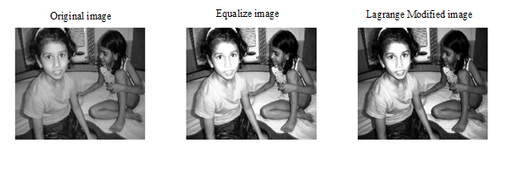

Fig.5 Image by using HE, LM method.

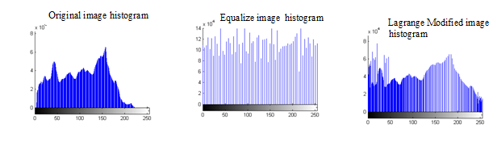

Fig.6Histogram produced with the HE, LM technique

**Test image results**:

**Table.1 Mean**

|  |  |  |  |
| --- | --- | --- | --- |
| Image | Original Image Mean | HE Image Mean | Lagrange Modified Image Mean |
| **DS03987** | 104.0286 | 127.5565 | 102.1223 |

**Table.2Entropy (bits/pixel)**

|  |  |  |  |
| --- | --- | --- | --- |
| Image | Original Image  (ENTROPY) | HE Image  (ENTROPY) | Lagrange Modified Image (ENTROPY) |
| DS03987 | 7.5872 | 5.9832 | 7.4172 |

**CONCLUSIONS AND FUTURE WORK**

Lagrange modified image technique provides good results related to image mean and image entropy and by using a 1.19 GHz PC computer which produce satisfactorily enhance images that yield bad results using HE.

**REFERENCES**

[1] R. C. Gonzalez and R. E. Woods, Digital Image Processing, Prentice Hall, second edition, 2001.

[2] M. Stamm, K.J.R, Liu, “Blind forensics of contrast enhancement in digital images,” IEEE International Conference on Image Processing, San Diego, CA, Oct. 2008.

[3] C. Wang and Z. Ye, “Brightness preserving histogram equalization with maximum entropy: a variational perspective,” IEEE Transactions on Consumer Electronics, Vol. 51, No. 4, pp. 1326-1334, November 2005.

[4] C. M. Tsai, and Z. M. Yeh, “Contrast enhancement by automatic and parameter-free piecewise linear transformation for color images,” IEEE Transactions on Consumer Electronics, Vol. 54, No. 2, May 2008.

[5] G. J. Erickson and C. R. Smith, Maximum entropy and Bayesian methods, Kluwer Academic Pulishers, Seattle, 1991.