**Chapter 01**

**Designing Controlled Release Formulations: Exploring Diffusion, Dissolution, and Ion Exchange Principles for Drug Delivery**

Reena Sheoran 1, Kumari Shanno 2,*, Avinash Kumar Rao 3, Jagriti Gairola 4

*1 Assistant Professor, Chaudhary Bansi Lal University, Bhiwani, Haryana - 127021*

*2 Research Scholar, Department of Pharmacy, Bansthali Vidyapith, Tonk Road Niwaru - 304022*

*3 Research Scholar, Madhyanchal Professional University, Ratibad, Bhopal, M. P. - 462044*

*4 Assistant Professor, Himgiri Zee University, Dehradun, Uttarakhand, India*

**\*Corresponding Author Details:**

Kumari Shanno

Research Scholar, Department of Pharmacy, Bansthali Vidyapith, Tonk Road Niwaru-304022

**ABSTRACT**

System based on controlled drug release had a revolutionized the field like pharmaceuticals by offering precise dosing, improved patient compliance, and enhanced therapeutic outcomes. This Book delves into the intricate world of designing release controlled formulations, that is chiefly focused on the exploration based on diffusion, dissolution, and ion exchange principles as fundamental mechanisms for drug delivery.Our scientific objective is to investigate these mechanisms comprehensively and harness their potential for creating innovative pharmaceutical formulations. We aim to advance the understanding of diffusion, dissolution, andI.E. (Ion exchange) objectives and their applications in the development of novel controlled release systems.This Book will address fundamental questions surrounding these principles, their optimization, and potential synergies between them, opening new avenues for multifunctional drug delivery systems. We will also explore recent advancements and cutting-edge technologies in the realm of controlled release, considering their potential for personalized medicine and improved patient care. In addition to scientific exploration, this study will address the practical challenges and regulatory considerations inherent for the betterment and advancement in the field of released controlled medications and formulations via planting and creating a bridge that fulfillgap between theory and application, our research endeavors to enhance patient compliance, therapeutic efficacy, and the overall quality of pharmaceutical treatments across various medical conditions.Through this comprehensive examination in the form Book about diffusion, dissolution, and ion exchange principles, our study in the form of book aspires to contribute to the evolution of drug delivery science, benefiting both pharmaceutical research and the broader healthcare landscape.

Top of Form

**KEYWORDS:** Controlled release drug delivery system, Time of dose, drug delivery period, physicochemical parameters, Dissolution, Diffusion, IER

**BACKGROUND AND RATIONALE STUDY**

The title "Designing Controlled Release Formulations: Exploring Diffusion, Dissolution, and Ion Exchange Principles for Drug Delivery" focused on a research study on developing innovative pharmaceutical formulations for controlled drug release. To establish a strong background and rationale for this study, some steps the idea of controlled drug release was put into practice is essential in pharmaceuticals, emphasizing the benefit role like improved compliance for patient, reduced adverse effects, and prolonged therapeutic effects and the need for Novel Formulations still in progress: Existing challenges in drug delivery, such as rapid drug clearance, fluctuating drug levels, and patient discomfort. Role of Diffusion, Dissolution, and Ion Exchange, these are fundamental mechanisms that play they vital role in the formation and designing for better delivery of drug systems, Diffusion governs action such as drug delivery within the body. Some examples of drugs that rely on diffusion for controlled release are Nicotine Patches:, Fentanyl Transdermal Patches, Contraceptive Patches, Scopolamine Patches, Rivastigmine Patches, Lidocaine Patches, .Challenges and limitations associated with diffusion-based systems are, Limited Drug Types, Dosing Variability, Burst Release ,Limited Control, Size and Shape Limitations, Patient Variability, Limited Duration, Dose Adjustment, Skin Irritation, Regulatory Considerations. Role of dissolution in drug release, particularly for solid dosage forms were discussed. Rate of dissolution can influence drug release kinetics. Some examples of drugs using dissolution-controlled release are Aspirin (Acetylsalicylic Acid, Metformin (Extended-Release Formulations, OxyContin (Oxycodone), Theophylline (Various Formulations), Propranolol (Extended-Release Capsules), Ion exchange's potential as a medication release mechanism and how ion-exchange resins and polymers can be employed to control drug release. Kayexalate, Calcium Polystyrene Sulfonate, Calcium Resonium, Amberlite Resins, and Sodium Polystyrene Sulfonate are a few examples of medications that use ion exchange principles. Cationic Exchange Resins in Extended-Release Formulations, Ion-Activated Drug Delivery Systems. Controlled release formulations are an essential area of research in pharmaceuticals, aimed at improving drug delivery by ensuring the gradual and sustained release of therapeutic agents. Here's an overview of existing research, recent advancements, challenges, and gaps in knowledge in this field.

**RECENT ADVANCEMENTS IN THE FIELDS OF FOLLOWING:**

Nanotechnology and Nanoparticles, 3D Printing, Biodegradable Polymers, Implantable Devices, Electrospinning, Personalized Medicine, Challenges, Complex Formulation Development, Regulatory Approval, Stability and Shelf-Life, Interpatient Variability, Gaps in Knowledge, Long-Term Safety and Efficacy, Combination Therapies, Biological Response, Global Access, Patient-Centered Outcomes, More research is needed to assess patient preferences, satisfaction, and adherence with controlled release formulations, as these factors significantly impact treatment outcomes. Controlled release formulations hold great promise in optimizing drug therapy, but they come with technical, regulatory, and clinical challenges. Our Book is based on Ongoing research seeks to address these challenges and close gaps in knowledge to advance the field, leading to improved treatment options and better patient outcomes.

**OBJECTIVE**

The scientific objective of the study titled "Designing Controlled Release Formulations: Exploring Diffusion, Dissolution, and the principles of diffusion, dissolution, and ion exchange to obtain accurate and customised controlled release of therapeutic drugs. Ion Exchange Principles for Drug Delivery" aims to research and develop novel pharmaceutical formulations that make use of these principles. In order to design and develop novel controlled release formulations that improve therapeutic efficacy, patient compliance, and treatment outcomes, our research aims to further our understanding of these mechanisms and their application in drug delivery.

**KEY QUESTIONS**

What are the fundamental principles of diffusion, dissolution, and ion exchange in drug delivery, and how do they impact controlled release formulations?

1. How can diffusion-based drug delivery systems be optimized to achieve precise and sustained release of therapeutic agents?
2. What are the key factors influencing the dissolution of drugs in controlled release formulations, and how can dissolution profiles be tailored for specific medical applications?
3. In what ways can ion exchange mechanisms be harnessed to control the release of drugs, and what are the advantages of utilizing ion exchange in drug delivery systems?
4. What are the challenges and limitations associated with each of these controlled release mechanisms (diffusion, dissolution, and ion exchange), and how can they be addressed in formulation design?
5. How can the combination of diffusion, dissolution, and ion exchange principles be used synergistically to create multifunctional drug delivery systems that offer superior controlled release profiles?
6. What recent advancements in drug delivery technologies leverage diffusion, dissolution, and ion exchange principles, and what potential applications do they hold for enhancing patient care?
7. How can personalized medicine and pharmacogenomics be integrated into the design of controlled release formulations that account for individual patient variations in drug response?
8. What are the regulatory considerations and challenges in bringing controlled release formulations based on these principles to the market, and how can these challenges be navigated effectively?
9. What is the potential impact of this research on improving patient compliance, therapeutic outcomes, and the overall effectiveness of pharmaceutical treatments in various medical conditions?

**INTRODUCTION**

The concept of controlled drug release was initially introduced through the validation, development, and formulation of sustained-release oral medications in the 1940s and the early years of the 1950s [1]. Initially, this field predominantly concentrated on specific applications related to soil science, such as the controlled release of marine antifoulants in the 1950s and controlled-release fertilizers in the 1970s [2]. Nevertheless, the significance of controlled release technologies began to grow as studies in pharmacology and pharmacokinetics demonstrated the pivotal role of drug release rates in influencing therapeutic outcomes [1,3]. The notion of altering drug release has a longstanding history, tracing back to around A.D. 900 when Rhozes developed pills coated with mucilage [4]. This method gained popularity in European regions during the 10th century, where pills and tablets were coated with materials like gold, silver, and pearl to manipulate the rates of drug release. Coating technology continued to advance, and in the late 1800s, sugar and enteric coatings were introduced for pills and tablets [5]. This progression ultimately led to the creation of enteric-coated tablets, and the incorporation of a second layer of medication within the sugar coating, which occurred around 1938. However, the first patent for an oral sustained-release preparation was granted to Lipowski, thanks to the small coated beads in his product, which provided a gradual and consistent release of medication [6]. Expanding upon this concept, the first commercially available sustained-release product was introduced in 1952.Over the last three decades, the subject of controlled drug release has gained substantial attention as the challenges associated with introducing new drugs to the market have increased, and the advantages of controlled release drug delivery systems (CRDDS) have become more evident. Today, oral controlled drug delivery methods are indispensable, especially for drugs with short biological half-lives and high-water solubilities [7]. Furthermore, controlled release technology is now applied in a variety of drug delivery methods, encompassing transdermal, ocular, vaginal, and parenteral routes [8].

**1.1 CONTROLLED RELEASE**

A novel approach in the field of drug therapy aims to rapidly attain the required drug levels in the bloodstream and sustain them consistently throughout the treatment course. The manner in which medication is administered is chiefly influenced by the drug's mean residence time (MRT) and biological half-life. Conventional drug delivery systems, due to their variable drug release patterns, can result in problems of both excessive and inadequate dosing, leading to various adverse drug reactions (ADRs). To tackle this issue, controlled release drug delivery systems (CRDDS) are utilized, which alter the drug's distribution and mitigate the risk of drug toxicity [9]. The term "controlled release" (CR) denotes a certain level of regularity and predictability in the kinetics of drug release. This means that the drug is released from the delivery system at a rate that remains consistent across different batches, aligning with its inherent kinetic properties. The objective of CRDDS is to exercise influence over the release of the drug within the body, which can be in terms of timing, location, or a combination of both [10]. It's worth noting that controlled release is often synonymous with the term "sustained release" (SR) [11]. A pharmaceutical dosage form known as sustained release is formulated to delay or extend the release of the active pharmaceutical ingredient (API) so that it enters the systemic circulation later, thereby maintaining a prolonged presence of the drug in the bloodstream. This delayed initiation of action allows for a sustained therapeutic effect [12]. For a visual representation of the drug's concentration in the bloodstream over time, please refer to **Figure 1.**

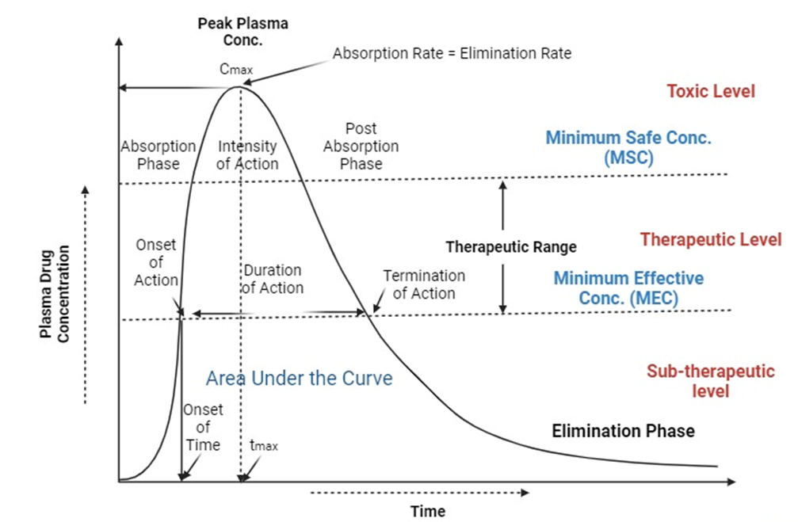Top of Form

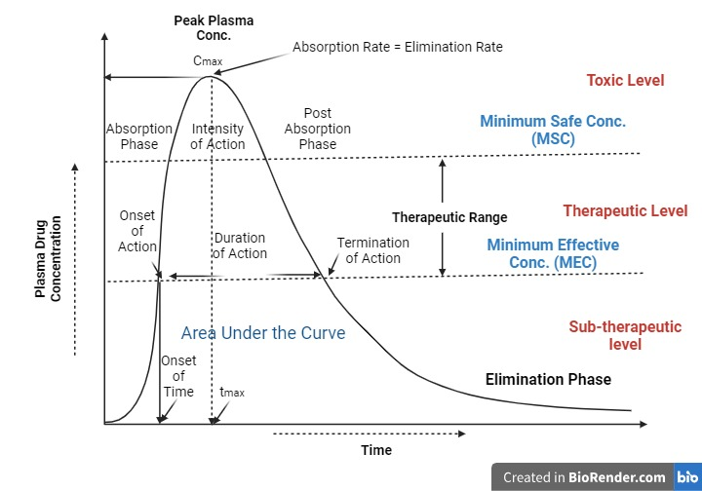

**Fig. 1: Drug concentration-time profile in plasma**

**Table 1: Pro’s and Con”s of Controlled drug therapy:**

|  |  |  |
| --- | --- | --- |
|  | | |
| **CONTROLLED DRUG THERAPY** | | |
| **S.No.** | **ADVANTAGES [13]** | **DISADVANTAGES [13,14]** |
|  | This distribution technique improved patient compliance, especially with reference to long-term treatments for chronic illnesses. | A major drawback of CRDDS (Controlled discharge Drug Delivery Systems) is the incidence of "dumping," or the abrupt and large discharge of medication from a controlled release formulation. This is an extremely dangerous phenomenon while utilising heavy medicines. |
|  | The medication's plasma concentration fluctuates while using conventional dosing forms. These modifications are influenced by the pharmacokinetics of the medication in the body, which includes processes including absorption, distribution, metabolism, and excretion. Controlled release devices are effective in removing this type of volatility in medication concentration in the bloodstream. | One significant limitation of Controlled Release Drug Delivery Systems (CRDDS) is the occurrence referred to as "dumping." This phenomenon involves the sudden and significant release of a large quantity of medication from a controlled release formulation. When dealing with potent pharmaceuticals, this situation can pose significant risks and dangers. |
|  | Frequency reduction in dosage and dosing. | Poor correlations between in vivo and in vitro data make it challenging to establish the exact dosage and dosing intervals. |
|  | Ensuring the necessary drug concentration in the bloodstream eliminates the risk of medication therapy failure and enhances the effectiveness of the treatment. | Patient-specific factors, such as fasting status, drug presence duration, and gastrointestinal emptying rate, impact the rate at which the drug is released. |

**1.2 Factors Influencing the Design and Performance of Controlled Release Products**

1. **Physical Characteristics:**
2. **Aqueous Solubility:** The solubility of many active pharmaceutical ingredients (APIs) in water is affected by their weakly acidic or basic properties. Developing controlled release medications for poorly water-soluble drugs can be quite challenging. Highly water-soluble drugs are well-suited for controlled release drug delivery systems (CRDDS) as they often show an initial burst release followed by a rapid increase in plasma drug concentration. Formulating CRDDS for drugs with pH-dependent solubility, particularly those falling under BCS classes III and IV, can be problematic [15].
3. **Partition Coefficient (P-value):** The P-value indicates how a drug distributes between oil and aqueous phases, which is critical for assessing passive diffusion through biological membranes. Drugs that readily dissolve in all phases are preferred for controlled release, as opposed to those with extremely high or low P-values [16].
4. **Drug pKa:** The ionization of a drug in the digestive system is significantly influenced by its pKa at physiological pH levels. Drugs with high ionization levels are generally less ideal for CRDDS, as non-ionized drugs are absorbed more rapidly through biological membranes. The typical pKa range for pH-dependent ionization is between 3.0 and 7.5 for acidic drugs and between 7 and 11 for basic drugs [17].
5. **Drug Stability:** Controlled release drugs must remain stable in both acidic and basic conditions, resist enzymatic degradation, and remain unaffected by stomach secretions. Drugs that degrade in the stomach and small intestine are not suitable for controlled release formulations, as they could reduce drug bioavailability [17].
6. **Molecular Size and Weight:** The size and weight of molecules significantly affect their ability to pass through biological membranes. Molecules larger than 400 Daltons (Da) face greater challenges in diffusion [18].
7. **Protein Binding:** Interactions between drugs and proteins can act as a reservoir for the drug in the bloodstream, extending its biological half-life. Drugs with high plasma protein binding are generally less suitable for CRDDS, as extended drug release is not necessary [19].
8. **Biological Factors:**
9. **Absorption:** Ensuring a consistent rate and extent of drug absorption is vital in the development of CRDDS. The challenge lies in controlling drug release from the dosage form to prevent sudden, excessive release (known as "dose dumping"). Several factors, including aqueous solubility, lipophilicity, and susceptibility to acid hydrolysis, influence drug absorption [20].
10. **Biological Half-life (t1/2):** Drugs with a short half-life require frequent dosing and are suitable for controlled release. In contrast, drugs with longer half-lives allow for less frequent dosing. Ideally, candidates for CRDDS have half-lives around 2-3 hours, while those exceeding 7-8 hours are less suitable [20,21].
11. **Dosage Amount:** CRDDS typically contain larger doses compared to conventional forms to reduce the need for frequent dosing. The conventional dose serves as a reference for determining the appropriate dosage in CRDDS, aligning with established criteria [22].
12. **Therapeutic Range:** Drugs with a narrow therapeutic range are less suitable for CRDDS, as a failure to control drug release could result in dose dumping and potential toxicity concerns [23].
13. **Absorption Profile:** Drugs that selectively absorb from a specific segment of the gastrointestinal tract (GIT) are not well-suited for CRDDS, whereas those uniformly absorbed throughout the GIT are excellent candidates for controlled release formulations [24]. Shown in fig. 2
14. **Patient Physiology:** The physiological state of the patient, which includes factors like gastric emptying speed, length of residency, and gastrointestinal (GI) disorders, might affect how quickly the drug is released from the dose form either directly or indirectly [25].

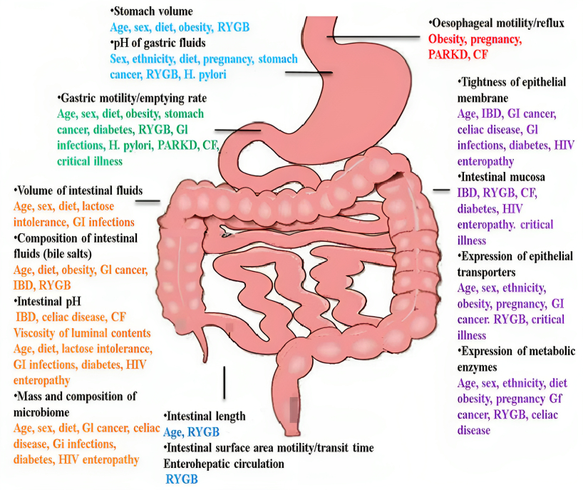

**Fig.2: Profile window of Absorption**

**1.3 The selection of the following drugs was made with consideration of pharmacokinetic factors.**

**Table 2: Pharmacokinetic Factors Affecting Drug Selection.**

|  |  |
| --- | --- |
| **Parameter** | **Comment** |
| Biological or half-life of elimination | Should be 2 to 6 hours. |
| Elimination rate constant (KE) | Necessary for design |
| Total clearance (CLT) | Unbiased by dosage |
| Intrinsic absorption rate | larger than the release rate ought to be the case. |
| Apparent volume of distribution (Vd) | Vd impact the necessary dosage of the medication |
| unconditional bioavailability | Should be at least 75% |
| Steady state concentration (Css) | smaller Vd and lower Css |
| Concentration of toxins | There should be a wider therapeutic window |

1. **CLASSIFICATION OF CONTROLLED RELEASE SYSTEMS:** Controlled release systems are typically categorized into main groups based on their release mechanisms [26].

**2.1 Rate-Preprogrammed Drug Delivery System:** In this type, the controlled release of drug molecules from the delivery system is meticulously designed to adhere to a specific rate profile. The system regulates the molecular diffusion of drug molecules, either within or through the surrounding barrier medium [27].

1. **Polymer Membrane Permeation-Controlled System:** This system involves either complete or partial encapsulation of the drug within a drug reservoir chamber. The surface responsible for drug release is shielded by a polymeric membrane that governs the release rate. The drug in the reservoir can be in solid form, a dispersion of solid drug particles, or a concentrated drug solution in either a liquid or solid dispersion medium. The polymeric membrane can take various forms, including non-porous, partially microporous, or semipermeable, and it can be either homogeneous or heterogeneous [28].
2. **Polymer Matrix Diffusion-Controlled System:** In this system, the drug reservoir is formed by uniformly dispersing drug particles within a rate-controlling hydrophilic or lipophilic polymer matrix. This results in a medicated polymer matrix with a defined surface area and controlled thickness [29].
3. **Micro-Reservoir Partition-Controlled System:** The drug reservoirs consist of a suspension of solid particles in an aqueous solution of a water-miscible polymer. The micro-dispersion partition-controlled system is created through high dispersion techniques, resulting in micro-reservoirs in both the reservoir and matrix dispersion forms [27].

**d. Activated Modulated Drug Delivery System:** In this category, the controlled release of drugs from the delivery system is governed or triggered by various physical, chemical, biological processes, or an external energy source. The drug release is managed through the input of energy or specific applied processes. This activation process can be classified in several ways [27, 30].

**2.2 Activation by Physical Processes:**

1. **Osmotic Pressure-Activated System:** This system utilizes osmotic pressure as the driving force to release the drug in a controlled manner [31]. **(Please refer to Figure 3** for an illustration).

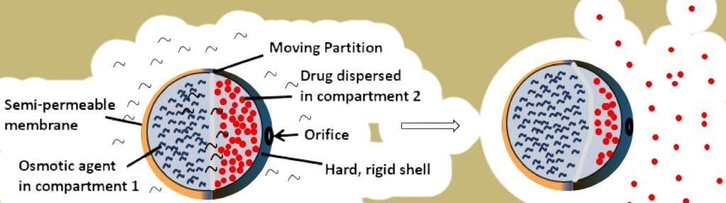

**Fig: 3 Osmotic pressure activated system**

1. **Hydrodynamic Pressure-Activated System:** In this technique, the medication is contained inside a collapsible, impermeable container to create a compartment known as the drug reservoir. This chamber is kept shut by a reliable cover [32].
2. **Vapour Pressure-Activated System:** In this configuration, pressure is delivered to a separate fluid volume while maintaining equilibrium between a liquid and its vapour phase. The device has two chambers, one of which contains a pharmaceutical solution and the other of which contains a vaporizable fluid, such as a fluorocarbon. After the medication has been released, the volatile liquid vapourizes at body temperature, generating vapour pressure that compresses the bottom chamber and permits controlled drug delivery [33]. **Demonstrarted in Fig.4**

**Drug release**

**During operation**

**Expanded push layer**

**Drug release**

**Water imbibing**

**Water imbibing**

**Water imbibing**

**Delivery orifice**

**Push layer**

**Delivery orifice**

**Semipermeable membrane**

**Drug layer**

**Before operation**

**Fig. 4: Osmotic drug delivery**

**2.3** **Activation through Mechanical Methods**

**a. Mechanical Activation System:** This approach involves a drug reservoir equipped with a mechanically operated pumping mechanism. It dispenses a controlled quantity of medication into a body cavity, such as the nose or mouth, using a spray system that relies on mechanical drug delivery pumping. Each pump spray administers a predetermined drug volume. An example is the metered-dose nebulizer for luteinizing hormone-releasing hormone (LHRH) [27].

**b. Magnetic Activation System:** Within this system, the drug reservoir contains peptide or protein powder within a polymer matrix. These reservoirs contain macromolecule drugs that are controlled and delivered using magnetic forces. In some cases, electromagnetic vibration mechanisms are also employed [34].

**c. Sonophoresis Activation System:** Ultrasonic devices are employed to initiate drug delivery. A very low frequency (55 kHz) is used for a very brief duration (15 seconds) to facilitate drug delivery through the skin. These handheld, battery-operated devices consist of a control unit, an ultrasonically generated horn, a disposable coupling medium sealed unit, and a return electrode. These devices can be constructed from both biodegradable and non-degradable polymers [29, 35].

**d. Iontophoresis Activation System:** Iontophoresis enables ionized drug molecules to penetrate biological membranes under the influence of an external electric current. A small electric current is applied to drive the drug (charge) into the skin through an electrode with the same charge as the drug. The drug enters the skin due to electrostatic repulsion forces, and the rate of drug penetration is directly proportional to the current density, which can be adjusted [29, 36].

**e. Hydration Activation System:** In this system, the drug reservoir is evenly dispersed within a swelling polymer matrix made from a hydrophilic polymer. Drug release is triggered by hydration-induced swelling of the polymer matrix, and the release rate is controlled by the rate of polymer matrix swelling [27].

**2.4 Activation through Chemical Processes:**

**a. pH-Activated System:** These drugs are designed to target drug delivery specifically to the intestinal tract, preventing release in the stomach. The drugs are coated with coatings sensitive to gastric fluid and combined with intestinal fluid-insoluble polymers like ethyl cellulose and hydroxypropyl methylcellulose phthalate. These coated drugs resist gastric fluid (pH 7.5), allowing pH to regulate drug release within the human body [27].

**b. Ion-Activated System:** This system utilizes ionic and ionizable drugs since the gastrointestinal fluid maintains a consistent level of ions, and drug delivery is adjusted accordingly [37].

**c. Hydrolysis-Activated System:** In this approach, the drug reservoir is enclosed in microcapsules or implantable devices made from biodegradable polymers. The release of the drug is triggered by the hydrolytic degradation of the polymer chains, and the rate of drug delivery is controlled by the polymer's degradation rate [15].

**2.5 Activation through Biochemical Means:** This approach involves drug release being triggered by biochemical reactions [38].

**2.6 Enzymatic Activation System:** In this system, the release of drugs depends on enzymatic activity.

**2.7 Feedback-Regulated Drug Delivery System:** In this category, physiological responses initiate drug release from the carrier. A triggering agent activates the drug release process through feedback mechanisms, such as biochemical substances within the body. The rate of drug release is synchronized with the concentration of the triggering agent, which is detected by a sensor within the feedback-regulated drug delivery system [27]. Feedback-regulated drug delivery systems are divided into three parts, **as illustrated in Figure 5.**

**Triggering Agents (Activate the release of drugs molecule)**

**Drug**

**Rate-Controlling surface**

**Drug Reservoir**

**Fig: 5 Feedback drug delivery system. Trigring agents activate the release of drugs**

**2.8 Bio-Erosion Controlled System:** In this system, the medication is coated with a coating of immobilised urease and is made of polyvinyl methyl ether. In a solution with a pH that is almost neutral, the polyvinyl methyl ether polymer erodes gradually. But when urea is present, urease metabolises the urea to produce ammonia on the drug's surface. The release of drug molecules is caused by the polymer matrix's accelerated breakdown as a result of the pH change [33, 40].

**2.9 Bioresponsive Controlled System:** In this system, the drug reservoir is contained within a bioresponsive polymeric membrane, and the response of biochemical agents in the surrounding tissue controls the permeability of drug molecules. Take an insulin delivery system that is triggered by glucose as an illustration. In this distribution device, a hydrogel membrane with NR2 (amide group) groups surrounds the insulin reservoir. The NR2 groups are stabilised in an alkaline solution, keeping the membrane flat and insulin-impermeable. As glucose passes through the membrane, it is oxidised there, creating gluconic acid. Through a self-regulatory process, this procedure causes the protonation of NR2 into N+R2H, which causes the hydrogel layer to enlarge and become permeable to insulin molecules [27].

Top of Form



**3.0 Autonomous Drug or Self-Regulating Drug Delivery Systems:**

This approach relies on a reversible and competitive binding process to activate and release drugs. In this method, a drug reservoir is encased within a semi-permeable polymeric membrane. The release of the drug is initiated by biochemical agents present in the surrounding tissue. For instance, a complex formed from biological components, such as insulin-sugar-lectin, is enclosed within a semi-permeable membrane to create a controlled drug delivery system. As blood glucose enters this system, referred to as CrDDS (Controlled Release Drug Delivery System), it binds to lectin molecules, resulting in the release of insulin sugar from the binding site. The concentration of released insulin is contingent on the concentration of glucose. This entire process is regulated by a self-regulating drug delivery system [27]. The process of delivering drugs to the intended tissue involves multiple phases of diffusion and partitioning. It is vital to prevent uncontrolled drug release from the drug delivery system and to ensure precise regulation of the drug release pathway. To prevent unintended drug release, drug delivery systems must be tailored to the specific target site. This concept can be divided into three components, **as illustrated in Figure 6,** which depicts nanocarrier systems designed for site-specific drug delivery.

**Drug**

**Receptor**

**Targeted drug delivery**

**Tumor cells**

**Normal cells**

**Drug**

**Untargeted drug delivery**

**Ligand**

**Fig.6 Schematic of nanocarrier systems for site-targeted drug delivery**

**3.1 Targeting Levels:**

**• First-Level Targeting:** At this level, drug carriers release medications in specific locations, such as organs, tissues, or body cavities.

**• Second-Level Targeting:** In this phase, drug carriers release drugs within specific cells, such as tumor cells, while sparing healthy cells. This is often referred to as a selective drug delivery system.

**• Third-Level Targeting:** Third-level targeting involves drug carriers releasing drugs intracellularly within targeted cells.

**3.2 Site-Targeting Drug Delivery System:**

**Passive Targeting:** In this method, drug carriers release drugs at specific sites based on physicochemical or pharmacological signals. Active Targeting: Active targeting, also known as ligand-mediated targeting, involves attaching ligands (drug molecules) to the surface of nanoparticles that interact with specific cells or diseased cells. Ligand molecules are carefully chosen to interact with infected cells while avoiding healthy ones. The design aims to create specific ligands for particular diseased cells. Several physicochemical factors can influence ligand-cell interactions, including ligand density, nanoparticle size, and the choice of targeting ligand. An example of active targeting is the use of monoclonal antibodies in cancer treatment [41].

**Oral Controlled Release System (OCRS) [42, 43]:**

* 1. Oral controlled release systems are frequently utilized for delivering drugs in a controlled manner due to several advantages:
  2. Convenient and straightforward administration
  3. Simple formulation and dosage form design
  4. Cost-effectiveness and ease of production
  5. Greater flexibility in dosage forms due to variations in gastrointestinal anatomy and physiology
  6. OCRS is typically administered in solid form, and drug release depends on various factors.

**3.1 Classification of OCRS Based on Drug Release Pattern [44, 45]:**

* + 1. **Dissolution-Controlled Release System:** This category includes matrix dissolution-controlled and encapsulation dissolution-controlled systems.
    2. **Diffusion-Controlled Release System:** This category comprises matrix diffusion-controlled and reservoir/laminated matrix devices.
    3. **Dissolution & Diffusion-Controlled Release System**
    4. **Osmotic Pressure-Controlled Release System**
    5. **Hydrodynamic-Controlled Release System**
    6. **Ion-Exchange Resin Drug Complexes**
    7. **pH-Dependent System**
    8. **Delayed Transit & Continuous Release System:** These systems increase the residence time in the gastrointestinal tract and release the drug throughout the gastrointestinal system, utilizing various mechanisms like altered density, mucoadhesion, and size-based systems. i. Delayed Release System: These systems deliver drugs in a controlled release manner, often targeting specific sections of the gastrointestinal tract, such as the colon. j. Intestinal Release System k. Colon-Targeted System. A well-designed controlled release drug delivery system can significantly enhance drug targeting to specific organs or tissues, control the rate of drug delivery to the target site, optimize pharmacokinetics and pharmacodynamics, and improve patient compliance. The ultimate goal of these systems is to deliver drugs to the target site at the right rate and in the correct amount, ensuring the highest efficacy while minimizing side effects and treatment duration.

**4.1 Dissolution-Controlled Drug Delivery Systems:** In dissolution-controlled release systems, drugs are either enveloped by or enclosed within slowly dissolving polymeric membranes (reservoir systems) or matrices (monolithic systems). In reservoir systems, drugs are safeguarded within polymeric membranes with low solubility. This category typically includes most conventional immediate-release tablets, pills, and effervescent tablets, where the dissolution rate constitutes the limiting factor [47] **depicted in fig 7.**

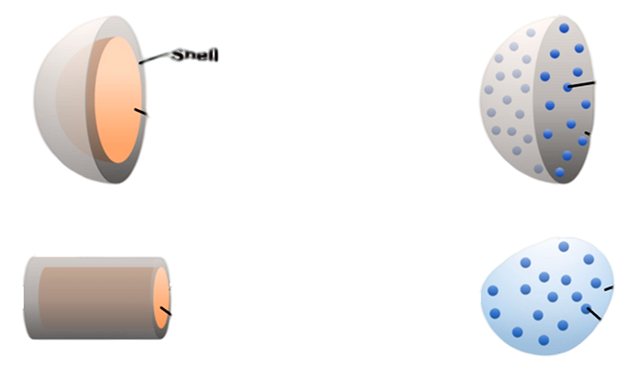

**Shell**



**Drug cargo**

**Drug cargo**

**Shell**

**Shell**

**Drug cargo**

**Drug cargo**

**Gel**

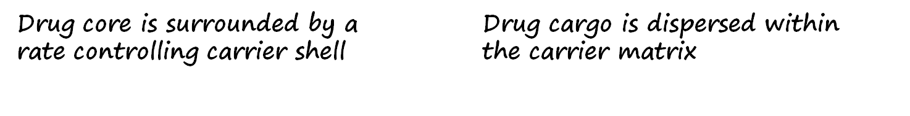

**Fig: 7 Reservoir and Matrix and membrane type drug delivery system**

**4.2 Diffusion-Controlled Drug Delivery Systems:** In systems that rely on diffusion control, drugs are either encapsulated within inert, water-insoluble polymeric membranes, known as reservoir systems, or embedded within polymeric matrices, referred to as monolithic systems. These can be further divided into membrane-controlled reservoir systems and monolithic matrix systems, as depicted in Figure 8. The release of drugs in these systems adheres to the principles outlined in Fick's laws of diffusion, where the key factor governing the release rate is drug diffusion [48, 49] **depicted in fig 8.**

Fick's first law of diffusion (Equation (1)) stipulates that the molar flux (J) resulting from diffusion is directly proportional to the concentration gradient (dc/dx). Fick's second law (Equation (2)) states that the rate of change in concentration within a solution at a specific spatial point is directly related to the second derivative of concentration concerning space.

Fick’s first law: J ∝ dc/dx or J = D. dc/dx…………………………….. (1)

Fick’s second law: dc/dt = D. d2c/dx2…………………………………… (2)

Where: dc = change in concentration of drug (g/cm3), dx = change in distance (cm), D = diffusion constant (cm2/s), J = flux (cm−2 s−1), dt = change in time (s).

Fick's first law pertains to changes in the concentration gradient over time at any given distance. Drug release in accordance with Fick's law is characterized as Fickian diffusion, while deviations from these principles are considered non-Fickian or indicative of anomalous diffusion.

Diffusion-controlled systems can be further classified into two primary types: membrane-controlled and monolithic (or matrix) systems. In membrane-controlled systems, the drug is positioned within a central reservoir and is encircled by a thin polymeric membrane. This membrane may be either porous or non-porous. Drug release takes place through diffusion across the membrane, and the release rate is influenced by various factors, including membrane thickness, porosity, and the physicochemical properties of the drugs, such as the partition coefficient, molecular size, diffusivity, protein binding, and dosage. Common techniques employed in the production of membrane-controlled reservoir systems include encapsulation and the press coating of tablets [48].Top of Form

**Drug dissolved in the polymer**

**Diffusion of drug**

**Diffusion of drug**

**Polymer**

**Drug dispersed in the polymer**

**Figure 8: A schematic of membrane-controlled delivery systems in diffusion of ring (drug dissolved and drug dispersed in polymer)**

In monolithic or matrix-controlled drug delivery systems, the drug is uniformly dissolved or spread throughout the polymer matrix. Because the outer layer is in touch with the surrounding solution, it dissolves first, allowing the drugs to diffuse out of the matrix and release most of the drugs in these systems. Drugs are dissolved in monolithic systems and injected into the matrix while being kept below their solubility limit. As the matrix gets smaller, the rate of drug release slows. This indicates that absorption is not happening at the same rate as elimination since drug release then occurs in a non-zero sequence. Contrarily, in monolithic systems where they are distributed, drugs are loaded atop the polymer matrix **depicted in fig 9.**

**Polymer membranes with different dissolution rate**

X

X

X

X

X

X

X X

X X X X X

X X X

X

X

X

X

X

X

X

X

X

X

XX

XX

XX

X X X X X X **Undissolved matrix**

XX

XX

XX

XX

XX

XX

XX

XX

XX

XX

XX

XX

**Matrix dissolution control**

**Released drugs**

**Dissolved polymer**

**Dissolution systems**

**Time = t**

**Time = 0**

**Released drugs**

**Dissolved polymer**

# Fig.9 Schematic of matrix dissolution control and undissolved matrix in targeted drug delivery system.

**4.0 Ion Exchange Resins (IERs):** Ion exchange resins are synthetic, high-molecular-weight polymers with water-insoluble properties, typically appearing as small white or yellowish beads. They are constructed from organic polymers that contain ionizable functional groups. In recent years, innovative drug delivery systems have gained popularity because of their capacity to reduce dosing frequency and enhance patient compliance. Ion exchange resins play a significant role in advancing drug delivery systems [51].

These IERs are insoluble polymers with either acidic or basic functional groups, capable of exchanging counter-ions when they come into contact with aqueous solutions. Typically, ion exchange resins are in the form of small beads with diameters ranging from 1 to 2 mm. Ion exchange is a reversible process in which ions carrying similar charges are exchanged between a liquid and a solid when they interact with an insoluble substance [52].

In drug delivery systems employing IERs, drugs are released through ion exchange with ions present in the gastrointestinal fluid, followed by drug diffusion [53]. These resins have high molecular weights and are water-insoluble, rendering them inert and unabsorbable by the body. The effectiveness of ion exchange resins is influenced by various physical properties, including exchange capacity, cross-linkage, ionization, porosity, swelling, particle size, form, purity, toxicity, and equilibrium rate. Typically, drug resinates are formulated using purified resins and drugs [54, 55].

Recent research has demonstrated the versatility of IERs in various drug delivery technologies, encompassing controlled release, transdermal, nasal, topical, oral, and taste masking. Synthetic ion exchange resins have been employed in pharmaceuticals and medicine since as early as the 1950s, primarily for taste masking or controlling drug release. These ion-exchange systems are particularly valuable for drugs prone to enzymatic degradation, offering cost-effective solutions [56, 57].

**Table 3: IES DIS-ADVANTAGES, CLINICAL ADVANTAGES, AND ADVANTAGES**

|  |  |  |  |
| --- | --- | --- | --- |
|  | | |  |
| **S.No.** | **ADVANTAGES [58]** | **CLINICAL ADVANTAGES [59]** | **DISADVANTAGES [60]** |
|  | Economic and readily available. | Reduction in frequency of drug administration | Reduced potential for dose adjustment. |
|  | Antigens either locally or systemic is not present | Improved patient compliance | The single-unit dose form is more expensive than traditional dosage forms. |
|  | In the form of numerous dosages such as suspensions, capsules, tablets they drug resinates can be formulated. | Reduction in drug level fluctuation in blood | Boost the likelihood of first pass metabolism. |
|  | Can be utilized for various purposes such as sustained, rapid release and taste masking. | Reduction in drug accumulation with chronic therapy | Extra patient education is necessary in order to give the right drug at the right time. |
|  | Effectively useful in low concentration (5- 20%w/w). | Balancing of conditions like medical (due to high uniform levels of drug) | Poor in vitro and in vivo correlations and decreased systemic availability compared to immediate release conventional dose forms |

**4.3.1 Types of Ion-Exchange Resin:** There are two classes of ion-exchange polymers [61]. **Shown in (Fig. 10)**

**a) Cation exchange resin**

**b) Anion exchange resins**.

These are discussed in the following two sub-sections.

1. **Cation Exchange Resins:** Functional groups that are negatively charged and may displace positively charged ions make up cation exchange resins. The copolymerization of styrene and divinyl benzene, which adds sulfonic acid groups (-SO3H) into many of the benzene rings, is the typical method used to create these resins. The resin polymer (R) having SO3 sites forms bonds with exchangeable cations (C+) during a cation exchange process, leading to an exchange reaction denoted by the formula: R- - ex+ + C+ R- - C+ + ex+. Strong acid and weak acid cation exchange resins are the two primary categories of cation exchange resins. While weak acid cation exchange resins resemble weak organic acids with their capacity dependent on pH, strong acid cation exchange resins behave like powerful acids.
2. **Anion Exchange Resins:** Positively charged functional groups found in anion exchange resins can swap out for negatively charged ions. To create these resins, benzene rings from a styrene-divinylbenzene copolymer are chloromethylated to attach CH2Cl groups, and then tertiary amines like triethylamine are added to the mixture.

**Fig.10 Classification of IER**

The resin polymer (R+) and exchangeable anions (A-) establish bonds during an anion exchange process, which causes the exchange reaction R+ - ex - + A- R+ - A- + ex-. Strong acid, weak acid, and anion exchange resins with a strong base are all forms of anion exchange resins.



**Fig. 11 Chemical structure of Styrene and Divinyl benzene**

**Table 4: Chemical constituents for IER**

|  |  |  |  |
| --- | --- | --- | --- |
| **S.No.** | **Resin Type** | **Chemical constitution** | **Usual form** |
|  | Strongly acidic cation exchanger | Sulfonic acid groups attached to a system and divinyl benzene copolymer | R-SO3-H+ |
|  | Weakly acidic cation exchanger | Carboxylic acid groups attached to an acrylic and divinyl benzene copolymers | R-COO-Na+ |
|  | Strongly basic anion exchanger | Quaternary ammonium groups attached to a styrene divinylbenzene  Copolymer | [Φ= CH₂N(CH3)3+] Cl- |
|  | Weakly basic anion exchanger | Polyallylamine groups attached to a styrene and divinyl benzene copolymer | [Φ= NH(R)] Cl |

**5. Drug Delivery Applications:**

1. **Oral Drug Delivery:** Ion exchange resins play a crucial role in the development of controlled or sustained-release systems, preventing abrupt dose release and enhancing drug retention.
2. **Nasal Drug Delivery:** They are used to achieve optimal combined pulsatile and sustained plasma profiles.
3. **Transdermal Drug Delivery:** Ion exchange resins assist in controlling drug release and maintaining consistent release rates.
4. **Ophthalmic Drug Delivery:** They improve the bioavailability of ophthalmic drugs, resulting in more effective treatments.
5. **Diagnostic and Therapeutic Applications:** Both synthetic and natural ion exchange resins are utilized in diagnostic testing and therapeutic treatments. They find applications in adsorbing toxins, serving as antacids, binding bile acids, and treating conditions like liver diseases, renal insufficiency, and skin disorders [84]. The versatility and unique properties of ion exchange resins make them valuable across various pharmaceutical and drug delivery contexts.
6. **Role of Ion Exchange Resins (IER) in Controlled Drug Delivery Systems:** Ion exchange resins play a pivotal role in controlled release formulations by addressing concerns about dose dumping, which pose safety and toxicity risks. They slow down drug release and act as drug reservoirs in hydrophilic polymer tablets. Their benefits include physicochemical stability, consistency, inert characteristics, spherical shapes suitable for coating, and predictable drug release in ionic environments [62-71].

**5.1 Mechanism and Principles:**

In anion exchange resins, anions are removed from acidic solutions, while cation exchange resins eliminate cations from basic solutions. Extending drug release duration depends on creating insoluble poly-salt resinates by combining pharmaceuticals with resins. Key factors in IER selection encompass capacity, degree of cross-linking, particle size, drug nature, environmental mimicry, swelling ratio, biocompatibility, and regulatory compliance [72-74].

**5.2 Properties of Ion Exchange Resins** [75-80].

1. **Particle Size and Form:** Smaller particles result in faster reactions and quicker equilibration, leading to accelerated release patterns.
2. **Porosity and Swelling:** These factors influence the size of ions that can penetrate the resin matrix.
3. **Cross-Linkage:** The extent of cross-linking impacts dimensional changes based on the bound ions.
4. **Exchange Capacity:** This metric measures a resin's ability to absorb exchangeable counter-ions.
5. **Moisture Content:** It affects resin properties, with sulfonic acid groups retaining moisture.
6. **Purity and Toxicity:** Ensuring purification is crucial to guarantee non-toxicity and safety.
   1. **Applications of Ion Exchange Resin** [81-84].
7. **Taste Masking:** Employed to enhance the taste of active ingredients in oral formulations.
8. **Polymorphism Resolution:** Resolves challenges related to multiple crystalline phases in pharmaceutical solids.
9. **Enhanced Dissolution of Poorly Soluble Drugs:** Improves dissolution rates without the need for micronization.
10. **Improved Stability:** Offers greater stability compared to the original drug.
11. **Enhanced Physical Characteristics:** Provides free-flowing solids with uniform properties.
12. **Drug Delivery Applications:** Utilized in controlled-release systems for oral, nasal, transdermal, and ophthalmic drug delivery.
13. **Diagnostic and Therapeutic Applications:** Utilized in adsorbing toxins, acting as antacids, binding bile acids, and treating various medical conditions.

**5. 4 Role of Ion Exchange Resins (IER) in Controlled Drug Delivery Systems:** Ion exchange resins play a crucial role in controlled release formulations by addressing concerns about dose dumping, which can pose safety and toxicity risks. They slow down drug release and act as drug reservoirs in hydrophilic polymer tablets. Their benefits include physicochemical stability, consistency, inert properties, spherical shapes suitable for coating, and predictable drug release in ionic environments [62-71].

**5.5 Mechanism and Principles:** Anion exchange resins remove anions from acidic solutions, while cation exchange resins remove cations from basic solutions. Extending drug release duration depends on creating insoluble poly-salt resinates by combining pharmaceuticals with resins. Key factors in IER selection encompass capacity, degree of cross-linking, particle size, drug characteristics, environmental simulation, swelling ratio, biocompatibility, and compliance with regulatory standards [72-74].

**5.6 Properties of Ion Exchange Resins**

Following properties of Ion exchange resin [75-80].

* 1. **Particle Size and Form:** Smaller particles lead to faster reactions and quicker equilibration, resulting in accelerated release patterns.
  2. **Porosity and Swelling:** These factors influence the size of ions that can penetrate the resin matrix.
  3. **Cross-Linkage:** The extent of cross-linking affects dimensional changes based on the ions bound.
  4. **Exchange Capacity:** This metric measures a resin's ability to absorb exchangeable counter-ions.
  5. **Moisture Content:** It impacts resin properties, with sulfonic acid groups retaining moisture.
  6. **Purity and Toxicity:** Ensuring purification is crucial to guarantee non-toxicity and safety.

**5.7 Applications of Ion Exchange Resin**

Following application of Ion exchange resin are [81-84]

* 1. **Taste Masking:** Employed to enhance the taste of active ingredients in oral formulations.
  2. **Polymorphism Resolution:** Addresses issues related to multiple crystalline phases in pharmaceutical solids.
  3. **Enhanced Dissolution of Poorly Soluble Drugs:** Improves dissolution rates without the need for micronization.
  4. **Improved Stability:** Offers greater stability compared to the original drug.
  5. **Enhanced Physical Characteristics:** Provides free-flowing solids with uniform properties.
  6. **Drug Delivery Applications:** Utilized in controlled-release systems for oral, nasal, transdermal, and ophthalmic drug delivery.
  7. **Diagnostic and Therapeutic Applications:** Utilized in adsorbing toxins, acting as antacids, binding bile acids, and treating various medical conditions.

1. **Drug Delivery Applications:**
2. **Oral Drug Delivery:** Ion exchange resins are essential in the development of controlled or sustained-release systems, preventing the abrupt release of doses and improving drug retention.
3. **Nasal Drug Delivery:** They are employed to achieve an optimal combination of pulsatile and sustained plasma profiles.
4. **Transdermal Drug Delivery:** Ion exchange resins assist in regulating drug release and maintaining consistent release rates.
5. **Ophthalmic Drug Delivery:** They enhance the bioavailability of ophthalmic drugs, resulting in more effective treatments.
6. **Diagnostic and Therapeutic Applications:** Ion exchange resins, whether synthetic or natural, find applications in diagnostic tests and therapeutic treatments. They are used for adsorbing toxins, acting as antacids, binding bile acids, and treating conditions like liver diseases, renal insufficiency, and skin disorders [84]. The versatility and unique properties of ion exchange resins make them valuable in various pharmaceutical and drug delivery contexts.
7. **CONCLUSION**

In our pursuit of developing controlled release formulations, this scientific book investigation has yielded valuable insights into the intricate realm of drug delivery. Our is based on examination of the principles of diffusion, dissolution, and ion exchange has shed light on their potential in shaping the future of pharmaceutical science. Through this book, we have delved into fundamental questions surrounding these principles, unveiling their critical roles in achieving precise and customized drug release patterns. This book has emphasized the significance of comprehending and harnessing diffusion, dissolution, and ion exchange to create inventive pharmaceutical formulations that enhance patient adherence and therapeutic effectiveness.By exploring the interplay between these principles, we have laid the groundwork for versatile drug delivery systems that provide superior control over the release of medications. The prospect of integrating personalized medicine and pharmacogenomics offers the potential to further optimize patient care, underlining the adaptability of controlled release systems to the unique needs of individual patients. We have also underscored the challenges and regulatory considerations that must be addressed, highlighting the importance of meticulous formulation design and thorough testing to ensure safety, efficacy, and quality control. In summary, this research serves as a bridge between theoretical understanding and practical application, presenting insights that can propel the field of pharmaceutical science forward. By enhancing patient adherence, therapeutic effectiveness, and the overall quality of pharmaceutical treatments for a range of medical conditions, our exploration of the principles of diffusion, dissolution, and ion exchange makes a substantial contribution to the evolving landscape of drug delivery. It paves the way for future innovations and improved healthcare outcomes, ultimately benefiting both patients and the broader healthcare community.

**Future Scope:**

The study "Designing Controlled Release Formulations: Exploring Diffusion, Dissolution, and Ion Exchange Principles for Drug Delivery" lays the foundation for promising avenues of research and development in the field of drug delivery. Building upon the findings and insights obtained from this exploration, there are several areas of future scope and potential research directions:

1. **Advanced Formulation Design:** Future research can focus on refining and optimizing controlled release formulations by incorporating a deeper understanding of diffusion, dissolution, and ion exchange. This may involve the development of more complex matrices or membranes that enable even more precise control over drug release profiles.
2. **Innovations in Nanotechnology:** Nanotechnology has vast potential in controlled drug delivery. Future studies can delve into the utilization of nanoscale materials and carriers to enhance controlled release systems, allowing for targeted and sustained drug delivery at the cellular or tissue level.
3. **Biodegradable and Implantable Devices:** Research into biodegradable polymers and implantable devices can open doors to long-term controlled release solutions for chronic conditions. Investigating their safety, efficacy, and potential applications for specific medical conditions will be essential.
4. **Combination Therapies:** As the demand for combination therapies increases, exploring controlled release systems for delivering multiple drugs in a single formulation will be of great importance. Research in this area can revolutionize the treatment of complex diseases.
5. **Regulatory Advancements:** The development of controlled release formulations often involves navigating complex regulatory pathways. Future research may focus on streamlining and improving the regulatory approval process, facilitating the translation of innovative drug delivery technologies into clinical practice.
6. **Personalized Medicine and Pharmacogenomics:** The integration of personalized medicine and pharmacogenomics into controlled release systems can be a game-changer. Future studies can concentrate on tailoring drug release profiles to individual patient genetics, enhancing treatment outcomes.
7. **Global Access and Affordability:** Addressing global access issues and ensuring the affordability of controlled release formulations, especially in resource-limited settings, is a crucial area for future research. Investigations into cost-effective manufacturing and distribution models are warranted.
8. **Patient-Centered Outcomes:** Conducting research that assesses patient preferences, satisfaction, and adherence to controlled release formulations is important for understanding the patient experience and tailoring drug delivery systems accordingly.
9. **Cross-Disciplinary Collaborations:** Collaboration between pharmaceutical scientists, materials scientists, biotechnologists, and clinicians will be vital to drive innovation in controlled release systems. Future research can explore multidisciplinary approaches to address complex challenges.
10. The future scope of research in the field of controlled release formulations is vast and promising. By continuing to explore and expand upon the principles of diffusion, dissolution, and ion exchange, researchers have the opportunity to develop cutting-edge drug delivery systems that not only improve patient care but also contribute to the broader landscape of pharmaceutical science and healthcare.

**REFERENCES**

1. Hoffman, A. S. (2008). The origins and evolution of “controlled” drug delivery systems. Journal of controlled release, 132(3), 153-163.
2. Acharya, G., & Park, K. (2006). Mechanisms of controlled drug release from drug-eluting stents. Advanced drug delivery reviews, 58(3), 387-401.
3. Uhrich, K. E., Cannizzaro, S. M., Langer, R. S., & Shakesheff, K. M. (1999). Polymeric systems for controlled drug release. Chemical reviews, 99(11), 3181-3198.
4. Edgren, D. E., & Theeuwes, F. (1990). U.S. Patent No. 4,931,285. Washington, DC: U.S. Patent and Trademark Office.
5. Buerki, R. A., & Higby, G. J. (2006). Dosage Forms and basic preparations: History. Encyclopedia of Pharmaceutical Technology. London: Informa Healthcare, 948-74.
6. Rekhi, G. S., Porter, S. C., & Jambhekar, S. S. (1995). Factors affecting the release of propranolol hydrochloride from beads coated with aqueous polymeric dispersions. Drug development and industrial pharmacy, 21(6), 709-729.
7. Pandya, D. B., Shinkar, D. M., & Saudagar, R. B. (2015). Revolutionized Topico-Systemic Era:Transdermal Drug Delivery System. Research Journal of Topical and Cosmetic Sciences, 6(2), 66-76.
8. Tibbitt, M. W., Dahlman, J. E., & Langer, R. (2016). Emerging frontiers in drug delivery. Journal of the American Chemical Society, 138(3), 704-717.
9. Fan, L. T., & Singh, S. K. (2012). Controlled release: A quantitative treatment (Vol. 13). Springer Science & Business Media. Tiwari, R. (2016). Controlled release drug formulation in pharmaceuticals: a study on their application and properties. World J Pharm Res, 5, 1740-1720.
10. Robinson, J. R. (1978). Sustained and controlled release drug delivery systems.
11. Shell, J. W. (1991). U.S. Patent No. 5,007,790. Washington, DC: U.S. Patent and Trademark Office.
12. Dawson, J., & Langer, R. (1990)., European Polymer Journal, 65,82-97, doi:10.1016/j.eurpolymj.2015.01.016.
13. Zhang, Y., Chan, H. F., & Leong, K. W. (2013). Advanced materials and processing for drug delivery: the past and the future. Advanced drug delivery reviews, 65(1), 104-120.
14. Hruby, M., Filippov, S. K., & Štěpánek, P. (2015). Smart polymers in drug delivery systems on crossroads: Which way deserves following. European Polymer Journal, 65, 82-97.
15. Langer, R. (1980). Invited review polymeric delivery systems for controlled drug release. Chemical Engineering Communications, 6(1-3), 1-48.
16. Qiu, Y., & Park, K. Environment-sensitive hydrogels for drug delivery (2012) Advanced Drug Delivery Reviews 64: 49-60.
17. Naik, A., Kalia, Y. N., & Guy, R. H. (2000). Transdermal drug delivery: overcoming the skin’s barrier function. Pharmaceutical science & technology today, 3(9), 318-326.
18. Aulton, M. E. (2002). Pharmaceutics: The science of dosage form design. .
19. Godbey, W. T., Wu, K. K., & Mikos, A. G. (1999). Size matters: molecular weight affects the efficiency of poly (ethylenimine) as a gene delivery vehicle. Journal of Biomedical Materials Research: An Official Journal of The Society for Biomaterials, The Japanese Society for Biomaterials, and The Australian Society for Biomaterials, 45(3), 268-275.
20. L Karpel, R. (2015). DNA binding proteins and drug delivery vehicles: tales of elephants and snakes. Current Protein and Peptide Science, 16(8), 718-726.
21. Benet, L. Z., Kroetz, D., Sheiner, L., Hardman, J., & Limbird, L. (1996). Pharmacokinetics: the dynamics of drug absorption, distribution, metabolism, and elimination. Goodman and Gilman’s the pharmacological basis of therapeutics, 3, e27.
22. Sleep, D., Cameron, J., & Evans, L. R. (2013). Albumin as a versatile platform for drug half-life extension. Biochimica et Biophysica Acta (BBA)-General Subjects, 1830(12), 5526-5534.
23. Hoeholt, J., Monrad, M., Andersen, C. S., Grubbe, M. S., & Pedersen, B. P. S. (2017). U.S. Patent No. 9,675,761. Washington, DC: U.S. Patent and Trademark Office.
24. Badhana, S., Garud, N., & Garud, A. (2013). Colon specific drug delivery of mesalamine using eudragit S100-coated chitosan microspheres for the treatment of ulcerative colitis. International Current Pharmaceutical Journal, 2(3), 42-48.
25. Walker, B. R., & Colledge, N. R. (2013). Davidson's principles and practice of medicine e-book. Elsevier Health Sciences.
26. Kumar, N., Singh, G. P., Kumar, A., Goswami, A. K., & Chauahan, R. S. International Journal for Pharmaceutical Research Scholars (IJPRS).
27. Kost, J., & Langer, R. (2012). Responsive polymeric delivery systems. Advanced drug delivery reviews, 64, 327-341.
28. Khan, N., S Harun, M., Nawaz, A., Harjoh, N., & W Wong, T. (2015). Nanocarriers and their actions to improve skin permeability and transdermal drug delivery. Current Pharmaceutical Design, 21(20), 2848-2866.
29. Chien, J. Y., & Ho, R. J. (2008). Drug delivery trends in clinical trials and translational medicine. Journal of pharmaceutical sciences, 97(7), 2543-2547.
30. Santus, G., & Baker, R. W. (1995). Osmotic drug delivery: a review of the patent literature. Journal of Controlled Release, 35(1), 1-21.
31. Namdeo, G. S., Nagesh, H. A., Ajit, S. K., Bhagyashree, S. S., Savita, H. B., & Sharad, N. D. (2014). Advances in gastroretentive drug delivery system: An Review. International Journal of Pharmacy and Pharmaceutical Science Research, 4(2), 37-48.
32. Agrawal, M., Limbachiya, M., Sapariya, A., & Patel, G. (2012). A review on parenteral controlled drug delivery system. International Journal of Pharmaceutical Sciences and Research, 3(10), 3657.
33. Lee, J. H., Chen, K. J., Noh, S. H., Garcia, M. A., Wang, H., Lin, W. Y., ... & Tseng, H. R. (2013). On‐demand drug release system for in vivo cancer treatment through self‐assembled magnetic nanoparticles. Angewandte Chemie International Edition, 52(16), 4384-4388.
34. Mohammed, S. S., & Babu, N. (2015). Formulation Development and Evaluation Bilayer Floating Sustained and Immediate Release Tablet of Verapamil Hydrochloride by Direct Compression Method. Research Journal of Pharmacy and Technology, 8(5), 539-548.
35. Saha, P., & Das, P. S. (2017). Advances in controlled release technology in pharmaceuticals: A review. World J Pharm Pharm Sci, 6(9), 2070-2084.
36. Balasubramaniam, J., & Pandit, J. K. (2003). Ion-activated in situ gelling systems for sustained ophthalmic delivery of ciprofloxacin hydrochloride. Drug delivery, 10(3), 185-191.
37. Karnovsky, M. L., & Lazdins, J. K. (1978). Biochemical criteria for activated macrophages. The Journal of Immunology, 121(3), 809-813.
38. Satav, S. S., Bhat, S., & Thayumanavan, S. (2010). Feedback regulated drug delivery vehicles: carbon dioxide responsive cationic hydrogels for antidote release. Biomacromolecules, 11(7), 1735-1740.
39. Polymer nanoparticles for smart drug delivery. Application of nanotechnology in drug delivery, 8.
40. Bertrand, N., Wu, J., Xu, X., Kamaly, N., & Farokhzad, O. C. (2014). Cancer nanotechnology: the impact of passive and active targeting in the era of modern cancer biology. Advanced drug delivery reviews, 66, 2-25.
41. McGinity, J. W., DiNunzio, J. C., & Keen, J. M. (2013). Oral Controlled‐Release Polymeric Drug Delivery Systems. Engineering Polymer Systems for Improved Drug Delivery, 283-318.
42. Haznar-Garbacz, D., Garbacz, G., Eisenächer, F., Klein, S., & Weitschies, W. (2012). A novel liquefied gas based oral controlled release drug delivery system for liquid drug formulations. European journal of Pharmaceutics and Biopharmaceutics, 81(2), 334-338.
43. Allen, T. M., & Cullis, P. R. (2004). Drug delivery systems: entering the mainstream. Science, 303(5665), 1818-1822.
44. Davis, S. S., Hardy, J. G., & Fara, J. W. (1986). Transit of pharmaceutical dosage forms through the small intestine. Gut, 27(8), 886-892.
45. Gupta, B. P., Thakur, N., Jain, N. P., Banweer, J., & Jain, S. (2010). Osmotically controlled drug delivery system with associated drugs. Journal of Pharmacy & Pharmaceutical Sciences, 13(4), 571-588.
46. Adepu, S., & Ramakrishna, S. (2021). Controlled drug delivery systems: current status and future directions. Molecules, 26(19), 5905.
47. Siepmann, J., Siegel, R. A., & Rathbone, M. J. (2012). Fundamentals and applications of controlled release drug delivery (Vol. 3, pp. 33-34). New York: Springer.
48. Siepmann, J., & Siepmann, F. (2012). Modeling of diffusion controlled drug delivery. Journal of controlled release, 161(2), 351-362.
49. Chaudhry, N. C., & Saunders, L. (1956). Sustained release of drugs from ion exchange resins. Journal of Pharmacy and Pharmacology, 8(1), 975-986.
50. Kasture, A.V., Wadodkar, S.G., Mahadik. K.K. More. H.N. (2002). A Textbook of pharmaceutical analysis and instrumental methods, 8, 3947.
51. Borodkin, S. (1993). Ion exchange resins and sustained release. Encyclopedia of pharmaceutical technology, 8, 203-216.
52. Pongjanyakul, T., Prakongpan, S., Rungsardthong, U., Chancham, P., & Priprem, A. (2005). Characteristics and in vitro release of dextromethorphan resinates. Powder technology, 152(1-3), 100-106.
53. Notari, R. E. (1987). Biopharmaceutics and clinical Pharmacokinetics 4, 130–218.
54. Bellamy Simon A, Hughes L. (2003). Method for the anhydrous loading of nicotine onto ion exchange resins, US patent 6 607 752,1-6.
55. Guo, X., Chang, R. K., & Hussain, M. A. (2009). Ion-exchange resins as drug delivery carriers. Journal of pharmaceutical sciences, 98(11), 3886-3902.
56. Bellamy, S. A., & Hughes, L. (2003). U.S. Patent No. 6,607,752. Washington, DC: U.S. Patent and Trademark Office.
57. Utreja, S., & Jain, N. K. (2001). Solid lipid nanoparticles. Advances in controlled and novel drug delivery, 408-425.
58. Pande, S. V., Kshirsagar, M. D., & Chandewar, A. V. (2011). Ion exchange resins pharmaceutical applications and recent advancement. International journal of advances in pharmaceutical sciences, 2(1).
59. Bhalekar, M., Avari, J. G., & Jaiswal, S. B. (2004). Anionon-exchanger in pharmaceutical formulation. Indian J Pharma Educ, 38, 184-8.
60. Jain, N. K. (Ed.). (2001). Advances in controlled and novel drug delivery. CBS publishers & distributors
61. Bhalekar, M., Avari, J. G., & Jaiswal, S. B. (2004). Cation-exchanger in pharmaceutical formulation. Indian J Pharma Educ, 38, 184-8.
62. Amsel, L. P., Hinsvark, O. N., Rotenberg, K., & Sheumaker, J. L. (1984). Recent advances in sustained release technology using ion exchange polymers. Pharm Technol, 8(4), 28-32.
63. Effect of ion exchange resins on the drug release from matrix tablets. European journal of pharmaceutics and biopharmaceutics, 46(3), 321-327.
64. Akkaramongkolporn, P., & Ngawhirunpat, T. (2003). Dual ambroxal and chlorpheniramine resinate as an alternative carrier in concurrent resinate administration. Die Pharmazie-An International Journal of Pharmaceutical Sciences, 58(3), 195-199.
65. Singh, I., Rehni, A. K., Kalra, R., Joshi, G., Kumar, M., & Aboul-Enein, H. Y. (2007). Ion exchange resins: Drug delivery and therapeutic applications. Fabad Journal of Pharmaceutical Sciences, 32(2), 91.
66. Chaudhry, N. C., & Saunders, L. (1956). Sustained release of drugs from ion exchange resins. Journal of Pharmacy and Pharmacology, 8(1), 975-986.
67. Cuna, M., Jato, J. V., & Torres, D. (2000). Controlled-release liquid suspensions based on ion-exchange particles entrapped within acrylic microcapsules. International Journal of Pharmaceutics, 199(2), 151-158.
68. Ichikawa, H., Fujioka, K., Adeyeye, M. C., & Fukumori, Y. (2001). Use of ion-exchange resins to prepare 100 μm-sized microcapsules with prolonged drug-release by the Wurster process. International journal of pharmaceutics, 216(1-2), 67-76.
69. Douglas, Stephen J, Bird Fiona, Drug adsorbates, US patent 5 219 563,.1993
70. . Mangesh, B., Nitin, K., Prashant, U., Madgulkar, A., & Kshirsagar, S. (2012). Formulation and in vitro evaluation of sustained release domeperidone–Indion 244 complexes. Fabad Journal of Pharmaceutical Sciences, 37(4), 175-182.
71. Elder, D. P., Park, A., Patel, P., & Marzolini, N. (2000). Ion exchange at the millenium ed. J. A Greig, 306-315.
72. Douglas, S.J., & Fiona, B. (1993). Drug adsorbates, U.S.Patent 5 219 563.
73. Raghunathan, Y., Amsel, L., Hinsvark, O., & Bryant, W. (1981). Sustained‐release drug delivery system I: Coated ion‐exchange resin system for phenylpropanolamine and other drugs. Journal of Pharmaceutical Sciences, 70(4), 379-384.
74. Clifford, D. A. (1976). Nitrate Removal From Water Supplies By Ion Exchange: Resin Selectivity And Multicomponent, Chromatographic Column Behavior Of Sulfate, Nitrate, Chloride And Bicarbonate. University Of Michigan.
75. Jeong, S. H., & Park, K. (2008). Development of sustained release fast-disintegrating tablets using various polymer-coated ion-exchange resin complexes. International journal of pharmaceutics, 353(1-2), 195-204.
76. Clifford, d. a. (1976). nitrate removal from water supplies by ion exchange: resin selectivity and multicomponent, chromatographic column behavior of sulfate, nitrate, chloride and bicarbonate. university of michigan.
77. Van Abbe, N. J., & Rees, J. T. (1958). Amberlite resin XE‐88 as a tablet disintegrant. Journal of the American Pharmaceutical Association, 47(7), 487-489.
78. Prabhu, N. B., Marathe, A. S., Jain, S., Singh, P. P., Sawant, K., Rao, L., & Amin, P. D. (2008). Comparison of dissolution profiles for sustained release resinates of BCS class i drugs using USP apparatus 2 and 4: a technical note. AAPS PharmSciTech, 9, 769-773.
79. Borodkin, S. (1991). Ion exchange resin delivery system (pp. 215-230). Boca Raton, FL: CRC Press.
80. Martin, G. J. (1951). Medical applications of adsorption and ion exchange materials. The American Journal of Digestive Diseases, 18(1), 16-24.
81. Jani, R., Gan, O., Ali, Y., Rodstrom, R., & Hancock, S. (1994). Ion exchange resins for ophthalmic delivery. Journal of Ocular Pharmacology and Therapeutics, 10(1), 57-67.
82. Keating, J. W. (1961). U.S. Patent No. 2,990,332. Washington, DC: U.S. Patent and Trademark Office.
83. Amsel, L. P., Hinsvark, O. N., & Sheumarker, J. L. (1984). Recent advances in sustain release technology using ion exchange polymer. Journal of Pharmacy Technology, 8, 28–48.