**Introduction to Deep Learning and Computer Vision**

Vikas Kumar1

Department of Computer Science and Engineering

Dev Bhoomi Uttarakhand University, Dehradun, India

Socse.vikaskumar@dbuu.ac.in

Yudhveer Singh Moudgil2 Department of Computer Science and Engineering

Dev Bhoomi Uttarakhand University, Dehradun, India

Yudhveer127@gmail.com

Sukesh Kumar Bhagat3

Department of Computer Science and Engineering

Uttaranchal University, Dehradun, India

[Sukeshtech@gmail.com](mailto:Sukeshtech@gmail.com)

ABSTRACT

This chapter provides an overview of deep learning and its applications to computer vision. Deep learning is a form of machine learning that models complex patterns discovered in large datasets using multiple-layered neural networks. This chapter begins with an introduction to the fundamental concepts of neural networks, including architectures such as Convolutional Neural Networks (CNNs) and their significance in the processing of visual data. The importance of regularization, transfer learning, and data augmentation in raising model performance and reducing overfitting is emphasized. A variety of deep learning applications in computer vision are also covered in this chapter, including object detection, image segmentation, and image classification. Through this introduction, readers will gain a fundamental knowledge of how deep learning alters computer vision problems and sets the stage for future advancements in artificial intelligence.

Keywords— Deep Learning; Computer Vision; Image Segmentation; Training Algorithms, Convolutional Neural Networks (CNNs), Neural Networks

**1.1 Overview of Deep Learning**

"Deep learning" is a subset of machine learning that uses multiple layers of algorithms to gradually extract higher-level features from raw input [1]. Its foundation is made up of neural networks, which are inspired by the composition and operations of the human brain. Deep learning has emerged as a result of three main factors: the availability of large datasets, the advancement of increasingly potent computers, especially GPUs, and advancements in algorithms [2].

**Historical Background**

* **Perceptrons and Early Neural Networks:** The perceptron, introduced by Frank Rosenblatt in 1958, was one of the earliest models of a neural network [3].
* **The AI Winter:** Interest in neural networks declined in the 1970s and 1980s due to limitations in computing power and the lack of large datasets.
* **Resurgence:** The 2000s saw a resurgence in interest, fueled by breakthroughs in training deep networks (e.g., Hinton et al., 2006) and the availability of large-scale datasets like ImageNet.

**Key Concepts**

* **Neural Networks:** Composed of layers of nodes (neurons), neural networks are the fundamental building blocks of deep learning [4].
* **Layers and Nodes:** A neural network's layers each modify the input data in a particular way, and the nodes—also known as neurons—in these layers use activation functions to generate output.
* **Activation Functions:** These functions give the network non-linearity, which helps it learn intricate patterns[5].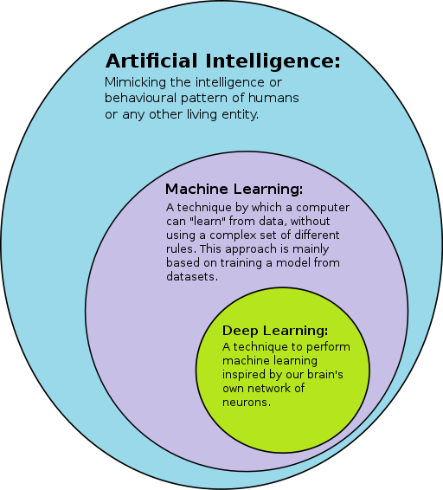

**Figure 1.1 Overview of Deep Learning**

**1.2 Fundamentals of Neural Networks**

Neural networks consist of an input layer, one or more hidden layers, and an output layer. Each neuron in a layer receives input, processes it using an activation function, and then transmits the outcome to the layer below it [6].

**Perceptron Model**

* A neural network that is single-layer and has a threshold activation function.
* Capable of binary classification tasks.

**Multi-Layer Perceptrons (MLPs)**

* Multiple-layer networks that sit between the input and output layers [7].
* Each layer transforms the input data by applying a series of weighted sums and activation functions.

**Forward Propagation**

* The method by which input data is sent across the network to produce output.
* Each layer applies its weights and biases, followed by an activation function.

**Backpropagation and Gradient Descent**

* **Backpropagation:** A neural network training approach that modifies weights in opposition to the loss function's gradient [8].
* **Gradient Descent:** A method of optimization that involves repeatedly changing the weights in order to minimize the loss function.

**1.3 Deep Learning Architectures**

Deep learning architectures vary based on the type of problem they aim to solve [9]. Some common architectures include:

**Convolutional Neural Networks (CNNs)**

* **Convolutional Layers:** Utilize convolutional processes to identify local patterns in the input data.
* **Pooling Layers:** Reduce the data's spatial dimensions to preserve key properties and cut down on processing complexity.
* **Fully Connected Layers:** To arrive at final forecasts, combine features that were learned in earlier levels.

**Recurrent Neural Networks (RNNs)**

* Made for sequential data, such text or time series.
* **Long Short-Term Memory (LSTM):** A kind of RNN with the ability to identify long-term dependencies [10].
* **Gated Recurrent Units (GRUs):** LSTM-like, but with a more straightforward structure.

**Generative Adversarial Networks (GANs)**

* Are composed of a discriminator and a generator, two networks.
* **Generator:** Makes up fake data.
* **Discriminator:** separates manufactured data from actual data.
* Trained in a competitive environment, which produced high-caliber synthetic data.

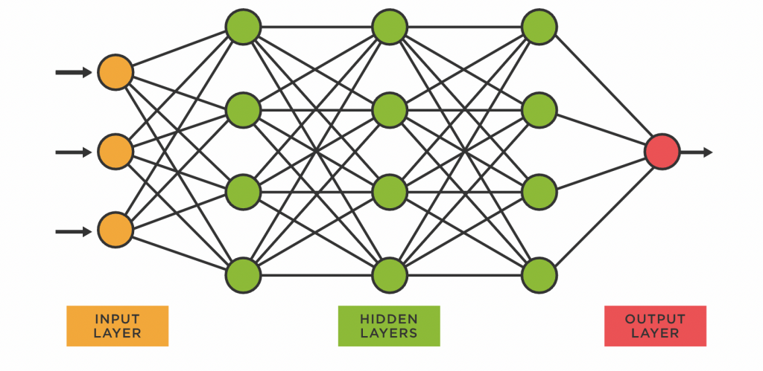

**Figure 1.2 Deep Learning Architecture**

**1.4 Computer Vision Basics**

The automatic extraction, analysis, and comprehension of meaningful information from a single image or a series of images is the focus of computer vision [11]. Automating tasks that can be performed by the human visual system is the aim.

**Image Representation**

* **Pixels and Color Channels:** Pixel grids are used to depict images, and each pixel in the grid has a color intensity value across many channels (such as RGB) [12].
* **Image Preprocessing:** Images are prepped for examination using methods like cropping, scaling, and normalization.
* **Image Augmentation:** The diversity of training datasets is artificially increased by using tricks like flipping, rotating, and zooming.

**Key Applications**

* **Object Detection:** Finding and recognizing things in an image [13].
* **Image Classification:** Assigning a label to an entire image.
* **Image Segmentation:** Dividing an image into several sections or areas.
* **Face Recognition:** Identifying or verifying a person from a digital image.

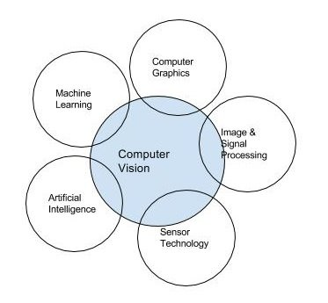

**Figure. 1.3 Computer Vision Fields**

**1.5 Deep Learning in Computer Vision**

Computer vision has greatly evolved thanks to deep learning, which has made it possible for robots to comprehend and interpret visual input with previously unheard-of accuracy [14]. This chapter explores the fundamental ideas, computer vision applications, and architectures of deep learning, emphasizing the ways in which these technologies are revolutionizing various fields and daily life.

**Role of Convolutional Neural Networks (CNNs)**

In computer vision, convolutional neural networks (CNNs) provide the foundation of deep learning [15]. They have been crucial in making advances in segmentation, object detection, and image recognition since they are made expressly to handle pixel data.Though little known to the general public, Convolutional Neural Networks (CNN) are a fundamental technique in deep learning for computer vision and are responsible for several significant advancements, such as safe autonomous vehicles and face recognition for phone unlocking.

**Key Components of CNNs:**

* **Convolutional Layers:** To identify local features like edges, textures, and patterns in the input image, apply filters [16].
* **Pooling Layers:** Reduce the data's spatial dimensions to preserve important properties and lighten the computing burden.
* **Fully Connected Layers:** To complete classification problems, integrate the features that convolutional layers have learned.

**Advantages of CNNs:**

* **Parameter Sharing:** Reduces the number of parameters and computational complexity[17].
* **Local Connectivity:** Focuses on local patterns, making them highly effective for image data.

**Common CNN Architectures**

Several CNN architectures have been developed to tackle various computer vision challenges [18]. Here are some of the most influential ones:

**LeNet-5**

* **Developed by:** Yann LeCun et al. in 1998.
* **Purpose:** Digit recognition from handwritten text.
* **Structure:** Consists of fully linked layers after two sets of convolutional and pooling layers.
* **Impact:** Demonstrated the power of CNNs in image recognition tasks.

**AlexNet**

* **Developed by:** Alex Krizhevsky et al. in 2012.
* **Purpose:** Large-scale image classification.
* **Structure:** Eight layers with dropout for regularization and ReLU activations—three fully connected layers and five convolutional layers—are included.
* **Impact:** Won the 2012 ImageNet Large Scale Visual Recognition Challenge (ILSVRC), which helped deep CNNs gain prominence.

**VGGNet**

* **Developed by:** 2014 saw Karen Simonyan and Andrew Zisserman.
* **Purpose:** Image classification and localization.
* **Structure:** Uses small (3x3) convolutional filters, with 16-19 layers.
* **Impact:** Demonstrated that depth (more layers) leads to better performance.

**ResNet (Residual Networks)**

* **Developed by:** Kaiming He et al. in 2015.
* **Purpose:** Image classification, detection, and segmentation.
* **Structure:** Uses skip-connected residual blocks to solve the deep network vanishing gradient issue.
* **Impact:** Enabled training of very deep networks (up to 152 layers), winning ILSVRC 2015.

#### **Applications of Deep Learning in Computer Vision**

An approach to machine learning called deep learning is used to create artificial intelligence (AI) systems. It is predicated on the concept of artificial neural networks (ANNs), which are made to process massive amounts of data through several layers of neurons in order to carry out intricate analysis.

Many computer vision applications have been made possible by deep learning, revolutionizing a number of fields [19]:

**Image Classification**

* **Description:** Assigning a label to an entire image.
* **Example:** Categorizing images of animals, vehicles, or everyday objects.
* **Real-World Use:** Automated tagging of photos on social media platforms.

**Table 1.1 Comparison of Different Deep Learning Algorithms**

|  |  |  |  |
| --- | --- | --- | --- |
| **Model** | **Advantages** | **Disadvantages** | **Application Suitability** |
| Fast RCNN | High accuracy due to region-based approach | Slower compared methods, inference speed to single-stage | Tasks requiring high accuracy with moderatecomputational resources |
| Faster RCNN | High accuracy and robustness to occlusions | Slower compared methods, inference speed to single-stage | Tasks requiring high accuracy with moderate to high computational resources |
| RetinaNet | High accuracy with focal loss for addressing class imbalance | Slower compared methods, inference speed to single-stage | Tasks requiring high accuracy with moderate to high computational resources |
| YOLOv3 | Fast inference speed due to single-stage architecture | Lower accuracy compared to region-based methods | Real-time applications with limited computational resources |
| Ultralytics YOLOv8.2.2 | State-of-the-art performance in object detection | Computational complexity may limit real-time deployment | High-accuracy object detection tasks with ample computational resources |
| SSD | Fast inference speed with single-shot architecture | May sacrifice some accuracy compared to region-based methods | Real-time applications with limited computational resources |
| EfficientDet | Balances accuracy and efficiency with compound scaling | May require substantial computational resources for larger models | Applications requiring a trade-off between accuracy and computational efficiency |
| LeNet | Pioneering CNN architecture for image classification on CIFAR-10 | Limited depth and capacity may restrict performance on more complex datasets | Simple image classification tasks with minimal computational resources |
| ResNet | Deep architecture with skip connections for effective training of very deep networks | May require significant computational resources for training deep variants | High-performance image classification tasks with sufficient computational resources |
| DenseNet | Encourages feature reuse and facilitates gradient flow with dense connectivity | May be computationally intensive compared to simpler architectures | High-performance image classification tasks with sufficient computational resources |
| MobileNets | Lightweight architecture suitable for deployment on mobile and embedded devices | May sacrifice some accuracy compared to larger architectures | Mobile and embedded applications where computational resources are limited |
| WideResNets | Capture richer feature representations by increasing the width of convolutional layers | May require more memory and computational resources compared to standard ResNets | High-performance image classification tasks with sufficient computational resources |
| Inception Networks | Capture both local and global features effectively with various kernel sizes | May be computationally intensive compared to simpler architectures | High-performance image classification tasks with sufficient computational resources |

**Object Detection**

* **Description:** Finding and recognizing items in an image.
* **Example:** Detecting pedestrians, cars, and traffic signs in autonomous driving.
* **Real-World Use:** Surveillance systems and advanced driver-assistance systems (ADAS).

**Image Segmentation**

* **Description:** Partitioning an image into segments, each representing a different object or region.
* **Example:** Segmenting medical images to identify different tissues or organs.
* **Real-World Use:** Medical diagnosis, autonomous driving, and augmented reality.

**Face Recognition**

* **Description:** Identifying or verifying a person from a digital image.
* **Example:** Unlocking smartphones using facial recognition.
* **Real-World Use:** Security systems, user authentication, and personalized user experiences.

**Image Generation**

* **Description:** Creating new images from scratch or based on existing images.
* **Example:** Generative Adversarial Networks (GANs) generating realistic images of non-existent people.
* **Real-World Use:** Art creation, data augmentation, and entertainment (e.g., deepfakes).

**Transfer Learning**

* Involves using pre-trained models on new tasks, leveraging knowledge from large-scale datasets [20].
* **Fine-Tuning:** Retraining parts or all of the layers of a pre-trained model to suit a particular job.

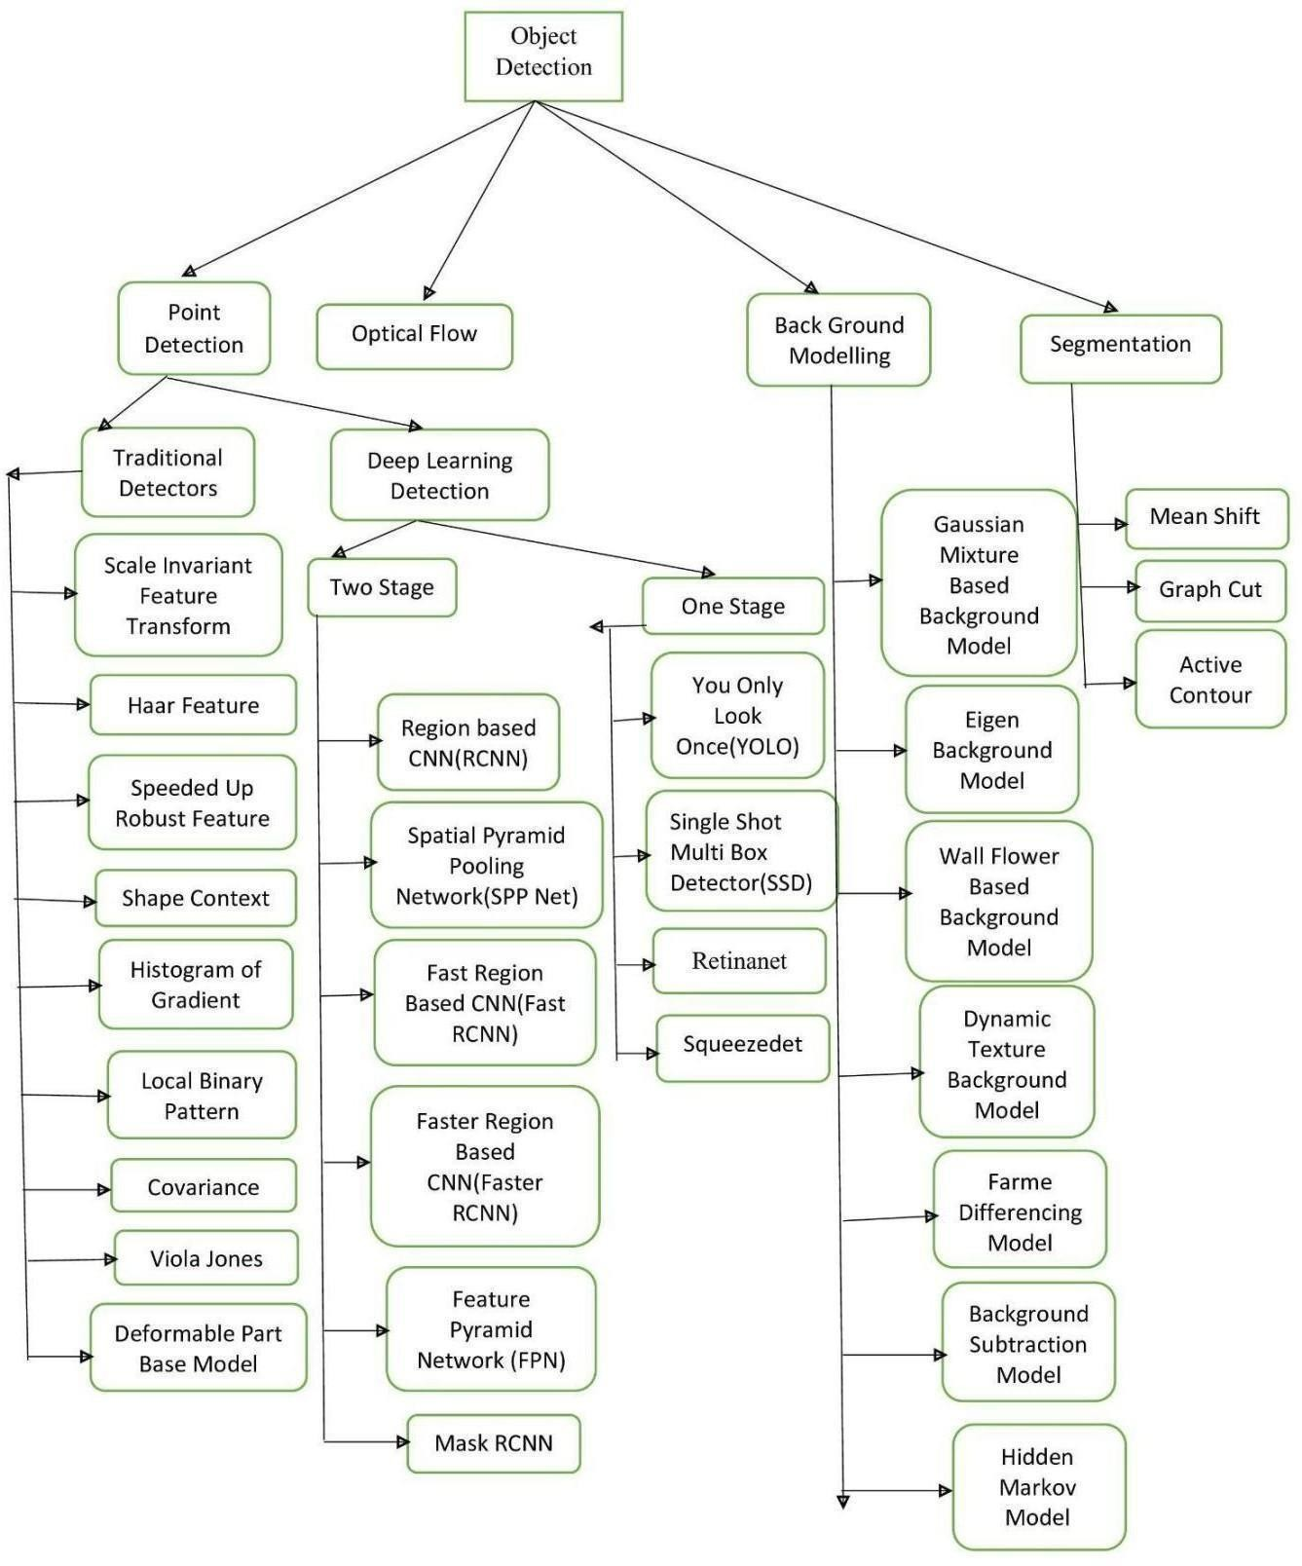

## **Figure 1.4: Approaches in Object Detectio**

**1.6 Datasets and Tools**

Large datasets and powerful tools have been crucial to the success of deep learning in computer vision [21].

**Popular Datasets**

* **CIFAR-10:** Includes 60,000 color, 32x32 photos divided into 10 classes.
* **ImageNet:** A large-scale dataset with millions of images across thousands of classes.
* **COCO:** A richly annotated dataset for object detection, segmentation, and captioning.

**Deep Learning Frameworks**

* **TensorFlow:** A Google library that is freely available and is frequently used for neural network construction and training [22].
* **PyTorch:** Known for its user-friendliness and dynamic calculation graph, Facebook developed the system.
* **Keras:** An advanced neural network API built on top of TensorFlow that makes model building and training easier.
  1. **. Conclusion**

Neural networks have played a key role in the rapid advancement of computer vision and deep learning, allowing machines to interpret and process visual information. These technologies are transforming a number of sectors by revolutionizing processes including object identification, image segmentation, and image recognition. Researchers and practitioners can train and assess models to achieve high accuracy in visual tasks by using datasets such as CIFAR-10. Large-scale datasets, increased computing power, and algorithmic breakthroughs are driving this field's development, which bodes well for future innovation and useful applications.

#### Deep learning has brought about a revolutionary shift in computer vision by enabling robots to perceive and interpret visual data with unprecedented efficiency and precision. This change has been largely attributed to the development and refinement of neural network architectures, such as Convolutional Neural Networks (CNNs), which are primarily meant to process and analyze visual data.

#### **Key Achievements**

1. **Object Recognition and Classification**: In many object recognition tasks, deep learning models have outperformed humans, opening up new applications such as automated image tagging, real-time video analysis, and sophisticated surveillance systems.
2. **Object Detection and Localization**: Techniques like YOLO (You Only Look Once), SSD (Single Shot MultiBox Detector), and R-CNNs (Region-based CNNs) have transformed autonomous driving and robotic vision by enabling exact recognition and localization of many things inside a single image.
3. **Image Segmentation**: Deep learning has made it possible to precisely segment images into relevant sections, which has made applications possible in a variety of fields, including agricultural monitoring for crop health assessment and medical imaging for tumor diagnosis.
4. **Generative Models**: Variational Autoencoders (VAEs) and Generative Adversarial Networks (GANs) have opened up new possibilities in image production and augmentation. These methods make it possible to produce realistic visuals, restore damaged images, and even produce artistic works of art.

**Challenges and Future Directions**

Despite these advancements, several challenges remain:

* **Data Requirements**: Large volumes of labeled data are often needed for training deep learning models, and gathering and curating this data can be resource-intensive.
* **Computational Resources**: Deep learning models can be difficult to train and implement widely since they require a lot of processing power.
* **Interpretability**: Deep learning models are black-box algorithms, which makes it challenging to comprehend and trust the decisions they make. This presents problems for important applications such as autonomous cars and healthcare.

Upcoming studies will probably concentrate on finding more effective ways to learn from data, enhancing the interpretability of models, and increasing their computing efficiency. Furthermore, combining deep learning with other AI paradigms—like unsupervised learning and reinforcement learning—holds the potential to produce computer vision systems that are more resilient and adaptable.

**References:**

1. LeCun, Y., Bengio, Y., & Hinton, G. (2015). Deep learning. *nature*, *521*(7553), 436-444.
2. Hatcher, W. G., & Yu, W. (2018). A survey of deep learning: Platforms, applications and emerging research trends. *IEEE access*, *6*, 24411-24432.
3. Rosenblatt, F. (1961). *Principles of neurodynamics. perceptrons and the theory of brain mechanisms*. Cornell Aeronautical Lab Inc Buffalo NY.
4. Bhardwaj, A., Di, W., & Wei, J. (2018). *Deep Learning Essentials: Your hands-on guide to the fundamentals of deep learning and neural network modeling*. Packt Publishing Ltd.
5. Nwankpa, C., Ijomah, W., Gachagan, A., & Marshall, S. (2018). Activation functions: Comparison of trends in practice and research for deep learning. *arXiv preprint arXiv:1811.03378*.
6. Sharma, S., Sharma, S., & Athaiya, A. (2017). Activation functions in neural networks. *Towards Data Sci*, *6*(12), 310-316.
7. Lin, Min, Qiang Chen, and Shuicheng Yan. "Network in network." *arXiv preprint arXiv:1312.4400* (2013).
8. Zhang, J. R., Zhang, J., Lok, T. M., & Lyu, M. R. (2007). A hybrid particle swarm optimization–back-propagation algorithm for feedforward neural network training. *Applied mathematics and computation*, *185*(2), 1026-1037.
9. Deng, L. (2014). A tutorial survey of architectures, algorithms, and applications for deep learning. *APSIPA transactions on Signal and Information Processing*, *3*, e2.
10. Lin, T., Horne, B. G., Tino, P., & Giles, C. L. (1996). Learning long-term dependencies in NARX recurrent neural networks. *IEEE transactions on neural networks*, *7*(6), 1329-1338.
11. Nixon, M., & Aguado, A. (2019). *Feature extraction and image processing for computer vision*. Academic press.
12. Welsh, T., Ashikhmin, M., & Mueller, K. (2002, July). Transferring color to greyscale images. In *Proceedings of the 29th annual conference on Computer graphics and interactive techniques* (pp. 277-280).
13. Thompson, W. B., & Pong, T. C. (1990). Detecting moving objects. *International journal of computer vision*, *4*(1), 39-57.
14. Hatcher, W. G., & Yu, W. (2018). A survey of deep learning: Platforms, applications and emerging research trends. *IEEE access*, *6*, 24411-24432.
15. Li, Z., Liu, F., Yang, W., Peng, S., & Zhou, J. (2021). A survey of convolutional neural networks: analysis, applications, and prospects. *IEEE transactions on neural networks and learning systems*, *33*(12), 6999-7019.
16. Liu, Y., Cheng, M. M., Hu, X., Wang, K., & Bai, X. (2017). Richer convolutional features for edge detection. In *Proceedings of the IEEE conference on computer vision and pattern recognition* (pp. 3000-3009).
17. Pham, H., Guan, M., Zoph, B., Le, Q., & Dean, J. (2018, July). Efficient neural architecture search via parameters sharing. In *International conference on machine learning* (pp. 4095-4104). PMLR.
18. Voulodimos, A., Doulamis, N., Doulamis, A., & Protopapadakis, E. (2018). Deep learning for computer vision: A brief review. *Computational intelligence and neuroscience*, *2018*(1), 7068349.
19. Sarker, I. H. (2021). Deep learning: a comprehensive overview on techniques, taxonomy, applications and research directions. *SN computer science*, *2*(6), 420.
20. Marcelino, P. (2018). Transfer learning from pre-trained models. *Towards data science*, *10*(330), 23.
21. Goodfellow, I., Bengio, Y., & Courville, A. (2016). *Deep learning*. MIT press.
22. Goldsborough, P. (2016). A tour of tensorflow. *arXiv preprint arXiv:1610.01178*.