**PREVENTING LOSS OF KNOWLEDGE BY RETRIEVAL PRACTICE AND SPACED LEARNING**

by

**Dr. Harshavardhan Balaganesan MBBS., MD., MHPE.,**

**TABLE OF CONTENTS**

|  |  |
| --- | --- |
| TOPIC | PAGE NO |
| 1. IMPORTANCE AND RELEVANCE | 01 |
| 1. BRIEF HISTORY | 02 |
| 1. ORIGIN AND INITIAL EXPERIENCE | 07 |
| 1. CURRENT LITERATURE ON THE TOPIC | 10 |
| 1. RESULT OF PREVIOUS STUDIES ABROAD | 16 |
| 1. IMPLEMENTATION IN THE INDIAN SITUATION | 22 |
| 1. CONCLUSION | 28 |
| 1. REFERENCES | 29 |
| 1. ANNEXURE – PLAGIARISM CERTIFICATE | 32 |

**PREVENTING LOSS OF KNOWLEDGE BY RETRIEVAL PRACTICE AND SPACED LEARNING**

**1. IMPORTANCE AND RELEVANCE**

At every stage of training, students in the medical field must learn, remember, and apply a large amount of material. Gained Knowledge degrades with time. But the main aim in education is to retain newly acquired knowledge. Reviewing study material often and on different occasions is a good strategy to ensure memory retention (1).The knowledge that the students have received gradually disappears if they do not use it once the course is over. In 1913, Ebbinghaus was the first to document on the rate of knowledge loss and termed it as ‘Forgetting Curve’.

Retrieval practice can be emphasised in the classroom itself when it is planned. It can range from using multiple choice questions, written essay response, group discussion or a project that requires using acquired cognitive capacity. Brain dump can be used in a teaching session, wherein small open ended questions are given as a trigger to jog through the learner’s memory. Spotters or flashcards also enables the learners to retrieve their knowledge in an effective way and is also less time consuming. In other words, all group activities, brainstorming sessions and concept mapping, all works as an effective retrieval practice as long as the learner is actively engaged in the activity.

With the advances in technology and availability of multiple digital applications the learning can be boosted by incorporating it during the learning session. For medical education, there are curriculum and syllabus contents available and so effective lesson plan can be created based on how the learners would be able to use the knowledge that they are learning. Spaced retrieval ensures that after teaching, the students are checked multiple times before their final summative examination thereby enhancing their long term memory retention.

**2. BRIEF HISTORY**

Knowledge retention generally refers to the procedure of taking in and remembering information. In the olden days before texts or scripts were in use, the only way they can transfer information was verbally and to do that effectively, knowledge retention had to outstanding. Knowledge retention makes information transferable and as the years advanced, different ways were used to do it effectively ranging from scripts to digital data. But the more the people started to store the knowledge externally in texts and digitally, the less they started to revisit the knowledge, and that might also play a part in their forgetting.

The three main processes involved in memory are encoding, storage and recalling or retrieving. The main challenge is to learn new information and at the same time remember the previously acquired knowledge. This is possible when the knowledge that is newly acquired is built on the pre-existing memory and thereby creating a meaningful correlation enabling them remember it better and for a longer duration.

In 1885, Ebbinghaus, German psychologist plotted the process of forgetting that happens with the lapse of time in the form of forgetting curve which was reproducible(2). He had suggested that mnemonic techniques and spaced repetition would be better methods for strengthening the memory. Additional research also revealed that the rate of forgetting would be slower the more the knowledge was initially gained.

The Forgetting Curve (Figure 1) is a mathematical function that depicts how quickly we forget newly acquired information over time. It shows that unless information is actively practised, memory retention declines over time. The graph indicates that memory retention declines quickly in the initial few hours or days following learning, then declines more gradually over a longer period of time.

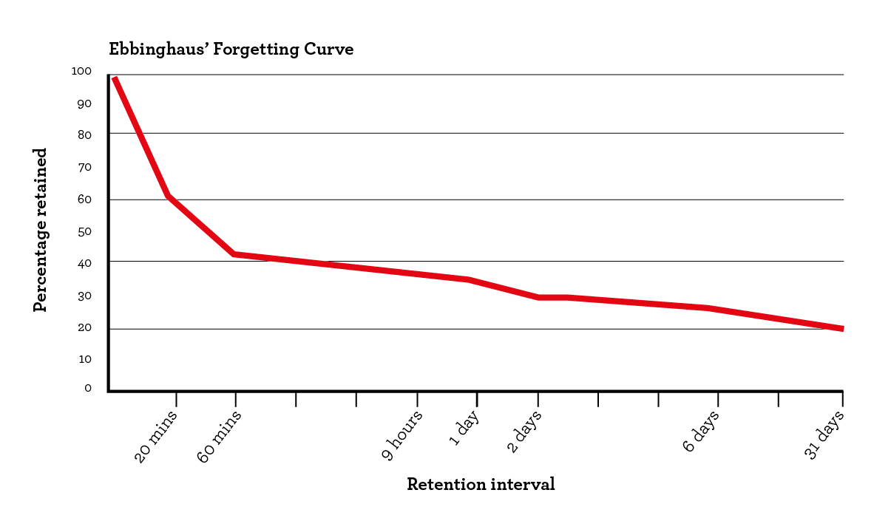

**Figure 1: A typical representation of the forgetting curve.**

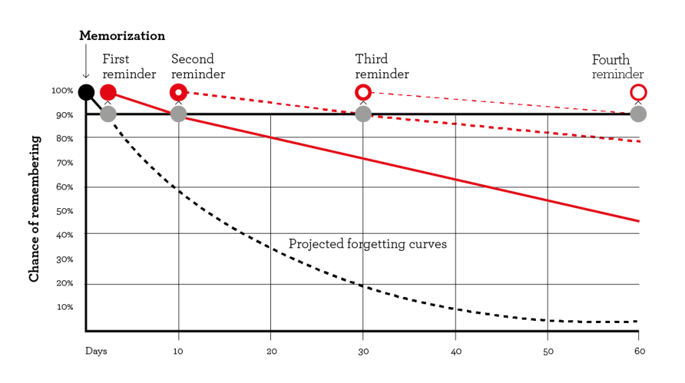

**Figure 2: Effect of spaced learning in reducing the knowledge loss**

Various variables, such as the kind of information, its complexity, and the person's cognitive ability, might affect the Forgetting Curve. Ebbinghaus initially used lists of meaningless syllables for his studies, but his conclusions hold true for all kinds of information.

The Forgetting Curve has substantial implications for teachers and students since it sheds light on the best practises for information learning and retention. In order to help students recall information for longer periods of time, educators might build their teaching techniques with the understanding of the forgetting curve.

The Forgetting Curve also highlights the importance of reviewing information regularly to help reinforce and retain it. It also emphasizes the need for active learning strategies, such as problem-solving, critical thinking, and concept mapping, which can help learners retain information for more extended periods.

There are various strategies that individuals can use to mitigate the impact of the forgetting curve, including:

1. **Spaced Repetition**: One of the most effective ways to mitigate the forgetting curve is through spaced repetition. This technique involves reviewing information at increasing intervals, starting from a few hours after learning and gradually increasing the time between reviews.
2. **Active Recall:** Active recall involves actively retrieving information from memory rather than passively reading it. This technique has been shown to be more effective in retaining information than passive reading.
3. **Mnemonics:** Mnemonics are memory aids that help learners remember information by associating it with a memorable image or phrase. This technique can be particularly effective in retaining complex information.
4. **Elaboration:** Elaboration involves linking new information to existing knowledge, which can help reinforce and retain it. This technique can be particularly effective in retaining complex information.

The decline in memory depends on the strength of the memory, its relevance, the time from which it was initially created, the presentation manner and the feeling that it had created.

When students increased the time between study sessions of the same subject, their recall level of the material also increased, according to a meta-analysis of 839 assessments of spacing in 184 research publications (3).

With the use of breaks, study time can be spread out over a longer length of time using the learning approach known as spaced practise. Even though there are multiple studies performed, the time periods for an effective interstudy space is not clearly defined.

Retrieval practise, also referred to as the testing effect, is a cognitive psychology phenomena that has been employed in education to boost long-term retention (4). Retrieval practise can be done during teaching and learning as well as during assessment.

During implementing retrieval practice during the teaching session, active engagement of the students would be made possible and feedbacks can be given to them immediately. The challenges would be in identifying the optimum spacing between learning and retrieving, supporting the students for the retrieval practice and formulate a plan to address to students who are not improving.

For self-directed learning, the retrieval works when the leaner recollects the acquired knowledge in regular intervals. Digital application based retrieval could be beneficial at an individual level for self-directed learners.

Instead of studying material repeatedly, taking a test or engaging in a memory-based activity improves long-term retention (4). But periodic re-learning, by preventing memory decay will also aid in long term memory and also aids in refinement of the understanding of the concept and their application(5). Without retrieval practice-based assessment, teachers and students would only be able to guess at the knowledge that learners hold.

With the use of breaks, study time can be spread out over a longer length of time using the learning approach known as spaced practice. Reading for 1 to 2 hours per day for a week will be more effective than cramming 12 hours in a single session. Interval between the study sessions will allow for neural consolidation that would result in augmenting long term memory.

When a student learns an unfamiliar content, the brain will struggle to establish the appropriate neural connections. One strategy for strengthening brain connections is to periodically step away from the material that one is studying and then come back to it repeatedly. This revisiting is believed to aid in the formation of permanent linkages in long-term memory as well as the development of preferential neural patterns in both the procedural and declarative pathways (6).

Durable learning includes both spaced learning and spaced retrieval as complementing components. The ideal method for long-term understanding is spaced practice with a longer interstudy (free) period.

**3. ORIGIN AND INITIAL EXPERIENCE** (Rationale)

Education was delivered and transmitted orally rather than in writing in ancient India. The initial step in education was Shravana (hearing), which is the process of learning through paying attention to the Shrutis. The second activity is manana (reflection), where students ponder, examine, and draw conclusions. The third is Nididhysana, when the students apply what they have learned to their everyday lives.

The majority of education was based on the Veda (hymns, formulae, and incantations, recited or chanted) and later Hindu writings and scriptures throughout the Vedic period, which lasted from approximately 1500 BC to 600 BC. According to the Vedas, liberation is the primary goal of education. There was medical information that was taught like herbal remedies for ailments or disorders like fever, cough, baldness, snake bite, and others. Ayurveda was among the subjects taught in the classroom. To transcend the huge volumes of knowledge through just orally without any written text in the olden days, needed them to possess precise remembering, recalling and narrating techniques emphasising that they must have had an excellent retrieval practice. The majority of education in ancient India was provided in Ashramas, which were governed by teachers or Gurus. There were also some well-known universities for medical training, like Taxilla, Nalanda, and Banaras (7).

During the Medieval period, the main European universities in the Middle Ages were based in Italy and France. This meant students from the British Isles or other countries had to travel to study medicine. In Europe, before important medical figures such as Hippocrates and Galen, what passed as medical knowledge was based on astrology, religion and superstition. The Ancient Greek physician Hippocrates was hailed by Medieval doctors as the ‘Father of Medicine’. He was one of the earliest doctors to believe that diseases and illnesses had natural rather than supernatural causes.

In the modern age, many educationalists have come up with a wide variety of concepts and methodology to make teaching effective and thereby ensuring student’s long term memory.

Many cognitive psychologists believe that the long-term memory is divided into two distinct types: explicit memory and implicit memory. Explicit memory, also known as declarative memory, is made up of memories that we are conscious of remembering and capable of describing in words. Implicit memory, also known as non-declarative memory, consists of subconscious memories, like knowledge that allows us to carry out basic tasks without even realizing we are recalling the information.

To ensure the long term retention of knowledge acquired the following memorizing strategies are suggested:

* Multiple repetition
* Using different methods to present the same information
* Integrating stories to trigger emotional connection
* Using scenarios and simulations to access previously learned content
* Chunking of learning material
* Promoting active retrieval of previously acquired knowledge

Preclinical knowledge's unequal retention and the possibility of forgetting details of significant clinical importance are inevitable consequences of its lack of application(8).

According to the Dual memory theory, studying alone strengthens an existing memory trace, while testing leads to the formation of a new memory trace (1).

Retrieval practise has a lot of potential as a way to encourage and improve long-term retention of professional attitudes and behaviours, according to published literature. Students will have the chance to align their professional compass to the correct orientation by being given real-world scenarios that have been verified by medical school instructors and administration. Additionally, developing formative feedback assessment methods would create the groundwork for several research to ascertain the long-term effects of early professional inculcation. This might include practise during residency and afterward, going far beyond the professional stage(4).

Testing the knowledge aid in better long term memory retention. The following are the benefits of testing (9):

* The testing effect: Retrieval aids later retention
* Testing identifies gaps in knowledge.
* Testing causes students to learn more from the next learning episode.
* Testing produces better organization of knowledge.
* Testing improves transfer of knowledge to new contexts.
* Testing can facilitate retrieval of information that was not tested.
* Testing improves metacognitive monitoring.
* Testing prevents interference from prior material when learning new material.
* Testing provides feedback to instructors.
* Frequent testing encourages students to study.

**4. CURRENT LITERATURE ON THE TOPIC**

(Comprehensive Review (Pros and Cons)

Pros

The following are the pros of retrieval practice and spaced learning:

**Long Term Memory:**

Multiple studies have showed that the spaced learning and spaced retrieval strategies aid in enhancing the long term memory (1,4,6,8,10). Spaced learning, by leaving gaps between the learning enhances the retention and the retrieval when spaced, triggers the earlier stored knowledge and aiding in concept concretization and reduced memory decay.

**Improved Performance:**

With the better long term memory, the students or the learners would be able to perform better when evaluated (11,12).

**Better Self Confidence:**

The ability of the students to retain memory for a longer time enables and improving their performance provides better self-confidence not just in facing examination but in real life scenarios too (1,13).

**Reduced student anxiety:**

Final summative examination usually makes the students very anxious. When the students have equipped enough it reduces the anxiety that they would encounter (13).

**Organizing the knowledge:**

Other than just be able to recollect, multiple retrieval will also aid in organizing and consolidating the knowledge (6). When a student or learner gets involved in spaced retrieval, as they re-visit they knowledge provided multiple times, it creates better understanding of it and thereby organizing it in an effective manner. Spacing generally enhances the generalization of learning and the retention of acquired knowledge (14)

**Can be performed at various levels:**

The implementation of spaced learning and knowledge retrieval can be performed at various levels, right from curriculum implementation to individual level. So depending on the feasibility, spaced retrieval can be followed. If possible spaced learning can be planned during curricular implementation level along with alignment of the subject topics. But that would require a lot of time in making it effective. But during planning the teaching learning sessions, the teachers can make sure of using group activities, discussion or concept mapping to emphasize retrieval. The assignments and the assessments when planned will also aid in better knowledge retrieval and thereby creating better long term memory retention. Having multiple evaluations in the form of formative assessments would aid in better retrieval practice and encourage spaced learning by the students. Cognitive and psychomotor components when evaluated in a spaced manner would encourage the knowledge retrieval and thereby would be able to demonstrate the skill efficiently.

**Students with different learning styles will be equally benefited:**

The retrieval practice will work for students with different learning styles in a similar manner because, here the information is not introduced into them but taken out of them. While retrieving every individual will have a unique way in recollecting, they might remember what they had read from a book or from a lecture or from a video that they had watched or from a podcast that they had heard.

Cons

The following are the cons of retrieval practice and spaced learning:

**No single effective length of time between exposures and the quantity of exposures:**

The length of time between exposures and the quantity of exposures necessary to achieve long-term memory are two key issues in spaced learning. But both of these are not yet very clearly defined. Although we know that most of the acquired knowledge starts to reduce within a week if not revisited(2), there is no specific time duration that is proved effective. Repetition within 24 hours to few days and weeks have all proven effective, but they is no specific recommendation in it. Even though the quantity of exposures makes knowledge retention effective, even for this there is no specific duration until which exposure is needed.

**Students may become frustrated with retrieval practise if they feel like they don't recall as much as they thought they did:**

Students must be oriented that gradual decrease in the knowledge acquired is a normal phenomenon and it could be combated by repetition and spaced learning. Because when performing the spaced retrieval assessments, during the initial retrievals, the knowledge drop one can encounter can get them frustrated. But this challenge can be tackled with orienting students and adequately spaced learning.

**Dedicated staff to monitor the spaced learning:**

The challenge in effectively spacing through assessment based retrieval practice is the manpower needed to monitor. With the increase in the number of students this is even more difficult. The teachers should be oriented towards this at an early duration, thereby enabling them to find the best possible way in the scenario they are in. Technology and mobile applications will also be useful in effective retrieval practice aiding the teachers.

**Few adult learners who are not motivated enough would not equally benefited:**

For a retrieval practice to be made effective, it is finally the student or the learner who has to retrieve the acquired knowledge. The active engagement of the students in the group activities will result in better knowledge retention. When they are not motivated, even when there are group activities targeting knowledge retrieval, one might not effectively participate in it and thereby might not get benefited out of it. In such a scenario, spaced assessment based knowledge retrieval would be beneficial. If still the student is not getting benefited, they might be needing additional curricular support. Dealing with less motivated students will be challenging for the teachers and that too with more number of students in a course.

**Curricular changes might be needed to make it effective:**

To make the necessary planning for spaced learning, curricular changes might be needed for the course for making better alignment of objectives, optimal learning experiences through spacing and evaluation approach.

**Time to conduct:**

As the number of students increase, the time to conduct assessment based retrieval become challenging too. Even for spaced learning, for the courses having a vast course content, the total time needed to revisit the contents will be more. Most of the studies conducted have used mobile technology to engage students either in for spaced learning by providing digital study material or retrieval by MCQ based assessments. So, when the student’s free time is planned to be used, it ultimately falls on how effective the student is going to use it.

**Retrieval induced forgetting:**

Retrieval-induced forgetting (RIF) is a memory phenomena in which recalling results in the loss of previously retained information. Even if retrieval is unsuccessful, when a category of information is learnt and only a portion of it is provided for recall at a later time, the memory of the presented information is reinforced and the memory of the unpresented information is diminished. RIF’s effect emerged when recognition was self-paced but not when participants were forced to make their judgments very quickly. Retrieval-induced forgetfulness may be lessened by grouping together relevant categorical information. RIF's effects were countered by the fact that forgotten material was retained more quickly than other information that had not yet been seen (15,16).

**Critiques:**

First criticism is on the information that testing improves transfer of knowledge to new contexts. Retrieval practise or testing study has drawn criticism for the possibility that students are memorising trivial details out of habit. Critics claim that testing is simply a modern version of the old ''kill and drill'' educational method from a century ago, producing ''inert knowledge'' that cannot be applied to fresh circumstances. However, others who support testing contend that retrieval practise results in information that is easily available and flexible enough to be applied to new challenges. This problem raises the critical question of whether retrieval practise's knowledge acquisition (in comparison to other procedures) can be adapted to new contexts. Studies have showed that the retrieval practise also enhances the transfer of knowledge to new contexts, demonstrating that the mnemonic benefits of taking a test go beyond the particular questions or topics that were examined (9).

Transfer may be defined as applying knowledge learned in one situation to a new situation. Researchers often categorize transfer as being near or far; near transfer occurs if the new situation is similar to the learning situation, whereas far transfer occurs if the new situation is very different from the learning situation (16).

Second criticism is on the information that frequent testing encourages student to study but will it be equal for simple and challenging materials. According to the discrepancy reduction model, for study time allocation is the assumption that students will have unlimited time to study. But in reality the decisions students make regarding what material to study change considerably when a time limit is applied. Students frequently study content that is just out of their current grasp rather than that which is the most challenging. The proximal learning framework model suggests that students will attempt to learn the material that is the most challenging for them down the lane pushing it to the last bit of the allotted time. When given a short amount of time to study, students frequently skip the most challenging material since they won't have enough time to master it. According to the study, students learned better when they choose what to study rather than when the experimenter provided the material. This finding implies that students are capable of making study decisions that will ultimately improve their own exam performance, at least at the level of choosing specific knowledge items to study (9).

Third criticism is on the information that testing based retrieval aids later retention. The knowledge retention might not be due to the testing at all. Instead, testing just permitted focused restudy of the information. So, the process of restudying may lead to a better performance as it would aid them to remember better. During testing, the students would be able to restudy only the information they might recall. Whereas, if they are just restudying, then they would have to go through the entire study material. Studies comparing groups, with one group of students restudying the set of material for the same amount of time that other group is engaged in taking a test showed that the testing effects did not disappear for the restudy control group and further studies were able to come to a conclusion that the testing effect is mostly due to causes other than just restudying the material (9).

**5. RESULTS OF PREVIOUS STUDIES ABROAD**

Study done at Radboud Institute for Health Sciences, Nijmegen, **Netherlands** by Donker et al involving Dutch Medical Sciences students, had 14 spaced examination with 80 questions each indicated knowledge preservation related to retrieval practice and spaced learning. The retrospective cohort study analysed examination results of medical and biomedical science students who had pursued Mechanisms of Health and Disease two year program where the questions from a new topic were labelled as regular questions (RQ) and when it was repeated in the subsequent exam with 3 questions from the same topic were labelled as retrieval practice questions (RPQ). Since each question may only be selected from the question pool once, every exam was distinct and had a separate set of questions. Data analysis was focused on identifying the relationship between the number of repetitions on question score and quality. The RPQs had a tiny but significantly larger proportion of accurate and incorrect responses compared to RQs, and there were also much fewer open-ended questions. According to the preservation of the mean score for the questions, this suggests that students were more likely to respond to RPQs. The absence of the "forgetting curve" was further supported by time-dependent examination of RPQs, which showed no significant change over several repetitions. This showed that information was being preserved within the programme under investigation. Third, RPQs' ability to discriminate was modestly but considerably lower than RQs, as measured by the RiT. Fourth, time-dependent analysis showed a negligible, inverse relationship between the total number of repetitions and the RiT score. The study suggested that using RPQs over the course of a two-year educational programme prevented considerable knowledge loss while maintaining the standard of the exams. The small increase in both the correct and incorrect responses for the RPQs with reduced percentage of non-answering suggested that the confidence levels were improved. (1)

Study done at University of Saskatchewan, **Canada** showed that in the three basic science courses tested, there was a significant loss of knowledge among medical students, and this loss varied across the courses. The grades on the final exam or the students' evaluation of the course's quality do not appear to be related to knowledge loss (10).

Study done at Chicago, **USA** by Kuperstock et al showed that spaced repetition using mobile technology was associated with improved trainee examination performance (11). In the study, prior to their in-service exam, residents were given access to an otolaryngology question bank on a spaced repetition review application. The scores of the participating residents increased by 3% when the post-graduate year was taken into account (11).

Residents in a study by Dabiri at Tehran University of Medical Sciences, **Iran** were given daily multiple-choice questions that were repeated every 10 days. Despite not exhibiting any significant difference from similar learners in prior years, residents at this programme performed statistically considerably better than similar learners on their national examination. In this study, a ten-day fixed interval with three repetitions had some positive impacts on the summative evaluation (17).

Study done by Smeds at **USA** showed that the usage of a spaced education app-based tool by third-year medical students during a general surgery rotation raised their final NBME exam scores. Three and seven days, respectively, found to be an effective spacing period in this study for wrong and right responses (18).

Study done by Matos et al at Beth Israel Deaconess Medical Center, Boston, Massachusetts, **USA** showed that spaced education using electronic intervention to medical residents improved the knowledge retention and competency. The study was limited due to the lower response rate. The study showed that repeating the Clinical Pearls led to considerably higher exam scores among interns, possibly as a result of their higher attendance at didactic sessions and involvement with the Clinical Pearls when compared to the residents (19).

In a study by Kerfoot et al, at Harvard medical school, **USA** examined spaced practise by sending short clinical questions or case studies on urology-related themes through email to its third-year medical students on a regular basis. Only two of the four necessary urological subjects were assigned to students at random in these email assignments. Even while spaced retrieval effects may possibly have contributed to the students' improved marks, the final tests demonstrated that the spaced learning email assignments had a favourable influence on the students' scores (20).

Pilot study done by Moulton et al at University of Toronto, **Canada**, examined the use of spaced learning for laparoscopic suturing methods in microvascular anastomosis showed that the group which received instruction in spaced learning outperformed the students who had received traditional training in all areas of the surgical assessment. They discovered that the students who used spaced learning were less anxious and felt more confident in their abilities than the students who practised in large groups according to traditional methods. They compared massed and spaced groups that trained in microsurgery on PVC-artery models and arteries from a turkey thigh, and then examined how well those skills transferred to a live rat one month later. They discovered that the dispersed group outperformed the massed group by a wide margin on a number of outcome metrics (13).

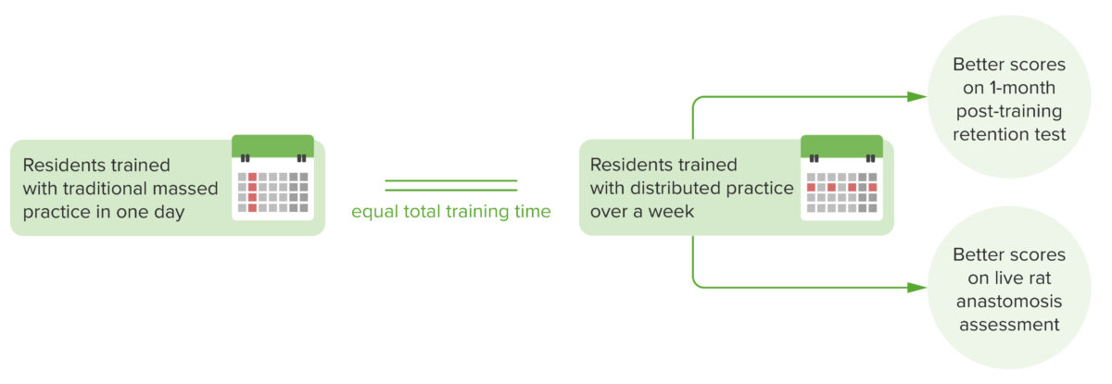

**Figure 3: Spacing effect successful with surgical resident training** (13)

**Table 1: Comparison between various studies performed abroad**

|  |  |  |  |  |  |  |  |  |
| --- | --- | --- | --- | --- | --- | --- | --- | --- |
| SL.No | Study by | Type of Study | Place, Country | Year | Students involved | Subject/ Speciality | Total number of participants | Remarks |
| 1. | Donker et al  (1) | Retrospective cohort study | Nijmegen, The Netherlands | 2022 | UG | Medical students and biomedical sciences students – Mechanism of Health and disease program | 400 | It suggested that the cumulative examination approach would work well to combat the forgetting curve. |
| 2. | MarcelFD'Eon  (10) | Prospective Study | Saskatchewan, Canada | 2006 | UG | Three first year courses: Immunology, physiology, and neuroanatomy | 20 | In the three basic science courses examined, there was a significant loss of knowledge among medical students, and this loss varied by course. |
| 3. | Kuperstock et al (11) | Cohort | Chicago, USA | 2019 | PG | Otolaryngology | 11 | Spaced repetition using mobile technology is associated with improved resident student performance |
| 4. | Sasan Dabiri (17) | Quasi-experimental study | Tehran, Iran | 2019 | PG | Otolaryngology | 44 | MCQ spaced repetition using mobile technology for Post graduate residents  (Spaced learning was every 10 days) |
| 5. | Smeds(18) | Observational cohort | Arkansas, USA | 2016 | UG | General Surgery | 152 | Third year Medical students used mobile app for spaced repetition at 3 and 7 days for wrong and right questions. |
| 6. | Matos et al  (19) | Randomized trial | Boston, Massachusetts, USA | 2017 | PG | Internal Medicine | 160 | Repeating the Clinical Pearls led to considerably higher exam scores among interns, possibly as a result of their higher attendance at didactic sessions and involvement with the Clinical Pearls when compared to the residents |
| 7. | Kerfoot et al  (20) | Cohort study | Boston, MA, USA | 2007 | UG | Third year Medical student in Surgical rotation | 133 | Spaced education consisting of clinical scenarios and questions distributed weekly via e-mail can significantly improve students’ retention of medical knowledge |
| 8. | Moulton et al  (13) | Randomized controlled trial | Toronto, Ontario, Canada | 2006 | PG | Junior surgical residents | 38 | Randomly were assigned to either massed (1 day) or distributed (weekly) practice regimens, and were taught a new skill (microvascular anastomosis) |

Higher generalisation performance for both simple and complicated topics was obtained by spacing lessons out over time. The benefits of the spacing effect for educational practises and curriculum are strengthened by the promotion of various types of learning through spaced learning schedules (21).

**6. IMPLEMENTATION IN THE INDIAN SITUATION**

Implementation can occur at the curricular level, the teacher level and at the student level.

* At the curricular level, based on the intended learning outcomes and the graduate attributes, interleaving courses in the form of integration and spaced assessments would provide ways to enhance the student memory retention. In Medical Education, there are competencies provided for various courses and suggestions for integration area also provided along with the assessments. But there is no clear road map of how to conduct the assessments and there is no emphasis on re-assessments. Having moving towards the single best answer based question in the upcoming NEXT examinations, ensuring that the formative assessments care spaced and are in alignment with it. For every subject, SBA data base to be created and that could be used to evaluate and re-evaluate the students with spacing to enhance their memory retrieval practice and thereby aiding them in better long term memory and better performance.
* At the teacher level, from creating a lesson plan till evaluation retrieval practice can be incorporated. Within the classroom, for large group teaching and for small group teaching as well, knowledge retrieving triggers can be used. Group activities especially making the students actively participating in it would enable them to retrieve previously acquired knowledge promoting them to create platform for the new knowledge that is to be imbibed. Re-evaluations in a spaced manner could be incorporated. Even a few questions from the previous assessments can be repeated in the next assessment, thereby promoting the knowledge retrieval practice.
* At the student level, orientation about this would aid them in using flash cards, mnemonics, mobile or application based platforms to promote knowledge retrieval and spacing. The common thing that happens is the student reads a topic once and never revisits the topic or tries to retrieve the knowledge acquired but keep on reading different topics and after a long duration feels difficult to recollect the knowledge to an extent where they feel they have completely forgotten it. This could be battled effectively when the student is aware of it and has a plan to handle it.

Based on the systems approach, the curricular refinement and the teacher would be the input, the teaching learning methods would form the process and the output being a student with a long term knowledge retention making them a competent IMG. Based on the feedbacks from the student and the evaluation results the process can be tweaked to better benefit the student.

The competency based medical education emphasizing the horizontal and vertical integration works for knowledge interleaving that would enhance the student memory retention and thereby promoting Connectivism by able to remember, recollect and connect.

There are few studies that have performed studies in India on retrieval practice and spaced learning.

In a study at Puducherry, India, showed that the students' learning and recall were significantly influenced by spaced learning, which improved their performance on the exam. The mean score for the test administered without spaced learning was 49.30 out of a possible 100. The mean score on the exam administered following spaced learning was 60.57 out of a possible 100. This study did not evaluate the effects on outcomes related to long-term memory (12). It would be better to perform a cohort study replicating the spacing effect over the entire medical curriculum and to analyse the long term effects.

Study by Chugh et al at NewDelhi, India showed that their medical students' recall was increased by spaced repetitions and learning that was reinforced by tests. Their research stressed the potential for improved higher-order thinking and elaborative processing, as well as for improved learning in the future. Researchers must specify conceptual and theoretical frameworks, focused study objectives, well-defined intervention and comparison interventions, and outcome measures in order to build the evidence base (22).

**Table 2: Comparison between various studies performed in India**

|  |  |  |  |  |  |  |  |  |
| --- | --- | --- | --- | --- | --- | --- | --- | --- |
| SL.No | Study by | Type of Study | Place, Country | Year | Students involved | Subject/ Speciality | Total participants in the study | Remarks |
| 1. | Kumar Kommu et al  (12) | Analytical study | Puducherry, India | 2023 | UG | Final year Medical students, Paediatric | 37 | The total duration of this “spaced” learning came to over 8 weeks |
| 2. | Chugh and Tripathi(22) | Randomized control study | New Dehli, India | 2020 | UG | Third semester Medical Students | 148 | The spaced educational material significantly increased composite formative exam scores at 24 weeks, and even though the scores declined at 72 weeks, there was still a retention of knowledge. |

By regularly scheduling the topics, students' memory is improved and the usefulness of spaced relearning is increased, especially students needing additional curricular support (23).

It is very much possible to implement spaced learning emphasising on retrieval practices in India. As such the CBME curriculum tries to provide a framework using which the desired planning can be made during curriculum implementation and scheduling. The constraints in implicating spaced learning are increased number of students and less number of teaching faculties.

As the number of medical students keep increasing, even the small group teaching numbers are larger. To efficiently guide the students and teach them is challenging as the personalized care that the student gets from the teachers gets reduced. So there are possibilities of students who are not actively participating in group activities emphasising spaced retrieval and learning and might even be not noted. As the student population increase, relying on technology to aid in spaced learning appears more practical and effective. So, with technological updates and including AI in it to monitor the students’ progress would be the way forward.

The teaching faculties should be aware of the benefits of spaced learning for them to make necessary lesson plans and evaluations. As the student numbers increases, and without the proportional increase number of the full time teachers physically available, to effectively plan and implement spaced education is challenging. Teaching in a discipline is a combined effort by the teachers handling it. If there is no consensus within them, there might only be partial implementation at individual sessions and not in all the teaching sessions.

Low and high achievers might be differentially benefited by the spaced learning and retrieval practice. The students needing additional curricular support, might be benefited by multiple but spaced retrieval practices other than the routinely practiced technique for the whole batch. To effectively incorporate it might be challenging as well.

**Implementation in the teaching**

Although spacing is a very effective learning technique, instructors need to be aware that it's necessary to let students know that it will still require the same amount of study time but will be more challenging. By giving students a concept map that incorporates content presented days or weeks earlier and asks them to apply it to the current topic, teachers can incorporate spaced learning into the classroom. Spacing is applicable to all subject areas and is especially effective for practical learning. Teachers could promote the use of the Leitner flashcard system, which organises topics for practise into categories of "successfully answered cards" and "yet-to-be-mastered cards" that are reviewed over and over again for longer and longer periods of time. Spreading out course material over a longer period of time allows instructors to incorporate scheduled review sessions. Combining spaced study with the interleaving technique of employing relevant and well-known material is effective.

Themes that can be implemented within expanded-retrieval platforms include presentation of related categorical information, schema formation, dual-coding, concrete examples, elaboration, changes in text appearance, and interleaving.

The rapporteur sessions, before the teachings, makes the student recall the knowledge acquired in the previous sessions. Within the sessions, using interactive group activities designed specifically to include the previously acquired knowledge will promote long term memory and constructivism. Problem based learning, Problem solving exercises and case based learning will also cause activation prior learning, elaboration of knowledge via group discussion and reflection to consolidate learning experiences. Problem solving exercises that need retrieval and recall of the facts is a better option that mere drill-practice retrieval. Formative assessments can include few questions from the previous assessments to encourage spaced retrieval and once students are aware of it they will be prepared for such questions by spaced learning.

**E-learning implementation**

The use of technology to successfully implement spaced learning has enormous promise. There are choices for practising spacing in certain electronic resources derived from textbooks or other course materials. To fully profit from spacing, material creators might strategically include intervals of passive learning in between active learning sessions. Spaced learning and techniques like spaced retrieval and interleaving can be tailored for students through adaptive e-learning tools and data-driven algorithms. Pumilia et al. pointed out that although the use of tactics like spacing gave students the impression of having poorer competency, it was really linked to better long-term memory of the content (15). This serves as a further reminder for teachers to inform their students about the research supporting the usage of these demanding instructional tools and the benefits of more lasting learning. Having using Learning management systems, development can made in it to identify what the students have learnt and automated timely revision of previously learned content in the form of assessments using MCQ’s can be made to mitigate knowledge loss.

**What the teacher has to do:**

Teachers should explain to students the scientific basis for study techniques like spacing and how they improve long-term memory. To incorporate spacing into their teaching, instructors should plan to cover the topic across a number of weeks. Educators may make sure that dispersed learning is used in their courses by designing their curricula with it in mind. By identifying means for students to review course material frequently during the term rather than only on a final cumulative exam, the course design should encourage them to employ this practise.

**What the student has to do:**

The student must be aware of the potential for procrastination when using online learning. Scheduling a time to use spacing techniques when learning new content is crucial for online learners. To allow for spacing techniques, students should set up a schedule for studying for exams at the beginning of the course and follow it. This is especially true for medical students, as their ability to retain knowledge will help them develop into skilled healthcare professionals in the future. Finally, it is important to urge students to assess their own study habits and to spend their valuable time on strategies that have been shown to promote learning. Emphasis on reflection by the students would promote consolidation of their knowledge.

**7. CONCLUSIONS**

Spaced practice is superior to massed practice because the desirable difficulties it produces in learners are rewarded by improved long-term retention of material. This is essential not just to have knowledge available when taking summative examinations, but also when making key judgements about the treatment of patients. Both from the viewpoints of cognitive science and neuroscience, there is a lot of evidence-based scientific research that supports this successful educational practise. Spaced retrieval can be incorporated in pedagogy, andragogy or Heutagogy and there is flexibility in using the various teaching learning methods that demands active participation. Distribution of learning and/or spaced reviewing of medical concepts and of clinical training is advantageous in almost every circumstance to massed practice and results in durable learning.

Alignment of the contents of different subjects with spacing during curriculum implementation would act as interleaving and by enabling spaced retrieval and spaced practice would result in long term understanding. The implementation of spaced learning is substantially facilitated by technological solutions.

**8. REFERENCES:**

1. Donker SCM, Vorstenbosch MATM, Gerhardus MJT, Thijssen DHJ. Retrieval practice and spaced learning: preventing loss of knowledge in Dutch medical sciences students in an ecologically valid setting. BMC Med Educ. 2022 Dec;22(1):65.

2. Murre JMJ, Dros J. Replication and Analysis of Ebbinghaus’ Forgetting Curve. Chialvo DR, editor. PLOS ONE. 2015 Jul 6;10(7):e0120644.

3. Cepeda NJ, Pashler H, Vul E, Wixted JT, Rohrer D. Distributed practice in verbal recall tasks: A review and quantitative synthesis. Psychol Bull. 2006 May;132(3):354–80.

4. Lee MW. Using Retrieval Practice to Teach Professionalism to Medical Students: A Proposal. Med Sci Educ. 2016 Dec;26(4):719–22.

5. McSparron JI, Vanka A, Smith CC. Cognitive learning theory for clinical teaching. Clin Teach. 2019 Apr;16(2):96–100.

6. Holland T. Uncommon Sense Teaching: Practical Insights in Brain Science to Help Students Learn: Barb Oakley, Beth Rogowsky, & Terrence J. Sejnowski., New York: TarcherPerigee (Penguin Random House), 2021. 321 Pages. ISBN: 9780593329733. J Geogr. 2022 Mar 4;121(2):86–86.

7. Choudhary A. The fully equipped physician: An ancient Indian competency framework. J Fam Med Prim Care. 2023;12(1):4.

8. Watt ME. Retention of preclinical knowledge by clinical students. Med Educ. 1987 Mar;21(2):119–24.

9. Roediger Iii HL, Putnam AL, Smith MA. Ten Benefits of Testing and Their Applications to Educational Practice. In: Psychology of Learning and Motivation [Internet]. Elsevier; 2011 [cited 2023 May 13]. p. 1–36. Available from: https://linkinghub.elsevier.com/retrieve/pii/B9780123876911000016

10. D’Eon MF. Knowledge loss of medical students on first year basic science courses at the university of Saskatchewan. BMC Med Educ. 2006 Dec;6(1):5.

11. Kuperstock JE, Horný M, Platt MP. Mobile app technology is associated with improved otolaryngology resident in-service performance: Mobile App Aids With In-Service. The Laryngoscope. 2019 Jan;129(1):E15–20.

12. Kumar Kommu P, Sahoo S, Kapoor A, Sharma A, Thomas V. Impact of a spaced learning initiative in an undergraduate student teaching program in pediatrics. J Curr Res Sci Med. 2018;4(1):37.

13. Moulton CAE, Dubrowski A, Macrae H, Graham B, Grober E, Reznick R. Teaching surgical skills: what kind of practice makes perfect?: a randomized, controlled trial. Ann Surg. 2006 Sep;244(3):400–9.

14. Smith CD, Scarf D. Spacing Repetitions Over Long Timescales: A Review and a Reconsolidation Explanation. Front Psychol. 2017 Jun 20;8:962.

15. Pumilia CA, Lessans S, Harris D. An Evidence-Based Guide for Medical Students: How to Optimize the Use of Expanded-Retrieval Platforms. Cureus [Internet]. 2020 Sep 11 [cited 2023 May 11]; Available from: https://www.cureus.com/articles/38813-an-evidence-based-guide-for-medical-students-how-to-optimize-the-use-of-expanded-retrieval-platforms

16. Verde MF. Retrieval-Induced Forgetting and Inhibition. In: Psychology of Learning and Motivation [Internet]. Elsevier; 2012 [cited 2023 May 15]. p. 47–80. Available from: https://linkinghub.elsevier.com/retrieve/pii/B9780123943934000029

17. DABIRI S, MOHAMMADI A, MOJTAHEDZADEH R. The effect of test-enhanced spaced learning on the otolaryngology board and annual examination results: A quasi-experimental study. J Adv Med Educ Prof [Internet]. 2019 Jul [cited 2023 May 6];7(3). Available from: https://doi.org/10.30476/jamp.2019.74696

18. Smeds MR, Thrush CR, Mizell JS, Berry KS, Bentley FR. Mobile spaced education for surgery rotation improves National Board of Medical Examiners scores. J Surg Res. 2016 Mar;201(1):99–104.

19. Matos J, Petri CR, Mukamal KJ, Vanka A. Spaced education in medical residents: An electronic intervention to improve competency and retention of medical knowledge. Vrana KE, editor. PLOS ONE. 2017 Jul 31;12(7):e0181418.

20. Kerfoot BP, DeWolf WC, Masser BA, Church PA, Federman DD. Spaced education improves the retention of clinical knowledge by medical students: a randomised controlled trial. Med Educ. 2007 Jan;41(1):23–31.

21. Vlach HA, Sandhofer CM. Distributing Learning Over Time: The Spacing Effect in Children’s Acquisition and Generalization of Science Concepts: Spacing and Generalization. Child Dev. 2012 Jul;83(4):1137–44.

22. Chugh PK, Tripathi C. Spaced education and student learning: Results from a medical school. Clin Teach. 2020 Dec;17(6):655–60.

23. Manivasakan S, Thangamuthu P, Raman SK, Manivasakan K. Mobile Application for Teaching and Assessing Students Needing Additional Curricular Support (SNACS) In Dental Education. Int J Psychosoc Rehabil. 2020;24(8):5397–405.

**ANNEXURE – PLAGIARISM CERTIFICATE**



