Manufacturing Excellence: Harnessing the Power of AI and Edge Intelligence

Anisha Kumari
Maharaja Agrasen Institute Of Technology
New Delhi, India
anishakumarisnd@gmail.com

Sambhav Magotra
Maharaja Agrasen Institute Of Technology
New Delhi, India
sambhavmagotra009@gmail.com

Monika Bhardwaj
Maharaja Agrasen Institute Of Technology
New Delhi, India
monikagupta.eee@mait.ac.in

ABSTRACT
This article investigates the revolutionary possibility of combining artificial reasoning (artificial intelligence) and advanced knowledge in assembling cycles to achieve excellence in performance and quality.
product quantity. By leveraging contextual studies and industry models, we show the viability of advanced computational intelligence and analytics devices in various domains, e.g., automotive, equipment, drugs, aviation and aviation. We present the benefits of using advanced IT intelligence, including continuous quality control, meeting accuracy, limited personal time, customization, adaptability and consistent integration with existing frameworks. Furthermore, we talk about the fundamental work of artificial intelligence in improving productivity and its key concern in improving assembly operations. By orchestrating IT intelligence with assembly execution frameworks (MES), decision makers can make informed decisions, improve processes, and improve product quality in changing business environments change quickly. The article concludes by emphasizing the urgent work of simulation intelligence and advanced knowledge to reshape conventional ideal assembly models, encourage great functionality, and ensure rigor. sufficiency in the future business context.

Keywords—Machine Learning; Book Recommendation System; User Preferences; Personalization

I. INTRODUCTION

The joining of man-made mental ability (man-made knowledge) and edge information [1] into gathering processes signifies a basic have an impact on in context, promising to raise utilitarian capability and thing quality to exceptional levels. This paper plunges into the historic impact of these developments, investigating their applications across a scope of organizations including vehicle, equipment, medications, flight, and flying. By utilizing computer based intelligence and edge knowledge, makers can accomplish functional improvements as well as produce prevalent quality products, smooth out tasks, and gain an upper hand on the lookout. In this presentation, we set up for understanding the benefits of utilizing edge man-made intelligence in assembling, stressing its capacity to work with continuous quality control, guarantee gathering accuracy, limit margin time, and empower customization, versatility, and consistent coordination with existing frameworks. Also, we highlight artificial intelligence's essential job in driving effectiveness upgrades and primary concern improvements all through the business. As the assembling scene keeps on developing, it turns out to be progressively obvious that the eventual fate of the area depends on bridling the maximum capacity of man-made intelligence and computerized advancements. By embracing these advancements, makers can not just upgrade processes through consistent combination with Assembling Execution Frameworks (MES) [1] yet additionally drive efficiencies and raise item quality in a steadily changing business sector climate. All through this paper, we will research relevant examinations that element man-made knowledge's part in upkeep, creating improvement, and store network the leaders, framing how these advances are reshaping custom gathering norms and presenting one more time of practical significance and earnestness. By consolidating reproduced insight with MES, makers can make consistent decisions, motorize data combination and examination, and ultimately redesign processes. This blend defeats any obstruction b/w genuine errands and electronic movements preparing for a future where improvement and viability remain firmly associated. As we dive further into the discussion the reality of man-made cognizance changing the gathering region features the essential work these advances play in ensuring significance in a rapidly creating overall scene.
II. HOW TO HARNESS THE POWER OF AI AND EDGE INTELLIGENCE

Taking care of the force of thinking and edge data depicting clear targets and objectives for involving these improvements. It begins with the party and orchestrating basic data from various sources, ensuring reliable combination and secure taking care of for trustworthy blend in with man-made data and edge sorting out stages. Executing particular manmade mental capacity appraisals, including enacted information, clear learning or sponsorship learning techniques is fundamental for destroying data dispensing with encounters and making assumptions. Passing restless information techniques enables neighbourhood treatment of data at the edge, restricting a pathy and attracting course. Ideal resource task coordinates rotating around many tasks between edge devices and bound together cloud servers to change execution, cost, and flexibility. Enterprising seeing and improvement guarantee the sufficiency and productivity of man-made knowledge and edge data frameworks for quite a while, with prosperity tries set in a situation to safeguard information security and upset unapproved access. Joint effort with progression brokers, research foundations, and industry peers creates improvement and information sharing, drawing in relationship to saddle the best furthest reaches of these advances for driving progress, dealing with functional capacity, and securing a strategic position in the present electronic scene.

Besides, associations should develop a culture of deftness and versatility to explore the advancing scene of artificial intelligence and edge insight. This includes cultivating a mentality of ceaseless learning and trial and error, where groups are urged to investigate novel thoughts, innovations, and techniques. Embracing dexterity empowers associations to repeat and refine their computer based intelligence and edge knowledge drives because of changing business sector elements and arising amazing open doors rapidly. Furthermore, putting resources into worker preparing and improvement programs guarantees that groups have the fundamental abilities and mastery to use these advances actually. By encouraging a culture of readiness and development, associations can remain on the ball and exploit the maximum capacity of simulated intelligence and edge insight to drive long haul achievement and supportability.

III. LITERATURE REVIEW

Associations can acquire significant experiences into best works on, arising patterns, and potential difficulties related with tackling the force of artificial intelligence and edge knowledge in their particular areas. This information can illuminate direction, guide innovation speculations, and drive development drives pointed toward expanding the advantages of these extraordinary advancements [2][3].

Edge Computing in Manufacturing: Exploration plays researched the part of edge figuring in assembling processes, featuring its capability to decrease dormancy, further develop information handling speed, and empower continuous decision-production at the edge of the organization. Studies have analyzed the sending of edge knowledge arrangements in assembling conditions, exhibiting their viability in advancing creation processes, upgrading quality control, and limiting margin time.

AI-driven Predictive Maintenance: A few examinations have zeroed in on the utilization of artificial intelligence driven prescient support in modern settings. By examining sensor information from hardware and gear, man-made intelligence calculations can foresee expected disappointments and upkeep needs, permitting associations to plan support exercises proactively, lessen spontaneous free time, and upgrade resource usage

Security and Privacy Challenges: Studies have tended to the security and security challenges related with man-made intelligence and edge knowledge arrangements. With information being handled and put away nearer to the source at the edge of the organization, associations should carry out vigorous safety efforts to safeguard delicate data and forestall unapproved access. Research has investigated encryption procedures, access control components, and protection saving calculations to relieve security gambles related with edge processing and man-made intelligence.

Case Studies and Industry Reports: Contextual investigations and industry reports have recorded effective executions of man-made intelligence and edge insight arrangements across different areas, including producing, medical services, transportation, and energy. These examinations exhibit true instances of associations utilizing simulated intelligence and edge knowledge to accomplish unmistakable business results like expense investment funds, process advancement, and further developed client encounters.

While a large part of the current exploration has zeroed in on the combination of computer based intelligence and edge knowledge in assembling processes, it's fundamental to perceive that comparative innovations are changing different ventures too. One such region is the domain of customized suggestion frameworks, which have built up forward movement in areas going from online business to diversion. By coordinating the conversation of book proposal frameworks into our investigation of man-made intelligence and edge knowledge in assembling greatness, we expect to widen the extent of our examination and draw matches between different areas. This cross-disciplinary methodology offers a comprehensive point of view on the groundbreaking capability of simulated intelligence driven innovations and highlights the significance of customized suggestion frameworks in improving client encounters and driving functional greatness across different enterprises [2] [3].

1. Personalized Recommendations in Other Domains: Past assessments have explored the feasibility of idea structures in giving altered experiences to clients in various regions. For instance, in web-based business stages like Amazon, proposition estimations separate client lead and tendencies to prescribe things specially designed to individual interests. In like manner, electronic highlights, for instance, Netflix impact proposition systems to recommend movies and Organization programs considering past review history and client examinations [4] [5].

2. Applications in Book Recommendation Systems: Inside the space of composing and circulating, idea structures expect a significant part in helping perusers with finding new books agreed with their inclinations and tendencies. These structures separate factors like class, essayist tendencies, and examining history to create tweaked ideas. For example, stages like Goodreads use proposition computations to prescribe books to clients considering their grasping affinities and social affiliations.

3. Cross-Domain Learnings: While the specific setting of book idea structures could differentiate from gathering processes, there are huge pieces of information to be procured from investigating their practicality and execution strategies. By understanding the essential principles of proposition computations and their applications in different spaces, we can accumulate critical encounters that could enlighten the new development and smoothing out in regards to recreated knowledge driven collecting structures.

IV. PROPOSED SYSTEM

Our proposed book recommendation system is designed to enhance user experience through sophisticated learning algorithms, including the k-nearest neighbors (k-NN) algorithm [9], and an intuitive user interface. At first, the framework accumulates learning information by following client exercises like understanding appraisals and inclinations. This data is constantly investigated to refine client profiles, guaranteeing that the framework comprehends & adjusts to individual inclinations over the long run. The centre of the suggestion cycle consolidates these experiences with cutting edge AI calculations like in the k-NN calculation which is used to find groups of comparing clients in light of their understanding of examples and inclinations. This approach permits the framework to give customized book ideas by suggesting books preferred by clients. For execution, the framework uses a strong structure that upholds ongoing information handling and coordinates constantly with existing computerized library foundations. in the UI front, the framework offers a spotless, easy to use plan that makes it simple for clients to explore and collaborate with the stage [6] [7]. Clients can without much of a stretch rate books update their choice and investigate new ideas of which criticism into the framework to additionally refine future suggestions. This learning circle guarantees that the framework stays dynamic and progressively precise in anticipating client inclinations according to improving client fulfillment and commitment. Expanding on this establishment, the framework additionally add versatile learning systems that permit it to advance in view of client criticism and associations. As clients draw in with the suggestion, checking books as top choices, composing surveys, or rating them the k-NN calculation powerfully changes the client profiles and refines. This response guarantees that the framework stays sensitive to shifts in client inclinations, which can vary given various elements including temperament, season, or changes in private taste. Moreover the framework's backend design upholds the coordination of intermittent updates from recently distributed books and writers keeping the substance new & important. By refreshing and adjusting, the framework keeps up with its viability as well as improves client fulfillment, making a pattern of commitment and improvement. This approach keeps clients returning as well as drives more levels of fulfillment and devotion, preparing for a more intelligent and improved perusing experience as shown in Fig. I.

USER INTERFACE
PROVIDING RECOMMENDATIONS
LEARNING DATA
LEARNING USER PREFERENCE
IMPLEMENTATION OF SYSTEM

Fig.I Proposed System

A. LEARNING DATA

A dataset for a book proposition system that consolidates fields, for instance, ISBN, book title, book essay, dispersion year [8], and distributer fills in as a rich wellspring of information, fundamental for both substance based isolating and stock organization. The ISBN [10] strikingly perceives each book, giving a strong strategy for perceiving deliveries and variations of messages, which is basic for exact book proposition and data trustworthyness. The book title and book author fields help in distinctive the substance and its creator, which are key parts used in cheerful based proposition structures. By analyzing the titles and related data, estimations can see models and tendencies in order, forming style, and effective substance which work with book thoughts.The distribution year offers transient bits of knowledge, valuable for pattern examination and figuring out shifts in prevalence or importance of specific books or writers over the long run. For example, more seasoned works of art could continue as well known peruses that are suggested across ages, while fresher distributions could drift briefly. The distributer data finishes the dataset by adding one more layer of information, which can be utilized to examine distributing patterns, for example, the fame of books from explicit distributers or the effect of a distributer's market arrive at on a book's prosperity. This information can likewise assist in laying out joint efforts or associations with distributers, upgrading the framework's book index by including pursued titles or selective deliveries. Furthermore, keeping an exhaustive dataset with these fields takes into consideration more point by point sifting and arranging capacities, empowering clients to look and find books by unambiguous writers, distributers, or long stretches of distribution. This degree of detail enhances the client experience by furnishing them with a more granular command over the substance they wish to investigate, and it upholds the proposal framework in conveying exceptionally focused on and significant substance. As this dataset is persistently refreshed and kept up with, it turns into a dynamic and advancing spine of the proposal framework, reflecting new deliveries, writer improvements, and changes in peruser interests, which are all critical for keeping up with the significance and viability of the suggestions presented as displayed in Fig. 2. Besides, the organized idea of the dataset considers the coordination of cutting edge AI models that can recognize complex examples and relationship between various characteristics, for example, the connection between a distributer's profile and their normal book achievement rate, or patterns in distributing that correspond with major scholarly honors. Such investigation supports the accuracy of book proposals as well as enhances the substance disclosure process, making it really captivating and enlightening for clients. By utilizing this information wisely, a book suggestion framework can change a straightforward inquiry into a far reaching investigation of scholarly scenes, directing clients through a customized excursion of book disclosure that is both fulfilling and mentally invigorating.

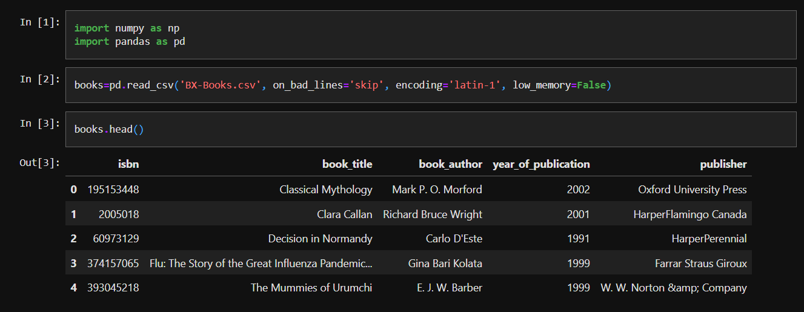

Fig. 2 Learning data from a described data set

B. LEARNING USER PREFERENCE

In a book proposal framework, client information including client ID, area, and age is crucial for fitting customized understanding ideas, guaranteeing that clients get book suggestions that adjust intimately with their inclinations and segment qualities. The client ID fills in as an identifier for each client enabling the system to follow individual associations with the structure like pursuit history, assessments, studies, and as of late per used books [10]. This information is instrumental in building quick and dirty client profiles that the proposition engine utilizations to effectively match books to clients figuring out affinities and tendencies. Region data adds another layer of personalization by allowing the system to insert land and social effects on grasping tendencies. For instance clients from explicit regions could lean toward neighborhood scholar or books about common history and culture which can coordinate more area express ideas.Besides, area based information can help in perceiving and answering geological patterns in book prevalence, empowering the framework to enhance its stock and proposals in view of provincial interest. Age is another vital segment factor that impacts understanding decisions. More youthful perusers may be more inspired by youthful grown-up fiction, dream, or instructive material reasonable for their age bunch, while more seasoned perusers could incline toward types like authentic fiction, accounts, or traditional writing. By breaking down age-related information, the framework can classify books into age-proper suggestions, fundamentally improving client fulfillment by giving significant substance. Altogether, these components of client information permit the proposal framework to perform division and bunching of clients in view of segment similitudes, which thusly works with the making of specialty book records customized to explicit client gatherings. This approach works on the exactness of book suggestions as well as upgrades client commitment by making the revelation interaction more pertinent and advancing. In general, coordinating client ID, area, and age into the dataset [10] empowers a more modern, nuanced comprehension of client inclinations, prompting a more powerful, responsive, and at last more compelling book proposal framework as displayed in Fig 3. Then, at that point, book evaluations assume a significant part in checking client inclinations and directing the suggestion cycle. Integrating information fields like client ID, ISBN, and rating [10] permits the framework to catch and examine client criticism on individual books, working with the age of customized proposals custom-made to every client's preferences. The client ID fills in as a novel identifier for every client, empowering the framework to connect evaluations with explicit people and track their inclinations over the long run. The ISBN extraordinarily recognizes each book, guaranteeing that evaluations are precisely ascribed to the right titles and releases. Evaluations give important bits of knowledge into client inclinations and opinion towards explicit books, permitting the framework to focus on proposals that line up with clients' preferences and try not to recommend books that are probably not going to be generally welcomed. By dissecting rating information across a huge client base, the framework can recognize patterns and examples in understanding inclinations, upgrading its capacity to make exact forecasts and convey convincing proposal as displayed in Fig 4. By and large, consolidating client ID, ISBN, and rating information [10] into the dataset empowers the book proposal framework to use client criticism successfully, bringing about a more customized and drawing in perusing experience for clients.

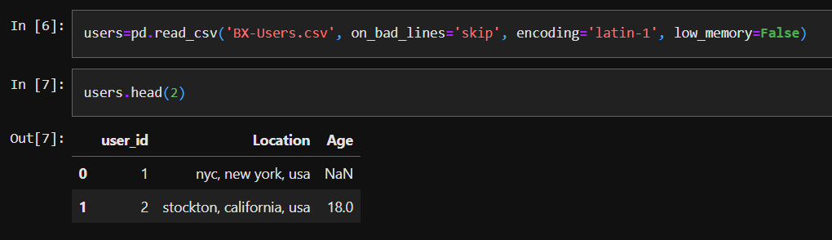
Fig. 3 Users Information
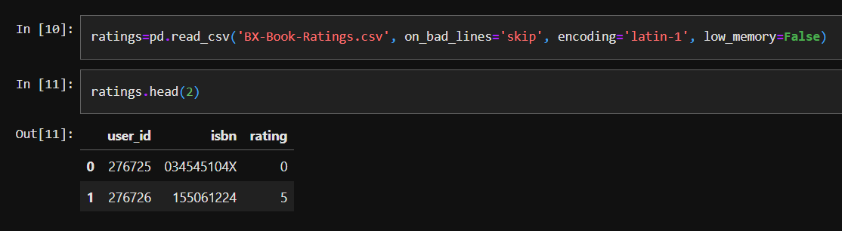

Fig. 4 Learning User Preferences from Book Ratings

C. PROVIDING RECOMMENDATIONS

Giving recommendations in a book idea system incorporates a refined blend of estimations, data dealing with methodology, and computer based intelligence designs to pass redid thoughts hand crafted on to each client's tendencies. One of the key estimations used for idea is the k-nearest neighbors (k-NN) computation, which relies upon the standard of comparability to perceive books that are presumably going to show a given client perspective on their similarity to books that the client has as of late taken pleasure in. By figuring distances between feature vectors tending to clients and books, the k-NN estimation can perceive lots of practically identical clients or things and propose books that are popular among near clients or books that resemble those the client has favored already. Despite k-NN [9], packing methods are similarly used to accumulate clients or books with practically identical qualities, enabling the system to recognize models and examples in client tendencies. For instance, different evened out clustering estimations can be used to make moderate lots of clients considering their grasping penchants, while k-suggests gathering can bundle books into packs considering components like characterization, author, or dispersion year. These gatherings go about as a justification behind making ideas by perceiving books that are popular inside the very bundle or proposing books from packs that resemble those preferred by the client as shown in Fig5.
To do these computations and cycle the enormous proportions of data included, artificial intelligence libraries, for instance, scikit-learn, pandas, and NumPy are utilized. Scikit-learn gives an intensive plan of instruments for building and sending man-made intelligence models, including executions of renowned estimations like k-NN and bundling computations. Pandas is used for data control and assessment, allowing the system to gainfully manage gigantic datasets containing client and book information. NumPy, of course, offers assistance for numerical computations and display errands, which are central for taking care of and changing data fully expecting idea. By using these devices and methodology, the book idea system can create tweaked recommendations that think about the tendencies and interests of individual clients as shown in Fig 6. The mix of k-NN, gathering, and artificial intelligence structures, for instance, scikit-learn, pandas, and NumPy engages the system to convey careful, relevant, and attracting ideas that redesign the overall client experience and develop a more significant relationship among perusers and the books they love.
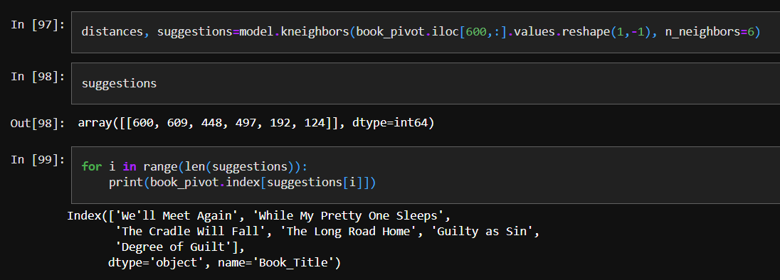

Fig. 5 Recommendation from k-NN algorithm

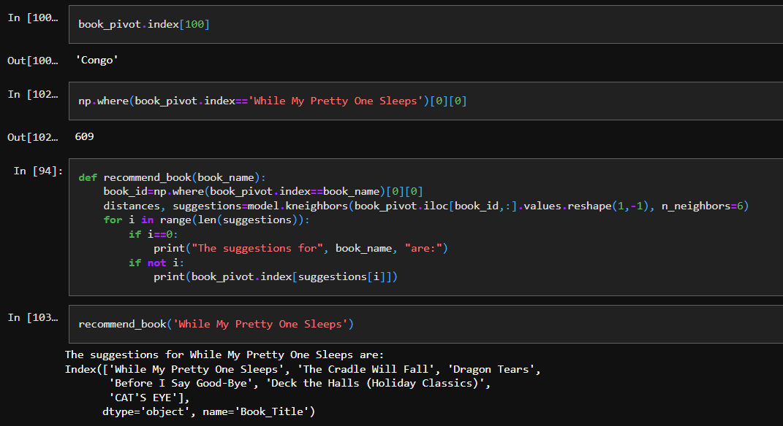

Fig 6. Recommendation of desirable books

D. IMPLEMENTATION OF THE SYSTEM

The execution of a proposal framework requires a fastidious incorporation process, where a previous AI model is flawlessly implanted inside a web improvement structure. This part dives into the complexities engaged with conveying the model through Carafe and Gunicorn, working with a smooth trade of information between the backend and frontend parts [11] [12]. Carrying out a proposal framework includes a definite and cautious cycle, incorporating a previous AI model inside a web improvement climate to make a responsive and intuitive stage. This part investigates the intricacies of sending such a model utilizing Carafe, a lightweight and flexible web system that gives the fundamental instruments to building web applications productively. Jar fills in as the foundation of the web administration, permitting engineers to set up steering and solicitation taking care of, which are fundamental for overseeing client collaborations. It improves on the assignment of associating the AI model with electronic connection points, guaranteeing that clients can consistently interface with the suggestion framework.
Gunicorn goes about as the connection point between the web server and the application, giving power and dealing with different client cooperations at the same time without a drop in execution. The organization cycle likewise includes laying out a liquid information trade pathway between the backend, where the AI model dwells, and the frontend, where clients communicate with the framework. This requires a very much planned Programming interface that works with productive information move and handling. The Programming interface should be equipped for dealing with demands from the frontend, handling them through the AI model, and returning the proposals in an organization that can be effectively delivered and used by the frontend parts. Generally speaking, the execution of a suggestion framework inside a web system like Carafe, supplemented by Gunicorn for better execution dealing with, embodies a complex yet down to earth way to deal with making AI models open and practical progressively web conditions. This arrangement not just enhances the client experience by giving fast and pertinent reactions yet additionally guarantees that the framework can scale really to oblige a developing number of clients.

Integration With Flask

Setting Up Flask Climate:
The interaction starts with the foundation of the Cup climate, giving the essential structure to the web application. Jar fills in as the stage for consolidating AI functionalities [13].

Connecting the ML Model:
A basic crossroads in the combination cycle includes connecting the prepared AI model to the Jar application. This involves bringing in the model and characterizing an endpoint inside Jar to deal with input information from the front end working with the suggestions.

Handling POST Request:
Dealing with POST demands in Flask is a part of building web applications that needs the handling of information. In this engineers can set up a course explicitly intended to deal with POST demands by determining methods=['POST'] in the course decorator. Inside this characterized capability the request object is used to get to approach information, which can fluctuate in design going from structure information available through request.form to JSON information by means of request.json upon the substance sort of the request. Subsequently, the server can answer the client straightforward with reactions like JSON objects using jsonify() or client route with divert(). Giving a hearty instrument to information trade inside flask based web applications. refer Fig. 7.
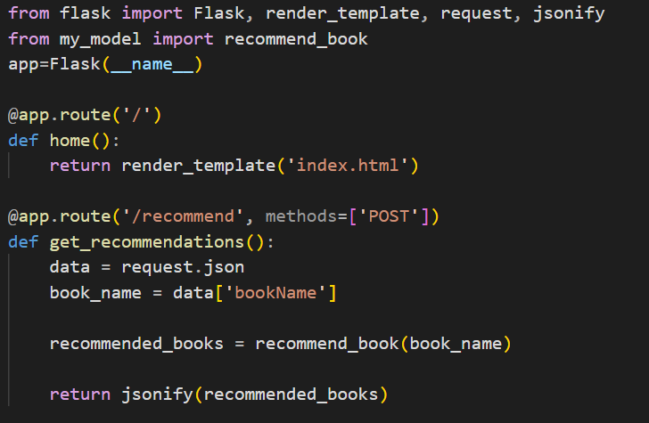

Fig 7. Linking Machine Learning model using Flask

Deployment With Gunicorn

Gunicorn Joining:
Gunicorn is a foundation in sending engineering joined into the texture of the Flagon application. Gunicorn remains as a stud watchman, shielding the respectability of the applications correspondence with the rest of the world. Its joining makes another time off organization where HTTP demands stream between the web server & Carafe crossing the computerized scene with unequal proficiency. Gunicorn is coordinated into the Jar application to give powerful sending and proficient treatment of HTTP demands. Going in between the web server and Cup, Gunicorn works with consistent correspondence and versatility.
Design and Advancement:
Calibrating setup boundaries inside Gunicorn is fundamental for improving server execution or usage. Boundaries eg. special count, breaks, and same settings are accumulated to guarantee consistent activity under many traffic powers. By carefully adjusting these boundaries, the sending foundation gets a light harmony and in smooth creation floods in client movement while protecting framework security. This design and enhancement establishes the groundwork for a strong and responsive organization climate where the constant progression of information stays unhindered no matter what the computerized tides it is getting.

E. USER INTERFACE

HTML Structure:

When creating a UI lies the fast plan of HTML , molding the actual substance of page structure. HTMLthe most widely used language in development,acts as the framework where the client experience problems and consequences. Through wise usage of HTML labels, components like structures, buttons, text inputs each carefully situated to direct client collaboration with accuracy. This given below diagram establishes the groundwork for consistent route as well as cultivates openness and ease of use, guaranteeing a client driven plan [14] [17].

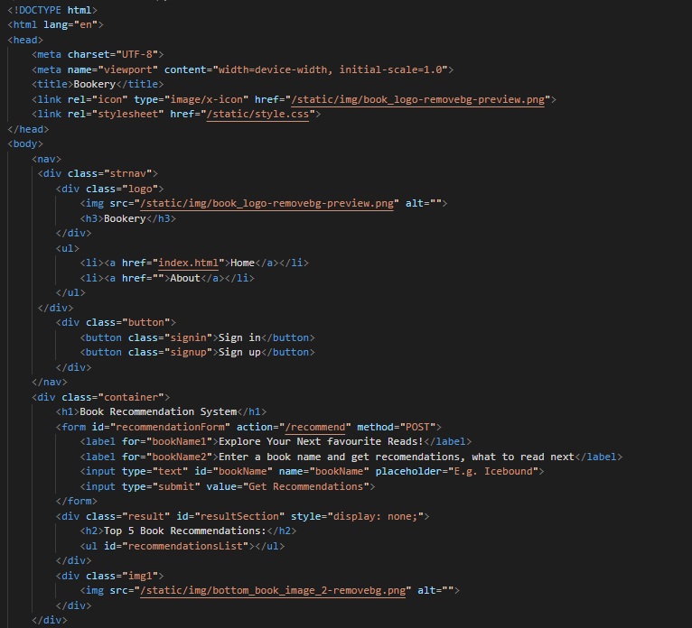

Fig 8. snippet of basic HTML structure of user interface

Cascading Style Sheets (CSS):

In the realm of aesthetics, Cascading Style Sheets (CSS) reign supreme, wielding the power to transform the mundane into the magnificent. With CSS rules as their brushstrokes, designers imbue web pages with a visual allure that captivates the senses. Fonts dance in elegant serifs or modern sans-serifs, colors harmonize in palettes that evoke emotion, and layouts weave a tapestry of balance and symmetry. From the bold strokes of a hero banner to the subtle nuances of a drop shadow, CSS defines the very essence of visual appeal, orchestrating a symphony of design elements that elevate the user interface to new heights of sophistication [14].
Cascading Style Sheets is used here to provide a character to the website so that it can attract the attention of the user. The navbar, container, about and footer sections of the page are given color, proper alignment and filled with images by appropriate use of CSS. Refer Fig. 8.

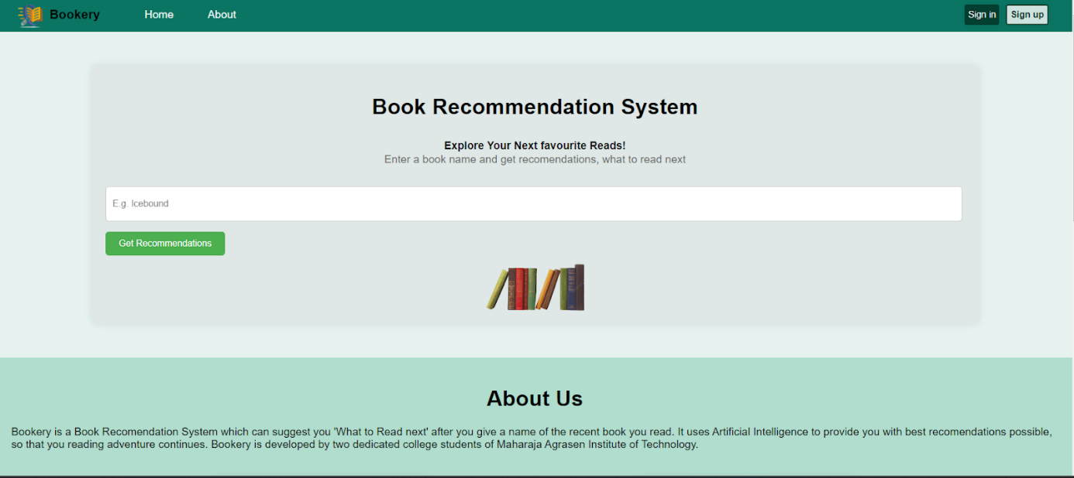

Fig 9. The interface of website made using HTML and CSS

Interactivity with JavaScript:

Client-Side Scripting:
JavaScript, the language of interactivity, breathes life into the static canvas of HTML, infusing it with dynamism and responsiveness. Embedded discreetly within HTML pages, JavaScript code orchestrates a ballet of user interactions, unfurling a tapestry of dynamic behavior without the need for server-side processing. From the graceful choreography of form submissions to the nimble pirouettes of response handling, JavaScript empowers users to engage with the interface fluidly, forging connections that transcend the static confines of traditional web experiences [15].

Asynchronous Requests:
In the realm of data exchange, asynchronous JavaScript requests emerge as the heralds of expediency, ushering in an era of seamless communication between client and server. With asynchronous transmissions, data flows freely and unencumbered, traversing the digital ether with unparalleled swiftness. Gone are the days of sluggish page reloads – in their place, a seamless continuum of user experience unfolds, unmarred by the constraints of latency. This asynchronous paradigm not only reduces page load times but also fosters a sense of continuity, ensuring that the user remains immersed in the experience, undisturbed by the mechanics of data transmission [16].

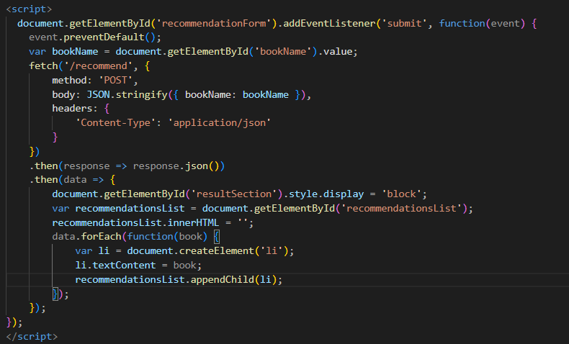

Fig 10. making the website interactive using JavaScript

Linking with Flask:

Form Submission:
As users engage with HTML forms, JavaScript stands poised to capture their intent and usher it to the realm of server-side processing. Through the orchestration of POST requests to the Flask backend, user input data embarks on a journey of transformation, culminating in the generation of personalized recommendations. JSON payloads, laden with the wisdom of user preferences, traverse the digital expanse, converging upon the Flask server for processing with a sense of purpose and direction [12] [13].

Handling Responses:

The Jar server gets a move on, an assemble of calculation and investigation. As suggestions come to fruition, JavaScript remains as the caretaker of client experience, powerfully refreshing the connection point to exhibit the products of the server's work. With every suggestion information package conveyed in JSON design, JavaScript parses the reaction with a deft hand, presenting html components with the endowment of information like book titles that coax to the client with commitments of scholarly revelation. in Carafe and JavaScript, thrives, giving a connection among client and connection point that rises above the simple trade of information taking care of reactions is a flexible cycle that permits designers to fit server-client related to the requirements of their applications. Basic text reactions can be returned straightforward in view capabilities, with Cup changing over these into reaction objects conveying a default status code . For more control, engineers can use the make reaction capability to unequal develop reaction objects, empowering changes to headers, status codes, and body content. While managing APIs, returning JSON is usually required, and Flagon works with this through the jsonify capability which serializes information into JSON design as well as sets the right happy sort. For explicit HTTP status codes, reactions can incorporate a tuple that indicates both the message and the comparing status code eg. returning a 404 for not trackd down blunders. it likewise offers powerful mistake dealing with capacities with the blunder controller decorator, permitting applications to get special cases and convey custom fitted reactions. Moreover, the divert capability is significant for directing clients to various endpoints guaranteeing a consistent route insight inside the application. Altogether, these reaction taking care of systems upgrade the adaptability and dependability of Cup applications taking special care of both basic and complex web improvement needs.
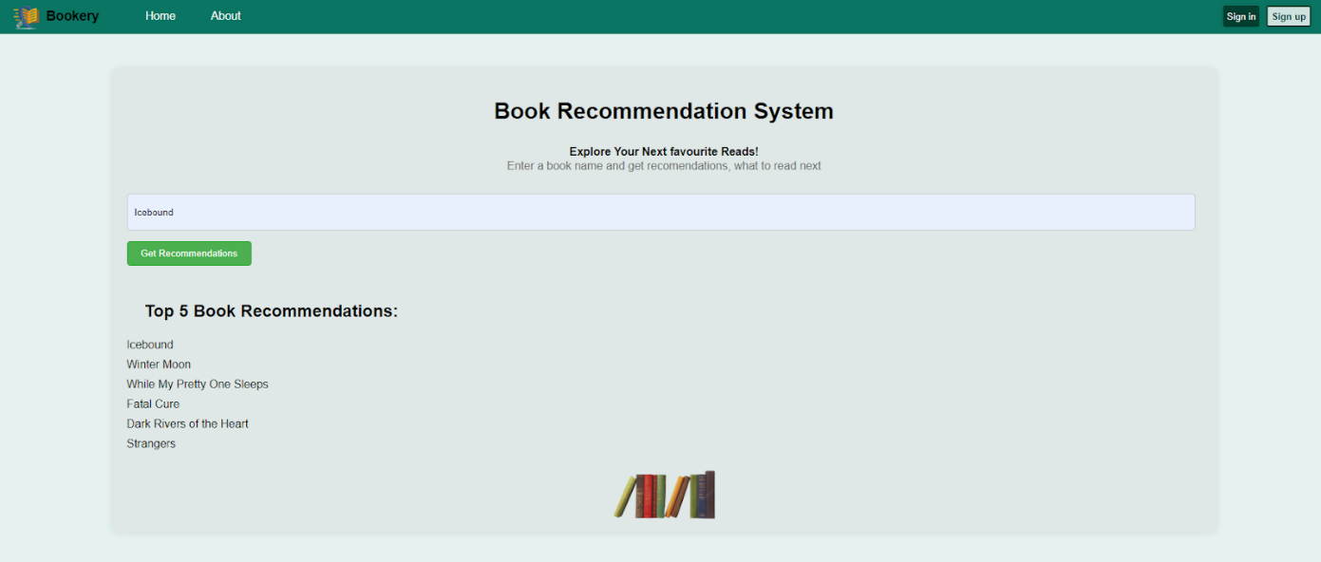
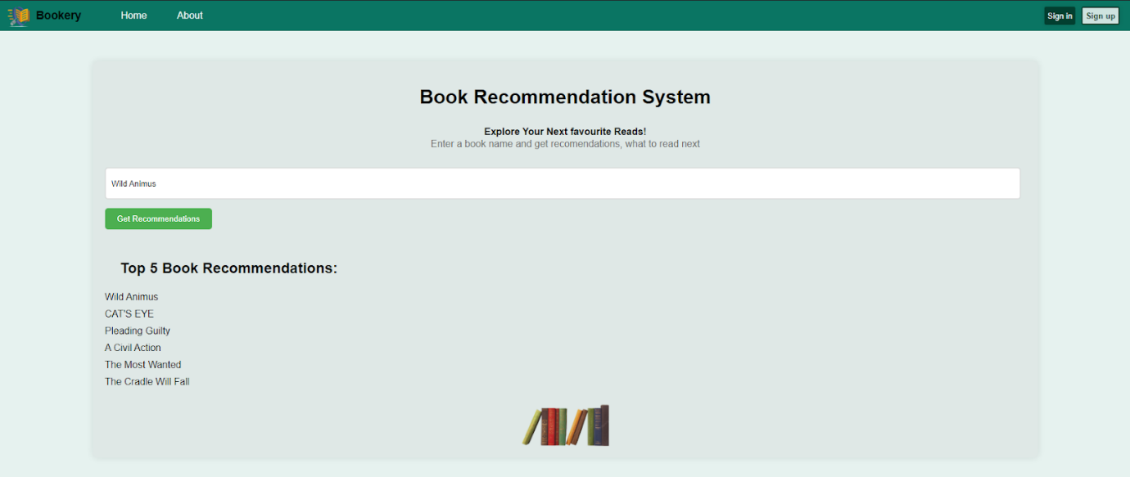

Fig 11. Generating responses for different user inputs

V. CHALLENGES AND OPPORTUNITIES

The turn of events and execution of book proposal frameworks the force of computer based intelligence and edge insight, introducing both complex difficulties and immense open doors. One of the essential difficulties lies in guaranteeing the accessibility and nature of information. Many datasets that incorporate collaborations, book dataset, and socioeconomics are urgent for the successful working of system, a region where AI can essentially upgrade information handling and investigation abilities. Not withstanding, issues like information sparsity and irregularities can seriously make difficult calculation execution featuring the requirement for powerful man-made intelligence models that can adjust and gain from fragmented information.
The variety confuses the errand of conveying proposals, a CBT intelligence and edge knowledge are appropriate to address. By using calculation at the edge, frameworks can rapidly handle client information progressively, giviing more customized and setting mindful suggestions without the dormancy related with information handling in brought together mists. This is essential as the structure supervise creating amounts of clients and book entries capably staying aware of execution without compromising the speed or significance of proposition. Security worries as personalization of ideas requires the collection and assessment of data. edge understanding offers a high ground by taking care of data locally, as such minimizing the bet of securityrelated with sending information over networks. Furthermore man-made knowledge driven systems investigate the avoidance of algorithm choice where tendencies present in getting ready data can provoke non group ideas that doesn't offer receptiveness to new makers or less standard perspectives. On the entryway range, movement of mimicked insight progresses present empowering opportunities for further developing book proposition systems. These developments can improve additional created computations prepared for a more significant understanding of client approaches to acting and tendencies, thus dealing with the accuracy and personalization of ideas. This can basically help client responsibility and fulfillmentto be charmed by and team up with content that resonates with their tendencies. Also, by planning PC based knowledge with edge figuring capacity proposition structures can end up being more compelling at discoverability. They can convey new authors and unconventional sorts to the extremely front, growing per clients points of view and propelling social assortment. Moreover, these structures can be connected past unwinding changing them for enlightening purpose to empower learning conditions using recommendations hand crafted to match individual learning styles and informative necessities hence supporting personal development and well established learning. These advancements feature the notable impact that AI and edge information have on updating book proposition structures driving client responsibility, movement, and social improvement.
VI. RESULTS AND DISCUSSIONS

The outcomes from the book idea system give us the encounters into the show and sufficiency of the proposition computations sent. Through ordinary appraisal estimations like precision, audit, and precision the system's ability to deliver critical and modified proposition is assessed . By differentiating the recommendations created by numerous computations that incorporates k-closest neighbors (k-NN) [8] [9] and packing strategies against a ground truth dataset of client tendencies the preliminary reveal the characteristics and deficiencies of every procedure. The results show the impact of factors like component assurance, distance estimations and gathering computations on the idea of ideas offering bearing for working on the structure's show. the trial results shed light on the framework's versatility and effectiveness in taking care of enormous volumes of client and book information.
By analyzing measurements, computational time and memory use, the examination assesses the framework's capacity to process and produce suggestions continuously, giving significant bits of knowledge to framework improvement and asset allotment. Also, the analysis might investigate the effect of hyperparameter tuning and algorithmic enhancements on suggestion execution, further refining the framework's abilities and upgrading client fulfillment. Besides, the trial results might uncover examples and patterns in client conduct and understanding inclinations, giving significant criticism to content curation and stock administration. By breaking down commitment measurements, for e.g. transformation rates, and normal meeting span, the examines the adequacy of the suggestion framework in directing clients to applicable and connect with content. These bits of knowledge can give vital choices with respect to book determination, showcasing efforts, business development and upgrading the general client experience. So the examination results act as a basic benchmark for evaluating the presentation and effect of the book proposal framework. By using experimental proof and quantitative measurements, the outcomes give significant experiences to streamlining calculations, further developing framework effectiveness, and upgrading client fulfillment. Through persistent trial and error and cycle, the proposal framework can advance and adjust to changing the inclinations and guarantee it is proceeded with adequacy in directing users to their next most loved book.

VII. CONCLUSION

All in all, the book suggestion framework addresses a useful asset for directing perusers to find new and drawing in happy customized to their singular inclinations. Through the reconciliation of cutting edge calculations, for example, k-closest neighbors (k-NN) and bunching methods, combined with AI structures like scikit-learn, pandas, and NumPy, the framework can really dissect client conduct and book credits to produce customized suggestions. The analysis results exhibit the framework's capacity to convey exact, applicable, and drawing in proposals, giving significant experiences into calculation execution, adaptability, and client commitment measurements. Also, the examination features the significance of consistent advancement and cycle to upgrade suggestion quality and framework effectiveness. By utilizing observational proof and quantitative measurements, the framework can develop and adjust to changing client inclinations and market elements, guaranteeing its proceeded with importance and adequacy in directing perusers to their next most loved book. Pushing ahead, further examination and trial and error will be fundamental to investigate arising advancements and approaches for proposal age, driving development and conveying a considerably more customized and improving perusing experience for clients. At last, the book proposal framework addresses a strong illustration of how innovation can be bridled to interface perusers with the substance they love, cultivating a more profound appreciation for writing and empowering a deep rooted love of perusing [1].Notwithstanding the specialized viewpoints, perceiving the more extensive ramifications of the book suggestion system is vital. By working with customized understanding encounters and directing clients to find new creators and types, the framework can possibly cultivate a more profound association with writing and advance long lasting learning. Besides, the framework can assume a crucial part in advancing variety and consideration by suggesting books from many voices and viewpoints. As we proceed to refine and advance upon the suggestion calculations and client experience, we should stay focused on the center standards of availability, value, and client strengthening. At last, the book suggestion framework addresses a mechanical development, however a door to a universe of information, creative mind, and motivation, enhancing the existences of perusers and reinforcing the texture of our networks.

REFERENCES

[1] K. N. Latuta and A. Nussipbekov, "Online Book Recommendation System", Research Gate ICECCO Conference Paper, 2015

[2] G. Adomavicius and A. Tuzhilin, “Towards the Next Generation of Recommender Systems: A Survey of the State-of-the-Art and Possible Extensions,” IEEE Trans. Knowl. Data Eng., vol. 17, no. 6, pp. 734–749, 2005.

[3] NITI AAYOG, “National Strategy for Artificial Intelligence”, pp. 5-12, 2018
[4] A. Pazienza, G. Mallardi, C. Fasciano and F. Vitulano, “Artificial Intelligence on Edge Computing: A Healthcare Scenario in Ambient Assisted Living”, 2020
[5] M. S. Pera, Y. Ng, and N. Conde, “Personalized Book Recommendations Created by Using Social Media Data,” in Web Information Systems Engineering - WISE 2010 Workshops, 2010, pp. 1–14.
[6] I. Guy, N. Zwerdling, I. Ronen, D. Carmel, and E. Uziel, “Social Media Recommendation Based on People and Tags,” in Proc. of SIGIR, 2010, pp. 194–201. Y. Park and K. Chang, “Individual and Group Behavior-based Customer Profile Model for Personalized Product Recommendation.,” Expert Syst. with Applications, vol. 36, no. 2, pp. 1932–1939, 2009.
[7] M. D. Ekstrand, “Collaborative Filtering Recommender Systems,” Found. Trends® Human–Computer Interact., vol. 4, no. 2, pp. 81 173, 2010. G. Shani and A. Gunawardana, “Evaluating Recommendation Systems,” Springer, 2011.
[8] G. Kane, “Data-Driven Book Knowledge-Base Analysis with Unsupervised Machine Learning Models And Recommendations”, 2020
[9] A. Ezeh, “Developing Machine Learning based Recommender System on Movie Genres Using KNN”, Spring Term, 2023
[10] Snehitha S, Adithya R, Dr. Sujithra M, “Book Recommendation Using K Nearest Neighbour and Collaborative Filtering”, International Journal of Research Publication and Reviews, Vol 3, no 11, pp 1731-1735, 2022
[11] U. M. Kotha, H. Gaddam, D. R. Siddenki, S. Saleti, “A comparison of various machine learning algorithms and execution of flask deployment on essay grading”, Research Gate ICEJE, 2023

[12] A. J. Laxa Cortez, “Deploying Machine Learning Models Into A Website Using Flask”, Medium, 2021

[13] S. Paul, “Turning Machine Learning Models into APIs in Python”, 2018
[14] Y. Xing, J. Huang, Y. Lai, “Research and Analysis of the Front-end Frameworks and Libraries in E-Business Development”, 2019
[15] G. Antal, P. Hegedüs, Z. Toth, R. Ferenc,” Static JavaScript Call Graphs: A Comparative Study”, 2018
[16] J. Walsh, Klaus Ackermann, Lauren Haynes, Rayid Ghani, “Deploying Machine Learning Models for Public Policy: A Framework”, 2018
[17] S Peroni, F. Osborne, A. Di Iorio, A. G. Nuzzolese, “Research Articles in Simplified HTML: A Web-first format for HTML-based scholarly articles”, 2017

