**Impact of PLA And ABS on the Mechanical Properties of Fused Filament Fabrication**

**PVR Girish Kumar a, Dr K. Devaki Devi b**

a Research Scholar, Jawaharlal Nehru Technological University Anantapur, AP, India.

a Assistant Professor, Geethanjali College of Engineering and Technology, Hyderabad, TS, 501301, India.

b Associate Professor, G. Pulla Reddy Engineering College, Kurnool, AP 518005, India.

**ABSTRACT**

This paper presents a parametric study on the impact of printing parameters on FFF-printed parts with PLA and ABS filament. To increase the strength qualities of PLA and ABS, this study sought to determine the ideal printing conditions for fused filament fabrication (FFF). The experimental investigation that was employed in this paper's approach to determining the effects of the infill percentage, wall line count, and infill pattern on the mechanical characteristics of the materials used Taguchi's method. PLA is found to be more rigid and possess higher tensile strength than ABS. The parameter with the most significant influence on the results is PLA, despite its more apparent effect. The study indicates that the optimal combination of manufacturing parameters can result in higher PLA strength than ABS, providing valuable insights for selecting suitable materials and parameters in FDM design and manufacturing. Insights into optimizing infill density, pattern, and wall line count, as well as enhancing mechanical properties, can be gained from the analysis of microstructural defects in conjunction with test results.

**KEYWORDS** FFF Printed Parts, ABS filament, PLA filament, Parameters, infill, wall count, pattern.

**1.INTRODUCTION**  
Depending on the choice of 3D printer, Filament material, and process parameter, the cost of a component 3D printed varies greatly. Comparative analysis of mechanical characteristics of components printed using ABS filament with various process parameters. 3D printing technology enables researchers to create complex structures with high impact energy absorption for various applications. An impact test measured energy absorption during plastic deformation of 3D Printed components with varying infill patterns and densities. Results showed fracture resistance depends on induced stress, crack propagation, and laminate composite mechanics. Impact of ultrasonic vibration on mechanical properties and microstructure of ABS and PLA samples using an open-source FDM 3D printer. Results show higher compressive strength in Z-axis orientation, similar bonding, and smoother surface roughness at 20 kHz. Build orientation significantly affects compressive strength, while ultrasonic vibration has no significant impact. [1]

**2. LITERATURE REVIEW**

The research aimed to enhance ABS mechanical properties using fused deposition modeling. Results showed contour numbers significantly improve properties, with layer thickness being the most effective. Both RSM and ANN models can control build properties individually, with a slight interaction between infill percentage and contour numbers. ANN modeling has a higher R value, making it more reliable for additive manufacturing ABS. [2] Additive manufacturing gains popularity due to its versatility, and fused deposition modeling (FDM) shifts from rapid prototyping to rapid manufacturing. This article presents a multi-objective optimization approach for selecting optimal 3D printing parameters for PLA and ABS parts, focusing on mechanical behavior and value analysis. It identifies optimal parameters based on desirability function. [3] A multi-objective optimization approach for selecting optimal 3D printing parameters for PLA and ABS parts, focusing on mechanical behavior and value analysis. It identifies optimal parameters based on desirability function. The study investigates the influence of FFF parameters on tensile, bending, and impact mechanical properties in 20% short-carbon-fiber reinforced PEEK. Results show that lower LH and PT reduce volumetric defects, while average values (385 °C) benefit the microstructure. The optimized parameters yielded UTS, UBS, and UIS values of 116.7 ± 5 MPa, 167.2 ± 11 MPa, and 28.2 ± 3 kJ/m2. [4] Additive manufacturing (AM) is rapidly growing, with 3D printing being used in automotive, aerospace, and medical sectors. Fused deposition modeling (FDM) is popular for fabricating PEEK parts for biomedical implants. An ANN model with 4-12-2 network architecture improves surface roughness and mechanical strength. [5] A Computational Fluid Dynamics (CFD) model predicts fiber orientation in extruded material during material extrusion. The model simulates fiber/polymer suspension deposition, providing detailed information on material extrusion and fiber orientation evolution. This simulation can improve mechanical properties and adhesion during layup. [6] Impact resistance of PLA 3D-printed components, focusing on infill percentage and layer thickness. Results show annealing increases impact energy, indicating potential for mechanical integrity. [7] This research explores the influence of FDM process parameters on surface roughness parameters in nylon carbon fiber printed parts. It uses a definitive screening design, Pareto chart, optical microscopy, and multi-response optimization to enhance 3D printed parts quality and performance. [8] influence of used filament fabrication (FFF) on part quality aspects and conducts dynamic analysis of FFF parts for various applications. [9] 3D printing critical materials for electrochemical energy storage devices (EESDs), particularly rechargeable batteries. It covers design principles, materials selection, and optimization strategies, as well as challenges and potential applications in the development of these materials. [10] Impact of filament colour on printed PLA parts' quality and properties has been limited. This study analysed dimensional accuracy, tensile strength, and friction properties of samples under different printing temperatures. [11] Impact of process parameters on tribological and frictional behavior of acrylonitrile butadiene styrene (ABS) and polylactic acid (PLA) 3D-printed parts. The optimal input parameters for achieving minimum friction and linear wear were found to be 50% infill percentage and 0.1 mm layer thickness. [12] FFF parts made from ABS, revealing that voids can be eliminated entirely, thereby opening new applications for FFF, despite its limitations. The study compares fatigue behavior of polymer weld joints 3D printed using additive manufacturing, revealing superior resistance in PLA/PLA joints compared to non-welded PLA. [13] This study successfully processed tensile samples of a tri-material based 3D-printed polymer composite using fused filament fabrication (FFF). The study found that selected FFF process parameters significantly impacted tensile properties. The results showed that high LT, high PS, and low ID led to defects, while high LT, high PS, and high ID resulted in no defects. [14] The study explores the impact of infill patterns and densities on tensile and impact strength in 3D printed lightweight geometrical designs, revealing that concentric patterns yield higher results. [15]

**METHODOLOGY**

**3.1 FDM 3D PRINTER**

Ultimaker/Netherlands has provided the FDM 3D printer with a maximum printing size of 330mm*240mm*300mm. shown in Fig 3.1 a & b as per ASTM technical standards, which is widely used to determine the mechanical properties of reinforced and non-reinforced plastics of 2d image of compression and flexural as shown in Fig 3.2 a & b

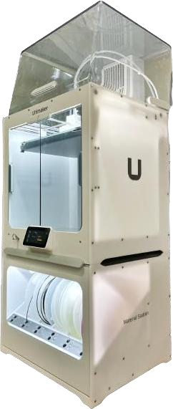

Fig 3.1 a) & b) 3D Printer

**3.2 MATERIAL**

The filament material used was PLA & ABS of 1.75 mm diameter, purchased from WOL3D.  [Table 1](https://www.sciencedirect.com/science/article/pii/S2590123021000657#tbl1) provides its properties.

**Table 1** PLA & ABS Filament Properties

|  |  |  |
| --- | --- | --- |
| **Properties** | **PLA** | **ABS** |
| Extrusion Temperature (°C) | 190–210 | 220–260 |
| Density (g/cm3) | 1.25 | 1.04 |
| Compressive strength (MPa) | 48.2-65 | 43-70 |
| Flexural strength (MPa) | 97 | 66 |
| Biodegradability | Yes | No |
| Fume toxicity | Very low | Medium |

### 3.3 DOE

The Taguchi method is used to improve the quality of products and processes. Improved quality results when a higher level of performance is consistently obtained. The highest possible performance is obtained by determining the optimum combination of design factors.

In this project, there is a total of 4 parameters. They are Infill %, Wall Count, Infill Pattern and Nozzle diameter. And for every parameter, there is a total of 3 values. They are one low value, intermediate value and high value. So, there are 4 factors and 3 levels. By using the Minitab software, we minimize the optimization of the design. L9 array is chosen with 3-levels and 4-factors. Optimization of the design by L9 array in Minitab shown in table 2.

**Table 2** Selected process parameters

|  |  |  |  |  |
| --- | --- | --- | --- | --- |
|  | FDM Process Parameters | | | |
| Run | Infill  % | Wall  Count | Infill  Pattern | Nozzle  Diameter |
| 1 | 20 | 2 | Honeycomb | 0.3 |
| 2 | 20 | 4 | Concentric | 0.4 |
| 3 | 20 | 8 | Gyroid | 0.5 |
| 4 | 50 | 2 | Concentric | 0.5 |
| 5 | 50 | 4 | Gyroid | 0.3 |
| 6 | 50 | 8 | Honeycomb | 0.4 |
| 7 | 80 | 2 | Gyroid | 0.4 |
| 8 | 80 | 4 | Honeycomb | 0.5 |
| 9 | 80 | 8 | Concentric | 0.3 |

In this Fixed Parameters are Speed-50mm/s, Orientation 0, Layer Thickness-0.1mm, Print Temperature -265C, Bed Temperature-67C. The Taguchi method adjusts average and reduces variance by arranging factors and their levels. Infill Density is adjusted to 20, 50, and 80 for nozzle diameter 0.4mm. This method requires fewer experiments, reducing production costs. The parameters and range were chosen based on previous studies, with a recommended printing temperature of 200-220°C. [12,13,14] High temperature yields higher tensile strength for PLA & ABS filament. In this present research Wall line count levels are 2,4, and 8, and infill patterns were Honeycomb, Concentric, and Gyroid and, Layer height 0.2mm, Print Speed 65mm/s and Print temperature is 2200C were set to print the specimens. The experiments were set up using Minitab software and Taguchi's [16] orthogonal array of fractional factorial design. [17].

**3.4 PREPARATION OF SPECIMENS**

Flexural and Compression specimens were prepared using Creo software shown in fig 3.3 a & band exported in Stereolithography (STL) file format for readable by slicer software cura 5.5.0 shown in fig 3.4 a &b. The sliced model was saved as G-code and read by a 3D printer to create a 3D shape. Fig 4 shows the samples Printed by using selected parmeters of Infill dinsilty and pattern, wall line count are shown in fig 3.5 shows the specimen after tested onUTM.

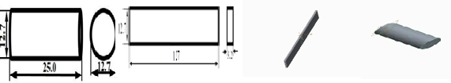

Fig 3.2 a) Compression b) Flexural specimen Fig 3.3 Design in Cre-o

### 

Fig 3.4 slicing using CURA 5.5.0 Fig 3.5 Printed samples a) Compression b) Flexural

The samples were tested using the universal testing machine FUEL INSTRUMENTS & ENGINEERS PVT LTD, with a 400 kN load as shown inf Fig 3.6 a & b and after testing the samples are shown in fig 3.7 a & b.

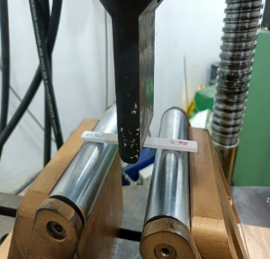 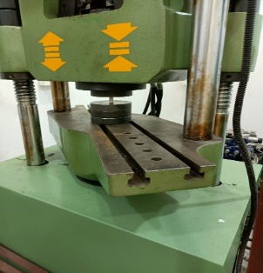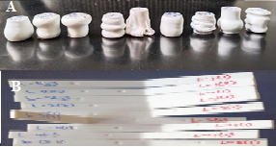

Fig 3.6 a) Flexural b) Compression Fig 3.7 After testing a) Compression b) Flexural

**4. RESULTS & DISCUSSION**

After testing the experimental results are entered in the minitab to find out the S/N ratio, table 3 shows the s/n ration of the specimens. From table 3 it is observed that the greater (L9 Specimen) flexural and compression strength got high S/N ration whereas the lesser (L1 Specimen) strength of both flexural and compression specimen got less S/N ration.

**Table 3 Results of Flexural and Compression test for both PLA & ABS**

|  |  |  |  |  |  |  |  |  |
| --- | --- | --- | --- | --- | --- | --- | --- | --- |
| Run | ABS | | | | PLA | | | |
| Flexural  (MPa) | S/N  Ratio | Compression  (MPa) | S/N  Ratio | Flexural  (MPa) | S/N  Ratio | Compression  (MPa) | S/N  Ratio |
| 1 | 35.07 | 30.90 | 13.74 | 22.76 | 13.86 | 22.84 | 54.57 | 34.74 |
| 2 | 37.26 | 31.42 | 17.01 | 24.61 | 16.56 | 24.38 | 56.27 | 35.01 |
| 3 | 39.99 | 32.04 | 24.52 | 27.79 | 18.47 | 25.33 | 57.81 | 35.24 |
| 4 | 43.25 | 32.72 | 27.79 | 28.88 | 34.45 | 30.74 | 60.01 | 35.56 |
| 5 | 54.04 | 34.65 | 32.82 | 30.32 | 38.86 | 31.79 | 65.6 | 36.34 |
| 6 | 55.01 | 34.81 | 42.45 | 32.56 | 55.48 | 34.88 | 73.78 | 37.36 |
| 7 | 60.88 | 35.69 | 44.56 | 32.98 | 78.97 | 37.95 | 85.9 | 38.68 |
| 8 | 71.56 | 37.09 | 55.75 | 34.92 | 85.4 | 38.63 | 86.13 | 38.7 |
| 9 | 82.36 | 38.31 | 56.44 | 35.03 | 87.63 | 38.85 | 100.94 | 40.08 |

The average performance Signal to Noise Ratio of each parameter and their levels are display in Table 4 & 5.

**Table 4 Average Performance S/N ration of ABS Material**

|  |  |  |  |  |  |  |  |  |
| --- | --- | --- | --- | --- | --- | --- | --- | --- |
|  | FLEXURAL | | | | COMPRESSION | | | |
| Level | Infill  % | Wall  Count | Infill  Pattern | Nozzle  diameter | Infill  % | Wall  Count | Infill  Pattern | Nozzle  diameter |
| 1 | 31.45 | 33.10 | **34.27** | **34.62** | 25.05 | 28.21 | 30.08 | 29.37 |
| 2 | 34.06 | 34.39 | 34.15 | 33.97 | 30.59 | 29.95 | 29.51 | 30.05 |
| 3 | **37.03** | **35.05** | 34.13 | 33.95 | **34.31** | **31.79** | **30.36** | **30.53** |
| Delta | 5.58 | 1.95 | 0.14 | 0.67 | 9.26 | 3.59 | 0.86 | 1.16 |
| Rank | 1 | 2 | 4 | 3 | 1 | 2 | 4 | 3 |

**Table 5 Average Performance S/N ratio of PLA Material**

|  |  |  |  |  |  |  |  |  |
| --- | --- | --- | --- | --- | --- | --- | --- | --- |
|  | FLEXURAL | | | | COMPRESSION | | | |
| Level | Infill  % | Wall  Count | Infill  Pattern | Nozzle  diameter | Infill  % | Wall  Count | Infill  Pattern | Nozzle  diameter |
| 1 | 31.60 | 31.33 | **32.40** | 24.18 | 36.31 | **38.71** | **37.01** | 35.89 |
| 2 | 30.51 | **32.12** | 31.57 | **38.48** | **37.83** | 34.99 | 36.96 | **37.54** |
| 3 | **33.02** | 31.69 | 31.16 | 32.47 | 36.42 | 36.86 | 36.59 | 37.14 |
| Delta | 2.51 | 0.79 | 1.24 | 14.30 | 1.52 | 3.72 | 0.42 | 1.65 |
| Rank | 2 | 4 | 3 | 1 | 3 | 1 | 4 | 2 |

The optimal parameters for tensile strength were determined by selecting the maximum S/N ratio for each factor. The optimal parameters include infill 80%, wall count 8, infill pattern Concentric, and 0.3 nozzle diameter, which significantly influence both compression and flexural properties was shown in below figure 4.1 & 4.2.



Fig 4.1 Main Effect plot for SN ratio of ABS Filament a) Flexural b) Compression



Fig 4.2 Main Effect plot for SN ratio of PLA Filament a) Flexural b) Compression

**Table 6 Annova of Flexural and Compression for both PLA & ABS Material**

|  |  |  |  |  |  |  |  |  |  |
| --- | --- | --- | --- | --- | --- | --- | --- | --- | --- |
|  | Compression | | | | | Flexural | | | |
| Source | DF | Adj SS | Adj MS | F-Value | P-Value | Adj SS | Adj MS | F-Value | P-Value |
| Model | 6 | 6408.22 | 1068.04 | 1469.20 | 0.001 | 5264.08 | 877.35 | 47.52 | 0.021 |
| Linear | 3 | 4263.67 | 1421.22 | 1955.05 | 0.001 | 3104.33 | 1034.78 | 56.04 | 0.018 |
| Infill % | 1 | 4248.43 | 4248.43 | 5844.19 | 0.000 | 2748.38 | 2748.38 | 148.86 | 0.007 |
| Wall Count | 1 | 1.46 | 1.46 | 2.01 | 0.292 | 3.74 | 3.74 | 0.20 | 0.697 |
| Infill Pattern | 1 | 3.57 | 3.57 | 4.91 | 0.157 | 29.67 | 29.67 | 1.61 | 0.333 |
| Square | 1 | 22.58 | 22.58 | 31.06 | 0.031 | 266.88 | 266.88 | 14.45 | 0.063 |
| Infill %*Infill % | 1 | 22.58 | 22.58 | 31.06 | 0.031 | 266.88 | 266.88 | 14.45 | 0.063 |
| 2-Way Interaction | 2 | 1.67 | 0.83 | 1.15 | 0.466 | 64.61 | 32.31 | 1.75 | 0.364 |
| Infill % * Wall Count | 1 | 0.00 | 0.00 | 0.00 | 0.971 | 23.72 | 23.72 | 1.28 | 0.375 |
| Infill %* Infill Pattern | 1 | 0.04 | 0.04 | 0.06 | 0.829 | 35.89 | 35.89 | 1.94 | 0.298 |
| Error | 2 | 1.45 | 0.73 |  |  | 36.93 | 18.46 |  |  |
| Total | 8 | 6409.67 |  |  |  | 5301.01 |  |  |  |

Taguchi classifies factors into control and noise, with control factors set by the designer and noise factors like humidity and temperature. The Taguchi method uses signal-to-noise ratio (S/N ratio) to make processes more robust, with three types: smaller, nominal, and bigger. In tensile tests, larger is better.

S/N = -10 log $\left[\frac{1}{n}\sum_{i=1}^{n}{\frac{1}{Y_{i}^{2}}}\right]$

This study uses n = 1 tests, with strength and S/N ratio results in Table. Run 9 maximum strength of 82.36 MPa and minimum of 38.31 MPa, whereas for Compression strength is high for 9th run and low for 1st run is 56.44 MPa and 13.74 MPa, the FDM creates the specimen with high strength in runs 5-9 due to high infill percentage and orientation. From Table 6 Infill density is significant for both the materials.

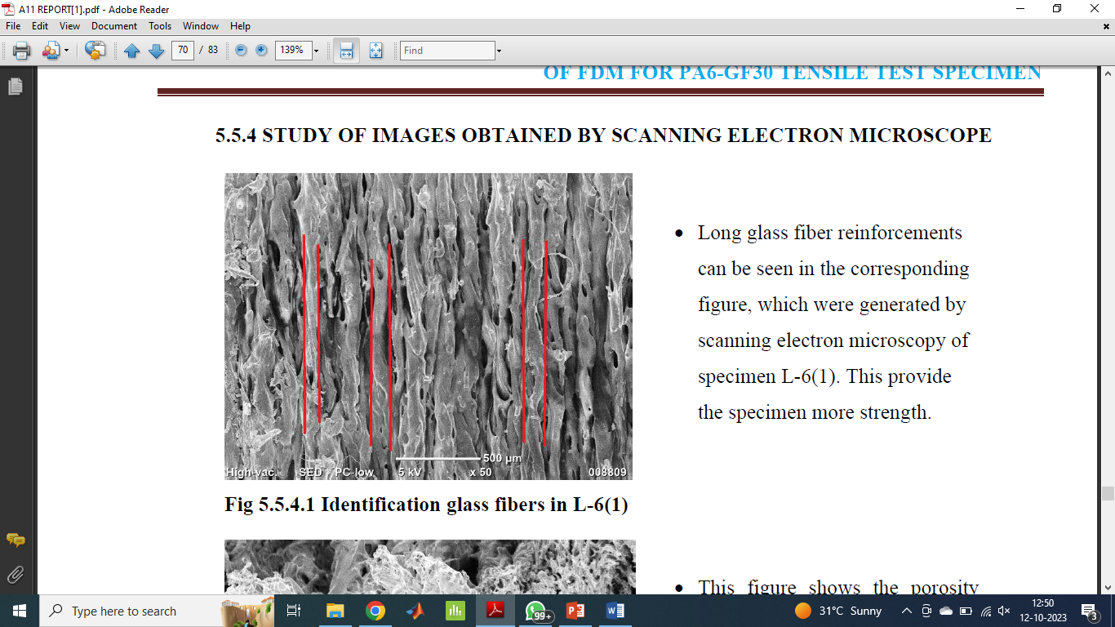

Fig 4.3 SEM images of fractured interface of (a) PLA (b) ABS

In the below SEM image, L9 we can see that Porosity has been developed between the layers. The mechanical properties of the specimen, including flexural and compression strength are reduced when porosity occurs. The failure of the specimen could be caused by porosity. Long reinforcements can be seen in the corresponding figure 4.3 (a), which were generated by scanning electron microscopy of specimen L-6. This provide the specimen more strength. Compare with ABS air gaps, wall lines and void areas of PLA specimens are very good as shown in figure 4.3 b.

Relevant studies were documented in ref. [19], Effect of PEG content on the mechanical properties of PCL/PLA/PEG composites, finding that increasing PEG content improved tensile and impact strength, but not compared with ABS material. In research [20] the influence of geometry and printing temperature on 3D printed PLA specimens, revealing that fillet radius and printer parameters influence material quantity and damage area. In Ref [21] use of PLA biodegradable material in additive manufacturing (AM) for fast prototyping, focusing on parameters like fill percentage, raster angle, and layer thickness and also found good mechanical and flexural properties, reducing printing time. From ref [4] shows that lower layer height and printing temperature reduce volumetric defects. Ref [12] Impact of process parameters of infill 50% and 100 microns achieved minimum friction during linear wear.

It can be observed from the results Compared to ABS, PLA printed samples exhibit a higher degree of variance in the mechanical property values. The mechanical properties varies by wall count, infill % and pattern

**5.CONCLUSION:**

From Experimental and ANNOVA the suitable process parameter to print specimens fast, flexible and filling with less material are infill 80%, wall count 8 and Concentric infill pattern for both ABS & PLA material.

The ANOVA table reveals that infill% is the only statistically significant parameter from Table 6 for both ABS and PLA materials, specimen 9 got high and specimen resulting in flexural strengths of 82.36 MPa for ABS and 87.63 MPa for PLA whereas for compression strength 56.44 MPA for ABS and 100.94 MPa for PLA.

The study reveals that PLA material exhibits high flexural and compression strength, while ABS material has a lower strength. From SEM compare to PLA, ABS got microstructural defects, such as air gaps and voids, are directly linked to the strength outcomes.

Compared to ABS material, PLA material exhibits an earlier onset of dependence between wall count, infill percentage, and pattern.

**6. REFERENCES:**

1. Maidin, S., Rajendran, T. K., Hayati, N. M. N., Sheng, Y. Y., Ismail, S., & Muhammad, A. H. (2023). Effect of ultrasonic vibration on the mechanical properties of 3D printed acrylonitrile butadiene styrene and polylactic acid samples. Heliyon.
2. Moradi, M., Beygi, R., Mohd. Yusof, N., Amiri, A., da Silva, L. F. M., & Sharif, S. (2023). 3D printing of acrylonitrile butadiene styrene by fused deposition modeling: Artificial neural network and response surface method analyses. Journal of Materials Engineering and Performance, 32(4), 2016-2028.
3. Zisopol, D. G., Tănase, M., & Portoacă, A. I. (2023). Innovative Strategies for Technical-Economical Optimization of FDM Production. Polymers, 15(18), 3787.
4. de Carvalho, W. S., Marzemin, F., Belei, C., Petersmann, S., Arbeiter, F., & Amancio-Filho, S. T. (2023). Statistical-based optimization of fused filament fabrication parameters for short-carbon-fiber-reinforced poly-ether-ether-ketone considering multiple loading conditions. Polymer Testing, 108207.
5. Borah, J., & Chandrasekaran, M. (2023). Experimental investigation and development of Artificial neural network modeling of 3D printed PEEK bio implants and its optimization.
6. Kermani, N. N., Advani, S. G., & Férec, J. (2023). Orientation Predictions of Fibers Within 3D Printed Strand in Material Extrusion of Polymer Composites. Additive Manufacturing, 103781.
7. Abas, M., Awadh, M. A., Habib, T., & Noor, S. (2023). Analyzing Surface Roughness Variations in Material Extrusion Additive Manufacturing of Nylon Carbon Fiber Composites. Polymers, 15(17), 3633.
8. Quarto, M., & Maccarini, G. (2023). Surface Quality Improvement Techniques for 3D Printed Metal Samples. In Selected Topics in Manufacturing: Emerging Trends from the Perspective of AITeM's Young Researchers (pp. 35-49). Cham: Springer Nature Switzerland.
9. Sharma, S., Datta, S., Roy, T., & Mahapatra, S. S. (2023). Study of parametric interaction during fused filament fabrication (FFF) using interpretive structural modelling (ISM) followed by experimental analysis. Rapid Prototyping Journal.
10. Yongbiao, M., Youqi, C., Pan, L., Buke, W., Lingfeng, Z., Jiafeng, H., ... & Zeng, L. (2023). 3D printing critical materials for rechargeable batteries: from materials, design and optimization strategies to applications. International Journal of Extreme Manufacturing.
11. Frunzaverde, D., Cojocaru, V., Ciubotariu, C. R., Miclosina, C. O., Ardeljan, D. D., Ignat, E. F., & Marginean, G. (2022). The influence of the printing temperature and the filament color on the dimensional accuracy, tensile strength, and friction performance of FFF-printed PLA specimens. Polymers, 14(10), 1978.
12. Frunzaverde, D., Cojocaru, V., Bacescu, N., Ciubotariu, C. R., Miclosina, C. O., Turiac, R. R., & Marginean, G. (2023). The Influence of the Layer Height and the Filament Color on the Dimensional Accuracy and the Tensile Strength of FDM-Printed PLA Specimens. Polymers, 15(10), 2377.
13. Parast, M.S.A., Bagheri, A., Kami, A., Azadi, M. and Asghari, V., 2022. Bending fatigue behavior of fused filament fabrication 3D-printed ABS and PLA joints with rotary friction welding. Progress in additive manufacturing, 7(6), pp.1345-1361.
14. Khan, I., Tariq, M., Abas, M., Shakeel, M., Hira, F., Al Rashid, A. and Koç, M., 2023. Parametric investigation and optimisation of mechanical properties of thick tri-material based composite of PLA-PETG-ABS 3D-printed using fused filament fabrication. Composites Part C: Open Access, 12, p.100392.
15. Agrawal, A.P., Kumar, V., Kumar, J., Paramasivam, P., Dhanasekaran, S. and Prasad, L., 2023. An investigation of combined effect of infill pattern, density, and layer thickness on mechanical properties of 3D printed ABS by fused filament fabrication. Heliyon, 9(6).
16. Lokesh, N., Praveena, B.A., Reddy, J.S., Vasu, V.K. and Vijaykumar, S., 2022. Evaluation on effect of printing process parameter through Taguchi approach on mechanical properties of 3D printed PLA specimens using FDM at constant printing temperature. *Materials Today: Proceedings*, *52*, pp.1288-1293.
17. Heidari-Rarani, M., Ezati, N., Sadeghi, P. and Badrossamay, M.R., 2022. Optimization of FDM process parameters for tensile properties of polylactic acid specimens using Taguchi design of experiment method. Journal of Thermoplastic Composite Materials, 35(12), pp.2435-2452.
18. Hikmat, M., Rostam, S. and Ahmed, Y.M., 2021. Investigation of tensile property-based Taguchi method of PLA parts fabricated by FDM 3D printing technology. Results in Engineering, 11, p.100264.
19. Haq, R.H.A., Marwah, O.M.F., Rahman, M.N.A., Ho, F.H., Abdullah, H., Ahmad, S., Arifin, A.M.T., Hassan, M.F. and Yunos, M.Z., 2018. Mechanical Properties of PCL/PLA/PEG composite blended with different molecular weight (MW) of PEG for Fused Deposition Modelling (FDM) filament wire. International Journal of Integrated Engineering, 10(5).
20. Sierra, J., Villa, D.S., Velasquez, A.M. and Villaneda, W., 2020. Relation Between Mechanical Properties and 3D Printer Configurations Parameters Using PLA at Open-Source Prusa I3. International Journal of Integrated Engineering, 12(8), pp.97-108.
21. Kumar, P. G. (2023). Impact of compression and bending behavior on fused deposition modeling of 3D printed components. Materials Today: Proceedings,92(2), pp.554-560.