PHYTOPHARMACEUTICALS: A NEW VENTURE INTEGRATING PHARMA & NATURE AND ITS EVOLVING HORIZONS
Yashika Saini¹ Mohseen²
- Ph.D. Scholar, School of Life & Basic Sciences, Jaipur National University, Jaipur, Rajasthan.
- Ph.D. Scholar, Department of Pharmacology, Institute of Pharmacy, NIMS University, Jaipur, Rajasthan.

Abstract:This chapter digs into the cutting-edge collaboration of Phytopharmaceuticals, nanotechnology, and Polypharmacology to discover new therapeutic paths. Phytopharmaceuticals generated from plants have been recognised for their wide range of therapeutic characteristics. However, by incorporating nanotechnology, these materials can be converted into targeted drug delivery systems, increasing efficacy and bioavailability while reducing side effects. This connection creates opportunities for precise and personalised treatment techniques. Polypharmacology, the study of medications impacting several targets, greatly intensifies the therapeutic potential of Phytopharmaceuticals. Polypharmacology allows for the simultaneous regulation of many pathways, resulting in synergistic therapeutic effects and reducing drug resistance. As the area evolves, new frontiers arise, creating potential for innovation and growth. This chapter delves into the most recent advances in the integration of nanotechnology and Phytopharmaceuticals, the complex mechanisms of Polypharmacology, and the intriguing future paths in this ever-changing landscape. The chapter's goal in describing these advances is to encourage additional study and foster the creation of next-generation treatments with increased efficacy and fewer side effects.

Key Words: Phytopharmaceuticals, Polypharmacology, Nanotechnology, Drug deliver,
Personalised treatment.

Introduction:
As we traverse the challenges of healthcare in the twenty-first century, a diverse range of therapeutic approaches have arisen to tackle illness and disease. The arsenal of medical approaches has grown to include traditional surgical interventions, such as organ transplantation, as well as psychological support through psychotherapy and physical therapy applications. Pharmacotherapy, or medication treatment, stands out as a key component in modern therapeutic procedures. Pharmacotherapy has evolved into the most commonly used method for treating a wide range of illness conditions. Its exceptional adaptability enables the treatment of ailments ranging from chronic disorders to acute infections. Notably, it is frequently the least expensive and most popular type of treatment. This choice stems from the non-invasive nature of the administration of pharmaceuticals, the capacity to target specific biochemical pathways, and the convenience it provides to patients as well as medical professionals. In the field of cancer treatment, particularly for malignancies such as breast cancer, pharmacology is progressively replacing the once-popular significant surgical techniques.
Importantly, medication goes beyond treatment and plays a critical role in disease prevention. Vaccines and immunization agents, which are essential components of preventive medicine, demonstrate medicines' proactive impact. As pharmacotherapy advances, its growing powers propel it to the forefront of 21st-century healthcare, altering the landscape of disease management and prevention (1). The Atharva-Veda, one of the oldest and most fundamental scriptures of ancient Indian wisdom, is regarded as a venerable repository of knowledge, particularly in the fields of health and medicine. The Atharva-Veda, the earliest historical text, dives into the fundamentals of existence, including health, disease, causation, and treatment ideas. Its words include the oldest utterances of Ayurveda, the conventional medical practice. The sacred hymns of the Atharva-Veda contain a rich mine of therapeutic passages that address a wide range of diseases. Over a hundred hymns have been devoted to the treatment of different medical conditions, demonstrating the ancient seers' vast knowledge of improving one's health. The use of herbs has illuminating worldwide roots that date back several thousand years to ancient Chinese, Greek, Egyptian, and Indian civilizations (2).The search for novel medications has rekindled interest in Ayurvedic medicine and its mechanisms of action. Over the course of the last 20 years, research has focused on extracted compounds from medicinal plants that are mentioned in Ayurvedic scriptures (3).Despite their differing traditions, Pharmaceutics and Ayurveda share an identical objective of improving health and treating ailments. The convergence of these two fields entails combining traditional Ayurvedic knowledge with modern pharmaceutical techniques.In pharmaceutics, there is an increasing interest in producing and standardising natural medicines using scientific methods. This combination is also known as “phytopharmaceutics”.

Phytopharmaceutical Drugs:
A new class of herbal medicines known as Phytopharmaceuticals drugs (PPDs) was created in India in compliance with guidelines provided by the The Central Drugs Standard Control Organisation (CDSCO) and the Department of Ayurveda, Unani, Siddha, and Homoeopathy (AYUSH) (4).The pharmaceutical business has long been drawn to natural products, particularly plant-derived medications and alternative cures. Synthetic medications offer immediate relief, but often come with negative side effects. The production process of synthetic medication can be costly, making it unaffordable for many people worldwide. Conventional drugs are generally safe, effective, and have minimal adverse effects. The human body metabolises them quickly. Because of social and cultural perspectives, they are readily available, moderately priced, and widely recognised. Raw plant material, including leaves, flowers, fruit, seeds, and stems, makes up herbs. Herbal materials also include dry herb powders, gums, fixed oils, essential oils, and fresh juices. Herbal preparations, which include tinctures, fatty oils, and comminuted or powdered plant components, form the basis for finished herbal medications (5). Phytopharmaceutical medicines (PPDs) are enhanced extracts including phytomolecules, flavonoids, carotenoids, polyphenols, lycopene, anthocyanidins, omega-3 fatty acids, phytoestrogens, and glucosinolates. Their unique pharmacological properties can help cure diabetes, allergies, inflammation, and other medical conditions.(9)
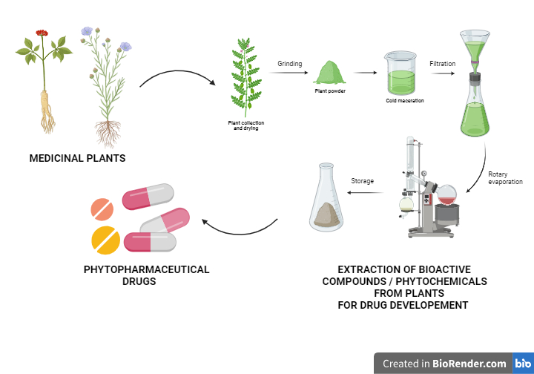
Figure 1.Phytopharmaceutical Drug Developement

Polypharmacology For Complex Diseases:
The one-drug/one-target/one-disease method for pharmaceutical development is currently confronting numerous issues related to safety, effectiveness, and sustainability (6).Drugs intended for targeting specific molecular targets are typically ineffective against multigenic diseases like cancer, In addition to illnesses including diabetes and immunoinflammatory disorders that impact a number of tissues or cell types (7). A multi-targeted approach is required for complex diseases such as diabetes, multiple sclerosis, cancer, and heart disease. This has led to the development of a novel tactic well-known as Polypharmacology, which is predicated on a multi-target methodology.Unlike the traditional 'one drug for one target for one disease' drug development paradigm, Polypharmacology shows how effective medications often influence numerous targets inside disease cellular networks or pathways. Unlike conventional pharmaceuticals, which typically include a single active component, herbal medicines are frequently composed of complex combinations of substances that can function synergistically or antagonistically to achieve therapeutic results.Natural products have more diverse chemical spectra compared to synthesised small molecule drugs, resulting in larger polypharmacological profiles.Natural products offer unique chemical scaffolds that can overcome cross-resistance to cancer medications, inspiring the development of new cancer therapies (8). A recent research investigation explores several methods for studying interactions between drugs and their targets while showcasing the polypharmacological qualities of five endogenous substances: curcumin, epigallocatechingallate, quercetin, resveratrol, and berberine. (8).Researchers are interested in further comprehending the mechanisms of action, optimizing formulations, and discovering novel therapeutic applications for traditional herbal medicines by systematically analysing the interactions between bioactive chemicals in plant-based medicines and their targets in the body. Furthermore, standardization and quality control techniques are being established to ensure that herbal products are consistent and safe for consumers.
Integration of Phytopharmaceuticals With Nanotechnology:
Plant-derived phytocompounds are widely recognised for their extensive pharmacological properties in a variety of diseases. One significant advantage of phytoconstituents is their low toxicity and unwanted effects. The use of ethosome, liposome, emulsion, phytosomes, microspheres, and powerful lipid nanoparticles in herbal formulations has increased the therapeutic efficacy of plant extracts. The use of all of these results in directed administration of the formulation, which has an impact on the site and increases bioavailability. Integrating nanomaterials with pharmaceuticals made from plants allows for more effective delivery to target cells or tissues (10).Nanoparticulate delivery technologies, including nanoemulsions, liposomes, and nanoparticles, can encapsulate hydrophobic phytochemicals, preventing degradation and improving solubility in biological fluids. This increased solubility can improve the absorption and bioavailability of Phytopharmaceuticals, resulting in a more effective therapeutic outcome. Nanoparticulate systems can target specific tissues or cells in the body, allowing for local administration of Phytopharmaceuticals to the point of action. Surface enhancement of nanoparticles with targeted ligands or antibodies can help accumulate in sick tissues while reducing off-target effects. This tailored delivery method can improve the therapeutic efficiency of Phytopharmaceuticals while minimizing systemic negative effects.Nanoparticle delivery methods are being developed capable of dispensing Phytopharmaceuticals in a regulated manner, resulting in continuous drug release over time. This controlled release strategy can improve the pharmacokinetics of Phytopharmaceuticals, keeping therapeutic drug levels stable in the body and reducing dose frequency. Furthermore, controlled-release formulations can help to reduce fluctuations in drug concentration, increasing patient compliance and lowering the risk of adverse effects. Nanoparticulate systems allow for the simultaneous delivery of several phytochemicals or other therapeutic agents, resulting in synergistic effects and combination therapy. This method can improve the therapeutic efficacy of Phytopharmaceuticals by targeting various pathways implicated in disease etiology. Nanoparticles, for example, can encapsulate a combination of plant extracts with complimentary bioactivities, such as anti-inflammatory and antioxidant characteristics, resulting in improved therapeutic advantages.Overall, the combination of Nanoparticulate systems and Phytopharmaceuticals shows significant promise for furthering the field of natural product-based therapy. Researchers can overcome the constraints of classic Phytopharmaceutical formulations by utilising the unique benefits of Nanoparticulate drug delivery, resulting in novel therapies with enhanced efficacy, safety, and patient outcomes.
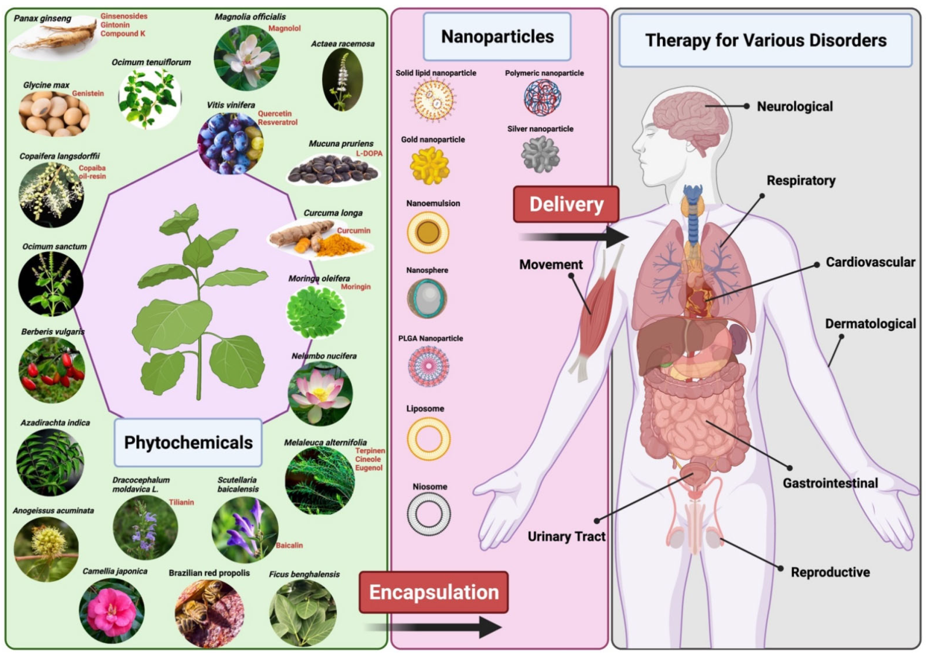
Figure 2.Representation of delivering Phytopharmaceuticals with nanotechnology (Source: Lim, C. L., et.al, 2022)

Current Uses of Phytochemicals:
It has been discovered that plant-derived bioactive chemicals have extraordinary properties such as healing, anti-cancer, anti-oxidant, and so on. Phytochemicals are bioactive molecules found in foods that have the potential to positively influence human metabolism. Alkaloids, terpenoids, phytosterols, resveratrol, and cardiac glycosides are the groups into which they are divided. Many bioactive compounds that are found in terrestrial plants, including carotenoids, diosgenin, resveratrol, quercetin, sulforaphane, tocotrienols, and isoflavones, have been associated with lowering the risk of cardiovascular disease, which is the leading cause of mortality worldwide. The potential of phytochemicals to lower the risk of cardiovascular diseases through their antioxidative, antihypercholesterolemic, antiangiogenic, anti-ischemic, platelet aggregation inhibition, and anti-inflammatory properties may be the cause of their cardioprotective benefits. (11). The use of herbal medications and other natural items in diverse diseases such as dentistry and rheumatoid arthritis (RA) sedative and anxiolytic actions, as well as anti-inflammatory activity, are being done (12). Although phytochemicals may prevent viruses through a number of methods, Phytochemicals have been used as therapeutic agents targeting a variety of viruses due to their ability to effectively block viruses entry points or during replication, as well as their capacity to modulate immune responses. Numerous plants and their parts appear to have promise antiviral activity against SARS-CoV-2, according to recent studies.A variety of compounds that are exclusive to plants, such as flavonoids, lignans, saponins, alkaloids, apigenin, baicalin, quercetin, kaempferol, luteolin, and polysulphates (sulphated polysaccharides), have been shown to have a variety of functions, including preventing the growth of viruses such as dengue, hepatitis C virus (HCV), herpes simplex virus (HSV), influenza, chikungunya, SARS, and others, as well as blocking viral entry alongside breaking down nucleocapsid and genetic material (13). A plant that is a part of the Rutaceae family, todaliaasiatica is frequently prescribed for the treatment of fever, neuralgia, epilepsy, malaria, sprains, cough, and dyspepsia, in addition to its anti-HIV as well as anti-cancer properties. Sapiumellipticum leaves shown considerable cytotoxic activity against MCF-7 cancer cells (14). Jatrophacurcas, Jatrophagossypifolia, Picralimanitida, and Pyrenacanthastaudtii have been successfully used to treat several cancer cell lines (15). Phytochemicals derived from many plant parts, including roots, leaves, stems, bark, and bulbs, have anticancer properties,antiviral activity, cardioprotective benefits, antioxidative, antihypercholesterolemic, antiangiogenic, anti-ischemic, platelet aggregation inhibition, and anti-inflammatory properties, and could be used to develop novel medications.
- Cancer - According to scientific predictions, there will be 18.1 million additional instances of cancer in 2018 (9.5 million excluding skin cancer that is not melanoma) and 9.6 million deaths from cancer in 2018. With 11.6% of all cases and the greatest percentage of cancer-related deaths (18.4% of all cancer-related deaths), lung cancer is one of the most common cancers in both sexes. It follows female breast cancer (11.6%), prostate cancer (7.1%), and colorectal cancer (6.1%) in terms of overall prevalence, and gastrointestinal cancer (9.2%), carcinoma of the stomach (8.2%), and tumours of the liver (8.2%) in terms of mortality (16). Research suggests that a diet high in fruits and vegetables may protect against cancer due to biologically active plant secondary metabolites. Compounds have been shown to have anti-carcinogenic properties in animal models of cancer, and their molecular actions are being studied further (19).Research evidence suggests that phytochemicals have strong anticancer activity. From 1940 to 2014, around half of the chemotherapy drugs with licences came from natural sources or were directly developed from them (17). In a number of cancer models, capsaicin functions as a radiosensitizer, tumour suppressor, chemopreventive, and anti-cancer agent. Applying topical capsaicin reduces pain and can be a useful treatment option for osteoarthritis symptoms when oral nonsteroidal anti-inflammatory drugs are not utilised because of negative side effects.Green tea and other liquids contain natural polyphenols and phytochemicals called catechins. Research suggests that consuming plant-based polyphenols through diet lowers the risk of developing cancer. Catechin (C), epicatechin (EC), epigallocatechin (EGC), and epigallocatechin-3-gallate (EGCG) are the main active components of green tea (18).
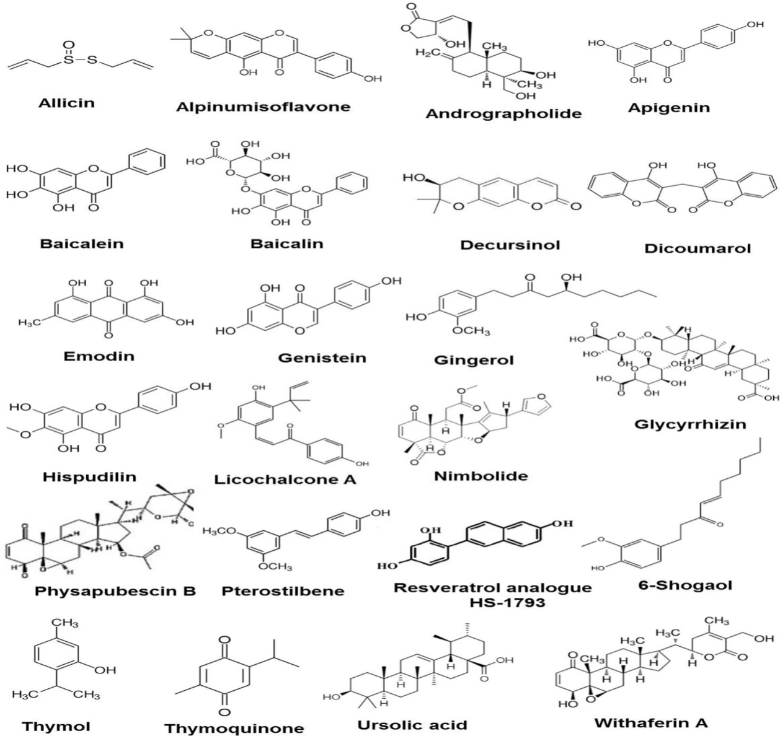
Figure 3.Certain Anticancer Phytochemicals used for Preclinical Investigations.(Source: Choudhari et.al, 2020)
- Polycystic Ovary Syndrome - PCOS is an endocrine disorder that impacts a woman's ability to regulate her metabolism throughout the stages of reproduction. It happens whenever a woman's adrenal glands or ovaries produce an excess of testosterone (21). One of Mimosa pudica's main ingredients, mimosine, has tumor-suppressive and estrogenic properties. One phytosterol that is present in medicinal plants that helps control urinary problems is called β-sitosterol (B). It efficiently lowers blood sugar, cholesterol, and improves insulin sensitivity, all of which are useful in treating PCOS (20).Numerous biochemical characteristics of PCOS showed substantial enhancements in all 12 investigations that looked at the influence of phytochemical-based supplementation on PCOS markers. These trials included daily supplementation of either EGCG, curcumin, quercetin, resveratrol, or berberine (21).
- Diabetes - Diabetes Mellitus is a metabolic condition that causes persistent hyperglycemia and disrupts carbohydrate, lipid, and protein metabolism due to abnormalities in insulin secretion, action, or both, according to the World Health Organisation. Plants have long been an excellent source of medications. Ethnobotanical information suggests 800 plants with possible anti-diabetic properties (22). Phytoactive substances such flavonoids, lignans, and prophenylphenols can help with diabetic wound healing by enhancing collagen deposition, improving fibroblasts, and reducing 11β-hydroxydehydrogenase levels. Plants rich in antioxidants can reverse diabetes-related cardiovascular abnormalities by lowering cholesterol levels (23).Plant-derived natural compounds can mimic insulin's activity and effectively treat hyperglycaemia. These phytochemicals may function within or outside of the pancreas (24). enhanced insulin production, reduced levels of insulin resistance, enhanced liver glycogen synthesis, and antioxidant and anti-inflammatory qualities are the fundamental mechanisms underpinning their anti-diabetic effects.
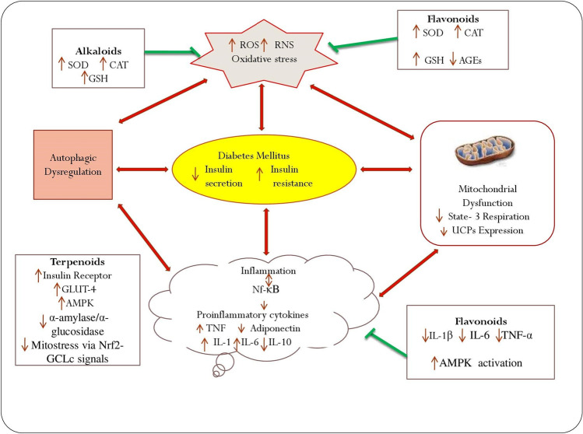
Figure 4.Diabetes: Mechanistic Pathways and Photochemical Management
(Source: Singh et.al, 2022)

- Hepatoprotective Effects - The primary organ that deals with the effects of oxidative stress is the liver. Inflammation brought on by a persistent liver damage can eventually develop into cirrhosis and liver cancer.The bodies of individuals are capable of self-defense. but it may require additional natural antioxidants to combat oxidative stress (26).Medicinal plants hold great promise as sources of medications used to treat a wide range of ailments. Among these varieties is the widely grown Moringaoleifera, popularly called the drumstick tree or Moringa.Proteins, fats, beta-carotene, vitamin C, iron, potassium, and other minerals are all present in large amounts. Promising hepatoprotective qualities are observed in the crude methanol extract of M. oleifera leaves (27).Fruits and plants that protect the liver include those that contain phenols, coumarins, lignans, essential oils, and monoterpenes, glycosides, alkaloids, carotenoids, flavonoids, organic acids, and xanthines.. Previous research have found that blueberries/cranberries, Opuntiaficus-indica, Matricariachamomilla or Chamomillarecutita, Silymarin, Spirulina maxima, Spirulinaplatensis, and Spirulinafusiformis, Grapefruit (Citrus paradisi), naringin and naringe have hepatoprotective benefits (28).
Future Perspectives of Phtyopharmaceuticals:
The future of Phytopharmaceuticals seems hopeful, because to advances in numerous scientific disciplines, changing consumer preferences, and a rising understanding of natural products' therapeutic potential.As our understanding of plant biochemistry, pharmacology, and genetics advances, there will be more opportunities to utilise Phytopharmaceuticals' medicinal potential. Metabolomics, transcriptomics, and bioinformatics will help identify and characterise bioactive molecules in medicinal plants, as well as understand their modes of action.With the introduction of precision medicine approaches, there is a growing interest in personalised healthcare based on individual genetic, physiological, and lifestyle characteristics. Phytopharmaceuticals may play a role in personalised medicine by delivering natural medicines suited to individual patients' distinct requirements and traits, thereby increasing treatment success and lowering side effects.Combining several plant-derived substances or Phytopharmaceuticals with conventional medications is becoming recognised for its potential synergistic effects. Future study could concentrate on identifying synergistic combinations of phytochemicals, understanding their mechanisms of action, and optimising combination therapy tactics for the treatment of complicated disorders.Despite their long history of usage in traditional medicine, many Phytopharmaceuticals lack strong clinical data to back up their efficacy and safety. Future research efforts will focus on conducting rigorous clinical trials and preclinical investigations to evaluate the therapeutic potential of Phytopharmaceuticals, determine optimal dose regimes, and understand their mechanisms of action.Ensuring the efficacy, safety, and quality of Phytopharmaceuticals products is still a key concern. Developments in analytical techniques, quality assurance processes, and regulatory standards will be required to address these issues and establish stringent criteria for Phytopharmaceuticals manufacturing, characterization, and quality control.The long-term prospects of Phytopharmaceuticals look promising, with several potentials for innovation, collaboration, and expansion. Phytopharmaceuticals have the potential to revolutionise healthcare by utilising the potential of plant-derived substances and developments in science and technology. They will also help to the development of more sustainable and comprehensive approaches to wellness and illness management.
Conclusion:To summarise, the exploration of Phytopharmaceuticals' dynamic potential, along with nanotechnology and Polypharmacology, reveals a promising frontier in modern medicine. The combination of these disciplines not only improves the therapeutic efficacy of plant-derived substances, but also transforms drug delivery systems, allowing for targeted and personalised treatments. The complex interplay between Phytopharmaceuticals and nanotechnology enables precise targeting of exhausted tissues while minimising off-target effects, paving the path for more effective and safer therapies. Furthermore, the use of Polypharmacology broadens the therapeutic range of Phytopharmaceuticals by simultaneously regulating several targets, reducing drug resistance and increasing treatment outcomes. As research in this subject advances, new vistas open up unparalleled prospects for healthcare innovation and advancement. By leveraging the synergistic potential of Phytopharmaceuticals, nanotechnology, and Polypharmacology, we are positioned to see transformative advances that will change the future of medicine, providing new hope for both patients and practitioners.

REFERENCES
- Banker, G. S., Siepmann, J., & Rhodes, C. (Eds.). (2002). Modern pharmaceutics. CRC Press.
- Parasuraman, S., Thing, G. S., &Dhanaraj, S. A. (2014). Polyherbal formulation: Concept of ayurveda. Pharmacognosy reviews, 8(16), 73–80.
- Sumantran, V. N., &Tillu, G. (2011). Ayurvedic pharmaceutics and insights on personalized medicine. Progress in Traditional and Folk Herbal Medicine, 1, 13-52.
- Nasim, N., Sandeep, I. S., &Mohanty, S. (2022). Plant-derived natural products for drug discovery: current approaches and prospects. The Nucleus : an international journal of cytology and allied topics, 65(3), 399–411.
- Bhatt, A. (2016). Phytopharmaceuticals: A new drug class regulated in India. Perspectives in clinical research, 7(2), 59-61.
- Chandran, U., Mehendale, N., Patil, S., Chaguturu, R., &Patwardhan, B. (2017). Network Pharmacology. Innovative Approaches in Drug Discovery, 127–164.
- Zimmermann, G. R., Lehar, J., & Keith, C. T. (2007). Multi-target therapeutics: when the whole is greater than the sum of the parts. Drug discovery today, 12(1-2), 34-42.
- Fang, J., Liu, C., Wang, Q., Lin, P., & Cheng, F. (2018). In silicoPolypharmacology of natural products. Briefings in bioinformatics, 19(6), 1153-1171.
- Nooreen, Z., Rai, V. K., &Yadav, N. P. (2018). Phytopharmaceuticals: A new class of drug in India. Ann. Phytomed, 7(1), 27-37.
- Lim, C. L., Raju, C. S., Mahboob, T., Kayesth, S., Gupta, K. K., Jain, G. K., ...&Nissapatorn, V. (2022). Precision and advanced nano-Phytopharmaceuticals for therapeutic applications. Nanomaterials, 12(2), 238.
- R Vasanthi, H., ShriShriMal, N., & K Das, D. (2012). Phytochemicals from plants to combat cardiovascular disease. Current medicinal chemistry, 19(14), 2242-2251.
- Raj, R., Lata, K. S., Raj, V., & Kumar, D. M. (2020). Phytochemicals and its application. The Pharma Innovation, 9(10), 386-390.
- Anand, A. V., Balamuralikrishnan, B., Kaviya, M., Bharathi, K., Parithathvi, A., Arun, M., ...&Dhama, K. (2021). Medicinal plants, phytochemicals, and herbs to combat viral pathogens including SARS-CoV-2. Molecules, 26(6), 1775.
- Sowemimo, A., van de Venter, M., Baatjies, L., &Koekemoer, T. (2009). Cytotoxic activity of selected Nigerian plants. African journal of traditional, complementary, and alternative medicines : AJTCAM, 6(4), 526–528.
- Engel N, Falodun A, Kühn J, Kragl U, Langer P, Nebe B. Pro-apoptotic and anti-adhesive effects of four African plant extracts on the breast cancer cell line MCF-7. BMC Complement Altern Med. 2014;14:334. Published 2014 Sep 9.
- Bray, F., Ferlay, J., Soerjomataram, I., Siegel, R. L., Torre, L. A., &Jemal, A. (2018). Global cancer statistics 2018: GLOBOCAN estimates of incidence and mortality worldwide for 36 cancers in 185 countries. CA: a cancer journal for clinicians, 68(6), 394-424.
- Choudhari, A. S., Mandave, P. C., Deshpande, M., Ranjekar, P., &Prakash, O. (2020). Phytochemicals in cancer treatment: From preclinical studies to clinical practice. Frontiers in pharmacology, 10, 497776.
- Ranjan, A., Ramachandran, S., Gupta, N., Kaushik, I., Wright, S., Srivastava, S., ...&Srivastava, S. K. (2019). Role of phytochemicals in cancer prevention. International journal of molecular sciences, 20(20), 4981.
- Johnson, I. T. (2007). Phytochemicals and cancer. Proceedings of the Nutrition Society, 66(2), 207-215.
- Temkar, V., &Menon, S. (2022). Combination of Phytochemicals in the Management of Polycystic Ovarian Syndrome Induced in Rats. Pharmacognosy Communications, 12(4).
- Chavez, G. N., Jaworsky, K., &Basu, A. (2023). The Effects of Plant-Derived Phytochemical Compounds and Phytochemical-Rich Diets on Females with Polycystic Ovarian Syndrome: A Scoping Review of Clinical Trials. International Journal of Environmental Research and Public Health, 20(15), 6534.
- B Gaikwad, S., Krishna Mohan, G., &Sandhya Rani, M. (2014). Phytochemicals for diabetes management. Pharmaceutical Crops, 5(1).
- Bacanli, M., Dilsiz, S. A., Başaran, N., &Başaran, A. A. (2019). Effects of phytochemicals against diabetes. Advances in food and nutrition research, 89, 209-238.
- Teoh, S. L., & Das, S. (2018). Phytochemicals and their effective role in the treatment of diabetes mellitus: a short review. Phytochemistry Reviews, 17, 1111-1128.
- Singh, S., Bansal, A., Singh, V., Chopra, T., &Poddar, J. (2022). Flavonoids, alkaloids and terpenoids: a new hope for the treatment of diabetes mellitus. Journal of diabetes and metabolic disorders, 21(1), 941–950.
- Fahmi, A., Hassanen, N., Abdur-Rahman, M., & Shams-Eldin, E. (2019). Phytochemicals, antioxidant activity and hepatoprotective effect of ginger (Zingiberofficinale) on diethylnitrosamine toxicity in rats. Biomarkers, 24(5), 436-447.
- Atta, A. H., Nasr, S. M., Almaweri, A. H., Sedky, D., Mohamed, A. M., Desouky, H. M., &Shalaby, M. A. (2018). Phytochemical, antioxidant and hepatoprotective effects of different fractions of Moringaoleifera leaves methanol extract against liver injury in animal model. Asian Pacific Journal of Tropical Medicine, 11(7), 423-429.
- Madrigal-Santillán, E., Madrigal-Bujaidar, E., Álvarez-González, I., Sumaya-Martínez, M. T., Gutiérrez-Salinas, J., Bautista, M., Morales-González, Á.,García-Luna y González-Rubio, M., Aguilar-Faisal, J. L., & Morales-González, J. A. (2014).

